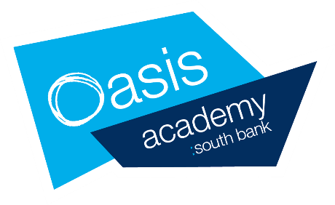
22nd June – 15th July Year 12 Provision
A packed lunch will be provided for all students each day that they are in school – this includes the 1:1 meetings.

 | Monday | Tuesday | Wednesday | Thursday | Friday
w/c 22nd June  9:00am-2.15pm | 22nd June | 23rd June | 24th June | 25th June | 26th June
 | All students will have a scheduled 1:1 meeting during the week  + 9:30-3pm study support  Online lessons will continue as normal | All students will have a scheduled 1:1 meeting during the week  + 9:30-3pm study support  Online lessons will continue as normal | All students will have a scheduled 1:1 meeting during the week  + 9:30-3pm study support  Online lessons will continue as normal | All students will have a scheduled 1:1 meeting during the week  + 9:30-3pm study support  Online lessons will continue as normal | All students will have a scheduled 1:1 meeting during the week  + 9:30-3pm study support  Online lessons will continue as normal
w/c 6th July  9:00am-2.15pm | 6th July | 7TH July | 8th July | 9th July | 10th July
 | Wellbeing 1:1 meetings + Personal statement support sessions  + 9:30-3pm study support  Online lessons will continue as normal | Wellbeing 1:1 meetings + Personal statement support sessions  + 9:30-3pm study support  Online lessons will continue as normal | Wellbeing 1:1 meetings + Personal statement support sessions  + 9:30-3pm study support  Online lessons will continue as normal | Wellbeing 1:1 meetings + Personal statement support sessions  + 9:30-3pm study support  Online lessons will continue as normal | Wellbeing 1:1 meetings + Personal statement support sessions  + 9:30-3pm study support  Online lessons will continue as normal
w/c 13th July  10:00am-2.15pm | 13TH July | 14th July | 15th July | 16th July | 17th July
 | Oxbridge University Preparation Day | Medic University Preparation Day | UCAS and Summer Projects Preparation Day

w/c 22nd June 1:1 meetings:
This will be an opportunity for your son/daughter to meet with a member of staff to review the following:
- How they are feeling about lockdown and Covid 19, an opportunity to speak about their wellbeing, any challenges they are facing
- Receive an equipment refresh (blank books, pens and other equipment)
- Receive new course material (Year 13 course textbooks and revision guides)
- A review of their engagement with online learning; what is going well, areas of challenge
- University application guidance
- How the school can further support your son/daughter?
- An opportunity to talk more generally about anything on their mind, issues on the news, within their community
- An opportunity to ask questions about their future, to begin to plan for post-18 provision, how to approach Year 13

Due to social distancing measures we are not able to accommodate parents as part of these meetings.

w/c 6th July 1:1 meetings:
Applications to Medical applicants and Oxford or Cambridge University applicants require additional preparation as they have an earlier submission date. These universities also require all students to sit an additional entrance exam as well as a challenging interview. These meetings will ensure that students are well prepared for the October deadline, including access to exam revision materials and wider reading.

w/c 13th July 1:1 meetings:
Meetings will be targeted at students that require additional support in;
- Staying motivated
- Organising their workload
- Decision making around post-18 provision
- Wellbeing in advance of the summer holidays
Staff will be able to direct students to begin thinking about post-18 options whether that be University, apprenticeship or employment.
In order for us to adhere to social distancing measures and student/teacher ratios, we ask that students strictly stick to their time slot on their given day. If your son/daughter arrives on the wrong day or outside of their allocated time slot, we may not be able to accommodate them and they will be asked to leave. Appointments will be sent out via email to both parents and students contact details.
There will be open evenings in September and October where parents can receive advice and guidance on applying to University, University finance and other post-18 opportunities. Applications for University do not need to be submitted until November/December 2020.

If you are unclear as to when your son/daughter should attend their 1:1 meeting please email sixthform@oasissouthbank.org
As well as attending their 1:1 meeting, students will be able to access an optional supervised study space on their allocated day from 9:30-3pm. This will be an opportunity for students to access support from teaching staff as well as providing them with a quiet space to work in school. As there are a limited number of spaces available, students will need to book a space for the study support by contacting Mr Holmes.

