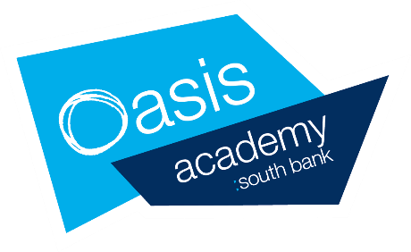
15th June – 17th July Year 10 Provision
A packed lunch will be provided for all students each day that they are in school – this includes the 1:1 meetings.
Please note – students will not be expected to be in their online lessons on the day that their class group is invited into school. e.g. Monday 15th June – 10A will not have online lessons (the rest of Year 10 will)

 | Monday | Tuesday | Wednesday | Thursday | Friday
w/c 15th June  9:30am-3pm | 15TH June | 16th June | 17th June | 18th June | 19th June
 | 10A 1:1 meetings  + 9:30-3pm study support | 10B 1:1 meetings  + 9:30-3pm study support | 10C 1:1 meetings  + 9:30-3pm study support | 10D 1:1 meetings  + 9:30-3pm study support | 10E 1:1 meetings  + 9:30-3pm study support
w/c 29th June  9:30am-3pm | 29th June | 30th June | 1st July | 2nd July | 3RD July
 | 10A wellbeing session  +study support | 10B wellbeing session  +study support | 10C wellbeing session  +study support | 10D wellbeing session  +study support | 10E wellbeing session  +study support
w/c 13th July  9:30-3pm | 13TH July | 14th July | 15th July | 16th July | 17th July
 |  |  | Year 10 study support | Year 10 study support | Year 10 study support

w/c 15th June 1:1 meetings:
This will be an opportunity for your son/daughter to meet with a member of staff to review the following:
- How they are feeling about lockdown and Covid 19, an opportunity to speak about their wellbeing, any challenges they are facing
- A review of their engagement with online learning; what is going well, areas of challenge
- How the school can further support your son/daughter?
- An opportunity to talk more generally about anything on their mind, issues on the news, within their community
- An opportunity to ask questions about their future, to begin to plan for post-16 provision, how to approach Year 11
Staff will be able to direct students to begin thinking about post-16 options whether that be A-Levels, college or an apprenticeship.
In order for us to adhere to social distancing measures and student/teacher ratios, we ask that students strictly stick to their below time slot on their given day. If your son/daughter arrives on the wrong day or outside of their allocated time slot, we may not be able to accommodate them and they will be asked to leave.

 | Monday 15th June: 10A | Tuesday 16th June: 10B | Wednesday 17th June: 10C | Thursday 18th June: 10D | Friday 19th June: 10E
9:30- 11:00am | First name A-H | First name A-H | First name A-H | First name A-H | First name A-H
11:00-12:30pm | First name I- P | First name I- P | First name I- P | First name I- P | First name I- P
12:30-2pm | First name Q- Z | First name Q- Z | First name Q- Z | First name Q- Z | First name Q- Z

Due to social distancing measures we are not able to accommodate parents as part of these meetings.
If you are unclear as to when your son/daughter should attend their 1:1 meeting please email office@oasissouthbank.org
As well as attending their 1:1 meeting, students will be able to access an optional supervised study space on their allocated day from 9:30-3pm. This will be an opportunity for students to access support from teaching staff as well as providing them with a quiet space to work in school.

w/c 29th June Wellbeing Morning:
 | Monday 29th June: 10A | Tuesday 30th June: 10B | Wednesday 1st July: 10C | Thursday 2nd July: 10D | Friday 3rd July: 10E
9:30- 10am | Arrival | Arrival | Arrival | Arrival | Arrival
10:00- 10:40am | Welcome & In The News Assembly | Welcome & In The News Assembly | Welcome & In The News Assembly | Welcome & In The News Assembly | Welcome & In The News Assembly
10:40-10:55am | Break | Break | Break | Break | Break
10:55-11:45 | Online safety, managing conflict, healthy relationships | Online safety, managing conflict, healthy relationships | Online safety, managing conflict, healthy relationships | Online safety, managing conflict, healthy relationships | Online safety, managing conflict, healthy relationships
11:45-12pm | Lunch | Lunch | Lunch | Lunch | Lunch
12:00-12:30pm | Small group mindfulness and wellbeing. | Small group mindfulness and wellbeing. | Small group mindfulness and wellbeing. | Small group mindfulness and wellbeing. | Small group mindfulness and wellbeing.
12:30-3pm | Study Support | Study Support | Study Support | Study Support | Study Support

