Instruction for Relocation Science work Year 7-11
For every Science Lesson in Relocation, you must complete the following:

Knowledge practice
- Use the knowledge for this term to complete your look, cover, write, check in your relocation book for at least one topic
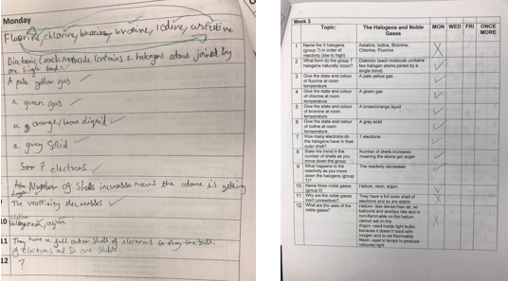
Learning ladders
- Using the knowledge and the Collins revision guides to help you, answer the learning ladder questions in your relocation booklet. Use the answers to self-assess your answers.
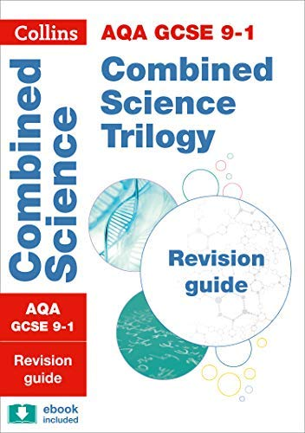
Other tasks
- Complete your Look, cover, write check 3 x per week homework, in the booklet your science teacher has given you
- Tassomai Quizzing online – at lunch / break times ONLY
