% | I can … | Prove it!
80%+ | Interpret graphs of reaction conditions versus rate (triple only)  Apply the principals of dynamic equilibrium to the Haber process (triple only)  Explain why oxygen levels increased and carbon dioxide levels decreased (linking to photosynthesis and sedimentation)  Explain why it is difficult to model global warming and how this has led to simplification, speculation and biased opinions in the media | - Explain how this graph shows that the forwards reaction in the Haber process is exothermic.  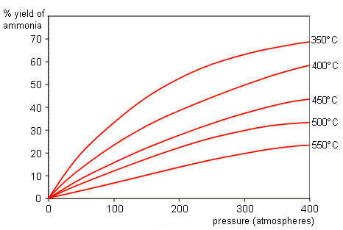  - Choose from the following words to explain what would happen in the Haber process in conditions a - e: exothermic, endothermic, temperature, pressure, catalyst, yield  a. high temperature  b. low temperature  c. high pressure  d. low pressure.  e. presence of a catalyst  - Use data from the graph to explain the trend in oxygen levels.  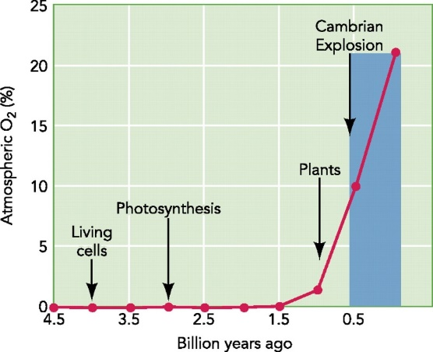  - Use the data in the pie chart to explain how carbon dioxide levels have changed over time.  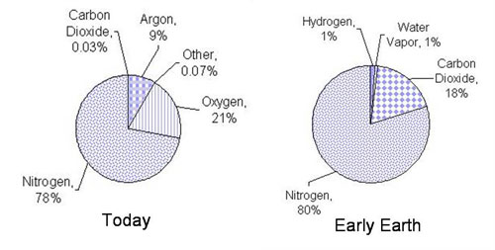  - Imagine that you are a scientist and an oil company approaches you to carry out a piece of research to find out how the levels of carbon dioxide have affected the average global temperatures. Explain the problem with you carrying out this research on their behalf.  - For each headline, explain the possible impact that these could have on public opinion and behaviour:  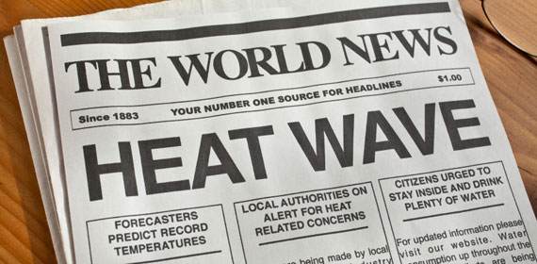  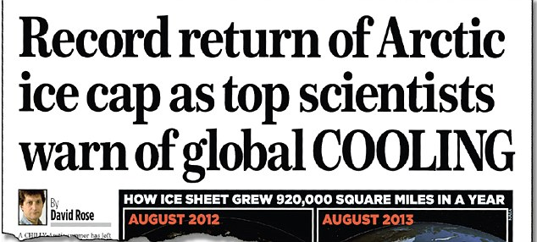
70% | Explain how peer review evidence have linked these activities to global climate change  Explain how phytomining and bioleaching and scrap iron and electrolysis can be used to extract copper from low grade ores  Discuss the scale, risks and environmental implication of global climate change  Explain how some natural products are being replaced by some agricultural and synthetic products  Use data to carry out LCA for shopping bags made from plastic and paper | - Explain what is meant by the term ‘peer review’ and give three reasons why it is important that scientific research undergo this process.  - Complete the following table:  Alternative methods of extracting metals  Method Product Description Advantages  electrolysis  phytomining  bioleaching  - Create a mind map to show how each of the following effects of climate change could impact on the earth:  - a rise in sea level  - more frequent and severe storms  - increased number of heatwaves  - more droughts  - changes to the distribution of plants and animals  - food shortages  - Explain why a family in 1200 AC could survive on using only resources from their local forest, whereas a family in 2017 could not.  - Use the data in this table to decide which bag is more sustainable:  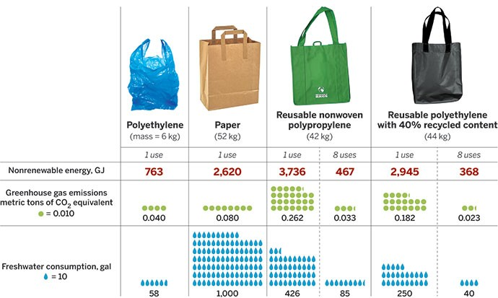

% | I can … | Prove it!
60% | Explain why large amounts of waste water are produced (urban life styles and industrial processes)  Explain what needs to be removed from sewage and agricultural waste in comparison with industrial waste water  Explain that water resources, energy and waste production can be easily quantified whereas pollutant effects are hard to quantify  Explain how glass is produced  Explain how these conditions are manipulated to produce optimum quantities of the desired products (triple only)  Discuss the environmental impact of using metal, glass, building materials, clay ceramics and plastics linking to the use of these limited resources and the energy used to extract and process them.  Evaluate the methods to produce potable water (linking to location and potential water supply)  Explain how the ammonia is removed and the hydrogen and nitrogen are recycled (triple only)  Describe how simplified life cycle assessments can be used in a biased manner to support advertising claims in the media | - Draw a flow chart to show how water is recycled from homes back to drinkable water again. Use these words: waste water, organic matter, microorganisms, toxic chemicals, screening, girt removal, sedimentation, anaerobic digestion, aerobic biological treatment.  - Complete the table to show the difference between what substances need to be removed from sewage compared to agricultural waste:  Sewage Agricultural waste  - Explain why it is difficult to quantify the effects of pollutants using an example to help illustrate your explanation.  - Draw a flow chart to show how glass is produced.  - Complete the table to show the chosen reaction conditions in the Haber process:  Factor Condition Reason  temperature  pressure  catalyst  - Draw a mind map to show how each of the following impact on the environment: metal, glass, building materials, clay, ceramics, and plastics. Make sure you include information on what they are used for, how limited they are on earth and how much energy is used to extract them.  - Write a paragraph evaluating both desalination and sterilisation of water.  - Complete the following paragraph: fractional distillation, liquefies, Haber, natural gas, nitrogen, nitrogen, ammonia, hydrogen  In the ______ process, the raw materials are _________ and hydrogen and the product is ___________. Purified nitrogen is obtained from the _____________ _______________ of air. Hydrogen is obtained from ______ ____ or steam. The reaction is reversible, which means that some of the ammonia will break back down into the reactants ___________ and ________. These are then recycled. The ammonia will cool down and turn back into a _______ and can be removed.  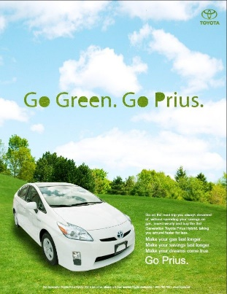  - This advert used a shortened version of the real LCA. Give one reason why a company would use this shortened version rather than the full one.

% | I can … | Prove it!
50% | Draw links between the early Earth’s atmosphere and that of other planets (Mars and Venus)  Evaluate different theories regarding the Earth’s early atmosphere  Explain how we can reduce our use of limited resources (reduce, reuse, recycle)  Explain how to produce clay ceramics  Compare low density and high density poly(ethane)  Compare and contrast thermosetting and thermosoftening polymers explaining the differences  Explain what ‘composites’ are and give some examples  Explain ways that we can reduce this environmental impact  Describe the ‘greenhouse effect’ linking to the wavelength of radiation  Describe actions to reduce our carbon footprint and explain why these actions may have limited impact  Describe the properties of potable water (is safe to drink) linking to purity, salt and microbe levels  Describe the different sources of drinking water in the UK and the process that it must undergo before it is potable  Describe the process of desalination (distillation or reverse osmosis) | - Complete the Venn diagram to show the similarities and differences between Earth’s early atmosphere and that of Mars and Venus.  - List examples of how we can carry out the following:  Reduce Reuse Recycle  - Draw a flow chart to show the stages in making clay ceramics.  - Complete the table to show the comparison between thermosetting and thermosoftening plastics.  Thermosoftening polymers Thermosetting polymers  Structure description  Structure diagram  Type of forces  Properties  - Write a definition of a composite material and give two examples.  - Complete the diagram to show how the greenhouse effect is created using these labels.  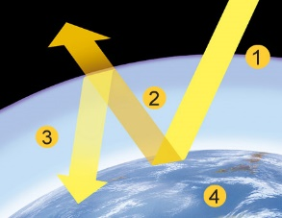  A. Infrared radiation is reflected back from the Earth’s surface.  B. The Earth becomes hotter as a result  C. Infrared radiation from the Sun enters the Earth’s atmosphere  D. Infrared radiation is absorbed by greenhouse gases and as a result becomes trapped in the Earth’s atmosphere  - There are many things we can do to reduce our carbon footprint. Write a description for each action:  Action Description  Using alternative energy resources  Wasting less energy  Carbon Capture and Storage (CCS)  Carbon taxes and licenses  Carbon off-setting  Carbon-neutral products  8. Explain some of the problems with reducing our carbon footprint (6 marks)  9. Write a description of potable water and include information about its purity, salt levels and the number of microorganisms it contains.  10. Create cycle to show each of the following processes:  A. producing potable water  B. Desalination

% | I can … | Prove it!
40% | Describe the composition of the atmosphere and how long this has been the case  Describe the development from early atmosphere to present day  Describe the term ‘greenhouse gases’ and give three examples (water vapour, carbon dioxide and methane)  Describe the effect of human activities on the levels of greenhouse gases, recalling two that affect methane and two that affect carbon dioxide  Describe 4 potential effects of global climate change  Describe what is meant by the term ‘carbon footprint’  Describe combustion as a major source of atmospheric pollution  Name gases release when fuels such as coal are burnt (carbon dioxide, water vapour, carbon monoxide, sulphur dioxide and nitrogen oxides) and predict which of these would be produced from a given fuel composition  Describe ‘particulates’  Describe issues arising from carbon dioxide, sulphur dioxide, nitrogen oxides and particulates  Recalls that humans use the Earth’s resources to provide; warmth, shelter, food, transport (through timber, clothing, fuels/energy and other materials)  Define what is meant by the term ‘finite resource’  Define what is meant by the term ‘sustainable development’ and explain the role that chemistry plays in developing agricultural and industrial processes  Required practical 8: Analyse and purify water samples from different sources, including pH, dissolved solids and distillation  Describe the 4 steps of sewage treatment  Compare the relative ease of obtaining potable water from waste, the ground and salt water  Describe what is meant by the term ‘life cycle assessment’  Describe the 4 stages of a life cycle assessment  Describe what factors affect the properties of polymers  Compare the composition and melting points of soda-lime glass and borosilicate glass  State what is produced in the Haber process and explain how ammonia produced from this process is used (triple only)  List the raw materials for the Haber process and where they are sourced from (triple only)  Recall the conditions required for the Haber process to take place (triple only)  Recall the word and symbol equation for the Haber process (triple only)  Describe what NPK fertilisers are (triple only)  Describe how NPK fertilisers are produced industrially (triple only)  Describe how sources of NPK are produced/found (ammonium salts, nitric acid and potassium chloride and phosphate rock) (triple only) | - Complete the diagram to show the stages in the evolution of the earth’s atmosphere:  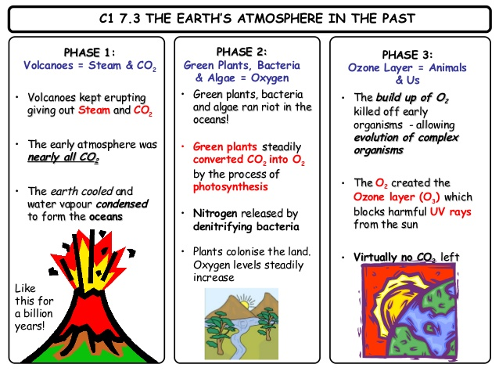  Words to use:  photosynthesis, Ozone, CO2,  condensed, nitrogen, oceans,  UV rays, oxygen  - Write a definition of a greenhouse gas and give three examples.  - Complete the table:  Greenhouse gas Human activity, which increases this gas. Effects on the Earth  Methane  Methane  Carbon dioxide  Carbon dioxide  - Make a mind map to show four effects of global warming.  - Complete the following sentence:  ‘Carbon footprint is. . . ‘  - Complete the word and symbol equations for combustion:  Complete combustion  word:  symbol:  Incomplete combustion  word:  symbol:  7. Complete the following:  Most fuels are made of ______ and _________ (hydrocarbons) but many also contain _______. During _________ (burning) of hydrocarbons, both carbon and hydrogen are oxidised and ______ is released. Carbon dioxide and water ________ are released into the atmosphere. If there is not enough oxygen then ___________ combustion takes place and carbon __________ and solid ___________ are released. Carbon monoxide is a colourless and odourless gas, which is _____. Global __________ can be caused by solid particulates building up in the atmosphere. They can also damage our _______. ___________ in the air can also react with oxygen to form nitrogen oxides. These gases can cause respiratory problems and react with rainwater to form _________. This can damage ________ and buildings. ______ can also be released from fuels and react with rainwater to produce acid rain.  Words: nitrogen, combustion, incomplete, monoxide, plants, carbon, acid rain, hydrogen, sulphur, vapour, dimming, energy, toxic, lungs, sulphur, particulates  - Put each of these uses into the correct resource:  Animals Plants Trees Fossil fuels  clothing, food, warmth, energy, fuels, shelter  - Write a definition for the term ‘finite resource’.  - Complete the following sentence:  ‘Sustainable development is…..’  - Describe one industrial process improved by our understanding of chemistry and explain your choice.  - Put these stages in sewage treatment into the correct order:  A. Aerobic digestion of sewage sludge  B. Sedimentation to produce sewage sludge and effluent  C. Screening and grit removal  D. Aerobic biological treatment of effluent  - a) What does the following acronym stand for: LCA?  b) Write a definition for what LCA means.  c) Write down the four stages of an LCA.  - True or false:  - Thermosoftening polymers have strong intermolecular forces between polymer chains.  - Thermosoftening polymers include poly(ethane).  - Thermosetting polymers have strong intermolecular forces between polymer chains called cross-links.  - Thermosetting polymers include melamine.  - Thermosoftening polymers will soften on heating.  - Thermosetting polymers will soften on heating.  - Complete the following table to compare soda-lime and borosilicate:  Made up of… Melting point Uses  soda-lime glass  borosilicate  - Write a word and symbol equation for the Haber process.  - Give two uses of the ammonia produced in the Haber process.  - Give the following conditions for the Haber process:  a) Temperature  b) Pressure  c) catalyst  - What does NPK stand for and what are they used for?  - Draw a flow chart to show how NPK fertilisers are made.  - Describe how each of the following are produced/found.  a) ammonium salts  b) nitric acid  c) phosphorous rock  d) potassium chloride

Key Words:
atmosphere, algae, locked up, limestone, sedimentary rocks, fossil fuels, crude oil, natural gas, coal, carbonates, infrared radiation, greenhouse gases, carbon dioxide, water vapour, methane (CH₄), biased, climate change, greenhouse effect, carbon footprint, distillation, sewage, phytomining, bioleaching, CCS, sustainable development, agriculture, potable, desalination, ceramics, composites, borosilicate glass (Pyrex), soda-lime, LCA, Haber process, reversible reaction, catalyst, NPK fertilisers, phosphate rock

