% | I can … | Prove it!
80% | - Describe the stages of pregnancy  - Use a genetic cross diagram to predict the chance of offspring inheriting a characteristic  - Use a genetic cross diagram to predict the chance of offspring being male or female  - Define ‘extremophile’ and give examples | - Use a punnet square to prove that there is a 50% change of having male or female offspring  Mother  Father x x  x xx xx  y xy xy  - If a homozygous recessive mother and a heterozygous father have 4 children what is the probability their offspring will carry the recessive allele?  Mother  Father r r  R Rr Rr  r rr rr  50% of offspring are carriers  50% of offspring are homozygous recessive  - Define ‘extremophile’ and give examples  Organisms that has adapted to live in conditions that would kill other organisms.  Thermophile  Cryophile  Halophile  Acidophile  Metallotolerant  Radioresistant
70% | - Describe the process of fertilisation in humans  - Describe the different ways in which the seeds are dispersed by plants  - Apply concept of variation to explain why some organisms are better adapted to their environment that others  - Apply the concept of adaptation to explain why some species become endangered and extinct | 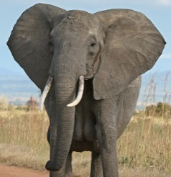  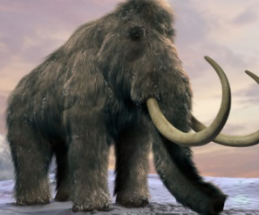  - These are two mammals, the woolly mammoth and the African elephant. How is the African elephant better adapted to survive in the plains of Africa?  The African elephant does not have a woollen coat and also has large ears to use for shad and keep cool  - The woolly mammoth is now extinct, what could have caused this? Humans hunting them, natural disasters, loss of habitat, new species/ predators, pollution.  - Describe two ways that seeds can be dispersed by plants. Seeds can be dispersed by wind or by animals eating them.
60% | - Identify the gametes in human and plant reproduction  - Describe the process of pollination  - Apply the concept of variation and inheritance to explain the process of selective breeding  - Define biodiversity and five examples of things that humans are doing to both harm and improve biodiversity | - Name the human gametes and where they are produced Sperm cells produces in the testes, egg cells produced in the ovaries  - Name the gametes in plants egg cells and pollen cells  - Describe how sheep can be selectively bred to provide extra wool. The desired characteristic would be sheep with extra wool. The breeder selects for this characteristic by breeding the sheep with more wool. Over generations, more and more sheep will have more wool  - Using the bar chart explain which area has the greatest biodiversity. The biodiversity is greater in the woodland because it has the largest number of species
50% | - Define ‘gamete’, ‘fertilisation’, ‘ovulation’, menstruation’, ‘gestation period’, ‘placenta’, ‘umbilical cord’  - Define ‘species’, ‘adaptation’, ‘engendered’ and ‘extinct’ | The menstrual cycle occurs on average every 28 days from day 1 -7 menstruation occurs, this is when the uterus lining is lost out of the vagina as a period. On day 14 ovulation occurs this is when an egg cell is released from the ovary and travels to the oviduct  Eggs and sperm are sex cells known as gametes. Fertilisation is the process where a sperm and egg cell fuse creating an embryo  If an egg is fertilised an embryo develops the embryo is protected by the placenta and the umbilical cord is used to provide nutrients and oxygen whist removing waste products  The gestation period for humans is 9 months  Animals of the same species are able to reproduce to produce fertile offspring  The process of animal’s characteristic changing over time is called adaptation  If animals are unable to do this, they become endangered and eventually extinct. This can happen for many reasons for example a new disease, loss of habitat, loss of food or introduction of a new predator
40% | - Label the male and female reproductive organs in humans and in plants  - Identify examples of genetic and environmental variation | - Add labels to the diagrams below  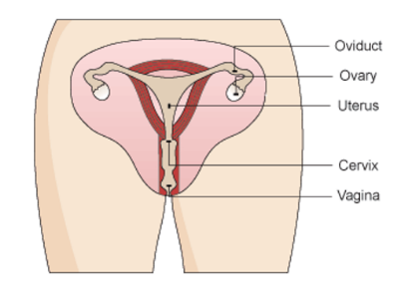  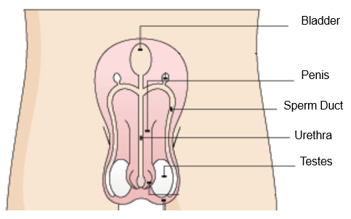  - Complete the table ticking if the characteristic is caused by genetic or environmental variation  Characteristic Genetic Environmental  Eye Colour /  Hair Length /  Foot size /  Scars /

