% | I can … | Prove it!
80% | - Create a classification key that can be used to classify organisms (Extension only)  - Explain how changes in the number of one organism can have an effect on another organism in a food web  - Interpret predator prey graphs (Extension only)  - Construct a pyramid of biomass (Extension only)  - Explain why biomass decreases as you move along a food chain (Extension only)  - Define stem cells and explain where they can be found in both plants and animals | - Explain what makes a stem cell different to a normal body cell, and where can these be found in plants and animals  Stem cells are able to differentiate into any type of cell where a body cells can only divide into the same type of cell. There are two types of stem cells in animals, embryonic and adult (usually found in bone marrow) and in plants they are found in the meristems.  - Draw a pyramid of biomass for this table  Grass 100kg  Rabbits 50kg  Foxes 10kg  (Each box represents 10kg)  - Why have the boxes got smaller as you go up the pyramid  In a food chain only around 10 per cent of the energy is passed on to the next trophic level. The rest of the energy passes out of the food chain in a number of ways:  it is used as heat energy, it is used for life processes (eg movement), faeces and remains are passed to decomposers  - Describe what this graph is showing, the blue line indicates the number of rabbits while the red line indicate the number of wolves  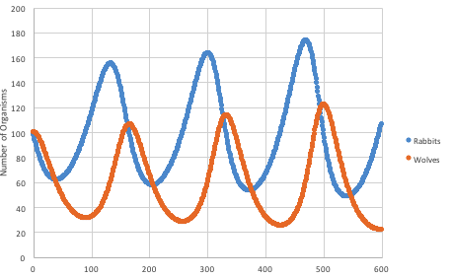  Rabbits are the prey and wolves are the predators, after the number of prey increase the number of predators increases because there are more rabbits to eat. But soon after the number of prey decreases because they are being eaten by the increased number of predators, this causes the number of predators to decrease because there is not enough food for them. The cycle then continues
70% | - Use a classification key to classify organisms  - Explain what the arrow in a food chain represents  - Combine food chains to produce a food web  - Construct a pyramid of numbers  - Describe the difference between a prokaryotic and eukaryotic cell | - What does the arrow in the food chain from the 60% box represent?  The arrow shows the movement of energy in a food chain  - Name the main difference between prokaryotic cells and eukaryotic cells  Eukaryotic cells have their DNA in a membrane bound nucleus whereas prokaryotic cells have their DNA free in the cytoplasm  - Draw a pyramid of numbers for this food chain  1 x Oak tree  5 x Squirrels  2 x Foxes  Foxes  Squirrel  Oak Tree  - What does a food web show?  The many different, interconnected food chains in an area.
60% | - Classify animals into phylum (vertebrates and invertebrates)  - Classify vertebrates into the five classes (mammals, birds, reptiles, amphibians and fish) giving justifications for classification  - Sequence organisms to create a food chain  - Compare and contrast animal and plant cells | - Describe the difference between a vertebrate and an invertebrate  A vertebrate has a backbone inside the body whilst an invertebrate does not  - Is a frog a reptile or an amphibian, explain why  A frog is an amphibian because it has an aquatic gill-breathing larval stage followed (typically) by a terrestrial lung-breathing adult stage whilst a reptile has dry scaly skin  - Draw a food chain for an oak tree, bird, aphid and ladybird  Oak tree aphid ladybird bird  - List three things that plant cells have that animal cell don’t and explain what function they carry out in a plant that is not needed in an animal cell  Chloroplast – plants have to make their own food by photosynthesis  Cell wall – for support, animals have a skeleton  Vacuole – to store cell sap, water and mineral ions
50% | - Classify living organisms into the five kingdoms (animals, plants, fungi, prokaryote and protists)  - State three things that organisms depend and compete with each other for  - Describe the sampling techniques that are used to collect population data (Extension only)  - Describe and explain the adaptations of the following specialised cells (ovum, sperm, ciliated cell, muscle cell, red blood cell, nerve cell, palisade and root hair cell) | 1)From these descriptions classify the following organisms in to one of the 5 kingdoms  Single celled organisms with a nucleus (contains DNA). Normally live in water _- Protista  Contain chlorophyll and can photosynthesise (make their own food using the Sun’s energy) Plants  Single celled organisms with no nucleus Prokaryote  2) Name something that both plants and animals compete for Space/Territory  - Match the adaptations to the specialised cell  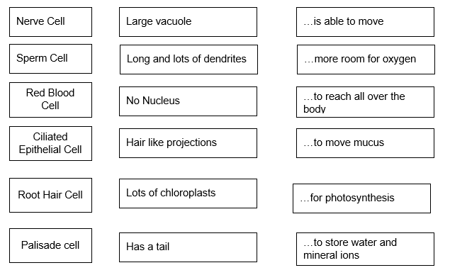
40% | - Identify living things (using MRS NERG)  - Define "habitat", "population", "species", "competition", "interdependence", "ecosystem", "producer", "consumer", "decomposer"  - Identify sub-cellular organelles in plant and animal cells (nucleus, cytoplasm, cell wall, cell membrane, chloroplast, mitochondria, ribosome, vacuole)  - Label a light microscope  - Order cells, tissues, organs and systems in terms of size | - How can you prove that a rock is not a living thing? A rock does not move, respire, sense, grow, reproduce, excrete or take on nutrients  - Define habitat The environment that an organism lives in  - Label the cells  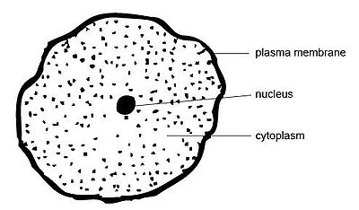  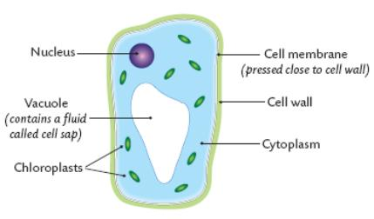  - Label the microscope  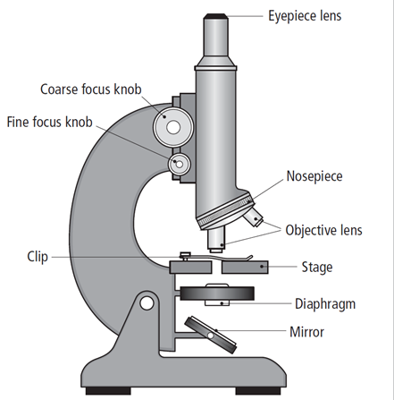  - Put these in order from smallest to largest.  Skin cell, Epithelial Tissue, Nose, Nervous System

