% | I can … | Prove it!
80%+ | 2.4. Interpret data for relative reactivity of different metals to evaluate the use of cells(triple only)  2.6. Compare and contrast the use of hydrogen and chemical cells (triple only)  6.3. Calculate the moles of a solute in a given volume of solution (triple only)  6.4. Use titration results to calculate the concentration of a solution (triple only) | 1. Complete the following statements:  a. At the negative electrode, ________ is produced if the metal is more reactive than hydrogen, and the _____ will be produced if it is less reactive than hydrogen.  b. At the positive electrode, _______ is produced unless the solution contains halide ions, otherwise the _______ is produced.  2. Draw a table to show the advantages and disadvantages of both hydrogen fuel cells and chemical cells.  3. Calculate the moles of sodium hydroxide in 2dm³ of a 0.25mol/dm³ solution,  4. A titration is carried out and 0.04dm³ HCl neutralises 0.08dm³ NaOH of concentration 1mol/dm³. Calculate the concentration of HCl.
70% | 1.7. Explain whether energy is supplied or released when bonds are broken and made (triple only)  1.8. Calculate the overall energy change in a reaction and link to endothermic and exothermic (triple only)  6.5. Explain how the concentration of a solution in Mol/dm3 is related to the mass and volume (triple only)  6.6. Explain how 1 mole of gas occupies the same volume for all elements (24dm3) at 20 °C and 1 atmosphere of pressure (triple only)  6.7. Calculate the volume of gas from its mass and relative formula mass (triple only)  6.8. Calculate the volumes of gaseous products and reactants from a balanced symbol equation (triple only)  6.9. Use and rearrange equations for calculating the volume of a gas (triple) | 1. Complete the following:  a. During an exothermic reaction, bonds are…  b. During an endothermic reaction, bonds are…  2. Calculate the energy transferred in this reaction and decide if it is endothermic or exothermic:  methane + oxygen carbon dioxide + water  Bond energies: C-H = 412kJ/mol C=O = 805kJ/mol  3. Draw an annotated diagram to show a concentrated solution and a dilute solution and explain each diagram using the words ‘mass’ and ‘volume’.  4. Recall the equation that links volume, amount (mol) and 24dm³.  5. 976 cm3 of oxygen was found to have a mass of 1.3 g. Calculate the molar volume of oxygen, at room temperature.  6. A student neutralised 2.68g of CaCO3 with 2.50 mol dm-3 Nitric Acid HNO3  CaCO₃ + 2HNO₃ Ca(NO₃)₂ + CO₂ + H₂O  Calculate the volume in cm3 of CO2 Produced at room temp and pressure  7. The number of moles of a gas can be found using the equation volume = amount (mol) x 24dm³  Rearrange the equation to find the amount (mol).

% | I can … | Prove it!
60% | 2.1. Describe what a chemical cell is and list the factors that affect the voltage produced (triple only)  2.2. Describe what a battery is (triple only)  2.3. Describe rechargeable and non-rechargeable batteries and cells (triple only)  2.5. Describe what a fuel cell is (triple only)  2.7. Write half equations for the electrode reactions in the fuel cell (triple only)  4.4. Explain and use Le Chatelier principle to make predictions about reactants and products (triple only)  4.5. Explain the effect of changing concentration, pressure and temperature on equilibrium (triple only)  1.3. Evaluate data to decide whether a reaction is exothermic or endothermic  5.3. Calculate the atom economy of a reaction  5.4. Calculate the percentage yield for a reaction | 1. Write a paragraph explaining what a chemical cell is using the following words: cell, voltage, battery, chargeable, rechargeable.  2. Draw an annotated diagram to explain what a fuel cell is.  3. Write the half equations for the reactions that occur at the anode and cathode in a hydrogen fuel cell.  4. State Le Chatelier’s principle.  5. Use Le Chatelier’s principle to explain and predict what will happen to the rate of the following reactions:  a. An exothermic reaction when the temperature is increased.  b. An endothermic reaction when the temperature is decreased.  c. A gaseous reaction when the pressure is increased.  d. Any reaction when the concentration of the reactants is increased.  6. This data was taken during a chemical reaction. Use it to decide if this reaction is exothermic or endothermic and explain why:  Temperature of beaker (⁰C) Time (s)  25 0  30 10  35 20  40 30  7. Calculate the atom economy for making hydrogen by reacting zinc with hydrochloric acid:  Zn + 2HCl → ZnCl₂ + H₂  8. What is the percent yield for a reaction if you predicted the formation of 21. grams of C₆H₁₂ and actually recovered only 3.8 grams?  9. For the below endothermic reaction, explain what will happen when:  a. the temperature is increased  b. the temperature is decreased  ammonium chloride ammonia + hydrogen chloride  10. For each diagram, explain if the reaction is exothermic or endothermic:  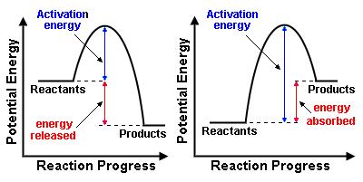  11. Draw a reaction profile to show a reaction involving a catalyst.

% | I can … | Prove it!
50% | 1.1. Explain how energy is conserved in reactions  3.6. Draw tangents on curves in order to calculate rates of reaction  3.7. Describe and explain factors that affect rates of reaction (concentration, pressure, surface area, catalysts and temperature)  3.9. Explain the collision theory and link to activation energy  4.2. Explain energy changes in reversible reactions (ammonium chloride and hydrated copper sulphate)  1.6. Use reaction profiles to show energies of reactants and products and link to exothermic and endothermic  3.3. Explain why one reactant is used in excess in a chemical reaction  3.11. Draw a reaction profile for a catalysed reaction | 1. Complete the following:  All chemical reactions involve ______ changes. Energy is _____ to break bonds in reactants, and energy is ________ when new bonds form in products. Endothermic reactions ______ energy, and exothermic reactions ______ energy. The law of __________ of energy states that matter cannot be created or _________.  words: conservation, used, absorb, destroyed, energy, release, released  2. Use the graph to calculate the rate of reaction in the first 50seconds:  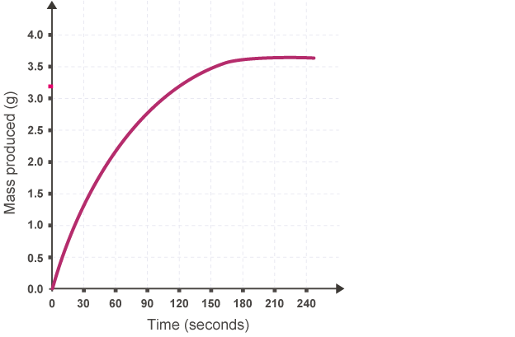  3. For each factor, explain how it can affect the rate of a chemical reaction using these words: particles, collide, frequency, activation energy, reaction, rate  a. concentration  b. pressure  c. surface area  d. catalysts  e. temperature  4. Explain what is meant by the term ‘collision theory’ using the word activation energy.  5. Explain what is meant by the term ‘excess’ in a chemical reaction and describe one example of a chemical reaction where an excess of a substance is used.

% | I can … | Prove it!
40% | 1.2. Define and give examples and uses of exothermic and endothermic reactions  1.5. Define activation energy  3.1. Calculate the mean rate of reaction  3.2. Recall the units for mass (g), volume (cm3) and rate (g/s, cm3/s, mol/s)  3.4. Describe what is meant by ‘a limiting reactant’  3.5. Plot and interpret graphs showing rates of reaction  3.10. Give examples of catalysts  4.1. Use the appropriate symbol to denote a reversible reaction  4.3. Explain what is meant by the term ‘equilibrium’  5.1. Link changes in mass to the word equation for a reaction  5.2. Calculate the relative formula mass of a substance  5.5. Calculate masses from balanced symbol equations  6.1. Calculate the mass of solute in a given volume of solution | 1a. Define the terms endothermic and exothermic.  b. When magnesium reacts with hydrochloric acid, the temperature of the test tube increases. Is this an endothermic reaction or an exothermic reaction?  c. When you bite into a sherbet sweet, it created a fizz in your mouth. The temperature of your mouth decreased slightly. Is this an endothermic reaction or an exothermic reaction?  2. Define the term activation energy.  3. Recall the formula for calculating the rate of a reaction.  4. What is the average rate of a reaction where 24 cm³ of hydrogen gas is produced in two minutes?  5. Give the units for the following: mass, volume and rate.  6. Define the term ‘limiting factor’ and give one example in a chemical reaction.  7. Plot a graph to show the results of the following experiment and describe the rate of the reaction:  Time (s) Mass of product (g)  0 0  2 5  4 10  6 15  8 17  10 18  12 18  8. List three examples of catalysts and write the symbol equation for the reaction they are used in.  9. Choose the correct symbol for a reversible reaction:  a. b. c.  10. Define the term ‘equilibrium’.  11. Calculate the relative formula mass of the following: H₂O, CO₂, CH₄  12. When it is heated in air, magnesium reacts with oxygen to form magnesium oxide.  magnesium + oxygen → magnesium oxide  48 g 32 g 80 g  What mass of oxygen is needed to make 20 g of magnesium oxide?

Key Words:
relative formula mass (Mr), relative atomic mass (Ar), mole, Avagadro’s constant, limiting reactant, concentration, percentage yield, atom economy, exothermic, endothermic, reversible reaction, energy level diagram, activation energy, reaction profile, catalyst, equilibrium, fuel cell, chemical cell, battery, half-equation, rate of reaction, collision theory, tangent, gradient, Le Chatelier’s principle, closed system

