Oasis Academy South Bank
Year 11 Mock Revision
Physics Separate Paper 1
Name: ___________________________
Class: _________
Teacher: __________________________
Step 1: Knowledge
Learn each of the quiz questions and answers off by heart. This could be done by:
- turning them into flash cards and testing yourself
- using ‘look, cover, write, check’
- asking a friend or family member to quiz you
Topic | LCWC | Quiz 1 | Quiz 2 | Quiz 3
Energy Types (P.1)
Work power and efficiency (P.2)
Elastic objects and potential Energy (P.3)
Static electricity (triple only) (P.20)
Nuclear physics (P.21)
Radioactive decay and radiation (P.22)
Background decay and radiation (P.23)
Nuclear fission and fusion (P.24)
Density (P.25)
Changes of state, latent heat and specific heat capacity (P.26)
Gas and fluid pressure (paper 1) (P.27)
Electricity introduction (P.29)
Series and parallel circuits (P.30)
Ohmic/non-ohmic types of resistors (P.31)
Mains electricity (P.32)
Energy and power of electricity and the National Grid (P.33)

Step 2: Exam practice
- Practice applying your knowledge using the past exam questions in each section.
- Self-assess these using the mark schemes at the back and rewrite your answers.
- Assess your progress using a ‘red, amber, green’ system (RAG)
Section | Completed | SA using green pen
1: Maths
2. Required Practicals
3. 6 markers

Exam practice
Section 1: Knowledge
Q1.
(a) Complete the sentence. Choose answers from the box.

charge | potential difference | power | temperature | time
The current through an ohmic conductor is directly proportional to the
_______________________ across the component, provided
that the _______________________ remains constant.
(2)
(b) Figure 1 shows a current − potential difference graph for a filament lamp.
Figure 1
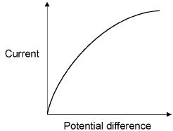
Explain how the resistance of a filament lamp changes as the potential difference across it increases.
___________________________________________________________________
___________________________________________________________________
___________________________________________________________________
___________________________________________________________________
___________________________________________________________________
___________________________________________________________________
(3)
(c) Many householders are replacing their filament lamps with LED lamps which are more energy efficient.
What does more energy efficient mean?
___________________________________________________________________
___________________________________________________________________
___________________________________________________________________
(1)
A Light Dependent Resistor (LDR) is used to turn on an outside lamp when it gets dark.
Part of the circuit is shown in Figure 2.
Figure 2
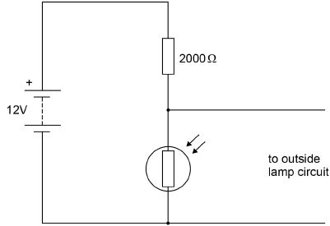
(d) The light intensity decreases.
What happens to the potential difference across the LDR and the current in the LDR?
Potential difference ___________________________________________________
Current ____________________________________________________________
(2)
(e) What is the resistance of the LDR when the potential difference across it is 4 V?
Give a reason for your answer.
Explain your answer.
Resistance = _______________________ Ω
Reason ____________________________________________________________
___________________________________________________________________
___________________________________________________________________
(2)
(f) Calculate the current through the LDR when the resistance of the LDR is 5000 Ω.
Give your answer to 2 significant figures.
___________________________________________________________________
___________________________________________________________________
___________________________________________________________________
___________________________________________________________________
Current = _______________________ A
(4)
(Total 14 marks)
Q2.
The photograph below shows a coffee machine. The coffee machine uses an electric element to heat water.
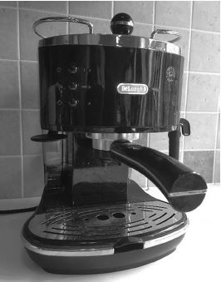
(a) The coffee machine has a metal case.
Why would it be dangerous for the live wire of the electric cable to touch the metal case?
___________________________________________________________________
___________________________________________________________________
(1)
(b) The power output of the coffee machine is 2.53 kW.
The mains potential difference is 230 V.
Calculate the current in the coffee machine.
___________________________________________________________________
___________________________________________________________________
___________________________________________________________________
___________________________________________________________________
Current = ____________________ A
(3)
(c) The coffee machine heats water from 20 °C to 90 °C.
The power output of the coffee machine is 2.53 kW.
The specific heat capacity of water is 4200 J/kg °C.
Calculate the mass of water that the coffee machine can heat in 14 seconds.
___________________________________________________________________
___________________________________________________________________
___________________________________________________________________
___________________________________________________________________
___________________________________________________________________
Mass = ____________________ kg
(5)
(Total 9 marks)
Q3.
The diagram below shows a wind turbine.
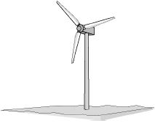
(a) At a particular wind speed, a volume of 2.3 × 10⁴ m³ of air passes the blades each second.
The density of air is 1.2 kg/m³.
Calculate the mass of air passing the blades per second.
___________________________________________________________________
___________________________________________________________________
___________________________________________________________________
___________________________________________________________________
Mass of air per second = ____________________ kg
(3)
(b) The power output of the turbine is directly proportional to the kinetic energy of the air passing the blades each second.
Describe the effect on the power output when the wind speed is halved.
___________________________________________________________________
___________________________________________________________________
___________________________________________________________________
___________________________________________________________________
___________________________________________________________________
___________________________________________________________________
(3)
(c) At a different wind speed, the wind turbine has a power output of 388 kW.
The mass of air passing the wind turbine each second is 13 800 kg.
Calculate the speed of the air passing the blades each second.
Assume that the process is 100% efficient.
___________________________________________________________________
___________________________________________________________________
___________________________________________________________________
___________________________________________________________________
Speed of air = ____________________ m/s
(3)
Q4.
Figure 1 shows a graph of current against potential difference for a solar cell when light of intensity 450 W/m² is incident on it.
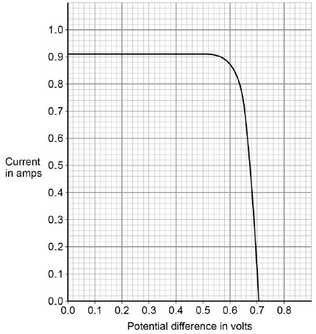
(a) Determine the power output of the solar cell when the potential difference is 0.5 V
Use data from Figure 1.
___________________________________________________________________
___________________________________________________________________
___________________________________________________________________
___________________________________________________________________
___________________________________________________________________
Power = ____________________ W
(3)
(b) Draw a sketch graph on Figure 2 to show how the power output of the solar cell varies with potential difference between 0.1 V and 0.5 V
No values need to be included on the vertical axis.
Figure 2
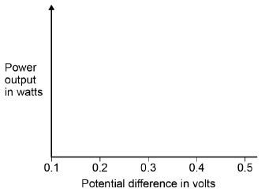
(2)
(c) The maximum power output of this solar cell is 0.52 W
When the light intensity is 450 W/m² the cell has an efficiency of 0.15 at the maximum power output.
Calculate the area of the solar cell.
___________________________________________________________________
___________________________________________________________________
___________________________________________________________________
___________________________________________________________________
___________________________________________________________________
___________________________________________________________________
Area = ____________________ m²
(4)
(d) A householder has four solar cells.
Each of the solar cells has a resistance of 0.78 Ω
Explain how the solar cells should be connected so that the total resistance is as low as possible.
___________________________________________________________________
___________________________________________________________________
___________________________________________________________________
___________________________________________________________________
(2)
(Total 11 marks)
Q5.
The figure below shows a student before and after a bungee jump.
The bungee cord has an unstretched length of 20.0 m.
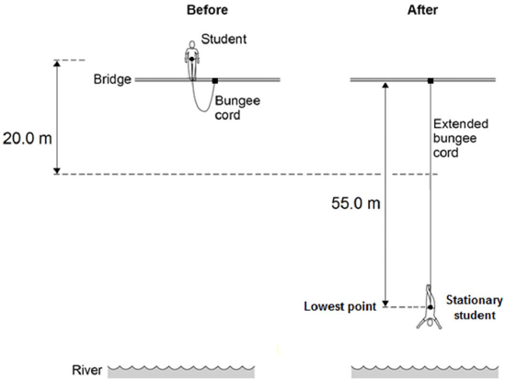
The mass of the student is 50.0 kg.
The gravitational field strength is 9.8 N / kg.
(a) Write down the equation which links gravitational field strength, gravitational potential energy, height and mass.
___________________________________________________________________
(1)
(b) Calculate the change in gravitational potential energy from the position where the student jumps to the point 20.0 m below.
___________________________________________________________________
___________________________________________________________________
___________________________________________________________________
Change in gravitational potential energy = _____________ J
(2)
(c) 80% of this change in gravitational potential energy has been transferred to the student’s kinetic energy store.
How much has the student’s kinetic energy store increased after falling 20.0 m?
Kinetic energy gained = ________________________ J
(1)
(d) Calculate the speed of the student after falling 20.0 m.
Give your answer to two significant figures.
___________________________________________________________________
___________________________________________________________________
___________________________________________________________________
___________________________________________________________________
Speed = __________________________ m / s
(4)
(e) At the lowest point in the jump, the energy stored by the stretched bungee cord is 24.5 kJ.
The bungee cord behaves like a spring.
Calculate the spring constant of the bungee cord.
Use the correct equation from the Physics Equation Sheet.
___________________________________________________________________
___________________________________________________________________
___________________________________________________________________
___________________________________________________________________
___________________________________________________________________
___________________________________________________________________
Spring constant = ________________________ N / m
(3)
(Total 11 marks)
Q6.
All European Union countries are expected to generate 20% of their electricity using renewable energy sources by 2020.
The estimated cost of generating electricity in the year 2020 using different energy sources is shown in Table 1.
Table 1

Energy source | Estimated cost (in the year 2020) in pence per kWh
Nuclear | 7.8
Solar | 25.3
Tidal | 18.8
Wind | 10.0
France generated 542 billion kWh of electricity using nuclear power stations in 2011.
France used 478 billion kWh of electricity and sold the rest of the electricity to other countries in 2011.
(a) France may continue generating large amounts of electricity using nuclear power stations instead of using renewable energy resources.
Suggest two reasons why.
1. _________________________________________________________________
___________________________________________________________________
2. _________________________________________________________________
___________________________________________________________________
(2)
(b) Give two disadvantages of generating electricity using nuclear power stations.
1. _________________________________________________________________
___________________________________________________________________
2. _________________________________________________________________
___________________________________________________________________
(2)
(c) A panel of solar cells has an efficiency of 0.15.
The total power input to the panel of solar cells is 3.2 kW.
Calculate the useful power output of this panel of solar cells in kW.
___________________________________________________________________
___________________________________________________________________
___________________________________________________________________
___________________________________________________________________
Useful power output = _______________ kW
(2)
(d) Table 2 shows the manufacturing cost and efficiency of different types of panels of solar cells.
Table 2

Type of Solar Panel | Cost to manufacture a 1 m² solar panel in £ | Efficiency in %
A | 40.00 | 20
B | 22.50 | 15
C | 5.00 | 10
Some scientists think that having a low manufacturing cost is more important than improving the efficiency of solar cells.
Use information from Table 2 to suggest why.
___________________________________________________________________
___________________________________________________________________
___________________________________________________________________
___________________________________________________________________
___________________________________________________________________
___________________________________________________________________
(2)
(Total 8 marks)
Q7.
The diagram below shows a person using a device called a jetpack. Water is forced downwards from the jetpack and produces an upward force on the person.
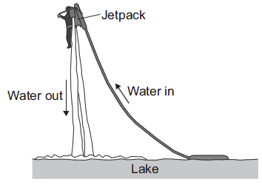
(a) State the condition necessary for the person to be able to remain stationary in mid-air.
___________________________________________________________________
___________________________________________________________________
(1)
(b) The person weighs 700 N and the jetpack weighs 140 N.
(i) Calculate the combined mass of the person and the jetpack.
Gravitational field strength = 10 N/kg
______________________________________________________________
______________________________________________________________
______________________________________________________________
Combined mass = ___________ kg
(2)
(ii) Increasing the upward force to 1850 N causes the person to accelerate upwards.
Calculate the acceleration of the person and the jetpack. Give the unit.
______________________________________________________________
______________________________________________________________
______________________________________________________________
______________________________________________________________
Acceleration = ___________ Unit ___________
(3)
(Total 6 marks)
Q8.
Under the same conditions, different materials heat up and cool down at different rates.
(a) What is meant by specific heat capacity?
___________________________________________________________________
___________________________________________________________________
___________________________________________________________________
___________________________________________________________________
(2)
(b) ‘Quenching’ is a process used to change the properties of steel by cooling it rapidly.
The steel is heated to a very high temperature and then placed in a container of cold water.
(i) A metalworker quenches a steel rod by heating it to a temperature of 900 °C before placing it in cold water. The mass of the steel rod is 20 kg.
The final temperature of the rod and water is 50 °C.
Calculate the energy transferred from the steel rod to the water.
Specific heat capacity of steel = 420 J/kg °C.
______________________________________________________________
______________________________________________________________
______________________________________________________________
Energy transferred = ____________________ J
(3)
(ii) The temperature of the steel rod eventually returns to room temperature.
Compare the movement and energies of the particles in the steel rod and in the air at room temperature.
______________________________________________________________
______________________________________________________________
______________________________________________________________
______________________________________________________________
______________________________________________________________
______________________________________________________________
(3)
(iii) When the steel rod is being quenched, the temperature of the water rises to 50 °C. After a few hours the water cools down to room temperature.
Some of the cooling of the water is due to evaporation.
Explain in terms of particles how evaporation causes the cooling of water.
______________________________________________________________
______________________________________________________________
______________________________________________________________
______________________________________________________________
______________________________________________________________
______________________________________________________________
______________________________________________________________
______________________________________________________________
______________________________________________________________
______________________________________________________________
(4)
(Total 12 marks)
Q9.
A ‘can-chiller’ is used to make a can of drink colder.
The image below shows a can-chiller.
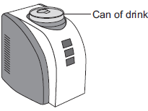
(a) The initial temperature of the liquid in the can was 25.0 °C.
The can-chiller decreased the temperature of the liquid to 20.0 °C.
The amount of energy transferred from the liquid was 6930 J.
The mass of liquid in the can was 0.330 kg.
Calculate the specific heat capacity of the liquid.
Give the unit.
___________________________________________________________________
___________________________________________________________________
___________________________________________________________________
___________________________________________________________________
Specific heat capacity = _____________________ unit ________________
(4)
(b) Energy is transferred through the metal walls of the can of drink by conduction.
Explain how.
___________________________________________________________________
___________________________________________________________________
___________________________________________________________________
___________________________________________________________________
___________________________________________________________________
___________________________________________________________________
___________________________________________________________________
___________________________________________________________________
(4)
(c) The energy from the can of drink is transferred to the air around the can-chiller.
A convection current is set up around the can-chiller. Explain how.
___________________________________________________________________
___________________________________________________________________
___________________________________________________________________
___________________________________________________________________
___________________________________________________________________
(3)
(d) The can-chiller has metal cooling fins that are designed to transfer energy quickly to the surroundings.
Give two features that would help the metal cooling fins to transfer energy quickly to the surroundings.
1. _________________________________________________________________
2. _________________________________________________________________
(2)
Q10.
(a) Figure 1 shows the forces acting on a model air-powered rocket just after it has been launched vertically upwards.
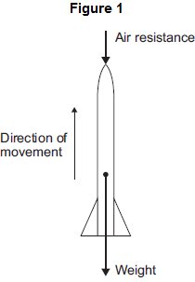
(i) How does the velocity of the rocket change as the rocket moves upwards?
______________________________________________________________
Give a reason for your answer.
______________________________________________________________
______________________________________________________________
(2)
(ii) The velocity of the rocket is not the same as the speed of the rocket.
What is the difference between the velocity of an object and the speed of an object?
______________________________________________________________
______________________________________________________________
______________________________________________________________
(1)
(b) The speed of the rocket just after being launched is 12 m / s.
The mass of the rocket is 0.05 kg.
(i) Calculate the kinetic energy of the rocket just after being launched.
______________________________________________________________
______________________________________________________________
______________________________________________________________
Kinetic energy = _____________________ J
(2)
(ii) As the rocket moves upwards, it gains gravitational potential energy.
State the maximum gravitational potential energy gained by the rocket.
Ignore the effect of air resistance.
Maximum gravitational potential energy = _____________________ J
(1)
(iii) Calculate the maximum height the rocket will reach.
Ignore the effect of air resistance.
Gravitational field strength = 10 N/kg.
______________________________________________________________
______________________________________________________________
______________________________________________________________
Maximum height = _____________________ m
(2)
(iv) Figure 2 shows four velocity−time graphs.
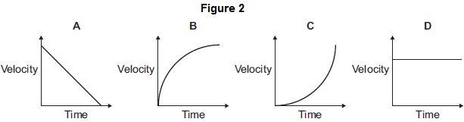
Taking air resistance into account, which graph, A, B, C or D, shows how the velocity of the rocket changes as it falls from the maximum height it reached until it just hits the ground?

Write the correct answer in the box.
(1)
(c) The rocket can be launched at different angles to the horizontal.
The horizontal distance the rocket travels is called the range.
Figure 3 shows the paths taken by the rocket when launched at different angles.
Air resistance has been ignored.
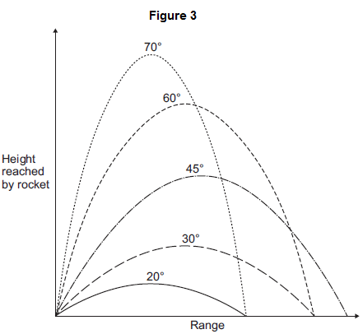
What pattern links the angle at which the rocket is launched and the range of the rocket?
___________________________________________________________________
___________________________________________________________________
___________________________________________________________________
___________________________________________________________________
(2)
(Total 11 marks)
Q11.
The diagram shows a wind turbine.
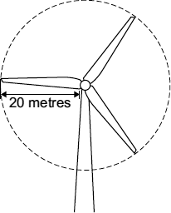
(a) The blades of the turbine are 20 metres long. On average, 15 000 kg of air, moving at a speed of 12 m/s, hit the blades every second.
Calculate the kinetic energy of the air hitting the blades every second.
Show clearly how you work out your answer.
___________________________________________________________________
___________________________________________________________________
Kinetic energy = _________________________ J
(2)
(b) Part of the kinetic energy of the wind is transformed into electrical energy.
The diagram shows that, for the same wind speed, the power output of a turbine, in kilowatts, depends on the length of the turbine blades.
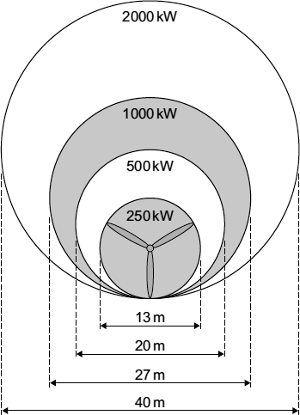
Give a reason why doubling the diameter of the blades more than doubles the power output of a turbine.
___________________________________________________________________
___________________________________________________________________
(1)
(Total 3 marks)
Q12.
The diagram shows a temperature sensing circuit used to control a heating system in a house.
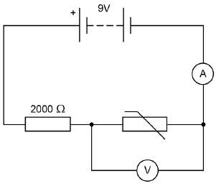
(a) What quantity does the ammeter measure?
___________________________________________________________________
(1)
(b) The current in the circuit is 3.5 mA when the potential difference across the thermistor is 4.2 V
Calculate the resistance of the thermistor.
___________________________________________________________________
___________________________________________________________________
___________________________________________________________________
Resistance = ____________________ Ω
(3)
(c) Calculate the charge that flows through the thermistor in 5 minutes when the current is 3.5 mA.
___________________________________________________________________
___________________________________________________________________
___________________________________________________________________
Charge = ____________________ C
(3)
(d) Explain why the potential difference across the thermistor changes as the temperature in the house decreases.
___________________________________________________________________
___________________________________________________________________
___________________________________________________________________
___________________________________________________________________
(2)
(e) The circuit shown in the diagram can be modified to turn lights on and off by replacing the thermistor with a Light Dependent Resistor (LDR).
Draw the circuit symbol for an LDR in the space below.
(1)
(Total 10 marks)
Q13.
A 12 V filament bulb is connected to a 12 V power supply.
The graph shows how the current changes after the bulb is switched on.
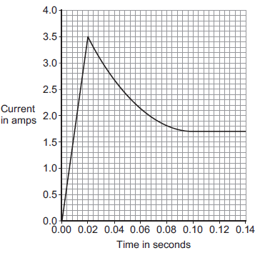
(a) (i) After 0.10 seconds, the bulb works at its normal brightness.
What is the current through the bulb when it is working at normal brightness?
Current = _____________________ A
(1)
(ii) The bulb works at normal brightness for 30 seconds before it is switched off.
Calculate the charge that flows through the bulb in the 30 seconds before it is switched off. Give the unit.
______________________________________________________________
______________________________________________________________
______________________________________________________________
Charge = _________________ unit _________________
(3)
(iii) Calculate the energy transferred by the 12 V bulb when it is working at normal brightness for 30 seconds.
______________________________________________________________
______________________________________________________________
Energy transferred = _____________________ J
(2)
(b) Between 0.02 seconds and 0.08 seconds, there is an increase in both the resistance and the temperature of the metal filament inside the bulb.
Explain, in terms of the electrons and ions inside the filament, why both the temperature and the resistance increase.
___________________________________________________________________
___________________________________________________________________
___________________________________________________________________
___________________________________________________________________
___________________________________________________________________
___________________________________________________________________
(2)
(Total 8 marks)
Q14.
The current in a circuit depends on the potential difference (p.d.) provided by the cells and the total resistance of the circuit.
(a) Using the correct circuit symbols, draw a diagram to show how you would connect 1.5 V cells together to give a p.d. of 6 V.
(2)
(b) Figure 1 shows a circuit containing an 18 V battery.
Two resistors, X and Y, are connected in series.
• X has a resistance of 3 Ω.
• There is a current of 2 A in X.
Figure 1
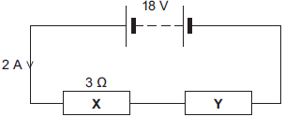
(i) Calculate the p.d. across X.
______________________________________________________________
______________________________________________________________
P.d. across X = ______________________ V
(2)
(ii) Calculate the p.d. across Y.
______________________________________________________________
______________________________________________________________
______________________________________________________________
P.d. across Y = ______________________ V
(2)
(iii) Calculate the total resistance of X and Y.
______________________________________________________________
______________________________________________________________
______________________________________________________________
Total resistance of X and Y = ______________________ Ω
(2)

(c) Figure 2 shows a transformer.
Figure 2
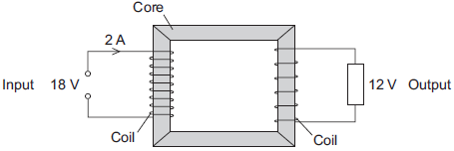
(i) An 18 V battery could not be used as the input of a transformer.
Explain why.
______________________________________________________________
______________________________________________________________
______________________________________________________________
______________________________________________________________
(2)
(ii) The transformer is 100% efficient.
Calculate the output current for the transformer shown in Figure 2.
______________________________________________________________
______________________________________________________________
______________________________________________________________
Output current = ______________________ A
(2)
(Total 12 marks)
Q15.
(a) The resistance of a 24 W, 12 V filament lamp depends on the current flowing through the lamp. For currents up to 0.8 A, the resistance has a constant value of 2.5 Ω.
(i) Use the equation in the box to calculate the potential difference across the lamp when a current of 0.8 A flows through the lamp.

potential difference = current × resistance
Show clearly how you work out your answer.
______________________________________________________________
______________________________________________________________
Potential difference = ______________________________ V
(2)
(ii) When the potential difference across the lamp is 12 V, the current through the lamp is 2 A.
On the axes below, draw a current–potential difference graph for the filament lamp over the range of potential difference from 0 to 12 volts.
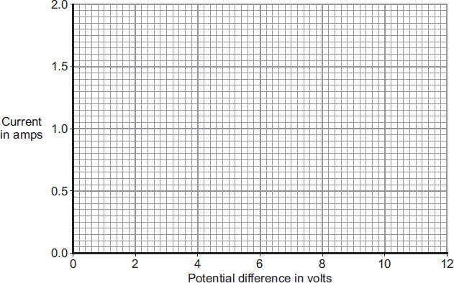
(2)
(iii) Why does the resistance of the lamp change when the current through the lamp exceeds 0.8 A?
______________________________________________________________
______________________________________________________________
(1)
(b) The lamp is now included in a circuit. The circuit is switched on for 2 minutes. During this time, 72 coulombs of charge pass through the lamp.
Use the equation in the box to calculate the energy transformed by the lamp while the circuit is switched on.

energy transformed = potential difference × charge
Show clearly how you work out your answer.
___________________________________________________________________
___________________________________________________________________
Energy transformed = ______________________________ J
(2)
(Total 7 marks)
Q16.
A student used the apparatus in Figure 1 to obtain the data needed to calculate the specific heat capacity of copper.
Figure 1
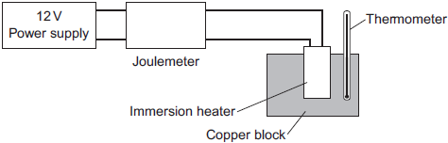
The initial temperature of the copper block was measured.
The power supply was switched on.
The energy transferred by the heater to the block was measured using the joulemeter.
The temperature of the block was recorded every minute.
The temperature increase was calculated.
Figure 2 shows the student’s results.
Figure 2
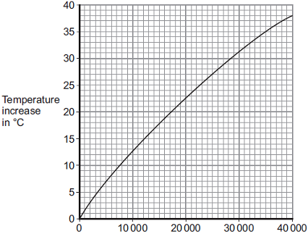
Energy transferred to copper block in joules
(a) Energy is transferred through the copper block.
What is the name of the process by which the energy is transferred?
Tick () one box.
Conduction
Convection
Radiation
(1)
(b) Use Figure 2 to determine how much energy was needed to increase the temperature of the copper block by 35 °C.
_________________ joules
(1)
(c) The copper block has a mass of 2 kg.
Use your answer to part (b) to calculate the value given by this experiment for the specific heat capacity of copper. Give the unit.
___________________________________________________________________
___________________________________________________________________
___________________________________________________________________
___________________________________________________________________
Specific heat capacity = ______________________________
(3)
(d) This experiment does not give the correct value for the specific heat of copper.
Suggest one reason why.
___________________________________________________________________
___________________________________________________________________
(1)
(Total 6 marks)
Q17.
A student models the random nature of radioactive decay using 100 dice.
He rolls the dice and removes any that land with the number 6 facing upwards.
He rolls the remaining dice again.
The student repeats this process a number of times.
The table below shows his results.

Roll number | Number of dice remaining
0 | 100
1 | 84
2 | 70
3 | 59
4 | 46
5 | 40
6 | 32
7 | 27
8 | 23
(a) Give two reasons why this is a good model for the random nature of radioactive decay.
1. _________________________________________________________________
___________________________________________________________________
2. _________________________________________________________________
___________________________________________________________________
(2)
(b) The student’s results are shown in Figure 1.
Figure 1
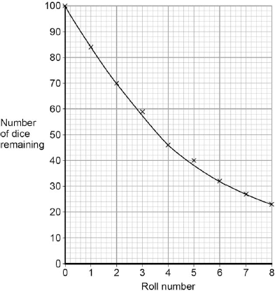
Use Figure 1 to determine the half-life for these dice using this model.
Show on Figure 1 how you work out your answer.
Half-life = ________________________ rolls
(2)
(c) A teacher uses a protactinium (Pa) generator to produce a sample of radioactive material that has a half-life of 70 seconds.
In the first stage in the protactinium generator, uranium (U) decays into thorium (Th) and alpha (α) radiation is emitted.
The decay can be represented by the equation shown in Figure 2.
Figure 2
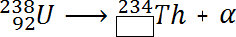
Determine the atomic number of thorium (Th) 234.
Atomic number = ______________________
(1)
(d) When protactinium decays, a new element is formed and radiation is emitted.
The decay can be represented by the equation shown in Figure 3.
Figure 3
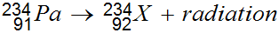
When protactinium decays, a new element, X, is formed.
Use information from Figure 2 and Figure 3 to determine the name of element X.
___________________________________________________________________
(1)
(e) Determine the type of radiation emitted as protactinium decays into a new element.
Give a reason for your answer.
___________________________________________________________________
___________________________________________________________________
___________________________________________________________________
___________________________________________________________________
(2)
(f) The teacher wears polythene gloves as a safety precaution when handling radioactive materials.
The polythene gloves do not stop the teacher’s hands from being irradiated.
Explain why the teacher wears polythene gloves.
___________________________________________________________________
___________________________________________________________________
___________________________________________________________________
___________________________________________________________________
(2)
(Total 10 marks)
Q18.
Electricity is generated in a nuclear power station.
Fission is the process by which energy is released in the nuclear reactor.
(a) Figure 1 shows the first part of the nuclear fission reaction.
Complete Figure 1 to show how the fission process starts a chain reaction.
Figure 1
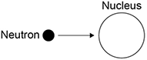
(3)
(b) Figure 2 shows the inside of a nuclear reactor in a nuclear power station.
Figure 2
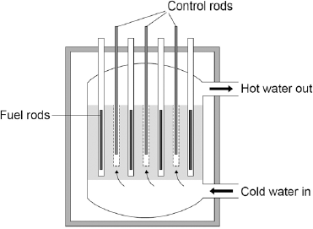
In a nuclear reactor a chain reaction occurs, which causes neutrons to be released.
The control rods absorb neutrons.
The control rods can be moved up and down.
Explain how the energy released by the chain reaction is affected by moving the control rods.
___________________________________________________________________
___________________________________________________________________
___________________________________________________________________
___________________________________________________________________
(2)
(c) Figure 3 shows how the power output of the nuclear reactor would change if the control rods were removed.
Figure 3
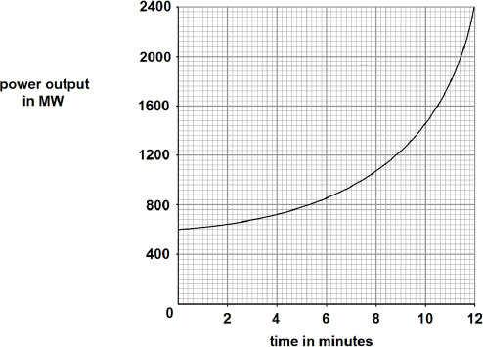
Calculate the rate of increase of power output at 10 minutes.
___________________________________________________________________
___________________________________________________________________
___________________________________________________________________
___________________________________________________________________
Rate of increase of power output = _________ MW / minute
(2)
(Total 7 marks)
Q19.
Atoms are different sizes.
One of the heaviest naturally occurring stable elements is lead.
Two of its isotopes are lead-206 (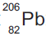) and lead-208 (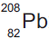).
(a) (i) What is meant by ‘isotopes’?
______________________________________________________________
______________________________________________________________
______________________________________________________________
______________________________________________________________
(2)
(ii) How many protons are in the nucleus of a atom?
__________________
(1)
(iii) How many neutrons are in the nucleus of a atom?
__________________
(1)
(b) A nucleus can be accelerated in a particle accelerator and directed at a large nucleus. This produces a heavy nucleus that will decay after a short time.
This is shown in Figure 1.
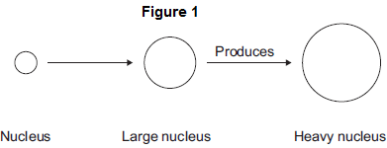
(i) In 1984, nuclei of iron (Fe) were directed at nuclei of lead (Pb). This produced nuclei of hassium (Hs).
Complete the equation for this reaction by writing numbers in the empty boxes.
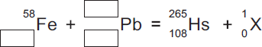
(3)
(ii) Use the correct answer from the box to complete the sentence.

an electron | a proton | a neutron
The particle X in part (b)(i) is _________________________________ .
(1)
(iii) After acceleration the iron nuclei travel at a steady speed of one-tenth of the speed of light.
The speed of light is 3.00 × 10⁸ m/s.
Calculate the time taken for the iron nuclei to travel a distance of 12 000 m.
______________________________________________________________
______________________________________________________________
Time taken = ____________________ s
(2)
(iv) Linear accelerators, in which particles are accelerated in a straight line, are not used for these experiments. Circular particle accelerators are used.
Suggest why.
______________________________________________________________
______________________________________________________________
______________________________________________________________
______________________________________________________________
______________________________________________________________
______________________________________________________________
(3)
(c) Hassium-265 (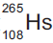) decays by alpha emission with a half-life of 0.002 seconds.
(i) What is meant by ‘half-life’?
Tick () two boxes.

Tick ()
The average time for the number of nuclei to halve
The time for count rate to be equal to background count
The time for background count to halve
The time for count rate to halve
(2)
(ii) Complete the equation for the decay of Hs-265 by writing numbers in the empty boxes.
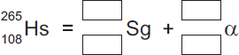
(2)
(d) The table below shows how the atomic radius of some atoms varies with atomic number.

Atomic  number | Atomic radius in  picometres (pm)
15 | 100
35 | 115
50 | 130
70 | 150
95 | 170
1 pm = 10^{–12} m
(i) On Figure 2, use the data from the table above to plot a graph of atomic radius against atomic number and draw a line of best fit.
Two points have been plotted for you.
Figure 2
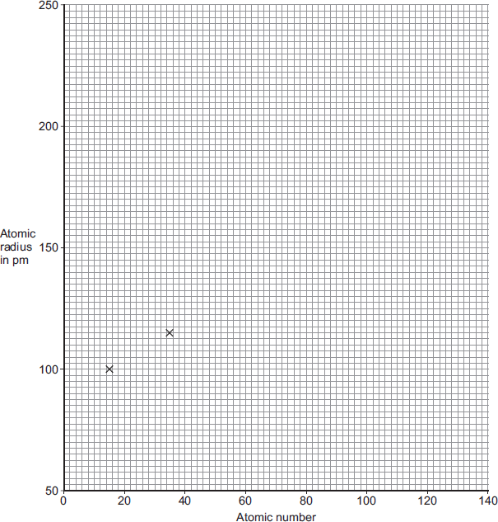
(2)
(ii) Scientists believe that the element with atomic number 126 can be produced and that it will be stable.
Use your graph in Figure 2 to predict the atomic radius of an atom with atomic number 126.
Atomic radius = ____________________ pm
(1)
(Total 20 marks)
Q20.
A teacher used the equipment shown in the diagram to measure the count rate at different distances from a radioactive source.
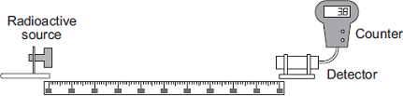
Metre rule
(a) Her results are shown in Table 1.
Table 1

Distance in metres | Count rate in counts  per minute | Corrected count rate in  counts per minute
0.4 | 143 | 125
0.6 | 74 | 56
0.8 | 49 | 31
1.0 | 38 | 20
1.2 | 32 | 14
1.4 | 28 | 10
1.6 | 18 | 0
1.8 | 18 | 0
2.0 | 18 | 0
The background count rate has been used to calculate the corrected count rate.
(i) What is the value of the background count rate?
Background count rate = _______________ counts per minute
(1)
(ii) What information does the corrected count rate give?
______________________________________________________________
______________________________________________________________
(1)
(iii) The radioactive source used in the demonstration emits only one type of radiation.
The radioactive source is not an alpha emitter.
How can you tell from the data in the table?
______________________________________________________________
______________________________________________________________
(1)
(iv) Plot a graph of corrected count rate against distance for distances between 0.4 m and 1.4 m.
Draw a line of best fit to complete the graph.
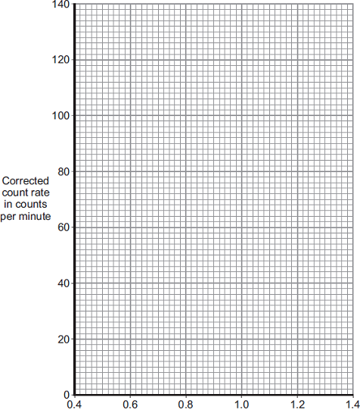
Distance in metres
(3)
(v) The ‘half-distance’ is the distance a detector has to be moved away from a radioactive source for the corrected count rate to halve.
A student has the hypothesis:
A radioactive source has a constant ‘half-distance’.
Table 1 has been repeated for your information.
Table 1

Distance in metres | Count rate in counts  per minute | Corrected count rate in  counts per minute
0.4 | 143 | 125
0.6 | 74 | 56
0.8 | 49 | 31
1.0 | 38 | 20
1.2 | 32 | 14
1.4 | 28 | 10
1.6 | 18 | 0
1.8 | 18 | 0
2.0 | 18 | 0
Use Table 1 to determine if the hypothesis is correct for this radioactive source.
You should use calculations in your answer.
______________________________________________________________
______________________________________________________________
______________________________________________________________
______________________________________________________________
______________________________________________________________
______________________________________________________________
______________________________________________________________
(3)
(b) A teacher places a beta source and a detector in a magnetic field.
The arrangement of the magnetic field is shown.
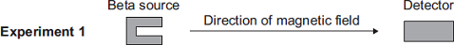
The teacher repeated the experiment with the magnetic field in a different direction.
A set of results is shown in Table 2.
Table 2

Distance between source and detector in metres | Count rate in counts per minute without magnetic field | Count rate in counts per minute in Experiment 1 | Count rate in counts per minute in Experiment 2
0.8 | 48 | 48 | 32
(i) Describe and explain the effect of the magnetic field on the count rate detected by the detector.
______________________________________________________________
______________________________________________________________
______________________________________________________________
______________________________________________________________
______________________________________________________________
______________________________________________________________
(2)
(ii) The experiment is repeated with a different distance between the source and the detector.
Table 3 shows the repeated results.
Table 3

Distance between  source and  detector  in metres | Count rate  in counts per  minute without  magnetic field | Count rate  in counts per  minute in  Experiment 1 | Count rate  in counts per  minute in  Experiment 2
1.8 | 19 | 18 | 20
Explain these results.
______________________________________________________________
______________________________________________________________
______________________________________________________________
______________________________________________________________
______________________________________________________________
______________________________________________________________
(2)
(Total 13 marks)
Q21.
(a) A teacher used a Geiger-Műller (GM) tube and counter to measure the background radiation in her laboratory.
The teacher reset the counter to zero, waited one minute and then took the count reading. The teacher repeated the procedure two more times.
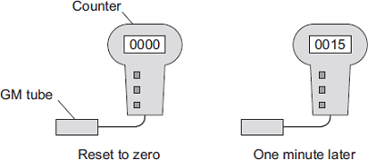
(i) Background radiation can be either from natural sources or from man-made sources.
Name one man-made source of background radiation.
______________________________________________________________
(1)
(ii) The three readings taken by the teacher are given in the table.

Count after one minute
15
24
18
The readings given in the table are correct.
Why are the readings different?
______________________________________________________________
______________________________________________________________
(1)
(b) Some scientists say they have found evidence to show that people living in areas of high natural background radiation are less likely to develop cancer than people living in similar areas with lower background radiation.
The evidence these scientists found does not definitely mean that the level of background radiation determines whether a person will develop cancer.
Suggest a reason why.
___________________________________________________________________
___________________________________________________________________
(1)
(c) An atom of the isotope radon-222 emits an alpha particle and decays into an atom of polonium.
An alpha particle is the same as a helium nucleus. The symbol below represents an alpha particle.
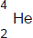
(i) How many protons and how many neutrons are there in an alpha particle?
Number of protons = ________
Number of neutrons = ________
(2)
(ii) The decay of radon-222 can be represented by the equation below.
Complete the equation by writing the correct number in each of the two boxes.
(2)
(d) The graph shows how, in a sample of air, the number of radon-222 nuclei changes with time.
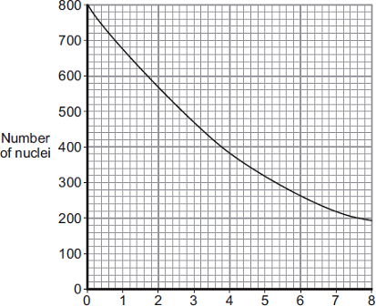
Time in days
Use the graph to find the half-life of radon-222.
Show clearly on the graph how you obtain your answer.
Half-life = _________________________ days
(2)
(Total 9 marks

Section 2: Required Practicals
Q22.
A student investigated how the resistance of a piece of nichrome wire varies with length.
Figure 1 shows part of the circuit the student used.
Figure 1
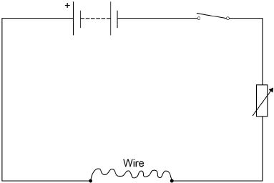
(a) Complete Figure 1 by adding an ammeter and a voltmeter.
Use the correct circuit symbols.
(3)
(b) Describe how the student would obtain the data needed for the investigation.
Your answer should include a risk assessment for one hazard in the investigation.
___________________________________________________________________
___________________________________________________________________
___________________________________________________________________
___________________________________________________________________
___________________________________________________________________
___________________________________________________________________
___________________________________________________________________
___________________________________________________________________
___________________________________________________________________
___________________________________________________________________
___________________________________________________________________
___________________________________________________________________
(6)
(c) Why would switching off the circuit between readings have improved the accuracy of the student’s investigation?
Tick one box.

The charge flow through the wire would not change.
The potential difference of the battery would not increase.
The power output of the battery would not increase.
The temperature of the wire would not change.
(1)
(d) The student used crocodile clips to make connections to the wire.
They could have used a piece of equipment called a ‘jockey’.
Figure 2 shows a crocodile clip and a jockey in contact with a wire.
Figure 2
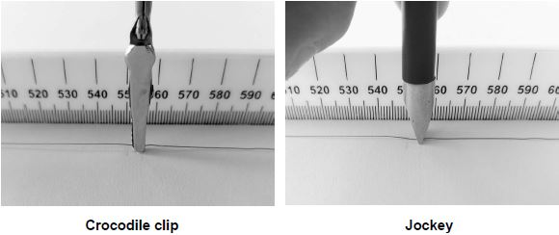
How would using the jockey have affected the accuracy and resolution of the student’s results compared to using the crocodile clip?
Tick two boxes.

The accuracy of the student’s results would be higher.
The accuracy of the student’s results would be lower.
The accuracy of the student’s results would be the same.
The resolution of the length measurement would be higher.
The resolution of the length measurement would be lower.
The resolution of the length measurement would be the same.
(2)
(Total 12 marks)
Q23.
If a fault develops in an electrical circuit, the current may become too great. The circuit needs to be protected by being disconnected.
A fuse or a circuit breaker may be used to protect the circuit.
One type of circuit breaker is a Residual Current Circuit Breaker (RCCB).
(a) (i) Use the correct answer from the box to complete the sentence.

earth | live | neutral
A fuse is connected in the ______________________ wire.
(1)
(ii) Use the correct answer from the box to complete the sentence.

are bigger | are cheaper | react faster
RCCBs are sometimes preferred to fuses because they ________________ .
(1)
(iii) RCCBs operate by detecting a difference in the current between two wires.
Use the correct answer from the box to complete the sentence.

earth and live | earth and neutral | live and neutral
The two wires are the _______________________________________ wires.
(1)
(b) An RCCB contains an iron rocker and a coil.
A student investigated how the force of attraction, between a coil and an iron rocker, varies with the current in the coil.
She supported a coil vertically and connected it in an electrical circuit, part of which is shown in the figure below .
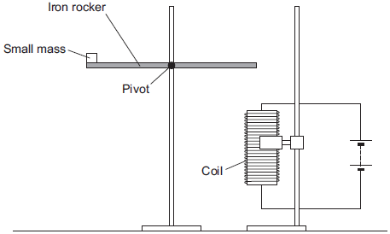
She put a small mass on the end of the rocker and increased the current in the coil until the rocker balanced. She repeated the procedure for different masses.
Some of her results are shown in the table below.

Mass  in grams | Current needed for the  rocker to balance in  amps
5 | 0.5
10 | 1.0
15 | 1.5
20 | 2.0
(i) State two extra components that must have been included in the circuit in the figure above to allow the data in the above table to be collected.

Give reasons for your answers.
______________________________________________________________
______________________________________________________________
______________________________________________________________
______________________________________________________________
______________________________________________________________
______________________________________________________________
______________________________________________________________
(4)
(ii) A teacher said that the values of current were too high to be safe.
Suggest two changes that would allow lower values of current to be used in this investigation.
Change 1 ______________________________________________________
______________________________________________________________
Change 2 ______________________________________________________
______________________________________________________________
(2)
Q24.
(a) A company is developing a system which can heat up and melt ice on roads in the winter. This system is called ‘energy storage’.
During the summer, the black surface of the road will heat up in the sunshine.
This energy will be stored in a large amount of soil deep under the road surface.
Pipes will run through the soil. In winter, cold water entering the pipes will be warmed and brought to the surface to melt ice.
The system could work well because the road surface is black.
Suggest why.
___________________________________________________________________
___________________________________________________________________
(1)
(b) (i) What is meant by specific latent heat of fusion?
______________________________________________________________
______________________________________________________________
______________________________________________________________
______________________________________________________________
(2)
(ii) Calculate the amount of energy required to melt 15 kg of ice at 0 °C.
Specific latent heat of fusion of ice = 3.4 × 10⁵ J/kg.
______________________________________________________________
______________________________________________________________
Energy = ___________________ J
(2)

(c) Another way to keep roads clear of ice is to spread salt on them.
When salt is added to ice, the melting point of the ice changes.
A student investigated how the melting point of ice varies with the mass of salt added.
The figure below shows the equipment that she used.
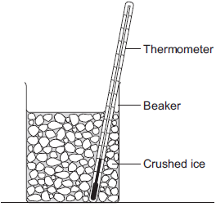
The student added salt to crushed ice and measured the temperature at which the ice melted.
(i) State one variable that the student should have controlled.
______________________________________________________________
______________________________________________________________
(1)
(ii) During the investigation the student stirred the crushed ice.
Suggest two reasons why.
Tick () two boxes.

Tick ()
To raise the melting point of the ice
To lower the melting point of the ice
To distribute the salt throughout the ice
To keep all the ice at the same temperature
To reduce energy transfer from the surroundings to the ice
(2)
(iii) The table below shows the data that the student obtained.

Mass of salt added in grams | 0 | 10 | 20
Melting point of ice in °C | 0 | -6 | -16
Describe the pattern shown in the table.
______________________________________________________________
______________________________________________________________
(1)
(d) Undersoil electrical heating systems are used in greenhouses. This system could also be used under a road.
A cable just below the ground carries an electric current. One greenhouse system has a power output of 0.50 kW.
Calculate the energy transferred in 2 minutes.
___________________________________________________________________
___________________________________________________________________
___________________________________________________________________
Energy transferred = ___________________ J
(3)
(e) In this question you will be assessed on using good English, organising information clearly and using specialist terms where appropriate.
A local council wants to keep a particular section of a road clear of ice in the winter.
Describe the advantages and disadvantages of keeping the road clear of ice using:
• energy storage
• salt
• undersoil electrical heating.
______________________________________________________________
___________________________________________________________________
___________________________________________________________________
___________________________________________________________________
___________________________________________________________________
___________________________________________________________________
___________________________________________________________________
___________________________________________________________________
___________________________________________________________________
___________________________________________________________________
___________________________________________________________________
___________________________________________________________________
(6)
(Total 18 marks)
Q25.
Electrical circuits have resistance.
(a) Draw a ring around the correct answer to complete the sentence.

When the resistance of a circuit increases, the current in the circuit | decreases.  increases.  stays the same.
(1)
(b) Use the correct answer from the box to complete each sentence.

a filament bulb | an LED | an LDR
An electrical component which has a resistance that increases as the
temperature increases is _________________________ .
An electrical component which emits light only when a current flows through it
in the forward direction is _________________________ .
(2)
(c) When some metals are heated the resistance of the metal changes.
The equipment for investigating how the resistance of a metal changes when it is heated is shown in the diagram.
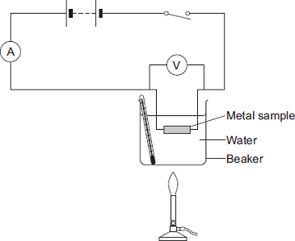
In this question you will be assessed on using good English, organising information clearly and using specialist terms where appropriate.
Describe an investigation a student could do to find how the resistance of a metal sample varies with temperature. The student uses the equipment shown.
Include in your answer:
• how the student should use the equipment
• the measurements the student should make
• how the student should use these measurements to determine the resistance
• how to make sure the results are valid.

___________________________________________________________________
___________________________________________________________________
___________________________________________________________________
___________________________________________________________________
___________________________________________________________________
___________________________________________________________________
___________________________________________________________________
___________________________________________________________________
___________________________________________________________________
___________________________________________________________________
___________________________________________________________________
___________________________________________________________________
___________________________________________________________________
___________________________________________________________________
___________________________________________________________________
___________________________________________________________________
___________________________________________________________________
___________________________________________________________________
(6)
(d) The table shows some data for samples of four metals P, Q, R and S.
The metal samples all had the same cross-sectional area and were the same length.

Metal sample | Resistance at 0°C in ohms | Resistance at 100°C in ohms
P | 4.05 | 5.67
Q | 2.65 | 3.48
R | 6.0 | 9.17
S | 1.70 | 2.23
A graph of the results for one of the metal samples is shown.
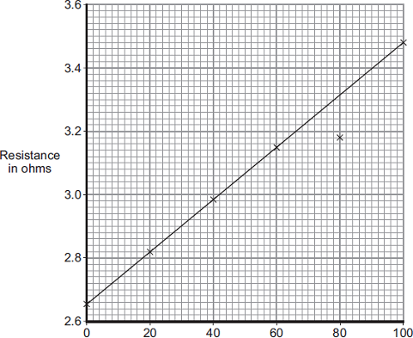
Temperature in °C
(i) Which metal sample, P, Q, R or S, has the data shown in the graph?
(1)
(ii) One of the results is anomalous. Circle this result on the graph.
(1)
(iii) Suggest a reason for the anomalous result.
______________________________________________________________
______________________________________________________________
(1)
(iv) The same equipment used in the investigation could be used as a thermometer known as a ‘resistance thermometer.’
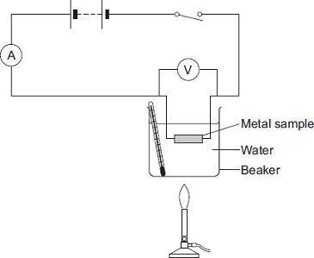
Suggest two disadvantages of using this equipment as a thermometer compared to a liquid-in-glass thermometer.
1. ____________________________________________________________
______________________________________________________________
2. ____________________________________________________________
______________________________________________________________
(2)
(Total 14 marks)
Q26.
A student wanted to determine the density of a small piece of rock.
(a) Describe how the student could measure the volume of the piece of rock.
___________________________________________________________________
___________________________________________________________________
___________________________________________________________________
___________________________________________________________________
___________________________________________________________________
___________________________________________________________________
___________________________________________________________________
___________________________________________________________________
___________________________________________________________________
___________________________________________________________________
(4)
(b) The volume of the piece of rock was 18.0 cm³.
The student measured the mass of the piece of rock as 48.6 g.
Calculate the density of the rock in g/cm³.
Use the equation:
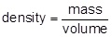
___________________________________________________________________
___________________________________________________________________
___________________________________________________________________
___________________________________________________________________
Density = _______________________ g/cm³
(2)

The graph below shows the densities of different types of rock.
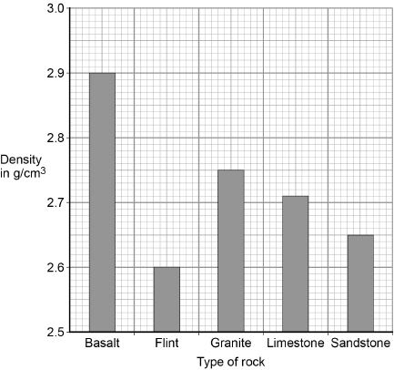
(c) What is the most likely type of rock that the student had?
Tick one box.

Basalt
Flint
Granite
Limestone
Sandstone
(1)
(d) Give one source of error that may have occurred when the student measured the volume of the rock.
___________________________________________________________________
___________________________________________________________________
(1)
(e) How would the error you described in part (d) affect the measured volume of the rock?
___________________________________________________________________
___________________________________________________________________
(1)
(Total 9 marks)
Q27.
A student investigated how the pressure of a gas varied with the volume of the gas.
The mass and temperature of the gas were constant.
The diagram shows the equipment the student used.
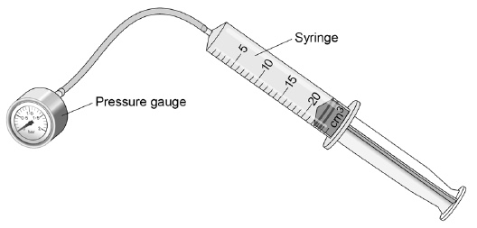
(a) What is the range of the syringe?
Tick one box.

0 to 1 cm³
0 to 5 cm³
0 to 20 cm³
0 to 25 cm³
(1)
(b) What type of variable was the mass of gas?
Tick one box.

Control
Dependent
Independent
(1)
The student compressed the gas in the syringe and read the pressure from the pressure gauge.
The graph shows the student's results.
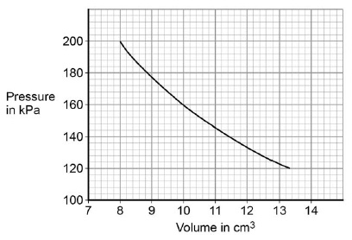
(c) The student concluded that when the pressure was multiplied by the corresponding volume the answer was the same.
Use data from the graph to show that the student's conclusion was correct.
___________________________________________________________________
___________________________________________________________________
___________________________________________________________________
___________________________________________________________________
___________________________________________________________________
___________________________________________________________________
(2)
(d) Complete the sentences.
Choose the answers from the box.
Each answer may be used once, more than once or not at all.

decreases | increases | remains the same
When the gas is compressed, the volume of gas in the syringe ________________ .
So the number of collisions each second between the gas particles inside the
syringe and the inside surface of the syringe ____________________ .
This means the force exerted on the inside surface of the container
walls ____________________ .
(3)
(Total 7 marks)
Q28.
A student investigated the cooling effect of evaporation.
She used the equipment (datalogger and probe) shown in Figure 1 to measure how the temperature of a liquid changed as the liquid evaporated.
Figure 1
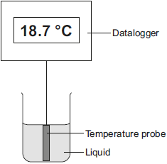
(a) Which type of variable was the temperature in this investigation?
Tick (✔) one box.

Tick (✔)
control
dependent
independent
(1)
(b) Before the investigation started, the student checked the accuracy of three different temperature probes. The student put the probes in a beaker of boiling water that had a temperature of 100.0 °C.
The readings from the three temperature probes are shown in Figure 2.
Figure 2
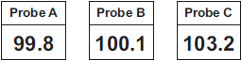
Which one of the temperature probes, A, B or C, was least accurate?
Write the correct answer in the box.
Give a reason for your answer.
___________________________________________________________________
___________________________________________________________________
(2)
(c) Figure 3 shows how the temperature recorded changed during the investigation.
Figure 3
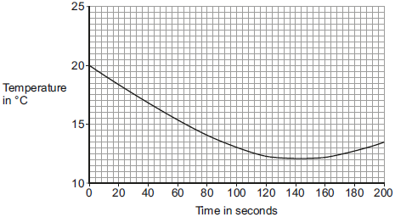
(i) Use Figure 3 to determine the lowest temperature recorded as the liquid evaporated.
Temperature = ______ °C
(1)
(ii) Use Figure 3 to determine how long it took for all the liquid to evaporate.
Give a reason for your answer.
Time = ________ seconds
Reason: __________________________________________________
______________________________________________________________
(2)
(iii) How would increasing the starting temperature of the liquid above 20 °C affect the rate of evaporation of the liquid?
______________________________________________________________
______________________________________________________________
(1)
(Total 7 marks)
Q29.
A student used the apparatus in Figure 1 to compare the energy needed to heat blocks of different materials.
Each block had the same mass.
Each block had holes for the thermometer and the immersion heater.
Each block had a starting temperature of 20 °C.
Figure 1
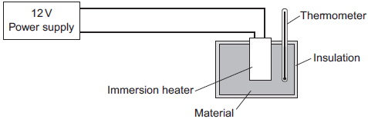
The student measured the time taken to increase the temperature of each material by 5 °C.
(a) (i) State two variables the student controlled.
1. ____________________________________________________________
2. ____________________________________________________________
(2)
Figure 2 shows the student’s results.
Figure 2
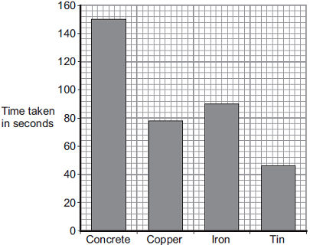
Material
(ii) Why was a bar chart drawn rather than a line graph?
______________________________________________________________
______________________________________________________________
(1)
(iii) Which material was supplied with the most energy?
______________________________________________________________
Give the reason for your answer.
______________________________________________________________
______________________________________________________________
(2)
(iv) The iron block had a mass of 2 kg.
Calculate the energy transferred by the heater to increase the temperature of the iron block by 5 °C.
The specific heat capacity of iron is 450 J / kg °C.
______________________________________________________________
______________________________________________________________
______________________________________________________________
Energy transferred = ______________________________ J
(2)
(b) The student used the same apparatus to heat a 1 kg block of aluminium.
He recorded the temperature of the block as it was heated from room temperature.
The results are shown in Figure 3.
Figure 3
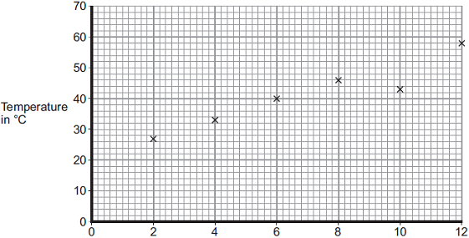
Time the immersion heater is switched on for in minutes
(i) One of the student’s results is anomalous.
Draw a ring around the anomalous result.
(1)
(ii) Draw the line of best fit for the points plotted in Figure 3.
(1)
(iii) What was the temperature of the room?
Temperature = _______________ °C
(1)
(iv) What was the interval of the time values used by the student?
Interval = _______________ minutes
(1)
(Total 11 marks)
Q30.
Alpha, beta and gamma are types of nuclear radiation.
(a) Draw one line from each type of radiation to what the radiation consists of.

Type of radiation |  | What radiation consists of
 |  | Electron from the nucleus
Alpha
 |  | Two protons and two neutrons
Beta
 |  | Electromagnetic radiation
Gamma
 |  | Neutron from the nucleus
(3)
(b) A teacher demonstrates the penetration of alpha, beta and gamma radiation through different materials.
The demonstration is shown in the figure below.
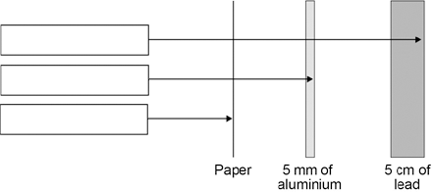
Complete the figure above by writing the name of the correct radiation in each box.
(2)
(c) Give two safety precautions the teacher should have taken in the demonstration.
1. _________________________________________________________________
___________________________________________________________________
2. _________________________________________________________________
___________________________________________________________________
(2)
(d) The table below shows how the count rate from a radioactive source changes with time.

Time in seconds | 0 | 40 | 80 | 120 | 160
Count rate  in counts/second | 400 | 283 | 200 | 141 | 100
Use the table to calculate the count rate after 200 seconds.
___________________________________________________________________
___________________________________________________________________
(2)
(e) The half-life of the radioactive source used was very short.
Give one reason why this radioactive source would be much less hazardous after 800 seconds.
___________________________________________________________________
___________________________________________________________________
(1)
(Total 10 marks)
Q31.
A student investigated the properties of three insulating materials.
Figure 1 shows the apparatus the student used.
Figure 1
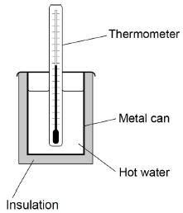
In the investigation, different insulating materials were used to insulate a metal can filled with hot water.
Figure 2 shows how the temperature measured by the thermometer changed over 25 minutes for each of the materials.
Figure 2
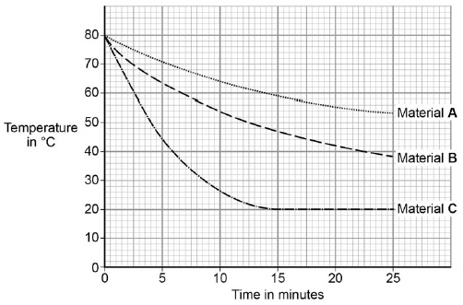
(a) What was the temperature of the room where the student carried out the investigation?
Tick one box.

20 °C |  | 38 °C |  | 53 °C |  | 80 °C
(1)
(b) Material C has the highest thermal conductivity.
How does the graph in Figure 2 show this?
___________________________________________________________________
___________________________________________________________________
(1)
(c) Another student repeated the investigation using the equipment shown in Figure 3.
Figure 1 shows the first set of equipment used.
Figure 1 Figure 3
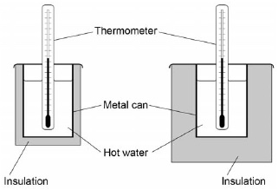
Suggest how using the equipment in Figure 3 will have affected the student's results.
___________________________________________________________________
___________________________________________________________________
___________________________________________________________________
___________________________________________________________________
(2)
(d) The students could have used a temperature probe and datalogger instead of a thermometer.
Figure 4 shows the datalogger screen and the thermometer.
Figure 4
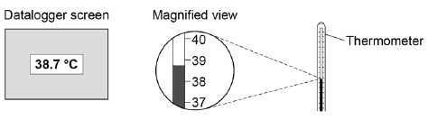
Complete the sentences.
Choose the answers from the box.

higher | lower | the same
Compared to the thermometer, the datalogger and temperature probe have
a resolution that is ____________________ .
Compared to the thermometer, the chance of misreading the datalogger and
temperature probe is ____________________ .
(2)
(e) The table gives information about four types of insulation that could be used in the walls of houses.

Type of insulation | Thermal conductivity in W/m °C
Felt wool | 0.070
Mineral wool | 0.040
Polyurethane foam | 0.030
Rock wool | 0.045
Which type of insulation would be most effective in reducing the rate of cooling of a building?
Tick one box.

Felt wool
Mineral wool
Polyurethane foam
Rock wool
Give a reason for your answer.
___________________________________________________________________
___________________________________________________________________
___________________________________________________________________
___________________________________________________________________
(2)
(Total 8 marks)

Section 3: 6 Mark Questions
Q1.
Describe, in as much detail as you can, how the energy stored in coal is transferred into electrical energy in a power station.
_______________________________________________________________________
_______________________________________________________________________
_______________________________________________________________________
_______________________________________________________________________
_______________________________________________________________________
_______________________________________________________________________
_______________________________________________________________________
_______________________________________________________________________
_______________________________________________________________________
(Total 5 marks)
Q2.
Antarctica is a huge land mass surrounding the Earth’s south pole. It is covered in a very thick layer of ice and is the only remaining large area of the Earth’s surface that has not been affected very much by humans.
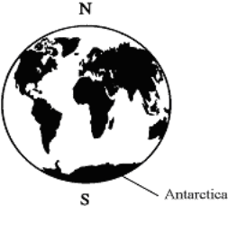
There are, however, teams of scientists from various countries studying Antarctica. These scientists need electricity for lighting, for their computers and other scientific instruments and to communicate, via satellite, with the rest of the world. The temperature in Antarctica is always sub-zero, so the scientists need some way of keeping their buildings warm. They also need fuel to be able to get around on their snowmobiles.
Scientists cannot avoid affecting the environment. However, they want to affect it as little as possible.
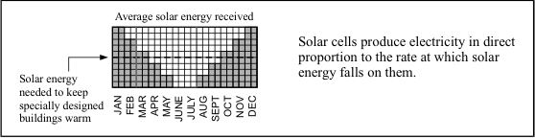
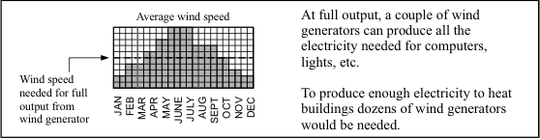
Atmospheric pollution produced in one country eventually affects the whole of the Earth’s atmosphere. The hole that appears each year in the ozone layer above Antarctica, for example, is mainly caused by pollutants such as CFCs from countries in the northern half of the Earth.
Discuss the advantages and disadvantages of using the following energy sources to meet the scientists’ needs:
• solar energy
• energy from the wind
• natural gas (present in large quantities deep down in the Antarctic land mass)
• diesel oil (which would have to be imported)
_______________________________________________________________________
_______________________________________________________________________
_______________________________________________________________________
_______________________________________________________________________
_______________________________________________________________________
_______________________________________________________________________
_______________________________________________________________________
_______________________________________________________________________
_______________________________________________________________________
_______________________________________________________________________
_______________________________________________________________________
(Total 10 marks)
Q3.
The image shows a battery-powered drone.
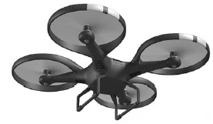
(a) The battery in the drone can store 97.5 kJ of energy.
When the drone is hovering, the power output of the battery is 65.0 W
Calculate the time for which the drone can hover.
___________________________________________________________________
___________________________________________________________________
___________________________________________________________________
___________________________________________________________________
___________________________________________________________________
___________________________________________________________________
Time = ____________________ seconds
(3)
(b) The battery powers 4 motors in the drone.
Each motor has a resistance of 1.60 Ω when the power input to each motor is 19.6 W
The 4 motors are connected in parallel with the battery.
Calculate the current through the battery.
___________________________________________________________________
___________________________________________________________________
___________________________________________________________________
___________________________________________________________________
___________________________________________________________________
___________________________________________________________________
___________________________________________________________________
Current = ____________________ A
(4)
(Total 7 marks)

Q4.
An electrician is replacing an old electric shower with a new one.
The inside of the old shower is shown in Figure 1.
Figure 1
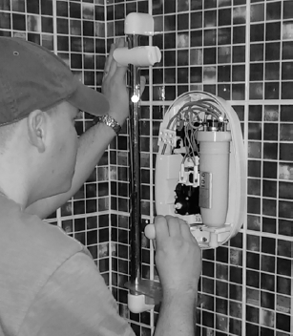
© Michael Priest
(a) If the electrician touches the live wire he will receive an electric shock.
Explain why.
___________________________________________________________________
___________________________________________________________________
___________________________________________________________________
___________________________________________________________________
___________________________________________________________________
___________________________________________________________________
___________________________________________________________________
___________________________________________________________________
(4)
(b) Different electrical wires need to have a cross-sectional area that is suitable for the power output.
Figure 2 shows the recommended maximum power input to wires of different cross-sectional areas.
Figure 2
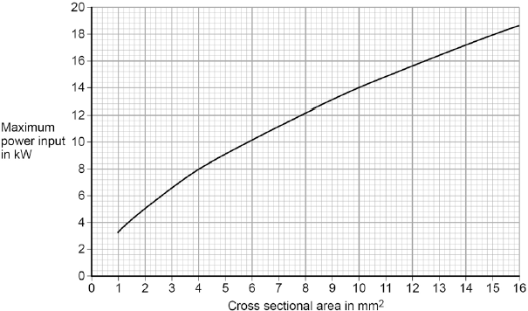
The new electric shower has a power input of 13.8 kW.
Determine the minimum diameter of wire that should be used for the new shower.
The diameter, d, can be calculated using the equation:
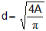
A is the cross-sectional area of the wire.
___________________________________________________________________
___________________________________________________________________
Minimum diameter = _________________________ mm
(2)
(c) The charge that flows through the new shower in 300 seconds is 18 000 C.
The new electric shower has a power of 13.8 kW.
Calculate the resistance of the heating element in the new shower.
Write down any equations you use.
___________________________________________________________________
___________________________________________________________________
___________________________________________________________________
___________________________________________________________________
___________________________________________________________________
___________________________________________________________________
___________________________________________________________________
Resistance = _______________________ Ω
(5)
(Total 11 marks)
Q5.
A student investigated how the pressure of a gas varied with the volume of the gas.
The mass and temperature of the gas were constant.
Figure 1 shows the equipment the student used.
Figure 1
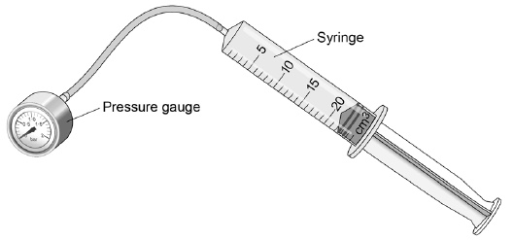
(a) What is the resolution of the syringe?
____________________ cm³
(1)
The student compressed the gas in the syringe and read the pressure from the pressure gauge.
Figure 2 shows the student's results.
Figure 2
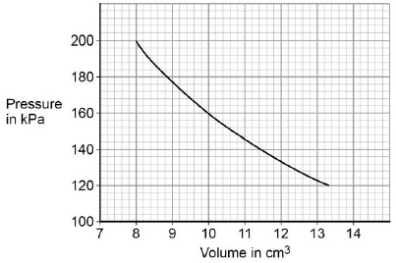
(b) What conclusion can the student make from the data in Figure 2?
Use data from Figure 2 in your answer.
Give the reason for your answer.
___________________________________________________________________
___________________________________________________________________
___________________________________________________________________
___________________________________________________________________
___________________________________________________________________
___________________________________________________________________
(3)
(c) Explain why the pressure in the gas increases as the gas is compressed.
___________________________________________________________________
___________________________________________________________________
___________________________________________________________________
___________________________________________________________________
___________________________________________________________________
___________________________________________________________________
___________________________________________________________________
___________________________________________________________________
___________________________________________________________________
___________________________________________________________________
(4)
(Total 8 marks)
Q6.
A student wants to calculate the density of the two objects shown in the figure below.
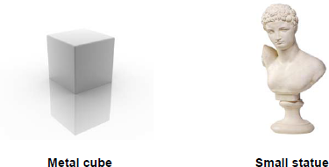
© Whitehoune/iStock/Thinkstock, © Marc Dietrich/Hemera/Thinkstock
Describe the methods that the student should use to calculate the densities of the two objects.
_______________________________________________________________________
_______________________________________________________________________
_______________________________________________________________________
_______________________________________________________________________
_______________________________________________________________________
_______________________________________________________________________
_______________________________________________________________________
_______________________________________________________________________
_______________________________________________________________________
_______________________________________________________________________
(Total 6 marks)
Q7.
According to kinetic theory, all matter is made up of small particles. The particles are constantly moving.
Diagram 1 shows how the particles may be arranged in a solid.
Diagram 1
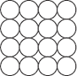
(a) One kilogram of a gas has a much larger volume than one kilogram of a solid.
Use kinetic theory to explain why.
___________________________________________________________________
___________________________________________________________________
___________________________________________________________________
___________________________________________________________________
___________________________________________________________________
___________________________________________________________________
___________________________________________________________________
___________________________________________________________________
___________________________________________________________________
___________________________________________________________________
(4)
(b) Diagram 2 shows the particles in a liquid. The liquid is evaporating.
Diagram 2
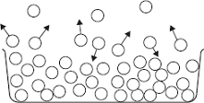
(i) How can you tell from Diagram 2 that the liquid is evaporating?
______________________________________________________________
______________________________________________________________
(1)
(ii) The temperature of the liquid in the container decreases as the liquid evaporates.
Use kinetic theory to explain why.
______________________________________________________________
______________________________________________________________
______________________________________________________________
______________________________________________________________
______________________________________________________________
______________________________________________________________
______________________________________________________________
______________________________________________________________
(3)
(Total 8 marks)
Q8.
In the early part of the 20th century, scientists used the ‘plum pudding’ model to explain the structure of the atom.
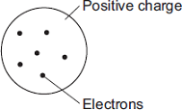
Following work by Rutherford and Marsden, a new model of the atom, called the ‘nuclear’ model, was suggested.
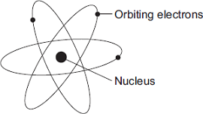
Describe the differences between the two models of the atom.
_______________________________________________________________________
_______________________________________________________________________
_______________________________________________________________________
_______________________________________________________________________
_______________________________________________________________________
_______________________________________________________________________
_______________________________________________________________________
_______________________________________________________________________
(Total 4 marks)

Q9.
(a) The Sun is at the stable stage of its life.
Explain, in terms of the forces acting on the Sun, what this means.
___________________________________________________________________
___________________________________________________________________
___________________________________________________________________
___________________________________________________________________
___________________________________________________________________
___________________________________________________________________
(3)
(b) At the end of the stable stage of its life a star will change.
Describe and explain the changes that could take place.
___________________________________________________________________
___________________________________________________________________
___________________________________________________________________
___________________________________________________________________
___________________________________________________________________
___________________________________________________________________
(6)
(Total 9 marks)

Section 1: Maths Mark Scheme
Mark schemes
Q1.
(a) potential difference
allow p.d.
allow voltage
1
temperature
1
in this order only
(b) the current increases (when the potential difference increases)
1
(which) causes the temperature of the filament to increase
1
(so) the resistance increases
do not accept resistance increases and then levels off
1
(c) a higher proportion / percentage of the (total) power / energy input is usefully transferred
wastes less energy is insufficient
or
higher (useful) power / energy output for the same (total) power / energy input
1
(d) potential difference increases
1
current decreases
1
(e) 1000 (Ω)
reason only scores if R = 1000 (Ω)
1
potential difference is shared in proportion to the resistance
allow a justification using a correct calculation
1
(f) 12 = I × 7000
1
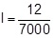
1
I = 1.71 × 10⁻³ (A)
an answer that rounds to 1.7 × 10⁻³ (A) scores 3 marks
1
I = 1.7 × 10⁻³ (A)
this answer only
or
I = 0.0017 (A)
an answer of 2.4 × 10⁻³ (A) scores 2 marks
if no other marks scored allow 1 mark for calculation of total resistance (7000 Ω)
1
an answer of 1.7 × 10⁻³ (A) scores 4 marks
[14]
Q2.
(a) risk of electric shock (if someone touched the case)
allow risk of electrocution (if someone touched the case)
1
(b) 2530 = I × 230
this mark may be awarded if P is incorrectly / not converted
1
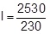
this mark may be awarded if P is incorrectly / not converted
1
I = 11 (A)
this answer only
an answer of 0.011 (A) scores 2 marks
1
an answer of 11 (A) scores 3 marks
(c) E = 2530 × 14
this mark may be awarded if P is incorrectly / not converted
1
E = 35 420 (J)
this answer only
1
35 420 = m × 4200 × 70
allow their calculated E = m × 4200 × 70
1
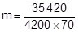
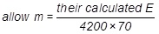
1
m = 0.12 (kg)
allow an answer that is consistent with their calculated value of E
1
[9]
Q3.
(a) 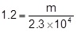
1
m = 1.2 × 2.3 × 10⁴
1
m = 27 600 (kg)
allow an answer of 28 000 (kg) or 2.8 × 10⁴ (kg)
or
m = 2.76 × 10⁴ (kg)
1
an answer of 27 600 (kg) scores 3 marks
(b) mass of air passing the turbine blades is halved which decreases kinetic energy by a factor of two
1
(wind speed is halved) decreasing kinetic energy by a factor of four
1
so kinetic energy decreases by a factor of eight
1
allow power output for kinetic energy throughout
(c) 388 000 = 0.5 × 13 800 × v²
this mark may be awarded if P is incorrectly / not converted
1
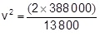
this mark may be awarded if P is incorrectly / not converted
or
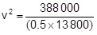
or
v² = 56.2
1
v = 7.50 (m/s)
an answer that rounds to 7.50 (m/s) only
1
[9]
Q4.
(a) current at 0.5 V = 0.91 (A)
1
P = 0.91 × 0.5
1
P = 0.455 (W)
an answer of 0.455 (W) scores 3 marks
1
(b) straight line with positive gradient
allow for 1 mark a straight line that passes through (0.1, 0)
1
positive y-axis intercept
ignore any values on y-axis
1
(c)
1
total P = 3.47 (W)
1
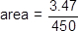
1
area = 7.7 × 10^{–3} (m²)
an answer of 7.7 × 10^{–3} (m²) scores 4 marks
allow use of student’s calculated incorrect total power for last 2 marking points
1
(d) connect the solar cells in parallel
1
(so that) the current has multiple paths it can take
or
the total resistance is less than the resistance of one solar cell
1
[11]
Q5.
(a) g.p.e. = mass × gravitational field strength × height
accept E_{p} = mgh
1
(b) E_{p} = 50 × 9.8 × 20
1
9800 (J)
allow 9800 (J) with no working shown for 2 marks
answer may also be correctly calculated using W = Fs
ie allow W = 490 × 20 for 1 mark
or answer of 9800 (J) using this method for 2 marks
1
(c) 7840 (J)
allow ecf from ‘11.2’
1
(d) 7840 = ½ × 50 × v²
1
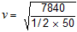
allow 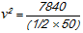 for this point
1
17.7(0875) (m / s)
1
18 (m / s)
allow ecf from ‘11.3’ correctly calculated for 3 marks
allow 18 (m / s) with no working for 2 marks
answer may also be correctly calculated using v² – u² = 2as
1
(e) extension = 35 (m) and conversion of 24.5 kJ to 24500 J
1
24 500 = ½ × k × 35²
1
40
1
allow 40 with no working shown for 3 marks
an answer of ‘16.2’ gains 2 marks
[11]
Q6.
(a) any two from:
• cost per kWh is lower (than all other energy resources)
allow it is cheaper
ignore fuel cost
ignore energy released per kg of nuclear fuel
• infrastructure for nuclear power already exists
accept cost of setting up renewable energy resources is high
accept many renewable power stations would be needed to replace one nuclear power station
accept (France in 2011 already had a) surplus of nuclear energy, so less need to develop more renewable capacity for increased demand in the future
accept France benefits economically from selling electricity
• more reliable (than renewable energy resources)
accept (nuclear) fuel is readily available
ignore destruction of habitats for renewables
2
(b) any two from:
• non-renewable
allow nuclear fuel is running out
• high decommissioning costs
accept high commissioning costs
• produces radioactive / nuclear waste
allow waste has a long half-life
• long start-up time
• nuclear accidents have widespread implications
allow for nuclear accident a named nuclear accident
eg Fukushima, Chernobyl
ignore visual pollution
2
(c) 0.48 (kW)
allow 1 mark for correct substitution
ie 0.15 = P / 3.2
an answer of 480 W gains 2 marks
an answer of 48 or 480 scores 1 mark
2
(d) the higher the efficiency, the higher the cost (per m² to manufacture)
accept a specific numerical example
1
more electricity could be generated for the same (manufacturing) cost using lower efficiency solar panels
or
(reducing the cost) allows more solar panels to be bought
accept a specific numerical example
1
[8]
Q7.
(a) resultant force = zero
or
upward force = downward force
accept forces are balanced
accept weight for downward force
1
(b) (i) 84
allow 1 mark for correct substitution ie 840 = m × 10
2
(ii) 12
accept 12.02 for both marks
or
1010 ÷ their (b)(i) correctly calculated
a resultant force of 1010 (N) gains 1 mark
an answer 22(.02) gains 1 mark
2
m/s²
accept m/s/s
1
[6]
Q8.
(a) energy required to raise the temperature of a substance by 1 °C
accept heat for energy
1
unit mass / 1 kg
1
(b) (i) 7 140 000 (J)
allow 2 marks for a correct substitution, ie
E = 20 × 420 × 850
provided no subsequent step
850 gains 1 mark if no other mark awarded
3
(ii) particles in the air have more (kinetic) energy than the particles in the steel
allow particles in the air have a greater speed.
1
steel
particles vibrate (about fixed positions)
1
air
particles move freely
1
(ii) the most energetic particles
accept molecules for particles throughout
accept the fastest particles
1
have enough energy to escape from (the surface of) the water
1
therefore the mean energy of the remaining particles decreases
accept speed for energy
1
as energy decreased, temperature has decreased
1
[12]
Q9.
(a) 4200
allow 2 marks for correct substitution
ie 6930 = 0.330 × c × 5.0
answers of 1050 or 840
or
correctly calculated answer from correct substitution of incorrect temperature change
or
identification of temperature change ie 5 °C
gain 1 mark
3
J / kg°C
accept J / kg K
1
(b) (in a metal) free electrons
to gain full credit the answer must be in terms of free electrons
1
gain kinetic energy
accept move faster
1
(free electrons) transfer energy to other electrons / ions / atoms
do not accept particles
1
by collision
allow a maximum of 2 marks for answers in terms of atoms / ions / particles
• gaining kinetic energy or vibrating faster / more
• transferring energy by collisions
1
(c) (air) particles spread out
1
(which causes the) air to become less dense / expand
do not accept particles become less dense
1
(so the) warm air rises
do not accept heat rises
particles rise is insufficient
1
(d) large surface area
ignore references to type of metal or external conditions
1
black / dark (colour)
1
[13]
Q10.
(a) (i) decreases (to zero)
1
resultant force acts in opposite direction to motion
accept air resistance and weight for resultant force
accept resultant force acts downwards
do not accept air resistance increases
1
(ii) velocity includes direction
or
velocity is a vector (quantity)
1
(b) (i) 3.6
allow 1 mark for correct substitution i.e.
½ × 0.05 × 12² provided no subsequent step
2
(ii) 3.6 or their (i)
1
(iii) 7.2
or
their (ii) ÷ 0.5 correctly calculated
allow 1 mark for correct substitution i.e.
3.6 or their (ii) = 0.05 × 10 × h
2
(iv) B
1
(c) range increases up to 45°
1
range decreases from 45°
the range is a maximum at 45° gains both marks
for any two angles that add up
to 90° the range is the same gains both marks
the range increases then decreases gains 1 mark
1
[11]
Q11.
(a) 1 080 000
allow 1 mark for correct substitution
ie ½ × 15 000 × 12 × 12
2
(b) any one from:
• KE (of wind) more than doubles
• mass of air (hitting blades) more than doubles
• area swept out by blades more than doubles
do not accept blades are larger / have a bigger area
• area swept out by blades increases × 4
1
[3]
Q12.
(a) current
1
(b) 4.2 = 3.5 × 10^{–3} × R
1
R = 4.2 / 3.5 × 10^{–3}
1
R = 1200 (Ω)
an answer of 1200 (Ω) scores 3 marks
an answer of 1.2 scores 2 marks
1
(c) conversion from minutes to seconds (300 s)
1
Q = 0.0035 × (5 × 60)
1
Q = 1.05 C
an answer of 1.05 (C) scores 3 marks
an answer of 17.5 scores 1 mark
an answer of 1050 or 0.0175 scores 2 marks
1
(d) (potential difference) increases
1
(because thermistor) resistance increases
2nd mark dependent on scoring 1st mark
1
(e) 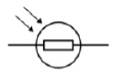
1
[10]
Q13.
(a) (i) 1.7
1
(ii) 51
or
30 × their (i) correctly calculated
allow 1 mark for correct substitution i.e. 1.7 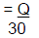
or their (i)
2
coulomb / C
do not accept c
1
(iii) 612
or
their (ii) × 12 correctly calculated
or
their (i) × 360 correctly calculated
allow 1 mark for correct substitution i.e. E = 12 × 51
or 12 × their (ii)
or their (i) × 360
2
(b) ions vibrate faster
or
ions vibrate with a bigger amplitude
accept atoms for ions throughout
accept ions gain energy
accept ions vibrate more
ions start to vibrate is insufficient
1
electrons collide more (frequently) with the ions
or
(drift) velocity of electrons decreases
electrons start to collide is insufficient
there are more collisions is insufficient, unless both electrons and ions are implied
1
[8]
Q14.
(a) attempt to draw four cells in series
1
correct circuit symbols
circuit symbol should show a long line and a short line, correctly joined together
example of correct circuit symbol:
1
(b) (i) 6 (V)
allow 1 mark for correct substitution, ie
V = 3 × 2 scores 1 mark
provided no subsequent step
2
(ii) 12 (V)
ecf from part (b)(i)
18 – 6
or
18 – their part (b)(i) scores 1 mark
2
(iii) 9 (Ω)
ecf from part (b)(ii) correctly calculated
3 + their part (b)(ii) / 2
or
18 / 2 scores 1 mark
provided no subsequent step
2
(c) (i) need a.c.
1
battery is d.c.
1
(ii) 3 (A)
allow 1 mark for correct substitution, ie
18 × 2 = 12 × I_{s} scores 1 mark
2
[12]
Q15.
(a) (i) 2
allow 1 mark for correct substitution i.e. 0.8 × 2.5 provided no further step shown
2
(ii) straight line drawn from origin to 2, 0.8
or
their (a)(i), 0.8
1
curve from 2, 0.8 to 12,2
or
their (a)(i) 0.8 to 12,2
accept curve from 2, 0.9 to 12,2
or
their (a)(i) 0.9 to 12,2
‘convex’ curve required
accept a curve that flattens between 10 and 12V
1
(iii) filament / lamp gets hot
accept temperature increases
1
(b) 108
allow 1 mark for correct substitution i.e. 1.5 × 72 provided no further step shown
2
[7]
Q16.
(a) conduction
1
(b) 35 000
1
(c) 500
their (b) = 2 x c x 35 correctly calculated scores 2 marks
allow 1 mark for correct substitution,
ie 35000 = 2 x c x 35
or
their (b) = 2 x c x 35
2
J / kg°C
1
(d) energy lost to surroundings
or
energy needed to warm heater
accept there is no insulation (on the copper block)
do not accept answers in terms of human error or poor results or defective equipment
1
[6]
Q17.
(a) cannot predict which dice / atom will ‘decay’
accept answers given in terms of ‘roll a 6’
1
cannot predict when a dice / atom will ‘decay’
1
(b) 3.6 to 3.7 (rolls)
allow 1 mark for attempt to read graph when number of dice = 50
2
(c) 90
1
(d) uranium
1
(e) beta
1
proton number has gone up (as neutron decays to proton and e–)
1
(f) prevents contamination
or
prevents transfer of radioactive material to teacher’s hands
1
which would cause damage / irradiation over a longer time period.
1
[10]
Q18.
(a) Nucleus splitting into two fragments and releasing two or three neutrons
1
(at least one) fission neutron shown to be absorbed by additional large nucleus and causing fission
1
two or three additional neutrons released from fission reaction
1
This diagram would gain all 3 marks:
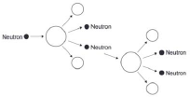
(b) lowering the control rods increases the number of neutrons absorbed
accept converse description
1
(so) energy released decreases
1
allow changing the position of the control rods affects the number of neutrons absorbed for 1 mark
(c) rate of increase between 240 and 276 (MW / min)
2
allow 1 mark for attempt to calculate gradient of line at 10 minutes
[7]
Q19.
(a) (i) (atoms with the) same number of protons
allow same atomic number
or same proton number
1
(atoms with) different number of neutrons
allow different mass number
1
(ii) 82
1
(iii) 124
1
(b) (i) 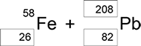

1 mark for each correct box
3
(ii) (a) neutron
1
(iii) 4.0 × 10⁻⁴ (s)
or
0.0004
3.00 × 10⁸ × 0.1 = 12 000 / t
gains 1 mark
2
(iv) particles need to travel a large distance
1
equipment would have to be very long
1
with circular paths long distances can be accommodated in a smaller space
1
(c) (i) the average time for the number of nuclei to halve
1
the time for count rate to halve
1
(ii) 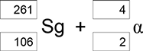

1 mark if top boxes total = 265
and bottom boxes total = 108
1 mark for 4 and 2 for alpha
2
(d) (i) 3 plotted points
± ½ small square
1
best line through points
1
(ii) 190−205 (pm)
or correct from student’s line
1
[20]
Q20.
(a) (i) 18
1
(ii) the count rate for the source
1
(iii) the alpha radiation would not cover such a distance
1
(iv) plots correct to within ½ small square
allow 1 mark for 4 correct points plotted
2
correct curve through points as judged by eye
1
(v) two attempts at finding ‘half-distance’ using the table
20 to 10 cpm d = 0.4 m
125 to 56 cpm d = 0.2 m
31 to 14 cpm d = 0.4 m
allow 1 mark for one attempted comparison
2
obeyed or not obeyed
dependent on previous two marks
1
(b) (i) there is no effect on the count rate in experiment 1 because the field is parallel or beta particles are not deflected or there is no force
1
count rate is reduced in experiment 2 because field is perpendicular or beta particles are deflected or there is a force
1
(ii) only background radiation (as beta do not travel as far)
1
slightly different values show the random nature of radioactive decay
1
[13]
Q21.
(a) (i) any one from:
• nuclear power (stations)
accept nuclear waste
accept coal power stations
• nuclear weapons (testing)
accept nuclear bombs / fallout
• nuclear accidents
accept named accident, eg Chernobyl or Fukushima
accept named medical procedure which involves a radioactive source
accept radiotherapy
accept X-rays
accept specific industrial examples that involve a radioactive source
nuclear activity / radiation is insufficient
smoke detectors is insufficient
1
(ii) (radioactive decay) is a random process
accept an answer in terms of background / radiation varies (from one point in time to another)
1
(b) any one from:
• (maybe) other factors involved
accept a named ‘sensible’ factor, eg smoking
• evidence may not be valid
accept not enough data
• may not have (a complete) understanding of the process (involved)
1
(c) (i) 2
1
2
1
(ii) 218
correct order only
1
84
1
(d) 3.8 (days)
allow 1 mark for showing correct method using the graph provided no subsequent steps
correct answers obtained using numbers other than 800 and 400 gain 2 marks provided the method is shown
2
[9]

Section 2: Required Practicals
Q22.
(a) ammeter and voltmeter symbols correct
1
voltmeter in parallel with wire
1
ammeter in series with wire
1
(b) Level 3: The method would lead to the production of a valid outcome. All key steps are identified and logically sequenced.
5−6
Level 2: The method would not necessarily lead to a valid outcome. Most steps are identified, but the method is not fully logically sequenced.
3−4
Level 1: The method would not lead to a valid outcome. Some relevant steps are identified, but links are not made clear.
1−2
No relevant content
0
Indicative content
• length measured
• length varied
• current measured
• potential difference measured
• repeat readings
• calculate resistance for each length
• 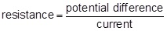
• plot a graph of resistance against length
• hazard: high current
• may cause wire to melt / overheat
• may cause burns (to skin)
• use low currents
(c) the temperature of the wire would not change
1
(d) the accuracy of the student’s results would be higher
1
the resolution of the length measurement would be higher
1
[12]
Q23.
(a) (i) live
1
(ii) react faster
1
(iii) live and neutral
1
(b) (i) ammeter
1
to measure current
accept to measure amps
1
plus any one from:
• variable resistor (1)
to vary current (1)
accept variable power supply
accept change or control
• switch (1)
to stop apparatus getting hot / protect battery
or
to reset equipment (1)
• fuse (1)
to break circuit if current is too big (1)
2
(ii) any two from:
• use smaller mass(es)
• move mass closer to pivot
• reduce gap between coil and rocker
• more turns (on coil)coil / loop
• iron core in coil
accept use smaller weight(s)
2
[9]
Q24.
(a) (black) is a good absorber of (infrared) radiation
1
(b) (i) amount of energy required to change (the state of a substance) from solid to liquid (with no change in temperature)
melt is insufficient
1
unit mass / 1kg
1
(ii) 5.1 × 10⁶ (J)
accept 5 x 10⁶
allow 1 mark for correct substitution ie E = 15 × 3.4 × 10⁵
2
(c) (i) mass of ice
allow volume / weight / amount / quantity of ice
1
(ii) to distribute the salt throughout the ice
1
to keep all the ice at the same temperature
1
(iii) melting point decreases as the mass of salt is increased
allow concentration for mass
accept negative correlation
do not accept inversely proportional
1
(d) 60 000 (J)
accept 60 KJ
allow 2 marks for correct substitution ie E = 500 × 2.0 × 60
allow 2 marks for an answer of 1000 or 60
allow 1 mark for correct substitution ie
E = 500 × 2.0 or 0.50 × 2.0 × 60
allow 1 mark for an answer of 1
3
(e) Marks awarded for this answer will be determined by the Quality of Communication (QC) as well as the standard of the scientific response. Examiners should also apply a ‘best-fit’ approach to the marking.
0 marks
No relevant content
Level 1 (1–2 marks)
There is an attempt at a description of some advantages or disadvantages.
Level 2 (3–4 marks)
There is a basic description of some advantages and / or disadvantages for some of the methods
Level 3 (5–6 marks)
There is a clear description of the advantages and disadvantages of all the methods.
examples of the points made in the response
extra information
energy storage
advantages:
• no fuel costs
• no environmental effects
disadvantages:
• expensive to set up and maintain
• need to dig deep under road
• dependent on (summer) weather
• digging up earth and disrupting habitats
salt spreading
advantages:
• easily available
• cheap
disadvantages:
• can damage trees / plants / drinking water / cars
• needs to be cleaned away
undersoil heating
advantages:
• not dependent on weather
• can be switched on and off
disadvantages:
• costly
• bad for environment
6
[18]
Q25.
(a) decreases
1
(b) a filament bulb
allow bulb
1
an LED
1
(c) Marks awarded for this answer will be determined by the Quality of Communication (QoC) as well as the standard of the scientific response.
0 marks
No relevant content.
Level 1 (1−2 marks)
There is a basic description of the method. This is incomplete and would not lead to any useful results.
Level 2 (3−4 marks)
There is a description of the method which is almost complete with a few minor omissions and would lead to some results.
Level 3 (5−6 marks)
There is a detailed description of the method which would lead to valid results.
To gain full marks an answer including graph, or another appropriate representation of results, must be given.
examples of the physics points made in the response:
• read V and I
• read temperature
• apply heat
allow hot water to cool
• read V and I at least one other temperature
• determine R from V / I
• range of temperatures above 50 °C
extra detail:
• use thermometer to read temperature at regular intervals of temperature
• remove source of heat and stir before taking readings
• details of attaining 0 °C or 100 °C
• last reading taken while boiling
• graph of R against T
• at least 3 different temperatures
6
(d) (i) Q
1
(ii) (80, 3.18)
1
(iii) any one from:
• measurement of V too small
• measurement of I too big
• incorrect calculation of R
• thermometer misread
allow misread meter
ignore any references to an error that is systematic
1
(iv) any two from:
• not portable
allow requires a lot of equipment allow takes time to set up
• needs an electrical supply
• cannot be read directly
accept it is more difficult to read compared to liquid-in-glass
2
[14]
Q26.
(a) Level 2: The method would lead to the production of a valid outcome. Key steps are identified and logically sequenced.
3−4
Level 1: The method would not necessarily lead to a valid outcome. Some relevant steps are identified, but links are not made clear.
1−2
No relevant content
0
Indicative content
• part fill a measuring cylinder with water
• measure initial volume
• place object in water
• measure final volume
• volume of object = final volume − initial volume
• fill a displacement / eureka can with water
• water level with spout
• place object in water
• collect displaced water
• measuring cylinder used to determine volume of displaced water
(b) 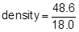
1
density = 2.70 (g/cm³)
1
an answer of 2.70 (g/cm³) scores 2 marks
(c) limestone
1
(d) eye position when using measuring cylinder
or
water level in can (at start) not at level of spout
or
not all water displaced by stone is collected in container
1
(e) volume would be lower / higher
1
[9]
Q27.
(a) 0 to 25 cm³
1
(b) control
1
(c) 2 sets of data recorded from line of best fit to show that the product is the same in both cases (1600)
allow for 1 mark one set of calculated data for one point on the line of best fit
2
(d) decreases
1
increases
1
increases
1
[7]
Q28.
(a) dependent
1
(b) (probe) C
allow 103.2
1
largest difference between reading and actual temperature
reason only scores if C chosen
accept larger
it is 3.2 greater is insufficient
comparing C with only one other probe is insufficient
1
(c) (i) 12(°C)
accept a value between 12.0 and 12.2 inclusive
1
(ii) 140 (seconds)
accept an answer between 130 and 150 inclusive
1
temperature starts to rise
only scores if time mark awarded
accept the temperature was lowest (at this time)
1
(iii) increase
accept faster (rate)
1
[7]
Q29.
(a) (i) any two from:
• mass (of block)
accept weight for mass
• starting temperature
• final / increase in temperature
temperature is insufficient
• voltage / p.d.
same power supply insufficient
• power (supplied to each block)
• type / thickness of insulation
same insulation insufficient
2
(ii) one of variables is categoric
or
(type of) material is categoric
accept the data is categoric
accept a description of categoric
do not accept temp rise is categoric
1
(iii) concrete
reason only scores if concrete chosen
1
(heater on for) longest / longer time
a long time or quoting a time is insufficient
do not accept it is the highest bar
1
(iv) 4500 (J)
allow 1 mark for correct substitution ie
2 × 450 × 5 provided no subsequent step shown
2
(b) (i) point at 10 minutes identified
1
(ii) line through all points except anomalous
line must go from at least first to last point
1
(iii) 20 (°C)
if 20°C is given, award the mark.
If an answer other than 20°C is given, look at the graph. If the graph shows a correct extrapolation of the candidate’s best-fit line and the intercept value has been correctly stated, allow 1 mark.
1
(iv) 2 (minutes)
1
[11]
Q30.
(a) Alpha – two protons and two neutrons
1
Beta – electron from the nucleus
1
Gamma – electromagnetic radiation
1
(b) Gamma
Beta
Alpha
allow 1 mark for 1 or 2 correct
2
(c) any two from:
• (radioactive) source not pointed at students
• (radioactive) source outside the box for minimum time necessary
• safety glasses or eye protection or do not look at source
• gloves
• (radioactive) source held away from body
• (radioactive) source held with tongs / forceps
accept any other sensible and practical suggestion
2
(d) half-life = 80 s
1
counts / s after 200 s = 71
accept an answer of 70
1
(e) very small amount of radiation emitted
accept similar / same level as background radiation
1
[10]
Q31.
(a) 20 (°C)
1
(b) largest temperature decrease
allow larger temperature decrease
1
(c) insulation is thicker
1
so temperature decrease will be lower (for all insulation types)
1
(d) Higher
1
Lower
1
(d) polyurethane foam
1
lowest thermal conductivity
1
[8]
Section 3: 6 Mark Questions
Mark schemes
Q1.
coal has chemical energy
when burnt heat/energy produced longest
used to boil water/make steam sequence
used to turn turbine(s)
which now have ke
turbine(s) turn generator(s)
(where (ke) transferred electrical energy)
(or electrical energy produced )
any 5 for 1 mark each
[5]

Q2.
ideas that
• direct solar radiation will provide enough energy to heat the (specially designed) buildings during the period Oct-Mar / summer
• solar cells will produce plenty of electricity in Oct-Mar / summer (when wind generators produce little)
• a couple of wind generators will produce all electricity needed (for all but heating) Apr-Oct / winter
• number required makes wind generators unsuitable for heating / buildings
• no solar energy in June and July / little in winter
• solar / wind have little effect on environment
• or cause no air pollution
• solar and wind complement each other
• or together provide energy all year
• fuel / gas / diesel can provide energy all the time / at any time
• fuel / gas / diesel needed for transport
• fuel / gas / diesel needed for heating in winter
• diesel has to be imported
• diesel likely to freeze
• gas wouldn’t have to be imported
• drilling for gas difficult / harms environment
• but atmospheric pollution a global rather than local matter so any produced in Antarctic doesn’t matter much
(deduct 1 mark (to min^{m}. zero) for incorrect claims about destroying ozone layer)
• gas produces less carbon dioxide (for the same energy released) than diesel*
• gas produces less sulphur dioxide (for the same energy released than diesel*
(* these ideas met by candidates in Q.16 so must be allowed, though not required)
any ten for 1 mark each
[10]
Q3.
(a) 97 500 = 65.0 × t
1
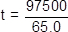
1
t = 1500 (s)
an answer of 1500 (s) scores 3 marks
an answer of 1.5 scores 2 marks
1
(b) 19.6 = I² × 1.60
1
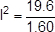
1
I = 3.5 (A)
allow 1 mark for a correct value for I correctly multiplied by 4
1
current through battery = 14 (A)
an answer of 14 (A) scores 4 marks
1
[7]
Q4.
(a) (because the) potential of the live wire is 230 V
1
(and the) potential of the electrician is 0 V
1
(so there is a) large potential difference between live wire and electrician
1
charge / current passes through his body
allow voltage for potential difference
1
(b) diameter between 3.50 and 3.55 (mm)
allow correct use of value of cross-sectional area of 9.5 to 9.9 (mm²) with no final answer given for 1 mark
2
(c) 18000 = I × 300
1
I = 18000 / 300 = 60
1
13 800 = (60²) × R
1
R = 13 800 / 60²
1
3.83 (Ω)
1
allow 3.83(Ω) with no working shown for 5 marks
answer may also be correctly calculated using P = IV and V = IR if 230 V is used.
[11]
Q5.
(a) 1 (cm³)
1
(b) pressure is inversely proportional to volume
1
data to prove inversely proportional relationship
eg 8 × 200 = 1600
and 10 × 160 = 1600
if no other marks score allow for 1 mark: as volume decreases pressure increases
2
(c) (as the gas is compressed) the volume of gas decreases
1
(so there are) more frequent collisions of gas particles with container walls
1
(and) each particle collision with the wall causes a force
1
(so there is a) greater force on walls
1
[8]
Q6.
Level 3 (5–6 marks):
Clear and coherent description of both methods including equation needed to calculate density. Steps are logically ordered and could be followed by someone else to obtain valid results.
Level 2 (3–4 marks):
Clear description of one method to measure density or partial description of both methods. Steps may not be logically ordered.
Level 1 (1–2 marks):
Basic description of measurements needed with no indication of how to use them.
0 marks:
No relevant content.
Indicative content
For both:
• measure mass using a balance
• calculate density using ρ = m / V
Metal cube:
• measure length of cube’s sides using a ruler
• calculate volume
Small statue:
• immerse in water
• measure volume / mass of water displaced
• volume of water displaced = volume of small statue
[6]
Q7.
(a) there are strong forces (of attraction) between the particles in a solid
accept molecules / atoms for particles throughout
accept bonds for forces
1
(holding) the particles close together
particles in a solid are less spread out is insufficient
1
or
(holding) the particles in a fixed pattern / positions
but in a gas the forces between the particles are negligible
accept very small / zero for negligible
accept bonds for forces
1
so the particles spread out (to fill their container)
accept particles are not close together
gas particles are not in a fixed position is insufficient
1
(b) (i) particles are (shown) leaving (the liquid / container)
accept molecules / atoms for particles throughout
accept particles are escaping
particles are getting further apart is insufficient
1
(ii) accept molecules / atoms for particles throughout
accept speed / velocity for energy throughout
particles with most energy leave the (surface of the) liquid
accept fastest particles leave the liquid
1
so the mean / average energy of the remaining particles goes down
1
and the lower the average energy (of the particles) the lower the temperature (of the liquid)
1
[8]
Q8.
any two pairs from:
to gain credit it must be clear which model is being described
do not accept simple descriptions of the diagram without comparison
• nuclear model mass is concentrated at the centre / nucleus (1)
accept the nuclear model has a nucleus / the plum pudding model does not have a nucleus for 1 mark
plum pudding model mass is evenly distributed (1)
• nuclear model positive charge occupies only a small part of the atom (1)
plum pudding model positive charge spread throughout the atom (1)
• nuclear model electrons orbit some distance from the centre (1)
accept electrons in shells / orbits provided a valid comparison is made with the plum pudding model
plum pudding electrons embedded in the (mass) of positive (charge) (1)
do not accept electrons at edge of plum pudding
• nuclear model the atom mainly empty space (1)
plum pudding model is a ‘solid’ mass (1)
[4]
Q9.
(a) the Sun is subject to two balancing forces / 2 forces in equilibrium
the forces are: gravity making it contract or inward force due to gravity
and a force due to temperature / heat / energy / radiation pressure making it
expand or outward force due to temperature / heat / energy / radiation pressure
for 1 mark each
3
(b) Read all the answer first. Stop after 6 marks.
hydrogen / fuel used up owtte the star will expand and become a red giant
it will contract under gravity become a white dwarf
it may explode and become a supernova throwing dust and gas into space
leaving a dense neutron star / black hole
(no mark for contradiction)
any six for 1 mark each
6
[9]

