Oasis Academy South Bank
Year 11 Mock Revision
Biology Separate Paper 1
Name: ___________________________
Class: _________
Teacher: __________________________
Step 1: Knowledge
Learn each of the quiz questions and answers off by heart. This could be done by:
- turning them into flash cards and testing yourself
- using ‘look, cover, write, check’
- asking a friend or family member to quiz you
Topic | LCWC | Quiz 1 | Quiz 2 | Quiz 3
Types of cells (B.1)
Specialised cells (B.2)
Microscopy (B.3)
Cell division (mitosis) (B.4)
Introducing pathogens and types of disease (B.7)
Detailed disease case studies (B.8)
Preventing pathogens from making us unwell (B.9)
Developing new medicines (B.10)
Plant diseases (triple only) (B.12)
Breathing and respiration (B.14)
The Heart (B.15)
The Blood (B.16)
Digestion (B.17)
Transport in cells (diffusion, active transport and osmosis) (B.19)
Structure of a plant (B.21)
Transport in plants (B.23)
Transpiration and translocation (B.24)
Photosynthesis (B.25)
The products of photosynthesis (B.26)
Investigating bacterial cells (triple only) (B.37)
Methods of cloning (triple only) (B.38)
Monoclonal antibodies (triple only) (B.39)
Exercise and metabolism (B.40)

Step 2: Exam practice
- Practice applying your knowledge using the past exam questions in each section.
- Self-assess these using the mark schemes at the back and rewrite your answers.
- Assess your progress using a ‘red, amber, green’ system (RAG)
Section | Completed | SA using green pen | RAG
1: Maths
2. Required Practicals
3. 6 marker questions

Exam practice
Section 1: Maths
Q1.
A student carried out an investigation using chicken eggs.
This is the method used.
1. Place 5 eggs in acid for 24 hours to dissolve the egg shell.
2. Measure and record the mass of each egg.
3. Place each egg into a separate beaker containing 200 cm³ of distilled water.
4. After 20 minutes, remove the eggs from the beakers and dry them gently with a paper towel.
5. Measure and record the mass of each egg.
Table 1 shows the results.
Table 1

Egg | Mass of egg without shell in grams | Mass of egg after 20 minutes in grams
1 | 73.5 | 77.0
2 | 70.3 | 73.9
3 | 72.4 | 75.7
4 | 71.6 | 73.1
5 | 70.5 | 73.8
(a) Another student suggested that the result for egg 4 was anomalous.
Do you agree with the student?
Give a reason for your answer.
___________________________________________________________________
___________________________________________________________________
___________________________________________________________________
(1)
(b) Calculate the percentage change in mass of egg 3.
___________________________________________________________________
___________________________________________________________________
___________________________________________________________________
___________________________________________________________________
Percentage change in mass = ______________________
(2)
(c) Explain why the masses of the eggs increased.
___________________________________________________________________
___________________________________________________________________
___________________________________________________________________
___________________________________________________________________
___________________________________________________________________
___________________________________________________________________
(3)
(d) Explain how the student could modify the investigation to determine the concentration of the solution inside each egg.
___________________________________________________________________
___________________________________________________________________
___________________________________________________________________
___________________________________________________________________
___________________________________________________________________
___________________________________________________________________
___________________________________________________________________
___________________________________________________________________
___________________________________________________________________
(3)

Chicken egg shells contain calcium. Calcium ions are moved from the shell into the cytoplasm of the egg.
Table 2 shows information about the concentration of calcium ions.
Table 2

Location | Concentration of calcium ions in arbitrary units
Egg shell | 0.6
Egg cytoplasm | 2.1
(e) Explain how calcium ions are moved from the shell into the cytoplasm of the egg.
___________________________________________________________________
___________________________________________________________________
___________________________________________________________________
___________________________________________________________________
___________________________________________________________________
___________________________________________________________________
(3)
(Total 12 marks)
Q2.
A student carried out an investigation using leaf epidermis.
This is the method used.
1. Peel the lower epidermis from the underside of a leaf.
2. Cut the epidermis into six equal sized pieces.
3. Place each piece of lower epidermis into a different Petri dish.
4. Add 5 cm³ of salt solution to the six Petri dishes. Each Petri dish should have a different concentration of salt solution.
5. After 1 hour, view each piece of epidermis under a microscope at ×400 magnification.
6. Count and record the total number of stomata present and the number of open stomata that can be seen in one field of view.
The student’s results are shown in the table.

Concentration of salt solution in mol / dm³ | Number of stomata in field of view | Number of open stomata in field of view | Percentage (%) of open stomata in field of view
0.0 | 7 | 7 | 100
0.1 | 8 | 8 | 100
0.2 | 7 | 6 | X
0.3 | 9 | 6 | 67
0.4 | 10 | 4 | 40
0.5 | 9 | 2 | 22
(a) Calculate value X in the table above.
___________________________________________________________________
___________________________________________________________________
X = ____________________ %
(1)
(b) Give one conclusion from the results in the table above.
___________________________________________________________________
___________________________________________________________________
(1)
(c) How could the student find out what concentration of salt solution would result in half of the stomata being open?
___________________________________________________________________
___________________________________________________________________
(1)
(d) The student measured the real diameter of the field of view to be 0.375 mm.
Calculate the number of open stomata per mm² of leaf for the epidermis placed in 0.4 mol / dm³ salt solution.
Use information from the table above.
Take π to be 3.14
___________________________________________________________________
___________________________________________________________________
___________________________________________________________________
___________________________________________________________________
___________________________________________________________________
___________________________________________________________________
Number of open stomata = ____________________ per mm²
(3)
(e) The diagram below shows two guard cells surrounding a closed stoma and two guard cells surrounding an open stoma.
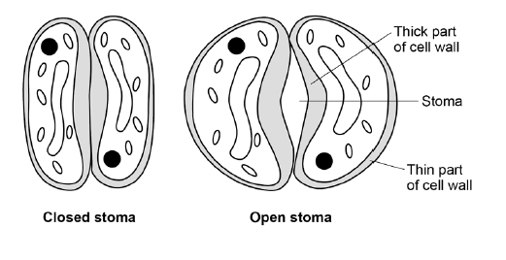
When light intensity is high potassium ions are moved into the guard cells.
Describe how the movement of potassium ions into the guard cells causes the stoma to open.
___________________________________________________________________
___________________________________________________________________
___________________________________________________________________
___________________________________________________________________
___________________________________________________________________
___________________________________________________________________
___________________________________________________________________
___________________________________________________________________
(4)
(Total 10 marks)
Q3.
The heart pumps blood to the lungs and to the cells of the body.
(a) Name the blood vessel that transports blood from the body to the right atrium.
___________________________________________________________________
(1)
(b) The aorta transports blood from the heart to the body.
In a person at rest:
• blood travels at a mean speed of 10 cm/s in the aorta
• blood travels at a mean speed of 0.5 mm/s in the capillaries
• the speed of blood decreases at a rate of 0.4 cm/s² as blood travels from the aorta to the capillaries.
Calculate the time it takes for blood to travel from the aorta to the capillaries.
Assume that the speed of blood decreases at a constant rate.
Use the equation:
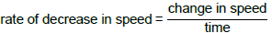
Give your answer to 2 significant figures.
___________________________________________________________________
___________________________________________________________________
___________________________________________________________________
___________________________________________________________________
___________________________________________________________________
___________________________________________________________________
___________________________________________________________________
Time = ____________________ s
(4)
(c) Describe the route taken by oxygenated blood from the lungs to the body cells.
___________________________________________________________________
___________________________________________________________________
___________________________________________________________________
___________________________________________________________________
___________________________________________________________________
___________________________________________________________________
___________________________________________________________________
___________________________________________________________________
(4)
(d) The digestive system and the breathing system both contain specialised exchange surfaces.
• In the digestive system, digested food is absorbed into the blood stream in structures called villi.
• In the breathing system, gases are absorbed into the blood stream in the alveoli.
The diagram below shows the structure of villi and alveoli.
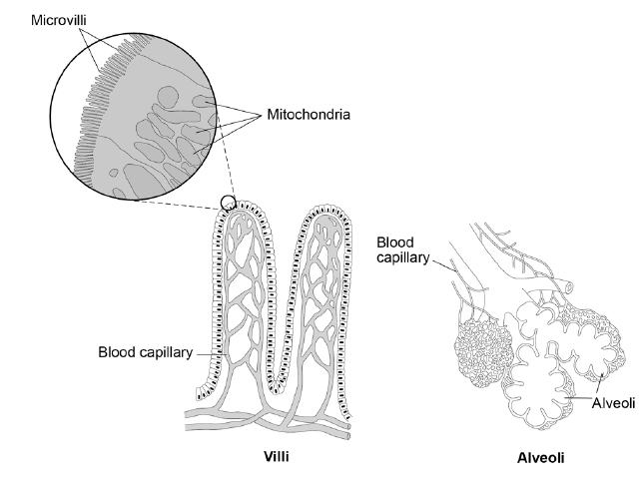
Explain how the villi and the alveoli are adapted to absorb molecules into the bloodstream.
(6)

___________________________________________________________________
___________________________________________________________________
___________________________________________________________________
___________________________________________________________________
___________________________________________________________________
___________________________________________________________________
___________________________________________________________________
___________________________________________________________________

Q4.
A student investigated the effect of different sugar solutions on potato tissue.
This is the method used.
1. Add 30 cm³ of 0.8 mol dm⁻³ sugar solution to a boiling tube.
2. Repeat step 1 with equal volumes of 0.6, 0.4 and 0.2 mol dm⁻³ sugar solutions.
3. Use water to give a concentration of 0.0 mol dm⁻³.
4. Cut five cylinders of potato of equal size using a cork borer.
5. Weigh each potato cylinder and place one in each tube.
6. Remove the potato cylinders from the solutions after 24 hours.
7. Dry each potato cylinder with a paper towel.
8. Reweigh the potato cylinders.
The table below shows the results.

Concentration of sugar solution in mol dm⁻³ | Starting  mass in g | Final mass  in g | Change of  mass in g | Percentage  (%) change
0.0 | 1.30 | 1.51 | 0.21 | 16.2
0.2 | 1.35 | 1.50 | 0.15 | X
0.4 | 1.30 | 1.35 | 0.05 | 3.8
0.6 | 1.34 | 1.28 | −0.06 | −4.5
0.8 | 1.22 | 1.11 | −0.11 | −9.0
(a) Calculate the value of X in the table above.
___________________________________________________________________
___________________________________________________________________
Percentage change in mass = _____________________ %
(2)
(b) Why did the student calculate the percentage change in mass as well as the change in grams?
___________________________________________________________________
___________________________________________________________________
(1)
(c) Complete the graph using data from the table above.
• Choose a suitable scale and label for the x-axis.
• Plot the percentage (%) change in mass.
• Draw a line of best fit.
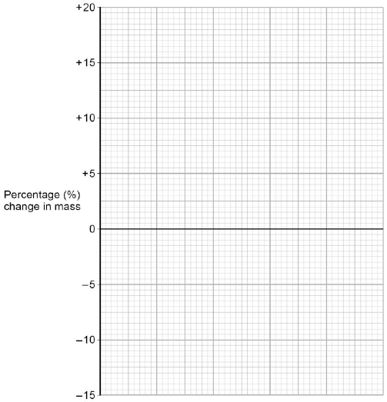
(4)
(d) Use your graph to estimate the concentration of the solution inside the potato cells.
Concentration = ________________________ mol dm⁻³
(1)
(e) The results in the table above show the percentage change in mass of the potato cylinders.
Explain why the percentage change results are positive and negative.
___________________________________________________________________
___________________________________________________________________
___________________________________________________________________
___________________________________________________________________
___________________________________________________________________
___________________________________________________________________
___________________________________________________________________
___________________________________________________________________
(3)
(f) Suggest two possible sources of error in the method given above.
1. _________________________________________________________________
___________________________________________________________________
2. _________________________________________________________________
___________________________________________________________________
(2)
(Total 13 marks)

Q5.
Figure 1 shows photographs of some animal cells at different stages during the cell cycle.
Figure 1
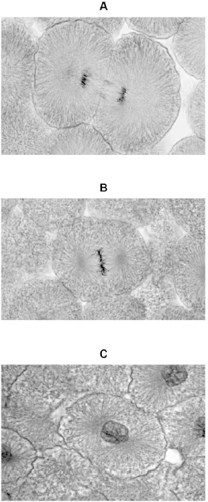
A © Ed Reschke/Photolibrary/Getty Images
B © Ed Reschke/Oxford Scientific/Getty Images
C © Ed Reschke/Photolibrary/Getty Images
(a) Which photograph in Figure 1 shows a cell that is not going through mitosis?
Tick one box.

 | A |  |  | B |  |  | C
(1)
(b) Describe what is happening in photograph A.
___________________________________________________________________
___________________________________________________________________
___________________________________________________________________
___________________________________________________________________
___________________________________________________________________
(2)
(c) A student wanted to find out more about the cell cycle.
The student made a slide of an onion root tip.
She counted the number of cells in each stage of the cell cycle in one field of view.
The table below shows the results.

 |  |  | Stages in the cell cycle
 |  | Non-dividing cells | Stage 1 | Stage 2 | Stage 3 | Stage 4 | Total
 | Number of cells | 20 | 9 | 4 | 2 | 1 | 36
Each stage of the cell cycle takes a different amount of time.
Which stage is the fastest in the cell cycle?
Give a reason for your answer.
Stage _____________________
Reason ____________________________________________________________
___________________________________________________________________
(2)

(d) The cell cycle in an onion root tip cell takes 16 hours.
Calculate the length of time Stage 2 lasts in a typical cell.
Give your answer to 2 significant figures.
___________________________________________________________________
___________________________________________________________________
___________________________________________________________________
___________________________________________________________________
Time in Stage 2 = ________________________ minutes
(3)
(e) Bacteria such as Escherichia coli undergo cell division similar to mitosis.
Figure 2 shows a growth curve for E. coli grown in a nutrient broth.
Figure 2
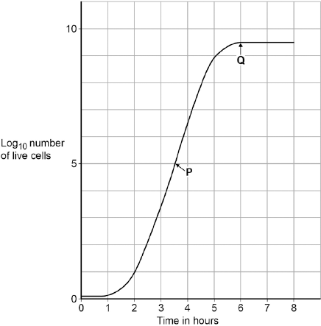
What type of cell division causes the change in number of E. coli cells at P?
___________________________________________________________________
(1)
(f) Suggest why the number of cells levels out at Q.
___________________________________________________________________
___________________________________________________________________
___________________________________________________________________
___________________________________________________________________
___________________________________________________________________
___________________________________________________________________
(2)
(Total 11 marks)
Q6.
Plants exchange substances with the environment.
(a) Plant roots absorb water mainly by osmosis.
Plant roots absorb ions mainly by active transport.
Explain why roots need to use the two different methods to absorb water and ions.
___________________________________________________________________
___________________________________________________________________
___________________________________________________________________
___________________________________________________________________
___________________________________________________________________
___________________________________________________________________
___________________________________________________________________
___________________________________________________________________
(4)
(b) What is meant by the transpiration stream?
___________________________________________________________________
___________________________________________________________________
___________________________________________________________________
___________________________________________________________________
___________________________________________________________________
___________________________________________________________________
(3)
(c) Students investigated the loss of water vapour from leaves.
The students:
• cut some leaves off a plant
• measured the mass of these leaves every 30 minutes for 180 minutes.
The graph shows the students’ results.
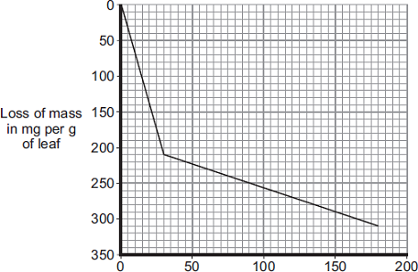
(i) The rate of mass loss in the first 30 minutes was 7 milligrams per gram of leaf per minute.
Calculate the rate of mass loss between 30 minutes and 180 minutes.
______________________________________________________________
______________________________________________________________
Rate of mass loss = _______________ milligrams per gram of leaf per minute
(2)
(ii) The rate of mass loss between 0 and 30 minutes was very different from the rate of mass loss between 30 and 180 minutes.
Suggest an explanation for the difference between the two rates.
______________________________________________________________
______________________________________________________________
______________________________________________________________
______________________________________________________________
(2)
(Total 11 marks)
Q7.
Table 1 shows information about some food components in cow’s milk.

 | Value per 500 cm³ | Recommended Daily Allowance (RDA) for a typical adult
Energy in kJ | 1046 | 8700
Fat in g | 8.4 | 70.0
Salt in g | 0.5 | 6.0
Calcium in mg | 605 | 1000
Vitamin B-12 in µg | 4.5 | 2.4

(a) How much more milk would a typical adult have to drink to get their RDA for calcium compared with the amount of milk needed to get their RDA for vitamin B-12?
___________________________________________________________________
___________________________________________________________________
___________________________________________________________________
___________________________________________________________________
___________________________________________________________________
___________________________________________________________________
Volume of milk = ______________________ cm³
(3)
(b) Describe how a student could test cow’s milk to show whether it contains protein and different types of carbohydrate.
___________________________________________________________________
___________________________________________________________________
___________________________________________________________________
___________________________________________________________________
___________________________________________________________________
___________________________________________________________________
___________________________________________________________________
___________________________________________________________________
___________________________________________________________________
___________________________________________________________________
___________________________________________________________________
___________________________________________________________________
___________________________________________________________________
___________________________________________________________________
___________________________________________________________________
___________________________________________________________________
___________________________________________________________________
___________________________________________________________________
(6)
A scientist investigated the effect of bile on the breakdown of fat in a sample of milk.
The scientist used an indicator that is colourless in solutions with a pH lower than 10, and pink in solutions with a pH above 10.
This is the method used.
1. Add 1 drop of bile to a test tube and one drop of water to a second test tube.
2. Add the following to each test tube:
• 5 cm³ of milk
• 7 cm³ of sodium carbonate solution (to make the solution above pH 10)
• 5 drops of the indicator
• 1 cm³ of lipase.
3. Time how long it takes for the indicator in the solutions to become colourless.
The results are shown in Table 2.
Table 2

 | Time taken for the indicator to become colourless in seconds
Solution with bile | 65
Solution without bile | 143
(c) Explain why the indicator in both tubes became colourless.
___________________________________________________________________
___________________________________________________________________
___________________________________________________________________
___________________________________________________________________
___________________________________________________________________
___________________________________________________________________
(3)

(d) Give the reason why the measurement of the time taken for the indicator to become colourless might be inaccurate.
___________________________________________________________________
___________________________________________________________________
(1)
(e) Explain the difference in the results for the two test tubes in Table 2.
___________________________________________________________________
___________________________________________________________________
___________________________________________________________________
___________________________________________________________________
___________________________________________________________________
___________________________________________________________________
(3)
(Total 16 marks)
Q8.
During exercise, the heart beats faster and with greater force.
The ‘heart rate’ is the number of times the heart beats each minute.The volume of blood that travels out of the heart each time the heart beats is called the ‘stroke volume’.
In an investigation, Person 1 and Person 2 ran as fast as they could for 1 minute. Scientists measured the heart rates and stroke volumes of Person 1 and Person 2 at rest, during the exercise and after the exercise.
The graph below shows the scientists’ results.
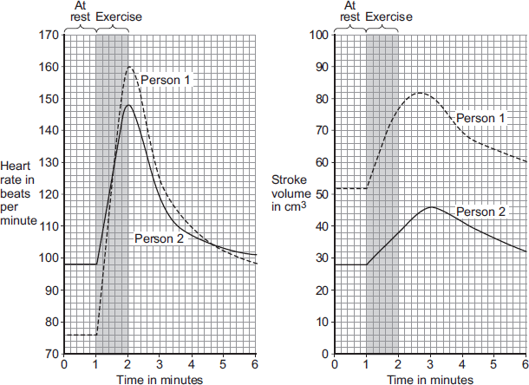
(a) The ‘cardiac output’ is the volume of blood sent from the heart to the muscles each minute.
Cardiac output = Heart rate × Stroke volume
At the end of the exercise, Person 1’s cardiac output = 160 × 77 = 12 320 cm³ per minute.
Use information from the figure above to complete the following calculation of Person 2’s cardiac output at the end of the exercise.
At the end of the exercise:
Person 2’s heart rate = _______________ beats per minute
Person 2’s stroke volume = _______________ cm³
Person 2’s cardiac output = _______________ cm³ per minute
(3)
(b) Person 2 had a much lower cardiac output than Person 1.
(i) Use information from the figure above to suggest the main reason for the lower cardiac output of Person 2.
______________________________________________________________
______________________________________________________________
(1)
(ii) Person 1 was able to run much faster than Person 2.
Use information from the figure above and your own knowledge to explain why.
______________________________________________________________
______________________________________________________________
______________________________________________________________
______________________________________________________________
______________________________________________________________
______________________________________________________________
______________________________________________________________
______________________________________________________________
______________________________________________________________
______________________________________________________________
(5)
(Total 9 marks)
Q9.
The leaves of most plants have stomata.
(a) (i) Name the cells which control the size of the stomata.
______________________________________________________________
(1)
(ii) Give one function of stomata.
______________________________________________________________
______________________________________________________________
(1)
(b) The image below shows part of the surface of a leaf.
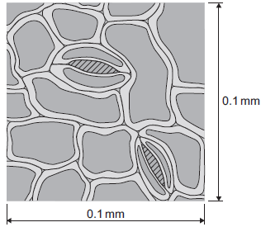
The length and width of this piece of leaf surface are both 0.1 mm.
(i) Calculate the number of stomata per mm² of this leaf surface.
______________________________________________________________
______________________________________________________________
_______________________ per mm²
(2)
(ii) A different plant species has 400 stomata per mm² of leaf surface.
Having a large number of stomata per mm² of leaf surface can be a disadvantage to a plant.
Give one disadvantage.
______________________________________________________________
______________________________________________________________
(1)
(c) A student investigated the loss of water from plant leaves.
The student did the following:
• Step 1: took ten leaves from a plant
• Step 2: weighed all ten leaves
• Step 3: hung the leaves up in a classroom for 4 days
• Step 4: weighed all ten leaves again
• Step 5: calculated the mass of water lost by the leaves
• Step 6: repeated steps 1 to 5 with grease spread on the upper surfaces of the leaves
• Step 7: repeated steps 1 to 5 with grease spread on both the upper and lower surfaces of the leaves.
All the leaves were taken from the same type of plant.
The table below shows the student’s results.

Treatment of leaves | Mass of water the leaves lost in g
No grease was used on the leaves | 0.98
Grease on upper surfaces of the leaves | 0.86
Grease on upper and lower surfaces of the leaves | 0.01
(i) What mass of water was lost in 4 days through the upper surfaces of the leaves?
______________________________________________________________
______________________________________________________________
Mass = ___________ g
(1)
(ii) Very little water was lost when the lower surfaces of the leaves were covered in grease.
Explain why.
______________________________________________________________
______________________________________________________________
______________________________________________________________
______________________________________________________________
______________________________________________________________
______________________________________________________________
______________________________________________________________
(3)
(Total 9 marks)
Q10.
The concentration of cholesterol in the blood affects people’s health.
(a) Give two factors that affect the concentration of cholesterol in the blood.
1. _________________________________________________________________
2. _________________________________________________________________
(2)
(b) Doctors screened men for blood cholesterol concentration.
The doctors then compared death rates from heart disease with deaths from all causes in this screened group.
The graph shows the results.
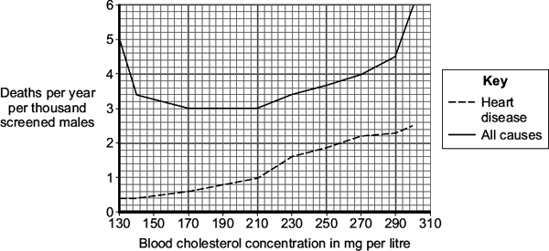
(i) Which is the best conclusion that can be drawn from the data?
Tick () one box.

There is a positive correlation between blood cholesterol concentration and deaths from all causes.
There is a negative correlation between blood cholesterol concentration and deaths from all causes.
Blood cholesterol concentration is only one of several factors affecting death from all causes.
(1)
(ii) Based on the data in the graph only, which is the ideal range for blood cholesterol concentration?
Range _________________ to _________________ mg cholesterol per litre.
(1)
(Total 4 marks)
Q11.
The diagram shows the apparatus used to investigate the digestion of milk fat by an enzyme. The reaction mixture contained milk, sodium carbonate solution (an alkali) and the enzyme. In Experiment 1, bile was also added. In Experiment 2, an equal volume of water replaced the bile. In each experiment, the pH was recorded at 2-minute intervals.
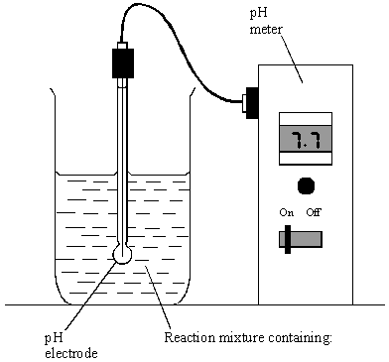

Either: | Experiment 1 | or: | Experiment 2
 | milk (contains fat)  sodium carbonate solution  bile  enzyme |  | milk (contains fat)  sodium carbonate solution  water  enzyme
The results of the two experiments are given in the table.
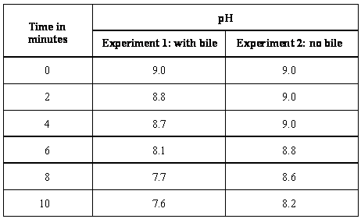
(a) Milk fat is a type of lipid. Give the name of an enzyme which catalyses the breakdown of lipids.
______________________________________________________________
(1)
(b) What was produced in each experiment to cause the fall in pH?
______________________________________________________________
(1)
(c) (i) For Experiment 1, calculate the average rate of fall in pH per minute, between
4 minutes and 8 minutes. Show clearly how you work out your final answer.
______________________________________________________________
______________________________________________________________
______________________________________________________________
______________________ pH units per minute
(2)
(ii) Why was the fall in pH faster when bile was present?
______________________________________________________________
______________________________________________________________
(1)
(Total 5 marks)
Q12.
A virus called RSV causes severe respiratory disease.
(a) Suggest two precautions that a person with RSV could take to reduce the spread of the virus to other people.
1. _________________________________________________________________
___________________________________________________________________
2. _________________________________________________________________
___________________________________________________________________
(2)
(b) One treatment for RSV uses monoclonal antibodies which can be injected into the patient.
Scientists can produce monoclonal antibodies using mice.
The first step is to inject the virus into a mouse.
Describe the remaining steps in the procedure to produce monoclonal antibodies.
___________________________________________________________________
___________________________________________________________________
___________________________________________________________________
___________________________________________________________________
___________________________________________________________________
___________________________________________________________________
___________________________________________________________________
___________________________________________________________________
(3)
(c) Describe how injecting a monoclonal antibody for RSV helps to treat a patient suffering with the disease.
___________________________________________________________________
___________________________________________________________________
___________________________________________________________________
___________________________________________________________________
(2)
A trial was carried out to assess the effectiveness of using monoclonal antibodies to treat patients with RSV.
Some patients were given a placebo.
(d) Why were some patients given a placebo?
___________________________________________________________________
___________________________________________________________________
(1)
A number of patients had to be admitted to hospital as they became so ill with RSV.
The results are shown in the table below.

Treatment received by patient | % of patients within each group admitted to hospital with RSV
Group A: Monoclonal antibody for RSV | 4.8
Group B: Placebo | 10.4
The trial involved 1 500 patients.
• Half of the patients (group A) were given the monoclonal antibodies.
• Half of the patients (group B) were given the placebo.
(e) Calculate the total number of patients admitted to hospital with RSV during the trial.
___________________________________________________________________
___________________________________________________________________
___________________________________________________________________
___________________________________________________________________
Total number of patients admitted to hospital = ____________________
(2)
(f) Evaluate how well the data in the table above supports the conclusion:
‘monoclonal antibodies are more effective at treating RSV than a placebo’.
___________________________________________________________________
___________________________________________________________________
___________________________________________________________________
___________________________________________________________________
(2)
(Total 12 marks)
Q13.
Many strains of bacteria have developed resistance to antibiotics.
The table shows the number of people infected with a resistant strain of one species of bacterium in the UK.

Year | 2004 | 2005 | 2006 | 2007 | 2008
Number of people infected  with the resistant strain | 3499 | 3553 | 3767 | 3809 | 4131

(a) Calculate the percentage increase in the number of people infected with the resistant strain between 2004 and 2008.
Show clearly how you work out your answer.
___________________________________________________________________
___________________________________________________________________
Percentage increase = _________________________
(2)
(b) Explain, in terms of natural selection, why the number of people infected with the resistant strain of the bacterium is increasing.
___________________________________________________________________
___________________________________________________________________
___________________________________________________________________
___________________________________________________________________
___________________________________________________________________
___________________________________________________________________
___________________________________________________________________
(3)
(Total 5 marks)
Q14.
The graph shows the uptake of carbon dioxide and the release of carbon dioxide by a bean plant on a hot summer’s day.
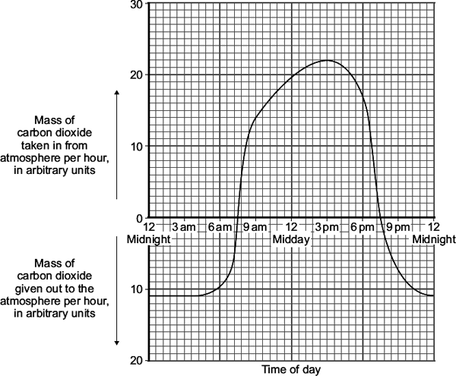
(a) At which two times in the day did the rate of photosynthesis exactly match the rate of respiration in the bean plant?
1. ______________________________ 2. ______________________________
(1)
(b) The bean plant respires at the same rate all through the 24 hour period.
(i) How much carbon dioxide is released each hour during respiration?
____________________________ arbitrary units
(1)
(ii) How much carbon dioxide is used by photosynthesis in the hour beginning at 3 pm?
______________________________________________________________
______________________________________________________________
Answer = ____________________________ arbitrary units
(1)
(c) Over the 24 hour period, the total amount of carbon dioxide taken in by the bean plant was greater than the total amount of carbon dioxide given out by the bean plant.
Explain, in detail, why this was important for the bean plant.
___________________________________________________________________
___________________________________________________________________
___________________________________________________________________
___________________________________________________________________
___________________________________________________________________
___________________________________________________________________
(2)
(Total 5 marks)
Q15.
(a) The concentration of sulfate ions was measured in the roots of barley plants and in the water in the surrounding soil.
The table shows the results.

 | Concentration of sulfate ions in mmol per dm³
Roots of barley plants | 1.4
Soil | 0.15
Is it possible for the barley roots to take up sulfate ions from the soil by diffusion?
Draw a ring around your answer. Yes / No
Explain your answer.
___________________________________________________________________
___________________________________________________________________
___________________________________________________________________
___________________________________________________________________
(2)
(b) Some scientists investigated the amounts of sulfate ions taken up by barley roots in the presence of oxygen and when no oxygen was present.
The graph below shows the results.
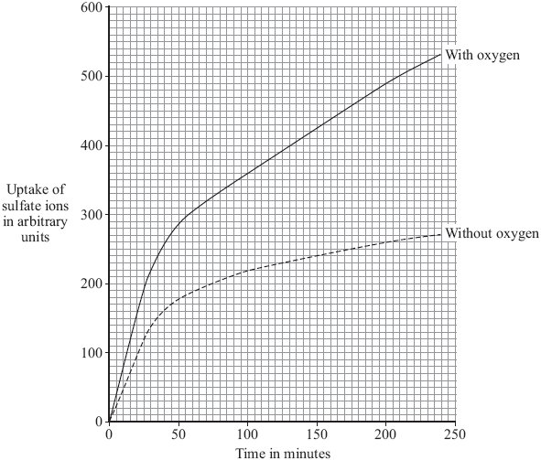
(i) The graph shows that the rate of sulfate ion uptake between 100 and 200 minutes, without oxygen, was 0.4 arbitrary units per minute.
The rate of sulfate ion uptake between 100 and 200 minutes, with oxygen, was greater.
How much greater was it? Show clearly how you work out your answer.
______________________________________________________________
______________________________________________________________
______________________________________________________________
Answer __________ arbitrary units
(2)
(ii) The barley roots were able to take up more sulfate ions with oxygen than without oxygen.
Explain how.
______________________________________________________________
______________________________________________________________
______________________________________________________________
______________________________________________________________
______________________________________________________________
______________________________________________________________
(3)
(Total 7 marks)

Section 2: Required Practicals
Q1.
Amylase is an enzyme found in the human body.
Amylase breaks down starch into sugars.
(a) Where is amylase produced in the human body?
Tick one box.

Liver and pancreas
Liver and stomach
Salivary glands and pancreas
Salivary glands and stomach
(1)
(b) Enzymes speed up chemical reactions.
Explain how amylase breaks down starch.
___________________________________________________________________
___________________________________________________________________
___________________________________________________________________
___________________________________________________________________
___________________________________________________________________
___________________________________________________________________
(3)
(c) One sugar in the body is glucose.
Glucose is used for respiration.
Give one other use for glucose in the body.
___________________________________________________________________
(1)
(d) A student investigated the effect of temperature on the activity of human amylase.
This is the method used.
1. Put 2 cm³ of 1% starch solution into a boiling tube.
2. Put 2 cm³ of amylase solution into a second boiling tube.
3. Put both boiling tubes into a water bath at 20 °C.
4. After 5 minutes, mix the amylase and the starch together in one boiling tube.
5. After 30 seconds, add a drop of the starch and amylase mixture to a drop of iodine solution in one well of a spotting tile.
6. Repeat step 5 until the iodine solution no longer changes colour.
7. Repeat steps 1 – 6 at 40 °C and at 60 °C and at 80 °C
Why did the student leave the starch and amylase solutions in the water bath for 5 minutes in step 3?
___________________________________________________________________
___________________________________________________________________
(1)
(e) The temperature of the human body is 37 °C
The diagram below shows the results of the investigation at 20 °C and at 80 °C
Complete the diagram to show the results you would expect at 40 °C and at 60 °C
You should write a tick or a cross in each well of the spotting tile.
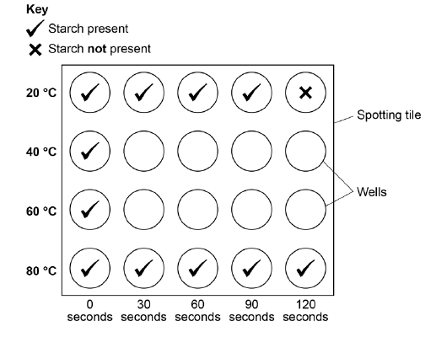
(2)
(f) There are different ways to investigate the breakdown of starch by amylase.
One other method is to measure the concentration of starch present in the solution every 30 seconds.
Why is this method better than the method the student used?
___________________________________________________________________
___________________________________________________________________
___________________________________________________________________
___________________________________________________________________
(2)
A colorimeter can be used to measure the concentration of starch present in the solution every 30 seconds.
A colorimeter measures the amount of light that cannot pass through a solution.
This is known as absorbance.
Below shows a graph of absorbance against concentration of starch.
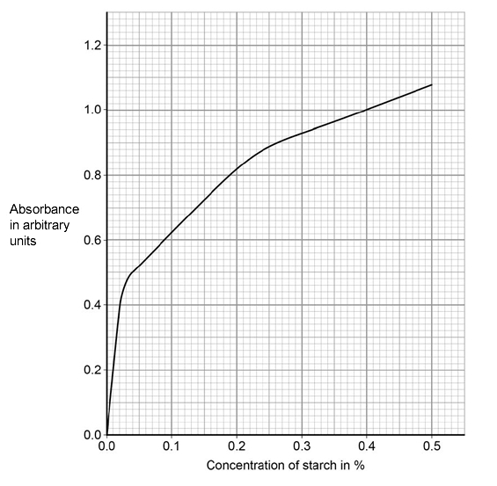
(g) The absorbance of the solution at 40 °C was 0.56 arbitrary units after 30 seconds.
What was the concentration of starch in this solution?
___________________________________________________________________
Concentration of starch = ____________________ %
(1)
(h) The concentration of starch in the solution at 20 °C after 1 minute is different from the concentration at 40 °C after 1 minute.
Explain why.
___________________________________________________________________
___________________________________________________________________
___________________________________________________________________
___________________________________________________________________
(2)
(i) Predict the absorbance for the solution at 80 °C after 30 seconds.
Give a reason for your answer.
Absorbance = ______________________ arbitrary units
Reason ____________________________________________________________
___________________________________________________________________
___________________________________________________________________
___________________________________________________________________
(3)
(Total 16 marks)
Q2.
All living cells respire.
(a) Respiration transfers energy from glucose for muscle contraction.
Describe how glucose from the small intestine is moved to a muscle cell.
___________________________________________________________________
___________________________________________________________________
___________________________________________________________________
___________________________________________________________________
(2)
(b) The diagram below shows an experiment to investigate anaerobic respiration in yeast cells.
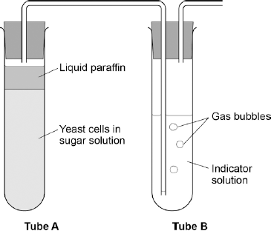
What is the purpose of the liquid paraffin in Tube A?

Tick one box.
To prevent evaporation
To stop air getting in
To stop the temperature going up
To stop water getting in
(1)
(c) The indicator solution in Tube B shows changes in the concentration of carbon dioxide (CO₂).
The indicator is:
• blue when the concentration of CO₂ is very low
• green when the concentration of CO₂ is low
• yellow when the concentration of CO₂ is high.
What colour would you expect the indicator to be in Tube B during maximum rate of anaerobic respiration?

Tick one box.
Blue
Green
Yellow
(1)
(d) Suggest how the experiment could be changed to give a reproducible way to measure the rate of the reaction.
Include any apparatus you would use.
___________________________________________________________________
___________________________________________________________________
___________________________________________________________________
___________________________________________________________________
(2)
(e) Compare anaerobic respiration in a yeast cell with anaerobic respiration in a muscle cell.
___________________________________________________________________
___________________________________________________________________
___________________________________________________________________
___________________________________________________________________
___________________________________________________________________
___________________________________________________________________
___________________________________________________________________
___________________________________________________________________
(3)
(Total 9 marks)

Q3.
Rose black spot is a disease of roses.
(a) What type of microorganism causes rose black spot?
Tick one box.

A bacterium
A fungus
A protist
A virus
(1)
(b) Explain how different types of organism defend themselves against microorganisms.
___________________________________________________________________
___________________________________________________________________
___________________________________________________________________
___________________________________________________________________
___________________________________________________________________
___________________________________________________________________
___________________________________________________________________
___________________________________________________________________
(6)
(c) A student tried to grow some bacteria in the laboratory.
The diagram shows some of the apparatus used.
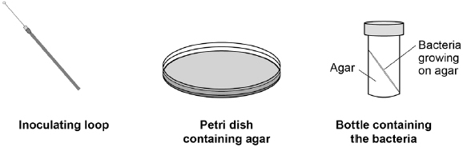
This is the method used.
1. Remove the lid of the Petri dish.
2. Remove the lid of the bottle containing the bacteria.
3. Use the inoculating loop to remove some of the bacteria from the bottle.
4. Spread the bacteria over the agar using the inoculating loop.
5. Put the lid back on the Petri dish.
6. Put the Petri dish into an incubator at 25 °C for 24 hours.
Steps 1−5 could cause the sample of the bacteria on the petri dish to be contaminated.
Give three improvements to the method to prevent contamination.
1. _________________________________________________________________
___________________________________________________________________
2. _________________________________________________________________
___________________________________________________________________
3. _________________________________________________________________
___________________________________________________________________
(3)
(d) Why did the student grow the bacteria at 25 °C rather than at 40 °C?
Tick one box.

So the bacteria grew more quickly
So the bacteria grew more slowly
To prevent the growth of a harmful pathogen
To save money
(1)
Q4.
Plants transport water and mineral ions from the roots to the leaves.
(a) Plants move mineral ions:
• from a low concentration in the soil
• to a high concentration in the root cells.
What process do plants use to move these minerals ions into root cells?

Tick one box.
Active transport
Diffusion
Evaporation
Osmosis
(1)
(b) Describe how water moves from roots to the leaves.
___________________________________________________________________
___________________________________________________________________
___________________________________________________________________
___________________________________________________________________
(2)
(c) Plants lose water through the stomata in the leaves.
The epidermis can be peeled from a leaf.
The stomata can be seen using a light microscope.
The table below shows the data a student collected from five areas on one leaf.

Leaf  area | Number of stomata
 | Upper surface | Lower surface
1 | 3 | 44
2 | 0 | 41
3 | 1 | 40
4 | 5 | 42
5 | 1 | 39
Mean | 2 | X
Describe how the student might have collected the data.
___________________________________________________________________
___________________________________________________________________
___________________________________________________________________
___________________________________________________________________
___________________________________________________________________
___________________________________________________________________
___________________________________________________________________
___________________________________________________________________
(3)
(d) What is the median number of stomata on the upper surface of the leaf?
___________________________________________________________________
(1)
(e) Calculate the value of X in the table.
Give your answer to 2 significant figures.
___________________________________________________________________
___________________________________________________________________
Mean number of stomata on lower surface of leaf = _____
(2)
(f) The plant used in this investigation has very few stomata on the upper surface of the leaf.
Explain why this is an advantage to the plant.
___________________________________________________________________
___________________________________________________________________
___________________________________________________________________
___________________________________________________________________
(2)
(Total 11 marks)
Q5.
Catalase is an enzyme found in many different tissues in plants and animals. It speeds up the rate of the following reaction.
hydrogen peroxide water + oxygen
Figure 1 shows a 25-day-old broad bean seedling.
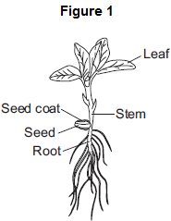
Some students investigated whether different parts of bean seedlings contained different amounts of catalase.
The students:
• put hydrogen peroxide into five test tubes
• added a different part of a bean seedling to each tube
• recorded the results after half a minute.
If there was catalase in part of the seedling, oxygen gas was given off.
When oxygen gas is given off, foam is produced in the tubes.
Figure 2 shows the results.
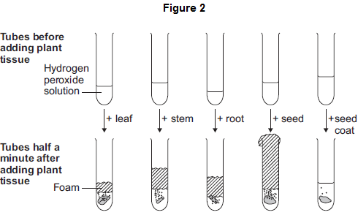
The students made the following conclusions:
• most parts of a bean seedling contain catalase
• the seed contains a lot of catalase
• stems and roots have quite a lot of catalase
• the leaves have a little bit of catalase
• the seed coat has hardly any catalase.
The students’ teacher said that the students needed to improve their investigation in order to make valid conclusions.
(a) In this question you will be assessed on using good English, organising information clearly and using specialist terms where appropriate.
Describe how you would carry out an investigation to compare the amounts of catalase in different parts of bean seedlings.
You should include details of how you would make sure your results give a valid comparison of the amounts of catalase.
___________________________________________________________________
___________________________________________________________________
___________________________________________________________________
___________________________________________________________________
___________________________________________________________________
___________________________________________________________________
___________________________________________________________________
___________________________________________________________________
___________________________________________________________________
___________________________________________________________________
(6)
(b) Scientists investigated the effect of pH on the activity of the enzyme catalase in a fungus.
The table below shows the scientists’ results.

pH | Enzyme activity in arbitrary units
 | Test 1 | Test 2 | Test 3 | Test 4 | Test 5 | Mean
3.0 | 0 | 0 | 0 | 0 | 0 | 0
4.0 | 6 | 5 | 8 | 4 | 7 | 6
5.0 | 38 | 65 | 41 | 42 | 39
5.5 | 80 | 86 | 82 | 84 | 88 | 84
6.0 | 100 | 99 | 96 | 103 | 102 | 100
6.5 | 94 | 92 | 90 | 93 | 91 | 92
7.0 | 61 | 63 | 61 | 62 | 63 | 62
8.0 | 22 | 22 | 21 | 24 | 21 | 22
(i) Calculate the mean enzyme activity at pH 5.0.
______________________________________________________________
______________________________________________________________
Mean = _____________ arbitrary units
(2)
(ii) On the graph paper in Figure 3, draw a graph to show the scientists’ results.
Remember to:
• add a label to the vertical axis
• plot the mean values of enzyme activity
• draw a line of best fit.
Figure 3
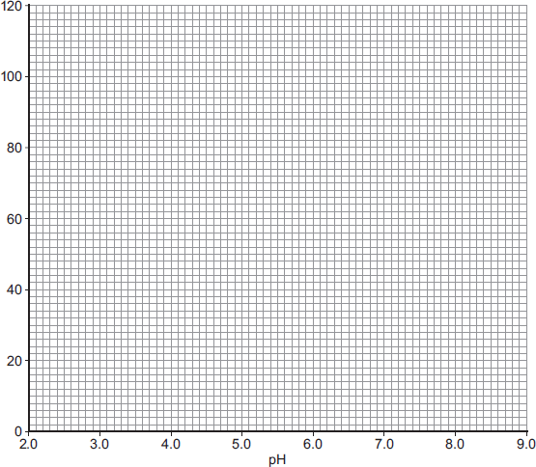
(4)
(iii) At what pH does the enzyme work best?
____________________
(1)
(iv) Predict the activity of the enzyme at pH 9.0.
____________________ arbitrary units
(1)
(v) Suggest why the enzyme’s activity at pH 3.0 is zero.
______________________________________________________________
______________________________________________________________
(1)
(Total 15 marks)
Q6.
Glucose is broken down in respiration.
(a) What is the chemical formula for glucose?
Tick one box.

C₆H₆O₆
C₃H₆O₃
C₆H₁₂O₆
C₆H₁₀O₆
(1)

The diagram shows the apparatus a student used to investigate aerobic respiration.
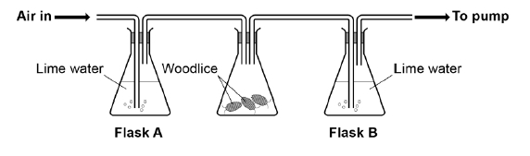
Limewater goes cloudy when carbon dioxide is added to it.
(b) After 10 minutes the limewater in flask B was cloudy, but the limewater in flask A remained colourless.
Explain why.
___________________________________________________________________
___________________________________________________________________
___________________________________________________________________
___________________________________________________________________
(2)
(c) Flask A acts as a control in this investigation.
What is the purpose of a control?
___________________________________________________________________
___________________________________________________________________
(1)
(d) The student repeated the investigation with no woodlice.
Describe the appearance of the limewater in flask A and flask B after 10 minutes.
Flask A ____________________________________________________________
___________________________________________________________________
Flask B ____________________________________________________________
___________________________________________________________________
(2)
Anaerobic respiration is another form of respiration in living organisms.
(e) What is produced during anaerobic respiration in humans?
Tick one box.

Carbon dioxide
Carbon dioxide and lactic acid
Lactic acid
Oxygen and water
(1)
(f) Complete the equation for anaerobic respiration in yeast.
glucose ⟶ carbon dioxide + ________________________
(1)
(Total 8 marks)

Q7.
In this question you will be assessed on using good English, organising information clearly and using specialist terms where appropriate.
Light intensity, carbon dioxide concentration and temperature are three factors that affect the rate of photosynthesis.
How would you investigate the effect of light intensity on the rate of photosynthesis?
The image below shows some of the apparatus you might use.
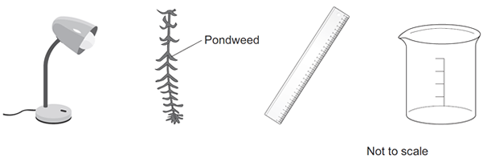
You should include details of:
• how you would set up the apparatus and the materials you would use
• the measurements you would make
• how you could make this a fair test.
_______________________________________________________________________
_______________________________________________________________________
_______________________________________________________________________
_______________________________________________________________________
_______________________________________________________________________
_______________________________________________________________________
_______________________________________________________________________
_______________________________________________________________________
_______________________________________________________________________
_______________________________________________________________________
_______________________________________________________________________
_______________________________________________________________________
_______________________________________________________________________
_______________________________________________________________________
_______________________________________________________________________
_______________________________________________________________________
_______________________________________________________________________
_______________________________________________________________________
(Total 6 marks)

Section 3: 6 Mark Questions
Q1.
The heart pumps blood to the lungs and to the cells of the body.
(a) Name the blood vessel that transports blood from the body to the right atrium.
___________________________________________________________________
(1)
(b) The aorta transports blood from the heart to the body.
In a person at rest:
• blood travels at a mean speed of 10 cm/s in the aorta
• blood travels at a mean speed of 0.5 mm/s in the capillaries
• the speed of blood decreases at a rate of 0.4 cm/s² as blood travels from the aorta to the capillaries.
Calculate the time it takes for blood to travel from the aorta to the capillaries.
Assume that the speed of blood decreases at a constant rate.
Use the equation:
Give your answer to 2 significant figures.
___________________________________________________________________
___________________________________________________________________
___________________________________________________________________
___________________________________________________________________
___________________________________________________________________
___________________________________________________________________
___________________________________________________________________
Time = ____________________ s
(4)
(c) Describe the route taken by oxygenated blood from the lungs to the body cells.
___________________________________________________________________
___________________________________________________________________
___________________________________________________________________
___________________________________________________________________
___________________________________________________________________
___________________________________________________________________
___________________________________________________________________
___________________________________________________________________
(4)
(d) The digestive system and the breathing system both contain specialised exchange surfaces.
• In the digestive system, digested food is absorbed into the blood stream in structures called villi.
• In the breathing system, gases are absorbed into the blood stream in the alveoli.
The diagram below shows the structure of villi and alveoli.
Explain how the villi and the alveoli are adapted to absorb molecules into the bloodstream.
(6)
(Total 15 marks)
Q2.
Explain how the human circulatory system is adapted to:
• supply oxygen to the tissues
• remove waste products from tissues.
_______________________________________________________________________
_______________________________________________________________________
_______________________________________________________________________
_______________________________________________________________________
_______________________________________________________________________
_______________________________________________________________________
_______________________________________________________________________
_______________________________________________________________________
_______________________________________________________________________
_______________________________________________________________________
(Total 6 marks)
Q3.
The villi of the small intestine absorb the products of digestion.
The diagram shows two villi. It also shows parts of some of the surface cells of a villus, as seen with an electron microscope.
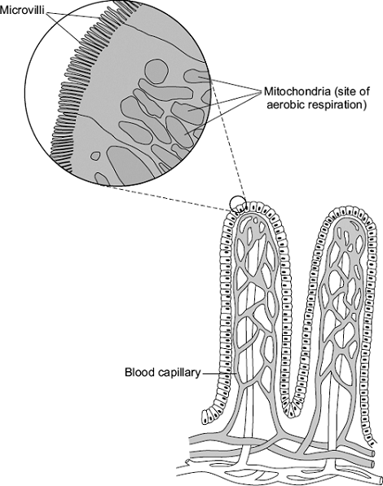
Describe and explain how the villi are adapted to maximise the rate of absorption
of the products of digestion.
_______________________________________________________________________
_______________________________________________________________________
_______________________________________________________________________
_______________________________________________________________________
_______________________________________________________________________
_______________________________________________________________________
_______________________________________________________________________
_______________________________________________________________________
_______________________________________________________________________
_______________________________________________________________________
_______________________________________________________________________
_______________________________________________________________________
(Total 5 marks)

Q4.
LDL is one form of cholesterol found in the blood.
People with a high concentration of LDL in their blood may be treated with drugs called statins.
A high concentration of LDL cholesterol in the blood may result in an increased risk of heart and circulatory diseases.
The graph shows the effects of the treatment of one person with four different statins,
A, B, C and D, over a period of 8 years. The arrows show when each new treatment was started.
Each treatment was continued until the next treatment was started.
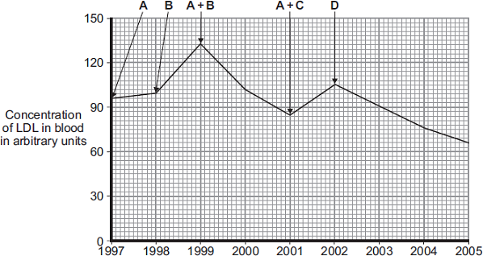
Year
Compare the effectiveness of the five treatments in reducing the risk of heart and
circulatory diseases for this person.
_______________________________________________________________________
_______________________________________________________________________
_______________________________________________________________________
_______________________________________________________________________
_______________________________________________________________________
_______________________________________________________________________
_______________________________________________________________________
_______________________________________________________________________
_______________________________________________________________________
_______________________________________________________________________
_______________________________________________________________________
_______________________________________________________________________
(Total 4 marks)
Q5.
Drugs must be trialled before the drugs can be used on patients.
(a) (i) Before the clinical trials, drugs are tested in the laboratory.
The laboratory trials are not trials on people.
What is the drug tested on in these laboratory trials?
______________________________________________________________
(1)
(ii) Drugs must be trialled before the drugs can be used on patients.
Give three reasons why.
______________________________________________________________
______________________________________________________________
______________________________________________________________
______________________________________________________________
______________________________________________________________
(3)
(b) Read the information about cholesterol and ways of treating high cholesterol levels.
Diet and inherited factors affect the level of cholesterol in a person's blood.
Too much cholesterol may cause deposits of fat to build up in blood vessels and reduce the flow of blood. This may cause the person to have a heart attack.
Some drugs can lower the amount of cholesterol in the blood.
The body needs cholesterol. Cells use cholesterol to make new cell membranes and some hormones. The liver makes cholesterol for the body.
Some drugs can help people with high cholesterol levels.
Statins block the enzyme in the liver that is used to produce cholesterol.
People will normally have to take statins for the rest of their lives. Statins can lead to muscle damage and kidney problems. Using some statins for a long time has caused high numbers of deaths.
Cholesterol blockers reduce the absorption of cholesterol from the intestine into the blood.
Cholesterol blockers can sometimes cause problems if the person is using other drugs.
Evaluate the use of the two types of drug for a person with high cholesterol levels.
___________________________________________________________________
___________________________________________________________________
___________________________________________________________________
___________________________________________________________________
___________________________________________________________________
___________________________________________________________________
___________________________________________________________________
___________________________________________________________________
___________________________________________________________________
___________________________________________________________________
___________________________________________________________________
___________________________________________________________________
___________________________________________________________________
___________________________________________________________________
(6)
Q6.
(a) Complete the equation for photosynthesis.
______________ + water 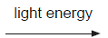 ______________ + ______________
(3)
(b) The rate of photosynthesis in a plant depends on several factors in the environment.
These factors include light intensity and the availability of water.
Describe and explain the effects of two other factors that affect the rate of photosynthesis.
You may include one or more sketch graphs in your answer.

___________________________________________________________________
___________________________________________________________________
___________________________________________________________________
___________________________________________________________________
___________________________________________________________________
___________________________________________________________________
___________________________________________________________________
___________________________________________________________________
___________________________________________________________________
___________________________________________________________________
(5)

Section 1: Maths Mark Scheme
Q1.
(a) (yes, because) the mass change (of egg 4) is much lower than the others
allow because it / egg 4 has gained (over) 50% less mass than the others
allow it / egg 4 has gained 1.5 g and the others have all gained more than 3 g (unit required)
1
(b) 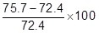
or equivalent
1
4.6 (%)
allow 4.558 / 4.56 (%)
allow any correct rounding of 4.558011049723757
1
an answer of 4.6 / 4.56 / 4.558 scores 2 marks
(c) (mass increased because) water entered by osmosis
1
from a dilute solution in the beaker to a more concentrated solution in the egg (cell)
allow from an area of high water concentration in the beaker to an area of low water concentration in the egg (cell)
allow ref to water potential
allow ref to ‘strong’ and ‘weak’ solutions
ignore along / across concentration gradient
do not accept ‘amount’ in place of concentration
through a partially permeable membrane
allow semi-permeable / selectively permeable membrane
1
(d) use five (or more) different concentrations of salt / sugar solution (in beakers)
allow any number of concentrations provided it is more than four
1
(by) plotting percentage change (in mass / volume) on / using a graph
1
determine the concentration where the curve / line crosses the zero percentage change (in mass / volume)
1
(e) (ions are moved) from an area of low concentration to high concentration
allow against the concentration gradient
allow in terms of solution
do not accept molecules
1
(by) active transport
1
(which) requires using energy
do not accept idea of energy being created
1
[12]
Q2.
(a) 86
allow this answer only
do not accept 85.7
if no answer given, check for answer in the table
1
(b) as salt concentration increases, percentage of open stomata (in field of view) decreases (above 0.1 mol / dm³)
or
allow percentage of open stomata stays the same between 0.0 and 0.1 (mol / dm³ then decreases as salt concentration increases)
ignore references to number of open stomata
allow converse
allow idea that mean concentration (of salt) in guard cells is between 0.3 and 0.4 mol per dm ³
1
(c) use concentrations between 0.3 (mol / dm ³ ) and 0.4 (mol / dm ³)
or
draw a graph of the data and read off the value at 50% (open stomata)
allow a list of appropriate concentrations i.e. 0.32 mol / dm ³), 0.34 (mol / dm ³), 0.36 (mol / dm ³) etc.
1
(d) (π × 0.1875²) = 0.11 (mm ²)
an answer of 36 scores 3 marks
1
1
36 (per mm ²)
allow 36.22 / 36.23 or 36.2
if answer is incorrect allow for 2 marks for sight of number of open stomata = 9 per mm ² (diameter used instead of radius)
if no other marks awarded allow for 1 mark any one from:
• sight of area = 0.44(mm ²) (diameter used instead of radius)
• sight of number of open stomata = 9.1 / 9.05 / 9.06 per mm ² (diameter used instead of radius and no rounding)
1
(e) (potassium) ions increase the concentration of the solution (inside guard cells)
or
(potassium) ions make cell more concentrated / less dilute
allow (potassium) ions decrease concentration of water / water potential (of guard cells)
1
water moves into the (guard) cell by osmosis
1
cell swells unevenly (so stoma opens)
1
as inner wall is less flexible than outer wall or thick part of the wall is less flexible than the thin part (of the wall)
1
[10]
Q3.
(a) vena cava
1
(b) 0.5 mm = 0.05 cm
1
time = 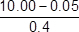
allow alternative correct substitution
1
24.875
1
25 (s)
an answer of 25 (s) scores 4 marks
allow 24 for 3 marks (no conversion of mm to cm)
allow 23.8 / 23.75 for 2 marks (no conversion of mm to cm and incorrect sf)
1
(c) (blood) travels through (the) pulmonary vein
1
(blood) enters left atrium
1
(blood) enters (the) left ventricle
1
(blood) leaves the heart via / through (the) aorta
allow blood travels through arterioles
allow blood (travels round the body and) reaches the cells / tissues via / in capillaries
1
ignore ref to valves / systole / diastole throughout
(d) Level 3 (5-6 marks):
Relevant points (reasons / causes) are identified, given in detail and logically linked to form a clear account.
Level 2 (3-4 marks):
Relevant points (reasons/causes) are identified, and there are attempts at logical linking. The resulting account is not fully clear.
Level 1 (1-2 marks):
Points are identified and stated simply, but their relevance is not clear and there is no attempt at logical linking.
No relevant content (0 marks)
Indicative content
S = structural F = functional
• (S) both have a large surface area
• (S) villi have many microvilli
• (S) alveolar walls are not flat / are folded
• (F) to maximise diffusion (of gases) / absorption of (food) molecules
• (S) both have many capillaries / good blood supply / capillaries near the surface
• (F) to maintain concentration / diffusion gradient
• (S) both have thin walls / walls that are one cell thick / one cell thick surface
• (F) to provide a short diffusion distance (for molecules to travel)
• (S) villi have many mitochondria
• (F) to provide energy for active transport (of food molecules)
• (S) cells of the villi have microvilli / more projections
• (F) to further increase the surface area / increase the number of proteins in the membrane / to allow more active transport to take place
[15]
Q4.
(a) (0.15 / 1.35) × 100
1
11.1 (%)
allow 11.1 (%) with no working shown for 2 marks
1
(b) to allow results to be compared
or
they had different masses at the start
1
(c) axis correct scale and labelled
1
5 points correctly plotted
allow ecf from 05.1
allow 1 mark for 4 points correctly plotted
2
line of best fit
1
(d) 0.5
allow 0.45–0.55
1
(e) (0.0 to 0.4) water moves into cells
1
(0.6 to 0.8) water leaves cells
1
by osmosis
1
(f) any two from:
• concentration of solutions
• drying of chips
• accuracy of balance
• evaporation from tubes
2
[13]
Q5.
(a) C
1
(b) cytoplasm and cell membrane dividing
accept cytokinesis for 1 mark
1
to form two identical daughter cells
1
(c) stage 4
1
only one cell seen in this stage
1
(d) (4 / 36) × 16 × 60
1
107 / 106.7
1
110 (minutes)
allow 110 (minutes) with no working shown for 3 marks
1
(e) binary fission
do not accept mitosis
1
(f) shortage of nutrients / oxygen
1
so cells die
or
death rate = rate of cell division
1
[11]
Q6.
(a) solution in soil is more dilute (than in root cells)
concentration of water higher in the soil (than in root cells)
1
so water moves from the dilute to the more concentrated region
so water moves down (its) concentration gradient or water moves from a high concentration of water to a lower concentration
1
concentration of ions in soil less (than that in root cells)
1
so energy needed to move ions
or
ions are moved against concentration gradient
the direction of the concentration gradient must be expressed clearly
accept correct reference to water potential or to concentrations of water
1
(b) any three from:
• movement of water from roots / root hairs (up stem)
• via xylem
• to the leaves
• (water) evaporates
• via stomata
3
(c) (i) 0.67/0.7
accept 0.66, 0.6666666... or ⅔ or 0.6
correct answer gains 2 marks with or without working
if answer incorrect allow evidence of for 1 mark
do not accept 0.6 or 0.70
2
(ii) during the first 30 minutes
any one from:
• it was warmer
• it was windier
• it was less humid
• there was more water (vapour) in the leaves
1
so there was more evaporation
ignore ‘water loss’
or
stomata open during first 30 minutes or closed after 30 minutes (1)
so faster (rate of) evaporation in first 30 min or reducing (rate of) evaporation after 30 min (1)
1
[11]
Q7.
(a) (for calcium)
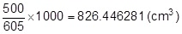
allow any correct rounding to minimum 3 significant figures
allow alternative route with correct rounding
1
(for vitamin B-12)
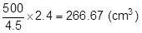
allow alternative route with correct rounding
1
560 / 559.8 / 559.78 / 559 (cm³)
allow only correct answer based on values given for vitamin B-12 and calcium
1
an answer of 560 / 559.8 / 559.78 / 559 (cm³) scores 3 marks
an incorrect answer for one step does not prevent allocation of marks for subsequent steps
(b) Level 2: Scientifically relevant facts, events or processes are identified and given in detail to form an accurate account.
4−6
Level 1: Facts, events or processes are identified and simply stated but their relevance is not clear.
1−3
No relevant content
0
Indicative content
• Biuret reagent (allow CuSO₄ and NaOH) tests for protein
• add Biuret reagent to milk
• solution will turn (from blue) to lilac if positive
• iodine solution tests for starch (ignore iodine unqualified)
• add iodine solution to milk
• solution will turn (from orange / brown) to blue / black if positive
• Benedict’s reagent tests for sugars
• add Benedict’s reagent to milk and boil / heat (allow any temperature above 60 °C)
• solution will turn (from blue) to (brick) red / brown / orange / yellow / green if positive
for level 2, reference to all three food tests is required
(c) lipase breaks down fat into fatty acids (and glycerol)
do not accept if ‘glycerol’ is contradicted
1
(and) fatty acids lower the pH
1
(and when) fatty acids cause the pH to be below 10 (the indicator becomes colourless)
1
(d) observation of colour change is subjective / based on opinion
ignore human error unqualified
ignore experimental error or examples of this
1
(e) bile emulsifies fats
allow a correct description of emulsification (i.e. breaks fat from large droplets into smaller droplets)
do not accept a description of chemical breakdown
1
creates a larger surface area (of fat)
1
(so) lipase can break down fat (to produce fatty acids) more quickly / effectively
allow fatty acids produced by action of lipase more quickly
1
[16]
Q8.
(a) 5624
allow 2 marks for:
• correct HR = 148 and correct SV = 38 plus wrong answer / no answer
or
• only one value correct and ecf for answer
allow 1 mark for:
• incorrect values and ecf for answer
or
• only one value correct
3
(b) (i) Person 2 has low(er) stroke volume / SV / described
eg Person 2 pumps out smaller volume each beat
do not allow Person 2 has lower heart rate
1
(ii) Person 1 sends more blood (to muscles / body / lungs)
1
(which) supplies (more) oxygen
1
(and) supplies (more) glucose
1
(faster rate of) respiration or transfers (more) energy for use
ignore aerobic / anaerobic
allow (more) energy release
allow aerobic respiration transfers / releases more energy (than anaerobic)
do not allow makes (more) energy
1
removes (more) CO2 / lactic acid / heat
allow less oxygen debt
or less lactic acid made
or (more) muscle contraction / less muscle fatigue
if no other mark awarded,
allow person 1 is fitter (than person 2) for max 1 mark
1
[9]
Q9.
(a) (i) guard (cells)
allow phonetic spelling
1
(ii) any one from:
ignore reference to cells
• allow carbon dioxide to enter
allow control loss / evaporation of water or control transpiration rate
• allow oxygen to leave.
allow ‘gaseous exchange’
1
(b) (i) 200
correct answer gains 2 marks with or without working
allow 1 mark for 0.1 × 0.1 = 0.01 (mm²)
2
(ii) more / a lot of / increased water loss
allow plant more likely to wilt (in hot / dry conditions)
1
(c) (i) 0.12
1
(ii) the lower surface has most stomata
1
stomata are now covered / blocked (by grease)
1
so water cannot escape / evaporate from the stomata
ignore waterproof
to gain credit stomata must be mentioned at least once
1
[9]
Q10.
(a) any two from:
• diet
ignore exercise
accept any reasonable reference to diet
do not accept salt / blood pressure
ignore age / gender / HDL / LDL
• heredity / genes / genetic makeup
• reference to cholesterol production by liver
2
(b) (i) Blood cholesterol concentration is only one of several factors
affecting death from all causes
1
(ii) 170 – 210
accept 210 - 170
1
[4]
Q11.
﻿
(a) lipase
1
(b) fatty acid
ignore glycerol
1
(c) (i) 0.25 or

if correct answer ignore working or lack of working
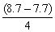 for 1 mark
2
(ii) fats emulsified or described re. Small droplets or large S.A.
(for enzyme action) or fats ‘mix’ better with water
do not allow breakdown / breakup unqualified
1
[5]
Q12.
(a) any two from:
• regular hand washing
or
use hand sanitiser / alcohol gel
• cover nose / mouth when coughing / sneezing
allow wear a face mask
• put used tissues (straight) in the bin
• don’t kiss uninfected people
allow isolate patient from others
or
don’t share cutlery / cups / drinks with uninfected people
• clean / disinfect / sterilise surfaces regularly
ignore responses referring to infected people
2
(b) any three from:
• stimulate (mouse) lymphocytes to produce antibody
for marking points 1 and 2 lymphocyte must be used at least once
• combine (mouse) lymphocyte with tumour cell
or
(create a) hybridoma
• clone (hybridoma) cell
• (hybridoma) divides rapidly and produces the antibody
3
(c) any two from:
• (monoclonal) antibody binds to virus or antibody binds to antigen on surface of virus
• (monoclonal) antibody is complementary (in shape) / specific to antigen (on surface of virus)
• white blood cells / phagocytes kill / engulf the virus(es)
2
(d) as a control
or
to see / compare the effects of the treatment (vs. no treatment)
1
(e) (4.8 + 10.4) ÷ 2 ÷ 100 × 1500
or
(4.8 ÷ 100 × 750) + (10.4 ÷ 100 × 750)
1
114
an answer of 114 scores 2 marks
allow 228 for 1 mark
1
(f) (supports the conclusion because)
over double the number / % of patients (in the trial) were hospitalised with the placebo (compared to MAB)
1
(does not support the conclusion because)
no information on patients not hospitalised / still unwell at home
or
other factors may have affected those admitted to hospital
allow correct named factor e.g. age / gender / other illness
or
don’t know if it was a double blind trial
1
[12]
Q13.
(a) 18.06 / 18 / 18.1
correct answer gains 2 marks
if answer incorrect evidence of
(4131 - 3499) ÷ 3499 × 100
or 632 ÷ 3499 × 100
or ((4131 ÷ 3499) × 100 ) - 100
or 0.18
gains 1 mark
2
(b) antibiotics kill non-resistant strain
or resistant strain bacteria survive
accept resistant strain the successful competitor
do not accept intentional adaptation
ignore strongest / fittest survive
ignore mutation
ignore people do not finish antibiotic course
1
resistant strain bacteria reproduce
or resistant strain bacteria pass on genes
1
population of resistant strain increases or proportion of resistant bacteria increases
allow high numbers of resistant bacteria
or
people more likely to be infected by resistant strain (than non-resistant strain)
1
[5]
Q14.
(a) 7.15 to 7.45 am and 7.15 to 7.45 pm
both required, either order
accept in 24 hr clock mode
1
(b) (i) 11
1
(ii) 32.5 to 33
allow answer to (b)(i) + 21.5 to 22
1
(c) any two from:
• more photosynthesis than respiration
• more biomass / carbohydrate made than used
allow more food made than used
• so plant able to grow / flower
accept plant able to store food
2
[5]
Q15.
(a) No
no mark
if yes max 1 for correct statement
diffusion is down the concentration gradient
accept by diffusion ions would leave the root
1
to enter must go up / against the concentration gradient
or concentration higher in the root
or concentration lower in the soil
1
(b) (i) 0.9 or 3.25
for correct answer with or without working
if answer incorrect 1.3 or their rate – 0.4 gains 1 mark
or 130 – 40 or 90 gains 1 mark
2
(ii) (uptake) by active transport
1
requires energy
more energy from aerobic respiration
1
or
more energy when oxygen is present
1
[7]

Section 2: Required Practicals Mark Scheme
Q1.
(a) salivary glands and pancreas
1
(b) starch / substrate fits into active site (of enzyme)
1
shape of active site is unique / complementary to substrate
allow converse
or
substrate is specific to active site / enzyme
allow enzyme has a high specificity for substrate
1
bonds (within starch / substrate
or
between sugar molecules) are broken
1
(c) converted to new carbohydrates / glycogen / named organic compound (e.g. protein / fat)
1
(d) to allow (the starch and amylase / solutions) to equilibrate (to the temperature of the water bath)
or
to get the starch and amylase / solutions to the same temperature / 20 °C
or
to get the starch and amylase / solutions to the (same) temperature of the water bath
1
(e) 40 °C
all wells contain a symbol
and
must contain at least two crossed wells at the end
allow final three wells crossed
1
60 °C
all wells contain a symbol
and
must have fewer crossed wells at the end than at 40 °C
allow all wells ticked (✔)
for either mp do not allow a crossed well followed by a ticked well
1
(f) more accurate
allow (so) closer to (the) true value
1
(because) it is a quantitative measure
allow (it’s) an actual value as opposed to an opinion
or
less / not subjective
allow colour is only qualitative
1
(g) 0.07 (%)
1
(h) starch is broken down less quickly (at 20 °C)
allow converse
1
because, at 20 °C, substrates / enzymes / molecules have less (kinetic) energy
1
(i) 1.08 (arbitrary units)
1
at 80 °C, enzyme / amylase has denatured
allow description of denaturation
do not allow enzyme is killed
1
so starch is not broken down (at all)
allow the concentration of starch is still 0.5%
1
[16]
Q2.
(a) glucose is absorbed by diffusion into the bloodstream
1
then blood delivers glucose to muscles in capillaries
1
(b) to stop air getting in
1
(c) yellow
1
(d) collect the CO₂ / gas with a measuring cylinder / gas syringe
1
(volume collected) in a certain time using a timer / watch
1
(e) yeast produces ethanol but muscles produce lactic acid
marks can be awarded from correct word or balanced symbol equations
1
yeast produces CO₂ but muscles do not
answers must be comparative
1
both release small amounts of energy
1
ignore both occur without oxygen
[9]
Q3.
(a) a fungus
1
(b) Level 3 (5-6 marks):
Relevant points (reasons / causes) are identified, given in detail and logically linked to form a clear account.
Level 2 (3-4 marks):
Relevant points (reasons / causes) are identified, and there are attempts at logical linking. The resulting account is not fully clear.
Level 1 (1-2 marks):
Points are identified and stated simply, but their relevance is not clear and there is no attempt at logical linking.
Level 0
No relevant content
Indicative content

 | defence | description of defence
animals | skin | sebum / oils to kill microbes  dead layer difficult to penetrate
 | nose | hairs keep out dust and microbes
 | trachea / bronchi | mucus traps microbes  cilia moves mucus
 | stomach | (hydrochloric) acid kills bacteria
 | white blood cells | produces antibodies  produces antitoxins  engulf microbes / phagocytosis
plants | cell wall | tough / difficult to penetrate
 | waxy cuticle | tough / difficult to penetrate
 | dead cells / bark | fall off, taking pathogens with them
 | production of antibacterial chemicals | kill bacteria
fungi | antibiotic production | kill bacteria
6
(c) any three from:
• sterilise agar (before use)
• sterilise (Petri) dish before use
• disinfect bench (before use)
• pass inoculating loop (through flame)
• secure lid with (adhesive) tape
• minimise exposure of agar / culture to air / lift and replace lid as quickly as possible
allow:
• dip loop into ethanol (after flaming)
• keep the lid on the plate for as long as possible
or
minimise exposure of agar to air
or
only tilt the lid off (rather than remove it)
• flame the neck of the bottle
3
(d) to prevent the growth of a harmful pathogen
1
[11]
Q4.
(a) active transport
1
(b) by transpiration stream / pull
1
in xylem
1
(c) any three in the correct order from:
• mount epidermis on a slide
• count stomata in one area
• repeat in four more areas
• repeat method on other surface of leaf
• calculate mean
allow nail varnish film
3
(d) 1
allow numbers written out in a line with middle number circled
1
(e) (44 + 41 + 40 + 42 + 39) / 5 = 41.2
1
41
allow 41 with no working shown for 2 marks
1
allow 41.2 for 1 mark
(f) less water lost
1
so it does not wilt
1
[11]
Q5.
(a) Marks awarded for this answer will be determined by the Quality of Communication (QC) as well as the standard of the scientific response. Examiners should also refer to the information in the Marking guidance and apply a ‘best-fit’ approach to the marking.
0 marks
No relevant content.
Level 1 (1−2 marks)
The method described is weak and could not be used to collect valid results, however does show some understanding of the sequence of an investigation.
Level 2 (3−4 marks)
The method described could be followed and would enable some valid results to be collected, but lacks detail.
Level 3 (5−6 marks)
The method described could be easily followed and would enable valid results to be collected.
Examples of the points made in the response:
• bean seedlings of same age
• cut material from same part of each organ (for repeats) e.g. top 1 cm of stem / a whole cotyledon / seed
• equal mass of each organ
accept weight for mass
• grind / homogenise
• in equal amounts of water / buffer
• equal volumes of hydrogen peroxide solution
• equal concentrations of hydrogen peroxide solution
• same temperature
• temperature maintained in water bath
• quantitative measure of gas production eg height of foam in mm / collect gas in graduated syringe in cm³
• for same time period
• repetitions (3+ times)
• calculate mean for each.
6
(b) (i) correct answer: 40
1 mark for 45 as the anomalous result has been included in the calculation
or
1 mark for 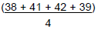
or
2
(ii) vertical axis correctly labelled:
‘Enzyme activity in arbitrary units’
allow ecf from (b)(i)
1
points plotted correctly ±1 mm
deduct 1 mark for each incorrect plot
2
suitable line of best fit
not feathery, not point to point
1
(iii) 6.0 / 6
allow ± 0.1
if 6.0 not given, allow correct for candidate’s graph ± 0.1
1
(iv) in range 0 to 14 units
allow correct for candidate’s graph
1
(v) enzyme denatured / enzyme (active site) shape changed
allow substrate no longer fits (active site)
ignore reference to temperature
do not allow enzyme dies
1
[15]
Q6.
(a) C₆H₁₂O₆
1
(b) atmospheric air contains less carbon dioxide than exhaled air
allow converse
1
(flask B goes more cloudy because) carbon dioxide is produced in (aerobic) respiration (by woodlice)
do not accept anaerobic respiration
1
(c) for comparison / to compare
allow answers in the context of the investigation e.g.
or
to check that no other factor / variable is influencing the results
to prove that the results obtained were due to the woodlice respiring and nothing else
or
to prove that the woodlice produced the carbon dioxide and nothing else
1
(d) (flask A) would remain colourless
ignore references to clear
allow not cloudy
1
(flask B) would remain colourless
1
(e) lactic acid
1
(f) alcohol / ethanol
1
[8]
Q7.
Marks awarded for this answer will be determined by the Quality of Written Communication (QWC) as well as the standard of the scientific response. Examiners should also apply a ‘best-fit’ approach to the marking.
Level 3 (5–6 marks):
A description of how the apparatus is used to measure the rate of photosynthesis at different light intensities is given.
For full marks reference must be made to a control variable
or
repeats
Level 2 (3–4 marks):
A description of how the apparatus is set up
and
a description of how photosynthesis can be measured.
or
a description of how light intensity is varied
or
a control variable or any other relevant point
Level 1 (1–2 marks):
A partial description of how the apparatus is set up
or
a description of how light is supplied
or
a simple description of how photosynthesis can be measured.
or
a control variable
0 marks:
No relevant content.
examples of the points made in the response:
• apparatus set up:
– weed in water in beaker
– light shining on beaker
• method of varying the light intensity–eg changing distance of lamp from plant
• method of controlling other variables
– use same pond weed or same length of pond weed
– temperature: water bath or heat screen
– CO₂
• leave sufficient time at each new light intensity before measurements taken
• method of measuring photosynthesis – eg counting bubbles of gas released or collecting gas and measuring volume in a syringe
• measuring rate of photosynthesis by counting bubbles for set period of time
• repetitions
extra information:
allow information in the form of a diagram
[6]
Q8.
(a) C
1
(b) cytoplasm and cell membrane dividing
accept cytokinesis for 1 mark
1
to form two identical daughter cells
1
(c) stage 4
1
only one cell seen in this stage
1
(d) (4 / 36) × 16 × 60
1
107 / 106.7
1
110 (minutes)
allow 110 (minutes) with no working shown for 3 marks
1
(e) binary fission
do not accept mitosis
1
(f) shortage of nutrients / oxygen
1
so cells die
or
death rate = rate of cell division
1
[11]
Section 3: 6 Mark Questions Mark Scheme
Q1.
(a) vena cava
1
(b) 0.5 mm = 0.05 cm
1
time =
allow alternative correct substitution
1
24.875
1
25 (s)
an answer of 25 (s) scores 4 marks
allow 24 for 3 marks (no conversion of mm to cm)
allow 23.8 / 23.75 for 2 marks (no conversion of mm to cm and incorrect sf)
1
(c) (blood) travels through (the) pulmonary vein
1
(blood) enters left atrium
1
(blood) enters (the) left ventricle
1
(blood) leaves the heart via / through (the) aorta
allow blood travels through arterioles
allow blood (travels round the body and) reaches the cells / tissues via / in capillaries
1
ignore ref to valves / systole / diastole throughout
(d) Level 3 (5-6 marks):
Relevant points (reasons / causes) are identified, given in detail and logically linked to form a clear account.
Level 2 (3-4 marks):
Relevant points (reasons/causes) are identified, and there are attempts at logical linking. The resulting account is not fully clear.
Level 1 (1-2 marks):
Points are identified and stated simply, but their relevance is not clear and there is no attempt at logical linking.
No relevant content (0 marks)
Indicative content
S = structural F = functional
• (S) both have a large surface area
• (S) villi have many microvilli
• (S) alveolar walls are not flat / are folded
• (F) to maximise diffusion (of gases) / absorption of (food) molecules
• (S) both have many capillaries / good blood supply / capillaries near the surface
• (F) to maintain concentration / diffusion gradient
• (S) both have thin walls / walls that are one cell thick / one cell thick surface
• (F) to provide a short diffusion distance (for molecules to travel)
• (S) villi have many mitochondria
• (F) to provide energy for active transport (of food molecules)
• (S) cells of the villi have microvilli / more projections
• (F) to further increase the surface area / increase the number of proteins in the membrane / to allow more active transport to take place
[15]
Q2.
Level 3 (5–6 marks):
A detailed and coherent explanation is provided with most of the relevant content, which demonstrates a comprehensive understanding of the human circulatory system . The response makes logical links between content points.
Level 2 (3–4 marks):
The response is mostly relevant and with some logical explanation. Gives a broad understanding of the human circulatory system. The response makes some logical links between the content points.
Level 1 (1–2 marks):
Simple descriptions are made of the roles of some of the following: heart function, gas exchange, named blood vessels, named blood cells. The response demonstrates limited logical linking of points.
0 marks:
No relevant content.
Indicative content
• dual / double circulatory system which means that it has higher blood pressure and a greater flow of blood to the tissues
• heart made of specialised (cardiac) muscle cells which have long protein filaments that can slide past each other to shorten the cell to bring about contraction for pumping blood
• heart pumps blood to lungs in pulmonary artery so that oxygen can diffuse into blood from air in alveoli
• blood returns to heart via pulmonary vein where muscles pump blood to the body via aorta
• oxygen carried by specialised cells / RBCs which contain haemoglobin to bind oxygen and have no nucleus so there is more space available to carry oxygen
• arteries carry oxygenated blood to tissues where capillaries deliver oxygen to cells for respiration and energy release
• thin walls allow for easy diffusion to cells
• large surface area of capillaries to maximise exchange
• waste products removed eg CO₂ diffuse from cells into the blood plasma
• blood goes back to the heart in veins which have valves to prevent backflow
• cardiac output can vary according to demand / is affected by adrenaline
accept annotated diagrams
[6]
Q3.
D – many microvilli (1)
Ex – provide large surface area (1)
five points made
max 3 descriptions
max 3 explanations
D – many capillaries / good blood supply (1)
Ex – maintain concentration / diffusion gradient or quickly removes food (1)
D – thin wall / one cell thick surface / capillaries near surface (1)
allow villi are thin
ignore villi are one cell thick
Ex – short distance for food to travel (1)
D – many mitochondria (1)
Ex – provide energy / ATP for active uptake / transport (1)
[5]
Q4.
A + B most effective (treatment)
ignore descriptions of LDL levels
1
D is (the most) effective (treatment)
D is the best single (treatment)
1
neither A nor B (alone) are effective
allow increase risk of heart disease instead of not effective
1
can’t tell if C is effective
OR
A + C is not effective
1
[4]
Q5.
(a) (i) any one from:
• cells
• tissues
• (live) animals / named
allow mammals
1
(ii) any three from:
(to test for)
• toxicity / check not poisonous / not harmful
allow side-effect
allow converse
• interaction with other drugs
• efficacy or to see if they work or check if they treat the disease
allow converse
• dosage or how much is needed
3
(b) argued evaluation
comparison can be written anywhere in evaluation allow use of ‘only’ for implied comparison for each point eg only statins damage muscles / kidneys / organs
any six from:
• statin can damage / muscles / kidneys / organs but cholesterol blockers don’t
ignore liver
if neither of the first 2 points are given accept for 1 mark
• statins can cause death but cholesterol blockers don’t
statins are more dangerous than cholesterol blockers or statins have more side effects
• cholesterol blockers can interfere with action of other drugs but statins don’t
• statins are for a life time but cholesterol blockers are not
• statins (might) reduce cholesterol to zero but cholesterol blockers only
reduce it or statins reduce cholesterol more
allow statins (might) stop membrane / hormone production but cholesterol blockers don’t
• statins better for people with inherited high cholesterol
• cholesterol blockers better for people with dietary cholesterol problems
• taking/using statins/cholesterol blockers is better than dying from heart
attack or build up of fat in blood vessels or reduced blood flow
6
[10]
Q6.
(a) LHS – carbon dioxide / CO₂
allow CO2
ignore CO²
1
RHS
in either order
glucose / carbohydrate / sugar
allow starch
allow C₆H₁₂O₆ / C6H12O6
ignore C⁶H¹²O⁶
1
oxygen
allow O₂ / O2
ignore O² / O
1
(b) any five from:
• factor 1: CO² (concentration)
• effect - as CO₂ increases so does rate and then it levels off or shown in a graph
• explanation:
(graph increases) because CO₂ is the raw material or used in photosynthesis / converted to organic substance / named eg
or
(graph levels off) when another factor limits the rate.
accept points made via an annotated / labelled graph
• factor 2: temperature
allow warmth / heat
• effect – as temperature increases, so does the rate and then it decreases or shown in a graph
allow ‘it peaks’ for description of both phases
• explanation:
(rise in temp) increases rate of chemical reactions / more kinetic energy
allow molecules move faster / more collisions
or
(decreases) because the enzyme is denatured.
context must be clear = high temperature

allow other factor plus effect plus explanation:
eg light wavelength / colour / pigments / chlorophyll / pH / minerals / ions / nutrients / size of leaves
2nd or 3rd mark can be gained from correct description and explanation
5
[8]

