Oasis Academy South Bank
Year 11 Mock Revision
Chemistry Combined Paper 1: Higher
Name: ___________________________
Class: _________
Teacher: __________________________
Step 1: Knowledge
Learn each of the quiz questions and answers off by heart. This could be done by:
- turning them into flash cards and testing yourself
- using ‘look, cover, write, check’
- asking a friend or family member to quiz you
Topic | LCWC | Quiz 1 | Quiz 2 | Quiz 3
The Three States (C.1)
Elements, compounds (C.2)
Mixtures (C.3)
Chromatography (C.4)
Structure of an atom (C.5)
The periodic table (C.6)
Types of bonding (C.7)
Properties of materials (C.8)
Describing chemical reactions, reactions of metals and gas tests (C.9)
Acids and Alkalis (C.10)
Electrolysis (C.12)
Electrolysis & Half equations (HT mainly) (C.13)
Endothermic and exothermic reactions (C.14)
Rates of reaction (C.17)
Chemical calculations, volumes and concentrations (C.19)
Metals and alloys (C.23)
Alkanes and alkenes (C.28)

Step 2: Exam practice
- Practice applying your knowledge using the past exam questions in each section.
- Self-assess these using the mark schemes at the back and rewrite your answers.
- Assess your progress using a ‘red, amber, green’ system (RAG)
Section | Completed | SA using green pen
1: Knowledge
2. Required Practicals
3. 6 markers
Exam practice
Section 1: Knowledge
Q1.
The halogens are elements in Group 7.
(a) Bromine is in Group 7.
Give the number of electrons in the outer shell of a bromine atom.
_______________________
(1)
(b) Bromine reacts with hydrogen. The gas hydrogen bromide is produced.
What is the structure of hydrogen bromide?
Tick one box.

Giant covalent
Ionic lattice
Metallic structure
Small molecule
(1)
(c) What is the formula for fluorine gas?
Tick one box.

F
F₂
F²
2F
(1)
A student mixes solutions of halogens with solutions of their salts.
The table below shows the student’s observations.

 | Potassium chloride (colourless) | Potassium bromide (colourless) | Potassium iodide (colourless)
Chlorine (colourless) |  | Solution turns orange | Solution turns brown
Bromine (orange) | No change |  | Solution turns brown
Iodine (brown) | No change | No change
(d) Explain how the reactivity of the halogens changes going down Group 7.
Use the results in the table above.
___________________________________________________________________
___________________________________________________________________
___________________________________________________________________
___________________________________________________________________
___________________________________________________________________
___________________________________________________________________
(3)
A company uses chlorine to produce titanium chloride from titanium dioxide.
(e) What is the relative formula mass (M_{r}) of titanium dioxide, TiO₂?
Relative atomic masses (A_{r}): O = 16 Ti = 48
Tick one box.

64
80
128
768
(1)
(f) The company calculates that 500 g of titanium dioxide should produce 1.2 kg of titanium chloride.
However, the company finds that 500 g of titanium dioxide only produces 900 g of titanium chloride.
Calculate the percentage yield.
___________________________________________________________________
___________________________________________________________________
___________________________________________________________________
___________________________________________________________________
Percentage yield = __________________ %
(2)
(Total 9 marks)
Q2.
This question is about the structure of the atom.
(a) Complete the sentences.
Choose answers from the box.
Each word may be used once, more than once, or not at all.

electron |  | ion |  | neutron
 | nucleus |  | proton
The centre of the atom is the _______________________ .
The two types of particle in the centre of the atom are the proton
and the _______________________ .
James Chadwick proved the existence of the _______________________ .
Niels Bohr suggested particles orbit the centre of the atom. This type of particle
is the _______________________ .
The two types of particle with the same mass are the neutron
and the _______________________ .
(5)
The table below shows information about two isotopes of element X.

 | Mass number | Percentage (%) abundance
Isotope 1 | 63 | 70
Isotope 2 | 65 | 30
(b) Calculate the relative atomic mass (A_{r}) of element X using the equation:
Use the table above.
Give your answer to 1 decimal place.
___________________________________________________________________
___________________________________________________________________
___________________________________________________________________
___________________________________________________________________
A_{r} = _________________
(2)
(c) Suggest the identity of element X.
Use the periodic table.
Element X is _______________________________________________________
(1)
(d) The radius of an atom of element X is 1.2 × 10⁻¹⁰ m
The radius of the centre of the atom is 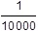 the radius of the atom.
Calculate the radius of the centre of an atom of element X.
Give your answer in standard form.
___________________________________________________________________
___________________________________________________________________
___________________________________________________________________
___________________________________________________________________
Radius = ___________________ m
(2)
(Total 10 marks)
Q3.
This question is about elements in Group 1.
A teacher burns sodium in oxygen.
(a) Complete the word equation for the reaction.
sodium + oxygen ⟶ ___________________
(1)
(b) What is the name of this type of reaction?
Tick one box.

Decomposition
Electrolysis
Oxidation
Precipitation
(1)
(c) The teacher dissolves the product of the reaction in water and adds universal indicator.
The universal indicator turns purple.
What is the pH value of the solution?
Tick one box.
(1)
(d) The solution contains a substance with the formula NaOH
Give the name of the substance.
___________________________________________________________________
(1)
(e) All alkalis contain the same ion.
What is the formula of this ion?
Tick one box.

H⁺
Na⁺
OH⁻
O²⁻
(1)
(f) A solution of NaOH had a concentration of 40 g/dm³
What mass of NaOH would there be in 250 cm³ of the solution?
___________________________________________________________________
___________________________________________________________________
___________________________________________________________________
___________________________________________________________________
Mass = ______________________ g
(2)
(g) The melting points of the elements in Group 1 show a trend.
The table below shows the atomic numbers and melting points of the Group 1 elements.

Element | Atomic number | Melting point in °C
Lithium | 3 | 181
Sodium | 11 | 98
Potassium | 19 | 63
Rubidium | 37 | X
Caesium | 55 | 29
Plot the data from the table on the graph below.
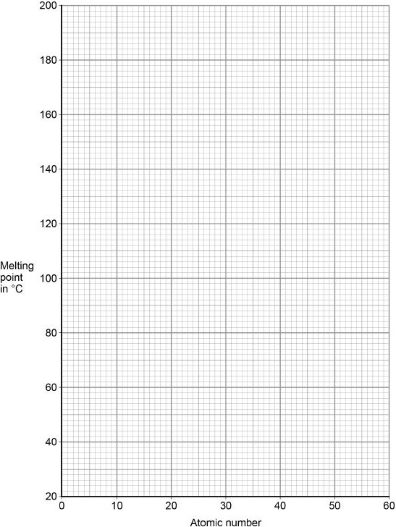
(2)
(h) Predict the melting point, X, of rubidium, atomic number 37
Use the graph above.
Melting point = ______________________ °C
(1)
(Total 10 marks)
Q4.
This question is about copper sulfate.
Blue copper sulfate turns white when it is heated.
The word equation for the reaction is:
hydrated copper sulfate ⇌ anhydrous copper sulfate + water
blue white
(a) What name is given to hydrated copper sulfate in this reaction?
Tick one box.

Catalyst
Element
Product
Reactant
(1)
(b) What does the symbol ⇌ mean?
Tick one box.

Endothermic
Exothermic
Reversible
Polymerisation
(1)
(c) Complete the sentence.
The colour change when the water is added to anhydrous copper sulfate
is white to _______________________ .
(1)
A student heats 2.5 g of hydrate copper sulfate in a test tube.
0.9 g of water is given off.
The remaining solid is anhydrous copper sulfate.
(d) Calculate the mass of anhydrous copper sulfate produced.
___________________________________________________________________
___________________________________________________________________
Mass of anhydrous copper sulfate = __________________ g
(2)
(e) Calculate the percentage of water contained in 2.5 g of hydrated copper sulfate.
___________________________________________________________________
___________________________________________________________________
___________________________________________________________________
Percentage of water = __________________ %
(2)
(f) Draw one line from each compound to the formula for the compound.
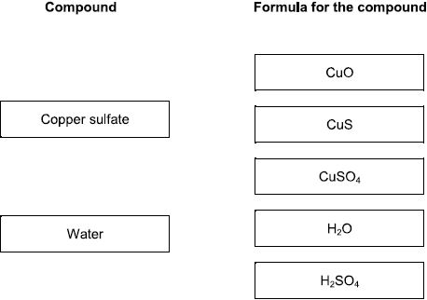
(2)
(Total 8 marks)
Q5.
This question is about atomic structure.
The figure below represents the structure of a lithium atom.
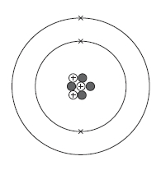
(a) Name the particle in the atom that has a positive charge.
___________________________________
(1)
(b) Name the particle in the atom that has the smallest mass.
___________________________________
(1)
(c) Complete the sentences.
Choose the answers from the box.

3 | 4 | 7 | 10
The mass number of the lithium atom is __________________.
The number of neutrons in the lithium atom is __________________.
(2)
(d) What are lithium atoms with different numbers of neutrons called?
Tick (✔) one box.

Compounds
Ions
Isotopes
Molecules
(1)
(e) Name the particle in the atom discovered by James Chadwick.
________________________ .
(1)
(f) An element has two isotopes.
The table shows information about the isotopes.

 | Mass number | Percentage (%) abundance
Isotope 1 | 10 | 20
Isotope 2 | 11 | 80
Calculate the relative atomic mass (A_{r}) of the element.
Use the equation:
Give your answer to 1 decimal place.
___________________________________________________________________
___________________________________________________________________
___________________________________________________________________
___________________________________________________________________
Relative atomic mass (A_{r}) = ______________________
(2)
(g) The radius of an atom is 0.2 nm
The radius of the nucleus is 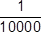 the radius of the atom.
Calculate the radius of the nucleus.
Give your answer in standard form.
___________________________________________________________________
___________________________________________________________________
___________________________________________________________________
___________________________________________________________________
Radius = ______________________ nm
(2)
(Total 10 marks)
Q6.
The electronic structure of the atoms of five elements are shown in the figure below.
The letters are not the symbols of the elements.
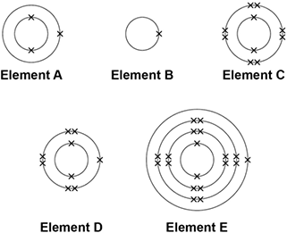
Choose the element to answer the question. Each element can be used once, more than once or not at all.
Use the periodic table to help you.
(a) Which element is hydrogen?
Tick one box.

A |  |  | B |  |  | C |  |  | D |  |  | E
(1)
(b) Which element is a halogen?
Tick one box.

A |  |  | B |  |  | C |  |  | D |  |  | E
(1)
(c) Which element is a metal in the same group of the periodic table as element A?
Tick one box.
A |  |  | B |  |  | C |  |  | D |  |  | E
(1)
(d) Which element exists as single atoms?
Tick one box.

A |  |  | B |  |  | C |  |  | D |  |  | E
(1)
(e) There are two isotopes of element A. Information about the two isotopes is shown in the table below.

Mass number of the isotope | 6 | 7
Percentage abundance | 92.5 | 7.5
Use the information in the table above above to calculate the relative atomic mass of element A.
Give your answer to 2 decimal places.
___________________________________________________________________
___________________________________________________________________
___________________________________________________________________
___________________________________________________________________
___________________________________________________________________
___________________________________________________________________
___________________________________________________________________
Relative atomic mass = _______________________
(4)
(Total 8 marks)
Q7.
There are eight elements in the second row (lithium to neon) of the periodic table.
(a) Figure 1 shows a lithium atom.
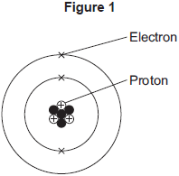
(i) What is the mass number of the lithium atom in Figure 1?

Tick (✔) one box.
3
4
7
(1)
(ii) What is the charge of an electron?

Tick (✔) one box.
–1
0
+1
(1)
(iii) Protons are in the nucleus.
Which other sub-atomic particles are in the nucleus?

Tick (✔) one box.
ions
molecules
neutrons
(1)
(b) What is always different for atoms of different elements?

Tick (✔) one box.
number of neutrons
number of protons
number of shells
(1)
(c) Figure 2 shows the electron arrangements of three different atoms, X, Y and Z.
These atoms are from elements in the second row (lithium to neon) of the periodic table.
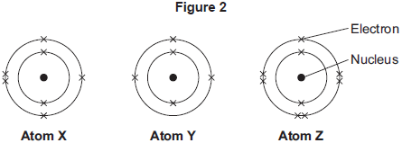
Which atom is from an element in Group 3 of the periodic table?

Tick (✔) one box.
Atom X
Atom Y
Atom Z
(1)
(d) Figure 3 shows the electron arrangement of a different atom from an element in the second row of the periodic table.
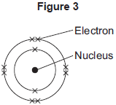
(i) Give the chemical symbol of this element.
______________________________________________________________
(1)
(ii) Why is this element unreactive?
______________________________________________________________
______________________________________________________________
(1)
(Total 7 marks)
Q8.
This question is about elements and the periodic table.
(a) Use the correct answers from the box to complete the sentences.

atoms | atomic weights | electrons | proton numbers
Newlands’ and Mendeleev’s periodic tables show the elements in order of
their __________________________ .
Following the discovery of protons and _________________, the modern periodic
table shows the elements in order of their ________________ .
(3)
(b) Figure 1 shows the position of six elements in the modern periodic table.
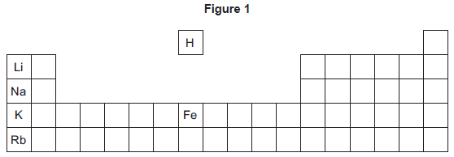
(i) Which one of these six elements has the lowest boiling point?
_____________________________________
(1)
(ii) Complete the sentence.
In the periodic table, rubidium (Rb) is in Group ____________ .
(1)
(iii) Which of these three elements is the most reactive?

Tick (✔) one box.
Lithium (Li)
Sodium (Na)
Potassium (K)
(1)
(iv) Which two statements are correct?

Tick (✔) two boxes.
Iron has a higher density than potassium.
Iron is softer than potassium.
Iron reacts vigorously with water.
Iron forms ions that have different charges.
(2)
(c) Figure 2 shows sodium being put into water.
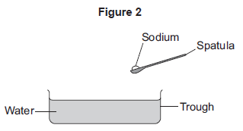
Describe three observations that can be seen when sodium is put into water.
1. _________________________________________________________________
___________________________________________________________________
2. _________________________________________________________________
___________________________________________________________________
3. _________________________________________________________________
___________________________________________________________________
(3)
(Total 11 marks)
Q9.
This question is about carbon and gases in the air.
(a) Carbon atoms have protons, neutrons and electrons.
Complete the table by writing the relative mass of a neutron and an electron.

Name of particle | Relative mass
proton | 1
neutron
electron
(2)
(b) What is the total number of protons and neutrons in an atom called?

Tick () one box.
The atomic number
The mass number
One mole of the atom
(1)
(c) An atom of carbon has six electrons.
Which structure, A, B or C, represents the electronic structure of the carbon atom?
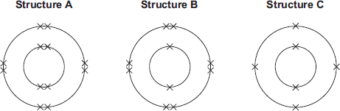

The carbon atom is structure
(1)
(d) Carbon reacts with oxygen to produce carbon dioxide (CO₂).
(i) How many different elements are in one molecule of carbon dioxide?
______________________________________________________________
(1)
(ii) What is the total number of atoms in one molecule of carbon dioxide?
______________________________________________________________
(1)
(e) Sometimes carbon reacts with oxygen to produce carbon monoxide (CO).
(i) Calculate the relative formula mass (M_{r}) of carbon monoxide.
Relative atomic masses (A_{r}): C = 12; O = 16
______________________________________________________________
______________________________________________________________
M_{r} of carbon monoxide = _______________
(1)
(ii) Calculate the percentage by mass of carbon in carbon monoxide.
______________________________________________________________
______________________________________________________________
Percentage by mass of carbon in carbon monoxide = _____%
(1)
(f) Carbon dioxide is one of the gases in the air.
(i) The graph shows the percentage of argon and the percentage of carbon dioxide in the air.
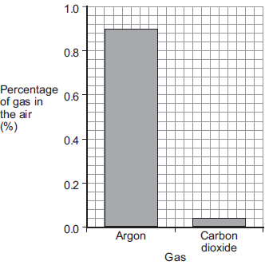
What is the percentage of argon in the air?
Percentage of argon = ____________________ %
(1)
(ii) An instrumental method is used to measure the amount of carbon dioxide in the air.
Give one reason for using an instrumental method.
______________________________________________________________
______________________________________________________________
(1)
(Total 10 marks)
Q10.
A student investigated the electrolysis of sodium chloride solution.
Figure 1 shows the apparatus.
Figure 1
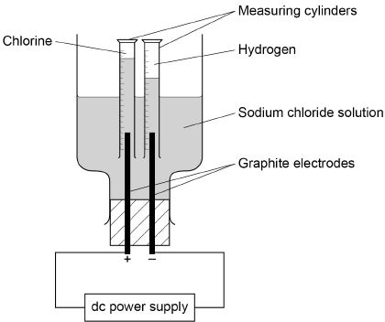
The student measured the volume of gas collected in each measuring cylinder every minute for 20 minutes.
(a) Figure 2 shows the volume of hydrogen gas collected in the measuring cylinder after 8 minutes.
Figure 2
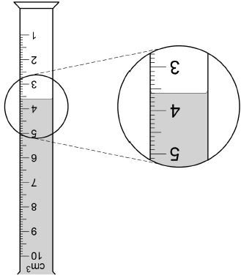
What is the volume of hydrogen gas collected?
Volume = ___________________ cm³
(1)
Figure 3 shows the results of the investigation.
Figure 3
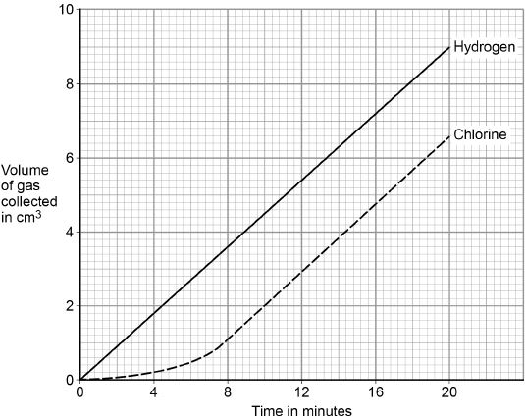
(b) Which of the lines on Figure 3 show that the volume of gas collected is directly proportional to the time?
Tick one box.

Both lines
Chlorine line only
Hydrogen line only
Neither line
(1)
(c) Which of the lines on Figure 3 show a positive correlation between the volume of gas collected and time?
Tick one box.

Both lines
Chlorine line only
Hydrogen line only
Neither line
(1)
A teacher demonstrates the electrolysis of different substances using graphite electrodes.
Figure 4 shows the apparatus used.
Figure 4
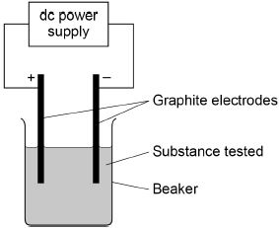
(d) Why can graphite conduct electricity?
Tick one box.

Graphite exists in layers of atoms.
Graphite has a giant structure.
Graphite has a high melting point.
Graphite has delocalised electrons.
(1)
(e) The teacher demonstrates the electrolysis of:
• molten zinc chloride
• potassium bromide solution.
Complete the table below to predict the products.
Choose answers from the box.

chlorine | bromine | hydrogen | oxygen | potassium | zinc

Substance electrolysed | Product at cathode (negative electrode) | Product at anode (positive electrode)
Molten zinc chloride
Potassium bromide solution
(4)
(Total 8 marks)
Q11.
This question is about different substances and their structures.
(a) Draw one line from each statement to the diagram which shows the structure.
Statement Structure
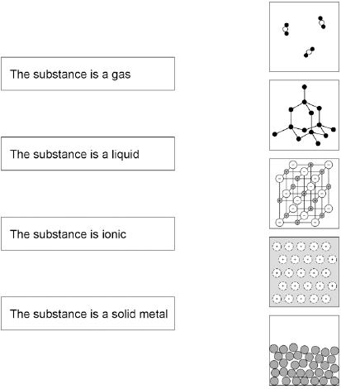
(4)
(b) Figure 1 shows the structure of an element.
Figure 1
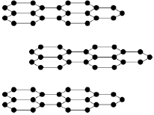
What is the name of this element?

Tick one box.
Carbon
Chloride
Nitrogen
Xenon
(1)
(c) Why does this element conduct electricity?

Tick one box.
It has delocalised electrons
It contains hexagonal rings
It has weak forces between the layers
It has ionic bonds
(1)
(d) Figure 2 shows the structure of an alloy.
Figure 2
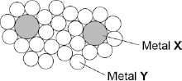
Explain why this alloy is harder than the pure metal Y.
___________________________________________________________________
___________________________________________________________________
___________________________________________________________________
___________________________________________________________________
(2)
(e) What percentage of the atoms in the alloys are atoms of X?
___________________________________________________________________
___________________________________________________________________
___________________________________________________________________
___________________________________________________________________
(2)
(f) What type of substance is an alloy?

Tick one box.
Compound
Element
Mixture
(1)
(Total 11 marks)
Q12.
This question is about zinc.
Figure 1 shows the electrolysis of molten zinc chloride.
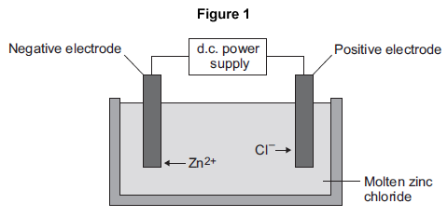
(a) Zinc chloride is an ionic substance.
Complete the sentence.
When zinc chloride is molten, it will conduct _________________________ .
(1)
(b) Zinc ions move towards the negative electrode where they gain electrons to produce zinc.
(i) Name the product formed at the positive electrode.
____________________________________
(1)
(ii) Explain why zinc ions move towards the negative electrode.
______________________________________________________________
______________________________________________________________
______________________________________________________________
______________________________________________________________
(2)
(iii) What type of reaction occurs when the zinc ions gain electrons?

Tick (✔) one box.
Neutralisation
Oxidation
Reduction
(1)
(c) Zinc is mixed with copper to make an alloy.
(i) Figure 2 shows the particles in the alloy and in pure zinc.
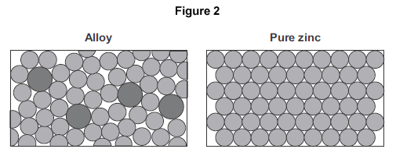
Use Figure 2 to explain why the alloy is harder than pure zinc.
______________________________________________________________
______________________________________________________________
______________________________________________________________
______________________________________________________________
(2)
(ii) Alloys can be bent. Some alloys return to their original shape when heated.
What name is used for these alloys?
______________________________________________________________
(1)
(Total 8 marks)
Q13.
The structures of four substances, A, B, C and D, are represented in Figure 1.
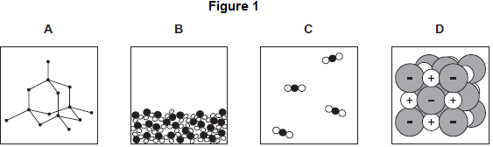
(a) Use the correct letter, A, B, C or D, to answer each question.

(i) | Which substance is a gas?
(1)

(ii) | Which substance is a liquid?
(1)

(iii) | Which substance is an element?
(1)

(iv) | Which substance is made of ions?
(1)
(b) Figure 2 shows the bonding in substance C.
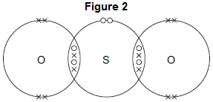
(i) What is the formula of substance C?
Draw a ring around the correct answer.

SO₂ | SO² | S₂O
(1)
(ii) Use the correct answer from the box to complete the sentence.

delocalised | shared | transferred
When a sulfur atom and an oxygen atom bond to produce substance C,
electrons are _____________________________________________
(1)
(iii) What is the type of bonding in substance C?
Draw a ring around the correct answer.

covalent | ionic | metallic
(1)
(Total 7 marks)
Q14.
The diagram shows a small part of the structure of silicon dioxide.
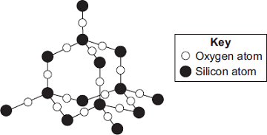
(a) Use the diagram above to answer the question.
Draw a ring around the correct answer to complete each sentence.

 | two
In silicon dioxide, each silicon atom is bonded with | three | oxygen atoms.
 | four

 | ionic.
The bonds in silicon dioxide are | covalent.
 | metallic.
(2)
(b)
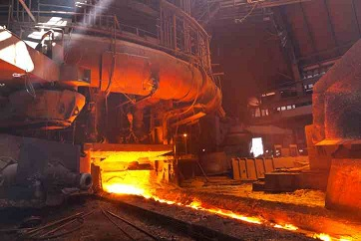
© Oleksiy Mark/iStock
Silicon dioxide is used as the inside layer of furnaces.
Suggest why.
___________________________________________________________________
___________________________________________________________________
(1)
(c) Nanowires can be made from silicon dioxide.
Draw a ring around the correct answer to complete the sentence.

 | brittle.
The word ‘nano’ means the wires are very | thick.
 | thin.
(1)
(Total 4 marks)
Q15.
The picture shows a student filling in a multiple choice answer sheet using a pencil.
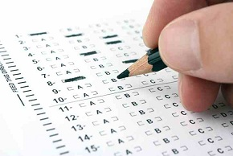
© Cihan Ta?k?n/iStock
The pencil contains graphite. Graphite rubs off the pencil onto the paper.
Diagrams 1 and 2 show how the atoms are arranged in graphite.
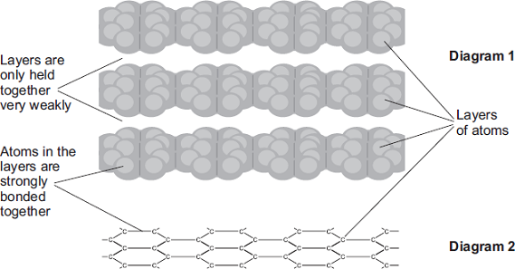
(a) Use the diagrams to help you explain why graphite can rub off the pencil onto the paper.
___________________________________________________________________
___________________________________________________________________
___________________________________________________________________
___________________________________________________________________
(2)
(b) Draw a ring around the type of bond which holds the atoms together in each layer.

covalent | ionic | metallic
(1)
(Total 3 marks)
Q16.
A student investigated the temperature change in displacement reactions between metals and copper sulfate solution.
This is the method used.
1. Measure 50 cm³ of the copper sulfate solution into a polystyrene cup.
2. Record the starting temperature of the copper sulfate solution.
3. Add the metal and stir the solution.
4. Record the highest temperature the mixture reaches.
5. Calculate the temperature increase for the reaction.
6. Repeat steps 1-5 with different metals.
(a) Draw one line from each type of variable to the name of the variable in the investigation.
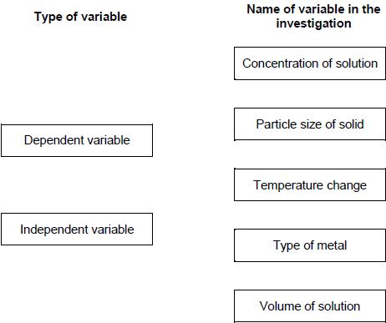
(2)
(b) The student used a polystyrene cup and not a glass beaker.
Why did this make the investigation more accurate?
Tick one box.

Glass is breakable
Glass is transparent
Polystyrene is a better insulator
Polystyrene is less dense
(1)
The table below shows the student’s results.

Metal | Temperature increase in °C
Magnesium | 38
Nickel | 8
Zinc | 16
(c) Complete Figure 1.
Use data from the table above.
Figure 1
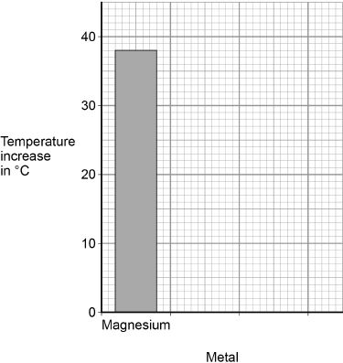
(2)
(d) The student concluded that the reactions between the metals and copper sulfate solution are endothermic.
Give one reason why this conclusion is not correct.
___________________________________________________________________
___________________________________________________________________
(1)
(e) The temperature increase depends on the reactivity of the metal.
Write the metals magnesium, nickel and zinc in order of reactivity.
Use the table above.
Most reactive _________________________
_________________________
Less reactive _________________________
(1)
(f) Y is an unknown metal.
Describe a method to find the position of Y in the reactivity series in Question (e)
___________________________________________________________________
___________________________________________________________________
___________________________________________________________________
___________________________________________________________________
___________________________________________________________________
___________________________________________________________________
___________________________________________________________________
___________________________________________________________________
(3)
Figure 2 shows the reaction profile for the reaction between zinc and copper sulfate solution.
Figure 2
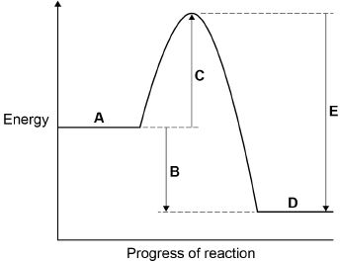
(g) Which letter represents the products of the reaction?
Tick one box.
(1)
(h) Which letter represents the activation energy?
Tick one box.
(1)
(Total 12 marks)
Q17.
A student investigated the reactivity of three different metals.
This is the method used.
1. Place 1 g of metal powder in a test tube.
2. Add 10 cm³ of metal sulfate.
3. Wait 1 minute and observe.
4. Repeat using the other metals and metal sulfates.
The student placed a tick in the table below if there was a reaction and a cross if there was no reaction.

 | Zinc | Copper | Magnesium
Copper sulfate
Magnesium sulfate
Zinc sulfate
(a) What is the dependent variable in the investigation?

Tick one box.
Time taken
Type of metal
Volume of metal sulfate
Whether there was a reaction or not
(1)
(b) Give one observation the student could make that shows there is a reaction between zinc and copper sulfate.
___________________________________________________________________
___________________________________________________________________
(1)
(c) The student used measuring instruments to measure some of the variables.
Draw one line from each variable to the measuring instrument used to measure the variable.

Variable |  | Measuring instrument
 |  | Balance
 |  | Measuring cylinder
Mass of metal powder
 |  | Ruler
 |  | Burette
Volume of metal sulfate
 |  | Theromometer
 |  | Test tube
(2)
(d) Use the results shown in table above to place zinc, copper and magnesium in order of reactivity.
Most reactive _____________________
_____________________
Least reactive _____________________
(1)
(e) Suggest one reason why the student should not use sodium in this investigation.
___________________________________________________________________
___________________________________________________________________
(1)
(f) Which metal is found in the Earth as the metal itself?

Tick one box.
Calcium
Gold
Lithium
Potassium
(1)
(g) Iron is found in the Earth as iron oxide (Fe₂O₃).
Iron oxide is reduced to produce iron.
Balance the equation for the reaction.
___Fe₂O₃ + ___C → ___Fe + ___CO₂
(1)
(h) Name the element used to reduce iron oxide.
___________________________________________________________________
(1)
(i) What is meant by reduction?

Tick one box.
Gain of iron
Gain of oxide
Loss of iron
Loss of oxygen
(1)
(Total 10 marks)
Q18.
A student investigated the reactivity of different metals.
The student used the apparatus shown in the figure below.
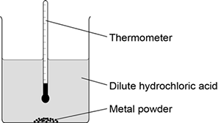
The student used four different metals.
The student measured the temperature rise for each metal three times.
The student’s results are shown in the table below.

Metal | Temperature rise in °C |  |  | Mean  temperature  rise in °C
 | Test 1 | Test 2 | Test 3
Calcium | 17.8 | 16.9 | 17.5
Iron | 6.2 | 6.0 | 6.1 | 6.1
Magnesium | 12.5 | 4.2 | 12.3 | 12.4
Zinc | 7.8 | 8.0 | 7.6 | 7.8
(a) Give two variables the student should control so that the investigation is a fair test.
1. _________________________________________________________________
___________________________________________________________________
2. _________________________________________________________________
___________________________________________________________________
(2)
(b) One of the results for magnesium is anomalous.
Which result is anomalous?
Suggest one reason why this anomalous result was obtained.
Result _____________________________________________________________
___________________________________________________________________
Reason ____________________________________________________________
___________________________________________________________________
(2)
(c) Calculate the mean temperature rise for calcium.
___________________________________________________________________
Mean temperature rise = _______________ °C
(1)
(d) The temperature rose when the metals were added to sulfuric acid.
Give one other observation that might be made when the metal was added to sulfuric acid.
How would this observation be different for the different metals?
___________________________________________________________________
___________________________________________________________________
___________________________________________________________________
___________________________________________________________________
(2)
(e) Aluminium is more reactive than iron and zinc but less reactive than calcium and magnesium.
Predict the temperature rise when aluminium is reacted with dilute hydrochloric acid.
___________________________________________________________________
Temperature rise = _______________ °C
(1)
(Total 8 marks)
Q19.
A student investigated the energy change occurring in the endothermic reaction between potassium hydrogencarbonate and hydrochloric acid.
Figure 1 shows the apparatus used.
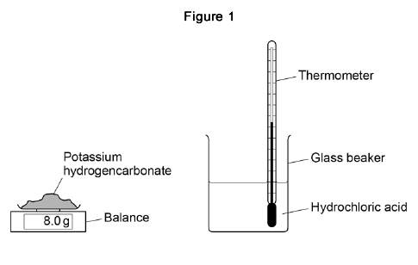
This is the method used.
1. Measure 50 cm³ hydrochloric acid into a glass beaker.
2. Measure 1.0 g of potassium hydrogencarbonate.
3. Add the potassium hydrogencarbonate to the hydrochloric acid.
4. Stir until all the potassium hydrogencarbonate has reacted.
5. Record the lowest temperature reached.
6. Repeat steps 1‒5 two more times.
7. Repeat steps 1‒6 with different masses of potassium hydrogencarbonate.
(a) Which is the most suitable apparatus to use to measure 50 cm³ of hydrochloric acid?
Tick (✔) one box.

Balance
Conical flask
Gas syringe
Measuring cylinder
(1)
(b) The student used a glass beaker for the reaction.
Suggest one change to the apparatus that would improve the accuracy of the results.
Give a reason for your answer.
___________________________________________________________________
___________________________________________________________________
___________________________________________________________________
___________________________________________________________________
(2)
(c) Which two variables should the student keep the same to make this a fair test?
Tick two boxes.

Mass of potassium hydrogencarbonate
Same balance
Same thermometer
Starting temperature of hydrochloric acid
Volume of hydrochloric acid
(2)
(d) Figure 2 shows part of the thermometer used to measure the temperature.
What is the temperature reading on the thermometer?
Temperature = ___________ °C
(1)
The table shows a set of results.

 | Test 1 | Test 2 | Test 3
Lowest temperature in °C | 16.1 | 15.8 | 15.9
(e) What is the range of the lowest temperature?
From _________ °C to _________ °C
(1)
(f) Calculate the mean lowest temperature.
Use the table above.
___________________________________________________________________
___________________________________________________________________
___________________________________________________________________
Mean lowest temperature = ______________________ °C
(2)
(g) How do the results show that the reaction is endothermic?
___________________________________________________________________
___________________________________________________________________
(1)
The graph shows the student’s results.
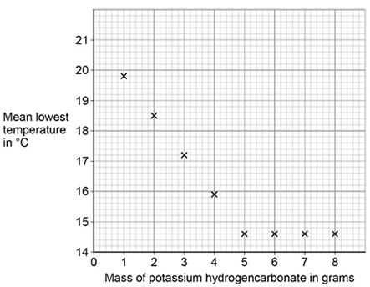
(h) Draw two straight lines of best fit on the graph above.
(2)
(i) Describe how the lowest temperature changes as the mass of potassium hydrogencarbonate added increases.
___________________________________________________________________
___________________________________________________________________
___________________________________________________________________
___________________________________________________________________
___________________________________________________________________
___________________________________________________________________
(3)
(Total 15 marks)
Q20.
This question is about energy changes in chemical reactions.
(a) Complete the word equation for the combustion of hydrogen.
hydrogen + oxygen → ___________________
(1)
(b) Figure 1 shows a simple energy level diagram.
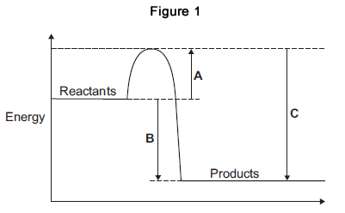
(i) Which arrow, A, B or C, shows the activation energy?

Tick (✔) one box.
A
B
C
(1)
(ii) What type of reaction is shown by the energy level diagram in Figure 1?
Give a reason for your answer.
Type of reaction _________________________________________________
Reason _______________________________________________________
______________________________________________________________
(2)
(iii) For a reaction, the value of A is 1370 kJ and C is 3230 kJ.
Calculate the value of B.
______________________________________________________________
______________________________________________________________
B = _______________________________ kJ
(1)
(c) Alcohols are used as fuels.
A group of students investigated the amount of energy released when different alcohols are burned.
The students used the apparatus shown in Figure 2.
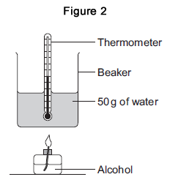
(i) Figure 3 shows the start temperature and the final temperature of the water.
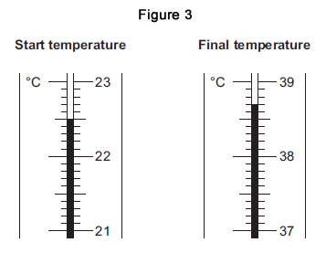
Write the start temperature and the final temperature of the water in Table 1.
Work out the increase in temperature to complete Table 1.

Table 1
Start temperature of the water in °C
Final temperature of the water in °C
Increase in temperature in °C
(3)
(ii) The students worked out the heat energy released by burning 1 g of each alcohol.
The students used the equation:
Heat energy released = m × 4.2 × increase in temperature
Look at Figure 2. What is the value of m?
m = _______________________________ g
(1)
(iii) Table 2 shows the students’ results.

Table 2
Name of alcohol | Number of carbon atoms in one molecule of alcohol | Heat energy released when 1 g of alcohol is burned in kJ
Methanol | 1 | 11.4
Ethanol | 2 | 13.5
Propanol | 3 | 20.1
Butanol | 4 | 16.8
Pentanol | 5 | 17.2
Which value of heat energy released is anomalous?
____________________________________
(1)
(iv) Look at Table 2.
What is the relationship between the number of carbon atoms in one molecule of alcohol and the heat energy released when 1 g of the alcohol is burned?
______________________________________________________________
______________________________________________________________
(1)
(v) The value in a data book for the amount of heat energy released when 1 g of butanol is burned completely is 36.2 kJ.
Suggest two reasons why the students’ result for butanol is lower than the data book value.
1. ____________________________________________________________
______________________________________________________________
2. ____________________________________________________________
______________________________________________________________
(2)
(vi) The displayed structure of butanol is:
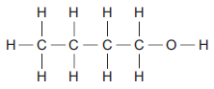
What is the functional group of the alcohol?

Tick (✔) one box.
–– C –– C
–– C –– H
–– O –– H
(1)
(Total 14 marks)
Q21.
A camping stove uses propane gas.
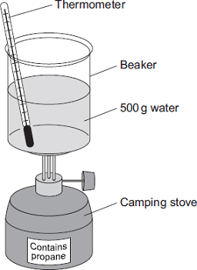
(a) A student did an experiment to find the energy released when propane is burned.
The student:
• put 500 g water into a beaker
• measured the temperature of the water
• heated the water by burning propane for 1 minute
• measured the temperature of the water again.
The student found the temperature change was 20 °C.
The student can calculate the energy released, in joules (J), using the equation:
energy released (J) = mass of water (g) × 4.2 × temperature change (°C)
(i) Use the student’s result to calculate the energy released in joules (J).
______________________________________________________________
______________________________________________________________
Energy released = _________________________ J
(2)
(ii) State two safety precautions that the student should take during the experiment.
1. ____________________________________________________________
______________________________________________________________
2. ____________________________________________________________
______________________________________________________________
(2)
(iii) Tick () two boxes which describe how the student could make his result more accurate.

Tick ()
Stir the water before measuring the temperature.
Heat the water until it boils.
Place a lid on the beaker.
Use a larger beaker for the water.
(2)
(b) The change in energy when propane is burned can be shown in an energy level diagram.
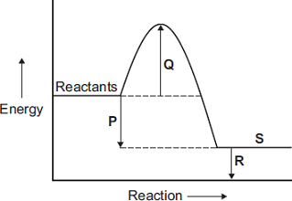
Draw one line from each description to the correct letter.

Description |  | Letter
 |  | P
products
 |  | Q
activation energy
 |  | R
energy released by the reaction
 |  | S
(3)
(c) Propane and hydrogen are both used as fuels.
Some information about propane and hydrogen is given in the table.

Fuel | Resource | Products formed when fuel burned
propane | crude oil | carbon dioxide and water
hydrogen | water | water
Use the information in the table to suggest two disadvantages that propane has as a fuel compared to hydrogen.
1. _________________________________________________________________
___________________________________________________________________
2. _________________________________________________________________
___________________________________________________________________
(2)
(Total 11 marks)
Q22.
Hydrogen peroxide decomposes slowly to give water and oxygen.
The reaction is exothermic.

2H₂O₂ | → | 2H₂O | + | O₂
(a) In an exothermic reaction, energy is given out.
Draw a ring around the correct answer to complete the sentence.

 | goes down.
In an exothermic reaction, the temperature | goes up.
 | stays the same.
(1)
(b) The energy level diagram for this reaction is shown below.
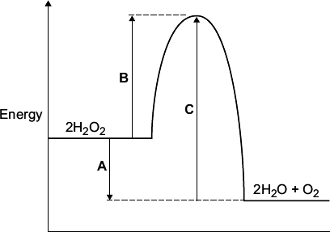
The energy changes, A, B and C, are shown on the diagram.
Use the diagram to help you answer these questions.

(i) | Which energy change, A, B or C, is the activation energy?
(1)

(ii) | Which energy change, A, B or C, shows that this reaction is exothermic?
(1)
(iii) Hydrogen peroxide decomposes quickly when a small amount of manganese(IV) oxide is added.
Draw a ring around the correct answer to complete each sentence.
Hydrogen peroxide decomposes quickly because

 | a catalyst.
manganese(IV) oxide is | an element.
 | a solid.

 | activation energy.
The manganese(IV) oxide has lowered the | boiling point.
 | temperature.
(2)
(c) A student did an experiment to find the amount of energy produced when hydrogen peroxide solution is decomposed using manganese(IV) oxide.
The apparatus the student used is shown in the diagram.
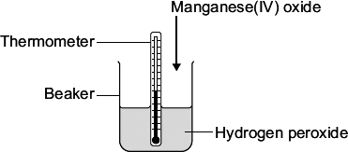
The student first measured the temperature of the hydrogen peroxide. Then the student added the manganese(IV) oxide, stirred the mixture and recorded the highest temperature.
(i) Suggest why the student stirred the mixture before recording the highest temperature.
______________________________________________________________
______________________________________________________________
(1)
(ii) The biggest error in this experiment is heat loss.
Suggest how the student could change the apparatus so that less heat is lost.
______________________________________________________________
______________________________________________________________
(1)
(Total 7 marks)

Section 2: Required Practicals

Q23.
Some students investigated the energy changes occurring in the reaction between potassium hydrogencarbonate and hydrochloric acid.
The equation for the reaction is:
KHCO₃(s) + HCl(aq) ⟶ KCl(aq) + CO₂(g) + H₂O(l)
This is the method used.
1. Measure 50 cm³ hydrochloric acid into a glass beaker.
2. Measure the temperature of the hydrochloric acid.
3. Measure a given mass of potassium hydrogencarbonate.
4. Add the potassium hydrogencarbonate to the hydrochloric acid.
5. Stir until all the potassium hydrogencarbonate has reacted.
6. Record the lowest temperature reached.
7. Repeat three more times, using the same mass of potassium hydrogencarbonate.
Each student used a different mass of potassium hydrogencarbonate.
(a) The method described will not give very accurate results.
Suggest one change to the apparatus that would improve the accuracy of the results.
Give a reason for your answer.
___________________________________________________________________
___________________________________________________________________
___________________________________________________________________
___________________________________________________________________
(2)
(b) The students controlled the volume of the hydrochloric acid.
Give one other control variable the students should use.
___________________________________________________________________
___________________________________________________________________
(1)
(c) The table shows one student’s results.

 | Trial 1 | Trial 2 | Trial 3 | Trial 4
Initial temperature in °C | 21.2 | 21.1 | 21.0 | 21.1
Final temperature in °C | 15.6 | 15.4 | 15.6 | 16.6
Temperature decrease in °C | 5.6 | 5.7 | 5.4 | 4.5
Calculate the mean temperature decrease for the results shown in the table above.
Ignore any anomalous results.
Give your answer to 1 decimal place.
Give the uncertainty in your answer.
___________________________________________________________________
___________________________________________________________________
___________________________________________________________________
Mean = __________ °C ± __________ °C
(3)
The graph below shows the students’ results.
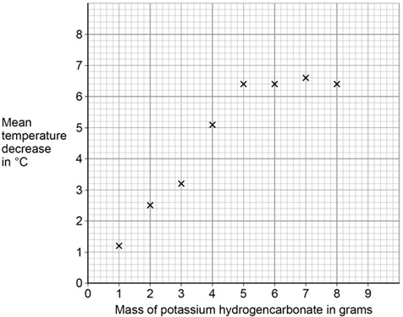
(d) Draw two intersecting straight lines of best fit on the graph above.
(2)
(e) Explain why the graph has this shape.
Use data from the graph.
___________________________________________________________________
___________________________________________________________________
___________________________________________________________________
___________________________________________________________________
___________________________________________________________________
___________________________________________________________________
(3)
(f) Suggest a possible reason for the anomalous points.
Do not include errors in measuring.
___________________________________________________________________
___________________________________________________________________
(1)
(Total 12 marks)
Q24.
Soluble salts are formed by reacting metal oxides with acids.
(a) Give one other type of substance that can react with an acid to form a soluble salt.
___________________________________________________________________
(1)
(b) Calcium nitrate contains the ions Ca²⁺ and NO₃⁻
Give the formula of calcium nitrate.
___________________________________________________________________
(1)
(c) Describe a method to make pure, dry crystals of magnesium sulfate from a metal oxide and a dilute acid.
___________________________________________________________________
___________________________________________________________________
___________________________________________________________________
___________________________________________________________________
___________________________________________________________________
___________________________________________________________________
___________________________________________________________________
___________________________________________________________________
___________________________________________________________________
___________________________________________________________________
___________________________________________________________________
___________________________________________________________________
___________________________________________________________________
___________________________________________________________________
___________________________________________________________________
___________________________________________________________________
___________________________________________________________________
___________________________________________________________________
___________________________________________________________________
___________________________________________________________________
(6)
(Total 8 marks)
Q25.
A student investigated the temperature change when zinc reacts with copper sulfate solution.
The student used a different concentration of copper sulfate solution for each experiment.
The student used the apparatus shown below.
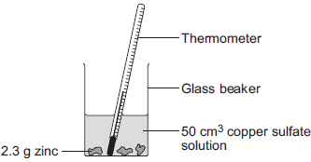
The student:
• measured 50 cm³ copper sulfate solution into a glass beaker
• measured the temperature of the copper sulfate solution
• added 2.3 g zinc
• measured the highest temperature
• repeated the experiment using copper sulfate solution with different concentrations.
The equation for the reaction is:
Zn(s) + CuSO₄(aq) Cu(s) + ZnSO₄(aq)
zinc + copper sulfate solution copper + zinc sulfate solution
(a) The thermometer reading changes during the reaction.
Give one other change the student could see during the reaction.
___________________________________________________________________
___________________________________________________________________
(1)
(b) Suggest one improvement the student could make to the apparatus.
Give a reason why this improves the investigation.
Improvement ________________________________________________________
___________________________________________________________________
Reason ____________________________________________________________
___________________________________________________________________
(2)
(c) In this question you will be assessed on using good English, organising information clearly and using specialist terms where appropriate.
The student’s results are shown in the table below.

Experiment number | Concentration of  copper sulfate  in moles per dm³ | Increase in temperature in °C
1 | 0.1 | 5
2 | 0.2 | 10
3 | 0.3 | 12
4 | 0.4 | 20
5 | 0.5 | 25
6 | 0.6 | 30
7 | 0.7 | 35
8 | 0.8 | 35
9 | 0.9 | 35
10 | 1.0 | 35
Describe and explain the trends shown in the student’s results.
___________________________________________________________________
___________________________________________________________________
___________________________________________________________________
___________________________________________________________________
___________________________________________________________________
___________________________________________________________________
___________________________________________________________________
___________________________________________________________________
___________________________________________________________________
___________________________________________________________________
(6)
(Total 9 marks)
Q26.
A student makes a hypothesis:
‘When different salt solutions are electrolysed with inert electrodes, the product at the negative electrode is always a metal’.
(a) Describe how you would test this hypothesis in the laboratory.
You should:
• draw a labelled diagram of the apparatus
• give the independent variable
• describe what you would see at the negative electrode if the hypothesis is true.
Diagram

Independent variable _________________________________________________
___________________________________________________________________
Observation _________________________________________________________
___________________________________________________________________
(5)
(b) The student’s hypothesis is only partially correct.
Explain why the product at the negative electrode is not always a metal.
___________________________________________________________________
___________________________________________________________________
___________________________________________________________________
___________________________________________________________________
(2)
(c) Predict the product at the positive electrode in the electrolysis of:
• sodium chloride solution
• copper sulfate solution.
Sodium chloride solution _______________________________________________
Copper sulfate solution ________________________________________________
(2)
(Total 9 marks)
Q27.
Diagram 1 shows the apparatus used to electrolyse magnesium sulfate solution.
Diagram 1
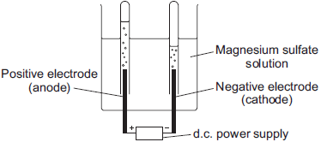
Gases were given off at both electrodes.
(a) The gas collected at the anode was oxygen.
Draw one line from the test for oxygen to the correct result.
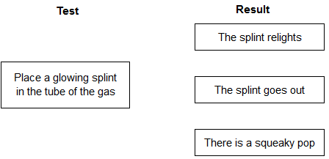
(1)
(b) (i) The gas collected at the cathode was hydrogen.
Describe how to test the gas to show that it is hydrogen.
Test __________________________________________________________
______________________________________________________________
Result ________________________________________________________
______________________________________________________________
(2)
(ii) Why is hydrogen, and not magnesium, produced at the cathode?
______________________________________________________________
______________________________________________________________
(1)
(c) A student wanted to use electrolysis to silver plate a metal spoon.
(i) Give one reason why metal spoons are sometimes silver plated.
______________________________________________________________
______________________________________________________________
(1)
(ii) Diagram 2 shows the apparatus the student used. The student did not set the apparatus up correctly.
Diagram 2
d.c. power
supply
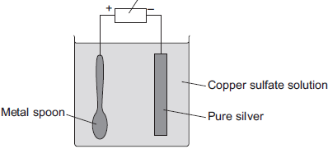
The student found that the metal spoon eroded and a thin layer of copper formed on the pure silver electrode.
Suggest two changes that the student must make to his apparatus to be able to silver plate the metal spoon. Give a reason for each change.
______________________________________________________________
______________________________________________________________
______________________________________________________________
______________________________________________________________
______________________________________________________________
______________________________________________________________
______________________________________________________________
(4)
(iii) Why is it difficult to electroplate plastic spoons?
______________________________________________________________
______________________________________________________________
(1)
(Total 10 marks)
Q28.
A student investigated the conductivity of different concentrations of sodium chloride solution.
The student set the apparatus up as shown in Figure 1.
Figure 1
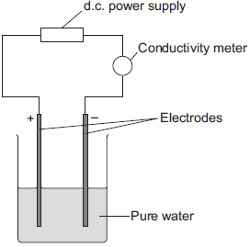
The student measured the conductivity of the pure water with a conductivity meter.
The reading on the conductivity meter was zero.
(a) The student:
• added sodium chloride solution one drop at a time
• stirred the solution
• recorded the reading on the conductivity meter.
The student’s results are shown in the table below.

Number of drops of  sodium chloride solution  added | Relative conductivity  of solution
0 | 0
1 | 100
2 | 120
3 | 310
4 | 400
5 | 510
6 | 590
7 | 710
8 | 800
(i) The student plotted the results on the grid shown in Figure 2.
Plot the four remaining results.
Draw a line of best fit, ignoring the anomalous result.
Figure 2
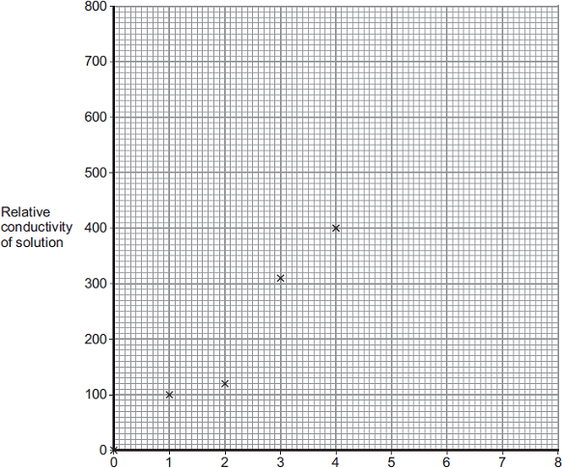
Number of drops of sodium chloride added
(3)
(ii) One of the points is anomalous.
Suggest one error that the student may have made to cause the anomalous result.
______________________________________________________________
______________________________________________________________
(1)
(iii) The student wanted to compare the conductivity of sodium chloride solution with the conductivity of potassium chloride solution.
State one variable he should keep constant when measuring the conductivity of the two solutions.
______________________________________________________________
(1)
(b) (i) Explain, in terms of bonding, why pure water does not conduct electricity.
______________________________________________________________
______________________________________________________________
______________________________________________________________
______________________________________________________________
(2)
(ii) Explain why sodium chloride solution conducts electricity.
______________________________________________________________
______________________________________________________________
______________________________________________________________
______________________________________________________________
(2)
(iii) After he had added sodium chloride solution, the student noticed bubbles of gas at the negative electrode.
Complete the sentence.
The gas produced at the negative electrode is __________________
(1)
(Total 10 marks)

Section 3: 6 Mark Questions

Q29.
This question is about Group 7 elements.
Chlorine is more reactive than iodine.
(a) Name the products formed when chlorine solution reacts with potassium iodide solution.
___________________________________________________________________
___________________________________________________________________
(1)
(b) Explain why chlorine is more reactive than iodine.
___________________________________________________________________
___________________________________________________________________
___________________________________________________________________
___________________________________________________________________
___________________________________________________________________
___________________________________________________________________
(3)
(c) Chlorine reacts with hydrogen to form hydrogen chloride.
Explain why hydrogen chloride is a gas at room temperature.
Answer in terms of structure and bonding.
___________________________________________________________________
___________________________________________________________________
___________________________________________________________________
___________________________________________________________________
___________________________________________________________________
___________________________________________________________________
(3)
(d) Bromine reacts with methane in sunlight.
The diagram below shows the displayed formulae for the reaction of bromine with methane.
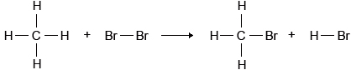
The table below shows the bond energies and the overall energy change in the reaction.

 | C—H | Br—Br | C—Br | H—Br | Overall energy change
Energy in kJ/mol | 412 | 193 | X | 366 | −51
Calculate the bond energy X for the C—Br bond.
Use the diagram and the table above.
___________________________________________________________________
___________________________________________________________________
___________________________________________________________________
___________________________________________________________________
___________________________________________________________________
___________________________________________________________________
___________________________________________________________________
Bond energy X = _______________ kJ/mol
(4)
(Total 11 marks)
Q30.
This question is about some compounds of iodine.
(a) Lead iodide can be made by mixing a solution containing lead ions with a solution containing iodide ions.
Lead iodide is formed as a precipitate.
Pb²⁺(aq) + 2l–(aq) → Pbl₂(s)
(i) The table below gives information about the solubility of some compounds.

Soluble compounds | Insoluble compounds
all sodium and potassium salts
all nitrates
most chlorides, bromides and iodides | silver and lead chlorides, bromides and iodides
Use the table to help you name:
a soluble compound which contains lead ions ___________________
a soluble compound which contains iodide ions __________________
(2)
(ii) Suggest a method of separating the lead iodide from the solution.
______________________________________________________________
(1)
(b) Magnesium iodide can be made by reacting magnesium with iodine.
Mg + I₂ → MgI₂
Magnesium iodide is an ionic compound. It contains magnesium ions (Mg²⁺) and iodide ions (I⁻).
Describe, in terms of electrons, what happens when magnesium reacts with iodine.
___________________________________________________________________
___________________________________________________________________
___________________________________________________________________
___________________________________________________________________
___________________________________________________________________
___________________________________________________________________
___________________________________________________________________
___________________________________________________________________
___________________________________________________________________
___________________________________________________________________
___________________________________________________________________
(4)
(c) The diagram shows the structure of potassium iodide.
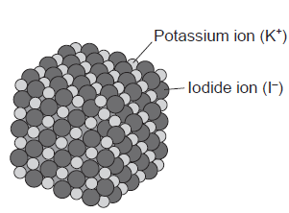
Explain why a high temperature is needed to melt potassium iodide.
___________________________________________________________________
___________________________________________________________________
___________________________________________________________________
___________________________________________________________________
(2)
(Total 9 marks)
Q31.
This question is about elements and the periodic table.
(a) Newlands and Mendeleev both produced early versions of the periodic table.
(i) Complete the sentence.
In their periodic tables, Newlands and Mendeleev arranged the elements in
order of __________________________ .
(1)
(ii) Name the particle that allowed the elements to be arranged in order of their atomic number in the modern periodic table.
____________________________________
(1)
(b) The diagram below shows the position of nine elements in the modern periodic table.
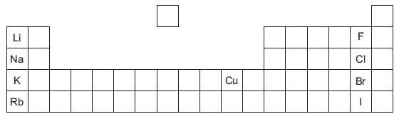
(i) Which one of the nine elements shown in the diagram above has the lowest boiling point?
____________________________________
(1)
(ii) Copper and potassium have different melting points and boiling points.
Give one other difference between the properties of copper and potassium.
______________________________________________________________
______________________________________________________________
(1)
(iii) Explain why the reactivity of the elements increases going down Group 1 from lithium to rubidium but decreases going down Group 7 from fluorine to iodine.
______________________________________________________________
______________________________________________________________
______________________________________________________________
______________________________________________________________
______________________________________________________________
______________________________________________________________
______________________________________________________________
______________________________________________________________
______________________________________________________________
______________________________________________________________
______________________________________________________________
______________________________________________________________
(4)
(Total 8 marks)
Q32.
The diagram represents a magnesium atom.
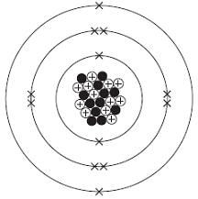
(a) Use words from the box to answer these questions.

electron | neutron | nucleus | proton
(i) What is the name of the central part of the atom? ______________________
(1)
(ii) What is the name of the particle with no charge? _______________________
(1)
(iii) What is the name of the particle with a negative charge? _________________
(1)
(b) Use the diagram above to help you answer these questions.
(i) Draw a ring around the atomic (proton) number of this magnesium atom.

12 | 24 | 36
(1)
(ii) Draw a ring around the mass number of this magnesium atom.

12 | 24 | 36
(1)
(c) The diagram shows how magnesium and iodine atoms form magnesium iodide.
Only the outer electrons are shown.
The dots (●) and crosses (×) are used to represent electrons.
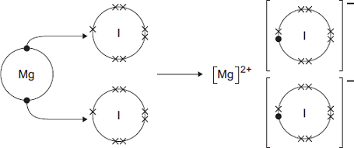
Use the diagram to help you to answer this question.
Describe, as fully as you can, what happens when magnesium reacts with iodine to make magnesium iodide.
To gain full marks you should use the words atom, electron and ion in your answer.
___________________________________________________________________
___________________________________________________________________
___________________________________________________________________
___________________________________________________________________
___________________________________________________________________
___________________________________________________________________
___________________________________________________________________
___________________________________________________________________
___________________________________________________________________
___________________________________________________________________
(4)
(Total 9 marks)
Q33.
The article gives some information about graphene.

Nanotunes!
Carbon can be made into nano-thin, strong sheets called graphene.
A graphene sheet is a single layer of graphite.
Graphene conducts electricity and is used in loudspeakers.
The picture shows the structure of graphene.
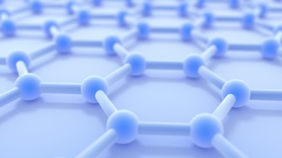
© 7immy/iStock
(a) Use the picture and your knowledge of bonding in graphite to:
(i) explain why graphene is strong;
______________________________________________________________
______________________________________________________________
______________________________________________________________
______________________________________________________________
______________________________________________________________
______________________________________________________________
(3)
(ii) explain why graphene can conduct electricity.
______________________________________________________________
______________________________________________________________
______________________________________________________________
______________________________________________________________
______________________________________________________________
______________________________________________________________
(2)
(b) Graphite is made up of layers of graphene.
Explain why graphite is a lubricant.
___________________________________________________________________
___________________________________________________________________
___________________________________________________________________
___________________________________________________________________
(2)
(Total 7 marks)
Q34.
In this question you will be assessed on using good English, organising information clearly and using specialist terms where appropriate.
Explain why chlorine (Cl₂) is a gas at room temperature, but sodium chloride (NaCl) is a solid at room temperature.
Chlorine Sodium chloride
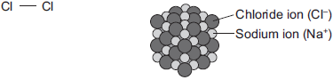
Include a description of the bonding and structure of chlorine and sodium chloride in your answer.
_______________________________________________________________________
_______________________________________________________________________
_______________________________________________________________________
_______________________________________________________________________
_______________________________________________________________________
_______________________________________________________________________
_______________________________________________________________________
_______________________________________________________________________
_______________________________________________________________________
_______________________________________________________________________
_______________________________________________________________________
_______________________________________________________________________
Extra space _____________________________________________________________
_______________________________________________________________________
_______________________________________________________________________
_______________________________________________________________________
_______________________________________________________________________
(Total 6 marks)
Q35.
Graphite and diamond are different forms of the element carbon.
Graphite and diamond have different properties.
The structures of graphite and diamond are shown below.
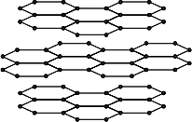 | 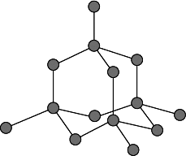
Graphite | Diamond
(a) Graphite is softer than diamond.
Explain why.
___________________________________________________________________
___________________________________________________________________
___________________________________________________________________
___________________________________________________________________
___________________________________________________________________
___________________________________________________________________
___________________________________________________________________
___________________________________________________________________
(4)
(b) Graphite conducts electricity, but diamond does not.
Explain why.
___________________________________________________________________
___________________________________________________________________
___________________________________________________________________
___________________________________________________________________
___________________________________________________________________
___________________________________________________________________
(3)
(Total 7 marks)

Section 1: Knowledge Mark Scheme
Q1.
(a) 7
1
(b) small molecule
1
(c) F₂
1
(d) the reactivity decreases (going down Group 7)
allow the reactivity decreases from chlorine to iodine
1
(because) chlorine displaces bromine and iodine
allow (because) chlorine has two reactions
allow (because) neither bromine nor iodine can displace chlorine
1
(and) bromine displaces iodine or iodine does not react
allow (and) bromine has one reaction
or iodine has no reactions
allow (and) iodine cannot displace bromine
1
(e) 80
1
(f) (1.2 kg =) 1200 (g)
or (900 g =) 0.9 (kg)
1
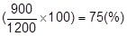
or
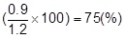
allow an answer correctly calculated from:
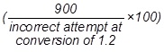
or
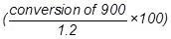
1
an answer of 75 (%) scores 2 marks
[9]
Q2.
(a) nucleus
1
neutron
1
neutron
1
electron
1
proton
1
must be in this order
(b) 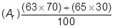
1
= 63.6
1
an answer of 63.6 scores 2 marks
(c) copper / Cu
allow ecf from answer to question (b)
1
(d) 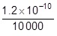
or
1.2 × 10⁻¹⁰ × 1 × 10⁻⁴
1
= 1.2 × 10⁻¹⁴ (m)
1
an answer of 1.2 × 10⁻¹⁴ (m) scores 2 marks
a correct answer not in standard form scores 1 mark
[10]
Q3.
(a) sodium oxide
allow Na₂O
1
(b) oxidation
1
(c) 13
1
(d) sodium hydroxide
1
(e) OH⁻
1
(f) 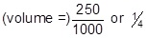
or 0.25 (dm³)
1
or
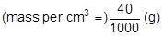
or 0.04 (g)
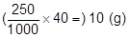
1
an answer of 10 (g) scores 2 marks
(g) all points correct
allow a tolerance of ±½ a small square
allow 1 mark for 3 points correct
ignore any attempt at a line of best fit
2
(h) 39 °C
allow any value from 34 to 46 (°C)
1
[10]
Q4.
(a) reactant
1
(b) reversible
1
(c) blue
allow shades of blue, e.g. pale blue
1
(d) 1.6 (g)
1
(e) 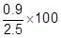
1
= 36 (%)
1
an answer of 36 (%) scores 2 marks
(f)
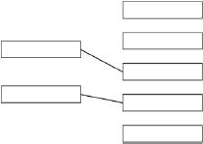
copper sulfate − CuSO₄
1
water − H₂O
1
[8]
Q5.
(a) proton
1
(b) electron
1
(c) 7
1
4
1
in this order only
(d) isotopes
1
(e) neutron
1
(f) 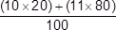
1
= 10.8
1
an answer of 10.8 scores 2 marks
(g) 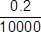
1
= 2 × 10⁻⁵ (nm)
allow 0.00002 (nm)
1
an answer of 2 × 10⁻⁵ (nm) scores 2 marks
[10]
Q6.
(a) B
1
(b) D
1
(c) E
1
(d) C
1
(e) 92.5 × 6 and
7× 7.5
1
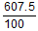
1
6.075
1
6.08
1
allow 6.08 with no working shown for 4 marks
[8]
Q7.
(a) (i) 7
1
(ii) –1
1
(iii) neutrons
1
(b) number of protons
1
(c) atom Y
1
(d) (i) Ne
allow neon
1
(ii) has a full outer shell
allow in Group 0
allow a noble gas
or
full outer energy level
allow the shells are full
or
has 8 electrons in its outer shell
ignore in Group 8
1
[7]
Q8.
(a) atomic weights
must be in this order
1
electrons
1
proton numbers
1
(b) (i) H/hydrogen
allow H₂ or h
1
(ii) one / 1
allow alkali metals
1
(iii) Potassium (K)
1
(iv) Iron has a higher density than potassium
1
Iron forms ions that have different charges
1
(c) any three from:
• melts
• fizzes / bubbles / effervesces
allow gas produced
• sodium floats
• size of the sodium decreases
allow dissolves / disappears
• sodium moves
allow two marks for moves around on the surface of the water
3
[11]
Q9.
(a) 1
must be in this order
1
very small
accept negligible, 1 / 2000
allow zero
1
(b) The mass number
1
(c) C
1
(d) (i) 2
1
(ii) 3
1
(e) (i) 28
1
(ii) 42.9
accept ecf from (e)(i)
accept 42 - 43
1
(f) (i) 0.9
1
(ii) any one from:
• accurate
• sensitive
• rapid
• small sample.
1
[10]
Q10.
(a) 3.6 (cm³)
1
(b) hydrogen line only
1
(c) both lines
1
(d) graphite has delocalised electrons
1
(e) cathode anode
zinc (1) chlorine (1)
do not accept chloride
allow 1 mark if chlorine and zinc the wrong way around
1+1
hydrogen (1) bromine (1)
do not accept bromide
allow 1 mark if bromine and hydrogen the wrong way around
1+1
[8]
Q11.
(a) Statement Structure
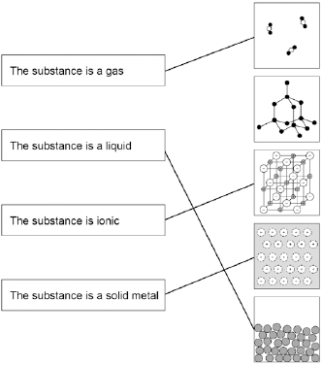
more than one line drawn from a variable negates the mark
4
(b) Carbon
1
(c) It has delocalised electrons
1
(d) the atoms / particles / ions are different sizes
do not accept molecules
1
so there are no rows / layers to slide
accept the layers are disrupted
1
(e) 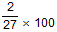
1
7.4%
1
allow 7.4% with no working shown for 2 marks
(f) Mixture
1
[11]
Q12.
(a) electricity
allow an electric current
1
(b) (i) chlorine/Cl₂
do not accept chloride
1
(ii) (zinc ions are) positive
ignore to gain electrons
1
and (opposite charges) attract
1
(iii) reduction
1
(c) (i) in alloy:
accept converse
different sized atoms/particles
or
no layers/rows
accept layers distorted
1
so cannot slide
1
(ii) shape memory (alloys)
accept smart
1
[8]
Q13.
(a) (i) C
1
(ii) B
1
(iii) A
1
(iv) D
1
(b) (i) SO₂
1
(ii) shared
1
(iii) covalent
1
[7]
Q14.
(a) four
1
covalent
1
(b) because it has a high melting point
accept it won’t melt
accept it won’t decompose or react
allow withstand high temperatures
ignore boiling point
1
(c) thin
1
[4]
Q15.
(a) layers
which have weak forces / attractions / bonds between them
second mark must be linked to layers
1
or
which can slide over each other or separate
ignore references to rubbing
1
(b) covalent
1
[3]
Q16.
(a)
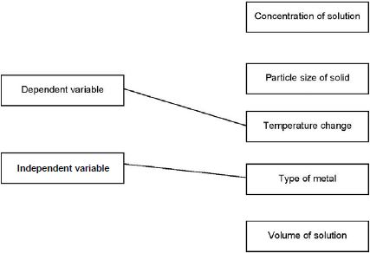
allow one mark if answers are reversed
1
1
(b) polystyrene is a better insulator
1
(c) both bars labelled
1
both bars correctly plotted
allow tolerance of ±½ small square
ignore width and spacing of bars
if no other mark scored, allow 1 mark for any one bar correctly plotted and labelled
1
(d) temperature increases
allow (because) energy / ‘heat’ is transferred to the surroundings
or
temperature does not decrease
energy / ‘heat’ is not taken in from the surroundings
allow the energy of the products is less than the energy of the reactants
1
(e) (most reactive)
magnesium
(zinc)
nickel
this order only
1
(f) suitable method described
1
the observations / measurements required to place in order
1
an indication of how results would be used to place the unknown metal in the reactivity series
1
approaches that could be used:
approach 1:
add the unknown metal to copper sulfate solution (1)
measure temperature change (1)
place the metals in order of temperature change (1)
approach 2:
add the metal to salt solutions of the other metals
or
heat the metal with oxides of the other metals (1)
measure temperature change (only if salt solutions used)
or
observe whether a chemical change occurs (1)
compare temperature change or whether there is a reaction to place in correct order (1)
approach 3:
add all of the metals to an acid (1)
measure temperature change or means of comparing rate of reaction (1)
place the metals in order of temperature change or rate of reaction (1)
approach 4:
set up electrochemical cells with the unknown metal as one electrode and each of the other metals as the other electrode (1)
measure the voltage of the cell (1)
place the metals in order of voltage (1)
(g) D
1
(h) C
1
[12]
Q17.
(a) Whether there was a reaction or not
1
(b) brown / orange / dark deposit on zinc
or
blue solution turns colourless / paler
1
(c) Variable Measuring instrument
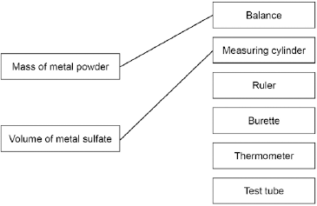
more than one line drawn from a variable negates the mark
2
(d) (Most reactive) Magnesium
Zinc
(Least reactive) Copper
must all be correct
1
(e) would not be safe or
too reactive
allow too dangerous
1
(f) Gold
1
(g) 2Fe₂O₃ + 3C → 4Fe + 3CO₂
allow multiples
1
(h) carbon
1
(i) Loss of oxygen
1
[10]
Q18.
(a) any two from:
• concentration / volume of dilute hydrochloric acid
• mass of metal powder
• surface area of metal powder
• stirring (of any) / rate of stirring
allow reacted for the same length of time
2
(b) 4.2 °C
allow Magnesium Test 2
1
and any one from:
• lower mass of magnesium added
• surface area of magnesium too low
• magnesium coated in magnesium oxide (so took a while to start reacting)
• not stirred
• not stirred as quickly as the other metals
• not reacted for as long a time as the other metals
allow reason for break in circuit
1
(c) 17.4(°C)
1
(d) bubbles of gas
1
more (bubbles) seen with calcium than other metals
allow any correct comparison between two metals
1
(e) any value between 7.9 °C and 12.3 °C
1
[8]
Q19.
(a) measuring cylinder
1
(b) use a polystyrene cup
allow insulate the beaker and / or use a lid
1
better insulator
or
reduces energy transfer from the surroundings
1
(c) starting temperature of hydrochloric acid
1
volume of hydrochloric acid
1
(d) 21.4 (°C)
1
(e) 15.8 (°C) to 16.1 (°C)
allow 16.1 (°C) to 15.8 (°C)
1
(f) 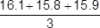
=15.9 (°C)
an answer of 15.9(333..) (°C) scores 2 marks
1
allow 15.9(333..) (°C)
1
(g) temperature decreases
1
(h) straight line from (1.0, 19.8) to (5.0, 14.6)
ignore continuation of line in either direction
1
horizontal straight line from (5.0, 14.6 to 8.0, 14.6)
ignore continuation of line in either direction
1
the answer below scores 2 marks
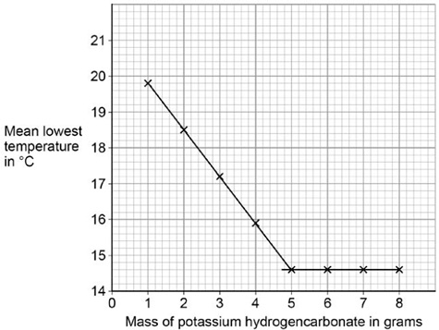
(i) (lowest) temperature decreases
1
to 14.6 °C
or
until 5 g added
1
then no change to temperature (after 5 g solid added)
or
then temperature remains at 14.6 °C (after 5 g solid added)
1
[15]
Q20.
(a) water / H₂O
allow steam or hydrogen oxide
1
(b) (i) A
1
(ii) exothermic
1
products (energy) lower than reactants (energy)
1
(iii) 1860 (kJ)
1
(c) (i) 22.5
1
38.7
1
16.2
allow ecf for correct subtraction
1
(ii) 50 (g)
1
(iii) 20.1 (kJ)
allow propanol
ignore 3
1
(iv) as the number of carbon atoms (in one molecule of alcohol) increases the heat energy given out increases (when the alcohol is burned)
1
(v) any two from:
• no lid
• no insulation
• no draught shield
Allow heat / energy loss to surroundings for any one of these marks
• incomplete combustion
• inaccurate measurement
• no repeats (to calculate a mean)
2
(iv) -O-H
1
[14]
Q21.
(a) (i) 42 000
correct answer gains 2 marks with or without working
allow 42 kJ
if answer incorrect : correct substitution 500 x 4.2 x 20 gains 1 mark
2
(ii) any two from:
• eye protection
• lab coat
• heat-proof mat
• (heat-proof) gloves
• (long) hair tied back
• stand up
• secure the beaker
2
(iii) Stir the water before measuring the temperature.
1
Place a lid on the beaker.
1
(b) the products → S
1
the activation energy → Q
1
the energy released by the reaction → P
1
(c) carbon dioxide produced
it = propane
allow converse arguments
allow greenhouse gas / global warming / atmospheric pollution
(crude oil / propane) non-renewable
1
allow crude oil running out
1
[11]
Q22.
(a) goes up
1
(b) (i) B
1
(ii) A
1
(iii) a catalyst
1
activation energy
1
(c) (i) eg (ensures) complete reaction
allow spread heat / energy
or even heating
allow mixes properly or mix them together or to get correct temperature
ignore dissolves
1
(ii) lid (on beaker)
accept cover beaker
or
insulate (beaker) / use a plastic cup
1
[7]

Section 2: Required Practicals Mark Scheme
Q23.
(a) use a polystyrene cup instead of a (glass) beaker
allow insulate the beaker
allow use a lid
1
minimises energy transfer from the surroundings
or
for better insulation
1
(b) concentration of hydrochloric acid
1
(c) 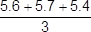
1
= 5.6 (°C)
1
± 0.2
1
(d) straight line from origin to (5.0, 6.4)
must not deviate to anomalous point
1
horizontal line from (5.0, 6.4) to (8.0, 6.4)
must not deviate to anomalous point
1
(e) as mass (of potassium hydrogencarbonate) increases, temperature decrease / change increases
1
until 5 g (to 8 g) (of potassium hydrogencarbonate has been added)
allow ecf from lines of best fit
1
(because) the reaction has finished
or
(because) all the acid has reacted
or
(because) no more solid can react
or
(because) the solid is in excess
1
(f) not stirred correctly
1
[12]
Q24.
(a) any one from:
• metal
• (metal) hydroxide
allow ammonium hydroxide
• (metal) carbonate
allow ammonium carbonate
• alkali
allow soluble base
allow ammonia
1
allow named example
allow correct formula
ignore base
(b) Ca(NO₃)₂
allow Ca²⁺(NO₃⁻)₂
1
(c) Level 3: The method would lead to the production of a valid outcome. All key steps are identified and logically sequenced.
5−6
Level 2: The method would not necessarily lead to a valid outcome. Most steps are identified, but the method is not fully logically sequenced.
3−4
Level 1: The method would not lead to a valid outcome. Some relevant steps are identified, but links are not made clear.
1−2
No relevant content
0
Indicative content
• use magnesium oxide and sulfuric acid
• add sulfuric acid to a beaker
• warm sulfuric acid
• add magnesium oxide
• stir
• continue adding until magnesium oxide is in excess
• filter
• using a filter paper and funnel
• to remove excess magnesium oxide
• heat solution in an evaporating basin
• to crystallisation point
• leave to crystallise
• pat dry with filter paper
credit may be given for diagrams
[8]
Q25.
(a) any one from:
• solution becomes colourless or colour fades
• zinc becomes bronze / copper coloured
allow copper (forms) or a solid (forms)
• zinc gets smaller
allow zinc dissolves
• bubbles or fizzing.
ignore precipitate
1
(b) improvement:
use a plastic / polystyrene cup or add a lid
accept use lagging / insulation
1
reason - must be linked
reduce / stop heat loss
OR
improvement:
use a digital thermometer
allow use a data logger
reason - must be linked
more accurate or easy to read or stores data
allow more precise or more sensitive
ignore more reliable
ignore improvements to method, eg take more readings
1
(c) Marks awarded for this answer will be determined by the Quality of Written Communication (QWC) as well as the standard of the scientific response. Examiners should also refer to the information in the Marking Guidance and apply a ‘best–fit’ approach to the marking.
0 marks
No relevant content
Level 1 (1−2 marks)
There is a statement about the results.
Level 2 (3−4 marks)
There are statements about the results. These statements may be linked or may include data.
Level 3 (5−6 marks)
There are statements about the results with at least one link and an attempt at an explanation.
Examples of chemistry points made in the response:
Description:
Statements
Concentration of copper sulfate increases
Temperature change increases
There is an anomalous result
The temperature change levels off
Reaction is exothermic
Linked Statements
Temperature change increases as concentration of copper sulfate increases
The temperature change increases, and then remains constant
After experiment 7 the temperature change remains constant
Statements including data
The trend changes at experiment 7
Experiment 3 is anomalous
Attempted Explanation
Temperature change increases because rate increases
Temperature change levels off because the reaction is complete
Explanation
As more copper sulfate reacts, more heat energy is given off
Once copper sulfate is in excess, no further heat energy produced
6
[9]
Q26.
(a) (diagram)
complete circuit with power supply
1
test solution in beaker or other appropriate apparatus
1
electrodes
allow carbon, platinum or inert electrodes
1
(independent variable)
salt solutions (with different metal ions)
1
(observation)
solid / metal deposit on the negative electrode
1
(b) (sometimes) hydrogen is produced
1
(because) the metal is more reactive than hydrogen
1
(c) chlorine
1
oxygen
1
[9]
Q27.
(a)
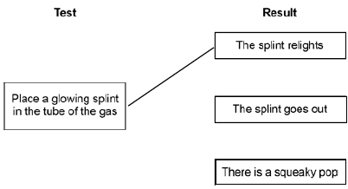
more than one line from test negates the mark
1
(b) (i) place a lighted splint at the mouth of the tube
1
there is a squeaky pop
dependent on correct test
1
(ii) hydrogen is less reactive than magnesium
accept converse
accept magnesium is too reactive
1
(c) (i) any one from:
• to improve appearance or make it look nice
• to prevent corrosion
• to make it more durable
• cheaper than solid silver
1
(ii) solution must be silver nitrate or contain silver ions
1
otherwise copper will be deposited or silver will not be deposited
1
spoon must be the negative electrode / cathode
1
because silver ions have a positive charge or go to negative electrode or are discharged at the negative electrode.
1
(iii) because (plastic is an) insulator or does not conduct electricity
accept does not contain mobile electrons
1
[10]
Q28.
(a) (i) points correctly plotted ( ± ½ small square)
four points = 2 marks
three points = 1 mark
Max 2
straight line of best fit using full range of points from 0,0
1
(ii) any one from:
must explain why the point is below the line
• the solution may not have been properly stirred
• the electrodes may have been a larger distance apart
• the drop of sodium chloride may have been a smaller volume / smaller
allow not enough sodium chloride added
allow smaller amount of sodium chloride
do not allow too few drops added
ignore the student may have misread the conductivity meter
1
(iii) any one from:
• the volume of pure water
allow amount
• the concentration (of the solutions added)
• the volume (of the drops) of solution added
ignore number of drops
• the distance between the electrodes
• the same electrodes or electrodes made of the same material
• same depth or surface area of electrodes in the water
• constant power supply
ignore current
• stirred
1
(b) (i) because (pure) water is covalent / molecular (simple) or contains molecules
1
therefore (pure) water has no free / mobile electrons or ions
molecules do not have a charge or molecules do not contain ions gains 2 marks
1
(ii) because there are ions in sodium chloride
allow Na⁺ and / or Cl–(ions) or ionic bonding.
Ignore particles other than ions for MP1.
1
which can move or carry the current / charge
MP2 must be linked to ions only.
1
(iii) Hydrogen
allow H₂ / H
1
[10]
Section 3: 6 Mark Questions Mark Scheme
Q29.
(a) potassium chloride and iodine
either order
allow KCl for potassium chloride and I₂ for iodine
1
(b) (chlorine’s) outer electrons / shell closer to the nucleus
allow chlorine has fewer shells
allow chlorine atom is smaller than iodine atom
ignore chlorine has fewer outer shells
1
(so) the chlorine nucleus has greater attraction for outer electrons / shell
allow chlorine has less shielding
do not accept incorrect types of attraction
1
(so) chlorine gains an electron more easily
1
max 2 marks can be awarded if the answer refers to chloride / iodide instead of chlorine / iodine
allow converse statements
allow energy levels for shells throughout
(c) hydrogen chloride is made of small molecules
allow hydrogen chloride is simple molecular
1
(so hydrogen chloride) has weak intermolecular forces*
1
(intermolecular forces) require little energy to overcome*
1
*do not accept reference to bonds breaking unless applied to intermolecular bonds
(d) (bonds broken = 4(412) + 193 =)1841
1
(bonds formed = 3(412) + 366 + X =) 1602 + X
1
−51 = 1841 − (1602 + X)
allow use of incorrectly calculated values of bonds broken and / or bonds formed from steps 1 and 2 for steps 3 and 4
1
(X =) 290 (kJ/mol)
allow a correctly calculated answer from use of −51 = bonds formed − bonds broken
1
OR
alternative method ignoring the 3 unchanged C−H bonds
(412 + 193 =) 605 (1)
366 + X (1)
−51 = 605 − (366 + X) (1)
(X =) 290 (kJ/mol) (1)
an answer of 290 (kJ/mol) scores 4 marks
an answer of 188 (kJ/mol) scores 3 marks
an incorrect answer for one step does not prevent allocation of marks for subsequent steps
[11]
Q30.
(a) (i) lead nitrate
accept Pb(NO₃)₂
do not accept nitride
1
sodium iodide / potassium iodide
accept NaI / KI
accept other correct soluble iodides
do not accept sodium iodine / potassium iodine
1
(ii) filter / filtration / filtering
accept decant / decanting etc.
accept centrifugation
ignore evaporation or heating if after filtration
1
(b) metallic / sharing / covalent or molecule = max 3
magnesium loses 2 electrons
all three underlined ideas must be present
two underlined ideas = 1 mark
eg magnesium loses electrons
or
magnesium gains 2 electrons
or
magnesium loses 2 ions
nb magnesium ion loses 2 electrons = 1 mark
2 errors = 0 marks
eg magnesium gains electrons
all four underlined ideas must be present
2
iodine gains 1 / an electron
three underlined ideas = 1 mark
eg iodine gains electron(s)
or
iodine loses 1 / an electron
or
iodine gains 1 / an ion
or
iodide (ion) gains 1 / an electron
2 errors = 0 marks
2
(c) any two from:
mention of molecules / intermolecular / covalent / atoms = max 1
• forces (of attraction) / bonds are strong or lot of energy needed to break bonds
• oppositely charged ions attract or electrostatic attraction between ions
• giant structure or lattice
allow many bonds
ignore ionic bonding unqualified
2
[9]
Q31.
(a) (i) atomic weights
allow atomic masses
1
(ii) proton
allow proton number
1
(b) (i) F/fluorine
allow F₂
1
(ii) any one from:
• copper has a higher density
• copper is stronger
• copper is harder
• copper is less reactive
allow named property
ignore colour, conductivity, melting point and boiling point
allow converse for potassium
1
(iii) relative distance from nucleus
allow more / fewer energy levels / shells or larger / smaller atom
1
relative attraction to nucleus
allow more / less shielding
1
relative ease of gain or loss of electron
1
opposite explanation of ease of gain or loss of electron for other group
1
max 3 marks if ‘outer’ not mentioned
[8]
Q32.
(a) (i) nucleus
1
(ii) neutron
1
(iii) electron
1
(b) (i) 12
1
(ii) 24
1
(c) any four from:
sharing / covalent / metallic = max 3
• magnesium (atom) reacts with two iodine (atoms)
• magnesium (atom) loses electrons
• 2 electrons (from each atom)
• Iodine (atom) gains electron(s)
• 1 electron or an electron (to each atom)
• iodide ion formed
allow iodine ion
• iodide has negative charge / is a negative ion / particle
allow iodine
ignore I^{2–}
• magnesium ion formed
• magnesium has positive charge
• oppositely charged ions attract
• a giant structure / lattice is formed
allow 1 mark for unqualified reference to ion formation or ionic bonding
4
[9]
Q33.
(a) (i) giant lattice
allow each carbon atom is joined to three others
1
atoms in graphene are covalently bonded
max. 2 marks if any reference to wrong type of bonding
1
and covalent bonds are strong or need a lot of energy to be broken
allow difficult to break
1
(ii) because graphene has delocalised electrons
allow each carbon atom has one free electron
1
which can move throughout the structure
do not accept just electrons can move.
1
(b) because there are weak forces between molecules
allow no bonds between the layers
1
so layers / molecules can slip / slide.
1
[7]
Q34.
Marks awarded for this answer will be determined by the Quality of Written Communication (QWC) as well as the standard of the scientific response.
0 marks
No relevant content
Level 1 (1–2 marks)
There is a statement about the bonding and / or structure or melting / boiling point of chlorine or sodium chloride.
Level 2 (3–4 marks)
There are statements about the bonding and / or structure of chlorine or sodium chloride.
Level 3 (5–6 marks)
There are statements about the bonding and / or structure of chlorine and sodium chloride.
There is an explanation of why chlorine is a gas or sodium chloride is a solid.
Examples of chemistry points made in response:
Chlorine:
covalent bonds between atoms
forming (simple) molecules
no / weak attraction / bonds between molecules
low boiling point
Sodium chloride:
ionic bonds or electrostatic attraction
strong bonds
in all directions
between oppositely charged ions
forming giant lattice
large amounts of energy needed to break bonds
high melting point
[6]
Q35.
(a) Graphite:
because the layers (of carbon atoms) in graphite can move / slide
it = graphite
1
this is because there are only weak intermolecular forces or weak forces between layers
accept Van der Waals’ forces allow no covalent bonds between layers
1
Diamond:
however, in diamond, each carbon atom is (strongly / covalently) bonded to 4 others
allow diamond has three dimensional / tetrahedral structure
1
so no carbon / atoms able to move / slide
allow so no layers to slide or so diamond is rigid
1
(b) because graphite has delocalised electrons / sea of electrons
allow free / mobile / roaming electrons
1
which can carry charge / current or move through the structure
1
however, diamond has no delocalised electrons
accept however, diamond has all (outer) electrons used in bonding
1
[7]

