Oasis Academy South Bank
Year 11 Mock Revision
Physics Combined Paper 1: Foundation
Name: ___________________________
Class: _________
Teacher: __________________________
Step 1: Knowledge
Learn each of the quiz questions and answers off by heart. This could be done by:
turning them into flash cards and testing yourself
using ‘look, cover, write, check’
asking a friend or family member to quiz you
Topic | LCWC | Quiz 1 | Quiz 2 | Quiz 3
Energy Types (P.1)
Work power and efficiency (P.2)
Elastic objects and potential Energy (P.3)
Nuclear physics (P.21)
Radioactive decay and radiation (P.22)
Density (P.25)
Changes of state, latent heat and specific heat capacity (P.26)
Gas and fluid pressure (paper 1) (P.27)
Electricity introduction (P.29)
Series and parallel circuits (P.30)
Ohmic/non-ohmic types of resistors (P.31)
Mains electricity (P.32)
Energy and power of electricity and the National Grid (P.33)

Step 2: Exam practice
Practice applying your knowledge using the past exam questions in each section.
Self-assess these using the mark schemes at the back and rewrite your answers.
Assess your progress using a ‘red, amber, green’ system (RAG)
Section | Completed | SA using green pen
1: Knowledge
2. Required Practicals
3. 6 marker questions

Exam practice
Section 1: Knowledge
Q1.
The diagram below shows a girl skateboarding on a semi-circular ramp.
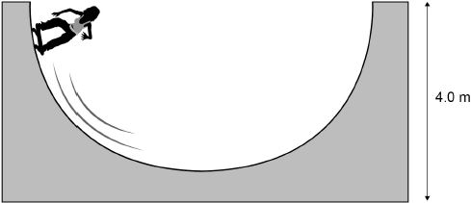
The girl has a mass of 50 kg
(a) Calculate the gravitational potential energy (g.p.e.) of the girl at the top of the ramp.
Use the equation:
g.p.e. = mass × gravitational field strength × height
gravitational field strength = 9.8 N/kg
___________________________________________________________________
___________________________________________________________________
g.p.e. = ________________________ J
(2)
(b) The girl has a speed of 7 m/s at the bottom of the ramp.
Calculate the kinetic energy of the girl at the bottom of the ramp.
Use the equation:
kinetic energy = 0.5 × mass × (speed)²
___________________________________________________________________
___________________________________________________________________
Kinetic energy = ________________________ J
(2)
(c) Not all of the g.p.e. has been transferred to kinetic energy.
Which two statements explain why?
Tick two boxes.

Some energy is wasted.
The mass of the girl is too low.
The ramp is not high enough.
The g.p.e. of the girl is not zero.
The speed of the girl is too great.
(2)
(d) Explain how lubricating the wheels of the skateboard can increase the speed of the girl.
Use ideas about energy in your explanation.
___________________________________________________________________
___________________________________________________________________
___________________________________________________________________
___________________________________________________________________
___________________________________________________________________
___________________________________________________________________
(3)
(Total 9 marks)
Q2.
Figure 1 shows the main energy transfers from a house.
Figure 1
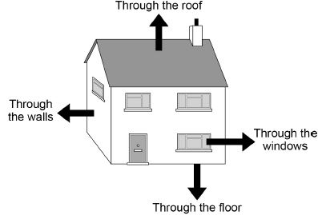
(a) Which two changes to the house would reduce the rate of energy transfer?
Tick two boxes.

Add thermal insulation to the roof
Increase the temperature of the house
Decrease the thickness of the walls
Replace the single-glazed windows with double-glazed windows
Use materials with a higher thermal conductivity
(2)
The temperature inside the house is controlled using a thermostat.
The thermostat switches the heating on when the temperature drops below a chosen value.
The thermostat switches the heating off when the temperature rises above the chosen value.
Figure 2 shows how the temperature of the house changes over a 150 minute period.
Figure 2
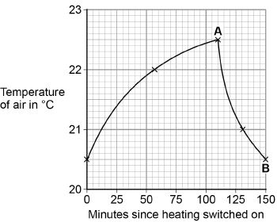
(b) For how many minutes was the heating switched on?
Number of minutes = ____________________
(1)
(c) The householder installs cavity wall insulation.
What would happen to the time taken for the temperature to fall between points A and B?
Tick one box.

The time taken decreases
The time taken increases
The time taken stays the same
(1)
(d) The householder has solar panels installed on the roof to heat water.
The householder can also heat water with an immersion heater which uses mains electricity.
Explain one advantage and one disadvantage of using a solar panel to heat water for the house, compared to the immersion heater.
Advantage __________________________________________________________
___________________________________________________________________
___________________________________________________________________
___________________________________________________________________
Disadvantage _______________________________________________________
___________________________________________________________________
___________________________________________________________________
___________________________________________________________________
(4)
(Total 8 marks)
Q3.
Different energy sources are used to generate electricity.
(a) Use words from the box to match the correct energy source to each of the descriptions given in the table.

biofuel | coal | geothermal | nuclear | waves

Description | Energy source
Energy from the Earth’s core is used to heat water.
Fission of uranium nuclei is used to heat water.
Gases from rotting plant material are burned to heat water.
(3)
(b) Energy can be stored in a pumped storage power station.
The figure shows a pumped storage power station.
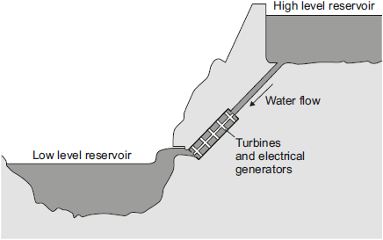
When electricity is needed, the water in the high level reservoir is allowed to flow to the low level reservoir. The flowing water generates electricity.
Use the correct answer from the box to complete each sentence.

electrical | gravitational potential | kinetic | nuclear | sound
The water in the high level reservoir stores ____________ energy.
The flowing water has ____________ energy.
The water turns the turbine which is connected to the generator.
The generator produces some ____________, this is wasted energy.
(3)
(c) The total power input to a pumped storage power station is 600 MW.
The useful power output is 540 MW.
(i) Calculate the efficiency of this pumped storage power station.
______________________________________________________________
______________________________________________________________
______________________________________________________________
Efficiency = _______________
(2)
(ii) Calculate how much power is wasted by the pumped storage power station.
______________________________________________________________
Power = ______________ MW
(1)
(iii) How is the temperature of the surroundings affected by the energy wasted by the pumped storage power station?
______________________________________________________________
(1)
(Total 10 marks)
Q4.
A heater uses energy from a laptop computer to keep a drink hot.
The image shows a metal mug on the heater.
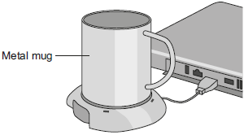
(a) The laptop computer is operating on battery power.
How would connecting the heater affect the amount of time the laptop computer would operate for, before needing to be recharged?
Tick (✔) one box.

Tick (✔)
it would decrease the time
it would not affect the time
it would increase the time
(1)
(b) The power output from the heater is 12 W.
Calculate the energy transferred to the metal mug in 60 seconds.
___________________________________________________________________
___________________________________________________________________
___________________________________________________________________
Energy = ________ joules
(2)
(c) The table lists changes that may affect the energy transfer per second from the heater to the liquid.
Tick (✔) one box to show the effect of each change.

Change | Energy transfer per second to the liquid
 | increases | decreases | does not change
use a mug with a smaller base
use a lower power heater
use a plastic mug instead of a metal mug
(3)
(Total 6 marks)
Q5.
The pictures show six different household appliances.
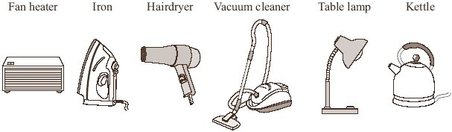
(a) Four of the appliances, including the fan heater, are designed to transform electrical energy into heat.
Name the other three appliances designed to transform electrical energy into heat.
1. _________________________________________________________________
2. _________________________________________________________________
3. _________________________________________________________________
(3)
(b) Complete the following sentence using one of the words from the box.
chemical heat kinetic sound
Energy that is not usefully transformed by the fan heater is wasted as
_________________________ energy.
(1)
(c) The table gives information about two different fan heaters.
 | Useful energy  transferred each  second in joules | Wasted energy  transferred each  second in joules
Fan heater L | 1200 | 10
Fan heater M | 1200 | 20
Complete the following sentence by drawing a ring around the line in the box that is correct.
Fan heater L | is more efficient than  has the same efficiency as  is less efficient than | fan heater M.
(1)
(Total 5 marks)
Q6.
The diagram shows how electricity gets from power stations to consumers.
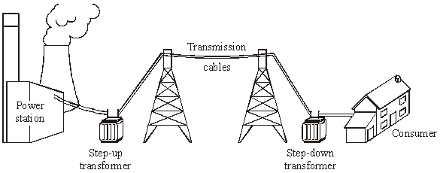
(a) Complete the following sentences by drawing a ring around the correct line in each box.
(i) The network of cables and transformers linking power stations to consumers

is called the national | grid  line  network
(1)
(ii)
A step-up transformer | decreases voltage  increases current  increases voltage
(1)
(iii)
Electricity is supplied to consumers’ homes at | 230 V  25 000 V  400 000 V
(1)
(iv)
Making the current in the cables smaller will | increase  make no difference to  reduce
the energy lost in the cables.
(1)
(b) Transformers always waste some energy.
(i) What effect does the waste energy from a transformer have on the air around the transformer?
______________________________________________________________
(1)
(ii) Which one of the following describes the efficiency of a transformer?
Draw a ring around your answer.
always 100 % less than 100 % more than 100%
(1)
(Total 6 marks)
Q7.
Some ceiling lights in the home are connected to the mains by a two-core cable.
Figure 1 shows a ceiling light.
Figure 1
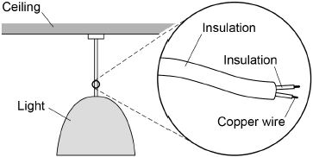
(a) Suggest why some ceiling lights do not have an earth wire.
___________________________________________________________________
___________________________________________________________________
___________________________________________________________________
___________________________________________________________________
(2)
(b) Write down the equation that links charge flow, current and time.
___________________________________________________________________
(1)
(c) There is a current of 2.95 A in one of the copper wires for 60 seconds.
Calculate the charge flow through the wire.
Use your equation from part (b)
___________________________________________________________________
___________________________________________________________________
Charge flow = _________________ C
(2)
(d) Figure 2 shows a current potential difference graph for a piece of copper wire.
Figure 2
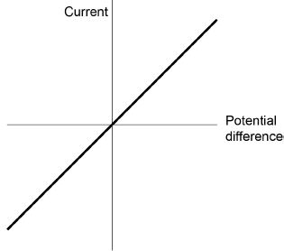
Draw another line on Figure 2 for a wire with a different resistance.
(2)
Some fuses have a thin piece of copper that melts if the current is too large.
(e) Draw the circuit symbol for a fuse.
(1)
(f) Describe how the movement of the copper particles in the wire changes when copper melts.
___________________________________________________________________
___________________________________________________________________
___________________________________________________________________
___________________________________________________________________
(2)
(g) Old copper wires are melted when they are recycled.
Calculate the energy needed to melt 500 kg of copper at its melting point.
Specific latent heat of fusion of copper = 200 kJ/kg
Use the Physics Equations Sheet.
___________________________________________________________________
___________________________________________________________________
Energy = _________________ J
(3)
(Total 13 marks)
Q8.
Figure 1 shows the circuit symbol for three different components.
Figure 1
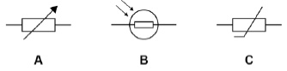
(a) Which component is a variable resistor?
Tick one box.

A |  | B |  | C
(1)
(b) Which component is a thermistor?
Tick one box.

A |  | B |  | C
(1)
(c) In which component will the resistance decrease when the temperature increases?
Tick one box.

A |  | B |  | C
(1)
(d) In which component will the resistance decrease when the light intensity increases?
Tick one box.

A |  | B |  | C
(1)
Figure 2 shows four different arrangements of resistors.
Figure 2
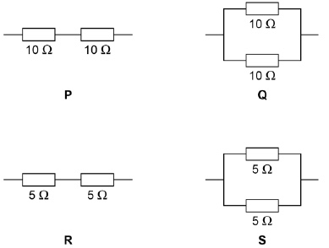
(e) Two of the arrangements are in series and two are in parallel.
Describe the difference between a series and a parallel arrangement.
___________________________________________________________________
___________________________________________________________________
___________________________________________________________________
___________________________________________________________________
(2)
(f) Which arrangement has a resistance of 10 Ω?
Tick one box.

P |  | Q |  | R |  | S
(1)
(g) Which arrangement has the highest resistance?
Tick one box.

P |  | Q |  | R |  | S
(1)
(h) A student connects a resistor to a cell for 60 seconds.
The current through the resistor is 0.97 A
Calculate the charge flow.
Use the equation:
charge flow = current × time
Give your answer to 2 significant figures.
___________________________________________________________________
___________________________________________________________________
___________________________________________________________________
___________________________________________________________________
___________________________________________________________________
___________________________________________________________________
Charge flow = ____________________ C
(3)
(Total 11 marks)
Q9.
Figure 1 shows a three pin plug connected to the cable of a metal toaster.
Figure 1
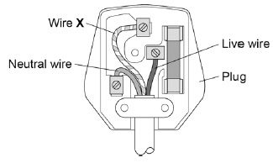
(a) Name wire X.
___________________________________________________________________
(1)
(b) What does wire X do?
Tick one box.

It provides extra energy to the toaster when needed.
It completes the circuit in the toaster.
It can prevent an electric shock from the toaster.
It supplies the current to the toaster.
(1)
(c) The toaster is plugged in to the mains electricity supply.
What is the potential difference between the live and neutral wires?
Tick one box.

0 V |  | 120 V |  | 230 V |  | 460 V
(1)
(d) Mains electricity is an alternating supply.
A battery is a direct supply.
Figure 2 shows an alternating supply and a direct supply.
Figure 2
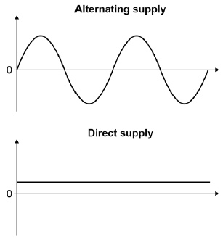
Give two differences between the alternating supply and the direct supply.
1. _________________________________________________________________
2. _________________________________________________________________
(2)
Energy is transferred to homes by the National Grid.
Figure 3 shows the percentage energy losses over the National Grid for different years.
Figure 3
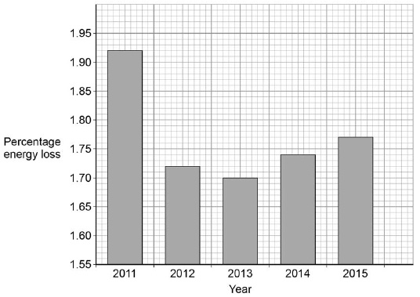
(e) Describe the changes in percentage energy loss.
___________________________________________________________________
___________________________________________________________________
___________________________________________________________________
___________________________________________________________________
(2)
(f) Calculate the mean percentage energy loss per year in Figure 3.
___________________________________________________________________
___________________________________________________________________
___________________________________________________________________
___________________________________________________________________
___________________________________________________________________
___________________________________________________________________
Mean energy loss per year = ____________________ %
(3)
(Total 10 marks)
Q10.
The image shows a girl riding a self-balancing scooter.
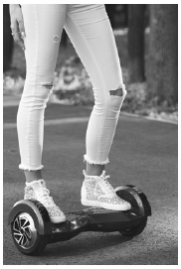
(a) The scooter has an electric motor powered by a battery.
During the ride the battery transfers 15 000 C of charge.
The potential difference across the battery is 36 V
Calculate the energy transferred by the battery.
Use the equation:
energy transferred = charge flow × potential difference
Give your answer in kJ
___________________________________________________________________
___________________________________________________________________
___________________________________________________________________
___________________________________________________________________
___________________________________________________________________
Energy transferred = ____________________ kJ
(3)
The table gives data for two scooters with different motors.
Both motors have the same efficiency.

 | Power of motor in W | Mass in kg
Scooter A | 500 | 10.5
Scooter B | 700 | 14.0
(b) Explain why scooter B has a higher maximum speed.
___________________________________________________________________
___________________________________________________________________
___________________________________________________________________
___________________________________________________________________
(2)
(c) Both scooters can be ridden for 20 minutes before the battery needs recharging.
Compare the amount of chemical energy stored in the batteries of each scooter.
___________________________________________________________________
___________________________________________________________________
(1)
(d) Write the equation that links energy transferred, power and time.
___________________________________________________________________
(1)
(e) Calculate the energy transferred by the motor in scooter B in 20 minutes.
___________________________________________________________________
___________________________________________________________________
___________________________________________________________________
___________________________________________________________________
___________________________________________________________________
___________________________________________________________________
Energy transferred = ____________________ J
(3)
(Total 10 marks)
Q11.
We use mains electricity in our homes.
(a) What is the frequency of the UK mains electricity supply?
Tick one box.

23 Hz
50 Hz
230 Hz
500 Hz
(1)
(b) Many appliances in the home use three-core electrical cable.
Look at the figure below.
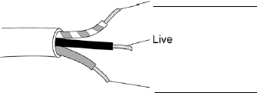
Label the wires in the cable in the figure above.
Use words from the box.

Earth | Negative | Neutral | Positive
(2)
(c) The sentences explain how touching the live wire in a cable can cause an electric shock.
Complete the sentences.
Use words from the box.

current | force | resistance | potential difference
Touching the live wire causes a large _____________________ to exist across the body.
This causes a _________________ through the body, which results in an electric shock.
(2)
(d) A heater has a power rating of 2500 W.
The heater is turned on for 180 seconds.
Calculate the energy transferred by the heater.
Use the equation:
energy transferred = power × time
Give your answer in kilojoules (kJ).
___________________________________________________________________
___________________________________________________________________
___________________________________________________________________
Energy transferred = _________________ kJ
(3)
(e) Write down the equation that links charge flow, energy transferred and potential difference.
___________________________________________________________________
(1)
(f) The mains electricity supply is at 230 V.
A different heater transfers 4200 J of energy.
Calculate the charge flow through the heater.
___________________________________________________________________
___________________________________________________________________
___________________________________________________________________
Charge flow = _________________ C
(3)
(Total 12 marks)
Q12.
Figure 1 shows the apparatus used to investigate how the current through a thermistor depends on the temperature of the thermistor.
Figure 1
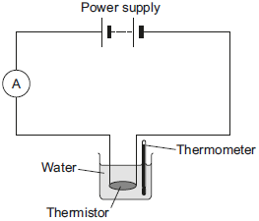
(a) Which one of the following is the correct circuit symbol for a thermistor?
Tick (✔) one box.
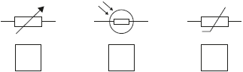
(1)
(b) To get a range of results, hot water at 60 °C was poured into the beaker.
The temperature of the water and current through the thermistor were then recorded as the water cooled.
The results of the investigation are shown in Figure 2.
Figure 2
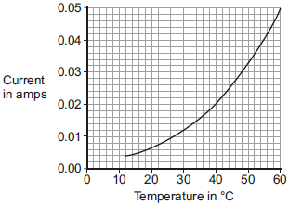
(i) Suggest one way the investigation could have been changed to give a wider range of temperatures.
______________________________________________________________
______________________________________________________________
(1)
(ii) Describe how the current through the thermistor depends on the temperature of the thermistor.
______________________________________________________________
______________________________________________________________
(1)
(iii) Use Figure 2 to determine the current through the thermistor at 40 °C.
Current at 40 °C = ___________ A
(1)
(iv) At 40 °C the thermistor has a resistance of 250 Ω.
Use your answer to part (iii) and the resistance of the thermistor to calculate the potential difference across the thermistor.
______________________________________________________________
______________________________________________________________
______________________________________________________________
______________________________________________________________
Potential difference = ___________ V
(2)
(v) The potential difference across the thermistor stays the same all through the investigation.
What conclusion can be made from the results in Figure 2 about the resistance of the thermistor as the temperature of the thermistor decreases?
Tick (✔) one box.

the resistance increases
the resistance does not change
the resistance decreases
(1)
(Total 7 marks)
Q13.
The left-hand rule can be used to identify the direction of the force acting on a current-carrying conductor in a magnetic field.
(a) Use words from the box to label Figure 1.

current | field | force | potential difference
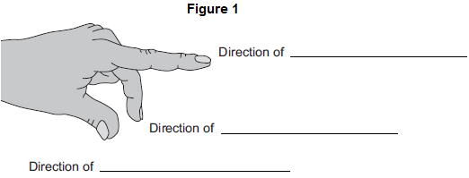
(3)
(b) Figure 2 shows an electric motor.
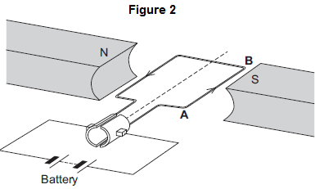
(i) Draw an arrow on Figure 2 to show the direction of the force acting on the wire AB.
(1)
(ii) Suggest two changes that would increase the force acting on the wire AB.
1. ____________________________________________________________
2. ____________________________________________________________
(2)
(iii) Suggest two changes that would reverse the direction of the force acting on the wire AB.
1. ____________________________________________________________
2. ____________________________________________________________
(2)
(c) A student used an electric motor to lift a mass. This is shown in Figure 3.
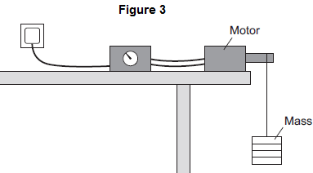
The student varied the electrical input power to the motor. For each different electrical input power, he recorded the time taken to lift the mass and calculated the output power of the motor.
The results are shown in the table.

Test | Electrical  input power  in watts | Work done  lifting the mass  in joules | Time taken to  lift the mass  in seconds | Output  power  in watts
A | 20 | 24 | 2.4 | 10
B | 40 | 24 | 1.2 | 20
C | 60 | 24 | 0.8 | 30
D | 80 | 24 | 0.2 | 120
The result for Test D is anomalous.
(i) Calculate the efficiency of the motor in Test D.
______________________________________________________________
______________________________________________________________
Efficiency = ____________________
(2)
(ii) Comment on your answer to part (c)(i).
______________________________________________________________
______________________________________________________________
(1)
(iii) Suggest a reason for this anomalous result.
______________________________________________________________
______________________________________________________________
(1)
(Total 12 marks)
Q14.
(a) Draw one line from each circuit symbol to its correct name.

Circuit symbol |  | Name
 |  | Diode
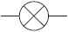
Light-dependent
resistor (LDR)
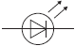
 |  | Lamp
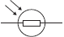
Light-emitting
diode (LED)
(3)
(b) Figure 1 shows three circuits.
The resistors in the circuits are identical.
Each of the cells has a potential difference of 1.5 volts.
Figure 1

Circuit 1 |  | Circuit 2 |  | Circuit 3
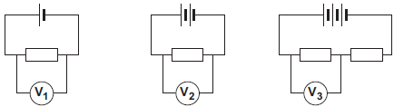
(i) Use the correct answer from the box to complete the sentence.

half twice the same as
The resistance of circuit 1 is _________________ the resistance of circuit 3.
(1)
(ii) Calculate the reading on voltmeter V₂.
______________________________________________________________
Voltmeter reading V₂ = _______________ V
(1)
(iii) Which voltmeter, V₁, V₂ or V₃, will give the lowest reading?
Draw a ring around the correct answer.

V₁ V₂ V₃
(1)
(c) A student wanted to find out how the number of resistors affects the current in a series circuit.
Figure 2 shows the circuit used by the student.
Figure 2
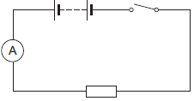
The student started with one resistor and then added more identical resistors to the circuit.
Each time a resistor was added, the student closed the switch and took the ammeter reading.
The student used a total of 4 resistors.
Figure 3 shows three of the results obtained by the student.
Figure 3
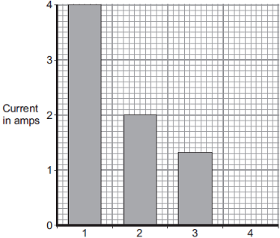
Number of resistors in series
(i) To get valid results, the student kept one variable the same throughout the experiment.
Which variable did the student keep the same?
______________________________________________________________
(1)
(ii) The bar chart in Figure 3 is not complete. The result using 4 resistors is not shown.
Complete the bar chart to show the current in the circuit when 4 resistors were used.
(2)
(iii) What conclusion should the student make from the bar chart?
______________________________________________________________
______________________________________________________________
(1)
(Total 10 marks)
Q15.
(a) Electrical circuits often contain resistors.
The diagram shows two resistors joined in series.
Calculate the total resistance of the two resistors.
___________________________________________________________________
Total resistance = _________________________ Ω
(1)
(b) A circuit was set up as shown in the diagram. The three resistors are identical.
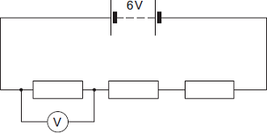
(i) Calculate the reading on the voltmeter.
______________________________________________________________
______________________________________________________________
Reading on voltmeter = _________________________ V
(2)
(ii) The same circuit has now been set up with two ammeters.
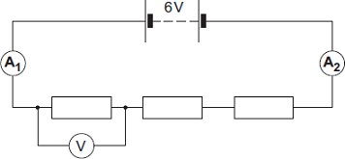
Draw a ring around the correct answer in the box to complete the sentence.

 | smaller than
The reading on ammeter A₂ will be | equal to | the reading on ammeter A₁.
 | greater than
(1)
(Total 4 marks)
Q16.
(a) The diagram shows the traces produced on an oscilloscope when it is connected across different electricity supplies.
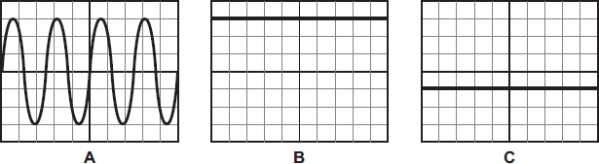
Which of the traces could have been produced by the mains electricity supply?
___________________________________________________________________
Give a reason for your answer.
___________________________________________________________________
___________________________________________________________________
(2)
(b) The picture shows two adaptors being used to plug five electrical appliances into the same socket.
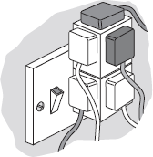
Explain why it is dangerous to have all five appliances switched on and working at the same time.
___________________________________________________________________
___________________________________________________________________
___________________________________________________________________
___________________________________________________________________
(2)
(Total 4 marks)
Q17.
(a) The diagram shows a simple circuit.
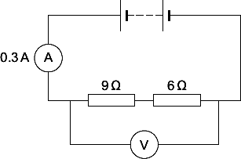
(i) Calculate the total resistance of the two resistors in the circuit.
______________________________________________________________
Total resistance = _________________________ Ω
(1)
(ii) Calculate the reading on the voltmeter.
Show clearly how you work out your answer.
______________________________________________________________
______________________________________________________________
Voltmeter reading = _________________________ V
(2)
(iii) Draw a ring around the correct answer in the box to complete the sentence.

Replacing one of the resistors with a resistor of higher value will | decrease  not change  increase
the reading on the ammeter.
(1)
(b) The voltmeter in the circuit is replaced with an oscilloscope.
Which one of the diagrams, X, Y or Z, shows the trace that would be seen on the oscilloscope?
Write your answer, X, Y or Z, in the box.
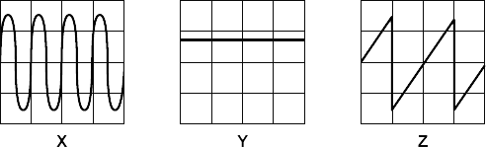

Diagram
Give a reason for your answer.
___________________________________________________________________
___________________________________________________________________
___________________________________________________________________
(2)
(Total 6 marks)
Q18.
(a) The lamps in the circuits drawn below are all identical.
Each of the cells has a potential difference of 1.5 volts.
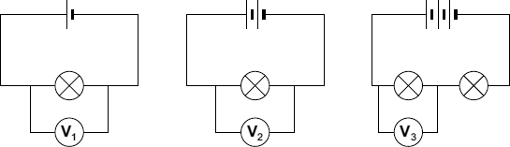
(i) What is the potential difference across the 3 cells that are joined in series?
______________________________________________________________
Potential difference = _________________________ V
(1)
(ii) What will be the reading on the voltmeter labelled V_{3?}
Voltmeter reading V₃ = _________________________ V
(1)
(iii) Which voltmeter, V₁, V₂ or V₃, will give the highest reading?
Draw a ring around your answer.

V₁ | V₂ | V₃
(1)
(b) The diagram below shows a simple circuit.
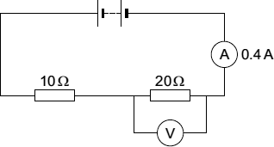
(i) Calculate the total resistance of the two resistors in the circuit.
______________________________________________________________
Total resistance = _________________________ Ω
(1)
(ii) Use the equation in the box to calculate the reading on the voltmeter.

potential difference = current × resistance
Show clearly how you work out your answer.
______________________________________________________________
______________________________________________________________
Voltmeter reading = _________________________ V
(2)
(iii) The current through a resistor at constant temperature changes when the potential difference across the resistor changes.
Which one of the graphs, X, Y or Z, shows how the current changes?
Write your answer, X, Y or Z, in the box.

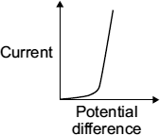  X | 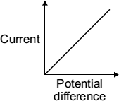  Y | 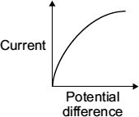  Z
Graph
(1)
(Total 7 marks)
Q19.
(a) (i) Complete the sentence by choosing the correct word from the box.

electrons neutrons protons
An electric current is a flow of __________________________________
(1)
(ii) What is the name and circuit symbol for the instrument used to measure electric current?
Name: ____________________________________________________
Symbol:

(2)
(b) When an electric current flows through a wire, the wire will get hot. Two of the following make use of this heating effect. Which two?
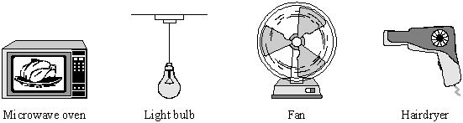
1. _________________________________________________________________
2. _________________________________________________________________
(2)
(Total 5 marks)
Q20.
The diagram shows an electrical circuit.
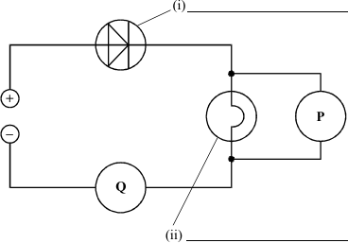
(a) Complete the two labels on the diagram.
(2)
(b) P and Q are meters.
What is meter P measuring? _______________________________________
What is meter Q measuring? _______________________________________
(2)
(Total 4 marks)
Q21.
Radioactive nuclei can emit alpha, beta or gamma radiation.
(a) Which type of radiation is the most penetrating?
Tick one box.

Alpha (α)
Beta (β)
Gamma (γ)
(1)
(b) Which type of radiation is the most ionising?
Tick one box.

Alpha (α)
Beta (β)
Gamma (γ)
(1)
(c) Which type of radiation has the longest range in air?
Tick one box.

Alpha (α)
Beta (β)
Gamma (γ)
(1)
When radioactive isotopes in the Earth’s crust decay they release energy.
The decay causes the heating of rocks in the crust.
(d) The diagram below shows the decay of uranium-238 (U-238) into thorium-234 (Th-234).
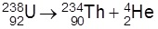
Complete the table below to show the number of neutrons and protons in the nuclei.

Isotope | Number of neutrons | Number of protons
uranium-238 | 146
thorium-234 |  | 90
(2)
(e) Geothermal power stations pump water through heated rocks.
The temperature of the water increases from 20 °C to its boiling point of 100 °C
Calculate the change in thermal energy when the mass of water heated is 150 kg
Specific heat capacity = 4 200 J/kg °C
Use the Physics Equations Sheet.
___________________________________________________________________
___________________________________________________________________
___________________________________________________________________
Change in thermal energy = _____________________ J
(3)
(Total 8 marks)
Q22.
Water exists as ice, water or steam.
(a) Complete the sentences.
Choose the answers from the box.

ice | steam | water
The particles are arranged in a regular pattern in ____________________ .
The particles are close together but not in a pattern in ____________________ .
The particles move quickly in all directions in ____________________ .
(2)
(b) Which will have the most internal energy?
Tick one box.

1 kg of ice
1 kg of steam
1 kg of water
(1)
(c) Which will have the lowest density?
Tick one box.

Ice
Steam
Water
(1)
The image shows an iceberg floating in the sea.
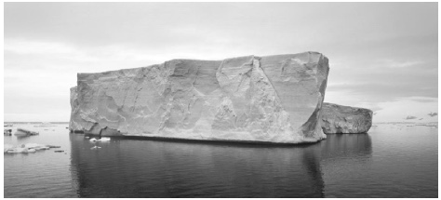
(d) The iceberg has a mass of 11 200 kg
The volume of the iceberg is 12.0 m³
Calculate the density of the iceberg.
Use the equation:
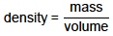
___________________________________________________________________
___________________________________________________________________
Density = ____________________ kg/m³
(2)
(e) Explain why the iceberg will melt.
___________________________________________________________________
___________________________________________________________________
___________________________________________________________________
___________________________________________________________________
(2)
(Total 8 marks)
Q23.
The diagram shows a model of the particles in a gas and in a liquid.
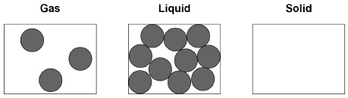
(a) Complete the diagram to show the arrangement of particles of the same substance as a solid.
(2)
(b) What is the name of the process when a substance changes from a gas to a liquid?
Tick one box.

Condensing
Evaporating
Freezing
Melting
(1)
(c) The substance in the diagram has a:
• melting point of 98 °C
• boiling point of 883 °C
What is the state of the substance at 20 °C?
Tick one box.

Gas |  | Liquid |  | Solid
(1)
(d) What type of change is a change of state?
Tick one box.

Chemical
Kinetic
Permanent
Physical
(1)
(e) Which two statements are correct about the particles when a liquid turns into a gas?
Tick two boxes.

Particles are bigger
Particles are lighter
Particles have more chemical energy
Particles have more kinetic energy
Particles move faster
(2)
(f) Which two quantities are needed to calculate the energy required to turn a liquid into a gas with no change in temperature?
Tick two boxes.

Mass of the liquid
Specific heat capacity of the gas
Specific latent heat of vaporisation
Time the liquid is heated
(2)
(g) A mass of 2.0 kg of water is heated.
The temperature increase of the water is 80 °C
The specific heat capacity of water is 4200 J / kg °C
Calculate the change in thermal energy when the water is heated.
Use the equation:
change in thermal energy = mass × specific heat capacity × temperature change
___________________________________________________________________
___________________________________________________________________
___________________________________________________________________
Change in thermal energy = ____________________ J
(2)
(Total 11 marks)
Q24.
Density can be explained using the particle model.
(a) What is the unit of density (ρ)?
Tick one box.

joules, J
joules per kilogram, J / kg
kilograms, kg
kilograms per metre cubed, kg / m³
(1)
(b) The figure below shows particles of the same substance in three states of matter.
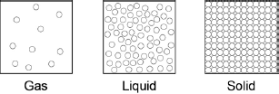
Use the figure above to explain why the solid has the highest density.
___________________________________________________________________
___________________________________________________________________
___________________________________________________________________
___________________________________________________________________
(2)
(c) Complete the sentences.
Use answers from the box.

downwards | kinetic | nuclear | potential | randomly | slowly
The particles in a gas are constantly moving.
The particles move _____________________________________________
When the temperature of the particles in a gas is increased
the particles have more ___________________________________energy .
(2)
(d) A gas is put into a closed container.
The container and the gas inside it are heated.
What will happen to the pressure inside the container?
___________________________________________________________________
(1)
(Total 6 marks)
Q25.
A student used the apparatus in Figure 1 to compare the energy needed to heat blocks of different materials.
Each block had the same mass.
Each block had holes for the thermometer and the immersion heater.
Each block had a starting temperature of 20 °C.
Figure 1
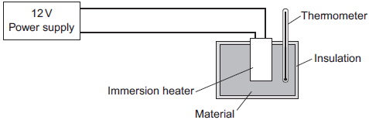
The student measured the time taken to increase the temperature of each material by 5 °C.
(a) (i) State two variables the student controlled.
1. ____________________________________________________________
2. ____________________________________________________________
(2)
Figure 2 shows the student’s results.
Figure 2
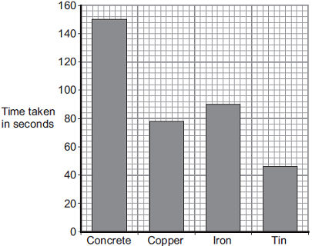
Material
(ii) Why was a bar chart drawn rather than a line graph?
______________________________________________________________
______________________________________________________________
(1)
(iii) Which material was supplied with the most energy?
______________________________________________________________
Give the reason for your answer.
______________________________________________________________
______________________________________________________________
(2)
(iv) The iron block had a mass of 2 kg.
Calculate the energy transferred by the heater to increase the temperature of the iron block by 5 °C.
The specific heat capacity of iron is 450 J / kg °C.
______________________________________________________________
______________________________________________________________
______________________________________________________________
Energy transferred = ______________________________ J
(2)
(b) The student used the same apparatus to heat a 1 kg block of aluminium.
He recorded the temperature of the block as it was heated from room temperature.
The results are shown in Figure 3.
Figure 3
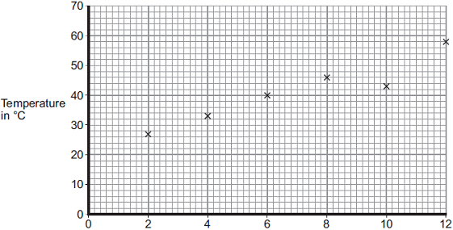
Time the immersion heater is switched on for in minutes
(i) One of the student’s results is anomalous.
Draw a ring around the anomalous result.
(1)
(ii) Draw the line of best fit for the points plotted in Figure 3.
(1)
(iii) What was the temperature of the room?
Temperature = _______________ °C
(1)
(iv) What was the interval of the time values used by the student?
Interval = _______________ minutes
(1)
(Total 11 marks)
Q26.
(a) The diagrams, X, Y and Z, show how the particles are arranged in the three states of matter.
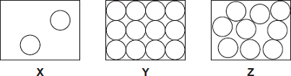
(i) Which one of the diagrams, X, Y or Z, shows the arrangement of particles in a liquid?
Write the correct answer in the box.
(1)
(ii) Which one of the diagrams, X, Y or Z, shows the arrangement of particles in a gas?
Write the correct answer in the box.
(1)
(b) Draw a ring around the correct answer in each box to complete each sentence.

 |  | vibrating in fixed positions.
(i) | In a gas, the particles are | moving randomly.
 |  | not moving.
(1)

 |  | stronger than
(ii) | In a solid, the forces between the particles are | equal to | the
 |  | weaker than
forces between the particles in a liquid.
(1)
(c) The picture shows a puddle of water in a road, after a rain shower.
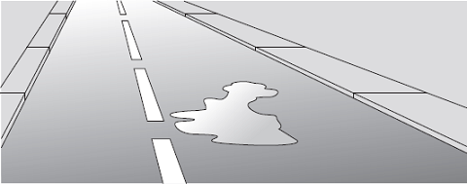
(i) During the day, the puddle of water dries up and disappears. This happens because the water particles move from the puddle into the air.
What process causes water particles to move from the puddle into the air?
Draw a ring around the correct answer.

condensation | evaporation | radiation
(1)
(ii) Describe one change in the weather which would cause the puddle of water to dry up faster.
______________________________________________________________
______________________________________________________________
(1)
(Total 6 marks)
Q27.
Many people use a sleeping bag when they sleep in a tent. Sleeping bags, designed to keep a person warm, have a fibre filling.
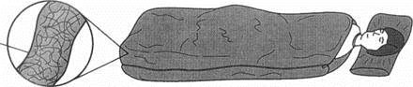
(i) Complete the sentence by choosing the correct words from the box.

conduction convection radiation
The fibre is designed to reduce heat transfer by ___________________ and
____________________
(ii) Explain why the fibre is good at reducing heat loss from a person sleeping in the bag.
___________________________________________________________________
___________________________________________________________________
___________________________________________________________________
___________________________________________________________________
(Total 3 marks)
Q28.
A student shakes a tube containing small balls to model the movement of particles in a gas.
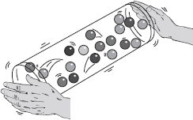
(a) Why is this a good model for the movement of particles in a gas?
Tick ( ) two boxes.

The balls move slowly.
The balls are far apart from each other.
The balls are different colours.
The balls move randomly.
(2)
(b) For a given material, in which state of matter:
are the particles in a regular arrangement?
___________________________________________________________________
do the particles have the most kinetic energy?
___________________________________________________________________
(2)
(Total 4 marks)
Q29.
Gamma radiation is emitted from the nuclei of some atoms.
(a) What is a gamma ray?
Tick one box.

A helium nucleus
A high speed electron
A neutron
A type of electromagnetic radiation
(1)
(b) Which would be the best absorber of gamma radiation?
Tick one box.

A few mm of air
A thick sheet of cardboard
A thick sheet of lead
A thin sheet of paper
(1)
Food can be irradiated with gamma rays to kill bacteria.
Below is a photograph of peaches.
Two of the peaches were irradiated.
The photograph was taken one week after irradiation.
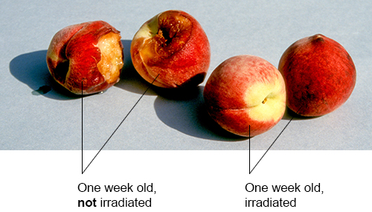
(c) Why do food producers need to kill bacteria on food?
Tick two boxes.

To change the colour of the food
To decrease the rate of decay of the food
To decrease the shelf life of the food
To prevent food poisoning
To remove dirt from food
(2)
(d) How do gamma rays kill bacteria?
Tick one box.

Gamma rays cause meiosis to occur
Gamma rays cause mutations
Gamma rays decrease the size of bacterial cells
Gamma rays destroy the food source for bacteria
(1)
(e) Food producers can irradiate food by passing it close to a radioactive source.
How can food producers increase the level of radiation that the food is exposed to?
Tick two boxes.

Boil the food before passing it close to the radioactive source
Decrease the distance between the food and the radioactive source
Increase the time for which the food is close to the radioactive source
Put the radioactive source in a box
Reduce the temperature of the radioactive source
(2)
(f) A student said:
‘The irradiated food would become radioactive.’
Give one reason why the student is not correct.
___________________________________________________________________
___________________________________________________________________
(1)
(Total 8 marks)
Q30.
The nuclei of some isotopes are radioactive.
(a) Which of the following statements could apply to a radioactive nucleus?
Tick one box.

The nucleus will emit an atom.
The nucleus will emit light.
The nucleus will emit a neutron.
The nucleus will emit sound.
(1)
(b) Potassium-40 is a radioactive isotope present in food, such as bananas.
The following equation shows how potassium-40 will decay into calcium-40
Give one similarity and one difference between nuclei of potassium-40 and calcium-40
Similarity ___________________________________________________________
Difference __________________________________________________________
(2)
(c) The activity of a sample of potassium-40 is measured 3 times.
The measurements are given below.

4906 Bq | 4956 Bq | 4889 Bq
Which of the following statements explains why the readings are different?
Tick one box.

Radioactive decay is constant.
Radioactive decay is hazardous.
Radioactive decay is random.
(1)
(d) The figure below shows how the activity of a sample of potassium-40 changes over time.
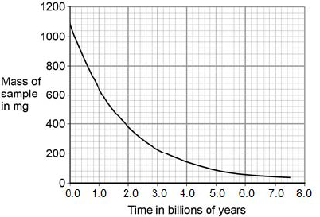
Use the figure above to determine the half-life of potassium-40.
___________________________________________________________________
___________________________________________________________________
Half-life = ____________________ billion years
(2)
(e) When food is eaten, some of the radiation the food emits is detectable outside the body.
Which type of radiation would not be detectable outside the body?
Tick one box.

alpha
beta
gamma
(1)
(Total 7 marks)
Q31.
The figure below is a diagram of an alpha particle and a helium atom.
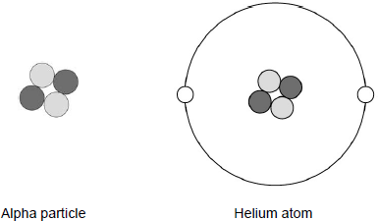
(a) What is the approximate size of a helium atom?
Tick one box.

1 × 10^{–5} m
1 × 10^{–10} m
1 × 10^{–15} m
1 × 10^{–20} m
(1)
(b) A helium atom is much larger than an alpha particle.
Give one other difference between a helium atom and an alpha particle.
___________________________________________________________________
___________________________________________________________________
(1)
(c) What is the atomic number of the helium atom in the figure above?
Tick one box.

2
4
6
8
(1)
(d) What is the charge on the helium atom in the figure above?
Explain your answer.
___________________________________________________________________
___________________________________________________________________
___________________________________________________________________
___________________________________________________________________
___________________________________________________________________
(3)
(e) Helium is a gas that occurs naturally.
There is very little helium on Earth.
Helium has important uses in medicine and is also used to inflate party balloons.
Some scientists believe that helium should not be used to inflate party balloons.
Why?
___________________________________________________________________
___________________________________________________________________
___________________________________________________________________
___________________________________________________________________
(2)
(Total 8 marks)
Q32.
Alpha, beta and gamma are types of nuclear radiation.
A teacher sets up a demonstration of the penetration properties of alpha, beta and gamma radiation.
The figure below shows the demonstration.
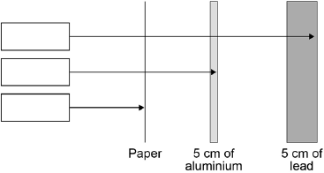
(a) Complete the figure above by writing the name of the radiation in each box.
(2)
(b) Give two safety precautions the teacher should take in the demonstration.
1. _________________________________________________________________
___________________________________________________________________
2. _________________________________________________________________
___________________________________________________________________
(2)
(c) The table below shows how the count rate of a radioactive source changes with time.

Time in seconds | 0 | 40 | 80 | 120 | 160
Count rate in counts / second | 600 | 463 | 300 | 221 | 150
Describe the relationship shown in the table above.
___________________________________________________________________
___________________________________________________________________
___________________________________________________________________
___________________________________________________________________
(2)
(d) Use the table above to predict the count rate after 200 seconds.
___________________________________________________________________
___________________________________________________________________
___________________________________________________________________
Count rate = ____________ counts / second
(2)
(e) The half-life of the radioactive source is very short.
Give one reason why the source would be much less hazardous after 800 seconds.
___________________________________________________________________
___________________________________________________________________
(1)
(Total 9 marks)
Q33.
The diagram shows the structure of an atom.
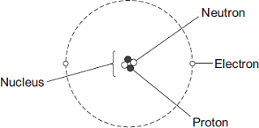Not drawn to scale
(a) In 1931 scientists thought that atoms contained only protons and electrons.
Suggest what happened in 1932 to change the idea that atoms contained only protons and electrons.
___________________________________________________________________
___________________________________________________________________
(1)
(b) The table gives information about the particles in an atom.
Complete the table by adding the names of the particles.

Particle | Relative Mass | Relative Charge
 | 1 | 0
 | very small | –1
 | 1 | +1
(2)
(Total 3 marks)
Q34.
The diagrams show two different models of an atom.

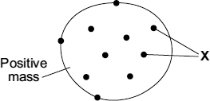 | 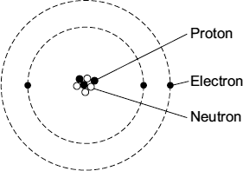
‘Plum pudding’ model | Model used today
(a) The particles labelled ‘Xߣ in the plum pudding model are also included in the model of the atom used today.
What are the particles labelled ‘X’ ?
_________________________
(1)
(b) Scientists decided that the ‘plum pudding’ model was wrong and needed replacing.
Which one of the following statements gives a reason for deciding that a scientific model needs replacing?
Tick () one box.

The model is too simple.

The model has been used by scientists for a long time.

The model cannot explain the results from a new experiment.
(1)
(c) The table gives information about the three types of particle that are in the model of the atom used today.

Particle | Relative mass | Relative charge
 | 1 | +1
 | very small | –1
 | 1 | 0
Complete the table by adding the names of the particles.
(2)
(Total 4 marks)
Q35.
The diagram represents an atom of beryllium. The three types of particle that make up the atom have been labelled.
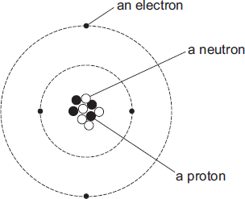
(a) Use the labels from the diagram to complete the following statements.
Each label should be used once.
The particle with a positive charge is ____________________________________
The particle with the smallest mass is ___________________________________
The particle with no charge is __________________________________________
(2)
(b) What is the atomic number of a beryllium atom?
Draw a ring around your answer.

4 | 5 | 9 | 13
Give a reason for your answer.
___________________________________________________________________
___________________________________________________________________
(2)
(c) Which one of the following statements describes what can happen to an atom to change it into an ion?
Tick () one box.

The atom loses a neutron.

The atom loses an electron.

The atom loses a proton.
(1)
(Total 5 marks)

Section 2: Required Practicals

Q1.
A student investigated the change in temperature when oils of different specific heat capacities were heated.
She set up the apparatus shown in the figure below.
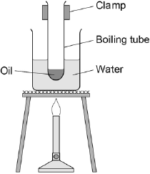
This is the method used.
1. Put 25 g of oil into a boiling tube.
2. Pour 100 ml of water into a beaker and heat it with a Bunsen burner.
3. When the water is boiling, put the boiling tube into the beaker.
4. When the temperature of the oil reaches 30 °C, heat for a further 30 seconds and record the rise in temperature.
5. Repeat with different oils.
6. Repeat the whole investigation.
(a) Name two pieces of apparatus the student used that are not shown in the figure above.
1. _________________________________________________________________
2. _________________________________________________________________
(2)
(b) What are the independent and dependent variables in the student’s investigation?
Independent ________________________________________________________
___________________________________________________________________
Dependent _________________________________________________________
___________________________________________________________________
(2)
(c) Give two safety precautions the student should have taken.
1. _________________________________________________________________
___________________________________________________________________
2. _________________________________________________________________
___________________________________________________________________
(2)
(d) Suggest one improvement to the student’s method.
___________________________________________________________________
___________________________________________________________________
___________________________________________________________________
___________________________________________________________________
(2)
(e) The table below shows the student’s results.

 | Temperature rise in °C
Type of oil | 1 | 2 | 3 | Mean
Castor oil | 20 | 19 | 21 | 20
Linseed oil | 19 | 18 | 19 | 19
Mineral oil | 21 | 21 | 21 | 21
Olive oil | 17 | 17 | 18
Sesame oil | 23 | 23 | 20 | 22
Calculate the mean temperature rise for olive oil.
Give your answer to two significant figures.
___________________________________________________________________
___________________________________________________________________
___________________________________________________________________
___________________________________________________________________
Mean temperature rise = __________________ °C
(2)
(f) The mean change in temperature of the castor oil is 20 °C
The specific heat capacity of castor oil is 1 800 J / kg °C
The mass of oil used is 0.025 kg
Calculate the change in thermal energy of the castor oil the student used.
Use the correct equation from the Physics Equations Sheet.
Select the correct unit from the box.

joule | newton | volt
___________________________________________________________________
___________________________________________________________________
___________________________________________________________________
___________________________________________________________________
___________________________________________________________________
Change in thermal energy = ____________________
Unit = ____________________
(3)
(Total 13 marks)
Q2.
A student investigated the specific heat capacity of five different metals.
(a) Complete the following sentence to show what is meant by specific heat capacity.
The specific heat capacity of a substance is the amount of energy required to
change the ____________________ of one kilogram of the substance by one
degree ____________________ .
(2)
(b) Each metal is in the form of a cylinder.
Each metal cylinder had a mass of 2 kg.
The student wrapped the same thickness of insulation around each metal cylinder.
He used an immersion heater to transfer the same amount of energy to each metal cylinder. Figure 1 shows the apparatus he used.
Figure 1
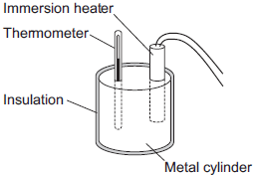
He measured the temperature of the metal cylinder at the start and at the end of each experiment, using a thermometer.
He calculated the increase in temperature of each metal cylinder.
His results are shown in Figure 2.
Figure 2
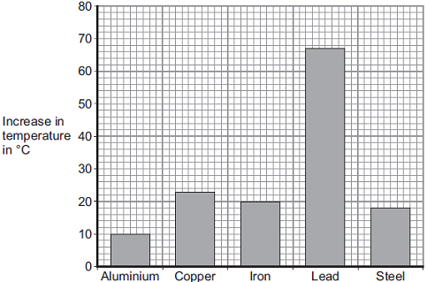
Metal Cylinder
(i) What was the independent variable in the investigation?
______________________________________________________________
(1)
(ii) The cylinders with a small increase in temperature were made of metals with a high specific heat capacity.
Tick (✔) the two correct conclusions that can be made from Figure 2.

Conclusions | Tick (✔)
Aluminium has the greatest temperature increase.
Copper and iron have similar specific heat capacities.
Steel has the highest specific heat capacity.
Lead has the lowest specific heat capacity.
(2)
(c) The steel cylinder had a mass of 2 kg.
The steel cylinder increased in temperature by 18 °C.
The specific heat capacity of the steel cylinder is 460 J / kg °C.
Calculate the energy transferred to the steel cylinder.
Use the correct equation from the Physics Equations Sheet.
___________________________________________________________________
___________________________________________________________________
___________________________________________________________________
Energy transferred = ____________________ J
(2)
(d) The student used a thermometer for the investigation.
Draw a ring around the correct answer to show the most appropriate resolution for the thermometer.

1 °C | 10 °C | 100 °C
(1)
(Total 8 marks)
Q3.
A student used the apparatus below to find out how the resistance of a light-dependent resistor (LDR) depends on light intensity.
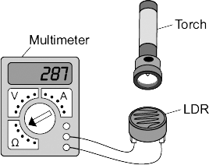
The resistance of the LDR was measured directly using a multimeter.
(a) (i) Which one of the following is the correct circuit symbol for a LDR?
Draw a ring around your answer.
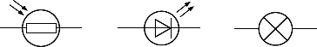
(1)
(ii) Name one factor that will affect the intensity of the light hitting the LDR.
______________________________________________________________
______________________________________________________________
(1)
(b) The manufacturer of the LDR provides data for the LDR in the form of a graph.
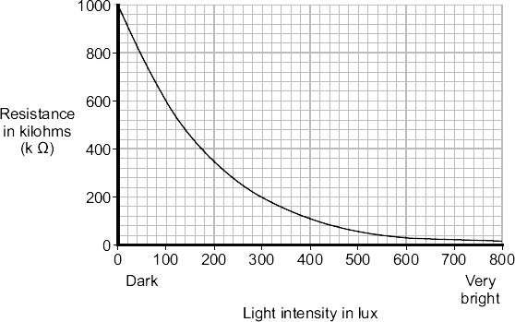
Describe how the resistance of the LDR changes when the light intensity increases from 100 lux to 300 lux.
___________________________________________________________________
___________________________________________________________________
___________________________________________________________________
(2)
(c) The student only obtained three results. These are given in the table.

Light intensity | Resistance in kilohms
Dark | 750
Bright | 100
Very bright | 1
(i) The student could not use the results to draw a line graph.
Why not?
______________________________________________________________
______________________________________________________________
(1)
(ii) Do the student’s results agree with the data the manufacturer provided?

Draw a ring around your answer. | YES | NO
Give a reason for your answer.
______________________________________________________________
______________________________________________________________
______________________________________________________________
(1)
(d) Which one of the following circuits probably includes a LDR?
Tick () one box.

A circuit that automatically switches outside lights on when it gets dark.
A circuit that automatically switches central heating on and off.
A circuit that automatically turns lights off when no one is in the room.
(1)
(Total 7 marks)
Q4.
(a) The diagram shows the circuit that a student used to investigate how the current through a resistor depends on the potential difference across the resistor.
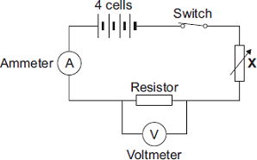
(i) Each cell provides a potential difference of 1.5 volts.
What is the total potential difference provided by the four cells in the circuit?
______________________________________________________________
Total potential difference = _________________________ volts
(1)
(ii) The student uses the component labelled X to change the potential difference across the resistor.
What is component X?
Draw a ring around your answer.

light-dependent resistor | thermistor | variable resistor
(1)
(iii) Name a component connected in parallel with the resistor.
______________________________________________________________
(1)
(b) The results obtained by the student have been plotted on a graph.
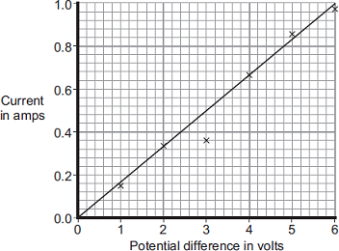
(i) One of the results is anomalous.
Draw a ring around the anomalous result.
(1)
(ii) Which one of the following is the most likely cause of the anomalous result?
Put a tick () in the box next to your answer.

The student misread the ammeter.
The resistance of the resistor changed.
The voltmeter had a zero error.
(1)
(iii) What was the interval between the potential difference values obtained by the student?
______________________________________________________________
______________________________________________________________
(1)
(c) Describe the relationship between the potential difference across the resistor and the current through the resistor.
___________________________________________________________________
___________________________________________________________________
(1)
(Total 7 marks)

Section 3: 6 Mark Questions

Q1.
(a) A resistor is a component that is used in an electric circuit.
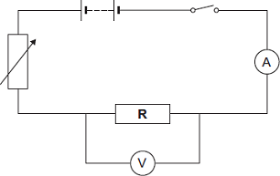
(i) Describe how a student would use the circuit to take the readings necessary to determine the resistance of resistor R.
______________________________________________________________
______________________________________________________________
______________________________________________________________
______________________________________________________________
______________________________________________________________
______________________________________________________________
______________________________________________________________
______________________________________________________________
______________________________________________________________
______________________________________________________________
______________________________________________________________
______________________________________________________________
______________________________________________________________
______________________________________________________________
(6)
(ii) Explain why the student should open the switch after each reading.
______________________________________________________________
______________________________________________________________
______________________________________________________________
______________________________________________________________
(2)
(iii) In an experiment using this circuit, an ammeter reading was 0.75 A.
The calculated value of the resistance of resistor R was 16 Ω.
What is the voltmeter reading?
______________________________________________________________
______________________________________________________________
Voltmeter reading = ________________ V
(2)
(iv) The student told his teacher that the resistance of resistor R was 16 Ω.
The teacher explained that the resistors used could only have one of the following values of resistance.

10 Ω | 12 Ω | 15 Ω | 18 Ω | 22 Ω
Suggest which of these resistors the student had used in his experiment.
Give a reason for your answer.
______________________________________________________________
______________________________________________________________
______________________________________________________________
______________________________________________________________
(2)
(b) The diagram shows a fuse.
Describe the action of the fuse in a circuit.
___________________________________________________________________
___________________________________________________________________
___________________________________________________________________
___________________________________________________________________
___________________________________________________________________
___________________________________________________________________
___________________________________________________________________
___________________________________________________________________
(3)
(Total 15 marks)
Q2.
A student wanted to determine the density of the irregular shaped object shown in Figure 1
Figure 1
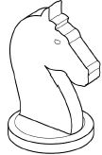
(a) Plan an experiment that would allow the student to determine the density of the object.
___________________________________________________________________
___________________________________________________________________
___________________________________________________________________
___________________________________________________________________
___________________________________________________________________
___________________________________________________________________
___________________________________________________________________
___________________________________________________________________
___________________________________________________________________
___________________________________________________________________
___________________________________________________________________
___________________________________________________________________
___________________________________________________________________
(6)
(b) Another student did a similar experiment.
He determined the density of five common plastic materials.
Table 1 shows the results.
Table 1

Plastic material | Density in kg/m³
Acrylic | 1200
Nylon | 1000
Polyester | 1380
Polystyrene | 1040
PVC | 1100
Figure 2 shows the results plotted in a bar chart.
Figure 2
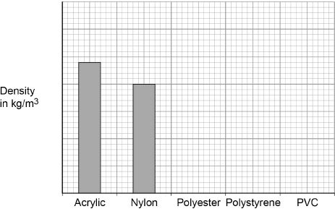
Complete Figure 2
You should:
• Write the correct scale on the y-axis.
• Draw the bars for polyester, polystyrene and PVC.
(4)
(c) The student is given a piece of a different plastic material.
The student determined the density of the material three times.
Table 2 shows the results.
Table 2

 | Density in kg/m³
1 | 960
2 | 1120
3 | 1040
Determine the uncertainty in the student’s results.
___________________________________________________________________
___________________________________________________________________
Uncertainty = _________________ kg/m³
(2)
(Total 12 marks)
Q3.
Solid, liquid and gas are three different states of matter.
(a) Describe the difference between the solid and gas states, in terms of the arrangement and movement of their particles.
___________________________________________________________________
___________________________________________________________________
___________________________________________________________________
___________________________________________________________________
___________________________________________________________________
___________________________________________________________________
___________________________________________________________________
___________________________________________________________________
___________________________________________________________________
___________________________________________________________________
___________________________________________________________________
(4)
(b) What is meant by ‘specific latent heat of vaporisation’?
___________________________________________________________________
___________________________________________________________________
___________________________________________________________________
___________________________________________________________________
(2)
(c) While a kettle boils, 0.018 kg of water changes to steam.
Calculate the amount of energy required for this change.
Specific latent heat of vaporisation of water = 2.3 × 10⁶ J / kg.
___________________________________________________________________
___________________________________________________________________
___________________________________________________________________
Energy required = __________________ J
(2)
(d) The graph shows how temperature varies with time for a substance as it is heated.
The graph is not drawn to scale.
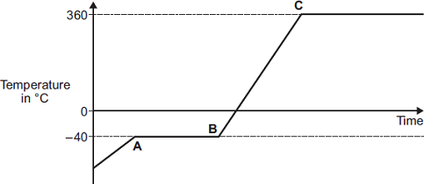
Explain what is happening to the substance in sections AB and BC of the graph.
Section AB _________________________________________________________
___________________________________________________________________
___________________________________________________________________
___________________________________________________________________
___________________________________________________________________
Section BC _________________________________________________________
___________________________________________________________________
___________________________________________________________________
___________________________________________________________________
___________________________________________________________________
(4)
(Total 12 marks)
Q4.
In this question you will be assessed on using good English, organising information clearly and using specialist terms where appropriate.
The information in the box is about the properties of solids and gases.

Solids:
• have a fixed shape
• are difficult to compress (to squash).
Gases:
• will spread and fill the entire container
• are easy to compress (to squash).
Use your knowledge of kinetic theory to explain the information given in the box.
You should consider:
• the spacing between the particles
• the movement of individual particles
• the forces between the particles.
_______________________________________________________________________
_______________________________________________________________________
_______________________________________________________________________
_______________________________________________________________________
_______________________________________________________________________
_______________________________________________________________________
_______________________________________________________________________
_______________________________________________________________________
_______________________________________________________________________
_______________________________________________________________________
_______________________________________________________________________
_______________________________________________________________________
Extra space ____________________________________________________________
_______________________________________________________________________
_______________________________________________________________________
_______________________________________________________________________
_______________________________________________________________________
_______________________________________________________________________
_______________________________________________________________________
_______________________________________________________________________
_______________________________________________________________________
_______________________________________________________________________
_______________________________________________________________________
_______________________________________________________________________
_______________________________________________________________________
_______________________________________________________________________
_______________________________________________________________________
(Total 6 marks)
Q5.
(a) Over 100 years ago, scientists thought the atom was like a ‘plum pudding’.
The diagram below shows the plum pudding model of the atom.
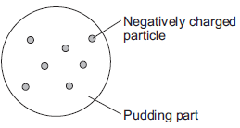
The scientists knew that an atom has negatively charged particles. They also knew that an atom has no overall charge.
What did the scientists conclude about the charge on the ‘pudding part’ of the atom?
___________________________________________________________________
___________________________________________________________________
(1)
(b) Two scientists named Rutherford and Marsden devised an experiment to investigate the plum pudding model of the atom. The experiment involved firing alpha particles at a thin sheet of gold. The scientists measured how many of the alpha particles were scattered.
Using the plum pudding model, the scientists predicted that only a few of the alpha particles would be scattered by more than 4°.
Over several months, more than 100 000 measurements were made.
(i) The results from this experiment caused the plum pudding model to be replaced by a new model of the atom.
Explain why.
______________________________________________________________
______________________________________________________________
______________________________________________________________
______________________________________________________________
______________________________________________________________
______________________________________________________________
(2)
(ii) Suggest one reason why other scientists thought this experiment provided valid evidence for a new model of the atom.
______________________________________________________________
______________________________________________________________
______________________________________________________________
(1)
(c) In this question you will be assessed on using good English, organising information clearly and using specialist terms where appropriate.
Describe the model now used for the structure of an atom.
In your answer you should:
• give details of the individual particles that make up an atom
• include the relative masses and relative charges of these particles.
Do not include a diagram in your answer.
___________________________________________________________________
___________________________________________________________________
___________________________________________________________________
___________________________________________________________________
___________________________________________________________________
___________________________________________________________________
___________________________________________________________________
___________________________________________________________________
___________________________________________________________________
___________________________________________________________________
(6)
(Total 10 marks)
Q6.
Alpha particles, beta particles and gamma rays are types of nuclear radiation.
(a) Describe the structure of an alpha particle.
___________________________________________________________________
___________________________________________________________________
(1)
(b) Nuclear radiation can change atoms into ions by the process of ionisation.
(i) Which type of nuclear radiation is the least ionising?
Tick (✔) one box.

alpha particles
beta particles
gamma rays
(1)
(ii) What happens to the structure of an atom when the atom is ionised?
______________________________________________________________
______________________________________________________________
(1)
(c) People working with sources of nuclear radiation risk damaging their health.
State one precaution these people should take to reduce the risk to their health.
___________________________________________________________________
___________________________________________________________________
(1)
(d) In this question you will be assessed on using good English, organising information clearly and using specialist terms where appropriate.
The type of radiation emitted from a radioactive source can be identified by comparing the properties of the radiation to the properties of alpha, beta and gamma radiation.
Describe the properties of alpha, beta and gamma radiation in terms of their:
• penetration through materials
• range in air
• deflection in a magnetic field.

(6)
(Total 10 marks)

Mark schemes
Q1.
(a) E_{p} = 50 × 9.8 × 4.0
1
E_{p} = 1960 (J)
allow an answer rounded to 2000 (J)
1
allow a maximum of 1 mark if g = 10 N/kg is used
an answer of 1960 scores 2 marks
(b) E_{k} = 0.5 × 50 × 7²
1
E_{k} = 1225 (J)
allow 1200 or 1230 (J)
1
an answer of 1225 scores 2 marks
(c) some energy is wasted
1
the g.p.e of the girl is not zero
1
(d) reduces the amount of friction
do not accept reference to friction between the wheels and the ramp
1
so more energy is usefully transferred
allow less energy is wasted or less heating
1
greater kinetic energy
1
[9]
Q2.
(a) add thermal insulation to the roof
1
replace the single-glazed windows with double-glazed windows
1
(b) 110
1
(c) the time taken increases
1
(d) advantage of solar panel:
cheap(er) to run / use (1)
ignore cheap / free unqualified
(as) no energy / fuel cost (1)
or
no carbon dioxide emissions (1)
allow no greenhouse gases emitted
(so) does not contribute to global warming or climate change (1)
allow description of effect of global warming
or
renewable (1)
(as) sunlight is replenished (1)
or
conserves nuclear / fossil fuels (1)
(as) sunlight is renewable (1)
or
does not burn fossil fuels (1)
(so) no carbon dioxide emissions (1)
allow no greenhouse gases emitted
Max 2 marks
disadvantage of solar panel:
unreliable (1)
allow water not always hot enough
allow it may not (always) work
(as sun)light not available (1)
allow not always sunny
allow as it might be cloudy / dark
ignore weather
ignore night unqualified
ignore no sun
or
expensive (1)
due to high cost of manufacturing / installing solar panels (1)
Max 2 marks
[8]
Q3.
(a) geothermal
1
nuclear
1
biofuel
1
(b) gravitational (potential)
1
kinetic
1
sound
1
(c) (i) 90% or 0.9(0)
an answer of 0.9(0) with a unit gains 1 mark
2
(ii) 60 (MW)
allow 10%
1
(iii) increased
1
[10]
Q4.
(a) it would decrease the time
1
(b) 720 (J)
allow 1 mark for correct substitution ie 12 × 60 provided no subsequent step
2
(c) decreases
1
decreases
1
decreases
1
more than one tick in any row negates the mark
[6]
Q5.
(a) iron
1
hairdryer
1
kettle
answers can be in any order
1
(b) sound
1
(c) is more efficient than
1
[5]
Q6.
(a) (i) grid
accept any way of indicating correct answer
1
(ii) increases voltage
accept any way of indicating correct answer
1
(iii) 230 V
accept any way of indicating correct answer
1
(iv) reduce
accept any way of indicating correct answer
1
(b) (i) increases the temperature
accept make it hotter / heat goes into the air
accept convection currents
accept sensible comment eg sound energy / it buzzes
ignore pollutes the air
1
(ii) less than 100%
1
[6]
Q7.
(a) (casing is) not made of metal
allow (casing is) made of plastic
allow they are double insulated
1
little / no chance of electric shock
1
(b) charge flow = current × time
allow the equation given in symbols
1
(c) Q = 2.95 × 60
an answer of 177 scores 2 marks
1
Q = 177 (C)
allow 180 (C)
1
(d) straight line with a different positive gradient
must go through the first and third quadrant
1
straight line with positive gradient through the origin
1
(e)
1
(f) the particles vibrate about a fixed position regular arrangement
allow the particles are in a regular arrangement
1
(the particles change) to being free to move around
allow correct description of translational kinetic energy
1
(g) L = 200 000 (J/kg)
1
E = 500 × 200 000
allow 1 × 10⁸ (J)
1
E = 100 000 000 (J)
allow correct calculation for incorrect conversion or no conversion of L for 2 marks
1
an answer of 100 000 000 scores 3 marks
[13]
Q8.
(a) A
1
(b) C
1
(c) C
1
(d) B
1
(e) a series circuit has only one path/loop/branch
1
a parallel circuit has a branch(es) to provide more than one path / loop
allow answers that describe the difference in terms of potential difference, current or resistance
1
(f) R
1
(g) P
1
(h) Q = 0.97 × 60
1
Q = 58.2 (C)
1
Q = 58 (C)
an answer of 58 (C) scores 3 marks
1
[11]
Q9.
(a) earth
1
(b) it can prevent an electric shock from the toaster
1
(c) 230 V
1
(d) (the potential difference) for the alternating supply changes direction
allow current
1
(the potential difference) for the alternating supply changes magnitude
allow current
allow converse
allow potential difference of alternating supply is greater
1
(e) there is an overall decrease
allow there is an decrease in percentage energy loss until 2013
1
but there is a (small) increase since 2013
1
(f) 1.92, 1.72, 1.70, 1.74, 1.77
1
(1.92 + 1.72 + 1.70 + 1.74 + 1.77)/5
1
1.77(%)
an answer of 1.77(%) scores 3 marks
1
[10]
Q10.
(a) E = 15 000 × 36
1
E = 540 000
1
E = 540 (kJ)
an answer of 540 (kJ) scores 3 marks
1
(b) (the motor in) scooter B has a higher power
1
therefore
(because both motors have the same efficiency) scooter B will have a greater kinetic energy
1
(c) the battery in scooter B has a greater store of chemical energy
1
(d) energy transferred = power × time
allow E = P × t
1
(e) 20 × 60
1
E = 1 200 × 700
1
E = 840 000 (J)
an answer of 840 000 (J) scores 3 marks
1
[10]
Q11.
(a) 50 Hz
1
(b) Top: Earth
1
Bottom: Neutral
1
(c) potential difference
1
current
1
(d) energy = 2500 × 180
1
= 450 000
1
= 450 kJ
1
allow 450 with no working shown for 3 marks
(e) energy transferred = charge flow × potential difference
allow E = QV
1
(f) 4 200 = Q × 230
1
Q = 4 200 ÷ 230
1
= 18.3 (C)
1
allow 18.3 with no working shown for 3 marks
[12]
Q12.
(a) last box ticked
1
(b) (i) use hotter water (than 60 °C)
accept use boiling water
accept use water at any stated temperature above 60 °C
or
add ice cubes
accept add water at any stated temperature below 12 °C
use different temperatures is insufficient
1
(ii) the current increases as the temperature increases
1
(iii) 0.02 (A)
1
(iv) 5 (V)
or
their (b)(iii) × 250 correctly calculated
allow 1 mark for correct substitution ie V = 0.02 × 250
or
V = their (b)(iii) × 250
2
(v) the resistance increases
1
[7]
Q13.
(a) field
correct order only
1
current
1
force
accept motion
accept thrust
1
(b) (i) arrow pointing vertically downwards
1
(ii) increase current / p.d.
accept voltage for p.d.
1
increase strength of magnetic field
accept move poles closer together
1
(iii) reverse (poles of) magnets
1
reverse battery / current
1
(c) (i) 1.5 or 150%
efficiency = 120 / 80 (× 100)
gains 1 mark
an answer of 1.5 % or 150
gains 1 mark
2
(ii) efficiency greater than 100%
or
output is greater than input
or
output should be 40 (W)
1
(iii) recorded time much shorter than actual time
accept timer started too late
accept timer stopped too soon
1
[12]
Q14.
(a)
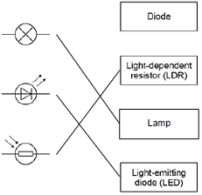
allow 1 mark for each correct line if more than one line is drawn from any symbol then all of those lines are wrong
3
(b) (i) half
1
(ii) 3(V)
1
(iii) V₁
1
(c) (i) potential difference / voltage of the power supply
accept the power supply
accept the voltage / volts
accept number of cells / batteries
accept (same) cells / batteries
do not accept same ammeter / switch / wires
1
(ii) bar drawn – height 1.(00)A
ignore width of bar
allow 1 mark for bar shorter than 3rd bar
2
(iii) as the number of resistors increases the current decreases
1
[10]
Q15.
(a) 25(Ω)
1
(b) (i) 2(V)
allow 1 mark for showing a correct method, ie 6 / 3
2
(ii) equal to
1
[4]
Q16.
(a) A
only scores if A chosen
1
it is alternating / a.c.
accept because B and C are d.c.
or
it changes direction/p.d.
accept voltage for p.d.
it goes up and down is insufficient
it is constantly changing is insufficient
an answer B and/or C with the reason because it is direct current/d.c scores 1 mark
1
(b) too much current (through socket)
accept electricity for current
accept too much power
accept socket/circuit overloaded
do not accept voltage/p.d for current
1
wiring / socket gets hot
accept melts for gets hot
accept risk of fire
risk of fire in appliances is insufficient
ignore reference to sparking
overloaded plugs and plugs getting hot or fuses melting is insufficient
1
[4]
Q17.
(a) (i) 15
1
(ii) 4.5 or their (a)(i) x 0.3 correctly calculated
allow 1 mark for correct substitution, ie 0.3 x 15/their (a)(i), provided no subsequent step
2
(ii) decrease
1
(b) Y
accept any correct indication
reason only scores if Y is chosen
accept voltage for p.d.
1
(only one that) shows a direct current / p.d.
or
a battery / cell gives a direct current
accept both X and Z are a.c.
or
a battery/cell gives a constant current/p.d.
accept it’s a constant current/p.d.
it is not changing is insufficient
1
[6]
Q18.
(a) (i) 4.5
1
(ii) 2.25 or their (a)(i) ÷ 2 correctly calculated
1
(iii) V₂
1
(b) (i) 30
1
(ii) 8
allow 1 mark for correct substitution
ie 0.4 × 20
allow 1 mark for answers of 4 or 12
2
(iii) Y
1
[7]
Q19.
(a) (i) electrons
1
(ii) ammeter
do not accept ampmeter
1
must be capital A
horizontal lines not required no e.c.f.
1
(b) light bulb
answers in either order
1
hairdryer
1
[5]
Q20.
(a) (i) diode
[Do not accept ‘rectifier’ or LED]
(ii) lamp / bulb / light
each for 1 mark
2
(b) • P = voltage / potential difference / p.d. / volts / V
[Allow ‘Voltmeter]
• Q = current / amperes / amps / A
[Allow ‘ammeter]
each for 1 mark
2
[4]
Q21.
(a) gamma
1
(b) alpha
1
(c) gamma
1
(d)
isotope | number of neutrons | number of protons
uranium-238 | 146 | 92 | 1
thorium-234 | 144 | 90 | 1
(e) Δθ = 80 °C
1
E = 150 × 4200 × 80
1
E = 50 400 000 (J)
allow 50 000 000 (J)
1
allow max 2 marks for correct calculation using incorrect value of Δθ
allow 1 mark for correct calculation using θ = 20
or θ = 100
an answer of 50 400 000 scores 3 marks
[8]
Q22.
(a) ice
water
steam
allow 1 mark for 1 or 2 correct answers
2
(b) 1 kg of steam
1
(c) steam
1
(d) ρ = 11 200 / 12.0
1
ρ = 933 (kg/m³)
an answer of 933 (kg/m³) scores 2 marks
1
(e) the internal energy of the iceberg increases
allow there is a temperature difference between ice and water / air
1
because
therefore
energy is transferred from the sea/water to the ice(berg)
1
[8]
Q23.
(a) (approximate same size particles as each other and as liquid and gas) touching
do not accept particles that overlap
1
regular arrangement (filling the square)
1
(b) condensing
1
(c) solid
1
(d) physical
1
(e) particles have more kinetic energy
1
particles move faster
1
(f) mass of the liquid
1
specific latent heat of vaporisation
1
(g) 2 × 4 200 × 80
1
672 000 (J)
an answer of 672 000 (J) scores 2 marks
1
[11]
Q24.
(a) kilograms per metre cubed, kg / m³
1
(b) (solid has) more particles
allow atoms for particles
1
in the same volume or in a given volume
allow description of a given area
1
(c) randomly
this order only
1
kinetic
1
(d) (pressure) rises
1
[6]
Q25.
(a) (i) any two from:
• mass (of block)
accept weight for mass
• starting temperature
• final / increase in temperature
temperature is insufficient
• voltage / p.d.
same power supply insufficient
• power (supplied to each block)
• type / thickness of insulation
same insulation insufficient
2
(ii) one of variables is categoric
or
(type of) material is categoric
accept the data is categoric
accept a description of categoric
do not accept temp rise is categoric
1
(iii) concrete
reason only scores if concrete chosen
1
(heater on for) longest / longer time
a long time or quoting a time is insufficient
do not accept it is the highest bar
1
(iv) 4500 (J)
allow 1 mark for correct substitution ie
2 × 450 × 5 provided no subsequent step shown
2
(b) (i) point at 10 minutes identified
1
(ii) line through all points except anomalous
line must go from at least first to last point
1
(iii) 20 (°C)
if 20°C is given, award the mark.
If an answer other than 20°C is given, look at the graph. If the graph shows a correct extrapolation of the candidate’s best-fit line and the intercept value has been correctly stated, allow 1 mark.
1
(iv) 2 (minutes)
1
[11]
Q26.
(a) (i) Z
1
(ii) X
1
(b) (i) moving randomly
1
(ii) stronger than
1
(c) (i) evaporation
1
(ii) any one from:
• becomes windy
• temperature increases
accept (becomes) sunny
“the sun” alone is insufficient
• less humid
1
[6]
Q27.
(i) conduction, convection
answer can be in either order
1
(ii) traps (lots of) air
do not accept heat is trapped in the fibre
1
air is a (good) insulator or poor conductor
1
[3]
Q28.
(a) balls are far apart from each other
1
balls move randomly
1
(b) solid
1
gas
1
[4]
Q29.
(a) a type of electromagnetic radiation
1
(b) a thick sheet of lead
1
(c) to decrease the rate of decay of the food
1
to prevent food poisoning
1
(d) gamma rays cause mutations
1
(e) decrease the distance between the food and the radioactive source
1
increase the time for which the food is close to the radioactive source
1
(f) (because) the source of radiation is not in the food
allow source of radiation is / remains outside food
1
[8]
Q30.
(a) The nucleus will emit a neutron.
1
(b) Similarity
same mass number
allow same number of nucleons (protons + neutrons)
1
difference
different atomic number
allow different number of protons
1
(c) Radioactive decay is random.
1
(d) 1.3 (billion years)
allow 1.2-1.4 (billion years)
2
allow 1 mark for horizontal line drawn from ~ 550
(e) alpha
1
[7]
Q31.
(a) 1 × 10⁻¹⁰ m
1
(b) (a helium atom) has 2 electrons
accept it has more mass
allow it is not charged
1
(c) 2
1
(d) neutral
accept 0 or ‘no charge’
1
(because) protons have positive charge and electrons have negative charge
1
(and) there are equal numbers of protons and electrons
1
(e) helium will one day run out
1
there will be none left for medical uses so balloons waste helium
1
[8]
Q32.
(a) gamma
allow 1 mark for 1 or 2 correct
beta
alpha
2
(b) any two from:
• do not point (radioactive) source at students
• keep (radioactive) source outside the box for minimum time necessary
• wear safety glasses or eye protection or do not look at source
• wear gloves
• hold (radioactive) source away from body
• hold (radioactive) source with tongs / forceps
2
(c) as time increases count rate decreases
1
count rate halves every 80 seconds
1
(d) half-life is 80 seconds
1
so after 200 seconds count rate = 113
1
(e) because a very small amount of radiation will be emitted or will be similar to / same as background radiation
1
[9]
Q33.
(a) neutron discovered
1
(b) neutron
all 3 in correct order
electron
allow 1 mark for 1 correct
proton
2
[3]
Q34.
(a) electron(s)
1
(b) 3rd box ticked
The model cannot explain the results from a new experiment
1
(c) all three correct

Particle
Proton
Electron
Neutron
allow 1 mark for 1 correct
2
[4]
Q35.
(a) proton
electron
neutron
all 3 in correct order
allow 1 mark for 1 correct
do not accept letters p, e, n
2
(b) 4
reason only scores if 4 is chosen
1
number of protons
accept number of electrons
accept there are 4 protons and 4 electrons
do not accept there are 4 protons and electrons
1
(c) The atom loses an electron.
1
[5]

Section 2: Required Pracicals
Q1.
(a) thermometer
1
stopclock / stopwatch
accept measuring cylinder
accept top pan balance
1
(b) independent: type of oil
1
dependent: temperature rise in °C
1
(c) wear safety goggles
1
oil not heated directly
accept any reasonable comment about not handling hot apparatus.
1
(d) repeat the experiment
1
and calculate the mean temperature rise
OR
heat the oil for a longer period of time (1)
to get a wider range of temperatures (1)
1
(e) (17 + 17 + 18) / 3 (= 17.33)
1
temperature rise = 17 (°C)
1
accept 17 (°C) with no working shown for 2 marks
allow 17.33 with no working shown for 1 mark
(f) E = 0.025 × 1800 × 20 (J)
1
E = 900 (J)
1
allow 900 without working shown for the 2 calculation marks
Joule
1
[13]
Q2.
(a) temperature
correct order only
1
celsius
accept kelvin / uppercase K
allow uppercase C / °C
allow centigrade
1
(b) (i) (type of) metal
allow metal cylinder
1
(ii) Copper and iron have similar specific heat capacities
1
Lead has the lowest specific heat capacity
1
(c) 16 560 (J)
correct substitution = 1 mark
e.g. E = 2 x 460 x 18 provided no subsequent step
2
(d) 1°C
1
[8]
Q3.
(a) (i) correct symbol ringed
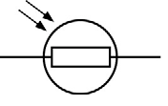
1
(ii) accept any suggestion that would change light intensity, eg:
• torch on or off
accept power of torch
do not accept watts / wattage of torch
• distance between torch and LDR
• lights in room on or off
• shadow over the LDR
1
(b) resistance decreases
1
from 600 kΩ to 200 kΩ
accept by 400 kΩ
1
(c) (i) no numbers for light intensity
or
light intensity is categoric / a description / not continuous
not enough results is insufficient
1
(ii) YES
mark is for the reason
both show that resistance increases with decreasing (light)
intensity / brightness
accept they both get the same results / pattern
1
(d) A circuit that automatically switches outside lights on when it gets dark.
1
[7]
Q4.
(a) (i) 6
1
(ii) variable resistor
1
(iii) voltmeter
1
(b) (i) point at 3 V ringed
1
(ii) The student misread the ammeter.
1
(iii) 1 (volt)
accept every volt
1
(c) as one increases so does the other
or
directly proportional
or
positive correlation
accept a numerical description, eg when one doubles the other also doubles
1
[7]
Section 3: 6 Mark Questions Mark Scheme
Q1.
(a) (i) any six from:
• switch on
• read both ammeter and voltmeter
allow read the meters
• adjust variable resistor to change the current
• take further readings
• draw graph
• (of) V against I
allow take mean
• R = V / I
allow take the gradient of the graph
6
(ii) resistor would get hot if current left on
1
so its resistance would increase
1
(iii) 12 (V)
0.75 × 16 gains 1 mark
2
(iv) 15 (Ω)
1
16 is nearer to that value than any other
1
(b) if current is above 5 A / value of fuse
1
fuse melts
allow blows / breaks
do not accept exploded
1
breaks circuit
1
[15]
Q2.
(a) Level 3: The method would lead to the production of a valid outcome. All key steps are identified and logically sequenced.
5−6
Level 2: The method would not necessarily lead to a valid outcome. Most steps are identified, but the method is not fully logically sequenced.
3−4
Level 1: The method would not lead to a valid outcome. Some relevant steps are identified, but links are not made clear.
1−2
No relevant content
0
Indicative content
• measure mass
• use a top pan balance or scales
• part fill a measuring cylinder with water
• measure initial volume
• place object in water
• measure final volume
• volume of object = final volume − initial volume
• fill a displacement / eureka can with water
• water level with spout
• place object in water
• collect displaced water
• measuring cylinder used to determine volume of displaced water
• use of:
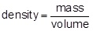
(b) all y-axis values correct (minimum of 3)
allow 1 mark for two correct values
2
all bars drawn to the correct height
allow 1 mark for two correct bars
allow ± ½ small square
2
(c) 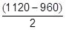
ignore + and / or − signs
1
= 80 (kg/m³)
an answer of 160 scores 1 mark
1
an answer of 80 scores 2 marks
[12]
Q3.
(a) solid
particles vibrate about fixed positions
1
closely packed
accept regular
1
gas
particles move randomly
accept particles move faster
accept freely for randomly
1
far apart
1
(b) amount of energy required to change the state of a substance from liquid to gas (vapour)
1
unit mass / 1 kg
dependent on first marking point
1
(c) 41000 or 4.1 × 10⁴ (J)
accept
41400 or 4.14 × 10⁴
correct substitution of
0.018 × 2.3 × 10⁶ gains 1 mark
2
(d) AB
changing state from solid to liquid / melting
1
at steady temperature
dependent on first AB mark
1
BC
temperature of liquid rises
1
until it reaches boiling point
dependent on first BC mark
1
[12]
Q4.
Marks awarded for this answer will be determined by the Quality of Written Communication (QWC) as well as the standard of the scientific response. Examiners should also apply a ‘best-fit’ approach to the marking.
0 marks
No relevant content.
Level 1 (1–2 marks)
Considers either solid or gas and describes at least one aspect of the particles.
or
Considers both solids and gases and describes an aspect of each.
Level 2 (3–4 marks)
Considers both solids and gases and describes aspects of the particles.
or
Considers one state and describes aspects of the particles and explains at least one of the properties.
or
Considers both states and describes an aspect of the particles for both and explains a property for solids or gases.
Level 3 (5–6 marks)
Considers both states of matter and describes the spacing and movement / forces between the particles. Explains a property of both solids and gases.
examples of the points made in the response
extra information
Solids
• (particles) close together
• (so) no room for particles to move closer (so hard to compress)
• vibrate about fixed point
• strong forces of attraction (at a distance)
• the forces become repulsive if the particles get closer
• particles strongly held together / not free to move around (shape is fixed)
any explanation of a property must match with the given aspect(s) of the particles.
Gases
• (particles) far apart
• space between particles (so easy to compress)
• move randomly
• negligible / no forces of attraction
• spread out in all directions (to fill the container)
[6]
Q5.
(a) (an equal amount of) positive charge
do not accept charge on the atom / nucleus is positive
1
(b) (i) a (significant) number of alpha particles were scattered by more than 4°
or
alpha particles deflected backwards
accept (some) measurements / results were unexpected
1
measurements / results could not be explained by ‘plum pudding’ model
or
measurements / results did not support predictions
can be explained by the nuclear model is insufficient
accept measurements / results did not support hypothesis
1
(ii) many / (over)100 000 measurements / results taken
accept Rutherford(and Marsden) were respected scientists
or
scientists were respected
accept measurements / results taken over several months
the experiment was repeated many times is insufficient
1
(c) Marks awarded for this answer will be determined by the Quality of Written Communication (QWC) as well as the standard of the scientific response. Examiners should also refer to the information on page 5 and apply a ‘best-fit’ approach to the marking.
0 marks
no relevant content
Level 1 (1−2 marks)
A brief description is given with some particles correctly named
Level 2 (3−4 marks)
A description is given with all three particles named
plus either
the polarity of charge associated with the
three particles
or
the relative mass of the three particles
or
the relative mass for one particle and the relative charge for one particle given
Level 3 (5−6 marks)
A more detailed description is given, naming the particles and polarity of charge
and either
the relative mass is given for at least two particles
or
the relative charge is given for at least two particles
Examples of the points made in the response
brief description
contains protons, neutrons and electrons
protons are positive
electrons are negative
neutrons are uncharged
has a nucleus
relative charge
proton +1
electron − 1
neutron 0
relative mass
proton 1
neutron 1
electron (about) 1 / 2000
accept protons and neutrons have the same mass
accept electrons have tiny / negligible mass
zero mass is neutral
more detailed description
protons and neutrons make up the nucleus
electrons orbit the nucleus
electrons are in shells
most of the atom is empty space
nucleus occupies a very small fraction of the volume of the atom
electrons orbit at a relatively large distance from the nucleus
most of the mass of the atom is contained in the nucleus
the nucleus as a whole is positively charged total number of protons in the nucleus equals the total number of electrons orbiting it in an atom
6
[10]
Q6.
(a) 2 protons and 2 neutrons
accept 2p and 2n
accept (the same as a) helium nucleus
symbol is insufficient
do not accept 2 protons and neutrons
1
(b) (i) gamma rays
1
(ii) loses/gains (one or more) electron(s)
1
(c) any one from:
• wear protective clothing
• work behind lead/concrete/glass shielding
• limit time of exposure
• use remote handling
accept wear mask/gloves
wear goggles is insufficient
wear protective equipment/gear is insufficient
accept wear a film badge
accept handle with (long) tongs
accept maintain a safe distance
accept avoid direct contact
1
(d) Marks awarded for this answer will be determined by the Quality of Written Communication (QWC) as well as the standard of the scientific response. Examiners should apply a ‘best-fit’ approach to the marking.
Level 3 (5 – 6 marks):
There is a description of all three types of radiation in terms of at least two of their properties
or
a full description of two types of radiation in terms of all three properties.
Level 2 (3 – 4 marks):
There is a description of at least two types of radiation in terms of some properties
or
a full description of one type of radiation in terms of all three properties
or
the same property is described for all three radiations
Level 1 (1 – 2 marks):
There is a description of at least one type of radiation in terms of one or more properties.
Level 0 (0 marks):
No relevant information
examples of physics points made in the response
alpha particles
• are least penetrating
• are stopped by paper / card
• have the shortest range
• can travel (about) 5cm in air
• are (slightly) deflected by a magnetic field
• alpha particles are deflected in the opposite direction to beta particles by a magnetic field
beta particles
• (some are) stopped by (about) 2mm (or more) of aluminium/metal
• can travel (about) 1 metre in air
• are deflected by a magnetic field
• beta particles are deflected in the opposite direction to alpha particles by a magnetic field
accept (some are) stopped by aluminium foil
gamma rays
• are the most penetrating
• are stopped by (about) 10cm of lead
• have the longest range
• can travel at least 1 km in air
• are not deflected by a magnetic field
6
[10]

