Oasis Academy South Bank
Year 11 Mock Revision
Chemistry Combined Paper 1: Foundation
Name: ___________________________
Class: _________
Teacher: __________________________
Step 1: Knowledge
Learn each of the quiz questions and answers off by heart. This could be done by:
- turning them into flash cards and testing yourself
- using ‘look, cover, write, check’
- asking a friend or family member to quiz you
Topic | LCWC | Quiz 1 | Quiz 2 | Quiz 3
The Three States (C.1)
Elements, compounds (C.2)
Mixtures (C.3)
Chromatography (C.4)
Structure of an atom (C.5)
The periodic table (C.6)
Types of bonding (C.7)
Properties of materials (C.8)
Describing chemical reactions, reactions of metals and gas tests (C.9)
Acids and Alkalis (C.10)
Electrolysis (C.12)
Endothermic and exothermic reactions (C.14)
Rates of reaction (C.17)
Chemical calculations, volumes and concentrations (C.19)
Metals and alloys (C.23)
Alkanes and alkenes (C.28)

Step 2: Exam practice
- Practice applying your knowledge using the past exam questions in each section.
- Self-assess these using the mark schemes at the back and rewrite your answers.
- Assess your progress using a ‘red, amber, green’ system (RAG)
Section | Completed | SA using green pen
1: Knowledge
2. Required Practicals
3. 6 markers

Exam practice
Section 1: Knowledge

Q1.
A student tested a sea water sample for dissolved solids.
Figure 1 shows the apparatus.
Figure 1
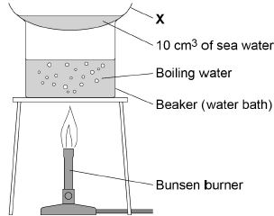
(a) What is apparatus X on Figure 1?
Tick one box.

Boiling tube
Condenser
Funnel
Watch glass
(1)
(b) The student did the test four times.
The student calculated the mass of solid on apparatus X after heating.
The table below shows the student’s results.

 | Test 1 | Test 2 | Test 3 | Test 4
Mass of solid in grams | 0.12 | 0.29 | 0.14 | 0.15
Calculate the mean mass of solid.
Do not include the anomalous result in your calculation.
Give your answer to 2 significant figures.
___________________________________________________________________
___________________________________________________________________
___________________________________________________________________
___________________________________________________________________
___________________________________________________________________
Mean mass = _______________________ g
(3)
The student distilled a sample of sea water in the apparatus shown in Figure 2
Figure 2
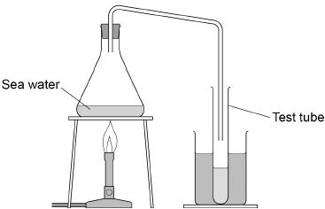
(c) What change of state is happening at the surface of the sea water in Figure 2?
___________________________________________________________________
(1)
(d) Describe how the water in the test tube in Figure 2 is different from the sea water.
___________________________________________________________________
___________________________________________________________________
(1)
(e) Why does producing drinking water from sea water using distillation cost a lot of money?
___________________________________________________________________
___________________________________________________________________
(1)
(f) River water is filtered then sterilised to make drinking water.
Why are these two processes done?
Filtering ____________________________________________________________
___________________________________________________________________
Sterilising __________________________________________________________
___________________________________________________________________
(2)
(Total 9 marks)
Q2.
A student investigated the effect of the size of marble chips on the rate of the reaction between marble chips and hydrochloric acid.
This is the method used.
1. Add 10.0 g of marble chips into the flask.
2. Add 50 cm³ of hydrochloric acid and start a timer.
3. Record the mass lost from the flask every 10 seconds.
4. Repeat steps 1 to 3 with different sizes of marble chips.
Figure 1 shows the apparatus.
Figure 1
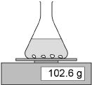
(a) Draw one line from each type of variable to the correct example of the variable.

Type of variable |  | Example of variable
 |  | Mass lost from flask
Independent |  | Size of flask
 |  | Size of marble chips
Control |  | Time taken
 |  | Volume of acid
(2)
(b) The equation for the reaction is:
CaCO₃(s) + 2HCl(aq) CaCl₂(aq) + H₂O(l) + CO₂(g)
Name the three products.
1. ______________________________
2. ______________________________
3. ______________________________
(2)
(c) Another student suggests putting some cotton wool in the top of the flask.
Suggest why this improves the investigation.
___________________________________________________________________
___________________________________________________________________
(1)
(d) The reaction produces 1.6 g of gas in 30 seconds.
Calculate the mean rate of the reaction in the first 30 seconds.
Use the equation:
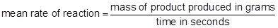
___________________________________________________________________
___________________________________________________________________
Mean rate of reaction = _________________________
(1)
(e) What is the unit for the mean rate of reaction calculated in part (d)?
Tick one box.

g |  | g/s |  | s |  | s/g
(1)
(f) The table below shows the student’s results.

Time in seconds | Mass of gas produced in g
0 | 0.0
10 | 0.8
20 | 0.6
30 | 1.6
40 | 1.8
50 | 2.0
60 | 2.0
Plot the data from the table above on Figure 2
Draw a line of best fit.
Figure 2
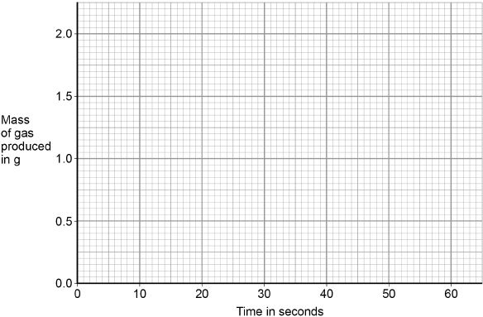
(3)
(g) Figure 3 shows a large marble chip and eight small marble chips.
Figure 3
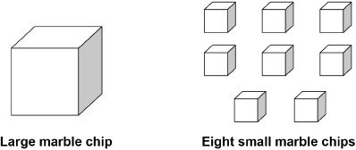
The large marble chip has the same total volume as the eight small marble chips, but a different surface area.
Why do the eight small marble chips react faster than the large marble chip?
Tick one box.

The eight small marble chips have a larger surface area, so less frequent collisions.
The eight small marble chips have a larger surface area, so more frequent collisions.
The eight small marble chips have a smaller surface area, so less frequent collisions.
The eight small marble chips have a smaller surface area, so more frequent collisions.
(1)
(Total 11 marks)
Q3.
An argon atom can be represented as
(a) What does the number 40 represent in ?
___________________________________________________________________
___________________________________________________________________
(1)
(b) How many protons does this atom of argon have?
Tick one box.

18
22
40
58
(1)
(c) How many neutrons does this atom of argon have?
Tick one box.

18
22
40
58
(1)
The diagram below shows the energy levels (shells) in a neon atom.
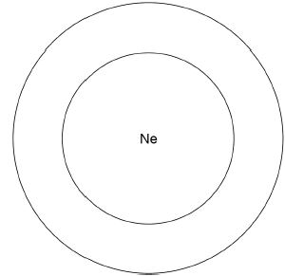
(d) A neon atom has 10 electrons.
Complete the diagram above to show the electronic structure of a neon atom.
Use x to represent an electron.
(1)
(e) The nucleus of a neon atom has a charge.
What is the charge?
Tick one box.

Negative
Neutral
Positive
(1)
(f) A neon atom has 10 protons, 10 electrons and 10 neutrons.
Explain why there is no overall charge on a neon atom.
___________________________________________________________________
___________________________________________________________________
___________________________________________________________________
(2)
(g) There are two different types of neon atom.
What are these different types of atom called?
Tick one box.

Compounds
Ions
Isotopes
Molecules
(1)
(h) Neon is a gas.
The states of matter can be shown by a simple particle model.
Draw one line from each state of matter to the correct particle model.

State of matter |  | Particle model
Gas
Liquid
 |  | 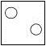
Solid
(2)
Q4.
This question is about Group 1 metals.
The graph below shows the melting points of Group 1 metals plotted against their atomic number.
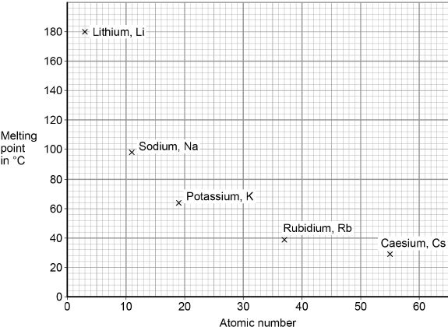
(a) Describe the trend shown by the melting points of Group 1 metals as the atomic number increases.
___________________________________________________________________
___________________________________________________________________
(1)
(b) Determine the atomic number and melting point of caesium.
Use the graph above.
Atomic number of caesium = __________________
Melting point of caesium = _______________ °C
(1)
Lithium is a Group 1 metal.
(c) A lithium atom can be shown as 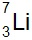
How many electrons does the outer shell of a lithium atom contain?
Tick one box.

1
3
4
7
(1)
(d) Lithium reacts with oxygen to produce lithium oxide.
Draw one line from each substance to the correct description of the substance.

Substance |  | Description
 |  | compound
Lithium oxide |  | element
 |  | metal
Oxygen |  | mixture
 |  | polymer
(2)
(e) Balance the equation for the reaction of lithium with oxygen.
(1)
(f) What type of bonding is present in lithium oxide?
Tick one box.

Covalent
Ionic
Metallic
(1)
(g) Calculate the relative formula mass (M_{r}) of lithium oxide (Li₂O).
Relative atomic masses (A_{r}): Li = 7 O = 16
___________________________________________________________________
___________________________________________________________________
___________________________________________________________________
Relative formula mass = _________________
(2)
(Total 9 marks)
Q5.
This question is about structure and bonding.
(a) Figure 1 shows part of one layer of graphene.
Figure 1
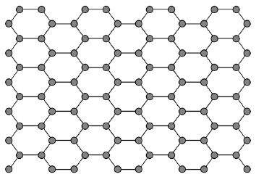
Which element is graphene made from?
Tick one box.

Carbon
Copper
Hydrogen
Sodium
(1)
(b) Each atom in graphene has one delocalised electron.
Complete the sentence.
Choose the answer from the box.

act as a lubricant | be used as a fuel
conduct electricity | dissolve in water
Delocalised electrons allow graphene to __________________________ .
(1)
(c) Which structure is a fullerene?
Tick one box.

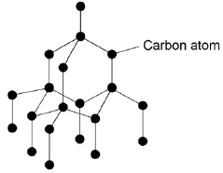
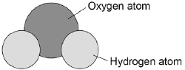
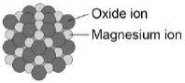
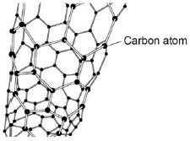
(1)
Figure 2 shows part of a large hydrocarbon molecule.
Figure 2
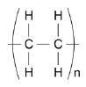
(d) Which two elements are in all hydrocarbons?
1. _________________________________________________________________
2. _________________________________________________________________
(2)
(e) Complete the sentence.
Choose the answer from the box.

an atom | a metal | a polymer | a salt
The large molecule represented in Figure 2 is __________________________ .
(1)
(f) Complete the sentence.
Choose the answer from the box.

attract | bond | slide | vibrate
Metals can be stretched into wires
because the layers of atoms can __________________________ .
Q6.
This question is about electrolysis.
(a) How many different elements are in the formula AgNO₃?
Tick one box.

2 |  | 3 |  | 5 |  | 6
(1)
(b) How many atoms are in the formula AgNO₃?
Tick one box.

2 |  | 3 |  | 5 |  | 6
(1)
An electric current is passed through silver nitrate solution.
Figure 1 shows the apparatus.
Figure 1
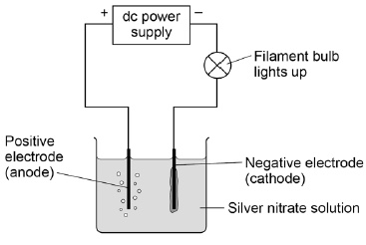
The solution contains four ions:
• Ag⁺
• H⁺
• NO₃–
• OH–
(c) Where do the H⁺ and OH– ions come from?
Tick one box.

Air
Electrodes
Silver nitrate
Water
(1)
(d) Ag⁺ ions and H⁺ ions are attracted to the negative electrode (cathode).
Give a reason why.
___________________________________________________________________
___________________________________________________________________
(1)
(e) Silver is produced at the negative electrode (cathode) and not hydrogen.
What does this tell you about the reactivity of silver?
Tick one box.

Silver is less reactive than hydrogen
Silver is less reactive than oxygen
Silver is more reactive than nitrate
Silver is more reactive than water
(1)
(f) The hydroxide ion (OH–) is attracted to the positive electrode (anode).
The equation shows what happens at the positive electrode (anode).
4OH– → 2H₂O + O₂ + 4e–
Name the gas produced at the positive electrode (anode).
___________________________________________________________________
(1)
(g) An electric current is passed through sodium chloride solution.
Figure 2 shows the apparatus.
Figure 2
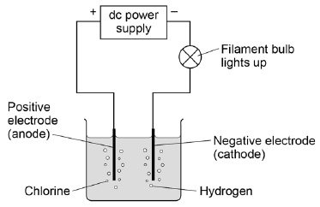
After passing an electric current through sodium chloride solution one product is sodium hydroxide (NaOH) solution.
The presence of sodium hydroxide can be shown by adding an indicator.
Name an indicator.
Give the colour of the indicator in sodium hydroxide solution.
Indicator __________________________________________________________
Colour ____________________________________________________________
(2)
(Total 8 marks)
Q7.
This question is about the periodic table.
In 1864 John Newlands suggested an arrangement of elements.
Figure 1 shows the arrangement Newlands suggested.
Figure 1
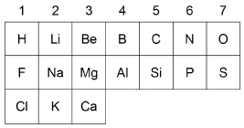
(a) Give two differences between column 1 in Figure 1 and Group 1 in the modern periodic table.
Use the periodic table to help you.
1. _________________________________________________________________
___________________________________________________________________
2. _________________________________________________________________
___________________________________________________________________
(2)
(b) In 1869 Mendeleev produced his periodic table.
Complete the sentence.
Choose the answer from the box.

insoluble | magnetic | undiscovered | unreactive
Mendeleev left gaps in his periodic table for elements that were
_________________________________________ .
(1)
(c) How are the elements ordered in the modern periodic table?
Tick one box.

Atomic mass
Atomic number
Melting point
Reactivity
(1)
Figure 2 shows part of the modern periodic table.
Figure 2
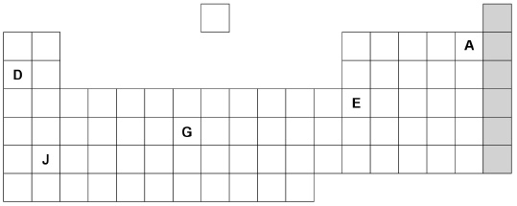
(d) Complete the sentences about the elements in Figure 2.
Choose the answers from the box.

A | D | E | G | J
Sodium is an alkali metal and is represented by the letter ____________________.
An element in group 3 is represented by the letter ____________________.
A gaseous non-metal element is represented by the letter ____________________.
(3)
(e) Figure 3 shows the electronic structure of an atom.
Figure 3
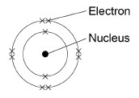
This element is in the shaded group on Figure 2.
Why is this element unreactive?
___________________________________________________________________
___________________________________________________________________
(1)
(f) Name the group of elements in the shaded column on Figure 2.
___________________________________________________________________
(1)
Q8.
A sodium atom and a fluorine atom react together to form an ionic compound.
Figure 1 shows the electron arrangements in the atoms and the ionic compound.
Only the outer shell electrons are shown.
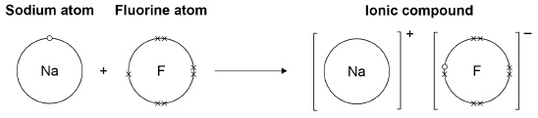
(a) What is the name of the ionic compound shown in Figure 1?
Tick one box.

Sodium fluorate
Sodium fluoride
Sodium fluorine
(1)
(b) What type of force acts between the ions in an ionic compound?
Tick one box.

Electrostatic
Frictional
Gravitational
Magnetic
(1)
(c) What are two properties of ionic compounds?
Tick two boxes.

Conducts electricity when molten
High melting point
Low boiling point
Small molecules
Weak bonds between particles
(2)
(d) Describe what happens when a sodium atom reacts with a fluorine atom to form an ionic compound.
Use Figure 1.
___________________________________________________________________
___________________________________________________________________
___________________________________________________________________
___________________________________________________________________
___________________________________________________________________
___________________________________________________________________
___________________________________________________________________
___________________________________________________________________
(4)
(e) Figure 2 shows the structure of the ionic compound formed in the reaction.
Figure 2
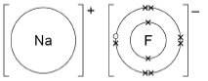
Suggest one limitation of using Figure 2 to show the structure of this compound.
___________________________________________________________________
___________________________________________________________________
(1)
(Total 9 marks)
Q9.
The pH scale is a measure of the acidity or alkalinity of a solution.
(a) Draw one line from each solution to the pH value of the solution.

Solution |  | pH value of the solution

 |  | 5
Acid |  | 7
 |  | 9
Neutral |  | 11
 |  | 13
(2)
(b) Which ion in aqueous solution causes acidity?
Tick one box.

H⁺
Na⁺
O²⁻
OH⁻
(1)

(c) When sulfuric acid is added to sodium hydroxide a reaction occurs to produce two products.
The equation is:
H₂SO₄ + 2NaOH Na₂SO₄ + 2H₂O
How many elements are in the formula H₂SO₄?
Tick one box.

3
4
6
7
(1)
(d) What is this type of reaction?
Tick one box.

Decomposition
Displacement
Neutralisation
Reduction
(1)
(e) Name the salt produced.
___________________________________________________________________
(1)
(f) Describe how an indicator can be used to show when all the sodium hydroxide has reacted with sulfuric acid.
___________________________________________________________________
___________________________________________________________________
___________________________________________________________________
___________________________________________________________________
___________________________________________________________________
___________________________________________________________________
(3)
(Total 9 marks)
Q10.
The figure below shows an atom of boron.
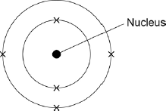
(a) When the mass of the boron atom is calculated, the mass of the electrons is ignored.
Why is the mass of the electrons ignored?
___________________________________________________________________
___________________________________________________________________
(1)
(b) How many electrons are there in the boron atom?
___________________________________________________________________
(1)
(c) What is the electrical charge on the nucleus of the boron atom?
Tick one box.

+1
+5
+6
+11
(1)
(d) The mass number of boron is 11.
Use the figure above to calculate the number of neutrons in the nucleus of the boron atom.
Explain how you worked out the answer.
Number of neutrons = _________________________________________________
Explanation _________________________________________________________
___________________________________________________________________
___________________________________________________________________
(3)
(e) Phosphorus has a mass number of 31 and has 16 neutrons.
What percentage of the mass number of phosphorus is the number of neutrons?
Give your answer to two significant figures.
___________________________________________________________________
___________________________________________________________________
Percentage = ____________________
(2)
(Total 8 marks)
Q11.
There are eight elements in the second row (lithium to neon) of the periodic table.
(a) Figure 1 shows a lithium atom.
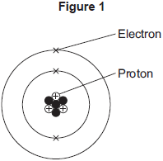
(i) What is the mass number of the lithium atom in Figure 1?

Tick (✔) one box.
3
4
7
(1)
(ii) What is the charge of an electron?

Tick (✔) one box.
–1
0
+1
(1)
(iii) Protons are in the nucleus.
Which other sub-atomic particles are in the nucleus?

Tick (✔) one box.
ions
molecules
neutrons
(1)
(b) What is always different for atoms of different elements?

Tick (✔) one box.
number of neutrons
number of protons
number of shells
(1)
(c) Figure 2 shows the electron arrangements of three different atoms, X, Y and Z.
These atoms are from elements in the second row (lithium to neon) of the periodic table.
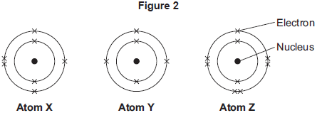
Which atom is from an element in Group 3 of the periodic table?

Tick (✔) one box.
Atom X
Atom Y
Atom Z
(1)
(d) Figure 3 shows the electron arrangement of a different atom from an element in the second row of the periodic table.
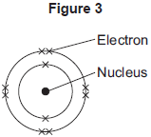
(i) Give the chemical symbol of this element.
______________________________________________________________
(1)
(ii) Why is this element unreactive?
______________________________________________________________
______________________________________________________________
(1)
Q12.
This question is about structure and bonding.
(a) Figure 1 shows part of the structure of calcium oxide (CaO).
Figure 1
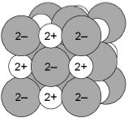
What type of bonding is present in calcium oxide?
Tick one box.

Covalent
Ionic
Macromolecular
Metallic
(1)
(b) Figure 2 shows a particle of methane (CH₄).
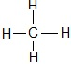
What type of particle is present in Figure 2?
Tick one box.

An ion
A lattice
A molecule
A polymer
(1)
(c) Figure 3 shows the structure of C₆₀
Figure 3
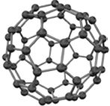
Complete the sentence.
Choose the answer from the box.

diatomic | giant ionic | a fullerene | giant metallic
The structure of C₆₀ is ________________________________________________ .
(1)
Figure 4 shows the structure of graphite.
Figure 4
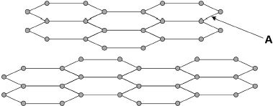
(d) What type of bond is labelled A in Figure 4?
Tick one box.

covalent
double
ionic
metallic
(1)
(e) In graphite, each carbon atom forms bonds with other carbon atoms as shown in Figure 4
How many electrons does one carbon atom use to form one bond?
Tick one box.

1 |  | 2 |  | 3 |  | 4
(1)
An electric current is passed through copper.
Figure 5 shows the apparatus used.
Figure 5
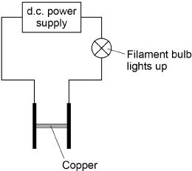
(f) Complete the sentence.
Choose the answer from the box.

gas | liquid | solid | solution
Figure 5 shows that copper conducts electricity as a ________________________ .
(1)
(g) Complete the sentence.
Choose the answer from the box.

atoms | electrons | ions | molecules
Copper conducts electricity because of the movement of delocalised ___________ .
(1)
(h) Figure 6 shows the apparatus used to investigate the effect of electricity on sodium chloride solution.
Figure 6
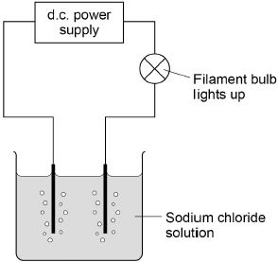
Complete the sentence.
Choose the answer from the box.

dissolved | gaseous | molten
Figure 6 shows that sodium chloride conducts electricity when ________________ .
(1)
(i) Sodium chloride is made up of ions.
Figure 7 shows the apparatus used to investigate the effect of electricity on solid sodium chloride and molten sodium chloride.
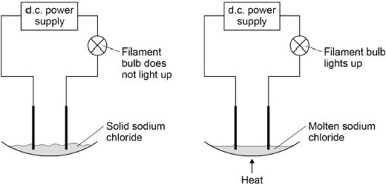
The table below shows the results.

 | Solid sodium chloride | Molten sodium chloride
Observation | The filament bulb does not light up | The filament bulb lights up
Deduction | Does not conduct electricity | Does conduct electricity
Draw one line from each statement to the correct reason.

Statement |  | Reason
 |  | The ions are fixed.
Solid sodium chloride does
not conduct electricity. |  | The ions are mobile.
Molten sodium chloride |  | The ions are neutral.
conducts electricity.
 |  | The ions are vibrating.
(2)
(Total 10 marks)
Q13.
The apparatus in the figure below is used to separate a mixture of liquids in a fuel.
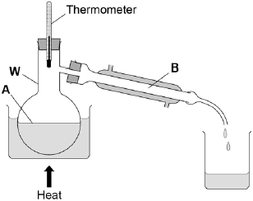
(a) What is apparatus W on above the figure above?
Tick one box.

Beaker
Boiling Tube
Flask
Jug
(1)
(b) What is the name of this method of separation?
Tick one box.

Crystallisation
Electrolysis
Filtration
Distillation
(1)
(c) Name the changes of state taking place at A and B in the figure above.
Use words from the box.

boiling | condensing | freezing | melting
Change of state at A: _________________________________________________
Change of state at B: _________________________________________________
(2)
(d) Table 1 shows the boiling points of the hydrocarbons in the fuel.
Table 1

Hydrocarbon | Boiling point  in °C
Pentane | 36
Hexane | 69
Heptane | 98
Octane | 125
Which hydrocarbon will be the last to collect in the beaker?
Tick one box.

Pentane
Hexane
Heptane
Octane
(1)
(e) The fuel is a mixture of liquids that has been designed as a useful product.
What name is given to this type of mixture?
Tick one box.

Catalyst
Formulation
Polymer
Solvent
(1)

(f) Describe how this fuel is different from crude oil.
___________________________________________________________________
___________________________________________________________________
___________________________________________________________________
___________________________________________________________________
(2)
(g) A student measured the melting point of a solid hydrocarbon four times.
The student’s results are in Table 2.
Table 2

 | Trial 1 | Trial 2 | Trial 3 | Trial 4
Melting point in °C | 35 | 48 | 37 | 37
Calculate the mean melting point of the hydrocarbon, leaving out any anomalous result.
Give your answer to two significant figures.
___________________________________________________________________
___________________________________________________________________
Mean melting point = __________________ °C
(2)
(Total 10 marks)
Q14.
Metal is bent and shaped to make a car body.
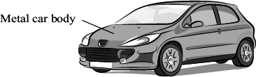
The diagram below represents how atoms are arranged in a metal.
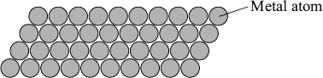
Which two statements in the table best explain why the metal can be bent and shaped?
Tick () the two statements.

Statement | Tick  ()
The atoms are in layers.
The metal is shiny.
The atoms can slide over each other.
All the atoms are linked by strong covalent bonds.
(2)

(Total 2 marks)
Q15.
A drill bit is used to cut holes through materials. The cutting end of this drill bit is covered with very small diamonds.
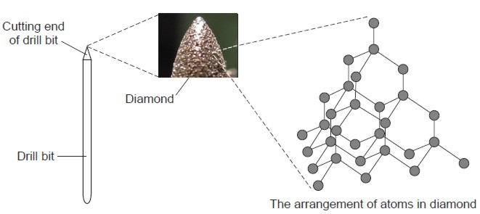
By Wanderlinse [CC By 2.0], via Flickr
Draw a ring around the correct word in each box.

 |  | carbon
(a) | Diamond is made from | nitrogen | atoms.
 |  | oxygen
(1)
 |  | none
(b) | Diamond has a giant structure in which | some | of the atoms are joined together.
 |  | all
(1)
 |  | covalent
(c) | The atoms in diamond are joined together by | ionic | bonds.
 |  | metallic
(1)
 |  | two
(d) | In diamond each atom is joined to | three | other atoms.
 |  | four
(1)
 |  | hard.
(e) | Diamond is suitable for the cutting end of a drill bit because it is | shiny.
 |  | soft
(1)
(Total 5 marks)
Q16.
This label was on a container of graphite lubricant.

Super G
Graphite Lubricant
Super G forms a thin anti-friction film on metal surfaces. It provides good lubrication when metal parts rub against each other.
(a) Give one reason why a lubricant is used when metal parts rub against each other.
___________________________________________________________________
___________________________________________________________________
(1)

(b) The diagram shows the arrangement of atoms in graphite.
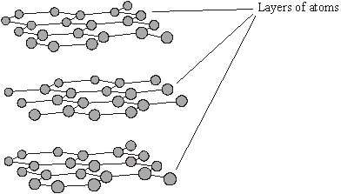
(i) Draw a ring around the type of atoms in graphite.
aluminium carbon silicon
(1)
(ii) Graphite is a good lubricant because it is slippery. Use the diagram to explain why graphite is slippery.
______________________________________________________________
______________________________________________________________
______________________________________________________________
______________________________________________________________
______________________________________________________________
(2)
(Total 4 marks)
Q17.
Bricks made from silica (silicon dioxide) are used to line furnaces that operate at high temperatures.
Part of the structure of silica is shown in the diagram.
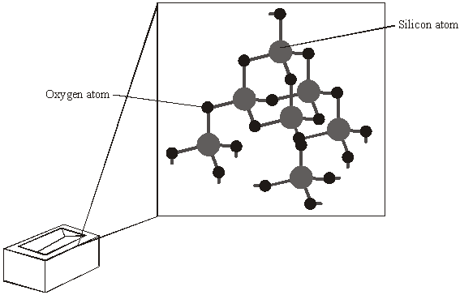
Use words from the box to complete the sentences.

covalent giant low small

four high six weak
One reason for using silica to make bricks for high-temperature furnaces is that silica has
a _____________________ melting point.
Silica has this property because it is a _____________________ structure in which each
silicon atom is joined to _____________________ oxygen atoms by
_____________________ bonds.
(Total 4 marks)
Q18.
This question is about the elements in Group 2 of the periodic table.
(a) Figure 1 shows the positions of four elements, A, B, C, and D, in the periodic table.
Figure 1
Which element is in Group 2?
Tick one box.

A |  | B |  | C |  | D
(1)
Group 2 metal carbonates break down when heated to produce a metal oxide and a gas.
metal carbonate ⟶ metal oxide + gas
(b) Name the two products when calcium carbonate (CaCO₃) is heated.
_______________________ and _______________________
(2)
(c) What type of reaction happens when a compound breaks down?
Tick one box.

burning
decomposition
neutralisation
reduction
(1)
(d) The metal carbonate takes in energy from the surroundings to break down.
What type of reaction takes in energy from the surroundings?
Tick one box.

combustion
electrolysis
endothermic
exothermic
(1)
(e) Figure 2 shows the volume of gas produced when a Group 2 metal carbonate is heated.
Figure 2
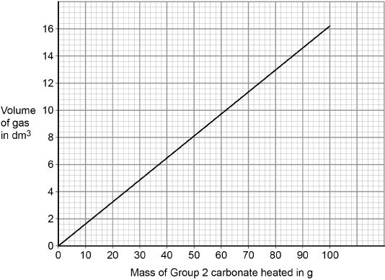
The student collected 5.2 dm³ of gas.
What mass of the Group 2 metal carbonate is heated?
Mass = ______________________ g
(1)
(f) Calculate the mass of the Group 2 carbonate needed to produce 24 dm³ of gas.
Use your answer from part (e) to help you.
___________________________________________________________________
___________________________________________________________________
___________________________________________________________________
___________________________________________________________________
Mass = ______________________ g
(2)
(g) A student heated different masses of a Group 2 carbonate. The student measured the volume of gas produced.
Figure 3 shows a graph of the student’s results.
The student calculates the gradient of the line in Figure 3
The student makes two mistakes.
Figure 3
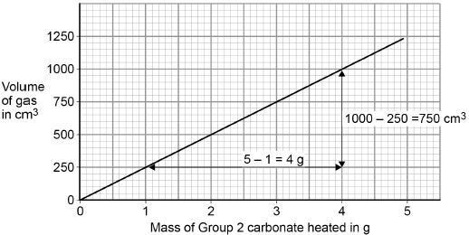
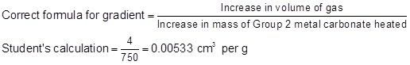
Identify the two mistakes the student makes.
Calculate the correct gradient of the line.
Mistake 1 ___________________________________________________________
___________________________________________________________________
Mistake 2 ___________________________________________________________
___________________________________________________________________
Calculation _________________________________________________________
___________________________________________________________________
Gradient = ______________________ cm³ per g
(4)
(h) A student repeated the experiment with a different Group 2 metal carbonate (XCO₃).
The relative formula mass (M_{r}) of XCO₃ is 84
Relative atomic masses (A_{r}): C = 12 O = 16
Calculate the relative atomic mass (A_{r}) of X.
Name metal X.
Use the periodic table.
___________________________________________________________________
___________________________________________________________________
___________________________________________________________________
___________________________________________________________________
Relative atomic mass (A_{r}) = ______________________
Metal X is ______________________
(4)
(Total 16 marks)
Q19.
A teacher extracted copper from copper oxide.
This is the method used.
1. Mix 1.30 g of zinc and 1.59 g of copper oxide.
2. Heat the mixture strongly.
3. When the mixture starts to glow, stop heating.
4. Let the glow spread through the mixture.
5. Leave the mixture to cool.
(a) This reaction is exothermic.
Which part of the method shows the reaction is exothermic?
Tick one box.

Mix zinc and copper oxide
Heat the mixture
Let the glow spread
Leave to cool
(1)
The equation for the reaction between zinc and copper oxide is:
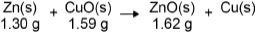
(b) 1.30 g of zinc fully reacted with 1.59 g of copper oxide to produce 1.62 g of zinc oxide.
What mass of copper was produced?
___________________________________________________________________
___________________________________________________________________
Mass of copper produced = __________________ g
(1)
(c) What is the physical state of zinc oxide in the reaction?
Tick one box.

Aqueous
Gas
Liquid
Solid
(1)
(d) Which substance has been oxidised in the reaction?
Tick one box.

Copper
Copper oxide
Zinc
Zinc oxide
(1)
(e) What type of reaction takes place when zinc reacts with copper oxide?
Tick one box.

Combustion
Crystallisation
Displacement
Neutralisation oxide
(1)
Copper is a metal.
(f) Which structure represents the arrangement of atoms in pure copper?
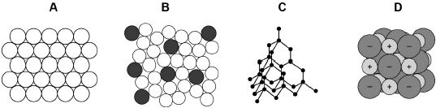
Tick one box.

A
B
C
D
(1)
(g) Copper is used in electrical wiring.
Give one reason why.
___________________________________________________________________
___________________________________________________________________
(1)
(h) In the UK, 40% of the copper we use is recycled copper.
The other 60% is copper obtained by mining.
What is the simplest ratio of recycled copper to copper obtained by mining?
Tick one box.

2 : 3
2 : 5
4 : 10
6 : 4
(1)
(i) What are two advantages of recycling copper?
Tick two boxes.

Conserves copper ores
Increase in greenhouse gases
Less energy used
More jobs for miners
More space used at landfill
(2)
(Total 10 marks)
Q20.
This question is about compounds of oxygen.
The reaction between carbon and oxygen is exothermic.
(a) What does exothermic reaction mean?
___________________________________________________________________
___________________________________________________________________
(1)
(b) Which is the correct reaction profile (energy level diagram) for an exothermic reaction?
Tick one box.

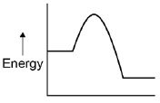
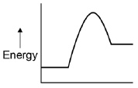
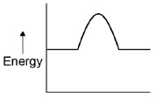
(1)
(c) The percentage by mass of oxygen in carbon dioxide (CO₂) is calculated by the equation:
Relative atomic masses (A_{r}): C = 12 O = 16
Calculate the percentage by mass of oxygen in carbon dioxide (CO₂).
___________________________________________________________________
___________________________________________________________________
___________________________________________________________________
___________________________________________________________________
___________________________________________________________________
___________________________________________________________________
___________________________________________________________________
Percentage by mass of oxygen = ____________________ %
(3)
Hydrogen peroxide decomposes to produce water and oxygen.
(d) Balance the chemical equation.
____ H₂O₂ → ____H₂O + O₂
(1)
(e) 6.8 g of hydrogen peroxide decomposes to produce 3.6 g of water.
Calculate the mass of oxygen produced when 68 g of hydrogen peroxide decomposes.
___________________________________________________________________
___________________________________________________________________
___________________________________________________________________
___________________________________________________________________
Mass of oxygen = ____________________ g
(2)

(Total 8 marks)
Q21.
This question is about carbon and gases in the air.
(a) Carbon atoms have protons, neutrons and electrons.
Complete the table by writing the relative mass of a neutron and an electron.

Name of particle | Relative mass
proton | 1
neutron
electron
(2)
(b) What is the total number of protons and neutrons in an atom called?

Tick () one box.
The atomic number
The mass number
One mole of the atom
(1)
(c) An atom of carbon has six electrons.
Which structure, A, B or C, represents the electronic structure of the carbon atom?
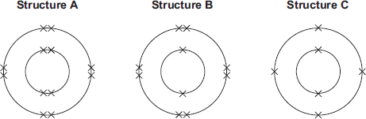

The carbon atom is structure
(1)
(d) Carbon reacts with oxygen to produce carbon dioxide (CO₂).
(i) How many different elements are in one molecule of carbon dioxide?
______________________________________________________________
(1)
(ii) What is the total number of atoms in one molecule of carbon dioxide?
______________________________________________________________
(1)
(e) Sometimes carbon reacts with oxygen to produce carbon monoxide (CO).
(i) Calculate the relative formula mass (M_{r}) of carbon monoxide.
Relative atomic masses (A_{r}): C = 12; O = 16
______________________________________________________________
______________________________________________________________
M_{r} of carbon monoxide = _______________
(1)
(ii) Calculate the percentage by mass of carbon in carbon monoxide.
______________________________________________________________
______________________________________________________________
Percentage by mass of carbon in carbon monoxide = _____%
(1)
(f) Carbon dioxide is one of the gases in the air.
(i) The graph shows the percentage of argon and the percentage of carbon dioxide in the air.
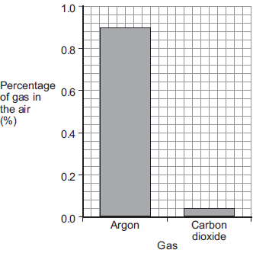
What is the percentage of argon in the air?
Percentage of argon = ____________________ %
(1)
(ii) An instrumental method is used to measure the amount of carbon dioxide in the air.
Give one reason for using an instrumental method.
______________________________________________________________
______________________________________________________________
(1)
(Total 10 marks)
Q22.
Calcium oxide (quicklime) is made by heating calcium carbonate (limestone).
calcium carbonate → calcium oxide + carbon dioxide
100 g ? 44 g
(a) 44 grams of carbon dioxide is produced when 100 grams of calcium carbonate is heated.
Calculate the mass of calcium oxide produced when 100 grams of calcium carbonate is heated.
___________________________________________________________________
mass _____________ g
(1)
(b) What mass of carbon dioxide could be made from 100 tonnes of calcium carbonate?
mass ____________ tonnes
(1)
(Total 2 marks)

Section 2: Required Practicals

Q23.
A student investigated displacement reactions of metals.
The student added different metals to copper sulfate solution and measured the temperature change.
The more reactive the metal is compared with copper, the bigger the temperature change.
The apparatus the student used is shown in Figure 1.
Figure 1
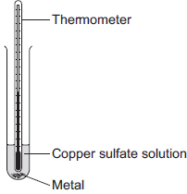
(a) State three variables that the student must control to make his investigation a fair test.
1. _________________________________________________________________
2. _________________________________________________________________
3. _________________________________________________________________
(3)
(b) Figure 2 shows the thermometer in one experiment before and after the student added a metal to the copper sulfate solution.
Figure 2

Before adding metal | After adding metal
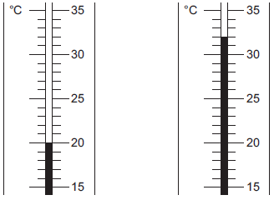
Use Figure 2 to complete Table 1.
Table 1

Temperature before adding metal in °C | ________
Temperature after adding metal in °C | ________
Change in temperature in °C | ________
(3)
(c) The student repeated the experiment three times with each metal.
Table 2 shows the mean temperature change for each metal.
Table 2

Metal | Mean temperature change in °C
Cobalt | 4.5
Gold | 0.0
Magnesium | 10.0
Nickel | 3.0
Silver | 0.0
Tin | 1.5
(i) On Figure 3, draw a bar chart to show the results.
Figure 3
(3)
(ii) Why is a line graph not a suitable way of showing the results?
______________________________________________________________
______________________________________________________________
(1)
(iii) Use the results to work out which metal is the most reactive.
Give a reason for your answer.
Most reactive metal _________________________
Reason _______________________________________________________
______________________________________________________________
(2)
(iv) Explain why there was no temperature change when silver metal was added to the copper sulfate solution.
______________________________________________________________
______________________________________________________________
______________________________________________________________
______________________________________________________________
(2)
(v) It is not possible to put all six metals in order of reactivity using these results.
Suggest how you could change the experiment to be able to put all six metals into order of reactivity.
______________________________________________________________
______________________________________________________________
______________________________________________________________
______________________________________________________________
______________________________________________________________
(2)
Q24.
A student was trying to produce hydrogen gas.
Figure 1 shows the apparatus she used.
Figure 1
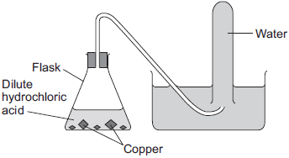
(a) No gas was produced.
The student’s teacher said that this was because the substances in the flask did not react.
(i) Suggest why the substances in the flask did not react.
______________________________________________________________
______________________________________________________________
______________________________________________________________
(1)
(ii) Which two substances could the student have put in the flask to produce hydrogen safely?
Tick (✓) one box.
Gold and dilute hydrochloric acid
Potassium and dilute hydrochloric acid
Zinc and dilute hydrochloric acid
(1)
(b) Another student did produce hydrogen from two substances.
Figure 2 shows the apparatus the student used to collect and measure the volume of the hydrogen gas.
Figure 2
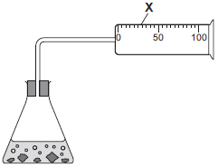
Give the name of the apparatus labelled X.
___________________________________________________________________
(1)
(c) The student did the experiment four times. Her results are shown in the table below.

Experiment | Volume of hydrogen collected in one minute in cm³
1 | 49
2 | 50
3 | 35
4 | 48

(i) One of the results is anomalous.
Which result is anomalous? Write your answer in the box.
Give a reason for your choice.
______________________________________________________________
(2)
(ii) Calculate the mean volume of hydrogen collected in one minute.
______________________________________________________________
______________________________________________________________
Mean volume = ____________________ cm³
(2)
(iii) Give a reason why the experiment should be repeated several times.
______________________________________________________________
______________________________________________________________
______________________________________________________________
(1)
(d) A teacher collected two tubes full of hydrogen gas, as shown in Figure 3.
Figure 3
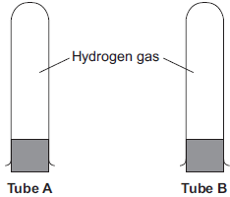
She tested tube A with a lighted splint as soon as she took the bung out.
She tested tube B with a lighted splint a few seconds after taking the bung out.
(i) Suggest why tube B gave a much louder pop than tube A.
______________________________________________________________
______________________________________________________________
______________________________________________________________
______________________________________________________________
(1)
(ii) Complete and balance the chemical equation for the reaction that takes place when the hydrogen reacts in this test.
H₂ + O₂
(2)
(Total 11 marks)
Q25.
The label shows the ingredients in a drink called Cola.

Cola
Ingredients:
Carbonated water
Sugar
Colouring
Phosphoric acid
Flavouring
Caffeine
(a) (i) The pH of carbonated water is 4.5.
The pH of Cola is 2.9.
Name the ingredient on the label that lowers the pH of Cola to 2.9.
______________________________________________________________
(1)
(ii) Which ion causes the pH to be 2.9?
______________________________________________________________
(1)
(b) A student investigated the food colouring in Cola and in a fruit drink using paper chromatography.
The chromatogram in the figure below shows the student’s results.
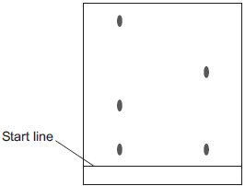
Cola Fruit drink
(i) Complete the sentence.
The start line should be drawn with a ruler and ___________________ .
Give a reason for your answer.
______________________________________________________________
______________________________________________________________
(2)
(ii) Suggest three conclusions you can make from the student’s results.
______________________________________________________________
______________________________________________________________
______________________________________________________________
______________________________________________________________
______________________________________________________________
______________________________________________________________
(3)
(c) Caffeine can be separated from the other compounds in the drink by gas chromatography.
Why do different compounds separate in a gas chromatography column?
___________________________________________________________________
___________________________________________________________________
(1)
(d) Caffeine is a stimulant.
Large amounts of caffeine can be harmful.
(i) Only one of the questions in the table can be answered by science alone.
Tick () one question.

Question | Tick ()
Should caffeine be an ingredient in drinks?
Is there caffeine in a certain brand of drink?
How much caffeine should people drink?
(1)
(ii) Give two reasons why the other questions cannot be answered by science alone.
Reason 1 ______________________________________________________
______________________________________________________________
Reason 2 ______________________________________________________
______________________________________________________________
(2)
(Total 11 marks)
Q26.
A student investigated the conductivity of different concentrations of sodium chloride solution.
The student set the apparatus up as shown in Figure 1.
Figure 1
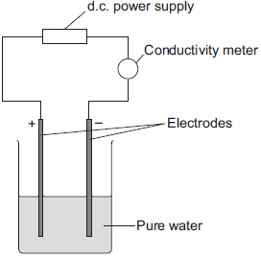
The student measured the conductivity of the pure water with a conductivity meter.
The reading on the conductivity meter was zero.
(a) The student:
• added sodium chloride solution one drop at a time
• stirred the solution
• recorded the reading on the conductivity meter.
The student’s results are shown in the table below.

Number of drops of  sodium chloride solution  added | Relative conductivity  of solution
0 | 0
1 | 100
2 | 120
3 | 310
4 | 400
5 | 510
6 | 590
7 | 710
8 | 800
(i) The student plotted the results on the grid shown in Figure 2.
Plot the four remaining results.
Draw a line of best fit, ignoring the anomalous result.
Figure 2
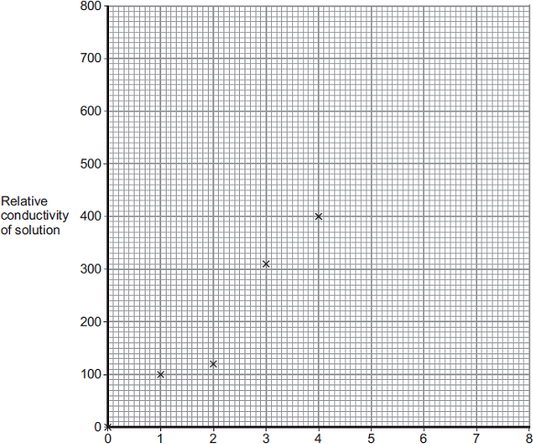
Number of drops of sodium chloride added
(3)
(ii) One of the points is anomalous.
Suggest one error that the student may have made to cause the anomalous result.
______________________________________________________________
______________________________________________________________
(1)
(iii) The student wanted to compare the conductivity of sodium chloride solution with the conductivity of potassium chloride solution.
State one variable he should keep constant when measuring the conductivity of the two solutions.
______________________________________________________________
(1)
(b) (i) Explain, in terms of bonding, why pure water does not conduct electricity.
______________________________________________________________
______________________________________________________________
______________________________________________________________
______________________________________________________________
(2)
(ii) Explain why sodium chloride solution conducts electricity.
______________________________________________________________
______________________________________________________________
______________________________________________________________
______________________________________________________________
(2)
(iii) After he had added sodium chloride solution, the student noticed bubbles of gas at the negative electrode.
Complete the sentence.
The gas produced at the negative electrode is __________________
(1)
(Total 10 marks)
Q27.
Some students investigated the change in temperature as sodium hydroxide solution is added to dilute sulfuric acid.
This is the method used.
1. Put 25 cm³ of dilute sulfuric acid into a polystyrene cup.
2. Measure the initial temperature of the dilute sulfuric acid.
3. Add 4 cm³ of sodium hydroxide solution to the dilute sulfuric acid.
4. Stir the mixture.
5. Measure the highest temperature of the mixture.
6. Repeat steps 3‒5 until 40 cm³ of sodium hydroxide solution have been added.
Figure 1 shows the apparatus the student used.
Figure 1
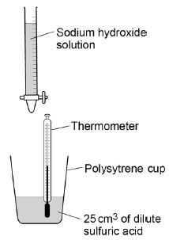
(a) The volume of sodium hydroxide solution is a variable.
Which two words can be used to describe this type of variable?
Tick two boxes.

Categoric
Continuous
Control
Dependent
Independent
(2)
(b) The dilute sulfuric acid has an initial temperature of 24.0 °C
Figure 2 shows the highest temperature.
Figure 2
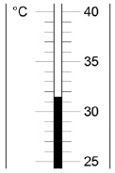
Calculate the change in temperature.
___________________________________________________________________
Temperature = ____________________ °C
(2)
Figure 3 shows the students’ results.
Figure 3
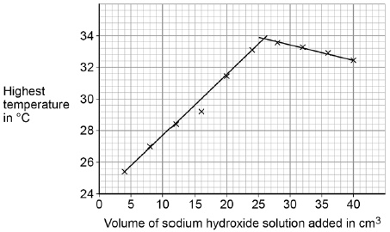
(c) Determine the volume of sodium hydroxide solution that gives the highest temperature change.
Use Figure 3 to help you answer this question.
Volume = ____________________ cm³
(1)
(d) In Figure 3 the temperature when 16 cm³ of sodium hydroxide solution is added is anomalous.
Suggest one error that could have been made in the method which would cause this anomalous result.
___________________________________________________________________
___________________________________________________________________
(1)
(e) The sodium hydroxide solution in this investigation contains 80 grams per dm³
The students use 40 cm³ of sodium hydroxide solution.
Calculate the mass of sodium hydroxide in 40 cm³
___________________________________________________________________
___________________________________________________________________
___________________________________________________________________
___________________________________________________________________
___________________________________________________________________
Mass = ____________________ g
(3)
(Total 9 marks)
Q28.
Diagram 1 shows the apparatus used to electrolyse magnesium sulfate solution.
Diagram 1
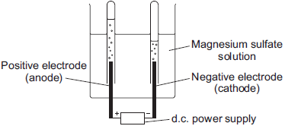
Gases were given off at both electrodes.
(a) The gas collected at the anode was oxygen.
Draw one line from the test for oxygen to the correct result.
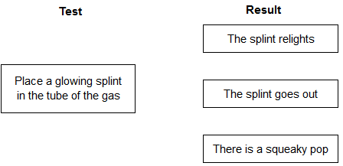
(1)
(b) (i) The gas collected at the cathode was hydrogen.
Describe how to test the gas to show that it is hydrogen.
Test __________________________________________________________
______________________________________________________________
Result ________________________________________________________
______________________________________________________________
(2)
(ii) Why is hydrogen, and not magnesium, produced at the cathode?
______________________________________________________________
______________________________________________________________
(1)
(c) A student wanted to use electrolysis to silver plate a metal spoon.
(i) Give one reason why metal spoons are sometimes silver plated.
______________________________________________________________
______________________________________________________________
(1)
(ii) Diagram 2 shows the apparatus the student used. The student did not set the apparatus up correctly.
Diagram 2
d.c. power
supply
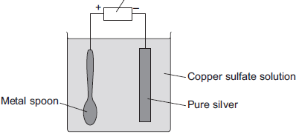
The student found that the metal spoon eroded and a thin layer of copper formed on the pure silver electrode.
Suggest two changes that the student must make to his apparatus to be able to silver plate the metal spoon. Give a reason for each change.
______________________________________________________________
______________________________________________________________
______________________________________________________________
______________________________________________________________
______________________________________________________________
______________________________________________________________
______________________________________________________________
(4)
(iii) Why is it difficult to electroplate plastic spoons?
______________________________________________________________
______________________________________________________________
(1)
(Total 10 marks)
Q29.
A student used paper chromatography to identify the pigments in spinach leaves.
She used propanone as a solvent.
Figure 1 shows the student’s results.
Figure 1
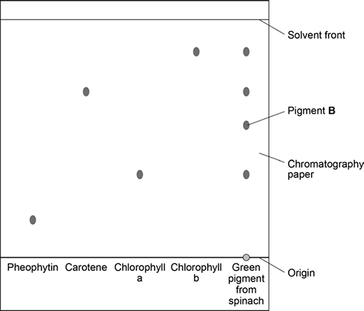
(a) Name the mobile phase and the stationary phase in the student’s experiment.
Mobile phase ________________________________________________________
Stationary phase _____________________________________________________
___________________________________________________________________
(2)
(b) What does Figure 1 tell you about the green pigment from spinach?
___________________________________________________________________
___________________________________________________________________
___________________________________________________________________
___________________________________________________________________
___________________________________________________________________
___________________________________________________________________
(3)
(c) Write the equation that links distance moved by solvent, distance moved by solute and R_{f} value.
___________________________________________________________________
(1)
(d) Use Figure 1 to calculate the R_{f} value for pigment B.
___________________________________________________________________
___________________________________________________________________
___________________________________________________________________
___________________________________________________________________
___________________________________________________________________
R_{f} value = ________________
(3)
(e) Another student set up the apparatus shown in Figure 2.
Figure 2
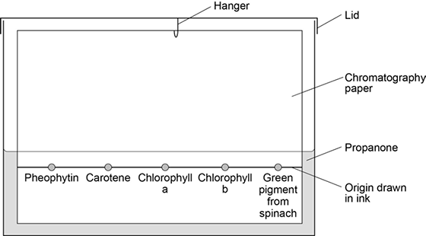
This student did not set up the apparatus correctly.
Identify the errors the student made.
Explain how the errors she made would affect her results.
___________________________________________________________________
___________________________________________________________________
___________________________________________________________________
___________________________________________________________________
___________________________________________________________________
___________________________________________________________________
___________________________________________________________________
___________________________________________________________________
(4)
(Total 13 marks)

Section 3: 6 Mark Questions

Q30.
This question is about making copper salts.
The figure below shows the apparatus given to a student.
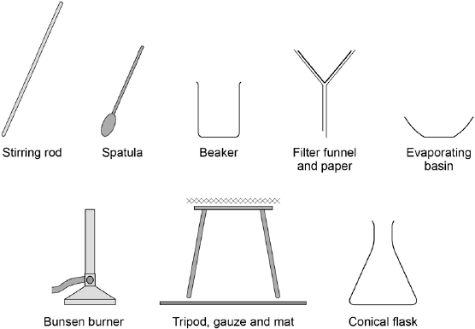
Outline a safe plan the student could use to make pure, dry, crystals of the soluble salt copper sulfate from the insoluble metal oxide and dilute acid.
_______________________________________________________________________
_______________________________________________________________________
_______________________________________________________________________
_______________________________________________________________________
_______________________________________________________________________
_______________________________________________________________________
_______________________________________________________________________
_______________________________________________________________________
_______________________________________________________________________
_______________________________________________________________________
(Total 6 marks)
Q31.
Magnesium is added to dilute hydrochloric acid.
An exothermic reaction takes place.
Magnesium chloride solution and hydrogen gas are produced.
The equation for the reaction is:
Mg (s) + 2HCl (aq) → MgCl₂ (aq) + H₂ (g)
(a) Describe the test for hydrogen gas.
Give the result of the test if hydrogen gas is present.
Test _______________________________________________________________
___________________________________________________________________
Result _____________________________________________________________
___________________________________________________________________

(2)
(b) A student investigates how the mass of magnesium used affects the temperature change during the reaction.
Plan a method the student could use.
You should include:
• the apparatus needed
• the measurements to be taken.
___________________________________________________________________
___________________________________________________________________
___________________________________________________________________
___________________________________________________________________
___________________________________________________________________
___________________________________________________________________
___________________________________________________________________
___________________________________________________________________
___________________________________________________________________
___________________________________________________________________
___________________________________________________________________
___________________________________________________________________
___________________________________________________________________
___________________________________________________________________
___________________________________________________________________
___________________________________________________________________
___________________________________________________________________
___________________________________________________________________
___________________________________________________________________
___________________________________________________________________
(6)
(Total 8 marks)
Q32.
John Newlands arranged the known elements into a table in order of atomic weight.
Figure 1 shows part of Newlands’ table.
Figure 1

Group | 1 | 2 | 3 | 4 | 5 | 6 | 7
 | H | Li | Be | B | C | N | O
 | F | Na | Mg | Al | Si | P | S
 | Cl | K | Ca
(a) What are the names of the elements in Group 5 of Newlands’ table?
Tick one box.

Calcium and sulfur
Carbon and silicon
Chlorine and silver
Chromium and tin
(1)
(b) In what order is the modern periodic table arranged?
Tick one box.

Atomic mass
Atomic number
Atomic size
Atomic weight
(1)
(c) Give two differences between Group 1 of Newlands’ table and Group 1 of the periodic table.
___________________________________________________________________
___________________________________________________________________
___________________________________________________________________
___________________________________________________________________
(2)
(d) In 1864, atoms were thought to be particles that could not be divided up into smaller particles.
By 1898, the electron had been discovered and the plum pudding model of an atom was proposed.
Figure 2 shows the plum pudding model of an atom of carbon and the nuclear model of an atom of carbon.
Figure 2
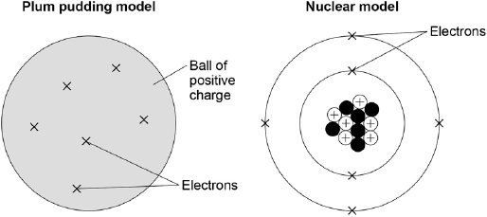
Compare the position of the subatomic particles in the plum pudding model with the nuclear model.
___________________________________________________________________
___________________________________________________________________
___________________________________________________________________
___________________________________________________________________
___________________________________________________________________
___________________________________________________________________
___________________________________________________________________
___________________________________________________________________
(4)

(e) Models are used to show the differences between elements, compounds and mixtures.
Which circle shows a model of a mixture?
Tick one box.
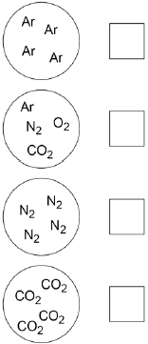
(1)
(f) Figure 3 shows a model of carbon dioxide.
Figure 3
What does each line between the atoms in Figure 3 represent?
Tick one box.

Covalent bond
Intermolecular force
Ionic bond
Metallic bond
(1)
(Total 10 marks)
Q33.
The diagram represents a magnesium atom.
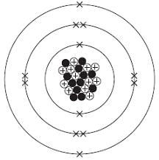
(a) Use words from the box to answer these questions.

electron | neutron | nucleus | proton
(i) What is the name of the central part of the atom? ______________________
(1)
(ii) What is the name of the particle with no charge? _______________________
(1)
(iii) What is the name of the particle with a negative charge? _________________
(1)
(b) Use the diagram above to help you answer these questions.
(i) Draw a ring around the atomic (proton) number of this magnesium atom.

12 | 24 | 36
(1)
(ii) Draw a ring around the mass number of this magnesium atom.

12 | 24 | 36
(1)
(c) The diagram shows how magnesium and iodine atoms form magnesium iodide.
Only the outer electrons are shown.
The dots (●) and crosses (×) are used to represent electrons.
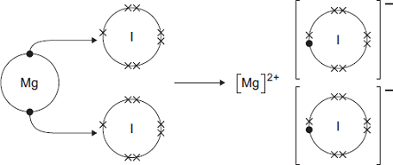
Use the diagram to help you to answer this question.
Describe, as fully as you can, what happens when magnesium reacts with iodine to make magnesium iodide.
To gain full marks you should use the words atom, electron and ion in your answer.
___________________________________________________________________
___________________________________________________________________
___________________________________________________________________
___________________________________________________________________
___________________________________________________________________
___________________________________________________________________
___________________________________________________________________
___________________________________________________________________
___________________________________________________________________
___________________________________________________________________
(4)
(Total 9 marks)

Q34.
The electrolysis of sodium chloride solution is an industrial process.
The diagram shows the apparatus used in a school experiment.
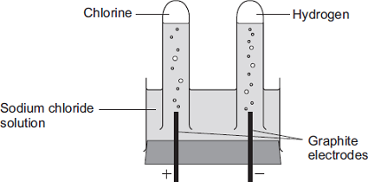
(a) One of the products of the electrolysis of sodium chloride solution is hydrogen.
(i) Why do hydrogen ions move to the negative electrode?
______________________________________________________________
______________________________________________________________
(1)
(ii) How does a hydrogen ion change into a hydrogen atom?
______________________________________________________________
______________________________________________________________
(1)
(b) Hydrogen is used to make ammonia (NH₃).
Complete the diagram to show the bonding in ammonia.
Use dots (●) and crosses (x) to show electrons.
Show only outer shell electrons.
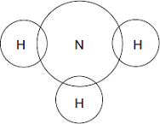
(2)
(c) The table shows the ions in sodium chloride solution.

Positive ions | Negative ions
hydrogen | chloride
sodium | hydroxide
In industry, some of the waste from the electrolysis of sodium chloride solution is alkaline and has to be neutralised.
(i) Which ion makes the waste alkaline?
______________________________________________________________
(1)
(ii) This waste must be neutralised.
Write the ionic equation for the neutralisation reaction.
______________________________________________________________
(1)
(d) In this question you will be assessed on using good English, organising information clearly and using specialist terms where appropriate.
The electrolysis of sodium chloride solution also produces chlorine and sodium hydroxide.
In industry, the electrolysis of sodium chloride solution can be done in several types of electrolysis cell.
Some information about two different types of electrolysis cell is given below.

 | Mercury cell | Membrane cell
Cost of construction | Expensive | Relatively cheap
Additional substances used | Mercury, which is recycled. Mercury is toxic so any traces of mercury must be removed from the waste | Membrane, which is made of a polymer. The membrane must be replaced every 3 years.
Amount of electricity used for each tonne of chlorine produced in kWh | 3400 | 2950
Quality of chlorine produced | Pure | Needs to be liquefied and distilled to make it pure.
Quality of sodium hydroxide solution produced | 50% concentration. Steam is used to concentrate the sodium hydroxide solution produced. | 30% concentration. Steam is used to concentrate the sodium hydroxide solution produced.
Use the information and your knowledge and understanding to compare the environmental and economic advantages and disadvantages of these two types of electrolysis cell.
___________________________________________________________________
___________________________________________________________________
___________________________________________________________________
___________________________________________________________________
___________________________________________________________________
___________________________________________________________________
___________________________________________________________________
___________________________________________________________________
___________________________________________________________________
___________________________________________________________________
___________________________________________________________________
___________________________________________________________________
___________________________________________________________________
___________________________________________________________________
___________________________________________________________________
(6)
(Total 12 marks)
Q35.
This question is about structure and bonding.
(a) Oxygen is in Group 6.
The diagram shows the outer shells in an oxygen molecule.
Complete the dot and cross diagram.
You should show only the electrons in the outer shell.
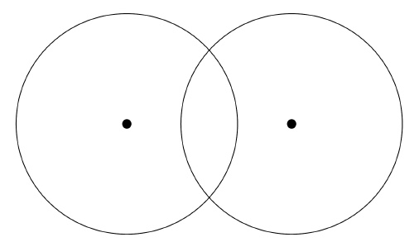
(2)
(b) Oxygen forms many compounds.
Which two compounds of oxygen are small molecules?
Tick two boxes.

Carbon dioxide
Magnesium oxide
Potassium oxide
Silicon dioxide
Water
(2)
(c) Explain why metals conduct electricity.
Refer to structure and bonding in your answer.
___________________________________________________________________
___________________________________________________________________
___________________________________________________________________
___________________________________________________________________
___________________________________________________________________
___________________________________________________________________
___________________________________________________________________
___________________________________________________________________
___________________________________________________________________
___________________________________________________________________
___________________________________________________________________
___________________________________________________________________
(4)
(Total 8 marks
Section 1: Knowledge Mark Scheme
Q1.
(a) watch glass
1
(b) identify 0.29 as anomaly
1
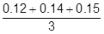
or
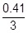
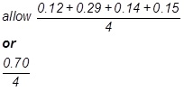
1
(=) 0.14 (g)
allow 0.18 (g) if first marking point not awarded
1
an answer of 0.14 (g) scores 3 marks
(c) evaporating
or
vaporisation
allow from liquid to vapour / gas
do not accept boiling
1
(d) pure
or
no salt
allow converse answers relating to seawater
allow not a mixture
allow desalinated
do not accept less salt
do not accept filtered
1
(e) uses (a lot of) energy
allow needs heating
allow needs electricity
allow needs fuel or any suitable fuel
ignore references to equipment
ignore references to time
1
(f) filtering removes particles
allow solids or suitable named solids
1
sterilising kills bacteria / microbes
allow destroys viruses
allow kills viruses
1
[9]
Q2.
(a) lines from:
• independent to size of marble chips
1
• control to volume of acid
1
ignore arrowheads
do not accept if more than one line from one box
(b) calcium chloride
carbon dioxide
do not accept carbon oxide
water
do not accept hydrogen oxide
2
all three needed for 2 marks
allow 1 mark if two correct
(c) stops loss of acid
allow stops loss of water / liquid
allow to ensure that only the gas escapes
do not accept stops acid evaporating
do not accept stops gas / CO₂ / water vapour escaping
1
(d) 0.053
allow 0.05
allow 0.053333…
do not accept 0.052
ignore units
1
(e) g/s
1
(f) all points correctly plotted
allow 1 mark for 5 points correctly plotted
allow ± ½ a small square
2
line of best fit
should be a curve nearer to (10,0.8) than the anomaly (20, 0.6) and through all other points
if plotting incorrect allow 1 mark for appropriate line of best fit through student’s points
1
(g) the eight small marble chips have a larger surface area, so more frequent collisions
1
[11]
Q3.
(a) the mass number
or
number of protons and neutrons
ignore (relative) atomic mass
1
(b) 18
1
(c) 22
1
(d)
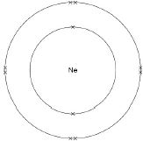
ignore pairing of electrons
1
(e) positive
1
(f) equal number of protons and electrons
do not accept equal number of protons, electrons and neutrons
1
(therefore) the positive cancels out the negative charge
allow (therefore) equal number of positives and negatives
1
(g) isotopes
1
(h)
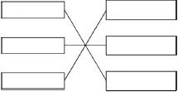
2
[10]
Q4.
(a) melting points decrease (as the atomic number increases)
allow negative correlation
1
(b) 55
and
29 (°C)
allow values in range 28−32 (°C)
1
(c) 1
1
(d)
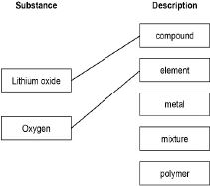
1
1
(e) 4 Li + O₂ ⟶ 2 Li₂O
allow correct multiples
1
(f) ionic
1
(g) (M_{r}) = (2 × 7) + 16
1
= 30
1
an answer of 30 scores 2 marks
[9]
Q5.
(a) carbon
1
(b) conduct electricity
1
(c) 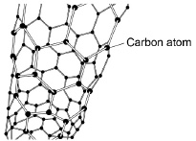
1
(d) carbon
hydrogen
either order
2
(e) a polymer
1
(f) slide
1
[7]
Q6.
(a) 3
1
(b) 5
1
(c) water
1
(d) opposite charges attract
1
(e) silver is less reactive than hydrogen
1
(f) oxygen
1
(g) universal indicator
allow other indicators
1
blue / purple
1
[8]
Q7.
(a) any two from:
• hydrogen is in group 1 on Newlands table
• fluorine / chlorine / halogens are in group 1 on Newlands table
• alkali metals are in group 2 on Newlands table
allow converse arguments relating to modern table
allow lithium / sodium / potassium for alkali metals
2
(b) undiscovered
1
(c) atomic number
1
(d) D
1
E
1
A
1
must be in this order
(e) has a complete outer shell of electrons
allow because has a stable arrangement of electrons
1
(f) noble gases
1
[9]
Q8.
(a) sodium fluoride
1
(b) electrostatic
1
(c) conducts electricity when molten
1
high melting point
1
(d) any four from:
• sodium loses electron(s)
• fluorine gains electron(s)
• reference to one electron being transferred
• (forming) positive sodium ion and negative fluoride ion
• ions have complete outer shells
• oppositely charged ions are attracted towards each other
4
(e) the diagram only shows a two-dimensional representation
or
the diagram is not three-dimensional
1
[9]
Q9.
(a)
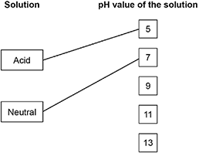
extra lines from solution negate the mark
2
(b) H⁺
1
(c) 3
1
(d) Neutralisation
1
(e) sodium sulfate
1
(f) Add indicator to sodium hydroxide solution
allow add indicator to sulfuric acid
1
Add sulfuric acid (gradually)
allow add sodium hydroxide solution (gradually)
1
allow pH probe
until indicator just changes (colour)
or until universal indicator turns green or shows pH7
1
[9]
Q10.
(a) because the mass of an electron is very small
do not accept has no mass
1
(b) 5 / five
1
(c) +5
1
(d) 6
1
(because) mass number = no. protons + no. electrons
allow atomic number = 5
1
(so the number of) neutrons = 11 – 5
allow mass number – number of protons
1
(e) (16 / 31) × 100 = 51.6
1
= 52
incorrect sig. figs max 1 mark
1
[8]
Q11.
(a) (i) 7
1
(ii) –1
1
(iii) neutrons
1
(b) number of protons
1
(c) atom Y
1
(d) (i) Ne
allow neon
1
(ii) has a full outer shell
allow in Group 0
allow a noble gas
or
full outer energy level
allow the shells are full
or
has 8 electrons in its outer shell
ignore in Group 8
1
[7]
Q12.
(a) ionic
1
(b) a molecule
1
(c) a fullerene
1
(d) covalent
1
(e) 1
1
(f) solid
1
(g) electron
1
(h) dissolved
1
(i)
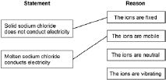
do not accept if more than 1 line from 1 box
1
1
[10]
Q13.
(a) Flask
1
(b) Fractional distillation
1
(c) A – boiling
in this order
1
B – condensing
1
(d) Pentane
1
(e) Formulation
1
(f) the fuel is a pure compound
1
and crude oil is a mixture
or
the fuel is made up of four hydrocarbons
allow crude oil contains a large number of compounds and the fuel contains four
and crude oil could have many more
1
(g) (35 + 37 + 37 / 3) = 36.33
1
36
1
allow (35 + 48 + 37 + 37 / 4 =) 39(.25) for 1 mark
[10]
Q14.
the atoms are in layers
1
the atoms can slide over each other
1
[2]
Q15.
(a) carbon
1
(b) all
1
(c) covalent
1
(d) four
1
(e) hard
1
[5]
Q16.
(a) reduce wear of metal ie don’t get damaged
or other sensible answer
or
stop / reduce friction
accept stop metal heating up
accept move more smoothly
ignore make it slippery / rub more smoothly
or
prevent seizing
accept can move freely
1
(b) (i) carbon
1
(ii) layers (of atoms)
1
can slide / slip over each other
allow slip off
or
weak forces of attraction / weak bonds (between layers)
allow no bonds
accept there are weak forces of attraction for
1 mark even when there is no reference to layers
accept atoms slide over each other (for 1 mark)
an answer which only states there are weak bonds would gain 0 mark when there is no reference to layers
weak covalent bonds = 0 marks
1
[4]

Q17.
high
1
giant
allow covalent
1
four
1
covalent
1
[4]
Q18.
(a) B
1
(b) calcium oxide or CaO
1
carbon dioxide or CO₂
1
either order
(c) decomposition
1
(d) endothermic
1
(e) 32 (g)
allow 31−33 (g)
1
(f) 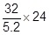
1
148 (g)
allow a range 143−153 (g)
or
uses graph e.g. 12 dm³ gives 74 (g) (1)
(then factors up so that 24 dm³ gives) 148 (g) (1)
allow a range 143−153 (g)
1
an answer of 148 (g) scores 2 marks
allow ecf from part (e)
(g) (mistakes)
increase in mass = 3 (not 4)
allow mistakes in either order
1
inserted numbers inversely into formula
allow numbers wrong way round
1
(calculation)
an answer of 250 scores the 2 calculation marks
1
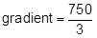
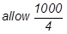
250 (cm³ per g)
if no calculation marks awarded
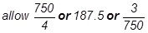
or 0.004 for 1 mark
1
(h) 3 × 16 or 48
1
(48) + 12 or 60
allow their mass of oxygen + 12
1
84 − (60) or 24
allow 84 − their mass of carbonate
1
magnesium or Mg
magnesium or Mg without working scores this mark
1
an answer of 24 scores the 3 calculation marks
[16]
Q19.
(a) let the glow spread
1
(b) 1.27 (g)
1
(c) solid
1
(d) zinc
1
(e) displacement
1
(f) A
1
(g) any one from:
• (good electrical) conductor
• can be bent easily
ignore malleability
• does not corrode
ignore does not rust
1
allow is ductile
(h) 2 : 3
1
(i) conserves copper ores
1
less energy used
1
[10]
Q20.
(a) (a reaction that) transfers energy to the surroundings
1
(b) 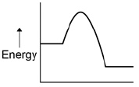
1
(c) 2 × 16 (= 32)
1
(M_{r} =) 44
1
72.7 (%)
1
(d) 2 2
allow multiples
1
(e) 3.2 g of O₂ produced from 6.8 g of H₂O₂
1
32 (g)
1
[8]
Q21.
(a) 1
must be in this order
1
very small
accept negligible, 1 / 2000
allow zero
1
(b) The mass number
1
(c) C
1
(d) (i) 2
1
(ii) 3
1
(e) (i) 28
1
(ii) 42.9
accept ecf from (e)(i)
accept 42 - 43
1
(f) (i) 0.9
1
(ii) any one from:
• accurate
• sensitive
• rapid
• small sample.
1
[10]
Q22.
(a) 56g
for 1 mark
1
(b) 44 tonnes
for 1 mark
1
[2]
Section 2: Required Practicals Mark Scheme
Q23.
(a) any three from:
• concentration of (salt) solution
• volume of (salt) solution
ignore amount of solution
• initial temperature (of the solution)
ignore room temperature
• surface area / form of metal
• moles of metal
allow mass / amount
ignore time
ignore size of tube
3
(b) 20
1
32
1
12
allow ecf
1
(c) (i) four bars of correct height
tolerance is + / - half square
3 correct for 1 mark
2
bars labelled
1
(ii) one variable is non-continuous / categoric
accept qualitative or discrete
accept no values between the metals
1
(iii) magnesium
1
because biggest temperature change
accept gives out most energy
ignore rate of reaction
dependent on first mark
1
(iv) does not react / silver cannot displace copper
1
because silver not more reactive (than copper) or silver below copper in reactivity series
do not accept silver is less reactive than copper sulfate
1
(v) replace the copper sulfate
could be implied
1
with any compound of a named metal less reactive than copper
allow students to score even if use an insoluble salt
1
[16]
Q24.
(a) (i) copper is less reactive than hydrogen or copper is unreactive
1
(ii) Zinc and dilute hydrochloric acid
1
(b) (gas) syringe
1
(c) (i) 35
allow 3
1
because not close to others
accept it is much lower than the others
ignore references to trends or patterns
dependent on the first mark
1
(ii) (49 + 50 + 48) / 3
= 49
correct answer with or without working gains 2 marks
1
allow ecf from anomaly identified in (i) for 2 marks:
• Exp 1 anomalous gives 43.3
• Exp. 2 anomalous gives 44
• Exp. 4 anomalous gives 44.7
answer of 45.5 or 46 (anomaly not excluded) gains 1 mark
correct working excluding anomaly but with wrong answer gains 1 mark
1
(iii) so that a mean can be calculated
accept improves accuracy of the mean or so anomalies can be identified / discarded or to reduce effect of random errors
ignore makes it a fair test
ignore reliability, validity, repeatability, reproducibility
1
(d) (i) idea of mixing with oxygen / air, letting air / oxygen in
accept converse
1
(ii) H₂O
do not accept incorrect additional products
1
balancing 2 … (1) … 2
allow fractions or multiples
dependent on first mark
1
[11]
Q25.
(a) (i) (phosphoric) acid
allow phosphoric
1
(ii) H⁺ / hydrogen (ion)
if ion symbol given, charge must be correct
1
(b) (i) pencil
1
so it will not run / smudge / dissolve
ignore pencil will not interfere with / affect the results
or
because ink would run / smudge / dissolve
ignore ink will interfere with / affect the results
1
(ii) any three from:
reference to spots / dots = max 2
allow colouring for colour
• 3 colours in Cola
allow more colours in cola or fewer colours in fruit drink
• 2 colours in Fruit drink
• one of the colours is the same
• two of the colours in Cola are different
• one of the colours in Fruit drink is different
allow some of the colours in the drinks are different
• one of the colours in Cola is the most soluble
accept one of the colours in Cola has the highest R_{f} value
3
(c) different substances travel at different speeds or have different retention times
accept different attraction to solid
ignore properties of compounds
1
(d) (i) Is there caffeine in a certain brand of drink?
1
(ii) any two from:
• cannot be done by experiment
• based on opinion / lifestyle choice
• ethical, social or economic issue
accept caffeine has different effects on different people
2
[11]
Q26.
(a) (i) points correctly plotted ( ± ½ small square)
four points = 2 marks
three points = 1 mark
Max 2
straight line of best fit using full range of points from 0,0
1
(ii) any one from:
must explain why the point is below the line
• the solution may not have been properly stirred
• the electrodes may have been a larger distance apart
• the drop of sodium chloride may have been a smaller volume / smaller
allow not enough sodium chloride added
allow smaller amount of sodium chloride
do not allow too few drops added
ignore the student may have misread the conductivity meter
1
(iii) any one from:
• the volume of pure water
allow amount
• the concentration (of the solutions added)
• the volume (of the drops) of solution added
ignore number of drops
• the distance between the electrodes
• the same electrodes or electrodes made of the same material
• same depth or surface area of electrodes in the water
• constant power supply
ignore current
• stirred
1
(b) (i) because (pure) water is covalent / molecular (simple) or contains molecules
1
therefore (pure) water has no free / mobile electrons or ions
molecules do not have a charge or molecules do not contain ions gains 2 marks
1
(ii) because there are ions in sodium chloride
allow Na⁺ and / or Cl–(ions) or ionic bonding.
Ignore particles other than ions for MP1.
1
which can move or carry the current / charge
MP2 must be linked to ions only.
1
(iii) Hydrogen
allow H₂ / H
1
[10]
Q27.
(a) continuous
1
independent
1
(b) 31.5 – 24.0
1
7.5 (°C)
an answer of 7.5 (°C) scores 2 marks
1
(c) 25.5 – 26(.0) cm³
1
(d) did not stir
or
did not wait long enough for the highest temperature to be reached
1
(e) 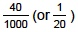
1
× 80
1
3.2 (g)
an answer of 3.2 (g) scores 3 marks
1
[9]
Q28.
(a)
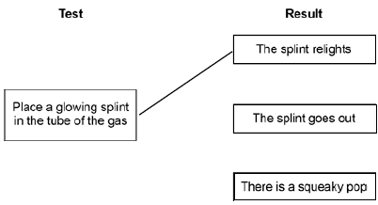
more than one line from test negates the mark
1
(b) (i) place a lighted splint at the mouth of the tube
1
there is a squeaky pop
dependent on correct test
1
(ii) hydrogen is less reactive than magnesium
accept converse
accept magnesium is too reactive
1
(c) (i) any one from:
• to improve appearance or make it look nice
• to prevent corrosion
• to make it more durable
• cheaper than solid silver
1
(ii) solution must be silver nitrate or contain silver ions
1
otherwise copper will be deposited or silver will not be deposited
1
spoon must be the negative electrode / cathode
1
because silver ions have a positive charge or go to negative electrode or are discharged at the negative electrode.
1
(iii) because (plastic is an) insulator or does not conduct electricity
accept does not contain mobile electrons
1
[10]
Q29.
(a) mobile phase propanone
1
stationary phase paper
1
(b) any three from:
• contains chlorophyll a, b and carotene
• contains Pigment B
• does not contain pheophytin
• contains (at least) one unknown substance
• contains five substances
• contains a substance that does not dissolve in the solvent
3
(c) 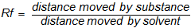
1
(d) both measurements correct
solvent front = 9.0 cm and pigment B distance = 5.0 cm
1
R_{f} = 5.0 / 9.0
1
= 0.56
allow ecf from incorrect measurements
1
(e) origin line drawn in ink
1
so it will run or dissolve in the solvent or split up
1
spots under solvent or solvent above spots / origin line
1
so they will mix with solvent or wash off paper or colour the solvent or dissolve in the solvent
1
[13]
Section 3: 6 Mark Questions Mark Scheme
Q30.
Level 3 (5–6 marks):
A coherent method is described with relevant detail, which demonstrates a broad
understanding of the relevant scientific techniques, procedures and safety precautions. The
steps in the method are logically ordered with the dependent and control variables correctly identified. The method would lead to the production of valid results.
Level 2 (3–4 marks):
The bulk of a method is described with mostly relevant detail, which demonstrates a
reasonable understanding of the relevant scientific techniques, procedures and safety precautions. The method may not be in a completely logical sequence and may be missing
some detail.
Level 1 (1–2 marks):
Simple statements are made which demonstrate some understanding of some of the relevant scientific techniques, procedures and safety precautions. The response may lack a logical structure and would not lead to the production of valid results.
0 marks:
No relevant content
Indicative content
Named chemicals
• copper oxide
• sulfuric acid
• copper sulfate
Correct use of apparatus
• stirring rod
• spatula
• beaker
• filter funnel and filter paper
• evaporating basin
• Bunsen burner
• tripod and gauze
• bench mat
• conical flask
Method
• add (excess) copper oxide to sulfuric acid
• heat the mixture
• filter the mixture
• method to evaporate some of the water from the filtrate eg using a water bath or evaporating to half volume
• leave solution (to cool and) to form crystals
• remove and dry crystals
Safety
• wearing of safety glasses / goggles
• care with use of sulfuric acid as corrosive
• warming not boiling mixture of copper oxide and sulfuric acid
• hold beaker containing warm mixture with tongs whilst filtering
[6]
Q31.
(a) (test)
burning splint (held at open end of test tube)
1
(result)
a (squeaky) pop
1
(b)
Level 3: The design/plan would lead to the production of a valid outcome. All key steps are identified and logically sequenced. | 5-6
Level 2: The design/plan would not necessarily lead to a valid outcome. Most steps are identified, but the plan is not fully logically sequenced. | 3-4
Level 1: The design/plan would not lead to a valid outcome. Some relevant steps are identified, but links are not made clear. | 1-2
No relevant content | 0
Indicative content
• measure volume of hydrochloric acid
• in a measuring cylinder
• pour hydrochloric acid into suitable container
• measure temperature of hydrochloric acid
• using a thermometer
• measure mass of magnesium
• using a balance
• add magnesium to hydrochloric acid
• stir
• measure maximum temperature reached
• record maximum temperature reached
• calculate the change / rise in temperature
• repeat procedure for same mass of magnesium
• find mean temperature rise
• repeat with different masses of magnesium
6
[8]
Q32.
(a) Carbon and silicon
1
(b) Atomic number
1
(c) Hydrogen / fluorine / chlorine are not in Group 1 of the periodic table
or
Hydrogen and fluorine / chlorine are not in the same group of the periodic table
1
Lithium / sodium / potassium are in Group 1 of the periodic table
1
(d) plum pudding model has a single ball of positive charge and nuclear model has positive charges in the centre / nucleus
1
plum pudding model has electrons in random positions and nuclear model has electrons
in fixed positions
1
plum pudding model has no nucleus and the nuclear model has a nucleus
1
plum pudding model has no neutrons and the nuclear model has neutrons in the nucleus
1
(e)
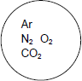
1
(f) Covalent bond
1
[10]
Q33.
(a) (i) nucleus
1
(ii) neutron
1
(iii) electron
1
(b) (i) 12
1
(ii) 24
1
(c) any four from:
sharing / covalent / metallic = max 3
• magnesium (atom) reacts with two iodine (atoms)
• magnesium (atom) loses electrons
• 2 electrons (from each atom)
• Iodine (atom) gains electron(s)
• 1 electron or an electron (to each atom)
• iodide ion formed
allow iodine ion
• iodide has negative charge / is a negative ion / particle
allow iodine
ignore I^{2–}
• magnesium ion formed
• magnesium has positive charge
• oppositely charged ions attract
• a giant structure / lattice is formed
allow 1 mark for unqualified reference to ion formation or ionic bonding
4
[9]
Q34.
(a) (i) because they are positively charged
accept they are positive / H⁺
accept oppositely charged or opposites attract
ignore they are attracted
1
(ii) gains one / an electron
accept H⁺ + e– → H or multiples
allow gains electrons
1
(b) 3 bonding pairs
1
1 lone pair
accept 2 non-bonding electrons on outer shell of nitrogen
1
(c) (i) hydroxide / OH–
do not accept sodium hydroxide
1
(ii) H⁺ + OH– → H₂O
ignore state symbols
ignore word equation
1
(d) Marks awarded for this answer will be determined by the Quality of
Written Communication (QWC) as well as the standard of the scientific response. Examiners should also refer to the information in the Reference material.
0 marks
No relevant content.
Level 1 (1-2 marks)
There are basic descriptions of advantages or disadvantages of the electrolysis cells.
Level 2 (3-4 marks)
There are clear descriptions of environmental or economic advantages or disadvantages of the electrolysis cells. Comparisons may be implied.
Level 3 (5-6 marks)
There are detailed descriptions of environmental and economic advantages and disadvantages, comparing the electrolysis cells.
Examples of chemistry points made in the response:
Accept converse where appropriate.
• mercury cell is more expensive to construct
• mercury is recycled but membranes must be replaced
• mercury is toxic but membrane / polymer is not
• removing traces of mercury from waste is expensive
• mercury cell uses more electricity
• mercury cell produces chlorine that is purer
• mercury cell produces higher concentration / better quality of sodium hydroxide (solution)
6
[12]
Q35.
(a) 4 electrons shared
1
each atom has 4 unshared electrons outside the bond
1
(b) carbon dioxide
1
water
1
(c) giant structure of atoms
1
delocalised electrons
1
(delocalised electrons) are free to move
1
through the whole structure
1

