Oasis Academy South Bank
Year 11 Mock Revision
Biology Combined Paper 1: Foundation
Name: ___________________________
Class: _________
Teacher: __________________________
Step 1: Knowledge
Learn each of the quiz questions and answers off by heart. This could be done by:
- turning them into flash cards and testing yourself
- using ‘look, cover, write, check’
- asking a friend or family member to quiz you
Topic | LCWC | Quiz 1 | Quiz 2 | Quiz 3
Types of cells (B.1)
Specialised cells (B.2)
Microscopy (B.3)
Cell division (mitosis) (B.4)
Introducing pathogens and types of disease (B.7)
Detailed disease case studies (B.8)
Preventing pathogens from making us unwell (B.9)
Developing new medicines (B.10)
Breathing and respiration (B.14)
The Heart (B.15)
The Blood (B.16)
Digestion (B.17)
Transport in cells (diffusion, active transport and osmosis) (B.19)
Structure of a plant (B.21)
Transport in plants (B.23)
Transpiration and translocation (B.24)
Photosynthesis (B.25)
The products of photosynthesis (B.26)
Exercise and metabolism (B.40)

Step 2: Exam practice
- Practice applying your knowledge using the past exam questions in each section.
- Self-assess these using the mark schemes at the back and rewrite your answers.
- Assess your progress using a ‘red, amber, green’ system (RAG)
Section | Completed | SA using green pen
1: Knowledge
2. Required Practicals
3. 6 marker questions

Exam practice
Section 1: Knowledge
Q1.
Figure 1 shows one type of white blood cell.
Figure 1
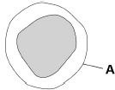
(a) What is structure A?
Tick one box.

Cell membrane
Cell wall
Cytoplasm
Nucleus
(1)
(b) White blood cells help to defend the body against pathogens.
How do the white blood cells do this?
Tick three boxes.

Clone pathogens
Engulf pathogens
Produce antibiotics
Produce antibodies
Produce antitoxins
Produce toxins
(3)
Measles is a serious disease. A person can die from measles.
Figure 2 shows the number of cases of measles in England and Wales between 2012 and 2015
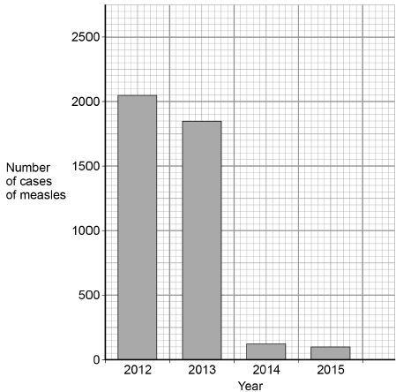
(c) Use Figure 2 to calculate the decrease in the number of cases of measles between 2012 and 2015
___________________________________________________________________
___________________________________________________________________
Answer = ______________________ cases
(2)
(d) Suggest one reason for the decrease in the number of cases of measles between 2012 and 2015
___________________________________________________________________
___________________________________________________________________
(1)
(e) Antibiotics cannot be used to treat measles.
Suggest why.
___________________________________________________________________
___________________________________________________________________
(1)
(f) Gonorrhoea is a disease caused by a bacterium.
Gonorrhoea can be treated with antibiotics.
Give one other way to control the spread of gonorrhoea.
___________________________________________________________________
___________________________________________________________________
(1)
A scientist investigated how effective different antibiotics were at killing gonorrhoea bacteria.
This is the method used.
1. Grow gonorrhoea bacteria on agar in a Petri dish.
2. Place one paper disc soaked in water onto the agar.
3. Place four other paper discs, each soaked in a different antibiotic, A, B, C, and D, onto the agar.
4. Use the same sized paper discs and the same concentration of each antibiotic.
5. Incubate the Petri dish for 3 days.
Figure 3 shows the scientist’s results.
A clear area around the disc means the antibiotic has killed the bacteria.
Figure 3
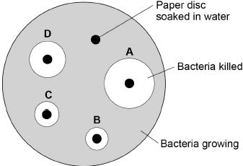
(g) Give one control variable the scientist used.
___________________________________________________________________
___________________________________________________________________
(1)
(h) Suggest why one disc was soaked in water.
___________________________________________________________________
___________________________________________________________________
(1)
(i) Which antibiotic in Figure 3 would be the best to treat gonorrhoea?
Give a reason for your answer.
Antibiotic ___________________________________________________________
Reason ____________________________________________________________
___________________________________________________________________
(2)
(Total 13 marks)
Q2.
This question is about cell structures.
(a) Draw one line from each cell structure to the type of cell where the structure is found.

Cell Structure |  | Type of cell where the structure is found
Nucleus |  | Prokaryotic cells
Permanent vacuole |  | Plant cells only
Plasmid |  | Eukaryotic cells
(2)
(b) Figure 1 shows a plant cell.
Figure 1
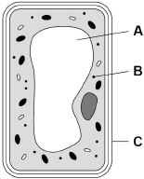
What are the names of structures A, B and C?
Tick one box.

Structure A | Structure B | Structure C
Chloroplast | Vacuole | Cell wall
Nucleus | Chloroplast | Cell membrane
Vacuole | Mitochondrion | Cell membrane
Vacuole | Ribosome | Cell wall
(1)
A student observed slides of onion cells using a microscope.
Figure 2 shows two of the slides the student observed.
Figure 2
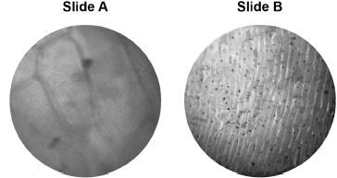
The cells on the slides are not clear to see.
(c) Describe how the student should adjust the microscope to see the cells on Slide A more clearly.
___________________________________________________________________
___________________________________________________________________
(1)
(d) Describe how the student should adjust the microscope to see the cells on Slide B more clearly.
___________________________________________________________________
___________________________________________________________________
___________________________________________________________________
(2)
(e) The student made the necessary adjustments to get a clear image.
Figure 3 shows the student’s drawing of one of the cells.
Figure 3
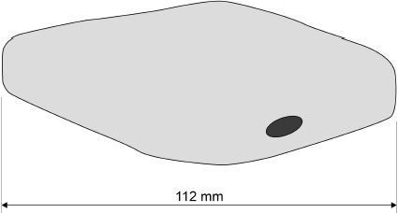
The real length of the cell was 280 micrometres (µm).
Calculate the magnification of the drawing.
___________________________________________________________________
___________________________________________________________________
___________________________________________________________________
___________________________________________________________________
___________________________________________________________________
Magnification = × _________________________
(3)
(Total 9 marks)
Q3.
The image below shows some muscle cells from the wall of the stomach, as seen through a light microscope.
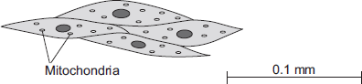
(a) Describe the function of muscle cells in the wall of the stomach.
___________________________________________________________________
___________________________________________________________________
___________________________________________________________________
___________________________________________________________________
(2)
(b) The figure above is highly magnified.
The scale bar in the figure above represents 0.1 mm.
Use a ruler to measure the length of the scale bar and then calculate the magnification of the figure above.
___________________________________________________________________
___________________________________________________________________
___________________________________________________________________
___________________________________________________________________
Magnification = _______________ times
(2)
(c) The muscle cells in Figure above contain many mitochondria.
What is the function of mitochondria?
___________________________________________________________________
___________________________________________________________________
___________________________________________________________________
___________________________________________________________________
(2)
(d) The muscle cells also contain many ribosomes. The ribosomes cannot be seen in the figure above.
(i) What is the function of a ribosome?
______________________________________________________________
______________________________________________________________
(1)
(ii) Suggest why the ribosomes cannot be seen through a light microscope.
______________________________________________________________
______________________________________________________________
(1)
(Total 8 marks)

Q4.
Muscle cells divide to form new muscle cells.
(a) Which two cell components are copied before the muscle cells start to divide?
Tick two boxes.

Cytoplasm
Mitochondria
Plasmids
Ribosomes
Vacuole
(2)
(b) Why do muscle cells need to divide by mitosis more often than most other cells?
Tick one box.

To contract the muscles
To repair the muscles
To supply more oxygen to the muscles
To transmit nerve impulses
(1)
Mitosis is part of the cell cycle.
The diagram below shows the percentage of time taken by each stage of a cell cycle.
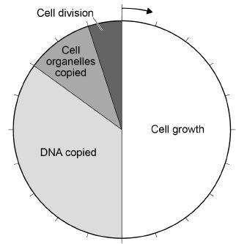
(c) The cell cycle shown in the diagram above takes 21 hours in total.
Cell division takes 5% of the total time.
Calculate how many hours cell division takes.
___________________________________________________________________
___________________________________________________________________
Time taken = _______________ hours
(2)
(d) What percentage of time is spent copying DNA in the cell cycle shown in the diagram above?
___________________________________________________________________
___________________________________________________________________
Percentage = _______________
(2)
(e) A sperm cell from a dog contains 39 chromosomes.
How many chromosomes are there in each dog muscle cell?
Tick one box.

39
78
156
312
(1)
(f) A sperm cell fuses with an egg cell.
What is this process called?
Tick one box.

Fertilisation
Meiosis
Ovulation
Respiration
(1)
(Total 9 marks)
Q5.
Our lungs help us to breathe.
The image below shows the human breathing system.
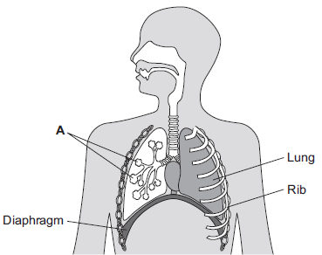

(a) (i) Name part A.
______________________________________________________________
(1)
(ii) Give one function of the ribs.
______________________________________________________________
(1)
(b) (i) Use the correct answer from the box to complete the sentence.

active transport | diffusion | osmosis
Oxygen moves from the air inside the lungs into the blood by the
process of __________________________ .
(1)
(ii) Use the correct answer from the box to complete the sentence.

arteries | capillaries | veins
Oxygen moves from the lungs into the blood through the walls
of the __________________________ .
(1)
(iii) Inside the lungs, oxygen is absorbed from the air into the blood.
Give two adaptations of the lungs that help the rapid absorption of oxygen into the blood.
1. ____________________________________________________________
______________________________________________________________
2. ____________________________________________________________
______________________________________________________________
(2)
(Total 6 marks)
Q6.
Plants need different substances to survive.
Figure 1 shows the roots of a plant.
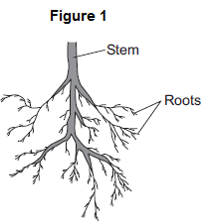
(a) (i) Mineral ions are absorbed through the roots.
Name one other substance absorbed through the roots.
______________________________________________________________
(1)
(ii) The plant in Figure 1 has a higher concentration of mineral ions in the cells of its roots than the concentration of mineral ions in the soil.
Which two statements correctly describe the absorption of mineral ions into the plant’s roots?
Tick () two boxes.

The mineral ions are absorbed by active transport.
The mineral ions are absorbed by diffusion.
The mineral ions are absorbed down the concentration gradient.
The absorption of mineral ions needs energy.
(2)
(iii) The plant in Figure 1 has roots adapted for absorption.
Figure 2 shows a magnified part of a root from Figure 1.
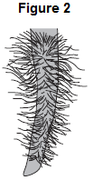
Describe how the root in Figure 2 is adapted for absorption.
______________________________________________________________
______________________________________________________________
______________________________________________________________
______________________________________________________________
(2)
(b) The leaves of plants have stomata.
What is the function of the stomata?
___________________________________________________________________
___________________________________________________________________
(1)
(c) Figure 3 shows the underside of two leaves, A and B, taken from a plant in a man’s house.
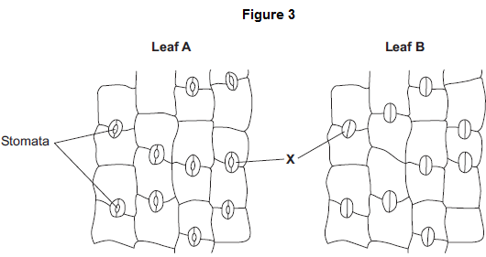

(i) In Figure 3, the cells labelled X control the size of the stomata.
What is the name of the cells labelled X?
Tick () one box.

Guard cells
Phloem cells
Xylem cells
(1)
(ii) Describe how the appearance of the stomata in leaf B is different from the appearance of the stomata in leaf A.
______________________________________________________________
______________________________________________________________
(1)
(iii) The man forgets to water the plant.
What might happen to the plant in the next few days if the stomata stay the same as shown in leaf A in Figure 3?
______________________________________________________________
______________________________________________________________
(1)
(Total 9 marks)
Q7.
Substances can move into and out of cells.
(a) (i) How does oxygen move into and out of cells?
Draw a ring around one answer.

diffusion | digestion | photosynthesis
(1)
(ii) Diagram 1 shows the percentage concentration of oxygen in three cells, A, B and C.
Diagram 1
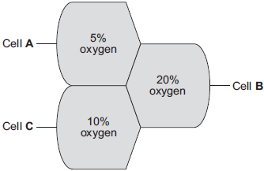
Oxygen can move from cell to cell.
Into which cell, A, B or C, will oxygen move the fastest?
(1)
(b) (i) How does water move into and out of cells?
Draw a ring around one answer.

breathing | osmosis | respiration
(1)

(ii) Differences in the concentration of sugars in cells cause water to move into or out of cells at different rates.
Diagram 2 shows three different cells, P, Q and R.
The information shows the percentage concentration of sugar solution
in cells P, Q and R.
Diagram 2
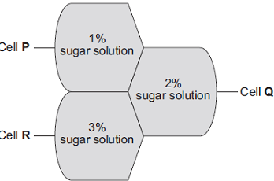
Water can move from cell to cell.
Into which cell, P, Q or R, will water move the fastest?
(1)
(Total 4 marks)
Q8.
Figure 1 shows the human digestive system.
Figure 1
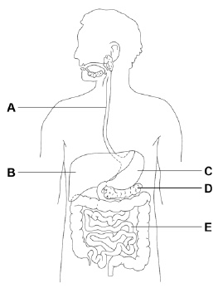
(a) Which organ in Figure 1 produces acid?
Tick one box.

A |  | B |  | C |  | D |  | E
(1)

(b) Which organ in Figure 1 produces bile?
Tick one box.

A |  | B |  | C |  | D |  | E
(1)
(c) Where in Figure 1 are digested foods absorbed into the blood?
Tick one box.

A |  | B |  | C |  | D |  | E
(1)
(d) Food molecules such as proteins cannot be absorbed unless they are digested.
Give one reason why.
___________________________________________________________________
___________________________________________________________________
(1)
A scientist investigated the effect of pH on the activity of two protease enzymes.
Figure 2 shows the results.
Figure 2
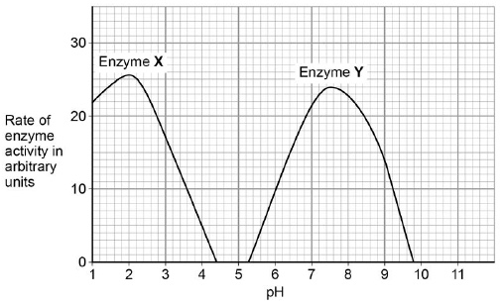
(e) What is the optimum pH for enzyme Y?
pH ____________________
(1)
(f) Where in the digestive system might the two protease enzymes be produced?
Tick one box.

Enzyme X | Enzyme Y
Mouth | Stomach
Pancreas | Mouth
Small intestine | Pancreas
Stomach | Small intestine
(1)
Figure 3 shows a model of an enzyme molecule.
Figure 3
(g) Which substrate fits the enzyme molecule in Figure 3?
Tick one box.
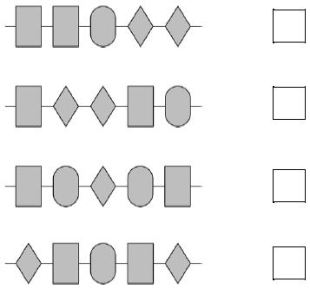
(1)
(h) The enzyme and substrate diagrams are used as a model for a theory of enzyme action.
What is the name of this theory?
Tick one box.

Evolution
Lock and key
Natural selection
Protein synthesis
(1)
(i) Explain why pH affects enzyme activity.
___________________________________________________________________
___________________________________________________________________
___________________________________________________________________
___________________________________________________________________
(2)
(Total 10 marks)

Q9.
An athlete decides to try a new type of protein drink after he exercises.
(a) The athlete tests the protein drink to check it contains protein.
Which solution is used to test for protein in the drink?
Tick one box.

Benedict’s
Biuret
Iodine
Universal indicator
(1)
(b) What colour will the solution turn to if there is protein in the drink?
Tick one box.

Blue-black
Purple
Red
Yellow
(1)
Figure 1 shows the proportion of different nutrients in the protein drink.
Figure 1
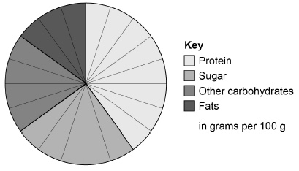
(c) What is the ratio of sugar to protein in the protein drink?

1:1 |  | 1:0:6 |  | 1:2 |  | 1:1:6
(1)
(d) Why is a high protein diet useful to an athlete?
Tick one box.

Provides amino acids to make new muscle.
Provides fatty acids to produce urea.
Provides glucose for energy.
Provides lactic acid for anaerobic respiration.
(1)
When the athlete drinks the protein drink the substances are digested.
The products of digestion are absorbed into the bloodstream.
Absorption happens in the small intestine.
Figure 2 shows a section of the small intestine.
Figure 2
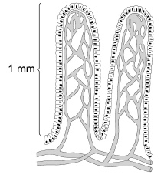
(e) How is the small intestine in Figure 2 adapted to absorb the products of digestion quickly?
Tick two boxes.

It has a large surface area.
It has a long diffusion pathway.
It has a thin surface.
The concentration inside the small intestine is low.
It has a poor blood supply.
(2)
(f) Figure 3 shows the proportion of different nutrients in four protein drinks.
Figure 3
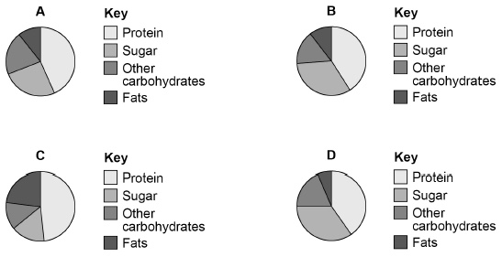
Which protein drink should an athlete with diabetes use?
Give a reason for your answer.
Drink ____________________
Reason ____________________________________________________________
___________________________________________________________________
(2)
(Total 8 marks)
Q10.
The heart is part of the circulatory system.
(a) (i) Name one substance transported by the blood in the circulatory system.
______________________________________________________________
(1)
(ii) What is the main type of tissue in the heart wall?
______________________________________________________________
(1)
(b) Figure 1 shows the human heart.
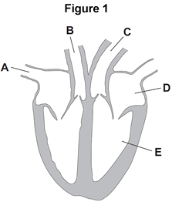
(i) Which blood vessel, A, B or C, takes blood to the lungs?

(1)
(ii) Name parts D and E shown in Figure 1.
D _______________________________________
E _______________________________________
(2)

(c) Figure 2 shows three types of blood vessel, F, G and H.
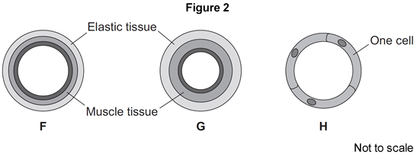
(i) What type of blood vessel is F?

Tick (✔) one box.
an artery
a capillary
a vein
(1)
(ii) A man needs to have a stent fitted to prevent a heart attack.
In which type of blood vessel would the stent be placed?

Tick (✔) one box.
an artery
a capillary
a vein
(1)
(iii) Explain how a stent helps to prevent a heart attack.
______________________________________________________________
______________________________________________________________
______________________________________________________________
______________________________________________________________
(2)
(Total 9 marks)
Q11.
Plants exchange substances with the environment.
(a) Use words from the box to complete each sentence.

alveoli | phloem | root hairs | stomata
storage organs |  | villi | xylem
(i) Most water enters a plant through ___________________________________
(1)
(ii) The water is transported up the stem to the leaves in the _________________
(1)
(iii) Carbon dioxide enters leaves through ________________________________
(1)
(iv) A leaf uses the carbon dioxide to produce sugars.
Sugars are transported to ________________________________ through
the _________________________________ .
(2)

(b) A student set up the apparatus shown in the diagram.
At the start of the experiment both balances showed a mass of 180.0 g.
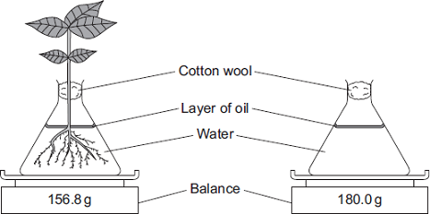
The diagram shows the reading on each balance 24 hours later.
(i) Look at the mass shown on each balance.
Calculate the difference between the two masses.
______________________________________________________________
______________________________________________________________
Difference in mass = _________________________ g
(1)
(ii) Suggest an explanation for the difference between the two masses.
______________________________________________________________
______________________________________________________________
______________________________________________________________
______________________________________________________________
(2)
(Total 8 marks)
Q12.
Obesity is linked to several diseases.
(a) Name two diseases linked to obesity.
1. _________________________________________________________________
2. _________________________________________________________________
(2)
(b) Scientists trialled a new slimming drug.
The table shows their results after one year.

Percentage change in mass  of each volunteer | Number of volunteers
gained mass or lost 0 to 3.9 % | 1900
lost 4.0 to 4.9 % | 1100
lost 5.0 to 9.9 % | 1500
lost 10 % or more | 1500
(i) Calculate the proportion of the volunteers who lost 10 % or more of their mass.
You should first calculate the total number of volunteers, then work out the proportion.
______________________________________________________________
______________________________________________________________
Proportion of volunteers = _________________________
(2)
(ii) The National Health Service (NHS) gave permission for the drug to be used.
Use information from the table to suggest a reason why the NHS gave permission for the drug to be used.
______________________________________________________________
______________________________________________________________
(1)
(Total 5 marks)
Q13.
The bar chart shows the concentration of oxygen in the blood in three different blood vessels, X, Y and Z.
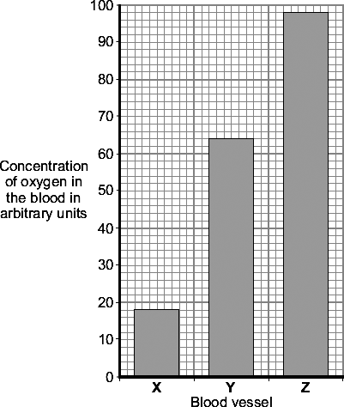
(a) (i) What is the concentration of oxygen in blood vessel X?
Answer _____________ arbitrary units.
(1)
(ii) Which blood vessel, X, Y or Z, carries blood from the lungs to the heart?
(1)
(b) Draw a ring around the correct answer to complete each sentence.

 |  | plasma.
(i) | Most of the oxygen in the blood is carried by the | red blood cells.
 |  | white blood cells.
(1)
(ii) Oxygen combines with a coloured pigment in the blood.

 | alveoli.
This coloured pigment is called | haemoglobin.
 | lactic acid.
(1)
(Total 4 marks)

Q14.
Complete the table to show which part of the blood carries out each function.
Choose your answers from the list.
plasma platelet red blood cell white blood cell
The first answer has been done for you.

Function | Part of the blood
Transports most of the carbon dioxide | plasma
Transports most of the oxygen
Helps blood to clot at a wound
Defends the body against microorganisms
Transports the products of digestion
(Total 4 marks)
Q15.
The following sentences are about the blood system. Choose words from the list in the box to complete these sentences. You may use a word once or not at all.

diffuse lowered narrow one
raised spread two wide
Capillaries have thin walls which are __________________ .cell thick. This allows
nutrients from digested food to __________________ through and reach the cells
of organs. Capillaries are very ________________ .and so blood flow through an
organ is slowed down and blood pressure is ____________________ .
(Total 4 marks)
Q16.
The diagram shows how a leaf of a green plant makes glucose.
(a) Use words from the box to complete the labels on the diagram. You may use each word once or not at all.
carbon dioxide chlorophyll glucose heat
light oxygen water
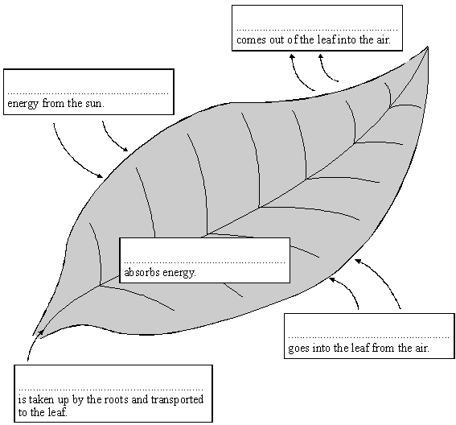
(5)
(b) (i) Compete the following sentence.
Glucose in food is a type of _________ . When we eat it, it gives us energy.
(1)
(ii) The plant turns some of the glucose into starch. Why is starch useful to the plant?
______________________________________________________________
______________________________________________________________
(1)
(iii) What does the plant do with the rest of the glucose?
______________________________________________________________
(1)
(c) (i) What is the name of the process outlined in the diagram?
______________________________________________________________
(1)
(ii) Give one way that leaves are adapted to do this process.
______________________________________________________________
(1)
(Total 10 marks)
Q17.
(a) (i) Complete the word equation for the process of aerobic respiration.
Glucose + ______________ → carbon dioxide + water
(1)
(ii) Which organ removes carbon dioxide from your body?
______________________________________________________________
(1)
(b) Use names from the box to complete the two spaces in the passage.

carbon dioxide lactic acid nitrogen oxygen water
Anaerobic respiration can occur when an athlete does vigorous exercise.
This is because there is not enough ___________________________ in the body.
The product of anaerobic respiration is ________________________________ .
(2)
(Total 4 marks)
Q18.
Antibiotics are used to kill some types of pathogen.
(a) Which illness could be treated with an antibiotic?
Tick one box.

AIDS
Measles
Salmonella
Type 2 diabetes
(1)
Alexander Fleming discovered the antibiotic penicillin.
He noticed that one of his Petri dishes containing bacteria had become contaminated with a fungus.
The diagram shows the Petri dish.
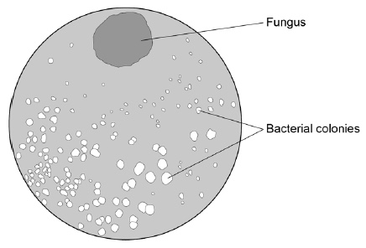
(b) Read the information about the discovery of penicillin.
Draw one line from each piece of information to its description.

Information |  | Description
 |  | Conclusion
Fleming noticed that there were only a few bacterial colonies growing near the fungus.
 |  | Hypothesis
Fleming thought the fungus must have produced a chemical (penicillin) that killed the bacteria around it.
 |  | Investigation
He injected 8 mice with bacteria and gave 4 of these mice an injection of penicillin.
 |  | Observation
The 4 mice injected with penicillin survived. The 4 mice not given penicillin died.
 |  | Result
(4)
(c) Look at the diagram of the petri dish.
The greater the distance from the fungus the more bacteria grew.
Suggest one reason for this.
___________________________________________________________________
___________________________________________________________________
(1)
(d) Give two reasons why Fleming’s discovery was important.
1. _________________________________________________________________
___________________________________________________________________
2. _________________________________________________________________
___________________________________________________________________
(2)
(Total 8 marks)

Q19.
Pathogens are microorganisms that cause infectious disease.
(a) Draw one line from each disease to the way the disease is spread.

Disease |  | Way the disease is spread

 |  | Animals that draw blood
Cholera |  | Drinking contaminated water
Cold |  | Droplets in the air when people cough or sneeze
Malaria |  | Eating food that is contaminated
 |  | Breathing air polluted with carbon dioxide
(3)
(b) One way the human body protects itself against the entry of pathogens is by producing antimicrobial chemicals.
Antimicrobial chemicals kill pathogens.
Give two other ways the human body protects itself against the entry of pathogens.
1. _________________________________________________________________
___________________________________________________________________
2. _________________________________________________________________
___________________________________________________________________
(2)
(c) Measles is a childhood disease caused by a microorganism.
Measles is not treated by antibiotics.
Give the reason why.
___________________________________________________________________
(1)
(d) Vaccinations help people become immune to infections.
In 2013, 92% of children in the UK had two vaccination injections against measles.
The figure below shows how the concentration of antibodies in the blood changes after each measles vaccination.
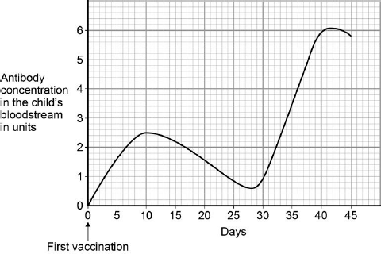

Suggest what day the second vaccination was given.
___________________________________________________________________
(1)
(e) What is the highest concentration of antibodies produced by the first vaccination?
___________________________________________________________________
(1)
(f) How will the number of children getting measles change as more children are vaccinated against measles?
Give a reason for your answer.
Change ___________________________________________________________
Reason ____________________________________________________________
___________________________________________________________________
(2)
(Total 10 marks)
Q20.
The photograph below shows human skin highly magnified. Groups of microbes can be seen on the skin.
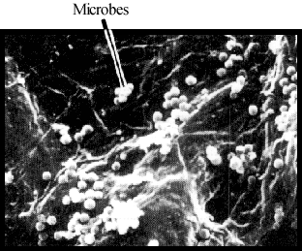
Give two ways in which the body protects itself from these microbes.
1. _____________________________________________________________________
_______________________________________________________________________
2. _____________________________________________________________________
_______________________________________________________________________
(Total 2 marks)
Q21.
Bacteria and viruses can reproduce quickly inside the body and make people feel ill.
(a) Use the correct answer from the box to complete the sentence.

antibodies | antitoxins | toxins
Bacteria and viruses make us feel ill because they produce __________________ .
(1)
(b) (i) Antibiotics can be used to treat some infections.
Use the correct answer from the box to complete the sentence.

bacteria | bacteria and viruses | viruses
Antibiotics are medicines that kill _____________________ .
(1)
(ii) New strains of pathogens have developed which are resistant to antibiotics.
Use the correct answer from the box to complete the sentence.

are short of food | invade body cells | mutate
New strains are produced when pathogens _____________________ .
(1)
(iii) What will scientists have to develop to kill these new resistant strains?
______________________________________________________________
______________________________________________________________
(1)
(Total 4 marks)
Q22.
New drugs have to be tested before they can be sold.
The graph shows how much time the different stages of testing took for a new drug.
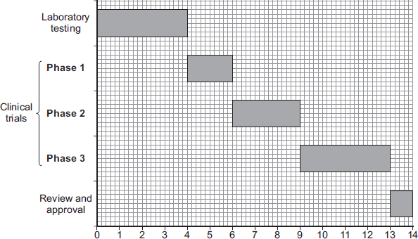
Time in years
(a) (i) How much time did the laboratory testing of the drug take?
____________________ years
(1)
(ii) Suggest what the drug was tested on during laboratory testing.
______________________________________________________________
(1)
(b) Clinical trials are carried out on human volunteers and patients.
(i) How much time did the clinical trials take for this drug?
______________________________________________________________
____________________ years
(2)
(ii) During Phase 1 clinical trials, the drug is tested on healthy volunteers using low doses.
Draw a ring around the correct answer to complete the sentence.

 | find the best dose.
The reason for Phase 1 testing is to | see if the drug works.
 | see if the drug has side effects.
(1)
(iii) During Phase 2 and Phase 3 clinical trials, half of the volunteers are given a fake drug called a placebo in a double blind trial.
In a double blind trial, who knows which volunteers are given the drug and which volunteers are given the placebo?
Tick ( ) one box.
Tick ( )
The doctors but not the volunteers
The doctors and the volunteers
The volunteers but not the doctors
Neither the volunteers nor the doctors
(1)
(Total 6 marks)
Q23.
Drugs affect our body chemistry.
(a) List A gives the names of some drugs.
List B gives the uses of some drugs.
Draw one line from each drug in List A to the use of the drug in List B.
List A  Drug |  | List B  Use
 |  | To increase fertility in women
Anabolic steroid
 |  | To treat leprosy
Statin
 |  | To stimulate muscle growth
Thalidomide
 |  | To reduce the risk of heart and circulatory diseases
(3)
(b) A new drug was trialled on 80 healthy volunteers.
The volunteers were asked to report any side effects.
The results of the trial are shown in the table.

Reported effects | Number of volunteers
No side effects | 20
Severe sickness | 42
Itchy skin | 18
Based on the results of this trial, what should the drug company do next?
Tick () one box.

Test on a small group of patients to find the optimum dose
Test on a large group of patients to see if the drug works on ill people
Stop the trial
Give a reason for your answer.
___________________________________________________________________
___________________________________________________________________
(2)
(Total 5 marks)
Q24.
Plants make glucose by photosynthesis.
(a) Complete the word equation for photosynthesis.
__________________ + __________________ → glucose + __________________
(1)
(b) What is the name of the chemical that makes a leaf look green?
Tick one box.

Cellulose
Chlorophyll
Chloroplast
Chromosome
(1)
(c) A test for starch is used to show that a plant has photosynthesised.
How does the presence of starch show that photosynthesis has taken place?
___________________________________________________________________
___________________________________________________________________
(1)
A student investigated where starch was made in a leaf.
She used a leaf that was part green and part white as shown in the diagram.
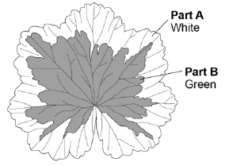
This is the method used.
1. Put the leaf in boiling water for 1 minute.
Reason: stops all chemical reactions in the leaf.
2. Transfer the leaf to boiling ethanol for 5 minutes.
Reason: removes the green colour.
3. Dip the leaf in hot water.
Reason: softens the leaf.
4. Spread the leaf on a white tile and test with iodine solution.
Reason: stains any starch.
(d) If the chemical reactions in the leaf were not stopped, the amount of starch in the leaf would decrease.
Give the reason why.
___________________________________________________________________
___________________________________________________________________
(1)
(e) Suggest why it is important to remove the green colour from the leaf before adding iodine solution.
___________________________________________________________________
___________________________________________________________________
(1)
(f) Ethanol is flammable.
The student wore safety goggles when testing the leaf for starch.
Give one other safety precaution the student should have taken.
___________________________________________________________________
___________________________________________________________________
(1)
(g) Look at the leaf in the diagram.
What colour would part A and part B stain with iodine solution after the starch test?
A ____________________
B ____________________
(2)
(Total 8 marks)

Q25.
Gas exchange takes place in the lungs.
The diagram shows an alveolus next to a blood capillary in a lung.
The arrows show the movement of two gases, A and B.
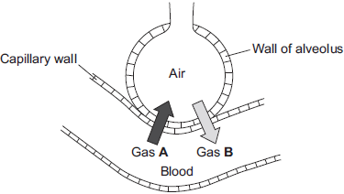
(a) (i) Draw a ring around the correct answer to complete the sentence.

Gases A and B move by | diffusion.  osmosis.  respiration.
(1)
(ii) Gas A moves from the blood to the air in the lungs.
Gas A is then breathed out.
Name Gas A.
______________________________________________________________
(1)
(iii) Which cells in the blood carry Gas B?
Draw a ring around the correct answer.
platelets red blood cells white blood cells
(1)
(b) The average number of alveoli in each human lung is 280 million.
The average surface area of 1 million alveoli is 0.25 m².
Calculate the total surface area of a human lung.
___________________________________________________________________
Answer ___________________________________ m²
(2)
(c) An athlete trains to run a marathon. The surface area of each of the athlete’s lungs has increased to 80 m².
Give one way in which this increase will help the athlete.
___________________________________________________________________
___________________________________________________________________
(1)
(Total 6 marks)
Q26.
One factor that may affect body mass is metabolic rate.
(a) (i) What is meant by metabolic rate ?
______________________________________________________________
______________________________________________________________
(1)
(ii) Metabolic rate is affected by the amount of activity a person does.
Give two other factors that may affect a person’s metabolic rate.
1. ____________________________________________________________
______________________________________________________________
2. ____________________________________________________________
______________________________________________________________
(2)
(b) Predicted early death is the number of years that a person will die before the mean age of death for the whole population. The predicted early death of a person is affected by their body mass.
Scientists have calculated the effect of body mass on predicted early death.
The graph shows the results of the scientists’ calculations.
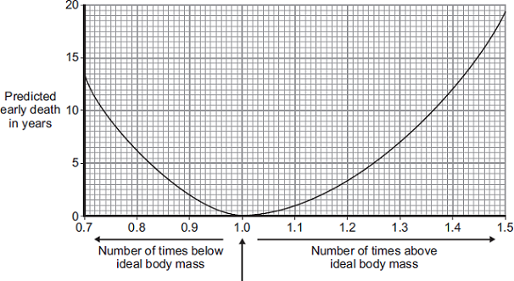
Ideal body mass
The number of times above or below ideal body mass is given by the equation:
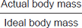
In the UK the mean age of death for women is 82.
A woman has a body mass of 70 kg. The woman’s ideal body mass is 56 kg.
(i) Use the information from the graph to predict the age of this woman when she dies.
______________________________________________________________
______________________________________________________________
______________________________________________________________
Age at death = ___________ years
(2)
(ii) The woman could live longer by changing her lifestyle.
Give two changes she should make.
1. ____________________________________________________________
______________________________________________________________
2. ____________________________________________________________
______________________________________________________________
(2)
(Total 7 marks)
Q27.
(a) Respiration is a process which takes place in living cells. What is the purpose of respiration?
___________________________________________________________________
___________________________________________________________________
(1)
(b) (i) Balance the equation for the process of respiration when oxygen is available.
C₆H₁₂O₆ + O₂ → CO₂ + H₂O
(1)
(ii) What is the name of the substance in the equation with the formula C₆H₁₂O₆?
______________________________________________________________
(1)
(c) Oxygen is absorbed through the alveoli in the lungs.
(i) How are the alveoli adapted for this function?
______________________________________________________________
______________________________________________________________
______________________________________________________________
(2)
(ii) Name the gas which is excreted through the alveoli.
______________________________________________________________
(1)
(d) (i) What is the name of the process of respiration when oxygen is not available?
______________________________________________________________
(1)
(ii) Describe the process of respiration which takes place in human beings when oxygen is not available and give an effect.
______________________________________________________________
______________________________________________________________
______________________________________________________________
______________________________________________________________
______________________________________________________________
______________________________________________________________
(3)
(Total 10 marks)

Section 2: Required Practicals
Q1.
This question is about photosynthesis.
(a) What are the two products of photosynthesis?
Tick two boxes.

Carbon dioxide
Chlorophyll
Glucose
Oxygen
Water
(2)
A student investigated the effect of light intensity on the rate of photosynthesis.
Figure 1 shows the apparatus.
Figure 1
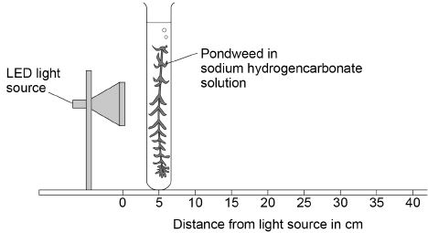
This is the method used.
1. Place the pondweed at 5 cm from the light source.
2. Measure the rate of photosynthesis by counting the number of bubbles produced in 30 seconds.
3. Repeat the investigation with the pondweed at different distances from the light source.
(b) How could the student measure the rate of photosynthesis more accurately?
Tick two boxes.

Count the number of bubbles produced in 1 minute
Measure the change in mass of the pondweed in 30 seconds
Measure the volume of gas produced in 30 seconds
Place the pondweed further from the light source
Use water instead of sodium hydrogencarbonate solution
(2)
(c) The LED light source does not get hot.
Why is this important?
___________________________________________________________________
___________________________________________________________________
___________________________________________________________________
(1)
The table below shows the student’s results.

Distance of light source from pondweed in cm | Number of bubbles produced in 30 seconds
5 | 40
10 | 13
15 | 5
20 | 2
25 | 1
30 | 0
(d) Calculate the number of bubbles produced in 2 minutes when the light source was 10 cm from the pondweed.
___________________________________________________________________
___________________________________________________________________
Number of bubbles produced in 2 minutes = ______________
(1)
(e) Plot the data from the table above on Figure 2
Draw a line of best fit.
Figure 2
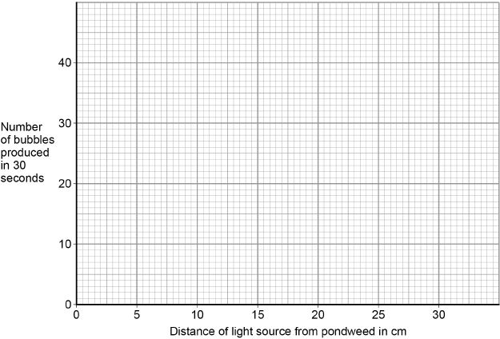
(3)
(f) Give one conclusion that can be made from these results.
___________________________________________________________________
___________________________________________________________________
(1)
(Total 10 marks)
Q2.
A student investigated the effect of different concentrations of sugar solution on pieces of potato.
This is the method used.
1. Cut three pieces of potato to the same length.
2. Dry each piece on a paper towel.
3. Weigh each piece.
4. Place each piece in a different concentration of sugar solution.
5. Leave all three pieces for 2 hours.
6. Remove the three pieces of potato from the solutions.
7. Dry each piece on a paper towel.
8. Measure the length and mass of each piece of potato.
Figure 1 shows how the investigation was set up.
Figure 1
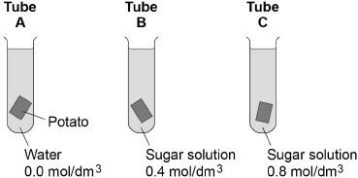
(a) Why did the student dry each piece of potato before weighing it?
___________________________________________________________________
___________________________________________________________________
(1)
(b) What two changes would you expect in the potato in tube A after 2 hours?
Tick two boxes.

Breaks into pieces
Decrease in hardness
Decrease in size
Increase in mass
Increase in length
(2)
(c) Complete the sentences.
Water moves into and out of cells by a process called ____________________ .
Water would move ____________________ the potato cells in tube A.
The solution outside the potato in tube A is at a ____________________
concentration than the solution inside the potato cells.
(3)
(d) The potato in tube B did not change.
Give one conclusion that can be made from this observation.
___________________________________________________________________
___________________________________________________________________
(1)
(e) Figure 2 shows the root of a germinating seed.
Figure 2
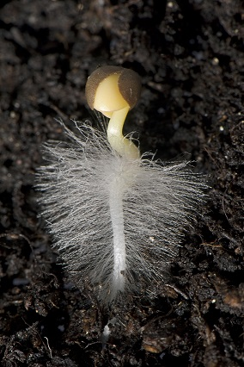
Describe two ways the root is adapted to absorb water efficiently.
1. _________________________________________________________________
___________________________________________________________________
2. _________________________________________________________________
___________________________________________________________________
(2)
(Total 9 marks)
Q3.
Some students tested a red cabbage leaf for starch.
This is the method used.
1. Boil the leaf in ethanol.
2. Rinse the leaf in water.
3. Add the reagent to test the leaf for starch.
(a) Give one safety precaution the students should take in this test.
___________________________________________________________________
___________________________________________________________________
(1)
(b) Which reagent is used to test the boiled leaf for starch?
Tick one box.

Benedict’s solution
Biuret solution
Iodine solution
Sodium chloride solution
(1)
(c) What colour will be seen if the test for starch is positive?
Tick one box.

Blue-black
Pale pink
Orange
Red
(1)
The students then used paper chromatography to investigate the coloured pigments in a red cabbage leaf.
(d) Complete the sentences.
Choose answers from the box.

distil | evaporate | filter | mobile | separate | solid
Chromatography can be used to ___________________________ mixtures.
In paper chromatography, the paper is part of the stationary phase.
The solvent is called the ___________________________ phase.
(2)
Table 1 shows the students’ results.
The distance each pigment moved was measured from the start line.

 | Distance moved in mm | R_{f} value
Yellow-green pigment | 17 | X
Yellow pigment | 46 | 0.42
Orange pigment | 100 | 0.91
The R_{f} value is calculated using the equation:
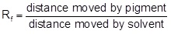
(e) The solvent moved 110 mm from the start line.
Calculate R_{f} value X in Table 1.
Give your answer to 2 significant figures.
___________________________________________________________________
___________________________________________________________________
___________________________________________________________________
___________________________________________________________________
R_{f} value X = ______________________
(2)
(f) The known ranges of R_{f} values of some pigments are shown in Table 2.
Table 2

Pigment | R_{f} value range
Carotene | 0.89 to 0.98
Chlorophyll a | 0.24 to 0.30
Chlorophyll b | 0.20 to 0.26
Xanthophyll | 0.04 to 0.28
The R_{f} value for the orange pigment in red cabbage leaves is 0.91
What is this orange pigment most likely to be?
Tick one box.

Carotene
Chlorophyll a
Chlorophyll b
Xanthophyll
(1)
(Total 8 marks)
Q4.
An athlete decides to try a new type of protein drink after he exercises.
(a) The athlete tests the protein drink to check it contains protein.
Which solution is used to test for protein in the drink?
Tick one box.

Benedict’s
Biuret
Iodine
Universal indicator
(1)
(b) What colour will the solution turn to if there is protein in the drink?
Tick one box.

Blue-black
Purple
Red
Yellow
(1)
Figure 1 shows the proportion of different nutrients in the protein drink.
Figure 1
(c) What is the ratio of sugar to protein in the protein drink?

1:1 |  | 1:0:6 |  | 1:2 |  | 1:1:6
(1)
(d) Why is a high protein diet useful to an athlete?
Tick one box.

Provides amino acids to make new muscle.
Provides fatty acids to produce urea.
Provides glucose for energy.
Provides lactic acid for anaerobic respiration.
(1)
When the athlete drinks the protein drink the substances are digested.
The products of digestion are absorbed into the bloodstream.
Absorption happens in the small intestine.
Figure 2 shows a section of the small intestine.
Figure 2
(e) How is the small intestine in Figure 2 adapted to absorb the products of digestion quickly?
Tick two boxes.

It has a large surface area.
It has a long diffusion pathway.
It has a thin surface.
The concentration inside the small intestine is low.
It has a poor blood supply.
(2)
(f) Figure 3 shows the proportion of different nutrients in four protein drinks.
Figure 3
Which protein drink should an athlete with diabetes use?
Give a reason for your answer.
Drink ____________________
Reason ____________________________________________________________
___________________________________________________________________
(2)
(Total 8 marks)
Q5.
A scientist investigated how effective 5 different antibiotics were at killing two types of bacteria, E.coli and S.aureus.
• The scientist grew the bacteria on agar in two different Petri dishes.
• He placed paper discs soaked in the 5 different antibiotic solutions, A, B, C, D and E, onto the agar.
• He used the same concentration of each antibiotic and the same sized paperdiscs.
• The Petri dishes were incubated at 25°C for 3 days.
A clear area around the paper disc means that the antibiotic has killed the bacteria there.
The results are shown in the diagram.

 | Petri dish containing  E.coli |  | Petri dish containing  S.aureus
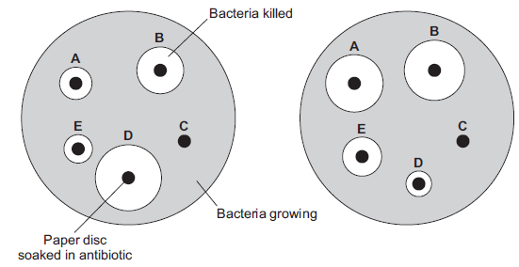
(a) Give one variable the scientist controlled.
___________________________________________________________________
(1)
(b) Use the results shown in the diagram to help you to answer the following questions.
(i) Which antibiotic, A, B, C, D or E, was the most effective at killing E.coli?
Write the correct answer in the box.
(1)
(ii) Which antibiotic, A, B, C, D or E, did not kill either E.coli or S.aureus?
Write the correct answer in the box.
(1)
(iii) Which antibiotic, A, B, C, D or E, would be the best to use to kill both E.coli and S.aureus?
Antibiotic: _______________
Give a reason for your answer.
______________________________________________________________
______________________________________________________________
______________________________________________________________
(2)
(c) MRSA is a strain of S.aureus. MRSA cannot be killed by most antibiotics.
Draw a ring around the correct answer to complete the sentence.

 | immune.
Bacteria that cannot be killed by antibiotics are | powerful.
 | resistant.
(1)
(Total 6 marks)

Section 3: 6 mark questions

Q1.
A man with breathing difficulties goes to hospital.
The photographs below show his lung scan and chest X-ray.
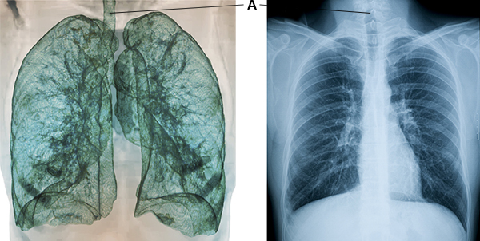
(a) What is part A?
Tick one box.

Bronchus
Capillary
Trachea
Vein
(1)
(b) Give one advantage of using the lung scan, rather than the chest X-ray, to diagnose problems with the man’s breathing system.
___________________________________________________________________
___________________________________________________________________
(1)
(c) Give one advantage of using the chest X-ray, rather than the lung scan, to diagnose problems with the man’s breathing system.
___________________________________________________________________
___________________________________________________________________
(1)

(d) Aerobic respiration and anaerobic respiration are the two types of cell respiration.
Give three differences between aerobic and anaerobic respiration.
1. _________________________________________________________________
___________________________________________________________________
2. _________________________________________________________________
___________________________________________________________________
3. _________________________________________________________________
___________________________________________________________________
(3)
(e) A health website contains the following advice:
Stop smoking and you will be healthier and live longer.
Explain why stopping smoking will improve a person’s health.
___________________________________________________________________
___________________________________________________________________
___________________________________________________________________
___________________________________________________________________
___________________________________________________________________
___________________________________________________________________
___________________________________________________________________
___________________________________________________________________
___________________________________________________________________
___________________________________________________________________
___________________________________________________________________
___________________________________________________________________
___________________________________________________________________
___________________________________________________________________
___________________________________________________________________
___________________________________________________________________
___________________________________________________________________
(6)
(Total 12 marks)
Q2.
The graph shows the rate of blood flow through different organs at rest and during exercise.
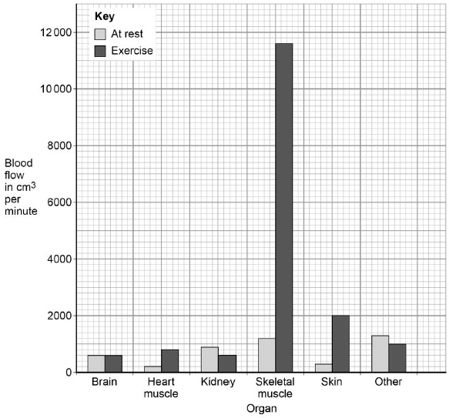
(a) Determine the total volume of blood that flows through the brain in 1 hour.
___________________________________________________________________
___________________________________________________________________
Volume = ____________________ cm³
(1)
(b) Look at the blood flow through the skeletal muscle.
Calculate how many times the blood flow increases by during exercise compared to at rest.
___________________________________________________________________
___________________________________________________________________
___________________________________________________________________
Answer = ____________________
(2)
(c) Explain why the blood flow to the skeletal muscles increases during exercise.
___________________________________________________________________
___________________________________________________________________
___________________________________________________________________
___________________________________________________________________
___________________________________________________________________
___________________________________________________________________
(3)
(d) Arteries and veins have different structures and different functions.
Explain how the different structure of arteries and veins relates to their different functions.
___________________________________________________________________
___________________________________________________________________
___________________________________________________________________
___________________________________________________________________
___________________________________________________________________
___________________________________________________________________
___________________________________________________________________
___________________________________________________________________
___________________________________________________________________
___________________________________________________________________
___________________________________________________________________
___________________________________________________________________
(6)
(Total 12 marks)
Q3.
Plants absorb light to photosynthesise.
(a) What is the correct word equation for photosynthesis?
Tick one box.

carbon dioxide + glucose oxygen + water
glucose + oxygen carbon dioxide + water
oxygen + water carbon dioxide + glucose
water + carbon dioxide oxygen + glucose
(1)
(b) Figure 1 shows some of the apparatus that can be used to measure the rate of photosynthesis.
Figure 1
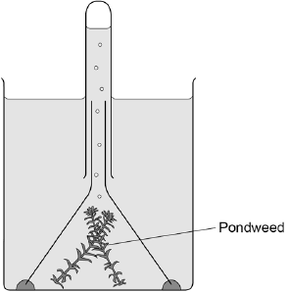
The rate of photosynthesis in the pondweed is affected by different colours of light.
Describe a method you could use to investigate this.
You should include:
• what you would measure
• variables you would control.
___________________________________________________________________
___________________________________________________________________
___________________________________________________________________
___________________________________________________________________
___________________________________________________________________
___________________________________________________________________
___________________________________________________________________
___________________________________________________________________
___________________________________________________________________
___________________________________________________________________
(6)
(c) A scientist carried out a similar investigation.
Her results are shown in Figure 2.
Figure 2
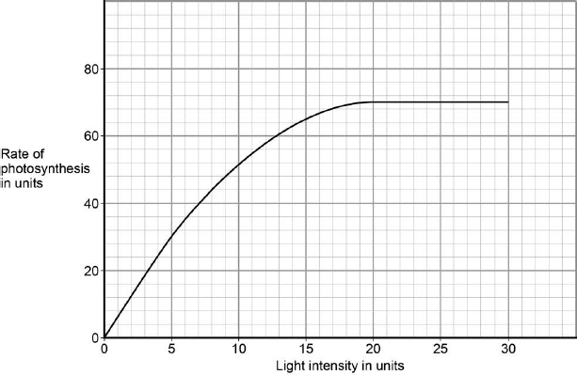
The scientist said:
‘Light stops being a limiting factor at a light intensity of 20 units.’
Give evidence from Figure 2 to support this statement.
___________________________________________________________________
___________________________________________________________________
(1)
(d) What could be limiting the rate of photosynthesis at a light intensity of 25 units?
Give one factor.
___________________________________________________________________
(1)
(Total 9 marks)
Q4.
An athlete ran as fast as he could until he was exhausted.
(a) Figure 1 shows the concentrations of glucose and of lactic acid in the athlete’s blood at the start and at the end of the run.
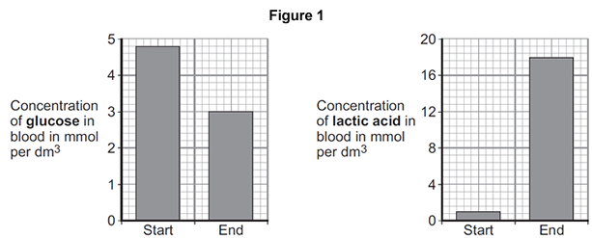
(i) Lactic acid is made during anaerobic respiration.
What does anaerobic mean?
______________________________________________________________
______________________________________________________________
(1)
(ii) Give evidence from Figure 1 that the athlete respired anaerobically during the run.
______________________________________________________________
______________________________________________________________
(1)
(b) Figure 2 shows the effect of running on the rate of blood flow through the athlete’s muscles.

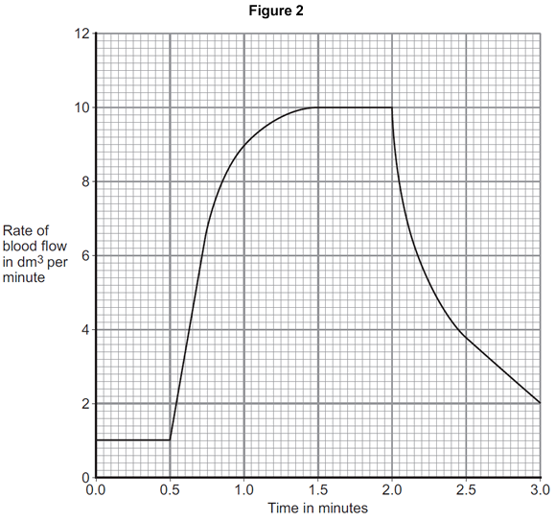
(i) For how many minutes did the athlete run?
Time = ______________________ minutes
(1)
(ii) Describe what happens to the rate of blood flow through the athlete’s muscles during the run.
Use data from Figure 2 in your answer.
______________________________________________________________
______________________________________________________________
______________________________________________________________
______________________________________________________________
(2)

(iii) Explain how the change in blood flow to the athlete’s muscles helps him to run.
______________________________________________________________
______________________________________________________________
______________________________________________________________
______________________________________________________________
______________________________________________________________
______________________________________________________________
______________________________________________________________
______________________________________________________________
(4)
(Total 9 marks)
Q5.
Coronary heart disease (CHD) is a non-communicable disease.
CHD is caused when fatty material builds up in the coronary arteries.
(a) Explain what a non-communicable disease is.
___________________________________________________________________
___________________________________________________________________
___________________________________________________________________
(2)
The diagram below shows a coronary artery of someone with CHD.
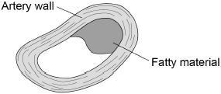
(b) Explain how CHD can cause a heart attack.
___________________________________________________________________
___________________________________________________________________
___________________________________________________________________
___________________________________________________________________
___________________________________________________________________
___________________________________________________________________
(3)
(c) Explain how lifestyle and medical risk factors increase the chance of developing CHD.
___________________________________________________________________
___________________________________________________________________
___________________________________________________________________
___________________________________________________________________
___________________________________________________________________
___________________________________________________________________
___________________________________________________________________
___________________________________________________________________
___________________________________________________________________
___________________________________________________________________
___________________________________________________________________
___________________________________________________________________
(6)
(Total 11 marks)
Q6.
(a) The graph shows the effect of pH on the activities of three enzymes, X, Y and Z.
These enzymes help to digest food in the human digestive system.
Each enzyme is produced by a different part of the digestive system.
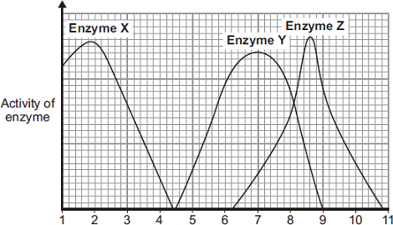
pH
(i) What is the optimum (best) pH for the action of enzyme Z?
__________________
(1)
(ii) The stomach makes a substance that gives the correct pH for enzyme action in the human stomach.
Name this substance. ____________________________________________
(1)
(iii) Which enzyme, X, Y or Z, will work best in the human stomach?
__________________
(1)
(b) In this question you will be assessed on using good English, organising information clearly and using specialist terms where appropriate.
Different parts of the human digestive system help to break down molecules of fat so that they can be absorbed into the body.
Describe how.
To gain full marks you should refer to:
• the enzyme and where the enzyme is produced
• the products of digestion
• any other chemicals involved.
___________________________________________________________________
___________________________________________________________________
___________________________________________________________________
___________________________________________________________________
___________________________________________________________________
___________________________________________________________________
___________________________________________________________________
___________________________________________________________________
___________________________________________________________________
___________________________________________________________________
___________________________________________________________________
___________________________________________________________________
___________________________________________________________________
___________________________________________________________________
___________________________________________________________________
(6)
(Total 9 marks)
Q7.
In this question you will be assessed on using good English, organising information clearly and using specialist terms where appropriate.
Diffusion is an important process in animals and plants.
The movement of many substances into and out of cells occurs by diffusion.
Describe why diffusion is important to animals and plants.
In your answer you should refer to:
• animals
• plants
• examples of the diffusion of named substances.
_______________________________________________________________________
_______________________________________________________________________
_______________________________________________________________________
_______________________________________________________________________
_______________________________________________________________________
_______________________________________________________________________
_______________________________________________________________________
_______________________________________________________________________
_______________________________________________________________________
_______________________________________________________________________
_______________________________________________________________________
_______________________________________________________________________
Extra space _____________________________________________________________
_______________________________________________________________________
_______________________________________________________________________
_______________________________________________________________________
_______________________________________________________________________
_______________________________________________________________________
_______________________________________________________________________
(Total 6 marks)

Section 1: Knowledge Mark Scheme
Q1.
(a) cell membrane
extra ticks negates marks
1
(b) engulf pathogens
1
produce antibodies
1
produce antitoxins
1
extra ticks negates marks
(c) 2050 − 100
1
= 1950
allow 1 mark for a correct subtraction of incorrect values
1
an answer of 1950 scores 2 marks
(d) any one from:
• (more) people vaccinated
ignore injections / treatments / medicines unqualified
allow vaccine produced
allow (more people given) MMR (vaccine)
do not allow antibiotics
ignore less people infected
• (more) people immune
• no new measles strain
1
(e) any one from:
• measles is (caused by) a virus
allow measles is not caused by a bacterium
• viruses cannot be killed / destroyed by antibiotics
allow antibiotics only kill / destroy bacteria
ignore harmed / treated
1
(f) any one from:
• use of a barrier method of contraception
ignore use of diaphragm
• use of a condom
ignore use protection / safe sex
• vaccination / immunisation
• avoid sexual intercourse / contact
do not accept less sexual intercourse / contact
1
(g) any one from:
• size / shape/ type of paper disc
ignore paper disc unqualified
• concentration of antibiotic
allow strength / dosage of antibiotic
• volume / amount of antibiotic
• (incubation) time
allow 3 days
• (incubation) temperature
ignore size of petri dish
1
(h) to check that the disc / water did not have an effect
or
to make sure it was the antibiotic that had an effect
allow for comparison with the antibiotics
allow as a (experimental) control
do not accept as a control variable
1
(i) (antibiotic) A
no marks if wrong antibiotic given
1
any one from:
• (antibiotic A) had the largest clear area around it
• (antibiotic A) killed the most bacteria
1
[13]
Q2.
(a)
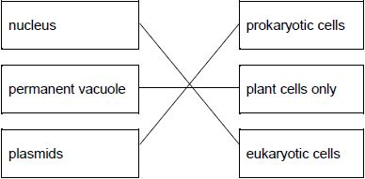
allow 1 mark for one or two correct links
2
(b)
vacuole | ribosome | cell wall
tick box takes precedence
if no tick is given, look at both the figure and the circling of words in the table
if writing is seen on the figure and in the table both must be correct
1
(c) turn the (fine focusing) knob until the cells are in focus
allow focus it
do not accept increase magnification
ignore decrease magnification
ignore clear
ignore references to resolution / illumination
ignore zoom in / out
1
(d) (rotate the) nosepiece / objective lens
allow change the (objective / eyepiece) lens
1
to a higher power (lens)
allow (to) increase the magnification
a comparator is required
ignore change / adjust the magnification
allow stronger or more powerful lens
ignore references to resolution / illumination unqualified
ignore zoom in / out
ignore references to an electron microscope
1
(e) conversion of units:
(112 mm ⟶) 112 000 (µm)
or
(280 µm ⟶) 0.28 (mm)
1
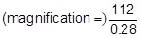
or
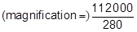
allow 1 mark for no conversion of units 112 / 280
or
incorrect value from step 1 correctly substituted
1
400 (×)
do not accept if units are given
if no other mark scored allow 1 mark for:
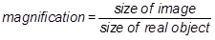
a triangle with words or letters in is insufficient, as the correct rearrangement is needed
1
an answer of 400 (×) scores 3 marks
[9]
Q3.
(a) contract / shorten
ignore relax
do not allow expand
1
to churn / move / mix food
accept peristalsis / mechanical digestion
ignore movement unqualified
1
(b) 400
acceptable range 390-410
allow 1 mark for answer in range of 39 to 41
allow 1 mark for answer in range of 3900 to 4100
2
(c) to transfer energy for use
allow to release / give / supply / provide energy
do not allow to ‘make’ / ߢproduce’ / ‘create’ energy
allow to make ATP
ignore to store energy
1
by (aerobic) respiration or from glucose
do not allow anaerobic
energy released for respiration = max 1 mark
1
(d) (i) to make protein / enzyme
ignore ‘antibody’ or other named protein
1
(ii) too small / very small
allow light microscope does not have sufficient magnification / resolution
allow ribosomes are smaller than mitochondria
ignore not sensitive enough
ignore ribosomes are transparent
1
[8]
Q4.
(a) mitochondria
1
ribosomes
1
(b) to repair the muscles
1
(c) 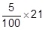
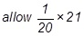
1
1.05 (hours)
allow for 2 marks 1 hour 3 minutes or 1:03 (hours)
1
an answer of 1.05 hours scores 2 marks
(d) 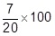
allow 5 × 7
1
35 (%)
1
an answer of 53 (%) scores 2 marks
(e) 78
1
(f) fertilisation
1
[9]
Q5.
(a) (i) alveoli / alveolus
allow air sacs
allow phonetic spelling
1
(ii) any one from:
• protection (of lungs / heart)
• help you breathe / inflate lungs.
1
(b) (i) diffusion
1
(ii) capillaries
1
(iii) any two from:
• (have many) alveoli
allow air sacs
• large surface / area
• thin (exchange) surface or short diffusion pathway
accept only one / two cell(s) thick
• good blood supply / many capillaries
allow (kept) ventilated or maintained concentration gradient.
2
[6]
Q6.
(a) (i) water / H₂O
accept oxygen
allow H₂O
do not allow H²O or H2O
1
(ii) the mineral ions are absorbed by active transport
1
the absorption of mineral ions needs energy
1
(iii) have (many root) hairs
1
(which) give a large surface area (for absorption)
1
(b) carbon dioxide in
or
oxygen out
or
control water loss
accept gas exchange
ignore gases in and out
ignore gain / lose water
1
(c) (i) guard cells
1
(ii) (stomata are) closed
allow there is no gap / space
1
(iii) plant will wilt / droop
ignore die
1
[9]
Q7.
(a) (i) diffusion
apply list principle
1
(ii) A
apply list principle
1
(b) (i) osmosis
apply list principle
1
(ii) R
apply list principle
1
[4]
Q8.
(a) C
1
(b) B
1
(c) E
1
(d) any one from:
• they are too big
• they are insoluble
1
(e) (pH) 7.5
allow answers in range 7.4 to 7.6
1
(f) (enzyme X) stomach
(enzyme Y) small intestine
1
(g) 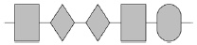
1
(h) lock and key
1
(i) (some pH values):
change the shape of the active site
allow some pH values denature enzymes
1
(so) so substrate will no longer fit / bind to the active site
1
[10]
Q9.
(a) biuret
1
(b) purple
1
(c) 1:1.6
1
(d) provides amino acids to make new muscle
1
(e) it has a large surface area
1
it has a thin surface
1
(f) C
1
lowest sugar (content)
1
[8]
Q10.
(a) (i) any one from:
• glucose
• oxygen
• carbon dioxide
• urea
• water
allow hormones
allow named example of a product of digestion
1
(ii) (cardiac) muscle
allow muscular
1
(b) (i) B
1
(ii) D atrium / atria
ignore references to left or right
1
E ventricle(s)
ignore references to left or right
1
(c) (i) a vein
1
(ii) an artery
1
(iii) keeps artery open / wider
allow ecf from part cii
1
(so) blood / oxygen can pass through (to the heart muscle)
1
[9]
Q11.
(a) (i) root hairs
if clear which word then allow
1
(ii) xylem
if clear which word then allow
1
(iii) stomata
if clear which word then allow
1
(iv) storage organs
in this order
1
phloem
1
(b) (i) 23.2
1
(ii) loss of water (from flask with plant) from leaves / plant
1
via transpiration / via evaporation
if no other marks allow used in
photosynthesis for one mark
1
[8]
Q12.
(a) any two from:
ignore eating disorder
ignore cancer
• arthritis
accept worn joints
• diabetes
accept high blood sugar
• high blood pressure
ignore cholesterol
• heart disease / heart condition / heart attack / blood vessel disease
allow blood clots / strokes
2
(b) (i) or 0.25 or 25%
correct answer gains 2 marks
if answer incorrect, evidence of 1500 ÷ 6000 gains 1 mark
25 without % gains 1 mark
2
(ii) majority / most / high proportion of people in trial lost mass / weight
ignore good results / it worked
1
[5]
Q13.
(a) (i) 18
1
(ii) Z
1
(b) (i) red blood cells
1
(ii) haemoglobin
1
[4]
Q14.
red (blood cell)
1
platelet
1
white (blood cell)
1
plasma
1
[4]
Q15.
one;
1
diffuse;
1
narrow;
1
lowered;
1
[4]
Q16.
(a)
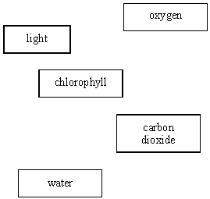
5
(b) (i) sugar or carbohydrate
1
(ii) it can be stored or it is insoluble
accept it has no osmotic effect
1
(iii) any one from:
respires it or releases or transfers
energy
turns it or stores it as fructose or
sucrose or lipid or protein or
cellulose
1
(c) (i) photosynthesis
1
(ii) any one from:
flat surface
stomata
thin
chloroplasts
veins
large surface area
air spaces
do not accept chlorophyll
1
[10]
Q17.
(a) (i) oxygen
do not credit air
1
(ii) lung(s)
do not credit blood or nose or windpipe alone but accept as a neutral answer if included with lungs
1
(b) oxygen
1
lactic acid
both words required
1
[4]
Q18.
(a) salmonella
1
(b)
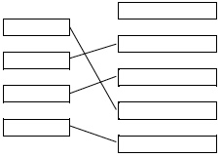
1
1
1
1
(c) lower concentration of antibiotic / chemical further from the fungus
allow less antibiotic / chemical further from the fungus
1
(d) lead to mass production of antibiotics
or
lead to development of other antibiotics
1
reduced infection by bacteria
or
antibiotics have saved many lives
1
[8]
Q19.
(a) Disease Way the disease is spread
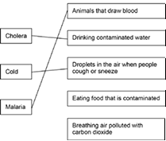
extra lines from left cancel the mark
3
(b) any two from:
• skin acts as a barrier
• blood clots (over cuts)
• nose (hairs) catch particles (breathed in)
• mucus (in trachea / bronchi) traps microorganisms
• acid in stomach kills microorganisms
2
(c) because measles is a virus
1
(d) 28 / twenty eight
± 0.5 small square tolerance
1
(e) 2.5
1
(f) number will decrease
1
less likely to come into contact with someone with measles / the disease
1
[10]
Q20.
blood clots to seal cuts;
kills microbes which enter
each for 1 mark
(allow higher level answers)
[2]
Q21.
(a) toxins
1
(b) (i) bacteria
1
(ii) mutate
1
(iii) new / different antibiotic
allow new / different drug
do not allow vaccine
1
[4]
Q22.
(a) (i) 4 / four (years)
1
(ii) any one from:
• animals
allow suitable examples eg rats
do not allow humans / plants
• (living) cells
allow human cells
do not allow plant cells
• (living) tissues
allow human tissues
do not allow plant tissues
1
(b) (i) 9 (years)
allow 1 mark for 13 – 4
or
2 + 3 + 4
2
(ii) see if the drug has side effects
1
(iii) neither the volunteers nor the doctors
1
[6]
Q23.
(a)
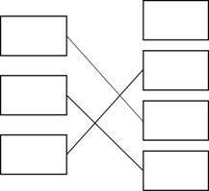
one mark for each correct line
extra line from drug negates mark
3
(b) stop the trial
1
second mark scores only if first mark correct
side effects too severe
allow people might die / get ill / harmed
or
(too) many people had side effects
allow use of numbers from table
ignore itchy skin
1
[5]
Q24.
(a) carbon dioxide + water → (glucose) + oxygen
allow reactants in either order
allow correct formulae, balancing not required
1
(b) chlorophyll
1
(c) glucose (produced in photosynthesis) is converted into starch
1
(d) starch could be broken down (into sugar)
1
(e) so the colour of the iodine solution / result can be seen
1
(f) any one from:
• turn off Bunsen / flame before collecting ethanol
• use a water bath to heat the ethanol
allow idea that there are no naked flames near the ethanol
1
(g) A orange / brown
1
B black / blue-black
1
[8]
Q25.
(a) (i) diffusion
1
(ii) carbon dioxide
accept CO₂ / CO2
do not accept CO²
1
(iii) red blood cells
1
(b) 70
if no / incorrect answer then
70 000 000
or
280 x 0.25 gains 1 mark
ignore doubling the answer
2
(c) allows more gas / oxygen / CO₂
(exchange)
do not accept air
1
[6]
Q26.
(a) (i) rate of chemical reactions (in the body)
1
(ii) any two from:
• heredity / inheritance / genetics
• proportion of muscle to fat or (body) mass
allow (body) weight / BMI
• age / growth rate
• gender
accept hormone balance or environmental temperature
ignore exercise / activity
2
(b) (i) 77
correct answer with or without working gains 2 marks
allow 1 mark for 70 / 56 or 1.25 or 5
2
(ii) increase exercise
accept a way of increasing exercise
1
reduce food intake
accept examples such as eat less fat / sugar
allow go on a diet or take in fewer calories
ignore lose weight
ignore medical treatments such as gastric band / liposuction
1
[7]
Q27.
(a) to transfer / provide / give release energy
or production of ATP / adenosine triphosphate (molecules)
accept to give heat
1
(b) (i) C₆H₁₂O₆ + 6O₂ → 6CO₂ + 6H₂O
accept any other
n : 6n : 6n : 6n ratio
do not credit if any other changes have been made
1
(ii) glucose
do not credit sugar / sucrose
1
(c) (i) any two from
large surface
thin (surface)
moist (surface)
(with a good) blood supply
2
(ii) carbon dioxide
accept water vapour
do not credit just water
1
(d) (i) anaerobic (respiration)
1
(ii) any three from
in mitochondria
glucose decomposes / breaks down / reacts
or glucose → lactic acid for (2) marks
to give lactic acid
or breathing hard
or lactic acid → CO2 + water
causing pain
(leaving an) oxygen debt
(quick) source of energy
(but) less efficient than aerobic respiration
accept less efficient than with oxygen
3

Secton 2: Required Practicals Mark Scheme
Q1.
(a) glucose
1
oxygen
1
extra ticks negates marks
(b) count the number of bubbles produced in 1 minute
1
measure the volume of gas produced in 30 seconds
1
extra ticks negates marks
(c) any one from:
• to control the temperature
allow so pondweed / solution did not warm up
• temperature affects the rate of photosynthesis
allow correct description of effect of temperature on rate
allow high temperatures denature enzymes
ignore references to limiting factors
1
ignore reference to ‘it’
(d) 52
1
(e) all points plotted correctly
allow ± ½ a square
allow 1 mark for three points correctly plotted
2
smooth curve drawn through all points
ignore extensions of line / curve unless inconsistent with line / curve drawn
1
(where a bar chart has been plotted)
allow 1 mark for all bars plotted correctly
if points are plotted as well as bars, ignore bars
(f) any one from:
• the nearer the light source to the pondweed the faster the rate of photosynthesis
allow the nearer the light source to the pondweed the faster the bubbles produced
• the greater the light intensity the faster the rate of photosynthesis
allow the greater the light intensity the faster the bubbles produced
allow the closer the light source the more the plant photosynthesises
ignore more bubbles are produced with no reference to rate
allow oxygen for bubbles
do not accept carbon dioxide
1
allow converse statements for all marking points
[10]
Q2.
(a) any one from:
• water on potato would increase mass
allow so only the mass of the potato is measured
• to control amount of water on potato
allow to remove water from outside of potato
allow liquid / solution / sugar solution for water
allow so you get the correct (starting) mass of the potato
do not accept so that all the pieces of potato weighed the same
1
(b) increase in mass
1
increase in length
1
extra ticks negates marks
(c) osmosis
allow diffusion
1
into
allow inside
do not accept through
1
lower
allow low / more dilute / dilute
1
in this order only
(d) any one from:
• the concentration (of sugar solution) in the cells is 0.4 (mol/dm³)
• the concentration (of sugar solution) in the cells is the same as the solution (in the tube)
1
allow reference to potato instead of cells
(e) any two from:
• has (root) hairs
allow root hair cells
• large surface / area
allow wide surface area
• (root) hairs extend into soil
allow (root) hairs are long / widespread
• (root) hairs have thin walls
2
ignore references to active transport and mineral uptake
[9]
Q3.
(a) (wear safety) goggles
allow (wear) safety glasses
allow (wear) eye protection
allow keep ethanol away from flame or in a water bath
allow use tweezers or a glass rod to remove leaf from ethanol / water
ignore gloves
1
(b) iodine solution
1
(c) blue-black
1
(d) separate
1
mobile
1
in this order only
(e) 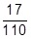
allow 0.154545 or correctly rounded answer
1
= 0.15
allow an answer from an incorrect calculation correctly given to 2 significant figures
1
an answer of 0.15 scores 2 marks
(f) carotene
1
[8]
Q4.
(a) biuret
1
(b) purple
1
(c) 1:1.6
1
(d) provides amino acids to make new muscle
1
(e) it has a large surface area
1
it has a thin surface
1
(f) C
1
lowest sugar (content)
1
[8]
Q5.
(a) any one from:
• amount / concentration of antibiotic
do not allow type of antibiotic ignore number of antibiotics allow type of paper
• size of discs
ignore number / position of discs
• (incubation) temperature
• incubated for same time / 3 days
allow left / kept for same time
• type of agar
ignore references to bacteria or petri dishes
1
(b) (i) D
1
(ii) C
1
(iii) B
no marks if wrong antibiotic
1
both had a large clear area around the disc
allow a description of this, eg B had the 2nd largest clear area with E.coli and the largest clear area on S.aureus
or
killed a lot of both bacteria
1
(c) resistant
1
[6]

Section 3: 6 mark questions Mark Scheme
(a) trachea
1
(b) any one from:
• can see more detail in lungs
ignore gives clearer image
• you can see the bronchus / bronchioles / soft tissues
ignore bones
allow it doesn’t use ionising radiation
allow X-rays can cause cancer / mutation
1
(c) you can see the ribs / bones
allow cheaper
allow takes less time
1
(d) any three from:
(aerobic)
• uses / needs / requires oxygen (and anaerobic does not)
• transfers more energy (than anaerobic)
allow releases more energy (than anaerobic)
do not accept energy is created / produced / made
• produces carbon dioxide / water (anaerobic does not)
• does not produce lactic acid (anaerobic does)
• does not cause an oxygen debt (anaerobic does)
allow aerobic takes place in mitochondria and anaerobic takes place in cytoplasm
allow converse in terms of anaerobic
3
(e) Level 3: Relevant points (reasons / causes) are identified, given in detail and logically linked to form a clear account.
5−6
Level 2: Relevant points (reasons / causes) are identified, and there are attempts at logical linking. The resulting account is not fully clear.
3−4
Level 1: Points are identified and stated simply, but their relevance is not clear and there is no attempt at logical linking.
1−2
No relevant content
0
Indicative content
(stopping smoking will improve health because):
• smoking is a risk factor for cardiovascular disease
• raises blood pressure
• increases cholesterol and / or lowers HDL
• increases atherosclerosis or thickened artery walls
• increases the risk of blood clots forming
• increases risk of stroke
• smoking is a risk factor for lung cancer
• as it can cause mutations
• caused by carcinogenic chemicals in smoke (tar)
• leading to uncontrolled growth of cells
• smoking damages alveoli
• causing the surface area of the alveoli to decrease
• causes emphysema / COPD
• causes shortness of breath or reduces gas exchange
• chemicals / tar / nicotine in the smoke irritate / inflame the bronchi / lung / bronchioles
• which damage the cilia
• causes goblet cells to secrete more mucus
• causes shortness of breath or reduces gas exchange
• causing chronic bronchitis or increases risk of infections
• carbon monoxide is produced
• which is toxic / poisonous
• binds / attaches to haemoglobin / Hb
• so oxygen carrying capacity of blood is decreased
[12]
Q2.
(a) 36 000 (cm³)
1
(b) 11600 / 1200
1
9.66666r
allow any number of decimals
1
(c) muscles need more energy (for contraction)
1
(so) more oxygen / glucose needed
need at least one reference to ‘more’ for full marks
allow so more carbon dioxide / thermal energy needs to be removed
1
(for) increased respiration
1
(d)
Level 3: Relevant points (differences / functions) are identified, given in detail and linked logically to form a clear account. | 5-6
Level 2: Relevant points (differences / functions) are identified and there are attempts at logical linking. The resulting account is not fully clear. | 3-4
Level 1: Points are identified and stated simply, but their relevance is not clear and there is no attempt at logical linking. | 1-2
No relevant content | 0
Indicative content
• artery has a thicker wall
• (because) artery has to withstand higher pressure
• artery has thicker layer of elastic tissue / fibres
• (so) it can stretch
• (so) artery returns to original size / shape
• artery has thicker layer of muscle
• to maintain a force on the blood
• vein has valves
• (valves) prevent backflow of blood
• artery carries blood away from the heart
• vein carries blood towards the heart
ignore references to oxygenated / deoxygenated blood
6
[12]
Q3.
(a) water + carbon dioxide oxygen + glucose
extra box ticked negates mark
1
(b) Level 3 (5–6 marks):
A coherent method is described with relevant detail, which demonstrates a broad understanding of the relevant techniques and procedures. The steps in the method are logically ordered. The method would lead to the production of valid results.
Level 2 (3–4 marks):
The bulk of the method is described with mostly relevant detail, which demonstrates a reasonable understanding of the relevant scientific techniques and procedures. The
method may not be in a completely logical order and may be missing some detail.
Level 1 (1–2 marks):
Simple statements are made which demonstrate some understanding of some of the relevant scientific techniques and procedures. The response may lack a logical structure and would not lead to the production of valid results.
0 marks:
No relevant content
Indicative content
• description of how the apparatus would be used
• reference to control intensity of light / brightness
• use of ruler to measure distance of light from beaker / pondweed
• reference to varying colour of light or use of different filters
• plant releases gas / oxygen
• measure number of bubbles / volume of gas produced
• same length of time
• reference to control of temperature
• reference to control / supply of carbon dioxide in water
• do repeats and calculate a mean
6
(c) rate does not increase further if light intensity increased beyond 20
allow graph levels off after 20
1
(d) any one from:
• temperature
• carbon dioxide (concentration)
• amount of chlorophyll
allow number of chloroplasts
1
[9]
Q4.
(a) (i) without oxygen
allow not enough oxygen
ignore air
ignore production of CO₂
ignore energy
1
(ii) more / high / increased lactic acid (at end)
allow approximate figures (to show increase)
ignore reference to glucose
1
(b) (i) 1.5
allow only 1.5 / 1½ / one and a half
1
(ii) increases at first and levels off
ignore subsequent decrease
1
suitable use of numbers eg
rises to 10 / by 9 (dm³ per min)
or
increases up to 1.5 (min) / levels off after 1.5 (min) (of x axis timescale)
allow answer in range 1.4 to 1.5
or
after the first minute (of the run)
1
(iii) supplies (more) oxygen
1
supplies (more) glucose
1
need ‘more/faster’ once only for full marks
allow removes (more) CO₂ / lactic acid / heat as an alternative for either marking point one or two, once only
for (more) respiration
1
releases (more) energy (for muscle contraction)
do not allow energy production or for respiration
1
[9]
Q5.
(a) is not caused by a pathogen / infective organism
allow not caused by a microorganism / microbe
ignore not caused by infection
ignore named pathogen unless bacteria, virus and fungus all mentioned
1
(so) is not passed / spread (from person to person)
allow cannot be spread / caught
allow is not infectious / contagious
1
(b) reduced / restricted / stopped blood flow
it does not matter where blood flow is restricted to − heart / body
1
(so) less oxygen reaches heart (muscle / cells)
must reference heart / it
allow no oxygen reaches the heart (muscle / cells)
1
(so heart muscle / cells) cannot respire (enough)
or
(so heart muscle / cells) do not release (enough) energy
do not accept do not make / produce / create energy
ignore references to breathing / suffocation
ignore blood clots / blockages
1
allow ‘it’ for heart
(c) Level 3: Relevant points (factors / effects) are identified, given in detail and logically linked to form a clear account.
5−6
Level 2: Relevant points (factors / effects) are identified and there are attempts at logical linking. The resulting account is not fully clear.
3−4
Level 1: Points are identified and stated simply, but their relevance is not clear and there is no attempt at logical linking.
1−2
No relevant content
0
Indicative content
medical risk factors:
• high blood pressure
• high cholesterol
• diabetes
• genetic factors
• medications
lifestyle risk factors:
• smoking
• obesity
• lack of exercise
• high fat / energy diet
• eating insufficient fruit / vegetables
• alcohol
• high salt intake
• exposure to air pollution
• certain drugs / correct named drug
examples of links:
• smoking − high bp / cholesterol / fatty deposition
• obesity − lack of exercise / high bp / cholesterol / fatty deposition / diabetes
• exercise − obesity / bp /diabetes
• diet − obesity / cholesterol / diabetes
• alcohol − bp / cholesterol
• high salt intake − high blood pressure
• genetic factors − bp / cholesterol / diabetes / obesity
• medication − can affect blood / blood vessels / metabolism
the main discriminator is the quality of linking
both lifestyle and medical factors are required for level 3
[11]
Q6.
(a) (i) 8.6
accept value in range 8.5 to 8.7
1
(ii) hydrochloric acid / HCl
accept HCL
accept hydrogen chloride
ignore hcl / etc.
1
(iii) X
1
(b) Marks awarded for this answer will be determined by the Quality of Written Communication (QWC) as well as the standard of the scientific response. Examiners should also refer to the information in the Marking guidance.
0 marks
No relevant content.
Level 1 (1-2 marks)
There is a simple description of part of a process or a reference to at least one of: mechanical digestion, lipase, product of enzyme action, bile, site of production or site of digestion
Level 2 (3-4 marks)
There is a description of at least one process linking ideas
Level 3 (5-6 marks)
There is a clear description of the process including reference to the majority of: mechanical digestion, lipase, bile, where they are produced, products, function of bile and site of digestion / absorption
Examples of biological points made in the response:
• mechanical breakdown in mouth / stomach
• fats →fatty acids and / or glycerol
• by lipase
• (produced by) pancreas
• and small intestine
• fat digestion occurs in small intestine
• bile
• produced by liver
• neutralises acid from stomach
• produces alkaline conditions in intestine
• refs. to increased surface area related to emulsification or chewing
• products are small molecules / water-soluble
• products absorbed by small intestine
6
[9]
Q7.
Marks awarded for this answer will be determined by the Quality of Written Communication (QWC) as well as the standard of the scientific response. Examiners should also apply a ‘best-fit’ approach to the marking.
0 marks
No relevant content.
Level 1 (1 – 2 marks)
An example is given of a named substance
or
a process
or
there is an idea of why diffusion is important eg definition.
Level 2 (3 – 4 marks)
At least one example of a substance is given
and
correctly linked to a process in either animals or plants.
Level 3 (5 – 6 marks)
There is a description of a process occurring in either animals or plants that is correctly linked to a substance
and
a process occurring in the other type of organism that is correctly linked to a substance.
examples of points made in the response
Importance of diffusion:
• to take in substances for use in cell processes
• products from cell processes removed
Examples of processes and substances:
• for gas exchange / respiration: O₂ in / CO₂ out
• for gas exchange / photosynthesis: CO₂ in / O₂ out
• food molecules absorbed: glucose, amino acids, etc
• water absorption in the large intestine
• water lost from leaves / transpiration
• water absorption by roots
• mineral ions absorbed by roots
extra information
Description of processes might include:
• movement of particles / molecules / ions
• through a partially permeable membrane
• (movement of substance) down a concentration gradient
• osmosis: turgor / support / stomatal movements
[6]

