% | I can… | Prove it!
70% | 3.7 Calculate average speed for  non-uniform motion  4.2 Draw tangents on a distance time graph to determine speed of an accelerating object (triple only)  5.1 Apply the equation v²-u²=2as (For moving and falling objects) [Newton’s equations of motion]  7.4 Explain how levers and gears transmit the rotational effects of levers and gears (triple only)  8.3 Describe and explain the effect of electric fields (triple only)  8.4 Draw an electric field pattern for an isolated charged sphere (triple only)  8.5 Link the concept of electric fields to electrostatic phenomena (triple only)  8.2 Explain why electrically charged objects attract or repel (triple only)  2.3 Use vector diagrams to illustrate the resolution of forces and determine resultant forces (scale drawings)  6.7 Describe the method to measure the speed of sound in air and the speed of ripples on the water surface  8.5 Show how properties of a sound wave changes as it moves from one medium to another (refraction) (triple only) | 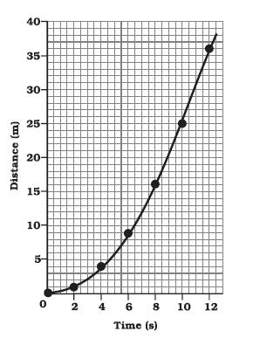  - Use the distance-time graph to find the speed at 5sec. You must draw a tangent onto the curve to show how you found the answer.  - An object accelerates from 2m/s to 6m/s over a distance of 8m. Use the equation v² - u² = 2as to find the acceleration of the object.  - A car mechanic wants to turn a tight nut in the engine of a car and she cannot decide whether or not to use a long handle spanner or a short handle spanner. Write three sentences explaining which one she should use and why.  - Complete the diagram to show the electric field pattern for an isolated sphere by adding either a + or - sign to the centre of each sphere:  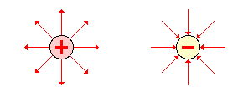  - Complete the summary about electric fields using these words: charge, closest, charged, weaker, positive  An electric field will exert a force on a ________ object. The electric field is strongest _________ to the charged object. Further away from the object the charge is __________. The direction of the field is towards the _________ charge. You can increase the strength of a field by adding more _______.  - Use your knowledge about electric fields to explain why an ionic bond is formed.  - Draw a vector diagram to show the forces and resultant force acting on a plane flying through the air at a constant speed.  - Write a method which would allow you to measure the speed of sound in air and the speed of ripples on the surface of water. List all of the equipment you would need and how you would take your measurements. Explain how to make your results accurate.  - Draw a labelled diagram to show how sound waves behave when they move from one medium to another during refraction.
% | I can… | Prove it!
60% | 1.7 Explain how to measure weight using a calibrated spring balance (i.e. a Newton meter)  3.9 Describe circular motion (triple only)  4.4 Estimate the magnitude of every day acceleration  5.3 Explain the acceleration of objects through fluids (terminal velocity) – making reference to parachutes travelling through air  6.2 Explain the concept of inertia (triple only)  6.4 Define inertial mass (triple only)  7.1 Describe examples in which forces cause rotation (triple only)  7.3 Describe moments for a balanced object (triple only)  8.1 Explain how insulating materials can become electrically charged (triple only) | 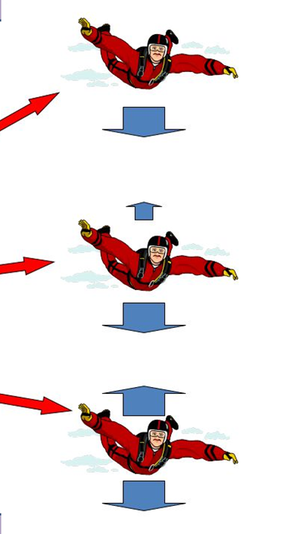  - Design an investigation to find out how to measure the weight of ten different objects using a Newton meter. Include your equipment list and a method.  - Explain why the Earth stays in orbit around the Sun using what you know about circular motion.  - Use the diagram (beside) to describe what is happening to the sky diver at each stage as the sky diver falls through the air. You must label the forces and describe what is happening to these forces at each arrow and how it is affecting the motion of the sky diver.  - Complete the following explanation of inertia using these key words: unbalanced, inactivity, motion, constant, rest, change  Inertia is the Latin word for _________. It means that an object will remain in its existing state of ________ (either at ____ or moving at a _________ speed) unless an ___________ force acts on it. The inertial mass is how difficult it is to _______ its velocity.  - If an object is balanced, the total clockwise moment about its pivot equals the what? Use your knowledge of moments to answer the question.  - Explain how you could cause a polythene rod to become electrically charged using a dry rod and draw a diagram to help you.
50% | 1.6 Describe “the centre of mass”  3.1 Explain the difference between distance and displacement  4.3 Use and rearrange the equation a = Δv / t (calculating acceleration)  4..6 Use velocity time graphs to calculate distance/displacement  6.5 Estimate the forces involved in large accelerations for every day road transport using ̴ correctly.  7.2 Define moment and use and rearrange the equation M = F x d (triple only)  8.13 Explain what a sound wave is and how the ear detects them (triple only)  8.17 Explain how waves can be used for detection and exploration of structures (ultrasound, seismic, echo sounding) (triple only) | - Write a definition for ‘centre of mass’ and draw an ‘x’ on these objects to show where their centre of mass would be:  - Write a definition for the following two words: distance and displacement.  - Find the acceleration of a car which reaches 12.5m/s in only 5seconds. Include the correct units.  - Use the velocity-time graph below to calculate the distance travelled.  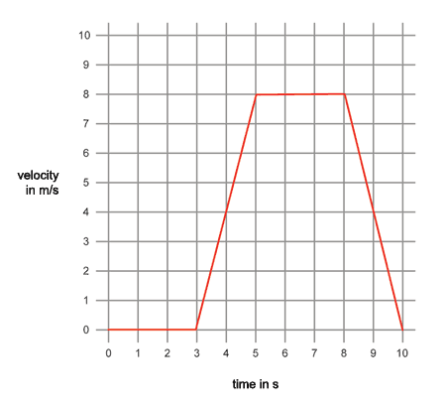  - Calculate the turning moment of each person in the diagram.  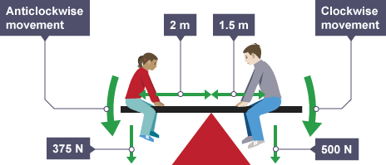  6. Draw a labelled diagram of the human ear and write a paragraph explaining how sound waves are created by a violin and then travel to reach the ear drum.  7. Draw a mind map to describe and explain the uses of waves in the following: echo sounding, seismic wave detection, the structure of the Earth.
% | I can… | Prove it!
40% | 1.2 Use arrows to represent vector quantities  1.4 Define weight and gravity  1.5 Use W=m x g  3.6 Use and rearrange s = v t (speed = d/t equation!)  4.1 Draw and interpret distance time graphs and use these to determine speed  4.5 Draw and interpret velocity time graphs in order to calculate acceleration  5.4 Draw and interpret velocity time graphs for objects that reach terminal velocity  6.1 Describe and explain Newton’s first law  6.3 Describe and explain Newton’s second law using F = m a  6.7 Describe and explain Newton’s third law | - Add arrows to this diagram to show the magnitude and direction of the forces and label the name of each force:  - Write a definition for each of the following key words: weight and gravity.  - An astronaut with a mass of 80kg stands on the moon. The moon has a gravitational field strength of 1.6N/kg. What is his weight?  - a. Draw a distance-time graph from this data table:  b. Use your graph to determine the average speed of the object at 2.5 seconds.  Time (s) Velocity (m/s)  0 0  1 5  2 10  3 15  4 15  5 15  6 15  7 10  8 5  9 0  - a. Draw a velocity-time graph using the data in the table:  b. Use the graph to calculate the acceleration of the object between 0s and 3s.  - Sketch a velocity-time graph to show the motion of a skydiver who reaches terminal velocity.  - Write a paragraph explaining what Newton’s first law of motion is.  - If a car has a mass of 1200kg and a resultant forward force of 500N, calculate its acceleration using F=ma.  - What did Newton mean when he said ‘For every action there is an equal and opposite reaction’? You could draw a force diagram to help explain this.
% | I can… | Prove it!
30% | 1.1 Define scalar and vector quantities  1.3 Define contact and non-contact forces giving examples of each  2.1 Calculate and define resultant forces  2.2 Use free body diagrams to show forces  3.2 Define ‘speed’ and explain factors that affect the speed a person walks, runs or cycles at (including average speeds for these activities)  3.3 Recall typical speeds for different types of transportation (TBC – bus, train, car, aeroplane!) using ̴ correctly.  3.4 Recall the speed of sound in air  3.5 State that most moving objects have varying speed including sound, wind, travelling people  3.8 Define ‘velocity’  5.2 Recall the value for acceleration due to gravity  8.14 Recall the range of normal human hearing (triple only) | - Write a definition for the terms vector and scalar.  - Decide if each of these is a vector or scalar quantity:  number of apples, velocity, height, speed, drag, acceleration.  - Calculate the resultant forces in these diagrams and give their directions:  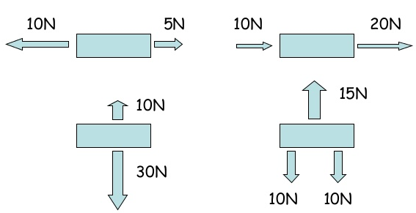  - Decide which person will have the fastest speed on their journey:  a. A 60 year old man who has to walk uphill to get to his bus stop.  b. A 20 year old woman who has to walk downhill to get to her bus stop.  - Complete the table to show what speed each activity or object is approximately (~) equal to:  Activity ~ speed (m/s)  walking  running  cycling  aeroplane  bus  train  car  - Give the speed of sound in air.  - Write a definition for the word ‘velocity’.  - What is the acceleration due to gravity on Earth? _____ m/s²  - What is the hearing range of a human (Hz)?

Key Terms
Acceleration Braking distance Centre of gravity Deceleration Elastic Electrostatic force
Equilibrium Extension Force Free fall Friction Gradient
Gravitational field strength Mass Moment Pivot or fulcrum Resultant force Speed
Terminal velocity Thinking distance Velocity Weight Satellite Galaxy
Universe Balanced Force Unbalanced Force Conservation of Momentum Momentum
Vector Scalar Gravity Resultant Force Displacement Static electricity
Frequency Range

