% | Prove it! | Answers
80% + | - State the limitations of the particle theory.  - Calculate the R_{f} value of a substance which move 44 mm, when the mobile phase moves 50 mm.  - Are group 1 metals harder or softer than transition metals?  - State how the reactivity of group 1 metals changes.  - How do the properties of group 7 elements change as you go down the group?  - How does the reactivity of group 7 elements change as you go down the group?  - Why are group 0 elements unreactive?  - How do the properties of group 0 elements change as you go down the group? | - Limitations of the simple model above include that in the model there are no forces, that all particles are represented as spheres and that the spheres are solid.  - 44/50 = 0.88  - Softer.  - The reactivity of group 1 metals increases as you go down the group.  - Group 7 elements become more dense and have higher melting points the further down the group you go.  - The reactivity of group 7 elements decreases as you go down the group.  - Group 0 elements are unreactive because they have full outer shells of electrons.  - Group 0 elements become denser and have higher melting and boiling points the further down the group you go.
70% | - Compare sand in water and salt in water using the key terms at left.  - In paper chromatography, what is the stationary phase?  - Why are metals useful as wires?  - How are compounds of transition metals different from group 1 metals?  - What does a chemical reaction always produce?  - How might I prevent the corrosion of a bike chain?  - Why is an alloy stronger than a pure metal?  - State the composition of brass, and steel. | - Sand is insoluble in water. Salt is soluble in water. Salt would be the solute, and water the solvent, to make a saltwater solution.  - The paper.  - Metals are ductile, and conduct electricity well.  - Transition metal compounds are coloured.  - A chemical reaction always produces a new substance.  - By applying a barrier like grease.  - Because the atoms of different sizes disrupt the layers of the pure metal atoms, making it harder for them to slide over each other.  - Brass: copper and zinc. Steel: iron and carbon.
60% | - Give the name of the following compound: MnO  - If a substance melts over a range of temperatures, is it a pure substance or a mixture?  - How would I obtain pure salt crystals from salt water?  - Why is it harder to separate elements in a compound than substances in a mixture?  - What is the radius of an atom?  - Draw the electronic structure of sodium.  - How is an isotope different from an atom?  - What is relative atomic mass?  - Why is relative atomic mass not an integer?  - What is the M_{r} of glucose, C₆H₁₂O₆? | - Manganese oxide  - A mixture.  - Though crystallisation. Heat the solution in an evaporating basin gently until crystals just start to form, then leave to evaporate slowly.  - Elements in a compound must be separated through a chemical change. Substances in a mixture can be separated by physical processes.  - Around 0.1 nm, or 10⁻¹⁰ m.  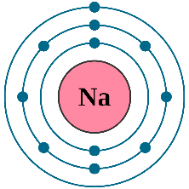  - Isotopes are versions of an element with different numbers of neutrons.  - The average mass of all the naturally-occurring isotopes of an element.  - Because relative atomic mass is an average.  - (12*6)+12+(16*6) = 180

% | Prove it! | Answers
50% | - Describe the particles in a solid.  - State the freezing and melting point of water.  - Is carbon dioxide an element or a compound?  - Is copper sulphate solution a pure substance or a mixture?  - Give an example of a formulation.  - What compounds are in M in the chromatogram at right?  Subatomic particle Mass charge  Proton  Neutron  Electron  - Complete the table.  - How many protons, neutrons, and electrons are in an atom of carbon-12? | - Fixed in place and vibrating.  - O° C.  - Compound  - Mixture.  - Fuel.  - Compounds 1, 4, and 5.  Subatomic particle Mass Charge  Proton 1 1+  Neutron 1 0  Electron Almost nothing 1-  - 6 protons, 6 neutrons, 6 electrons.
40% | - Draw the particle arrangement in a gas.  - Give the element symbols for neon, argon, potassium, sulfur, and phosphorus.  - Draw the plum pudding model of the atom.  - Why did Mendeleev leave gaps on his periodic table?  - Why is potassium classified as a metal, even though it is quite soft?  - State the test for chlorine gas. | 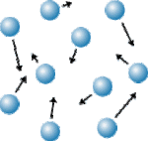  - Ne, Ar, K, S, P  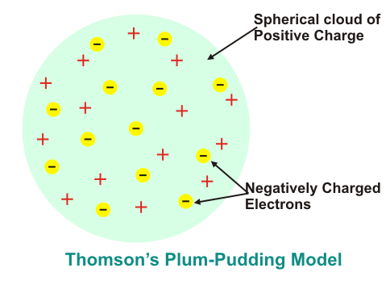  - For undiscovered elements.  - Because it forms positive ions.  - Damp litmus paper bleaches white.

