% | I can … | Prove it!
80%+ | Explain the theory of Jean Baptiste Lamarck and the theory of evolution (triple only)  Explain the role of Alfred Russell Wallace in developing the theory of evolution and his pioneering work on speciation (triple only)  Interpret graphs relating to hormone levels in the menstrual cycle (triple only)  Explain how developments in microscopy have enabled IVF treatments to be improved (triple only)  Evaluate social and ethical issues and risks from the perspective of patients and doctors (triple only) | - Complete the table comparing the different theories of evolution:  Scientist Jean Baptiste Lamarck Alfred Russell Wallace Charles Darwin  Time period  Big Idea  Evidence  Reasons the theory was not accepted  - Use the graph to answer the following questions:  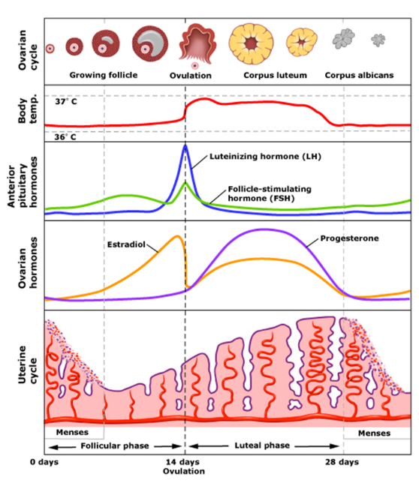  - On which day does LH peak?  - As the level of progesterone increases, what happens to the thickness of the uterus wall?  - On which day is the body temperature the highest?  - How can you tell from the graph that oestrogen stimulates LH release?  - How can you tell from the graph that oestrogen inhibits FSH release?  - Find three developments in microscopes and explain how each one has helped us to understand and use UVF.  - Write a statement for each of the following for a newspaper article about IVF:  a. from the perspective of a patient (what are your hopes and concerns)  b. from the perspective of a doctor (what are your concerns and aims)
70% | Explain how classification models have developed over time due to improvements in microscopy and biochemistry)  Describe the role of Charles Darwin and his book ‘The origin of species’ on the development of the theory of evolution and the issues he had with getting people to accept this theory (triple only)  Explain the role of Mendel and other scientists on our changing understanding of genetics (triple only)  Evaluate the use of genetic engineering and modification and describe the potential uses of this in the future  Use tables and graphs to extract information about reflex actions  Explain the effect on cells of osmotic changes in bodily fluids (triple only)  Describe how water ions and urea are lost from the body (triple only)  Explain the roles of thyroxine (produced by the thyroid gland) and adrenaline (produced by the adrenal gland) linking this to negative feedback loops (triple only)  Explain the use of FSH and LH as a fertility drug (triple only)  Explain IVF (in vitro fertilisation) (triple only)  Link hormone cycles to ovulation and menstruation | 1. For each of the below developments, write a sentence explaining how it has helped us to develop classification models:  a. the invention of a transmission electron microscope  b. mapping the genome  c. discovering DNA  d. the invention of the scanning electron microscope  2. Write a synopsis to go on the back of ‘The Origin of the Species’ explaining briefly what the book is about.  3. Imagine you could go back in time. Write a speech to the other scientists who were working at the same time as Charles Darwin trying to convince them that he is correct. You should counter each of the following arguments:  a. God created all living things  b. There is no evidence  c. We do not know how characteristics are inherited  - Write a short biography of Gregor Mendel outlining his work and his discoveries.  - Complete the table to evaluate the use of genetic engineering  Advantages Disadvantages  - Complete the diagrams to show how thyroxine and adrenaline control our internal conditions in a negative feedback loop.  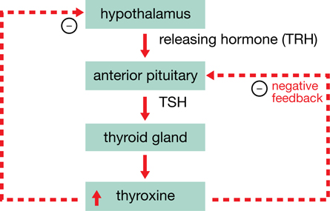  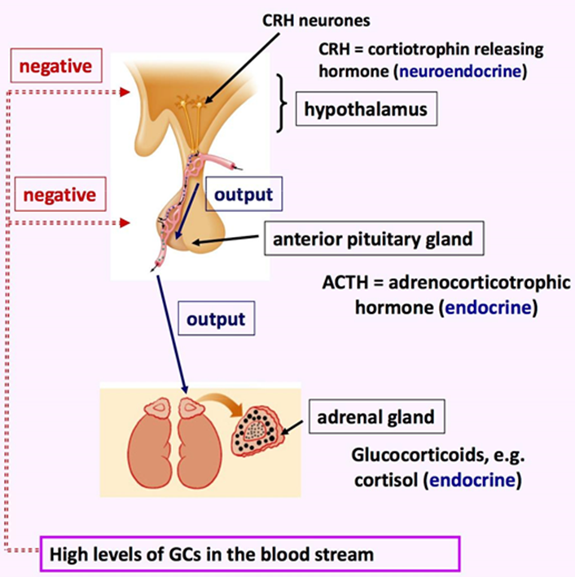  - Create a leaflet to display in an IVF clinic to prospective parents explaining the science behind their fertility drugs. Make sure you explain the roles of LH and FSH. Include a description of the stages they will go through during the process of IVF  9. a. During the menstrual cycle, which hormone peaks during ovulation?  b. During the menstrual cycle, which hormone peaks before menstruation?

% | I can … | Prove it!
60% | Describe what monitors and controls body temperature (triple only)  Explain the role of the skin in thermoregulation (triple only)  Describe and explain the body’s response to extreme body temperature (triple only)  Describe and explain how the body controls blood glucose concentration (making reference to glucose, glycogen, glucagon, negative feedback cycle, insulin and the pancreas)  Compare data (from graphs) regarding blood glucose levels in people with and without diabetes  Explain how these automatic systems are controlled: blood glucose, water (triple only) and temperature  Evaluate hormonal and non-hormonal methods of contraception (oral, injection, implant, skin patch, condoms, diaphragms, intrauterine device, spermicidal agents, abstinence, sterilisation)  Explain why issues around contraception are not answered solely by the field of Science  Explain the process of embryo screening and evaluate based on ethical, social and economic perspectives | - Complete the following paragraph using these key words: sweat, blood, 37⁰C, skin, shiver, energy, contract, thermoregulatory, vasoconstriction, vasodilation  Human body temperature should be kept at around ___. This gives an optimum temperature for __________ to work. The ___________________ centre in the brain monitors and controls body temperature using receptors that detect the temperature of _______ flowing through the brain and by receiving electrical impulses from receptors in the ______. If the body temperature is too high then ______________ happens, where blood vessels near the surface widen. More ______ is also produced. These processes cause _________ to be transferred to the surroundings. If the body temperature is too low then _____________ happens, where blood vessels near the surface of the skin narrow. Less _______ is also produced and skeletal muscles _______ and relax quickly (________).  - Draw a flow diagram to describe how the body controls blood glucose levels:  - Read the graph and answers the questions below:  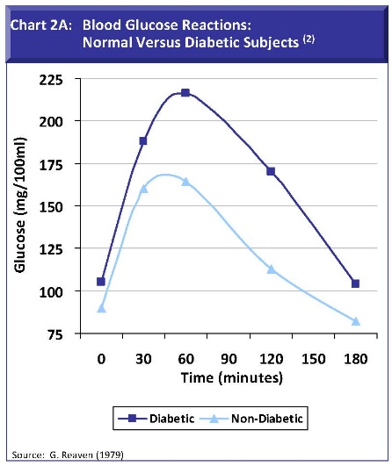  a. Compare the blood glucose concentration between the diabetic and non-diabetic in the first 60 minutes following a meal.  b. Explain this difference.  c. Draw a line on the graph where you think the insulin level would be for the non-diabetic  - Complete the table below:  Contraceptive Reliability Side-effects Convenience  Oral  Injection  Implant  Skin patch  Condoms  Diaphragms  Intrauterine  Spermicidal  Abstinence  Sterilisation  - For each of the below, give a reason why this might affect a person’s decision about which type of contraception to use: Ethical, Religious, Financial, Social  - A couple know that they are both carriers of the cystic fibrosis allele. They want to have a child but are considering screening their embryo or foetus before they make a decision on whether or not they will carry the baby full term. Write them a letter explaining the advantages and disadvantages of screening their embryo and foetus.  - Complete the diagram to show how water levels are controlled:  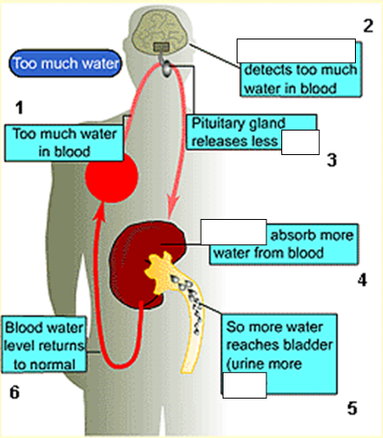

% | I can … | Prove it!
50% | Describe the role of Carl Linnaeus in development of a classification system  Explain the binomial naming system of organisms  Describe and explain the theory of ‘natural selection’ and ‘evolution’  Describe the evidence for evolution including antibiotic resistant and the fossil record  Describe what a fossil is and explain how they form and explain why these cannot be used as evidence for how life began on Earth  Describe selective breeding and explain the potential benefits and risks of this process  Describe the process of ‘genetic engineering’  Explain how the nervous system is adapted for it’s function and why it is important  Describe the role of the pituitary gland  Describe the roles of FSH, LH, Oestrogen and progesterone in the menstrual cycle  Describe the roles of oestrogen and progesterone in puberty  Explain type 1 and type 2 diabetes and how they can be treated  Compare and contrast the two types of diabetes | - Complete the following sentences to describe the work done by Carl Linnaeus:  a. Carl Linnaeus was…  b. He classified living things into…  c. A binominal system means…  d. For example…  - For each of the below examples, highlight the genus in green and the species in blue:  a. Panthera leo (lion)  b. Acinonyx jubatus (cheetah)  c. Panthera tigiris (tiger  d. Canis lupus (wolf)  - Complete the following to show the process of natural selection using these words: reproduce, evolution, variation, mutations, genes, sexual  There is ___________ between different organisms of the same species (caused by __________reproduction and by random ____________)  Some organisms will have a selective advantage for that particular environment and they will be more likely to ____________  If they survive, they can __________________ and pass on the ___________ for these characteristics to their offspring  This means there will be more organisms with that characteristic in the next generation, leading to a gradual change in the species, which we call ________________.  - Use the above structure to explain how bacteria become resistant to antibiotics.  - Explain how the below fossil record shows that a horse has evolved slowly over time:  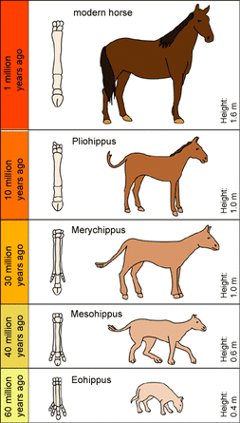  - a) Fossils are the _______ of an organism from ______________ of years ago.  b) Fossils can be made in four ways:  - From ___________ of the animals not ____________ properly.  - Because the __________ were not correct for decay so part of the animal did not decay.  - When parts of the organism were replaced by other __________ as it decayed.  - Traces of the organism were _________ e.g. foot prints  c) Fossils provide evidence for how organisms have ________ over time (evolution).  d) Fossils cannot be used as evidence for how life began on Earth because the fossil record is ___________, (there are gaps where fossils are missing).  - Complete the table to summarise selective breeding:  Use of selective breeding Example Benefits Risks  Disease resistance in crops  Animals with more meat or milk  Large/unusual flowers  Domesticated dogs with a good nature  - Complete the diagram to show the stages in genetically engineering insulin:  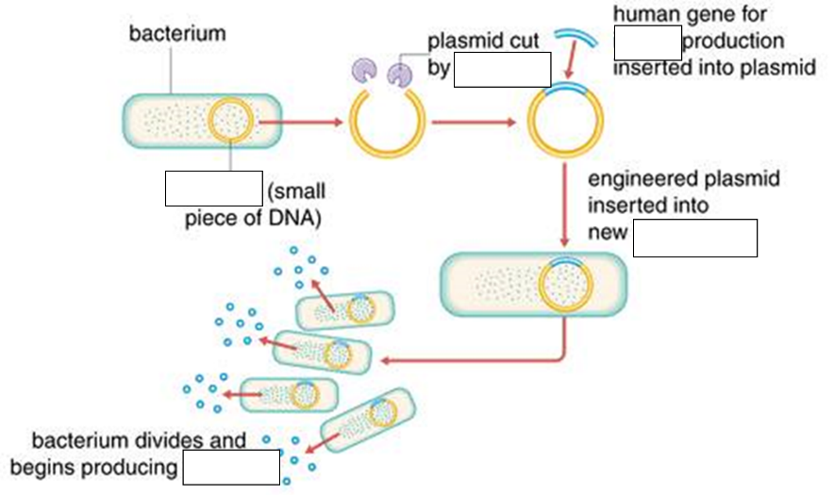  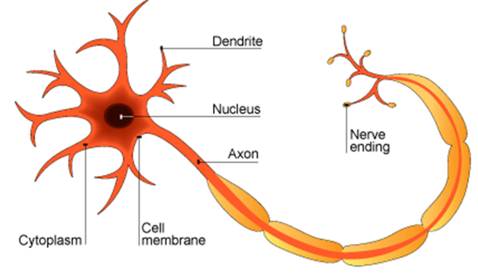  - Match the feature to its function:  a. Neurones are long, which means that they can… …to travel quickly along the neurone.  b. Neurones have branched endings called dendrites, which allow them to… …carry electrical impulses to distant parts of the body.  c. Neurones have an insulating sheath, which allows the electrical impulse… …connect with other neurones.  - For each of the above adaptations, give a reason why this feature is important to the nervous system.  a.  b.  c.  - Give three processes that the pituitary gland is involved in and describe its role in each process.  Hormone Role in puberty Role in menstrual cycle  Luteinising hormones  Follicle stimulating hormone  Oestrogen  Progesterone  - Complete the table to compare Type I and Type II diabetes:  Cause Age of diagnoses Treatment  Type I  Type II

% | I can … | Prove it!
40% | Define ‘species’ (linking to future fertility and breeding)  Interpret information from evolutionary trees  Explain what extinction is and describe factors which may contribute to the extinction of a species  Give examples of genetic engineering  Describe the structure of the nervous system  Describe the pathway of a message from stimulus to response  Describe the design of a reflex arc and explain its purpose  Define ‘homeostasis’ and explain why it is important  List three factors controlled by homeostasis in the human body  Describe the principals of hormonal coordination including what makes up the endocrine system  Describe what hormones are and label six glands in the body  Compare nervous system and hormonal responses | - Complete the following definition of a species using these words: fertile, organisms, reproduce  ‘ A species is a group of _________ that can ________ together to produce offspring that are ________ (can also reproduce).’  - Use the evolutionary tree below to answer the questions:  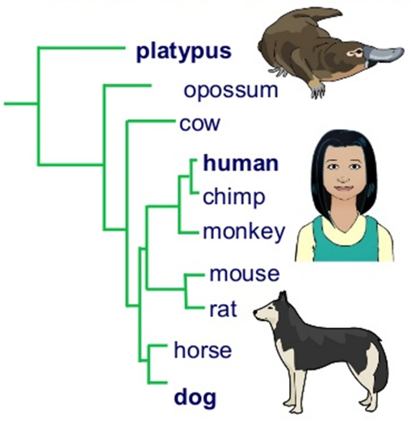  a. Which organism is most closely related to humans?  b. Which organism is least closely related to humans?  c. Which organism is most closely related to the platypus?  - a) Write a definition of extinction that includes these words: species, alive  b) List the 5 reasons that a species may become extinct and give an example of each one:  Reason Example  1. Changes to the …….  2. New …..  3. New ……  4. New, more successful …….  5. A single, catastrophic………  - List 5 examples of when we might use genetic engineering  - Label the structures of the nervous system  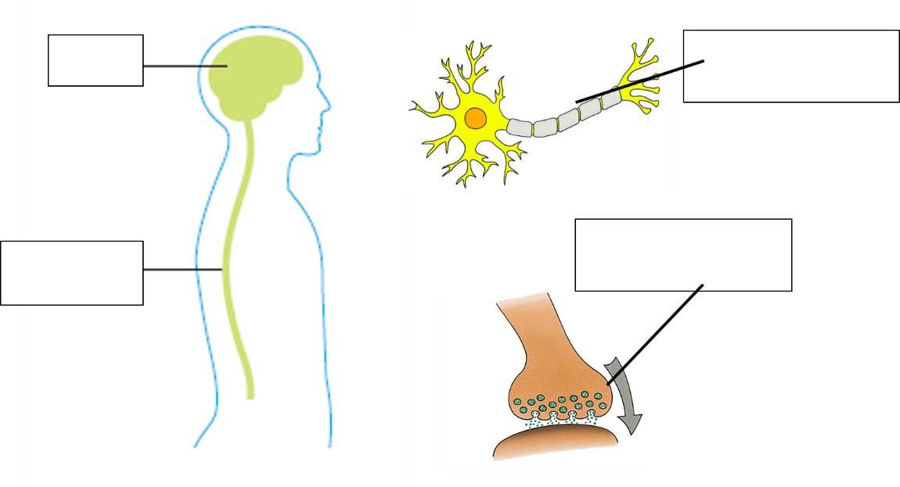  - Use these words to complete the flow chart to show the pathways taken by an electrical impulse:  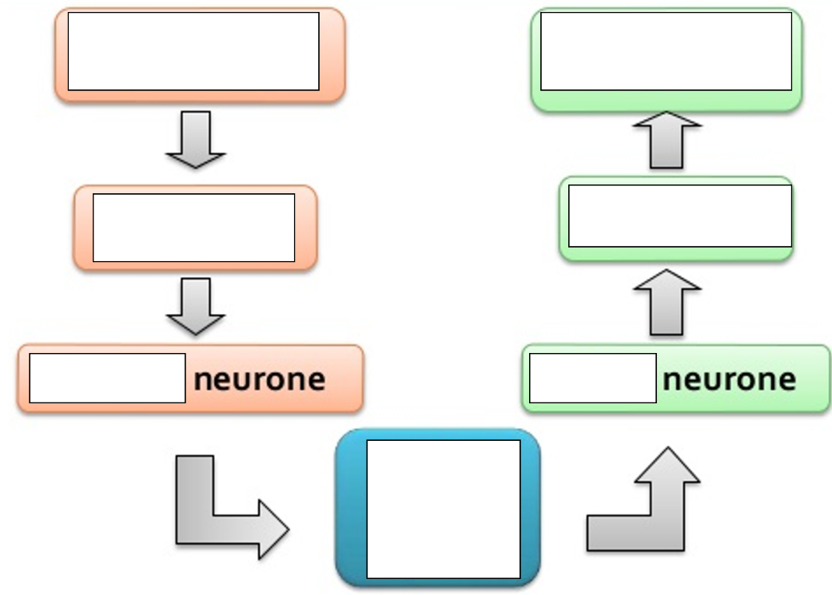  CNS  receptor  motor  sensory  response  effector  stimulus  - Use these words to complete the flow chart to show the pathways taken by an electrical impulse during a reflex action:  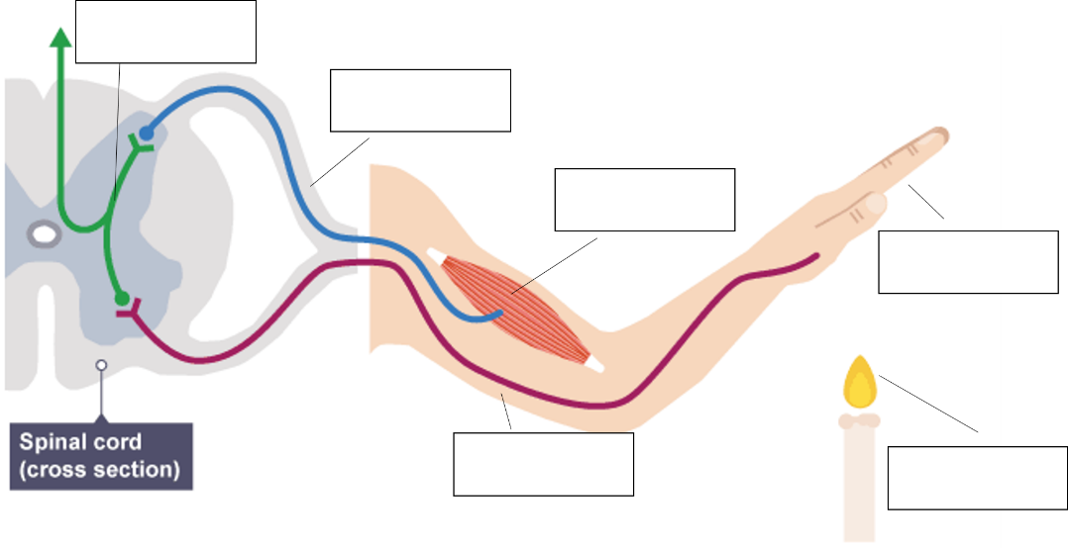  stimulus  relay neurone  effector  sensory neurone  receptor  motor neurone  - Explain why the reflex arc is used instead of the normal pathway.  - a) Write a definition for homeostasis  b) Explain what would happen, if we did not control our internal conditions (use the word enzyme in your answer).  c) List 3 examples of thongs we control in the body.  - Label this diagram of the endocrine system:  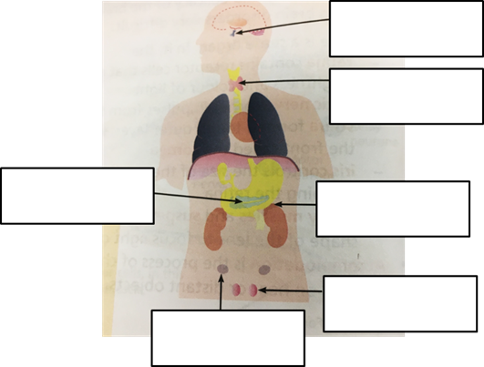  - Give a definition of a hormone and list 5 examples.  - Complete the table to compare nervous and hormonal responses:  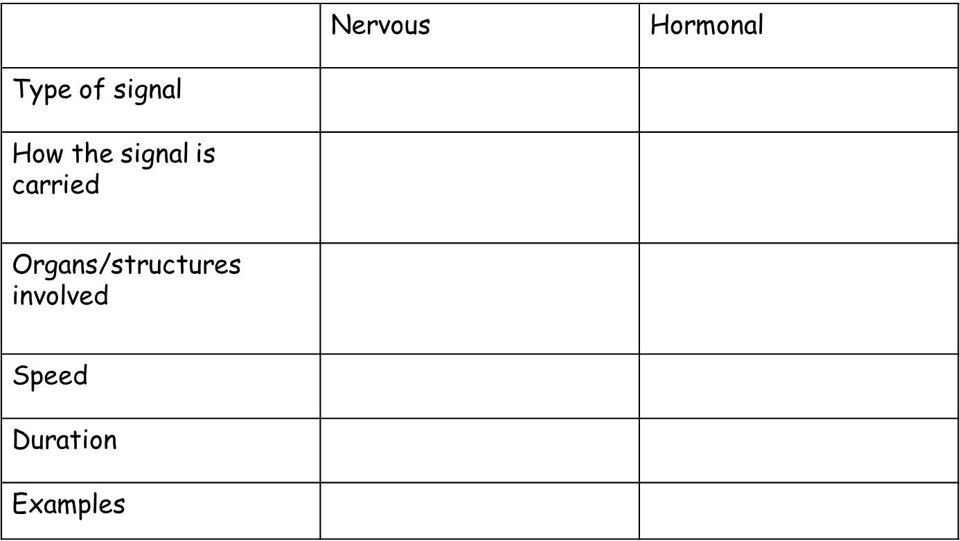

Key Words:
evolution, natural selection, speciation, species, extinction, classification, binominal. genus, species, evolutionary tree, fossil, selective breeding, genetic engineering (modification), plasmid, Gregor Mendel, Charles Darwin, Jean Baptiste Lamarck, Alfred Russell Wallace, CNS, neurone, synapse, reflex arc, sensory neurone, motor neurone, stimulus, receptor, effector, response, relay neurone, hormone, endocrine system, gland, pituitary gland, anti-diuretic hormone (ADH), insulin, glucagon, glycogen, pancreas, thermoregulatory centre, vasodilation, vasoconstriction, Type I diabetes, Type II diabetes, oestrogen, progesterone, testosterone, menstrual cycle, puberty, luteinising hormone (LH), follicle stimulant hormone (FSH), ovulation, menstruation, negative feedback, adrenaline, thyroxine, urea, deamination, selective reabsorption, tubules, dialysis, contraception, in vitro fertilisation (IVF),

