Cambridge Nationals

Unit R041 – Lo3

Relocation work

Reducing the Risk of Sports Injuries

Learning Outcome 3: Know how to respond to injuries within a sporting context.

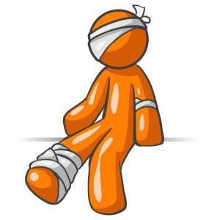

Instructions:
Complete LCWC on the key knowledge and then answer the questions that follow

Q | Topic | Responding to injuries 1
1 | Injuries in sports are usually divided into 2 types, they are: | Acute injuries and Chronic injuries
2 | Describe an acute injury: | Happen quickly and caused by sudden trauma to the body e.g. hard rugby tackle, hit by ball
3 | What do acute injuries usually result in? | Immediate pain, usually swelling with a loss of function
4 | Give examples of types of acute injuries: | Soft tissue injuries (sprains/ Strains)  Fractures (open or closed)  Concussion e.g. clash of heads in football  Cuts- abrasions/ grazes  Contusions-bruises  Cramp  Blisters
5 | Describe a chronic injury. | Aka Overuse injuries and are a result of continuous/ excessive stress on an area. Tend to develop over time, Inflammation and painful
6 | Give 6 examples of types of chronic injuries: | 1. Tennis elbow/ golfers elbow e.g. hitting a tennis/ golf ball repeatedly  2. Achilles tendonitis  3. Shin splints  4. Injuries related to children:  Severs disease  5. Osgood Schlatter’s disease  6. Injuries related to poor posture- round shoulders etc
7 | Describe the overuse injury- Shin splints: | Pain in the shins or the front of the lower leg bone (tibia), usually caused by exercise.
8 | Describe the overuse injury- Tennis elbow: | Tendon injury due to repetitive actions such as tennis strokes.
9 | Describe the overuse injury- Tendonitis: | Chronic injury to tendons e.g. Achilles tendonitis, tennis elbow, etc
10 | Describe Soft tissue injuries: | Damage to muscles, ligaments or tendons e.g. sprains, strains

Q | Topic | Responding to injuries 2
1 | State the difference between a Strain injury and a Sprain injury: | Strain: Injuries to muscles e.g, pulled muscle  Sprain: Injuries to ligaments e.g. twisted ankle
2 | Describe a fracture: | Partial or complete break in a bone. 2 main types: open and closed
3 | Describe a Closed fracture: | Broken bone with no break in the skin.
4 | Describe an Open fracture? | Broken bone in which the skin is also broken, exposing the bone.
5 | Describe a Concussion | Injury in which the brain is shaken inside the skull e.g. head collision to another person or object.
6 | Give symptoms and treatments of concussion | Symptoms: dizziness, nausea, vomiting, memory loss, loss of balance, headaches  Treatment: requires medical assistance. Temporary relief- cold compress applied to head.
7 | Describe Abrasion: | Surface damage to the skin e.g. grazes (skin scraped away) and cuts
8 | Describe Contusion: | A bruise to a part of the body.
9 | Describe Blisters: | Bubbles of fluid under the skin caused by friction.
10 | Describe Cramp: | Painful sensations caused my involuntary muscle contraction. Often caused by excessive exercise or poor hydration
11 | Describe Sever’s disease (injury related to children): | Heel pain caused by an inflamed growth plate.
12 | Describe Osgood-Schlatter’s disease (injury related to children) | Knee pain caused by growth spurts.

Q | Topic | Responding to injuries 3
1 | One way to respond to injuries is SALTAPS, describe this on-field assessment routine [7] | See: did you see injury occur?
 |  | Ask: ask player what happened?
 |  | Look: at injury/ compare to other limbs
 |  | Touch: feel for tenderness
 |  | Active: can player move injured area?
 |  | Passive: coach to see if they can move injured area
 |  | Strength: can player hold their weight on it?
2 | The 2nd way to respond to injuries is R.I.C.E, describe this process [2]: | Rest, Ice, Compression, Elevation:
 |  | treatment for acute soft tissue injuries to reduce swelling, ease pain and prevent further damage for acute but less serious injuries to soft tissues.
3 | Stretching and massage response to sports injury [3]: | Increases blood flow to affected body part and increases flexibility
 |  | Relaxes muscles and relieve tension
 |  | Manages pain and DOMS
4 | What can be used to support weak or injured muscles and joints? [3] | Taping and strapping- reduce pain
 |  | Bandaging- prevents swelling and decrease blood flow to the injured area.
 |  | Can reduce pain keeps area immobilised
5 | Describe a Splint as a treatment method [1] | Plastic or fibreglass support for acute limb fractures and sprains e.g. fractured arm
6 | Describe a Sling as a treatment method [1]: | Support, usually of folded cloth, to immobilise and rest the injured limb (injured elbow)

Q | Topic | Responding to injuries 4
1 | Ice therapy can manage sports injuries by: | Reducing pain and swelling. Apply for 15-20 mins every 2-3hours.
2 | Heat treatment can manage sports injuries by: | Reducing pain and stiffness, increasing blood flow to the area which promotes healing.
3 | What is an Emergency Action Plan (EAP)? | Written document identifying what action to take in the event of an emergency at a sporting event.
4 | List the 3 main components of an emergency Action Plan (EAP) | - Emergency personnel
 |  | - 2. Emergency communication
 |  | 3.Emergency equipment
5 | Define emergency personnel in a EAP: | People who are responsible in a emergency e.g. first responders, first aider, coach
6 | Define emergency communication in a EAP? | Details of whom to contact in an emergency e.g. telephone, emergency services 999 and location of nearest phone.
7 | Define emergency equipment in a EAP? | Equipment required in an emergency situation e.g. first aid kits, evacuation chair, defibrillator

Acute and Chronic Injuries

- Task 1 – Fill in the gaps using the words from the box.

immediate | overuse |  | sudden |  |  | gradually |  |  |  |  | function | continuous
Acute injuries are caused as a result of a |  |  |  |  |  |  |  |  | trauma to the body.
They result in |  |  | pain.
They usually result in a lot of swelling and a loss of |  |  |  |  |  |  |  |  |  |  | .
Chronic Injuries are also known as |  |  |  |  |  |  | injuries.
They are the result of |  |  |  |  |  | stress to an area.
They tend to develop |  |  |  |  |  | over a period of time

- Task 2 - In the diagram below list as many acute and chronic injuries as you can.

Acute Chronic

Types, causes and treatment of common sports injuries

- Task 3 – Complete the table to identify causes and treatments of common injuries

Injury | Picture | Symptoms | Treatment
Soft Tissue Injuries |  | Result in
E.G. Sprains/Strains |  | swelling/bruising
Overuse Injuries |  | Caused by repetitive
 |  | trauma.
 |  | Gradual onset of pain.
E.G. Tendonitis/Tennis |  | Stiffness.
 |  | Aching.
Elbow/Shin Splints
 |  | Swelling.
Fractures |  | Immediate pain.
 |  | Unable to move.
 |  | Disfigurement of limb.
E.G Open/Closed/ |  | Open – bone breaking
Displaced/Non Displaced |  | through the skin.
Concussion |  | A head injury with
 |  | temporary loss of brain
 |  | function.
E.G. Signs and |  | Headaches/trouble
 |  | with memory/blurry
Symptoms
 |  | vision/nausea.
Abrasion |  | Split skin.
 |  | Blood seeping out of
E.G. Grazes and Cuts |  | area.
Contusions |  | Bleeding under the
 |  | surface of the skin.
E.G. Bruises |  | Discolouring of an
 |  | area or skin.
Blisters |  | Red, raised skin.
E.G. Different parts of |  | Painful to touch.
the body
Cramp |  | Painful sensations
 |  | caused by muscles
E.G. Different parts of |  | contractions or over
 |  | shortening
the body
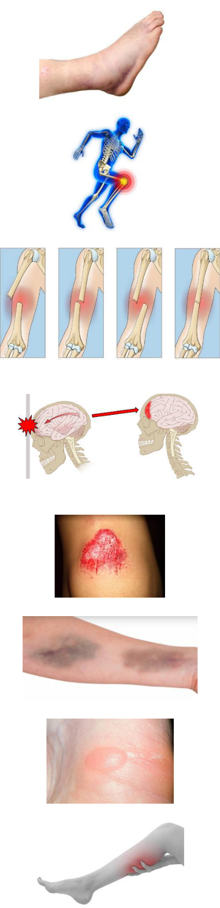

How to respond to injuries and medical conditions in a sporting context

- Task 4 - Complete the bottom chart to work through an example (Use QR code for extra help).

See | Ask | Look | Touch | Active | Passive | Strength
 | ask | look for | gently touch |  |  | get them to
you’ve seen | questions | specific | the area to | ask them to | you move
 |  |  |  |  |  | place
 | about the | signs of | identify | move the
the injury |  |  |  |  | the injured | pressure on
 | injury e.g. | injury e.g. | swelling or | injured part
happen |  |  |  |  | part | injury e.g.
 | where, how | blood, | areas of | on their own
 |  |  |  |  |  | standing up
 | painful | dislocation | pain
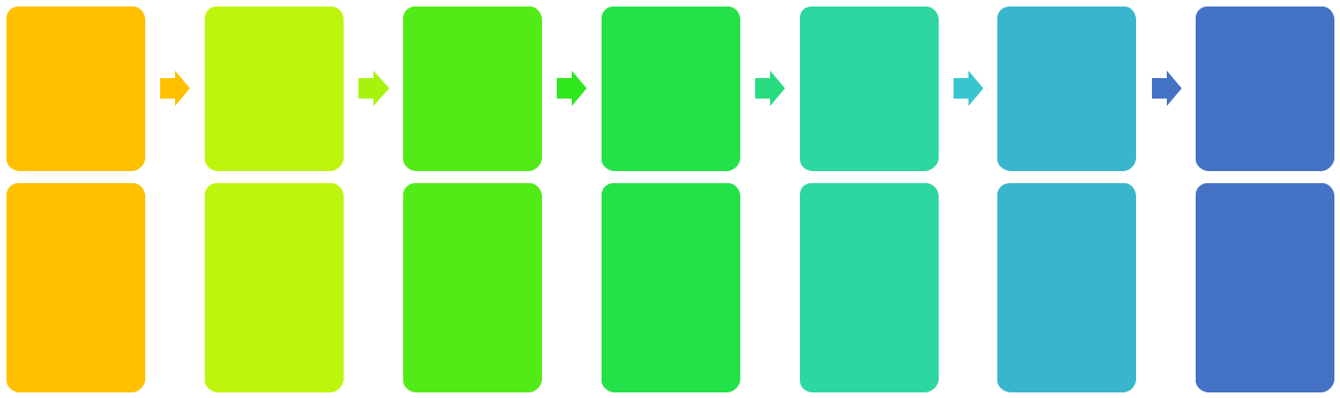

- player goed down after a bad tackle to the left ankle.

Top Tip – when assessing an injury and a participant cannot do the next stage of SALTAPS you must STOP. If they can do all of this, it is time to consider how to treat them.

- Task 5 - Identify the word for each stage of the R.I.C.E. procedure (Use QR code for extra help).

R |  |  | E
 | I | C | Lift the injured
Get them to rest | Apply ice to | Help support and | part above the
and not used the |  |  | heart to reduce
 | reduce swelling | reduce swelling
injured part |  |  | blood flow and
 |  |  | swelling

Top Tip – You would not use RICE for a serious injury (E.G. a fracture) where a participant is unable to move the injury. This could cause further damage.

- Task 6 - Fill in the gaps to describe how stretching and massage can help aid recovery.

Stretching | If the performer has pulled a muscle, | This will increase |  |  |  |  |  | to promote
 | they will need to get the muscle to relax | healing and remove |  |  |  |  |  | products such
 | and stretch it back to its normal self
 |  | as lactic acid.
 | using active and passive stretching.
Massage | Massage helps promote blood flow to
 |  | It helps to |  |  |  |  |  |  | waste products
 | the targeted area which can help
 |  | such as |  |  |  |  | acid, reducing stiffness.
 | healing as well as relaxing the injured
 | area.
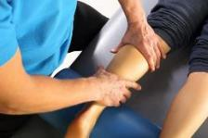

- Task 7 - To stop an injury become worse, further support can be provided in the following ways. Match the picture to the correct name.

Taping | Taping the area to keep it rigid and structured,
 | reduce movement.
Bandaging | Wrapped around the area to support and reduce
 | swelling.
Slings | Reduce load and movement allowed.
Splints | Keep the part very rigid and unable to move.
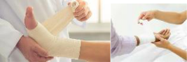
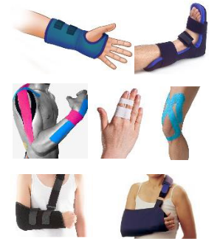

- Task 8 - Fill in the gaps to describe how hot and cold treatment can aid recovery.

Ice | Used for | Apply the cold for 20 minutes at |  |  | the pain
 |  | a time and repeat every few |  |  | the blood flow.
 | acute
 | injuries | hours. |  |  | the swelling.
Heat | Used for | Apply for 20 minutes. |  |  | relax.
 |  |  |  |  | blood flow.
 | chronic | Do not repeat. |  |  | pliability of
 | injuries
 |  |  |  | muscles, tendons and ligaments.
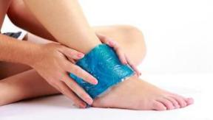
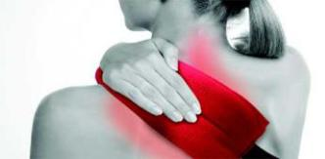

Emergency Action Plans (EAP) in a sporting context.

Sports clubs/events/venues need to have a plan in place ready in case of a serious injury or incident. They need to know what to do if something happens. Without this response a person could be put at greater risk.

□ Task 9 - Can you identify the Emergency Personnel that could be identified in an EAP?
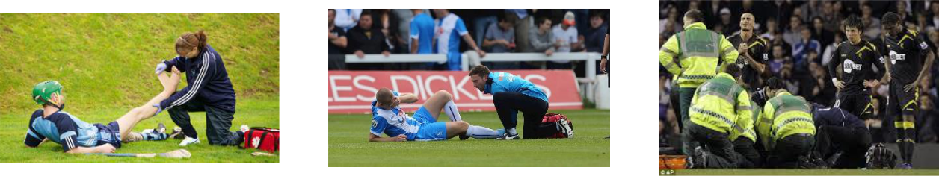

Raich evacnoita

Raised Rift

Achoc

Therapy Istiophs

Friedn Presorts

Designated people

Must hold a relevant up to date qualification.

React to injury and start treatment process.

Word bank: coach, physiotherapist, evacuation chair, first aider, first responder,

The size of the event/venue will determine the amount of emergency personnel. At a premier league football match their will be significantly more than at a game of U10’s local football.

- Task 10 - Can you identify the Emergency Communication that could be identified in an EAP?

 |  |  | 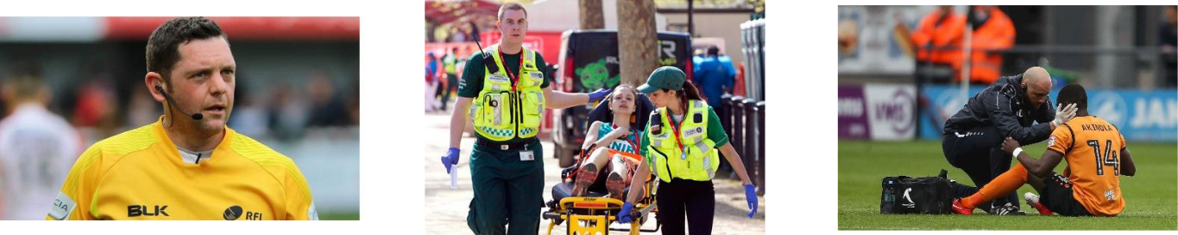
Referee using |  |  | First Aiders using |  |  | Physiotherapist using

There must be a way of communicating either to get the emergency personnel or the emergency services.

This is important as depending on the situation it may require more people, equipment to be brought out, or at worst an ambulance.

On the plan there will also be emergency numbers to contact.

- Task 11 - Can you identify the Emergency Equipment that could be identified in an EAP?
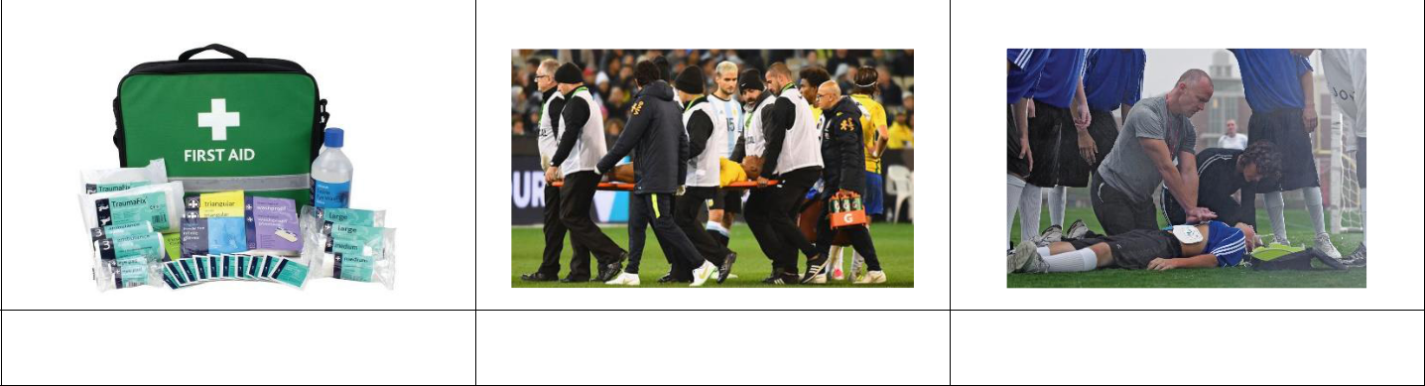

You need to have the appropriate equipment to be able to treat and respond to injuries. E.g. a first aid kit, stretcher, evacuation chair for if you need to get them down or up steps etc.

Again this is vitally important as you need to have the correct tools to be able to treat the injury or start the treatment process while further help arrives.

Use the QR code to watch a video where different aspects of an EAP come into force.
Can you spot SALTAPS being used as well?

Case Study

Name: Fabrice Muamba
Date: 17th March 2012

Location: White Hart Lane

Details

Emergency
Personnel

Emergency Communication

Emergency
Equipment

Further incidents:

- Muamba was playing football for Bolton Wanderers against Tottenham Hotspur.

- 43 minutes into the game Muamba collapsed.

- Rafael van der Vart (a Spurs player) noticed and signalled to the pitch side medical teams to come to help.

- Spurs had 5 fully medically trained assistants on pitch side and the St John Ambulance Unit.

- Medical Staff began to administer CPR.

- A doctor (a heart specialist!) from the crowd persuaded stewards to let him on the pitch to help.

- The physiotherapist had a head set on and could communicate with other team personnel.

- An ambulance was called.

- Muamba received 2 defibrillation shocks on the pitch.

- Muamba was carried off the pitch on a stretcher to the tunnel.

- The referee called the game off.

- Down the tunnel, Muamba received another defibrillation shock whilst they waited for an ambulance.

- There were a number of medical professionals present: Tottenham’s Club Doctor, 2 paramedics, Bolton’s Physiotherapist, Bolton’s Club Doctor, The doctor from the crowd.

- The doctor from the crowd persuaded the ambulance men to go to a different hospital. They had planned to go to the nearest, but the doctor persuaded them that Muamba needed the specialist equipment at a hospital 8 miles away.

- During the ambulance journey Muamba received 12 more defibrillation shocks and continued to receive CPR.

- Once in the hospital Muamba continued to receive treatment and finally regained consciousness on the Monday – 2 days later.

Exam Questions

1. Give one example of each one of the following common sports injuries

Type of Injury | Example of type of injury
Soft Tissue Injuries
Overuse Injuries
Fractures
Abrasions
Contusions

(5 marks)

- Which one of the following is not a suitable response when dealing with a muscle strain?

  - Heat Packs

  - Bandaging

  - Elevation

  - Ice Packs

(1 mark)

3. Explain the R.I.C.E..method when dealing with a soft tissue injury.

(4 marks)

4. a) Identify one acute injury and describe why it is an acute injury

(3 marks)

b) Identify one chronic injury and describe why it is a chronic injury

(3 marks)

5. Describe two possible causes and one suitable treatment for blisters.

(3 marks)

- Tendonitis is a common sports injury. Complete the following table below to show the type of injury it is, one symptom of it and its treatment.

Injury Type | Symptom | Treatment

(3 marks)

- Debbie is training for a marathon and is running 50KM per week. Identify three possible injuries that she may experience as a result of her training and what might have caused each of them.

Injury 1: |  | (1)
Cause:
 |  |  |  | (1)
Injury 2: |  | (1)
Cause:
 |  |  |  | (1)
Injury 3: |  |  | (1)

Cause:

(1)

8. Which one of the following does the term R.I.C.E. stand for?

A. Reassurance, Ice, Compress, Emergency

B. Rest, Ice, Compress, Elevate

C. Rest, Insulin, Cold, Emergency

D. Response, Ice, Compress, Elevate

(1 mark)

9. Which one of the following does the term S.A.L.T.A.P.S. stand for?

A. See, Ask, Look, Touch, Active, Passive, Strength

B. Search, Ask, Look, Touch, Active, Passive, Strength

C. See, Ask, Look, Touch, Action, Passive, Strength

D. See, Ask, Look, Touch, Action, Passive, Success

(1 mark)

- All sporting clubs have a responsibility to and duty of care to ensure a safe environment for participants and spectators and this is often highlighted in their Emergency Action Plan (EAP)

Identify three different components of an Emergency Action Plan

1.

2.

3.

(3 marks)

Answers

1. Accept one for each

Soft Tissue Injuries | Sprain/Strain/Tearing/Twisted ankle/bruising/pulled muscle
Overuse Injuries | Tendonitis/Tennis Elbow/Golfer’s elbow/Shin Splints
Fractures | Open/Closed/ Broken limb/chipped bone/cracked bone
Abrasions | Grazes/Cuts
Contusions | Bruises/Hematoma

- A Ice Packs

- Four marks from:

R - Rest the injured part/stop the activity/don’t put your weight on it.

Use crutches/Use splints/putting feet up/continued activity can cause further harm/injury. I – Apply ice

15/20 minutes every 2/3 hours to stop internal bleeding/reduce swelling/relieve pain.

C – Compress

Bandage the injured area to prevent swelling/movement or to stop/control bleeding or to

support/protect.

E – Elevate

Above level of heart/keep leg up/keep limb up to reduce swelling/pain/blood flow.

Answers must include a description of ‘how’ or an explanation of ‘why’.

4. a) Acute Injuries

One mark max for example:

Acute injuries such as sprained ankle, strained back, fractured hand, strain, sprain, concussion (or any other example that happens suddenly during an activity). Two marks max for description

Caused as a result of a sudden trauma or blow to the body.

Immediate pain.

Immediate swelling

Immediate loss of function/weakness

- Chronic Injuries

One mark max for example:

Chronic injuries such as tendonitis, shin splints, tennis elbow, golfer’s elbow

(or any other relevant example) Two marks max for description
Overuse injuries/result of continuous stress on an area.

These injuries tend to develop gradually over a period of time.

Resulting in pain.

Swelling over a period of time.

Lasts a long time or keep recurring.

Gradual loss of function or increase in weakness.

5. Any two marks for a reason from:

Caused by friction/rubbing from footwear/poorly fitting footwear/inappropriate footwear/new footwear.

No socks/inappropriate socks.

Heat/hot weather.

Sweating/wet feet.

Large amounts of stress/impact/overtraining/overuse/long distances.

Not used to the training.

Any one mark for a treatment

Sterilise/clean/disinfect/use cream.

Leave the blister to heal/intact.

Cover/Put a plaster on/Put a dressing on.

If signs of infection seek advice.

Puncture with sterilised needle.

Apply ice pack to blood blisters.

- Injury type (one mark from the following) Overuse injury
Chronic injury Soft Tissue injury
Symptoms (one mark from the following)

Pain/soreness in the area where the tendon is

Inflammation

Swelling

Treatments (one mark from the following)

Rest

Ice Pack

Taping/Bandaging

Mobility Exercises

Ultrasound

RICE

Anti-inflammatory medicine

- One mark for each injury and one mark for each correctly identified cause.

  - Shin Splints or stress fracture

Caused through overuse, too much running on hard surfaces/incorrect footwear.

- Fractures Caused by falling.

- Blisters

Caused by ill-fitting footwear or clothing e.g. Wearing a new pair of trainers for a long run without breaking them in/ over use.

- Cramp

Caused by muscular contraction- lack of fluids/minerals in body or poor hydration.

- Abrasions/Cuts

- Contusions/Bruises

- Tendonitis Caused by overuse.

- Sprain

- Strain

Caused by not being fit enough/doing too much at once/not warming up properly.

- Concussion

Caused by falling/tripping over and banging head/colliding with something.

- Which one of the following does the term R.I.C.E. stand for?

  - Rest, Ice, Compress, Elevate

- Which one of the following does the term S.A.L.T.A.P.S. stand for?

  - See, Ask, Look, Touch, Active, Passive, Strength

- Any three marks from:

Emergency personnel (accept named person e.g. first aider/coach/first respondent)

Emergency communication (telephone/emergency telephone numbers/emergency services)

Emergency equipment (accept named examples e.g. first aid kit/defibrillator/stretcher)

8 Mark Question Practice

Describe how SALTAPS can be used to respond to injuries and medical conditions.

(8 marks)

Intro paragraph –

What is SALTAPS?

What does it stand

for? When is it

used?

What are the

different sections

of SALTAPS and

what do they

involve?

TIP 1: Could

you use an

example to

demonstrate

how SALTAPS

would be

using in a

sporting

context?

Are there any

incidents when

SALTAPS should

stop?
Sum up your

overall comments

TIP 1: Can you

think of the

next step once

SALTAPS has

been

completed?

Push yourself because no one else is going to do it for you! Good Luck with your exams ☺

