Cambridge Nationals
Unit R041 - Lo1
Revision Guide
Reducing the Risk of Sports Injuries

Learning Outcome 1: Understand different factors which influence the risk of injury.
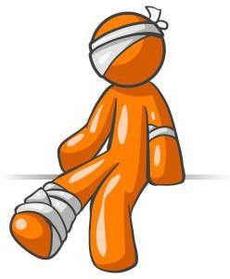
Instructions:
Complete LCWC on the key knowledge and then answer the questions that follow

 | Topic: | Extrinsic risk factors 1
1 | Define risk [1] | Likelihood of a hazard occurring
2 | Define a hazard? [1] | Something that can cause harm.
3 | What is an extrinsic risk factors [1] | Risk of factors from outside the body
4 | Name the 5 extrinsic risk factors [5] | - Type of activity (contact or non-contact sports)
 |  | - Environmental factors
 |  | - Equipment
 |  | - Safety Hazards
 |  | - Coaching/supervision
5 | How can equipment influence the risk of injury [3] | - Protective equipment is needed to prevent injury e.g. cricket helmet, shin guards
 |  | - Performance equipment is needed to play a sport e.g. hockey stick, cricket ball
 |  | - Suitable clothing and footwear e.g. specific to sport
6 | How can Coaching/Supervision influence the risk of injury [3] | - Incorrect coaching techniques,  - ineffective communication skills  - not adhering to rules can cause a performer to injure themselves
7 | How can Type of activity influence the risk of injury? [2] | Contact sports present different injury risks and are more dangerous than non-contact sports e.g. rugby compared to swimming

 | Topic: | Extrinsic risks of injury 2
1 | How can Environmental factors influence the risk of injury? [3] | Factors include:  *Weather e.g. too hot= heat exhaustion, dehydration or heat stroke.
 |  | *Playing surface e.g. too wet= player could slip on wet surface.
 |  | *Other participants
2 | How can Safety hazards influence the risk of injury? [3] | 1) Risk assessments
 |  | 2) Safety checks e.g. of equipment
3) Emergency action plans (EAP)
-will all minimise risk of injury
3 | Give 3 sports examples of protective equipment and their use? [3] | 1) Cricket Helmet to protect the head when a player is batting.
 |  | 2) Shin guards in football to protect football players lower legs.
 |  | 3) Gum shields for Rugby players to protect the mouth (teeth, gums) during high impact contact.
4 | Name and describe 4 health risks linked to Environmental risk factors [4] | - Hypothermia: dangerous drop in body temperature
 |  | - Heat exhaustion: Fatigue resulting from exposure to high temperatures
 |  | - Dehydration: reduction in amount of water in the body
 |  | - Heatstroke: in high temperatures can cause fever and unconsciousness
5 | What is the purpose of a risk assessment? [4] | 1) Safety- evaluate chances of injuries
 |  | 2) Checking- Check hazards
 |  | 3) Actions- measures taken to avoid injury
 |  | 4) Hazards- assessed as low/ medium/ high
6 | Define a hazard? [1] | Something that can cause harm.

 | Topic: | Intrinsic risks of injury 1
1 | What is an intrinsic risk factor? [1] | Risks or factors from within the body.
2 | Name the 5 intrinsic risk factors [5] | 1) Physical Preparation
 |  | 2) Individual variables (age, gender, flexibility)
 |  | 3) Psychological factors
 |  | 4) Medical conditions
 |  | 5) Sport injuries and poor posture
3 | How can Physical Preparation influence the risk of injury? [5] | 1) Training
 |  | 2) Warm up
 |  | 3) Cool down
 |  | 4) Overuse- chronic injuries caused by repetitive movements which damage tendons and ligaments
 |  | 5) Muscle imbalance- one muscle more powerful than the other
4 | How can Individual variables influence the risk of injury? [6] | 1) Age: older age more injury prone
 |  | 2) Flexibility: more flexible= less chance of injury
 |  | 3) Nutrition: poor nutrition can cause fatigue and dehydration= lose focus/ concentration
 |  | 4) Sleep: lack of sleep= poor decision making
 |  | 5) Gender: what may be suitable for females may not be for males (+ vice versa)
 |  | 6) Previous/ recurring injuries: increased chance of injuring themselves again
5 | How can Psychological factors influence the risk of injury? [5] | Mental factors-can affect a performer positively and negatively e.g.
 |  | 1) Motivation. Over motivation - performer can become reckless
 |  | 2) Aggression – Behaviour against another person or object.
 |  | 3) Arousal – physiological and psychological activation level of a performer, ranging from a coma to high excitement
 |  | 4) Anxiety levels - negative emotional state of worry causing performer to become unfocussed.
6 | Give 3 examples of medical conditions that can influence the risk of injury? [3] | Asthma, epilepsy, diabetes

Q | Topic: | Intrinsic risks of injury 2
1 | How can the 5th intrinsic risk factor: ‘Sport injuries and poor posture’ influence the risk of injury? [4] | 1)Sports injuries examples: strain, sprain, concussion, contusions etc
 |  | 2) Poor stance/ gait e.g. hunched shoulders, slouching
 |  | 3) Postural misalignments e.g. pelvic tilt, lordosis, kyphosis, round should, scoliosis
 |  | 4) Lack of exercise e.g. being overweight= strain on posture
2 | Describe what lordosis is and the impact it can have [2] | Excessive forward or inward curving of the lower back/ spine. Impact= back pain
3 | Describe what kyphosis is and the impact it can have [2] | Excessive backward or outward curvature of the upper part of the spine Impact= back pain
4 | Describe what scoliosis is and the impact it can have [2] | Condition where the spine is visibly curved to the side, giving an ‘S’ or ‘C’ shape. Impact= back pain.
5 | The femur is [1] | Thigh bone
6 | The pelvis is [1] | Large bone attached to the backbone and forming the hip joint with the legs
7 | What is the role of tendons? [1] | Attach muscles to bone
8 | What is the role of ligaments? [1] | Attach bone to bone

Extrinsic Factors which can influence the risk of injury.

These are factors outside of the individual that can alter the risk of them getting injured.
Type of Activity
Coaching / Supervision

Environmental Factors

Equipment
Safety Hazards
□ Task 1 – Complete the table to describe the type of injury would expect to see in each sport.

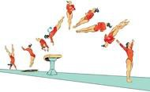 | 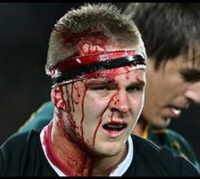 |  | 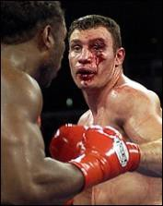
Gymnastics - vaulting | Rugby | Swimming | Boxing

□ Task 2 – Identify 3 ways a coach or manager could increase the risk of a participant getting injured: 1. 2.
3.
□ Task 3 – Identify the 3 different categories of environmental factors from the pictures.

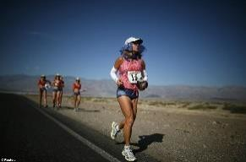 | 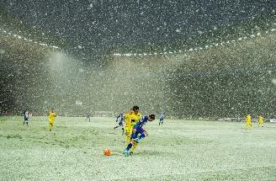 | 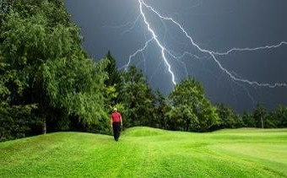 | 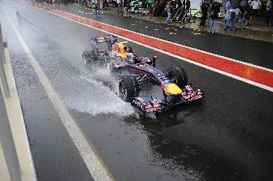
Environmental Factor:

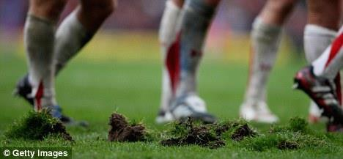 | 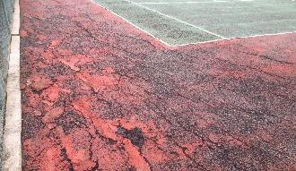 | 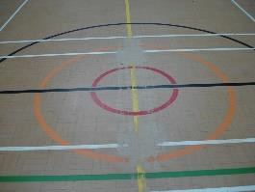
Environmental Factor:

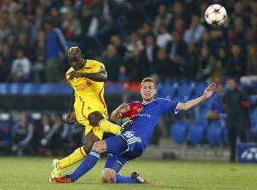 | 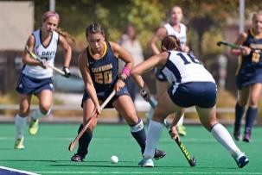 | 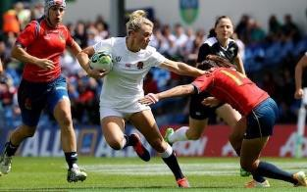 | 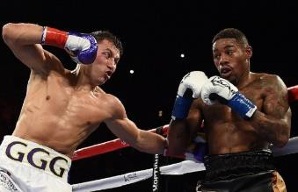

Environmental Factor:
- Task 4 – Complete the table to describe how the equipment can influence the risk of an injury.

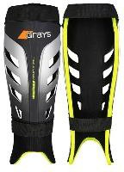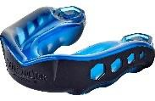  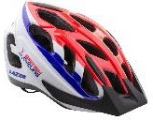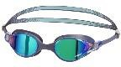 | 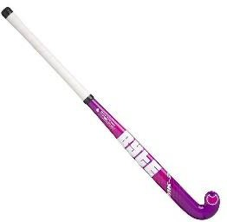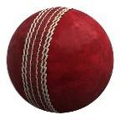 | 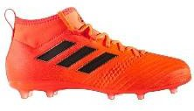  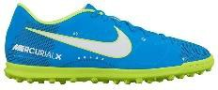
Protective Equipment | Performance Equipment | Suitable clothing/footwear

- Task 5 - Complete the table to describe how each step to reduce hazards can influence the risk of injury.

Risk Assessment | Safety Checks | Emergency Action Plan

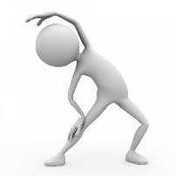
Intrinsic Factors which can influence the risk of injury.

Fle
N
S
These are factors that an individual can take control of which can alter the risk of them getting injured.
Physical Preparation
Individual Variables

Psychological Factors

Posture

Sports Injuries
- Task 6 – Answer the clues to work out the 6 ways that physical preparation can influence the risk of a participant getting injured:

The exercise you do over a period of time to help prepare for an event. | T
The pulse raiser and stretches you do before you start exercising. | W U
The pulse raiser and stretches you do when you have finished exercising. | C D
How fit you are depending on how much training you have been doing. | F L
Working your body or certain muscles too hard without giving them enough  time to rest and repair. | O
Overtraining some of your muscles but not training others enough. | M Im

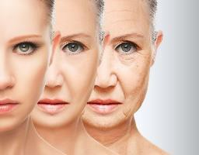
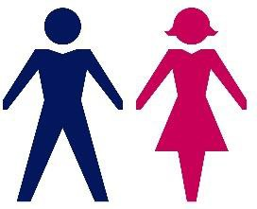
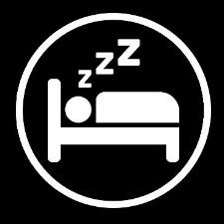
- Task 7 – Consider 6 individual variables between people that could influence the risk of a participant getting injured.
A
Previous
I
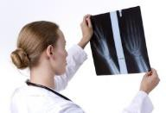
G

- Task 8 – Consider how the 3 psychological factors could influence the risk of a participant getting injured.

Motivation | Aggression | Arousal/Anxiety
The reason for people’s actions.  If they are hugely motivated they will put in lots of effort.  If they are not very motivated they  will not try very hard. | Hostile or violent behaviour. Some sports have an element of aggression BUT how much is appropriate? | Anxiety - negative emotional state. Arousal - how alert and attentive a performer is.
How could this affect the risk of  injury? | How could this affect the risk of  injury? | How could this affect the risk of  injury?

- Posture is the position you hold your body. Poor posture can impact on the risk of injury.
- Poor stance/gait - hunching shoulders/bending knees.
- Sitting positions – slumping/slouching.
- Physical defects – where muscles have weakened around an injured area.
- Lack of exercise – lack of core muscle strength = less support, overweight = strain on posture.
- Clothing/Footwear – high heels can affect posture.
- Fatigue – tired muscles unable to support the skeleton properly.
- Emotional Factors – low self esteem/lack of confidence can influence posture.

- Task 9 – Poor posture can lead to specific sports injuries. Write a description for each condition

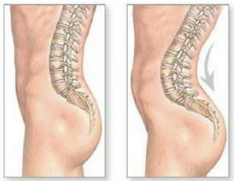 | Lordosis
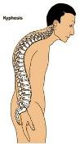 | Kyphosis
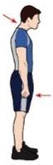 | Round shoulder
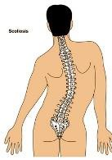 | Scoliosis

Exam Questions
- a) Identify three different extrinsic factors that may influence the risk of injury to a participant in physical activity.
1. (1)
2. (1)
3. (1)
b) Describe each of these extrinsic factors.
1. (1)
2. (1)
3. (1)

- Explain how four individual variables can influence the risk of injury to a sports performer.
1. (1)
2. (1)
3. (1)
4. (1)

- Using practical examples, explain how risk assessments can help to reduce the risk of injuries to participants in physical activity.

(4 marks)
- Using examples, describe two environmental factors that may cause injury to sports performers.
1.

2.

(2 marks)

- A lack of exercise can be one cause of poor posture.
  - Describe four other causes of poor posture
1.

2.

3.

4.

(4 marks)
  - Identify two types of sports injuries related to poor posture
1.

2.

(2 marks)
- Chronic injuries are also known as overuse injuries. Give two examples of overuse injuries in sport. 1.

2.

(2 marks)

Answers
- a) Any three from:
Type of activity or sport
Coaching/Supervision/Poor coaching technique/poor instructions/following rules/refereeing Environmental factors/weather/playing surface/other participants
Equipment/protective equipment/performance equipment/clothing/footwear Hazards/Risk Assessments/Safety Checks/Emergency Action Plans

b) Description must link to example from part a.
Contact sports present a greater risk of collision injuries (or other relevant examples)
Incorrect coaching technique could lead to a performer carrying out a skill incorrectly which could lead to an injury.
Excessive rain on an outdoor playing area could lead to participants slipping and injuring themselves.
Wearing shin pads in football can reduce the chance of sustaining an injury to the front of the leg. Carrying out a risk assessment before an activity begins ensures that the playing area, participants and equipment are all safe and reduces the risk of an injury.

- Any four from:
Gender - males are generally stronger so less prone to injuries. Age – older people are generally weaker/more prone to injury. Flexibility – increased flexibility decreases chance of injury.
Nutrition – drinking enough to water to prevent dehydration/eating enough to avoid fatigue. Sleep – important we have enough sleep so we are focussed.
Previous injuries – can lead to weak areas that are prone to injury. Psychological factors – being over aggressive can lead to dangerous tackles. Individual Physical Preparation – fully warming up can reduce the risk of injury.
Fitness – The fitter we are the less likely we are to get injured (especially towards the end of a game) Behaviour – Not following the rules and being reckless can lead to injuries.
Experience/Ability – being aware of risks to be able to protect yourself. Know how to time a tackle.

- Any four from (or any other appropriate examples).
Assessing the possibilities of an accident by identifying hazards.
Referee completing a pitch inspection and calling game off if it’s frozen. Action taken to avoid/prevent/reduce chances of accident.
Removing debris/litter from a tennis court. Checking/assessing facilities during the activity. Referee stopping the game due to heavy rain. Checking/assessing equipment.
Referee checking goal posts. Checking/assessing participants.
Officials checking if players are wearing jewellery. Surrounding area/spectators.
Boarding/objects too close to the pitch.

- Any two from
Weather/climate/sun/rain/snow/ice e.g. a wet football pitch would cause players to slip/fall. Playing surface/potholes/surrounding area e.g players colliding with advertising boards.
Litter/sharp objects/glasss/stones/wet leaves e.g. players could trip on them/cut themselves. Other participants e.g. being tackled and injured.
Equipment in the environment e.g goal posts/hit in the head by a ball.

- a) Any four from
Poor stance/gait - hunching shoulders/bending knees when walking. Sitting positions – slumping/slouching.
Physical defects – where muscles have weakened around an injured area.
Lack of exercise – lack of core muscle strength = less support, overweight = strain on posture. Clothing/Footwear – high heels can affect posture.
Fatigue – tired muscles unable to support the skeleton properly.
Emotional Factors – low self esteem/lack of confidence can influence posture.

b) Any two from Lordosis Kyphosis
Round shoulder Scoliosis

- Any two from Tendonitis Tennis Elbow Golfer’s Elbow Shin Splints
Repitive Strain Injury Osgood Schlatter Disease

