iY10 – Spanish
Homework 1
Question 1: Qué hay en la foto?

- ______________________________
- ______________________________
- ______________________________
- ______________________________

Question 2: A healthy living poster

What advice does the poster give? Mention three things.
1. _______________________________________
2. _______________________________________
3. _______________________________________

Question 3: Read what Marcel says about poverty and homelessness. Find the Spanish for the English phrases.
1. unfortunately = desafortunadamente
2. they have no house = no tienen casa
3. they are unemployed = están en paro
4. not enough money = no tienen bastante dinero
5. coins = cambio
6. very sad = muy triste
Desafortunadamente hay muchas personas que duermen por las calles de mi pueblo porque no tienen casa. Están en paro y como consecuencia no tienen bastante dinero. Les doy el cambio cuando los veo, pero estoy siempre triste. Dime, qué piensas-tu?
Marco

Question 4: Write down the present tense endings. Some have been done for you.

 | AR | ER | IR
Yo (I) | o | o | o
Tú (you) | as | es | es
Él/ella (he/she) | a | e | e
Nosotros (we) | amos | emos | imos
Vosotros (you all) | áis | éis | ís
Ellos/as (they) | an | en | en

To conjugate in the present tense, follow these steps:
- Start with an infinitive
- Take off the ending (ar/er/ir)
- Add new ending

Question 5: Conjugate these verbs in the present tense. The first one has been done for you.

Example.  Hablar | Escuchar | Comer | Vivir
Yo – hablo  Tú – hablas  él/ella – habla  Nosotros – hablamos  Vosotros – habláis  Ellos/as - hablan | escucho  escuchas  escucha  escuchamos  escucháis  escuchan | como  comes  come  comemos  coméis  comen | vivo  vives  vive  vivimos  vivís  viven

Homework 2
Revising the present tense
The present tense tells you what normally happens, or what is happening now.
Make sure you know the present tense endings for the three types of regular verbs:
-ar | -er | -ir
-o | -o | -o
-as | -es | -es
-a | -e | -e
-amos | -emos | -imos
-áis | -éis | -ís
-an | -en | -en

Question 1: Translate each verb into English.

ayudan ayudo haces participamos ayuda
trabajo trabaja vais hacen vives

Question 2: Complete the sentences by choosing the correct verb form from the list. The first one has been done for you.

- Mi padre él trabaja en una residencia de ancianos.
- Mis tíos ellos no _____________ nada.
- Siempre yo _____________ a las personas necesitadas.
- A veces mis amigas ellos ___________ en una tienda con fines benéficos.
- ¿Y tú? ¿Qué _____________ para ayudar?
- ¿Qué _____________ a hacer para recaudar fondos?
- Mi familia siempre ____________ a preparar comidas.
- Mis amigos y yo nosotros_____________ en las actividades de un grupo ecologista.
- Yo _____________ en una tienda solidaria los sábados.
- ¿Dónde _____________ tú?

Question 3: Translate the sentences into English
- ___________________________________________________________________________
- ___________________________________________________________________________
- ___________________________________________________________________________
- ___________________________________________________________________________
- ___________________________________________________________________________
- ___________________________________________________________________________
- ___________________________________________________________________________
- ___________________________________________________________________________
- ___________________________________________________________________________
- ___________________________________________________________________________

Homework 3
Question 1: Match the Word with the definition by writing the correct letter.

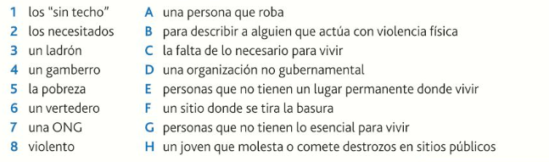

Question 2: Write four sentences to describe the photo.

1. _______________________________________
2. _______________________________________
3. _______________________________________
4. _______________________________________

Revising the present tense.

Question 3. Complete the sentences with the correct present tense form of the verb in brackets.

- Mi tío él _______________________ (ayudar) a limpiar el bosque cerca de su casa.
- Jaime y yo nosotros _______________________ (trabajar) en un comedor social.
- A veces mi hermana ella _______________________ (preparar) bebidas para los “sin techo”.
- Yo _______________________ (ayudar) como voluntario en una organización benéfica.
- Nosotros _______________________ (recaudar) fondos para ayudar a los “sin techo”.
- Mi hermano menor él _______________________ (repartir) periódicos todas las mañanas.
- ¿Qué _______________________ (hacer) tú?
- ¿_______________________ (Conocer) vosotras a ese chico que _______________________ (vivir) en la casa de al lado?
- Cada año los estudiantes _______________________ (organizar) un concierto benéfico.
- Mis amigas no _______________________ (hacer) nada para ayudar..

Question 4 - Translate the sentences from activity 2 into English.
- _________________________________________________________________________________
- _________________________________________________________________________________
- _________________________________________________________________________________
- _________________________________________________________________________________
- _________________________________________________________________________________
- _________________________________________________________________________________
- _________________________________________________________________________________
- _________________________________________________________________________________
- _________________________________________________________________________________
- _________________________________________________________________________________

Homework 4
The conditional tense translates as “would” in English.

Question 1: Write down the conditional tense endings.

AR/ER/IR
Yo (I)
Tú (you)
Él/ella (he/she)
Nosotros (we)
Vosotros (you all)
Ellos/as (they)

To conjugate in the conditional tense, follow these steps:

- Start with an infinitive
- Add conditional ending

Question 2: Conjugate these verbs in the conditional tense. The first one has been done for you.

Example.  Hablar | Escuchar | Comer | Vivir
Yo – hablaría
Tú – hablarías
él/ella – hablaría
Nosotros – hablaríamos
Vosotros – hablaríais
Ellos/as - hablarían

Question 3: For each verb, write the 1st person singular (‘I’ form) of the conditional tense. The first one has been done for you.
- comprar compraría
- vivir _________________________________
- aprender _________________________________
- asistir _________________________________
- dar _________________________________
- repartir _________________________________
- aprender _________________________________
- ir _________________________________
- llamar _________________________________
- ser _________________________________

Question 4: Complete the sentences with the correct conditional form of the verbs in brackets.

- Mi hermano él ____________________ (visitar) a las tres.
- Mis amigos y yo nosotros ____________________ (deber) ayudar. (deber = should)
- ¿Qué ____________________ (comprar) tú, si tuvieras mucho dinero? (tuvieras = you had)
- Mis padres ____________________ (llamar) a las cuatro. (llamar = to call)
- ¿Qué tu ____________________ (donar) a los pobres?
- Mi amiga ____________________ (aprobar) el examen. (aprobar = to pass)
- Si fueras a la universidad, ¿qué tú ____________________ (estudiar)? (fueras = you go)
- Ellos ____________________ (ayudar) a limpiar el bosque. (limpiar = to clean)
- Me ____________________ (gustar) ayudar, pero _________________ (ser) muy difícil.
- ¿Qué ____________________ (comprar) tú como regalo para tu hermana?

Question 5: Translate the completed sentences from activity 2 into English.

1. ________________________________________________________________________
2. ________________________________________________________________________
3. ________________________________________________________________________
4. ________________________________________________________________________
5. ________________________________________________________________________
6. ________________________________________________________________________
7. ________________________________________________________________________
8. ________________________________________________________________________
9. ________________________________________________________________________
10. ________________________________________________________________________

Homework 5
Question 1: Read about what the young people do to keep healthy. What do they say is the most important thing?

A: Eat healthily
B: Don’t smoke
C: Sleep well
D: Don’t drink
E: Get plenty of exercise
F: Avoid drugs

- Puede ser difícil si tienes amigos que fuman, pero para mí lo más importante es evitar el tabaco.

- Yo siempre intento dormir ocho horas cada noche.

- Creo que es muy importante mantenerme en forma. Paso por lo menos una hora cada día en el gimnasio o practicando deporte.

- En mi opinión, si quieres tener buena salud hay que evitar las drogas.

- Para mí, lo más importante es comer bien. Siempre intento tomar las cinco raciones diarias de fruta y verdura.

Question 2: Translate the paragraph into English.
__________________________________________________________________________________________________________________________________________________________________________________________________________________________________________________________________________________________________________________________________________________________________________________
Pienso trabajar como voluntario y el sábado quiero participar en un partido de fútbol para recaudar dinero para la organización benéfica “Médicos sin Fronteras”. Espero pasarlo bien y ¡espero marcar algún gol!

Homework 6
Using me gustaría (I would like)

Question 1: Match the Spanish with the English by writing the correct letter.
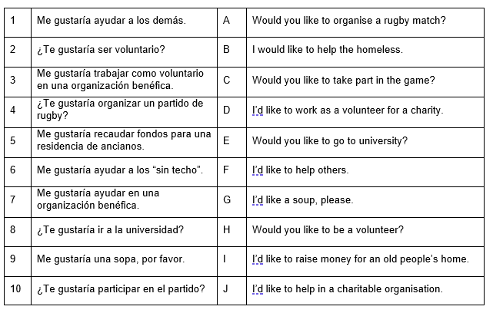

Question 2: Reorder the words in each sentence so that it makes sense.

- en una ayudar Me gustaría residencia ancianos de.
__________________________________________________________________________
- a gustaría los Me atender clientes.
___________________________________________________________________________
- en un comedor gustaría social Me ayudar.
___________________________________________________________________________
- tienda me en benéfica gustaría No trabajar una.
___________________________________________________________________________
- Me ayudar gustaría un alimentos de en banco.
___________________________________________________________________________
- gustaría noche me No la toda trabajar.
___________________________________________________________________________
- ¿ayudar demás Te a gustaría los?
___________________________________________________________________________
- un gustaría maratón ¿Te participar en?
___________________________________________________________________________

Question 3: Translate into English the sentences from question 2.

1. ________________________________________________________________________
2. ________________________________________________________________________
3. ________________________________________________________________________
4.________________________________________________________________________
5. _______________________________________________________________________
6. ________________________________________________________________________
7. ________________________________________________________________________
8. ________________________________________________________________________

