Year 8 Spring 1
What was the Holocaust?

Name: _____________________ Class:__________________ Teacher: ______________

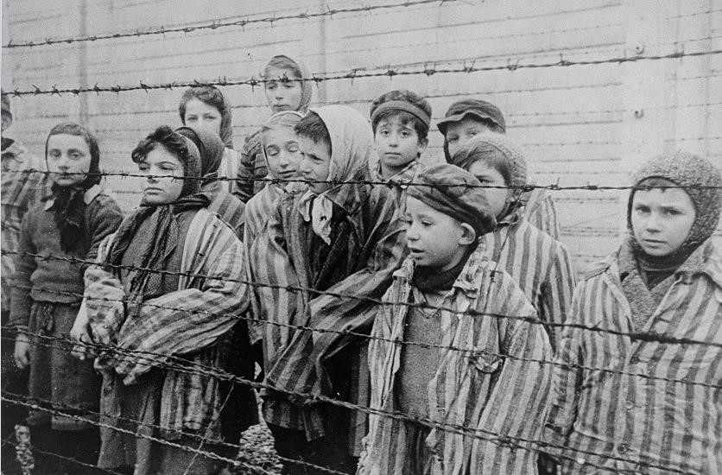
 | Contents
Lesson/Resource |  | Page Numbers | Tick when complete
Maps |  | 2
Knowledge Organiser |  | 3-4
Lesson 1 |  | 5-11
Lesson 2 |  | 12-17
Lesson 3 |  | 18-20
Lesson 4 |  | 21-24
Lesson 5 |  | 24-26
Lesson 6 |  | 26-30

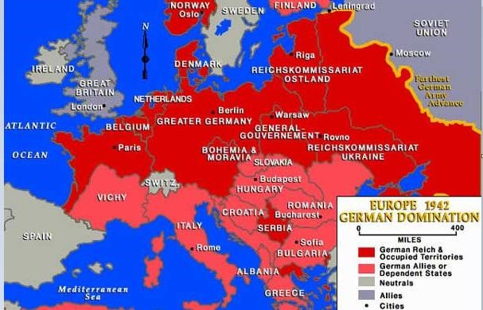

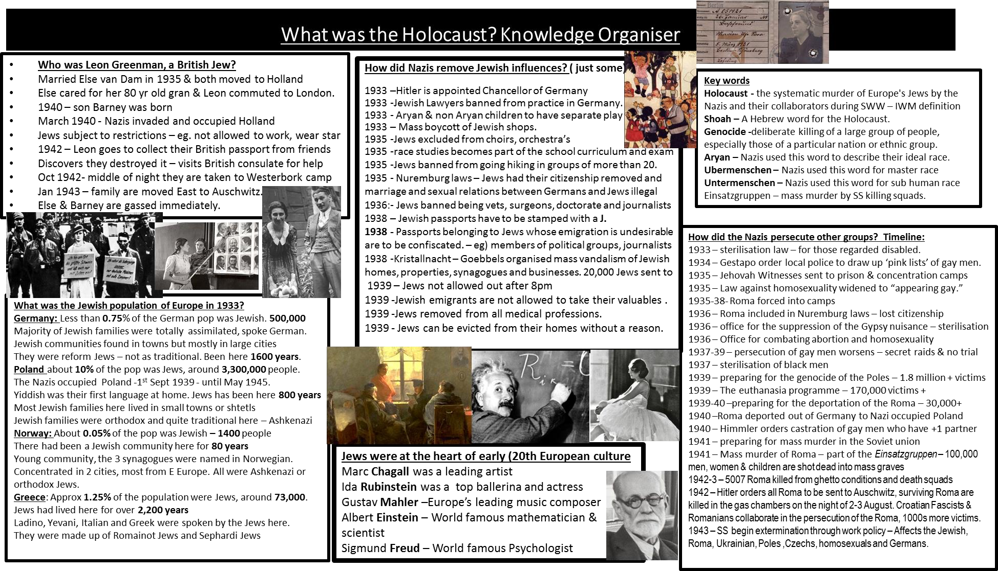

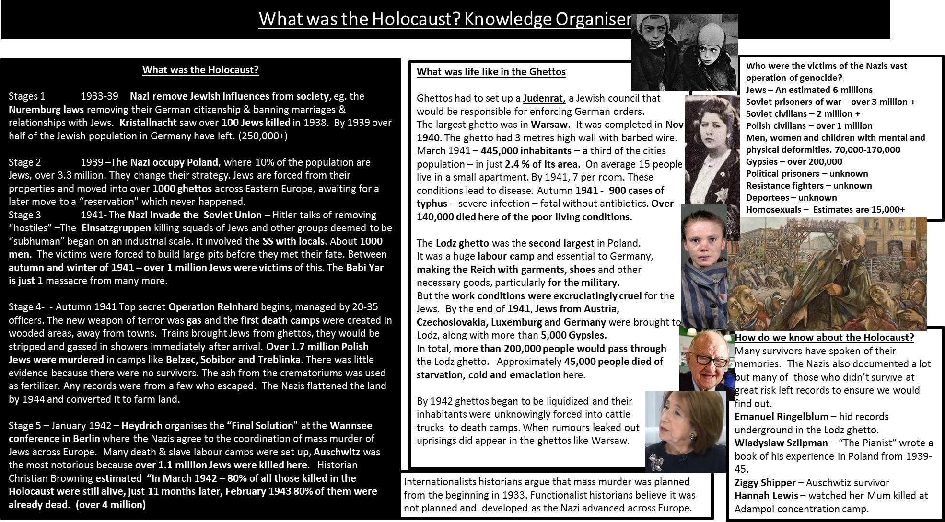

Lesson 1: Who were the 6 million Jews? What was it like to be Jewish before the Second World War?
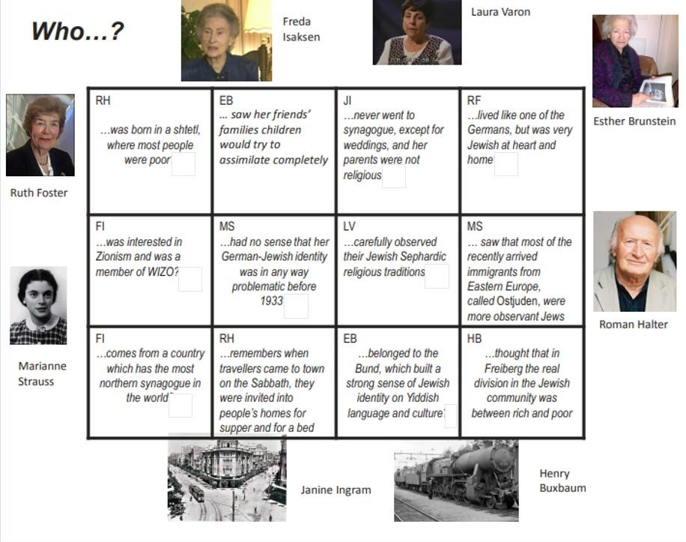

What can you infer about the Jews in Europe before 1933 from these eye witness accounts from Jews?
I can infer…
Details that support this are…

What can you learn about the Jews in Europe before World War 2 from this documentary?
The Harper family in Czechoslovakia were…
Whereas, the family in Poland…
In Europe there were over million Jews
Jews were very important to European life but they differed from each other. For example…
However, all belonged to a world that was…
Some Jews were successful and lived in Europe’s most vibrant cities such as…
Gustav Mahler was…
Ida Rubinstein was…
Marc Chagall…
Albert Einstein…

What was the Jewish population across Europe like?
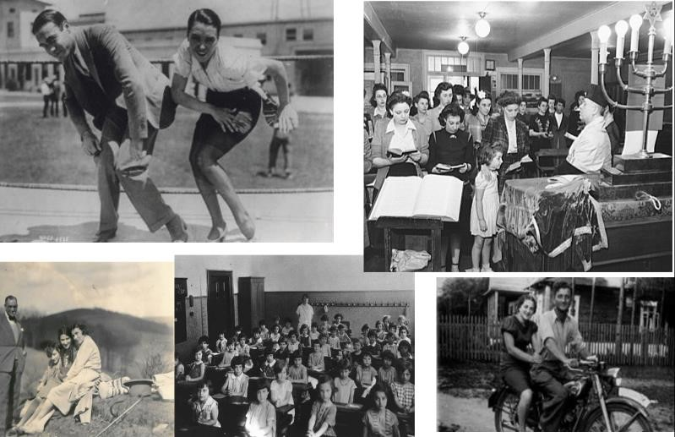
The Jewish population in Germany

Jews made up just of the German population
Overall, the Jewish population was around…
Most Jews were well integrated into German society. This meant that…
Jewish communities were mostly centred around…
Most Jews were reform Jews. This meant…

The Jewish population in Poland
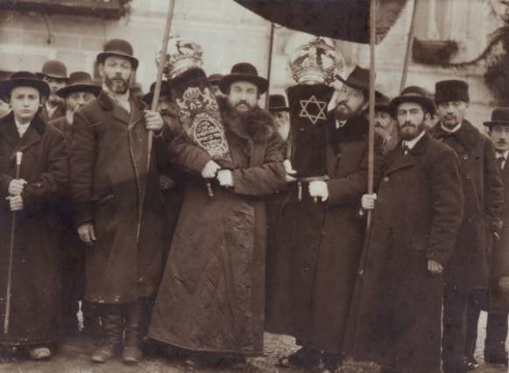

Jews made up… of the population in Poland.
Overall, the Jewish population was around… people
The Nazis invaded Poland on…
Their first language was…
Most Jewish families here lived…
Jewish families were orthodox, Ashkenazi Jews. This means that…

Jewish population in Norway
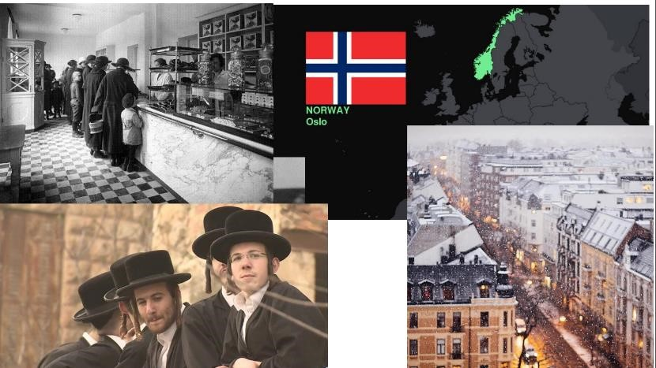

Jews made up… of the population in Norway.
Overall, the Jewish population was around… people
Jews had been here for only… years
There were only…
They mostly lived in…
The type of Jews in Norway were mostly….

Jewish population in Greece
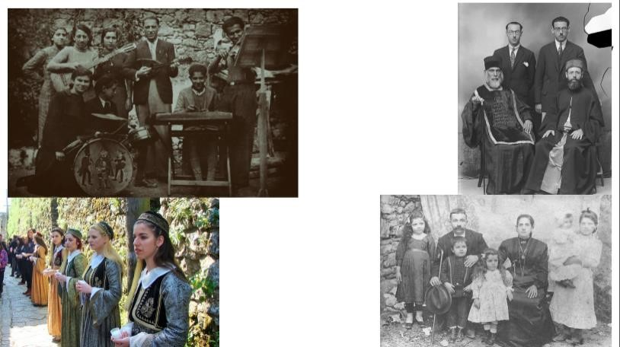

Jews made up… of the population in Greece.
Overall, the Jewish population was around… people
Jews had been here for over… years
The type of Jews in Greece were mostly….

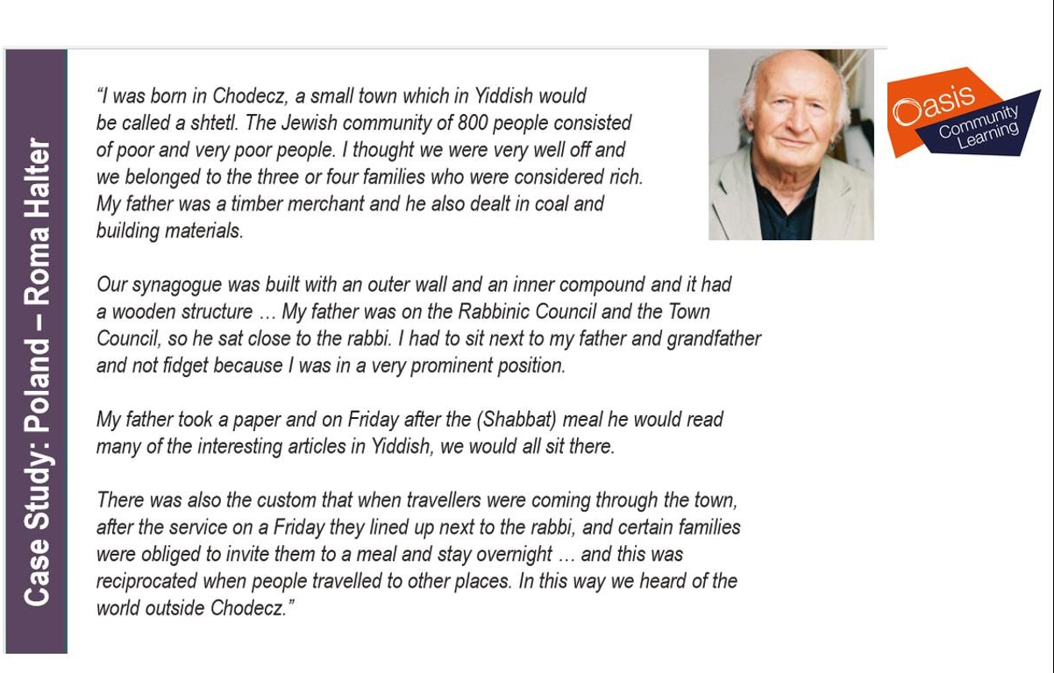
One thing I can infer about Jews in Poland is…
I know because it says….
Another inference is…
I know because it says….
Third inference:
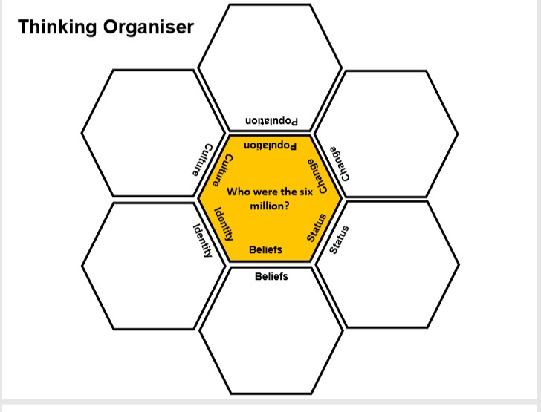
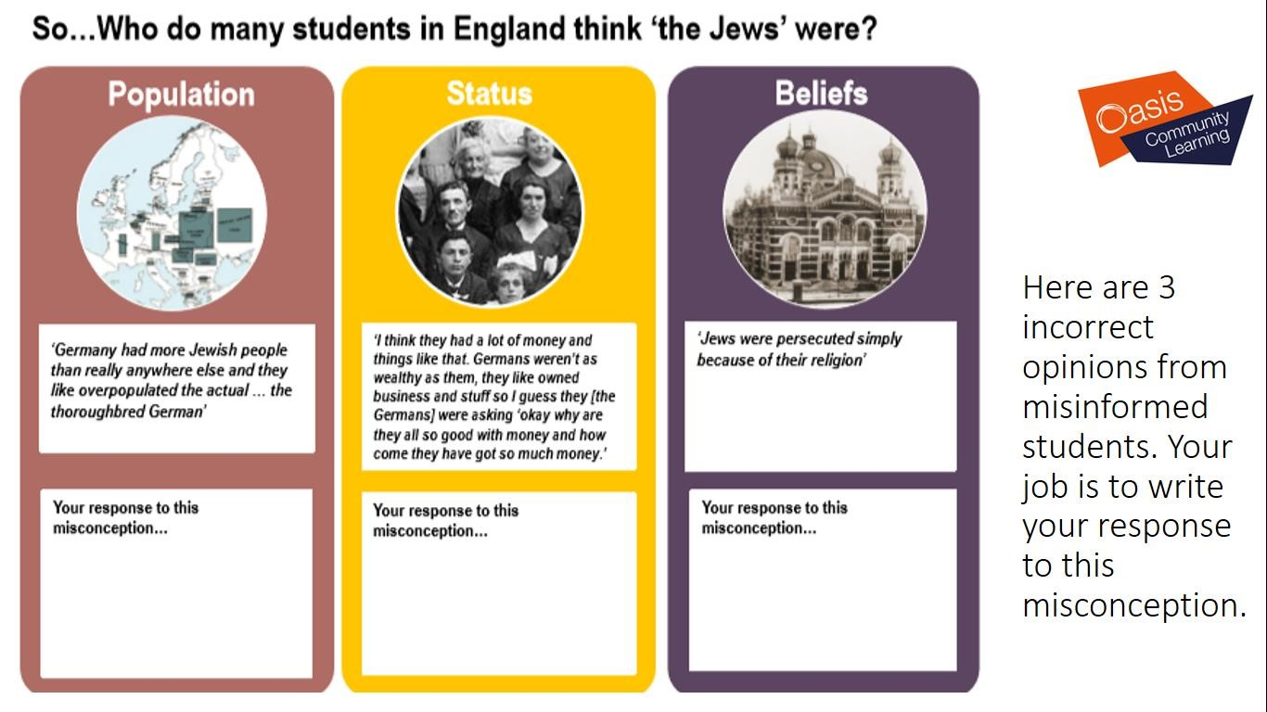

The Jewish population of Europe in 1933? Who were the 6 million?

1. Who was a top European Jewish psychologist?
Albert Einstein | Sigmund Freud | Marc Chagall
2. The % of Jews who lived in Germany in 1933 was..
0.75% | 10% | 50%
3. The amount of Jews who lived in Germany at this time was…
500,000 | 1 million | 2 million
4. Jews had lived in Germany for
80 years | 800 years | 1600 years
5. The % of Jews who lived in Poland was
10% | 20% | 50%
6. The amount of Jews living in Poland
3.3 million people | 5 million people | 10 million people
7. Name 3 other countries where Jews lived in Europe in 1933
8. Some Jews were members of the BUND. This was…
An organisation promoting worker’s rights | An organisations promoting women’s rights. | An organisation promoting civil rights.
9. The Jewish holy day of the week is known as the ..
Shabbat | Shul | Shteti
10. A small town, often with poor living standards where a Jewish community live
Shabbat | Shul | Shteti
11. You cannot generalise about Jews in Europe because…
The population of European Jews was too small and centred in Germany. | European Jews are all the same and like to be seen as the same as each other. | European Jews all have different histories, traditions, ways of life, language and worship.

What was the Holocaust? Stage 1 Removing Jewish Influences from society.
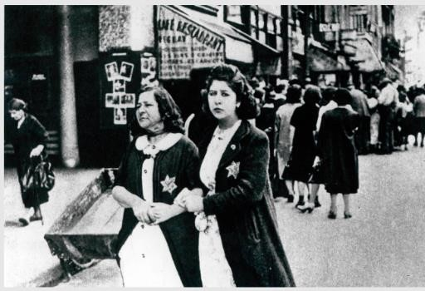
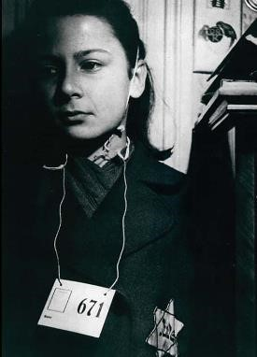

Historian Christopher Browning defines the Holocaust as the ‘genocide of the Jews.’ The Holocaust (Shoah in Hebrew) is the term for the murder of an estimated six million Jews by the Nazi regime and their collaborators during the Second World War.
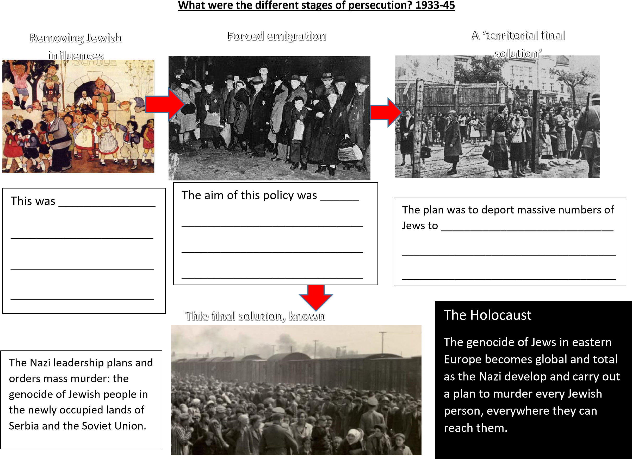

Task: Match the meaning of the word with the definition by drawing a line
Genocide |  | The term for the murder of an estimated six million Jews by the Nazi regime and their collaborators during World War 2.
Anti semitism |  | The Hebrew word for the mass murder of Jews under the German Nazi regime during 1941–5; the Ηolocaust.
Shoah |  | Hostility to or prejudice, discrimination and persecution against the Jews.
Ghetto |  | The deliberate killing of a large group of people, especially those of a particular nation or ethnic group.
Holocaust |  | A part of a city, especially a slum area, occupied by a minority group or groups. Often people are put in or restrict to an isolated or segregated area or group.

Stage 1: How did the Nazis remove Jewish influences from their society? 1933-3
Here are just a small selection of laws that were put into place between 1933 and 1939
 | Anti Semitic legislation | How would this have impacted on the lives of Jews?
March 1933 | Jewish lawyers are banned from conducting legal affairs in Berlin.
April 1933 | Aryan and non Aryan children not allowed to play with one another.
August 1933 | Jews are excluded from choirs | Jews are beginning to be socially isolated from their peers. Their lives begin to lose meaning, they are being prevented from contributing to culture.
September 1933 | 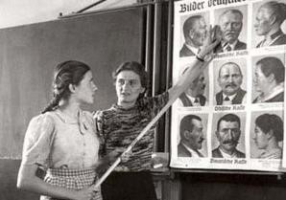  ‘Race studies’ becomes part of the school examination syllabus.
March 1935 | Jewish musicians are not allowed to practice their profession & Jewish writers cannot write. | The Nazis intensified their range and depth of discrimination and removal of Jewish influences. Jews with money would be attempting to emigrate by now.
July 1935 | Young Jews are not allowed to go hiking in groups of more than 20.
September 1935 | Nuremberg Laws – Marriages and sexual relationships with Jews was now banned. Jews had their German citizenship removed.
January 1936 | Jews must hand over all electrical equipment, bicycles, type writers and records. | Jews would struggle to communicate and spread messages within Germany and outside to the world.  Forming opposition and defence would be tough.
April 1936 | Jewish vets are banned from practising. | Jews were prevented from becoming professionals. Not only are Jews being forced into low paid jobs but they have lost their power, influence and status.
April 1937 | Jews are forbidden to obtain a  doctorate
October 1938 | 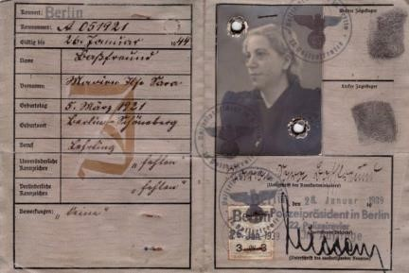  Jewish passports stamped with a J. Any Jews whose emigration was seen as undesirable had their passport removed.
November 1938 | Jewish children expelled from state schools.  Jews cannot buy newspapers  Jews banned from running a business, university, going to cinemas, theatres, operas & concerts. | Jews are being forced into absolute isolation, they have no rights, no opportunity to earn money, no access to society. This is social, economic and political isolation. They have no power to defend themselves and are losing the ability to even escape Germany.
April 1939 | Jews can be evicted from their homes without any reason. They had already lost their jewellery in Feb 1939.

An example of a law that would have had a social impact on the Jews was …
More specifically….
An example of a law that would have had an economic impact on the Jews was …
More specifically….
An example of a law that would have had a political impact on the Jews was
More specifically…
Thinking point: Was there a turning point in the pattern of the anti Semitism? Was there a point where there was an opportunity for it to be stopped?
What can we learn from Uri Ben Ari about the experience of a Jew living in Germany during the years 1933-39?
The number of Jews in Uris school was …
Every morning Uri had to study…
When Uri asked to be excused from this lesson he received…
The other account highlighted how as Jewish children they faced extreme persecution in 1934. For example…
His father was a gunner in world war 1 and a member of the German Front Fighter Association. But in 1933…
His parents said they may never have thought about leaving Germany until 1938. This was because…
The final comment was the “The problem with the German Jewry …it was so much a part of German
society…that the Nazis blew hit from within…It didn’t come from without as for the Polish Jews.” This means that…
What can we learn from John Fink about the nature of anti-Semitism in Germany between 1933-39?
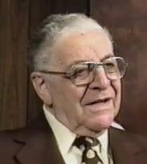
John Fink was a German Jewish Youth, an electrician’s apprentice, Berlin.
“When Hitler came to power I had to leave my school. I went to a Jewish school for one year then my parents decided, as there was no sense in continuing education, I should learn a trade. They found me a position as an apprentice in a small Jewish outfit, just the boss and me. I was fourteen years old. We had a motorcycle with a sidecar and we did gas and water installations as well as electrics. In 1936 the boss, who was married to an ‘Aryan’ woman, had to flee Germany. He went to South Africa and I lost my job. I was lucky enough to find another job in Berlin, again in a small electrical contractor where I finished the four years’ apprenticeship.”
It is possible to infer…
Because he says…
The Nazis began removing Jewish influences to encourage them to leave Germany voluntarily from..
1918 | 1933 | 1939
After 1945 which of these words was created to explain what happened to the European Jews? (pick 2)
Genocide | massacre | Holocaust
Phase 1 of the events that built up to the Holocaust has been referred to as..
Removing Jewish influences | Ghettos | Forced migration
In 1933 which of these laws were introduced? (pick 2)
Jewish lawyers banned from practise | Jews forced into ghettos | Aryan children were not allowed to play with non Aryan children.
Jewish people could not go hiking in groups of more than 20 from
1933 | 1935 | 1939
The Nuremburg Laws were introduced in what year?
1933 1935 1939
The Nuremburg laws meant the Jews lost their right to….. (pick 2)
work | Be a German citizen | Marry and/or have a relationship with a non Jew.
Jewish passports have to be stamped with a J. Passports belonging to Jews whose emigration is undesirable are to be confiscated. In what year were these restrictions introduced?
1935 | 1938 | 1939
Jews were not allowed out after 8pm after what year?
1933 | 1935 | 1939
From 1939 restrictions on Jews increased. (Pick 2)
Jews forcibly be evicted from their own home | When emigrating Jews had their personal valuables removed | Jews could keep their own businesses.

Today we are going to examine how the persecution of the Jewish community lead to the Holocaust. Phase 2
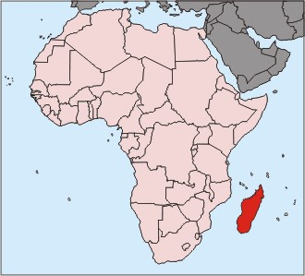
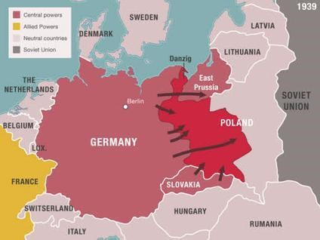

The Nazis from December 1938 began to force their migration. More specifically, the Jewish community faced…
Goering ordered the Jews to…
Things worsened by January 1939 when Hitler commented…
The Nazis even talked about creating Jewish reservations in …
Invading Poland after 1939 meant the Germans had to change their policy on how they had been treating the Jews. This was because…

The hell of the ghettos: Phase 3
The Nazis solution with dealing with the Jews in Poland was to concentrate Polish Jews into ghetto’s with the aim of transporting them to a reservation when it was found.

A ghetto were enclosed districts that isolated Jews by separating Jewish communities from non- Jewish communities. They varied in size but there were hundreds in German occupied Poland.

The largest ghetto was in Warsaw and was completed by November 1940. The conditions were beyond difficult. More specifically…

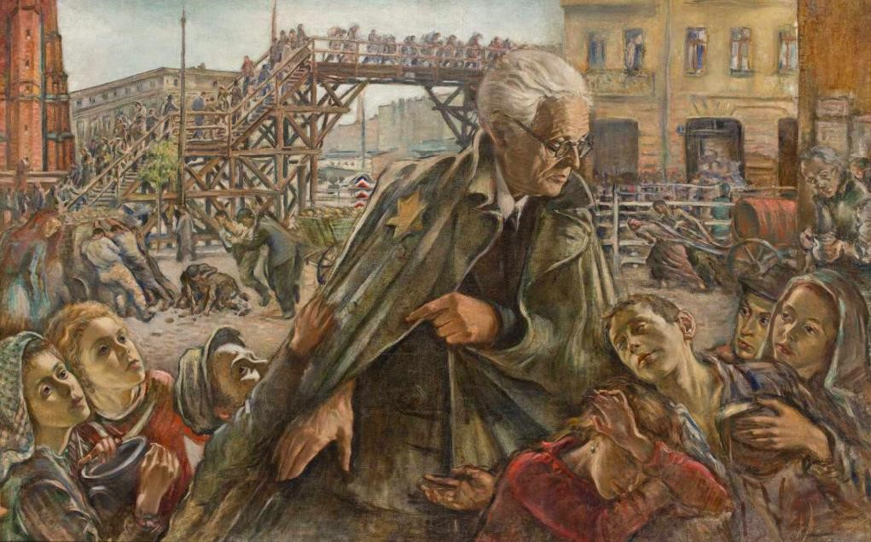
What can we infer from Izrael Leizerowicz’s painting about life in the Lodz ghetto for Jews in 1940?

I can infer….
Detail that tell me this is…
Second inference:
Why is Emanuel Ringelblum’s diary so important?
Emanuel was a Polish- Jewish historian, teacher and political activist. In 1940 he and his family were forced into Warsaw ghetto. He realised the world needed to have evidence of what was happening to the Jews. At risk he and others documented what was going on. They hid notes in 3 metal milk cans and 10 metal boxes. The documents were discovered after the war, sadly Ringelblum and his family were killed by the Gestapo.
Remaining alive are only those who worked, directly or indirectly, for the Germans. The history has never seen such a tragedy of a nation. The nation which hates the Germans with all their senses, can escape death only by paying the price of helping the enemy [...]. As a result, the Warsaw Ghetto works intensively for the Germans.
Clothes of killed soldiers are being altered, waistcoats, jackets and padded trousers are being made for winter. They are also making straw shoes, furniture etc. The main center for all of this is the company “Toebbens” at Prosta 12, where more than (Jewish ) 1000 workers are employed.
Emanuel Ringelblum, 8th May 1942, Warsaw
We can learn a lot about the ghetto from Ringelblum’s account, for example…+More specifically…+furthermore….

Dozens of smugglers were eliminated tonight through the known process of dragging people from their homes and shooting them in the street. The slaughter by the walls took place also this morning and last night. „Frankenstein”, disguised as a Jew, with an armband — shot, with a machine gun hidden in a bag, a few Jews. The same thing happened in other places, especially in the small ghetto, in the Krochmalna and Warm Street.
The plan to exterminate the Jews in Poland is apparently being executed in larger cities through starvation. They are doing it in Łódź. The same is beginning to happen now in Warsaw, where they [the occupiers] want, at all costs, to eliminate smuggling and thus force the Jewish people to be content with 7.5 decks of bread a day.
Emanuel Ringelblum, 10th June 1942, Warsaw.
We can learn a lot about the ghetto from Ringelblum’s account, for example…+More specifically…+furthermore….
Ringelblum’s account is very valuable. This is because…

The Final solution: Phase 4: mass murder. The hell of the Einsatzgruppen

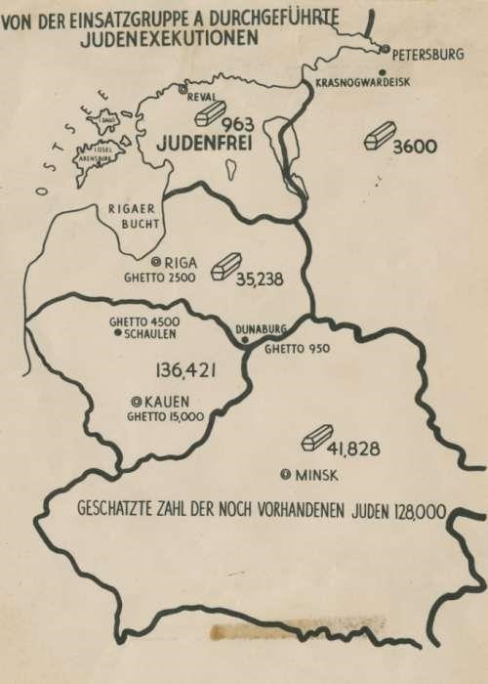

When the Nazis entered the Soviet Union an order was given to target…
The men who carried this out this belonged to the Einsatzgruppen – These were…
This had a devastating impact, the Holocaust had begun. More specifically…
One of the worse massacres was…

What can we learn from Raisa Dashekevich about the Einsatzgruppen?
What was operation Reinhard?
From Autumn 1941 the idea of creating reservations or resettling Jews ended as plans moved to mass murder. This was known as Operation Reinhard. In Poland, at Chelmno exhaust fumes in vans were being used to suffocate the Jews.
The Nazis felt this had less psychological impact on the SS killing squads and allowed larger numbers of Jews to be killed. 1942: New death camps were created. Belzec, Sobibor and Treblinka
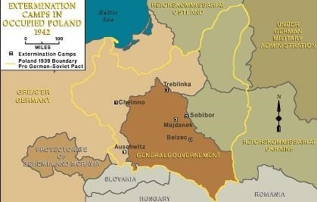

Camps like Sobibor, Belzec and Reblinka were top secret. They were run by…
Typically located near…
Because…
On arrival to these camps, the procedure was…

Why was the Wannsee conference important?

Organiser of the Wannsee conference was the Nazi lieutenant called…
The date of the meeting was…
At this meeting he organised…
Historian Christian Browning highlights the statistics show significance of this conference. Shockingly…

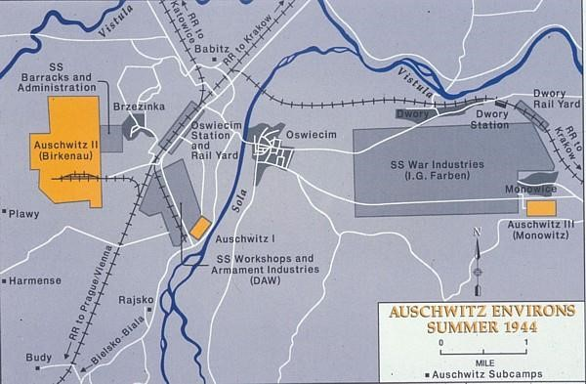
Auschwitz, the horror of the largest death camp

Auschwitz in Poland was constructed by October 1940, outside a village called Oswiecim –the German name was Auschwitz. Experiments using Zyklon B, a gas begun here in Sept 1941. By late 1941 it was expanded and was the Nazis chosen site for mass extermination. Auschwitz II – Birkenau was created. There were 4 gas chambers and a crematoria. Jews were brought here in cattle trucks with no water or toilets, they endured journeys from hell. On arrival Jews were split by doctors and guards into those fit to work as slaves in their factories or those who faced immediate death.
At its peak 12,000 Jews were killed here every day. An estimated 1.1 million Jews were killed here, 1 in 6 of all victims. In January 1945 the Soviets liberated camp, sadly not before Himmler had ordered the destruction of the gas chambers and took thousands on death marches to Germany.
What can learn from Ziggy Shipper about the Holocaust?
Ziggy eventually understood why so many women were dying in the ghetto. This was because…
Ziggy jumped from the lorry because he realised …
Ziggy’s experience about being transported on the cattle trucks was..
On arrival Ziggy observed…
Even today Ziggy struggles to understand what about the guards:
Ziggy would like to meet Hitler today and tell him…

When the Nazis invaded what country was the order given to kill all hostiles, what begun?
Holland | Poland | Soviet Union
The SS sent mobile killing units who were supported by the locals from Autumn 1941, this was called the
Einsatzgruppen | segregation | Extermination camps
How many SS men and locals were involved in these killings, like the Babi Yar
10 | 100 | 1000
Between Autumn and winter 1941 how many Jews were killed this way?
Over 6 million | Over 1 million | Over 445,000
In 1941 operation Reinhard begun, they felt that shooting squads were psychologically draining so begun to use
Gas | bullets | ghettos
To achieve this camps were set up in
Germany | Belzec, Sobibor and Treblinka | Warsaw and Lodz
Heydrich’s Wannsee conference was in
January 1939 | January 1941 | January 1942
The Wannsee conference was important because…
Between March 1942 and February 1943 what proportion of Jews were killed across Europe?
20% | 60% | 80%
One of the largest extermination camps killed over one sixth of all Jews, over 1.1 million was..
Belsen | Treblinka | Auschwitz

Who is responsible for the Holocaust? Who killed Leon’s wife and child?
The UCL centre of Holocaust education highlighted that there are 4 groups of people who are involved in the Holocaust. In the table can you match the category of these people with their correct definition?
Perpetrators  Collaborators  Bystanders  Rescuer and resisters |  | Saved people or tried to stop the Nazis.
 |  | Ordered, organised or carried out the persecution.
 |  | Supported the Nazis. Helped make the killing possible.
 |  | Did nothing to support the Nazis or to help their victims.

Person involved in the Holocaust | Named example | Explain why they fit this category?
The
Perpetrators
The collaborators | The | The
The Bystanders
Rescuers
The resisters

Who killed Barney Greenman? Is Hitler solely responsible for the Holocaust and the deaths of over 6 million Jews and over 7 million citizens across Germany and Nazi occupied Europe?

What was the nature of Jewish resistance?
What caused the Warsaw ghetto uprising?
What actually happened?
Why was the uprising important?

Name & details | Details of their resistance | What type of resistance was this? | Why was their resistance important? What was the effect of it? (Short term and long term)
HenryK Ross was a talented Polish photographer imprisoned in Lodz ghetto | Henryk took photographs of living conditions and working conditions of life in the Lodz ghetto.  Henryk even took photos of formal events and provided evidence to the Nazi occupiers of the ghetto’s usefulness.  He also secretly recorded everything from children playing, through to starvation, deportation and death. When the ghetto was liquidized in 1944 Henry buried a box containing thousands of negatives. After surviving the war, Henryk returned and recovered the box with images . He gave evidence at the trial of Adolf Eichmann in 1961.
Alice Herz-Sommer was a exceptionally talent pianist living in Czechoslovakia. Married Leopold and had 1 son called Raphael. | When the Nazis occupied Czechoslovakia she was no longer allowed to play in public but raised money by teaching. In 1943 Alice, Leopold and Raphael were sent to the camp-ghetto Theresienstadt. She performed concerts for the other prisoners, some were used by the Nazis to mislead the International Red Cross that the Jews were treated humanely.  In September 1944 Leopold was sent to Auschwitz, and then Dachau where he died of an illness. Alice and Raphael managed to survive and were liberated in 1945.  “People ask, 'How could you make music?' We were so weak. But music was special, like a spell, I would say. I gave more than 150 concerts there. There were excellent musicians there, really excellent. Violinists, cellists, singers, conductors and composers.”
Masha Brushina was a teenager who lived in the Soviet Union. When the Nazi invaded Minsk in June 1941 Masha and her mother were forced to move to the ghetto. | After escaping Masha tried to hide her Jewish identity by dying her hair and using her mother’s maiden name. A fierce Communist, Masha joined a resistance group. She worked in the hospital nursing wounded Soviet soldiers before helping them escape into the forests.  On 14 October Masha was arrested after a patient told the Nazis what she was doing. Along with other prisoners she was tortured, but Masha refused to submit. Twelve days later the Nazis paraded Masha and two other prisoners through the streets. A placard was hung around her neck saying “We are partisans who shot at  German soldiers”. The three were then hung, their bodies were left hanging for three days. Masha was 17 years old.
Rabbi Kalonymus was a religious leader, writer, teacher and founder of a religious school in Warsaw, Poland.  When the Nazis invaded Poland his wife, son and close family were killed in a  bombing raid. | Kalonymus was given opportunities to flee Warsaw, but he chose to stay and was interned in the ghetto. There, he worked tirelessly to maintain Jewish cultural life and act as a spiritual leader. He upheld various social customs, created a secret synagogue, and delivered sermons to a small congregation.  In early January 1943 Kalonymus buried his writings. Months later he was deported from the ghetto and after passing through various camps was killed in Operation Harvest Festival, November 1943.(The largest single execution of Jews during the Holocaust – 43,000 murdered)
Nahum Remba  was the secretary of the Jews in the  Warsaw ghetto  and did his best to fight corruption and support cultural activities. | During the deportation process in 1942, Jews would be rounded up in the Umschlagplatz –a sealed-off area by the railway station. They were held here before being taken to Treblinka death camp. Here the Jewish council put a first-aid post, although it offered little. As the deportations began in July 1942 Nahum took to wearing a white doctors’ coat and went around the area identifying people he claimed were too ill to travel, and convinced the guards to allow them into his “clinic”. Once they were inside, the Jews were then “treated” before being smuggled back to the ghetto. By the spring of 1943 the Nazis had discovered this, and he was deported to Majdanek, where he was killed in Operation Harvest Festival, November 1943.
Zalman Gradowski was a prisoner in Auschwitz-Birkenau who was forced to lead Jews  into the gas chambers. He dragged out their bodies, took their gold teeth and burned their bodies. | After the war, documents were found buried in the soil of Auschwitz-Birkenau, written by Jewish prisoners like Zalman Gradowski.  They knew that the Nazis would try to hide their crimes, and that they would be murdered to stop them telling what they had seen. So they hid these papers in the human ashes they were made to bury, in the hope that one day the truth might be discovered. Zalman Gradowskiwas also one of the leaders of the revolt of 7 October 1944. He was killed after the Jewish prisoners attacked their SS guards and blew up one of the crematoria in AuschwitzBirkenau.
The Auschwitz Revolt  Esther,17, her sister, Hanka, 15, smuggled out tiny bits of gunpowder from the  factory, hidden in their clothing. They gave this to Rosa who passed it to members of the Auschwitz resistance to make homemade bombs. | On 7 October 1944, the Jewish prisoners attacked their SS guards with hammers, stones and axes. With their homemade bombs they blew up the crematoria then cut the barbed wire surrounding the camp and fled into a nearby wood. Hundreds of prisoners escaped, but all were recaptured and killed.  The SS discovered that Rosa, Regina, Ella and Ester had stolen the gunpowder. Despite being tortured they refused to give the names of others in the resistance. The four women were taken to the gallows to be hanged in front of the other inmates. At the last moment of her life, Rosa Robota cried out to the crowd: ‘Be strong and have courage!’
Jack Kagan was 14 when in September 1943 he was in a labour camp in Nowogrodek, Poland. He joined Jews planning to escape from the camp through a dug-out tunnel and meet up with local partisans. | Jack was one of 200 who fled the camp, but as he crossed a frozen river his boots became drenched with frozen water. He missed his rendezvous with the partisans. Jack came across a farm, but the lady living there was too frightened to give him shelter. Jack made his way back to Nowogrodek and sneaked into the camp on a horse-drawn cart. His toes were frost bitten so a dentist amputated them. Some remaining in the camp began a new tunnel, once completed Jack was one of the last to get out before it was discovered. This time he managed to meet the partisans and joined the Bielski brothers. Jack survived the war as one of the 30,000 Jews who fought the Nazis in the forests of Eastern Europe.

