Year 7: Spring 1
How similar were the changes affecting England and Benin in the 16th century?

Name: _____________________ Class:__________________ Teacher: ______________

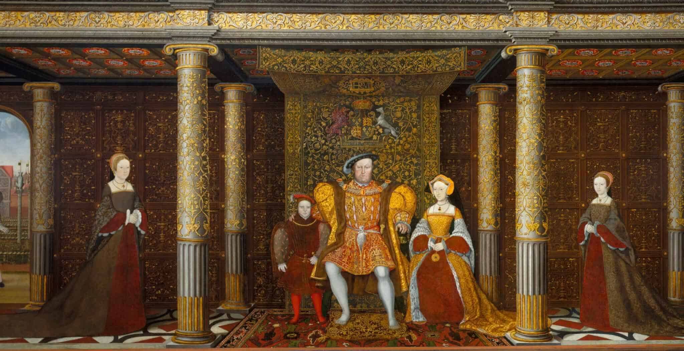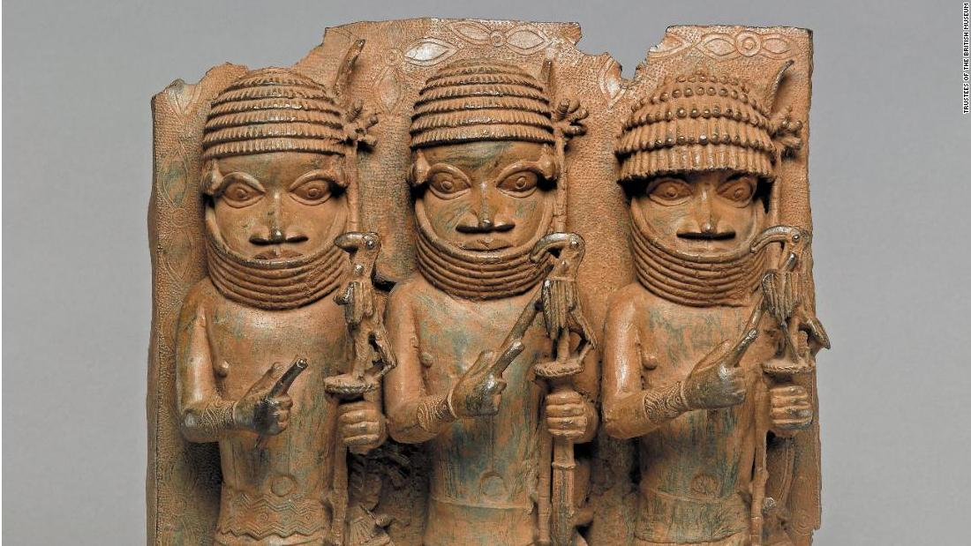

Contents
Lesson/Resource | Page Numbers | Tick when complete
Knowledge Organiser | 2
Blank Knowledge for look/cover/write/check | 3
First ‘do now!’ | 4
- Changes in Tudor England | 5-8
- Changes in the Kingdom of Benin | 9-12
- Power in Tudor England and Benin | 13-18
- Society and culture in Tudor England and Benin | 19-23
- Similarities and differences | 24-25
- Writing | 26-27
Learning Ladder | 28
“Because, but, so” vocabulary table | 29

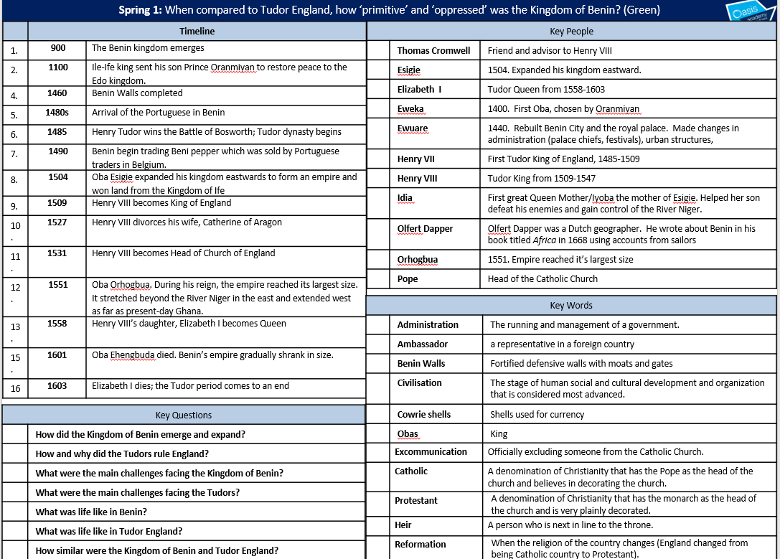
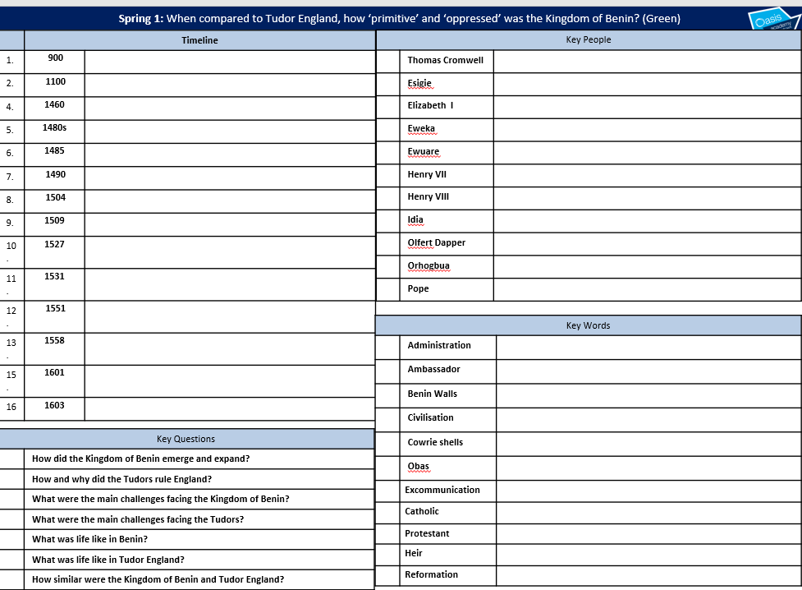
Lesson 1 Do now!
1. In which century is the year 1534?
15th | 16th | 14th

2. Write in the correct name of the century next to these years:
1428
1716
1515
724

3. 1534 is in what period of history?
Middle Ages  (Also known as the Medieval Period)  500- 1500 | Early Modern Period  1500-1700 | Industrial Period  1700-1900 | Modern Period  1900-present

4. What is Henry VIII most famously known for?
The Reformation – changing the religion of England | Defeating Harold Godwinson at the Battle of Hastings | Being King of England during the peak of the British Empire

5. Historians state that Henry VIII broke with Rome. What does this mean?
Rome is in Italy. The Pope is head of the catholic church and lives in a place called the Vatican (in Rome). Breaking from Rome means Henry VIII no longer visited Rome. | Rome is in Italy. The Pope is head of the catholic church and lives in a place called the Vatican (in Rome). Breaking from Rome means that England was no longer a catholic country.

1. Why did the Kingdom of Benin experience lots of change in the 16th century?

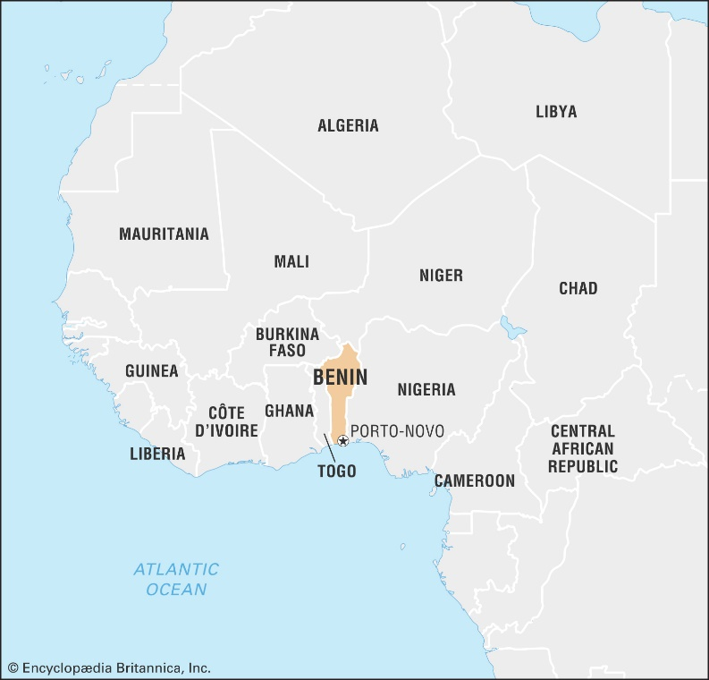
“Until the Lion has a historian of it’s own, tales of hunting will always be about the hunter”
- African proverb
Explain: In other words….
Example: This means that…

The kingdom of Benin began in the 900s when the Edo people settled in the rainforests of West Africa. Why is it important?
- Africa is a continent. It contains many diverse countries, of which Benin is one. Learning about Benin will help us understand part of African history.
- African histories have often not been taught in schools.
- It can help us better understand English history in the same period.
- Understanding one part of African history before the slave trade can help tackle beliefs that emerged during that time.

Tick which you think are correct
Africa has many countries | African history is all the same | Understanding Benin can help us better understand England at the same time
Being taught about Benin is only relevant if you are from Africa | Understanding Benin can help us better understand how racist attitudes emerged | African history is relevant to you as a student

How did the kingdom begin?
Around the year 900 groups of Edo people began to cut down trees and make clearings in the rainforest. At first they lived in small family groups, but gradually these groups developed into a kingdom. The kingdom was called Igodomigodo. It was ruled by a series of kings, known as Ogisos, which means ‘rulers of the sky’.
In the 1100s there were struggles for power and the Ogisos lost control of their kingdom. According to Edo oral sources, village chiefs (the Uzama) sent a messenger to a neighbouring country to request a divine ruler to restore order after a period of disruption as they feared their country would fall into chaos. They asked the King of Ife, for help. The king sent his son Prince Oranmiyan to restore peace to the Edo kingdom.
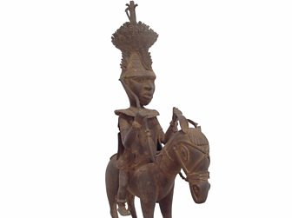
Prince Oranmiyan
Oranmiyan chose his son Eweka to be the first Oba of Benin. Eweka was the first in a long line of Obas, who reached the peak of their power in the 1500s.
Edo - a member of a people inhabiting Benin
Oba – a local chief
Uzama – village chiefs

True or false?
 | TRUE | FALSE – write the correct answer
- The Edo people had a kingdom called Igodomigodo
- This kingdom was ruled by kings known as Ogisos, which means ‘rulers of the earth’
- In the 12th century, the Edo asked the King of Ife for help
- The King went to restore peace to Edo
- Eweka was the first Oba of Benin

How did Benin become an empire?
Around 1440, Ewuare became the new Oba of Benin. He built up an army and started winning land. He also rebuilt Benin City and the royal palace. Oba Ewuare was the first of five great warrior kings. His son Oba Ozolua was believed to have won 200 battles. Changes in the way that the country was organised and run (administration) consolidated the kingdom, with the establishment of palace chiefs and royal festivals which were meant to protect the kingdom. Such festivals were dedicated to the Oba’s sacred ancestors, and strengthened the Oba’s divine powers. A big part of Benin’s rise was Oba Ewuare’s reputation as both a magician and warrior. The belief that the dynasty was supernaturally gifted fed military success, which in turn fed this belief.
Ewuare also expanded the urban structures of Edo, improving the road system. This was able to happen due to a growth in Benin’s military power, as Benin expanded East to the land on the right bank of the Niger, South to the Ocean, and West towards Lagos.
1. Ewuare, the Oba of Benin from around 1440
Lost territory and money | Built up an army and won land | Built up an army and won land, as well as rebuilt Benin City and the royal palace
2. His son Oba Ozolua was believed to have won
200 battles | the royal palace | Important festivals
3. Festivals were very important because
They were a chance to relax | They celebrated ancestors and strengthened the belief in the Oba’s divine powers | They were a good way to spend the money earned in war
4. Oba Ewuare had a reputation for being a good
Father | Magician and warrior | Religious leader
5. The Kingdom expanded East to the Niger River and
South towards Lagos | West towards Lagos | South to the Ocean, and West towards Lagos

What happened to the kingdom?
Ewuare was followed by Oba Esigie in 1504, who expanded his kingdom eastwards to form an empire and won land from the Kingdom of Ife. During this time, trade with the Portuguese began. Benin used wealth from trade to build up a vast army.
Trade in the 1490s started with Beni pepper which was sold by Portuguese traders through their markets and networks in Belgium. Although this allowed the empire to expand, by the end of the 16th century, the empire began to shrink.
- How did trade with Portugal help the Benin kingdom?

- What did the Portuguese buy, and where did they sell it?

Although the empire declined, it was still seen as very impressive by visitors. This is what a Dutch writer, Olfert Dapper, was told by traders in 1688:
‘Benin City has wide, straight roads. The houses are large and handsome. The people are very friendly and there seems to be no stealing.’
I can infer/ work out that…
Detail that tells me this

There were political changes in 16th century Benin, for example…
These changes were (use RATE, NATURE, EXTENT terms)…
Because…

There were economic changes in 16th century Benin, for example…
These changes were (use RATE, NATURE, EXTENT terms)…
Because…

2. Why did Tudor England experience lots of change in the 16th century?

The Tudors were a family who became the Royal family in England in the late 15th century. The most famous member of this family is probably Henry, who became Henry VIII of England.

Background on Henry VIII
Henry became King of England on 21st April 1509 after the death of his father, Henry VII. Henry VIII was 17 years old at the time. Henry VIII nearly didn't become King. Henry VII's eldest son was Arthur, and therefore heir to the throne. Arthur died at the age of 15 in 1502, meaning that his younger brother, Henry, would take his place as future King. Henry VIII famously married six times.
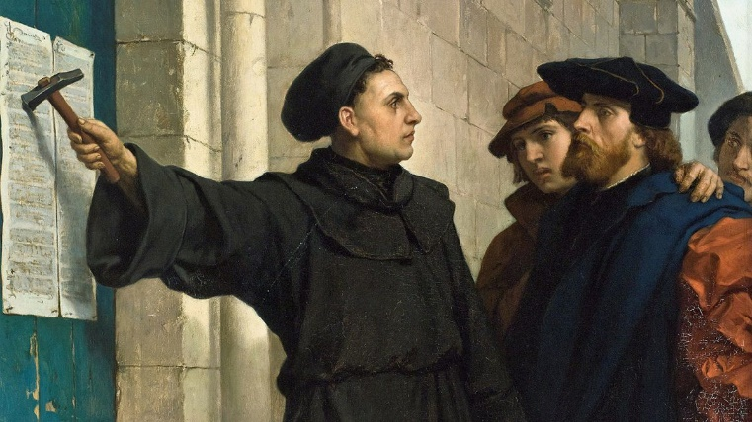
Who was Martin Luther?
A monk named Martin Luther began to question the practices of the Catholic Church. He found many areas where he felt the Bible and the Catholic Church disagreed, for example that the Bible should be read in your own language and not Latin. He disagreed with the Pope and began the protestant religion in PROTEST.

Less Money for the Church
One of the practices that Luther disagreed with was the paying of indulgences. This practice allowed people to be forgiven of their sins when they paid the church money.
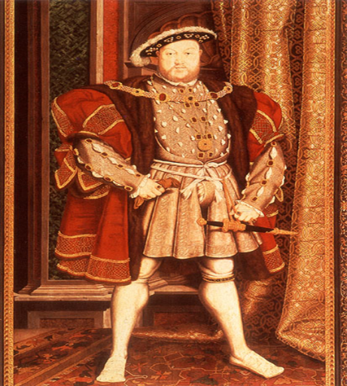
The Reformation
The Reformation occurred during Renaissance times. It was a split in the Catholic Church where a new type of Christianity called Protestantism was born. In 1534 Henry VIII split the English Church away from the Pope and Catholicism.

As a young man, Henry disagreed with Martin Luther. He was given the title ‘Defender of the Faith’ by the Pope.

Check your understanding by answering the following questions.

1. Henry became king of England in 1509. More specifically Henry became King because…

3. Martin Luther believed in the idea of Protestantism. More specifically….

4. One of the practices that Luther disagreed with was the paying of indulgences. This means
5. Henry VIII disagreed with Luther and was awarded the title …….
6. The Reformation was…..
Challenge! Answer these questions in your books.
- Why did people start to question the Catholic Church and Pope?
- What can we learn about Henry’s religious views from 1517?

Before 1534, everybody in England was supposed to be a Catholic – there was only one type of Christianity. This is also known as being Roman Catholic, because the leader of the Catholic Church was the Pope in who lived in Rome. However, Luther’s ideas started to spread in England.
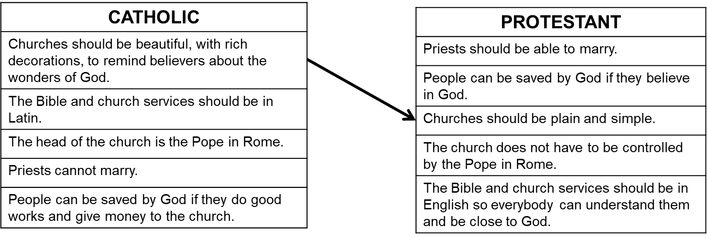
Check your understanding by drawing lines to match up the OPPOSITE beliefs.

Check your understanding by drawing lines to match up the OPPOSITE beliefs.
2. Catholics believed the bible and church services should be in Latin but Protestants believed…
3.Protestants believe priests should marry but Catholics believe…
4.Catholics believe that churches should be finely decorated but protestants believe…
5.Name a catholic early modern monarch:
6.Name a protestant early modern monarch

So why did Henry ‘break with Rome’?
He wanted a son
Henry desperately wanted a son and argued that his marriage to Catherine of Aragon, with whom he had a daughter, was not lawful. He asked Wolsey to use his influence in Rome to get a papal annulment of Henry's marriage so that he could remarry. Wolsey was unable to accomplish this, partly because Catherine's nephew, the Holy Roman Emperor Charles V, dominated the pope at the time. Wolsey was widely disliked, particularly among those around Anne Boleyn, Henry VIII's prospective new bride. Wolsey's failure to arrange an annulment for Henry was quickly followed by his downfall. Wolsey was arrested near York in November 1530 and accused of treason. He died on 29 November of the same year at Leicester on his journey south to face trial.

Henry grew impatient and was desperate for a son. Therefore, in 1533, Henry VIII broke with the church and married the now pregnant Anne Boleyn in a secret ceremony. The Pope excommunicated Henry. The English reformation had begun.

He wanted money
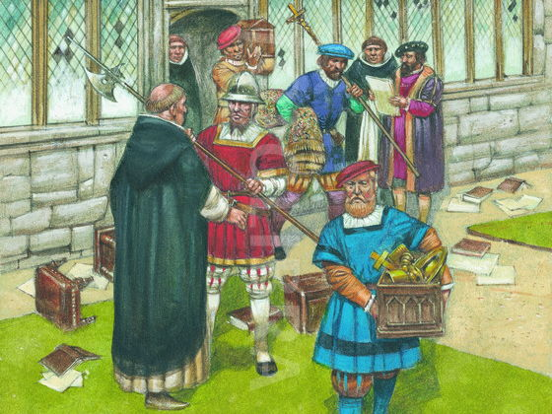
Henry sent round government officials to check up on what the Catholic monks were doing in the monasteries. This was organised by his chief minister, Thomas Cromwell. The officials knew what the king wanted in their reports – information that the monks were not working, were not saying their prayers etc. By doing this, the King could justify the ‘dissolution’ of the monasteries – meaning they were closed down. Henry made £15,000 from dissolving the monasteries.
He wanted power
In 1534, Parliament passed the Act of Supremacy, recognizing King Henry VIII as supreme head of the church in England. Nobles and lords had to swear an oath recognising the King as head of the church. Catholics, most famously Sir Thomas More, who still held the Pope as the supreme head of the church, refused to swear this oath, and were indicted for treason and hung.

Check your understanding
1. The definition of the reformation is:
The changing of England’s religion from Protestantism to Catholic | The changing of England’s religion from Catholic to Protestantism | The changing of a monarch from King to Queen
2. Martin Luther was….
A monk from Germany who disagreed with the Catholic church and wanted to change the religion to Protestantism. | A monk from Germany who disagreed with the Protestant church and wanted to change the religion to Catholicism. | A monk from Germany who wanted to over through the Pope and become head of the catholic church.
3.In a Protestant church you would find…
A German Bible, wooden pews, lot of decorations and priests are allowed to marry | An English Bible, wooden pews, no decorations, priests can marry. | A Latin Bible, lots of decorations, priests cannot marry.
4. Henry VIII became king of England in ….
1507 | 1508 | 1509
5. Henry’s successor was….
Elizabeth | Edward | Mary

There were political changes in 16th century England, for example…
These changes were (use RATE, NATURE, EXTENT terms)…
Because…

There were economic changes in 16th century England, for example…
These changes were (use RATE, NATURE, EXTENT terms)…
Because…

- How powerful were the Tudors and Obas of Benin?

Power in Tudor England
According to historian Geoffrey Elton, there was a ‘revolution’ in the way England was run under the Tudors.
Historian Geoffrey Elton says there was a ‘revolution’ in the way England was run under the Tudors. This suggests that…

Henry VIII talked to Parliament, but Parliament was there simply to agree to his decisions. The Statute of Proclamations in 1539 gave him the right to make any laws he wanted. Henry believed it was his god given right to rule England and that the Pope, a foreign Catholic, should not have a say in England.
When Henry VIII was King, Parliament…
The Statute Of Proclamations gave Henry…
Henry also believed it was his god given right to…

When Henry destroyed the monasteries, many people were upset. There was a march to complain called the Pilgrimage of Grace. About 30,000 people took part, hoping to convince Henry to listen to Parliament. It failed, and 250 of the rebels were executed.

When Henry closed the monasteries, there was a…
This shows that Henry had power, however…

When Henry died, his son Edward became King. When he died, Edward’s sister became Queen. She was a Catholic. She had 300 people burned alive for being Protestant. Her sister, Elizabeth, replaced her in 1558. Elizabeth I, like her father Henry, bullied and controlled her Parliaments. Also, like her father, she believed it was her god given right to rule England and that the Pope, a foreign Catholic, should not have a say in England. When the MP Peter Wentworth complained about this in 1576 he was arrested and sent to the Tower of London.

Elizabeth was like Henry because she…
When MP Peter Wentworth complained in 1576…

Elizabeth was concerned that as a Queen, she might be considered unfit to rule. She spent a lot of time on tours of England, staying with wealthy nobles. These were known as progresses. She would take part in festivities to show her wealth and knowledge, and which also helped her to check up on what was happening in her kingdom! Elizabeth could show her authority and power to those who might question it. They were also a way for her to meet her ordinary subjects and also important foreign officials. Her people enjoyed these progresses too, as it was a chance for them to see their Queen.

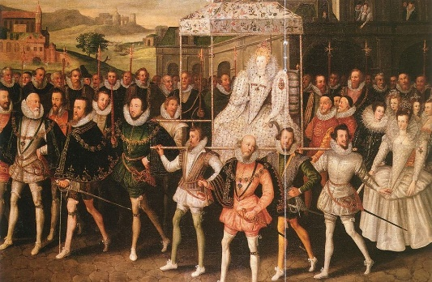 Elizabeth on progress

Elizabeth was also determined to maintain her independence from other, powerful, countries like Spain. Spain was Catholic, but Elizabeth managed to avoid invasion during the Spanish Armada of 1588 which had aimed to force England to become Catholic.

Elizabeth spent a lot of time on… which were…
The purpose of these were to…
The use of these show that Elizabeth was…
Elizabeth wanted to maintain…
Defeat of the Spanish meant that…

Henry VIII:
Always did what Parliament wanted | Told could make any laws he wanted | Did not have a Parliament
Henry believed that the Catholic Pope:
Should have no say on matters in England | Should decide on religious matters in England | Should be given more power in England
Henry’s changes were:
Rejected by everyone – as shown by the Pilgrimage of Grace | Rejected by no one – everyone was pleased | Rejected by some – as shown by the Pilgrimage of Grace
Elizabeth I was like her father. For instance:
She bullied Parliaments | She did not want the Pope to have a say in England | She arrested and imprisoned anyone who opposed her
Elizabeth went on many progresses, which were:
Tours of her palace | Tours of England | Tours of Europe

Power in Benin
The most powerful Obas put into place some of the most important pieces of Benin’s administration. Town chiefs were introduced and new roads built to connect parts of the Kingdom. The Benin walls were also built to protect Benin City. The wall, completed by 1460, covered a border distance of 16,000km. The Guinness Book of World Records (1974) describes the walls of Benin City as the world's second largest man-made structure after China's Great Wall.
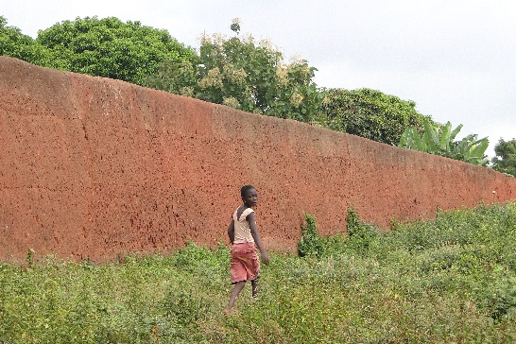
Ewuare (c.1440-1473) introduced several new religious cults to worship characters of heroic stories such as Ake, Oza and Okhwahe Other Obas founded new shrines or set up new festivals: for instance, the Ugie Erhe Oba dedicated to the Oba’s sacred ancestors, and Igue. During the 16th and 17th century, a ten foot wall was built around the capital, Edo, to protect it from enemies.

Religious power was also very important. Obas thought it was very important that foreign rulers should not have a say in Benin’s affairs. As a result, the kingdom rejected Catholic Portuguese missionaries trying to convert people.

Oba Ewuare introduced new…
Other Obas introduced new shrines and festivals, such as…
Obas also thought it was very important that…

The Obas also put in place sumptuary laws. These were laws which controlled what the people of Benin could access, make and use. This meant that they limited who could access items such as brass and coral. Only the Oba could access brass and the Oba decided who could access bronze to make items or could display it or wear it, and the same with coral.

As a result, they controlled who could dress in certain ways, wear items of jewellery of, and have certain items in their homes. This meant that the Oba was able to use items that they wore or how they decorated their palace to demonstrate their wealth and power. This was a way to control the population.

The Obas introduced sumptuary laws, which were…
Obas also controlled…

In order to maintain power, the Obas conducted a yearly cycle of public ceremonies held in and around the palace, which involved people at all levels of the kingdom. The ceremonies celebrated and strengthened the power of the king and the good order of the kingdom. A great number of people played their own parts in the ritual pageantry, as chiefs and officials, craft guilds or representatives of local communities.
Finally, Obas conducted yearly…
These were similar to the progresses held by… which shows that…

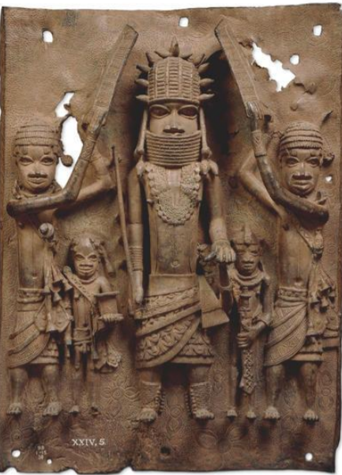 Bronze plaques were made to show these events.
This plaque shows a procession, with a king or chief flanked by attendants who shade him from the sun with their shields.
The Obas of Benin were was determined not to bow to pressure from Portuguese missionaries to convert to Catholicism. The Portuguese gave up trying to convert the people of Benin.

The Obas of Benin did not want…
The failure of the Portuguese shows that…

Oba Ewuare introduced religious cults based on characters like:
Ake, Oza and Okwahe | Ugie Erhe | Benin
Obas rejected missionaries trying to convert people to:
Islam | Catholicism | Protestantism
The Obas used sumptuary laws which were:
Laws about what people could wear | Laws about what people could eat | Laws about what people could make and use
Like Elizabeth, Obas used ceremonies to show off their power. These are shown on:
Items of clothing | Bronze plaques | Tapestries and paintings

Sources - Benin
The king shows himself just once a year to his people. He is beautifully dressed with all sorts of royal ornaments. 3 or 400 noblemen accompany their king. And a great number of musicians walk before and behind him, playing tunes on all sorts of musical instruments.
From a 1668 account by a Dutch writer called Olfert Dapper
I can infer/ work out that…
Detail that tells me this

When the nobleman are in his [the Oba’s] presence, they never look him in the face, but sit cowering...upon their buttocks with their elbows upon their knees and their hands before their faces, not looking up until the king command them...likewise when they depart they turn not their backs toward him but go creeping backward.

From a 1558 account by an English trader

I can infer/ work out that…
Detail that tells me this

Sources - England
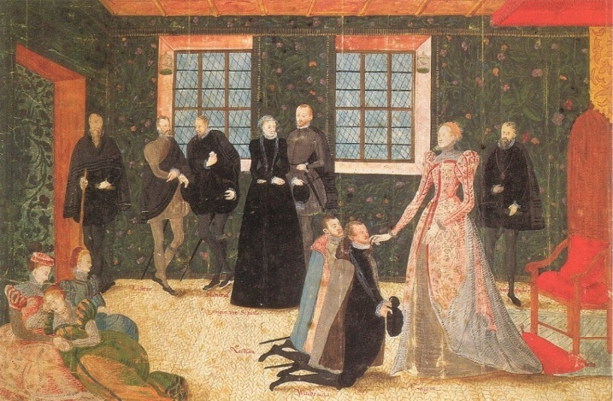 Elizabeth I receiving Dutch ambassadors
I can infer/ work out that…
Detail that tells me this

The first course of the banquet was announced with a fanfare. At the sound, a duke entered riding a huge horse covered with cloth of gold How can I describe the abundance of fine and delicate food prepared for this magnificent and lordly feast [of 9 courses] produced both abroad and in the many and various parts of this realm.

From a Tudor writer, seeing a meal for Henry VIII, 1509

I can infer/ work out that…
Detail that tells me this

Making comparisons
The Obas in the 16th century were keen to show their power. For example…
Tudor monarchs in the 16th century were keen to show their power. For example…
This shows that in both Benin and England…
This suggests that in both places, there were changes happening in the 16th century. These changes were…

The Obas in the 16th century took religion very seriously. For example…
Tudor monarchs in the 16th century took religion very seriously. For example…
This shows that in both Benin and England…
This suggests that in both places, there were changes happening in the 16th century. These changes were…

- What was life like in Tudor England and Benin?

Some historians have claimed that this period saw a ‘Golden Age’ in culture in England. This would mean:
- People became richer and happier
- Leisure time improved
- Access to culture increases

Everyday life

For peasants in the countryside, their houses would likely be made of a wooden structure covered with straw and mud. However, historians have found that by the 1570s in England, people were living much more comfortably than they had 50 years earlier. They would likely have had metal cutlery, and even pillows to lie on. The very wealthiest people built fantastic houses in the Tudor period much grander than any built before. An example is Burghley House built by William Cecil, Elizabeth I’s closest advisor.

It has been claimed that this period was a Golden Age in England.
In other words…
Most people lived in…
However…

Entertainment

Whereas the wealthy and the nobility took part in hunting on horseback, fishing, real tennis and fencing, the very poorest would play violent games like football. Tudor football was very different to football today: there were no pitch markings, violence was common and there was only one rule, no murder.

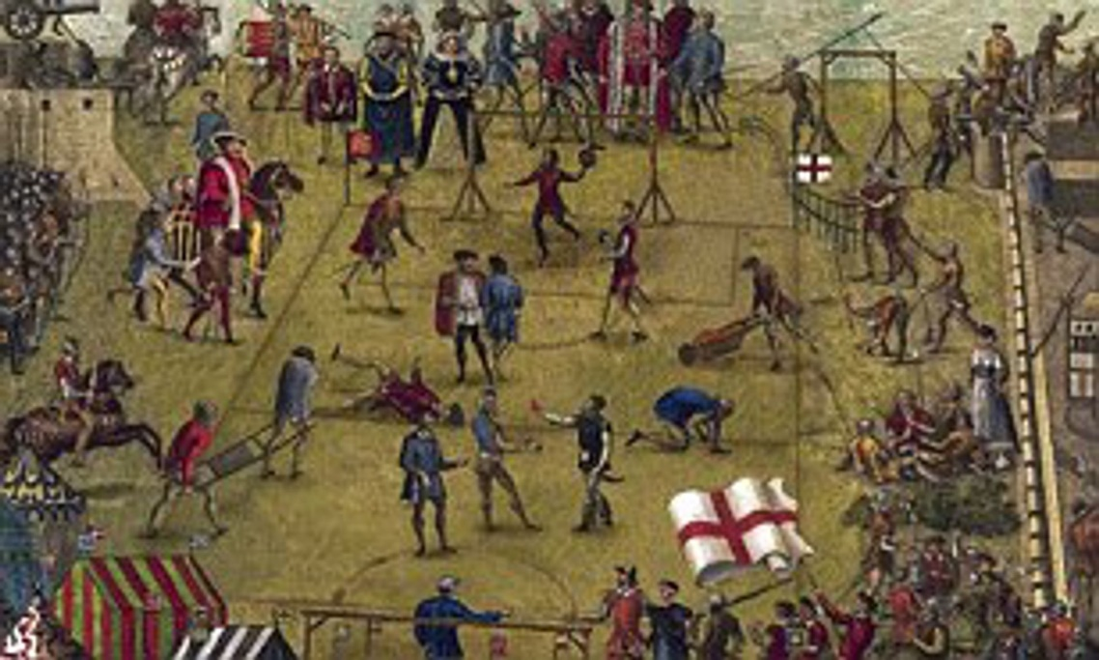 A game of Tudor football

Poor people often gambled in pubs. Often these were based on cruel fights between animals such as cock fighting. All classes, including the Queen, enjoyed bear baiting. Special arenas were built, in which a bear would be chained to a post in the middle of the arena. Dogs would be set upon the bear and money gambled on the outcome.
In Tudor England, the nobility took part in…
The very poorest would play… more specifically…
People often gambled. For example…

Perhaps the most famous example of Tudor culture comes in the theatre. People from all social classes loved the theatre. For one penny you could stand in ‘the pit’ very close to the stage. This meant that even the poorest person could go to the theatre. The Queen did not go to the theatre, but she loved plays so much she created her own company of actors to put on plays at Court called ‘The Queen’s Men’. The Queen also commissioned artists to paint her. The most well-known playwright in this period is William Shakespeare, whose work is still read and acted today.

A Tudor theatre 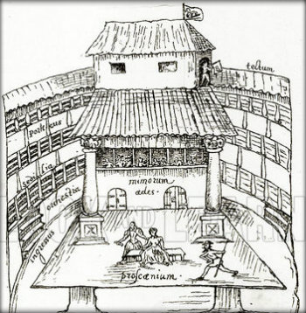

Anyone could go to the theatre in Tudor England. For example…
The Queen liked the arts. For example she…

Trade

However, despite this, life was still hard. Food prices doubled during Elizabeth’s reign because of bad harvests causing inflation (prices go up but wages don’t). The cloth trade collapsed in the 1550s leading to increased unemployment. And, in 1572, the government passed a law saying that homeless people could be whipped and a hole burned through their ear.

Life was hard in Tudor England. For instance,…
When unemployment and homelessness increased, the government…

In Tudor England during the 16th century there was a ‘Golden Age’, which is:
Period when everyone got more gold | Period when people grew wealthier, had more leisure time, and better access to culture | Period when people all had the same amount of money, and so society was equal
Poor people in England lived in:
Stone houses | Mud houses | Wooden houses with straw and mud walls
All groups in society enjoyed sports like:
Football | Hunting | Bear baiting
Everyone could go to the theatre, although the Queen had her own performers, and also:
Commissioned artists | Commissioned footballers | Commissioned writers
Poverty was caused in this period by:
Bad harvests and poor wages | Inflation and cloth trade collapsing | All of these

Benin
Historian Toby Green has claimed that in Benin there was also a ‘cultural renewal’ in this period. This means that new cultures emerged, as Benin became wealthier.
Everyday life
Many people in Benin lived in villages in the rainforest. They cleared away the trees to grow vegetables and they built their houses from mud, wood and palm leaves. However, in towns, bigger houses were built which were impressive, as Olfert Dapper mentioned.

Benin was famous for its craft workers. Specialists in a craft (like ivory-carvers) formed groups called guilds. All the members of a guild lived and worked together.
There were more than 40 guilds in Benin City and each guild had to perform a special duty for the Oba. Not all the guilds were for craft workers. Doctors, drummers, acrobats and dancers had their own guilds too. Some brave boys trained as hunters. They started their training very young and the bravest of all became elephant hunters.
It has been claimed that there was a ‘cultural renewal’ in Benin in this period.
In other words…
Most people lived in…
However…
Benin was famous for…
More specifically…

Entertainment
The most famous example of this are the Benin bronzes. These were pieces of art commissioned by the Obas and displayed in the Obas palace. The method used to ‘cast’ these bronzes is very sophisticated. These were so highly prized, only the Oba was allowed to own brass objects. The images were designed to ‘wow’, to impress, by presenting the power, wealth, and authority of the Oba, much like palaces in Europe. They were propaganda aimed at merchants, courtiers, ambassadors, and subjects of the Oba.
The Benin bronzes are…
They were designed to…
The bronzes were aimed at…

Some of the famous Benin bronzes 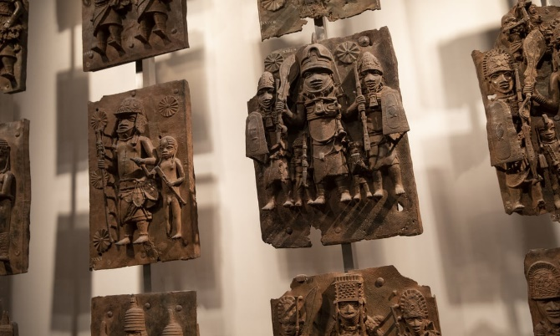

Trade

At this time, Benin began trading with Portugal. Benin traders liked the copper bracelets the Portuguese brought from Europe. Brass bracelets were of value because they could melt them down to produce molten brass. This molten brass could be used by skilled metalworkers in the royal court to make beautiful plaques and statues.

The wealth in Benin allowed the Kingdom to resist Europeans who wanted to buy slaves. However, by the end of the 17th century, as Portuguese and other Europeans offered vast riches to Benin in exchange for slaves, Benin like other African kingdoms, took part in the selling of slaves.

Benin began trading with the Portuguese. More specifically…
However, by the 17th century, this trade changed to one dealing with slaves. For example…

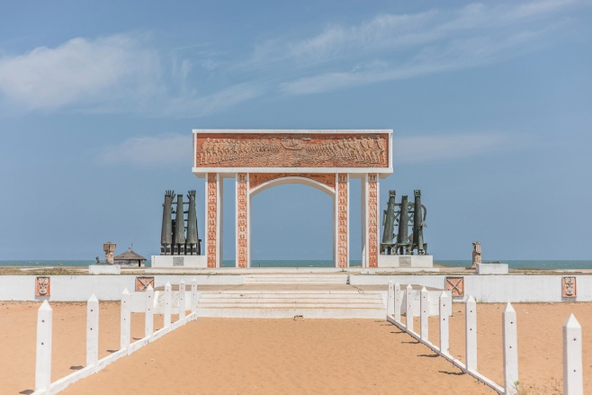 The door of no return, Ouidah, Benin.
Toby Green has said there was what in Benin at this time:
No culture | The same sort of culture | New culture developing
Most people lived in:
Stone houses | Mud houses | Wooden houses with mud and palm leaves
Benin was famous for its guilds, more specifically…
Groups of specialist workers who lived and worked together | Doctors | Groups of workers
The most famous form of art in Benin at this time are:
Painted vases | Bronze casts | Copper bracelets
Benin traded with Portugal, although by the 17th century this became a trade based on…
Copper | Slaves | Pepper

During this period, life for ordinary people in England was…
During this period, life for ordinary people in Benin was…
This shows that…

During this period, culture in England…
During this period, culture in Benin…
This shows that…

During this period, trade in England…
During this period, trade in Benin…
This shows that…

During this period, the greatest similarity between England and Benin was…
+because…
During this period, the greatest difference between England and Benin was…
+because…

- How useful are sources for telling us about the similarities between 16th century England and Benin?
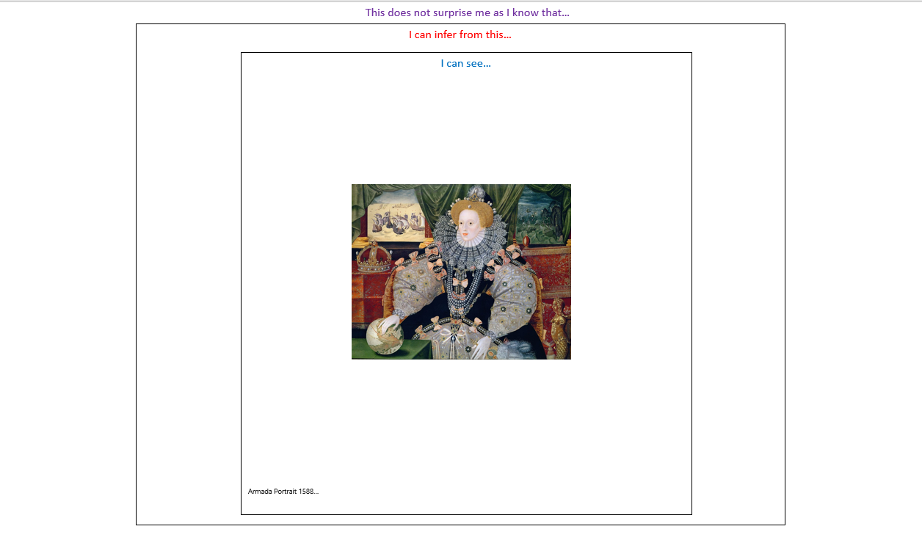
It is thought this was painted by a court painter – someone paid to paint the Queen in a positive way
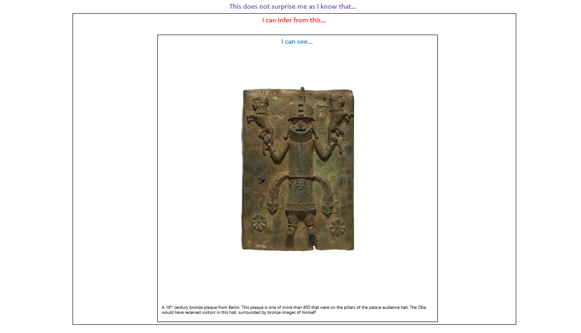

- How similar were Benin and Tudor England in the 16th century?

Source A shows…
I can infer that…
Detail that tells me this:
This does not surprise because I know that…
This means the source is useful as it shows us that…

Source A also shows…
I can infer that…
Detail that tells me this:
This does not surprise because I know that…
This means the source is useful as it shows us that…

Source A was made by…
This source was made to…
This means that the source also tells us that…

Source B shows…
I can infer that…
Detail that tells me this:
This does not surprise because I know that…
This means the source is useful as it shows us that…

Source B also shows…
I can infer that…
Detail that tells me this:
This does not surprise because I know that…
This means the source is useful as it shows us that…

Source B was made by…
This source was made to…
This means that the source also tells us that…

Source A and B both show that in Benin and England…
They also show that…
However, the sources show that there were differences, for instance…
Overall, the sources are useful because they show that 16th century Benin and England was…
For example…

Learning Ladder
I can…. | Prove it!
Identify features relating to 16th century Benin | 1. List 4 important moments in Benin’s development  2. List 4 ways in which the Obas were powerful  3. List 3 reasons why bronzes were important  4. List 2 changes to life in Benin during this period
Identify features relating to Tudor England | 1. List 3-4 key reasons for changes in Tudor England  2. List 4 ways in which Tudor monarchs showed their power  3. List 3 ways in which culture changed during this period  4. List 2 changes to life in England at this time
Describe features of 16th century Benin  Say a lot about a little, try and include at least three details.  - For example…More specifically…. This meant that… | 1. Describe 3 changes to Benin over the 16th century  2. Describe 3 ways in which bronzes were important  3. Describe 3 ways in which Obas were powerful
Describe features of Tudor England  Say a lot about a little, try and include at least three details.  - For example…More specifically…. This meant that… | 1. Describe 3 changes to England over this period  2. Describe 3 ways in which monarchs were powerful  3. Describe 3 cultural or social changes in this period
Explain the similarities/ differences between Benin and England | 1.One difference between Benin and England is to do with power. More specifically… This shows that…  2. One difference between Benin and England is to do with culture. More specifically… This shows that…  3.One similarity between Benin and England is to do with culture. More specifically… This shows that…  4.One similarity between Benin and England is to do with culture. More specifically… This shows that…

Glossary of Academic Vocabulary
Word | Definition | Because | But | So

