‘The landscape of Medieval England, a place of fear and decay.’
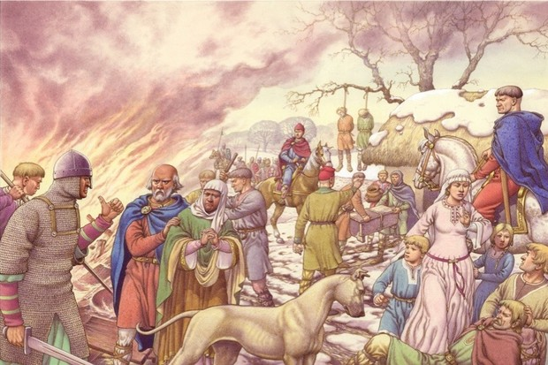

Year 7: Autumn 2
Name: Class Teacher
Term 2 History will be an exciting opportunity to find out about what mattered to Medieval people. How accurate was this observation by the historian Ian Mortimer who wrote the best selling novel ‘The Time Traveller’s guide to Medieval England?’

Do Now: Chronology and the Normans
- The Middle Ages began in 1066, this was the………….century.
- In 1348 the Black Death arrived in Britain. This is the……………century
- 1485 marks the end of the Medieval times, this was in the ……………… century.
- The Normans begun to change the landscape of Britain. For example, they ..…

- They Normans changed the way many peasants lived because of the new laws. For example,

Extension:
- The Normans brought a ‘truckload of trouble’ to England. For example,

- The Normans made life better for some Medieval people. For example,

What mattered to Medieval people living in a village?
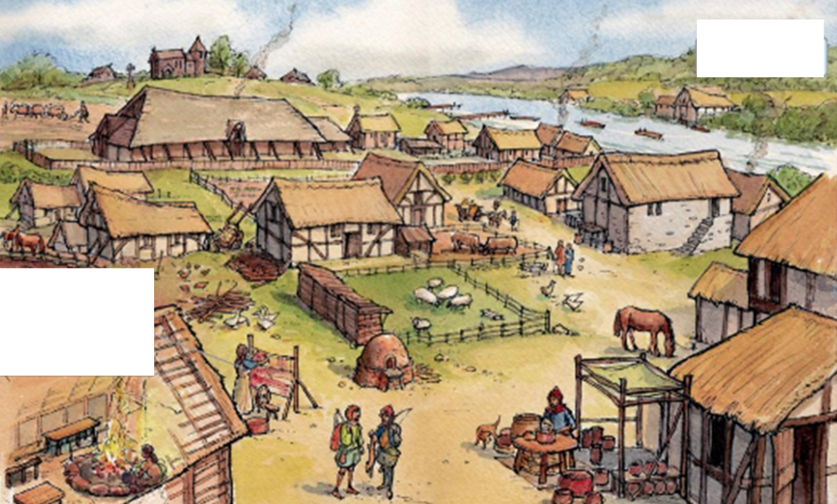
Villeins had to pay a tithe to the church. This was…
Villeins were tied to their land. This meant...
Most villeins to survive were subsistence farmers. This meant…
The houses were made from
Women lived shorter lives than men because…
Every village had a church. They were important because…..
Every village had a ……….. Their job was to look after the land on behalf of the King.
Their life expectancy was…
A Villein was
About ……….%. of the population lived in villages.

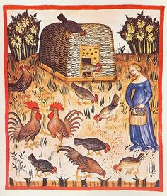
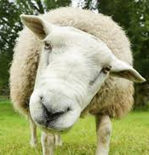
What would a time traveller expect to see in a Medieval village?

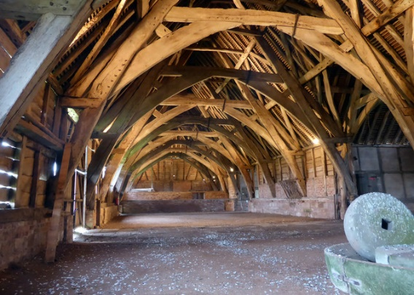
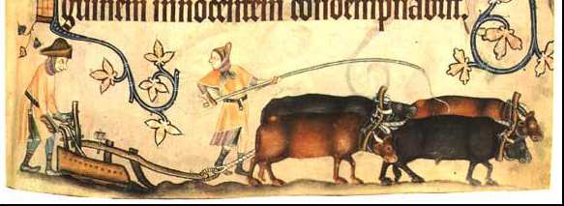

Key Feature | This was important because…
River or stream

Sheep, goats, chickens

Church

Plough

Tithe barn

Which one of these ways was not used by Medieval peasants to remove their waste
What were the health and hazards of being a Medieval peasant?
Put in a midden | Put in a cess pit |  | Hole in garden & covered with ash | Muck rakers remove waste |  | Villeins walking to the woods! :)
Which of these products was not a regular feature of a villeins diet?
vegetables | Barley & wheat |  | meat | nuts |  | honey
The most important time of the year for a Medieval villain was…
Easter |  | Christmas |  |  | harvest
What proportion of the population died during the Great famine of 1315-16
1% |  | 10% |  |  | 50%
Bad harvests lasted to
1317 |  | 1320 |  |  | 1322
A disease that was caused by damp conditions, leading to fungus growing on the rye was called
ergotism |  | Black death |  |  | Chicken pox
Many people nicknamed it “St Anthony’s Fire” believing it to have been caused by….
germs |  | filth |  |  | demons
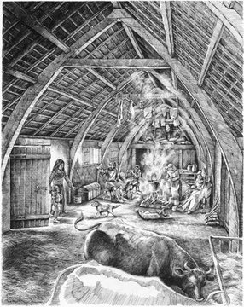
What can you infer about life in the Middle Ages from this image?
What was it actually like to live inside a villein’s cottage?
An artists reconstruction of a peasants cottage, drawn 1990.
I can infer that life was..
What details in the source helped you to make that inference?
The details in the source

The landscape of Medieval England, a place of fear and decay. To explain what was life like in a Medieval town?

About ………………….of the population lived in a Medieval village.
A villain was …………………..…………......

- An important feature of a Medieval village was…
- In a village they disposed of their waste by..
- The most important time of year for a villein was..
- During the Great famine of 1315-16 about………………………….of the population died.
Extension:
- Some peasants may not have wanted to have run away from a Medieval village because….

…………………………………………………………………………………………………………………………………………..

- The source produced from English Heritage in 2018 is useful in telling us about Medieval villages for many reasons. For example..

………………………………………………………………………………………………………………………………………………………………….
…………………………………………………………………………………………………………………………………………………………………..
………………………………………………………………………………………………………………………………………………………………
………………………………………………………………………………………………………………………………………………………………….
………………………………………………………………………………………………………………………………………………………………..
………………………………………………………………………………………………………………………………………………………………..
……………………………………………………………………………………………………………………………………………………………….
………………………………………………………………………………………………………………………………………………………………
……………………………………………………………………………………………………………………………………………………………..

Was a medieval town really a place of fear and decay?
What were the key features of a Medieval town?
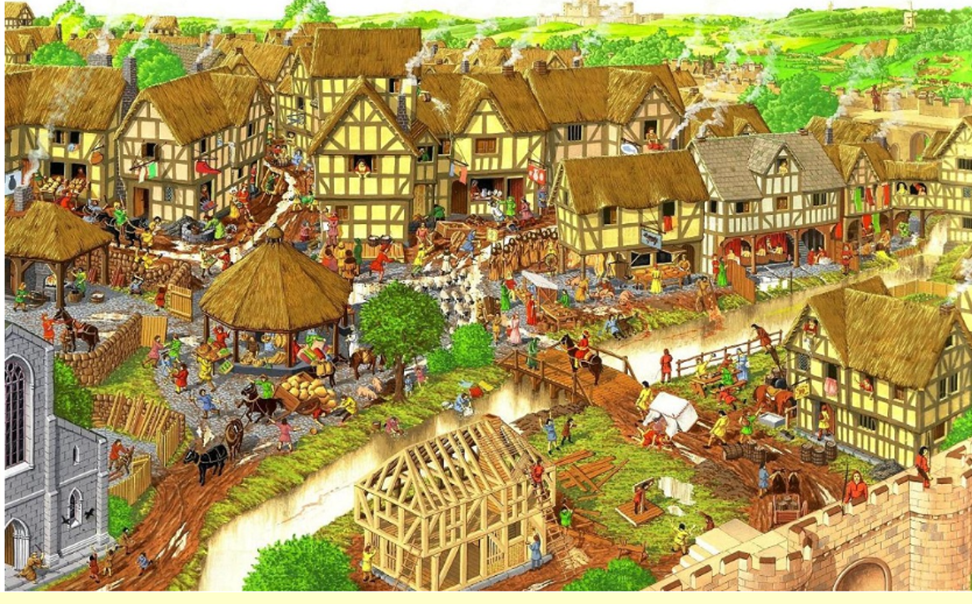

Most Medieval towns developed by a castle. This was because………………………………………………………………………………..
……………………………………………………………………………………………………………………………………………………………………….…………
…………………………………………………………………………………………………………………………………………………………………………………
They were located near a river because…………………………………………………………………………………………………………………….
……………………………………………………………………………………………………………………………………………………………………………………
……………………………………………………………………………………………………………………………………………………………………………………
The church was a vital part of the community because ………………………………………………………………………………………………
…………………………………………………………………………………………………………………………………………………………………….………………
…………………………………………………………………………………………………………………………………………………………………………………..
Planning of streets and houses in the town was………………………………………………………………………………………………………….
…………………………………………………………………………………………………………………………………………………………………………………….
…………………………………………………………………………………………………………………………………………………………………………………….
Public health was …………………………………………………………………………………………………………………………………………………………
…………………………………………………………………………………………………………………………………………………………………………………….
…………………………………………………………………………………………………………………………………………………………………………………….

The % of the population who lived in Medieval towns was.
10% |  | 50% |  | 90%
In 1066 there were not many towns, there were only
5 |  | 15 |  | 50
The average size of a town’s population in 1066 was
300 |  | 3,000 |  | 30,000
London was the capital, replacing Winchester. Its population in 1066 was only..
1,000 |  | 3,000 |  | 10,000
Which of these reasons does not explain why some Medieval towns developed
Towns located near a Norman castle. | Towns located near a river or major route. |  | Towns on the East of England that traded with Scandinavia |  | Towns that were located near a village.
Which town appeared as a result of a Norman castle being built here.
Bristol |  | London |  | Newcastle
Which town went into decline because they could no longer trade easily with Scandanavian countries
Bristol |  | York |  | Southampton
Which town began to grow bigger because they traded with France
Southampton |  | Manchester |  | York

1. A key feature of a Medieval town was……………………………………………………………..
2. The % of the population that lived in a Medieval town was……………………….
3. There were only……………….……. towns in England in 1066.
4. The average size of a town was…
5. A town that grew in importance because of its new trading links with Normandy was…
6. A new town that was created as a result of a Norman castle being there was ..
Extension:
Towns on the East coast of England began to go into decline because..

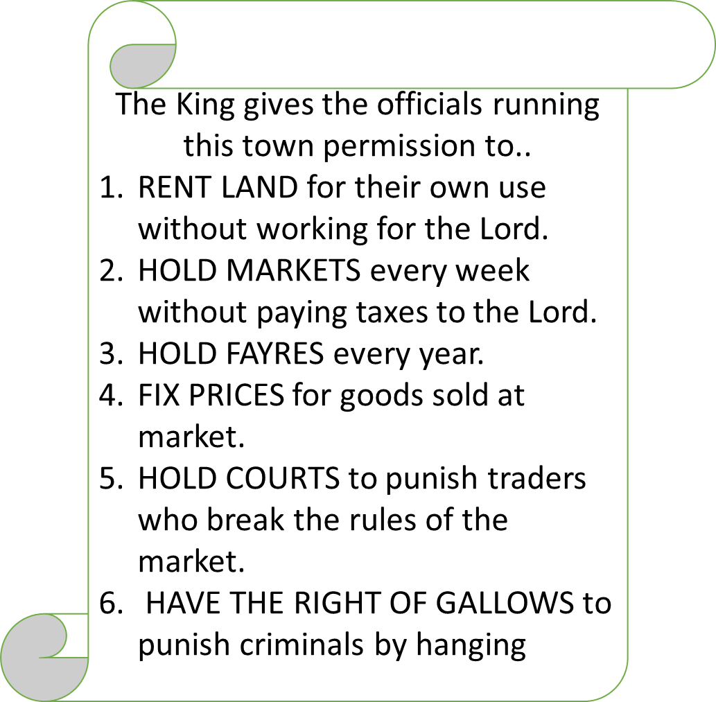
Life in a town was very different to life in a Medieval village

This is an example of a charter, what is a charter?
A person who writes rules and puts up the posters around the town. | A document that has been given by the monarch or their representative allowing the rights of what has been listed. | A speech that a monarch makes to persuade their people to support them.

What can we infer from Source A about how life was different in a town?
I can infer …………………………………………………………
…………………………………………………………
The details in the source that tell me this are..
…………………………………………………………
………………………………………………………………….……………
…………………………………………………………………………………………

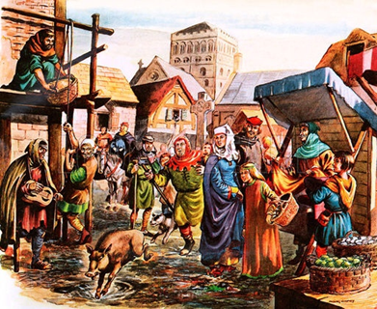

Did the Black Death make the landscape of England a place of doom and decay?

What is the artist telling us about the Black Death? Draw a line using a ruler to part of the painting that you are going to use.

The artist is telling me _________________________________________________________________________

I know this because I can see____________________________________________________________________

____________________________________________________________________________________________

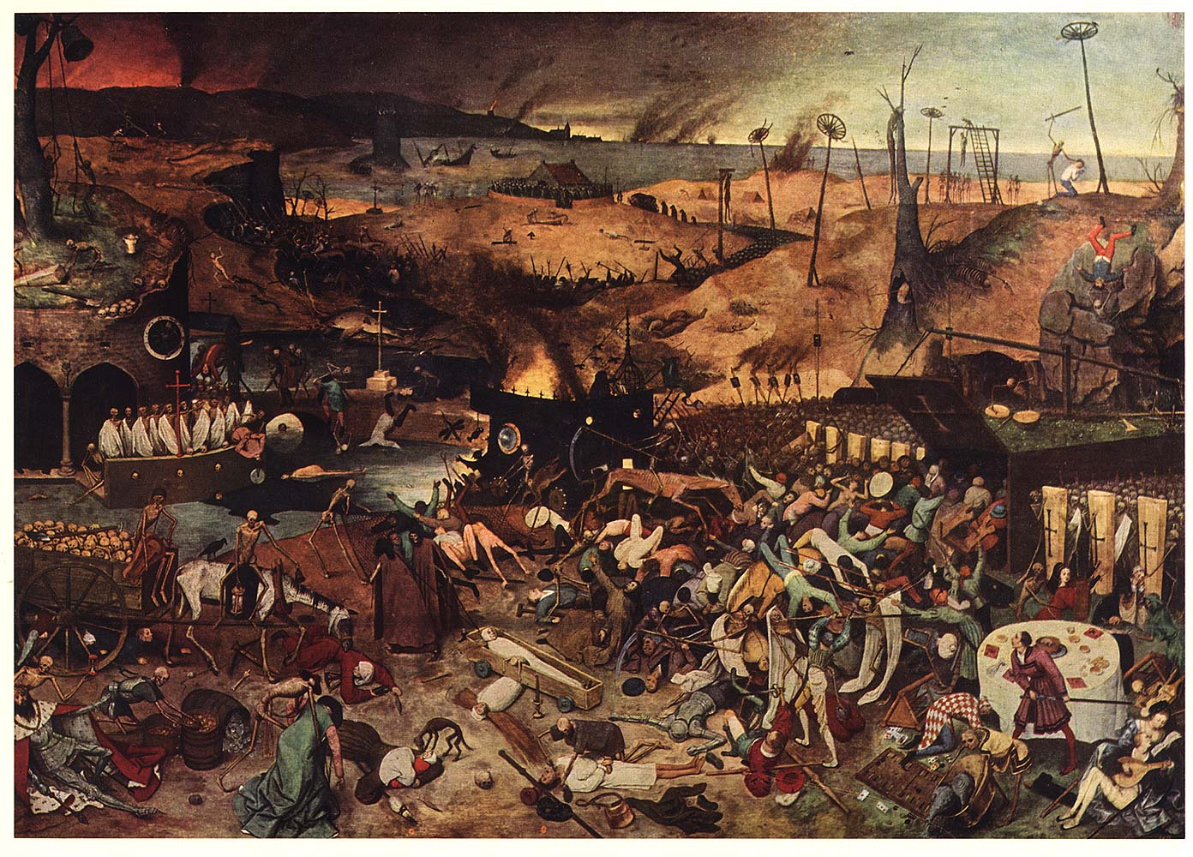

The artist is telling me _________________________________________________________________________

I know this because I can see____________________________________________________________________

____________________________________________________________________________________________

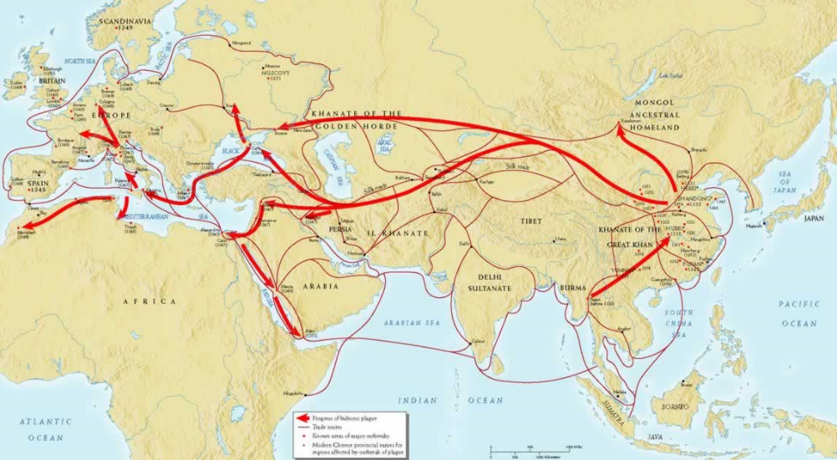
How did the Black Death spread?

Early cases of the Black Death were first recorded in…
Britain | Europe | China
The first cases were in reported in the 1330s, which century is this in?
12th century | 13th century | 14th century
We know the disease spread from trading ships carrying black rats, but what was the name of the virus?
Black germ | Yesinia Pestis | Pesina Yestis
Another name for the Black Death was…
Bird flu | Pneumonic plague | Bubonic plague
The real cause was not discovered until
1396 | 1896 | 1996
Historians estimate that the death rate across Europe was..
6% | 40% | 60%
The amount of people who died in Europe between 1348 and 1349 was
Over 50 million | 5 million | 30 million
Extension
Historians have to estimate the deaths and cannot give a precise figure because…
____________________________________________________________________________________

_____________________________________________________________________________________

____________________________________________________________________________________

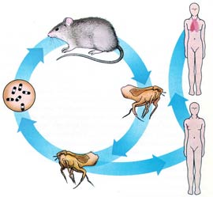 | Explain how the virus spread to humans  ___________________________________________________________  __________________________________________________________  ___________________________________________________________  ___________________________________________________________  __________________________________________________________  ___________________________________________________________  ___________________________________________________________  __________________________________________________________  ___________________________________________________________
What can we learn from Dan Snow’s filthy cities about the Black death?

International trade continued during the Black death. This tells us that _________________________
___________________________________________________________________________________
The rat population expanded in London because ___________________________________________
____________________________________________________________________________________
____________________________________________________________________________________
Scientists say there are over________________________ cases of the Black Death reported each year.
The virus Black Death today is stored _____________________________________________________
____________________________________________________________________________________
The symptoms of the bubonic plague were ______________________________________________
__________________________________________________________________________________
___________________________________________________________________________________
The pneumonic plague was more lethal. For example, _______________________________________
____________________________________________________________________________________
Scientists need to have Yesinia Pestis in the laboratory because________________________________
___________________________________________________________________________________
___________________________________________________________________________________
In 1348 London was gripped by the bubonic plague. For example______________________________
___________________________________________________________________________________
___________________________________________________________________________________

Extension: What evidence did Dan Snow refer to in his documentary to help explain the impact of the Black Death? ___________________________________________________
_________________________________________________________________________
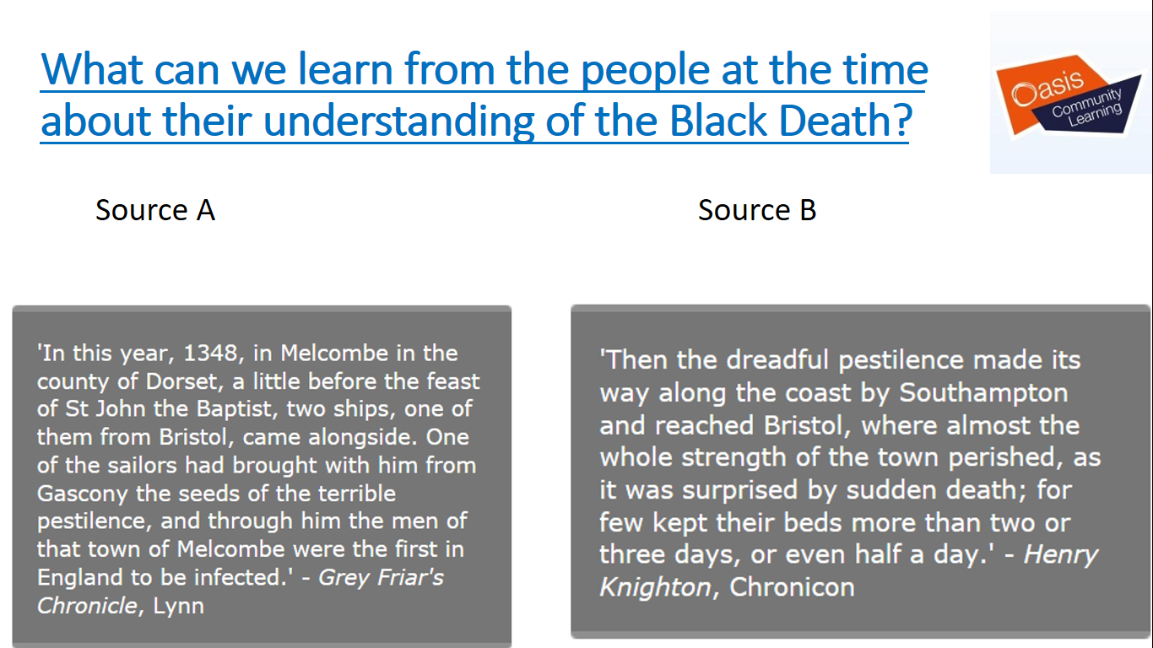
From source A we can learn ________________________________________________
__________________________________________________________________________
__________________________________________________________________________
_________________________________________________________________________
The details in the source that tell me this are____________________________________
________________________________________________________________________
_________________________________________________________________________
_________________________________________________________________________
From source B we can learn ________________________________________________
__________________________________________________________________________
__________________________________________________________________________
_________________________________________________________________________
The details in the source that tell me this are____________________________________
________________________________________________________________________
_________________________________________________________________________
_________________________________________________________________________

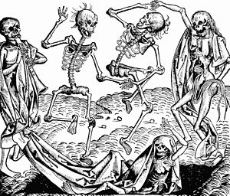
Do NOW: Why is it important to study the Black Death?
What can we learn about Medieval knowledge from how people responded at the time?
- The Black death originated from..
- It spread by…
- The virus was called…
- It is estimated to have killed…
- It spread throughout Britain because…

- We can find out about the Black death from primary sources like…

Extension
- It is difficult to get precise information because…

- From studying the virus today scientists can…

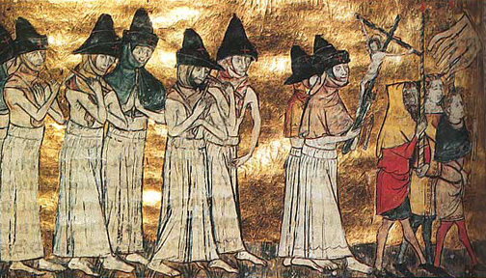
Source A

This showed they believed the cause of the Black Death was……………………………………………..…………………..……….
…………………………………………………………………………………………………………………………………………….…….………………….….
…………………………………………………………………………………………………………….……………………………………………………..…….
…………………………………………………………………………………………………………….………………………………………….………………..
Therefore they dealt with it by …………………………………………………………..………………………………………………………………
……………………………………………………………………………………………………………..…………………………………………………………..
…………………………………………………..………………………………………………………………………………………………………………………
……………………………………………………………..…………………………………………………………………………………………………………..
…………………………………………………………………
A Medieval painting of the flagellants responding to the Black Death.
A Medieval manuscript showing a Priest blessing victims of the Black.

Source B
“Whatever the people said, the truth is that there is one general cause. The close position of the three great planets. Saturn, Jupiter and Mars. They had taken place in 1345 in 24th March in the 14th degree of Aquinas. Such a coming together of planets is always a sign of wonderful, terrible or violent things to come.
Guy de Chauliac, a French doctor in the 1300s.
This showed a French Dr from the time believed that the cause of the Black Death was...
……………..…………………………………………………….……………………………………………………………………………………………..
……………………………………………………………………………………………………………………………………………………..…………………
This tells you a lot about their knowledge. For example………………………………………………………………………………….
…………………………………………………………………………………………………………………………………………………………………………
…………………………………………………………………………………………………………………………………………………………………………

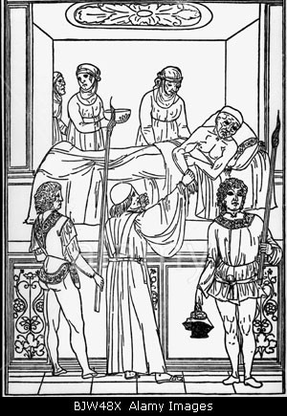
Source C

This shows that they believed the cause of the Black Death was..
………………………………………………………………………………………………………..
This was the idea that……………………………………………………………………..
……………………………………………………………………………………………………….
……………………………………………………………………………………………………….
……………………………………………………………………………………………………….
Therefore, they dealt with it by………………………………………….…………..
……………………………………………………………………………………………………..
……………………………………………………………………………………………………..
Extension: Poorer people might .……………………………………………………
……………………………………………………………………………………………………….

Source D
Many people have been killed for the cause of the plague is not only the corruption of the air, but the corrupt humours with those who die. You should avoid over indulgence of food, also avoid hot baths. These open the pores through which poisonous air can enter.
In cold or rainy weather you should light fires in your chamber. Ring church bells to break up miasma’s. On going to bed, burn juniper branches so that the smoke and scent fills the room. If the infected blood is in the armpits, blood should be let from the cardiac vein.
If however the epidemic occurs during hot weather you must eat cold things and also drink more than you eat. Be sparing with hot substances such as pepper, garlic, onions and everything else that generates excessive heat and use cucumbers, fennel and spinach.”
John of Burgundy, a physician describes Medieval ideas about what they thought caused the Black death and how they might treat it

Written by John of Burgundy in 1365.
This showed they believed there were many causes of the Black Death. For example,1.…………………………………….
2.………………………………………………………………………..………….
3…………………………………………………………………………………….
4……………………………………………………………..……………………..
Therefore they dealt with it in many ways. For example.
…………………………………………………………………………………...
………………………………………………………………..…………………..
Also they, ……………………………………………………………………
…………………………………………………………………………………..
This shows a lot about their knowledge…………………..…
………………………………………………………………………………………
………………………………………………………………………………………
………………………………………………………………………………………Extension: Their knowledge was limited because.
……………………………………………………………………………………..
………………………………………………………………………………………

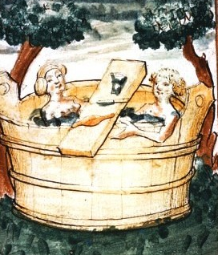
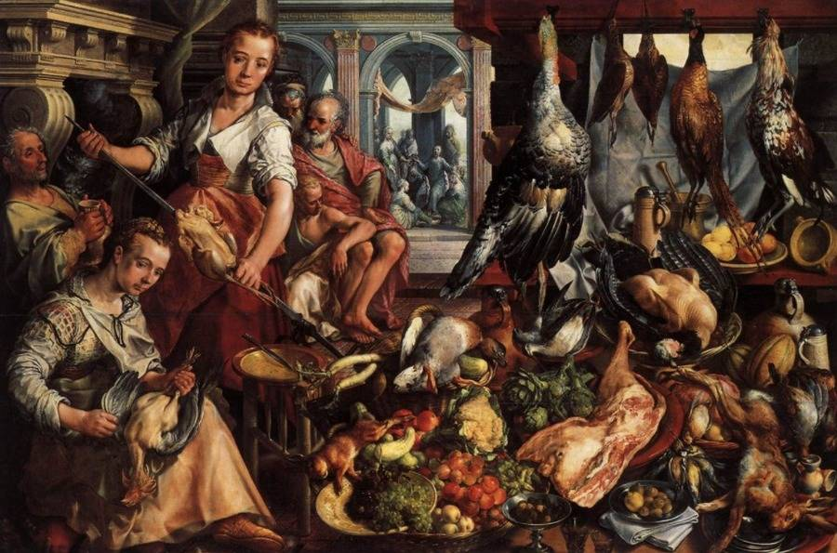
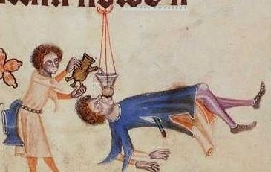

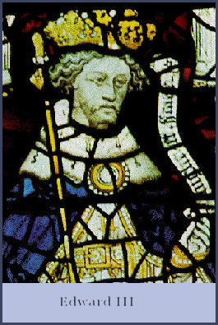
Source E
A letter from King Edward III, 1349
To the Lord Mayor of London
An order to cause the human excreta and other filth lying in the streets in the city to be removed with all speed. This is so that no greater cause of death may arise from such smells.

Source 5 shows that Edward III believed the Black Death was caused by……………………………………………………
This details in the source that show this are………………………………………………………………………………………………………
………………………………………………………………………………………………………………………………………………………………………….
This would have had a positive effect because……………….……………………………………………………………………………….
………………………………………………………………………………………………………………………………………………………..…………………
…………………………………………………………………………………………………………………………………………………………………………..

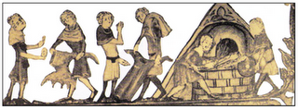
Source F
A Medieval manuscript showing villagers burning the clothes of the victims of the Black death.

Source 6 shows that they believed the cause of the Black Death was……………………………………………….......................
……………………………………………………………………………………………………………………………………………………….……………………
Therefore, they dealt with it by……………………………………………………………………………………………………………………………
…………………………………………………………………………………………………………………………………………………………………………….
This shows their approach was…………………………………………………………………………………………………………………………….

The Black Death brought fear and decay to the English landscape.
How far do you agree with Ian Mortimer’s interpretation of the Black Death?
Do Now:

- Religious responses to the Black death included__________________________________________

_________________________________________________________________________________

- Many people believed miasma’s caused the black death. These were _______________________

________________________________________________________________________________

- To deal with miasma’s they _________________________________________________________

________________________________________________________________________________

- They also used Ancient Greek & Roman ideas. For example ______________________________

_________________________________________________________________________________

- The Feudal system was _____________________________________________________________

________________________________________________________________________________

Extension:
Estimates of death rates vary between one third and two thirds of the population. Why is there such a difference in the estimates?

_______________________________________________________________________________________

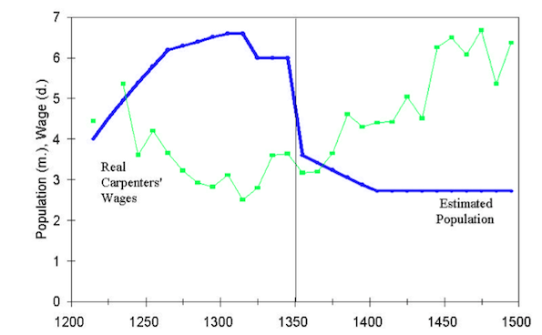
Stretch: Here is a graph that shows what happened to the population and also the wages of a labourer during the Black death. What do you notice? Create 1 question you would like to ask about this graph.

___________________________________________________

___________________________________________________

____________________________________________________
What can we learn from the documentary about the effect of the Black Death?
Clip 1: Before the Black death, famine was common amongst the peasants. However, after..

The Black death could be considered beneficial for peasants. This was because..

More peasants were landowners, this was an important change. For example..

The diets of peasants changed. For example..

The Old landlords and nobles struggled. For example..

Clip 2: After the Black Death there were less. Labourers. This caused changes. For example,

The King tried to control wages. For example…

Before the Black Death peasants commonly experienced
over indulgence | freedom | famine
After the Black Death there were significantly less
Labourers | Pigs and sheep | Corn and wheat
This meant landlords were desperate for workers to labour on their fields so had to increase their
crops | wages | Pigs and sheep
Many houses and farms had been abandoned in the village. This affected peasants by…. (pick 2)
Buy land cheaply and become independent | Run away and start a new life in a town or another village. | forcing them to stay in the village & work for the Lord for the same wage.
King Edward III attempted and failed to control wages by
Commanding that wages should go up to keep the peasants happy. | Commanding that wages should go down to keep nobles happy. | Commanding that wages should stay at 1346 level.
The Black Death brought fear and decay to the English landscape.
How far do you agree with Ian Mortimer?

- Read the information sheet about the effects of the Black Death.

- Read the sheet again. Then:

- Underline in red any facts that suggest the Black Death had a negative effect on the people at the time.

- Underline in green any facts that suggest the Black Death had a positive effect on the people in terms of their work. These are the economic effects

- Underline in yellow any facts that suggest the Black death had a positive effect on the people in terms of their social behaviour. These are the social effects.

- complete the chart show your findings:-

What were the effects of the Black Death?

Facts that show the Black death had a bad effect on people. - Which ones? | Facts that show the Black Death had a positive effect on the people and their work. | Facts that show the Black death had a positive effect on people socially.

- “Was the Black Death really a time of fear and decay?” In your answer you need to include the following:

- An introduction, this should be about the facts you have learnt about the Black Death, when was it? What was this illness?
- The first main part of this article is, the ways in which this disease was really a time of fear and decay. You can use your red column, but also knowledge from a previous lesson or homework.
- The second main part of this article is on the ways in which the Black Death improved the lives of many economically.
- The third part of this article is about the ways in which the Black death improved many people’s social lives and habits.
- A conclusion: You need to give your final opinion considering all the evidence that is available.

