Geography Workbook

Instructions of how to complete the work below.
- Complete all the green boxes below.
- Complete all work in your exercise book. Your teacher will mark this when you return.
- Complete the work in the normal time you would have Geography.

Objective: to explain how animals adapt to the ecosystem they live within.
Do now: complete the sentences below

- An ecosystem is……
- Large ecosystems are known as….
- The tropical rainforest is located along the……
- The tropical rainforest has a humid climate. In other words….
- The desert is located….
- The desert has sparse / dense vegetation because….
- The tropical rainforest has dense / sparse vegetation.
- The deserts climate is known as arid. In other words…..
- Decomposers are responsible for breaking down producers and consumers after they die. This returns……………………...to the soil.
- Ecosystems are made up of p…………………..…….., c………………….…….and decomposers.
- A food chain is…..
- There are………..layers of vegetation in the rainforest.

READ the information below.

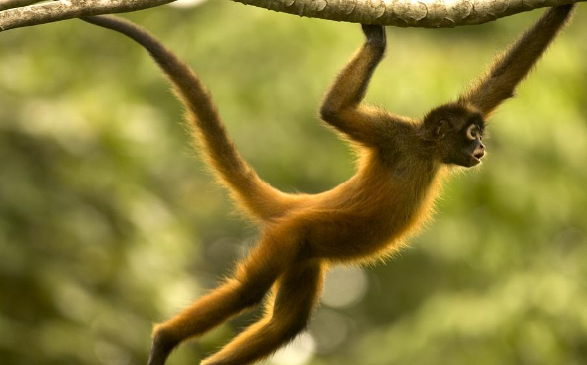
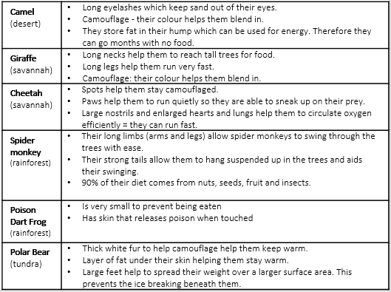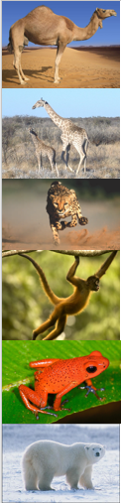

Task 1: complete the below:
- Which animal do you find in the Tundra?
- Explain how one of its adaptations helps it survive in the Tundra?
- Which animal do you find in the Rainforest?
- Explain how one of its adaptations helps it survive in the Rainforest?
- Which animal do you find in the Desert?
- Explain how one of its adaptations helps it survive in the Desert?

Geography Workbook

Instructions of how to complete the work below.
- Complete all the green boxes below.
- Complete all work in your exercise book. Your teacher will mark this when you return.
- Complete the work in the normal time you would have Geography.

Objective: to outline the key characteristics of the tropical rainforest ecosystem.

Do now: complete the sentences below
- An ecosystem is….
- The ecosystem that is located along the tropic line is called….
- Ecosystems are made up of p…………………………….., c………………………….and decomposers.
- The nutrient cycle is….
- Identify one animal that lives in the tundra.
- State one way your animal from question 6 has adapted to the tundra.

READ the information below.
LOCATION:
- The rainforest is located along the equator in central Africa (Nigeria, Congo), south-east Asia (Malaysia, Indonesia), north Australia and South America (Brazil, Peru).
CLIMATE:
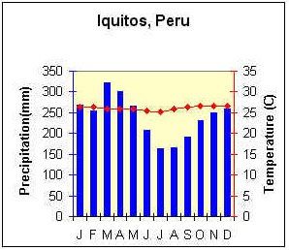
- The climate is Humid (hot & wet). The average daily temperature is 28°C. It t never goes below 20°C and rarely above 35°C. It receives at least 2000mm of rain each year. There are no real seasons.
VEGETATION:
- It has very dense vegetation. There are over 1,000 different types of trees including hardwoods such as mahogany and greenheart. There are four layers of vegetation in the tropical rainforest. The vegetation has had to adapt, in order to survive with the constant high temperatures and the heavy rainfall.
- The trees grow over 40 metres tall to get sunlight. Large buttress roots anchor the tall trees and prevent them falling over.
- The leaves have drip tips to shed the heavy rainfall.
- Lianas are vine like plants. They use large trees as support to climb up to the canopy.
- The forest floor is dark as the leaves block out the sunlight. As a result, the leaves in this lower level are very large as they try to catch as much sunlight as possible.
ANIMALS:
- Millions of species (e.g. jaguar, alligator, monkeys, apes). It is believed that in the Amazon Rainforest there are over 2,000 species of birds and 1,500 species of fish. There is also thought to be 50,000 kinds of insects in a single square mile. Animals have to adapt to survive in the rainforest.

Task 1: complete the below:
- Where are rainforests located?
- What does a ‘Humid’ climate mean?
- What are the average temperatures in the rainforest?
- How many layers of vegetation (plants) are in the rainforest (name them)?

- Why do trees in the rainforest have large Buttress roots?

- Explain one way plants have had to adapt in the rainforest?

- What types of species do you find in the rainforest?
Geography Workbook

Instructions of how to complete the work below.
- Complete all the green boxes below.
- Complete all work in your exercise book. Your teacher will mark this when you return.
- Complete the work in the normal time you would have Geography.

Objective: to assess the impact of human use of Malaysia’s rainforest.

Do now: complete the sentences below.

- A large ecosystem is known as a…….
- A producer gets its energy from the…….
- The camel has adapted to the desert ecosystem. For example…
- The rainforest is located along the…….
- The rainforest has a……………………….climate.
- There are……………..…..layers of vegetation in the rainforest.

READ the information below.

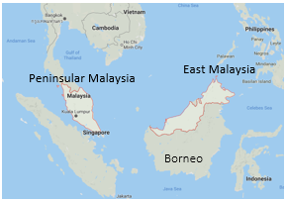
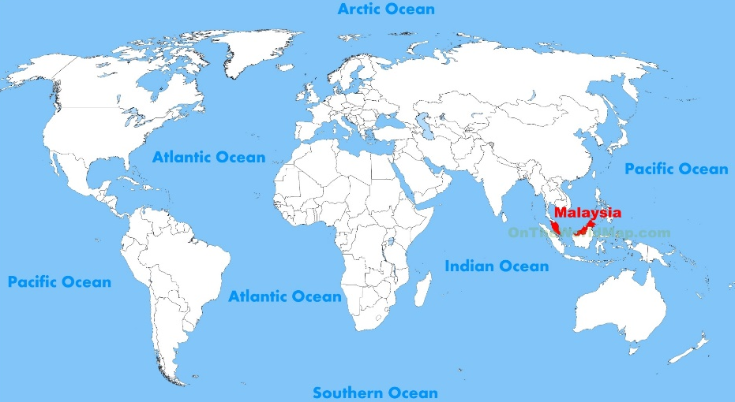
Malaysia is a country in South East Asia. It is made up of Peninsular Malaysia and East Malaysia (part of the island of Borneo). 67% of Malaysia is covered in tropical rainforest.

Humans use the tropical rainforest in Malaysia for a number of economic industries. This has resulted in widespread deforestation. The rate of deforestation in Malaysia is increasing faster than in any tropical country in the world. Between 1990 and 2010, Malaysia lost over 1.9 million hectares of rainforest! This is destroying the local habitats of many animals whose home is the rainforest, such as the Orang-utan.

Task 1: Complete the questions below

- Where is Malaysia located?
- What percentage of Malaysia is covered in rainforest?
- What is deforestation?
- How many hectares of rainforest have been destroyed?

READ the information below.
Humans use the Malaysian rainforest in a number of ways. Read the descriptions below.

HYDRO-ELECTRIC POWER STATIONS
- The high quantity of water in the rainforest can be used to create cheap energy in hydro-electric power stations. The Bakun Dam is a dam in Malaysia that generates electricity for its people.
- The dam supplies energy for many industries in Peninsular Malaysia as well as for the local population. It also earns Malaysia money as the energy can be sold.
- Having said this, hydro-electric power stations require the building of massive reservoirs (lakes), which flood and destroy massive areas of the rainforest and uproot people, destroying their homes, land and culture. The Bakun Dam flooded over 700km2 of forests and farmland.

FARMING: CATTLE PRODUCTION
- Large areas of the rainforest are used to create cattle ranches. In 2017, 744,000 cows were sold for their meat.
- These provide jobs for locals and the meat sold can help the country develop by bringing in lots of money.
- Unfortunately, before they bring their cattle in they must clear large areas of the rainforest by burning away all of the vegetation meaning habitats are lost.

FARMING: PALM OIL PRODUCTION
- Malaysia also makes money from palm oil production. In the 1970s large areas of the rainforest were cleared and made into massive palm oil plantations (farms).Palm oil can be used in cooking oil, bread, cake, chocolate & candles.
- This gives jobs to the locals
- It results in widespread deforestation.

Task 2: Complete the questions below
- HEP is created using what resource in the rainforest?
- What are cows in the rainforest sold for?
- What is palm oil used for?
- State a positive of HEP in the rainforest?
- State a negative of HEP in the rainforest?
- State a positive of farming and palm oil production in the rainforest?
- State a negative impact of farming and palm oil production in the rainforest?

MINING FOR MINERALS
- There are huge deposits of minerals (copper, tin) in the Malaysian rainforest, which are mined and sold to rich countries for lots of money.
- The roads they create for mining also help accessibility.
- This causes problems too as large areas of the rainforest have been cleared to create mines. The mines release chemicals and pollution that are poisoning the atmosphere and river.

LOGGING
- Hardwood trees (ebony and mahogany) can be sold and earn Malaysia money. In 1980, Malaysia became the world’s largest exporter of tropical wood.
- Large sections of the rainforest were cut down destroying animal habitats. These trees can take 100s of years to regrow!
- Also new roads cut through the forest, meaning large areas are deforested and habitats are lost

Task 3: Complete the questions below
- State a mineral found in the rainforest?
- State an example of a hardwood tree found in the rainforest?
- State a positive of mining in the rainforest?
- State a negative of mining in the rainforest?
- State a positive of logging in the rainforest?
- State a negative impact of logging in the rainforest?

Geography Workbook

Instructions of how to complete the work below.
- Complete all the green boxes below.
- Complete all work in your exercise book. Your teacher will mark this when you return.
- Complete the work in the normal time you would have Geography.

Objective: to explain how the use of sustainable strategies can reduce human impact

Do now: complete the sentences below
- There are three types of consumer: carnivore, o……………………….and h……………………..…
- Within the nutrient cycle, d………………………….return nutrients to the soil.
- Malaysia is located…………………
- The average temperature in a rainforest is…………..….°C
- Human use of the rainforest brings benefits, such as………………...
- Human use of the rainforest harms the ecosystem. For example….

READ the information below.
Malaysia’s rainforests are at risk from deforestation.
Therefore, they need to be protected due to their high biodiversity (home to millions of animal & plant species), role in climate change, production of hardwood trees & local indigenous tribes.
Below are some of the strategies that can be used.

Selective Logging  Trees are only cut down when they reach a certain height or age. This allows trees to re-establish themselves. Malaysia implemented a Selective Management System in 1977 which identifies which trees are to be cut down and implements strict fines for illegal logging. | National Parks  Areas are protected from development and deforestation. There are more than 30 national parks in Malaysia, including Taman Negara National Park, which protects 4344km2 from development and deforestation. | Coppicing  Coppicing is when you only cut trees down halfway. This means you get the wood you need to make furniture, fuel or paper, however the trees can regrow quickly. This means there is a constant supply of wood.
Afforestation (replanting trees)  When you plant trees to replace the ones cut down. Trees stabilize the soil, replenish lost nutrients and provide habitats for wildlife. | Raise Awareness of Education  Educate people and companies on how they are harming the rainforest and provide ideas of how they can make money in the rainforest, however in a more sustainable way. The World Wildlife Fund (WWF) works with governments to better create and protect National Parks. It also helps to identify the most suitable areas to build dams or roads to have minimal impact on the rainforest and its people.

Task 1: complete the below: (a model paragraph has been completed for you)

Explain how sustainable strategies can be used to reduce the human impact and deforestation in the Malaysian rainforest.

Malaysia is located……………………………………………..……………..and It is at risk from deforestation due to logging.
TO REDUCE THIS IMPACT, WE CAN use afforestation. MORE SPECIFICALLY, this is when trees are planted to replace those that are cut down AS A RESULT there are more trees to provide habitats for animals

It is also at risk from deforestation due to…..
More specifically….
As a result….

