

We use a blue cloth for _____________________________.

We use a tea towel for _____________________________.

**Objective:** …………………………………………………………………………………………………………………………………………

**Year 7 Gastronomy: Workbook**

**‘Nutrition and Nutrients’**

**Big Learning Question:**

How do we eat healthily and why do we need a range of different foods?

**Routines and Rules in the Kitchen**

**Do Now:**

Finish the sentence starters below:

The purpose, or point, of food is… _________________________________________________

_____________________________________________________________________________

Gastronomy is… _______________________________________________________________

My favourite food is ______________________. A food I don’t like is ____________________.

One thing I know how to cook is… ________________________________________________.

One thing I would like to learn to cook is… _________________________________________.

To wash our equipment correctly we need to:

1. __________________________________________________________
2. __________________________________________________________
3. ____________________________________________________________________________________________________________________

Rules and Routines Poster:

Success Criteria:

* Minimum 5 rules of the gastronomy kitchen
* Include at least 2 pictures
* Add colour
* Neat and organised

**Food Hygiene**

**Objective:** …………………………………………………………………………………………………………………………………………

**Do Now: Label 10 things they are doing wrong in this kitchen.**

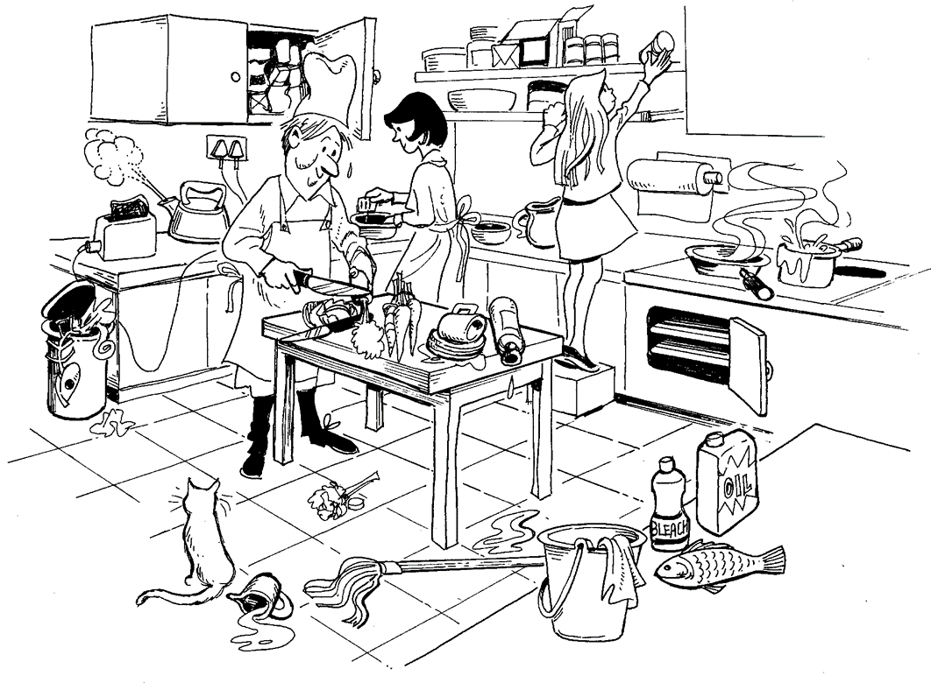

C__________________ C___________________

C__________________ C_________________

Keywords: **Bacteria Illness Cleaning**

**Equipment Chilling Food**

**Hands Food Cooking**

**Food Poisoning Cross Contamination**

### **Fact File:**

To make more notes we use our *left* hand. Put your thumb on the back of the neck, pointing up. Use the tip of your second finger to press the *second fret* of the G string.

A pathogenic micro-organism is __________________. We find these micro-organisms in many places. Some of the places they may be found are __________________, _____________________ or ______________________. These micro-organisms can cause different problems for us. A couple of things they could cause are _____________________ or ______________________. We can prevent the spread of micro-organisms by _______________________, ______________________, ___________________ and _______________________

An example of good hygiene in the kitchen would be __________________________

______________________________________________________________________

We need good hygiene in the kitchen because ____________________________

______________________________________________________________________

### **Fact File:**

To make more notes we use our *left* hand. Put your thumb on the back of the neck, pointing up. Use the tip of your second finger to press the *second fret* of the G string.

### **Fact File:**

To make more notes we use our *left* hand. Put your thumb on the back of the neck, pointing up. Use the tip of your second finger to press the *second fret* of the G string.

**WWW**:



**EBI**:

**Objective:** …………………………………………………………………………………………………………………………………………

**The Eatwell Guide _______________________**

S.A.

**Do Now: List the 5 main categories of the Eatwell Plate.**

**1 …**………………………………………………………………………………………………………………………………………

**2 …**………………………………………………………………………………………………………………………………………

**3 …**………………………………………………………………………………………………………………………………………

**4 …**………………………………………………………………………………………………………………………………………

**5 …**………………………………………………………………………………………………………………………………………

**Identify 2 foods from each category.**



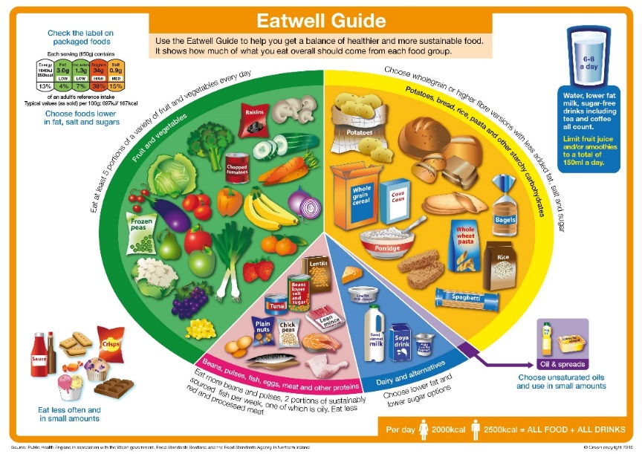Section 1: Most important

______________________________________ This is needed in the body for: ______________________________________

Section 2: Second most important

______________________________________

This is needed in the body for:

______________________________________

Section 3: Third most important

______________________________________

This is needed in the body for:

______________________________________

Section 4: Fourth most important

___________________________ this is needed in the body for ___________________________________

Section 5: Least important

_____________________ this is needed in the body for _________________________________________

For each of the below meals:

Beef Burger and Wedges:

1. ________________________________________________________
2. ________________________________________________________
3. ________________________________________________________

Margherita Pizza and Chips:

1. ________________________________________________________
2. ________________________________________________________
3. ________________________________________________________

Chicken Curry and Rice:

1. ________________________________________________________
2. ________________________________________________________
3. ________________________________________________________

Success Criteria:

1. Identify food groups included
2. Identify an issue
3. Identify an improvement

 **Eating a Balanced Diet**

The Eatwell Plate shows us _______________________________ and ___________________________

________________________. A balanced diet is when ___________________________________________

____________________________________________. The most important sections of the Eatwell Plate are ____________________________ and __________________________. These are most important because ______________________________________________________________________. The least important section of the Eatwell Plate is _________________________ this is because ________________________

_______________________________________________________________________________________.

**Seasonality in Food ___________________**

**Objective:** …………………………………………………………………………………………………………………………………………

**Do Now: Identify the below vegetables.**

**1 2 3**

**____________________ ____________________ __________________**

**Give at least one thing they have in common.**

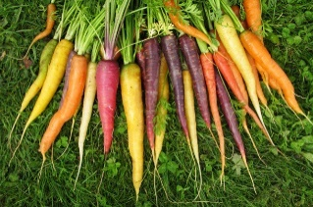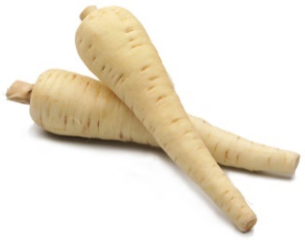

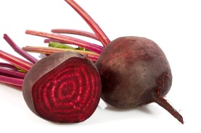

The four seasons are ________________, ___________________, ___________________, ________________

Examples of fruits or vegetables that could be eaten in different seasons are:

__________________________________________________________________

__________________________________________________________________

__________________________________________________________________

__________________________________________________________________

**Analysing Seasonal Eating:**

Fruit and vegetables grow at different times in the year. Eating food in season means ___________ ______________________________________________________________. An example of this is _____________________________________________________. Another example would be ________________________________________________________________. Some reasons why eating food in season is good are ___________________________________, ________________ and _____________________________. A reason eating seasonally could be bad is ____________

Seasonal Dishes: Design a seasonal dish. In the circle draw, label and colour what the dish looks like.

Spring Salad:

The ingredients included in my spring salad are:

____________________________________________________________________________________________________________________________________

The garnish I will include is:

___________________________

Summer Salad:

The ingredients included in my summer salad are:

____________________________________________________________________________________________________________________________________

The garnish I will include is:

___________________________

Autumn Soup:

The ingredients included in my autumn soup are:

____________________________________________________________________________________________________________________________________

The garnish I will include is:

___________________________

Winter Soup:

The ingredients included in my winter soup are:

____________________________________________________________________________________________________________________________________

The garnish I will include is:

___________________________

**Objective:** …………………………………………………………………………………………………………………………………………

**Gluten and Bread Making ___________________**

**Do Now: Design 5 balanced meals using the Eatwell Plate as a guide.**

**Monday:**

**Tuesday:**

**Wednesday:**

**Thursday:**

**Friday:**

Success Criteria:

* 2 vegetables in each
* 1 carbohydrate in 4-5
* Protein in 2-4
* Dairy in 1-2
* Fats in 1

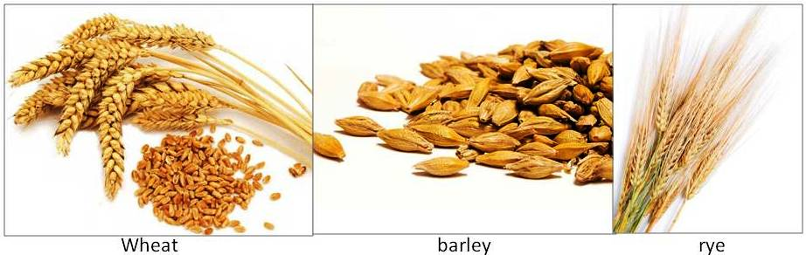

These are all types of ________________. We use them to make _________________, _______________ and _________________. Gluten is ____________________________.

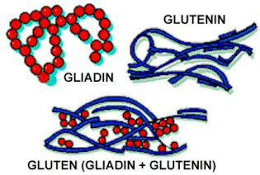Gluten is found in _____________ such as ___________, barley and _________. Barley ____________ and _________ are made into __________ which is used to make pasta and __________________. Some people are __________________ to gluten and therefore can’t eat anything that has wheat, _______________ or rye in. This disease is called _________________ disease.

**Key Words:**

**Grains Barley Wheat Rye**

**Coeliac Intolerant Bread Flour**

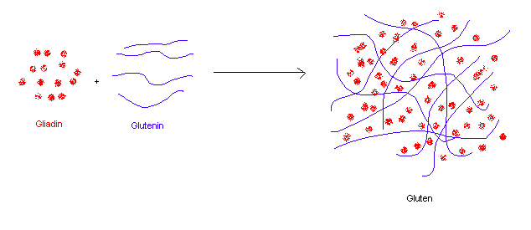**Making a Bread Dough: 3 Stages**

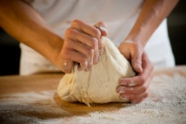****

_________________ _________________ _________________

The _______ most important stages in making bread dough are ________________________, ______________________ and ______________________. Gluten is a protein found in __________. It is created when you mix __________________ and __________________ together. This is why the dough becomes ____________________. We need to _________________ the dough, so the ________________ gets stronger. The gluten needs to be strong so it traps the _________________. The gas is created when the __________________ eats the sugar in the dough. This is why the dough gets ______________________.

**Key Words: Yeast Flour 3 Kneading Gluten**

**Carbon Dioxide Bigger Gluten Forming Stretchy**

**Fermentation Knead Water Flour**

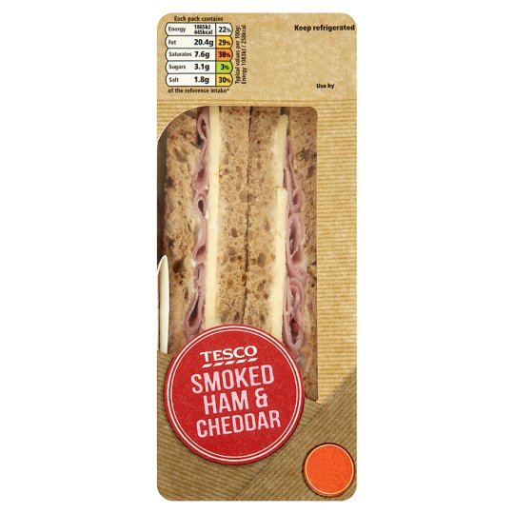

Two ways in which this sandwich is healthy:

1. ___________________________________________________
2. ___________________________________________________

Two ways in which this sandwich is unhealthy:

1. ___________________________________________________
2. ___________________________________________________

Two ways in which this sandwich is gastronomic:

1. ___________________________________________________
2. ___________________________________________________

Two ways in which this sandwich is not gastronomic:

1. ______________________________ 2) __________________________________

Three modifications I would make to this sandwich are:

1. ___________________________________________________
2. ___________________________________________________
3. ___________________________________________________

Design 4 gastronomic sandwiches. Use the success criteria and the resource for help.

|  |  |
| --- | --- |
| Sandwich 1 | Sandwich 2 |
| Sandwich 3 | Sandwich 4 |

Success Criteria:

* Include 1 knife skill - Realistic
* Complementary flavour combinations - Sketch in pencil
* Variety in colours - Label Sandwiches
* Variety in textures - Add colour

**Sensory Appeal** _______________

**ving Motifs ___________________**

**Objective:** …………………………………………………………………………………………………………………………………………

**Do Now:**

1. Our five senses include ____________________, ____________________, _____________, _____________________ and ____________________.
2. From the image, what do you think the term sensory appeal means?

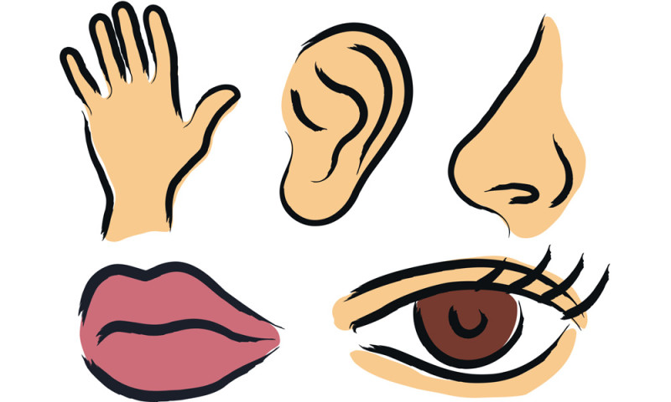

1. If a dish is gastronomic it must have _____________________________________________.

Our Five Senses:

Our first sense is ________________________. This sense helps us to ________________ more specifically _____________________________________________________________. If a dish of food is going to appeal to this sense it should: ___________________________________________________________________________

For example _________________________________________________________________



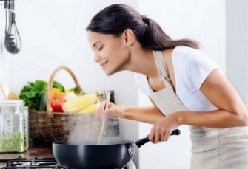

Another sense is ________________________. This sense helps us to ________________ more specifically _____________________________________________________________. If a dish of food is going to appeal to this sense it should: ___________________________________________________________________________

For example _________________________________________________________________

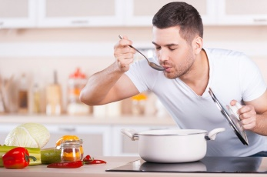

Our third sense is ________________________. This sense helps us to ________________ more specifically _____________________________________________________________. If a dish of food is going to appeal to this sense it should: ___________________________________________________________________________

For example _________________________________________________________________

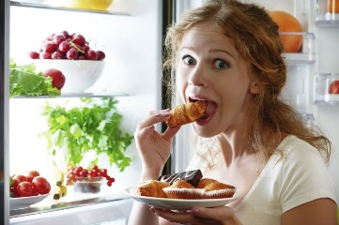

Another sense is ________________________. This sense helps us to ________________ more specifically _____________________________________________________________. If a dish of food is going to appeal to this sense it should: ___________________________________________________________________________

For example _________________________________________________________________

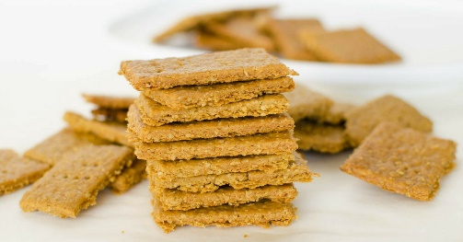

Our final sense is ________________________. This sense helps us to ________________ more specifically _____________________________________________________________. If a dish of food is going to appeal to this sense it should: ___________________________________________________________________________

For example _________________________________________________________________

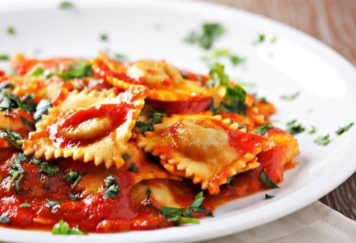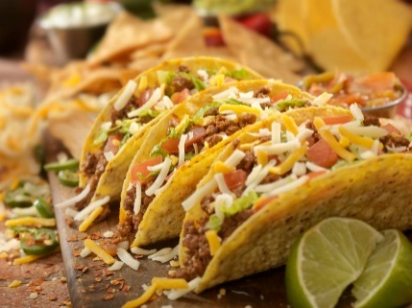Does this Dish have Sensory Appeal?

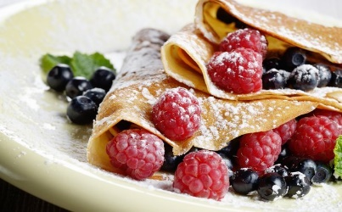

The senses this dish appeals to are:

__________________________________________________________

I know this because…

_______________________________________________________________________________________

If I were to change one thing about the dish to increase its sensory appeal I would…

_______________________________________________________________________________________

The senses this dish appeals to are:

__________________________________________________________

I know this because…

_______________________________________________________________________________________

If I were to change one thing about the dish to increase its sensory appeal I would…

_______________________________________________________________________________________

The senses this dish appeals to are:

__________________________________________________________

I know this because…

_______________________________________________________________________________________

If I were to change one thing about the dish to increase its sensory appeal I would…

_______________________________________________________________________________________

Dish Designs: Sensory Appeal

Design 2 dishes, sweet or savoury that have sensory appeal. Use the success criteria below to **SA** each of your dish designs.

Success Criteria:

* The dishes appeal to all 5 senses
* I have sketched in pencil
* I have labelled in pen
* I have included colour
* I have included a garnish

|  |  |
| --- | --- |
| Sweet Treat 1 | Sweet Treat 2 |

|  |  |
| --- | --- |
| Sandwich 1 | Sandwich 2 |

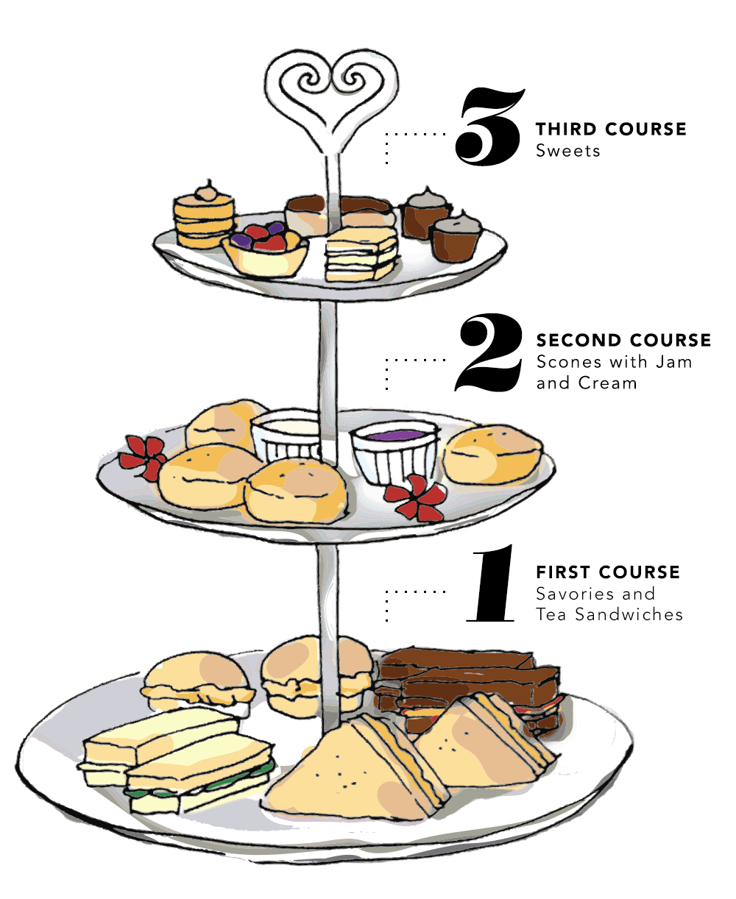

**In the boxes and circles below, design an afternoon that could be served.**

**Success Criteria:**

* **All designs must be gastronomic**
* **Sketches done in pencil**
* **Labels done in pen**
* **Add colour where possible**

**Afternoon Tea is:**

____________________________________________________________________________________________________________________________________________________________

**Do Now:**

1. The United Kingdom is made up of __________________, ___________________, ________________ and ______________________.
2. A traditional British dish would be ______________________________________________
3. People like to drink tea because ________________________________________________
4. When tourists come to the UK they like to eat _______________________________ this is because ___________________________________________________________________.

**Objective:** …………………………………………………………………………………………………………………………………………

**Afternoon Tea ___________________**