Year 9 Autumn 2: English Relocation Lesson 1
Task one. Answer the following questions in full sentences in your book.
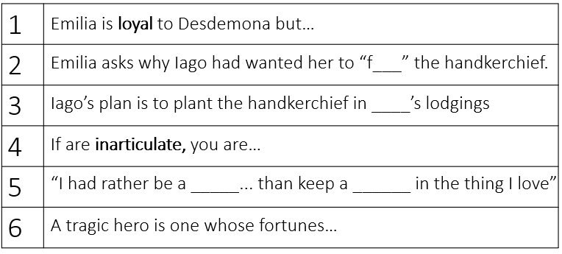
Task two. Read the extract from Othello. Complete questions in book.
Othello, after Iago convinces him that Desdemona is being unfaithful with Cassio
O, that the slave had forty thousand lives!
Now do I see 'tis true. Look here, Iago;
All my fond love thus do I blow to heaven.
'Tis gone.
Arise, black vengeance, from thy hollow cell! Yield up!

Even though Othello’s love for Desdemona used to be steadfast, …
Othello states ‘’black vengeance’’ because…
How did Iago convince Othello that Desdemona is unfaithful? Write a paragraph
Task three. Look cover write check for the spelling and definition of the words
Date: Spelling |  |  |  | Definition
1 | Duplicitous |  | Lying, two faced
2 | Credulous |  | Too trusting
3 | Malevolent |  | Someone who tries to cause harm
4 | Benevolent |  | Someone who wants to do good
5 | Impervious to |  | Not changed
6 | Susceptible to |  | Likely to change
7 | Dehumanize |  | To treat as less than human
8 | Defer to |  | Show respect
9 | Stabilize |  | To make stable
10 | Destabilize |  | To make unstable
1 | Duplicitous |  | Lying, two faced
2 | Credulous |  | Too trusting
3 | Malevolent |  | Someone who tries to cause harm
4 | Benevolent |  | Someone who wants to do good
5 | Impervious to |  | Not changed
6 | Susceptible to |  | Likely to change
7 | Dehumanize |  | To treat as less than human
8 | Defer to |  | Show respect
9 | Stabilize |  | To make stable
10 | Destabilize |  | To make unstable

Year 9 Autumn 2: English Relocation Lesson 2
Task one. Answer the following questions in full sentences in your book.
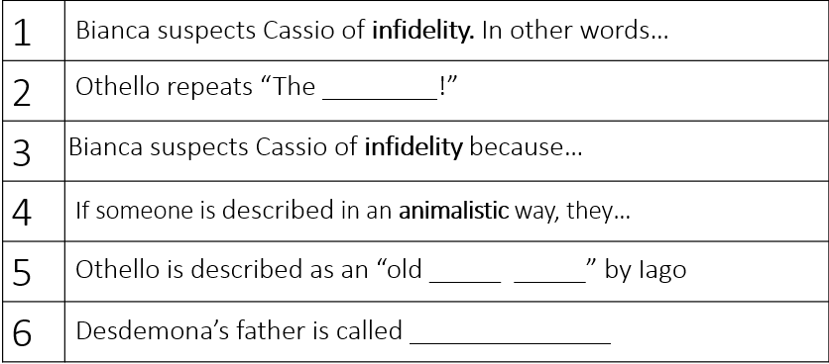
Task two. Read the extract from Othello. Complete questions in book.
Othello: he has become inarticulate (lost his ability to speak properly) because of jealousy
Lie with her! lie on her! We say lie on her, when
they belie her. Lie with her! that's fulsome.
--Handkerchief--confessions--handkerchief!--To
confess, and be hanged for his labour;--first, to be
hanged, and then to confess.--I tremble at it.
Nature would not invest herself in such shadowing
passion without some instruction. It is not words
that shake me thus. Pish! Noses, ears, and lips.
--Is't possible?--Confess--handkerchief!--O devil!--Falls in a trance’’

Othello has been reduced to inarticulacy because…
Even though Othello was powerful at the beginning of the play,…

Task three. Look cover write check for the spelling and definition of the words
Date: Spelling |  |  |  | Definition
1 | Subservient |  | To do whatever you are told
2 | Hierarchy |  | System ranking people
3 | Entrance |  | Take up all your attention
4 | Deceptive |  | Making you believe something not true
5 | Animalistic |  | Like an animal
6 | Alien |  | Not normal or expected
7 | Controlled |  | Stopping yourself from behaving badly
8 | Logical |  | Sensible
9 | Malcontent |  | Always unhappy
10 | Steadfast |  | Confident
1 | Subservient |  | To do whatever you are told
2 | Hierarchy |  | System ranking people
3 | Entrance |  | Take up all your attention
4 | Deceptive |  | Making you believe something not true
5 | Animalistic |  | Like an animal
6 | Alien |  | Not normal or expected
7 | Controlled |  | Stopping yourself from behaving badly
8 | Logical |  | Sensible
9 | Malcontent |  | Always unhappy
10 | Steadfast |  | Confident

Year 9 Autumn 2: English Relocation Lesson 3
Task one. Answer the following questions in full sentences in your book.
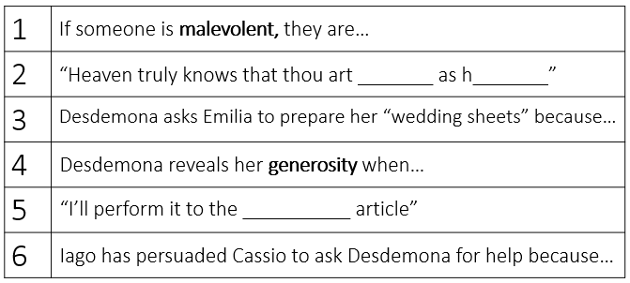
Task two. Read the extract from Othello. Complete questions in book.
Othello, having decided that he must sacrifice Desdemona
Let me not name it to you, you chaste stars!--
It is the cause. Yet I'll not shed her blood;
Nor scar that whiter skin of hers than snow,
And smooth as monumental alabaster.
Yet she must die, else she'll betray more men
When Othello says ‘’I’ll not shed her blood’ he means…
Othello’s mind has been corrupted because…
Othello has convinced himself that Desdemona ‘’must die’’. More specifically… (write a paragraph)
Task three. Look cover write check for the spelling and definition of the words
Date: Spelling |  |  |  | Definition
1 | Subvert |  | Destroy the power of a person/idea
2 | Stereotype |  | Set of untrue ideas
3 | Deferential |  | Polite, Respectful
4 | Machiavellian |  | Hungry for power
5 | Machination |  | Plot, plan
6 | Manipulation |  | To control someone/thing
7 | Hyperbole |  | Making something sound more impressive
8 | Contrast |  | Great difference
9 | Knavery |  | Dishonest act
10 | Motive |  | Reason for doing something
1 | Subvert |  | Destroy the power of a person/idea
2 | Stereotype |  | Set of untrue ideas
3 | Deferential |  | Polite, Respectful
4 | Machiavellian |  | Hungry for power
5 | Machination |  | Plot, plan
6 | Manipulation |  | To control someone/thing
7 | Hyperbole |  | Making something sound more impressive
8 | Contrast |  | Great difference
9 | Knavery |  | Dishonest act
10 | Motive |  | Reason for doing something

