Year 8 Autumn 2: English Relocation Lesson 1
Task one. Answer the following questions in full sentences in your book.
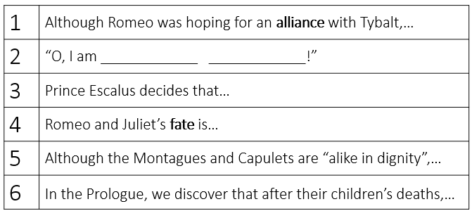
Task two. Read the extract from Romeo and Juliet. Complete questions in book.
JULIET: She has just found out that Romeo killed Tybalt
Shall I speak ill of him that is my husband?
Ah, poor my lord, what tongue shall smooth thy name,
When I, thy three-hours wife, have mangled it?
But, wherefore, villain, didst thou kill my cousin?
That villain cousin would have kill'd my husband:
Back, foolish tears, back to your native spring;
Your tributary drops belong to woe,
Which you, mistaking, offer up to joy.
My husband lives, that Tybalt would have slain;
And Tybalt's dead, that would have slain my husband:
Even though Juliet finds out that Romeo killed Tybalt,… (does she hate Romeo or still love him?)
Juliet does not scorn Romeo after he killed Tybalt because…
Task three. Look cover write check for the spelling and definition of the words
Date: Spelling |  |  |  | Definition
1 | Inevitable |  | Definitely going to happen
2 | Inescapable |  | Cannot be escaped
3 | Discord |  | Disagreement
4 | Feud |  | Argument lasting for a long time
5 | Patriarchal |  | Controlled by men
6 | Vulgar |  | Rude and offensive
7 | Fate |  | Things that will happen
8 | Free Will |  | Having power over what happens
9 | Scorn |  | To show dislike
10 | Masculinity |  | Qualities typical of men
1 | Inevitable |  | Definitely going to happen
2 | Inescapable |  | Cannot be escaped
3 | Discord |  | Disagreement
4 | Feud |  | Argument lasting for a long time
5 | Patriarchal |  | Controlled by men
6 | Vulgar |  | Rude and offensive
7 | Fate |  | Things that will happen
8 | Free Will |  | Having power over what happens
9 | Scorn |  | To show dislike
10 | Masculinity |  | Qualities typical of men
Year 8 Autumn 2: English Relocation Lesson 2
Task one. Answer the following questions in full sentences in your book.
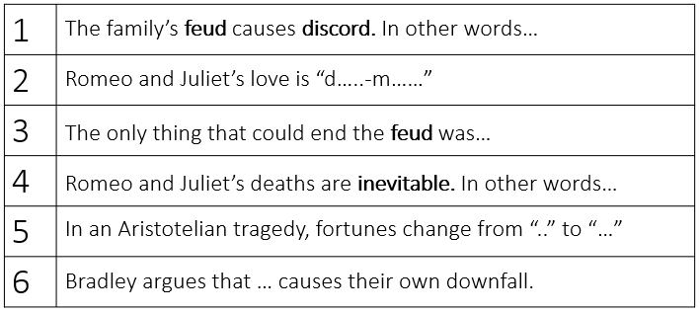
Task two. Complete question in book.
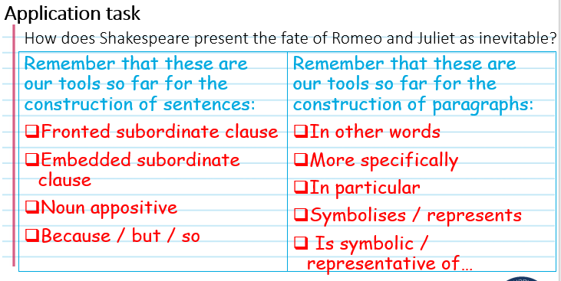
Task three. Look cover write check for the spelling and definition of the words
Date: Spelling |  |  |  | Definition
1 | Pervasive |  | Everywhere
2 | Turmoil |  | State of disturbance
3 | Melodramatic |  | Reacting in an exaggerated way
4 | Sincere |  | Honest
5 | Duality |  | Two opposite ideas existing together
6 | Objectify |  | To treat someone as an object
7 | Defiant |  | Refusing to obey someone of authority
8 | Potency |  | Power
9 | Inadvertently |  | By accident
10 | Impending |  | Happening very soon
1 | Pervasive |  | Everywhere
2 | Turmoil |  | State of disturbance
3 | Melodramatic |  | Reacting in an exaggerated way
4 | Sincere |  | Honest
5 | Duality |  | Two opposite ideas existing together
6 | Objectify |  | To treat someone as an object
7 | Defiant |  | Refusing to obey someone of authority
8 | Potency |  | Power
9 | Inadvertently |  | By accident
10 | Impending |  | Happening very soon

Year 8 Autumn 2: English Relocation Lesson 3
Task one. Answer the following questions in full sentences in your book.
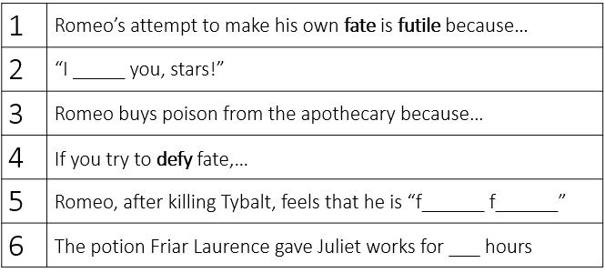
Task two. Read the extract from Romeo and Juliet. Complete questions in book.
Romeo has found Juliet dead and is preparing to take his own life
Depart again: here, here will I remain
With worms that are thy chamber-maids; O, here
Will I set up my everlasting rest,
And shake the yoke of inauspicious stars
From this world-wearied flesh. Eyes, look your last!
Arms, take your last embrace! and, lips, O you
The doors of breath, seal with a righteous kiss
A dateless bargain to engrossing death!
When Romeo says ‘’here will I set up my everlasting rest’’ he means…
Before Romeo takes his own life, he wants to…
Yoke means prison. Romeo compares fate to being imprisoned because…(write a paragraph)
Task three. Look cover write check for the spelling and definition of the words
Date: Spelling |  |  |  | Definition
1 | Volatile |  | Likely to change suddenly
2 | Stable |  | Not likely to change suddenly
3 | Excess |  | Too much
4 | Moderation |  | Reasonable, not extreme
5 | Resolute |  | Purposeful, determined
6 | Cooperative |  | They do what you ask them
7 | Fickle |  | Changing frequently
8 | Sacred |  | Holy
9 | Enmity |  | Hatred
10 | Alliance |  | Agreement to work together
1 | Volatile |  | Likely to change suddenly
2 | Stable |  | Not likely to change suddenly
3 | Excess |  | Too much
4 | Moderation |  | Reasonable, not extreme
5 | Resolute |  | Purposeful, determined
6 | Cooperative |  | They do what you ask them
7 | Fickle |  | Changing frequently
8 | Sacred |  | Holy
9 | Enmity |  | Hatred
10 | Alliance |  | Agreement to work together

