Year 7 Autumn 2: English Relocation Lesson 1
Task one. Answer the following questions in full sentences in your book.
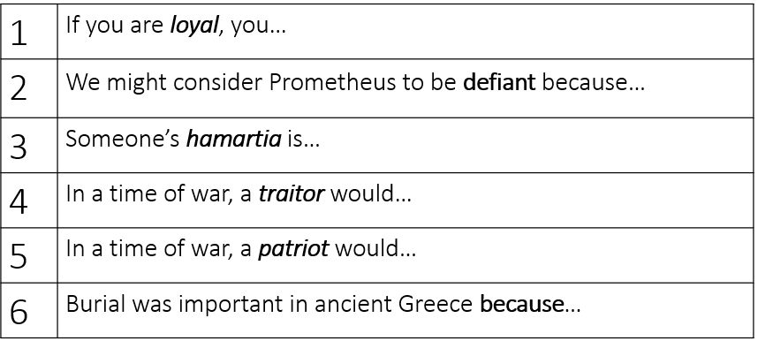
Task two. Read the extract from Antigone. Complete questions in book.
Antigone speaking about her two brothers who have died
Why not? Our own brothers' burial!
Hasn't Creon graced one with all the rites,
disgraced the other? Eteocles, they say,
has been given full military honours,
rightly so—Creon has laid him in the earth
and he goes with glory down among the dead.
But the body of Polynices, who died miserably—
why, a city-wide proclamation, rumour has it,
forbids anyone to bury him, even mourn him.
Antigone has two dead brothers Eteocles and Polynices, but only one was allowed to be buried. Which one?
How might Antigone react to the news that her brother will not allowed to be buried?
Antigone is upset because…
Task three. Look cover write check for the spelling and definition of the words
Date: Spelling |  |  |  | Definition
1 | Patriot |  | Loving your country
2 | Traitor |  | Betraying your country
3 | Disgrace |  | To cause shame
4 | Honour |  | Respect from doing what is right
5 | Joyous |  | Happy
6 | Desolate |  | Sad
7 | Disloyal |  | Not supporting friends/country
8 | Loyal |  | Supporting someone/something
9 | Meek |  | Gentle and quiet
10 | Forthright |  | Say what you think or feel
1 | Patriot |  | Loving your country
2 | Traitor |  | Betraying your country
3 | Disgrace |  | To cause shame
4 | Honour |  | Respect from doing what is right
5 | Joyous |  | Happy
6 | Desolate |  | Sad
7 | Disloyal |  | Not supporting friends/country
8 | Loyal |  | Supporting someone/something
9 | Meek |  | Gentle and quiet
10 | Forthright |  | Say what you think or feel
Autumn 2: English Relocation Lesson 2
Task one. Answer the following questions in full sentences in your book.
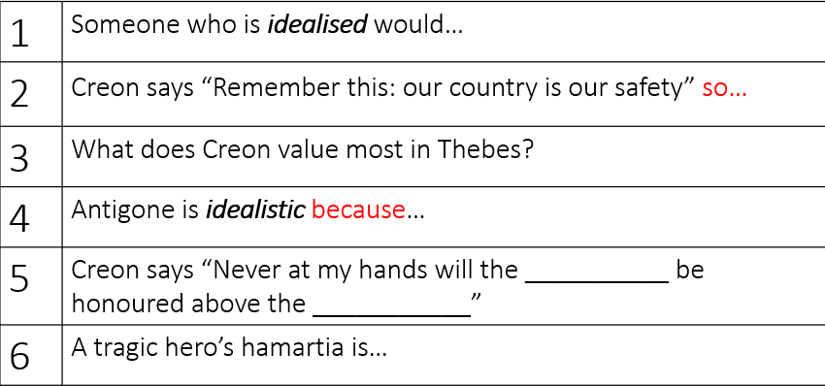
Task two. Read the extract from Antigone. Complete questions in book.
After Creon finds out that someone has buried Polynices despite his orders, he is worried about traitors
Exactly when did you last see the gods
celebrating traitors? Inconceivable!
No, from the first there were certain citizens
who could hardly stand the spirit of my regime,
grumbling against me in the dark, heads together.
Creon believes that the gods would never…
Creon is worried that some citizens are ‘’grumbling in the dark’’. In other words,…
In this extract, Creon believes that the gods __________ and he is worried that… (write a paragraph)
Task three. Look cover write check for the spelling and definition of the words
Date: Spelling |  |  |  | Definition
1 | Idealistic |  | Behave based on big ideas
2 | Pragmatic |  | Dealing with things in a practical way
3 | Suppress |  | Not expressing feelings
4 | Provoke |  | Deliberately annoy someone
5 | Pious |  | Very religious
6 | Blasphemous |  | Showing disrespect for God
7 | Compassion |  | Sympathy and understanding
8 | Indifference |  | Not caring
9 | Compliant |  | Do what they are asked to
10 | Defiant |  | Refusing to obey
1 | Idealistic |  | Behave based on big ideas
2 | Pragmatic |  | Dealing with things in a practical way
3 | Suppress |  | Not expressing feelings
4 | Provoke |  | Deliberately annoy someone
5 | Pious |  | Very religious
6 | Blasphemous |  | Showing disrespect for God
7 | Compassion |  | Sympathy and understanding
8 | Indifference |  | Not caring
9 | Compliant |  | Do what they are asked to
10 | Defiant |  | Refusing to obey

Autumn 2: English Relocation Lesson 3
Task one. Answer the following questions in full sentences in your book.
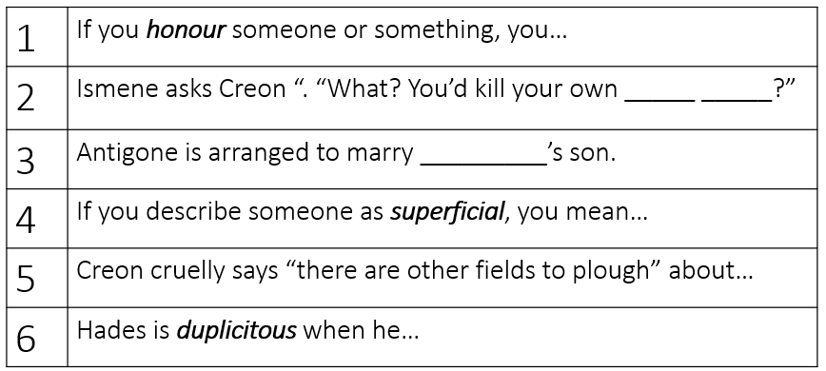
Task two. Read the extract from Antigone. Complete questions in book.
Haemon (Creon’s son) to Creon
Now don't, please,
be quite so single-minded, self-involved,
or assume the world is wrong and you are right.
It's no disgrace for a man, even a wise man,
to learn many things and not to be too rigid.
Haemon advises Creon that even a wise man should…
What advice does Haemon give to his father? (write a paragraph)
Task three. Look cover write check for the spelling and definition of the words
Date: Spelling |  |  |  | Definition
1 | Ashamed |  | Embarassed
2 | Prudent |  | Sensible and careful
3 | Proud |  | Pleased about something you have done
4 | Rash |  | Acting without thinking
5 | Condemn |  | Judging
6 | Elevate |  | To bring up
7 | Contemptible |  | Strong dislike
8 | Noble |  | Unselfish and morally good
9 | Detached |  | Not involved
10 | Passionate |  | Strong feelings
1 | Ashamed |  | Embarassed
2 | Prudent |  | Sensible and careful
3 | Proud |  | Pleased about something you have done
4 | Rash |  | Acting without thinking
5 | Condemn |  | Judging
6 | Elevate |  | To bring up
7 | Contemptible |  | Strong dislike
8 | Noble |  | Unselfish and morally good
9 | Detached |  | Not involved
10 | Passionate |  | Strong feelings

