In every English lesson in relocation you must:

- LCWC the plot of Macbeth.
- LCWC the adjectives used to describe Macbeth.
- Read and LCWC the Most Revealing Moments that you have covered in class.
- Complete the practice tasks

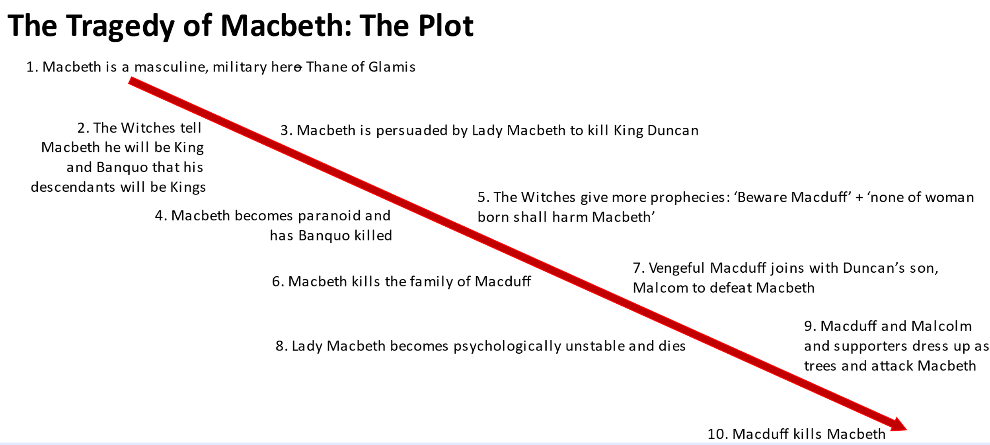
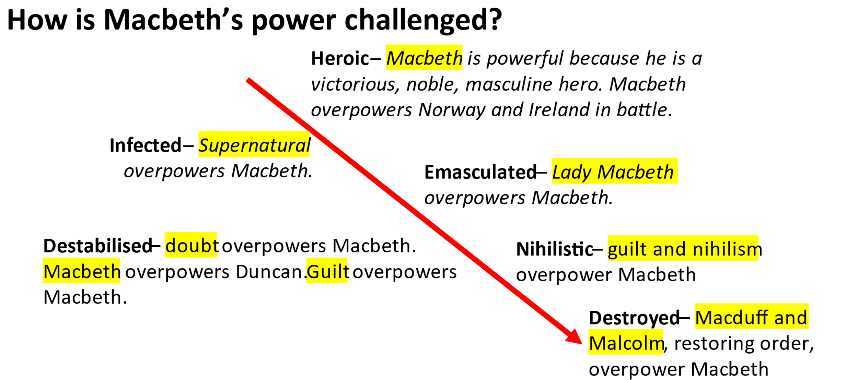

Macbeth: The Most Revealing Moments

Act 1
Moment | Quotation | What is revealed
The play opens with turmoil and treachery. | “thunder and lightning”  “multiplying villainies of nature” | +reveals the main themes of the play at the beginning.
The Witches corrupt Macbeth with riddles. | “Stay, you imperfect speakers, tell me more.” | +revealing the Witches’ skill in taking possession of Macbeth using words rather than magic.
Macbeth’s First Soliloquy | “Why do I yield to that suggestion…?” | +revealing the weakness inside Macbeth is his ambition – and he is beginning to give into it.
Macbeth’s Second Soliloquy | “That is a step on which I must fall down or else o’erleap” | +revealing that Macbeth feels jealous and betrayed by Duncan – despite being rewarded by the King.
Lady Macbeth’s metaphor for her husband’s ‘weakness’. | “I fear thy nature, it is too full of the milk of human kindness” | +reveals Lady Macbeth’s twisted view of morality – she views empathy and innocence as a weakness.
Lady Macbeth corrupts her body and soul. | “take my milk for gall, you murdering ministers”. | +revealing how Lady Macbeth associates innocence with the female body – and how she rejects nature.
Lady Macbeth’s Machiavellian advice. | “look like the innocent flower, but be the serpent under it”. | +reveals Shakespeare’s specific reference to the story of Genesis – connecting the Macbeths to Lucifer and the Fall of Man.
Macbeth changes his mind – revealing his equivocation. | “this even-handed justice  Commends the ingredients of our poison'd chalice  To our own lips”. | +revealing he is aware that justice will prevail - he knows that there are consequences for violent actions
Macbeth’s Third Soliloquy – Macbeth changes his mind. | “[Duncan’s] virtues will plead like angels, trumpet-tongued against [his murder]”. | +revealing that Macbeth’s conscience recognises the sin that he will commit and the danger of giving into ambition.
Lady Macbeth uses emotional blackmail to corrupt Macbeth. | “Woulds’t thou live a coward ... like the poor cat?” | +revealing Lady Macbeth’s intelligence and her skill in manipulating and corrupting her husband.

Act 2
Moment | Quotation | What is revealed
Banquo prays to God to stop his dreams of the Wyrd Sisters. | “Merciful powers, restrain in me the cursed thoughts” | +reveals a contrast to Macbeth. Banquo is tempted, but he is seeking God’s help to resist the corruption of ambition.
Macbeth’s Fourth Soliloquy –  Macbeth embraces dark images and chooses to follow the bloody dagger. | “Is this a dagger I see before me?”  “witchcraft celebrates pale Hecate’s offerings” | +reveals Macbeth’s fall to the forces of darkness.
Macbeth cannot say “amen” because of his murderous thoughts. | “the word stuck in my throat” | +reveals Macbeth’s damnation and God’s judgement.
Macbeth recalls hearing a ghostly voice cursing him for his murder of Duncan. | “Macbeth shall sleep no more” | +reveals Macbeth’s loss of innocence – as a good night’s sleep is associated with a clear conscience. Macbeth will not sleep again.
Macbeth and Lady Macbeth wash Duncan’s blood from their hands. | “All Great Neptune’s ocean”  “A little water clears us” | +reveals the contrast between Macbeth and his wife in the immediate aftermath of Duncan’s death.
Macbeth embraces his Machiavellian deceptions. | “Here lay Duncan, his silver skin laced with his golden blood” | +reveals a major twist in Macbeth’s character. A moment ago, he was panicking – now he is putting on a “false face”.
Malcolm and Donalbain feel threatened and flee. | “There’s daggers in mens’ smiles” | +reveals a theme of the play – do not trust people based on their superficial appearance.
The Old Man and Ross discuss the strange turmoil in nature. | “dark night strangles the [sun]”  “A falcon” was killed by a “mousing owl” | +reveals the effect of Macbeth’s treachery – nature has been corrupted. The falcon symbolises Duncan, the owl symbolises Macbeth.

Act 3
Moment | Quotation | What is revealed
Banquo’s Soliloquy Opens Act Three – He suspects Macbeth. | “Played most foully” | +reveals Banquo’s suspicions that Macbeth has been corrupted by treachery.
Macbeth’s Fifth Soliloquy | “defiled my mind”  “seed of Banquo”  “Barren sceptre” | +reveals Macbeth’s fears that he has corrupted his mind to benefit Banquo’s legacy
Macbeth convinces the murderers that Banquo is their enemy. |  | +reveals Macbeth’s ability to corrupt and manipulate others.
The murder of Banquo and the escape of Fleance. |  | +revealing the role of fate in thwarting Macbeth’s plans. It suggests that he cannot escape his tragic inevitability.
Macbeth hints at scorpions in his mind, but wants to protect Lady Macbeth from his treacherous plans. | “full of scorpions is my mind”  “Be innocent of the knowledge dearest chuck” | +reveals Macbeth’s growing obsession and corruption.  +also reveals either his growing distance from LM…  +or his love and care for her.
Macbeth hypocritically “toasts” Banquo – and invokes his friend’s ghost. | “Our dear friend Banquo, who we miss” | +This moment reveals Macbeth’s lack of remorse and suggests that he may be:  Guilty  Ashamed  Selfishly Afraid  Cursed by God

Act 4
Moment | Quotation | What is revealed
Hecate communicates with the witches. |  | +revealing the darker powers that the Witches work for are real and powerful.
Macbeth seeks out the witches and desires further prophecies. | “None of woman born shall harm Macbeth” | +revealing Macbeth’s obsession with his legacy and his reliance of dark and corrupting forces.  +revealing his trust in the Witches (clearly) riddling language.
The parade of Banquo’s heirs are presented to Macbeth. | “Thy crown does sear my eye-balls” | +revealing Macbeth’s realisation that his legacy is now doomed. He has no future left to fight for.
The graphic murder of Lady Macduff and her children. | “Mother, I am slain” | +reveals Macbeth’s true cowardice and corruption – he will destroy innocence to protect himself.
Malcolm compares Macbeth to Lucifer. | “Angels are bright still, though the brightest [Lucifer] fell – all things foul would wear the [mask] of grace”. | +reveals that Malcolm understands how corrupt souls hide behind attractive facades. His father did not grasp this.

Act 5
Moment | Quotation | What is revealed
Lady Macbeth’s fear of the dark and her sleepwalking | “Hell is murky” | +reveals Lady Macbeth’s true nature – she feels guilt and regret. It suggests that Shakespeare sympathises with her.
Lady Macbeth cannot wash her hands clean of invisible blood. | “all the perfumes of Arabia will not sweeten this little hand” | +reveals that Macbeth was right about “Neptune’s Ocean” back in Act 2.
The Doctor’s lesson for Macbeth. | “The patient must minister to himself” | +revealing that the only way to cure a corrupted soul or mind is through true repentance from the sinner. Macbeth does not see the need to repent.
Macbeth’s Sixth and final soliloquy. | “Life’s but a walking shadow” | +revealing Macbeth’s tired and weary belief that life is meaningless. After everything – his power means nothing.
Macbeth’s bravery in the final battle. | “Blow wind! Come wrack! At least we’ll die with harness on our back” | +reveals Macbeth’s lost valour. It reminds the audience of what he was and should have been.
Macduff’s Revenge | “Despair thy charm” | +revealing the witches’ true treachery – they knew all along. It also reveals the restoration of order and justice through MacDuff’s actions.
Malcolm is Crowned King | “The time is free” (MacDuff) | +revealing the true conclusion of tragedy – the restoration of order and justice.

Practice 1
Use the quotation, vocabulary and grammar to write a paragraph of analysis. When you finish your paragraph, circle the vocabulary and grammar of analysis you have used in green pen
Quotation | Vocabulary | Grammar of analysis
“fair is foul and foul is fair” | +turmoil  +chaos  +instability  +destabilise  +supernatural  +immoral | +the Jacobean era, a time when…,  +not only… but also…  +because  +…, who….,….
Paragraph
Shakespeare presents _______________________________________________________________
________________________________________________________________
when the witches chant “fair is foul and foul is fair”. In other words,_________
________________________________________________________________
________________________________________________________________
More specifically, the use of _______________________reveals ____________
________________________________________________________________
________________________________________________________________
________________________________________________________________
It is almost as if ___________________________________________________
________________________________________________________________
Perhaps Shakespeare ______________________________________________
________________________________________________________________
________________________________________________________________

Practice 2
Use the quotation, vocabulary and grammar to write a paragraph of analysis. When you finish your paragraph, circle the vocabulary and grammar of analysis you have used in green pen
Quotation | Vocabulary | Grammar of analysis
“yield to that suggestion”  “unfix my hair” | +turmoil  +chaos  +instability  +destabilise  +corrupt  +”fair”  +”foul” | +despite  +both… and…  +because  +and so  +…, who….,….
Paragraph
Shakespeare presents ______________________________________________
________________________________________________________________
when Macbeth wonders why he “yield[s] to that suggestion”, which “unfix[es] his hair”. In other words,___________________________________________
________________________________________________________________
________________________________________________________________
More specifically, _______________________________reveals ____________
________________________________________________________________
________________________________________________________________
________________________________________________________________
It is almost as if ___________________________________________________
________________________________________________________________
________________________________________________________________
Arguably, Shakespeare _____________________________________________
________________________________________________________________
________________________________________________________________
Practice 3
Use the quotation, vocabulary and grammar to write a paragraph of analysis.
When you finish your paragraph, circle the vocabulary and grammar of analysis you have used in green pen
Quotation | Vocabulary |  | Grammar of analysis
“look like the innocent flower but be the serpent under it” | +duplicitous  +passive  +pious  +interior  +exterior  +façade | +pure  +transgress  +corrupt  +immoral  +”fair”  +”foul” | +while  +although  +not only… but also…  +because  +and so  +…, who….,….
Paragraph
While Jacobean women ____________________________________________, Shakespeare presents Lady Macbeth as_______________________________
_______________________________________________________________
when she ______________________________________________________ In other words,___________________________________________________
________________________________________________________________
________________________________________________________________
More specifically, _________________________________________________
________________________________________________________________
________________________________________________________________
________________________________________________________________
It is as though ____________________________________________________
________________________________________________________________
________________________________________________________________
Perhaps Shakespeare ______________________________________________
________________________________________________________________
Practice 4
Use the quotation, vocabulary and grammar to write a paragraph of analysis.
When you finish your paragraph, circle the vocabulary and grammar of analysis you have used in green pen
Quotation | Vocabulary |  | Grammar of analysis
“false face must hide what the false heart doth know” | +duplicitous  +interior  +exterior  +façade  +conceal  +beneath | +pure  +transgress  +corrupt  +immoral  +”fair”  +”foul”  +”look like” | +while  +despite  +both… and…  +because  +before  +and so  +…, who….,….
Paragraph
Shakespeare presents Macbeth as____________________________________
________________________________________________________________
when he says ___________________________________________________ In other words,___________________________________________________
________________________________________________________________
________________________________________________________________
More specifically, _________________________________________________
________________________________________________________________
________________________________________________________________
________________________________________________________________
It is as though ____________________________________________________
________________________________________________________________
________________________________________________________________
Shakespeare intends ______________________________________________
________________________________________________________________

Practice 5
Use the quotation, vocabulary and grammar to write a paragraph of analysis.
When you finish your paragraph, circle the vocabulary and grammar of analysis you have used in green pen
Quotation | Vocabulary |  | Grammar of analysis
“a little water clears us of this deed”  “Neptune’s ocean” | +irreparable  +trivialise  +façade  +conceal  +callous  +immoral | +pure  +transgress  +corrupt  +immoral  +damnation  +moral | +although  +both… and…  +not only… but also…  +because  +after  +and so  +…, who….,….
Paragraph
Whereas Macbeth ________________________________________________, Shakespeare presents Lady Macbeth as________________________________
________________________________________________________________
when she says ___________________________________________________ In other words,___________________________________________________
________________________________________________________________
________________________________________________________________
In particular, _____________________________________________________
________________________________________________________________
________________________________________________________________
________________________________________________________________
It is as though ____________________________________________________
________________________________________________________________
________________________________________________________________
Maybe Shakespeare ______________________________________________
________________________________________________________________

Practice 6
Use the quotation, vocabulary and grammar to write a paragraph of analysis.
When you finish your paragraph, circle the vocabulary and grammar of analysis you have used in green pen
Quotation | Vocabulary |  | Grammar of analysis
“full of scorpions is my mind, dear wife” | +irreparable  +malevolent  +immoral  +attack  +toxic  +”brave” | +intangible  +predatory  +corrupt  +”foul”  +”black and deep desires” | +…, …. and, ultimately,…  +both… and…  +not only… but also…  +because  +although  +and so  +…, who….,….
Paragraph
After ___________________________________________________________, Shakespeare presents Macbeth as____________________________________
________________________________________________________________
when he says ___________________________________________________ Here, he means,__________________________________________________
________________________________________________________________
________________________________________________________________
In particular, _____________________________________________________
________________________________________________________________
________________________________________________________________
________________________________________________________________
It is as though ____________________________________________________
________________________________________________________________
________________________________________________________________
Perhaps Shakespeare ______________________________________________
________________________________________________________________

Practice 7
Use the quotation, vocabulary and grammar to write a paragraph of analysis.
When you finish your paragraph, circle the vocabulary and grammar of analysis you have used in green pen
Quotation | Vocabulary |  | Grammar of analysis
“unsex me here” | +supernatural  +passive  +pious  +pure  +transgress  +corrupt | +liberated  +imprisoned  +femininity  +”foul”  +immoral  +malevolent | +…, …. and, ultimately,…  +both… and…  +not only… but also…  +despite  +although  +while  +despite
Paragraph
While Jacobean women were expected to be _______________________________________________________________, Shakespeare presents Lady Macbeth _________________________________
________________________________________________________________
when she says ___________________________________________________ Here, she means,__________________________________________________
________________________________________________________________
________________________________________________________________
In particular, _____________________________________________________
________________________________________________________________
________________________________________________________________
________________________________________________________________
It is as if ________________________________________________________
________________________________________________________________
Shakespeare _____________________________________________________
________________________________________________________________

Practice 7
Use the quotation, vocabulary and grammar to write a paragraph of analysis.
When you finish your paragraph, circle the vocabulary and grammar of analysis you have used in green pen
Quotation | Vocabulary |  | Grammar of analysis
“coward”  “cat i’th’adage” | +emasculate  +passive  +dominant  +manipulate  +transgress  +corrupt | +liberated  +masculinity  +undermine  +”foul”  +immoral  +malevolent | +both… and…  +despite  +although  +because  +which  +transgressively
Paragraph
While Jacobean women were expected to be _______________________________________________________________, Shakespeare presents Lady Macbeth _________________________________
________________________________________________________________
when she says ___________________________________________________ Here, she means,__________________________________________________
________________________________________________________________
________________________________________________________________
In particular, _____________________________________________________
________________________________________________________________
________________________________________________________________
________________________________________________________________
It is as if ________________________________________________________
________________________________________________________________
Shakespeare _____________________________________________________
________________________________________________________________

Practice 8
Use the quotation, vocabulary and grammar to write a paragraph of analysis.
When you finish your paragraph, circle the vocabulary and grammar of analysis you have used in green pen
Quotation | Vocabulary |  | Grammar of analysis
“a dagger of the mind” | +tangible  +intangible  +manifestation  +psychological  +status quo  +transgress | +regicide  +unstable  +destabilise  +”foul”  +immoral  +hallucination | +both… and…  +despite  +and so  +because  +which  +not only… but also…
Paragraph
Before__________________________________________________________, Shakespeare presents Macbeth, who_________________________________,
as______________________________________________________________
when he says ___________________________________________________ Here, he means,__________________________________________________
________________________________________________________________
________________________________________________________________
More specifically, _________________________________________________
________________________________________________________________
________________________________________________________________
________________________________________________________________
It is as if ________________________________________________________
________________________________________________________________
Shakespeare intends______________________________________________
________________________________________________________________

Practice 9
Use the quotation, vocabulary and grammar to write a paragraph of analysis.
When you finish your paragraph, circle the vocabulary and grammar of analysis you have used in green pen
Quotation | Vocabulary |  | Grammar of analysis
“Macbeth shall sleep no more” | +turmoil  +tranquillity  +haunted  +psychological  +status quo  +transgress | +regicide  +chaos  +destabilise  +”foul”  +hallucination | +both… and…  +despite  +and so  +because  +who  +not only… but also…
Paragraph
After__________________________________________________________, Shakespeare presents Macbeth, who_________________________________,
as______________________________________________________________
when he says ___________________________________________________ Here, he means,__________________________________________________
________________________________________________________________
________________________________________________________________
In particular, _____________________________________________________
________________________________________________________________
________________________________________________________________
________________________________________________________________
It is almost as though_______________________________________________
________________________________________________________________
Perhaps Shakespeare ______________________________________________
________________________________________________________________

Practice 10
Use the quotation, vocabulary and grammar to write a paragraph of analysis.
When you finish your paragraph, circle the vocabulary and grammar of analysis you have used in green pen
Quotation | Vocabulary |  | Grammar of analysis
“played most foully” | +turmoil  +façade  +duplicitous  +interior  +exterior  +beneath | +regicide  +chaos  +destabilise  +”foul”  +”fair”  +suspicious | +both… and…  +revealing  +and so  +because  +who  +not only… but also…
Paragraph
Shakespeare presents Banquo, who_________________________________,
as______________________________________________________________
when he says ___________________________________________________ In other words___________________________________________________
________________________________________________________________
________________________________________________________________
In particular, _____________________________________________________
________________________________________________________________
________________________________________________________________
________________________________________________________________
It is almost as though_______________________________________________
________________________________________________________________
Perhaps Shakespeare ______________________________________________
________________________________________________________________

