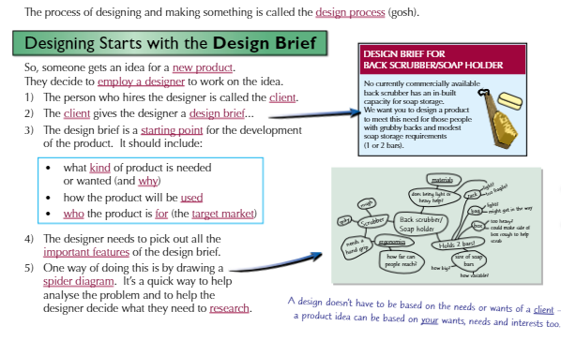
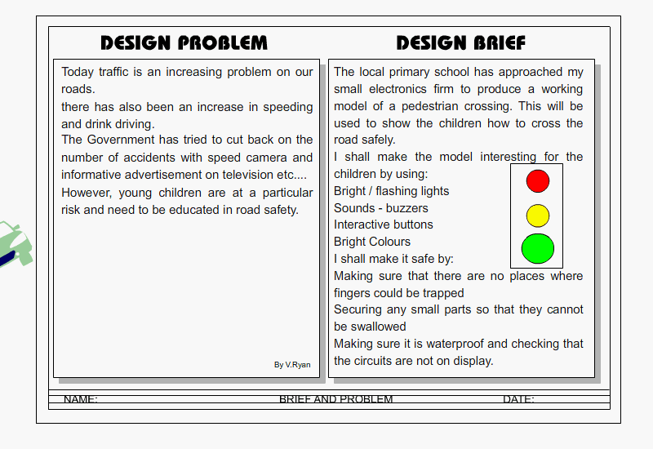

What is the design problem to be solved in this brief?
____________________________________________________________________________________________________________________________________________________________________
Who is the client in this design brief?
____________________________________________________________________________________________________________________________________________________________________
What product is the designer planning on making?
____________________________________________________________________________________________________________________________________________________________________
How should it work? What design features should it have?
____________________________________________________________________________________________________________________________________________________________________
Who is the target market/user of the product?
____________________________________________________________________________________________________________________________________________________________________
Draw a mind map with ideas for this design brief. Use the headings – who, where, what, when, how why – to help you:

Charles Rennie Mackintosh
Charles Rennie Mackintosh (1868 to 1928) was a renowned Scottish designer and architect, who contributed greatly to design in the early twentieth century. He designed buildings, including the impressive and imposing facade for the Glasgow School of Art (1899). He also produced floral watercolours, landscape watercolours, textile designs and interior designs. His furniture is especially memorable and their innovative design was important, at a time of change from Art Nouveau to Modernism.
Many of his designs were influenced by Art Nouveau and the Arts and Craft Movement. He can be regarded as a leading force in the modernist movement, although his designs were more artistic than those who followed strict modernist ideals. He often included floral patterns and Celtic Art, as simple decoration.
He was also influenced by Japanese style and design. He recognised that the Japanese brought simplicity, style, functionality and the use of natural materials to their designs/products.
Charles Rennie Mackintosh did not design for mass production, but usually for individuals and for specific rooms. Mackintosh utilised a combination of design principles derived from Art Nouveau, the Arts and Craft Movement and Japanese design.
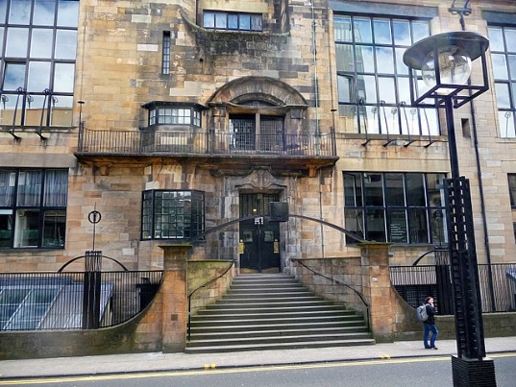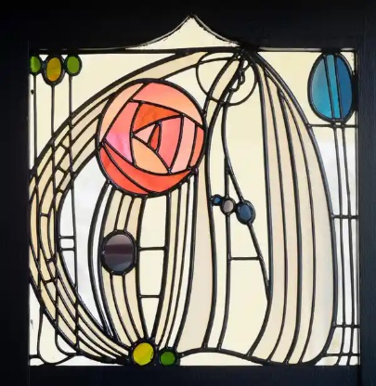
Left: Glasgow School of Art building designed by Charles Rennie Mackintosh
Right: Stained glass designed by Charles Rennie Mackintosh
Quiz
When was Charles Rennie Mackintosh born? _____________________________________________
What nationality was the designer? _____________________________________________________
What type of products did he design?
__________________________________________________________________________________
What was the name of the building that he designed in 1899?
__________________________________________________________________________________
What design movements was Charles Rennie Mackintosh influenced by?
__________________________________________________________________________________
What other design features are typical of Charles Rennie Mackintosh’s work?
__________________________________________________________________________________

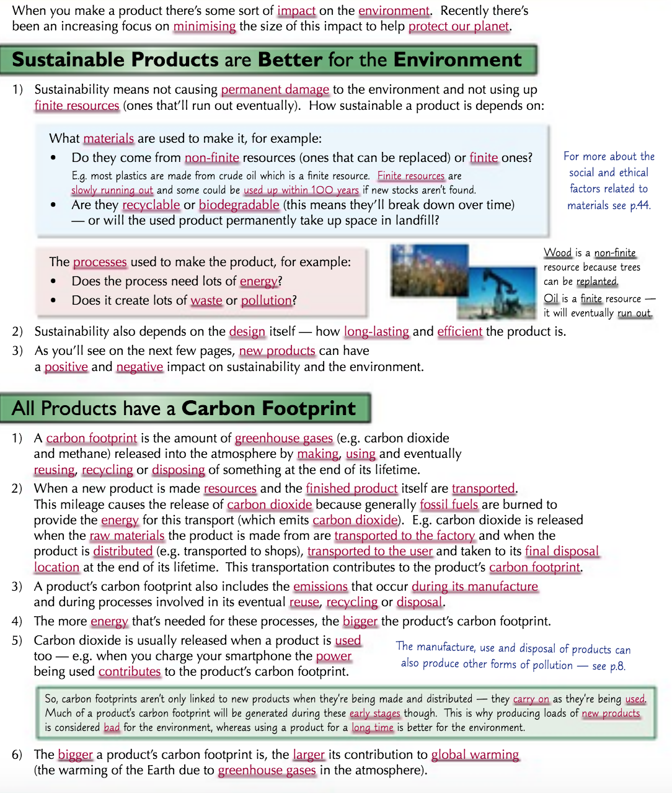

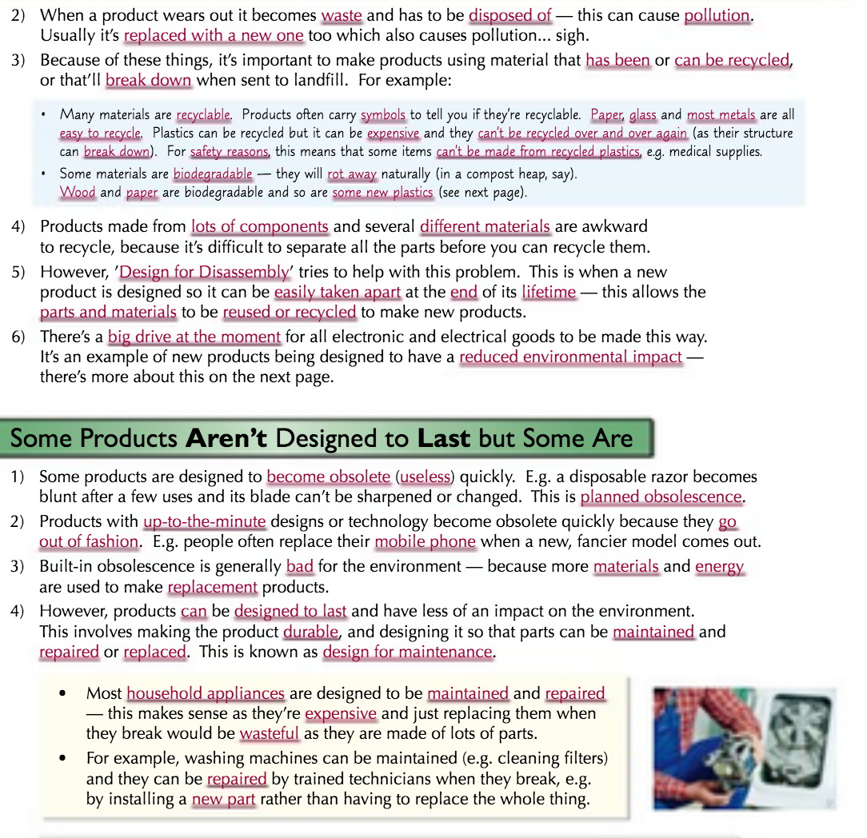

- Circle the correct term to match the definition:

Finite resources/non-finite resources | Resources that can be easily replaced
Finite resources/non-finite resources | Resources that cannot be easily replaced once they are used up.

- Put the type of fuel in the correct column depending on whether it is a renewable energy or a fossil fuel.
Oil, Wind power, Hydro power (water), Natural gas, Coal, Solar power, Biomass
Renewable energy | Fossil fuel

- Draw an arrow to connect the ‘R’ with the correct definition.
Rethink  means… |  | can you as a designer refuse to work with certain materials or processes which are harmful to the environment?
Repair  means… |  | can a products and materials be recycled instead of being sent to landfill? This process does use up energy but far less than extracting brand new materials.
Re-use  means… |  | can a product be fixed so that it can continue to be used? Sometimes products are perfectly functional but may need parts replacing or updating so that they don’t get sent to landfill.
Recycle  means… |  | can you rethink the way that something is designed with a new approach that will reduce the impact on the environment? For example, could you make a radio wind-up rather than using batteries?
Reduce  means… |  | can the life cycle of a product be extended by passing it on to somebody else or using it for an entirely different purpose altogether?
Refuse  means… |  | can you reduce the amount of energy used to make the product, or the amount of finite resources used for materials?

- The 6 Rs are…
________________________________________________________________________________________________________________________________________________
- Repair means…
_______________________________________________________________________________________________________________________________________________
- Finite resources means…
________________________________________________________________________________________________________________________________________________
- Give 3 examples of fossil fuels…
________________________________________________________________________
- An example of a non sustainable material is… because…
________________________________________________________________________________________________________________________________________________
- A more sustainable alterative is…because
______________________________________________________________________________________________________________________________________________________
- Green house gases are…
_______________________________________________________________________________________________________________________________________________
- Global warming is caused by…
______________________________________________________________________________________________________________________________________________________
- A more sustainable source of energy is…
______________________________________________________________________________________________________________________________________________________
- Designed for maintenance means…
______________________________________________________________________________________________________________________________________________________
- By designing products for maintenance, a design limits their impact on the environment because…
________________________________________________________________________________________________________________________________________________

Sustainability
Sustainability | Meeting present-day needs without compromising the needs of future generations.
Finite resources | is a resource that does not renew itself quickly enough to meet the needs of future generations
Non-finite resources | resources that can replenish quickly enough to meet our needs
Ecological footprint | The impact of a person or community on the environment; the amount of land needed to supply the natural resources they use
Social footprint | The impact a company or organisation has on people and communities
Landfill | The process of putting waste into the ground and burying it
Incineration | Burning waste materials

Look cover write check
Sustainability
Finite resources
Non-finite resources
Ecological footprint
Social footprint
Landfill
Incineration

