Revise the information of material properties for timber and polymers
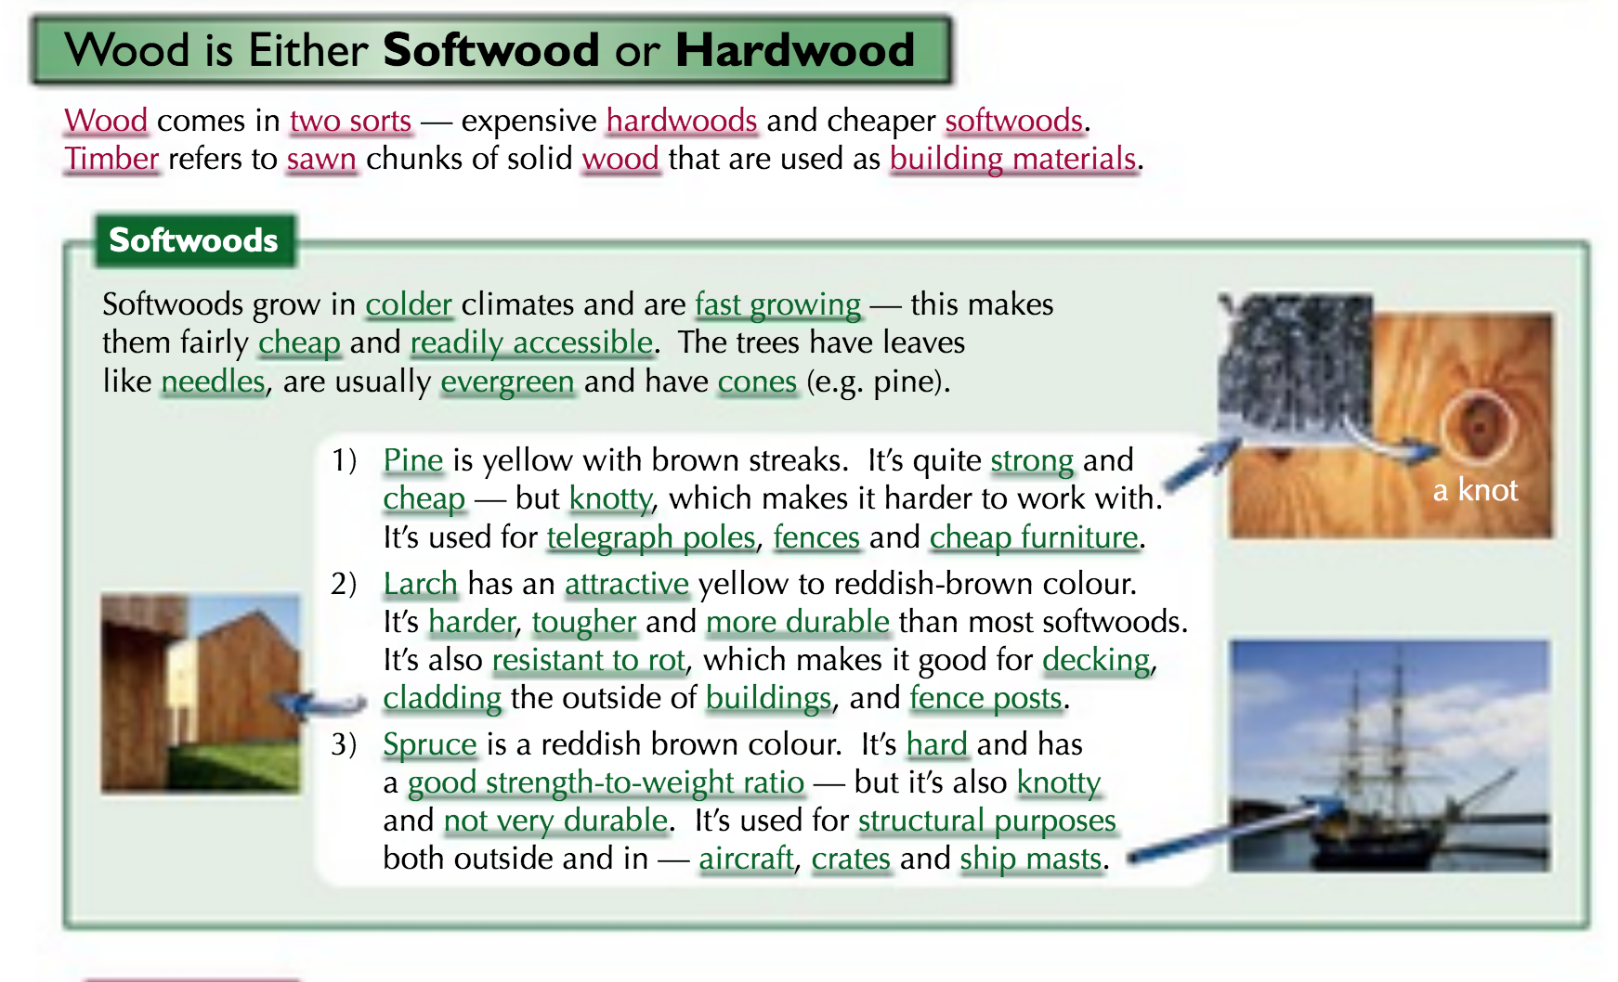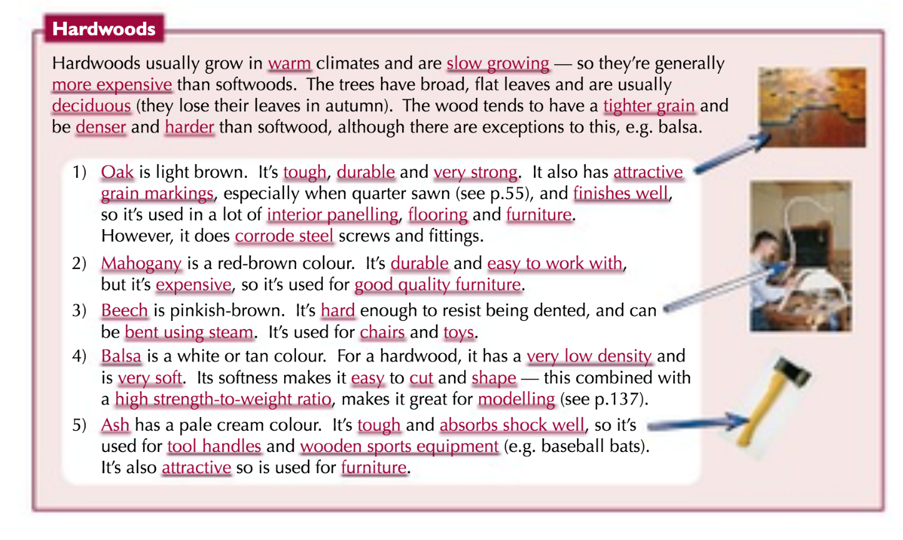

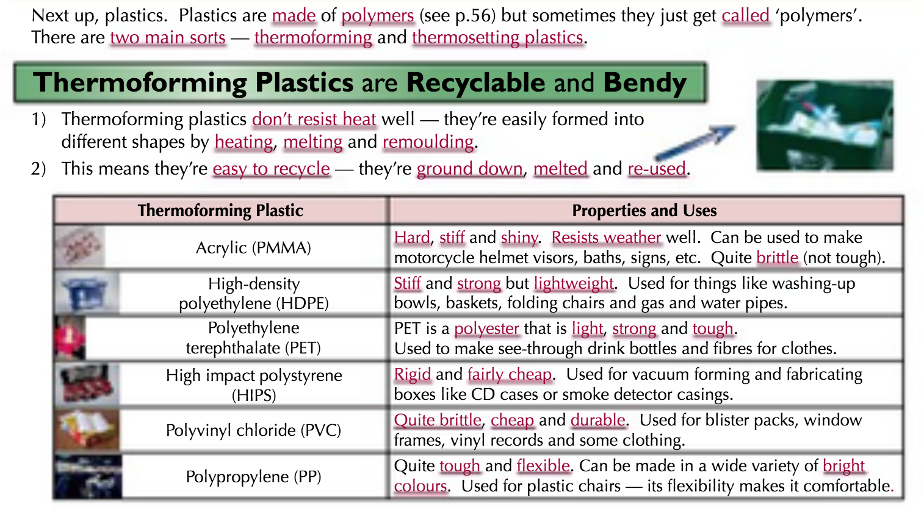
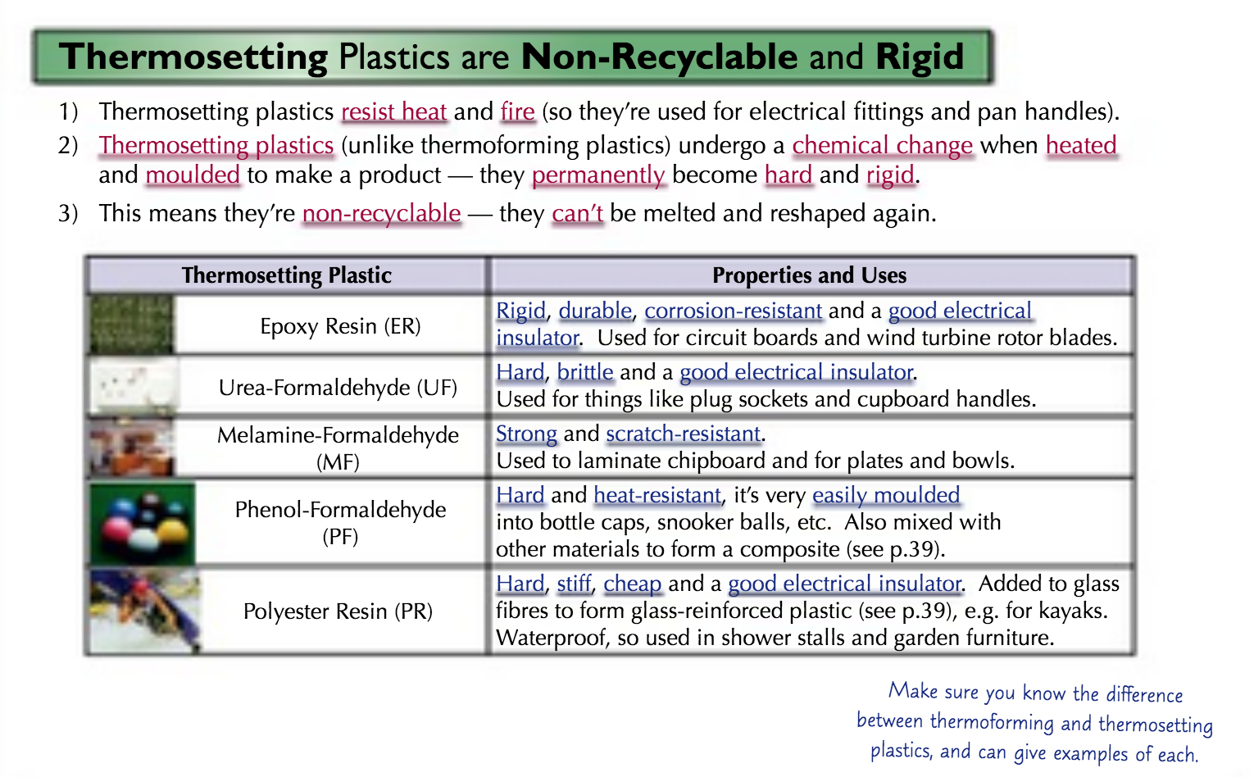

- Complete the table putting the timber material in the correct column depending on whether it is a hardwood or a softwood.
Pine, Balsa, Ash, Oak, Larch, Mahogany, Spruce, Beech
Hardwoods | Softwoods

Which material is being described?
- A yellowish softwood with brown streaks. This wood is strong and cheap but can be difficult to work with. Answer:
- A hardwood which is red-brown in colour and is durable but expensive. It is often used for good quality furniture. Answer:
- A softwood which is red-brown in colour. It has a good strength-to-weight ratio and is used for structural purposes. Answer:

- Complete the table putting the polymer material in the correct column depending on whether it is thermoforming or thermosetting.
Epoxy resin, Acrylic, Polypropylene, Phenol-formaldehyde, Urea-formaldehyde, High density polyethylene
Thermoforming plastics | Thermosetting plastics
Which polymer material is being described?
- A thermoforming plastic which is rigid and fairly cheap to by. It is used for vacuum forming to create products such as CD cases and smoke detectors. Answer:
- A thermosetting plastic which is hard brittle and a good electrical insulator. It is used for products such as plug sockets. Answer:
- A thermoforming plastic which is hard and waterproof and is often used for bathroom products and garden furniture. It is also a good electrical insulator. Answer:

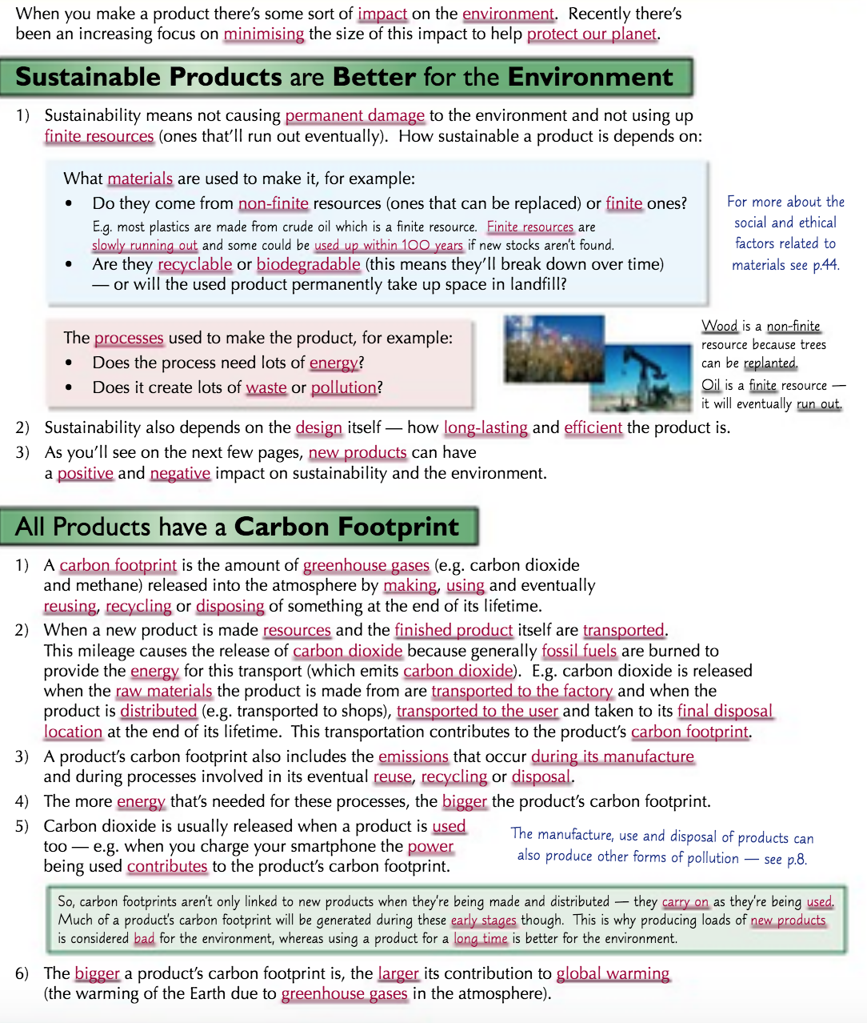

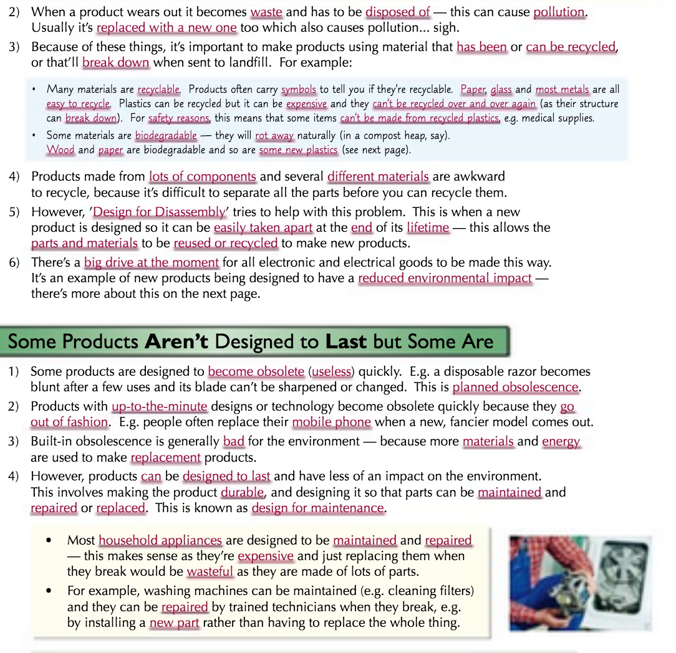

- Circle the correct term to match the definition:

Finite resources/non-finite resources | Resources that can be easily replaced
Finite resources/non-finite resources | Resources that cannot be easily replaced once they are used up.

- Put the type of fuel in the correct column depending on whether it is a renewable energy or a fossil fuel.
Oil, Wind power, Hydro power (water), Natural gas, Coal, Solar power, Biomass
Renewable energy | Fossil fuel

- Draw an arrow to connect the ‘R’ with the correct definition.
Rethink  means… |  | can you as a designer refuse to work with certain materials or processes which are harmful to the environment?
Repair  means… |  | can a products and materials be recycled instead of being sent to landfill? This process does use up energy but far less than extracting brand new materials.
Re-use  means… |  | can a product be fixed so that it can continue to be used? Sometimes products are perfectly functional but may need parts replacing or updating so that they don’t get sent to landfill.
Recycle  means… |  | can you rethink the way that something is designed with a new approach that will reduce the impact on the environment? For example, could you make a radio wind-up rather than using batteries?
Reduce  means… |  | can the life cycle of a product be extended by passing it on to somebody else or using it for an entirely different purpose altogether?
Refuse  means… |  | can you reduce the amount of energy used to make the product, or the amount of finite resources used for materials?

- The 6 Rs are… ________________________________________________________________________________________________________________________________________________

- Repair means… ________________________________________________________________________________________________________________________________________________

- Finite resources means…
________________________________________________________________________________________________________________________________________________

- Give 3 examples of fossil fuels…
________________________________________________________________________

- An example of a non sustainable material is… because…
________________________________________________________________________________________________________________________________________________

- A more sustainable alterative is…because
________________________________________________________________________________________________________________________________________________

- Green house gases are…
________________________________________________________________________________________________________________________________________________

- Global warming is caused by…
________________________________________________________________________________________________________________________________________________

- A more sustainable source of energy is…
________________________________________________________________________________________________________________________________________________

- Designed for maintenance means…

________________________________________________________________________________________________________________________________________________

- By designing products for maintenance, a design limits their impact on the environment because… ________________________________________________________________________________________________________________________________________________

In DT and manufacturing materials are split into three categories:
Traditional materials – these are materials that have been around for hundreds of years such as timber, stone etc.
Modern materials – these are materials that have been developed in the last century using modern processes. In other words after the industrial revolution such as manufactured boards, concrete etc.
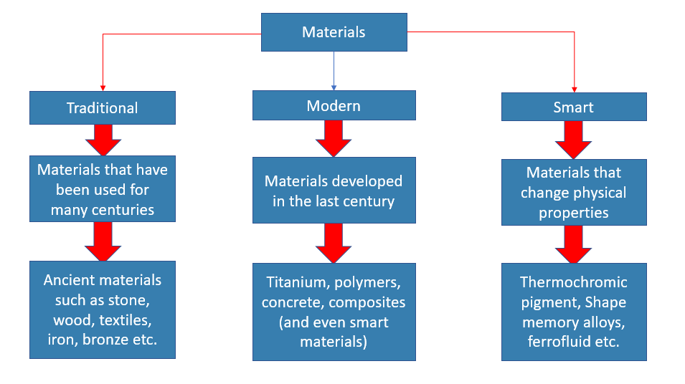
Smart materials – these are also considered as modern materials but they specifically change form or property such as thermochromic pigment.

What is considered to be a traditional material? Give 1 example.
__________________________________________________________________________________
What is considered to be a modern material? Give 1 example.
__________________________________________________________________________________
What is considered to be a smart material? Give 1 example.
__________________________________________________________________________________

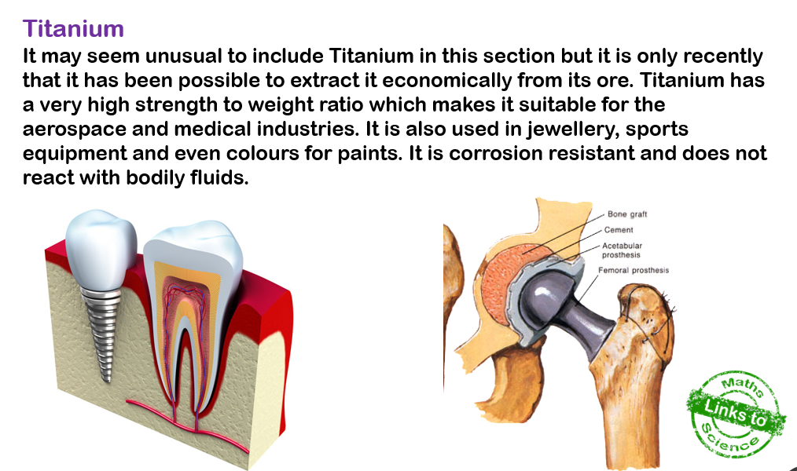
What are the properties of titanium?
__________________________________________________________________________________
What industries or products commonly use titanium?
__________________________________________________________________________________
What properties make it suitable for this product/industry?
__________________________________________________________________________________
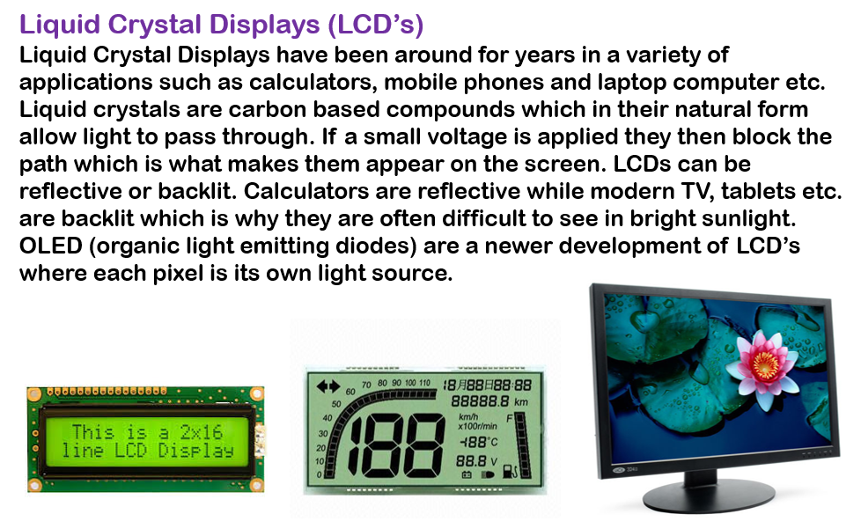
What are LCDs made up of?
__________________________________________________________________________________
What are the properties of LCDs?
__________________________________________________________________________________
What industries or products commonly use LCDs?
__________________________________________________________________________________
What properties make it suitable for this product/industry?
__________________________________________________________________________________

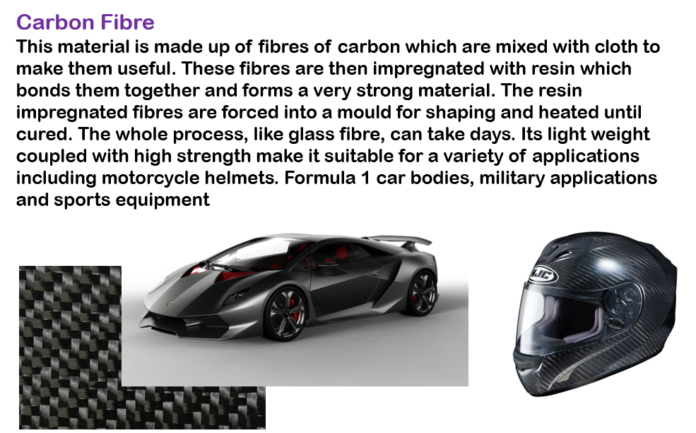

What is the origin of carbon fibre materials?
__________________________________________________________________________________
What are the properties of LCDs?
__________________________________________________________________________________
What industries or products commonly use LCDs?
__________________________________________________________________________________
What properties make it suitable for this product/industry?
__________________________________________________________________________________

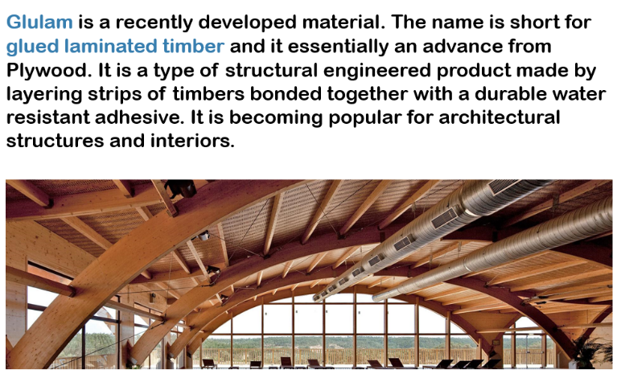
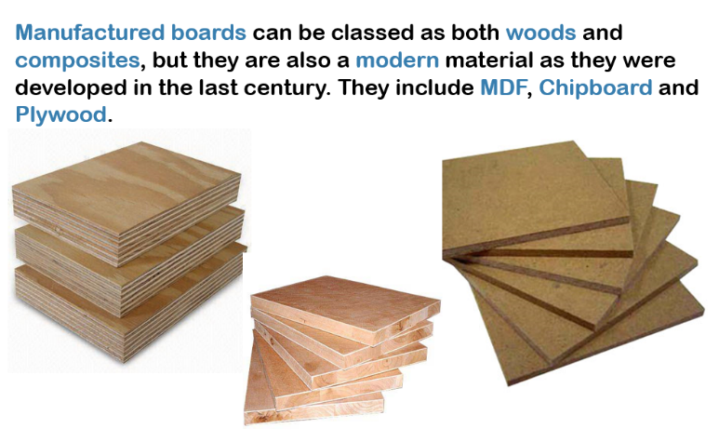
Manufactured boards are a timber based material. They are also classified as a composite material because they are made up of surplus timber chippings mixed with adhesive. They were only invented in the 1960s when manufactures discovered a way of using up left over timber from other products. This means that they are a very cost effective material and also good for the environment because the reduce waste.
They because popular with mass produced furniture because of their cost. Another advantage to manufactured boards are that they are smooth and come in any size. They are versatile because they can be painted easily or covered with a range of veneers.
Another development in manufactured boards is Flexiply or Glulam which is thin layers or veneers of timber which are bonded and glued together which means that, unlike natural timber, they can bend.
Why did manufactured boards become popular over natural timber?
__________________________________________________________________________________
Why are manufactured boards considered to be versatile?
__________________________________________________________________________________
Give one other advantage to manufactured boards over natural timber?
__________________________________________________________________________________
What is Glulam and flexiply made up of?
__________________________________________________________________________________

- Give 1 material in each of the following categories:
- Traditional __________________________ 1 mark
- Modern ____________________________ 1 mark

- Explain what is meant by the term modern material. Give an example in your answer.
2 marks
______________________________________________________________________________________________________________________________________________________________
- Name a modern material and describe how it can be used in a product. 4 marks
Material: _____________________________________
Product/description: ____________________________________________________________________________________________________________________________________________________________________________________________________________________________________________________________________________________________________________________________

- Give the properties of the following modern materials. 4 marks
- Titanium
_______________________________________________________________________________
- Carbon fibre
_______________________________________________________________________________
- Liquid crystal displays
_______________________________________________________________________________
- Glulam
_______________________________________________________________________________

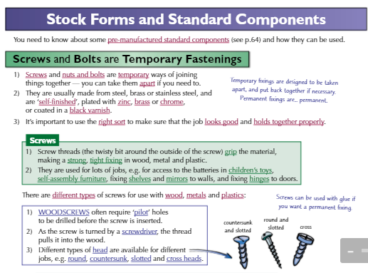
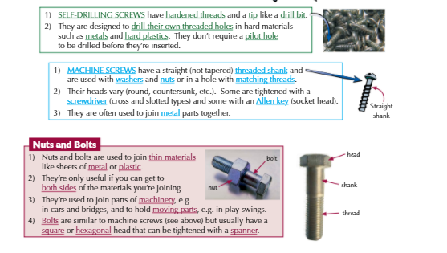
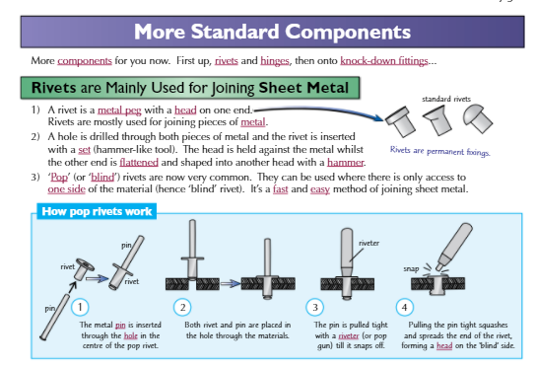
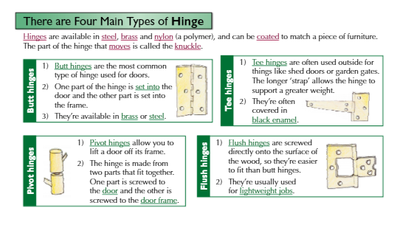
- True or false: Knock down fittings are permanent?
- What is one advantage of using a knock down fitting?
- Knock down fittings are most commonly used for…
- What tool is used for knock down fittings?
- Which of the below is the most strong?

2. What makes this component so strong?
3. What tool is used with this component?
4. Nuts and bolts are only used when…
5. Nuts and bolts are fastened using…
6. Typically what products are nuts and bolts used for?
