**NAME:**

**PAPER O**

**Date to be handed in:**

**MARK (out of 100):**

|  |  |  |  |  |  |  |  |  |  |  |  |  |  |  |  |
| --- | --- | --- | --- | --- | --- | --- | --- | --- | --- | --- | --- | --- | --- | --- | --- |
| **Qu** | **1** | **2** | **3** | **4** | **5** | **6** | **7** | **8** | **9** | **10** | **11** | **12** | **13** | **14** | **15** |
|  |  |  |  |  |  |  |  |  |  |  |  |  |  |  |  |

**Pure Mathematics**

**A Level: Practice Paper**

**Time: 2 hours**

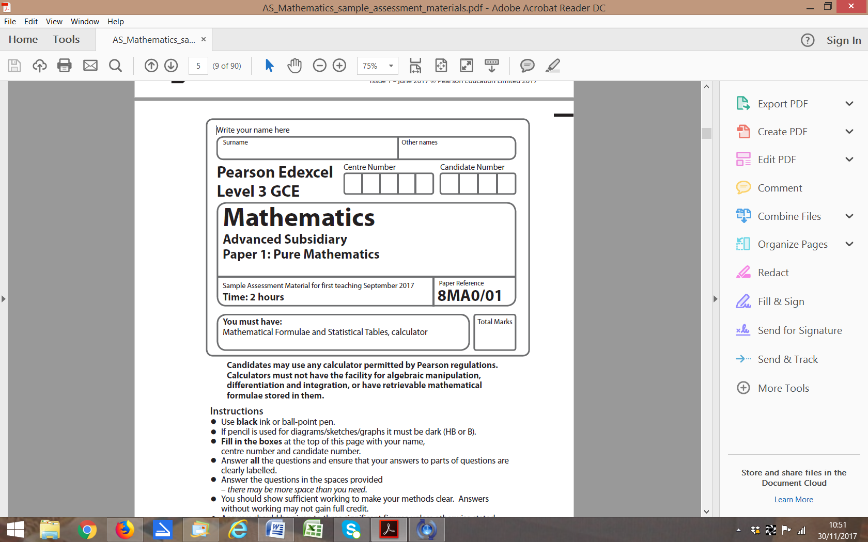

**Questions to revise:**

**1** Showing all steps, find **(3 marks)**

**2** Use proof by contradiction to show that there is no greatest positive rational number. **(4 marks)**

**3** Find **(4 marks)**

**4** Given that ,

find the values of the constants *A*, *B* and *C*, where *A*, *B* and *C* are integers. **(5 marks)**

**5** Prove by contradiction that if *n* is odd, *n*3+ 1 is even. **(5 marks)**

**6** An infinite geometric series has first four terms 

The series is convergent.

**a** Find the set of possible values of *x* for which the series converges. **(2 marks)**

**b** Given that , calculate the value of *x*. **(3 marks)**

**7** Given that , find the values of *a*, *b* and *c*.

**(6 marks)**

**8** The function g(*x*) is defined by, *x*∈ℝ, *x* > 4.

Find g−1(*x*) and state its domain and range. **(6 marks)**

**9** 

Show that f (*x*) can be written in the form , where *A*, *B* and *C* are constants

to be found. **(7 marks)**

**10** The diagram shows the right-angled trianglesand, with and.

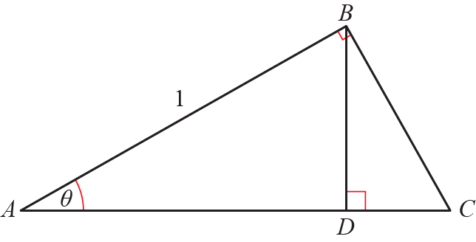

Prove that  **(8 marks)**

**11** The curve *C* has parametric equations,,

**a** Show that the cartesian equation of *C* can be written as,

where *a*, *b* and *c* are integers which should be stated. **(3 marks)**

**b** Sketch the curve *C* on the given domain, clearly stating the endpoints of the curve. **(3 marks)**

**c** Find the length of *C*. Leave your answer in terms of *π*. **(2 marks)**

**12** A curve has parametric equations *x* = cos 2*t*, *y* = sin *t*,.

**a** Find an expression forin terms of *t*.

Leave your answer as a single trigonometric ratio. **(3 marks)**

**b** Find an equation of the normal to the curve at the point *A* where **(5 marks)**

**13 **

**a** By drawing an appropriate sketch, show that there is only one solution to the equation g(*x*) = 0

**(2 marks)**

**b** Show that the equation g(*x*) = 0 may be written in the form *x* = 2e−*x* + 1

**(2 marks)**

**c** Let *x*0 = 1.5. Use the iterative formulato find to 4 decimal places the values

of *x*1, *x*2, *x*3 and *x*4. **(2 marks)**

**d** Using *x*0 = 1.5 as a first approximation, apply the Newton–Raphson procedure once to g(*x*)

to find a second approximation to *α*, giving your answer to 4 decimal places. **(4 marks)**

**14 a** Find the binomial expansion of  in ascending powers of *x* up to and including the *x*2 term, simplifying each term. **(4 marks)**

**b** State the set of values of *x* for which the expansion is valid. **(1 mark)**

**c** Show that when , the exact value of  is  **(2 marks)**

**d** Substitute  into the binomial expansion in part **a** and hence obtain an approximation to

Give your answer to 5 decimal places. **(3 marks)**

**15** The diagram shows the curve with equation

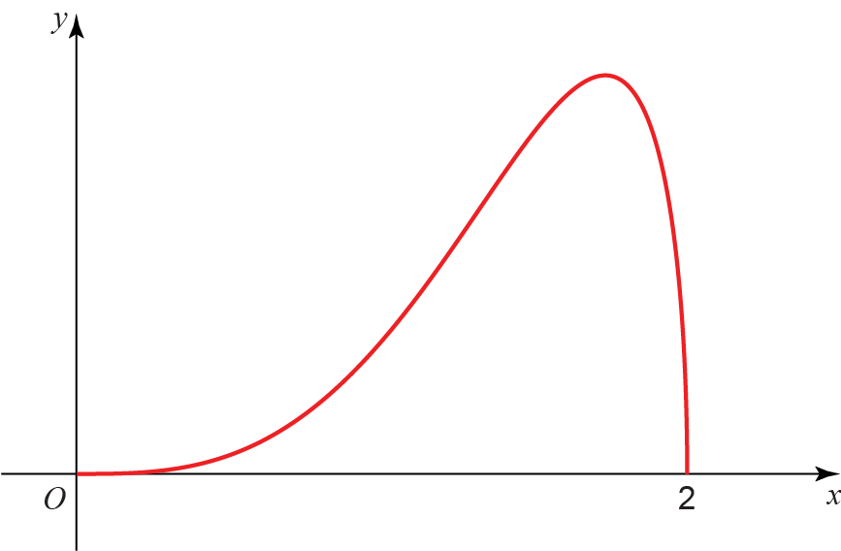

**a** Complete the table with the value of *y* corresponding to *x* = 1.5.

Give your answer correct to 5 decimal places. **(1 mark)**

|  |  |  |  |  |  |
| --- | --- | --- | --- | --- | --- |
| ***x*** | 0 | 0.5 | 1 | 1.5 | 2 |
| ***y*** | 0 | 0.12103 | 0.86603 |  | 0 |

**b** Given that, use the trapezium rule with 4 equal width strips

to find an approximate value of *I*, giving your answer to 4 significant figures. **(3 marks)**

**c** By using an appropriate substitution, or otherwise, find the exact value of, leaving your answer as a rational number in its simplest form. **(6 marks)**

**d** Suggest one way in which your estimate using a trapezium rule could be improved. **(1 mark)**

**(TOTAL: 100 MARKS)**