Year 8 Science Homework Pack

Autumn 1 - Chemistry – The Periodic Table

Name:____________________________________

Teacher: __________________________________

Homework Tracker
Week | Topic | LCWC |  |  |  | Quiz score | Extended writing completed | Extended MAD completed
 |  | MON | WED | FRI | ONCE MORE
1 | Atomic structure and Electron Configuration
2 | The Alkali Metals
3 | The Halogens and the Noble Gases
4 | Reaction Properties
5 | Common chemical reactions
6 | Common chemical reactions (extension only)
7 | Extended practice: your teacher will choose a knowledge table

Model ‘Look, Cover, Write, Check’

- ‘Look’ - read the first piece of knowledge once.
- ‘Cover’ - put your hand over the right hand column (the answers)
- ‘Write’ - write the answer down from memory as number 1.
- ‘Check’ - uncover your hand and check your answer using a green pen to tick each correct part and change any errors.
- Tick your box for ‘MON’
- If you make an error you also need to tick ‘ONCE MORE’.
- Repeat this on Tuesday and Wednesday.
- Choose one more day to repeat the knowledge that you got wrong.
- Once you have completed your weekly quiz in class, you can then highlight the knowledge you got correct in the table below. Any pieces of knowledge you are struggling to remember can be written on a flash card and practised for 15 minutes each day.

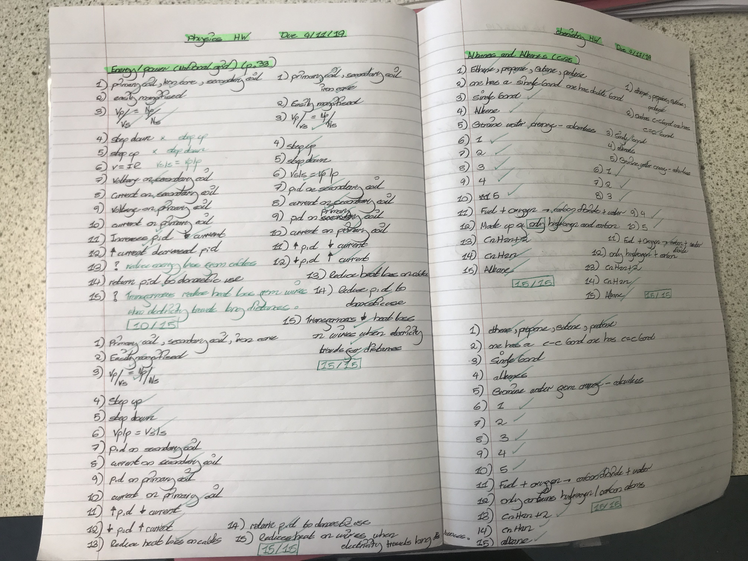

The Knowledge

Week 1
 | Topic: | Atomic structure and electronic configuration | MON | WED | FRI | ONCE MORE
1 | Define atomic mass number | The number of protons added to the number of neutrons. (this is the bigger number for each element)
2 | Define atomic number | The number of protons  (this is the smaller number for each element)
3 | How do you calculate the number of protons for an element? | Use the atomic number
4 | How do you calculate the number of electrons for an element? | Use the atomic number
5 | How do you calculate the number of neutrons for an element? | Mass number - atomic number
6 | Where are electrons located in an atom? | Orbiting the nucleus in energy levels (shells)
7 | What is the maximum number of electrons the first shell can fit? | 2 electrons
8 | What is the maximum number of electrons the remaining shells can fit? | 8 electrons
9 | How do we represent the electron configuration short hand? | 2.8.8.
10 | What does the electron configuration tell us? | Number of electrons in each shell
11 | What rule do we have when drawing the electron configuration? | The lowest energy levels (first shell) must be filled before adding electrons to the next level up
12 | How do you calculate the relative formula mass of a compound? (extension only) | Add up the mass numbers

Q. | Monday
1
2
3
4
5
6
7
8
9
10
11
12

Q. | Wednesday
1
2
3
4
5
6
7
8
9
10
11
12

Q. | Friday
1
2
3
4
5
6
7
8
9
10
11
12

Q. | Once more on _______________________________
1
2
3
4
5
6
7
8
9
10
11
12

Week 2
 | Topic: | The Alkali Metals | MON | WED | FRI | ONCE MORE
1 | Which group are alkali metals found in? | Group 1
2 | Name the 6 alkali metals in order of reactivity (low to high) | Lithium, sodium, potassium, rubidium, caesium, francium
3 | Why are they called the alkali metals? | They react with water to form an alkaline product (metal hydroxide)
4 | What colour would a metal hydroxide turn when universal indicator is added? | Purple
5 | How many electrons do group 1 (alkali metals) have in the outer shell? | 1 electron
6 | State 3 properties of alkali metals | - Shiny when cut  - Soft  - Solid at room temperature
7 | What is produced when an alkali metal reacts with oxygen? | Metal oxide
8 | What happens to the number of electron shells as you go down the group? | The number of shells increases by one each time, meaning the atom gets larger
9 | What happens to reactivity as you move down the alkali metals (group 1)? | The reactivity increases

Q. | Monday
1
2
3
4
5
6
7
8
9

Q. | Wednesday
1
2
3
4
5
6
7
8
9

Q. | Friday
1
2
3
4
5
6
7
8
9

Q. | Once more on _______________________________
1
2
3
4
5
6
7
8
9

Week 3
 | Topic: | The Halogens and Noble Gases | MON | WED | FRI | ONCE MORE
1 | Name the 5 halogens (group 7) in order of reactivity (low to high) | Astatine, Iodine, Bromine, Chlorine, Fluorine
2 | What form do the group 7 halogens naturally occur? | Diatomic (each molecule contains two halogen atoms joined by a single bond)
3 | Give the state and colour of fluorine at room temperature | A pale yellow gas
4 | Give the state and colour of chlorine at room temperature | A green gas
5 | Give the state and colour of bromine at room temperature | A brown/orange liquid
6 | Give the state and colour of iodine at room temperature | A grey solid
7 | How many electrons do the halogens have in their outer shell? | 7 electrons
8 | State the trend in the number of shells as you move down the group | Number of shells increases meaning the atoms get larger
9 | What happens to the reactivity as you move down the halogens (group 7)? | The reactivity decreases
10 | Name three noble gases (group 0) | Helium, neon, argon
11 | Why are the noble gases inert (unreactive)? | They have a full outer shell of electrons and so are stable
12 | What are the uses of the noble gases? | Helium- less dense than air, so balloons and airships rise and is non-flammable so the helium cannot set on fire  Argon- used inside light bulbs because it doesn’t react with oxygen and is not flammable  Neon- used in lamps to produce coloured light

Q. | Monday
1
2
3
4
5
6
7
8
9
10
11
12

Q. | Wednesday
1
2
3
4
5
6
7
8
9
10
11
12

Q. | Friday
1
2
3
4
5
6
7
8
9
10
11
12

Q. | Once more on _________________________________
1
2
3
4
5
6
7
8
9
10
11
12

Week 4
 | Topic: | Reaction Properties | MON | WED | FRI | ONCE MORE
1 | Recall the six signs of a chemical reaction | 1) Odour, 2) colour change, 3) precipitate formed, 4) temperature change, 5) gas produced, 6) light emitted
2 | Define "exothermic" | A reaction which gives out energy
3 | Define "endothermic" | A reaction which takes in energy
4 | Describe the test for oxygen gas | Relights a glowing splint
5 | Describe the test for hydrogen gas | A lit splint causes a squeaky pop
6 | Describe the test for carbon dioxide gas | Turns limewater cloudy
7 | If a salt contains two elements only, what ending is given to the name? (extension only) | "-ide"
8 | If a salt contains more than two elements (including oxygen!), what ending is given to the name? (extension only) | "-ate"
9 | What is the formula for copper sulphate? | CuSO₄
10 | What is the formula for calcium carbonate? | CaCO₃

Q. | Monday
1
2
3
4
5
6
7
8
9
10.

Q. | Wednesday
1
2
3
4
5
6
7
8
9
10.

Q. | Friday
1
2
3
4
5
6
7
8
9
10.

Q. | Once more on _______________________________
1
2
3
4
5
6
7
8
9
10.

Week 5
 | Topic: | Common chemical reactions | MON | WED | FRI | ONCE MORE
1 | Define "reactant" | Substance that react together
2 | Define "product" | Substances made in a reaction
3 | What is an oxidation reaction? | A substance combining with oxygen
4 | What is the general equation for the oxidation of a metal? | Metal + oxygen  -> metal oxide
5 | Which gas is produced when a metal reacts with acid? | Hydrogen
6 | What is the general equation when a metal reacts with an acid? | Metal + acid -> salt + hydrogen
7 | Define "combustion" | A reaction with oxygen in which energy is transferred to the surroundings
8 | What is "combustion" more commonly known as? | Burning
9 | What is the general equation for combustion? | Fuel + oxygen -> carbon dioxide + water
10 | Define "conservation of mass" | Mass of reactants = mass of products

Q. | Monday
1
2
3
4
5
6
7
8
9
10

Q. | Wednesday
1
2
3
4
5
6
7
8
9
10

Q. | Friday
1
2
3
4
5
6
7
8
9
10

Q. | Once more on _________________________________
1
2
3
4
5
6
7
8
9
10

Week 6
 | Topic: | Common chemical reactions (extension only) | MON | WED | FRI | ONCE MORE
1 | What type of reaction is an acid + metal hydroxide reaction? | Neutralisation reaction
2 | Recall the general equation for an acid + metal hydroxide reaction | Acid + metal hydroxide -> metal salt + water
3 | Recall the general equation for an acid + metal carbonate reaction | Acid + metal carbonate -> metal salt + water + carbon dioxide
4 | What is the state symbol for a solid? | (s)
5 | What is the state symbol for a liquid? | (l)
6 | What is the state symbol for a gas? | (g)
7 | What is the state symbol for a solution? | (aq) = aqueous
8 | Which salt is produced when hydrochloric acid is used? | Metal chloride
9 | Which salt is produced when sulphuric acid is used? | Metal sulphate
10 | Which salt is produced when nitric acid is used? | Metal nitrate

Q. | Monday
1
2
3
4
5
6
7
8
9
10

Q. | Wednesday
1
2
3
4
5
6
7
8
9
10

Q. | Friday
1
2
3
4
5
6
7
8
9
10

Q. | Once more on _______________________________
1
2
3
4
5
6
7
8
9
10

Week 7
 | Topic: | Chosen by your teacher: ___________________ | MON | WED | FRI | ONCE MORE

Q. | Monday
1
2
3
4
5
6
7
8
9
10

Q. | Wednesday
1
2
3
4
5
6
7
8
9
10

Q. | Friday
1
2
3
4
5
6
7
8
9
10

Q. | Once more on _______________________________
1
2
3
4
5
6
7
8
9
10

Mastery Matrix

Our Mastery Matrix shows us all the individual things we will learn over this unit. When you are revising for your post-assessment you can read each one and check if you can do it. If not, use the revision guide pages in the table to review the content.

Mastery Matrix

Subject | Year Group | HT | Topic | Course | Learning statement
Chemistry | 8 | Au1 | The periodic table | All | Define "period" and "group" and identify these on the periodic table
Chemistry | 8 | Au1 | The periodic table | Ext | Describe the development of the periodic table over the last 200 years (Extension only)
Chemistry | 8 | Au1 | The periodic table | All | Identify the metals and non-metals in the periodic table
Chemistry | 8 | Au1 | The periodic table | Ext | Describe the structure and properties of alloys - linking to the particle model (Extension only)
Chemistry | 8 | Au1 | The periodic table | All | Identify the atomic number and mass number of an element on the periodic table
Chemistry | 8 | Au1 | The periodic table | All | Use the periodic table to calculate the number of protons, neutrons and electrons in an atom
Chemistry | 8 | Au1 | The periodic table | Ext | Calculate the relative atomic mass and relative formula mass for different substances (Extension only)
Chemistry | 8 | Au1 | The periodic table | All | Identify the alkali metals on the periodic table and state some properties of elements in this group
Chemistry | 8 | Au1 | The periodic table | All | Identify the halogens on the periodic table and state some properties of elements in this group
Chemistry | 8 | Au1 | The periodic table | Ext | Identify the noble gases on the periodic table and state some properties of elements in this group (Extension only)
Chemistry | 8 | Au1 | Materials | Ext | Describe the structure and properties of ceramics (Extension only)
Chemistry | 8 | Au1 | Materials | Ext | Describe the structure and properties of polymers (Extension only)
Chemistry | 8 | Au1 | Materials | Ext | Describe the structure and properties of composites (Extension only)
Chemistry | 8 | Au1 | Reaction properties | All | Recall the six signs of a chemical reaction
Chemistry | 8 | Au1 | Reaction properties | All | Define "exothermic" and "endothermic" reactions
Chemistry | 8 | Au1 | Reaction properties | All | Describe the tests for oxygen, hydrogen and carbon dioxide
Chemistry | 8 | Au1 | Reaction properties | Ext | Recall the rules for naming salts (-ide and -ate) (Extension only)
Chemistry | 8 | Au1 | Reaction properties | Ext | Write formulae for given salts (Extension only)

