Year 8: Autumn 1
Why did the Industrial Revolution turn Victorian London into an ‘abyss’ for the poorest people?

Name: _____________________ Class:__________________ Teacher: ______________

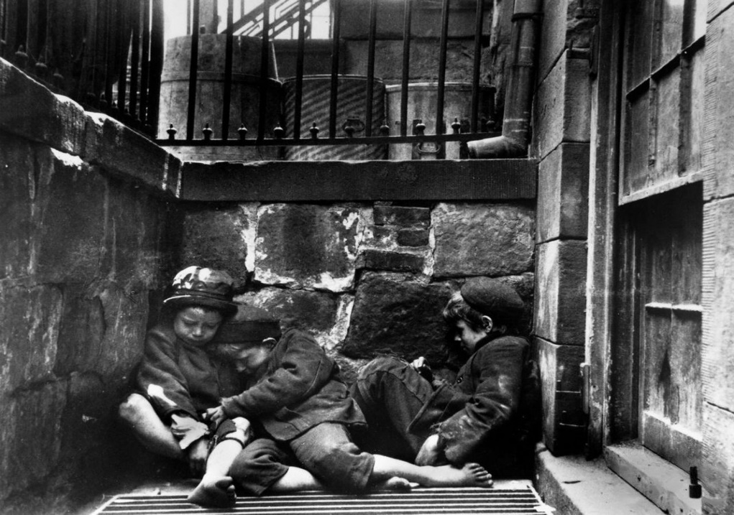
Contents
Lesson/Resource | Page Numbers | Tick when complete
Knowledge Organiser | 2
Blank Knowledge for look/cover/write/check | 3
Map and definitions of factors | 4
Lesson 1: What was the Industrial Revolution? What were its causes and consequences? | 5-9
Lesson 2-3: How did jobs turn London into an ‘abyss’ for the poorest people? | 10-15
Lesson 4-5: How did accommodation turn London into an ‘abyss’ for the poorest people? | 16-23
Lesson 6-7: How did eating drinking and entertainment turn London into an ‘abyss’ for the poorest people? | 24-28
Learning Ladder | 29
“Because, but, so” vocabulary table | 30

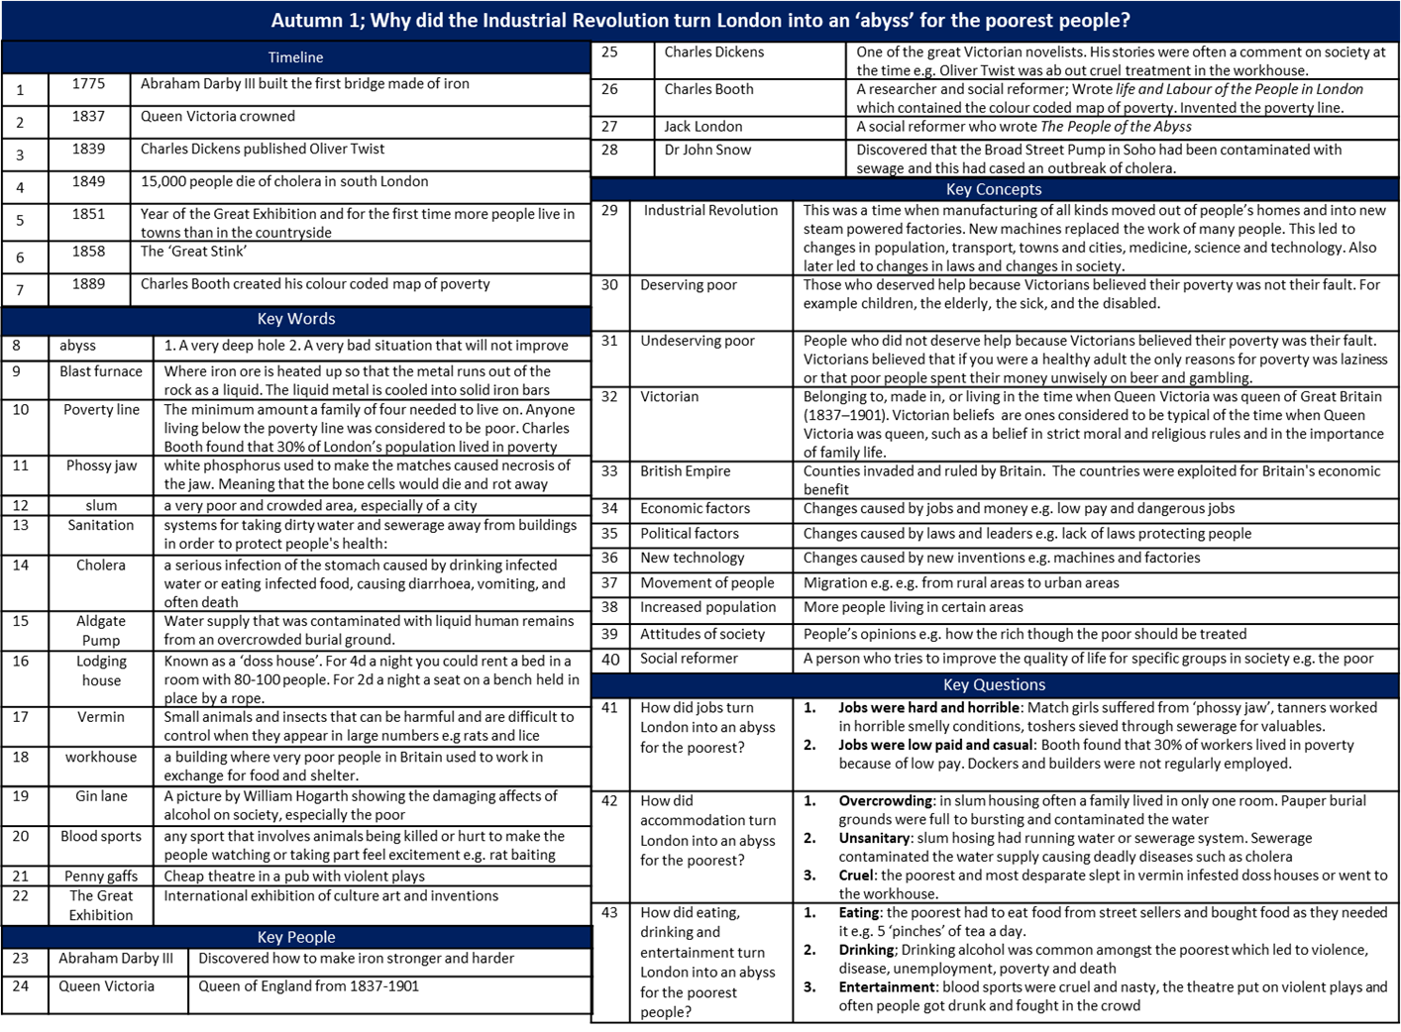
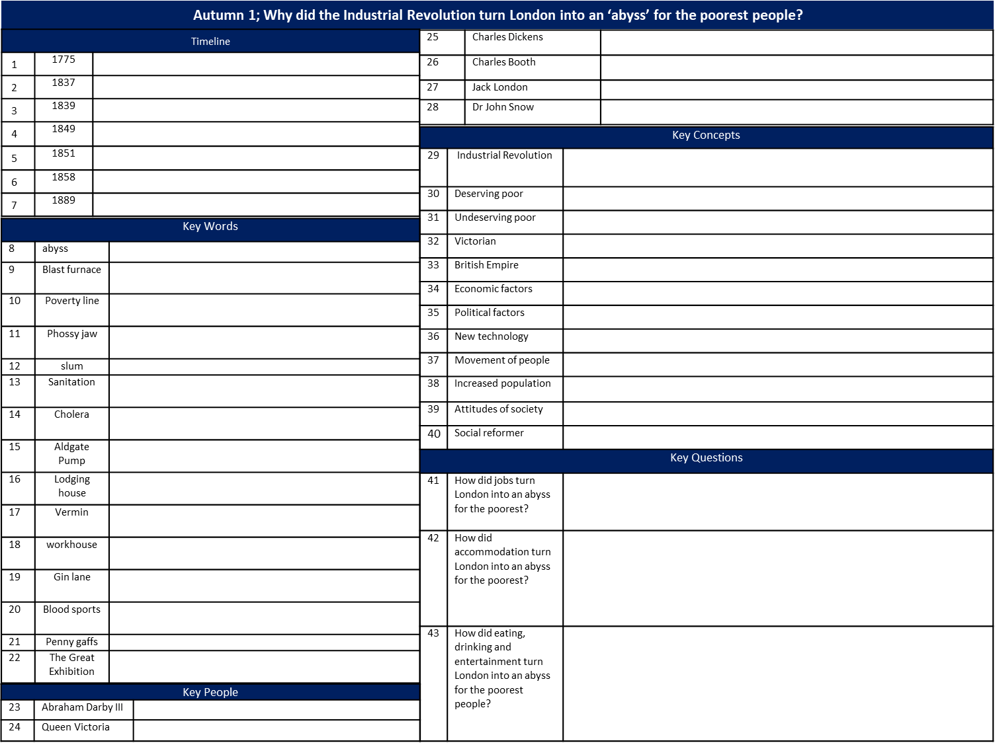

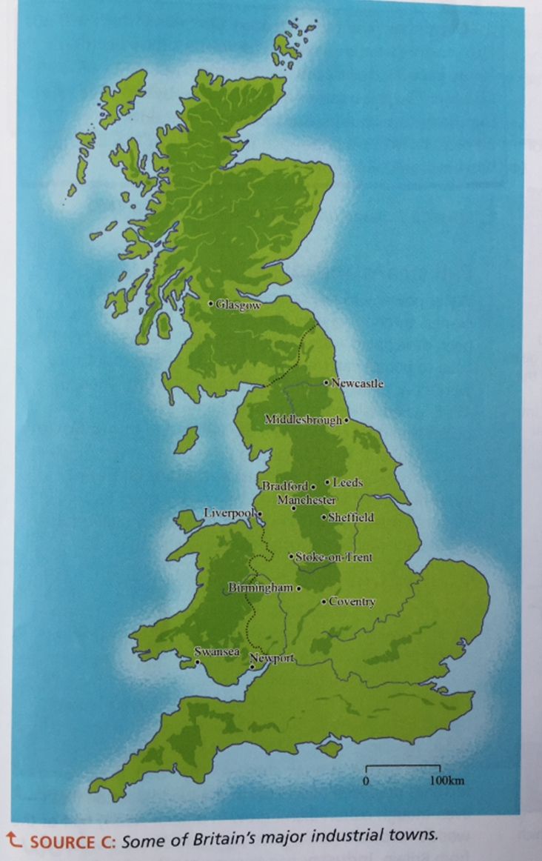
The Industrial Revolution affected the whole of Britain. Can you add any other industrial towns to the map?
To help explain why the Industrial Revolution caused terrible conditions for the poorest people we will use thee factors
- Economic factors (jobs and money) e.g. low pay and dangerous jobs
- Political factors (laws and leaders) e.g. lack of laws protecting people
- New technology e.g. machines and factories
- Movement of people e.g. from rural areas to urban areas
- Increased population
Attitudes of society at the time e.g. how the rich though the poor should be treated
Lesson 1 Do now!
1. The Victorian Period lasted from 1837-1901? Which two centuries was this period in?
17th and 18th centuries | 19th and 20th centuries | 20th and 21st centuries

2. Write in the correct name of the century next to these years:
The Battle of Hastings was in 1066
The Black Death arrived in England in 1348
The Slave Trade was abolished in 1807
Queen Victoria died in 1901

3. To work out the century a year is in, you look at the first two digits of the year (if it is a four-digit year) and…
……………………………………………………………………………………………………………………………………………………………………………………..
4. The Victorian Age is in what period(s) of history?
Middle Ages  (Also known as the Medieval Period)  500- 1500 | Early Modern Period  1500-1700 | Industrial Period  1700-1900 | Modern Period  1900-present

4. Which definitions of an ‘abyss’ are correct? Two of the definitions are correct.
A very deep hole | A painful, swollen area on the body that contains a yellow liquid | A very bad situation that will not improve

5. The People of the Abyss (1903) is a book by Jack London about the life of London’s poorest people. He wrote this book after living in the East End, sometimes sleeping on the streets. In his attempt to understand the people of this poor area of London Jack stayed with a poor family. The conditions he experienced and wrote about were the same as those experienced by an estimated 500,000 of London’s population.
When Jack London says that the poor people living in London are the ‘people of the abyss’, what does he mean?
He means that that the poorest people of Victorian London live in a very dark, deep hole in the ground | He means that the poorest people of Victorian London life in very bad conditions and that these conditions will not improve.

Why did the Industrial Revolution turn London into an ‘abyss’ for the poorest people?
What was the Industrial Revolution? What were its causes and consequences?
What was the Industrial Revolution?

The ‘Industrial Revolution’ was a phrase first used by British writer Arnold Toynbee (1852-1883) to describe the huge changes that occurred in the way people lived and worked after 1750. This was a time when manufacturing of all kinds moved out of people’s homes and into new steam powered factories. New machines replaced the work of many people. This led to changes in population, transport, towns and cities, medicine, science and technology. Also later led to changes in laws and changes in society.

Explain: In other words the Industrial revolution was when….
Example: Examples of changes caused by the Industrial Revolution were…
Illustrate: Draw a picture to show the Industrial Revolution. Or think of a metaphor.

Causes of the Industrial Revolution 1. Role of Individuals
- Watch the clip on slide 12. Start the clip at 2.15. The first time you watch the clip, watch and listen carefully. The second time you watch the clip. Answer the questions below. https://www.youtube.com/watch?v=GEpTXRKB4sE

Coalbrookdale is famous for two things. What are they?
The Industrial Revolution began here | It had the best quality coal in Britain | Its bridge made out of iron
What job did Abraham Darby have, which his family had held for generations?
Coal master; Than owned coal mines | Ironmaster; they made iron | Bridge master; they built bridges
What is a blast furnace?
Where clay objects are fired (hardened or baked) to make pottery | Where rubbish is burnt and any gases released are collected to make energy | Where iron ore is heated up so that the metal runs out of the rock as a liquid. The liquid metal is cooled into solid iron bars
What problem did Abraham Darby solve?
How to make iron that was hard and strong by using coke to heat the iron ore | How to make iron the was hard but brittle by using coal to heat the iron ore | How to make iron the was strong but malleable by using coke to heat the ore
What has been removed from coal to make coke?
Oxygen | Sulphur | Nitrogen
Why did Abraham Darby III build a bridge of cast iron in 1781?
To shorten his commute to work | As a advert for his strong iron to improve sales | Coalbrookdale Parish Council paid him to build the bridge
The invention of iron that was harder and stronger than any previous type of metal made other inventions possible; List as many as you can that you notice from the clip

Causes of the Industrial Revolution 2. Machines and factories
- Watch the clip on slide 13. Stop the clip at 4.40. The first time you watch the clip, watch and listen carefully. The second time you watch the clip. Answer the questions below.
- https://www.youtube.com/watch?v=BUnCmpD78Dg

Quarrybank is a cotton mill. What did it produce?
Coal and coke | Iron and steel | Cotton thread and woven cloth
Quarry bank contained machines that could do the work of hundreds of people. In one day how much thread could be spun?
240 millimetres | 240 miles | 240 metre
What new type of building was Quarrybank? A type of building created by the Industrial Revolution
Furnace | Factory | Mine
Where did textile workers work before factories?
At home | In the Lords house | In the fields
Why did capitalists (very rich men) put home based textile workers out of business?
They paid higher wages. | They made better quality cloth | They had the money to invest in building factories and machines
Causes of the Industrial Revolution 3. Natural Resources
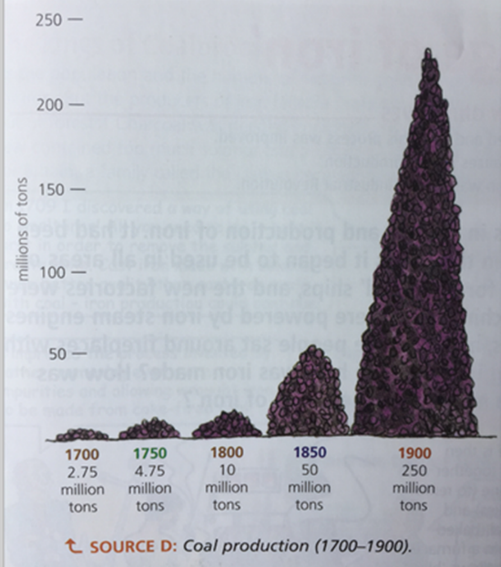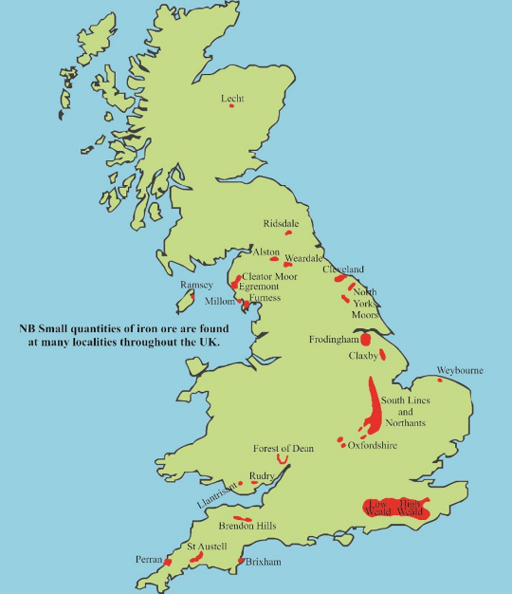
The graph about coal production suggests that…
I know because I can see…
The map about iron ore deposits suggest that…
I know because I can see…
Challenge Question: answer in your book
How did Britain’s natural resources link to Abraham Darby’s production of cast iron?

Causes of the Industrial Revolution 4. The British Empire

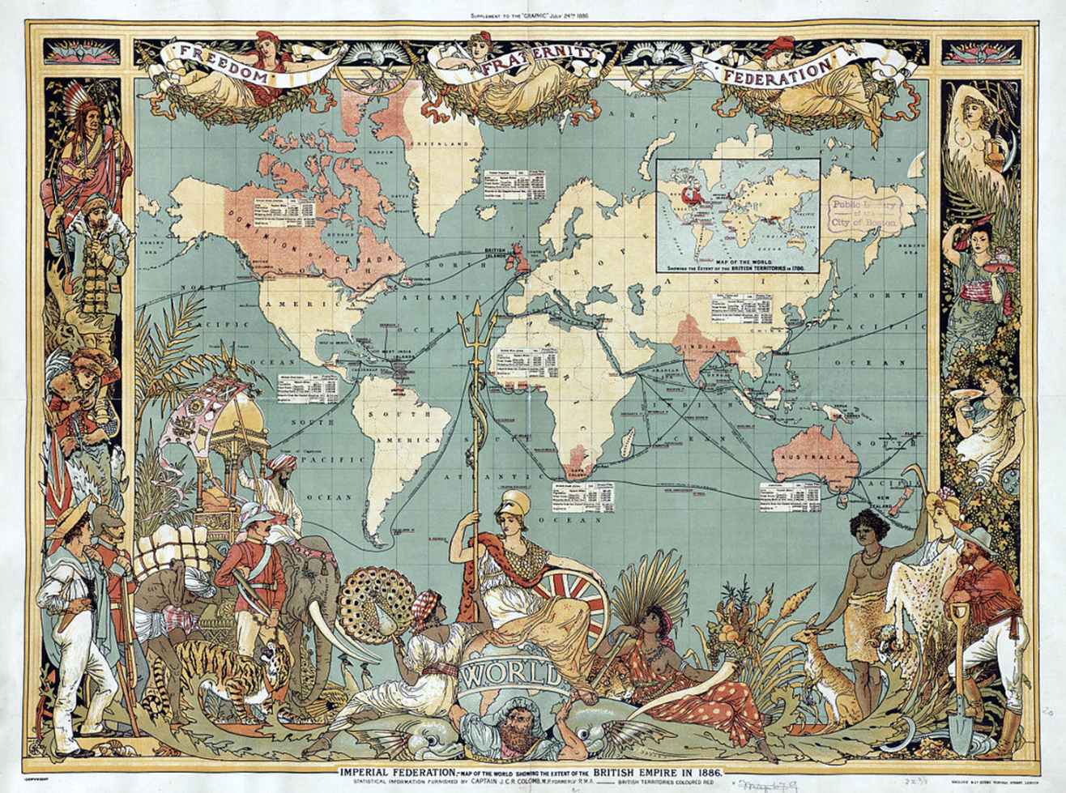

Study the map: List 5 countries that were part of the British empire in the 19th century
Which two parts of the British Empire grew cotton?
Having an Empire allowed Britain to produce products like textiles much more cheaply because of access to cheap raw materials, more specifically…
Having an Empire allowed Britain to sell the products they made really easily, more specifically…

Challenge! Answer these questions in your books
What does the map reveal about how the British felt about themselves and their empire? (Look at the position of Britain on the map. Look at how Britannia – the personification of Britain- has been drawn)

Check your understanding by answering the following questions.
The ‘Industrial Revolution’ was a phrase first used by British writer Arnold Toynbee (1852-1883) to describe the huge changes that occurred in the way people lived and worked after 1750. In other words the Industrial Revolution was…

Match the statements in the first column to the explanations in the second column.
The role of an individual was important for the beginning of the Industrial Revolution. For example Abraham Darby invented a process of making iron that was strong and hard |  | This led to factories being built to house the machines and attracted thousands of workers. This meant that more products were made and production was controlled by wealthy men who could afford to build factories and buy machines.
Machines were invented that could complete the work of hundreds of people. Such as power looms and spinning jennies |  | This meant that British factory owners could make money more quickly. Raw materials were cheap and there were millions of people who had to buy their products
Britain had lots of natural resources, in particular coal and iron ore. |  | This meant that metal could be used to make bridges, trains, ships and machines. This led to increased employment and production
Britain had a large Empire which meant they could get cheap raw materials and had a large market for manufactured products. For example, India provided cheap cotton and also a large market for cloth. |  | This allowed Britain to gain a head start over its industrial rivals. By 1830 Britain produced 80% of Europe’s coal and 50% of Europe’s iron. All the steam engines in the entire world were made in England.

Why did the Industrial Revolution turn London into an ‘abyss’ for the poorest people?
How did jobs turn London into an ‘abyss’ for the poorest people?

Watch the video clip from 4.40 until the end. The first time you watch the clip, watch and listen carefully. The second time you watch the clip. Answer the questions below. https://www.youtube.com/watch?v=BUnCmpD78Dg

How did cotton mills pollute the air and cause lung diseases in workers?
Smoke and fog | Cotton dust | diesel fumes
What kind of accidents happened in the looms?
Drowning | Teeth knocked out | Arms and fingers chopped off
How long did shifts last?
Over 12 hours | 6 hours | 8 hours
Why were children employed in factories?
Their families needed the money | Children were small enough to reach certain part of the machines | Education was not compulsory

The problems associated with cotton mills in the north of England were also problems associated with jobs for the poorest people in London.
- Hours were very long
- Pay was often very low
- Jobs were very dangerous
- Work was very hard
- Working conditions caused horrible diseases. There was no National Health Service
- Society’s attitude at the time valued hard work. Anyone who was poor was considered lazy.
- There was little help from the government for the poorest in society
- Poor people needed to earn money to survive and so took on jobs that we would not consider today
- By 1851 more people lived in towns and cities than in the countryside
- People moved from the countryside to towns to find work because machines had replaced many jobs on farms.

- Jobs were hard and horrible

Name of Job? | Description | Dangerous? | Dirty/Smelly?
 | A seller of fish
 | A man or woman who collects rubbish, especially the ashes from fireplaces. This is taken to a tip and sifted through for objects that could be sold
 | A child who sold watercress on street corners
 | Worked in a factory making matches. The white phosphorus used to make the matches caused necrosis of the jaw. Meaning that the bone cells would die and rot away. This was called ‘phossy jaw’
 | A person who works at a port, putting goods onto and taking them off ships. Being crushed by cargo and falling down ships holds was a big danger
 | A seller of meat
 | Women who delivered milk
 | A person who repaired, made, and adjusted (= make changes to) clothes,
 | Disposal of dead or unwanted horses. The meat was made into dog food and the bones boiled to make glue.
 | A maid; duties could include cooking, washing clothes , cleaning and looking after children
 | Made beer
 | Emptied holes in the ground called cesspits. This were built under houses and in back gardens. By 1841 London had a population of 2 million and 200,000 cesspits full to the brim and overflowing. Falling in was a hazard. Human excrement was sold a useful fertiliser to farms and gardens outside London
 | A person who tans leather. Tanning is the chemical process of turning animal skin into leather. First, the skins were soaked in water to clean and soften them. Then the skin would be scraped to remove any remaining flesh and fat. Next, the tanner needed to remove the hair from the skin. This was done by soaking the skin in urine. After the hairs were loosened, they were scraped them off with a knife. Once the hair was removed, the tanners would "bate" (soften) the skin. Bating was a fermentation process meaning that the skin as left for a long time in the dung so the enzymes could work. Pidgeon and dog dung were commonly used.
 | A person who sells all kinds of goods, especially fruit and vegetables, from a handcart in the street.
 | Picked up dog poo from the street and delivered it to tanners
 | A seller of animal hides and skins
 | A seller of offal, especially animal stomachs.
 | Roamed the sewers looking for valuables or other items to sell that had been flushed by mistake

Night soil man | Tanner | Fishmonger | Butcher | Fellmonger | Knacker | Tripe dresser | Brewer | tailor
Dustmen/women | Docker | costermonger | Pure collector | Water cress girl | Milk women | Domestic service | Match girl | Tosher

Check your understanding of hard and horrible jobs by answering the following questions.
1. Which job was dangerous and caused the jaw bone to rot away, known as ‘phossy jaw’?
Tanner | Match making |  | Docker
2. Which job was smelly because it involved working with urine and dog poo
Tanner | Match making |  | Docker
3. Which job was dangerous because workers might beak bones through falls from great heights
Tanner | Match making |  | Docker
4. Which of these jobs was NOT dangerous
Night soil man | Docker |  | Tosher
Match girl | Domestic service
5. Which of these jobs is NOT smelly
tailor | butcher |  | Tripe dresser
fishmonger | tanner |  | Pure collector
6. When Jack London says that the poor people living in London are the ‘people of the abyss’, what does he mean?
He means that that the poorest people of Victorian London live in a very dark, deep hole in the ground |  | He means that the poorest people of Victorian London life in very bad conditions and that these conditions will not improve.
7. Give examples of ‘jobs of the abyss’ that were very bad because of dangerous conditions
8. Give examples of ‘jobs of the abyss’ that were very bad because of unhygienic conditions
9. What factors (look at page 4) explain how the Industrial Revolution caused London to be an ‘abyss’ for the poorest people?

2. Jobs were low paid and casual:

We know this because of the work of some Victorians who wanted to help poor people, understand their problems and make their lives better. These Victorians were known as ‘social reformers’. One social reformer was Charles Booth. In 1889 Charles Booth published Life and Labour of the People. He had spent years researching why people were poor. Booth created the idea of the poverty line, the minimum amount a family of four needed to live on. He set the line at 20 shillings a week. The equivalent of £1 today. Anyone living below the poverty line was considered to be poor. Booth found that 30% of London’s population lived in poverty; of whom 10% were very poor. As most of these people had jobs, he concluded that the cause of their poverty as low pay. In his book, Booth published a colour coded map which illustrated which households lived above and below the poverty line

Mark on the map; 1. Oasis South Bank 2. Imperial War Museum 3. Waterloo station. 4. Lower Marsh 5. Archbishops Park 6. Where you live
Mark on the map; 1. Areas of the map that were ‘semi criminal’ 2. Areas on the map that were ‘very poor’ 3. Areas on the map that were ‘poor’. 4. The only ‘wealthy’ building on the map
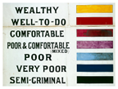

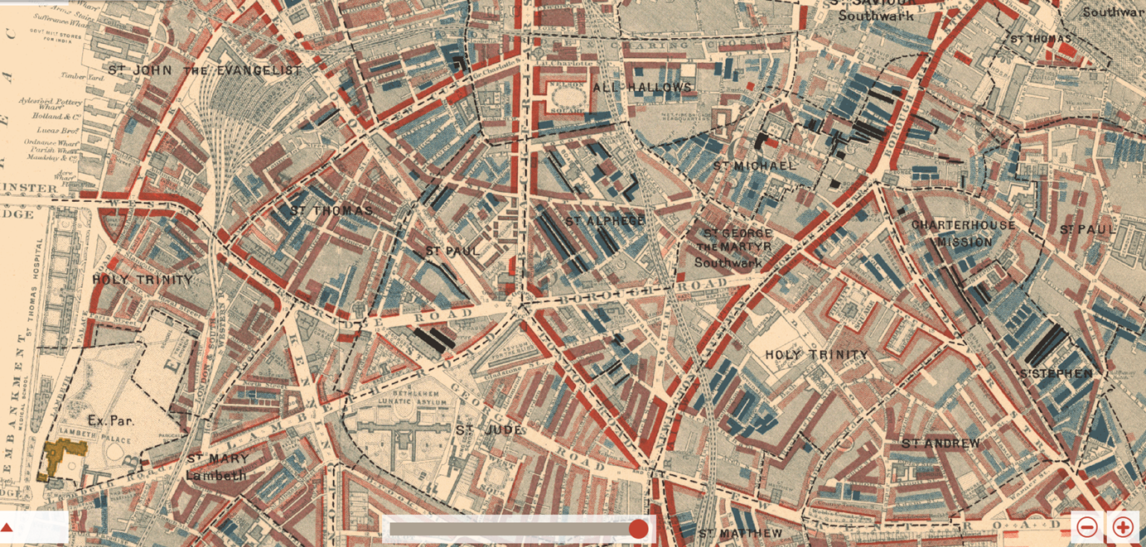

The work of Charles Booth suggests that the Industrial Revolution led to poverty because ….
More specifically….
The factors (look at page 4) that explain how the Industrial Revolution caused London to be an ‘abyss’ for the poorest people are…

A contributing factor to low pay was the attitude of society to the poor. Victorians believed that there were two type of poor people the deserving poor and the undeserving poor. The deserving poor were those who deserved help because Victorians believed their poverty was not their fault. For example children, the elderly, the sick, and the disabled.
The underserving poor were people who did not deserve help because Victorians believed their poverty was their fault. Victorians believed that if you were a healthy adult the only reasons for poverty was laziness or that poor people spent their money unwisely on beer and gambling. Therefore low pay was not even recognised as a problem or a cause of poverty at the time. This meant nothing was done by the government and no pressure was put on the government by society to do anything to help people working in low paid jobs
Underserving poor were people who did not deserve help because Victorians believed their poverty was their fault, in other words…
Examples of underserving poor were…
Factors to explaining why the Industrial Revolution caused London to be an ‘abyss’ for the poorest (page 4)…
Because…
Another factor that contributed to poverty was that there was no protection from the government for workers in low paid jobs. There was no minimum wage like today. This meant that desperate people would offer to work for less than other people. Wealthy people encouraged the poor to be thrifty = spend money carefully.
Jack London wrote that “encouraging thrift means that one worker undercuts another which drives wages down for all. You can’t preach thrift to those who spend ¾ of their wages a week on rent”
I can infer that poverty was caused by…
I know because it says….
London also suggests poverty was caused by …
When he writes…

Some jobs were casual, meaning there was no guarantee of work all year round. For example if no ships had arrived in port there was no work for Dockers. In the winter the building trade stopped working and sacked all workers until spring. Dockers might only work 2-3 days a week, builders 8-9 months of the year.
Some jobs were casual, in other words….
For example…
This suggests poverty was caused by…

Check your understanding of low paid jobs by answering the following questions.
1. Charles Booth was a ‘social reformer’ in other words…
He blamed poor people for their poverty | He gave tips to poor people about how to improve their lives |  |  | He researched the lives of poor people to find out causes of their poverty
2. Charles Booth defined the poverty line as…
The amount of money a family needed to survive. | The minimum wage paid to dock workers |  |  | The colours used on his map to show the poorest areas
3. How much money did a family need to earn each week to be above the poverty line in London?
10 shillings (50p today) | 40 shillings (£2 today) |  |  | 20 shillings (£1 today)
4. Booth published a map illustrating wealth and poverty by household. What % of families did he class as living below the poverty line
30% | 20% |  |  | 10%
5. What % of families did he class as very poor?
30% | 20% |  |  | 10%
6. Which is the correct definition of undeserving poor?
Victorians believed their poverty was not their fault. For example children, the elderly, the sick, and the disabled. |  | Victorians believed their poverty was their fault. Victorians believed that if you were a healthy adult the only reasons for poverty was laziness or that poor people spent their money unwisely on beer and gambling.
7. When Jack London says that the poor people living in London are the ‘people of the abyss’, what does he mean?
He means that that the poorest people of Victorian London live in a very dark, deep hole in the ground |  |  | He means that the poorest people of Victorian London life in very bad conditions and that these conditions will not improve.
8. Explain why the poorest people lived in the ‘abyss’ because of the attitude of Victorian society.
The attitude of Victorians to undeserving poor was…
This meant this group didn’t receive help because…
9. The factors (look at page 4) that explain how the Industrial Revolution caused London to be an ‘abyss’ for the poorest people are…
10. Because…

