The Challenge of Natural Hazards Page 1
Lesson 1
QUIZ:
- A plate boundary/margin is….
- In what direction do plates move at a constructive plate margin?
- In what direction do plates move at a destructive plate margin?
- In what direction do plates move at a conservative plate margin?
- In what direction do plates move at a collision plate margin?
- At what plate margin do you get subduction?
- At what plate margin is new land formed?
- What is sea floor spreading?
- At which plate margins do you get volcanoes and earthquakes?
- What which plate margins do you get just earthquakes?
- Fold mountains are…
- At which plate margins do you find fold mountains?

PRACTICE EXAM QUESTIONS

- Using Figure 1, explain why tectonic hazards occur at destructive plate margins. (6 marks)
- Study Figure 2, a map showing the earth’s tectonic plates and margins (boundaries). With the help of Figure 2, explain why tectonic hazards occur at location X. (6 marks)
- Three plate margins (X, Y and Z) are shown in Figure 2. Identify the two types of plate margins that are represented by Y and Z in Figure 2. (2 marks)
- Explain the factors that affect a locations level of hazard risk. (4 marks)
Figure 2
Figure 1

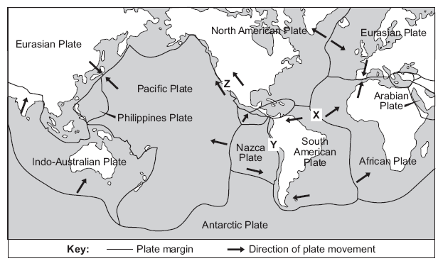

HOMEWORK EXAM QUESTIONS

- Explain why tectonic plates move. (6 marks)
- Using Figure 2, explain why tectonic hazards occur at location Z. (6 marks)
- Explain why tectonic hazards occur at collision plate margins. (4 marks)
- State two differences between oceanic and continental crust (2 marks)

