Year 9: Gastronomy Week of 20th April
LO: To explain the 4C’s of food hygiene and how to stay safe in the kitchen.
Task 1: Do Now
Three things you can do to keep the kitchen clean are…
It is important to wash your hands before preparing food because…
Using soap when washing dishes and hands is best practice because…
It is good practice to wear an apron because…
The three macronutrients are…
The two micronutrients are…
Three reasons our bodies need water are…

Task 2: Read the following information on good hygiene in the kitchen.
It is important that good hygiene is used at all times in a kitchen or other food preparation space. Good hygiene helps to protect the people who are preparing and serving the food as well as the people who are going to eat the food. Good hygiene when preparing food is important because it can help to get rid of bacteria that could otherwise end up in our food, this bacteria could make us ill. Good hygiene in the kitchen means that all steps are taken to protect people from bacteria and other food borne illnesses that could be harmful. Good hygiene in the kitchen includes practices such as washing your hands often, wiping down countertops, wearing an apron, washing fruits and vegetables before using them, washing up dishes and other equipment, keeping foods separate from one another, taking out the bins, storing food appropriately and many more. Good hygiene in the kitchen is all about taking steps to ensure the food that is being prepared is safe for people to eat.
Task 3: Complete the sentence starters based on the above reading.
Good hygiene is important in the kitchen because…
Good hygiene in the kitchen looks like…
Four steps you can take to make sure you are using good hygiene in the kitchen are…
1.
2.
3.
4.
If good hygiene is not used in the kitchen one thing that could happen is… more specifically…

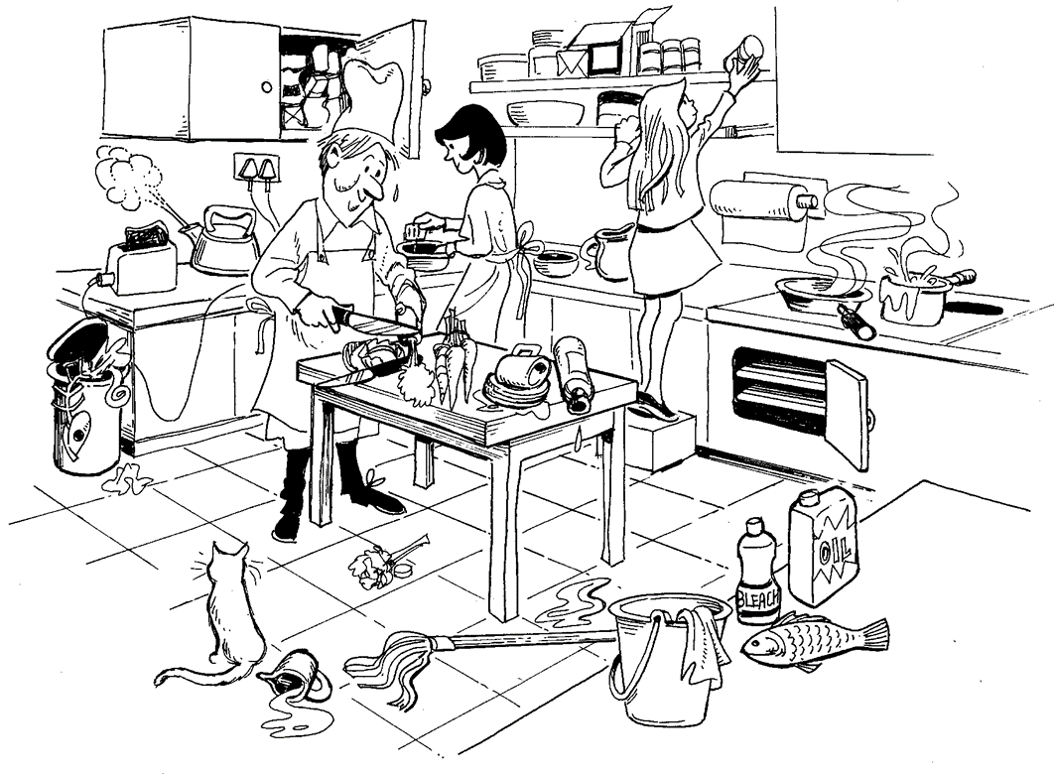
Task 4: Identify as many things as possible that are going wrong in this kitchen and give a reason for each. You should have at least 7.

Problem 1:
Reason:
Problem 2:
Reason:
Problem 3:
Reason:
Problem 4:
Reason:
Problem 5:
Reason:
Problem 6:
Reason:
Problem 7:
Reason:

Task 5: Use the sentence starters to help you to identify and describe the 4C’s of food hygiene and safety.
The first of the 4C’s is… more specifically… This is important for food safety because…
The second of the 4C’s is… for example… This is important for hygiene in the kitchen because…
The third 4C is… more specifically… This will make food safer to eat because…
The last of the 4C’s is… for example… This is important for food safety and hygiene because…

Task 6: Read the following information on bacteria and how to prevent the spread.
Bacteria is a micro-organism that exists everywhere. Although we cannot see bacteria they can be found on our hands, work surfaces, clothes, dishes, sofas, tables, door handles, light switches, food, pens, paper, pretty much everywhere. Sometimes bacteria can be harmful to us. When bacteria is present in our food and we do not prepare it properly the bacteria can get into our digestive system and can make us ill. Sometimes bacteria in food, on our hands or work surfaces and is transferred to our food can cause food poisoning. Food poisoning can cause flu like symptoms and can become very dangerous if the person becomes dehydrated. To prevent the spread of bad bacteria in our food and in food preparation areas we must follow the 4C’s of food hygiene. Cleaning, cooking, chilling and avoiding cross contamination can all help to prevent and stop the spread of bad bacteria.
Task 7: Complete the following sentence starters on bacteria and the 4C’s. If you need help look back over the reading.
Bacteria is…
We find bacteria in many places. Some places we might find bacteria are… more specifically…
Bacteria can do many things, some of the things bacteria can do are… This could be bad because…
We can prevent the spread of bad bacteria by… more specifically… Another way we can prevent the spread of bacteria is… for example…

Task 8: Use the box to complete a poster on the 4C’s, food safety and hygiene in the kitchen. You can change the font colour and size and could copy and paste a picture in. See the powerpoint for success criteria.

