**Lesson 8 – Parallel Circuits and Current**

**Do now:**

1. Is this circuit series or parallel? (1)
2. Describe how current flows in a parallel circuit.(1)
3. Describe the difference between a cell and a battery. (1)
4. Name the piece of equipment used to measure current. (1)
5. Give the units for charge flow. (1)

**Challenge: Compare** series and parallel circuits**.**

**Key Knowledge:**

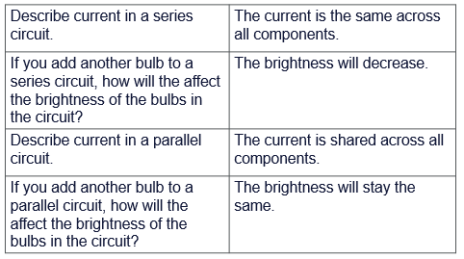

**Quiz:**

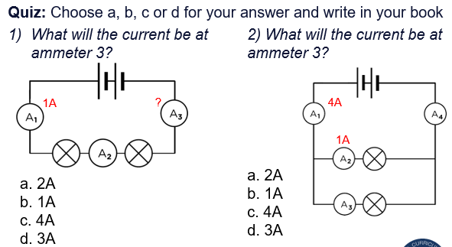

**Application Task:** Fill in the blanks

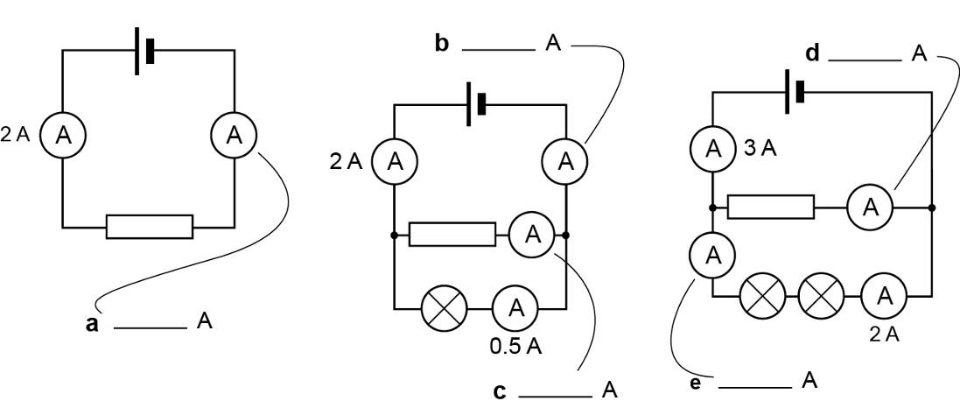





**Lesson 9: Potential Difference**

**Do now:**

1. Describe current in a series circuit. (1)
2. Describe how the brightness of a bulb would be affected if another bulb was added in series. (1)
3. Which subatomic particles has a negative charge? (1)
4. Explain why we use control variables. (1)
5. Calculate the charge flow through a component if a current of 5A flows for 10 seconds. (1)

**Challenge:** Explain why a parallel circuit would be better to use if you were linking 8 bulbs in a circuit together to light up a classroom.

**Key knowledge:**

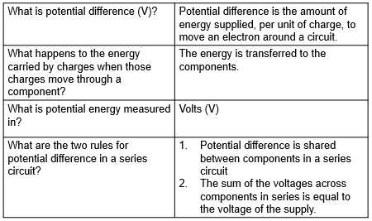

**Quiz:**

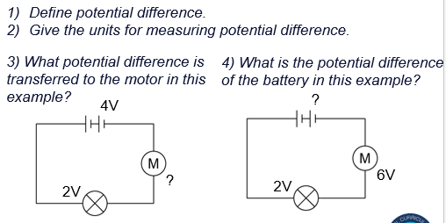

**Application task:**

Explain how potential difference across a component in a circuit is determined by the cell and number of components in a circuit (5 marks)

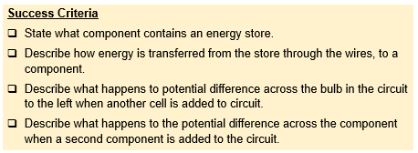

……………………………………………………………………………………………………………………………………………………………………..…………………………………………………………………………………………………………………………………………………………………..…………………………………………………………………………………………………………………………………………………………………..…………………………………………………………………………………………………………………………………………………………………..…………………………………………………………………………………………………………………………………………………………………..…………………………………………………………………………………………………………………………………………………………………..………………………………………………………………………………………………………………………………………………………………………………………………….

**Lesson 10: Measuring Potential Difference**

**Do now:**

1. Define potential difference. (1)
2. Give the units for potential difference. (1)
3. Explain why electrical current can flow through a conductor. (1)
4. Name the piece of equipment used to measure the current in a circuit. (1)
5. Calculate the range of these numbers: (1) 13 17 2 8 22 19 24 1

**Challenge:** Comparecurrent and potential difference in series circuits.

**Key Knowledge:**

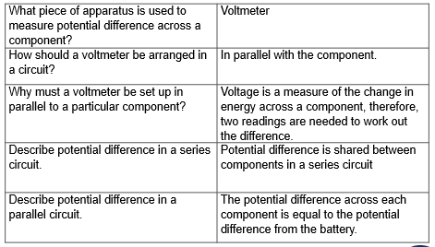

**Quiz:**

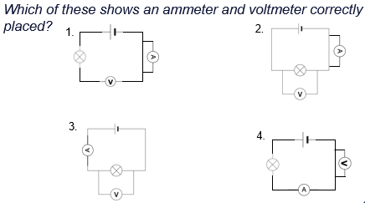

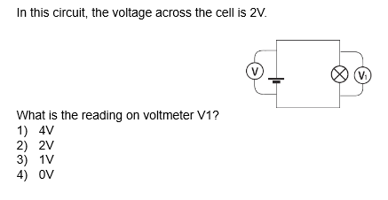

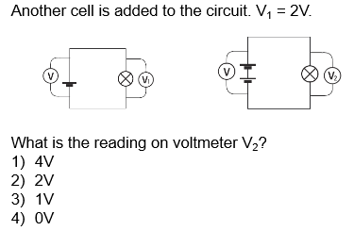

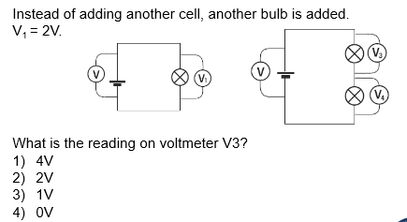

**Application task:** Draw the circuits described in the table

|  |  |  |
| --- | --- | --- |
| **Circuit** | **Description** | **Drawing** |
| 1 | One cell, one bulb. Voltmeter connected in parallel across the lamp. |  |
| 2 | One cell, one bulb. Voltmeter connected in parallel across the cell. |  |
| 3 | Two cells, one bulb. Voltmeter connected across the bulb. |  |
| 4 | Two cells, two bulbs. Voltmeter connected across one of the lamps (Doesn’t matter which one) |  |
| 5 | Two cells, two bulbs. Voltmeter connected across both lamps. |  |
| 6 | Two cells, two bulbs. Voltmeter connected across the cell. |  |

**Lesson 11: Parallel Circuits and Voltage**

**Do now:**

1. Potential difference is the difference in ______ from one point in a circuit to another. (1)
2. How do we connect a voltmeter to measure the voltage across a component? (1)
3. Describe the main energy transfer involved in a circuit. (1)
4. Name the piece of equipment used to measure potential difference in a circuit. (1)
5. Give the rearranged equation to find time from current and charge flow. (1)



**Challenge: The potential difference across at V3 is 4.5V, what is the p.d. at V4 and across the cell?**

**Key knowledge:**

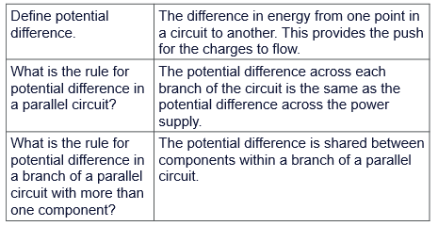

**Quiz:**

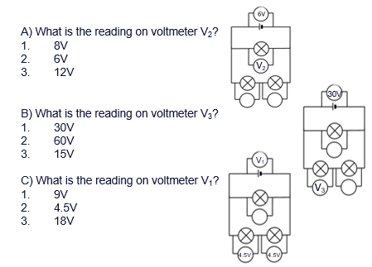

**Application task:** Fill in the blank readings

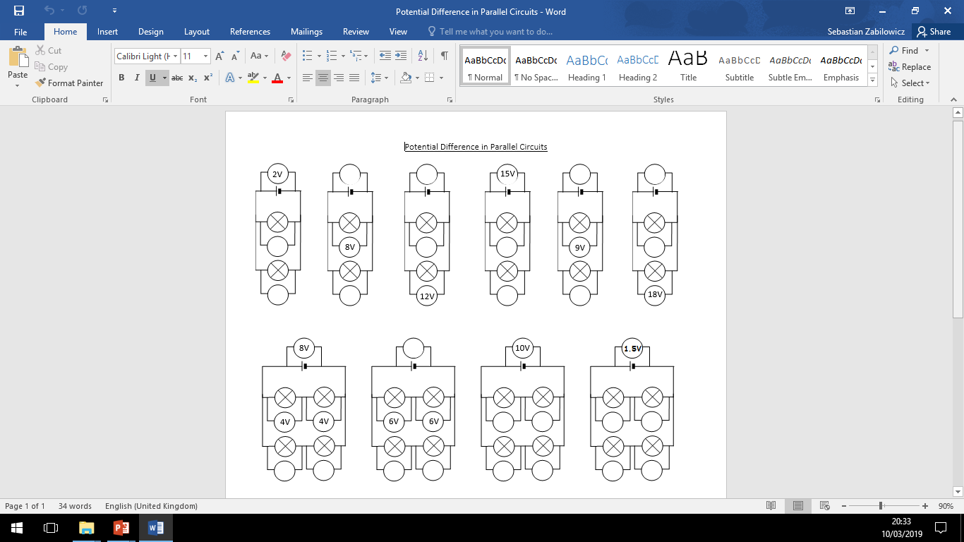

**Lesson 12: Resistance in a Circuit**

**Do now:**

1. In a series circuit, potential difference is _____ between components. (1)
2. 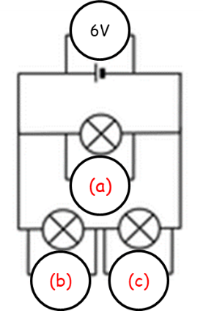In a parallel circuit, the potential difference of each branch is equal to… (1)
3. State the reading on the voltmeters at points (a), (b) and (c). (3)
4. Name the variables which we keep the same in an experiment. (1)
5. State the units for current. (1)

**Challenge:** Calculate the time taken for 5C of charge to pass through a 10A bulb.

**Key Knowledge:**

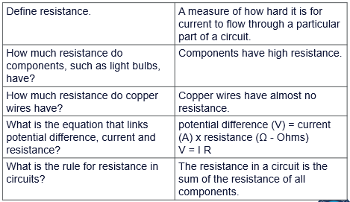

**Quiz:**

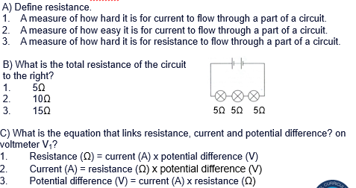

**Application task:**

|  |  |  |
| --- | --- | --- |
| 1. What is the formula linking potential difference, current and resistance? | 5. Calculate the resistance through a device which has a potential difference output of 230V and a current of 100A. | 9. If the resistance of a kettle is 20Ω, with a potential difference of 2.5V, what is the current flowing through it? |
| 1. Rearrange this formula to find current. | 6. Calculate the resistance of a device with a potential difference of 640V when a 12.8A current is running through it. | 10. If the resistance of a TV is 60Ω, with a potential difference of 150V, what is the current flowing through it? |
| 1. Rearrange this formula to find resistance. | 7. Calculate the resistance of a device with a potential difference of 230V and a current of 46A. | 11. If the resistance of a toaster is 20Ω, with a current flowing through it of 20A, what is the potential difference? |
| 1. A circuit contains two 1.5 volt batteries and a bulb with a resistance of 3 ohms. Calculate the current. | 8. What is the voltage of a circuit with 15 amps of current and toaster with 8 ohms of resistance? | 12. A light bulb has a resistance of 4 ohms and a current of 2 A. What is the potential difference across the bulb? |

**Lesson 13: Power in a Circuit**

**Do now:**

1. What are the 3 sub-atomic particles that make up an atom?
2. What is the unit for resistance?
3. What is the unit for wave speed?
4. 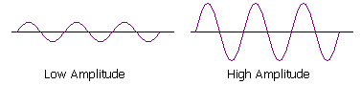Which wave, A or B has a high amplitude?

A B

1. A solution has a pH of 6.5. Is this an acid, alkali or neutral?

**Challenge:** Find the resistance in a component with 6V of p.d. and a current of 1.5A flowing through.

**Key knowledge:**

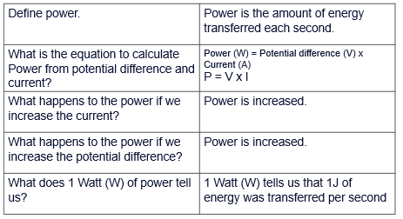

**Quiz:**

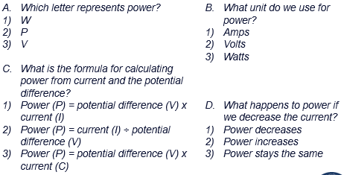

**Application task:**

|  |  |  |
| --- | --- | --- |
| **30%** | **50%** | **70%** |
| 1. What is the formula linking power, current and voltage? | 4. A kettle has a current of 10A and a p.d. of 230V. Calculate the power output. | 7. The heating element in a kettle produces an output of 1200W with a p.d. of 230V. Calculate the current flowing through it. |
| 1. Rearrange this formula to calculate current. | 5. A TV has a current of 80A and a p.d. of 230V. Calculate the power output. | 8. A TV produces an output of 5kW with a p.d. of 230V. Calculate the current flowing through it. |
| 1. Rearrange this formula to calculate voltage. | 6. A toaster has a current of 20A and a p.d. of 230V. Calculate the power output. | 9. A toaster produces an output of 2.5kW with a p.d. of 230V. Calculate the current flowing through it. |

**Lesson 14: Mini Quiz**

**Do now:**

1. Define power. (1)
2. What happens to power of a component if the potential difference is increased across the component? (1)
3. Explain why adding a bulb to a series circuit with a bulb and battery will decrease the brightness of the bulb. (1)
4. Define repeatable. (1)
5. Calculate the power of a bulb if 20A of current is flowing with a potential difference across the bulb 230V. (1)

**Challenge:** A pair of hair straighteners has a power output of 2.2kW and a potential difference of 110V. Calculate the current flowing through them.

**Mini quiz:**

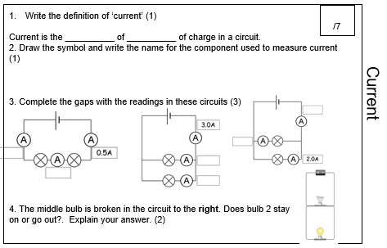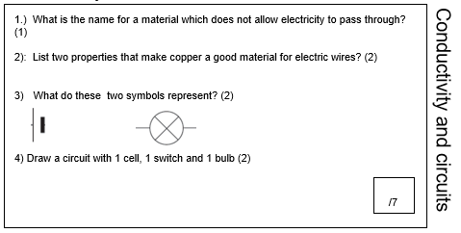

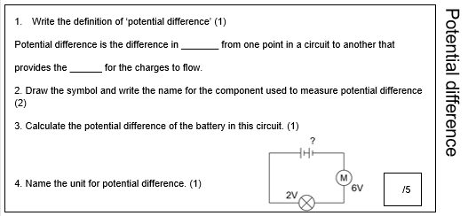

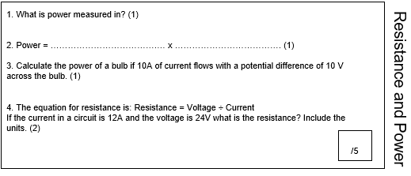

**MAD Time task:** choose based on which section you scored lowest

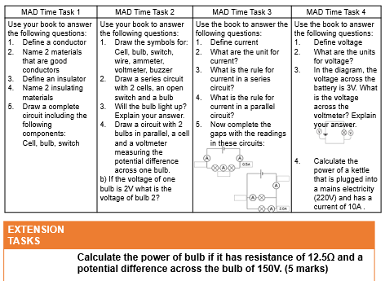

**Lesson 15: Magnetic Fields**

**Do now:**

1. Define a permanent magnet.
2. State the magnetic materials
3. Explain why electrical circuits for lighting in buildings are typically parallel circuits.
4. Name a piece of equipment to use for accurately measuring pH.
5. State the equation for power.

**Challenge:** Explain how you could test to see if a magnet is permanent (2).

**Key knowledge:**

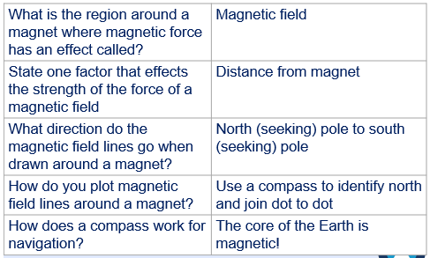

**Quiz:**

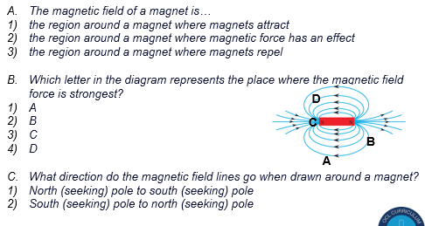

**Application task:**

**Q1.**

**Figure 1** shows two bar magnets suspended close to each other.

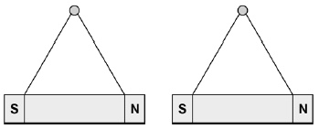

(a)     Explain what is meant by the following statement.

‘A non-contact force acts on each magnet'.

___________________________________________________________________

___________________________________________________________________

___________________________________________________________________

___________________________________________________________________

**(2)**

(b)     Describe how to plot the magnetic field pattern of a bar magnet.

___________________________________________________________________

___________________________________________________________________

___________________________________________________________________

___________________________________________________________________

___________________________________________________________________

___________________________________________________________________

**(3)**

**Q2.**

**Figure 1** shows a straight wire passing through a piece of card.

A current (I) is passing down through the wire.

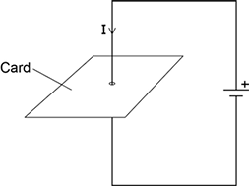

(a)     Describe how you could show that a magnetic field has been produced around the wire.

___________________________________________________________________

___________________________________________________________________

___________________________________________________________________

___________________________________________________________________

**(2)**

**Q3.**

(a)     **Diagram 1** shows a magnetic closure box when open and shut. It is a box that stays shut, when it is closed, due to the force between two small magnets.

These boxes are often used for jewellery.

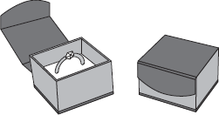

**Diagram 2** shows the two magnets. The poles of the magnets are on the longer faces.

**Diagram 2**

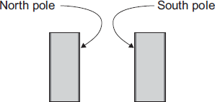

 (i)      Draw, on **Diagram 2**, the magnetic field pattern between the two facing poles.

**(2)**

(ii)     The magnets in the magnetic closure box must **not** have two North poles facing each other.

Explain why.

______________________________________________________________

______________________________________________________________

______________________________________________________________

______________________________________________________________

**(2)**

**Lesson 16: Magnets**

**Do now:**

1. State the equation for calculating power. (1)
2. What is the power of a phone if the current flowing through it is 5A and the potential difference is 200V? (1)
3. I want to find out if a substance is an acid or an alkali, how could I do this? (1)
4. I have got the following results for an acidic solution: 2.8, 3, 3.2, 3.1 and 6. State the anomaly in my results and explain why you chose it. (2)
5. Rearrange the power equation to find current. (1)

**Challenge:** Explain the difference between potential difference and current in a parallel circuit.

**Key knowledge:**

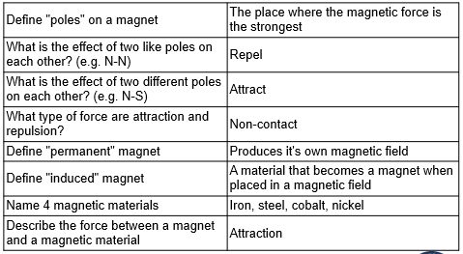

**Quiz:**

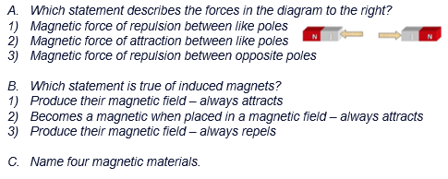

**Application task:**

**Q1.**

David put two bars of iron close to each other.  
There was **no** magnetic force between them.  
David recorded the result as shown below.

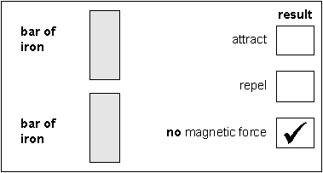

(a)     David did three other tests.  
Tick the correct box to show the result for each test.

(i)

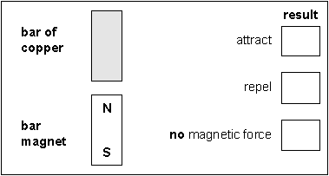

1 mark

(ii)

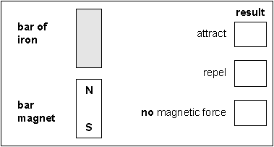

1 mark

(iii)

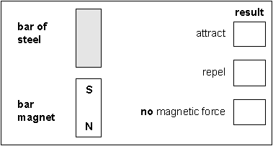

1 mark

(b)     David then did two experiments with magnets.

The tick in each box shows David’s results in each experiment.

Label the missing poles on **each** magnet to match David’s results.

(i)

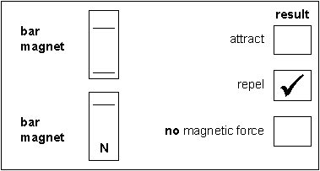

1 mark

(ii)

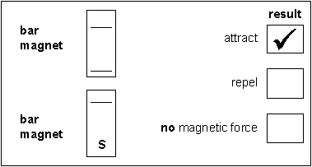

1 mark

maximum 5 marks

**Q2.**

The diagram below shows three trolleys.  
Peter put a bar magnet on each trolley.

(a)     He pushed trolleys A, B and C together.

•    Magnet B **attracted** magnet A.

•    Magnet B **repelled** magnet C.

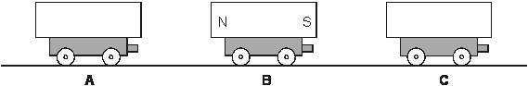

**On the diagram above**, label the north and south poles of   
magnets A and C.  
Use the letters N and S.

2 marks

(b)     Peter turned trolley B around. Trolleys A and C were **not** turned around.

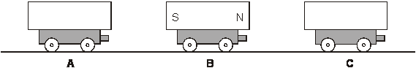

          What would happen now when Peter pushed them all together?  
Use either **attract** or **repel** to complete each sentence below.

          Magnet B would .................................... magnet A.

          Magnet B would .................................... magnet C.

1 mark

(c)     Peter held two trolleys close together and then let go.

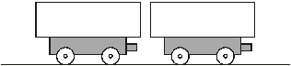

          The magnets repelled each other.

**Draw an arrow** on both magnets to show which way they would move.

1 mark

(d)     Peter took a magnet, a steel bar and an aluminium bar.

          He put them on three trolleys as shown below.

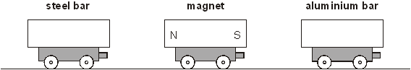

(i)      What happens to the steel bar as he moves it closer to the magnet?

...............................................................................................................

1 mark

(ii)     What happens to the aluminium bar as he moves it closer to the magnet?

...............................................................................................................

1 mark

maximum 6 marks

**Q3.**

Sam made a model cat.

          He mixed modelling powder with water.

          He poured all of the mixture into a mould.

          He covered the mould with plastic film so that water could **not** evaporate.

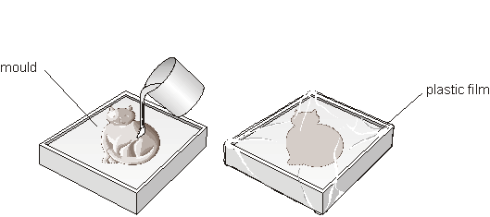

(a)     (i)      After 10 minutes, Sam removed the model cat from the mould.



         Sam had mixed 40 g of modelling powder with 12 g of water.  
What was the mass of the model cat?

................. g

(ii)     Complete the sentence below using words from the list.

**gas**             **liquid**         **solid**           **vapour**

         After 10 minutes, the mixture in the mould changed from a

.......................................... into a .............................................

2 marks

(b)     Sam attached a small magnet to the model cat.  
The magnet was attracted to the fridge door.

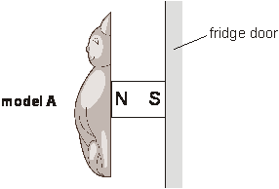

          What metal are magnets made from?

...................................................

1 mark

(c)     Sam made another model, B. He attached a small magnet to model B.

(i)      Sam placed model A next to model B. The magnets attracted each other.

         Label the poles on the magnet on model B  
Use the letters N and S.

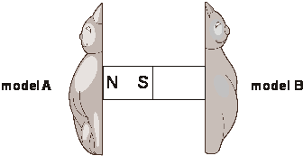

(ii)     Sam then turned the magnet on model A around.  
What would happen to model B?

..........................................................

2 marks

maximum 5 marks

**Lesson 17: Electromagnets**

**Do now:**

1. How does a compass work for navigation?
2. What direction do the magnetic field lines go when drawn around a magnet?
3. Define a permanent magnet.
4. Describe a method for plotting the magnetic field lines around a magnet.
5. State the equation for calculating current for charge flow and time.

**Challenge:** What is the rule for potential difference in a branch of a parallel circuit with more than one component?

**Key knowledge:**

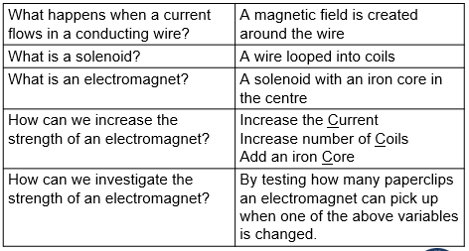

**Quiz:**

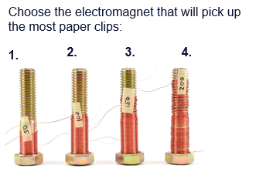

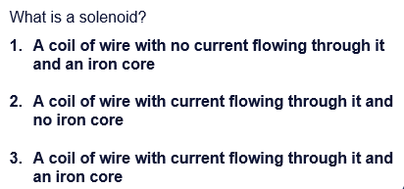

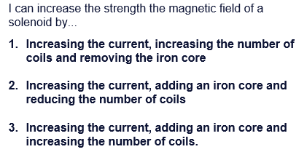

**Application task:**

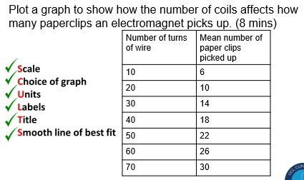



**Lesson 18: Making Magnets**

**Do now:**

1. How does a compass work for navigation?
2. The direction of magnetic field lines is from ______ to ______.
3. Define an induced magnet.
4. Describe a method for plotting the magnetic field lines around a magnet.

**Challenge:** Calculate the time taken for 300C of charge to pass through a 30A bulb.

**Key knowledge:**

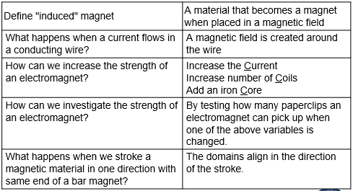

**Recall quiz:**

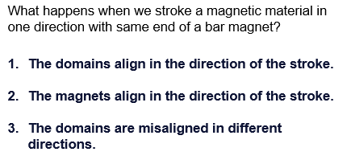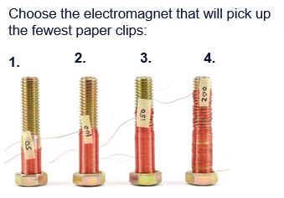

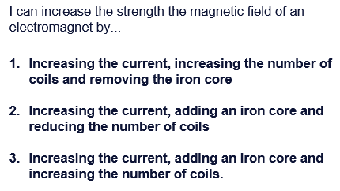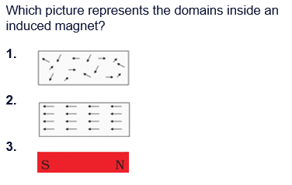

**Application task:**

Compare permanent and induced magnets and describe how to make an induced magnet

(5 marks)

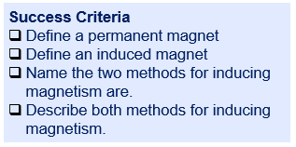

……………………………………………………………………………………………………………………………………………………………………..…………………………………………………………………………………………………………………………………………………………………..…………………………………………………………………………………………………………………………………………………………………..…………………………………………………………………………………………………………………………………………………………………..…………………………………………………………………………………………………………………………………………………………………..…………………………………………………………………………………………………………………………………………………………………..………………………………………………………………………………………………………………………………………………………………………………………………….

**Lesson 19: Uses of Electromagnets**

**Do now:**

1. Name the two methods for inducing magnetism.
2. Describe how to increase the strength of an electromagnet.
3. State where the magnetic force is the strongest around a bar magnet.
4. Give two types of error that can occur in an investigation
5. Give this number to 2 decimal places: 927.49162

**Challenge:** Explain why hitting an induced magnet against a hard object can cause it to lose it’s magnetism

**Key knowledge:**

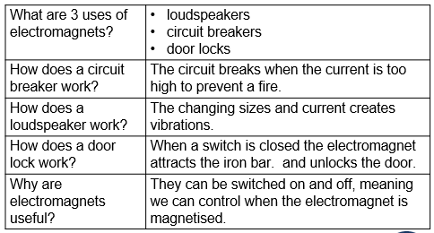

**Quiz:**

1. What are 3 uses of electromagnets?
2. How does a circuit breaker work?
3. How does a loudspeaker work?
4. How does a door lock work?

**Application task:**

**1.** A student has set up the apparatus shown in **Figure 2**.The iron rod is fixed to the track and cannot move.

**Figure 2**

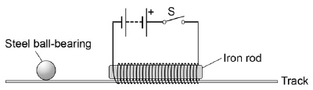

     The student gives the steel ball bearing a gentle push in the direction of the iron rod.

At the same time the student closes the switch **S**.

Explain the effect on the motion of the ball bearing when the switch **S** is closed.

___________________________________________________________

___________________________________________________________

___________________________________________________________

___________________________________________________________

___________________________________________________________

___________________________________________________________

___________________________________________________________

___________________________________________________________

**(4)**

**Q2. Figure 2** shows the ignition circuit used to switch the starter motor in a car on.

The circuit includes an electromagnetic switch.

**Figure 2**

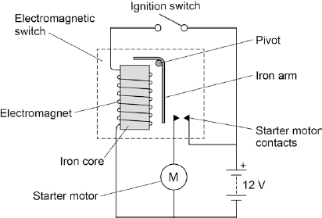

Explain how the ignition circuit works.

___________________________________________________________

___________________________________________________________

___________________________________________________________

___________________________________________________________

___________________________________________________________

___________________________________________________________

___________________________________________________________

___________________________________________________________

**(6)**

**Q3.**

The diagram shows a switch that is operated by an electromagnet.

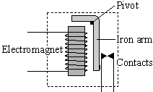

      The switch is used in a car starter motor circuit.

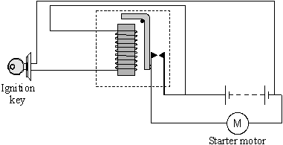

Explain how turning the ignition key makes a current flow in the starter motor.

___________________________________________________________

___________________________________________________________

___________________________________________________________

___________________________________________________________

___________________________________________________________

___________________________________________________________

___________________________________________________________

___________________________________________________________

**(4)**

**Q5. Challenge Example**

A fault in an electrical circuit can cause too great a current to flow.  
Some circuits are switched off by a circuit breaker.

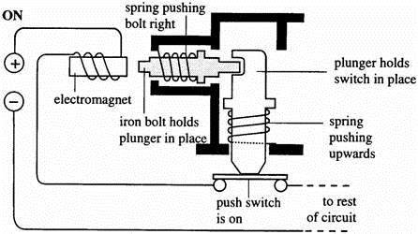

One type of circuit breaker is shown above. A normal current is flowing.  
Explain, in full detail, what happens when a current which is bigger than normal flows.

___________________________________________________________

___________________________________________________________

___________________________________________________________

___________________________________________________________

___________________________________________________________

___________________________________________________________

___________________________________________________________

___________________________________________________________

**(Total 4 marks)**