Year 8: Summer 1
Was London the ‘place to be’ for immigrants after 1945?
Name: _____________________ Class:__________________ Teacher: __________

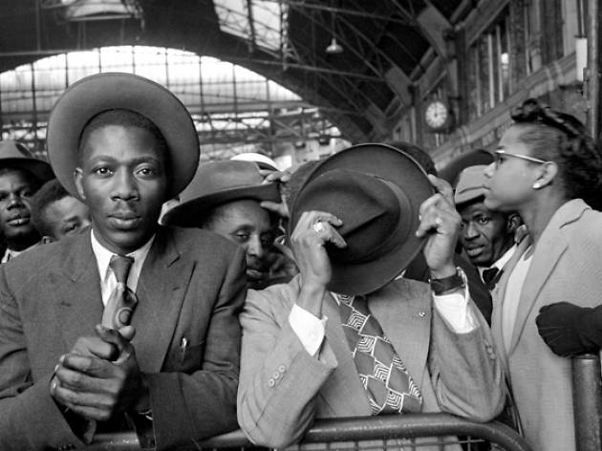

Contents
Lesson/Resource | Page Numbers | Tick when complete
Knowledge Organiser | 2
Black Knowledge for look/cover/write/check | 3
First ‘do now!’ | 4
1. Lesson 1 - Background on the SS Empire Windrush | 4-7
3. Lesson 2 - ‘London was the place to be’ | 7-10
5. Lesson 3 – ‘London was not the place to be’ | 10-13
7. Lesson 4 – Changing Laws and Culture | 13-17
9. Lesson 5&6- Essay planning and writing | 17-22
10. Revision | 23-25
Learning Ladder | 26
vocabulary table | 27

Vocabulary
1 | Immigrant | A person who leaves the country where they were born and comes to live permanently in a foreign country |  | Key | People
2 | Discrimination | When you are treated unfairly because of your race, religion, gender or sexuality | 15 | Teddy Boys | A gang in London formed in the 1950’s. They wore smart, fashionable clothes and listened to Rock music. They committed violent acts towards immigrants.
3 | Prejudice | The belief that one group of people is superior to others | 16 | Bob Marley | He was a Jamaican singer, songwriter and musician. Considered one of the pioneers of reggae.
4 | West Indies | The West Indies is another name for the Caribbean | 17 | Benjamin Zephaniah | He is known for his poetry as well as novels, plays, and other works. His poetry is called “dub poetry,” which means that is performed.
5 | NHS | National Health Service |  | Key | Dates
6 | Hurricane | A huge storm. It can be up to 600 miles across and have strong winds spiralling inward and upward at speeds of 75 to 200 mph | 18 | 1944 | Sugar Trade declines in Jamaica
7 | Citizen | A legally recognised person of a country | 19 | 1945 | World War Two Ends
8 | Ethnic Minorities | A group that has different national or cultural traditions from the main population. | 20 | 1945 | A Hurricane hit Jamaica
9 | RAF | Royal Air Force | 21 | 1948 | British Nationality Act is passed and the SS Empire Windrush set sail
10 | Recession | A drop in economic growth that lasts at least six months. During a recession, businesses sell fewer goods and services | 22 | 1954 | Greenwich Nursing School advertised for more people
11 | unemployment | Being without a job | 23 | 1958 | Notting Hill Riots
12 | The Commonwealth | About one third of the world's population lives in the countries of the Commonwealth. Almost all the member countries, more than 50 of them, were at one time associated with the British Empire | 24 | 1965 | This outlawed racial discrimination in public places. It forbid discrimination on the "grounds of colour, race, or ethnic or national origins“
13 | Rioting | To take part in violent and uncontrolled public behaviour | 25 | 1968 | It is now illegal to refuse housing, employment, or public services to a person on the grounds of colour
14 | Rastafarian | A religious movement among black Jamaicans that teaches the eventual redemption of blacks and their return to Africa, forbids the cutting of hair | 26 | 1976 | It is now illegal to encourage racial hatred. A commission for Racial Equality will be set up

Vocabulary
1 | Immigrant |  |  | Key | People
2 | Discrimination |  | 15 | Teddy Boys
3 | Prejudice |  | 16 | Bob Marley
4 | West Indies |  | 17 | Benjamin Zephaniah
5 | NHS |  |  | Key | Dates
6 | Hurricane |  | 18 | 1944
7 | Citizen |  | 19 | 1945
8 | Ethnic Minorities |  | 20 | 1945
9 | RAF |  | 21 | 1948
10 | Recession |  | 22 | 1954
11 | unemployment |  | 23 | 1958
12 | The Commonwealth |  | 24 | 1965
13 | Rioting |  | 25 | 1968
14 | Rastafarian |  | 26 | 1976

Lesson 1 Do now!
1. In which century is the year 1845?
19th | 20th | 21st

2. Write in the correct name of the century next to these years:
1850
1945
1066
453

3. 1945 is in what period of history?
Middle Ages  (Also known as the Medieval Period)  500- 1500 | Early Modern Period  1500-1700 | Industrial Period  1700-1900 | Modern Period  1900-present

4. What does ‘discrimination’ mean?
When a person is not legally recognised in a country | The belief that one group of people is superior to others | When you are treated unfairly because of your race, sex, religion or gender

5. Does Arthur Curling have a positive or negative view about living in London? Why? He joined the RAF and served in World War II
Arthur Curling: ‘I had gone to Britain and it was dangerous but exciting. It was something beautiful at the time to all the young fellows in uniform. When you are young you want to be a part of something’

1. Was London the ‘place to be’ for immigrants after 1945?
LO: To explain the impact the Windrush Movement had on immigration in Britain
Post Wold War Two
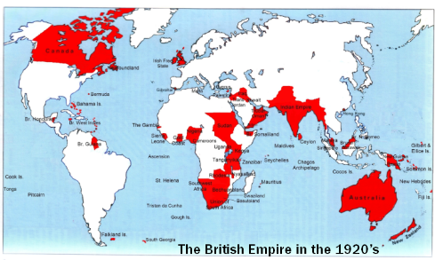
During World War Two Britain relied heavily on people from all over the Empire to survive the attack of the Nazis. The Caribbean islands had over 10,000 fighting on Britain’s side, in the navy, army and air force. For many of these men the war was an exciting opportunity full of new sights and experiences. When the fighting ended they found little to celebrate when they were sent back home. Life was very hard in the West Indies. For ambitious young men, it was clear that their future lay abroad under the skies of Britain.
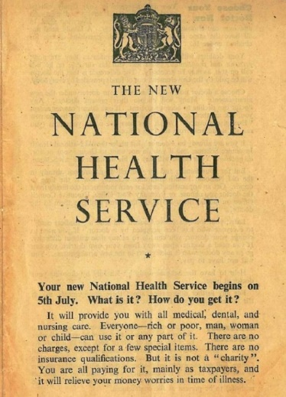
In 1948, Britain was just starting to recover from World War II. Thousands of buildings had been bombed, loads of houses were destroyed and it all needed to be rebuilt.
The National Health Service began opening in July 1948. It promised to give cradle to grave free hospital and medical care for everyone in the country, regardless of income. This meant that Britain now need many more doctors and nurses to care for the people. Housing was also a problem. There was a critical shortage. Air raids had destroyed half a million housing units. Britain was in much need of both money and workers due to all the roads, bridges, buildings and more that had been destroyed in the fighting.
In the Caribbean, lots of young men and women had served in the British armed forces because at the time, many Caribbean countries were still under British rule and not yet independent. After the war, some of these people answered an advert to come to Britain where there were lots of different jobs to do.
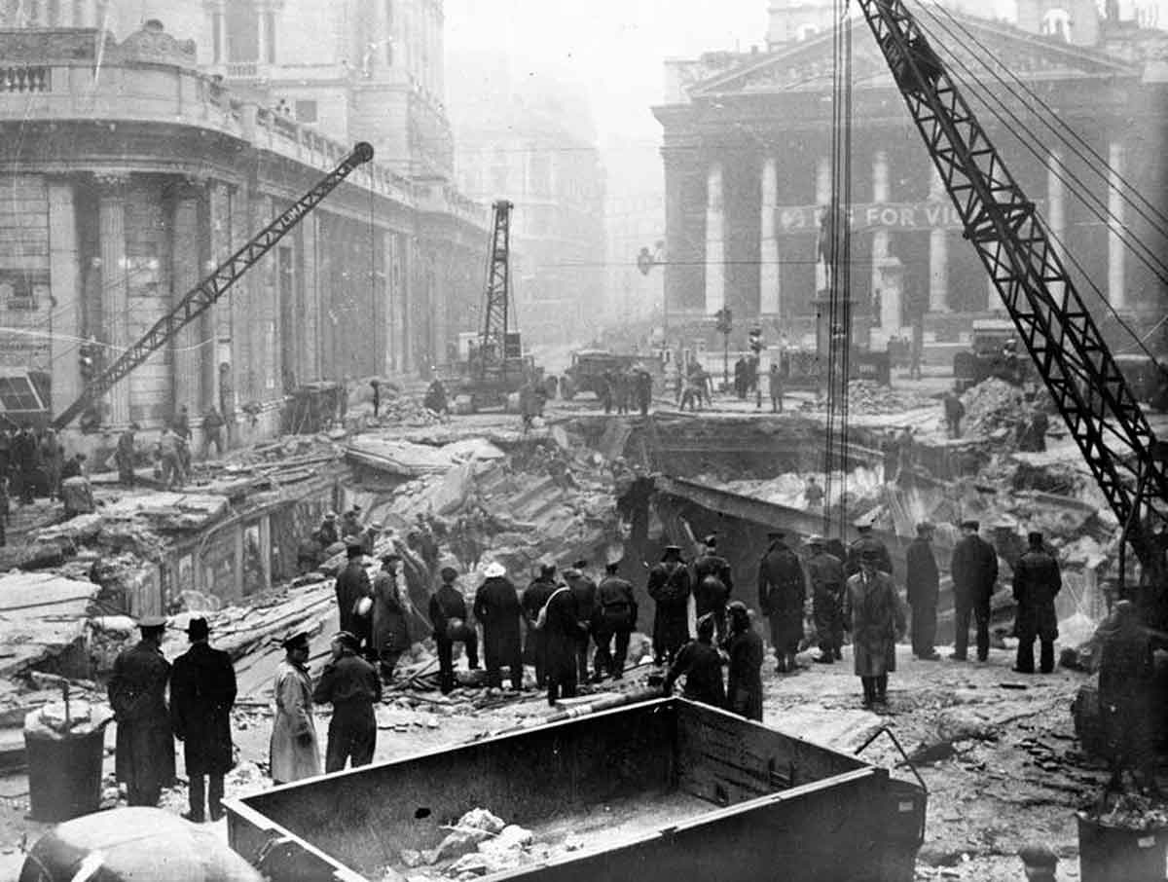

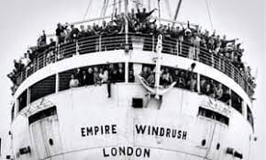
The Windrush 1948:
In June 1948 the SS Empire Windrush docked in Britain. Most of the 492 Jamaicans on board had fought in World War Two. They were ex-service men. Those arriving in the UK between 1948 and 1971 from Caribbean countries have been labelled the Windrush generation. The ship carried 1027 passengers. When the Windrush docked, the smartly dressed West Indians smiled nervously at the journalists waiting for them. One of the men decided to sing a song ‘London’s the place for me’. Multiculturalism in Britain had arrived.
Check your understanding by answering the following questions.
1. Britain had lots of counties from the Empire fighting with them in World War Two. For example…
2. In 1948 Britain set up the….
+ This now meant Britain needed more …
3. The Caribbean was still under British Rule. This meant that people could come to England from the Caribbean because..
4.The Windrush was a ship that set sail from _____________ to ______________ The ship carried_______
People on it.

Listen to the song sung by Aldwyn Roberts (better known as Lord Kitchener) who arrived on the HM Windrush Empire in 1948, one of the first 5,000.
Here are the lyrics to the first 2 versus:
London is the place for me
London this lovely city
You can go to France or America
India, Asia or Australia
But you must come back to London city.
Well believe me I am speaking broadmindedly
I am glad to know my Mother Country
I have been travelling to countries years ago
But this is the place I wanted to know
London that is the place for me.
Check your understanding by answering the following questions.
1. Is Kitchener being positive or negative about being in London?
Quote to back this up:
Here are the lyrics to the last verse:
Yes, I cannot complain of the time I have spent
I mean my life in London is really magnificent
I have every comfort and every sport
And my residence is Hampton Court
So London, that's the place for me.
Check your understanding by answering the following questions.
1. Where is Kitchener saying he lives in London to be able to enjoy all of the lovely things London has to offer?
2. Who actually lives here?
3. What do you think he is trying to say about living in London?

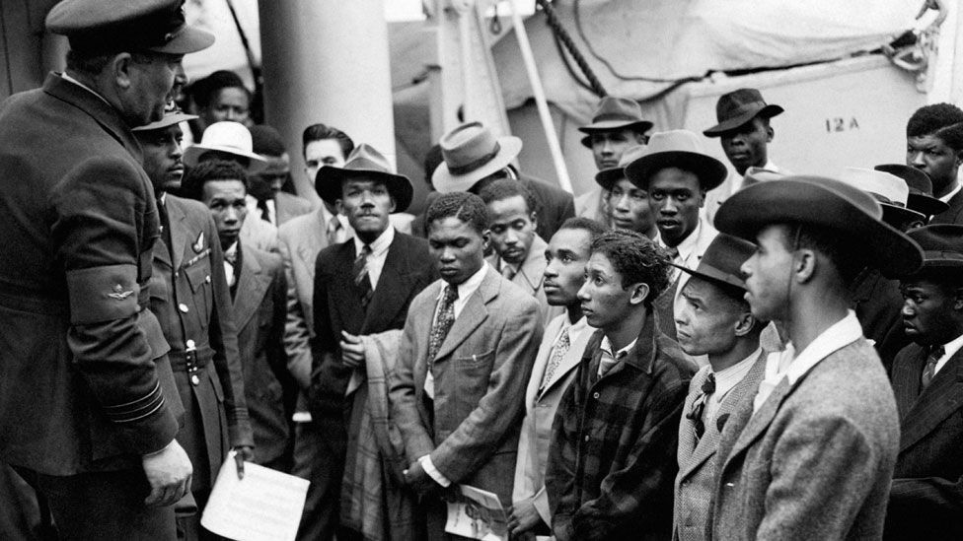
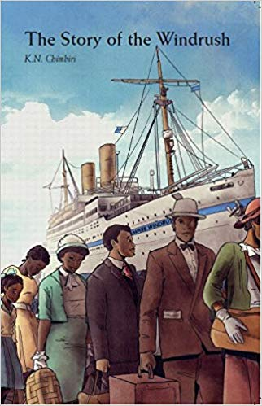
The Voyage of the Windrush made headlines in Britain before the ship had even landed. Thousands of immigrants from Europe and Ireland had been pouring into the country since the war had finished, but it was the arrival of one ship of English speaking, Christian, British subjects that caused alarm. Newspapers were full of stories of the ‘colour problem’ that was heading towards British shores. Some MP’s demanded that the ship turn around. The new arrivals wondered what the problem was. This was their ‘Mother Country’, so why the cold welcome? After all they spoke English, shared a love of football and cricket, were committed Christians and fought on the same side in World War Two. Yet racism soon got worse. In the years that followed there were many stories of terrible violence being used against black communities. For example in Kensington in 1958 where black communities suffered at the hands of young whites. In Middlesbrough in August 1961 hundreds of whites went into the streets chanting racist slogans. These gangs smashed windows of black families’ houses terrifying the people inside.
However many people black and white worked hard to stop racism. Britain needed more workers; they needed immigrants and still do, to do the jobs that many white people would not do. But for many of those people traveling the seas to be in Britain, was London the place to be?
Check your understanding by answering the following questions.
1.People had been immigrating to England for a while. However British people were worried about the immigrants on the Windrush. For example one MP said …..
+This shows that …
2.There were violent attacks on black communities, for example in Middlesbrough. More specifically ….
3.Despite there being multiple violent attacks on black communities immigrants wanted to stay in Britain for new opportunities. More specifically…
Check your understanding by answering the questions below.
1. The NHS was set up in Britain in the year:
1945 | 1946 | 1948
2. The SS Empire Windrush arrived in Britain in:
May 1948 | June 1948 | June 1945
3.The Windrush carried _______ passengers in it
1027 | 1270 | 1200
4. Immigrants came to Britain because:
They needed food and housing | Britain did not have enough people willing to do many new jobs that had been created. | It was free to come on the Windrush.

2. Was London the ‘place to be’ for immigrants after 1945?
LO: To explain reasons why people wanted to immigrate to Britain after 1945
Do Now!
1.The SS Empire Windrush came to Britain in 1948. More specifically ….
2. Britain needed more workers in 1948 because the government had set up the….
3. The West Indies were an ex-colony of Britain’s. More specifically…
4. In my own words discrimination is ….

Why would anyone want to move to England in 1951?
Key Words for this lesson:
An immigrant is a person who leaves that country where they were born and comes to live permanently in a foreign country. For example, in 1948 people born in the West Indies travelled on the Empire Windrush to live permanently in Britain
Prejudice: The belief that one group of people is superior to others.
Descrimination: When you are treated unfairly because of your race, relgion, sexuality or gender.
Reasons to immigrate from Jamaca to England:
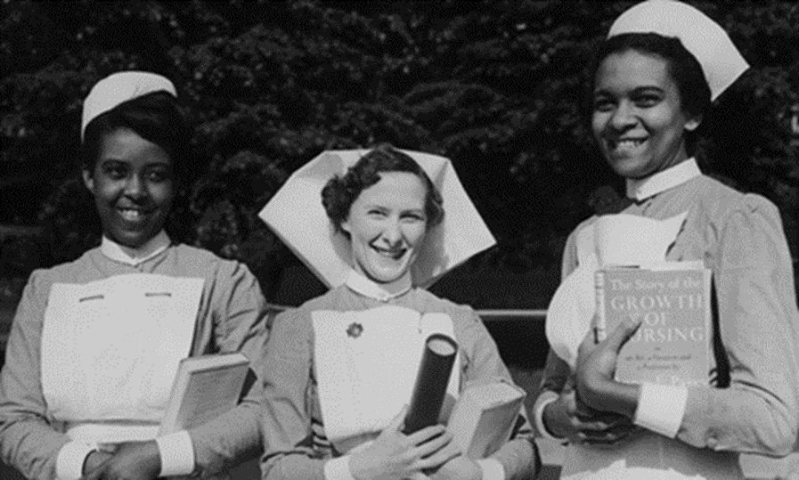
The motivation for people wanting to immigrate to Britain was due to two things. The first is life in Jamaica after 1945 was hard, work was difficult to find and natural disasters had made living in Jamaica difficult. We call this a push factor, feeling like you have to leave or you are being ‘pushed out’.
The second was London seemed like a good place to live. It had been seen as the ‘Mother country’ for all the years the West indies had been apart of the British Empire and people believed their lives would be better if they moved to Britain. This is called a pull factor, feeling like you want to leave you are being ‘pulled’ somewhere else.
1. In 1948 the British Government passed the Nationality Act. This was a law that gave British citizenship to people who lived in the country that used to be a part of the British Empire. This meant people who lived in the West Indies could come and stay in Britain for the rest of their lives.
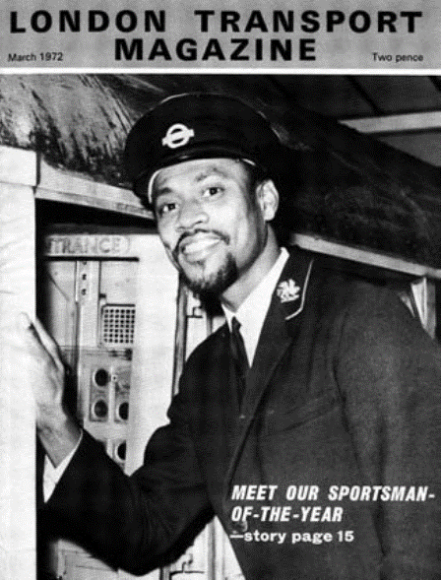
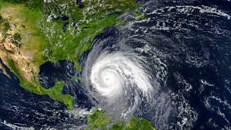
2. In 1944, the year before the war ended, a hurricane destroyed much of Jamaica. £16 million worth of damage was done to houses and businesses. - A hurricane is a huge storm! It can be up to 600 miles across and have strong winds spiralling inward and upward at speeds of 75 to 200 mph. Each hurricane usually lasts for over a week, moving 10-20 miles per hour over the open ocean.
3. In 1945 the price of sugar dropped. This meant many Jamaicans who worked in the sugar industry lost their jobs and now had no means of making money.
4.In 1948 the NHS was created in Britain and transport was developing quickly. England needed more nurses, trains drivers and bus drivers.
Check your understanding by answering the following questions.
1. An immigrant is….
2. In my own words a pull factor is…
3. One pull factor for people immigrating to Britain was because of job opportunities. More specifically …..
4. In my own words a push factor is…
5. One push factor that made people want to move to Britain was the hurricane. More specifically …
6. Another push factor was sugar in Jamaica. More specifically ….

Source A: An interview with Mr. Oswald on his experience of the Windrush
“It was common knowledge that there was work in Britain, just after the war. The war ended 3 years earlier. So there was a lot of scope. It took me a week to wind things up to travel.
I had no ties I wasn't married or anything like that I come from Montego Bay, Jamaica. I knew no one in England, I had travelled before to America and Panama. I had no idea what I was coming to.”
What can you infer from source A about why people came to Britain after 1945?
I can Infer:
Detail from the source:

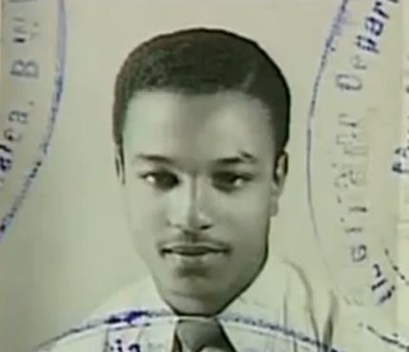
Source B: Arthur Curling
“I came to England first in 1944 and flew planes in the Royal Air Force in World War II. I’d joined the Royal Air Force when I was 16. I had gone to Britain and it was dangerous but exciting. It was something beautiful at the time to all the young fellows in uniform. When you are young you want to be a part of something, you don't stop and think of the dangers and things. I returned to Jamaica in 1946. After two years in Britain Jamaica was too small for me. You don't realise how small it is until after you've travelled. I returned to Britain on the Empire Windrush in 1948”.

What can you infer from source B about why people came to Britain after 1945?
I can Infer:
Detail from the source:

Source C: Sam King
“I as a young man volunteered to contribute and fight Nazi Germany and by the Grace of God we won. I came back to England on the Windrush with my own directive, I have been here during the war fighting Nazi Germany and I came back and help build Britain.”
What can you infer from source C about why people came to Britain after 1945?
I can Infer:
Detail from the source:

Check your understanding by answering the following questions.
1. An immigrant is …
A person who lives illegally in a country | A person who leaves the country they were born in to live in another country | A person who goes to other countries for a few weeks at a time
2. The post war Nationality Act was passed in the year…
1945 | 1946 | 1948
3. A pull factor for people immigrating from Jamaica to Britain was….
The 1944 Hurricane | The decline in sugar trade | The NHS and development in transport
4. A push factor for people immigrating from Jamaica to Britain was …
The decline in the sugar trade | The NHS and development in transport | The Nationality Act
5. Prejudice is…
When a person is not legally recognised in a country | The belief that one group of people is superior to others | When you are treated unfairly because of your race, sex, religion or gender

3. Was London the ‘place to be’ for immigrants after 1945?
LO: To explain reasons why London may not have been the ‘place to be’ for immigrants after 1945
Do Now!
1.Immigration in my own words is when …
2. One factor for people immigrating to Britain was because of the NHS. More specifically …..
3.Another factor for people immigrating to Britain was because of how hard life was in Jamaica. More specially …
4.In my own words discrimination is….
5.In my own words prejudice is…
+What did one newspaper state as the SS Empire Windrush docked in Britain in 1948?

Why was London not the ‘place to be’ for immigrants?

Despite Britain needing immigrants to help support the NHS and the growing transport system, as well as the fact that many people from the West Indies took on jobs that white British people didn’t want, prejudice and racism got worse. Not only was there violence used against black communities around the country, day to day racism also continued.

It was especially hard to find places to live. West Indians were sometimes greeted by boarding house signs saying ‘NO BLACKS, NO IRISH, NO DOGS’. Some low paid Afro-Caribbean’s had to rent rooms in a slum. If they tried to buy or rent homes in better areas, they were abused or attacked. Most therefore stayed in the ‘black areas’ of London or other big cities such as Toxteth (Liverpool), St Pauls (Bristol) and Moss Side (Manchester) to name a few.

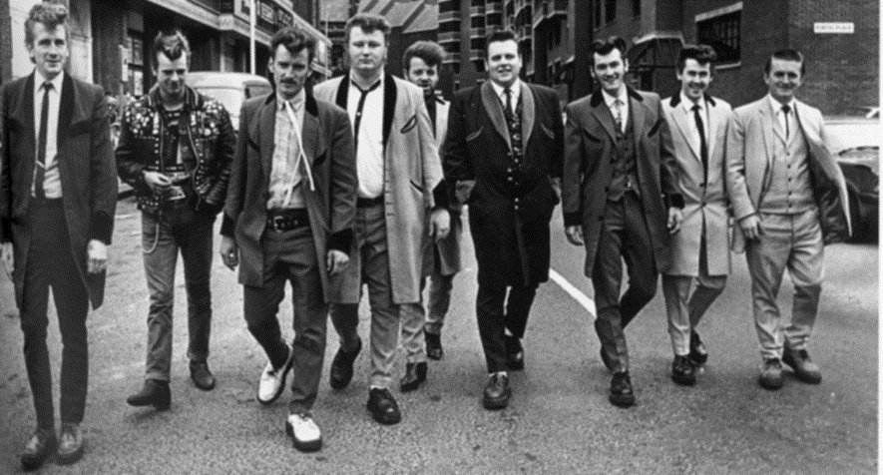
Black and Asian immigrants faced racial prejudice in Britain. Surveys conducted in the mid 1960s,revealed that four out of five British people felt that 'too many immigrants had been let into the country'. A group better known as the Teddy Boys were a type of gang that started in London in the 1950s. The group was mainly made up of teenage boys who wore smart clothes, had gelled, quiffed hair and listened to rock and roll music. Teddy Boys often had fights with rival gangs. With some holding racist views and even attacking immigrants, most famously in the Notting Hill riots of 1958. They displayed hostility towards black families, which was inflamed by far-right groups.
The Notting Hill Riots 1958:
The Caribbean population across London grew to over 100,000 by 1961 with most living in areas such as Notting Hill. This led to competition for housing between poor black and poor white families, leaving many local residents fearing being displaced in housing by the newcomers from overseas.
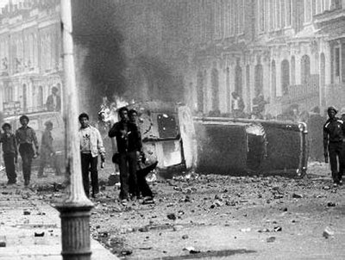
The Teddy Boys were openly hostile to members of the black community in Notting Hill. Concerns were raised by the Caribbean community leaders about this flourishing prejudice and the potential it had to develop into violent conflict, yet government officials took no action.
Violence broke out on August 20th 1958 when property owned by Caribbean immigrants was vandalised and violence was used against the owners themselves. The violence quickly escalated on August 24th when nine Teddy Boys attacked five black men in Shepherd’s Bush and Notting Hill, leaving three seriously injured.
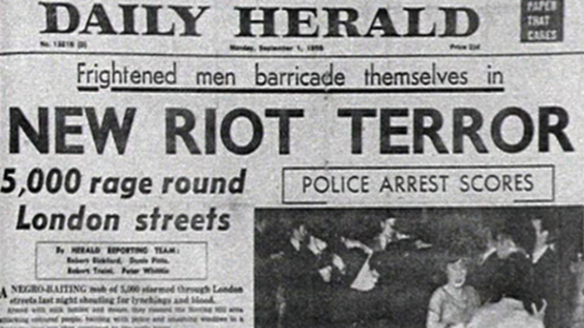
This led to the Notting Hill Riots, which began on August 30th 1958. Crowds of white youths, reportedly numbering 400, chased the Caribbean population in the area. Petrol bombs and milk bottles were launched as missiles, and some rioters armed themselves with iron bars and butcher’s knives. There were counterattacks by black youths also armed. The rioting stopped after a week, by that point approximately 140 people, mainly white, had been arrested.
Check your understanding by answering the following questions. Fill ALL of the space.
1. Some West Indians struggled to find rooms to rent. More specifically …
2. The Teddy Boys were a group of young men. Some of them held prejudice and had racist views. More specifically …
3. The Notting Hill Riots were triggered by the events on the 20th August 1958. For example …
4. The riots themselves started on the 30th August 1958. This was when …
5. These examples show that London was not the place to be. More specifically ….
Source A: Cecil Holness talking about his experience in London in 1949
“Just when we got married I saw this advert in a shop window about rooms to let and then when I phoned the lady she say, ‘Oh yes, come around, you’ll get the room.’ But the moment she answered the door it’s like as if she’s so frightened because she did expect to see a black man. First of all she said in that sugary way, ‘Oh I’m so sorry. You are five minutes too late. The room is taken’. So I say to her, ‘Madam do you see that telephone kiosk down there? That’s where I was phoning from and I didn’t see anyone come to your door.’ She paused for a while and said, ‘Well I don’t want black people.’ …. That’s one of the things I can never forget.”

What can you infer from source A about why it was hard for immigrants to find housing?
I can Infer:
Detail from the source:

Source B: Natalie Simmons writes about her grandmother experience of 1960s Britain after arriving from the Caribbean island of Grenada.
“On arrival into Britain, ‘shock’ and ‘dismay’ were the words my grandmother used to describe her experience at seeing the racial discrimination; albeit the fact that my grandmother responded to a warm invitation to come to rebuild Britain, she claims it was ironic that the reception from some of the white British people was opposite. Signs on buildings read “No Blacks, No Irish, No dogs” she said that this blatant racism made her feel like returning to Grenada.”
What can you infer from source B about why London was not the place to be after 1945?
I can Infer:
Detail from the source:
Source C: The Guardian Newspaper Article on the 1958 Notting Hill Riots
On the night of Saturday August 20 when a 400-strong crowd of white men, many of them "Teds", attacked houses occupied by West Indians. Among the victims was Majbritt Morrison, a young white Swedish bride of a Jamaican. She was pelted with stones, glass and wood, and struck in the back with an iron bar as she tried to get home
What can you infer from source C about why London was not the place to be after 1945?
I can Infer:
Detail from the source:
I can also infer:
Detail from the source:

Check your understanding by answering the following questions.
1. The Notting Hill Riots were in the year..
1956 | 1957 | 1958
2. The ‘Teddy Boys’ were …
A group of teenagers who wore smart clothes and slick backed hair | A group of teenagers who wore smart clothes and slick backed hair but also inflicted violence on immigrants | A band who were about in the 1960’s
3. The post war Nationality Act was passed in the year…
1946 | 1948 | 1949
4. Discrimination is…
When a person is not legally recognised in a country | The belief that one group of people is superior to others | When you are treated unfairly because of your race, sex, religion or gender
5. Prejudice is…
When a person is not legally recognised in a country | The belief that one group of people is superior to others | When you are treated unfairly because of your race, sex, religion or gender

4. Was London the ‘place to be’ for immigrants after 1945?
LO: To explain how changes in laws impacted on Britain’s changing culture
Do Now!
1.One reason London was not the place for immigrants after 1945 was because of white British peoples discrimination when renting rooms. More specifically ….
2. Due to the lack of places to rent, many immigrants ended up living in big cities. For example…
3.One event that showed Britain was not the place to be for immigrants after 1945 was the Notting Hill riots. More specifically….
4.One push factor for people immigrating to Britain was...

Watch the clip and answer the following questions.

1. Getting houses and rooms to rent was difficult for many immigrants. For example…
2.To try and prevent racism and discrimination the government introduced…
3.However this did not fully stop racism and discrimination. For example…..

Tackling prejudice:
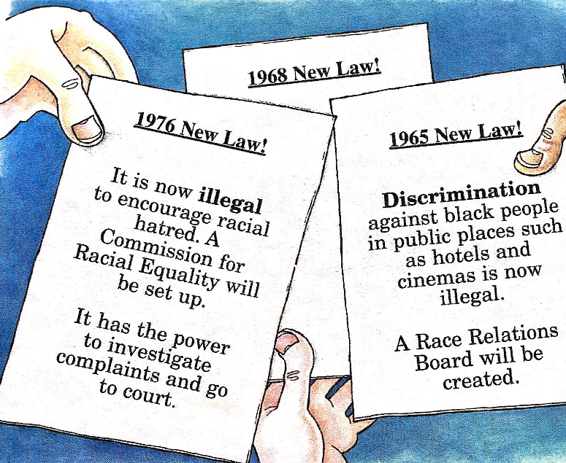
By 1965 it was at last becoming clear to the British government that something needed to be done about race relations. Labour governments passed Race Relations Acts in 1965, 1968 and 1976.
1965 New Law! Discrimination against black people in public places such as hotels and cinemas is now illegal. A Race Relations Board will be created.
1968 New Law! It is now illegal to refuse housing, employment, or public services to a person on the grounds of colour.
1976 New Law! It is now illegal to encourage racial hatred. A commission for Racial Equality will be set up. It has the power to investigate complaints and go to court.
But did this help?
Despite these laws, problems continued. In 1979 a National Dwelling and housing survey made some worrying findings:
- 5% of whites suffered from overcrowded houses
- 20% of West Indians suffered from overcrowded houses
Overcrowding made it even harder for young people to break down barriers at school. It was difficult to invite friends home to socialise if there was no space. Instead, they would meet on the streets. This too led to problems in the 1970’s and 80’s especially with the police.
One Christian minister, Pastor Blisset from Birmingham warned in 1978 that frustrations felt by black people were going to explode “The youths of Birmingham are like a time bomb, and sooner or later there is going to be an explosion. I hope to God that the eyes of the government could be opened to this.”
Check your understanding by answering the following questions.
1.What does Pastor Blisset mean by ‘Sooner or later there will be an explosion’?
2.What does he think the government should be doing?
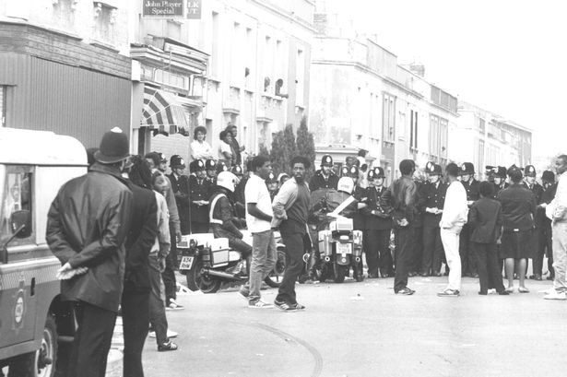
‘Explosions’ soon took place. In St Paul’s area in Bristol in April 1980. A black café owner was arrested. Black people watching felt the police were too heavy handed. They were angry. The crowd swelled. Violent rioting soon followed. The rioters injured police officers, destroyed dozens of police cars, looted shops and set cars and buildings on fire.
A year later in April 1981, violent rioting took place in Brixton. Following this, there were 12 months of similar events in other inner city areas, including Toxteth and Moss Side.
There was also an economic unfairness. In the 1970’s there was a recession. From 1973 to 1980 the number of people out of work doubled but black unemployment went up fourfold. It is thought that racism played a part in this as many employers would give jobs to white people over black. This led to tension and violence in inner city areas. In Brixton the rate of unemployment among black males under nineteen was 55%.
It was even harder for black people to get better paid office and professional jobs. 1984 researcher Colin Brown found that one in three white men had higher paid jobs and one in twenty men of West Indian origin had these jobs. To fight this injustice the Commission for Racial Equality came up with a code of practise in 1984. This supported the idea that attitudes were changing. There were now efforts in the 1980’s and 1990’s to encourage people from different ethnic backgrounds to join higher professions.
Check your understanding by answering the following questions. Fill ALL of the space.
1. To try and prevent racism and discrimination the government introduced three laws around race. There were…
1
2
3
2. However the dwelling and housing survey showed that the lives of black people were not equal to those of white. More specifically…
3.it is said that ‘explosions’ took place. For example….
+Another example is…
4. This therefore shows that introducing new laws did not get rid of racism and discrimination. More specifically…
5. Immigrants suffered more economically in the 1970’s and 80’s than white Britons. For example…
6. The Commission for Racial Equality wanted to prevent racial discrimination in the work place by….
Challenge! Answer these questions in your books.
- Do the riots in the 1980’s prove that introducing new laws in the 1960’s and 70’s did not help at all?
- How could we argue that there was a link between the recession and riots in Britain in the 1980’s?

A story changing
Immigration changed Britain drastically. Food, art, fashion and religion all changed a great deal. In the 1960’s and 70’s, when many cities took an interest in eastern culture and Afro-Caribbean’s became involved in the Rastafarian movement. Although the movement brought stories and history from Africa, the part of the movement that attached both black and white people the most was the Reggae music. Many black youths could understand the lyrics quite easily, as they spoke about culture back in Africa and the Caribbean and referred to parts of history understood by these cultures. But how could whites understand them unless they knew something of the history that led to them? Gradually young whites began to understand that these songs spoke about:
- Remembering the days of slavery
- Challenged racism still being faced by black people
- Showed links to Africa
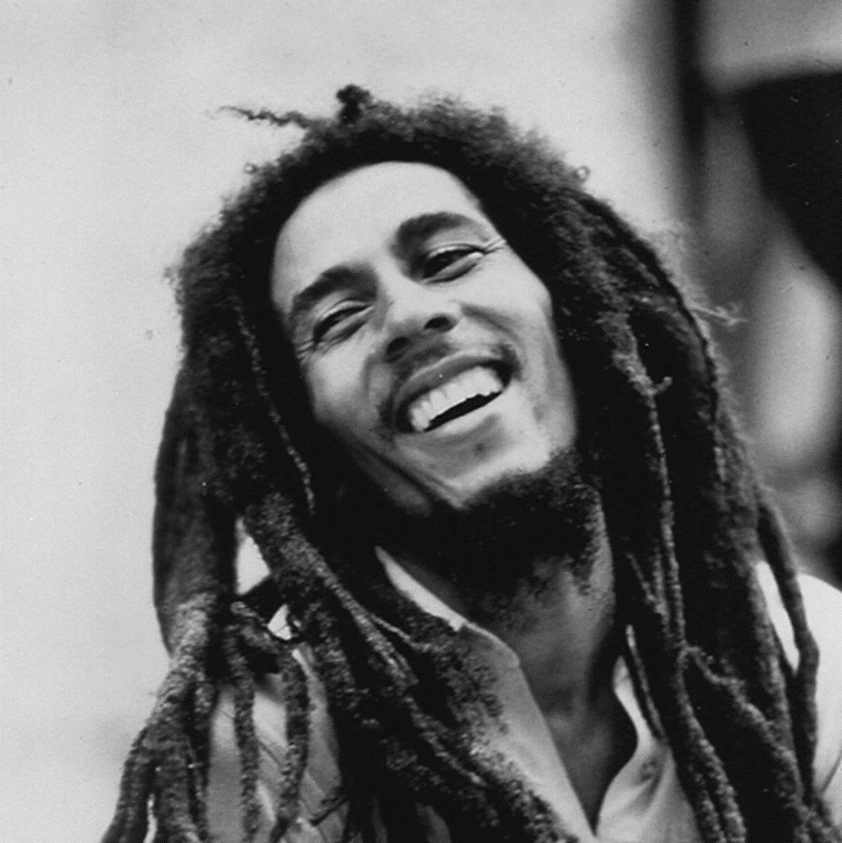
Reggae music helped to raise awareness of black culture and to change attitudes. Bob Marley, a son of a Jamaican women and a white solider from Liverpool was Reggae’s first superstar. Bob Marley and the Wailers entered the charts in 1975, their hits never lost their popularity.
Poetry was affected too. Benjamin Zephaniah in the late 1980’s became Britain’s nest known Rastafarian poet.
One Poet said this about the effects of Rasta ‘Most Rastas have become so because of empathy that they have with music. The movement has brought back to the people a sense of pride in their ancestry’.
Check your understanding by answering the following questions.
1.What is this poet saying Rasta has done for many black immigrants?
Quote to back this up:
2.Why has the Rasta movement been so effective in their opinion?
Quote to back this up:
Black music did not only help to bring pride in black history it also changed all kinds of white culture. Many white people started to enjoy black culture without realising it.
Soul singer Jazzie B from the band Soul II Soul explained how he felt about this:
‘When we first started out, I can remember running away from the Teddy Boys who were trying to duff us up, and I can remember a bunch of skin heads and them playing some U-Roy (Reggae music) and I’m totally amazed that these guys who try and beat us up are listening to our music….Soul II Soul is not just a London thing. We are really more of a British thing, I mean now black Britain has all types of things to be proud of. I’m black and I’m definitely British and that’s what I am’
What can you infer from Jazzie B about the impact music had on changing Britain and immigration?
I can Infer:
Detail from the source:
I can also infer:
Detail from the source:

Check your understanding by answering the following questions.
1. The 1965 law introduced …..
Discrimination against black people in public places such as hotels and cinemas is now illegal. A Race Relations Board will be created. | It is now illegal to encourage racial hatred. A commission for Racial Equality will be set up. It has the power to investigate complaints and go to court. | It is now illegal to refuse housing, employment, or public services to a person on the grounds of colour.
1. The 1976 law introduced …..
Discrimination against black people in public places such as hotels and cinemas is now illegal. A Race Relations Board will be created. | It is now illegal to encourage racial hatred. A commission for Racial Equality will be set up. It has the power to investigate complaints and go to court. | It is now illegal to refuse housing, employment, or public services to a person on the grounds of colour.
3.The Rastafarian movement helped to change Britain by….
Introducing a new form of music that help Africa-Caribbean’s to feel proud of their culture and heritage | It encouraged white people to understand African-Caribbean history | To introduced a new type of music ’Reggae’
4. In 1984 Colin Brown found that for white men…
One in three had a higher paid professional job | One in twenty had a higher paid professional job | One in ten had a higher paid professional job
4. In 1984 Colin Brown found that for black men…
One in three had a higher paid professional job | One in twenty had a higher paid professional job | One in ten had a higher paid professional job

Lessons 5&6. Was London the ‘place to be’ for immigrants after 1945?
L.O: To evaluate if London really was ‘the place to be’ for immigrants after 1945
‘London was the ‘place to be’ for immigrants after 1945’ To what extent do you agree with this statement?
Some people such as Arthur Churling who travelled from the West Indies to Britain on the SS Empire Windrush would argue that London was ‘the place to be’. This is because Britain was seen as ‘exciting’ and post World War Two some home countries to soldiers, such as Jamaica just ‘seemed to small’. Britain presented itself as an opportunity for adventure. However, it has been argued that London was ‘not the place to be’. As seen by Cecil Holness, Britain also brought prejudice, discrimination and even racial violence. Leaving many immigrants isolated and disadvantaged.

‘London was the place to be for immigrants’
Explain: In my own words this means…
Example: Examples of why London was the ‘place to be’ for immigrants after 1945…..
1
2
3
Evidence that London brought more job opportunities:
Evidence that London brought the chance of a fresh start and a new life:
Example: Examples of why London was not the ‘place to be’ for immigrants after 1945…..
1
2
3
Evidence that there was discrimination in London:
Evidence that there was racial violence in London:
Extra: Example: Examples of how London became multicultural…..
1
2
3
PARAGRAPH ONE: London WAS the place to be. Instructions for great writing:
- In your own words what is meant by this
- Arthur Churling believes that London offered opportunities that the West Indies did not have Describe examples of how London was the place to be for immigrants after 1945.
- Explain why these examples lead to London being the place to be.
- Use a counter-point to explain why London was not the place to be for everyone
- Evaluate: overall, does this agree or disagree with London being the place to be for immigrants
- Challenge; give more examples at bullet point 2 and 4.
How accurate is it to say that ‘London was the place to be for immigrants after 1945?

On the one hand there is a large amount of evidence that agrees with this statement. For example, after the Second World War Britain launched the National Health Service in 1948 meaning that as the medical care for all Britons was extending so was the need for more doctors and nurses. This resulted in the British Government creating the Nationality Act, giving British citizenship to people who lived in the country that used to be a part of the British Empire. This meant people who lived in the West Indies could come and stay in Britain for the rest of their lives. Britain was also expanding their transport system and therefore needed more train and bus drivers, as well as more labor workers to help re build Britain after the bombing of World War Two. These pull factors acted as a reason for many immigrants to come to London after 1945. For example, Arthur Churling who had fought for Britain in World War Two, when returning to Jamaica, found life was just too small, this combined with the decline in the sugar trade from 1944, as well as the hurricane in 1945 that destroyed hundreds of homes, meant that for him London now offered more job opportunities as well as a new start.+ Furthermore the SS Empire Windrush which docked in Britain in 1948, of the 1027 passengers 492 were from Jamaica, showing that for many London was the place to be. However, It cannot be ignored that even as the first boat arrived with immigrants keen to work and be a part of a new life in London, contention and discrimination was already at play. With one MP demanding that, the ship turn around. Overall, London in 1945 was seen as the’ place to be’. Many countries had suffered from the war and Britain offered a chance for employment and a new way of life. This made Britain economically the place to be.
Rewrite
For example..
More specifically..
Furthermore…
In addition….
This meant that….
This led to…
However + because…
This agrees with the statement that ‘London was the place to be for immigrants after 1945’ because …
PARAGRAPH TWO: London was not the place to be: Discrimination/ Racial violence
Instructions for great writing:
- State your reason for why London was ‘not the place to be’
- Describe examples of how immigrants were treated when they moved to London
- Explain why these examples mean that London was not the place to be
- Use a counter-point to explain why London may still have been the place to be despite this
- Evaluate: overall, does this agree or disagree with the statement that London was ‘the place to be’
- Challenge; give more examples at bullet point 2 and 4.

Notes from discussion
On the other hand..
For example..
More specifically..
Furthermore…
In addition….
This meant that….
This led to…
However + because…
This agrees/disagrees with The statement that London was the place to be because …
Notes from discussion: Questions:
PARAGRAPH THREE: Laws passes to prevent racism and cultural change in Britain
Instructions for great writing:
- State your argument that London was or was not the place to be based on the changing laws and the changing culture
- Describe examples of changing laws and changing culture
- Explain why these examples mean that London either was or was not the place to be
- Use a counter-point to explain why London was or was not the place to be
- Evaluate: overall, does this agree or disagree with statement that London was the place to be
- Challenge; give more examples at bullet point 2 and 4.

Did the British Government try and stop racism? How?
Did this stop racism happening?
In your opinion does this show that London was or was not the place to be? Why?
How did culture in Britain change?
In your opinion does this show that London was or was not the place to be? Why?
For example..
More specifically..
Furthermore…
In addition….
This meant that….
This led to…
However + because…
This agrees/disagrees with the statement that London was the place to be because …
PARAGRAPH FIVE: Conclusion
Instructions for great writing:
- Summarise your overall opinion on if London was or was not ‘the place to be’ for immigrants
- Summarise the evidence about how London was the place to be for immigrants after 1945
- Summarise the evidence about how London was not the place to be for immigrants after 1945
- Summarise the evidence about changing laws and culture and if this links with London being the ‘place to be’ or not.
- Explain your overall opinion on if London was or was not the place to be for immigrants after 1945
Overall I slightly/partially/fully/do not agree with the statement that London was the place ‘to be’ for immigrants after 1945.
Experiences such as those of Arthur Churling clearly show that London was the’ place to be’ for immigrants after 1945 because…
However for many immigrants London was not the ‘place to be’. More specifically …
Therefore I slightly/partially/fully/do not agree with the statement that London was the ‘place to be’ because…..

Revision: Was London the ‘place to be’ for immigrants after 1945?
L.O: To explain if London really was ‘the place to be’ for immigrants after 1945
Do now: Circle the correct answer
1. The NHS was set up in Britain in the year:
1945 | 1946 | 1948
2. The SS Empire Windrush arrived in Britain in:
May 1948 | June 1948 | June 1945
3.The Windrush carried _______ passengers in it
1027 | 1270 | 1200
4. Immigrants came to Britain because:
They needed food and housing | Britain did not have enough people willing to do many new jobs that had been created. | It was free to come on the Windrush.
5. An immigrant is …
A person who lives illegally in a country | A person who leaves the country they were born in to live in another country | A person who goes to other countries for a few weeks at a time
6. The post war Nationality Act was passed in the year…
1945 | 1946 | 1948
7. A pull factor for people immigrating from Jamaica to Britain was….
The 1944 Hurricane | The decline in sugar trade | The NHS and development in transport
8. A push factor for people immigrating from Jamaica to Britain was …
The decline in the sugar trade | The NHS and development in transport | The Nationality Act
9. Prejudice is…
When a person is not legally recognised in a country | The belief that one group of people is superior to others | When you are treated unfairly because of your race, sex, religion or gender
10. The Notting Hill Riots were in the year..
1956 | 1957 | 1958
11. The ‘Teddy Boys’ were …
A group of teenagers who wore smart clothes and slick backed hair | A group of teenagers who wore smart clothes and slick backed hair but also inflicted violence on immigrants | A band who were about in the 1960’s
12. Discrimination is…
When a person is not legally recognised in a country | The belief that one group of people is superior to others | When you are treated unfairly because of your race, sex, religion or gender
13. The 1965 law introduced …..
Discrimination against black people in public places such as hotels and cinemas is now illegal. A Race Relations Board will be created. | It is now illegal to encourage racial hatred. A commission for Racial Equality will be set up. It has the power to investigate complaints and go to court. | It is now illegal to refuse housing, employment, or public services to a person on the grounds of colour.
14. The 1976 law introduced …..
Discrimination against black people in public places such as hotels and cinemas is now illegal. A Race Relations Board will be created. | It is now illegal to encourage racial hatred. A commission for Racial Equality will be set up. It has the power to investigate complaints and go to court. | It is now illegal to refuse housing, employment, or public services to a person on the grounds of colour.
15.The Rastafarian movement helped to change Britain by….
Introducing a new form of music that help Africa-Caribbean’s to feel proud of their culture and heritage | It encouraged white people to understand African-Caribbean history | To introduced a new type of music ’Reggae’
16. In 1984 Colin Brown found that for white men…
One in three had a higher paid professional job | One in twenty had a higher paid professional job | One in ten had a higher paid professional job
17. In 1984 Colin Brown found that for black men…
One in three had a higher paid professional job | One in twenty had a higher paid professional job | One in ten had a higher paid professional job
/17
Source A: John Edwards speaks about how life was for him when he arrived in Britain after 1945
I know a lot about Britain from school days but it was a different picture from that one, when you came face to face with the facts. It was two different things.
They tell you it is the 'mother country', you're all welcome, you all British. When you come here you realise you're a foreigner and that's all there is to it.
The average person knows you as a colonial and that's all. You cut cane or carry bananas and that's it. Anybody wants to diddle you they say I just come off the banana boat and things like that.
Q1. Study Source A: Give two things you infer from Source A about why London was difficult for immigrants who moved to Britain after 1945.

i) What I can infer:
Details in the source that tell me this:
ii) What I can also infer:
Details in the source that tell me this:

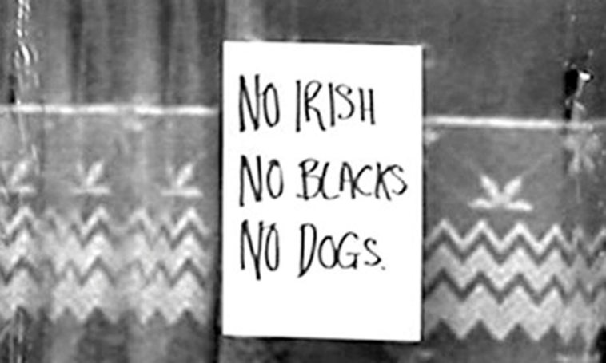
Source B: A sign in the window of a hotel in London, 1960

Q2. Study Source B: Give two things you infer from Source B about why London was difficult for immigrants who moved to Britain after 1945.

i) What I can infer:
Details in the source that tell me this:
ii) What I can also infer:
Details in the source that tell me this:
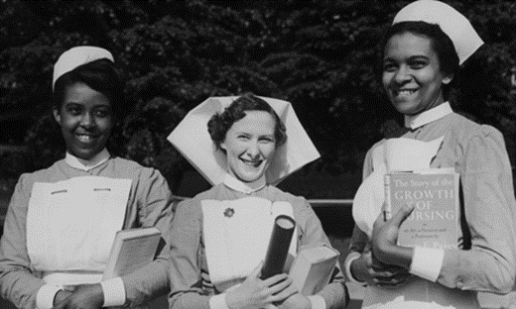
Source C: Prize winning nurses. Greenwich Nursing School, 1954. The British Government made it possible from people from the Commonwealth to live in Britain permanently by passing the Nationality Act

Q3. Study Source C: Give two things you infer from Source C about why London was the place people wanted to immigrate to after 1945.

i) What I can infer:
Details in the source that tell me this:
ii) What I can also infer:
Details in the source that tell me this:

Learning Ladder
I can…. | Prove it!
Identify words and terms | 1.What does the NHS stand for?  2.What does ‘discrimination’ mean?  3.What does ‘prejudice’ mean?  4.What was the SS Empire Windrush?  5.Who were the Teddy Boys?  6. Define ‘immigration’
Describe why London was and was ‘not the place’ to be for immigrants after 1945.  Say a lot about a little, try and include at least three details.  - For example…More specifically…. This meant that…  One reason why London was the ‘place to be’ was because of pull factors. For example, the NHS had been created in 1948 and Britain needed more doctors and nurses. More specifically, the British government passed the Nationality Act in 1948 to encourage people from the commonwealth to come to Britain to work. This meant that London was the place to be as it offered more job opportunities and a permanent home. | 1.Describe how pull factors such as job opportunities meant London was the ‘place to be’.  2.Describe how push factors such as the 1944 Hurricane meant London was the ‘place to be’.  3.Describe how discrimination in housing meant London was ‘not the place’ to be.  4.Describe how the actions of the Teddy Boys meant London was not the ‘place to be’.  5.Describe how British culture changed positively because of immigration.
Explain how London was the place to be and also how it was not the place to be for immigrants.  Use key words  - Economic, cultural, social … because…  Therefore London offered new economic opportunities. This is because post World War Two many jobs that white British people did not want immigrants were happy to do, for example helping to rebuild homes after the bombings from the war. | For each of the questions 1-5 above, explain how this meant London was or was not’ the place to be’ for immigrants after 1945.
Evaluate if London was really the ‘place to be’ for immigrants after 1945.  - Summarise you overall opinion about the statement that London was the ‘place to be’  - Summarise the evidence that agrees with the statement  - Summarise the evidence that disagrees with The statement  - Explain your overall opinion of the statement | Overall, how far do you agree with the statement “London was the’ place to be’ for immigrants after 1945”?  Overall, I agree with the statement that London was the ‘place to be’ to a large/certain/small extent.  On the one hand, I disagree with the statement, London was not the ‘place to be ‘for immigrants after 1945, more specifically…  However, this ignores the fact that…  Therefore, I agree to a large/certain/small extent because…

Glossary of Academic Vocabulary
Word | Definition | Because | But | So
Discrimination | When you are treated unfairly because of your race, religion, gender or sexuality. In Britain, immigrants who came over after World War Two faced discrimination. | Many people who were renting out their flats or homes would not rent to anyone who was not white. This meant it was extremely difficult for immigrants to find accommodation or more importantly feel accepted in British society. | But in 1968 a law was passed that made it illegal to refuse housing, employment, or public services to a person on the grounds of colour. Therefore showing that the British government was trying to stop racism. | So although London was a difficult place to be and still needed to improve how immigrants were treated progress was made to try and make it a better and fairer place for all.
Prejudice
Hurricane
Recession
NHS
Teddy Boys
Continue in the back of your exercise book

