**WEEK 1: WORK BOOKLET**

**Instructions of how to complete the work below.**

1. **Complete all the blue boxes below.**
2. **Complete all work in your exercise book. Your teacher will mark this when you return.**
3. **Complete the work in the normal time you would have Geography.**

**Lesson 2 - Objective: to outline the main stages of the Greenhouse Effect.**

|  |
| --- |
| **Complete these do now questions:**   1. Over the last 800,000 years global temperatures have….. 2. One piece of evidence of long term climate change is…. 3. One piece of evidence of recent global warming is…. 4. Climate change is….. 5. Rises in temperature and melting sea ice cause…. 6. Arctic ice cover has reduced by _____% 7. A glacial is…. 8. An interglacial is…. 9. The word fluctuated means…. 10. The Little Ice Age happened in the 1900’s. True/false? |

|  |
| --- |
| **Read this information:** |
| **Answer these questions:**   1. Define the term **climate.** 2. Give an example of a major change in the weather over a long period of time. 3. What is a glacial period? 4. What is an interglacial period? 5. Are we in an interglacial or glacial period? |

|  |
| --- |
| **Read this information:**  **KEY TERM ALERT!**  **Fossil fuel** – a natural fuel found in the ground such as coal or oil. Humans burn fossil fuels for activities such as driving cars and powering factories.   * Recently the earth’s temperature has risen. This is known as global warming. **Global warming** means the Earth is warming up. * The reason why our Earth is getting hotter is due to the ‘**Greenhouse Effect’.** Without the greenhouse effect, the earth’s temperature would be minus 17 degrees *colder*! * The greenhouse effect is a natural process. However, when humans burn **fossil fuels** (e.g. to drive cars) they release greenhouse gases that makes this process worse! |
| **Answer these questions:**   1. **True or false?** Recently the earth’s temperatures have fallen. 2. **True or false?** Global warming means the Earth is warming up. 3. **True or false?** Without the greenhouse effect, the earth’s temperature would be 17 degrees *warmer*. 4. **True or false?** The greenhouse effect is a natural process. 5. **True or false?** Humans have no influence on how many gases are added to the atmosphere. 6. **True or false?** Humans burn fossil fuels when driving cars. |

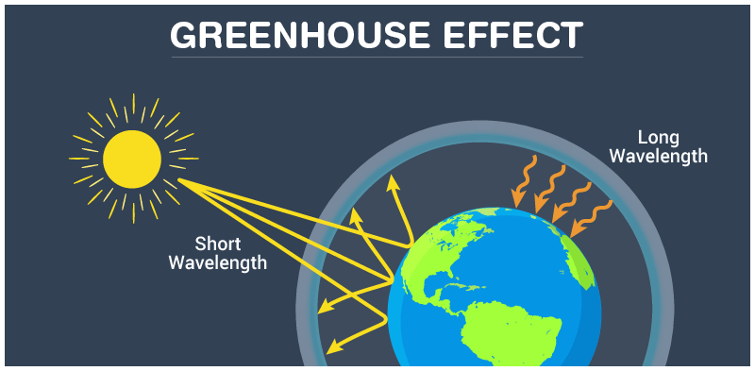

|  |
| --- |
| **But what exactly is the Greenhouse Effect? Read the information below from A-D and use the diagram to help:**    **C**  Heat from the sun is reflected by the land and the sea. The rays are reflected as infrared radiation. The greenhouse gases trap the reflected heat. Eventually more heat is trapped by the greenhouse gases. The temperature rises.  **A**  Humans burn **fossil fuels** to make energy. This produces a layer of greenhouse gases (carbon dioxide, nitrous oxide) in the atmosphere.  **B**  Sunlight passes through the earth’s atmosphere as short wave radiation and warms up the earth.  **D**  Some heat does manage to pass through the greenhouse gases and escape into space. |
| **Watch this video:** [**https://www.bbc.com/bitesize/guides/zx234j6/revision/1**](https://www.bbc.com/bitesize/guides/zx234j6/revision/1) |
| **Answer these questions:**   1. How many degrees colder would the earth’s atmosphere be without the greenhouse effect? 2. What is a fossil fuel? 3. Name 2 greenhouse gases. 4. True or false? Sunlight passes through the earth’s atmosphere as infrared radiation. 5. What happens when there is an increase in greenhouse gases in the atmosphere? 6. True or false? Some heat does manage to pass through the greenhouse gases and escape into space. 7. Name 3 human activities that cause greenhouse gases (through burning **fossil fuels**). |

|  |
| --- |
| **Explain how the greenhouse effect heats our atmosphere.**  *The greenhouse effect is a natural process, where gases in the atmosphere trap heat within our atmosphere. Without the greenhouse effect, the earth’s temperature would be 17°C.*  *Human activities, such as driving cars, creates……*  *More specifically……*  *Sunlight travels…….* |