Comparing Methods – Boyle’s Law
Two different methods can be used to investigate Boyle’s Law empirically. One such method shall be denoted as the ‘syringe’ method, the other being the ‘foot pump’ method.
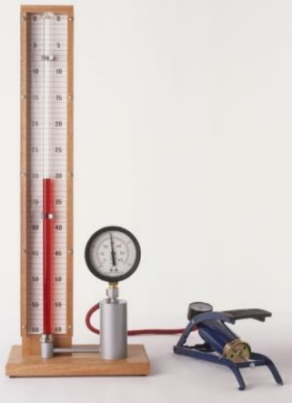
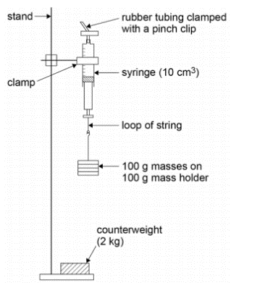
Methods
Foot Pump Method apparatus
Figure obtained from (Munster, 1991)
Syringe Method apparatus
Figure obtained from (AQA, 2017)

Both methods take a different approach to their setups. The ‘syringe’ method involves the use of a syringe clamped to a stand that uses weights as a means to exert pressure onto the system which changes the volume of the gas column. A pinch clip is used to ensure that no air can escape from the nozzle (AQA, 2017)
The ‘foot pump’ method also alters the volume of a gas column but by exerting pressure using a foot pump which causes oil to climb up the manometer tube. The bourdon gauge is used to display the pressure on the oil reservoir. (Muncaster, 1991)
A key part of the method that is overlooked by the ‘syringe’ method but accounted for by the ‘foot pump’ method is the fact that steps should be taken to ensure that the temperature is constant; the apparatus is left for a minute as the temperature rises due to the exerted pressure, so time should be given so that the temperature falls back to room temperature. (Muncaster, 1991)
Safety Precautions
More dexterity and proactivity in terms of safety is required for the ‘syringe’ method since it uses a suspended syringe with weights which can easily topple. Hence, a 2kg counterweight is used for stability as well as care must be taken to gently add weights to the base of the plunger, which must have the loop of string securely tightened. (AQA, 2017)
The ‘foot pump’ method is less hazardous since all apparatus can be setup on a flat worktop (as shown on the respective figure). No key safety precautions are mentioned, though these would likely be commonplace dexterity, akin to any experiment.
Data Analysis
The data analyses for both methods involve arranging data to be plottable on a ‘Pressure against 1/Volume’ graph which should result in a straight line if Boyle’s law holds true.
Several prerequisites are required before plotting the graph with the ‘syringe’ method - the force imposed on the syringe is based on the weight of the masses, which should be calculated using F=mg (where g=9.81 ms⁻²). The pressure of the weights is then found using pressure = Force/area (Cross-sectional Area of the Plunger ($\frac{πd^{2}}{4}$), which is found by the diameter of the rubber seal using a micrometer, converting to metres). The pressure of the air sample is the found by deducting the pressure exerted by the weights from atmospheric pressure (constant of 101kPa) (AQA, 2017)
The ‘foot pump’ method, on the other hand, can plot the obtained values from the manometer tube and the bourdon gauge directly with little external analysis
Overall, the ‘foot pump’ method is more optimal if the equipment is readily available since it is generally safer and involves less analysis, which could be sources of error as assumptions of g and atmospheric pressure are made.

Bibliography
AQA, 2017. AQA: AS and A Level Practicals. [Online]
Available at: https://filestore.aqa.org.uk/resources/physics/AQA-7407-7408-PHBK.PDF
[Accessed 22 February 2020].
Muncaster, R., 1991. A level Physics. 3rd ed. Chelenham: Stanley Thornes Publishers Ltd.

