Objective: Evaluate the extent of improvement in individual rights
Do Now:
- In the 1970s, cinema and film became of form of escapism, for example…
- In the 1970s, the commercial side of sports changed because…
- In the 1970s, music became more fragmented, in other words…
- President Carter faced criticism following the Iranian Hostage Crisis, in other words…
- Johnson’s ‘Great Society’ helped to improve the lives of the elderly, for example…
In June 1969, 21-year-old Norma McCorvey discovered she was pregnant with her third child. She returned to Dallas, Texas, where friends advised her to assert falsely that she had been raped in order to obtain a legal abortion (with the understanding that Texas law allowed abortion in cases of rape and incest). However, this scheme failed because there was no police report documenting the alleged rape. In any case, the Texas statute allowed abortion only ”for the purpose of saving the life of the mother”. She attempted to obtain an Illegal abortion, but found that the unauthorized facility had been closed down by the police. Eventually, she was referred to attorneys Linda Coffee and Sarah Weddington.(McCorvey would end up giving birth before the case was decided, and the child was put up for adoption.)
In 1970, Coffee and Weddington filed suit in the United States District Court for the Northern District of Texas on behalf of McCorvey (under the alias Jane Roe). The defendant in the case was Dallas County District Attorney Henry Wade, who represented the State of Texas. McCorvey was no longer claiming her pregnancy was a result of rape, and later acknowledged that she had lied about having been raped. "Rape" is not mentioned in the judicial opinions in the case.

Quick write:
- Why was having an abortion difficult in America?
- What did McCorvey attempt to do to get an abortion?
https://www.youtube.com/watch?v=9HZj8Qp4p2A
The ‘Roe v Wade’ case was a supreme court decision that voted 7-2 against Texas’s anti-abortion law. Justice Harry Blackmun declared that ‘a women’s right to privacy under the 14th Amendment superseded a states right to ban abortion’ in other words…
How did women’s rights improve in the 1970s?
The women's movement attracted women of all races, backgrounds and political beliefs because many of them felt that they were being treated like second-class citizens. Despite making up more than half the American population, women were not admitted to colleges at the same rate as men or allowed equal pay or job opportunities.
As the feminist wave swept across the country, the support for ERA (Equal Rights Amendment) picked up even more steam.
The amendment was passed by both houses of Congress and President Richard Nixon in 1972, and was sent off to be ratified into law by the states
Mid-decade, the women's liberation movement had inundated America. The changes were so rampant that TIME awarded its "Man of the Year" in 1975 to "American women.
Check for understanding: True/False
Statement | True/False | Why?
The women’s movement was divisive; it only attacked a certain type of women from mainly the upper classes.
The ERA was passed by Nixon in 1972
The ERA was a law that tried to maintain better rights for American men.
In 1977 the TIME awarded ‘Man of the Year’ to the American Women
The ‘Redstocking Movement’ was a feminist group formed in New York. Look at the symbol of the hand. What does this remind you of and why would this group have chosen this sign?
_________________________________________

_________________________________________

_________________________________________

_________________________________________

_________________________________________
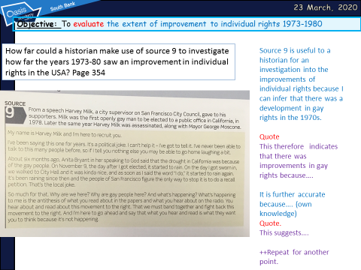
Task: Complete the source paragraph on content

