Globalisation Revision – essay practice questions.

- Cultural erosion. Assess the impact of TNCs (transnational corporations) on creating both winners and losers for people and environments. (SAMS)
- Negative impact on developed world. Assess the view that globalisation inevitably damages the physical environment. (2018)
- Positive impact on developed world. Assess the methods used in local communities to reduce the impact of globalisation on the environment. (2019)

- Negative Impact on developing world. Assess the extent to which cultural diffusion caused by globalisation inevitably leads to social and political tension. (SAMS AS)
- Measuring development. Assess the role of trade blocs in contributing to the growth of both the global economy and national economies. (2017 AS)
- Global shift = losers. Assess the impacts of rural-urban migration on the wellbeing of people in cities in developing countries. (2018 AS)
- Political tensions caused due to globalisation. Assess whether the economic benefits of globalisation always outweigh the social costs. (2019 AS)

Additional: notes for planning each essay in Miss Martin’s notes.
- Assess the role played by TNCs in the globalisation process (12 marks)

Examiner comments for: Assess whether the economic benefits of globalisation always outweigh the social costs. (2019 AS)

- Provide planning sheet and plan the four main paragraph sections. For each state the example you will use to exemplify your points.
- Use these notes to improve their exam question from the mock.

Examiner comments for: Assess the impacts of rural-urban migration on the wellbeing of people in cities in developing countries. (2018 AS)

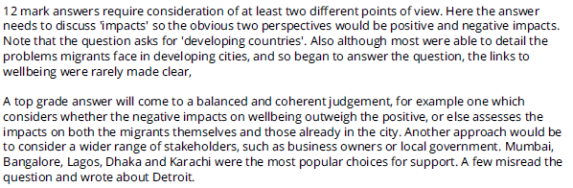

- Provide planning sheet and plan the four main paragraph sections. For each state the example you will use to exemplify your points.
- Read the exemplar student copy from the examiner’s report (page 10-11 2018 A Level).
- Improve theirs to achieve full marks.

Examiner comments for: Assess the view that globalisation inevitably damages the physical environment. (2018)
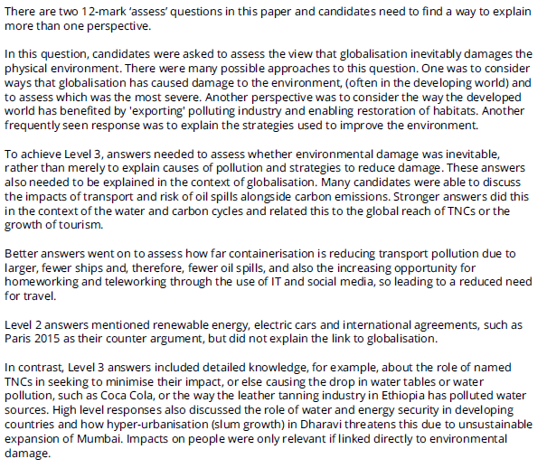

- Provide planning sheet and plan the four main paragraph sections. For each state the example you will use to exemplify your points.
- Read the exemplar student copy from the examiner’s report (page 5-6 2019 A Level).
- Improve theirs to achieve full marks.

Assess the role of trade blocs in contributing to the growth of both the global economy and national economies. (2017 AS)
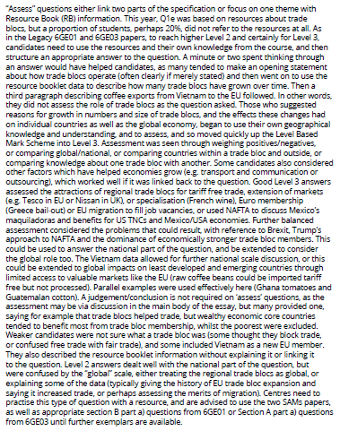
- Provide planning sheet and plan the four main paragraph sections. For each state the example you will use to exemplify your points.
- Read the exemplar student copy from the examiner’s report (page 5-6 2019 A Level).
- Improve theirs to achieve full marks.

