OASB Science Department
Physics Paper 2 Revision Pack (Foundation)

Contents | Lesson
Mastery Matrix Physics Paper 2
Knowledge | 1
Waves and Electromagnetic Waves Summary Page
Notes page
Exam Questions
Knowledge | 2
Forces and Stopping Distances Summary Page
Notes page
Exam Questions
Knowledge | 3
Speed and Velocity / Distance-Time and Velocity-Time Graphs Summary Page
Notes page
Exam Questions
Knowledge | 4
Falling Objects Summary Page
Notes page
Exam Questions
Knowledge | 5
Newton’s Laws Summary Page
Notes page
Exam Questions
Knowledge | 6
Magnets and The Motor Effect Summary Page
Notes page
Exam Questions

Mastery Matrix Physics paper 2
Topic | Tier | Revision guide (Combined) | Learning Statement
Waves | F | 182 | Describe what is meant by ‘a wave’
Waves | F | 182 | Describe the difference between longitudinal and transverse waves giving examples for both
Waves | F | 182 | Describe amplitude, wavelength (λ), wave speed (v), frequency (f) and period of a wave (T) and give units for each
Waves | F | 183 | Use and rearrange T = 1/f
Waves | F | 183 | Use and rearrange v = f λ
Waves | F | 182 | Identify amplitude and wavelength from diagrams of a wave
Waves | F | 183 | Describe the method to measure the speed of sound in air and the speed of ripples on the water surface
Waves | F | 183 | RP Waves: Make observations to identify the suitability of apparatus for measuring frequency, wavelength and speed of waves in a ripple tank and waves on a string or elastic cord.
Electromagnetic Waves | F | 184 | Describe what ‘electromagnetic waves’ are
Electromagnetic Waves | F | 186 | Recall the order of EM waves & recall their frequency and wavelength and give examples of the uses of these
Electromagnetic Waves | F | 186 | Explain how EM waves are generated and absorbed
Electromagnetic Waves | F | 187 | Explain the hazardous effects of UV, X-rays and Gamma rays
Electromagnetic Waves | F | 186 | RP Radiation and Absorption: investigate how the amount of infrared radiation absorbed or radiated by a surface depends on the nature of that surface
Stopping Distances | F | 168 | Define ‘stopping distance’, ‘thinking distance’ and ‘braking distance’
Stopping Distances | F | 168 | Recall typical values for reaction times (0.2-0.9 seconds)
Stopping Distances | F | 168 | Describe factors that effect a drivers reaction time
Stopping Distances | F | 168 | Explain methods used to measure human’s reaction times
Stopping Distances | F | 169 | Describe factors affecting ‘braking distance’
Stopping Distances | F | 169 | Predict how the distance for a vehicle to make an emergency stop varies over a range of speeds
Stopping Distances | F | 169 | Explain the energy transfers when a vehicle brakes
Stopping Distances | F | 169 | Link braking force, deceleration and stopping distances
Stopping Distances | F | 169 | Explain the dangers caused by large decelerations
Forces and Motion | F | 158 | Define scalar and vector quantities
Forces and Motion | F | 158 | Use arrows to represent vector quantities
Forces and Motion | F | 158 | Define contact and non-contact forces giving examples of each
Forces and Motion | F | 158 | Define weight and gravity
Forces and Motion | F | 159 | Use W=m x g
Forces and Motion | F | 158 | Describe what the centre of mass is
Forces and Motion | F | 159 | Explain how to measure weight using a calibrated spring balance (i.e. a Newton meter)
Forces and Motion | F | 159 | Calculate and define resultant forces
Forces and Motion | F | 159 | Use free body diagrams to show forces
Forces and Motion | F | 166 | Describe and explain Newton’s third law
Speed and velocity | F | 162 | Explain the difference between distance and displacement
Speed and velocity | F | 162 | Define ‘speed’ and explain factors that affect the speed a person walks, runs or cycles at (including average speeds for these activities)
Speed and velocity | F | 162 | Recall typical speeds for different types of transportation (TBC – bus, train, car, aeroplane!) using ̴ correctly.
Speed and velocity | F | 162 | Recall the speed of sound in air
Speed and velocity | F | 162 | State that most moving objects have varying speed including sound, wind, travelling people
Speed and velocity | F | 162 | Use and rearrange s = v t (speed = d/t equation!)
Speed and velocity | F | 162 | Calculate average speed for non-uniform motion
Speed and velocity | F | 162 | Define ‘velocity’
Distance time and velocity time graphs | F | 163 | Draw and interpret distance time graphs and use these to determine speed
Distance time and velocity time graphs | F | 164 | Use and rearrange the equation a = Δv / t (calculating acceleration)
Distance time and velocity time graphs | F | 164 | Estimate the magnitude of every day acceleration
Distance time and velocity time graphs | F | 164 | Draw and interpret velocity time graphs in order to calculate acceleration
Falling objects | F | 164 | Apply the equation v²-u²=2as (For moving and falling objects) [Newton’s equations of motion]
Falling objects | F | 166 | Recall the value for acceleration due to gravity (9.8m/s²)
Falling objects | F | 166 | Explain the acceleration of objects through fluids (terminal velocity) – making reference to parachutes travelling through air
Falling objects | F | 166 | Draw and interpret velocity time graphs for objects that reach terminal velocity
Newton’s Laws | F | 163 | Describe and explain Newton’s first law
Newton’s Laws | F | 165 | Describe and explain Newton’s second law using F = m a
Newton’s Laws | F | 164 | Estimate the forces involved in large accelerations for every day road transport using ̴ correctly.
Newton’s Laws | F | 165 | RP Acceleration: Investigate the effects of varying force on the acceleration of an object with a constant mass and the effects of varying the mass on the acceleration produced by a constant force
Stopping Distances | F | 166 | Describe and explain Newton’s third law
Stopping Distances | F | 168 | Define ‘stopping distance’, ‘thinking distance’ and ‘braking distance’
Stopping Distances | F | 168 | Recall typical values for reaction times (0.2-0.9 seconds)
Stopping Distances | F | 168 | Describe factors that effect a drivers reaction time
Stopping Distances | F | 168 | Explain methods used to measure human’s reaction times
Stopping Distances | F | 169 | Describe factors affecting ‘braking distance’
Stopping Distances | F | 169 | Predict how the distance for a vehicle to make an emergency stop varies over a range of speeds
Stopping Distances | F | 169 | Explain the energy transfers when a vehicle brakes
Stopping Distances | F | 169 | Link braking force, deceleration and stopping distances
Magnetism | F | 206 | Describe the polarity of magnets and list 4 magnetic materials
Magnetism | F | 206 | Explain the difference between a permanent and induced magnet
Magnetism | F | 206 | Describe the force between a magnet and a magnetic material
Magnetism | F | 206 | Describe the direction and strength of a magnetic field around a magnet
Magnetism | F | 206 | Explain how compasses work
Magnetism | F | 207 | Describe how to make an electromagnet and how to increase its strength

Lesson 1: Waves and Electromagnetic Waves
Topic: Waves (9.2.4)
What are the two types of waves? | Transverse and longitudinal
What type of wave is sound? | Longitudinal
What type of wave is visible light? | Transverse
How do the particles that make up a wave transfer energy? | They oscillate (vibrate)
What are the 4 properties of a wave? | Frequency, amplitude, wavelength, period
State the equation to calculate the period of a wave | T=1/f  Period (s) = 1/ frequency (Hz)
State the equation to calculate wave speed | v = f x λ  wave speed (m/s) = frequency (Hz) x wavelength (m)

Topic: Electromagnetic Waves (9.2.5)
What type of waves are electromagnetic waves? | Transverse
At what speed do all electromagnetic waves travel? | Speed of light (300,000,000m/s)
List the electromagnetic waves in order of frequency from lowest to highest | Radio waves, microwaves, infrared waves, visible light, ultraviolet, X-Rays, gamma rays
Which type of wave is the most ionising? | Gamma Rays
Which 3 rays can have hazardous effects on the human body? | UV, X-Ray and Gamma rays
Which wave is used in medical imaging? | X-Rays
Which wave is used in telecommunications? | Radio waves and microwaves

Physics Revision: Waves and Electromagnetic Waves
Mastery Matrix Points
Describe the difference between longitudinal and transverse waves giving examples for both
Use and rearrange T = 1/f
Use and rearrange v = f λ
Identify amplitude and wavelength from diagrams of a wave
Describe what ‘electromagnetic waves’ are
Recall the order of EM waves & recall their frequency and wavelength and give examples of the uses of these

Key Knowledge
Oscillation – another word for v___________.

Waves transfer e_____ from one place to another.

Longitudinal waves have r__________ and c__________ e.g. s____ waves. In longitudinal waves the oscillations are p________ to the direction of energy.

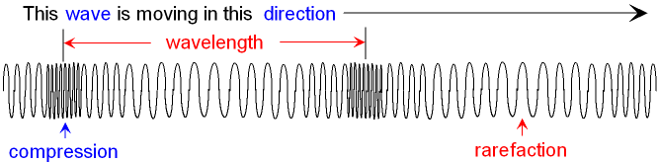

Transverse waves have oscillations that are at r____ a_____ to the direction of the energy e.g. electromagnetic waves.

Frequency = the number of w___ passing a fixed p___ per s___, measured in h___ (__)
Amplitude = the d______ of the particles from their original position, measured in m____ (__)
Wavelength = the d______ from one point on a wave to the s____ point on the n___ wave, measured in m_____ (__)
Period = the t___ takes to complete one o________, measured in s_______ (__)

wave speed (m/s) = ________ (Hz) × ________ (m)
v = f x λ

Electromagnetic (EM) waves are t________ waves.
The electromagnetic waves are arranged from long w____________ to short w________________.

Understanding and Explaining
- Explain the difference between longitudinal and transverse waves:
Longitudinal waves have oscillations that are p________ to the direction of the e______, whereas transverse waves have oscillations that are at r______ a______ to the direction of the e______.

- Complete the labels to show the amplitude and the wavelength:
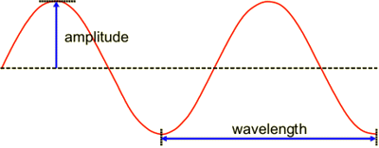
- A wave travels with a frequency of 100Hz and a wavelength of 2m. Calculate the wave speed.

- An object has a frequency of 2.0 Hz. Calculate its time period using the equation
period = 1 ÷ frequency

- Complete the table to show:
a) the order of the electromagnetic spectrum
b) one use of each wave
a) | Longest wavelength |  |  |  |  |  |  |  | Shortest wavelength
b) | Use

Notes

Guided Exam Questions:
Q1.Small water waves are created in a ripple tank by a wooden bar. The wooden bar vibrates up and down hitting the surface of the water.
The figure below shows a cross-section of the ripple tank and water.
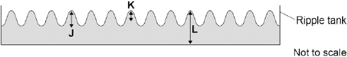
(a) Which letter shows the amplitude of a water wave?

Tick one box.
J
K
L

(1)
(b) The speed of the wooden bar is changed so that the bar hits the water fewer times each second.
What happens to the frequency of the waves produced?

Tick one box.
Increases
Does not change
Decreases

(1)
(c) Describe how the wavelength of the water waves in a ripple tank can be measured accurately.
.............................................................................................................................
.............................................................................................................................
.............................................................................................................................
(2)
(d) The speed of a wave is calculated using the following equation.
wave speed = frequency × wavelength
The water waves in a ripple tank have a wavelength of 1.2 cm and a frequency of 18.5 Hz.
How does the speed of these water waves compare to the typical speed of a person walking?
.............................................................................................................................
.............................................................................................................................
.............................................................................................................................
.............................................................................................................................
.............................................................................................................................
.............................................................................................................................
(4)
(Total 8 marks)
Q2.The figure below shows an incomplete electromagnetic spectrum.

 | A | microwaves | B | C | ultraviolet | D | gamma

(a) What name is given to the group of waves at the position labelled A in the figure above?

Tick one box.
infrared
radio
visible light
X-ray

(1)
(b) Electromagnetic waves have many practical uses.
Draw one line from each type of electromagnetic wave to its use.

 | Electromagnetic wave |  | Use
 |  |  | For fibre optic communications
 | Gamma rays
 |  |  | For communicating with a satellite
 | Microwaves
 |  |  | To see security markings
 | Ultraviolet
 |  |  | To sterilise surgical instruments

(3)

(c) Complete the sentence.
Use an answer from the box.

 | black body | ionising | nuclear

X-rays can be dangerous to people because X-rays are
.......................................... radiation.
(1)
(Total 5 marks)

Independent Exam Questions:
Q3.A lorry has an air horn. The air horn produces sound waves in the air.
(a) Use one word to complete the following sentence.
Sound waves cause air particles to ................................................................. .
(1)
(b) The air horn produces sound waves at a constant frequency of 420 Hz.
The wavelength of the sound waves is 0.80 m.
Calculate the speed of the sound waves.
.............................................................................................................................
.............................................................................................................................
.............................................................................................................................
Speed = .......................................................... m/s
(2)
(Total 3 marks)
Q4. (a) The diagram below shows six of the seven types of wave that make up the electromagnetic spectrum.

Gamma  rays |  | Ultraviolet | Visible  light | Infrared | Microwaves | Radio  waves

(i) What type of electromagnetic wave is missing from the diagram?
...................................................................................................................
(1)
(ii) Which of the following electromagnetic waves has the most energy?
Draw a ring around the correct answer.

 | gamma rays | radio waves | visible light

(1)
(iii) Which of the following electromagnetic waves is given out by a TV remote control?
Draw a ring around the correct answer.

 | infrared | microwaves | ultraviolet

(1)

(b) Draw a ring around the correct answer in the box to complete the sentence.

 | a slower speed than
Microwaves travel through a vacuum at | the same speed as | radio waves.
 | a faster speed than

(1)

(c) The diagram shows waves being produced on a rope.
The waves are not reflected by the wall.
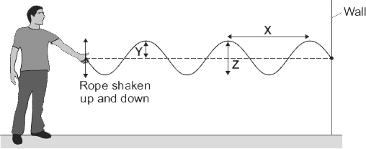
(i) Draw an arrow on the diagram to show the direction in which the waves transfer energy.
(1)

(ii) Which one of the arrows, labelled, X, Y or Z, shows the amplitude of a wave?

Write the correct answer in the box.

(1)

(iii) The waves produced on the rope are transverse.
Name one other type of transverse wave.
...................................................................................................................
(1)

(d) The rope is shaken up and down, producing 3 waves every second.The waves have a wavelength of 1.2 metres.
(i) State the frequency of the waves.
.............................. Hz
(1)
(ii) Calculate the speed of the waves.
Show clearly how you work out your answer.
...................................................................................................................
...................................................................................................................
Wave speed = .................................................. m/s
(2)
(Total 10 marks
Q5.Diagram 1 shows four of the seven types of wave in the electromagnetic spectrum.
 |  |  |  | Diagram 1
 | J | K | L | Visible  light | Infrared | Microwaves | Radio  waves

(a) The four types of electromagnetic wave named in Diagram 1 above are used for communication.
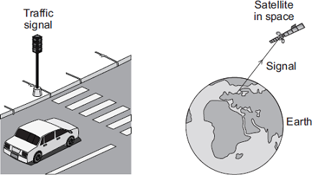
(i) Which type of electromagnetic wave is used when a traffic signal communicates with a car driver?
...............................................................................................................
(1)

(ii) Which type of electromagnetic wave is used to communicate with a satellite in space?
...............................................................................................................
(1)
(b) Gamma rays are part of the electromagnetic spectrum.
Which letter, J, K or L, shows the position of gamma rays in the electromagnetic spectrum?
Draw a ring around the correct answer.

 | J | K | L

(1)

(c) Diagram 2 shows an infrared wave.
Diagram 2
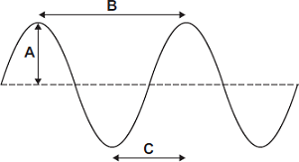
(i) Which one of the arrows, labelled A, B or C, shows the wavelength of the wave?

Write the correct answer, A, B or C, in the box.

(1)

(ii) Draw a ring around the correct answer to complete the sentence.

 |  | shorter than
 | The wavelength of infrared waves is | the same as | the wavelength of radio waves.
 |  | longer than

(1)

(d) Mobile phone networks send signals using microwaves. Some people think the energy a person’s head absorbs when using a mobile phone may be harmful to health.
(i) Scientists have compared the health of people who use mobile phones with the health of people who do not use mobile phones.
Which one of the following statements gives a reason why scientists have done this?
Tick () one box.

To find out if using a mobile phone is harmful to health.
To find out if mobile phones give out radiation.
To find out why some people are healthy.

(1)

(ii) The table gives the specific absorption rate (SAR) value for two different mobile phones.
The SAR value is a measure of the maximum energy a person’s head absorbs when a mobile phone is used.

 | Mobile Phone | SAR value in W/kg
 | X | 0.28
 | Y | 1.35

A parent buys mobile phone X for her daughter.
Using the information in the table, suggest why buying mobile phone X was the best choice.
...............................................................................................................
...............................................................................................................
...............................................................................................................
(2)
(Total 8 marks)

Lesson 2: Forces and Stopping Distances
 | Topic: | Forces (9.2.7)
1 | Scalar quantities have only _______ | magnitude (size)
2 | Vector quantities have ____ and ___ | magnitude and direction
3 | State 3 scalar quantities | Distance, speed, time
4 | State 3 vector quantities | Displacement, velocity, acceleration
5 | What is the equation for calculating weight? | Weight (N))= Mass (Kg) X Gravitational Field Strength (N/Kg)
6 | What is the name of the type of force that occurs when the objects are physically touching? | Contact forces e.g. tension, upthrust
7 | What is the name of the type of force that occurs when the objects are separated? | Non-contact e.g. magnetic, weight,

 | Topic: | Stopping Distances (11.3.1)
1 | Define "stopping distance" | Thinking distance + braking distance
2 | Define "thinking distance" | The distance travelled during the driver's reaction time
3 | Define "braking distance" | The distance travelled under the braking force
4 | What are the typical values for reaction time | 0.2-0.9 seconds
5 | State 4 factors that effect a driver's reaction time | Tiredness, alcohol, drugs, distractions
6 | State 3 factors that may effect braking distance | Adverse weather conditions (ice/snow/wet), worn tyres, worn brakes
7 | Describe the energy transfers that occur when a force is applied to a car's brakes | Kinetic energy of car -> thermal energy in the brakes

Physics Revision: Forces
Mastery Matrix Points
Define scalar and vector quantities and use arrows to represent vector quantities
Define contact and non-contact forces giving examples of each
Define weight and gravity and use W=m x g
Describe what the centre of mass is
Explain how to measure weight using a calibrated spring balance (i.e. a Newton meter)
Calculate and define resultant forces
Use free body diagrams to show forces

Key Knowledge
Scalar - quantities with a m___________ only.
Examples of scalar quantities:
- d__________
- s__________
- t__________
Vectors - quantities with a m________ and d________
Examples of vector quantities:
- v____________
- d____________
- a_____________
Vectors can be draw using an a_________

The l________ of the arrow represents the magnitude, and the d__________ of the arrow the direction of the vector quantity.

Contact forces are where the objects have to be physically t____________for the force to act.

Non-contact forces where the objects _________ have to be physically touching for the force to act.

The resultant force is the o_________ force acting on an object.

Weight is the downwards force due to g__________.
weight (N) = m_____ (___) x g__________________ (_____)
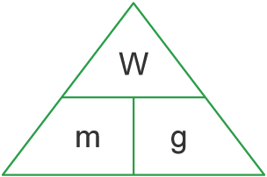
The gravitational field strength on Earth is _________

Centre of mass is the point at which all the mass of an object __________________________________.

Understanding and Explaining
1. Put these forces into the correct column: weight, upthrust, friction, magnetic force, air resistance
Contact forces | Non-contact forces
2. Complete the diagram using these labels to show the car accelerating. You need to add the forward arrow: normal contact force, weight, friction, force from the engine
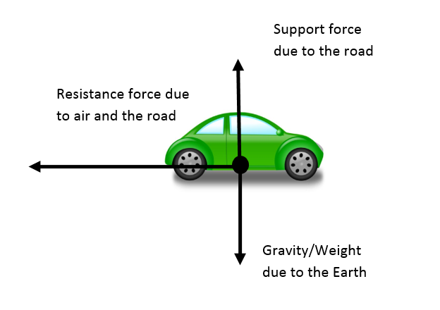
3. Calculate the resultant force for the moving object and choose from the words below to complete the sentence: accelerate, decelerate, left, right
The object would __________________ to the __________
4. The mass of a man is 72 kg. Calculate his weight on Earth:

Mastery Matrix Points
Define ‘stopping distance’, ‘thinking distance’ and ‘braking distance’
Recall typical values for reaction times (0.2-0.9 seconds)
Describe factors that effect a drivers reaction time
Explain methods used to measure human’s reaction times
Describe factors affecting ‘braking distance’
Predict how the distance for a vehicle to make an emergency stop varies over a range of speeds
Explain the energy transfers when a vehicle brakes

Physics Revision: Stopping Distances
Key Knowledge

Stopping distance = _________ distance + _________ distance

Thinking distance - the r_______ _______ of the driver

Thinking distance is affected by:
- a_____________
- t_____________
- d______
- d_____________

Typical reaction times are _______ - _________

Braking distance – the distance travelled while the b________f_______ is applied

Braking distance is affected by the:
- condition of the ________
- condition of the ________

The greater the s________ of a vehicle the greater the braking f_______ needed to stop the vehicle in a certain distance.

Energy transfer when the brakes are applied:

k____________ t____________

Large decelerations may lead to brakes o__________ and/or loss of control (s_____________)

Understanding and Explaining
- A driver sees a traffic light turn red and travels 2m before he puts his foot on the brake. It takes him another 5m before he stops. Calculate the stopping distance.

- Describe a method you would use to calculate the reaction time of a person.

- Describe what effect icy roads will have on braking distance and explain why.
Icy roads will increase/decrease stopping distance. This is because there is more/less friction between the tyres and the road.

- Give two risks of braking suddenly at a high speed.

Notes

Guided Exam Question
Q6.(a) The diagrams, A, B and C, show the horizontal forces acting on a moving car.
Draw a line to link each diagram to the description of the car's motion at the moment when the forces act.
Draw only three lines.

stationary
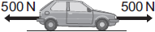
A
constant speed
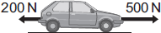
B
slowing down
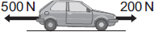
C
accelerating forwards

(3)

(b) The front crumple zone of a car is tested at a road traffic laboratory. This is done by using a remote control device to drive the car into a strong barrier. Electronic sensors are attached to a dummy inside the car.
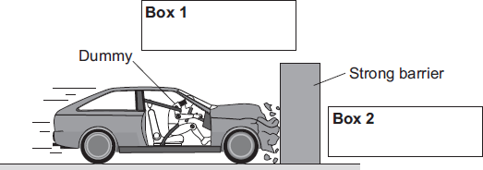
(i) Draw an arrow in Box 1 to show the direction of the force that the car exerts on the barrier.
(1)

(ii) Draw an arrow in Box 2 to show the direction of the force that the barrier exerts on the car.
(1)

(iii) Complete the following by drawing a ring around the correct line in the box.
The car exerts a force of 5000 N on the barrier. The barrier does not move. The force

 |  | more than
 | exerted by the barrier on the car will be | equal to | 5000 N.
 |  | less than

(1)
(iv) Which one of the following gives the most likely reason for attaching electronic sensors to the dummy?
Put a tick () in the box next to your answer.

To measure the speed of the car just before the impact.
To measure the forces exerted on the dummy during the impact.
To measure the distance the car travels during the impact.

(1)
(Total 7 marks)
Q7.The diagram shows how the thinking distance and braking distance of a car add together to give the stopping distance of the car.
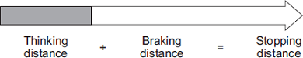
(a) Use words from the box to complete the sentence.

 | distance | energy | force | time

The stopping distance is found by adding the distance the car travels during the
driver’s reaction ........................................ and the distance the car travels under the
braking ........................................ .
(2)

(b) Which one of the following would not increase the thinking distance?
Tick () one box.

The car driver being tired.
The car tyres being badly worn.
The car being driven faster.

(1)

(c) The graph shows how the braking distance of a car changes with the speed of the car.
The force applied to the car brakes does not change.
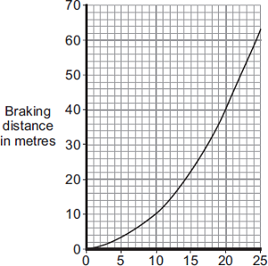
Speed in metres/second
(i) What conclusion about braking distance can be made from the graph?
...............................................................................................................
...............................................................................................................
...............................................................................................................
...............................................................................................................
(2)

(ii) The graph is for a car driven on a dry road.
Draw a line on the graph to show what is likely to happen to the braking distance at different speeds if the same car was driven on an icy road. (1)

(d) A local council has reduced the speed limit from 30 miles per hour to 20 miles per hour on a few roads. The reason for reducing the speed limit was to reduce the number of accidents.
(i) A local newspaper reported that a councillor said:
“It will be much safer because drivers can react much faster when driving at 20 miles per hour than when driving at 30 miles per hour.”
This statement is wrong. Why?
...............................................................................................................
...............................................................................................................(1)

(ii) The local council must decide whether to introduce the lower speed limit on a lot more roads.
What evidence should the local council collect to help make this decision?
...............................................................................................................
...............................................................................................................
...............................................................................................................
...............................................................................................................(2) (Total 9 marks)

Independent Exam Question:
Q8. (a) The total stopping distance of a car has two parts. One part is the distance the car travels during the driver’s reaction time. This distance is often called the ‘thinking distance’.
What distance is added to the ‘thinking distance’ to give the total stopping distance?
........................................................................................................................
........................................................................................................................
(1)

(b) The graph shows the relationship between the speed of a car and the thinking distance.
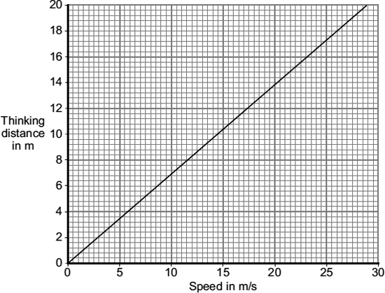
Describe the relationship between speed and thinking distance.
........................................................................................................................
........................................................................................................................
(2)

(c) The diagram shows two students investigating reaction time.
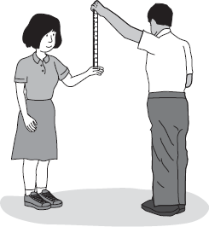
One student holds a 30 cm ruler, then lets go. As soon as the second student sees the ruler fall, she closes her hand, stopping the ruler. The further the ruler falls before being stopped, the slower her reaction time.

(i) One student always holds the ruler the same distance above the other student’s hand.
In this experiment, what type of variable is this?
Put a tick () in the box next to your answer.

Put a tick () in the box next to your answer.

independent variable
dependent variable
control variable

(1)

(ii) Describe how this experiment could be used to find out whether listening to music affects reaction time.
...............................................................................................................
...............................................................................................................
...............................................................................................................
...............................................................................................................
(2)

(d) The following information is written on the label of some cough medicine.

WARNING: Causes drowsiness.
Do not drive or operate machinery.

How is feeling drowsy (sleepy) likely to affect a driver’s reaction time?
........................................................................................................................
........................................................................................................................
(1)

(e) Three cars, X, Y and Z , are being driven along a straight road towards a set of traffic lights.
The graphs show how the velocity of each car changes once the driver sees that the traffic light has turned to red.
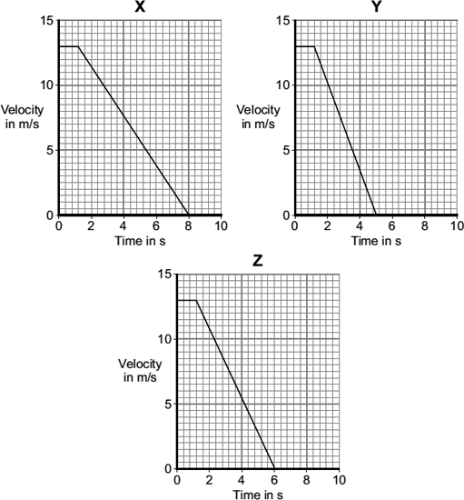
Which one of the cars, X, Y or Z , stops in the shortest distance?
......................................
(1)
(Total 8 marks)
Q9. (a) The diagram shows a rectangle made out of a sheet of cardboard.
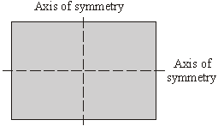
Draw an X on the diagram so that the centre of the X is at the centre of mass of the rectangle.
(1)

(b) The drawing shows a car tyre.
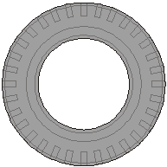
(i) Where is the centre of mass of the tyre?
...................................................................................................................
(1)
(ii) Explain your answer to (b)(i).
...................................................................................................................
...................................................................................................................
(1)
(Total 3 marks)
Q5 10.(a) The diagram shows two forces acting on an object.
What is the resultant force acting on the object?
Tick ( ) one box.
8 N to the right
8 N to the left
4 N to the right
4 N to the left

(1)

(b) BASE jumpers jump from very high buildings and mountains for sport.
The diagram shows the forces acting on a BASE jumper in flight.
The BASE jumper is wearing a wingsuit.
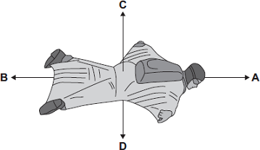
(i) Draw a ring around the correct answer in the box to complete each sentence.

 |  | smaller than
 | The BASE jumper accelerates forwards when force A is | equal to | force B.
 |  | bigger than

 |  | smaller than
 | The BASE jumper falls with a constant speed when force C is | equal to | force D.
 |  | bigger than

(2)

(ii) To land safely the BASE jumper opens a parachute.
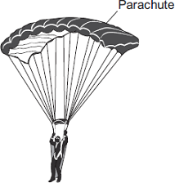
What effect does opening the parachute have on the speed of the falling BASE jumper?
...............................................................................................................
Give a reason for your answer.
...............................................................................................................
...............................................................................................................
(2)
(Total 5 marks)
Lesson 3: Speed and Velocity / Distance-Time and Velocity-Time Graphs

 | Topic: | Speed and Velocity (9.2.8)
1 | What is the difference between distance and displacement? | Distance = scalar, displacement = vector
2 | Define "speed" | Distance covered in a given time
3 | What is the equation linking displacement, velocity and time? | displacement = velocity x time  s (m) = v (m/s) x t (s)
4 | State three factors that may affect the speed a person walks | Age, terrain, fitness
5 | State the typical speed for a person walking | 1.5m/s
6 | State the typical speed for a person running | 3m/s
7 | State the typical speed for a person cycling | 6m/s
 | Topic: | Distance and Velocity-Time Graphs (9.2.9)
1 | Describe what is meant by a flat horizontal line (───) on a distance-time graph? | The object is stationary
2 | Describe what is meant by a straight diagonal line (/) away from the x-axis on a distance-time graph? | Object is moving at a constant speed AWAY from start
3 | Describe what is meant by a straight diagonal line (\) towards the x-axis on a distance-time graph? | Object is moving at a constant speed back TOWARDS the start
4 | How do you calculate the speed of an object using a distance-time graph if the speed is constant? | Calculate gradient (ΔY/ΔX)
5 | What does a steeper line on a distance-time graph represent? | An object moving faster
6 | Describe what is meant by a flat horizontal line (───) on a velocty-time graph? | The object is moving at a constant velocity
7 | Describe what is meant by a straight diagonal line (/) away from the x-axis on a velocity-time graph? | Object is accelerating

Physics Revision: Speed and Velocity
Mastery Matrix Points
Explain the difference between distance and displacement
Define ‘speed’ and explain factors that affect the speed a person walks, runs or cycles at (including average speeds for these activities)
Recall typical speeds for different types of transportation (TBC – bus, train, car, aeroplane!) using ̴ correctly.
Recall the speed of sound in air
State that most moving objects have varying speed including sound, wind, travelling people
Use and rearrange s = v t (speed = d/t equation)
Calculate average speed for non-uniform motion
Define ‘velocity’

Key Knowledge

Distance is how f___ an object moves. It is a s________ quantity.

Displacement is the d________ an object moves and the d_______________. It is a v______ quantity.

Displacement is measured by drawing a s________ l_____ from start to finish.

Speed is how quickly something moves. It is a s_______ quantity.

speed (m/s) = d_________ (__) ÷ t______ (__)
v s t

Typical speeds for:
- walking ̴ ________
- running ̴ ________
- cycling ̴ ________
- sound ̴ _________

The speed a person can move depends on:
- a__________
- t__________
- f__________
- d______________________________

The velocity of an object is its s______ in a given d______________. Velocity is a ________ quantity.

- Explain the difference between distance and displacement:
Distance is ______________________________________________________________________,
whereas displacement is ____________________________________________________________.

- Calculate the displacement from A to B:
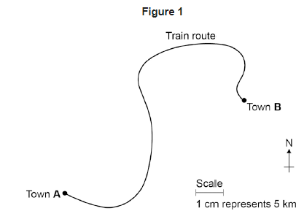
- a) A car travels 50m in 5 seconds. Calculate its speed.

b) A car travels 300m in 1 minute. Calculate its speed.

c) A car travels at 10m/s for 20s. Calculate the distance it travels.

Physics Revision: DT and VT Graphs
Mastery Matrix Points
Draw and interpret distance time graphs and use these to determine speed
Use and rearrange the equation a = Δv / t (calculating acceleration)
Estimate the magnitude of every day acceleration
Draw and interpret velocity time graphs in order to calculate acceleration

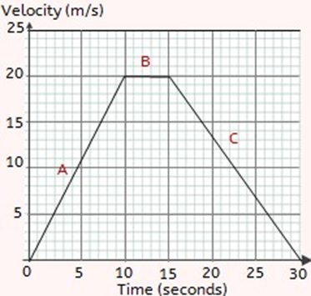
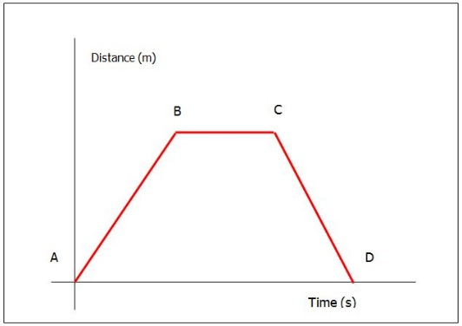
- Describe the journey of the object from each point on the graph:
From A – B the object is _____________________________
From B – C the object is ______________________________
Challenge: From C – D the object is ______________________
______________________________

- Describe the journey of the object from each point on the graph:
At A the object is ________________________
At B the object is _____________________________________
At C the object is ___________________________

- A car accelerates in 5s from 25m/s to 35m/s. Calculate its acceleration.

- Calculate the acceleration of the object in question 2 between points A and B. Show your working out on the graph.

Key Knowledge

Distance time graph:
a) stationary b) constant speed

c) accelerating d) decelerating

Velocity or speed time graph:
a) stationary b) constant speed

c) accelerating d) decelerating

Acceleration is the c_______ in v_______ over t____

Acceleration (m/s²)= ______________ (____) ÷ _____ (___)

a = Δv / t

Notes

Guided Exam Question
Q11. A high-speed train accelerates at a constant rate in a straight line.
The velocity of the train increases from 30 m/s to 42 m/s in 60 seconds.
(a) (i) Calculate the change in the velocity of the train.
...............................................................................................................
Change in velocity = .............................. m/s
(1)

(ii) Use the equation in the box to calculate the acceleration of the train.
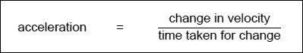
Show clearly how you work out your answer and give the unit.
Choose the unit from the list below.

m/s | m/s² | N/kg | Nm

...............................................................................................................
...............................................................................................................
Acceleration = ..................................................
(2)

(b) Which one of the graphs, A, B or C, shows how the velocity of the train changes as it accelerates?
Write your answer, A, B or C, in the box.

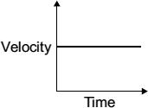  A | 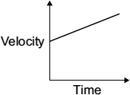  B | 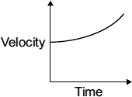  C

Graph

(1)
(Total 4 marks)
Q12. Part of a bus route is along a high street.
The distance – time graph shows how far the bus travelled along the high street and how long it took.
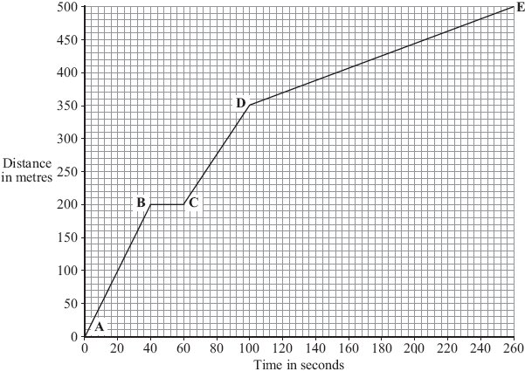

(a) The bus travels the slowest between points D and E.
How can you tell this from the graph?
.............................................................................................................................
.............................................................................................................................
(1)

(b) Between which two points was the bus travelling the fastest?
Put a tick () in the box next to your answer.

Points
A – B
B – C
C – D

(1)

(c) There is a bus stop in the high street.
This is marked as point B on the graph.
(i) What is the distance between point A on the graph and the bus stop?
Distance .............................. metres
(1)

(ii) How long did the bus stop at the bus stop?
Show clearly how you work out your answer.
...................................................................................................................
Time = .............................. seconds
(2)

(d) A cyclist made the same journey along the high street.
The cyclist started at the same time as the bus and completed the journey in 200 seconds. The cyclist travelled the whole distance at a constant speed.
(i) Draw a line on the graph to show the cyclist’s journey.
(2)
(ii) After how many seconds did the cyclist overtake the bus?
The cyclist overtook the bus after .............................. seconds.
(1)
(Total 8 marks)

Q13. A car and a bicycle are travelling along a straight road. They have stopped at road works.
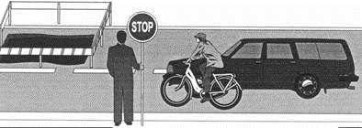

The graph shows how the velocity of the car changes after the sign is changed to GO.
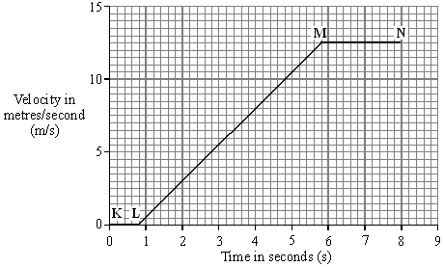

(a) Between which two points on the graph is the car moving at constant velocity?
.............................................................................................................................
(1)

(b) Between which two points on the graph is the car accelerating?
.............................................................................................................................
(1)

(c) Between the sign changing to GO and the car starting to move, there is a time delay. This is called the reaction time.
(i) What is the reaction time of the car driver?
Reaction time = ................................. seconds
(1)

(ii) Which one of the following could increase the reaction time of a car driver? Tick the box next to your choice.
Drinking alcohol
Wet roads
Worn car brakes
(1)
(d) The cyclist starts to move at the same time as the car. For the first 2 seconds the cyclist’s acceleration is constant and is greater than that of the car.
Draw a line on the graph to show how the velocity of the cyclist might change during the first 2 seconds of its motion.
(2)
(Total 6 marks)
Independent Exam Practice
Q14. The graph shows the distance a person walked on a short journey.
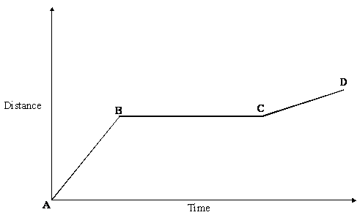

(a) Choose from the phrases listed to complete the statements which follow. You may use each statement once, more than once or not at all.
standing still
walking at constant speed
walking with an increasing speed
walking with a decreasing speed

(i) Between points A and B the person is
...................................................................................................................
(1)
(ii) Between points B and C the person is
...................................................................................................................
(1)
(b) Complete the sentence.
You can tell that the speed of the person between points A and B is ................
than the speed between points C and D because ..............................................
.............................................................................................................................
(2)

(c) Write the equation which relates distance, speed and time.
.............................................................................................................................
(1)
(Total 5 marks)

Q15. A horse and rider take part in a long distance race. The graph shows how far the horse and rider travel during the race.
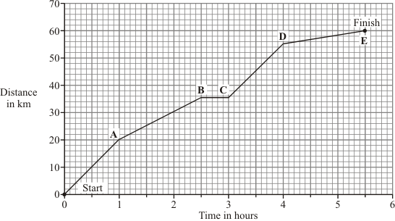

(a) What was the distance of the race?
distance = .................................................................. km
(1)

(b) How long did it take the horse and rider to complete the race?
.............................................................................................................................
(1)

(c) What distance did the horse and rider travel in the first 2 hours of the race?
distance = .................................................................. km
(1)

(d) How long did the horse and rider stop and rest during the race?
.............................................................................................................................
(1)

(e) Not counting the time it was resting, between which two points was the horse moving the slowest?
................................. and ..................................
Give a reason for your answer.
.............................................................................................................................
.............................................................................................................................
(2)
(Total 6 marks)

Lesson 4: Falling Objects
Falling Objects (9.2.10)
What is the acceleration of an object free falling due to gravity close to the Earth? | 9.8m/s2
What are the two forces acting upon a falling object? | Weight and air resistance
Describe the motion of an object as it begins to fall through a fluid | It accelerates (weight is bigger than air resistance)
What is the term that’s given to describe the motion of an object when it's weight and the air resistance acting upon it are equal? | Terminal velocity
Describe what happens to the forces acting upon a parachuter when they open their parachute | Air resistance ↑, weight stays constant
Uniform acceleration means… | The rate of acceleration is constant
Uniform acceleration can be calculated using the equation | (Final velocity) ² – (initial velocity) ² = 2 x acceleration x distance  [V² - u² = 2 a s]

Physics Revision: Falling Objects
Mastery Matrix Points
Apply the equation v2-u2=2as (For moving and falling objects) [Newton’s equations of motion]
Recall the value for acceleration due to gravity
Explain the acceleration of objects through fluids (terminal velocity) – making reference to parachutes travelling through air
Draw and interpret velocity time graphs for objects that reach terminal velocity

Key Knowledge

Uniform acceleration can be calculated using:

(__________) ² – (__________) ² = 2 × a__________ × d_______

v² − u² = 2 a s

- f_____ velocity, v, in metres per second, m/s
- i______ velocity, u, in metres per second, m/s
- a______________, a, in metres per second squared, m/s²
- d__________, s, in metres, m

Acceleration of a falling object towards earth due to gravity = _____ m/s²

The journey of a falling object:

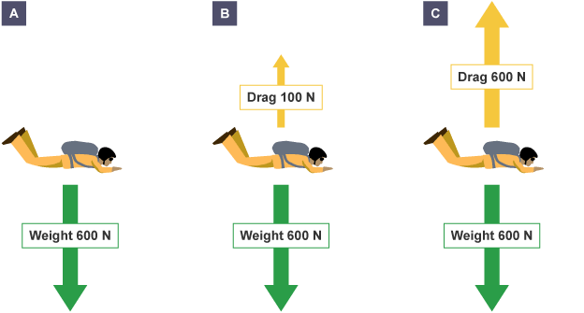

A + B. The object will a_______________

C. The object reaches a constant velocity = t________ velocity

Understanding and Explaining
- An object accelerates from 2m/s to 6m/s over a distance of 8m. Use the equation v2 − u2 = 2as to find the acceleration of the object (Hint: you need to rearrange the equation to find a!).
v = 6m/s
u = 2m/s
a = ?
s = 8m

- An object accelerates from 3m/s to 7m/s at an acceleration of 4m/s2. Use the equation v2 − u2 = 2as to find the distance travelled by the object. (Hint: you need to rearrange the equation to find s!)
v = 7m/s
u = 3m/s
a = 4m/s2
s = ?

3. Describe what happens to the motion of a sky diver when they fall out of a plane.
Initially, the sky diver ____________________________
Then, the sky diver will eventually _______________________________________________

4. Describe what happens to the motion of a metal ball falling through water.
Initially, the ball will _____________________
Then, the ball will eventually __________________________________________________

Notes

Guided exam questions
Q16.On 14 October 2012, a skydiver set a world record for the highest free fall from an aircraft.
After falling from the aircraft, he reached a maximum steady velocity of 373 m / s after 632 seconds.
(a) Draw a ring around the correct answer to complete the sentence.

 | This maximum steady velocity is called the | frictional  initial  terminal | velocity.

(1)

(b) The skydiver wore a chest pack containing monitoring and tracking equipment.
The weight of the chest pack was 54 N.
The gravitational field strength is 10 N / kg.
Calculate the mass of the chest pack.
.........................................................................................................................
.........................................................................................................................
Mass of chest pack = ........................................ kg
(2)

(c) During his fall, the skydiver’s acceleration was not uniform.
Immediately after leaving the aircraft, the skydiver’s acceleration was 10 m / s².
(i) Without any calculation, estimate his acceleration a few seconds after leaving the aircraft.
Explain your value of acceleration in terms of forces.
Estimate ................................................................................................
Explanation ............................................................................................
................................................................................................................
................................................................................................................
................................................................................................................
................................................................................................................
................................................................................................................
(3)

(ii) Without any calculation, estimate his acceleration 632 seconds after leaving the aircraft.
Explain your value of acceleration in terms of forces.
Estimate ................................................................................................
Explanation ............................................................................................
................................................................................................................
................................................................................................................
................................................................................................................
................................................................................................................
................................................................................................................
(3)
(Total 9 marks)
Q17. The diagram shows a sky-diver in free fall. Two forces, X and Y, act on the sky-diver.
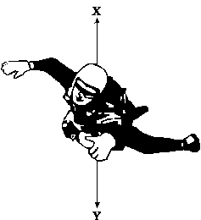
(a) Complete these sentences by crossing out the two lines in each box that are wrong.
(i) Force X is caused by 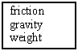 .
(1)

(ii) Force Y is caused by 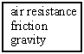 .
(1)

(b) The size of force X changes as the sky-diver falls. Describe the motion of the sky-diver when:
(i) force X is smaller than force Y,
...................................................................................................................
...................................................................................................................
(2)

(ii) force X is equal to force Y.
...................................................................................................................
...................................................................................................................
(1)
(Total 5 marks)
Independent Exam Questions:
Q18. A small object falls out of a balloon.
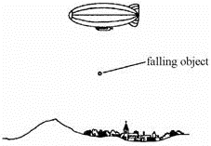
Choose words from the list to complete the sentences below.
friction gravity air pressure
accelerates falls at a steady speed slows down
• The weight of an object is the force of ............................................ which acts on it.
• When you drop something, first of all it ............................................... .
• The faster it falls, the bigger the force of ........................................... which acts on it.
• Eventually the object ............................................. .
(Total 4 marks)

Q19.A student investigated how the speed of a ball bearing changes as the ball bearing falls through a tube of oil.
Figure 1 shows the equipment the student used.
Figure 1
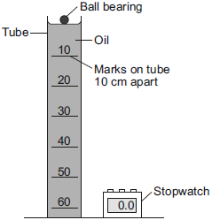

The student measured the time taken for the ball bearing to fall different distances.
Each distance was measured from the top of the oil.
(a) What is likely to have been the main source of error in this investigation?
.............................................................................................................................
.............................................................................................................................
(1)

(b) Figure 2 shows the student’s results plotted as a graph.
Figure 2
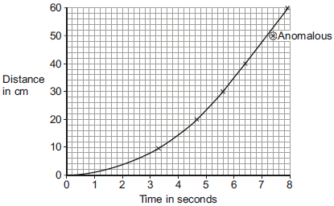

(i) The student has identified one of the results as being anomalous.
Use the correct answer from the box to complete the sentence.

 | after | as | before

The anomalous result was caused by the stopwatch being started
..................... the ball bearing was released.
(1)

(ii) What can you conclude from the graph about the speed of the ball bearing during the first four seconds?
...................................................................................................................
...................................................................................................................
(1)

(iii) The graph shows that the ball bearing reached its terminal velocity.
Describe how the graph would be used to calculate the terminal velocity of the ball bearing.
...................................................................................................................
...................................................................................................................
(1)

(iv) The directions of the two forces acting on the ball bearing as it falls through the oil are shown in Figure 3.
Figure 3
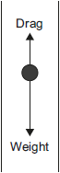
Explain, in terms of the forces shown in Figure 3, why the ball bearing reaches its terminal velocity.
...................................................................................................................
...................................................................................................................
...................................................................................................................
...................................................................................................................
(2)

(c) The student repeated the investigation using warmer oil.
Figure 4 shows the set of results using the warmer oil and the set of results using the cooler oil.
Figure 4
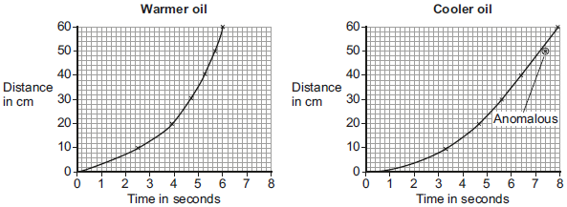
Compare the two graphs in Figure 4.
Use the correct answer from the box to complete the sentence.

 | less than | equal to | greater than

After falling 40 cm, the drag force on the ball bearing in the warmer oil is
..................... the drag force on the ball bearing in the cooler oil.
Explain the reason for your answer.
.............................................................................................................................
.............................................................................................................................
.............................................................................................................................
.............................................................................................................................
(3)
(Total 9 marks)
Lesson 5: Newton’s Laws
Newton’s Laws (9.2.11)
Which of Newton's laws states that an object will remain in the same state of motion unless acted on by an external force | First
According to Newton's First Law, what will affect an object's velocity? | A resultant force
What will happen to a stationary object if the resultant force remains 0? | It will stay stationary
What will happen to an object moving at a constant speed if the resultant force remains 0? | Stay at a constant speed
Which of Newton's laws states that the acceleration of an object is proportional to the resultant force acting on the object and inversely proportional to the mass of the object. | Second
What is the equation that represents Newton's Second Law? | Force (N) = mass (kg) x acceleration (m/s²)
Newton's Third Law states that whenever two objects interact the forces they exert on each other are __________ and __________________. | equal and opposite

Physics Revision: Newton’s Laws
Mastery Matrix Points
Describe and explain Newton’s first law
Describe and explain Newton’s second law using F = m a
Estimate the forces involved in large accelerations for every day road transport using ̴ correctly.
RP Acceleration: Investigate the effects of varying force on the acceleration of an object with a constant mass and the effects of varying the mass on the acceleration produced by a constant force

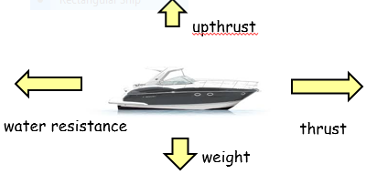
Key Knowledge

Newton’s First Law:
An object will remain in the s_____ state of m______ unless acted on by an external f__________.
This means that if the resultant force is zero:
- a stationary object will stay s________________
- a moving object will keep moving at a c________ v_______

Newton’s Second Law:
‘The a_____________ of an object is p____________ to the resultant force acting on the object and i_________ p__________ to the mass of the object.’

Force (N) = m_____ (__) x A_____________ (_____)

F = ma

Newton’s Third Law:

‘Whenever two objects interact, the forces they exert on each other are e______ and o_______________.’

Understanding and Explaining
- A car is travelling at a steady velocity of 5m/s to the right. Explain what happens to the car when the thrust of the engine increases.
ANS: The car will start to ________ to the ______. This is
because the force of the thrust acting to the right has
increased which means that the resultant force is no
longer ______N.
- A car is travelling at a steady velocity of 7m/s to the right. Explain what happens to the car when the friction increases.
ANS: The car will start to ___________. This is because
the force of the friction acting to the left has increased
which means that the resultant force is no longer ____N.

- A boat is travelling at a constant speed. Explain why using what you know about Newton’s First Law of Motion.
ANS: The boat is travelling at a ________ speed because all of
the forces acting on the boat are ________ which means that the
resultant force is ___N and the boat will remain in the same state
of motion.

- A car accelerates at a rate of 5m/s2. If it weighs 500kg how much driving force is the engine applying?

- A force of 1000N is applied to push a mass of 500kg. How quickly does it accelerate?

- A force of 3000N acts on a car to make it accelerate by 1.5m/s2. How heavy is the car?

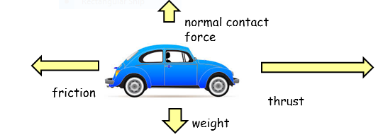

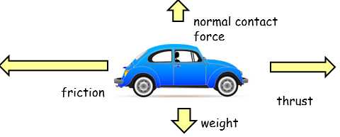

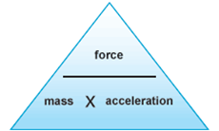

Notes

Guided exam questions
20 (a) Figure 1 shows the distance–time graph for a person walking to a bus stop.
Figure 1
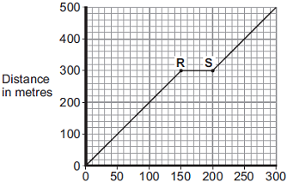
Time in seconds
(i) Which one of the following statements describes the motion of the person between points R and S on the graph?
Tick (✓) one box.
Not moving
Moving at constant speed
Moving with increasing speed

(1)
(ii) Another person, walking at constant speed, travels the same distance to the bus stop in 200 seconds.
Complete Figure 2 to show a distance–time graph for this person.
Figure 2
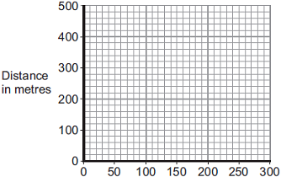
Time in seconds
(1)
(b) A bus accelerates away from the bus stop at 2.5 m/s².
The total mass of the bus and passengers is 14 000 kg.
Calculate the resultant force needed to accelerate the bus and passengers.
........................................................................................................................
........................................................................................................................
........................................................................................................................
Resultant force = ........................................ N
(2)
(Total 4 marks)

Q21. The diagram shows the horizontal forces acting on a car travelling along a straight road.
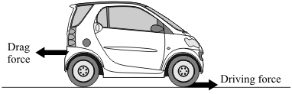
(a) Complete the following sentences by drawing a ring around the correct word in each box.

 | (i) When the driving force equals the drag force, the speed ofthe car is | decreasing  constant  increasing

(1)

 | (ii) Putting the brakes on transforms the car’s kinetic energy mainly into | heat  light  sound

(1)

(b) The charts, A, B and C give the thinking distance and the braking distance for a car driven under different conditions.
(i) Draw straight lines to match each chart to the correct conditions.
Draw only three lines.
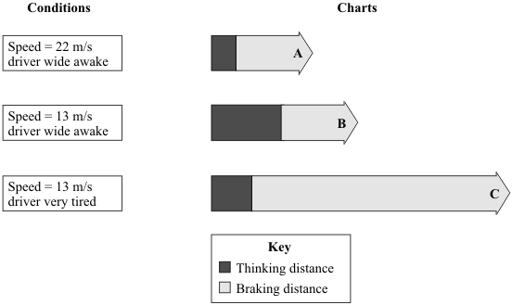
(2)
(ii) The three charts above all apply to dry road conditions.
How would the braking distances be different if the road were wet?
...................................................................................................................
(1)
(Total 5 marks)
Q22. The diagram shows the forces on a small, radio-controlled, flying toy.
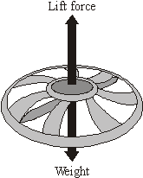
(a) (i) The mass of the toy is 0.06 kg.
Gravitational field strength = 10 N/kg
Calculate the weight of the toy.
Show clearly how you work out your answer and give the unit.
...................................................................................................................
...................................................................................................................
Weight = .................................................
(3)
(ii) Complete the following sentence by drawing a ring around the correct line in the box.
When the toy is hovering stationary in mid-air, the lift force is
bigger than  the same as  smaller than | the weight of the toy.

(1)

(b) When the motor inside the toy is switched off, the toy starts to accelerate downwards.
(i) What does the word accelerate mean?
...................................................................................................................
(1)
(ii) What is the direction of the resultant force on the falling toy?
...................................................................................................................
(1)

(Total 6 marks)
Independent Exam Practice
Q23.The diagram shows a boat pulling a water skier.
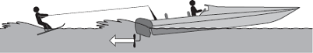
(a) The arrow represents the force on the water produced by the engine propeller.
This force causes the boat to move.
Explain why.
........................................................................................................................
........................................................................................................................
........................................................................................................................
........................................................................................................................
(2)

(b) The boat accelerates at a constant rate in a straight line. This causes the velocity of the water skier to increase from 4.0 m/s to 16.0 m/s in 8.0 seconds.
(i) Calculate the acceleration of the water skier and give the unit.
...............................................................................................................
...............................................................................................................
...............................................................................................................
Acceleration = ..................................................
(3)

(ii) The water skier has a mass of 68 kg.
Calculate the resultant force acting on the water skier while accelerating.
...............................................................................................................
...............................................................................................................
...............................................................................................................
Resultant force = .................................................. N
(2)
(iii) Draw a ring around the correct answer to complete the sentence.
The force from the boat pulling the water skier forwards

 |  | less than
 | will be | the same as | the answer to part (b)(ii).
 |  | greater than

Give the reason for your answer.
...............................................................................................................
...............................................................................................................
(2)
(Total 9 marks)

Q24.
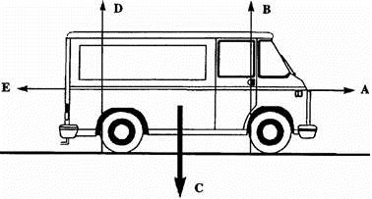
Five forces, A, B, C, D and E act on the van.

(a) Complete the following sentences by choosing the correct forces from A to E.
Force ................ is the forward force from the engine.
Force ................ is the force resisting the van’s motion.
(1)

(b) The size of forces A and E can change.
Complete the table to show how big force A is compared to force E for each motion of the van.
Do this by placing a tick in the correct box.
The first one has been done for you.

 | MOTION OF VAN | FORCE A SMALLER  THAN FORCE E | FORCE A EQUAL  TO FORCE E | FORCE A BIGGER  THAN FORCE E
 | Not moving
 | Speeding up
 | Constant speed
 | Slowing down

(3)

(c) When is force E zero?
.............................................................................................................................
(1)

(d) The van has a fault and leaks one drop of oil every second.
The diagram below shows the oil drops left on the road as the van moves from W to Z.
Describe the motion of the van as it moves from:
W to X .................................................................................................................
X to Y ..................................................................................................................
Y to Z ..................................................................................................................
(3)

(e) The driver and passengers wear seatbelts.
Seatbelts reduce the risk of injury if the van stops suddenly.
backwards downwards force forwards mass weight
Complete the following sentences, using words from the list above, to explain why the risk of injury is reduced if the van stops suddenly.
A large ........................................ is needed to stop the van suddenly.
The driver and passengers would continue to move ........................................ .
The seatbelts supply a ........................................ force to keep the driver and passengers
in their seats.
(3)
(Total 11 marks)

Lesson 6: Magnetism and The motor Effect
Magnetism (10.2.5)
Define "poles" on a magnet | The place where the magnetic force is the strongest
What do two magnets next to each other do? | Exert a force on each other
What is the effect of two like poles on each other? (e.g. N-N) | Repel
What is the effect of two different poles on each other? (e.g. N-S) | Attract
Define "permanent" magnet | Produces it's own magnetic field
Define "induced" magnet | A material that becomes a magnet when placed in a magnetic field
Name 4 magnetic materials | Iron, steel, cobalt, nickel
The Motor Effect (10.2.6)
What happens when a current flows through a wire? | A magnetic field is produced around wire
State two factors that effect the strength of the magnetic field around a wire | Current & distance from the wire
How do you determine the direction of the magnetic field around a wire? | Flemmings right hand rule (thumb = current direction, fingers = magnetic field direction)
What is a solenoid? | A coil of wire
How can you increase the strength of a solenoid? | Increase current, increase number of coils, add iron core
Define an "electromagnet" | A solenoid (coil of wire) with an iron core

Physics Revision: Magnetism and The Motor Effect
Mastery Matrix Points
Describe the polarity of magnets and list 4 magnetic materials
Explain the difference between a permanent and induced magnet
Describe the force between a magnet and a magnetic material
Describe the direction and strength of a magnetic field around a magnet
Explain how compasses work
Describe how to make an electromagnet and how to increase its strength

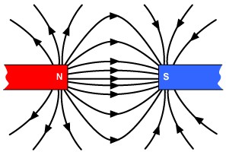
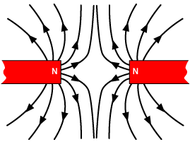
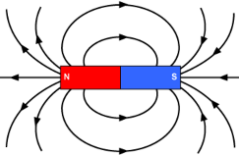
Understanding and Explaining
- What will happen to opposite poles of a magnet?

- What will happen to like poles?

- What is created around a magnet?

- Which type of magnet will always produce its own magnetic field?

- Which type of magnet will only behave like a magnet when it is placed inside a magnetic field?

- Where is the magnetic force strongest?

- Draw the magnetic field around these magnets for a and b:

a) b)

- Explain how a compass works.
Compasses contain a ___________ called a needle, which points in the direction of the Earth’s _____________________.

Key Knowledge
A magnet is a material which produces a m________ f_______

A magnetic field is the invisible area around the magnetic where the m__________ f________ acts.

A permanent magnet produces _________________________________

An induced magnet is a material that becomes a magnet when ____________
__________________________________________________________

The 4 magnetic materials are:
- i______
- s_______
- c_______
- n_________

The magnetic field is strongest at the p__________ of the magnet.

Two of the same poles will _________:

Two opposite poles will r________:

An electromagnet is an iron c______ with a wire c_________ around it with a c___________ flowing through. An electromagnet can increase its strength by:
- increasing the number of c_______
- increases the c_________
- adding an i_______ c______

The motor effect - when a current flows through a conducting wire a m_________ f__________ is produced around the w_______.

Notes

Guided Exam Practice
Q25.Figure 1 shows two iron nails hanging from a bar magnet.
The iron nails which were unmagnetised are now magnetised.
Figure 1
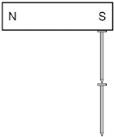
(a) Complete the sentence.
Use a word from the box.

 | forced | induced | permanent

The iron nails have become .......................................... magnets.
(1)
(b) Each of the three metal bars in Figure 2 is either a bar magnet or a piece of unmagnetised iron.
The forces that act between the bars when different ends are placed close together are shown by the arrows.
Figure 2
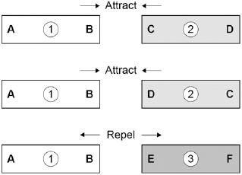

Which one of the metal bars is a piece of unmagnetised iron?

Tick one box.
Bar 1
Bar 2
Bar 3

Give the reason for your answer.
.............................................................................................................................
.............................................................................................................................
(2)
(c) A student investigated the strength of different fridge magnets by putting small sheets of paper between each magnet and the fridge door.
The student measured the maximum number of sheets of paper that each magnet was able to hold in place.
Why was it important that each small sheet of paper had the same thickness?
.............................................................................................................................
.............................................................................................................................
.............................................................................................................................
(1)
(d) Before starting the investigation the student wrote the following hypothesis:
‘The bigger the area of a fridge magnet the stronger the magnet will be.’
The student’s results are given in the table below.

 | Fridge  magnet | Area of  magnet  in mm² | Number of sheets of paper held
 | A | 40 | 20
 | B | 110 | 16
 | C | 250 | 6
 | D | 340 | 8
 | E | 1350 | 4

Give one reason why the results from the investigation do not support the student’s hypothesis.
.............................................................................................................................
.............................................................................................................................
(1)
(Total 5 marks)
Independent Exam Practice:
Q26.A student is investigating the strength of electromagnets.
Figure 1 shows three electromagnets.
The student hung a line of paper clips from each electromagnet.
Figure 1
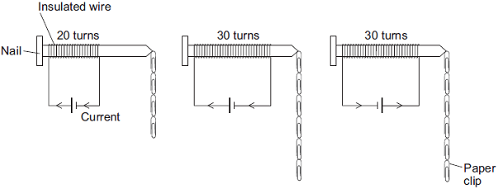

 | Electromagnet A | Electromagnet B | Electromagnet C

No more paper clips can be hung from the bottom of each line of paper clips.
(a) (i) Complete the conclusion that the student should make from this investigation.
Increasing the number of turns of wire wrapped around the nail will ........................
the strength of the electromagnet.
(1)

(ii) Which two pairs of electromagnets should be compared to make this conclusion?
Pair 1: Electromagnets .................... and ....................
Pair 2: Electromagnets .................... and ....................
(1)

(iii) Suggest two variables that the student should control in this investigation.
1 .............................................................................................................
2 .............................................................................................................
(2)

(b) The cell in electromagnet A is swapped around to make the current flow in the opposite direction. This is shown in Figure 2.
Figure 2
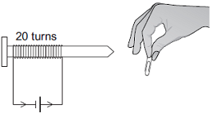
What is the maximum number of paper clips that can now be hung in a line from this electromagnet?
Draw a ring around the correct answer.
fewer than 4 4 more than 4
Give one reason for your answer.
........................................................................................................................
........................................................................................................................
........................................................................................................................
(2)

(c) Electromagnet A is changed to have only 10 turns of wire wrapped around the nail.
Suggest the maximum number of paper clips that could be hung in a line from the end of this electromagnet.
Maximum number of paper clips = ..................................................
(1)
(Total 7 marks)

Q27.(a) Electromagnets are often used at recycling centres to separate some types of metals from other materials.
Give one reason why an electromagnet would be used rather than a permanent magnet.
.............................................................................................................................
.............................................................................................................................
(1)

(b) In this question you will gain marks for using good English, organising information clearly and using scientific words correctly.
Some students want to build an electromagnet.
The students have the equipment shown below.
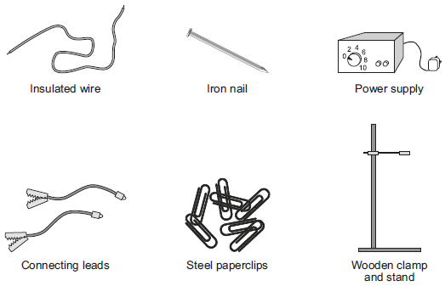
Describe how the students could build an electromagnet. Include in your answer how the students should vary and test the strength of their electromagnet.
........................................................................................................................
........................................................................................................................
........................................................................................................................
........................................................................................................................
........................................................................................................................
........................................................................................................................
........................................................................................................................
........................................................................................................................
........................................................................................................................
........................................................................................................................
........................................................................................................................
........................................................................................................................
(6)
(Total 7 marks)

