**Physics Revision: Waves and Electromagnetic Waves**

Mastery Matrix Points

|  |
| --- |
| Describe the difference between longitudinal and transverse waves giving examples for both |
| Use and rearrange T = 1/f |
| Use and rearrange v = f  λ |
| Identify amplitude and wavelength from diagrams of a wave |
| Describe what ‘electromagnetic waves’ are |
| Recall the order of EM waves & recall their frequency and wavelength and give examples of the uses of these |

Understanding and Explaining

1. Explain the difference between longitudinal and transverse waves:

Longitudinal waves have oscillations that are parallel to the direction of the energy, whereas transverse waves have oscillations that are at right angles to the direction of the energy.

1. Complete the labels to show the **amplitude** and the **wavelength**:

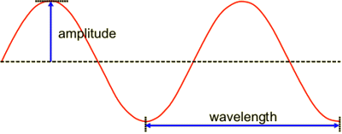

1. A wave travels with a frequency of 100Hz and a wavelength of 2m. Calculate the wave speed.

v = f x λ

= 100 x 2

= 200 m/s

1. An object has a frequency of 2.0 Hz. Calculate its time period using the equation

**period = 1 ÷ frequency**

**= 1 ÷ 2**

**= 0.5 s**

1. Complete the table to show:

a) the order of the electromagnetic spectrum

b) one use of each wave

|  |  |  |  |  |  |  |  |  |  |
| --- | --- | --- | --- | --- | --- | --- | --- | --- | --- |
| a) | Longest wavelength | radio waves | micro waves | infra red | visible light | ultra violet | x-rays | gamma rays | Shortest wavelength |
| b) | Use | TV, radios | Cooking food, satellites | Cooking food, heaters | Fibre optics | Tanning, security markers | Imaging bones | Sterilising medical equiment |  |

Key Knowledge

**Oscillation** – another word for vibration

Waves transfer energy from one place to another.

**Longitudinal waves** have rarefactions and compressions e.g. sound waves. In longitudinal waves the oscillations are parallel to the direction of energy.

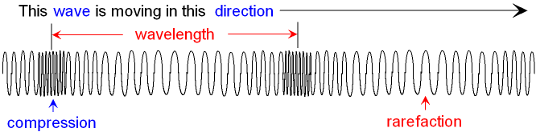

**Transverse** waves have oscillations that are at right angles to the direction of the energy e.g. electromagnetic waves.

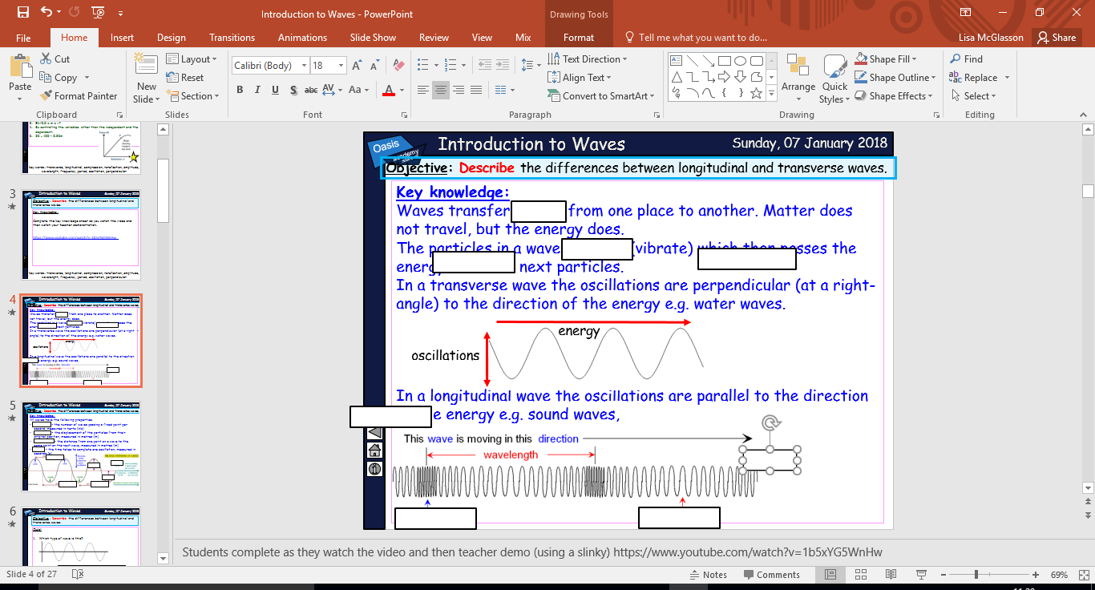

**Frequency** = the number of waves passing a fixed point per second measured in Hertz (Hz)

**Amplitude** = the direction of the particles from their original position, measured in metres (m).

**Wavelength** = the distance from one point on a wave to the same point on the next wave, measured in metres (m).

**Period** = the time takes to complete one oscillation, measured in seconds (s).

**wave speed (m/s) = frequency (Hz) × wavelength (m)**

**v = f x λ**

**Electromagnetic (EM) waves are transverse waves.**

**The electromagnetic waves are arranged from long wavelength to short wavelength**

**Physics Revision: Forces**

Mastery Matrix Points

|  |
| --- |
| Define scalar and vector quantities and use arrows to represent vector quantities |
| Define contact and non-contact forces giving examples of each |
| Define weight and gravity and use W=m x g |
| Describe what the centre of mass is |
| Explain how to measure weight using a calibrated spring balance (i.e. a Newton meter) |
| Calculate and define resultant forces |
| Use free body diagrams to show forces |

Key Knowledge

**Scalar -** quantities with a magnitude only.

Examples of scalar quantities:

* distance
* speed
* time

**Vectors** - quantities with a magnitude and direction.

Examples of vector quantities:

* velocity
* displacement
* acceleration

Vectors can be drawn using an arrow.

The length of the arrow represents the magnitude, and the direction of the arrow the direction of the vector quantity.

**Contact forces** are where the objects have to be physically touching for the force to act.

**Non-contact forces** where the objects do not have to be physically touching for the force to act.

The **resultant force** is the overall force acting on an object.

**Weight** is the downwards force due to gravity.

weight (N) = mass (Kg) x gravitational field strength (N/Kg)

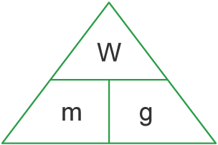

The gravitational field strength on Earth is 9.8 N/Kg

**Centre of mass** is the point at which all the mass of an object appears to act.

Understanding and Explaining

1. Put these forces into the correct column: **weight, upthrust, friction, magnetic force, air resistance**

|  |  |
| --- | --- |
| Contact forces | Non-contact forces |
| upthrust | weight |
| friction | magnetic force |
| air resistance |  |

2. Complete the diagram using these labels to show the car **accelerating**. You need to add the forward arrow: **normal contact force, weight, friction, force from the engine**

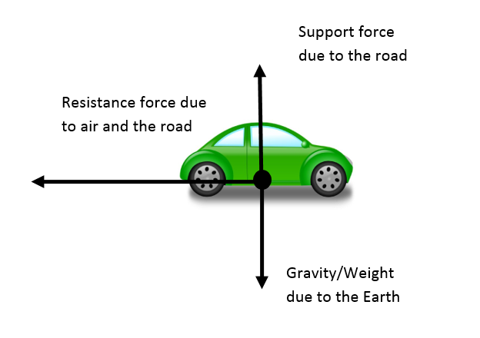

**3.** Calculate the resultant force for the moving object and choose from the words below to complete the sentence: **= 20N**

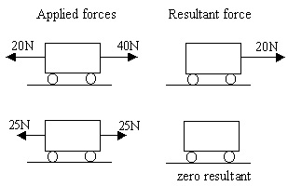 **The object would accelerate to the right**

**4.** The mass of a man is 72 kg. Calculate his weight on Earth:

**w = m x g**

**= 72 x 9.8 = 705.6 N**

force from the engine

normal contact force

friction

weight

**Physics Revision: Stopping Distances**

Mastery Matrix Points

|  |
| --- |
| Define ‘stopping distance’, ‘thinking distance’ and ‘braking distance’ |
| Recall typical values for reaction times (0.2-0.9 seconds) |
| Describe factors that effect a drivers reaction time |
| Explain methods used to measure human’s reaction times |
| Describe factors affecting ‘braking distance’ |
| Predict how the distance for a vehicle to make an emergency stop varies over a range of speeds |
| Explain the energy transfers when a vehicle brakes |

Key Knowledge

**Stopping distance** = thinking distance + braking distance

**Thinking distance –** the reaction time of the driver

**Thinking distance** is affected by alcohol, tiredness, and drugs.

Typical reaction times are 0.2s – 0.9s

**Braking distance –** the distance travelled while the braking force is applied

**Braking distance** is affected by the condition of the road and the condition of the car.

The greater the speed of a vehicle the greater the braking force needed to stop the vehicle in a certain distance.

Energy transfer when the brakes are applied:

kinetic 🡪 thermal

Large decelerations may lead to brakes overheating and/or loss of control (skidding)

Understanding and Explaining

1. A driver sees a traffic light turn red and travels 2m before he puts his foot on the brake. It takes him another 5m before he stops. Calculate the stopping distance.

stopping distance = thinking distance + braking distance

= 2 + 5

= 7m

1. Describe a method you would use to calculate the reaction time of a person.

*1. Person 1 holds a ruler from the same height each time (0cm)*

*2. Person 2 sits down with their eyes closed and catches the ruler between their thumb and finger when person 1 shouts ‘go’.*

*3. Record the distance on the ruler where person 2 caught it.*

*4. Repeat 5 times and calculate the mean distance,*

*5. Use a conversion chart to find the reaction time of person 2.*

1. Describe what effect icy roads will have on braking distance and explain why.

Icy roads will increase stopping distance. This is because there is less friction between the tyres and the road.

1. Give two risks of braking suddenly at a high speed.

* overheating of the brakes
* skidding of the car

**Physics Revision: Speed and Velocity**

Mastery Matrix Points

|  |
| --- |
| Explain the difference between distance and displacement |
| Define ‘speed’ and explain factors that affect the speed a person walks, runs or cycles at (including average speeds for these activities) |
| Recall typical speeds for different types of transportation (TBC – bus, train, car, aeroplane!) using ̴ correctly. |
| Recall the speed of sound in air |
| State that most moving objects have varying speed including sound, wind, travelling people |
| Use and rearrange s = v t (speed = d/t equation) |
| Calculate average speed for non-uniform motion |
| Define ‘velocity’ |

Key Knowledge

**Distance** is how far an object moves. It is a scalar quantity.

**Displacement** is the distance an object moves and the direction.

Displacement is measured by drawing a straight line from start to finish.

**Speed** is how quickly something moves. It is a scalar quantity.

speed (m/s) = distance (m) ÷ time (s)

*v s t*

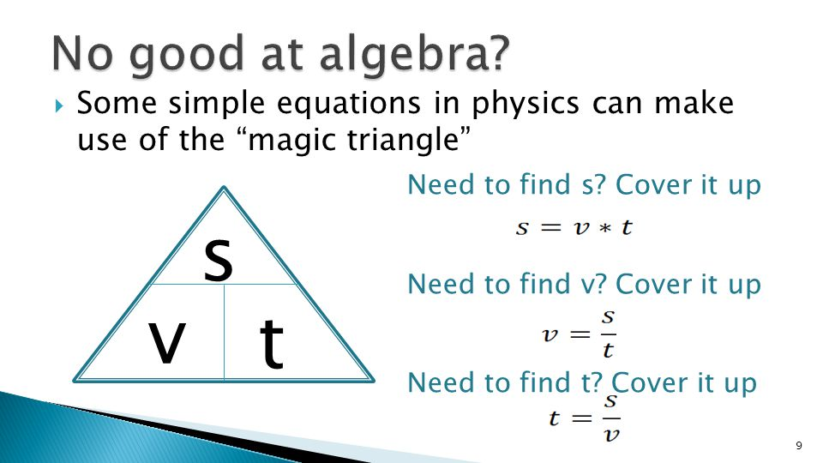

Typical speeds for:

* walking ̴ 1.5 m/s
* running ̴ 3 m/s
* cycling ̴ 6 m/s
* sound ̴ 330 m/s

The speed a person can move depends on:

* age
* terrain
* fitness
* distance travelled

The **velocity** of an object is its speed in a given direction. Velocity is a vector quantity.

Displacement (s) = Velocity (v) x Time (t)

(m) (m/s) (s)

1. Explain the difference between distance and displacement:

Distance is how far an object moves and is a scalar quantity, whereas displacement is the distance an object moves and the direction.

1. Calculate the displacement from A to B:

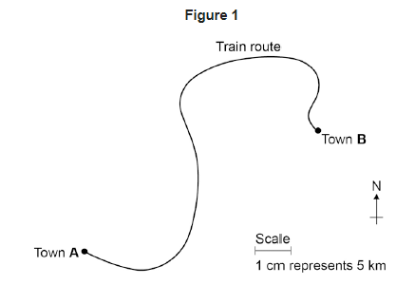

1. a) A car travels 50m in 5 seconds. Calculate its speed.

speed (m/s) = distance (m) ÷ time (s)

= 50 ÷ 5

= 10m/s

b) A car travels 300m in 1 minute. Calculate its speed.

speed (m/s) = distance (m) ÷ time (s)

= 300 ÷ 60

= 5m/s

c) A car travels at 10m/s for 20s. Calculate the distance it travels.

distance (m) = speed (m/s) x time (s)

= 10 x 20

= 200 m

**Physics Revision: DT and VT Graphs**

Mastery Matrix Points

|  |
| --- |
| Draw and interpret distance time graphs and use these to determine speed |
| Use and rearrange the equation a = Δv / t (calculating acceleration) |
| Estimate the magnitude of every day acceleration |
| Draw and interpret velocity time graphs in order to calculate acceleration |

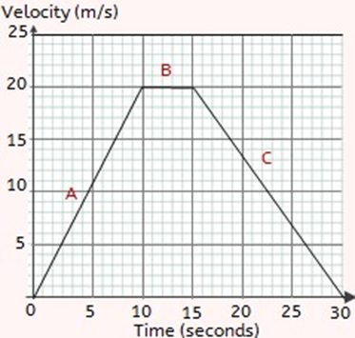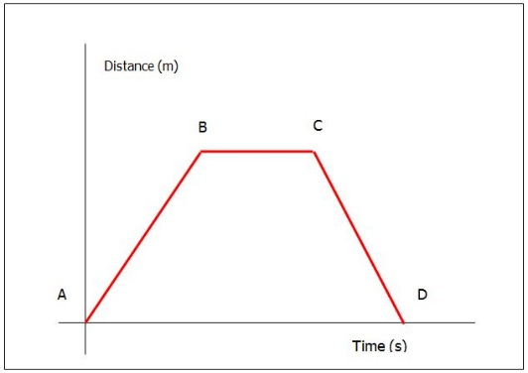

1. Describe the journey of the object from each point on the graph:

From A – B the object is travelling at a constant speed

From B – C the object is stationary

Challenge: From C – D the object is travelling back to where

they started from

1. Describe the journey of the object from each point on the graph:

At A the object is accelerating

At B the object is travelling at a constant velocity

At C the object is decelerating

1. A car accelerates in 5s from 25m/s to 35m/s. Calculate its acceleration.

Acceleration (m/s2) = change in velocity (m/s) ÷ time (s)

= 10 ÷ 5

= 2m/s2

1. Calculate the acceleration of the object in question 2 between points A and B. Show your working out on the graph.

Acceleration (m/s2) = change in velocity (m/s) ÷ time (s)

= 20 ÷ 10

= 2m/s2

Key Knowledge

Distance time graph:

a) stationary b) constant speed

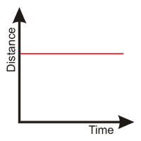 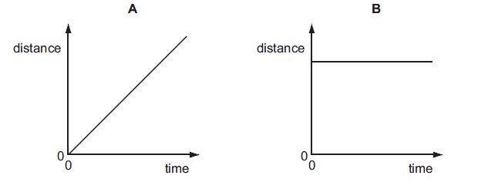

c) accelerating d) decelerating

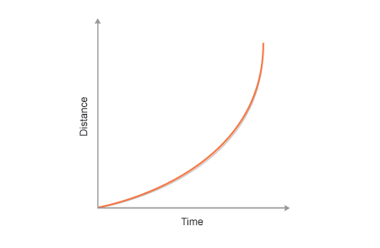 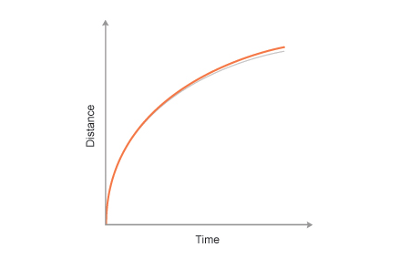

Velocity or speed time graph:

a) stationary b) constant speed

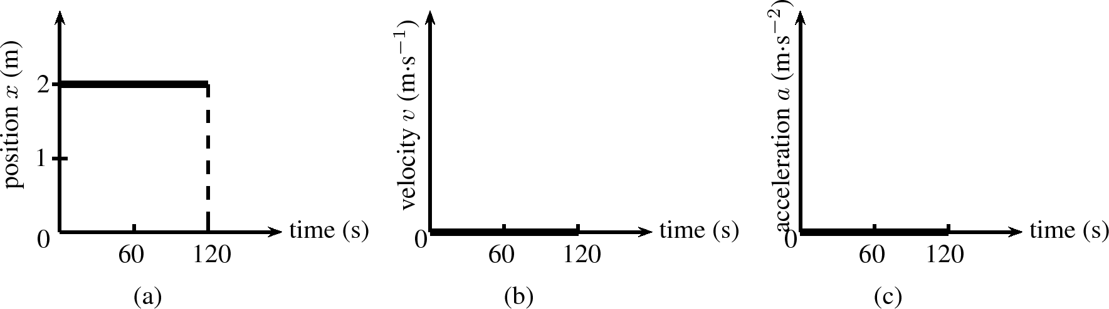 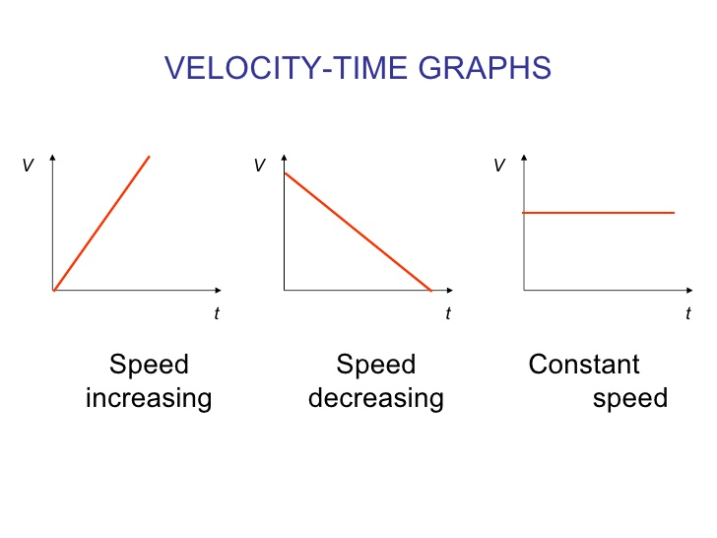

c) accelerating d) decelerating

 

Acceleration is the change in velocity over time.

Acceleration (m/s2)= change in velocity (m/s) ÷ time (s)

a = Δv / t

**Physics Revision: Falling Objects**

Mastery Matrix Points

|  |
| --- |
| Apply the equation v2-u2=2as (For moving and falling objects) [Newton’s equations of motion] |
| Recall the value for acceleration due to gravity |
| Explain the acceleration of objects through fluids (terminal velocity) – making reference to parachutes travelling through air |
| Draw and interpret velocity time graphs for objects that reach terminal velocity |



s = v2 – u2

2a

s = 49-9

8

s = 5m

Understanding and Explaining

1. An object accelerates from 2m/s to 6m/s over a distance of 8m. Use the equation v2 − u2 = 2as to find the acceleration of the object (Hint: you need to rearrange the equation to find a!).

v = 6m/s

u = 2m/s

a = ?

s = 8m

1. An object accelerates from 3m/s to 7m/s at an acceleration of 4m/s2. Use the equation v2 − u2 = 2as to find the distance travelled by the object. (Hint: you need to rearrange the equation to find s!)

v = 7m/s

u = 3m/s

a = 4m/s2

s = ?

3. Describe what happens to the motion of a sky diver when they fall out of a plane.

Initially, the sky diver accelerates.

Then, the sky diver will eventually reach a constant velocity called terminal velocity.

4. Describe what happens to the motion of a metal ball falling through water.

Initially, the ball will accelerate.

Then, the ball will eventually reach a constant velocity called terminal velocity.

Key Knowledge

**Uniform acceleration can be calculated using:**

(­final velocity) 2 – (initial velocity) 2 = 2 × acceleration × distance

v2 − u2 = 2 a s

* final velocity, v, in metres per second, m/s
* initial velocity, u, in metres per second, m/s
* acceleration, a, in metres per second squared, m/s2
* distance, s, in metres, m

Acceleration of a falling object towards earth due to gravity = 9.8 m/s2

The journey of a falling object:

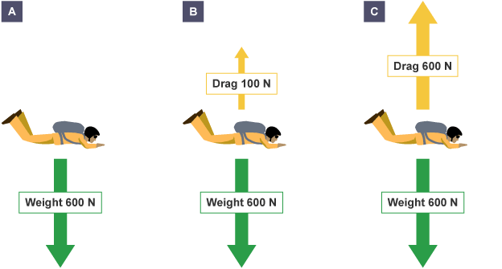

A + B. The object will accelerate

C. The object reaches a constant velocity = terminal velocity

**Physics Revision: Newton’s Laws**

Mastery Matrix Points

|  |
| --- |
| Describe and explain Newton’s first law |
| Describe and explain Newton’s second law using F = m a |
| Estimate the forces involved in large accelerations for every day road transport using ̴ correctly. |
| RP Acceleration: Investigate the effects of varying force on the acceleration of an object with a constant mass and the effects of varying the mass on the acceleration produced by a constant force |

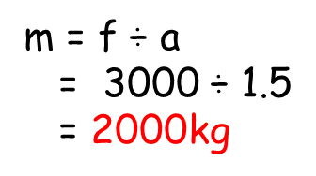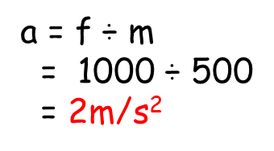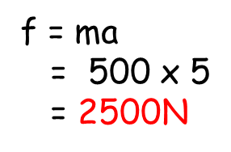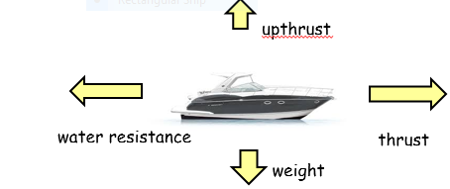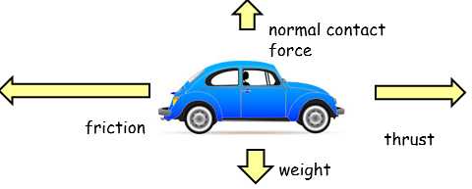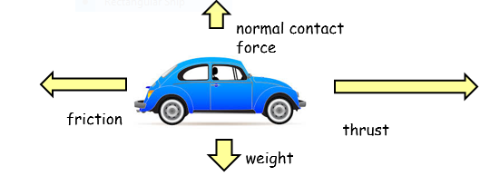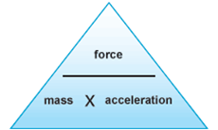

Understanding and Explaining

1. A car is travelling at a steady velocity of 5m/s to the right. Explain what happens to the car when the thrust of the engine increases.

ANS: The car will start to accelerate to the right. This is

because the force of the thrust acting to the right has

increased which means that the resultant force is no

longer 0N.

1. A car is travelling at a steady velocity of 7m/s to the right. Explain what happens to the car when the friction increases.

ANS: The car will start to decelerate. This is because

the force of the friction acting to the left has increased

which means that the resultant force is no longer 0N.

1. A boat is travelling at a constant speed. Explain why using what you know about Newton’s First Law of Motion.

ANS: The boat is travelling at a constant speed because all of

the forces acting on the boat are balanced which means that the

resultant force is 0N and the boat will remain in the same state

of motion.

1. A car accelerates at a rate of 5m/s2. If it weighs 500kg how much driving force is the engine applying?
2. A force of 1000N is applied to push a mass of 500kg. How quickly does it accelerate?
3. A force of 3000N acts on a car to make it accelerate by 1.5m/s2. How heavy is the car?

Key Knowledge

**Newton’s First Law:**

An object will remain in the same state of motion unless acted on by an external force.

This means that if the resultant force is zero:

* a stationary object will stay stationary
* a moving object will keep moving at a constant velocity

**Newton’s Second Law:**

‘The acceleration of an object is proportional to the resultant force acting on the object and inversely proportional to the mass of the object.’

Force (N) = Mass (Kg) x Acceleration (m/s2)

F = ma

**Newton’s Third Law:**

‘Whenever two objects interact, the forces they exert on each other are equal and opposite.’

**Physics Revision: Magnetism and The Motor Effect**

Mastery Matrix Points

|  |
| --- |
| Describe the polarity of magnets and list 4 magnetic materials |
| Explain the difference between a permanent and induced magnet |
| Describe the force between a magnet and a magnetic material |
| Describe the direction and strength of a magnetic field around a magnet |
| Explain how compasses work |
| Describe how to make an electromagnet and how to increase its strength |

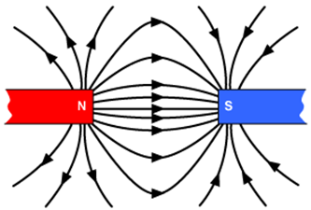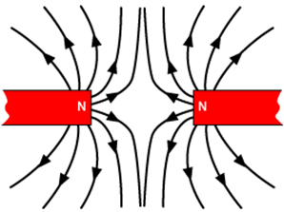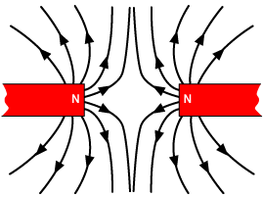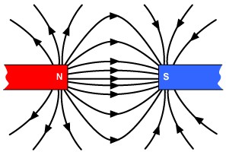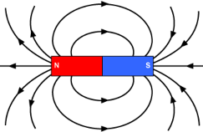

Understanding and Explaining

1. What will happen to opposite poles of a magnet? Attract
2. What will happen to like poles? Repel
3. What is created around a magnet? A Magnetic field
4. Which type of magnet will always produce its own magnetic field? Permanent magnet
5. Which type of magnet will only behave like a magnet when it is placed inside a magnetic field? Induced magnet
6. Where is the magnetic force strongest? At the poles
7. Draw the magnetic field around these magnets for a and b:

a) b)

1. Explain how a compass works.

Compasses contain a small bar magnet called a needle, which points in the direction of the Earth’s magnetic field.

Key Knowledge

A magnet is a material which produces a magnetic field.

A magnetic field is the invisible area around the magnetic where the magnetic force acts.

A permanent magnet produces its own magnetic field.

An induced magnet is a material that becomes a magnet when it is placed in a magnetic field.

The 4 magnetic materials are:

* iron
* steel
* cobalt
* nickel

The magnetic field is strongest at the pole of the magnet.

Two of the same poles will repel:

Two opposite poles will attract:::

An electromagnet is an iron core with a wire coiled around it with a current flowing through. An electromagnet can increase its strength by:

* increasing the number of coils
* increases the current
* adding a n iron core

The motor effect - when a current flows through a conducting wire a magnetic field is produced around the wire.