**OASB Science Department**

**Chemistry Paper 1 Revision Pack (Double – FT)**

|  |  |  |
| --- | --- | --- |
| Contents | Lesson | Page |
| Mastery Matrix Chemistry Paper 1 |  |  |
| Knowledge | 1 | 4-9 |
| Elements and compounds and mixtures Summary Page |
| Notes page |
| Exam Questions |
| Knowledge | 2 | 10-16 |
| Summary of an atom and types of bonding Summary Page |
| Notes page |
| Exam Questions |
| Knowledge | 3 | 17-23 |
| The periodic table and reactions of metals Summary Page |
| Notes page |
| Exam Questions |
| Knowledge | 4 | 24-29 |
| Describing chemical reactions & groups in the periodic table Summary Page |
| Notes page |
| Exam Questions |
| Knowledge | 5 | 30-36 |
| Acids & alkalis and calculations Summary Page |
| Notes page |
| Exam Questions |
| Knowledge | 6 | 37-42 |
| Electrolysis Summary Page |
| Notes page |
| Exam Questions |
| Knowledge | 7 | 43-49 |
| Exothermic and endothermic reactions Summary Page |
| Notes page |
| Exam Questions |
| Knowledge | 8 | 50-56 |
| Rates of reaction and collision theory Summary Page |
| Notes page |
| Exam Questions |



|  |  |  |  |
| --- | --- | --- | --- |
| **Topic** | **Tier** | **RG**  **Page** | **Learning statement** |
| Elements & Compounds | F | 88 | Describe and draw a model of the three states of matter |
| Elements & Compounds | F | 94 | Use the particle model to explain melting, boiling, freezing and condensing |
| Elements & Compounds | F | 94 | Identify a substance’s state using its melting and boiling point |
| Elements & Compounds | F | 88 | Classify a substance as an element or compound |
| Elements & Compounds | F | 88 | Identify the symbol for the first 20 elements |
| Elements & Compounds | F | 88 | Name common compounds from their formula |
| Mixtures | F | 89 | Use key terms (soluble, insoluble, solute, solvent and solution) correctly to describe a substance dissolving |
| Mixtures | F | 89 | Explain how to separate given mixtures (filtration, crystallisation, simple distillation, fractional distillation, chromatography) |
| Structure of an atom | F | 213 | Describe the plum pudding model of the atom |
| Structure of an atom | F | 213 | Describe the current (nuclear) model of the atom giving the relative charge and mass of the subatomic particles |
| Structure of an atom | F | 90 | Recall the radius of an atom and it’s nucleus |
| Structure of an atom | F | 91 | Calculate protons, neutrons and electrons for an atom linking to mass and atomic number |
| Structure of an atom | F | 91 | Draw the electronic structure and work out the electronic configuration for a given atom |
| Structure of an atom | F | 91 | Define an ‘isotope’ |
| Structure of an atom | F | 91 | Link isotopes to relative atomic mass to explain why this is an average |
| Structure of an atom | F | 103 | Calculate the relative atomic mass of an element given the percentage abundance of its isotopes |
| Structure of an atom | F | 103 | Calculate the relative formula mass of a substance |
| Metals in the periodic table | F | 92 | Describe how Mendeleev has arranged the periodic table |
| Metals in the periodic table | F | 100 | Explain why something is classified as a metal or non-metal |
| Metals in the periodic table | F | 100 | Describe the uses of metals |
| Metals in the periodic table | F |  | Define a ‘chemical reaction’ and give examples |
| Metals in the periodic table | F | 100 | Explain what an alloy is and how it’s properties differ from a pure metal |
| Groups in the periodic table | F | 92 | Describe the key properties (state, easy to cut, appearance) of group 1 |
| Groups in the periodic table | F | 92 | Describe and explain how the reactivity changes as you move down group 1 (oxygen, chlorine, water) |
| Groups in the periodic table | F | 93 | Describe the key properties (molecular mass, boiling and melting point) of group 7 |
| Groups in the periodic table | F | 93 | Describe and explain how the reactivity changes as you move down group 7 |
| Groups in the periodic table | F | 92 | Describe the key properties (boiling point, density, reactivity) of group 0 |
| Groups in the periodic table | F | 92 | Describe and explain how the reactivity changes as you move down group 0 |
| Types of bonding | F | 96 | Describe the structure and properties of giant ionic structures |
| Types of bonding | F | 96 | Link the structure of giant ionic structures to its properties |
| Types of bonding | F | 98 | Describe the structure and properties of simple covalent structures |
| Types of bonding | F | 99 | Describe the structure and properties of giant covalent structures (including diamond, graphite and silica) |
| Types of bonding | F | 100 | Compare and contrast giant carbon structures (diamond, graphite, graphene and fullerene – Buckminster fullerenes and nanotubes as examples) |
| Types of bonding | F | 101 | Describe how a substance bonds metallically |
| Types of bonding | F | 101 | Link the structure of giant metallic structures to their properties |
| Describing chemical reactions | F |  | Write a word equation for a given reaction |
| Describing chemical reactions | F |  | Write a balanced symbol equation for a given reaction |
| Describing chemical reactions | F | 95 | Include appropriate state symbols in an equation |
| Describing chemical reactions | F | 102 | Compare the mass of reactants and products when looking at a word equation, linking this to the theory of ‘conservation of mass’ (metal and oxygen, thermal decomposition of metal carbonates) |
| Describing chemical reactions | F |  | Calculate ‘uncertainty’ for a given set of measurements |
| Reactions of metals | F | 115 | Describe the reaction of given metals with oxygen |
| Reactions of metals | F | 115 | Describe the reaction of given metals with water |
| Reactions of metals | F | 116 | Describe the reactions of given metals with acids (magnesium, zinc and iron with hydrochloric and sulphuric acid) |
| Reactions of metals | F | 115 | Predict products from given reactants |
| Reactivity of metals | F | 114 | Use evidence to rank metals in order of reactivity |
| Reactivity of metals | F | 115 | Predict what would happen in a displacement reaction between two substance |
| Acids & alkalis | F | 116 | Identify the ions produced by different acids and alkalis |
| Acids & alkalis | F | 116 | Describe the pH scale and how to test pH using universal indicator or a pH probe |
| Acids & alkalis | F | 116 | Describe neutralisation reactions (alkalis and bases, metal carbonates and acid) |
| Acids & alkalis | F | 117 | Deduce the formulae of salts from their given ions |
| Acids & alkalis | F | 117 | Explain the method for producing soluble salts |
| Acids & alkalis | F | 117 | **RP Making Salts:** Prepare a pure dry sample of a soluble salt from an insoluble oxide or carbonate |
| Acids & alkalis | F | 116 | Recall the ionic equation for neutralisation |
| Chemical tests & calculations | F |  | Link changes in mass to the word equation for a reaction |
| Chemical tests & calculations | F | 103 | Calculate the relative formula mass of a substance |
| Electrolysis | F | 118 | Link reactivity to how metals are extract from their ore |
| Electrolysis | F | 118 | Describe how electrolysis is carried out |
| Electrolysis | F | 118 | Explain the electrolysis of molten compounds eg. Lead bromide |
| Electrolysis | F | 118 | Predict what is produced at each electrode |
| Electrolysis | F | 118 | Explain how electrolysis can be used to extract metals from their ores |
| Electrolysis | F | 118 | Explain how electrolysis can be used to determine the presence of hydrogen in an aqueous solution |
| Electrolysis | F | 119 | **RP Electrolysis:** Investigate what happens when aqueous solutions are electrolysed (including the development of a hypothesis) |
| Exo/Endothermic reactions | F | 120 | Explain how energy is conserved in reactions |
| Exo/Endothermic reactions | F | 120 | Define and give examples and uses of exothermic and endothermic reactions |
| Exo/Endothermic reactions | F | 120 | Evaluate data to decide whether a reaction is exothermic or endothermic |
| Exo/Endothermic reactions | F |  | **RP Temperature Changes:** Investigate the variables that affect temperature changes in reacting solutions |
| Exo/Endothermic reactions | F | 124 | Define activation energy |
| Exo/Endothermic reactions | F | 120 | Use reaction profiles to show energies of reactants and products and link to exothermic and endothermic and draw simple reaction profiles for endothermic and exothermic reactions. |
| Volumes and concentrations | F |  | Calculate the mass of solute in a given volume of solution |

**Lesson 1: Elements, compounds and Separating Mixtures**

|  |  |  |
| --- | --- | --- |
|  | **Topic:** | **Solubility** |
| 1 | What do we call a substance that doesn't dissolve? | Insoluble |
| 2 | What do we call a substance that does dissolve? | Soluble |
| 3 | What is the substance that dissolves called? | Solute |
| 4 | What is the liquid the substance dissolves in called? | Solvent |
| 5 | What do we call a mixture of a solvent and solute together? | Solution |
| 6 | What do we call more than one type of atom together but not chemically joined? | Mixture |
| 7 | What do we call more than one type of atom chemically joined together? | Compound |
| 8 | What do we call a substance with only one type of atom? | Element |

|  |  |  |
| --- | --- | --- |
|  | **Topic:** | **Separating Mixtures** |
| 1 | What does **filtration** separate? | An insoluble solid from a liquid |
| 2 | What is **simple distillation** used to separate? | Two liquids of different boiling points. |
| 3 | What does crystallisation separate? | A soluble solid from a liquid |
| 4 | What technique is used to separate ethanol from water? | Distillation |
| 5 | What two states of change happen in distillation? | Evaporation and condensation |
| 6 | What technique is used to separate two or more different coloured solvents? | Chromatography |
|  |  |  |
| 7 | What does crystallisation separate? | A soluble solid from a liquid |

Notes

**Chemistry Revision: Elements & Compounds**

Mastery Matrix Points. Revision guide page number: 88 + 94

|  |
| --- |
| Describe and draw a model of the three states of matter |
| Use the particle model to explain melting, boiling, freezing and condensing |
| Identify a substance’s state using its melting and boiling point |
| Classify a substance as an element or compound |
| Identify the symbol for the first 20 elements |
| Name common compounds from their formula |

Key Knowledge

Definitions:

Element - ____________________

Compound –____________________

Melting –____________________

Boiling – ____________________

Freezing –____________________

Condensing –____________________

How many elements are in the periodic table? Approximately ____.

Particle model – the atoms are represented as __________________.

|  |  |  |
| --- | --- | --- |
| Solid | Liquid | Gas |
|  |  |  |

The stronger the forces between particles the __________ the melting and boiling point, so ______ energy is needed to break the bonds between particles.

|  |  |
| --- | --- |
| *Temperature* | *Solid, liquid or gas?* |
| Lower than its melting point |  |
| Between the melting and boiling point |  |
| Higher than its boiling point |  |

Understanding and Explaining

1. Describe how the movement and rearrangement of particles changes during
   1. Melting:
   2. Boiling:
   3. Freezing:
   4. Condensing:
2. Use the table to answer these questions.
   1. What state (solid, liquid or gas) would each of the elements be at room temperature (25°C)? See table above.

Copper: Carbon:  
Magnesium: Helium  
Oxygen: Sulphur:

* 1. Which 4 elements would be a gas at 2000°C?

1. Are these elements or compounds?
   1. Sodium chloride
   2. Oxygen gas
   3. KI
   4. Co
   5. CO
2. Write the symbols for these elements.

|  |  |  |  |  |  |  |  |
| --- | --- | --- | --- | --- | --- | --- | --- |
| Hydrogen |  | Carbon |  | Sodium |  | Sulfur |  |
| Helium |  | Nitrogen |  | Magnesium |  | Chlorine |  |
| Lithium |  | Oxygen |  | Aluminium |  | Argon |  |
| Beryllium |  | Fluorine |  | Silicon |  | Potassium |  |
| Boron |  | Neon |  | Phosphorus |  | Calcium |  |

1. Name these compounds.

|  |  |  |
| --- | --- | --- |
| 1. LiO | 6. CuCl2 | 11. HCl |
| 2. AlCl3 | 7. H2O | 12. CaBr |
| 3. MgCl2 | 8. H2SO4 | 13. K2O |
| 4. FeS | 9. KNO3 | 14. Al2O3 |
| 5. NaCl | 10. LiOH | 15. CO2 |

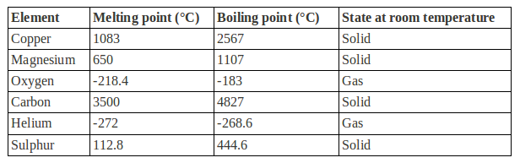

**Chemistry Revision: Mixtures**

Key Knowledge

Mixture – ____________________

Soluble – ____________________

Insoluble –____________________

Solute – ____________________

Solvent – ____________________

Filtration

Used to separate: _____________

Equipment list:

Crystallisation

Used to separate: _____________

Equipment list:

Simple distillation

Used to separate: _____________

Equipment list:

Chromatography

Used to separate: _____________

Equipment list:

Fractional distillation

Used to separate: _____________

Equipment list:

Mastery Matrix Points. Pg 88

|  |
| --- |
| Use key terms (soluble, insoluble, solute, solvent and solution) correctly to describe a substance dissolving |
| Explain how to separate given mixtures (filtration, crystallisation, simple distillation, fractional distillation, chromatography) |
| Explain the difference in difficulty of separating compounds compared to mixtures |

Understanding and Explaining

1. Mixtures can be separated by physical processes, these processes do not involve _______ _____________
2. Explain why compounds cannot be separated by physical processes.

_____________________________________________________________  
_____________________________________________________________

1. Label the apparatus and state which separation process it is.

The separation process is called ______________________________________

Label the apparatus and state which separation process would be used to separate copper sulphate crystals from a copper sulfate solution.  
The separation process is called ______________________________________

1. Describe the process of paper chromatography and how you could use it to see if a food dye is pure.
2. Label the apparatus and state which separation process it is.



**Guided Exam Question**

1. Ammonium nitrate (NH4NO3) is produced by reacting ammonia with nitric acid.

A student measured the mass of ammonium nitrate that dissolves in 100 cm3 of water at different temperatures. Table 3 shows the student’s results

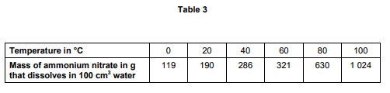

* 1. Use **Table 3** to plot a graph of the solubility of ammonium nitrate **on Figure 9**.

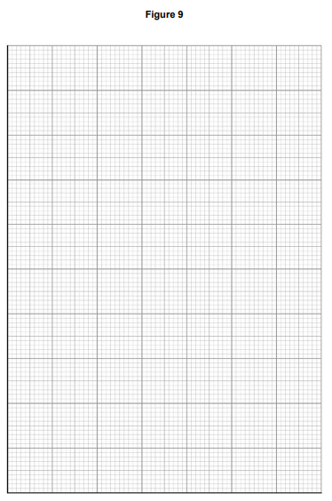[4 marks]

* 1. At 20 °C, 190 g of ammonium nitrate dissolves in 100 cm3 of water. Predict the amount of ammonium nitrate that dissolves at 30°C. [1 mark]

…………………………………………………………………………………………………………………………………………………………………………

…………………………………………………………………………………………………………………………………………………………………………

…………………………………………………………………………………………………………………………………………………………………………

* 1. Farmers use ammonium nitrate as a fertiliser. Farmers want to slow down the rate at which ammonium nitrate fertiliser dissolves in the water in the soil. Suggest why they spread the fertiliser in the form of small beads instead of a fine powder. [2 marks]

…………………………………………………………………………………………………………………………………………………………………………

…………………………………………………………………………………………………………………………………………………………………………

…………………………………………………………………………………………………………………………………………………………………………

…………………………………………………………………………………………………………………………………………………………………………

…………………………………………………………………………………………………………………………………………………………………………

**Independent Exam Question**

* 1. Rock salt is a mixture of sand and salt. Salt dissolves in water. Sand does not dissolve in water. Some students separated rock salt.

This is the method used.

1. Place the rock salt in a beaker.

2. Add 100 cm3 of cold water.

3. Allow the sand to settle to the bottom of the beaker.

4. Carefully pour the salty water into an evaporating dish.

5. Heat the contents of the evaporating dish with a Bunsen burner until salt crystals start to form.

* 1. Suggest one improvement to step 2 to make sure all the salt is dissolved in the water.

[1 mark]

…………………………………………………………………………………………………………………………………………………………………………

…………………………………………………………………………………………………………………………………………………………………………

* 1. The salty water in step 4 still contained very small grains of sand. Suggest one improvement to step 4 to remove all the sand.

[1 mark]

…………………………………………………………………………………………………………………………………………………………………………

…………………………………………………………………………………………………………………………………………………………………………

* 1. Suggest one safety precaution the students should take in step 5.

[1 mark]

…………………………………………………………………………………………………………………………………………………………………………

…………………………………………………………………………………………………………………………………………………………………………

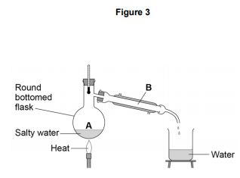Another student removed water from salty water using the apparatus in Figure 3.

* 1. Describe how this technique works by referring to the processes at A and B.

[2 marks]

…………………………………………………………………………………………………………………………………………………………………………

…………………………………………………………………………………………………………………………………………………………………………

…………………………………………………………………………………………………………………………………………………………………………

…………………………………………………………………………………………………………………………………………………………………………

* 1. What is the reading on the thermometer during this process?

[1 mark]

…………………………………………………………… oC

**Lesson 2: Summary of an atom and types of bonding**

**Structure of the atom**

|  |  |  |
| --- | --- | --- |
| **1** | What is the charge, relative size and location of a proton? | Charge: 1+, Size = 1, Location = Nucleus |
| **2** | What is the charge, relative size and location of a neutron? | Charge: 0, Size = 1, Location = Nucleus |
| **3** | What is the charge, relative size and location of an electron? | Charge: -1, Size = 1/2000, Location = Shells |
| **4** | What 3 things did the alpha scattering experiment prove? | 1) Nucleus of atom is positive (causing deflection and reflection of positive alpha particles) 2) Mass of nucleus is concentrated in the centre 3) Most of the atom is empty space |
| **5** | Define "atomic number" | Number of protons in an atom (smaller number) |
| **6** | Define "atomic mass number" | Sum of protons and neutrons in an atom (larger number) |
| **7** | Describe Thompson's 'Plum Pudding' model of an atom. | Ball of positive charge with electrons embedded throughout |

**Types of bonding**

|  |  |  |
| --- | --- | --- |
| **1** | Which type of bonding occurs between metals and non-metals? | Ionic |
| **2** | Which type of bonding occurs between non-metals? | Covalent |
| **3** | Which type of bonding occurs between metals? | Metallic |
| **4** | When electrons leave the shells of an atom, they are said to be ……? | Delocalised |
| **5** | Define graphene? | A single layer of graphite |
| **6** | Define a fullerene? | Molecules of carbon that have a hollow shape |
| **7** | What is Buckminster Fullerene? | Spherical carbon shape with 60 carbon atoms |

Notes

**Chemistry Revision: Structure of an Atom**

Key Knowledge

Definitions:

Plum pudding model: Thomson thought _______ contained tiny ___________ surrounded by __________________

Isotope: ______________________

Ion: ______________________

Relative atomic mass: _____________  
_____________________________

Radius of an atom = nm

= m

Radius of a nucleus is __________ times smaller than the atomic radius, about ____________m.

What order were the parts of the atom discovered?

Subatomic particles

|  |  |  |
| --- | --- | --- |
| *Name* | *Relative mass* | *Charge* |
| Proton |  |  |
| Neutron |  |  |
| Electron |  |  |

Using the periodic table:

*To find the number of protons you…*

*To find the number of electrons you…*

*To find the number of neutrons you…*

Mastery Matrix Points, Pg 90

|  |
| --- |
| Describe the plum pudding model of the atom |
| Describe the current (nuclear) model of the atom giving the relative charge and mass of the subatomic particles |
| Recall the radius of an atom and it’s nucleus |
| Calculate protons, neutrons and electrons for an atom linking to mass and atomic number |
| Draw the electronic structure and work out the electronic configuration for a given atom |
| Define an ‘isotope’ |
| Isotopes to relative atomic mass to explain why this is an average |
| Calculate the relative atomic mass of an element given the percentage abundance of its isotopes |
| Calculate the relative formula mass of a substance |

Understanding and Explaining

1. Draw a diagram of the structure of the atom using the nuclear model.
2. Describe what the atomic number and mass number on the periodic table tell us.   
   The atomic number tells us ____________________________________________________  
   Whereas, the mass number tells us ___________________________________________________
3. Describe the alpha scattering experiment, its results and why the results led to a change in the theory of the atom.   
   Most of the ___________________________________________. Therefore, it was concluded that _________  
   _______________________________________________________________________________________  
   Some of the __________________________________________. Therefore, it was concluded that _________  
   _______________________________________________________________________________________  
   A very small amount of the _____________________________. Therefore, it was concluded that _________  
   _______________________________________________________________________________________
4. Atomic theory: Niels Bohr stated that ___________________________________________________________, otherwise the electrons would _________________________________________________________________
5. Calculate the relative formula mass of carbon dioxide.

1. *Calculate the relative atomic mass of neon if the abundances of the atoms are: Ne20 90.92%, Ne21 0.26%, Ne22 8.82%.

**Chemistry Revision: Types of Bonding**

Mastery Matrix Points pg 96-100

|  |
| --- |
| Describe the structure and properties of giant ionic structures |
| Link the structure of giant ionic structures to its properties |
| Describe the structure and properties of simple covalent structures |
| Describe the structure and properties of giant covalent structures (including diamond, graphite and silica) |
| Describe how a substance bonds metallically |
| Link the structure of giant metallic structures to their properties |

Key Knowledge

Ionic bond – _____________________

Covalent bond – ___________________

Metallic bond – ____________________

Alloy – _____________________

Lattice structure (definition and picture) –

Ways of showing bonding and their drawbacks:

|  |  |  |
| --- | --- | --- |
| *Name of model* | *Example* | *Limitations* |
| Ball and stick | Image result for ball and stick model ionic |  |
| Dot and cross | Image result for dot and cross model |  |
| 2D models | Image result for display formula ethane |  |
| 3D models | Image result for ball and stick model ionic |  |

Examples of simple covalent molecules –

Examples of giant covalent molecules –

Uses of fullerenes –

Understanding and Explaining

1. Describe and explain the properties of **simple covalent** molecules.

|  |  |
| --- | --- |
| *Property* | *Explanation* |
|  |  |
|  |  |

1. Describe and explain the properties of **ionic** compounds.

|  |  |
| --- | --- |
| *Property* | *Explanation* |
|  |  |
|  |  |

1. Describe and explain the properties of **metallic** structures.

|  |  |
| --- | --- |
| *Property* | *Explanation* |
|  |  |
|  |  |
|  |  |

1. Describe and explain the properties of each of these giant covalent structures.

|  |  |  |  |
| --- | --- | --- | --- |
| *Name* | *Structure* | *Properties* | *Explanations* |
| Diamond |  |  |  |
|  |  |
|  |  |
| Graphite |  |  |  |
|  |  |
| Graphene |  |  |  |
|  |  |
| Fullerenes |  |  |  |
|  |  |
| Polymers |  |  |  |

1. Explain why alloys are harder and stronger than pure metals, use a particle diagram to support your explanation.

**Guided Exam Question**

3. **Figure 1** shows the outer electrons in an atom of the Group 1 element potassium and in an atom of the Group 6 element sulfur.

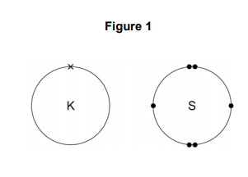

3.1. Potassium forms an ionic compound with sulfur.

Describe what happens when two atoms of potassium react with one atom of sulfur.

Give your answer in terms of electron transfer.

Give the formulae of the ions formed.

[5 marks]

…………………………………………………………………………………………………………………………………………………………………………

…………………………………………………………………………………………………………………………………………………………………………

…………………………………………………………………………………………………………………………………………………………………………

…………………………………………………………………………………………………………………………………………………………………………

…………………………………………………………………………………………………………………………………………………………………………

…………………………………………………………………………………………………………………………………………………………………………

…………………………………………………………………………………………………………………………………………………………………………

…………………………………………………………………………………………………………………………………………………………………………

…………………………………………………………………………………………………………………………………………………………………………

…………………………………………………………………………………………………………………………………………………………………………

…………………………………………………………………………………………………………………………………………………………………………

…………………………………………………………………………………………………………………………………………………………………………

…………………………………………………………………………………………………………………………………………………………………………

…………………………………………………………………………………………………………………………………………………………………………

3.2. The structure of potassium sulfide can be represented using the ball and stick model in Figure 2.

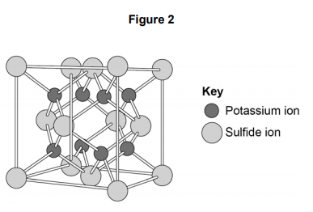

The ball and stick model is not a true representation of the structure of potassium sulfide. Give one reason why.

[1 mark]

…………………………………………………………………………………………………………………………………………………………………………

…………………………………………………………………………………………………………………………………………………………………………

…………………………………………………………………………………………………………………………………………………………………………

…………………………………………………………………………………………………………………………………………………………………………

**Independent exam questions**3.3. Sulfur can also form covalent bonds.

Complete the dot and cross diagram to show the covalent bonding in a molecule of hydrogen sulfide.

Show the outer shell electrons only.

[2 marks]

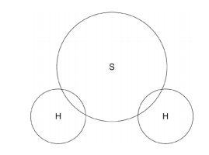

3.4. Calculate the relative formula mass (Mr) of aluminium sulfate, Al2(SO4)3

Relative atomic masses (Ar): oxygen = 16; aluminium = 27; sulfur = 32

[2 marks]

…………………………………………………………………………………………………………………………………………………………………………

…………………………………………………………………………………………………………………………………………………………………………

…………………………………………………………………………………………………………………………………………………………………………

…………………………………………………………………………………………………………………………………………………………………………

Relative formula mass =………………………………..

3.5. Covalent compounds such as hydrogen sulfide have low melting points and do not conduct electricity when molten.

Draw one line from each property to the explanation of the property.

[2 marks]

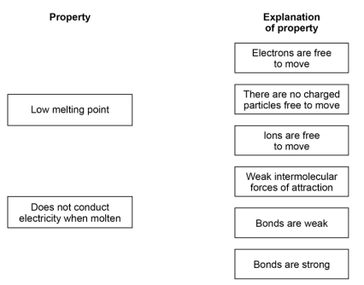

3.6. Ionic compounds such as potassium sulfide have high boiling points and conduct electricity when dissolved in water. Draw one line from each property to the explanation of the property.

[2 marks]

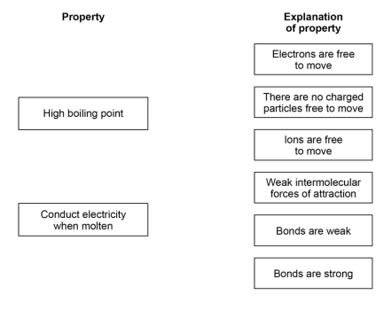

**3.7.** Describe and explain how the reactivity of the group 1 alkali metals changes as you go down the group. Refer to electrostatic attraction in your answer.

[4 marks]

…………………………………………………………………………………………………………………………………………………………………………

…………………………………………………………………………………………………………………………………………………………………………

…………………………………………………………………………………………………………………………………………………………………………

…………………………………………………………………………………………………………………………………………………………………………

…………………………………………………………………………………………………………………………………………………………………………

…………………………………………………………………………………………………………………………………………………………………………

…………………………………………………………………………………………………………………………………………………………………………

…………………………………………………………………………………………………………………………………………………………………………

…………………………………………………………………………………………………………………………………………………………………………

…………………………………………………………………………………………………………………………………………………………………………

…………………………………………………………………………………………………………………………………………………………………………

…………………………………………………………………………………………………………………………………………………………………………

…………………………………………………………………………………………………………………………………………………………………………

…………………………………………………………………………………………………………………………………………………………………………

…………………………………………………………………………………………………………………………………………………………………………

…………………………………………………………………………………………………………………………………………………………………………

…………………………………………………………………………………………………………………………………………………………………………

…………………………………………………………………………………………………………………………………………………………………………

**Lesson 3: The periodic table and reaction of metals.**

|  |  |  |
| --- | --- | --- |
|  |  | **The periodic table** |
| 1 | How are elements arranged in the periodic table? | In order of atomic number (lowest to highest) |
| 2 | What does the column (group) in the periodic table tells us? | Number of electrons in the outer shell |
| 3 | What did Mendeleev do when creating the modern periodic table? | Left gaps to make the pattern fit |
| 4 | Name the groups in the periodic table (1, 7, 0) | 1 = Alkali metals, 7 = Halogens, 0 = Noble gases |
| 5 | What happens to reactivity as you move down group 7? | They become less reactive - it is harder to gain an electron |
| 6 | What happens to reactivity as you move down group 1? | They become more reactive - it is easier to lose their outer electron. |
| 7 | What is the name of the elements found in the middle of the periodic table that are not part of a group? | Transition metals |

|  |  |  |
| --- | --- | --- |
|  |  | **Reaction of metals** |
| 1 | metal + oxygen -> | metal oxide |
| 2 | metal + water -> | metal hydroxide + hydrogen gas |
| 3 | metal + acid -> | metal salt + hydrogen gas |
| 4 | Define oxidation (in terms of oxygen) | Addition of oxygen to an element |
| 5 | Define reduction (in terms of oxygen) | Removal of oxygen from a compound |
| 6 | What is the law of conservation of mass? | No atoms are lost or made during a reaction (mass of reactants = mass of products) |
| 7 | acid + alkali (or base) -> | salt + water |

Notes

**Chemistry Revision: Development of**

Mastery Matrix Points

|  |
| --- |
| Describe how Mendeleev has arranged the periodic table |

**Periodic Table**

Key Knowledge

PERIODIC TABLE BEFORE MENDELEEV:

The periodic table was arranged in order of _______________ and some elements were ___________.

The properties were not the same in the __________.

MENDELEEV’S CHANGES:







This meant that the elements in the same group had similar _______.

Later the discovery of __________ explained why the order of atomic weight had not worked properly.

MODERN PERIODIC TABLE:

In the periodic table, the elements are arranged in order of ______________.

Periods are the _____ of the periodic table, which show that the properties repeat. Elements in the same period have the same number of ______ _________.

Groups are the _________ of the periodic table, which have similar properties within them. Elements in the same group have the same number of ______ in their outer shell.

Understanding and Explaining

1. Explain why elements in the same groups did not have similar properties before Mendeleev’s changes to the periodic table.
2. Describe and explain Mendeleev’s contribution to the modern periodic table.
3. Describe what has been added to the periodic table since Mendeleev made his changes.
4. Sulfur and sodium are in the same period of the periodic table. Suggest one similarity and one difference about their electronic structure.   
   Similarity:

Difference:

1. Lithium and sodium are in the same group of the periodic table. Suggest one similarity and one difference about their electronic structure.  
   Similarity:

Difference:

**Chemistry Revision: Reactivity of metals**

Mastery Matrix Points

|  |  |  |  |  |  |  |  |
| --- | --- | --- | --- | --- | --- | --- | --- |
| Explain why something is classified as a metal or non-metal   |  | | --- | | Use evidence to rank metals in order of reactivity | | Predict what would happen in a displacement reaction between two substance | | Link reactivity to how metals are extract from their ore | | Describe the reaction of given metals with oxygen | | Describe the reaction of given metals with water | | Describe the reactions of given metals with acids (magnesium, zinc and iron with hydrochloric and sulphuric acid) | | Predict products from given reactants | |

Key Knowledge

Metals are found on the _____ of the periodic table.

Non-metals are found on the _____ of the periodic table.

The reactivity series (with 8 metals and 2 non-metals):



Metal displacement reactions are when ……………………………………………………………………………………………………………………………………………………

Oxidation

Definition 1 –

Reduction

Definition 1 –

Ore –

Low reactivity metals are extracted from their ore by……………………………….

High reactivity metals are extracted by…………………………

Understanding and Explaining

1. Complete the positive tests for each of the gases:

|  |  |  |
| --- | --- | --- |
| Gas | Description of test | Positive test result |
|  |  |  |
|  |  |  |
|  |  |  |
|  |  |  |

1. Describe the reactions below.

|  |  |  |
| --- | --- | --- |
| *Metal* | *Reaction with room temperature water* | *Reaction with dilute acid* |
| Potassium |  |  |
| Sodium |  |  |
| Lithium |  |  |
| Calcium |  |  |
| Magnesium |  |  |
| Zinc |  |  |
| Iron |  |  |
| Copper |  |  |

1. Explain why metals such as gold do not need to be extracted from an ore.
2. Explain how metals such as copper and iron are extracted from their ores.

**Guided Exam Question**

4.1 An atom of aluminium has the symbol 27 A

13

Give the number of protons, neutrons and electrons in this atom of aluminium. [3 marks]

Number of protons _____________________

Number of neutrons _____________________

Number of electrons ______________________

* 1. Why is aluminium positioned in Group 3 of the periodic table?

[1 mark]

…………………………………………………………………………………………………………………………………………………………………………

…………………………………………………………………………………………………………………………………………………………………………

…………………………………………………………………………………………………………………………………………………………………………

5.1 In 1866 John Newlands produced an early version of the periodic table.

Part of Newlands’ periodic table is shown below.

|  |  |  |  |  |  |  |  |
| --- | --- | --- | --- | --- | --- | --- | --- |
| **Column** | **1** | **2** | **3** | **4** | **5** | **6** | **7** |
|  | H | Li | Be | B | C | N | O |
|  | F | Na | Mg | Al | Si | P | S |
|  | Cl | K | Ca | Cr | Ti | Mn | Fe |

Newlands’ periodic table arranged all the known elements into columns in order of their atomic weight.

Newlands was trying to show a pattern by putting the elements into columns.

     Iron (Fe) does **not** fit the pattern in column 7.

Give a reason why.

___________________________________________________________________

___________________________________________________________________

**(1)**

5.2     In 1869 Dmitri Mendeleev produced his version of the periodic table.

Why did Mendeleev leave gaps for undiscovered elements in his periodic table?

___________________________________________________________________

___________________________________________________________________

**(1)**

5.3      Newlands and Mendeleev placed the elements in order of atomic weight.

Complete the sentence.

The modern periodic table places the elements in order of

______________________ .

**(1)**

5.4    Lithium, sodium and potassium are all in Group 1 of the modern periodic table.

Explain why.

___________________________________________________________________

___________________________________________________________________

___________________________________________________________________

___________________________________________________________________

**(2)**

**Independent Exam Questions**

**6.1** A student investigated the reactivity of three different metals.

This is the method used.

1.       Place 1 g of metal powder in a test tube.

2.       Add 10 cm3 of metal sulfate.

3.       Wait 1 minute and observe.

4.       Repeat using the other metals and metal sulfates.

The student placed a tick in the table below if there was a reaction and a cross if there was no reaction.

|  |  |  |  |
| --- | --- | --- | --- |
|  | **Zinc** | **Copper** | **Magnesium** |
| **Copper sulfate** |  |  |  |
| **Magnesium sulfate** |  |  |  |
| **Zinc sulfate** |  |  |  |

(a)     What is the dependent variable in the investigation?

|  |  |
| --- | --- |
| Tick **one** box. |  |
| Time taken |  |
| Type of metal |  |
| Volume of metal sulfate |  |
| Whether there was a reaction or not |  |

**(1)**

6.2    Give **one** observation the student could make that shows there is a reaction between zinc and copper sulfate.

___________________________________________________________________

___________________________________________________________________

**(1)**

6.3    The student used measuring instruments to measure some of the variables.

Draw **one** line from each variable to the measuring instrument used to measure the variable.

|  |  |  |
| --- | --- | --- |
| **Variable** |  | **Measuring instrument** |
|  |  | Balance |
|  |  |  |
|  |  | Measuring cylinder |
| Mass of metal powder |  |  |
|  |  | Ruler |
|  |  |  |
|  |  | Burette |
| Volume of metal sulfate |  |  |
|  |  | Theromometer |
|  |  |  |
|  |  | Test tube |

**(2)**

6.4    Use the results shown in table above to place zinc, copper and magnesium in order of reactivity.

Most reactive         _____________________

                       _____________________

Least reactive        _____________________ **(1)**

6.5    Suggest **one** reason why the student should **not** use sodium in this investigation.

___________________________________________________________________

___________________________________________________________________**(1)**

6.6    Which metal is found in the Earth as the metal itself?

|  |  |
| --- | --- |
| Tick **one** box. |  |
| Calcium |  |
| Gold |  |
| Lithium |  |
| Potassium |  |

**(1)**

**Lesson 4: Describing chemical reactions and groups in the periodic table**(Some key knowledge points are repeated!)

|  |  |  |
| --- | --- | --- |
|  |  | **Groups in the periodic table** |
| 1 | The rows of the periodic table are called.. | Periods |
| 2 | Where are non-metals found in the periodic table? | Right |
| 3 | State 3 properties of group 7 | Non-metal, highly reactive, diatomic |
| 4 | What happens to reactivity as you move down group 7? | They become less reactive |
| 5 | Give 4 properties of metals | *High melting point *Good thermal and electrical conductors *Ductile *Malleable |
| 6 | Give 4 properties of non-metals | *Low melting point *Poor thermal and electrical conductors *Brittle |
| 7 | Give 5 properties of the alkali metals | *Highly reactive  *Low melting and boiling points *Low density  *Shiny when cut *Soft |
| 8 | What happens to reactivity as you move down group 1? | They become more reactive |

Notes

**Chemistry Revision: Describing Chemical Reactions**

Understanding and Explaining

1. Complete word equations for these reactions.   
   CHALLENGE: Write balanced symbol equations for each reaction and **include state symbols.**
2. magnesium + hydrochloric acid 🡪

1. calcium carbonate + hydrochloric acid 🡪
2. potassium + water 🡪
3. sodium + sulfuric acid 🡪
4. sulfuric acid + copper oxide 🡪
5. magnesium + oxygen 🡪
6. sodium hydroxide + hydrochloric acid 🡪
7. zinc + hydrochloric acid 🡪

Key Knowledge

Rules for chemical equations:

* Use an ____, **never** an equals sign.
* Show the reactants on the ____ hand side.
* Show the products on the ____ hand side.
* Use only words for a _____equation and symbols for a ______ equation.
* All lower case for word equations and correct case for symbols.

State symbols:

Solid –

Liquid -

Gas –

Aqueous (dissolved)-

*(Note:* Most salts are usually aqueous).

General word equations

metal + oxygen 🡪

metal + acid 🡪

metal oxide + acid 🡪

metal hydroxide + acid 🡪

metal carbonate + acid 🡪

metal + halogen 🡪

metal + water 🡪

|  |  |
| --- | --- |
| *Acid* | *Formula* |
| Hydrochloric acid |  |
| Sulfuric acid |  |
| Nitric acid |  |

Mastery Matrix Points

|  |
| --- |
| Write a word equation for a given reaction |
| Write a balanced symbol equation for a given reaction |
| Include appropriate state symbols in an equation |

**Chemistry Revision: Groups in the Periodic Table**

Understanding and Explaining

1. Describe the reactions below.

|  |  |  |
| --- | --- | --- |
| **Reactants** | **Product made (name and formula)** | **Observations during the reaction** |
| Lithium + water |  |  |
| Sodium + water |  |  |
| Potassium + water |  |  |
| Lithium + chlorine |  |  |
| Sodium + chlorine |  |  |
| Potassium + chlorine |  |  |
| Lithium + oxygen |  |  |
| Sodium + oxygen |  |  |
| Potassium + oxygen |  |  |

1. **Describe** and **explain** how the reactivity of group 1 changes as you go down the group.
2. **Explain** why group 7 elements have similar reactions when reacting with metals and non-metals.
3. **Describe** the reactions below.

|  |  |  |
| --- | --- | --- |
| **Reactants** | **Product made (name and formula)** | **Is the product a covalent molecule or ionic lattice?** |
| sodium + chlorine |  |  |
| hydrogen + chlorine |  |  |
| copper + bromine |  |  |
| Sulfur + bromine |  |  |
| lithium + iodine |  |  |
| phosphorus + iodine |  |  |

1. Explain why group 0 elements are unreactive.
2. Explain why the boiling point of group 0 increases as you go down the group.

1. Explain why the reactivity of halogens decreases as you go down the group.

Mastery Matrix Points

|  |
| --- |
| Describe the key properties (state, easy to cut, appearance) of group 1 |
| Describe and explain how the reactivity changes as you move down group 1 (oxygen, chlorine, water) |
| Describe the key properties (molecular mass, boiling and melting point) of group 7 |
| Describe and explain how the reactivity changes as you move down group 7 |
| Describe the key properties (boiling point) of group 0 |
| Describe and explain how the reactivity changes as you move down group 0 |

Key Knowledge

Group 1 is called the _____________

The properties of group 1 are

-

-

-

As you go down group 1, the reactivity ………………………..

Group 1 elements all have ____ ___________ in their outer shell.

Group 7 is called the _____________

Properties of group 7

-

-

-

As you go down group 7, the reactivity ………………………..

Group 7 elements all have ____ ___________ in their outer shell.

As you go down group 7, the melting point and boiling point……………………….

Group 0 is called the _____________

Properties of group 0

-

-

-

As you go down group 0 the boiling points ………………………..

Group 0 elements all have ____ ___________ in their outer shell, apart from helium which has _____.

**Guided Exam Question**

**7.1.** The elements in Group 1 of the periodic table are metals.

The elements in Group 1 are called the alkali metals. Why are they called the alkali metals?

[2 marks]

…………………………………………………………………………………………………………………………………………………………………………

…………………………………………………………………………………………………………………………………………………………………………

…………………………………………………………………………………………………………………………………………………………………………

…………………………………………………………………………………………………………………………………………………………………………

7.2. Explain the increase in reactivity of elements further down the group.

[4 marks]

…………………………………………………………………………………………………………………………………………………………………………

…………………………………………………………………………………………………………………………………………………………………………

…………………………………………………………………………………………………………………………………………………………………………

……………………………………………………………………………………………………………………………………………………………………………………………………………………………………………………………………………………………………………………………………………………

…………………………………………………………………………………………………………………………………………………………………………

…………………………………………………………………………………………………………………………………………………………………………

…………………………………………………………………………………………………………………………………………………………………………

7.3. Lithium oxide is an ionic compound. Draw a dot and cross diagram to show how lithium and oxygen combine to form lithium oxide. Only show the electrons in the outer shell of each atom. Give the charges on the ions formed.

[4 marks]

…………………………………………………………………………………………………………………………………………………………………………

…………………………………………………………………………………………………………………………………………………………………………

…………………………………………………………………………………………………………………………………………………………………………

…………………………………………………………………………………………………………………………………………………………………………

…………………………………………………………………………………………………………………………………………………………………………

…………………………………………………………………………………………………………………………………………………………………………

…………………………………………………………………………………………………………………………………………………………………………

…………………………………………………………………………………………………………………………………………………………………………

**Independent Exam Question**

**8.** In 1869 there were 60 known elements.

Mendeleev arranged the elements in order of their atomic mass (atomic weight).

He realised that elements with similar properties occurred at regular intervals.

8.1. Suggest why one of the groups that is on today’s periodic table was not in Mendeleev’s periodic system. [1 mark]

…………………………………………………………………………………………………………………………………………………………………………

…………………………………………………………………………………………………………………………………………………………………………

…………………………………………………………………………………………………………………………………………………………………………

8.2. Explain the arrangement of the first 20 elements in today’s periodic table. You should answer in terms of atomic structure.

[2 marks]

…………………………………………………………………………………………………………………………………………………………………………

…………………………………………………………………………………………………………………………………………………………………………

…………………………………………………………………………………………………………………………………………………………………………

…………………………………………………………………………………………………………………………………………………………………………

…………………………………………………………………………………………………………………………………………………………………………

8.3. A student put some potassium bromide solution in a test tube. She added a few drops of chlorine solution and observed the result. She repeated the process using different potassium halide salts and different halogens.

**Table 2** shows the student’s results.

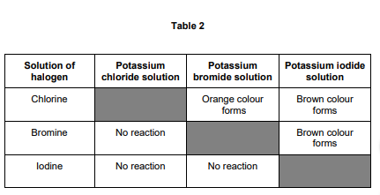

Give the order of reactivity of the halogens from the results in Table 2. Explain how you used the results to show this order of reactivity.

[2 marks]

Order…………………………………………………………………………………………………………………………………………………………………………

…………………………………………………………………………………………………………………………………………………………………………………

Explanation……………………………………………………………………………………………………………………………………………………………………………………………………………………………………………………………………………………………………………………………………………………

…………………………………………………………………………………………………………………………………………………………………………………

……….…………………………………………………………………………………………………………………………………………………………………………

…………………………………………………………………………………………………………………………………………………………………………………

……….…………………………………………………………………………………………………………………………………………………………………………

8.4. Write a balanced ionic equation for the reaction of chlorine with bromide ions in solution.

[3 marks]

…………………………………………………………………………………………………………………………………………………………………………………

8.5. Explain the order of reactivity of Group 7 elements. Include information about atomic structure. [2 marks]

…………………………………………………………………………………………………………………………………………………………………………………

…………………………………………………………………………………………………………………………………………………………………………………

…………………………………………………………………………………………………………………………………………………………………………………

…………………………………………………………………………………………………………………………………………………………………………………

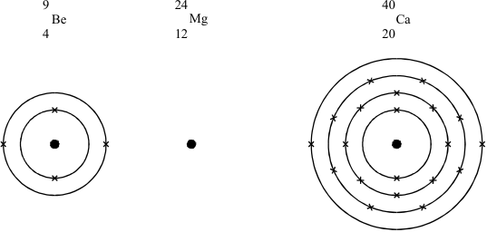…………………………………………………………………………………………………………………………………………………………………………………  
9. 1 Three elements in Group 2 of the periodic table are beryllium (Be), magnesium (Mg) and calcium (Ca). Their mass numbers and proton numbers are shown below. The electronic structure is shown for beryllium and calcium.

(a)     In a similar way, draw the electronic structure for magnesium.

**(3)**

**Lesson 5: Acids and Alkalis and calculations**

|  |  |  |
| --- | --- | --- |
|  |  | **Acids and Alkalis** |
| 1 | Which ions make a solution alkaline? | OH- (hydroxide) |
| 2 | Which ions make a solution acidic? | H+ |
| 3 | Give 3 ways to measure the pH of a substance | Litmus paper, universal indicator, pH probe |
| 4 | What pH and colour is universal indicator in an strongly ACIDIC solution? | pH 1 - 3 (red) |
| 5 | What pH and colour is universal indicator in an strongly ALKALINE solution? | pH10-14 (purple) |
| 6 | What pH and colour is universal indicator in a weak ACID? | pH 4-6 (orange/yellow) |
| 7 | What pH and colour is universal indicator in a weak ALKALI? | pH8-9 (blue) |

|  |  |  |
| --- | --- | --- |
|  |  | **Indicators and neutralisation reaction** |
| 1 | Name the type of salt produced when a metal reacts with hydrochloric acid | Metal chloride |
| 2 | Name the type of salt produced when a metal reacts with sulfuric acid | Metal sulfate |
| 3 | Name the type of salt produced when a metal reacts with nitric acid | Metal nitrate |
| 4 | What colour is methyl orange in acid and alkali? | Red (acid), orange (alkali) |
| 5 | What colour is phenolphthalein in acids and alkali? | Colourless (acid), pink (alkali) |
| 6 | Relative formula mass (Mr)= | The sum of the relative atomic masses of the atoms |
| 7 | Relative atomic mass (Ar)= | (mass x percentage) + (mass x percentage)/ 100 |

Notes

**Chemistry Revision: Acids and Alkalis**

Key Knowledge

Insoluble metal hydroxide - base or alkali?

Soluble metal hydroxide - base or alkali?

Metal oxide - base or alkali?

Metal carbonate - base or alkali?

What ions do acids produce in aqueous solutions?

What ions do alkalis produce in aqueous solutions?

pH Scale – Label strong acid, weak acid, neutral, weak alkali, strong alkali:

|  |  |  |
| --- | --- | --- |
| ***pH*** | ***Description*** | ***Colour in universal indicator*** |
| Image result for ph scale to fill out vertical |  |  |

Ionic equation for neutralisation:

Complete the general word equations:

acid + metal oxide 🡪

acid + metal hydroxide 🡪

acid + metal carbonate 🡪

Mastery Matrix Points

|  |
| --- |
| Identify the ions produced by different acids and alkalis |
| Describe the pH scale and how to test pH using universal indicator or a pH probe |
| Describe neutralisation reactions (alkalis and bases, metal carbonates and acid) |
| Deduce the formulae of salts from their given ions |
| Explain the method for producing soluble salts |
| **Required practical 1: Prepare a pure dry sample of a soluble salt from an insoluble oxide or carbonate** |
| Recall the ionic equation for neutralisation |

Understanding and Explaining

1. Explain why using a pH probe to measure the pH of a chemical may give more precise results than using an indicator, such as universal indicator.
2. Complete the word equations. *Then turn to symbol equations.

Copper carbonate + sulfuric acid 🡪 _______________________________________________________

Iron carbonate + hydrochloric acid 🡪 _______________________________________________________

Zinc carbonate + nitric acid 🡪 _______________________________________________________

Iron oxide + hydrochloric acid 🡪 _______________________________________________________

Copper hydroxide + nitric acid 🡪 _______________________________________________________

Copper oxide + hydrochloric acid 🡪 _______________________________________________________

1. Complete the table to show the chemical formula of these salts.

|  |  |  |  |
| --- | --- | --- | --- |
| ***Name*** | ***Formula*** | ***Name*** | ***Formula*** |
| Sodium sulfate |  | Zinc sulfate |  |
| Lithium chloride |  | Zinc nitrate |  |
| Magnesium chloride |  | Potassium sulfate |  |

1. Describe the method and equipment needed to prepare a dry sample of a soluble salt, such as producing copper sulfate from copper oxide and sulfuric acid (pg 117).

**Step 1:** Add the copper ____________ to warm solution of sulphuric acid

**Step 2:** Do this until _________________________.

**Step 3:**

**Step 4:**

**Step 5:**

**Chemistry Revision: Calculations**

Mastery Matrix Points

|  |
| --- |
| Link changes in mass to the word equation for a reaction |
| Calculate the relative formula mass of a substance |

Understanding and Explaining

1. Calculate the mass of magnesium in this experiment.

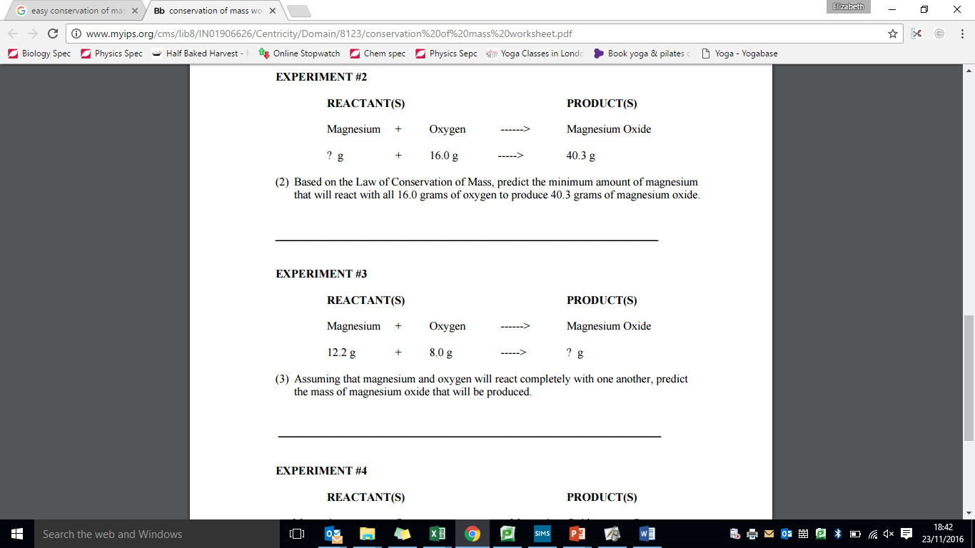

1. Explain why the mass appears to decrease during this reaction.

magnesium + hydrochloric acid 🡪 magnesium chloride + hydrogen

1. Relative atomic mass calculations:
2. Calculate the relative atomic mass of beryllium if its 85% 9Be and 15% 10Be.
3. Calculate the relative atomic mass of sodium if its 73% 23Na and 27% 24Na.
4. Calculate the relative atomic mass of phosphorus it is 90% 31P, 5% 30P and 5% 29P.
5. Calculate the relative formula masses for:   
   a) Carbon monoxide CO

b) Oxygen O2

1. Water H2O
2. Carbon dioxide CO2
3. Sodium hydroxide NaOH
4. Sodium Chloride NaCl
5. Fe2SO4

Key Knowledge

Law of conservation of mass: in a chemical reaction, the ______ mass of the ________ is _________ to the total mass of the ______________

Example of a symbol equation for the conservation of mass:

Some reactions *appear* to have a change in mass e.g. _______________________

Relative atomic mass (Ar) = (percentage x ______) + (percentage x ______) / _____

Relative formula mass (Mr) is the ______ of the relative _____ ___________ of each atom

How to calculate relative formula mass:

**Guided Exam Question**

**9. 1** Calamine lotion is used to treat itching. The main ingredients are two metal oxides.

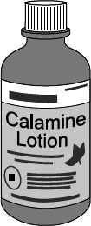

   One of the metal oxides has a relative formula mass (*M*r) of 81.

The formula of this metal oxide is MO.  
(M is **not** the correct symbol for the metal.)

The relative atomic mass (*A*r) of oxygen is 16.

      Calculate the relative atomic mass (*A*r) of metal M.

______________________________________________________________

______________________________________________________________

______________________________________________________________

Relative atomic mass (*A*r) = _____________

**(2)**

9.2    Use your answer to part (a)(i) and the periodic table on the Data Sheet to name metal M.

The name of metal M is ___________________________________ .

**(1)**

**9.3**  The formula for ammonia is NH3. What does the formula tell you about each molecule of ammonia?

___________________________________________________________________

___________________________________________________________________

___________________________________________________________________

___________________________________________________________________

**(3)**

9.4   Ammonia is used to make nitric acid (HNO3). Calculate the formula mass (Mr) for nitric acid. (Show your working).

___________________________________________________________________

___________________________________________________________________

___________________________________________________________________

___________________________________________________________________

___________________________________________________________________

**(3)**

**Independent exam questions**

9.5 Two gases react as shown in the balanced symbol equation.

2H2  +  O2  →  2H2O

          Complete the word equation for this reaction.

hydrogen + ............................... → ......................................

**(2)**

10.1 Sando-K is a medicine. It is given to people whose bodies contain too little of a particular element.

          Sando-K is a mixture of two compounds. The formulae of the two compounds are given below.

**KHCO3**                        **KCl**

Name all the elements in these compounds.

.....................................................................................................................................

.....................................................................................................................................

.....................................................................................................................................

.....................................................................................................................................

**(3)**

**10.2 .**Most water contains dissolved compounds.

The concentrations of these dissolved compounds are higher in sea water than in drinking water.

Draw a ring around the correct answer to complete the sentence.

|  |  |  |
| --- | --- | --- |
|  | Pure water can be obtained from sea water by | distillation.  filtration.  neutralisation. |

**(1)**

10. 3     What is the boiling point of pure water?        ................................... °C

**(1)**

10. 4     A student wanted to find out how much solid was dissolved in sea water.

This is the method the student used:

•        measure the mass of an empty evaporating basin

•        measure 25 cm3 of sea water and pour it into the evaporating basin

•        heat the evaporating basin gently until all of the water has evaporated

•        measure the mass of the evaporating basin containing the solid residue.

    What piece of apparatus would be suitable for measuring 25 cm3 of sea water?

...............................................................................................................

**(1)**

10. 5     The results the student obtained using 25 cm3 of sea water are:

    mass of empty evaporating basin = 23.21 g  
    mass of evaporating basin and dry solid residue = 24.04 g

Calculate the mass of solid dissolved in 1000 cm3 of the sea water.

...............................................................................................................

...............................................................................................................

...............................................................................................................

Mass dissolved in 1000 cm3 = ............................ g

**(2)**

**Lesson 6: Electrolysis**

|  |  |  |
| --- | --- | --- |
|  |  | **Electrolysis** |
| 1 | Define 'electrolysis' | A substance is decomposed (broken down) using electricity |
| 2 | Why can electrolysis only occur if an ionic substance is molten or aqueous? | The ions are free to move |
| 3 | What is the name of the negative and positive electrode? (PANCAKE) | Positive: Anode (PA)  Negative: Cathode (NCAke) |
| 4 | Which ions are attracted to the anode and which to the cathode? | Anode = negative Cathode = positive |
| 5 | Define "electrolyte" | Ions in a solution that are free to move and can conduct electricity |
| 6 | What happens at the anode? | Electrons transferred from the ion to the anode and the non-metal forms |
| 7 | What happens at the cathode? | Electrons transferred from the cathode to the ion and a metal is formed |

Notes

**Chemistry Revision: Electrolysis (pg 118-119)**

Mastery Matrix Points

|  |
| --- |
| Describe how electrolysis is carried out |
| Explain the electrolysis of molten compounds eg. Lead bromide |
| Predict what is produced at each electrode |
| I can explain how electrolysis can be used to extract metals from their ores |
| I can explain how electrolysis can be used to determine the presence of hydrogen in an aqueous solution |
| **Required practical 3: Investigate what happens when aqueous solutions are electrolysed (including the development of a hypothesis)** |

Understanding and Explaining

1. Describe how electrolysis works.

Passing an electric current through ___________________ causes the ions to move to the electrodes. Positively charged ions move to the _____________electrode (the ____________), and negatively charged ions move to the ______________electrode (the ___________). Ions are ______________ at the electrodes producing elements.

1. Describe and explain the electrolysis of molten lead bromide.
2. Explain why electrolysis is used for the extraction of metals such as aluminium (rather than reduction by heating with carbon, which is used to extract other metals like iron).

1. Describe and explain the electrolysis of molten aluminium oxide.
2. Why is cryolite is used in the electrolysis of aluminium oxide?
3. Write a method to show how you would investigate what happens in the electrolysis of sodium chloride solution. Include a diagram.

Key Knowledge

Electrolysis –

Electrolyte -

Cathode –

Anode -

Electrolysis works with a molten or dissolved compound because…

In the electrolysis of aqueous solutions, at the negative electrode (________), hydrogen is produced if the metal

is _____ reactive than hydrogen.

At the positive electrode (______), _______ is produced unless the

solution contains halide ions when the halogen is produced.

This happens because in the aqueous solution water molecules break down producing _________ions and ________ions that are discharged.

**Guided Exam Question**

**11.** Aluminium is produced from an ore called bauxite. Bauxite contains aluminium oxide.

Look at Figure 7.

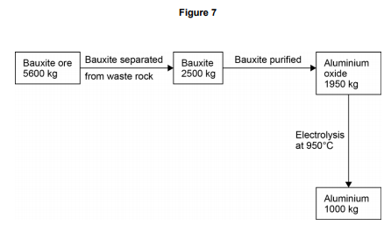

11.1. Calculate the percentage of bauxite that is converted into aluminium oxide.

[2 marks]

…………………………………………………………………………………………………………………………………………………………………………

…………………………………………………………………………………………………………………………………………………………………………

…………………………………………………………………………………………………………………………………………………………………………

Percentage = …………………………………

**12.1.**This question is about zinc.

Zinc is produced by electrolysis of molten zinc chloride, as shown in the figure below.

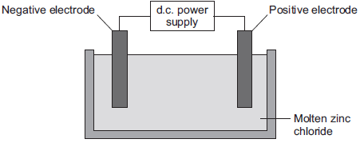

Why must the zinc chloride be molten for electrolysis?

..................................................................................................................................................................................................................................................................................................................................

**(1)**

12.2     Describe what happens at the negative electrode.

.....................................................................................................................................................................................................................................................................................................................................................................................................................................................................................................................................................................................................................................................................................................................................................................................................................................

**(2)**

**Independent Exam Question**

**13.1.** A student investigates a potassium salt, X.

She finds that salt X:

• has a high melting point

• does not conduct electricity when it is solid

• dissolves in water and the solution does conduct electricity.

What is the type of bonding in salt X?

[1 mark]

Tick one box.

Covalent

Giant molecular

Ionic

Metallic

13.2. What is the name given to solutions that conduct electricity?

[1 mark]

…………………………………………………………………………………………………………………………………………………………………………

…………………………………………………………………………………………………………………………………………………………………………

13.3. Why does a solution of salt X in water conduct electricity?

[1 mark]

…………………………………………………………………………………………………………………………………………………………………………

…………………………………………………………………………………………………………………………………………………………………………

…………………………………………………………………………………………………………………………………………………………………………

13.4. The student electrolyses a solution of potassium chloride.

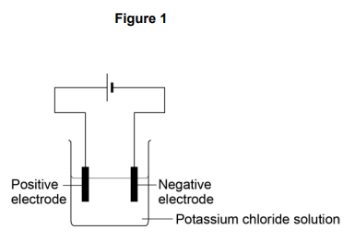**Figure 1** shows the apparatus she uses.

When the current is switched on, bubbles of hydrogen gas are given off at the negative electrode. Explain why hydrogen is produced and not potassium.

[2 marks]

…………………………………………………………………………………………………………………………………………………………………………

…………………………………………………………………………………………………………………………………………………………………………

…………………………………………………………………………………………………………………………………………………………………………

13.5. The student then compares the relative conductivity of different concentrations of potassium chloride. **Figure 2** shows the apparatus she uses.

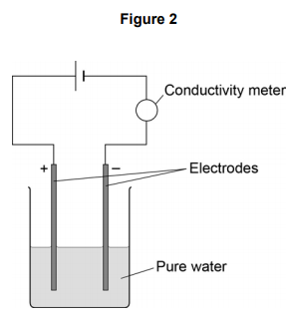

This is the method used.

1. Add potassium chloride solution to the water one drop at a time.

2. Stir the mixture.

3. Record the reading on the conductivity meter.

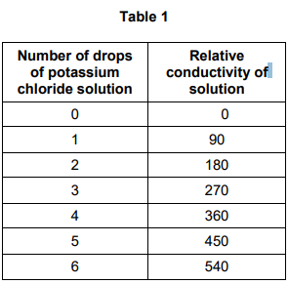

**Table 1** shows the student’s results.

13.6. When there is no potassium chloride in the beaker no electrical charge flows.

Suggest why pure water does not conduct electricity.

[2 marks]

…………………………………………………………………………………………………………………………………………………………………………

…………………………………………………………………………………………………………………………………………………………………………

…………………………………………………………………………………………………………………………………………………………………………

…………………………………………………………………………………………………………………………………………………………………………

…………………………………………………………………………………………………………………………………………………………………………

…………………………………………………………………………………………………………………………………………………………………………

13.7. Describe the relationship shown in **Table 1.**

[2 marks]

…………………………………………………………………………………………………………………………………………………………………………

…………………………………………………………………………………………………………………………………………………………………………

…………………………………………………………………………………………………………………………………………………………………………

…………………………………………………………………………………………………………………………………………………………………………

…………………………………………………………………………………………………………………………………………………………………………

**Lesson 7: Exothermic and Endothermic reactions**

|  |  |  |
| --- | --- | --- |
|  |  | **Exothermic and Endothermic reactions** |
| 1 | Which type of reaction releases energy into the surroundings? | Exothermic |
| 2 | Which type of reaction absorbs energy from the surroundings? | Endothermic |
| 3 | In an exothermic reaction, what has more energy in it? The products or the reactants? | Reactants |
| 4 | In an endothermic reaction, what has more energy in it? The products or the reactants? | Products |
| 5 | Define "activation energy" | Minimum amount of energy that particles must collide with to react |
| 6 | Give three examples of endothermic reactions | 1.Thermal decomposition reactions 2.Citric acid + sodium hydrogen carbonate  3.Sports injury packs |
| 7 | Give two examples of exothermic reactions | Self-heating cans Hand warmers |

Notes

**Chemistry Revision: Exothermic and Endothermic Reactions**

Mastery Matrix Points

|  |
| --- |
| Explain how energy is conserved in reactions |
| Define and give examples and uses of exothermic and endothermic reactions |
| Evaluate data to decide whether a reaction is exothermic or endothermic |
| **Required practical 4: Investigate the variables that affect temperature changes in reacting solutions** |
| Define activation energy |
| Use reaction profiles to show energies of reactants and products and link to exothermic and endothermic and draw simple reaction profiles for endothermic and exothermic reactions. |

Key Knowledge

Conservation of energy in chemical reactions –

Exothermic –

Exothermic Examples:

Endothermic –

Endothermic Examples:

Activation energy –

BENDOMEX –

Reaction profile - exothermic reaction:  
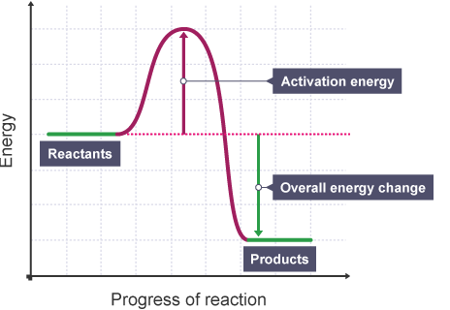

Reaction profile - endothermic reaction:  


Understanding and Explaining

1. Are these exothermic or endothermic reactions?

|  |  |  |  |  |  |  |
| --- | --- | --- | --- | --- | --- | --- |
| Initial Temp (⁰C) | Final Temp (⁰C) | Exothermic or endothermic? |  | Initial Temp (⁰C) | Final Temp (⁰C) | Exothermic or endothermic? |
| 56 | 80 |  |  | 99 | 200 |  |
| 45 | 22 |  |  | 23 | 26 |  |
| 65 | 65 |  |  | 30 | 10 |  |
| 70 | 21 |  |  | 18 | 25 |  |

1. Complete the paragraph by selecting the correct key word:

In chemical reactions, atoms are rearranged as old bonds are broken and new _______ are made. For bonds to be broken, reacting particles must ________ with enough ________. The minimum amount of energy that the particles must have for the reaction to take place is called the ___________ _________. The energy changes in a chemical reaction can be shown using an ________ ________ ________ or _________ profile.  
**reaction energy level diagram bonds energy collide activation energy**

1. Link the reaction to the descriptions by matching two descriptions to each name.

Temperature of the surroundings decreases

Exothermic - More energy is needed to make new bonds than break old bonds.

Temperature of the surroundings increases.

Endothermic - More energy is needed to break old bonds than make new bonds.

1. What can be used to reduce the activation energy needed for a reaction? Show what this looks like on a reaction profile.

C

C

**Guided Exam Question**

14.1 Firework rockets contain fuel and potassium nitrate.

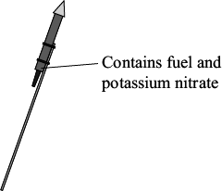

The potassium nitrate provides oxygen for the fuel to react.

The table shows how a student worked out the relative formula mass (*M*r) of potassium nitrate.

Some of the numbers are missing.

Relative atomic masses (*A*r): N = 14; O = 16; K = 39.

|  |  |  |  |
| --- | --- | --- | --- |
| **Name of atom (symbol)** | **Number of atoms** | ***A*r** | **Mass** |
| potassium (K) | 1 | 39 | 39 |
| nitrogen     (N) | 1 | 14 | 14 |
| oxygen      (O) |  | 16 |  |
| The *M*r of potassium nitrate = | | | 101 |

14.1       The mass of oxygen is not shown in the table.

Draw a ring around the correct mass of oxygen.

|  |  |  |
| --- | --- | --- |
| **16** | **32** | **48** |

**(1)**

14.2      Draw a ring around the number of oxygen atoms in the formula of potassium nitrate.

|  |  |  |
| --- | --- | --- |
| **1** | **2** | **3** |

**(1)**

14.3     When the fuel reacts with the oxygen an *exothermic* reaction takes place.

What does *exothermic* mean?

___________________________________________________________________

___________________________________________________________________

___________________________________________________________________

___________________________________________________________________

**(2)**

14.4     The fuel contains carbon. Carbon reacts with oxygen to make carbon dioxide.

Which **two** statements in the table explain why carbon dioxide is a gas at room temperature?

Tick () the **two** statements.

|  |  |
| --- | --- |
| **Statement** | **Tick ()** |
| It has a giant structure |  |
| It has a low boiling point. |  |
| It is made of small molecules. |  |
| It is made of ions. |  |

**(2)**

**(Total 6 marks)**

15.1 The word equation below shows a reaction used in an industrial process.

chromium oxide   +   aluminium    →    chromium   +   aluminium oxide

          The reaction is highly exothermic.

What is an exothermic reaction?

___________________________________________________________________

___________________________________________________________________

**(2)**

15.2      Name the products of this reaction.

___________________________________________________________________

**(1)**

15. 3     In the reaction one substance is reduced.

Name the substance which is reduced.

______________________________________________________________

**(1)**

15.4      What happens to the substance when it is reduced?

______________________________________________________________

______________________________________________________________

**(1)**

**Independent Exam Question**

**16.1** This question is about energy changes in chemical reactions.

    Complete the word equation for the combustion of hydrogen.

hydrogen          +          oxygen          →          ___________________

**(1)**

16.2     **Figure 1** shows a simple energy level diagram.

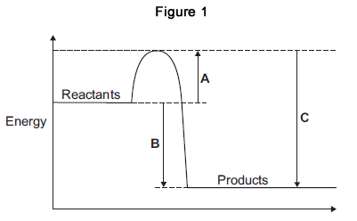

      Which arrow, **A**, **B** or **C**, shows the activation energy?

|  |  |
| --- | --- |
| Tick (✔) **one** box. |  |
| **A** |  |
| **B** |  |
| **C** |  |

**(1)**

16.3     What type of reaction is shown by the energy level diagram in **Figure 1**?

Give a reason for your answer.

Type of reaction _________________________________________________

Reason _______________________________________________________

______________________________________________________________**(2)**

**16. 4**    Alcohols are used as fuels.

A group of students investigated the amount of energy released when different alcohols are burned.

The students used the apparatus shown in **Figure 2**.

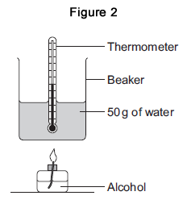16.4      **Figure 3** shows the start temperature and the final temperature of the water.

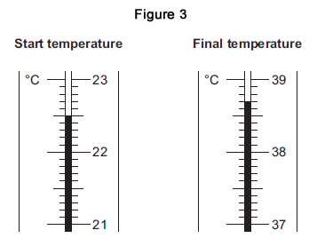

Write the start temperature and the final temperature of the water in **Table 1**.

Work out the increase in temperature to complete **Table 1**.

|  |  |
| --- | --- |
| **Table 1** | |
| Start temperature of the water in °C |  |
| Final temperature of the water in °C |  |
| Increase in temperature in °C |  |

**(3)**

16.5     The students worked out the heat energy released by burning 1 g of each alcohol.

The students used the equation:

                Heat energy released = m × 4.2 × increase in temperature

Look at **Figure 2**. What is the value of m?

m = _______________________________ g

**(1)**

**Lesson 8: Rates of reaction and collision theory**

|  |  |  |
| --- | --- | --- |
|  |  | **Rates of reaction and collision theory** |
| 1 | What are the two equations for calculating mean rate of reaction? | mean ROR = quantity of reactant used/time take or quantity of product formed/time taken |
| 2 | If the mass of the product or reactant is given in grams, which unit should you use for the rate? | g/s |
| 3 | If the volume of the product or reactant is given in cm3, which unit should you use for the rate? | cm3/s |
| 4 | What does a steep gradient on a graph tell us about the rate of a reaction? | The rate of reaction is fast |
| 5 | What does a flat line (0 gradient) on a graph tell us about the rate of a reaction? | The reaction has stopped |
| 6 | What has a higher surface area? A powder or lumps of a substance | Powder because more particles are exposed and able to successfully collide |
| 7 | State 4 factors that affect rate of reaction | Pressure (in gases), concentration, temperature, a catalyst |

Notes

**Chemistry Revision: Rates of reaction and collision theory**

Understanding and Explaining

1. Describe how you can measure the amount of reactant used in a chemical reaction:
2. Describe how you can measure the amount of products formed:
3. Describe how you can measure the time it takes for a reaction mixture to change colour:
4. Describe how the following factors affect the rate of reaction:  
   a) temperature:

b) concentration:

c) surface area:

d) catalyst

1. Calculate the mean rate of reaction of 24cm3 of hydrogen gas is produced in 2 minutes.

Mastery Matrix Points

|  |
| --- |
| Calculate the mass of solute in a given volume of solution |
| Describe how the rate of a chemical reaction can be found |
| Use collision theory to explain how factors affect the rate of reactions. |

Key Knowledge

Conservation of mass:

In some situations, it may *appear* that mass it lost- when might this be?

How to calculate the mean rate of reaction:



Name the 4 factors that affect the rate of reaction:



How to convert:

cm3 to dm3 -

dm3 to cm3 -

Sketch a graph to show 2 reactions, A and B. Reaction A is faster than reaction B.  
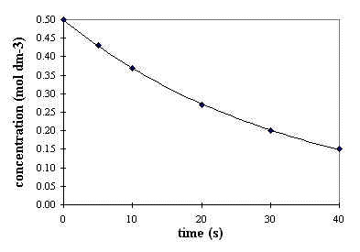

**Guided Exam Question**

**17. 1** A student investigated the temperature change when zinc reacts with copper sulfate solution.

The student used a different concentration of copper sulfate solution for each experiment.

The student used the apparatus shown below.

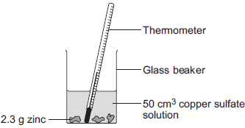

The student:

•        measured 50 cm3 copper sulfate solution into a glass beaker

•        measured the temperature of the copper sulfate solution

•        added 2.3 g zinc

•        measured the highest temperature

•        repeated the experiment using copper sulfate solution with different concentrations.

The equation for the reaction is:

Zn(s)     +                 CuSO4(aq)                    Cu(s)       +              ZnSO4(aq)

zinc       +      copper sulfate solution        copper      +    zinc sulfate solution

    The thermometer reading changes during the reaction.

Give **one** other change the student could **see** during the reaction.

___________________________________________________________________

___________________________________________________________________

**(1)**

17.2      Suggest **one** improvement the student could make to the apparatus.

Give a reason why this improves the investigation.

Improvement ________________________________________________________

___________________________________________________________________

Reason ____________________________________________________________

___________________________________________________________________

**(2)**

17.3     **In this question you will be assessed on using good English, organising information clearly and using specialist terms where appropriate.**

The student’s results are shown in the table.

**Table**

|  |  |  |
| --- | --- | --- |
| **Experiment number** | **Concentration of copper sulfate in moles per dm3** | **Increase in temperature in °C** |
| 1 | 0.1 | 5 |
| 2 | 0.2 | 10 |
| 3 | 0.3 | 12 |
| 4 | 0.4 | 20 |
| 5 | 0.5 | 25 |
| 6 | 0.6 | 30 |
| 7 | 0.7 | 35 |
| 8 | 0.8 | 35 |
| 9 | 0.9 | 35 |
| 10 | 1.0 | 35 |

Describe **and** explain the trends shown in the student’s results.

___________________________________________________________________

___________________________________________________________________

___________________________________________________________________

___________________________________________________________________

___________________________________________________________________

___________________________________________________________________

___________________________________________________________________

___________________________________________________________________

___________________________________________________________________

___________________________________________________________________

**(6)**

**(Total 9 marks)**

**Independent Questions:**

18. 1 Marble chips are mainly calcium carbonate (CaCO3).

A student investigated the rate of reaction between marble chips and hydrochloric acid (HCl).

**Figure 1** shows the apparatus the student used.

**Figure 1**

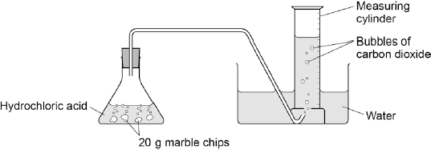

     Complete and balance the equation for the reaction between marble chips and hydrochloric acid.

_________  +  _________  →    CaCl2  +  _________  +  _________

**(2)**

18.2     The table below shows the student’s results.

|  |  |  |
| --- | --- | --- |
|  | **Time in s** | **Volume of gas in dm3** |
|  | 0 | 0.000 |
|  | 30 | 0.030 |
|  | 60 | 0.046 |
|  | 90 | 0.052 |
|  | 120 | 0.065 |
|  | 150 | 0.070 |
|  | 180 | 0.076 |
|  | 210 | 0.079 |
|  | 240 | 0.080 |
|  | 270 | 0.080 |

On **Figure 2**:

•        Plot these results on the grid.

•        Draw a line of best fit.

**Figure 2**

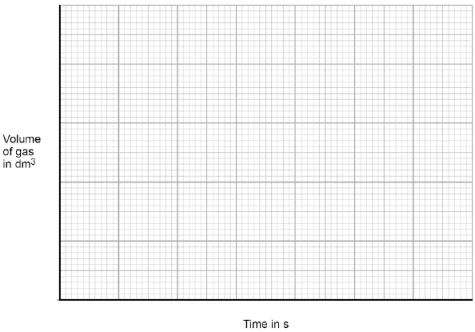

**(4)**

18. 3     Sketch a line on the grid in **Figure 2** to show the results you would expect if the experiment was repeated using 20 g of smaller marble chips.

Label this line **A**.

**(2)**

18. 4     Explain, in terms of particles, how and why the rate of reaction changes during the reaction of calcium carbonate with hydrochloric acid.

___________________________________________________________________

___________________________________________________________________

___________________________________________________________________

___________________________________________________________________

___________________________________________________________________

___________________________________________________________________

**(4)**

18.5     Another student investigated the rate of reaction by measuring the change in mass.

**Figure 3** shows the graph plotted from this student’s results.

**Figure 3**

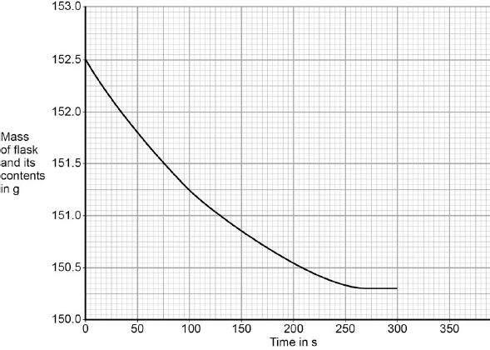

Use **Figure 3** to calculate the mean rate of the reaction up to the time the reaction is complete.

Give your answer to three significant figures.

___________________________________________________________________

___________________________________________________________________

___________________________________________________________________

___________________________________________________________________

___________________________________________________________________

___________________________________________________________________

Mean rate of reaction = ______________________ g / s

**(4)**

18.6     Use **Figure 3** to determine the rate of reaction at 150 seconds.

Show your working on **Figure 3**.

Give your answer in standard form.

___________________________________________________________________

___________________________________________________________________

___________________________________________________________________

___________________________________________________________________

___________________________________________________________________

Rate of reaction at 150 s = ______________________ g / s

**(4)**