**Chemistry Revision: Elements & Compounds**

Key Knowledge

Definitions: **Element –** substance made from only 1 type of atom.

**Compound** – substance made from 2 or more types of atom chemical bonded. The chemical properties of the compound is different than the elements by themselves.

**Melting** – solid 🡪 liquid

**Boiling** – liquid 🡪 gas

**Freezing** – liquid 🡪 solid

**Condensing** – gas 🡪 liquid

**How many elements are in the periodic table?** Approximately 100.

Particle model – the atoms are represented as **small solid spheres.**

|  |  |  |
| --- | --- | --- |
| Solid | Liquid | Gas |
| Image result for particle model | Image result for particle model | Image result for particle model |

The stronger the forces between particles the **HIGHER** the melting and boiling point, so the **MORE** energy is needed to break the bonds between particles.

|  |  |
| --- | --- |
| *Temperature* | *Solid, liquid or gas?* |
| Lower than its melting point | **Solid** |
| Between the melting and boiling point | **Liquid** |
| Higher than its boiling point | **gas** |

Mastery Matrix Points

|  |
| --- |
| Describe and draw a model of the three states of matter |
| Use the particle model to explain melting, boiling, freezing and condensing |
| Identify a substance’s state using its melting and boiling point |
| Classify a substance as an element or compound |
| Identify the symbol for the first 20 elements |
| Name common compounds from their formula |

Understanding and Explaining

1. Describe how the movement and rearrangement of particles changes during
   1. Melting – FROM neat rows, regular arrangement, vibrations TO closely packed, random arrangement, moving.
   2. Boiling – FROM closely packed, random arrangement, moving TO moving in random directions, variety of speeds, filling the space.
   3. Freezing – FROM closely packed, random arrangement, moving TO neat rows, regular arrangement, vibrations
   4. Condensing – FROM moving in random directions, variety of speeds, filling the space TO closely packed, random arrangement, moving
2. Use the table to answer these questions.
   1. What state would each of the elements be at room temperature (25°C)?

Copper – Solid, Magnesium – solid, Oxygen – gas, Carbon – soild, helium – gas, sulfur – soild.

* 1. Which elements would be a gas at 2000°C?

Magnesium, oxygen, helium, sulphur

1. Are these elements or compounds?
   1. Sodium chloride - compound
   2. Oxygen gas - element
   3. KI - compound
   4. Co – element
   5. CO - compound
2. Write the symbols for these elements.

|  |  |  |  |  |  |  |  |
| --- | --- | --- | --- | --- | --- | --- | --- |
| Hydrogen | H2 | Carbon | C | Sodium | Na | Sulfur | S |
| Helium | He | Nitrogen | N2 | Magnesium | Mg | Chlorine | Cl2 |
| Lithium | Li | Oxygen | O2 | Aluminium | Al | Argon | Ar |
| Beryllium | Be | Fluorine | F2 | Silicon | Si | Potassium | K |
| Boron | B | Neon | Ne | Phosphorus | P | Calcium | Ca |

1. Name these compounds.

|  |  |  |
| --- | --- | --- |
| 1. LiO lithium oxide | 6. CuCl2 copper chloride | 11. HCl hydrochloric acid |
| 2. AlCl3 aluminium chloride | 7. H2O water | 12. CaBr calcium bromide |
| 3. MgCl2 magnesium chloride | 8. H2SO4 sulfuric acid | 13. K2O potassium oxide |
| 4. FeS iron sulfide | 9. KNO3 potassium nitrate | 14. Al2O3 aluminium oxide |
| 5. NaCl sodium chloride | 10. LiOH lithium hydroxide | 15. CO2 carbon dioxide |

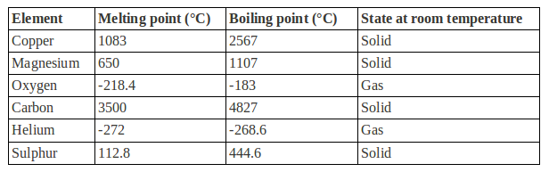

**Chemistry Revision: Mixtures**

Key Knowledge

**Mixture** – consists of two or more elements or compounds not chemically combined together. The chemical properties of each substance in the mixture are unchanged.

**Soluble** – can dissolve

**Insoluble** – cannot dissolve

**Solute** – a solid that can dissolve

**Solvent** – a liquid that dissolves a soluble solid

**Filtration**

**Used to separate**: insoluble solids from liquids

**Equipment**: filter paper, funnel, conical flask

**Crystallisation**

**Used to separate:** soluble solids from liquids

**Equipment**: evaporating basin, Bunsen burner, tripod, guaze, heat proof mat.

**Simple distillation**

**Used to separate**: either soluble solid from liquid OR liquids with different boiling points.

**Equipment:** round bottom flask, condensing tube, test tube, beaker, heater/Bunsen burner.

**Chromatography**

Used to separate: different coloured dyes.

**Equipment:** chromatography paper, solvent (water or ethanol), beaker…

**Fractional distillation**

**Used to separate**: liquids of different boiling points

**Equipment:** fractionating column.

Mastery Matrix Points

|  |
| --- |
| Use key terms (soluble, insoluble, solute, solvent and solution) correctly to describe a substance dissolving |
| Explain how to separate given mixtures (filtration, crystallisation, simple distillation, fractional distillation, chromatography) |
| Explain the difference in difficulty of separating compounds compared to mixtures |

Understanding and Explaining

1. Mixtures be separated by physical processes. Explain what a physical process is and give four examples.

Physical processes are reversible processes that can turn a mixture back into its elements i.e. they are reversible. E.g. melting, condensing, evaporating, freezing

1. Explain why compounds cannot be separated by physical processes.

Compounds are chemically bonded so require chemical processes to separate the elements out, not physical ones.

1. Label the apparatus and state which separation process it is: **Filtration**



1. Label the apparatus and state which separation process would be used to separate copper sulphate crystals from a copper sulfate solution.: **Crystallisation**
2. Describe the process of paper chromatography and how you could use it to see if a food dye is pure.   
    Chromatography is used for separating dissolved substances that have different colours, such as food dyes. It works because some of the coloured substances dissolve in the liquid and separate. If the food dye is pure then no colours will separate on the chromatography paper.
3. Label the apparatus and state which separation process it is. **Simple Distillation**



funnel

Conical flask

Filter paper

Residue

Filtrate

Evaporating basin

Bunsen   
burner

Gauze

Tripod

Heat proof mat

**Chemistry Revision: Structure of an Atom**

Mastery Matrix Points

|  |
| --- |
| Describe the plum pudding model of the atom |
| Describe the current (nuclear) model of the atom giving the relative charge and mass of the subatomic particles |
| Recall the radius of an atom and it’s nucleus |
| Calculate protons, neutrons and electrons for an atom linking to mass and atomic number |
| Draw the electronic structure and work out the electronic configuration for a given atom |
| Define an ‘isotope’ |
| Isotopes to relative atomic mass to explain why this is an average |
| Calculate the relative atomic mass of an element given the percentage abundance of its isotopes |
| Calculate the relative formula mass of a substance |

Key Knowledge

Definitions:

Plum pudding model – Thomson thought **atoms** contained **tiny negative electrons** surrounded by a **ball of positive charge**.

**Isotope** – atoms of the same element with the same number of protons and a different number of neutrons.

**Ion** – charged particles (have lost or gained electrons)

Relative atomic mass **(Ar) = (% x mass) + (% x mass) / 100**

Radius of an atom = **0.1 nm**

**= 1 x 10-10 m**

Radius of a nucleus is **TEN THOUSAND** times smaller than the atomic radius, about **1 x 10-14m.**

What order were the parts of the atom discovered? ELECTRON, PROTON, NEUTRON

Subatomic particles

|  |  |  |
| --- | --- | --- |
| *Name* | *Relative mass* | *Charge* |
| Proton | 1 | +1 |
| Neutron | 1 | 0 |
| Electron | Very small! | -1 |

Using the periodic table:

*To find the number of protons…*

*Look up the atomic number*

*To find the number of electrons…*

*Look up to the atomic number*

*To find the number of neutrons…*

*Mass number – atomic number*

Understanding and Explaining

1. Describe in detail the structure of the atom using the nuclear model.

* Small positive nucleus containing protons and neutrons in the centre of the atom.
* Nucleus has a positive charge
* Electrons in energy levels called shells around the nucleus.
* The atom has no charge overall (as the number of protons and electrons are the same)

1. Describe what the atomic number and mass number on the periodic table tell us.

* Atomic number – number of protons
* Mass number – total number of protons and neutrons added together (nucleons)

1. Describe the alpha scattering experiment, its results and why the results led to a change in the theory of the atom.

(Fire atoms from an alpha source at a thin sheet of gold foil. Use a GM tube detector so look at the path of the alpha particles)

RESULTS – 1. Most of the alpha particles went straight through🡪most of the atom is empty space

2 .Some of the atoms were deflected 🡪 this shows there was a positive nucleus repelling the alpha particles.

3. Very few (one in 20000) alpha particles reflected straight back 🡪 the positive nucleus is very small.

1. Explain the role of Niels Bohr in atomic theory. Bohr completed calculations to show that electrons are in energy levels called shells, otherwise the electrons would spiral inwards.
2. Describe the contribution of James Chadwick to atomic theory.

James Chadwick discovered neutrons.

1. Calculate the relative formula mass of carbon dioxide.

C= (1 x12) O2= (16 x2)   
= Mr = 44g

1. Calculate the relative atomic mass of neon if the abundances of the atoms are: Ne20 90.92%, Ne21 0.26%, Ne22 8.82%.

Relative atom mass = 90.92/100*20 +0.26/100*21+8.82/100*22

**= 20.179**

**Chemistry Revision: Types of Bonding**

Key Knowledge

**Ionic bond** – occurs in compounds formed when metals combined with non-metals, the particles are oppositely charged ions.

**Covalent bond** – when non-metal atoms share pairs of electrons. (The electrostatic attraction between the protons in the nucleus and electrons make the bond strong).

**Metallic bond** – occurs in metallic elements and alloys.

**Alloy –** a mixture of a metal and another substance (a metal or carbon etc).

**Lattice structure (definition and picture)** –

Alternating positive and negative ions in a regular 3D structure.

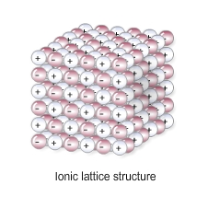

Ways of showing bonding and their drawbacks:

|  |  |  |
| --- | --- | --- |
| *Name of model* | *Example* | *Limitations* |
| Ball and stick | Image result for ball and stick model ionic | Doesn’t show electrons |
| Dot and cross | Image result for dot and cross model | Doesn’t show 3d shape |
| 2D models | Image result for display formula ethane | Doesn’t show electron shells or 3d shape |
| 3D models | Image result for ball and stick model ionic | Doesn’t show electron shells. |

**Examples of simple covalent molecules –** Chlorine (Cl2), oxygen, water, methane, ammonia, hydrochloric acid

**Examples of giant covalent molecules** –

Diamond, graphite, silicon dioxide.

**Uses of fullerenes –** nanotechnology (can be used in medicine), electronics, materials

Mastery Matrix Points

|  |
| --- |
| Describe the structure and properties of giant ionic structures |
| Link the structure of giant ionic structures to its properties |
| Describe the structure and properties of simple covalent structures |
| Describe the structure and properties of giant covalent structures (including diamond, graphite and silica) |
| Describe how a substance bonds metallically |
| Link the structure of giant metallic structures to their properties |

Understanding and Explaining

1. Describe and explain the properties of simple covalent molecules. E.G. CARBON DIOXIDE, WATER ETC.

|  |  |
| --- | --- |
| *Property* | *Explanation* |
| **Low melting and boiling points** | Don’t need to break covalent bonds, only weak intermolecular forces which doesn’t take much energy. |
| **Do not conduct electricity** | The molecules do not have an overall electric charge (no delocalised electrons or ions that can move) |

1. Describe and explain the properties of ionic compounds.

|  |  |
| --- | --- |
| *Property* | *Explanation* |
| **High melting and boiling points** | Large amounts of energy needed to break the many strong bonds. |
| **Conduct electricity when molten or dissolved** | As the ions are free to move, charge can flow (although, not free when solid) |

1. Describe and explain the properties of metallic structures.

|  |  |
| --- | --- |
| *Property* | *Explanation* |
| **High melting and boiling point** | Large amounts of energy needed to break the strong bonds. |
| **Malleable (bent and shaped)** | In pure metals, atoms are arranged in layers, which can slide over each other. |
| **Good conductors** | the delocalised electrons in the metal carry electrical charge through the metal |

1. Describe and explain the properties of each of these giant covalent structures.

|  |  |  |  |
| --- | --- | --- | --- |
| *Name* | *Structure* | *Properties* | *Explanations* |
| Diamond | each carbon atom forms four covalent bonds with other carbon atoms | Hard | Lots of strong rigid bonds |
| High melting point | Need to break all strong bonds |
| Doesn’t conduct | No free charges (electrons/ions) |
| Graphite | carbon atom forms three covalent bonds with other carbon atoms in layers of hexagonal rings. | Slippery | Layers can slide over each other |
| Conducts electricity | One electron from each carbon atom is delocalised. |
| Graphene | a single layer of graphite | NOTE: useful in electronics and composites. | |
| Fullerenes | molecules of carbon atoms with hollow shapes or cylindrical fullerenes with very high length to diameter ratios. | NOTE: The first fullerene to be discovered was Buckminsterfullerene (C60) which has a spherical shape.  Their properties make them useful for nanotechnology, electronics and materials | |
| Polymers | Very large molecules with the atoms joined by covalent bonds. | Intermolecular forces between molecules are strong | Therefore they are solid at room temperature (very difficult to melt) |

1. **Explain why alloys are harder and less malleable that the pure metals they are made from**. IN ALLOYS ATOMS CANNOT SLIDE OVER EACH OTHER BECAUSE THE ATOMS ARE NOT IN NEAT ROWS AS THE ATOMS ARE DIFFERENT SIZES. 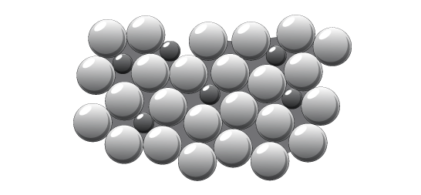

**Chemistry Revision: Development of**

Mastery Matrix Points

|  |
| --- |
| Describe how Mendeleev has arranged the periodic table |

**Periodic Table**

Key Knowledge

PERIODIC TABLE BEFORE MENDELEEV:

The periodic table was arranged in order of ATOMIC WEIGHTS and some elements were MISSING.

The properties were not the same in the GROUPS/COLUMNS.

MENDELEEV’S CHANGES:

1. **Arranged in order of atomic number**
2. **Left gaps for undiscovered elements.**

This meant that the elements in the same group had similar **properties**.

Later the discovery of **isotopes** explained why the order of atomic weight had not worked properly.

MODERN PERIODIC TABLE:

In the periodic table, the elements are arranged in order of **atomic number**.

Periods are the **rows (across)** of the periodic table, which show that the properties repeat. Elements in the same period have the same number of **electron shells (NOTE – NOT electrons, but shells).**

Groups are the **columns (down)** of the periodic table, which have similar properties within them. Elements in the same group have the same number of **electrons** in their outer shell.

Understanding and Explaining

1. Explain why elements in the same groups did not have similar properties before Mendeleev’s changes to the periodic table.

* The elements in each group didn’t have the same number of electrons in their outer shell so they reacted differently and had different properties.
* This is because some elements hadn’t been discovered which meant the order was incorrect.

1. Describe and explain Mendeleev’s contribution to the modern periodic table.

* Arranged in order of atomic **number (not weight)**
* Left gaps for undiscovered elements.

1. Describe what has been added to the periodic table since Mendeleev made his changes.

* New elements have discovered such as group 0 which are unreactive so were discovered later.

1. Sulfur and sodium are in the same period of the periodic table. Suggest one similarity and one difference about their electronic structure.

* Similarity: Same number of electron shells
* Difference: Different number of electrons in their outer shell.

1. Lithium and sodium are in the same group of the periodic table. Suggest one similarity and one difference about their electronic structure.

* Similarity: the same number of electrons in the outer shell.
* Difference: Different numbers of electron shells

**Chemistry Revision: Reactivity of metals**

Mastery Matrix Points

|  |
| --- |
| Use evidence to rank metals in order of reactivity |
| Predict what would happen in a displacement reaction between two substance |
| Write ionic half equations for displacement reactions (HT only) |
| Link reactivity to how metals are extract from their ore |
| Describe the reaction of given metals with oxygen |
| Describe the reaction of given metals with water |
| Describe the reactions of given metals with acids (magnesium, zinc and iron with hydrochloric and sulphuric acid) |
| Predict products from given reactants |

Key Knowledge

Metals are found on the **left** of the periodic table.

Non-metals are found on the **right** of the periodic table.

Understanding and Explaining

1. Complete the positive tests for each of the gases:

|  |  |  |
| --- | --- | --- |
| Gas | Description of test | Positive test result |
| Hydrogen | Burning splint held at the open end of a test tube of the gas | Hydrogen burns rapidly with a squeaky pop sound |
| Oxygen | A glowing splint inserted into a test tube of the gas | The splint relights in oxygen |
| Carbon dioxide | Use a solution of limewater | When carbon dioxide is shaken with or bubbled through limewater it turns milky (cloudy) |
| Chlorine | Use damp litmus paper and place into the gas | Litmus paper is bleached and turns white. |

1. Describe the reactions below.

|  |  |  |
| --- | --- | --- |
| *Metal* | *Reaction with room temperature water* | *Reaction with dilute acid* |
| Potassium | **Fizzes (H2 released), lilac flame.** | **Fizzes (H2 released), lilac flame.** |
| Sodium | **Fizzes, floats on the water (cushion of H2 gas)** | **Fizzes, floats on the water (cushion of H2 gas)** |
| Lithium | **Fizzes (H2 released)** | **Fizzes (H2 released)** |
| Calcium | **Fizzes (H2 released)** | **Fizzes (H2 released)** |
| Magnesium | **Bubbles gently if no oxide layer, corrodes over time.** | **Bubbles** |
| Zinc | **Corrodes over time.** | **Bubbles gently** |
| Iron | **Corrodes over time.** | **No reaction/ very gentle corrosion over time.** |
| Copper | **Corrodes over time.** | **No reaction/ very gentle corrosion over time.** |

1. Explain why metals such as gold do not need to be extracted from an ore.

**Its unreactive so hasn’t formed compounds/ it is found native.**

1. Explain how metals such as copper and iron are extracted from their ores.

**Heat the metal to melt it then, they mix with carbon. The carbon displaces the metal to produce carbon dioxide. Iron oxide + carbon 🡪 iron + carbon dioxide. Iron is reduced and carbon is oxidised.**

The reactivity series (with 8 metals and 2 non-metals):

1. **Potassium**
2. **Sodium**
3. **Lithium**
4. **Calcium**
5. **Magnesium**
6. **CARBON**
7. **Zinc**
8. **Iron**
9. **HYDROGEN**
10. **Copper**

Metal displacement reactions are when **a more reactive metal displaces a less reactive metal in a compound.**

Oxidation

Definition 1 – **reacting with oxygen**

Reduction

Definition 1 – **losing oxygen**

Ore – **a compound/rock with enough of a metal to make it worthwhile extracting it.**

Low reactivity metals are extracted from their ore by…**reduction with carbon.**

High reactivity metals are extracted by **electrolysis.**

**Chemistry Revision: Describing Chemical Reactions**

Mastery Matrix Points

|  |
| --- |
| Write a word equation for a given reaction |
| Write a balanced symbol equation for a given reaction |
| Include appropriate state symbols in an equation |

Key Knowledge

Rules for chemical equations:

* Use an ARROW, never an equals sign.
* Show the reactants on the LEFT hand side.
* Show the products on the RIGHT hand side.
* Use only words for a WORD equation and symbols for a BALANCED/SYMBOL equation.
* All lower case for word equations and correct case for symbols.

State symbols:

Solid – (s)

Liquid - (l)

Gas – (g)

Aqueous (dissolved)- (aq)

*Note:* Most salts are usually aqueous.

General word equations

metal + oxygen 🡪 **metal oxide**

metal + acid 🡪 **salt + hydrogen**

metal oxide + acid 🡪 **salt + water**

metal hydroxide + acid 🡪 **salt + water**

metal carbonate + acid 🡪 **salt + water + carbon dioxide**

metal + halogen 🡪 **metal halide**

metal + water 🡪 **metal hydroxide + hydrogen**

|  |  |
| --- | --- |
| *Acid* | *Formula* |
| Hydrochloric acid | **HCl** |
| Sulfuric acid | **H2SO4** |
| Nitric acid | **HNO3** |

Understanding and Explaining

1. Complete word and symbol equations for these reactions. CHALLENGE: Write balanced symbol equations for each reaction and **include state symbols.**
2. magnesium + hydrochloric acid 🡪 **magnesium chloride + hydrogen**
3. calcium carbonate + hydrochloric acid 🡪 **calcium chloride + water + carbon dioxide**
4. potassium + water 🡪 **potassium hydroxide + hydrogen**
5. sodium + sulfuric acid 🡪 **sodium sulfate + hydrogen**
6. sulfuric acid + copper oxide 🡪 **copper sulfate + water**
7. magnesium + oxygen 🡪 **magnesium oxide**
8. sodium hydroxide + hydrochloric acid 🡪 **sodium chloride +water**
9. zinc + hydrochloric acid 🡪 **zinc chloride + hydrogen**

**Chemistry Revision: Groups in the**

Mastery Matrix Points

|  |
| --- |
| Describe the key properties (state, easy to cut, appearance) of group 1 |
| Describe and explain how the reactivity changes as you move down group 1 (oxygen, chlorine, water) |
| Describe the key properties (molecular mass, boiling and melting point) of group 7 |
| Describe and explain how the reactivity changes as you move down group 7 |
| Describe the key properties (boiling point) of group 0 |
| Describe and explain how the reactivity changes as you move down group 0 |

**Periodic Table**

Understanding and Explaining

1. Describe the reactions below.

|  |  |  |
| --- | --- | --- |
| **Reactants** | **Product made (name and formula)** | **Observations during the reaction** |
| Lithium + water | Lithium hydroxide + hydrogen  LiOH + H2 | Lithium floats across the surface and gently fizzes (hydrogen gas). UI in water changes from green to purple due to an alkali being produced. |
| Sodium + water | Sodium hydroxide + hydrogen  NaOH + H2 | Sodium moves quickly across the surface and fizzes. UI in water changes from green to purple due to an alkali being produced. |
| Potassium + water | Potassium hydroxide + hydrogen  KOH + H2 | Potassium speeds across the surface and fizzing vigorously with purple flames also produced due to the hydrogen igniting. UI in water changes from green to purple due to an alkali being produced. |
| Lithium + chlorine | Lithium chloride  LiCl | Lithium reacts vigorously with chlorine to produce a salt. |
| Sodium + chlorine | Sodium chloride  NaCl | Sodium reacts vigorously with chlorine to produce a salt. |
| Potassium + chlorine | Potassium chloride  KCl | Potassium reacts vigorously with chlorine to produce a salt. |
| Lithium + oxygen | Lithium oxide  Li2O | Reacts with oxygen to produce a dull metal oxide. |
| Sodium + oxygen | Sodium oxide  Na2O | Reacts vigorously with oxygen to produce a dull metal oxide. |
| Potassium + oxygen | Potassium oxide  K2O | Reacts vigorously with oxygen to produce a dull metal oxide. |

1. Describe and explain how the reactivity of group 1 changes as you go down the group.

Group 1 metals react easily because they only have 1 electron in their outer shell and need to lose 1 electron to form a positive ion and become stable. They get more reactive as you move down the group because the atoms get larger. This means that the outer electron gets further from the nucleus and the electrostatic attraction between the positive nucleus and the negative outer electron gets weaker, so the electron is more easily lost.

1. Explain why group 7 elements have similar reactions when reacting with metals and non-metals.   
   Halogens have similar reactions with both metals, such as lithium, and non-metals, such as hydrogen or carbon, because they can react with both to become stable, either by gaining an electron in ionic bonding or sharing an electron in covalent bonding.

|  |  |  |
| --- | --- | --- |
| **Reactants** | **Product made (name and formula)** | **Is the product a covalent molecule or ionic lattice?** |
| sodium + chlorine | Sodium chloride (NaCl) | Ionic |
| hydrogen + chlorine | Hydrogen chloride (HCl) (hydrochloric acid in water) | Covalent |
| copper + bromine | Copper bromide (CuBr2) | Ionic |
| Sulfur + bromine | Sulphur dibromide (Br2S) | Covalent |
| lithium + iodine | Lithium iodide (LiI) | Ionic |
| phosphorus + iodine | Phosphorus triiodide (PI3) | Covalent |

5.Explain why group 0 elements are unreactive.   
Group 0 elements are unreactive due to have full outer shells of electrons, thus not needing to gain or lose electrons to become stable.

Key Knowledge

Group 1 is called the alkali metals

The properties of group 1 are

- Soft, shiny solids and can be cut by a knife

- Very reactive metals (e.g react vigorously with water)

- Low melting and boiling points compared to other metals

As you go down group 1, the reactivity increases

Group 1 elements all have one electron in their outer shell.

Group 7 is called the halogens

Properties of group 7

- Reactive non-metals

- low melting and boiling points

- Change state as you go down group (gas to liquid to solid)

As you go down group 7, the reactivity decreases

Group 7 elements all have seven electrons in their outer shell.

As you go down group 7, the melting point and boiling point increases

Group 0 is called the Noble gases

Properties of group 0

- Stable

- Gases at room temperature

- Unreactive

As you go down group 0 the boiling points increase

Group 0 elements all have eight electrons in their outer shell, apart from helium which has two.

1. Explain why the boiling point of group 0 increases as you go down the group.

The boiling point of group 0 increases as you go down the group due to the atoms getting larger and denser.

7.. Explain why the reactivity of halogens decreases as you go down the group.   
Group 7 halogens react easily because they have 7 electrons in their outer shell meaning that to complete a full outer shell they only need to gain one electron. As you move down the group the atoms become larger as they gain one electron shell. This means that the outer shell becomes further away from the electrostatic attraction of the nucleus and it becomes harder for the nucleus to attract the one electron.

(add this on to a powerpoint slide)

**Chemistry Revision: Acids and Alkalis**

Mastery Matrix Points

|  |
| --- |
| Identify the ions produced by different acids and alkalis |
| Describe the pH scale and how to test pH using universal indicator or a pH probe |
| Describe neutralisation reactions (alkalis and bases, metal carbonates and acid) |
| Deduce the formulae of salts from their given ions |
| Explain the method for producing soluble salts |
| **Required practical 1: Prepare a pure dry sample of a soluble salt from an insoluble oxide or carbonate** |
| Recall the ionic equation for neutralisation |

Key Knowledge

Insoluble metal hydroxide - Base

Soluble metal hydroxide - Alkali

Metal oxide - Base

Metal carbonate - Base

What ions do acids produce in aqueous solutions? H+

What ions to alkalis produce in aqueous solutions? OH-

pH Scale –

|  |  |  |
| --- | --- | --- |
| ***pH*** | ***Description*** | ***Colour in universal indicator*** |
| Image result for ph scale to fill out vertical | Strong acid  Weak acid  Neutral  Weak alkali  Strong alkali | Red  Orange-yellow  Green  Blue-green  Purple |

Ionic equation for neutralisation:

H+ (aq) + OH- (aq) 🡪 H2O (l)

Complete the general word equations:

acid + metal oxide 🡪 salt + water

acid + metal hydroxide 🡪 salt + water

acid + metal carbonate 🡪 salt + water + carbon dioxide

Understanding and Explaining

1. Explain why using a pH probe to measure the pH of a chemical may be give precise results than using an indicator, such as universal indicator.

A pH probe has smaller intervals and is accurate to 0.01 of a pH unit. Universal indicator is subject to human error as it is subjective (down to the person’s opinion on the correct shade of colour).

1. Complete the word equations. Then turn to symbol equations.

Copper carbonate + sulfuric acid 🡪 Copper sulfate + water + carbon dioxide CuCO3 + H2SO4 🡪 CuSO4 + H2O

Iron carbonate + hydrochloric acid 🡪 Iron chloride + water + carbon dioxide Fe2(CO3)3 + 6HCl 🡪 2FeCl3 + 3H2O + 3CO2

Zinc carbonate + nitric acid 🡪 Zinc nitrate + water + carbon dioxide ZnCO3 + 2HNO3 🡪 Zn(NO3)2 + H2O + CO2

Iron oxide + hydrochloric acid 🡪 Iron chloride + water Fe2O3 + 6HCl 🡪 2FeCl3 + 3H2O

Copper hydroxide + nitric acid 🡪 Copper nitrate + water Cu(OH)2 + 2HNO3 🡪 Cu(NO3)2 + 2H2O

Copper oxide + hydrochloric acid 🡪 Copper chloride + water CuO + 2HCl 🡪 CuCl2 + H2O

1. Complete the table to show the chemical formula of these salts.

|  |  |  |  |
| --- | --- | --- | --- |
| ***Name*** | ***Formula*** | ***Name*** | ***Formula*** |
| Sodium sulfate | Na2SO4 | Zinc sulfate | ZnSO4 |
| Lithium chloride | LiCl | Zinc nitrate | Zn(NO3)2 |
| Magnesium chloride | MgCl2 | Potassium sulfate | K2SO4 |

1. Describe the method and equipment needed to prepare a dry sample of a soluble salt, such as producing copper sulfate from copper oxide and sulfuric acid.

An excess of solid copper oxide powder is added to a solution of sulfuric acid in a suitable reaction vessel, e.g. a conical flask, forming aqueous copper sulfate. CuO + H2SO4 🡪 CuSO4 + H2O. The solution will turn a characteristic blue colour. The solution is then filtered using filter paper – copper oxide is insoluble so it will not pass through the filter paper. The resultant solution is then either left to evaporate or heated using a crucible until blue copper sulfate crystals are formed.

**Chemistry Revision: Calculations**

Mastery Matrix Points

|  |
| --- |
| Link changes in mass to the word equation for a reaction |
| Calculate the relative formula mass of a substance |

Understanding and Explaining

1. Calculate the mass of magnesium in this experiment: **24.3g**

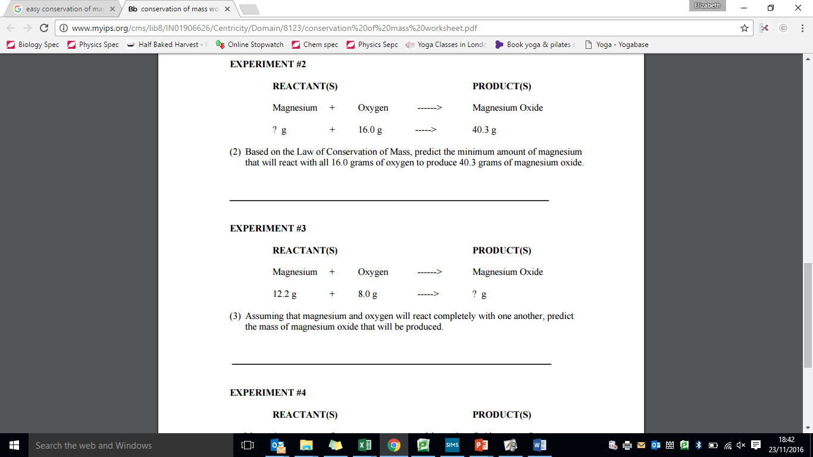

1. Explain why the mass appears to decrease during this reaction.

magnesium + hydrochloric acid 🡪 magnesium chloride + hydrogen  
Hydrogen gas diffuses away, so its mass is not measured.

1. Relative atomic mass calculations:
2. Calculate the relative atomic mass of beryllium if its 85% 9Be and 15% 10Be.   
   (85 x 9) + (15 x 10)/ 100=   
   **Mr= 9.15**
3. Calculate the relative atomic mass of sodium if its 73% 23Na and 27% 24Na.   
   (73 x 23) + (27 x 24)/ 100=   
   **Mr= 23.27**
4. Calculate the relative atomic mass of phosphorus it is 90% 31P, 5% 30P and 5% 29P.   
   (90 x 31) + (5x 30) + (5 x 29)=   
   **Mr= 30.85**
5. Calculate the relative formula masses for:   
   a) Carbon monoxide CO: Ar of C= 12  
   Ar of O= 16   
   Total= 16+12= **28**  
   b) Oxygen O2: ar of O= 16 x 2

Total= **32**c) Water H2O: Ar of H = 1 x 2  
Ar of O = 16 x 1   
Total = **18**

1. Carbon dioxide CO2 : Ar of C= 12  
   Ar of O= 16 x 2  
   Total= (32 + 12)= **44**

Key Knowledge

Law of conservation of mass: in a chemical reaction, the total mass of the reactants is equal to the total mass of the products

Example of a symbol equation for the conservation of mass:  
Fe(s) + CuSO4 (aq) 🡪 Cu(s) + FeSO4 (aq)

Some reactions *appear* to have a change in mass e.g. Where mass could be lost by a gas escaping

Relative atomic mass (Ar) = (percentage x MASS) + (percentage x MASS) /100

Relative formula mass (Mr) is the SUM of the relative ATOMIC MASS of each atom

How to calculate relative formula mass:  
Relative formula mass= sum of Ar of each atom

**Chemistry Revision: Electrolysis**

Mastery Matrix Points

|  |
| --- |
| Describe how electrolysis is carried out |
| Explain the electrolysis of molten compounds eg. Lead bromide |
| Predict what is produced at each electrode |
| I can write half equations for the reaction occurring at each electrode |
| I can explain how electrolysis can be used to extract metals from their ores |
| I can explain how electrolysis can be used to determine the presence of hydrogen in an aqueous solution |
| **Required practical 3: Investigate what happens when aqueous solutions are electrolysed (including the development of a hypothesis)** |

Understanding and Explaining

1. Describe how electrolysis works.

Passing an electric current through molten or dissolved ionic compounds causes the ions to move to the electrodes. Positively charged ions move to the negative electrode (the cathode), and negatively charged ions move to the positive electrode (the anode). Ions are oxidised or reduced at the electrodes producing elements.

1. Describe and explain the electrolysis of molten lead bromide.

Molten ionic compounds separate into ions that are free to move and conduct electricity. The electrolyte, lead bromide, breaks down to lead cations and bromide anions. The lead cations (positive) are attracted to the negative electrode (cathode) where lead is produced by reduction. Bromide ions are attracted to the anode, where they are oxidised to produce diatomic bromine.

1. Explain why electrolysis is used for the extraction of metals such as aluminium (rather than reduction by heating with carbon, which is used to extract other metals like iron).

Aluminium is more reactive than carbon and so carbon cannot displace it from its compound whereas iron is less reactive.

1. Describe and explain the electrolysis of molten aluminium oxide..

The electrolyte, aluminium oxide, breaks down to aluminium cations and oxide anions in a mixture of cryolite (an aluminium compound). The aluminium cations are attracted to the graphite cathode where pure aluminium is produced by reduction and sinks to the bottom of the container, due to its higher density than the cryolite. The pure aluminium is then tapped off at the bottom of the container. Oxide ions are attracted to the graphite anodes, where they are oxidised to produce carbon dioxide. This burns away the positive anode meaning the anodes must be regularly replaced.

1. Why cryolite is used in the electrolysis of aluminium oxide?

Cheaper than pure aluminium oxide

1. Write a method to show how you would investigate what happens in the electrolysis of sodium chloride solution. Include a diagram

Key Knowledge

**Electrolysis** – the breakdown of ionic compounds into their ions using electricity.

**Electrolyte** - the compound being broken down.

**Cathode** – negative electrode

**Anode** - positive electrode.

Electrolysis works with a molten or dissolved ionic compounds because electricity is able to flow due to the ions carrying charge.

OIL RIG:

Oxidation is loss

Reduction is gain

At the anode:

Oxidation - Negative ions lose electrons

At the cathode

Reduction- Positive ions gain electrons

In the electrolysis of aqueous solutions, at the negative electrode (cathode), **hydrogen** is produced if the metal

is **more** reactive than hydrogen.

At the positive electrode **(anode),** metal is produced unless the

solution contains halide ions when the halogen is produced.

This happens because in the aqueous solution water molecules break down producing **hydroxide** ions and **hydrogen** ions that are discharged.

1. Sodium hydroxide NaOH: Ar of Na= 23  
   Ar of O= 16  
   Ar of H= 1  
   Total= **40**
2. Sodium Chloride NaCl: Ar of Na= 23 Ar of Cl= 35.5  
   Total= **58.5**
3. Fe2SO4: Ar of Fe= 56 x2  
   Ar of S= 32  
   Ar of 0= 16 x 4

Total= **208**

**Chemistry Revision: Exothermic and Endothermic Reactions**

Mastery Matrix Points

|  |
| --- |
| Explain how energy is conserved in reactions |
| Define and give examples and uses of exothermic and endothermic reactions |
| Evaluate data to decide whether a reaction is exothermic or endothermic |
| **Required practical 4: Investigate the variables that affect temperature changes in reacting solutions** |
| Define activation energy |
| Use reaction profiles to show energies of reactants and products and link to exothermic and endothermic and draw simple reaction profiles for endothermic and exothermic reactions. |

Key Knowledge

**Conservation of energy in chemical reactions** – Energy is transferred to or from the surroundings.

**Exothermic** – A reaction which releases energy into the surroundings

**Exothermic Examples**: Self-heating cans, Hand warmers

**Endothermic** – A reaction which absorbs energy from the surroundings.

**Endothermic Examples:** Thermal decomposition reactions, Citric acid + sodium hydrogen carbonate, Sports injury packs

**Activation energy –** Minimum amount of energy that particles must collide with to react

**BENDOMEX** – Bond- breaking is endothermic, Bond-making is exothermic.

Reaction profile - exothermic reaction:  
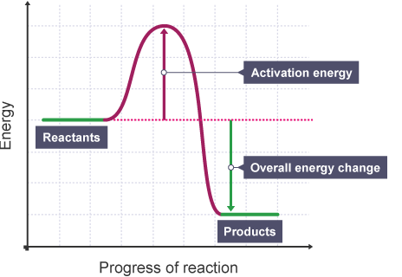

Reaction profile - endothermic reaction:  
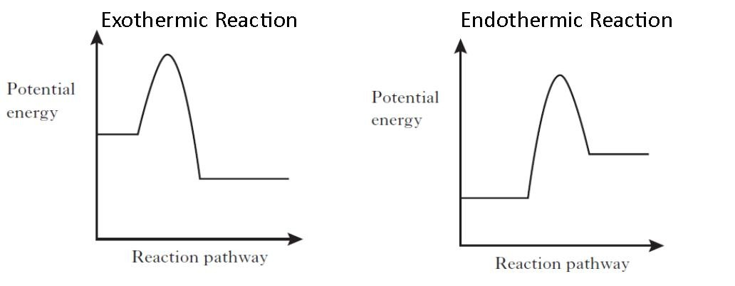

Understanding and Explaining

1. Are these exothermic or endothermic reactions?

|  |  |  |  |  |  |  |
| --- | --- | --- | --- | --- | --- | --- |
| Initial Temp (⁰C) | Final Temp (⁰C) | Exothermic or endothermic? |  | Initial Temp (⁰C) | Final Temp (⁰C) | Exothermic or endothermic? |
| 56 | 80 | Exothermic |  | 99 | 200 | Exothermic |
| 45 | 22 | Endothermic |  | 23 | 26 | Exothermic |
| 65 | 65 | No reaction |  | 30 | 10 | Endothermic |
| 70 | 21 | Endothermic |  | 18 | 25 | Exothermic |

1. Complete the paragraph by selecting the correct key word:

In chemical reactions, atoms are rearranged as old bonds are broken and new BONDS are made. For bonds to be broken, reacting particles must COLLIDE with enough ENERGY. The minimum amount of energy that the particles must have for the reaction to take place is called the ACTIVATION ENERGY. The energy changes in a chemical reaction can be shown using an ENERGY LEVEL DIAGRAM or REACTION profile.  
**reaction energy level diagram bonds energy collide activation energy**

1. Link the reaction to the descriptions by matching two descriptions to each name.

Temperature of the surroundings increases.

Exothermic - More energy is needed to make new bonds than break old bonds.

Temperature of the surroundings decreases

Endothermic - More energy is needed to break old bonds than make new bonds.

1. What can be used to reduce the activation energy needed for a reaction? Show what this looks like on a reaction profile.   
   A catalyst 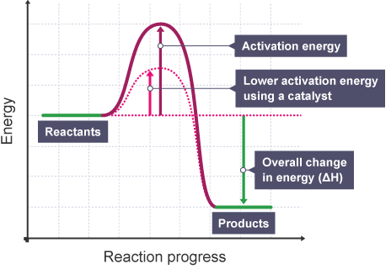

**Chemistry Revision: Rates of reaction and collision theory**

Understanding and Explaining

1. Describe how you can measure the amount of reactant used in a chemical reaction:   
   If one of the products is a gas, measure the mass in grams of the reaction mixture before and after the reaction takes place and the time it takes for the reaction to happen.   
   The mass of the mixture will decrease  
   The units for rate of reaction may then be given as g/s
2. Describe how you can measure the amount of products formed:

If one of the products is a gas, measure the total volume of gas produced in cm3 with a gas syringe and the time it takes for the reaction to happen.

The units for the rate of reaction may then be given as cm3/s

1. Describe how you can measure the time it takes for a reaction mixture to change colour:  
   Time how long it takes for a reaction mixture to change colour.  
   Rate of reaction= ___________1_____________  
    time taken for solution to change colour
2. Describe how the following factors affect the rate of reaction:  
   a) temperature: the higher the temperature, the faster the rate of reaction. This is because the particles move quicker, collide more often and with greater energy.

b) concentration: The higher the concentration, the faster the rate of reaction. This is because the particles are crowded closer together, they collide more often, so there are more successful collisions.

c) surface area: the larger the surface area (e.g. smaller pieces), the faster the rate of reaction. This is because more particles are exposed and available for collisions, so there are more collisions.

d) catalyst: a catalyst increases the rate of reaction. This is because it reduces the amount of energy needed for a successful collision, which makes more successful collisions, which in turn speeds up the reaction.

1. Calculate the mean rate of reaction of 24cm3 of hydrogen gas is produced in 2 minutes.  
   Mean rate of reaction= amount of product formed  
    time taken

= __24___

120 (2 x 60 as minutes need converting to seconds)

mean rate of reaction= 0.2cm3/s

Mastery Matrix Points

|  |
| --- |
| Calculate the mass of solute in a given volume of solution |
| Describe how the rate of a chemical reaction can be found |
| Use collision theory to explain how factors affect the rate of reactions. |

Key Knowledge

Conservation of mass: in a chemical reaction, the total mass of the products is equal to the total mass of the reactants

In some situations, it may *appear* that mass it lost- when might this be? When a gas is released

How to calculate the mean rate of reaction:

1. Mean rate of reaction=   
   amount of reactant used   
    time taken
2. Mean rate of reaction=   
   amount of product formed  
    time taken

Name the 4 factors that affect the rate of reaction:

1. Volume
2. Concentration
3. Surface area
4. Pressure

How to convert:

cm3 to dm3 – divide by 1000

dm3 to cm3 – multiply by 1000

Sketch a graph to show 2 reactions, A and B. Reaction A is faster than reaction B.

A

B