**Biology Revision: DNA & Inheritance**

Mastery Matrix Points

|  |
| --- |
| Describe the structure of DNA |
| Explain what the human genome is and the importance of mapping it |
| Use genetic crosses to predict outcomes of a monohybrid cross |

Key Knowledge:  
**DNA:**

Genome – *the entire* genetic material *of that organism*

DNA – the genetic material found in the nucleus of a cell, *made up of two strands forming a DOUBLE HELIX*

Chromosomes –*Humans have 23 pairs.*

Gene – *A SECTION OF DNA, CODES FOR CHARACTERISTICS*

Each gene codes for: A SEQUENCE OF AMINO ACIDS to make a specific protein  
  
**Inheritance:**   
Allele: A DIFFERENT FORM OF THE SAME GENE

Dominant: ALWAYS EXPRESSED   
   
Recessive: EXPRESSED ONLY WITH TWO OF THE SAME ALLELES  
  
Homozygous: TWO OF THE **SAME** ALLELES e.g. BB  
  
Heterozygous: TWO DIFFERENT ALLELES e.g. Bb  
  
Genotype: THE TWO ALLELES PRESENT E.G. BB

Phenotype: THE CHARACTERISTIC EXPRESSED E.G. BLUE EYES

Understanding and Explaining

1. *Label the following diagram:*

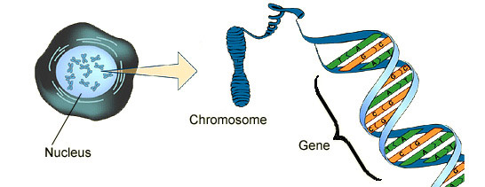

1. The whole human genome has now been studied. Suggest some important uses for this in the future (at least 2):

Locating disease causing genes  
Treating inherited disorders  
Tracing human migration patterns.

1. Describe the structure and function of DNA, word fill.

DNA is a POLYMER with a double HELIX shape that contains the instructions for making PROTEINS. DNA is made from 4 different nucleotides/bases: A, T, C AND G. Each nucleotide consists of a common SUGAR and PHOSPHATE group with one of four different bases attached to the sugar.   
**Phosphate 4 Sugar Polymer Protein Helix A T C G**

1. Draw a genetic cross to show the likelihood of:   
   a) Cystic fibrosis is a recessive genetic disorder, both parents are carriers of the disease. What is the % likelihood of a child having this disease? 25% chance of the child having cystic fibrosis

-Complete the punnett square and circle the child with cystic fibrosis.

|  |  |  |
| --- | --- | --- |
|  | *F* | *f* |
| *F* | *FF* | *Ff* |
| *f* | *Ff* | *ff* |

1. b) The allele for green peas (G) is dominant over the allele for white peas (g). Draw a Punnett square to show the possible offspring when a heterozygous green pea mates with a white pea.  
   Percentage green peas: 25% Percentage white peas: 75%

|  |  |  |
| --- | --- | --- |
|  | *G* | *g* |
| *g* | *Gg* | *gg* |
| *g* | *gg* | *gg* |

**Biology Revision: Reproduction**

Mastery Matrix Points

|  |
| --- |
| Explain the process of sexual reproduction and link this to variation |
| Explain the process of meiosis which leads to the formation of gametes |
| Explain the process of asexual reproduction |
| Model the behaviour of chromosomes during meiosis |

Key Knowledge:

Sexual reproduction:  
 – number of parents involved: two  
- involves the joining of gametes (male and female sex cells)

- Advantage (s):  
produces variation  
  
- Organisms that reproduce sexually: Humans (sperm and egg cell)  
Flowering plants (pollen and egg cell)

Asexual reproduction   
– number of parents involved: 1

- Advantage: faster/ more efficient than sexual as only one parent needed.  
  
Organisms that reproduce asexually: Strawberry plants, daffodils

Variation – Differences

Mitosis:  
- is used for growth and repair  
- produces 2 genetically identical daughter cells.

Meiosis:  
- is used for making gametes  
- produces 4 genetically **different daughter cells.**

What are the 2 gametes in animals?

Sperm (male) and Egg cell (female)

What are the 2 gametes in flowering plants?  
Pollen (male) and Egg cell (female)

Understanding and Explaining

1. What is the cell division that produces gametes? Meiosis
2. What is the cell division that enables the embryo to grow? Mitosis
3. Which type of *reproduction* is mitosis involved in? Asexual reproduction only.
4. Complete the summary paragraph on meiosis using the **key words** below:   
   Meiosis produces GAMETES. A human body cell contains 46 chromosomes (arranged in 23 pairs). The gametes are SPERM or EGG CELL and only contain 23 chromosomes (half the amount). At FERTILISATION, the NUCLEUS of the sperm and egg join, thereby restoring the full number of 46 CHROMOSOMES for all body cells.

**Chromosomes Fertilisation Nucleus 23 46 23 Gametes Sperm Egg**

1. Compare mitosis and meiosis.

|  |  |
| --- | --- |
| Mitosis | Meiosis |
| Produces genetically identical cells | Produces different identical cells |
| Produces 2 daughter cells | Produces 4 daughter cells |
| Involved in asexual reproduction | Involved in sexual reproduction |
| Is used for growth and repair | Is used for making gametes |

**Biology Revision: Ecosystems and interdependence**

Key Knowledge

Ecosystems – Interaction of a community of living organisms with non-living parts of the environment

Interdependence – Species compete and rely on each other

Extremophile- Organisms that live in extreme environments

Species depend on each other for:

1. Food
2. Shelter
3. Pollination
4. Seed dispersal

|  |  |
| --- | --- |
| **Competition** | |
| **Animals** | **Plants** |
| Food | Light |
| Mates | Water |
| Territory | Space |
|  | Mineral/ions |

|  |  |  |
| --- | --- | --- |
| **Adaptations** | Definition | Example |
| Structural | Physical feature | Long tail for balance |
| Behavioural | Exhibited behaviour | Mating dance |
| Physiological/  functional | Body process | Plants photosynthesise |

|  |  |
| --- | --- |
| **Biotic factors** | **Abiotic factors** |
| Availability of food | Light intensity |
| New predators | Temperature |
| New pathogens | Moisture levels |
| Species competition | Soil pH |
|  | Wind intensity |
|  | CO2 level |
|  | O2 level |

Mastery Matrix Points

|  |
| --- |
| Define “ecosystem” and ‘’interdependence’’ |
| Describe what plants and animals ‘compete’ with each other for |
| Describe structural, behavioural and functional adaptations of organisms |
| Define extremophiles linking to the conditions that they inhabit (bacteria in deep sea vents) |
| Interpret data from graphs and tables relating to predator and prey relationships predicting numbers of species based on changes in this data |
| List biotic and abiotic factors and explain how changes in them would affect a given community |
| Define primary, secondary and tertiary consumers |
| Use a range of experimental methods to calculate the abundance and distribution of species in a given ecosystem |

1. **Draw** a food chain for Lion, Zebra, Grass.

**Grass --> Zebra --> Lion**

Understanding and Explaining

1. **Describe** the trend in the predator prey diagram using the key words: **Increase, decrease, predator, prey, cycle**

As the number of prey begins to increase the number of predators also increase. Over time the number of prey then begin to decrease and the number of predators then also decrease in a constant cycle.

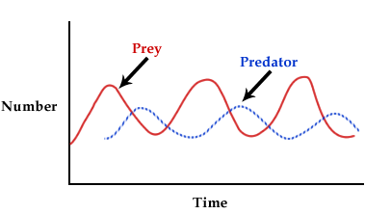

1. **Complete the following:**

A Quadrat can be used to estimate the *population* of a species. To do this the quadrat must be placed at random on the ground. The number of species inside the quadrat must be counted. This must be repeated a number of times and a mean number of species calculated. The area of the habitat should be divided by the area of the quadrat and multiplied by the mean number of species.

To estimate the *distribution* of species a transect line must be used. It must be place across an area and a quadrat must be placed along it at regular intervals. Then the number of species must be counted in each quadrat. This must be repeated in regular intervals across the entire transect line.

|  |  |
| --- | --- |
| **Key Definitions: Interdependence** | |
| Quadrat | Square frame used to sample organisms in their environment |
| Transect | A fixed line used to sample populations and their distribution |
| Predator | An animal that hunts and kills and eats other animals |
| Prey | An animal that is hunted and killed by a predator |
| Primary consumer | Organisms that eat producers |
| Secondary consumer | Organisms that eat primary consumers |
| Tertiary consumer | Organisms that eat secondary consumers |
| Herbivore | An animal which eats only producers |
| Carnivore | An which eats only other consumers |
| Omnivore | An animal that eats both consumers and producers |

**Biology Revision: Natural Selection, Evolution, selective breeding, genetic engineering**

Understanding and Explaining

1. **Describe** how bacteria become resistant to antibiotics using the key words: Natural selection, reproduce, mutated, survive, randomly

Some bacteria will reproduce at a fast rate and random mutations will occur. Some mutated bacteria are resistant and survive. These resistant bacteria then reproduce rapidly and pass on the antibiotic resistant gene until there is a whole strain of antibiotic resistant bacteria. This is called natural selection.

1. **Describe two** pieces of evidence for the theory of evolution by natural selection.

(i)_Fossils show evolution over a long time

(ii) Genes show that characteristic are passed from generation to generation

1. **Complete** the following:

Scientists use fossils to look at how organisms gradually change over time.

However, there are gaps in the fossil record which means we cannot use them as evidence for how life began because many early life forms were soft bodied and left few traces behind. Traces that were left may have been destroyed by geological activity,

1. **Complete** the following:

Selective breeding would could be used to produce cows with more meat by choosing parents with desired characteristic and breeding them together. The offspring produced with the most desired characteristic are chosen to breed again. This process is continued over many generations.

1. **Evaluate** the advantages and disadvantages of genetic engineering

There are many advantages of genetic engineering, these include creating large quantities of insulin to treat diabetes, It can help produce golden rice increasing vitamin A content. Plant crop yields can increase and more food can be produced.

However, the disadvantages of genetic engineering are they could have long term effects on human health and the population of wild flowers and insects. It could also cross contaminate wild plants. In addition to this genetically modified organisms are expensive.

Key Knowledge

Define:

Evolution- theory of natural selection

* Variation
* Sexual reproduction
* Mutations
* Survive
* Reproduce
* Genes (offspring)
* Evolution

|  |
| --- |
| **Four ways fossils are formed:** |
| Hard parts of animals that don’t decay |
| Animal hasn’t decayed as wrong conditions |
| Parts of organism replaced during decay |
| Preserved traces of organisms e.g. footprints |

Extinction- When a species completely dies out

Two factors the lead to extinction:

1. New predators/diseases
2. Catastrophic event/competition

Selective breeding – Breeding process used by scientists/farmers to produce organisms with desired characteristics

Five uses of selective breeding

- Animals producing more milk

- Large/unusual flowers

- Domestic dogs with gentle nature

- Disease-resistant crops

- Animals with more meat

Genetic engineering – A process which involves modifying the genome of an organism by introducing a gene with the desired characteristic.

Uses of genetic engineering

- Plants resistant to disease

- Producing insulin

- Produce plants with bigger and better fruits

Mastery Matrix Points

|  |
| --- |
| Describe and explain the theory of ‘natural selection’ and ‘evolution’ |
| Describe the evidence for evolution including antibiotic resistant and the fossil record |
| Describe what a fossil is and explain how they form and explain why these cannot be used as evidence for how life began on Earth |
| Interpret information from evolutionary trees |
| Explain what extinction is and describe factors which may contribute to the extinction of a species |
| Describe selective breeding and explain the potential benefits and risks of this process (linking to disease resistance in crops, animals with more milk and meat, large or unusual flowers and domestic dogs with a gentle nature) |
| Define ‘genetic engineering’ |
| Give examples of genetic engineering (including crop resistance to diseases, insect attack and herbicides, crops with bigger, better fruits and bacterial cells used in the production of insulin) |
| Evaluate the use of genetic engineering and modification and describe the potential uses of this in the future |

**Biology Revision: The Endocrine**

Mastery Matrix Points

|  |
| --- |
| Describe the principals of hormonal coordination including what makes up the endocrine system |
| Describe what hormones are and label six glands in the body |
| Describe the role of the pituitary gland |
| Describe and explain how the body controls blood glucose concentration (making reference to glucose, glycogen, glucagon, negative feedback cycle, insulin and the pancreas) |

Key Knowledge

Endocrine system – MADE UP OF GLANDS THAT SECRETE HORMONES INTO THE BLOOD STREAM

Hormones – CHEMICAL MESSENGERS CARRIED IN THE BLOOD TO A TARGET ORGAN WHERE THEY PRODUCE AN EFFECT

How are hormones transported? IN THE BLOOD

Gland- AN ORGAN THAT RELEASES A HORMONE INTO THE BLOODSTREAM

Name six glands in the human body:

- PITUITARY

- THYROID

-ADRENAL

-TESTES (MALE)

-OVARY (FEMALE)

-PANCREAS

Which gland is known as the ‘master gland’?

PITUITARY GLAND

Type 1 diabetes can be treated with: INSULIN INJECTIONS.

Type 1 diabetes can be treated with: REGULAR EXERCISE AND A CONTROLLED DIET.

**System**

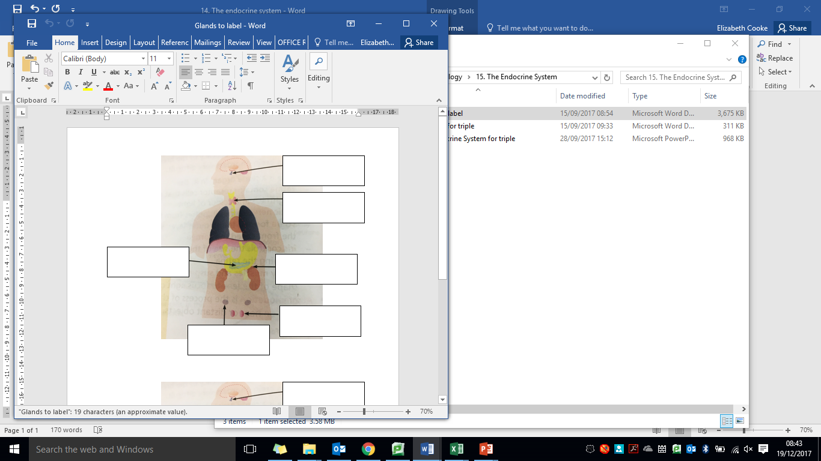

Pancreas

Ovary (female)

Testes (male)

Adrenal gland

Thyroid gland

Pituitary gland

Electrical impulse

Along neurones

Neurones, brain, spinal cord

Fast

Short

Reflex actions, thermoregulation

Chemical

In the blood

Glands

Slower

Longer

Blood glucose, menstrual cycle

Understanding and Explaining

1. Complete the table comparing hormonal and nervous responses: 2. Label the glands on the diagram below.



1. Explain how the body controls the concentration of glucose in the blood if it’s *too high*. Use the key words: **pancreas, insulin, glucose, blood, cells.**If the blood glucose concentration is too high:  
   - the pancreas releases more insulin  
   - insulin causes glucose to move out of the blood and into cells  
   - in liver and muscle cells, excess glucose is converted (to glycogen) for storage
2. Why is the pituitary gland called the master gland?

**Biology Revision: The Nervous**

Mastery Matrix Points

|  |
| --- |
| Describe the structure of the nervous system |
| Explain how it is adapted for its function and why it is important |
| Describe the pathway of a message from stimulus to response |
| Describe the design of a reflex arc and explain its purpose |
| Use tables and graphs to extract information about reflex actions |
| **RP Reaction Time:** Plan and carry out an investigation into the effect of a factor on human reaction time |

Key Knowledge

The nervous system – enables humans to react to their surroundings and coordinate their behaviour

CNS (Central nervous system) – Spinal cord and brain

Three types of neurones –   
Sensory  
Relay  
Motor

Effector- a muscle/ gland

Synapses – gaps between neurones

Reflex action- Are automatic and rapid

They are important so they can protect the body.

How does the message travel (your answer will either be: chemical messenger or electrical impulse) in:

1. The sensory neurone: Electrical impulse
2. Synapses: chemical messenger
3. The relay neurone: Electrical impulse
4. The motor neurone: electrical impulse

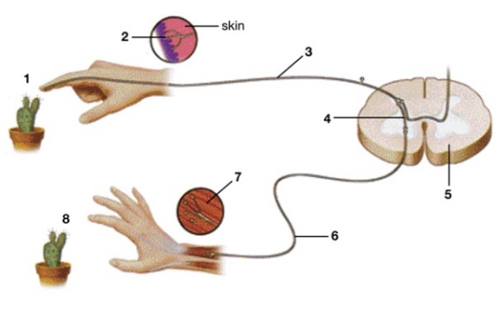**System**

Understanding and Explaining

1. Lizzy has touched a prickly cactus and withdraws her hand immediately. Label the path of the reflex response in the diagram to the right using the **key** words: **Effector Stimulus Motor neuron Sensory neuron Relay neuron Receptor**  
   1- _Stimulus (cactus)  
   2- Receptor (skin)  
   3- Sensory neuron  
   4- Relay neuron_  
   5- Spinal cord (CNS)  
   6- Motor neuron   
   7- Effector (muscle in the hand)  
   8- Response- takes hand away
2. Which type of neuron is responsible for:   
   Carrying an electrical impulse from the CNS to an effector: Motor neuron   
   Carrying an electrical impulse from one part of the CNS to another: Relay neuro  
   Carrying an electrical impulse from the receptor to the CNS: Sensory neuron
3. Describe how the message is transmitted across a **synapse.**   
   When an electrical impulse reaches a synapse, a chemical is released that diffuses across the gap between two neurones. This causes an electrical impulse to be generated in the second neuron.
4. Write a **method** for how to investigate if caffeine affects reaction time. Use the key words:   
   **Ruler test, subjects, caffeine, no caffeine,**   
   The experimenter holds a metre ruler vertically from the end  
   The subject has their finger and thumb a small distance apart, either side of the ruler at 0cm.  
   The experimenter lets go of the ruler and the subject traps it as quickly as possible.   
   The distance the ruler travels from the 0cm line is recorded.  
   The experiment is repeated on subjects that have just drunk coffee/ coke **and** subjects that have not.

**Biology Revision: Homeostasis**

Mastery Matrix Points

|  |
| --- |
| Define ‘homeostasis’ and explain why it is important |
| List three factors controlled by homeostasis in the human body (blood glucose concentration, temperature, water levels) |
| Explain how these automatic systems are controlled |

Key Knowledge

Homeostasis – the maintenance of a CONSTANT, INTERNAL ENVIRONMENT

Homeostasis is important because it maintains optimal (the best) conditions for: ENZYME ACTION and CELL FUNCTION

Three things that are controlled in the body

- BLOOD GLUCOSE concentration

- BODY temperature

- WATER levels

Define the key terms: All control systems in the body contain

- Receptors: DETECT STIMULI (CHANGES IN THE ENVIRONMENT)

- Coordination centres :E.G. BRAIN AND SPINAL CORD, PANCREAS- RECEIVE AND PROCESS INFO FROM RECEPTORS

- Effectors: MUSCLES OR GLANDS, BRING ABOUT RESPONSES WHICH RESTORE OPTIMAL LEVELS.

Examples:

How the body keeps water levels constant:

- DRINKING

- URINATING

- BREATHING

- SWEATING

How the body keeps warm:

- MUSCLES CONTRACTING/ SHIVERING

Understanding and Explaining

1. For each response, circle the correct Receptor, Co-ordination centre and Effector:

|  |  |  |  |
| --- | --- | --- | --- |
| **Response** | **Receptor** | **Co-ordination centre** | **Effector** |
| Temperature | Pancreas/ hypothalamus | Thermoregulatory centre in the brain/ pancreas | Blood vessels, sweat glands and skeletal muscles/ liver and muscle cells |
| Blood glucose levels | Pancreas/ hypothalamus | Thermoregulatory centre in the brain/ pancreas | Blood vessels, sweat glands and skeletal muscles/ liver and muscle cells |

1. What is the temperature of the human body?

37 DEGREES CELCIUS

1. Why is a constant body temperature important?   
   ENZYMES CONTROL CHEMICAL REACTIONS IN THE BODY AND WORK BEST AT 37 ºC. IF THE BODY GETS TOO HOT OR TOO COLD, THE ENZYMES STOP WORKING AND THESE VITAL CHEMICAL REACTIONS SLOW DOWN
2. During homeostasis, are responses nervous or hormonal? Explain your answer using examples.

REPONSES ARE BOTH NERVOUS AND HORMONAL. E.g.   
Hormonal: maintaining blood glucose levels  
Nervous:

**Biology Revision: Hormones in the**

Mastery Matrix Points

|  |
| --- |
| Describe the roles of FSH, LH, Oestrogen and progesterone in the menstrual cycle |
| Describe the roles of oestrogen and progesterone in puberty |
| Link hormone cycles to ovulation and menstruation |
| Evaluate hormonal and non-hormonal methods of contraception (oral, injection, implant, skin patch, condoms, diaphragms, intrauterine device, spermicidal agents, abstinence, sterilisation) |
| Explain why issues around contraception are not answered solely by the field of Science |
| Explain the process of embryo screening and evaluate based on ethical, social and economic perspectives |

Key Knowledge

During puberty reproductive hormones cause SECONDARY SEX CHARACTERISTICS to develop

**Male hormones**

Testosterone – PRODUCED BY THE TESTES AND STIMULATES SPERM PRODUCTION

**Female hormones**

|  |  |
| --- | --- |
| Hormone | Roles: |
| FSH | Causes egg to mature in the ovaries |
| LH | Stimulates release of an egg from the ovary (ovulation) |
| Oestrogen | Makes the lining of the uterus grow again after menstruation |
| Progesterone | Maintains lining of uterus during the second half of the cycle |

Ovulation is the release of an egg

Ovulation happens about every 28 days.

Hormonal contraceptive methods include…

Oral contraceptives, injection, implant or skin patch

Non-hormonal contraceptive methods include…  
Condom and diaphragm, IUD, spermicidal creams

**Reproductive System**

Understanding and Explaining

1. Main female hormone and role: Oestrogen. Role: makes the lining of the uterus grow after menstruation

Main male hormone and role: Testosterone: stimulates sperm production.

1. Which organ secretes FSH and LH? Pituitary gland
2. Which hormone causes the release of an egg from the ovaries? Luteinising hormone (LH)
3. Describe how oral contraceptives work. Use the **key** terms: **hormones, reduce fertility, FSH, egg, mature**

Oral contraceptives contain hormones which inhibit (stop) FSH production. This is so that no egg mature and therefore a sperm cell cannot fertilise the egg cell.

1. Compare oral contraceptives methods to barrier methods such as the condom.

Oral contraceptives contain hormones, whereas barrier methods such as condoms, do not contain any hormones. Barrier methods form a physical barrier to stop the sperm cell from reaching the egg cell.