OASB Science Department
Biology Paper 1 Revision Pack (Double - FT)
Name: ___________________________________

Contents | Lesson
Mastery Matrix Biology Paper 1
Knowledge | 1
Types of cells and Microscopy Summary Page
Notes page
Exam Questions
Knowledge | 2
Mitosis and Meiosis Summary Page
Notes page
Exam Questions
Knowledge | 3
Pathogens and Disease Summary Page
Notes page
Exam Questions
Knowledge | 4
Preventing pathogens from making us unwell & developing new medicines Summary Page
Notes page
Exam Questions
Knowledge | 5
Using & interpreting data Summary Page
Notes page
Exam Questions
Knowledge | 6
Breathing and respiration and blood and the heart Summary Page
Notes page
Exam Questions
Knowledge | 7
Digestion and The Transport Systems (Diffusion, Digestion and Active Transport) Summary Page
Notes page
Exam Questions
Knowledge | 8
Photosynthesis Summary Page
Notes page
Exam Questions

Topic | Tier | Revision Guide | Learning statement
Types of cell | F | 16 | Describe the structure of plant, animal and bacteria cells, classifying as prokaryotic and eukaryotic cells.
Types of cell | F | 16 | Identify and explain the functions of sub-cellular structures
Types of cell | F | 20 | Describe the difference between ‘cell differentiation’ and ‘cell division’
Types of cell | F | 24 | Describe how cells are specialised and explain their roles (animal cells: sperm cells, nerve cells, muscle cells. Plant cells: root hair, xylem and phloem).
Types of cell | F | 25 | Define ‘tissue’, ‘organ’ and ‘organ system’ and explain how they work together to create a functioning ‘organism’
Microscopy | F | 18 | Compare and contrast electron and light microscopes
Microscopy | F | 18 | Define ‘magnification’ and ‘resolution’
Microscopy | F | 19 | Calculate magnification using a formula (magnification = size of image ÷ size of real object)
Microscopy | F | 18 | Explain how electron microscopy has improved our understanding of subcellular structures
Microscopy | F | 18 | Define and apply the prefixes ‘centi’, ‘milli’, ‘micro’ and ‘nano’
Microscopy | F | 19 | RP Microscopy: Use a light microscope to observe, draw and label a selection of plant and animal cells. A scale magnification must be included.
Cell division (mitosis) | F | 20 | Define, locate and rank in terms of size, ‘Genes’, ‘Chromosomes’, ‘DNA’ and ‘nucleus’
Cell division (mitosis) | F | 20 | Explain the process of ‘mitosis’ and the ‘cell cycle’ (when, where, how and why)
Cell division (mitosis) | F | 21 | Describe what stem cells are, where they can be found and how the can be used
Cell division (mitosis) | F | 21 | Explain the process of ‘therapeutic cloning’
Cell division (mitosis) | F | 21 | Evaluate the risks and benefits, including the social and ethical implications, of using stem cells in treatments
Cell division (mitosis) | F | 21 | Explain how plants can be cloned from stem cells and the benefits of doing this
Introducing pathogens and types of disease | F | 30 | Define ‘health’
Introducing pathogens and types of disease | F | 30 | List factors that affect mental and physical health
Introducing pathogens and types of disease | F | 40 | Define ‘pathogens’ and explain the difference between ‘communicable’ and ‘non-communicable’ diseases
Introducing pathogens and types of disease | F | 40 | Explain how ‘viruses’, ‘bacteria’, ‘protists’ and ‘fungi’ are spread in animals and plants
Introducing pathogens and types of disease | F | 41 | Describe the how bacteria and virus cause problems within the body
Introducing pathogens and types of disease | F | 42 | State 4 ways to reduce or prevent the spread of communicable diseases
Detailed disease case studies | F | 40 | Describe three viral diseases in details – the effects, how they are spread, how people are trying to reduce its impact (Measles, HIV and Tobacco Mosaic Virus)
Detailed disease case studies | F | 41 | Describe two bacterial diseases in detail – the effects, how they are spread, how people are trying to reduce its impact (Gonorrhoea and Salmonella)
Detailed disease case studies | F | 41 | Describe one fungal disease in detail – the effects, how it is spread, how people are trying to reduce its impact (Rose Black Spot)
Detailed disease case studies | F | 41 | Describe one protist disease in detail – the effects, how it is spread, how people are trying to reduce its impact (malaria)
Preventing pathogen from making us unwell | F | 42 | Describe how the body prevents entry of pathogens into the body
Preventing pathogen from making us unwell | F | 43 | Describe how the immune system tackles pathogens once they have made it into the body (phagocytosis, antibody production and antitoxin production)
Preventing pathogen from making us unwell | F | 43 | Explain how vaccines work
Preventing pathogen from making us unwell | F | 43 | Discuss the global use of vaccination in the prevention of disease
Preventing pathogen from making us unwell | F | 44 | Explain the use of antibiotics and other medicines
Developing new medicines | F | 44 | Describe how bacteria have developed resistance to antibiotics – in particular MRSA (and use this as an example of evolution)
Developing new medicines | F | 44 | Explain the issues with the development of new antibiotics in the race against antibiotic resistance and what we can do as a society to reduce the rate of development of antibiotic resistance bacteria (linking to medicine and agriculture)
Developing new medicines | F | 45 | Describe how many new drugs are still developed from plants and microorganisms (including digitalis and aspirin)
Developing new medicines | F | 45 | Explain how preclinical and clinical trials are used to test new drugs (including tests for safety, effectiveness, toxicity and dosage)
Developing new medicines | F | 44 | Compare and contrast painkillers and antibiotics
Developing new medicines | F | 44 | Explain the benefits and drawbacks of antibiotics and limitations of antivirals
Using and interpreting data | F | 30 | Describe situations where types of diseases interact (poor physical health, viruses causing cancer, pathogens -> allergic reactions, immune system defects -> more susceptible to infectious disease)
Using and interpreting data | F |  | Translate numerical information between tables and graphs
Using and interpreting data | F |  | Construct and interpret bar charts and histograms
Breathing and respiration | F | 48 | Describe the purpose of cellular respiration, recalling the word & symbol equation for aerobic respiration
Breathing and respiration | F | 48 | Explain how the body responds to exercise in terms of heart rate, breathing rate and breath volume
Breathing and respiration | F | 49 | Explain when anaerobic respiration occurs in humans and recall the word equation for this process
Breathing and respiration | F |  | Explain anaerobic respiration in yeast, recalling the word equation for this process
Breathing and respiration | F | 49 | Describe how this process of anaerobic respiration (fermentation) is used by humans in the manufacturing industry
Breathing and respiration | F | 29 | Label the structure and describe the function of the human lungs (including how they are adapted for gaseous exchange)
Blood and the heart | F | 29 | Describe the structure and function of the human heart
Blood and the heart | F | 29 | Describe the roles of the four blood vessels associated with the heart
Blood and the heart | F | 28 | Describe the 3 different types of blood vessel in the body and their structure
Blood and the heart | F |  | Carry out rate calculations for blood flow
Blood and the heart | F | 29 | Describe how our body controls our natural resting heart rate
Blood and the heart | F |  | Describe the composition of blood and know the functions of each of the components
Blood and the heart | F |  | Draw blood cells from under a microscope and recognise different types of blood cells from a photo or diagram, explaining how they are adapted to their functions
Blood and the heart | F | 31 | Describe coronary heart disease
Blood and the heart | F | 31 | Describe what a ‘stent’, ‘statin’, ‘mechanical/biological valve replacement’, ‘pacemaker’ and ‘transplant’ are
Blood and the heart | F | 31 | Evaluate the advantages and disadvantages of treating cardiovascular diseases using drugs, mechanical devices or transplants
Blood and the heart | F |  | Evaluate risks associated with the use of blood products
Interpreting disease data | F |  | Construct and interpret frequency tables and diagrams
Interpreting disease data | F | 30 | Apply the techniques of scientific sampling to disease incident information
Interpreting disease data | F | 31 | Discuss the human and financial cost of non-communicable diseases (individual, local community, national and global level)
Interpreting disease data | F | 31 | Describe the causal mechanisms of some risk factors for non-communicable diseases (causes of: cardiovascular disease, type 2 diabetes, brain and liver function, lung disease and lung cancer, cancers and foetal damage) including the effects of diet, alcohol and smoking
Interpreting disease data | F |  | Use a scatter diagram to identify a correlation between two variables (linking to disease incidence)
Digestion | F | 26 | Describe what the digestive system is
Digestion | F | 26 | Explain the role of enzymes in the digestive system making reference to ‘lock and key’
Digestion | F | 26 | Explain how carbohydrates, proteins and lipids are synthesised, broken down and used, making reference to sugars, amino acids, fatty acids and glycerol
Digestion | F | 27 | Link carbohydrase (amylase), protease, lipase & bile to the breakdown of particular food groups, identifying where they are produced

Lesson 1 – Types of Cell and Microscopy
 | Topic: | Types of cell (9.3.1)
1 | Give an example of a eukaryote and prokaryote cell. | Eukaryotic cells - animal/plant,  Prokaryote cells - bacteria/archaea
2 | What is the function of cell wall? | Supports/ Strengthens the cell
3 | What is the function of mitochondria? | Where respiration takes place
4 | What is the function of the nucleus? | Controls the activities of the cell
5 | What is the function of chloroplasts? | Absorb light for photosynthesis
6 | What is the function of cytoplasm? | Where chemical reactions of the cell takes place
7 | What is the main difference between a prokaryotic cell and a eukaryotic cell? | Eukaryotic have their DNA contained within a nucleus

 | Topic: | Microscopy (9.3.2)
1 | How do you calculate the magnification? | magnification = size of image/size of object
2 | Which microscope has the highest magnification? | electron microscopes
3 | Which microscope has the lowest resolution? | Light microscope
4 | Which microscope shows black and white images? | Scanning and transmission electron microscope
5 | Which sub-cellular structures can you see with a higher resolution? | Mitochondria and ribosomes
6 | Define "tissue" | A group of similar specialised cells working together to fulfil a function
7 | Define "organ" | A group of different tissues working together to fulfil a function

Notes

Biology Revision: Types of Cell and
Mastery Matrix Points. Revision guide page- 16-18, 25
Describe the structure of plant, animal and bacteria cells, classifying as prokaryotic and eukaryotic cells.
Identify and explain the functions of sub-cellular structures
Describe the difference between ‘cell differentiation’ and ‘cell division’
Describe how cells are specialised and explain their roles (animal cells: sperm cells, nerve cells, muscle cells. Plant cells: root hair, xylem and phloem).
Define ‘tissue’, ‘organ’ and ‘organ system’ and explain how they work together to create a functioning ‘organism’
Compare and contrast electron and light microscopes
Define ‘magnification’ and ‘resolution’
Calculate magnification using a formula (magnification = size of image ÷ size of real object)
Explain how electron microscopy has improved our understanding of subcellular structures
Define and apply the prefixes ‘centi’, ‘milli’, ‘micro’ and ‘nano’
Required Practical 1: Use a light microscope to observe, draw and label a selection of plant and animal cells. A scale magnification must be included.
Compare and contrast electron and light microscopes

Microscopy
Key Knowledge- define the key words
Prokaryote cells – _____________

e.g. __________________________

Eukaryote cells – _____________

e.g. _____________

Cell differentiation - _____________

Cell division – _____________

Tissue – _____________

Organ – _____________

Organ System – _____________

Label the cells:

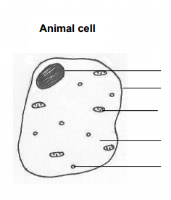

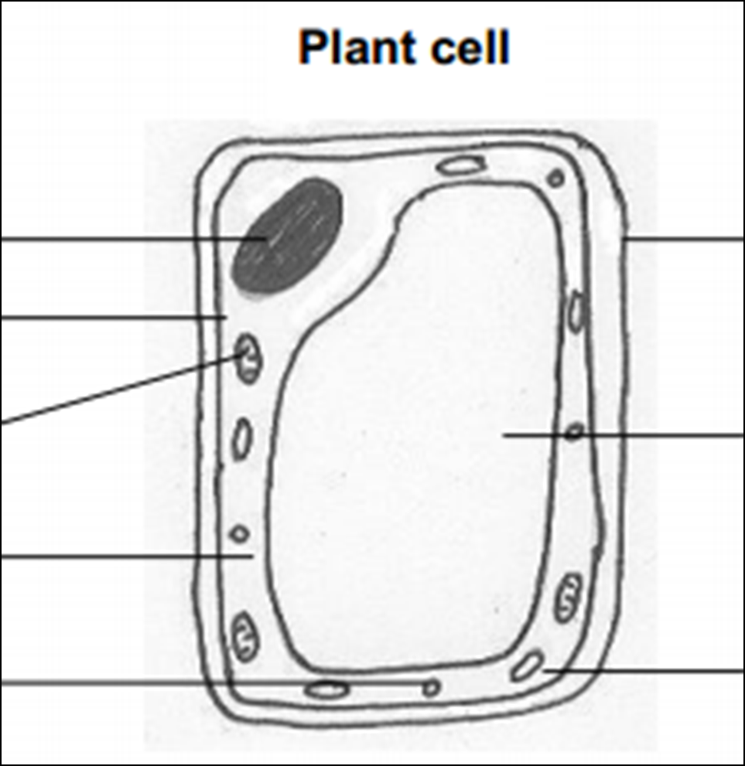
Definitions:
Magnification – _____________
Resolution – _____________
Equation:
Magnification =
Understanding and Explaining
Describe the structure of a bacteria cell: _____________________________________________________________

- Complete the table about the subcellular structures.
Subcellular structure | Plant, animal or both? | Function:
Nucleus
- Complete the table about specialised cells.
Cell | Function | Adaptations
Muscle
Sperm
Nerve
Root
Xylem
Phloem
- Name the type of microscope that gives the greatest resolution (allows us to see smaller sub-cellular structures):
________________________________________________
- Give one advantage and one disadvantage of light microscopes: ____________________________________
________________________________________________
- Give on advantage and one disadvantage of electron microscopes: ____________________________________
________________________________________________

Guided Exam Question
Q1. The image below shows some muscle cells from the wall of the stomach, as seen through a light microscope.
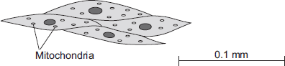
(a) Describe the function of muscle cells in the wall of the stomach.
___________________________________________________________________
___________________________________________________________________
___________________________________________________________________
___________________________________________________________________
(2)
(b) Figure above is highly magnified.
The scale bar in Figure above represents 0.1 mm.
Use a ruler to measure the length of the scale bar and then calculate the magnification of Figure above.
___________________________________________________________________
___________________________________________________________________
___________________________________________________________________
___________________________________________________________________
Magnification = _______________ times
(2)
(c) The muscle cells in Figure above contain many mitochondria.
What is the function of mitochondria?
___________________________________________________________________
___________________________________________________________________
___________________________________________________________________
___________________________________________________________________
(2)
(d) The muscle cells also contain many ribosomes. The ribosomes cannot be seen in Figure above.
(i) What is the function of a ribosome?
______________________________________________________________
______________________________________________________________
(1)
(ii) Suggest why the ribosomes cannot be seen through a light microscope.
______________________________________________________________
______________________________________________________________
(1)
(Total 8 marks)
Q2.
Diagrams A, B and C show cells from different parts of the human body, all drawn to the same scale.
A B C
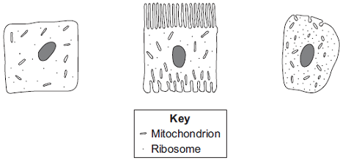
(a) Which cell, A, B or C, appears to be best adapted to increase diffusion into or
out of the cell?
Give one reason for your choice.
___________________________________________________________________
___________________________________________________________________
(1)
(b) (i) Cell C is found in the salivary glands.
Name the enzyme produced by the salivary glands.
______________________________________________________________
(1)
(ii) Use information from the diagram to explain how cell C is adapted for producing this enzyme.
______________________________________________________________
______________________________________________________________
______________________________________________________________
______________________________________________________________(2)
Lesson 2 Mitosis and Meiosis

 | Topic: | Cell division (mitosis) (9.3.4)
1 | Put in order of size (smallest to largest): genes, chromosomes, DNA, cell, nucleus | DNA, gene, chromosome, nucleus, cell
2 | Name the 3 stages of the cell cycle | Interphase, Mitosis, Cytokinesis
3 | Describe the three things that happen during interphase | 1) The cell grows, 2) chromosomes are copied, 3) more mitochondria and ribosomes are made
4 | Describe what happens during mitosis | Chromosomes pulled to opposite ends of the cell
5 | Describe what happens during cytokinesis | Cell membrane and cytoplasm split in two
6 | State why the cell cycle is important | More cells are made for growth and repair
7 | State what is produced in the cell cycle | Two genetically identical daughter cells
8 | Mitosis is used for… | Growth and repair

 | Topic: | Meiosis (9.3.5)
1 | Another word for sex cells is… | gametes
2 | State the 2 gametes in animals | Sperm & egg cells
3 | State the 2 gametes in flowering plants | Pollen & egg cells
4 | State the number of parents involved in sexual reproduction | 2
5 | State the number of parents involved in asexual reproduction | 1
6 | Describe the cells produced from meiosis | 4 genetically different daughter cells
7 | Meiosis is used for… | …making gametes
Notes

Biology Revision: Mitosis and meiosis
Mastery Matrix Points. Revision guide Pg 20-21
Define, locate and rank in terms of size, ‘Genes’, ‘Chromosomes’, ‘DNA’ and ‘nucleus’
Explain the process of ‘mitosis’ and the ‘cell cycle’ (when, where, how and why)
Describe what stem cells are, where they can be found and how the can be used
Explain the process of ‘therapeutic cloning’
Evaluate the risks and benefits, including the social and ethical implications, of using stem cells in treatments
Explain how plants can be cloned from stem cells and the benefits of doing this

Key Knowledge
Inside the nucleus is a chemical called _____. A length of DNA is called a _____. These genes make up ________. Humans have ____ pairs of chromosomes.

Definitions:
Mitosis - ________________________

Cell cycle – _______________________

Stem cell –_______________________

Therapeutic cloning - _______________

Stage of cell cycle | What happens?
Growth stage
Mitosis
Cytokinesis

3 places you would find stem cells
1. ________________________

2. ________________________

3. ________________________

Two conditions that might be cured by stem cells:
- ________________________
2, ________________________
D
C
B
A
Understanding and Explaining
- Label the diagram to show the following: DNA, nucleus, chromosome, gene
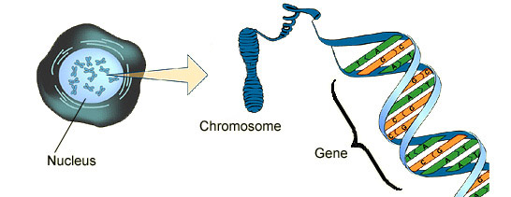 A = B= C= D=

- Chromosomes are found in ______ in the nucleus. There are ____ of these pairs. One from each pair is __________ (comes from) your _________ and one from each pair is ____________ (comes from) your ___________. In total, there are _____ chromosomes in the nucleus of every normal body cell. In the _________ (sex cells), there are only ____ because these cells are made by a process called ________, where the number of chromosomes is halved.

inherited, 23, mother, pairs, 23, father, 46, meiosis, inherited, gametes

- Complete the table below to compare mitosis and meiosis:
 | Meiosis | Mitosis
Cells produced
Number of chromosomes produced
Number of cell divisions
Number of daughter cells produced
Genetic information in daughter cells
Purpose

Guided Exam Question
Q3. (a) In humans there are two types of cell division: mitosis and meiosis.
The table below gives statements about cell division.
Tick () one box in each row to show if the statement is true for mitosis only, for meiosis only, or for both mitosis and meiosis.
The first row has been done for you.

Statement | Mitosis only | Meiosis only | Both mitosis  and meiosis
How cells are replaced
How gametes are made
How a fertilised egg undergoes cell division
How copies of the genetic information are made
How genetically identical cells are produced
(4)
(b) Stem cells can be taken from human embryos.
In therapeutic cloning, an embryo is produced that has the same genes as the patient.
(i) Name one source of human stem cells, other than human embryos.
______________________________________________________________
(1)
(ii) Stem cells from embryos can be transplanted into patients for medical treatment.
Give one advantage of using stem cells from embryos, compared with cells from the source you named in part (i).
(1)
______________________________________________________________
______________________________________________________________
(Total 6 marks)

Q4.Human cells and yeast cells have some parts that are the same.
(a) The diagram shows a yeast cell.
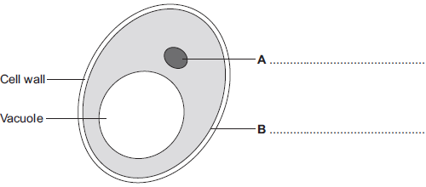
Parts A and B are found in human cells and in yeast cells. On the diagram, label parts A and B.
(2)
(b) Many types of cell can divide to form new cells.
Some cells in human skin can divide to make new skin cells.
Why do human skin cells need to divide?
___________________________________________________________________
___________________________________________________________________
(1)
(c) Human stem cells can develop into many different types of human cell.
(i) Use the correct answer from the box to complete the sentence.

embryos | hair | nerve cells
Human stem cells may come from
______________________________________________________________
(1)
(ii) Use the correct answer from the box to complete the sentence.

cystic fibrosis | paralysis | polydactyly
Human stem cells can be used to treat
______________________________________________________________
(1)
(Total 5 marks)

Q5.
A woman gives birth to triplets.
Two of the triplets are boys and the third is a girl.
The triplets developed from two egg cells released from the ovary at the same time.
The diagram shows how triplets A, B and C developed.
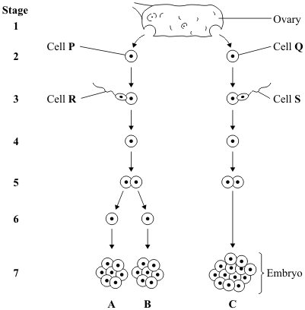
(a) Which stages on the diagram show gametes?
Draw a ring around your answer.
1 and 2 2 and 3 3 and 7 1 and 7
(1)
(b) Embryo B is male.
Which of the following explains why embryo B is male?
Tick () one box.

Cell P has an X chromosome; cell R has an X chromosome.
Cell P has a Y chromosome; cell R has an X chromosome.
Cell P has an X chromosome; cell R has a Y chromosome.
(1)
(c) The children that develop from embryos A and C will not be identical.
Explain why.
You may use words from the box in your answer.
egg genes sperm
___________________________________________________________________
___________________________________________________________________
___________________________________________________________________
(2)
(d) Single cells from an embryo at Stage 7 can be separated and grown in a special solution.
(i) What term describes cells that are grown in this way?
Draw a ring around your answer.
lleles screened cells stem cells
(1)
(ii) What happens when the cells are placed in the special solution?
Tick () two boxes.

The cells divide
The cells fertilise
The cells differentiate
The cells separate
(2)
(iii) Give one use of cells grown in this way.
______________________________________________________________
______________________________________________________________
(1)
(iv) Some people might object to using cells from embryos in this way.
Give one reason why.
______________________________________________________________
______________________________________________________________
______________________________________________________________
(1)
Q6.
Stem cells can be collected from human embryos and from adult bone marrow.
Stem cells can develop into different types of cell.
The table gives information about using these two types of stem cell to treat patients.

Stem cells from human embryos | Stem cells from adult bone marrow
It costs £5000 to collect a few cells. | It costs £1000 to collect many cells.
There are ethical issues in using embryo stem cells. | Adults give permission for their own bone marrow to be collected.
The stem cells can develop into most other types of cell. | The stem cells can develop into only a few types of cell.
Each stem cell divides every 30 minutes. | Each stem cell divides every four hours.
There is a low chance of a patient’s immune system rejecting the cells. | There is a high chance of a patient’s immune system rejecting the cells.
More research is needed into the use of these stem cells. | Use of these stem cells is considered to be a safe procedure.
Scientists are planning a new way of treating a disease, using stem cells.
Use only the information above to answer these questions.
(a) Give three advantages of using stem cells from embryos instead of from adult bone marrow.
1. _________________________________________________________________
2. _________________________________________________________________
3. _________________________________________________________________
(3)
(b) Give three advantages of using stem cells from adult bone marrow instead of from embryos.
1. _________________________________________________________________
2. _________________________________________________________________
3. _________________________________________________________________
(3)
(Total 6 marks)

Lesson 3 – Pathogens and Disease

 | Topic: | Introducing pathogens and types of disease
1 | Define "health" | State of physical and mental well being
2 | What is the name for a disease that can be passed on from person to person? | Communicable (or infectious)
3 | What is the name for a disease that can NOT be passed on from person to person? | Non-communicable
4 | State three factors other than disease that can have an impact on health | Diet, stress, life events
5 | State one risk factor for type 2 diabetes | Obesity
6 | What is the name given to a disease causing microorganism? | Pathogen
7 | Define "risk factors" | Factors that are linked to an increased rate of disease

 | Topic: | Detailed disease case studies
1 | Name 4 types of pathogen | Virus, bacteria, fungi, protist
2 | Name 3 viral diseases | Measles, HIV, TMV (tobacco mosaic virus)
3 | Name 2 bacterial diseases | Salmonella & Gonorrhoea
4 | Name 1 fungal disease | Rose black spot
5 | Name 1 protist disease | Malaria
6 | How is measles spread & prevented? | Spread: Air Prevented: Vaccination
7 | How is Gonorrhoea spread & prevented? | Spread: Sex Prevented: Condoms

Notes

Biology Revision: Pathogens and Disease
Mastery Matrix Points. Revision guide page 40-41
Define ‘health’
List factors that affect mental and physical health
Define ‘pathogens’ and explain the difference between ‘communicable’ and ‘non-communicable’ diseases
Explain how ‘viruses’, ‘bacteria’, ‘protists’ and ‘fungi’ are spread in animals and plants
Describe the how bacteria and virus cause problems within the body
State 4 ways to reduce or prevent the spread of communicable diseases
Describe three viral diseases in details – the effects, how they are spread, how people are trying to reduce its impact (Measles, HIV and Tobacco Mosaic Virus)
Describe two bacterial diseases in detail – the effects, how they are spread, how people are trying to reduce its impact (Gonorrhoea and Salmonella)
Describe one fungal disease in detail – the effects, how it is spread, how people are trying to reduce its impact (Rose Black Spot)

Understanding and Explaining
- Compare the structure and size of viruses and bacteria.
Bacteria are much _______ than viruses. Bacteria have p______ and chromosomal DNA inside of a cell w____ and a cell membrane, sometimes with a f__________ for transport. Viruses consist of a fragment of genetic information inside a protective p______ coat.

- Name 3 ways communicable diseases can be spread, and give an example of each:
- w________ e.g. ____________________________________________________________________
- a_____ e.g. _______________________________________________________________________
- t_________ e.g. ____________________________________________________________________

- Complete the table about the diseases.
Disease | Type of pathogen | How is it spread | How can it be prevented? | Can it be treated? How?
Measles

HIV

TMV

Gonorrhoea

Salmonella

Rose black spot

Key Knowledge

Health – ______________________

Pathogens – _____________________

Factors that affect mental and physical health:
- _____________________
- _____________________
- _____________________

Communicable disease – ____________
_____________________
Non-communicable disease – _________
_____________________
Four types of pathogen
- _____________________
- _____________________
- _____________________
- _____________________
Bacteria make us feel ill because…

Viruses make us feel ill because…

Ways diseases can be spread:
- _____________________
- _____________________
- _____________________
-
Ways to prevent the spread of diseases:
- _____________________
- _____________________
- _____________________
- _____________________

Guided Exam Question
Q7.
Microorganisms can cause disease.
(a) Draw one line from each disease to the correct description.
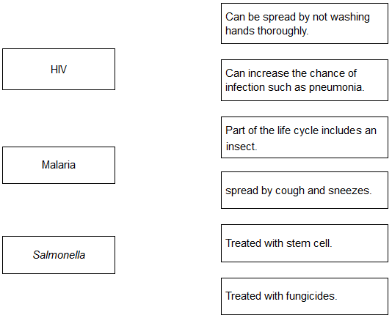
(3)
(b) Gonorrhoea is a sexually transmitted disease.
A bacterium causes gonorrhoea.
What are the symptoms of gonorrhoea?

Tick two boxes.
Headache
Pain when urinating
Rash
Vomiting
Yellow discharge
(2)

(c) The table below shows the number of people in the UK diagnosed with gonorrhoea in different years.

Number of people diagnosed
with gonorrhoea in thousands
Year | Female | Male
2005 | 5.0 | 12.5
2007 | 5.0 | 12.5
2009 | 5.5 | 12.0
2011 | 6.0 | 14.0
2013 | 7.5 | 22.0
Use the data in the table to complete the graph below.
• The numbers for males have already been plotted.
• Only some of the numbers for females have been plotted.
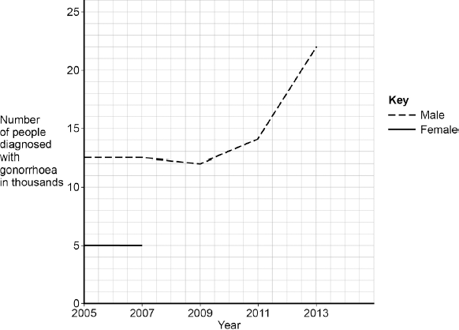
(3)
(d) Describe the patterns in the numbers of males and females with gonorrhoea from 2005 to 2013.
Use the data in the graph.
___________________________________________________________________
___________________________________________________________________
___________________________________________________________________
___________________________________________________________________
(3)
(e) Gonorrhoea is treated with an antibiotic.
HIV is another sexually transmitted disease.
Explain why prescribing an antibiotic will not cure HIV.
___________________________________________________________________
___________________________________________________________________
___________________________________________________________________
___________________________________________________________________
(2)
(Total 13 marks)
Independent exam questions:
Q8.
Scientists investigated the effect of different factors on health.
(a) People who are not active may have health problems.
The graph shows the percentage of 16-year-olds in some countries who are not active.
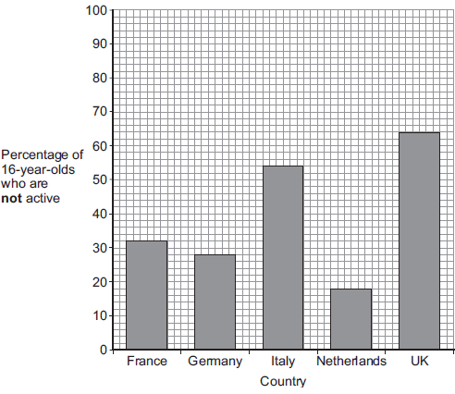
(i) What percentage of 16-year-olds in the UK are not active?
_____________ %
(1)
(ii) What percentage of 16-year-olds in the UK are active?
_____________ %
(1)
(iii) A newspaper headline states:
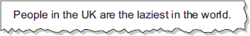
Information in Figure 1 does not support the newspaper headline.
Suggest one reason why the newspaper headline may be wrong.
______________________________________________________________
______________________________________________________________
(1)
(b) Doctors gave a percentage rating to the health of 16-year-olds.
100% is perfect health.
The table shows the amount of exercise 16-year-olds do and their health rating.

Amount of exercise done in minutes every week | Health rating as %
Less than 30 | 72
90 | 76
180 | 82
300 | 92
What conclusion can be made about the effect of exercise on health?
Use information from the table.
___________________________________________________________________
___________________________________________________________________
(1)
(c) Inherited factors can also affect health.
Give one health problem that may be affected by the genes someone inherits.
Draw a ring around the correct answer.

being  malnourished | having a high  cholesterol level | having a  deficiency disease
(1)
(d) White blood cells are part of the immune system.
Use the correct answer from the box to complete each sentence.

antibiotics | antibodies | pathogens | vaccines
(i) When we are ill, white blood cells produce _______________________ to kill microorganisms.
(1)
(ii) Many strains of bacteria, including MRSA, have developed resistance to drugs called
______________________________________________________________
(1)
(Total 7 marks)
Q9.
Scientists began to keep records of cases of H5N1 bird flu in humans in January 2004. The graph shows the total number of cases of bird flu in humans and the total number of deaths up to January 2006.
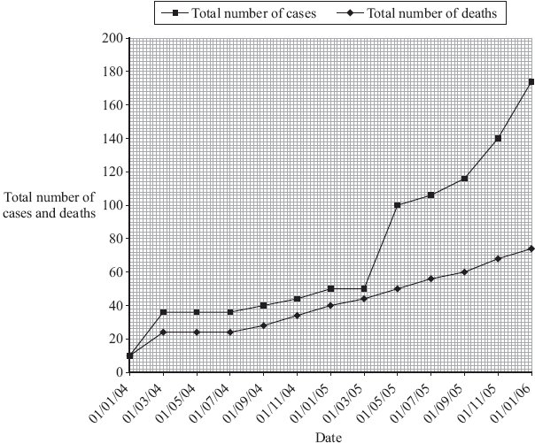
(a) (i) How many people had died from bird flu up to 01/07/05?
______________________________________________________________
(1)

(ii) Describe, as fully as you can, how the number of cases of bird flu in humans changed between 01/07/04 and 01/01/06.
______________________________________________________________
______________________________________________________________
______________________________________________________________
______________________________________________________________
(2)
(b) At present, humans can only catch bird flu from contact with infected birds. The bird flu virus may mutate into a form that can be passed from one human to another.
Explain why millions of people may die if the bird flu virus mutates in this way.
___________________________________________________________________
___________________________________________________________________
___________________________________________________________________
___________________________________________________________________
(2)
(Total 5 marks)

Q10.
Obesity is linked to several diseases.
(a) Name two diseases linked to obesity.
1. _________________________________________________________________
2. _________________________________________________________________
(2)
(b) Scientists trialled a new slimming drug.
The table shows their results after one year.

Percentage change in mass  of each volunteer | Number of volunteers
gained mass or lost 0 to 3.9 % | 1900
lost 4.0 to 4.9 % | 1100
lost 5.0 to 9.9 % | 1500
lost 10 % or more | 1500
(i) Calculate the proportion of the volunteers who lost 10 % or more of their mass.
You should first calculate the total number of volunteers, then work out the proportion.
______________________________________________________________
______________________________________________________________
Proportion of volunteers = _________________________
(2)
(ii) The National Health Service (NHS) gave permission for the drug to be used.
Use information from the table to suggest a reason why the NHS gave permission for the drug to be used.
______________________________________________________________
______________________________________________________________
(1)
(Total 5 marks)

Lesson 4 – Preventing pathogens from making us unwell and developing new medicines
 | Topic: | Preventing pathogens from making us unwell
1 | State 3 ways that pathogens can be spread | Direct contact, water, air
2 | How do bacteria make us feel unwell? | Produce toxins (poisons) that damage tissues
3 | How do viruses make us feel unwell? | Live & reproduce in cells causing cell damage
4 | Name 4 of the body's non-specific defence systems | Skin, nose, trachea, stomach
5 | State three ways that white blood cells can help to defend us against pathogens | Phagocytosis, antibody production, antitoxin production
6 | Define "benign tumour" | Growth of abnormal cells contained in ONE area in a membrane
7 | Define "malignant tumour" | Growth of abnormal cells that SPREAD to other parts of the body in blood and INVADE other tissues.

 | Topic: | Developing new medicines
1 | State three ways that drugs can be produced | Extracted from plants, microorganisms & synthesised
2 | What is a placebo? | A substance that contains no medicine (a control)
3 | State three things that drugs are tested and trialled for before use | 1) Toxicity (safe), 2) efficacy (does it work), 3) dose (quantity)
4 | What is used to test drugs during preclinical testing? | Cells, tissues & live animals
5 | Who are medicines tested on in stage 1 of clinical trials? | Healthy volunteers (low doses - test for toxicity)
6 | Who are medicines tested on in stage 2 of clinical trials? | Patient volunteers (low doses - test for efficacy & dose)
7 | What is a double blind trial? | Neither experimenter or patient knows if they are taking medicine or placebo

Notes

Biology Revision: Preventing Diseases
Mastery Matrix Points. Revision guide page number 42-45
Describe how the body prevents entry of pathogens into the body
Describe how the immune system tackles pathogens once they have made it into the body (phagocytosis, antibody production and antitoxin production)
Explain how vaccines work
Discuss the global use of vaccination in the prevention of disease
Explain the use of antibiotics and other medicines
Compare and contrast painkillers and antibiotics
Explain the benefits and drawbacks of antibiotics and limitations of antivirals

Key Knowledge
How do these parts of the body try to prevent pathogens entering?
Skin – _________________________________

Nose – ________________________________

Trachea and bronchi – ____________________

Stomach – ______________________________

Three jobs of white blood cells –
- ______________________________
- ______________________________
- ______________________________

Definition:
Vaccination – ___________________________

Phagocytosis – ___________________________

Immunising –___________________________

Antibiotics –___________________________
e.g. ___________________________

Painkillers –___________________________
e.g. ___________________________

Antivirals – ___________________________

Disadvantage of antivirals: _____________ ___________________________________

Understanding and Explaining
- Explain how white blood cells help to prevent disease:
a) phagocytosis – ___________________________________________________________________
b) producing antibodies – _____________________________________________________________
c) producing antitoxins – _____________________________________________________________

- Explain how vaccinations help to prevent disease:
Vaccination involves introducing small quantities of ________ or_________ forms of a pathogen into the body to stimulate the white blood cells to produce ______________. If the same pathogen re-enters the body the white blood cells respond ____________ to produce the correct antibodies, preventing infection.

- Describe and explain the shape of this graph showing the number of antibodies produced during a first and second chickenpox infection.
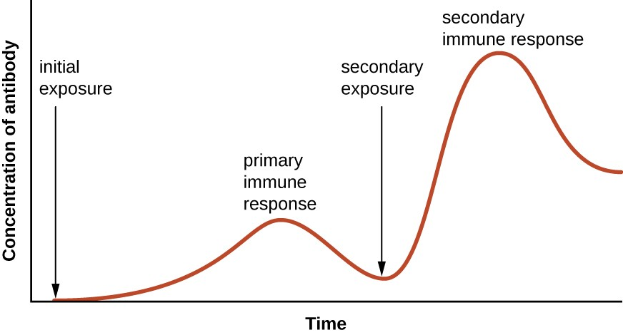

- Explain why antibiotics would not help to make you feel better if you had the flu.
__________________________________________________________________________________________________________________________________________________________________
__________________________________________________________________________________________________________________________________________________________________

Initially, the number of antibodies produced __________ slowly. Once most of the pathogens are destroyed, the number of antibodies starts to ____________ again as they are no longer needed. Some of the antibodies remain in the __________. After the second exposure, the number of antibodies increases much ________ and in a higher number than after the first exposure. This means that they are able to respond much more quickly and the person does not become unwell/ show any symptoms.

Biology Revision: Developing New Medicines
Understanding and Explaining
Complete the summary of how new drugs are developed.

Most new drugs are first extracted from _________. New medical drugs have to be tested and trialled before being used to check that they are ________ and ___________. New drugs are extensively tested for t________, e__________and d_______. Preclinical testing is done in a laboratory using cells, tissues and live a_______. This tests for toxicity.
Clinical trials use h__________ volunteers and patients.
1. Very ______ doses of the drug are given at the start of the clinical trial.
2. If the drug is found to be safe, further clinical trials are carried out to find the __________ dose for the drug.
3. In double blind trials, some patients are given a _____________
A placebo is a tablet that does not contain the _________.
A double blind trial means that no one, not even the doctor, knows who has the real drug and who has the placebo. This avoids ________ from the doctor.

drug, animals, plants, low, bias, safe, healthy, optimum, placebo, effective, efficacy, dose, toxicity
Key Knowledge

Drug | Made from | Used to treat
Digitalis
Aspirin
Penicillin

Definitions:
Placebo - _______________________

Double blind trial - _______________
_____________________________

Toxicity – ______________________
______________________________

Efficacy – _____________________
_____________________________

Dose –________________________
_____________________________

Mastery Matrix Points
Describe how bacteria have developed resistance to antibiotics – in particular MRSA (and use this as an example of evolution)
Describe how many new drugs are still developed from plants and microorganisms (including digitalis and aspirin)
Explain how preclinical and clinical trials are used to test new drugs (including tests for safety, effectiveness, toxicity and dosage)

Guided Exam Question
Q11. Read the following passage.
One of the deadliest diseases in history to be making a comeback in Britain. Doctors are alarmed at the rising number of cases of tuberculosis (TB) over the past three years, after decades in which it had declined.
In the middle of the last century TB accounted for 16% of all deaths in Britain. The turning point in the fight against TB came in 1882 when Robert Koch identified the bacterium that causes the disease. In 1906 two French scientists began developing the vaccine to provide immunity against TB. The vaccine, BCG, (so-called from the initials of the two scientists) has routinely been injected into children aged 12 or 13 who are not already infected with the TB bacterium. BCG does not protect people who are already infected with TB. Recently, however, some Health Authorities have dropped their school vaccination programme.
(a) People infected with a small number of TB bacteria often do not develop the disease.
Explain, as fully as you can, how the body defends itself against the TB bacteria.
__________________________________________________________________
_________________________________________________________________
___________________________________________________________________
(3)
(b) The BCG vaccine contains a mild form of the TB bacterium. A person injected with it does not develop the disease.
Explain, as fully as you can, how the vaccine makes the person immune to tuberculosis.
___________________________________________________________________
___________________________________________________________________
___________________________________________________________________
_____________________________________________________________________
___________________________________________________________________
_________________________________________________________________
(3)
(c) Explain why the BCG vaccine is not effective as a cure for people who already have tuberculosis.
___________________________________________________________________
___________________________________________________________________
___________________________________________________________________
___________________________________________________________________
___________________________________________________________________
(2)
(Total 8 marks)

Independent question:
Q12. Drugs must be trialled before the drugs can be used on patients.
(a) (i) Before the clinical trials, drugs are tested in the laboratory.
The laboratory trials are not trials on people.
What is the drug tested on in these laboratory trials?
______________________________________________________________
(1)
(ii) Drugs must be trialled before the drugs can be used on patients.
Give three reasons why.
______________________________________________________________
______________________________________________________________
______________________________________________________________
______________________________________________________________
______________________________________________________________
______________________________________________________________(3)
This notice is from a doctor’s surgery.

Unfortunately,
antibiotics
will NOT get
rid of your flu.

(c) (i) Why will antibiotics not get rid of flu?

______________________________________________________________

______________________________________________________________

(1)

(ii) The symptoms of flu include a sore throat and aching muscles.

What would a doctor give to a patient to relieve the symptoms of flu?

______________________________________________________________(1)

(iii) It is important that antibiotics are not overused.

Explain why. Use words from the box to complete the sentence.

antibody | bacteria | immune | resistant | viruses

Overuse of antibiotics might speed up the development of __________________________ strains of _________________________ . (2)
(b) Read the information about cholesterol and ways of treating high cholesterol levels.
Diet and inherited factors affect the level of cholesterol in a person's blood.
Too much cholesterol may cause deposits of fat to build up in blood vessels and reduce the flow of blood. This may cause the person to have a heart attack.
Some drugs can lower the amount of cholesterol in the blood.
The body needs cholesterol. Cells use cholesterol to make new cell membranes and some hormones. The liver makes cholesterol for the body.
Some drugs can help people with high cholesterol levels.
Statins block the enzyme in the liver that is used to produce cholesterol.
People will normally have to take statins for the rest of their lives. Statins can lead to muscle damage and kidney problems. Using some statins for a long time has caused high numbers of deaths.
Cholesterol blockers reduce the absorption of cholesterol from the intestine into the blood.
Cholesterol blockers can sometimes cause problems if the person is using other drugs.
Evaluate the use of the two types of drug for a person with high cholesterol levels.
___________________________________________________________________
___________________________________________________________________
___________________________________________________________
___________________________________________________________________
___________________________________________________________________
___________________________________________________________________
___________________________________________________________________
___________________________________________________________________
___________________________________________________________________
___________________________________________________________________
___________________________________________________________________
___________________________________________________________________
___________________________________________________________________
___________________________________________________________________
(6)
(Total 10 marks)

Lesson 5 Using and interpreting data

 | Topic: | Using data
1 | Name 5 types of graph used in science | Histogram, bar chart, frequency table, scatter graph, line graph
2 | When would you draw a bar chart? | When one of your variables is categorical
3 | When would you draw a line graph/scatter graph? | When both of your variables are continuous
4 | When would you draw a pie chart? | To show how a total is broken down into its components
5 | How do you know from looking at a graph that data is directly proportional? | A straight line graph through the origin
6 | How do you know from looking at a graph that data is inversely proportional? | Straight line from the top left and ending bottom right
7 | What is an anomaly? | A result that doesn’t fit the pattern of results (aka outlier)

Biology Revision: Using Data
Mastery Matrix Points
Describe situations where types of diseases interact (poor physical health, viruses causing cancer, pathogens -> allergic reactions, immune system defects -> more susceptible to infectious disease)
Translate numerical information between tables and graphs
Construct and interpret bar charts and histograms
Construct and interpret frequency tables and diagrams
Apply the techniques of scientific sampling to disease incident information
Discuss the human and financial cost of non-communicable diseases (individual, local community, national and global level)
Describe the causal mechanisms of some risk factors for non-communicable diseases (causes of: cardiovascular disease, type 2 diabetes, brain and liver function, lung disease and lung cancer, cancers and foetal damage) including the effects of diet, alcohol and smoking
Use a scatter diagram to identify a correlation between two variables (linking to disease incidence)

Key Knowledge

State 2 risk factors for:
- Cardiovascular disease:
(i) _____________________________
(ii) ____________________________

- Type 2 diabetes
(i) ____________________________
(ii) ____________________________

- Reduced brain function
(i) ____________________________
(ii) ____________________________

- Reduced liver function
(i) ____________________________
(ii) ____________________________

- Lung disease/lung cancer
(i) ____________________________
(ii) ____________________________

- Foetal damage
(i) ____________________________
(ii) ____________________________

Understanding and Explaining
- Describe and explain the relationship shown in this graph (6marks)
Give some data to support you answer…
Pattern for males: __________________________________________
Pattern for females: ________________________________________
In comparison, you can see that over time, males have __________________
__________________________________________________________
However, from the year 2000 both female and male __________________
_____________________________________________________

              - 2) Describe the relationships shown in this graph (6 marks)
Include data to support your answer.

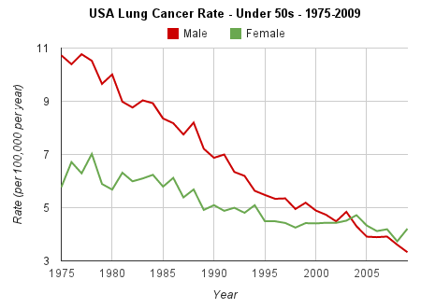

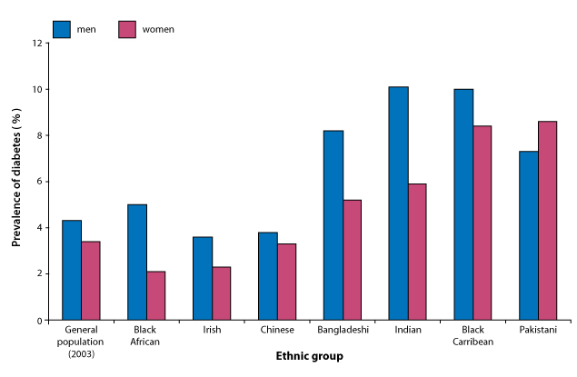
This graph shows ________________________________
The general population shows that _____________
with a prevalence of __% in males and ____% in females
Overall in every ethnic group, males have _____________
Apart from Pakistani whereby females have ____________
The ethnic groups that have the highest prevalence are…
________________________________________
The ethnic groups that have the lowest prevalence are
________________________________________

Guided exam question
Q13
The lynx is a wild cat which lives in Canada. The table shows the number of lynx trapped in a part of Canada in certain years.

Year | Number of lynx  in thousands
1918 | 45
1920 | 25
1922 | 10
1924 | 20
1926 | 40
1928 | 50
The snowshoe hare is another wild animal found in Canada. The graph shows the number of snowshoe hares trapped in the same years. The lynx eats the snowshoe hare.
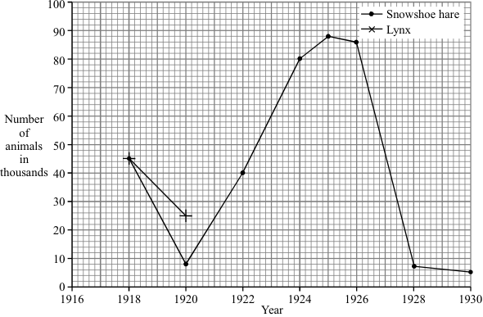
(a) Draw a graph of the data in the table. The first two points have been plotted for you.
(2)
(b) From your graph, predict how many lynx were trapped in 1925.
_____________________________________ thousand
(1)
(c) Use the information to answer the following.
(i) What would you expect to happen to the number of lynx trapped in 1930? Draw a ring around your answer.
rise fall stay the same
(1)
(ii) Give a reason for your answer to part (c)(i).
______________________________________________________________
______________________________________________________________
(1)
(d) The lynx is a predator. What is a predator?
______________________________________________________________
______________________________________________________________
(1)
(Total 6 marks)

Independent exam practice

Q14 Some infections are caused by bacteria.
(a) The genetic material is arranged differently in the cells of bacteria compared with animal and plant cells.
Describe two differences.
___________________________________________________________________
___________________________________________________________________
___________________________________________________________________
___________________________________________________________________
(2)
(b) Tuberculosis (TB) is an infection caused by bacteria.
The table below shows the number of cases of TB in different regions of southern England from 2000–2011.
Number of cases of TB per 100 000 people

Year | London | South East | South West
2000 | 37 | 5 | 3
2001 | 36 | 6 | 4
2002 | 42 | 6 | 6
2003 | 42 | 7 | 4
2004 | 42 | 7 | 5
2005 | 49 | 8 | 5
2006 | 44 | 8 | 3
2007 | 43 | 8 | 5
2008 | 44 | 8 | 5
2009 | 44 | 9 | 6
2010 | 42 | 9 | 5
2011 | 45 | 10 | 5
(i) How does the number of cases of TB for London compare with the rest of southern England?
______________________________________________________________
______________________________________________________________
______________________________________________________________
(1)
(ii) Describe the pattern in the data for cases of TB in the South East.
______________________________________________________________
______________________________________________________________
(1)
(iii) Describe the pattern in the data for cases of TB in the South West.
______________________________________________________________
______________________________________________________________
______________________________________________________________
______________________________________________________________
(2)
(c) (i) On the graph paper below:
• plot the number of cases of TB in London
• label both the axes on the graph
• draw a line of best fit.
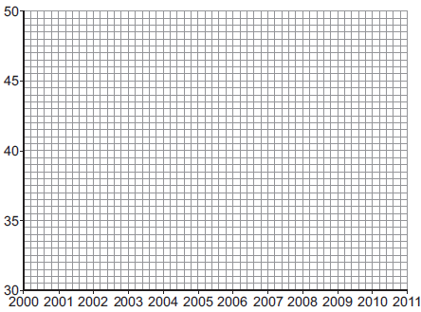
(4)

(ii) Suggest why a student thought the value for 2005 in London was anomalous.
______________________________________________________________
______________________________________________________________
(1)
(d) People can be vaccinated against TB.
Suggest how a vaccination programme would reduce the number of people with TB.
Details of how a vaccine works are not required.
___________________________________________________________________
___________________________________________________________________
___________________________________________________________________
___________________________________________________________________
(2)
(Total 13 marks)

Lesson 6 Breathing and respiration, Blood and the heart

 | Topic: | Breathing and respiration
1 | What is the name of respiration with oxygen? | Aerobic
2 | What is the name of respiration that occurs without oxygen? | Anaerobic
3 | What is the word equation for aerobic respiration | Oxygen + glucose -> carbon dioxide + water
4 | What is the word equation for anaerobic respiration in animals | Glucose -> Lactic acid
5 | What is the word equation for anaerobic respiration in yeast and plant cells | Glucose -> Ethanol + carbon dioxide
6 | What is anaerobic respiration in yeast cells called? | Fermentation
7 | State three uses of energy in organisms | 1) Chemical reactions to build larger molecules, 2) movement, 3) keeping warm

 | Topic: | Blood and the heart
1 | Which type of vessel carries blood AWAY from the heart? | Arteries
2 | Which type of vessel carries blood IN to the heart? | VeINs
3 | What is the name of the 4 chambers of the heart? | Top: Left and right Atrium  Bottom: Left and right ventricle
4 | Name the 4 chambers of the heart? | Top: Left/right Atrium  Bottom: Left/right ventricle
5 | Where is the body's natural pacemaker (cells that control the bodies resting heart rate)? | Right atrium
6 | Which side of the heart is thicker? | Left
7 | Which side of the heart pumps oxygenated blood out of it and which side pumps deoxygenated? | Oxygenated = Left  Deoxygenated = Right

Notes

Biology Revision: Breathing and Respiration
Mastery Matrix Points. Revision guide page 48-49
Describe the purpose of cellular respiration, recalling the word & symbol equation for aerobic respiration
Explain how the body responds to exercise in terms of heart rate, breathing rate and breath volume
Explain when anaerobic respiration occurs in humans and recall the word equation for this process
Explain what is meant by the term ‘oxygen debt’
Explain anaerobic respiration in yeast, recalling the word equation for this process
Describe how this process of anaerobic respiration (fermentation) is used by humans in the manufacturing industry
Label the structure and describe the function of the human lungs (including how they are adapted for gaseous exchange)

Key Knowledge
Aerobic Respiration –___________________

Word equation: _______________________

Happens in: __________________________

Anaerobic Respiration in animals:

Word equation: __________________

Happens when: __________________

Fermentation is anaerobic respiration in _______ cells

Word equation: __________________

Two uses of fermentation:
1) _____________________________

2) ______________________________

Gas exchange is - _____________________
____________________________________
____________________________________

Understanding and Explaining (use page 48-49 to help you)
- Describe how these factors change during vigorous (intense) exercise (increase or decrease):
- breathing rate: ____________________________________
- heart rate: ____________________________________
- breath volume: ____________________________________

- Explain why all of these 3 factors above change during vigorous exercise:
________________________________________________________________
________________________________________________________________________
___________________________________________________________________

- Explain why anaerobic respiration takes place during vigorous exercise. ___________________________________________________________________
- Explain what effects the lactic acid produced has on the muscles during vigorous exercise.
______________________________________________________________
- Compare anaerobic respiration in humans to anaerobic respiration in yeast.
____________________________________________________________________

8 Label the lungs

4. Gas exchange happens in the alveoli. There are millions of alveoli and they have 3 adaptations that make them very good at gas exchange. List them:
- Large…
- Very rich …
- Very close to…

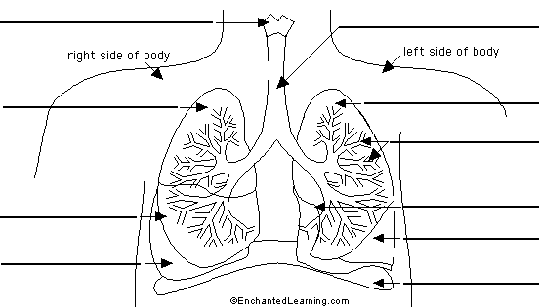

Biology Revision: Blood and the Heart
Label:
A: P__________ a_________
B:V______ C______
C: R ______ A________
D: R______ V_________
E: A________ (to body)
F: P_________ V_______
G: L_______ A________
H: V______
I: L__________ A________
A
B
C
D

Key Knowledge

What are the roles of these parts of the heart?
Vena cava – ___________________
Pulmonary artery – _______________
Pulmonary vein – ________________
Aorta – _______________________

Blood vessel | Job | adaptations
Artery

Vein

Capillary

Four parts of the blood and their function:
- p______________
- r______________
- w______________
- p______________

Definition of coronary heart disease:
____________________________
____________________________

Mastery Matrix Points
Describe the structure and function of the human heart
Describe the roles of the four blood vessels associated with the heart
Describe the 3 different types of blood vessel in the body and their structure
Carry out rate calculations for blood flow
Describe how our body controls our natural resting heart rate
Describe the composition of blood and know the functions of each of the components
Draw blood cells from under a microscope and recognise different types of blood cells from a photo or diagram, explaining how they are adapted to their functions
Describe coronary heart disease
Describe what a ‘stent’, ‘statin’, ‘mechanical/biological valve replacement’, ‘pacemaker’ and ‘transplant’ are
Evaluate the advantages and disadvantages of treating cardiovascular diseases using drugs, mechanical devices or transplants
Evaluate risks associated with the use of blood products

E
F
G
H
I

Understanding and Explaining (use page 29 to help)
- Complete the sentences for the route of blood flow: Blood enters the heart through the _______. The atria _______ and force blood down into the ___________. The ventricles ________ and force blood out of the _______. Valves make sure the blood flows in the ________ direction. The right side of the heart receives _____________ blood, whereas the left side of the heart receives _______ blood.
Oxygenated Deoxygenated Atria Contract Contract Heart Correct
- Which side of the heart is more muscular? Explain why: __________________________________________
____________________________________________________________________________________

- Calculate the cardiac output of the heart if the 4. Label the components of blood on this microscope photo.
stroke volume is 50cm³ and the heart rate is 67bpm?
Cardiac output= stroke volume x heart
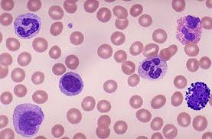
- Sketch a diagram below to show what coronary heart disease looks like:

- State 2 treatments for coronary heart disease:

- Type 2 diabetes and cardiovascular disease have proven risk factors: State what they are: ____________________________________________________________________________________

Guided exam questions
Q15.An athlete ran as fast as he could until he was exhausted.
(a) Figure 1 shows the concentrations of glucose and of lactic acid in the athlete’s blood at the start and at the end of the run.
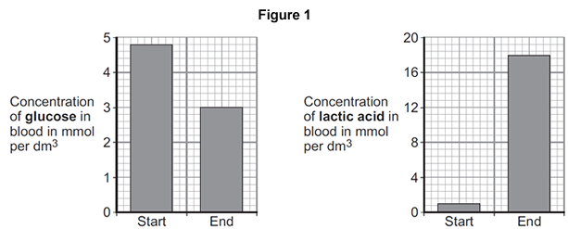
(i) Lactic acid is made during anaerobic respiration.
What does anaerobic mean?
______________________________________________________________
______________________________________________________________
(1)
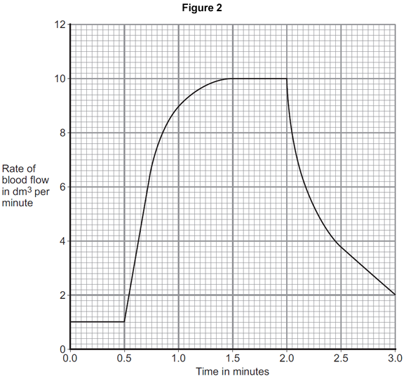
(ii) Give evidence from Figure 1 that the athlete respired anaerobically during the run.
______________________________________________________________
______________________________________________________________
(1)
(b) Figure 2 shows the effect of running on the rate of blood flow through the athlete’s muscles.
(i) For how many minutes did the athlete run?
Time = ______________________ minutes
(1)
(ii) Describe what happens to the rate of blood flow through the athlete’s muscles during the run.
Use data from Figure 2 in your answer.
__________________________________________________________________________________________________________________________________________________________________________________________
____________________________________________________________________________________________
(2)
(iii) Explain how the change in blood flow to the athlete’s muscles helps him to run.
______________________________________________________________________________________________________________________________________________________________________________________________
______________________________________________________________________________________________________________________________________________________________________________________________
____________________________________________________________________________________________________________________________________________________________________________________________
(4)
(Total 9 marks)
Independent exam questions
Q16. Gas exchange takes place in the lungs.
The diagram shows an alveolus next to a blood capillary in a lung.
The arrows show the movement of two gases, A and B.
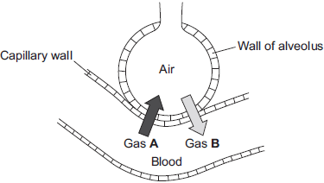
Gases A and B move by | diffusion.  osmosis.  respiration.
(a) (i) Draw a ring around the correct answer to complete the sentence.
(1)

(ii) Gas A moves from the blood to the air in the lungs.
Gas A is then breathed out.Name Gas A.
______________________________________________________________
(1)
(iii) Which cells in the blood carry Gas B?
Draw a ring around the correct answer.
platelets red blood cells white blood cells
(1)
(b) The average number of alveoli in each human lung is 280 million.
The average surface area of 1 million alveoli is 0.25 m².
Calculate the total surface area of a human lung.
___________________________________________________________________
Answer ___________________________________ m²
(2)
(c) An athlete trains to run a marathon. The surface area of each of the athlete’s lungs has increased to 80 m².
Give one way in which this increase will help the athlete.
___________________________________________________________________
___________________________________________________________________
(1)
(Total 6 marks)
Q17. (a) List A gives four structures in the human body.
List B gives the functions of some structures in the body.
Draw a straight line from each structure in List A to the correct function in List B.
List A – Structure |  | List B – Function
 |  | Surround and protect the lungs
Alveoli
 |  | Filter the blood
Veins
 |  | Carry blood towards the heart
Villi
 |  | Absorb digested food
Ribs
 |  | Allow oxygen to enter the blood
(4)
(b) Draw a ring around the correct answer to complete the sentence.

 | diffusion.
In the lungs, oxygen enters the blood from the air by | filtration.
 | respiration.
(1)
(Total 5 marks)

Lesson 7 Digestion and Transport systems
 | Topic: | Digestion
1 | Which enzyme breaks down lipids, carbohydrates and proteins? | Lipids = lipase  carbohydrates = amylase  Proteins = protease
2 | What is the name of the leaf shaped organ that produces enzymes? | Pancreas
3 | What is added to the stomach to kills pathogens? | Hydrochloric acid
4 | Which part of the digestive system are nutrients and water absorbed into the blood from? | Nutrients = small intestine  Water = large intestine
5 | Write the word equation for the digestion of carbohydrates | Starch -> glucose
6 | Write the word equation for the digestion of proteins | Proteins -> amino acids
7 | Write the word equation for the digestion of fats | lipids -> fatty acids + glycerol

 | Topic: | Diffusion, Osmosis and Active Transport
1 | Substances moving from a high concentration to a low concentration is called… | Diffusion
2 | Two examples of diffusion in humans are: | CO2 + O2 in gas exchange, urea from cells to blood
3 | Three factors that affect the rate of diffusion are: | Concentration gradient, temperature, surface area of the membrane
4 | Water moves from a dilute to concentrated solution across a partially permeable membrane via... | Omosis
5 | Pure water will move into a potato because | Of osmosis
6 | When a substance moves against the concentration gradient, it is called.. | Active transport
7 | Active transport requires ________ from _________. | energy respiration

Notes

Biology Revision: Digestion
Mastery Matrix Points
Describe what the digestive system is
Explain the role of enzymes in the digestive system making reference to ‘lock and key’
Explain how carbohydrates, proteins and lipids are synthesised, broken down and used, making reference to sugars, amino acids, fatty acids and glycerol
Link carbohydrase (amylase), protease, lipase & bile to the breakdown of particular food groups, identifying where they are produced
Required practical: Use qualitative reagents to test for a range of carbohydrates, proteins and lipids
Describe the effects of temperature and pH on the rate of enzyme reactions and investigate the effect of pH on the rate of reaction of amylase
Required practical: Investigate the effect of pH on the rate of reaction of amylase enzyme
Define ‘metabolism’
Calculate the rate of given chemical reactions
Explain the 5 processes that contribute to our metabolism (starch formation, lipid formation, protein synthesis, respiration and protein breakdown)

Understanding and Explaining
- Explain how carbohydrates are broken down in the body.
___________________________________________________________________________________________________
___________________________________________________________________________________________________
- Explain how proteins are broken down in the body.
___________________________________________________________________________________________________
___________________________________________________________________________________________________
- Explain how lipids are broken down in the body.
___________________________________________________________________________________________________
___________________________________________________________________________________________________
- Describe the role of bile in the body. Include where it is produced, stored and where it works.

- Depending on the enzyme, they all have an ‘optimum pH’ value. Describe what is meant by optimum pH..

- Describe a 5 step method for investigating the effect of pH on an enzyme such as amylase (page 27). Include a diagram
1-________________________________________________________________________
2-________________________________________________________________________
3-________________________________________________________________________
4-________________________________________________________________________
5-________________________________________________________________________

Key Knowledge
Metabolism -

Digestion –

Enzymes –

Lock and key model (include a diagram) –

Enzyme | Breaks down… | To produce…
Amylase
Protease
Lipase

Enzyme | Produced in | Works in
Amylase
Protease
Lipase

Food Tests (page 26):
Chemical | Used to test for: | Positive result is:
 | Sugars
 | Starch
 | Protein

Biology Revision: Diffusion, Osmosis and Active Transport
Mastery Matrix Points
Define ‘diffusion’ and give examples of diffusion in plants and animals (gas exchange and urea in the kidney)
Explain how different factors affect the rate of diffusion. (concentration, surface area, temperature)
Explain how surface area: volume ratio of a single celled organism (amoeba) allows sufficient molecule transport
Explain adaptations for exchange materials in: small intestines, lungs, gills, roots and leaves

Key Knowledge

Diffusion –

Two examples of diffusion
-
-

Sketch a diagram to show how diffusion occurs (page 22)
High Low
Concentration Concentration

Osmosis:

Active transport:

Two examples of active transport:
-

-

Understanding and Explaining
- Name the 3 factors that affect the rate of diffusion:
–___________________________________________
–___________________________________________
–___________________________________________

- The small intestine and lungs in mammals, gills in fish and the roots and leaves in plants, are all adapted for exchanging materials. Explain at least 3 ways in which they are adapted:
- They have a large __________________________________________________________________________
__________________________________________________________________________________________
- The surface is thin so that ___________________________________________________________________
- In animals, a rich blood supply ________________________________________________________________
- Comparing the 3 processes: diffusion, osmosis and active transport.
Complete the table by putting YES or NO next to each statement
e.g. the first row has been done for you- all 3 processes allow molecules to move.
 | Diffusion | Osmosis | Active Transport
Allows molecules to move | YES | YES | YES
Needs energy from respiration
Always involves the movement of water
Movement is down a concentration gradient

- RP: To investigate the effect of a range of concentration of salt or sugar solutions on the mass of plant tissue.
Write a simple, 3 step method explaining how you would set this experiment up.
- _______________________________________________________________________________________
- _______________________________________________________________________________________
- _______________________________________________________________________________________

Guided exam questions
Q18 (a) A food contains protein. Describe, in as much detail as you can, what happens to this protein after the food is swallowed.
___________________________________________________________________
___________________________________________________________________
___________________________________________________________________
___________________________________________________________________
___________________________________________________________________
___________________________________________________________________
___________________________________________________________________
___________________________________________________________________
(4)

(b) The table shows the activity of lipase on fat in three different conditions.

CONDITION | UNITS OF LIPASE ACTIVITY PER MINUTE
Lipase + acid solution | 3.3
Lipase + weak alkaline solution | 15.3
Lipase + bile | 14.5
Explain, as fully as you can, the results shown in the table.
___________________________________________________________________
___________________________________________________________________
___________________________________________________________________
___________________________________________________________________
___________________________________________________________________
___________________________________________________________________
(3)
(Total 7 marks)

Independent exam questions
Q19 Plants transport water and mineral ions from the roots to the leaves.
(a) Plants move mineral ions:
• from a low concentration in the soil
• to a high concentration in the root cells.
What process do plants use to move these minerals ions into root cells?

Tick one box.
Active transport
Diffusion
Evaporation
Osmosis
(1)
(b) Describe how water moves from roots to the leaves.
___________________________________________________________________
___________________________________________________________________
___________________________________________________________________
___________________________________________________________________
(2)
(c) Plants lose water through the stomata in the leaves.
The epidermis can be peeled from a leaf.
The stomata can be seen using a light microscope.
The table below shows the data a student collected from five areas on one leaf.

Leaf  area | Number of stomata
 | Upper surface | Lower surface
1 | 3 | 44
2 | 0 | 41
3 | 1 | 40
4 | 5 | 42
5 | 1 | 39
Mean | 2 | X
Describe how the student might have collected the data.
___________________________________________________________________
___________________________________________________________________
___________________________________________________________________
___________________________________________________________________
___________________________________________________________________
___________________________________________________________________
___________________________________________________________________(3)
(d) What is the median number of stomata on the upper surface of the leaf?
___________________________________________________________________
(1)
(e) Calculate the value of X in the table.
Give your answer to 2 significant figures.
___________________________________________________________________
___________________________________________________________________
Mean number of stomata on lower surface of leaf = _____
(2)
(f) The plant used in this investigation has very few stomata on the upper surface of the leaf.
Explain why this is an advantage to the plant.
___________________________________________________________________
___________________________________________________________________
___________________________________________________________________
___________________________________________________________________
(2)
(Total 11 marks)

Lesson 8 Plant structures and Photosynthesis
 | Topic: | Plant structures
1 | What is the name for the process that converts water and carbon dioxide into glucose and oxygen? | Photosynthesis
2 | What is the name of the specialised plant cell adapted to absorb water & nutrients from the soil? | Root Hair Cell
3 | What is the name of the specialised plant cell adapted to open and close the stomata of a plant? | Guard Cell
4 | What is the name of the tissue in a plant that transports glucose? | Phloem
5 | What is the name of the specialised cell that is adapted to absorb lots of light energy in the leaf? | Palisade cell
6 | What is the chemical in chloroplasts that allow plant cells to absorb lots of light energy? | Chlorophyll
7 | What is the name of the tissue in a plant that transports water? | Xylem

 | Topic: | Photosynthesis
1 | Name the two reactants in photosynthesis | Carbon Dioxide and water
2 | Name the two products formed in photosynthesis | Oxygen and glucose
3 | Write the word equation for photosynthesis | Carbon dioxide + water -> oxygen and glucose
4 | Write the symbol equation for photosynthesis | CO2 + H2O -> O2 + C6H12O6
5 | State three limiting factors for photosynthesis | 1) Carbon dioxide concentration, 2) Temperature, 3) Light intensity
6 | How can you calculate the rate of photosynthesis of an aquatic plant? | Count the number of O2 bubbles produced in a minute
7 | How are palisade cells adapted for increased rates of photosynthesis? | Lots of chloroplasts (and chlorophyll)

Notes

Biology Revision: Plant Structures
Mastery Matrix Points
Draw and label an unspecialised plant cell and a palisade, root hair, xylem and phloem specialised cell | Describe the process of transpiration and translocation (including the structure and function of stomata).
Describe the 5 tissues and name the key organs in the plant
Label a transverse section of a leaf
Describe the process of osmosis
Calculate the rate of water uptake by a plant | Explain the effect of changing temperature, humidity, air movement and light intensity on the rate of transpiration
Calculate the percentage change in mass following osmosis | Calculate surface area, volume and mean in transpiration investigation
Analyse and draw graphs relating to osmosis | Analyse data from graphs and tables relating to transpiration experiments
Required practical: Analyse the range of concentrations of solutions on the change in mass of plant tissue | Describe in detail the location, function and adaptations of xylem tissue, phloem tissue, stomata and guard cells

Key Knowledge
Describe how each specialised cell is adapted to do its job:
Root hair cells:
Xylem:
Phloem:
Guard cells:

Definitions (page 33):
Transpiration:
Translocation:

State how Phloem cells are adapted for translocation:

Understanding and Explaining
- Label the leaf tissues on the diagram (page 32):
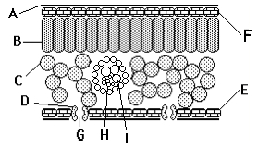

- State the function of the following plant tissues:
a) epidermal tissue: _____________________________________________________________
- palisade mesophyll: ____________________________________________________________
- spongy mesophyll: _____________________________________________________________
- xylem: ______________________________________________________________________
- phloem:______________________________________________________________________
- meristem tissue: _______________________________________________________________
- Give 2 environmental factors that slow down transpiration:

______________________________________________________________________________
______________________________________________________________________________
______________________________________________________________________________

A:
B:
C:
D:
E:
F:
G:
H:
I:

Biology Revision: Photosynthesis
Mastery Matrix Points
Describe the process of photosynthesis
Recall the word and symbol equation for photosynthesis
Explain the effects of temperature, light intensity, carbon dioxide intensity and the amount of chlorophyll on the rate of photosynthesis
Analyse data and calculate rates of photosynthesis and limiting factors from graphs and tables
Required Practical: Investigate the effect of light intensity on the rate of photosynthesis on an aquatic plant
Describe how glucose is used after photosynthesis
Explain the use of nitrate ions within plants

Key Knowledge

Define photosynthesis:

Word equation for photosynthesis:

Symbol equation for photosynthesis:

Four factors that affect the rate of photosynthesis:
-
-
-
-

Uses of glucose after photosynthesis
-
-
-
-
-

Understanding and Explaining
- Using your knowledge of endothermic reactions, explain why photosynthesis is an endothermic reaction:
__________________________________________________________________________________________________________________________________________________________________________________________________________________________________________________________________
- State the chemical within a plant that absorbs the sunlight’s energy needed for photosynthesis?
___________________________________________________________________________

- 4 factors affect the rate of photosynthesis, explain how each one affects this rate (page 46):
- Temperature:___________________________________________________________________________

- Carbon dioxide concentration:______________________________________________________________

- Light intensity : __________________________________________________________________________
- Chlorophyll concentration __________________________________________________________________
- RP: Write a 3 step method to explain how to investigate the effect of light intensity on the rate of photosynthesis using pondweed:
- ______________________________________________________________________________________
- ______________________________________________________________________________________
- ______________________________________________________________________________________

asdasd

Guided exam questions
Q20
(a) Complete the equation for photosynthesis.
______________ + water 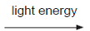 ______________ + ______________
(3)
(b) The rate of photosynthesis in a plant depends on several factors in the environment.
These factors include light intensity and the availability of water.
Describe and explain the effects of two other factors that affect the rate of photosynthesis.
You may include one or more sketch graphs in your answer.

___________________________________________________________________
___________________________________________________________________
___________________________________________________________________
___________________________________________________________________
___________________________________________________________________
___________________________________________________________________
___________________________________________________________________
___________________________________________________________________
___________________________________________________________________
___________________________________________________________________
___________________________________________________________________
___________________________________________________________________
(5)
(Total 8 marks)

Independent exam questions
Q21.
Photosynthesis needs light.
(a) Complete the balanced symbol equation for photosynthesis.
light
6CO2 + _______________________ _______________________ + 6O2
(2)
(b) A green chemical indicator shows changes in the concentration of carbon dioxide (CO2) in a solution.
The indicator solution is green when the concentration of CO2 is normal.
The indicator solution turns yellow when the concentration of CO2 is high.
The indicator solution turns blue when the concentration of CO2 is very low or when there is no CO2.
The indicator solution does not harm aquatic organisms.
Students investigated the balance of respiration and photosynthesis using an aquatic snail and some pondweed.
The students set up four tubes, A, B, C and D, as shown in the table below.
The colour change in each tube, after 24 hours in the light, is recorded.
Tube A | Tube B | Tube C | Tube D
Indicator solution  only | Indicator solution  + pondweed | Indicator solution  + snail | Indicator solution  + pondweed  + snail
Stays green | Turns blue | Turns yellow | Stays green
(i) What is the purpose of Tube A?
________________________________________________________________________________________________________________________________________________________________________________________
(1)
(ii) Explain why the indicator solution in Tube C turns yellow.
____________________________________________________________________________________________________________________________________________________________________________________________________________________________________________________________________________________
(2)
(iii) Predict the result for Tube D if it had been placed in the dark for 24 hours and not in the light.
Explain your prediction.
Prediction ___________________________________________________________________________________
Explanation __________________________________________________________________________________________________________________________________________________________________________________________________________________________________________________________________________________(3)

