**OASB Science Department**

**Chemistry Paper 2 Revision Pack (Triple – HT)**

|  |  |  |
| --- | --- | --- |
| Contents | Lesson | Page |
| Mastery Matrix Chemistry Paper 2 |  | 2-6 |
| Knowledge | 1 | 7 |
| Notes | 8 |
| Rates of reaction & reversible reactions Summary Page | 9-10 |
| Exam Questions | 11-14 |
| Knowledge | 2 | 15 |
| Mixtures, Chemical tests & calculations Summary Page | 16-17 |
| Notes page | 18 |
| Exam Questions | 19-21 |
| Knowledge | 3 | 22 |
| The Earth’s Early Atmosphere & Global warming Summary Page | 23-24 |
| Notes page | 25 |
| Exam Questions | 26-27 |
| Knowledge | 4 | 28 |
| Air Pollution & Finite resources Summary Page | 30-31 |
| Notes page | 32 |
| Exam Questions | 33-36 |
| Knowledge | 5 | 37 |
| Water and waste & Life Cycle Assessments Summary Page | 38-39 |
| Notes page | 40 |
| Exam Questions | 41-45 |
| Knowledge | 6 | 46-47 |
| Composites, ceramics & polymers & The Haber Process and Fertilisers Summary Page | 48-49 |
| Notes page | 48 |
| Exam Questions | 49-55 |
| Knowledge | 7 | 56-57 |
| Fractional Distillation, Cracking & Organic compounds Summary Page | 58-59 |
| Notes page | 60 |
| Exam Questions | 61-63 |
| Knowledge | 8 | 64 |
| Alcohols & Polymerisation Summary Page | 65-66 |
| Notes page | 67 |
| Exam Questions | 68-69 |



|  |  |  |  |
| --- | --- | --- | --- |
| **Topic** | **Tier** | **Revision Guide**  **(triple)** | **Learning statement** |
| Mixtures | F | C84 | Define ‘pure substances’ and explain the difference between its scientific and everyday meaning |
| Mixtures | F | C84 | Use melting and boiling point data to establish pure substances from mixtures |
| Mixtures | F | C84 | Describe what a ‘formulation’ is and give examples (Fuels, cleaning agents, paints, medicines, alloys, fertilisers and foods) |
| Mixtures | F | C84 | Describe the two phases (stationary and mobile) of chromatography and its purpose |
| Mixtures | F | C85 | Calculate Rf values |
| Mixtures | F | C84 | Interpret chromatograms to decide whether a substance is pure of a mixture |
| Mixtures | F | C84 | **RP Chromatography**: Use paper chromatography to investigate the colours within different substances and calculate Rf values |
| Mixtures | F | C8+C9 | Explain the difference in difficulty of separating compounds compared to mixtures |
| Metals in the periodic table | F | C18 | Describe corrosion as a reaction and explain how to prevent it (triple only) |
| Metals in the periodic table | F | C18 | Explain what an alloy is and how it’s properties differ from a pure metal |
| Metals in the periodic table | F | C19 | Link the properties and use of different alloys to their composition (bronze, brass, gold, steel, aluminium alloys) (triple only) |
| Groups in the periodic table | F | C85 | Describe the gas test for carbon dioxide, hydrogen, oxygen and chlorine |
| Acids & alkalis | F | C35 | **RP Neutralisation:** Determine the reacting volume of a solution of strong acid and strong alkali by titration linking to concentration (triple only) |
| Chemical tests | F | C87 | Explain how to use silver nitrate solution in the presence of dilute nitric acid to test for halide ions (chloride, bromide, iodide) (triple only) |
| Chemical tests | F | C87 | Explain how to use barium chloride solution in the presence of dilute hydrochloric acid to test for sulphate ions (triple only) |
| Chemical tests | F | C86+C87 | **RP Identifying Ions:** Use all of the chemical tests listed above to test for the presence of different ions (testing for metal ions: flame tests, hydroxide solutions and testing for negative ions – halides, sulphate ions, and carbonates) (triple only) |
| Rates of reaction | F | C60 | Calculate the mean rate of reaction |
| Rates of reaction | F | C60 | Recall the units for mass (g), volume (cm3) and rate (g/s, cm3/s, mol/s) |
| Rates of reaction | F | C61 | Draw tangents on curves in order to calculate rates of reaction |
| Rates of reaction | F | C60 | Explain the collision theory and link to activation energy |
| Rates of reaction | F | C60+C61+C62 | Describe and explain factors that affect rates of reaction (concentration, pressure, surface area, catalysts and temperature) |
| Rates of reaction | F | C61 | Plot and interpret graphs showing rates of reaction |
| Rates of reaction | F | C33 | Explain why one reactant is used in excess in a chemical reaction |
| Rates of reaction | F | C33 | Describe what is meant by ‘a limiting reactant’ |
| Rates of reaction | F | C61 | **RP Rates of Reaction:** Investigate how changes in concentration affect the rates of reactions by measuring volume of the gas and change of colour |
| Rates of reaction | F | C62 | Give examples of catalysts |
| Rates of reaction | F | C57 | Draw a reaction profile for a catalysed reaction |
| Reversible reactions | F | C62 | Use the appropriate symbol to denote a reversible reaction |
| Reversible reactions | F | C63 | Explain energy changes in reversible reactions (ammonium chloride and hydrated copper sulphate) |
| Reversible reactions | F | C63 | Explain what is meant by the term ‘equilibrium’ |
| Reversible reactions | HT | C63 | Explain and use Le Chatelier principle to make predictions about reactants and products (HT only) |
| Reversible reactions | HT | C63 | Explain the effect of changing concentration, pressure and temperature on equilibrium (HT only) |
| The Earths Early Atmosphere | F | C89 | Describe the composition of the atmosphere and how long this has been the case |
| The Earths Early Atmosphere | F | C88 | Describe the development from early atmosphere to present day |
| The Earths Early Atmosphere | F | C88 | Draw links between the early Earth’s atmosphere and that of other planets (Mars and Venus) |
| The Earths Early Atmosphere | F | C88 | Evaluate different theories regarding the Earth’s early atmosphere |
| The Earths Early Atmosphere | F | C89 | Explain why oxygen levels increased and carbon dioxide levels decreased (linking to photosynthesis and sedimentation) |
| Global Warming | F | C90 | Describe the term ‘greenhouse gases’ and give three examples (water vapour, carbon dioxide and methane) |
| Global Warming | F | C90 | Describe the ‘greenhouse effect’ linking to the wavelength of radiation |
| Global Warming | F | C90 | Describe the effect of human activities on the levels of greenhouse gases, recalling two that affect methane and two that affect carbon dioxide |
| Global Warming | F | C90 | Explain how peer review evidence have linked these activities to global climate change |
| Global Warming | F | C90 | Explain why it is difficult to model this and how this has led to simplification, speculation and biased opinions in the media |
| Global Warming | F | C91 | Describe 4 potential effects of global climate change |
| Global Warming | F | C91 | Discuss the scale, risks and environmental implication of global climate change |
| Global Warming | F | C91 | Describe what is meant by the term ‘carbon footprint’ |
| Global Warming | F | C91 | Describe actions to reduce our carbon footprint and explain why these actions may have limited impact |
| Air pollution | F | C90 | Describe combustion as a major source of atmospheric pollution |
| Air pollution | F | C89 | Name gases release when fuels such as coal are burnt (carbon dioxide, water vapour, carbon monoxide, sulphur dioxide and nitrogen oxides) and predict which of these would be produced from a given fuel composition |
| Air pollution | F | C90 | Describe ‘particulates’ |
| Air pollution | F | C90 | Describe issues arising from carbon dioxide, sulphur dioxide, nitrogen oxides and particulates |
| Finite resources | F | C92 | Recalls that humans use the Earth’s resources to provide; warmth, shelter, food, transport (through timber, clothing, fuels/energy and other materials) |
| Finite resources | F | C92 | Define what is meant by the term ‘finite resource’ |
| Finite resources | F | C92 | Define what is meant by the term ‘sustainable development’ and explain the role that chemistry plays in developing agricultural and industrial processes |
| Finite resources | F | C92 | Explain how some natural products are being replaced by some agricultural and synthetic products |
| Water and waste | F | C92 | Describe the properties of potable water (is safe to drink) linking to purity, salt and microbe levels |
| Water and waste | F | C92 | Describe the different sources of drinking water in the UK and the process that it must undergo before it is potable |
| Water and waste | F | C92 | Describe the process of desalination (distillation or reverse osmosis) |
| Water and waste | F | C92 | Evaluate the methods to produce potable water (linking to location and potential water supply) |
| Water and waste | F | C93 | **RP Water Purification:** Analyse and purify water samples from different sources, including pH, dissolved solids and distillation |
| Water and waste | F | C93 | Explain why large amounts of waste water are produced (urban life styles and industrial processes) |
| Water and waste | F | C93 | Explain what needs to be removed from sewage and agricultural waste in comparison with industrial waste water |
| Water and waste | F | C93 | Describe the 4 steps of sewage treatment |
| Water and waste | F | C92 | Compare the relative ease of obtaining potable water from waste, the ground and salt water |
| Life Cycle Assessments | HT | C93 | Explain how phytomining and bioleaching and scrap iron and electrolysis can be used to extract copper from low grade ores |
| Life Cycle Assessments | F | C95 | Describe what is meant by the term ‘life cycle assessment’ |
| Life Cycle Assessments | F | C95 | Describe the 4 stages of a life cycle assessment |
| Life Cycle Assessments | F | C95 | Explain that water resources, energy and waste production can be easily quantified whereas pollutant effects are hard to quantify |
| Life Cycle Assessments | F | C95 | Describe how simplified life cycle assessments can be used in a biased manner to support advertising claims in the media |
| Life Cycle Assessments | F | C95 | Use data to carry out LCA for shopping bags made from plastic and paper |
| Life Cycle Assessments | F | C95 | Explain how we can reduce our use of limited resources (reduce, reuse, recycle) |
| Making Materials | F | C94 | Explain how to produce clay ceramics (triple only) |
| Making Materials | F | C70 | Describe what factors affect the properties of polymers |
| Making Materials | F | C70 | Compare low density and high density poly(ethane) |
| Making Materials | F | C71 | Compare and contrast thermosetting and thermosoftening polymers explaining the differences |
| Making Materials | F | C95 | Explain what ‘composites’ are and give some examples |
| Making Materials | F | C94 | Explain how glass is produced |
| Making Materials | F | C94 | Compare the composition and melting points of soda-lime glass and borosilicate glass |
| Making Materials | F | C95 | Discuss the environmental impact of using metal, glass, building materials, clay ceramics and plastics linking to the use of these limited resources and the energy used to extract and process them. |
| Making Materials | F | C95 | Explain ways that we can reduce this environmental impact |
| The Haber Process and Fertilisers | F | C96 | State what is produced in the Haber process and explain how ammonia produced from this process is used (triple only) |
| The Haber Process and Fertilisers | F | C96 | List the raw materials for the Haber process and where they are sourced from (triple only) |
| The Haber Process and Fertilisers | F | C96 | Recall the conditions required for the Haber process to take place (triple only) |
| The Haber Process and Fertilisers | F | C96 | Recall the word and symbol equation for the Haber process (triple only) |
| The Haber Process and Fertilisers | F | C96 | Explain how the ammonia is removed and the hydrogen and nitrogen are recycled (triple only) |
| The Haber Process and Fertilisers | F | C96 | Interpret graphs of reaction conditions for Haber process versus rate (triple only) |
| The Haber Process and Fertilisers | F | C96 | Apply the principals of dynamic equilibrium to the Haber process (triple only) |
| The Haber Process and Fertilisers | F | C96 | Explain how these conditions are manipulated to produce optimum quantities of the desired products (triple only) |
| The Haber Process and Fertilisers | F | C97 | Describe what NPK fertilisers are (triple only) |
| The Haber Process and Fertilisers | F | C97 | Describe how NPK fertilisers are produced industrially (triple only) |
| The Haber Process and Fertilisers | F | C97 | Describe how sources of NPK are produced/found (ammonium salts, nitric acid and potassium chloride and phosphate rock) (triple only) |
| Alkanes and Alkenes | F | C64 | Explain what crude oil is and how it is formed |
| Alkanes and Alkenes | F | C64 | Define ‘alkanes’ and give the general formula |
| Alkanes and Alkenes | F | C65 | Recall the formulae and structures for the first 4 alkanes (methane, ethane, propane and butane) |
| Alkanes and Alkenes | F | C66 | Define ‘alkenes’ and give the general formula |
| Alkanes and Alkenes | F | C67 | Recall the formulae and structures for the first 4 alkenes (ethene, propene, butane, pentene) |
| Alkanes and Alkenes | F | C64+C66 | Define the terms ‘saturated’ and ‘unsaturated’ and link to alkanes and alkenes |
| Alkanes and Alkenes | F | C67 | Use the bromine test to identify whether there are alkanes or alkenes present |
| Fractional Distillation | F | C64 | Explain the process of fractional distillation |
| Fractional Distillation | F | C64 | Name and describe the uses (fuels and feedstock for the petrochemical industry e.g. solvents, lubricants, polymers and detergents) of each of the fractions produced (petrol, diesel, kerosene, heavy fuel oil and LPG) |
| Fractional Distillation | F | C64 | Describe why carbon can form such a vast array of natural and synthetic compounds |
| Fractional Distillation | F | C64 | Explain how the size of hydrocarbon is linked to their boiling point, viscosity and flammability |
| Fractional Distillation | F | C65 | Describe the combustion of hydrocarbons and write balanced symbol equations |
| Cracking | F | C66 | Describe what is meant by ‘cracking’ |
| Cracking | F | C66 | Describe why cracking is required |
| Cracking | F | C66 | Describe the methods and conditions used for ‘catalytic cracking’ and ‘steam cracking’ |
| Cracking | F | C70 | Recall the uses of alkenes produced during cracking (polymers) |
| Cracking | F | C66 | Balance chemical equations for cracking |
| Organic Compounds | F | C68 | Define an ‘organic compound’ (triple only) |
| Organic Compounds | F | C68+C69 | Identify the different functional groups of organic compounds (alkanes, alkenes, alcohols, carboxylic acids) from their formulae/structural diagram (triple only) |
| Organic Compounds | F | C67 | Describe the reactions and conditions between alkenes and hydrogen, water, the halogens (Cl, Br, I) and oxygen (triple only) |
| Organic Compounds | F | C67 | Draw the displayed structural formulae for the products of the reactions between alkenes, hydrogen, water, halogens and oxygen (triple only) |
| Alcohols | F | C68 | Recall the formulae and structures for the first 4 alcohols (methanol, ethanol, propanol and butanol) (triple only) |
| Alcohols | F | C68 | Recall the main uses of these alcohols (triple only) |
| Alcohols | F | C68 | Describe the reactions between alcohols and sodium, oxygen, water and an oxidising agent (triple only) |
| Alcohols | F | C68 | Explain how ethanol is produced by fermentation (triple only) |
| Alcohols | F | C68 | Write balanced symbol equations for the reactions of alcohols with oxygen (triple only) |
| Alcohols | F | C69 | Recall the formulae and structures for the first 4 carboxylic acids (methanoic acid, ethanoic acid, propanoic acid and butanoic acid) (triple only) |
| Alcohols | F | C69 | Describe the reactions between carboxylic acids and carbonates and alcohols (triple only) |
| Alcohols | F | C69 | Describe what happens when carboxylic acids dissolve in water (triple only) |
| Alcohols | F | C69 | Explain why carboxylic acids are weak acids in terms of ionisation and pH (triple only) |
| Alcohols | F | C69 | Draw the structure of ethyl ethanoate (triple only) |
| Polymerisation | F | C70 | Describe the process of addition polymerisation (triple only) |
| Polymerisation | F | C70 | Represent addition polymers using structural equations (triple only) |
| Polymerisation | F | C70 | Draw diagrams to show the conversion of a monomer to a polymer and vice versa (triple only) |
| Polymerisation | F | C71 | Explain the process of condensation polymerisation (triple only) |
| Polymerisation | F | C71 | Use simple diagrams to show condensation polymerisation e.g. ethane diol and hexanedioc acid reacting together (triple only) |
| Polymerisation | F | C69 | Describe the structure of amino acids (triple only) |
| Polymerisation | F | C69 | Describe how amino acids form polypeptides by condensation polymerisation (triple only) |
| Polymerisation | F | C68 | Link this to the structure of DNA and the importance of polymers in producing proteins, cellulose and starch (triple only) |
| Polymerisation | F | C68 | Name the monomers that make up DNA (nucleotides), protein (amino acids), starch (glucose) and cellulose (triple only) |

**Lesson 1**



Notes

**Chemistry Revision:**

1. 1. Calculate rate of reaction AND write the word and symbol equation in each of these scenarios:
2. (a) Sarah is reacting calcium carbonate with hydrochloric acid. She times how much gas is produced in 2 minutes 30 using a gas syringe. She find that 45cm3 of gas is produced in this time.

____________________________________________________________________________

____________________________________________________________________________

Word: ______________________________________________________________________

Symbol: _____________________________________________________________________

1. (b) Abdi is reacting copper carbonate with hydrochloric acid. He sets this up on a top pan balance. The initial mass of the two substances is 450g. After 10 minutes, the mass of the conical flask and it’s contents is 200g.

____________________________________________________________________________

____________________________________________________________________________

Word: ______________________________________________________________________

Symbol: _____________________________________________________________________

1. (c) Linda reacts 5g of magnesium with sulphuric acid. It takes 5 minutes for the magnesium to have reacted completed. Calculate the rate of reaction, giving your answer in mol/s.

____________________________________________________________________________

____________________________________________________________________________

Word: ______________________________________________________________________

Symbol: _____________________________________________________________________

Mastery Matrix Points

|  |
| --- |
| Calculate the mean rate of reaction |
| Recall the units for mass (g), volume (cm3) and rate (g/s, cm3/s, mol/s) |
| Draw tangents on curves in order to calculate rates of reaction |
| Explain the collision theory and link to activation energy |
| Describe and explain factors that affect rates of reaction (concentration, pressure, surface area, catalysts and temperature) |
| Plot and interpret graphs showing rates of reaction |
| Explain why one reactant is used in excess in a chemical reaction |
| Describe what is meant by ‘a limiting reactant’ |
| **RP Rates of Reaction:** Investigate how changes in concentration affect the rates of reactions by measuring volume of the gas and change of colour |
| Give examples of catalysts |
| Draw a reaction profile for a catalysed reaction |

**Rates of reaction**

Key Knowledge

**TWO** equations for calculating rate of reaction:

Mean rate of reaction = ____________

Mean rate of reaction = ____________

Units for rate of reaction:

1. _____________________
2. _____________________
3. _____________________

5 factors that affect rate of reaction:

1) ____________________________

2) ____________________________

3) ____________________________

4) ____________________________

5) ____________________________

Define:

Activation energy:________________

______________________________

______________________________

Catalyst: _______________________

____________________________________________________________

According to **collision theory**, particles must collide with ___________ ___________ to react.

Draw a reaction profile for a reaction with and without a catalyst.

3. Describe AND explain the effect of the 4 factors on rate of reaction:

(a) Concentration: ____________________________________________________________________________________________________________

__________________________________________________________________________________________________________________________

__________________________________________________________________________________________________________________________

(b) Temperature: ____________________________________________________________________________________________________________

__________________________________________________________________________________________________________________________

_________________________________________________________________________________________________________________________

(c) Surface area: ____________________________________________________________________________________________________________

__________________________________________________________________________________________________________________________

__________________________________________________________________________________________________________________________

(d) Catalyst: ________________________________________________________________________________________________________________

_________________________________________________________________________________________________________________________

____________________________________________________________________________________________________________



|  |  |
| --- | --- |
| Time (s) | Volume of CO2 (cm3) |
| 0 | 0 |
| 10 | 10 |
| 20 | 18 |
| 30 | 24 |
| 40 | 30 |
| 50 | 35 |
| 60 | 38 |
| 70 | 40 |
| 80 | 41 |
| 90 | 41 |
| 100 | 41 |

3. a) Plot the graph to show these results.

(b) Use it to calculate the rate of reaction at 15 seconds.

_____________________________

_____________________________

_____________________________

_____________________________

(c) describe AND explain the pattern shown by the results.

_____________________________

_____________________________

_____________________________

_____________________________

**Chemistry Revision: Reversible Reactions**

Mastery Matrix Points

|  |
| --- |
|  |
| Use the appropriate symbol to denote a reversible reaction |
| Explain energy changes in reversible reactions (ammonium chloride and hydrated copper sulphate) |
| Explain what is meant by the term ‘equilibrium’ |
| Explain and use Le Chatelier’s principle to make predictions about reactants and products (HT only) |
| Explain the effect of changing concentration, pressure and temperature on equilibrium (HT only) |

Key Knowledge

Define:

Reversible reactions: ______________

______________________________

______________________________

Endothermic reaction: _____________

______________________________

______________________________

Exothermic reaction: ______________

______________________________

______________________________

Equilibrium: _____________________

______________________________

______________________________

Complete the word equation:

Ammonium chloride Equilibrium symbol _______ + __________________

If a reaction is endothermic in one direction, the opposite direction would be __________________.

For e.g.

Hydrated copper sulphate (blue) Equilibrium symbol anhydrous copper sulphate (white) + water

The forward reaction is endothermic, so the backward reaction is ___________________.

The 3 factors that affect equilibrium:

-_________________________

-_________________________

-_________________________

1. Use Le Chatelier's principle to predict how the changes listed will affect the following equilibrium reaction:

**2HI(g) ⇆ H2(g) + I2(g) Δ9400 (endothermic)**

1. What is the effect on the concentration of HI if a small amount of H2 is added?

_____________________________________________________________________________________________________

_____________________________________________________________________________________________________

1. What is the effect on the concentration of HI if the pressure of the system is increased?

_____________________________________________________________________________________________________

_____________________________________________________________________________________________________

1. What is the effect on the concentration of HI if the temperature of the system is increased?

_____________________________________________________________________________________________________

_____________________________________________________________________________________________________

1. What is the effect on the concentration of HI if a catalyst is added?





1. Methanol (methyl alcohol) can be manufactured using the following equilibrium reaction. Predict the effect of the following changes on the equilibrium concentration of CH3OH(g).

CO(g) + 2H2(g) ⇆ CH3OH(g) + energy Δ-75

1. a decrease in temperature



1. an increase in pressure



1. addition of H2(g)



1. addition of a catalyst

**Guided Exam Question**

**Q1.**Marble chips are mainly calcium carbonate (CaCO3).

A student investigated the rate of reaction between marble chips and hydrochloric acid (HCl).

**Figure 1** shows the apparatus the student used.

**Figure 1**

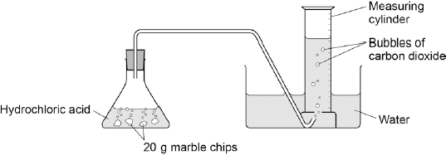

(a)     Complete and balance the equation for the reaction between marble chips and hydrochloric acid.

..................  +  ..................  →    CaCl2  +  ..................  +  ..................

**(2)**

(b)     The table below shows the student’s results.

|  |  |  |  |
| --- | --- | --- | --- |
|  |  | **Time in s** | **Volume of gas in dm3** |
|  |  | 0 | 0.000 |
|  |  | 30 | 0.030 |
|  |  | 60 | 0.046 |
|  |  | 90 | 0.052 |
|  |  | 120 | 0.065 |
|  |  | 150 | 0.070 |
|  |  | 180 | 0.076 |
|  |  | 210 | 0.079 |
|  |  | 240 | 0.080 |
|  |  | 270 | 0.080 |

On **Figure 2**:

•        Plot these results on the grid.

•        Draw a line of best fit.

**Figure 2**

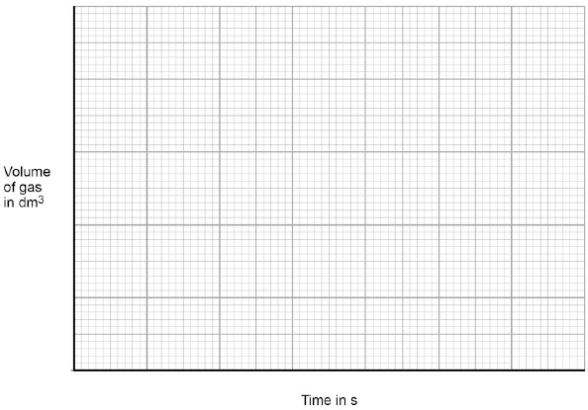

**(4)**

(c)     Sketch a line on the grid in **Figure 2** to show the results you would expect if the experiment was repeated using 20 g of smaller marble chips. Label this line **A**.

**(2)**

(d)     Explain, in terms of particles, how and why the rate of reaction changes during the reaction of calcium carbonate with hydrochloric acid.

………………………….................................................................................................................................

………………………….................................................................................................................................

………………………….................................................................................................................................

………………………….................................................................................................................................

………………………….................................................................................................................................

………………………….................................................................................................................................

**(4)**

(e)     Another student investigated the rate of reaction by measuring the change in mass. **Figure 3** shows the graph plotted from this student’s results.

**Figure 3**

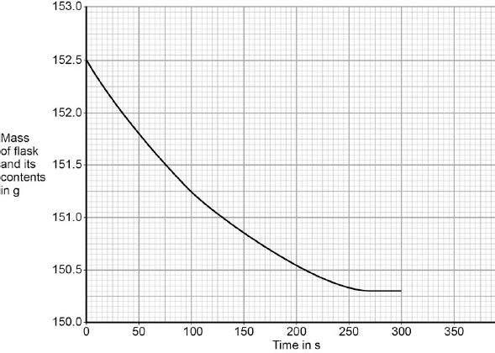

Use **Figure 3** to calculate the mean rate of the reaction up to the time the reaction is complete. Give your answer to three significant figures.

………………………….................................................................................................................................

………………………….................................................................................................................................

………………………….................................................................................................................................

………………………….................................................................................................................................

       Mean rate of reaction = ........................................... g / s

**(4)**

(f)     Use **Figure 3** to determine the rate of reaction at 150 seconds.Show your working on **Figure 3**.

Give your answer in standard form.

.............................................................................................................................

.............................................................................................................................

.............................................................................................................................

.............................................................................................................................

.............................................................................................................................

  Rate of reaction at 150 s = ........................................... g / s

**(4)**

**(Total 20 marks)**

**Independent Exam Question**

**Q2.**A company manufactures ethanol (C2H5OH).The reaction for the process is:

C2H4(g) + H2O(g)        C2H5OH(g)            Δ*H* = −45 kJ per mole

The temperature and pressure can be changed to increase the yield of ethanol at equilibrium.

(a)     Explain what is meant by equilibrium.

………………………………........................................................................................................................

………………………………........................................................................................................................

………………………………........................................................................................................................

………………………………........................................................................................................................

………………………………........................................................................................................................

………………………………........................................................................................................................

………………………………........................................................................................................................

**(3)**

(b)     (i)      How would increasing the temperature change the **yield** of ethanol at equilibrium? Give a reason for your answer.

………………………………........................................................................................................................

………………………………........................................................................................................................

………………………………........................................................................................................................

………………………………........................................................................................................................

………………………………........................................................................................................................

**(2)**

(ii)     How would increasing the pressure change the **yield** of ethanol at equilibrium?Give a reason for your answer.

………………………………........................................................................................................................

………………………………........................................................................................................................

………………………………........................................................................................................................

………………………………........................................................................................................................

………………………………........................................................................................................................

**(2)**

(c)     A catalyst is added to increase the rate of the reaction.Explain how adding a catalyst increases the rate of a chemical reaction.

………………………………........................................................................................................................

………………………………........................................................................................................................

………………………………........................................................................................................................

………………………………........................................................................................................................

**(2)**

**Lesson 2**



**Chemistry Revision: Mixtures**

Mastery Matrix Points

|  |
| --- |
| Use key terms (soluble, insoluble, solute, solvent and solution) correctly to describe a substance dissolving |
| Explain how to separate given mixtures (filtration, crystallisation, simple distillation, fractional distillation, chromatography) |
| Explain the difference in difficulty of separating compounds compared to mixtures |

Key Knowledge

Mixture –

Soluble –

Insoluble –

Solute –

Solvent –

Filtration

Used to separate:

Equipment:

Crystallisation

Used to separate:

Equipment:

Simple distillation

Used to separate:

Equipment:

Chromatography

Used to separate:

Equipment:

Fractional distillation

Used to separate:

Equipment:

Understanding and Explaining

1. Mixtures be separated by physical processes. Explain what a physical process is and give four examples.





1. Explain why compounds cannot be separated by physical processes.







1. Describe the process of filtration using sandy water as an example.







1. Describe the process of crystallisation using copper sulfate solution as an example.







1. Describe the process of paper chromatography and how you could use it to see if a food dye is pure.







1. Describe the process of distillation using an ethanol and water mixture as an example.







1. Explain the difference between simple distillation and fractional distillation.







**Chemistry Revision: Chemical tests & calculations**

Mastery Matrix Points

|  |
| --- |
| Describe the gas test for carbon dioxide, hydrogen, oxygen and chlorine |
| Explain how to use silver nitrate solution in the presence of dilute nitric acid to test for halide ions (chloride, bromide, iodide) (triple only) |
| Explain how to use barium chloride solution in the presence of dilute hydrochloric acid to test for sulphate ions (triple only) |
| **RP Identifying Ions:** Use all of the chemical tests listed above to test for the presence of different ions (testing for metal ions: flame tests, hydroxide solutions and testing for negative ions – halides, sulphate ions, and carbonates) (triple only) |

Understanding and Explaining

1. Write a word and symbol equation (with state symbols) for the reaction of:
2. calcium bromide with dilute silver nitrate solution.





1. magnesium carbonate with sulphuric acid.





1. Iron (II) sulphate solution and sodium hydroxide solution





2 Genesis believes that a metal is calcium. Tyler disagrees. Describe two chemical tests that Genesis could do to prove that she is correct. You should include the results that she would expect.









3.Simone believes that a substance is Iron (II) bromide. Describe two chemical tests that she could use to prove that she is correct. You should include the results that she would expect if she is correct.









**Metal ions (cations)**

**Flame test** are used to identify **metal ions** (cations)

|  |  |  |  |  |  |
| --- | --- | --- | --- | --- | --- |
| Metal ion | Colour of flame |  | Metal ion | Colour of flame | |
| Li |  |  | Ca |  | |
| Na |  |  | Cu |  | |
| P |  |  |  | |  | |

**Sodium hydroxide solution** can be used to identify some **metal ions** (cations).

|  |  |  |  |  |  |  |
| --- | --- | --- | --- | --- | --- | --- |
| **Metal ion** | **Colour of precipitate formed** |  | **Metal ion** | | **Colour of precipitate formed** | |
| Al |  |  | Cu (II) | |  | |
| Ca |  |  | Fe (II) | |  | |
| Mg |  |  | Fe (III) |  | |

**Halides (group 7)**

**React with dilute nitric acid, THEN dilute silver nitrate solution** to produce coloured precipitates.

|  |  |
| --- | --- |
| **Halide** | **Colour of silver halide (precipitate formed)** |
| Bromide |  |
| Chloride |  |
| Iodide |  |

Key Knowledge

**Gas tests:**

|  |  |  |  |
| --- | --- | --- | --- |
| Gas | Description of test | Positive result | Negative result |
| O2 |  |  |  |
| H2 |  |  |  |
| CO2 |  |  |  |
| Cl2 |  |  |  |

**Sulfates** produce a _________ precipitate when they react with **dilute HCl** and THEN **barium chloride** solution.

**Carbonates** react with acid to produce _______ _________ gas. This can be identified using _________ __________.

Notes

**Guided Exam Question**

**Q3.**This is part of an article about food additives.

|  |  |
| --- | --- |
|  | **THE PERIL OF FOOD ADDITIVES** |
|  | Some orange drinks contain the additives E102 (Tartrazine), E104 (Quinoline Yellow) and E110 (Sunset Yellow).These three coloured additives are thought to cause hyperactivity in children. |

(a)     State **two** reasons that a manufacturer might give to justify the use of these additives.

1 ....................................................................................................................

.......................................................................................................................

2 .....................................................................................................................

.......................................................................................................................

**(2)**

(b)     Some scientists asked 4000 twelve-year-old children to help them investigate if there is a link between these three coloured additives and hyperactivity.

How would the scientists use these 4000 children to investigate if there is a link between these three coloured additives and hyperactivity in children?

……………………………………........................................................................................................................

……………………………………........................................................................................................................

……………………………………........................................................................................................................

……………………………………........................................................................................................................

……………………………………........................................................................................................................

……………………………………........................................................................................................................

……………………………………........................................................................................................................

**(4)**

(c)     A manufacturer used an independent scientist to show that their orange drink did not contain these three coloured additives.

(i)      Suggest why the manufacturer would use a scientist who was independent instead of using their own scientist.

……………………………………........................................................................................................................

……………………………………........................................................................................................................

**(1)**

(ii)     The scientist had samples of E102, E104 and E110 and the orange drink. The scientist used paper chromatography for the test.Describe how the scientist could use the results to show if the orange drink contained any of these three coloured additives.You may include a diagram of the paper chromatography results.

……………………………………........................................................................................................................

……………………………………........................................................................................................................

……………………………………........................................................................................................................

……………………………………........................................................................................................................

……………………………………........................................................................................................................

……………………………………........................................................................................................................

**(2)**

**Independent Exam Question**

**Q4.**A student was investigating a magnesium salt, **X**.

The student found that **X**:

•        has a high melting point

•        does not conduct electricity

•        dissolves in water and the solution conducts electricity.

(b)     The student dissolved **X** in water.

The student added dilute nitric acid and silver nitrate solution to the solution of **X**.

A white precipitate was formed.

Salt **X** contains chloride ions.

Explain why a white precipitate was formed.

.........................................................................................................................

.........................................................................................................................

.........................................................................................................................

.........................................................................................................................

**(2)**

(c)     The student dissolved **X** in water.

The student added a few drops of sodium hydroxide solution to the solution of **X**.

A white precipitate was formed.

(i)      Salt **X** contains magnesium ions.

Name **two** other metal ions that would give a white precipitate when a few drops of sodium hydroxide solution are added.

1 ..........................................................................................................................................................

2 .........................................................................................................................................................

**(2)**

(ii)     Describe the **two** further tests the student would have to do to show that salt **X** contains magnesium ions, and **not** the two metal ions you identified in part **(c) (i)**.

Give the expected results of each test.

……………………………………........................................................................................................................

……………………………………........................................................................................................................

……………………………………........................................................................................................................

……………………………………........................................................................................................................

……………………………………........................................................................................................................

……………………………………........................................................................................................................

……………………………………........................................................................................................................

……………………………………........................................................................................................................

**(4)**

**Lesson 3**



**Chemistry Revision: The Earth’s Early Atmosphere**

Mastery Matrix Points

|  |
| --- |
| Describe the composition of the atmosphere and how long this has been the case |
| Describe the development from early atmosphere to present day |
| Draw links between the early Earth’s atmosphere and that of other planets (Mars and Venus) |
| Evaluate different theories regarding the Earth’s early atmosphere |
| Explain why oxygen levels increased and carbon dioxide levels decreased (linking to photosynthesis and sedimentation) |

Key Knowledge

Which gases were in our atmosphere 4.6 billion years ago when the Earth was created?

_____% of __________________________

_____% of __________________________

_____% of __________________________

_____% of __________________________

The atmosphere was very similar to the current atmosphere on two other planets __________ and ________________. The majority of these gases are thought to have been produced by ________________.

Which gases are currently in our Earth’s atmosphere?

____% of __________________________

____ % of _________________________

Very small amounts of ___+++___________, ___________ and __________________.

State the 4 ways that is thought to have led to a decrease in the concentration of CO2 in the atmosphere between the Early Atmosphere and today.

-

-

-

-

The process which caused water vapour in the atmosphere to reduce was _______. This formed the _________ on our planet.

The process which caused oxygen levels to increase was ____________. This was carried out by _______ and algae.

Understanding and Explaining

1. Write the word and balanced symbol equation for photosynthesis.





1. Compare and contrast the composition of the current atmosphere to that of the atmosphere 4.6 billion years ago. (4 marks)













1. The current atmosphere contains significantly more oxygen than the early atmosphere. Explain why. (4 marks)











1. The current atmosphere contains significantly less carbon dioxide than the early atmosphere. Explain why. (4 marks)













**c**

**Chemistry Revision: Global warming**

Mastery Matrix Points

|  |
| --- |
| Describe the term ‘greenhouse gases’ and give three examples (water vapour, carbon dioxide and methane) |
| Describe the ‘greenhouse effect’ linking to the wavelength of radiation |
| Describe the effect of human activities on the levels of greenhouse gases, recalling two that affect methane and two that affect carbon dioxide |
| Explain how peer review evidence have linked these activities to global climate change |
| Explain why it is difficult to model this and how this has led to simplification, speculation and biased opinions in the media |
| Describe 4 potential effects of global climate change |
| Discuss the scale, risks and environmental implication of global climate change |
| Describe what is meant by the term ‘carbon footprint’ |
| Describe actions to reduce our carbon footprint and explain why these actions may have limited impact |

Key Knowledge

Name the 3 main greenhouse gases:

-

-

-

The waves entering the atmosphere from the sun are made up of ___________ wavelength radiation that is easily able to pass through the atmosphere.

Some of this is _____________ by the surface of the Earth whilst some is _______________ as _______________ wavelength radiation. This cannot pass through the atmosphere and so more is reflected back to the earth’s surface or absorbed causing the atmosphere to ___________ in temperature.

Name 2 human activities that increase the amount of:

1. Methane:

-

-

1. Carbon dioxide:

-

-

State 4 potential effects of global climate change

-

-

-

-

Define ‘carbon footprint’:

State 3 ways to reduce our carbon footprint:

-

-

-

Understanding and Explaining

1. Explain why we need some greenhouse gases in our atmosphere.













1. Use the graph to describe the average global temperature between 1860

and today.











1. Humans are said to be having an effect on the increasing global temperature. Give two reasons why humans may be to blame and two ways that humans can help to reduce their impact over the next ten years.















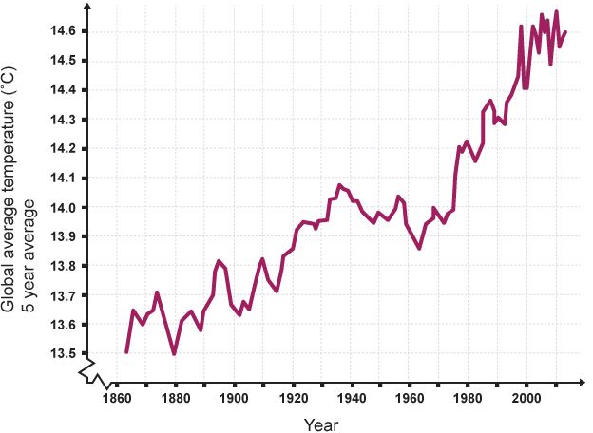

Notes

**Guided Exam Question**

**Q5.**This question is about the temperature of the Earth’s atmosphere.

(a)     Give **one** reason why it is difficult to produce models for future climate change.

…………………………………..............................................................................................................................

…………………………………..............................................................................................................................

**(1)**

(b)     Describe how carbon dioxide helps to maintain temperatures on Earth.

…………………………………..............................................................................................................................

…………………………………..............................................................................................................................

…………………………………..............................................................................................................................

…………………………………..............................................................................................................................

…………………………………..............................................................................................................................

…………………………………..............................................................................................................................

**(3)**

(c)     The figure below shows the change in mean global air temperature from 1860 to 2000.

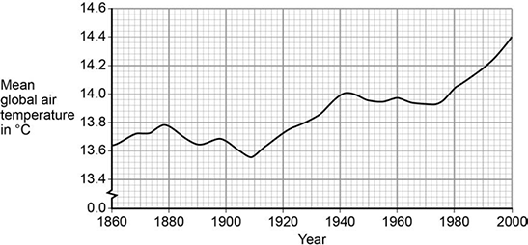

Explain how human activities have contributed to the main trend shown from 1910 in the figure above.

.............................................................................................................................

.............................................................................................................................

.............................................................................................................................

.............................................................................................................................

.............................................................................................................................

**(3)**

**Independent Exam Question**

**Q6.** (a)     For the last 200 million years the amount of carbon dioxide in the atmosphere has remained almost the same. Describe the natural processes which remove carbon dioxide from the atmosphere.

…………………………………......................................................................................................................................

…………………………………......................................................................................................................................

…………………………………......................................................................................................................................

…………………………………......................................................................................................................................

…………………………………......................................................................................................................................

…………………………………......................................................................................................................................

…………………………………......................................................................................................................................

…………………………………......................................................................................................................................

…………………………………......................................................................................................................................

…………………………………......................................................................................................................................

…………………………………......................................................................................................................................

…………………………………......................................................................................................................................

**(4)**

(b)     The amount of carbon dioxide in the atmosphere has increased over the last one hundred years. Suggest **two** reasons why this has happened.

…………………………………......................................................................................................................................

…………………………………......................................................................................................................................

…………………………………......................................................................................................................................

…………………………………......................................................................................................................................

…………………………………......................................................................................................................................

…………………………………......................................................................................................................................

**(2)**

**Lesson 4**



**Chemistry Revision: Air Pollution**

Mastery Matrix Points

|  |
| --- |
| Describe combustion as a major source of atmospheric pollution |
| Name gases release when fuels such as coal are burnt (carbon dioxide, water vapour, carbon monoxide, sulphur dioxide and nitrogen oxides) and predict which of these would be produced from a given fuel composition |
| Describe ‘particulates’ |
| Describe issues arising from carbon dioxide, sulphur dioxide, nitrogen oxides and particulates |

Key Knowledge

One of the biggest sources of atmospheric pollution is _________________ of fuels.

The gases released into the atmosphere when a fuel is burned include:

-

-

-

-

-

Solid particles of hydrocarbons released into the atmosphere are called ________.

State 3 properties of carbon monoxide:

1)

2)

3)

State 2 effects of increased sulphur dioxide and nitrogen oxides being released into the atmosphere:

1)

2)

State 2 effects of increased particulates being released into the atmosphere:

1)

2)

To test for the presence of carbon dioxide, I would….

To test for the presence of water, I would….

Understanding and Explaining

1. Oxides of nitrogen are produced when fuels are burnt. Write a balanced symbol equation for the production of nitrogen dioxide (NO2) from nitrogen and oxygen.





2. Coal is a fossil fuel. Coal contains the elements hydrogen, sulfur, oxygen and carbon. Name two products of burning coal that have an impact on the environment. What impact does each of the products you named have on the environment?











3. Fuels react with oxygen to produce carbon dioxide. The reaction of a fuel with oxygen can produce a different oxide of carbon. Name this different oxide of carbon and explain why it is produced.







4. The table to the right shows the composition of gases found in the exhaust of a car.

Explain how nitrogen oxides are formed in a car’s engine.















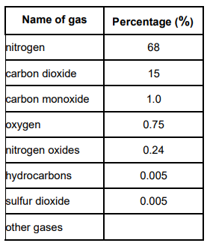

**Chemistry Revision: Finite Resources**

Key Knowledge

Define:

*“Finite resource”:*







*“Renewable resource”:*

**

**

**

*“Synthetic”:*

**

**

**

*“Sustainable development”:*

**

**

**

Humans use the Earth’s resources for 4 things:

1) 

2) 

3) 

4) 

Give two examples of synthetic materials that are used because we do not have sufficient natural resources.

-

-

Mastery Matrix Points

|  |
| --- |
| Recalls that humans use the Earth’s resources to provide; warmth, shelter, food, transport (through timber, clothing, fuels/energy and other materials) |
| Define what is meant by the term ‘finite resource’ |
| Define what is meant by the term ‘sustainable development’ and explain the role that chemistry plays in developing agricultural and industrial processes |

Understanding and Explaining

1. Coal is described as a *‘finite’* resource. Explain why.





1. Using manure from cows is described as a ‘*sustainable’* way of farming. Explain why.







1. Recycling is viewed as being more sustainable than incinerating our waste or placing it into landfill sites. Explain why recycling is better for the environment and future population than either of the alternatives.







1. Wind turbines are very expensive to build yet the government has agreed £274 million of funding to build more wind farms around the UK. Suggest why they have made this decision.











1. Developments in farming have led to the use of synthetic fertilisers. State two advantages and two disadvantages of using man made fertilisers rather than using natural fertilisers like manure.













Notes

**Guided Exam Question**

**Q7.1**

Coal is used as a fuel in power stations.

The table shows the percentage of carbon and sulfur in four different coal samples.

|  |  |  |
| --- | --- | --- |
| **Sample** | **Percentage (%) by mass in coal** | |
| **Carbon** | **Sulfur** |
| **A** | 22.1 | 0.4 |
| **B** | 46.8 | 0.6 |
| **C** | 66.3 | 0.9 |
| **D** | 92.0 | 0.7 |

(a)     Sulfur produces a gas that causes acid rain.

Name the gas.

___________________________________________________________________

**(1)**

(b)     Give **one** environmental effect caused by acid rain.

___________________________________________________________________

**(1)**

(c)     Which coal sample produces the most acid rain from 1 kg of coal?

Use the table above.

Give a reason for your answer.

Sample __________

Reason ____________________________________________________________

___________________________________________________________________

**(2)**

(d)     Calculate the mass of coal sample **A** that would produce the same amount of carbon dioxide as 1 kg of coal sample **C**.

___________________________________________________________________

___________________________________________________________________

Mass of coal sample **A** = ____________________ kg

**(2)**

(e)     Incomplete combustion of coal can produce carbon monoxide.

Carbon monoxide is a toxic gas.

Give **two** reasons why people may be unaware of the presence of carbon monoxide.

1. _________________________________________________________________

2. _________________________________________________________________

**(2)**

**(Total 8 marks)**

**Q7.2**

This information about diesel was printed in a magazine.

Almost all of the crops that we eat can be converted into fuel for cars.  
Vegetable oils can be used as biodiesel. Diesel from crude oil is called fossil diesel.  
When either biodiesel or fossil diesel burn they both produce similar amounts of carbon dioxide.  
Both types of diesel produce carbon monoxide. However, biodiesel produces fewer carbon particles and less sulfur dioxide.

(a)     Carbon monoxide can be produced when diesel burns in a car engine. Explain how.

___________________________________________________________________

___________________________________________________________________

___________________________________________________________________

___________________________________________________________________

**(2)**

(b)     Use the information at the start of this question and your knowledge and understanding to evaluate the use of biodiesel compared with fossil diesel as a fuel for cars.

Remember to give a conclusion to your evaluation.

___________________________________________________________________

___________________________________________________________________

___________________________________________________________________

___________________________________________________________________

___________________________________________________________________

___________________________________________________________________

___________________________________________________________________

___________________________________________________________________

___________________________________________________________________

___________________________________________________________________

___________________________________________________________________

___________________________________________________________________

___________________________________________________________________

**(5)**

**(Total 7 marks)**

**Independent Exam Question**

**Q8.** Since 2000 there has been a lot more research into alternative, environmentally-friendly fuels for road transport.Several pollutants are found in the exhaust emissions produced when fossil fuels are used for road transport.

Carbon monoxide (CO) interferes with the way that red blood cells carry oxygen. Carbon dioxide (CO2) increases the level of carbon dioxide in the atmosphere and causes global warming.

Oxides of nitrogen (NOx) are produced at high temperatures when nitrogen and oxygen from the atmosphere combine.

Sulfur dioxide (SO2) is produced when sulfur impurities in the fuel combine with oxygen in the atmosphere.

Tiny particles of solids are produced when the fuel does not burn completely. This increases the level of particulates (PM10) in the atmosphere.

(a)     Name the environmental effect caused by:

(i)      oxides of nitrogen (NOx) and sulfur dioxide (SO2)

..........................................................................................................................

**(1)**

(ii)     the increased level of particulates (PM10).

..........................................................................................................................

**(1)**

(b)     Diesel obtained from crude oil is often called fossil diesel. Biodiesel can be made from many vegetable oils. One research project compared the exhaust emissions when fossil diesel or biodiesel were used as fuels.

Some of the relative amounts of these exhaust emissions are shown in the bar chart.

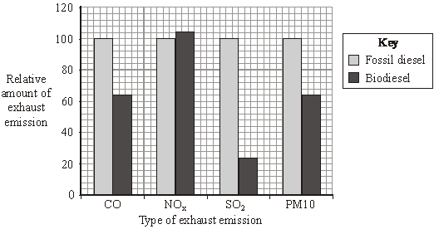

(i)      Use your knowledge and the information above to explain the environmental benefits of using biodiesel as a sustainable, low pollution fuel.

……………………………………...................................................................................................................

……………………………………...................................................................................................................

……………………………………...................................................................................................................

……………………………………...................................................................................................................

……………………………………...................................................................................................................

……………………………………...................................................................................................................

**(3)**

(ii)     Biodiesel is called a green fuel.This is because the life-cycle emission of carbon dioxide from biodiesel is less than that from fossil diesel.

Use your knowledge and the information above to explain why biodiesel’s contribution to global warming is considered to be much less than that of fossil diesel.

……………………………………...................................................................................................................

……………………………………...................................................................................................................

……………………………………...................................................................................................................

……………………………………...................................................................................................................

……………………………………...................................................................................................................

……………………………………...................................................................................................................

……………………………………...................................................................................................................

……………………………………...................................................................................................................

**(3)**

**Lesson 5**:



**Chemistry Revision: Waste & water**

Mastery Matrix Points

|  |
| --- |
| Describe the properties of potable water (is safe to drink) linking to purity, salt and microbe levels |
| Describe the different sources of drinking water in the UK and the process that it must undergo before it is potable |
| Describe the process of desalination (distillation or reverse osmosis) |
| Evaluate the methods to produce potable water (linking to location and potential water supply) |
| **RP Water Purification:** Analyse and purify water samples from different sources, including pH, dissolved solids and distillation |
| Explain why large amounts of waste water are produced (urban life styles and industrial processes) |
| Explain what needs to be removed from sewage and agricultural waste in comparison with industrial waste water |
| Describe the 4 steps of sewage treatment |
| Compare the relative ease of obtaining potable water from waste, the ground and salt water |

Key Knowledge

Define ‘*potable’*:





What are the two steps in producing **potable** water from **ground** (rain/fresh) water?

1) 



2) 



Give three substances that can be used to **sterilise** water:

-

-

-

What are the two steps taken during **desalination** of salty water?

1)



2)



Which 2 substances must be removed from waste water from agriculture and sewage?

1)

2)

Which two substances must be removed from industrial waste water?

1)

2)

Understanding and Explaining

1. Describe the 4 stages of treating sewage. (4 marks)







1. Compare and contrast waste water from agriculture (farming) and from a factory. (2 marks)







1. Which method of creating potable water would be used in the lake district? Give reasons for your choice. (3 marks)







1. Which method of creating potable water is likely to be used in Istanbul? Give reasons for your choice. (3 marks)









**Chemistry Revision: Life cycle assessments**

Mastery Matrix Points

|  |
| --- |
| Explain how phytomining and bioleaching and scrap iron and electrolysis can be used to extract copper from low grade ores |
| Describe what is meant by the term ‘life cycle assessment’ |
| Describe the 4 stages of a life cycle assessment |
| Explain that water resources, energy and waste production can be easily quantified whereas pollutant effects are hard to quantify |
| Describe how simplified life cycle assessments can be used in a biased manner to support advertising claims in the media |
| Use data to carry out LCA for shopping bags made from plastic and paper |
| Explain how we can reduce our use of limited resources (reduce, reuse, recycle) |

Key Knowledge

Name 2 ways of extracting copper from low grade ores:

1)

2)

Give 3 advantages of using these methods instead of more traditional mining methods:

1)

2)

3)

How can copper be removed from the metal compounds produced by these two methods?

1)

2)

Name the 4 stages that must be evaluated during an LCA.

1)

2)

3)

4)

Understanding and Explaining

1. Describe the 3 steps to producing copper compounds using **plants**: (3 marks)





1. Describe 2 steps to producing copper compounds using **bacteria**: (2 marks)





1. Jared tells Waeil that an LCA is not an objective process.

Explain why this is the case (2 marks)







1. Use the information to the right to carry out a simple LCA for plastic

and paper shopping bags. Use this to decide which is better for us to use

and why. The number indicates the relative quantities e.g. paper bags

require 4 times more water during their entire life time. (6 marks)

















|  |  |  |
| --- | --- | --- |
|  | **Plastic** | **Paper** |
| Consumption of non-renewable energy | 1 | 1.1 |
| Consumption of water | 1 | 4 |
| Greenhouse gas emissions | 1 | 3.3 |
| Solid waste produced | 1 | 1.7 |
| Average number of uses | 10 | 2 |
| Years taken to biodegrade | 25 | 2 |

Notes

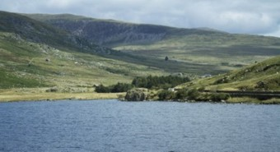**Guided Exam Question**

**Q9.1**Water in Britain is taken from reservoirs to use as drinking water.

(a)     What are the **two** main steps used to treat water from reservoirs?

Give **one** reason for each step.

………………………………........................................................................................................................

………………………………........................................................................................................................

………………………………........................................................................................................................

………………………………........................................................................................................................

………………………………........................................................................................................................

………………………………........................................................................................................................

………………………………........................................................................................................................

………………………………........................................................................................................................

………………………………........................................................................................................................

**(4)**

(b)     Some people use water filters to treat water before drinking it.

(i)      Water filters remove hardness from hard water. What is in water filters that removes hardness from water?

………………………………........................................................................................................................

………………………………........................................................................................................................

**(1)**

(ii)     Suggest why water filters used in the home contain particles of silver.

………………………………........................................................................................................................

………………………………........................................................................................................................

**(1)**

(c)     Pure water can be produced by distillation.Why is distillation **not** usually an economic method of treating water for drinking?

………………………………........................................................................................................................

………………………………........................................................................................................................

**(1)**

(d)     Drinking hard water has health benefits.State **one** health benefit of drinking hard water.

………………………………........................................................................................................................

………………………………........................................................................................................................

**(1)**

**Q9.2**

Read the article and then answer the questions.

|  |
| --- |
| **Supermarkets launch eco-friendly plastic milk bags. Could this be the end of the milk bottle?** |
|  |
| Milk bottles are made from glass or from plastic. |
| Glass milk bottles contain 0.5 litres of milk. When the milk is used up the empty bottles are returned to be re-used. Glass milk bottles are re-used 24 times on average. The glass to make new milk bottles is produced when a mixture of sand, limestone, soda and recycled glass is heated to about 1600 °C in a furnace. There are almost unlimited amounts of the raw materials needed to produce this glass. About 35% of used glass is recycled. |
| The most common plastic milk bottles contain 2 litres of milk. When the milk is used up the empty bottles are discarded as waste. The plastic used to make these milk bottles is poly(ethene). Poly(ethene) is produced from crude oil by first using fractional distillation, then cracking the naphtha fraction and finally polymerising the ethene. About 5% of used poly(ethene) is recycled. |
| The new plastic milk bags contain 2 litres of milk. The milk bags are also made from poly(ethene). A milk bag uses 75% less poly(ethene) than is used to make the poly(ethene) milk bottles. When the milk is used up the empty bags are discarded as waste. |

(b)     Supermarkets claim that using milk bags instead of milk bottles would have less environmental impact.

Do you agree with this claim?

Use the information in the article and your knowledge and understanding to make appropriate comparisons to justify your answer.

___________________________________________________________________

___________________________________________________________________

___________________________________________________________________

___________________________________________________________________

___________________________________________________________________

___________________________________________________________________

___________________________________________________________________

___________________________________________________________________

___________________________________________________________________

___________________________________________________________________

___________________________________________________________________

___________________________________________________________________

___________________________________________________________________

___________________________________________________________________

___________________________________________________________________

___________________________________________________________________

**(4)**

**Independent Exam Question**

**Q10.1**

Plastic and glass can be used to make milk bottles.

(b)     The table below gives information about milk bottles.

|  |  |  |
| --- | --- | --- |
|  | **Glass milk bottle** | **Plastic milk bottle** |
| Raw materials | Sand, limestone, salt | Crude oil |
| Bottle material | Soda-lime glass | HD poly(ethene) |
| Initial stage in production of bottle material | Limestone and salt used to produce sodium carbonate. | Production of naphtha fraction. |
| Maximum temperature in production process | 1600 °C | 850 °C |
| Number of times bottle can be used for milk | 25 | 1 |
| Size(s) of bottle | 0.5 dm3 | 0.5 dm3, 1 dm3, 2 dm3, 3 dm3 |
| Percentage (%) of recycled material used in new bottles | 50 % | 10 % |

Evaluate the production and use of bottles made from soda-lime glass and those made from HD poly(ethene).

Use the information given and your knowledge and understanding to justify your choice of material for milk bottles.

___________________________________________________________________

___________________________________________________________________

___________________________________________________________________

___________________________________________________________________

___________________________________________________________________

___________________________________________________________________

___________________________________________________________________

___________________________________________________________________

___________________________________________________________________

___________________________________________________________________

**(6)**

**Q10.2**This question is about copper.

(b) Read the information in the box.

|  |  |
| --- | --- |
|  | **Copper extraction**  World demand for copper for the year 2011 was about 20 million tonnes.  World reserves of copper are estimated to be 700 million tonnes.  Most of the copper used is obtained from copper ores, which are mined.  The copper ore chalcopyrite is heated in a furnace to produce copper sulfide, CuS  The furnace is heated by burning fossil fuels.  Air is then blown through the hot copper sulfide, to produce copper and sulfur dioxide.  CuS + O2 → Cu + SO2 |

A scientist made the statement: ‘Copper should be recycled’. Use the information in the box and your own knowledge and understanding to justify the scientist’s statement.

………………………………........................................................................................................................

………………………………........................................................................................................................

………………………………........................................................................................................................

………………………………........................................................................................................................

………………………………........................................................................................................................

………………………………........................................................................................................................

………………………………........................................................................................................................

………………………………........................................................................................................................

………………………………........................................................................................................................

………………………………........................................................................................................................

**(6)**

(c)     Phytomining is used to obtain copper from land that contains very low percentages of copper compounds.

Describe how copper compounds are obtained by phytomining.

………………………………........................................................................................................................

………………………………........................................................................................................................

………………………………........................................................................................................................

………………………………........................................................................................................................

………………………………........................................................................................................................

………………………………........................................................................................................................

**(3)**

**Lesson 6**





**Chemistry Revision: Composites, glass and ceramics.**

Mastery Matrix Points

|  |
| --- |
| Explain how to produce clay ceramics |
| Describe what factors affect the properties of polymers |
| Compare low density and high density poly(ethene) |
| Compare and contrast thermosetting and thermosoftening polymers explaining the differences |
| Explain what ‘composites’ are and give some examples |
| Explain how glass is produced |
| Compare the composition and melting points of soda-lime glass and borosilicate glass |
| Discuss the environmental impact of using metal, glass, building materials, clay ceramics and plastics linking to the use of these limited resources and the energy used to extract and process them. |
| Explain ways that we can reduce this environmental impact |

Key Knowledge

Clay ceramics (including bricks and pottery) are made by:

1. 

2. 

The properties of polymers depend on:

1. 

2. 

Two properties of low density poly(ethene) are:

1. 

2. 

3. 

Two properties of high density poly(ethene) are:

1. 

2. 

3. 

Define ‘thermosetting polymer’:





Define ‘themosoftening polymer’:





Most of the glass we use is ______ - ____ glass. It is made by heating the following things together:

1. 

2. 

3. 

Another type of glass is called ____________ glass which is made from ______ and ______ ___________.

Composites are made from 2 materials:

- 

- 

Two examples of composites are:

1. 2)

Understanding and Explaining

1. Compare and contrast thermosetting and thermosoftening polymers. You should make reference to their properties AND structure.





1. Give an advantage of using borosilicate glass and describe one object that would be made from this material based on this property.





1. Looking at the table to the right, explain which material

should be chosen for each purpose:

1. Overhead wires





1. Iron is often used to make bridges in hot countries.

Which property makes it appropriate for this use? Explain your

Answer.





1. In reference to the question above (b), why is iron often used as an alloy rather than the pure metal? You must make reference to the answer given in (b) and the table of properties.





1. Describe the effect that making glass has on the environment. How could we reduce this impact?





|  |  |  |  |  |
| --- | --- | --- | --- | --- |
| **Property** | **Zinc** | **Aluminium** | **Magnesium** | **Iron** |
| Tensile strength | 54 | 47 | 34 | 31 |
| Density | 6300 | 2713 | 1827 | 6920 |
| Electrical conductivity | 27.7 | 27 | 11.5 | 17 |
| Thermal expansion (when put under 68⁰C) | 23.3mm | 21.2mm | 25.2mm | 12.1mm |

**Chemistry Revision:**

Mastery Matrix Points

|  |
| --- |
| State what is produced in the Haber process and explain how ammonia produced from this process is used (triple only) |
| List the raw materials for the Haber process and where they are sourced from (triple only) |
| Recall the conditions required for the Haber process to take place (triple only) |
| Recall the word and symbol equation for the Haber process (triple only) |
| Explain how the ammonia is removed and the hydrogen and nitrogen are recycled (triple only) |
| Interpret graphs of reaction conditions for Haber process versus rate (triple only) |
| Apply the principals of dynamic equilibrium to the Haber process (triple only) |
| Explain how these conditions are manipulated to produce optimum quantities of the desired products (triple only) |
| Describe what NPK fertilisers are (triple only) |

**The Haber Process**

Key Knowledge

The purpose of the Haber process is.

The word equation is:





The balanced symbol equation (with state symbols) is:





The conditions used are:

1) 

2) 

3) 

At the end of the process, the mixture is cooled. This causes the __________________ to liquefy and be collected and the _____________ and __________________ remain a gas so can be recycled.

Define Equilibrium:

Reversible reactions:

Which elements are found in NPK fertilisers?

1) 

2) 

3) 

Understanding and Explaining

1. Use the graph to the right to determine the conditions that should be used to

produce the highest **yield** of ammonia.





1. Making reference to both **yield** and **rate** **of reaction** explain why these are not

the conditions used.









1. Synthetic fertilisers are prepared in the lab by the reaction of an acid with an alkali. A quantity of alkali is placed in a beaker and a solution of acid is run in until the solution is neutral. The neutral solution of salt is evaporated until crystals form. These are filtered out, washed and dried. Ammonia sulphate is produced using this method. Write the method below that must be used to create Ammonia sulphate crystals.







1. Potassium chloride and potassium sulphate can be obtained by mining. Phosphate rock must be reacted with an acid to form fertilisers that can be used. For each of the below acids, decide on the name of the compound that would be formed.
2. Sulphuric acid - 
3. Nitric acid - 
4. Phosphoric acid - 
5. Calculate the percentage by mass of phosphorus in ammonium phosphate (NH4)3PO4.





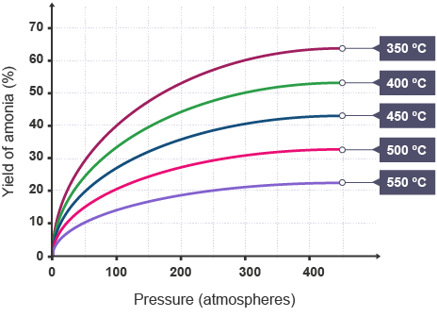

Notes

**Guided Exam Question**

**Q11.**          (a)     PEX is a material that is used as an alternative to copper for hot water pipes.  
PEX is made from poly(ethene).

(iii)     The simplified structures of poly(ethene) and PEX are shown.

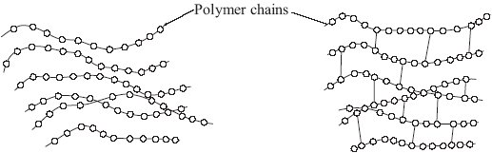

**Poly(ethene)**                                           **PEX**

Poly(ethene) is a thermoplastic that softens easily when heated. Suggest and explain how the structure of PEX changes this property.

……………………………………...................................................................................................................

……………………………………...................................................................................................................

……………………………………...................................................................................................................

……………………………………...................................................................................................................

……………………………………...................................................................................................................

……………………………………...................................................................................................................

**(3)**

**Q11.2**

The graph in **Figure 1** shows a flow diagram for the Haber process.

**Figure 1**

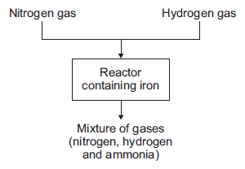

(a)     (i)      Hydrogen gas is obtained from methane.

Name **one** source of methane.

____________________________________

**(1)**

(ii)     Air is the source used to produce nitrogen for the Haber process.

Suggest why air must **not** get into the reactor.

______________________________________________________________

______________________________________________________________

**(2)**

(iii)     Describe what happens to the mixture of gases from the reactor.

______________________________________________________________

______________________________________________________________

______________________________________________________________

______________________________________________________________

______________________________________________________________

______________________________________________________________

**(3)**

(b)     The graph in **Figure 2** shows the percentage yield of ammonia using different conditions.

**Figure 2**

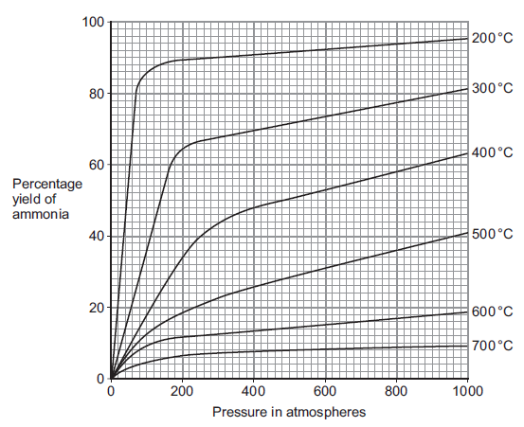

(i)      Use **Figure 2** to suggest the conditions that produce the greatest yield of ammonia.

______________________________________________________________

______________________________________________________________

**(1)**

(ii)      Use **Figure 2** to suggest and explain why the conditions used to produce ammonia in the Haber process are a temperature of 450 °C and a pressure of 200 atmospheres.

______________________________________________________________

______________________________________________________________

______________________________________________________________

______________________________________________________________

______________________________________________________________

______________________________________________________________

______________________________________________________________

______________________________________________________________

______________________________________________________________

______________________________________________________________

______________________________________________________________

______________________________________________________________

______________________________________________________________

______________________________________________________________

**(5)**

**(Total 12 marks)**

**Q11.2.**

Fertilisers are used to improve agricultural productivity.

(a)     Ammonium nitrate is used in fertilisers.

Name the **two** compounds used to manufacture ammonium nitrate.

___________________________________________________________________

___________________________________________________________________

**(1)**

(b)     A fertiliser contains the following information on the label:

**NPK value = 14 : 11 : 11**

Explain why this information is useful to farmers.

___________________________________________________________________

___________________________________________________________________

___________________________________________________________________

___________________________________________________________________

___________________________________________________________________

**(2)**

**Independent Exam Question**

**Q12.**  Ammonia is manufactured from nitrogen and hydrogen. The reaction is shown in the equation below.



The diagram shows some details of the manufacturing process.

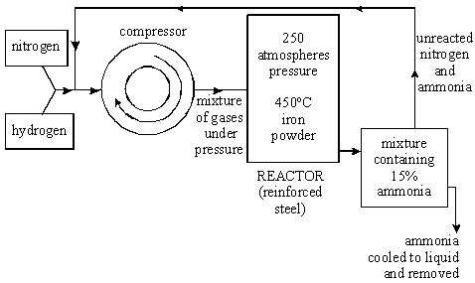

The graph shows the percentage of reacting gases converted into ammonia at different temperatures and pressures.

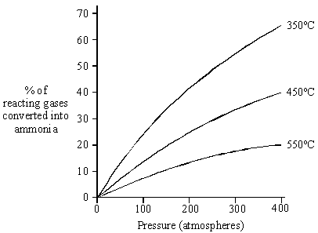

At room temperature and pressure, the reaction is very slow and only a small percentage of the reacting gases is converted to ammonia.

Use the information on the diagram and graph to:

(a)     describe the conditions used in the manufacture of ammonia **to increase the rate of reaction**.

………………………….................................................................................................................................

………………………….................................................................................................................................

………………………….................................................................................................................................

………………………….................................................................................................................................

………………………….................................................................................................................................

………………………….................................................................................................................................

**(4)**

(b)     describe and explain the conditions used in the manufacture of ammonia **to increase the yield.**

………………………….................................................................................................................................

………………………….................................................................................................................................

………………………….................................................................................................................................

………………………….................................................................................................................................

………………………….................................................................................................................................

………………………….................................................................................................................................

………………………….................................................................................................................................

………………………….................................................................................................................................

………………………….................................................................................................................................

………………………….................................................................................................................................

………………………….................................................................................................................................

………………………….................................................................................................................................

………………………….................................................................................................................................

………………………….................................................................................................................................

………………………….................................................................................................................................

**(7)**

**Lesson 7**







**Chemistry Revision: Fractional Distillation**

Mastery Matrix Points

|  |
| --- |
| Explain the process of fractional distillation |
| Name and describe the uses (fuels and feedstock for the petrochemical industry e.g. solvents, lubricants, polymers and detergents) of each of the fractions produced (petrol, diesel, kerosene, heavy fuel oil and LPG) |
| Describe why carbon can form such a vast array of natural and synthetic compounds |
| Explain how the size of hydrocarbon is linked to their boiling point, viscosity and flammability |
| Describe the combustion of hydrocarbons and write balanced symbol equations |
| Describe what is meant by ‘cracking’ |
| Describe why cracking is required |
| Describe the methods and conditions used for ‘catalytic cracking’ and ‘steam cracking’ |
| Recall the uses of alkenes produced during cracking (polymers) |
| Balance chemical equations for cracking |

**and Cracking**

Key Knowledge

What is the purpose of ‘fractional distillation’?

State the name of some of the fuels produced from the fractions made during fractional distillation…

1) 2)

3) 4)

5)

State the name of some of the products made from the fractions made during fractional distillation in the petrochemical industry…

1) 2)

3) 4)

State 3 properties of fractions collected at the top of the column:

1) 

2) 

3) 

Define ‘cracking’:







Two methods of cracking are:

1)

2)

The steps used for method (1) are:





The steps used for method (2) are:





Understanding and Explaining

1. Explain how refinery gases are extracted from crude oil using fractional distillation. (6 marks)











1. Compare and contrast the properties of fractions collected at the top and bottom of the column

(4 marks).









1. Cracking is a really important industrial process. Explain why it is necessary. (3 marks)



 Complete the symbol equations to predict the products of these cracking reactions. (4 marks)

EXT: Complete the word equations underneath!

1. C10H22 -> C2H4  + _________ (c) C4H10 -> C2H6  + _______



1. C5H12 -> ________   + C2H4 (d)C4H10  -> __________  + C3H6



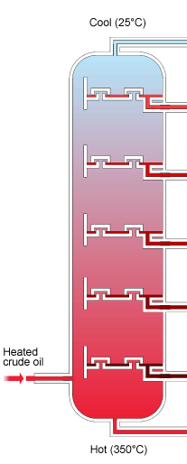

**Chemistry Revision: Organic Compounds**

|  |
| --- |
| Explain what crude oil is and how it is formed |
| Define ‘alkanes’ and give the general formula |
| Recall the formulae and structures for the first 4 alkanes (methane, ethane, propane and butane) |
| Define ‘alkenes’ and give the general formula |
| Recall the formulae and structures for the first 4 alkenes (ethene, propene, butane, pentene) |
| Define the terms ‘saturated’ and ‘unsaturated’ and link to alkanes and alkenes |
| Use the bromine test to identify whether there are alkanes or alkenes present |
| Define an ‘organic compound’ (triple only) |
| Identify the functional groups of organic compounds (alkanes, alkenes, alcohols, carboxylic acids) from formulae/structural diagram (triple only) |
| Describe the reactions and conditions between alkenes and hydrogen, water, the halogens (Cl, Br, I) and oxygen (triple only) |
| Draw the displayed structural formulae for the products of the reactions between alkenes, hydrogen, water, halogens and oxygen (triple only) |

Key Knowledge

What was crude oil made from?





Define:

*Organic compound:*

*Saturated: *

*Unsaturated: *

**Alkanes and Alkenes:**

|  |  |  |
| --- | --- | --- |
| **Homologous group** | Alkane | Alkene |
| **General formula** |  |  |
| *Name & formula with..* | | |
| 1 carbon |  |  |
| 2 carbons |  |  |
| 3 carbons |  |  |
| 4 carbons |  |  |
| 5 carbons |  |  |

Define *combustion*:





Write the general word equation for combustion of a hydrocarbon: 



To test whether a substance is an alkene you…





Understanding and Explaining

1. Draw the structural formula for:
2. Butane (b) Propene
3. Alkenes tend to burn with smoky flames. Explain why.





1. Ethene can react with hydrogen in an addition reaction. State the conditions used and write a symbol equation and draw the structural formula for this reaction.







1. Propene can react with water in an addition reaction. State the conditions used and write a symbol equation and draw the structural formula for this reaction.







1. Butene can react with chlorine in an addition reaction. State the conditions used and write a symbol equation and draw the structural formula for this reaction.







Notes

**Guided Exam Question**

**Q13.**          Crude oil is obtained by drilling into the Earth’s crust. The diagram shows a section through the Earth’s crust to show how this is done.

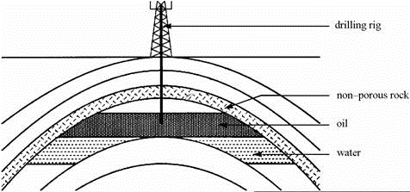

(a)     Crude oil contains many hydrocarbons. Which elements do hydrocarbons contain?

....................................................................................................................................

**(1)**

(b)     The crude oil is separated by fractional distillation. The diagram shows a column used for this.

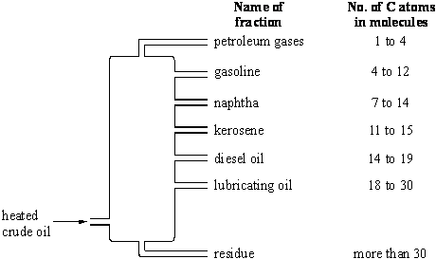

(i)      Explain, as fully as you can, how fractional distillation works.

……………………………............................................................................................................................

……………………………............................................................................................................................

……………………………............................................................................................................................

……………………………............................................................................................................................

……………………………............................................................................................................................

**(3)**

(ii)     Naphtha burns more easily than diesel oil. Explain why.

……………………………............................................................................................................................

……………………………............................................................................................................................

……………………………............................................................................................................................

**(1)**

(iii)     Naphtha contains a saturated hydrocarbon with the formula C7H16 .  
Draw the structural formula of this compound.

**(2)**

**Independent Exam Question**

**Q14.**Poly(butene) is a polymer made from crude oil in two stages.

(a)     The first stage in making poly(butene) is to break down large hydrocarbon molecules from crude oil into smaller hydrocarbon molecules, as shown in the figure below.

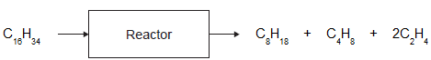

(i)      The products contain two types of hydrocarbon with different general formulae.

Name the two types of hydrocarbon.

...............................................................................................................

**(1)**

(ii)     Describe the conditions in the reactor.

……………………………………...................................................................................................................

……………………………………...................................................................................................................

……………………………………...................................................................................................................

……………………………………...................................................................................................................

**(2)**

(iii)    Suggest why air must **not** enter the reactor.

……………………………………...................................................................................................................

……………………………………...................................................................................................................

**(1)**

(iv)    Suggest a method that can be used to separate butene (C4H8) from the other hydrocarbons.

...............................................................................................................

**(1)**

(b)     The second stage is to use butene (C4H8) to produce poly(butene).

(i)      Draw the displayed structure of a butene (C4H8) molecule.

**(1)**

(ii)     Describe how molecules of butene (C4H8) form poly(butene).

……………………………………...................................................................................................................

……………………………………...................................................................................................................

……………………………………...................................................................................................................

……………………………………...................................................................................................................

**(2)**

**Q14.2**

Ethanol can be made from plants and from crude oil as shown in the diagram below.

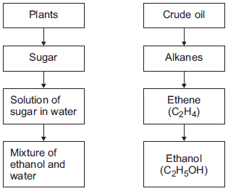

(a)     Describe how the solution of sugar in water is used to produce the mixture of ethanol and water.

___________________________________________________________________

___________________________________________________________________

___________________________________________________________________

___________________________________________________________________

**(2)**

(b)     Ethanol has a boiling point of 78 °C.

Water has a boiling point of 100 °C.

Describe how distillation is used to separate a mixture of ethanol and water.

___________________________________________________________________

___________________________________________________________________

___________________________________________________________________

___________________________________________________________________

___________________________________________________________________**(3)**

**Lesson 8**





Notes

**Chemistry Revision: Organic Compounds**

Mastery matrix

|  |
| --- |
| Recall the formulae and structures for the first 4 alcohols (methanol, ethanol, propanol and butanol) (triple only) |
| Recall the main uses of these alcohols (triple only) |
| Describe the reactions between alcohols and sodium, oxygen, water and an oxidising agent (triple only) |
| Explain how ethanol is produced by fermentation (triple only) |
| Write balanced symbol equations for the reactions of alcohols with oxygen (triple only) |
| Recall formulae & structures for first 4 carboxylic acids (methanoic acid, ethanoic acid, propanoic acid & butanoic acid) (triple only) |
| Describe the reactions between carboxylic acids and carbonates and alcohols (triple only) |
| Describe what happens when carboxylic acids dissolve in water (triple only) |
| Explain why carboxylic acids are weak acids in terms of ionisation and pH (triple only) |
| Draw the structure of ethyl ethanoate (triple only) |

Key Knowledge

Functional group of

* an alcohol?
* a carboxylic acid is?
* An ester?

|  |  |  |  |  |
| --- | --- | --- | --- | --- |
| No. of carbons | Alcohol formula | Alcohol name | Carboxylic acid formula | Carboxylic acid name |
| 1 |  |  |  |  |
| 2 |  |  |  |  |
| 3 |  |  |  |  |
| 4 |  |  |  |  |

2 uses of alcohols are:

1. 2)

Alcohol can be made in two ways:

1. 2)

Alcohols **burn in air**. The general equation is:

____________ + __________ -> __________ + ___________

Alcohols that are added to water form solutions with **a pH of _____.**

Alcohols react with sodium to product ________ and a ________. E.g.

Ethanol + sodium -> _______ + sodium ethoxide

Alcohols react with **oxygen** to form a _________ acid. E.g. ethanol reacts with oxygen in the air to form _____________.

When a carboxylic acid reacts with a carbonate, _________ , __________ and _________ are produced.

When ethanol reacts with ethanoic acid, ____________ ______________ is produced. This is called an ___________ and has the functional group __________. It is very ________smelling.

Understanding and Explaining

1. Write the word equation for the reaction of butanol with oxygen.



1. Write the word equation for combustion of methanol.



1. Write the word equation for the reaction of methanoic acid with sodium carbonate.



1. I have two substances. I want to test which is and alcohol and which is a carboxylic acid. Describe 3 tests I could do to identify them.







1. Draw the structural formula for ethanoic acid.
2. Draw the structure for ethyl ethanoate.
3. Explain why carboxylic acids are weak acids.







Mastery matrix

|  |
| --- |
| Describe the process of addition polymerisation (triple only) |
| Represent addition polymers using structural equations (triple only) |
| Draw diagrams to show the conversion of a monomer to a polymer and vice versa (triple only) |
| Explain the process of condensation polymerisation (triple only) |
| Use simple diagrams to show condensation polymerisation e.g. ethane diol and hexanedic acid reacting together (triple only) |
| Describe the structure of amino acids (triple only) |
| Describe how amino acids form polypeptides by condensation polymerisation (triple only) |
| Link this to the structure of DNA and the importance of polymers in producing proteins, cellulose and starch (triple only) |
| Name the monomers that make up DNA (nucleotides), protein (amino acids), starch (glucose) and cellulose (triple only) |
| Describe the process of addition polymerisation (triple only) |

**Chemistry Revision: Polymerisation**

Key Knowledge

Define polymerisation:



Define monomer:



|  |  |  |
| --- | --- | --- |
| **Type of polymerisation** | **Addition** | **Condensation** |
| Reactants |  |  |
| Products |  |  |
| Examples |  |  |

Functional groups in a:

Diol –

Diacid -

Amino acids -

Type of monomer that makes:

DNA is:

Protein is:

Starch is:

Cellulose is:

Fl

Understanding and Explaining

1. Draw the polymer that would be formed from this monomer:

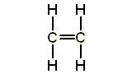

1. Describe what happens in addition polymerisation. You should include the reactants and products formed in your answer. You can use a specific example to support your description.





1. Draw the products that would be formed from polymerisation of these monomers:

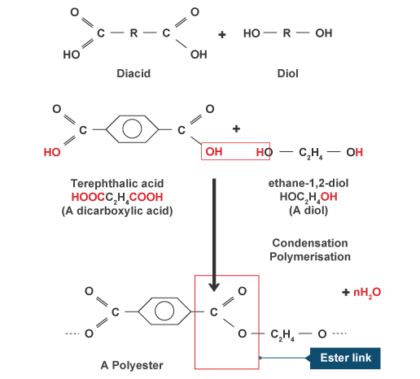

1. Describe what happens in condensation polymerisation. You should include the reactants and products formed in your answer. You can use the example above to support your description.





1. Use the diagram to the right to:
2. Explain how you know that these are amino acids.





1. The type of polymerisation that has occurred and how you can tell that this is the type of polymerisation occurring.





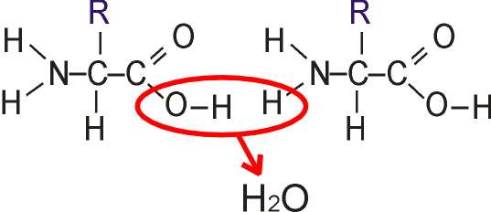

**Guided Exam Question**

**Q15.**This question is about organic compounds.

(a)     Ethanol is an alcohol. One use of ethanol is in alcoholic drinks. Give **two** other uses of ethanol.

………………………………........................................................................................................................

………………………………........................................................................................................................

**(2)**

(b)     Which gas is produced when sodium reacts with ethanol? Tick () **one** box.

|  |  |  |
| --- | --- | --- |
|  | Carbon dioxide |  |
|  | Carbon monoxide |  |
|  | Hydrogen |  |
|  | Oxygen |  |

**(1)**

(c)     Ethanoic acid (CH3COOH) can be produced from ethanol (CH3CH2OH).

(i)      What type of reaction produces ethanoic acid from ethanol?

...............................................................................................................

**(1)**

(ii)     Complete the displayed structure of ethanoic acid.

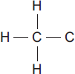

**(1)**

(iii)    Solutions of ethanoic acid and hydrochloric acid with the same concentration have different pH values.

Explain why the solution of ethanoic acid has a higher pH than the solution of hydrochloric acid.

………………………………………...............................................................................................................

………………………………………...............................................................................................................

………………………………………...............................................................................................................

………………………………………...............................................................................................................

**(2)**

(d)     Ethanol and ethanoic acid react in the presence of a catalyst to form an ester.

(i)      Name the ester made from ethanol and ethanoic acid.

............................................................................................................... **(1)**

(ii)     What type of chemical is used as a catalyst in this reaction?

...............................................................................................................

**(1)**

(iii)    Esters are used in perfumes because they smell pleasant and are volatile. What does volatile mean?

...............................................................................................................

**(1)**

**Q16**

Ethene is used to produce poly(ethene).

(a)     Draw the bonds to complete the displayed formulae of ethene and poly(ethene) in the equation.

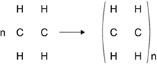

**(2)**

(b)     Polyesters are made by a different method of polymerisation.

The equation for the reaction to produce a polyester can be represented as:



Compare the polymerisation reaction used to produce poly(ethene) with the polymerisation reaction used to produce a polyester.

___________________________________________________________________

___________________________________________________________________

___________________________________________________________________

___________________________________________________________________

___________________________________________________________________

___________________________________________________________________

___________________________________________________________________

___________________________________________________________________

___________________________________________________________________

**(4)**

**(Total 6 marks)**

**Independent Exam Question**

**Q17.**

(b)     The flow diagram shows some reactions of ethanoic acid.

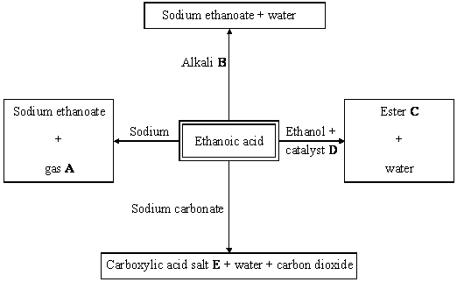

Give the name of:

(i)      gas **A**, ............................................................................................................................

**(1)**

(ii)     alkali **B**, ............................................................................................................................

**(1)**

(iii)     ester **C**, ............................................................................................................................

**(1)**

(iv)    catalyst **D**, ............................................................................................................................

**(1)**

(v)     carboxylic acid salt **E**.......................................................................................................

**(1)**

**Q17.**This question is about polymers.

(a)     The polymer polyvinyl chloride (PVC) is non-biodegradable. Give **one** problem caused by non-biodegradable polymers.

…………………………….........................................................................................................................

…………………………….........................................................................................................................

**(1)**

(b)     **Figure 1** shows a short section of a PVC molecule. PVC is produced from a monomer that contains two carbon atoms. Complete the structure of the monomer in **Figure 2.**

**Figure 1 Figure 2**

|  |  |  |
| --- | --- | --- |
|  | **C** | **C** |

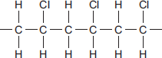

**(2)**

(d)     Monomer **A** and monomer **B** react to form polymer **C**.

The displayed structures of monomer **A**, monomer **B** and a short section of polymer **C** are shown in **Figure 3**. The functional group of each structure is shown in a box.

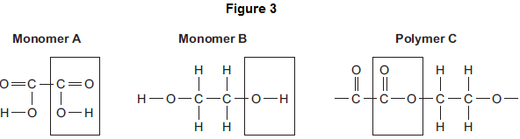

Complete the **Table** below below by writing the names of the functional groups for monomer **A** and polymer **C**.

**Table**

|  |  |  |
| --- | --- | --- |
|  |  | **Name of functional group** |
|  | Monomer **A** | ........................................................................... |
|  | Monomer **B** | alcohol |
|  | Polymer **C** | ........................................................................... |

**(2)**

**Lesson 9**

|  |  |  |
| --- | --- | --- |
|  | **Topic:** | RP: Rates of reaction (C5) (C.39) |
| 1 | What is the aim of experiment 1? | Investigate how concentration affects rate of reaction (using volume of gas produced) |
| 2 | What is the independent variable of experiment 1? | Concentration of hydrochloric acid |
| 3 | What is the dependent variable of experiment 1? | Volume of gas produced in 30 seconds |
| 4 | Name 3 control variables of experiment 1 | 1) length of magnesium 2)volume of acid 3) whether the mixture is stirred |
| 5 | How is the gas collected? | A bung attached to a delivery tube is placed in the conical flask |
| 6 | Give two ways the volume of gas can be measured | 1)Gas syringe 2) Displacement of water |
| 7 | Give the most accurate way to measure the volume of gas produced | Using a gas syringe |
| 8 | What results should you see? | As the concentration increases, the volume of gas increases |
| 9 | Name one error | Gas escapes from the conical flask |
| 10 | What is the aim of experiment 2? | Investigate how concentration affects rate of reaction (using turbidity – aka cloudiness) |
| 11 | What is the independent variable of experiment 2? | Concentration of sodium thiosulphate |
| 12 | What is the dependent variable of experiment 2? | Time taken for the cross to disappear |
| 13 | Name 3 control variables of experiment 2 | 1) concentration of acid 2)size/thickness of the cross 3)stirring the solutions |
| 14 | What results should you see? | As the concentration increases, the time taken for the cross to disappear decreases |
| 15 | What are possible variations in this method? | 1) Effect of temperature 2) Effect of volume 3) Effect of a catalyst |

|  |  |  |
| --- | --- | --- |
|  | Topic: | RP: Chromatography (C6) (C.40) |
| 1 | What is the aim of the experiment? | Investigate the colours that are found within a mixture of food colourings |
| 2 | What is the independent variable? | Dye/ink colour |
| 3 | What is the dependent variable? | Rf value |
| 4 | Name 3 controls variables | 1) Start point of the colour 2) Size of the coloured dot 3) Start point of the solvent |
| 5 | Name 3 sources of error | 1) Starting line drawn in ink 2) Solvent above the starting line 3) Dots too close together or too big |
| 6 | Why is a pencil used to draw the starting line? | To avoid any dye in a pen also moving up the paper |
| 7 | Name 3 types of solvent that can be used | Water, alcohol and acetone |
| 8 | How should the distance of the dye be measured? | Use a ruler to measure the distance between the starting line and the centre of the dye |
| 9 | How should the distance moved by the solvent be measured? | Use a ruler to measure the distance between the starting line and the top of the solvent line/curve |
| 10 | How is the Rf value calculated? | Rf value = distance moved by dye / distance moved by solvent |
| 11 | How do you use the Rf value to identify the unknown substance? | Compare with a known value from a data base |
| 12 | How could you identify the unknown substance visually? | Observe which known colours the unknown dye lines up with on the chromatography paper |
| 13 | What is used to transfer the dyes to the chromatography paper? | Capillary tube |
| 14 | What are the units for the Rf value? | No units |
| 15 | What are possible variations in this method? | Investigate whether this pen is a pure colour or a mixture. |

|  |  |  |
| --- | --- | --- |
|  | **Topic:** | RP: Ion testing (C7) (triple only) (C.41) |
| 1 | What is the aim of the experiment? | Identify the ions in ionic compounds |
| 2 | Name the 4 tests | 1) Flame tests 2) Carbonate tests 3) Sulfate tests 4) Halide tests |
| 3 | Describe the steps in flame tests | 1) Pour 1cm3 of each metal chloride solution into a test tube 2) Dip the loop into the solution 3) Place the loop into the blue flame of the Bunsen burner. Observe the colour. |
| 4 | Describe the results in flame tests | Li = crimson Na = Yellow K = Lilac Ca = orange-red Copper = green |
| 5 | Why is the blue flame used? | So that coloured flames can be seen more clearly (yellow flame would hide colour of some metal ions) |
| 6 | Describe the steps in sulfate tests | 1) Pour 1cm3 of each sodium solution into a different test tubes 2) Add a few drops of dilute HCl into each test tube 3) Add 1cm3 of barium chloride solution to each test tube |
| 7 | Describe the results in sulfate tests | White precipitate forms |
| 8 | What is the precipitate that has formed? | Barium sulfate |
| 9 | Describe the steps in carbonate tests | 1) Pour 1cm3 of each sodium solution into a different test tube 2) Pour 1cm3 of limewater into the 6th test tube. 3) Add 1cm3 of dilute HCl to each sodium solution. 4) Collect the gas using a pipette and bubble through the limewater solution. |
| 10 | Describe the results in carbonate tests | If limewater turns cloudy = carbonate ions present |
| 11 | Why does the limewater turn cloudy? | Acid reacts with carbonate ions to produce CO2 gas. |
| 12 | Describe the steps in halide tests | 1) Pour 1cm3 of each sodium solution into different test tubes 2) Add a few drops of dilute nitric acid to each solution 3) Add 1cm3 of silver nitrate solution to each test tube |
| 13 | Describe the precipitate results in halide tests | Bromide = cream Iodide = yellow Chloride = white |
| 14 | What are the precipitates formed? | Silver bromide, silver iodide, silver chloride |
| 15 | What is a precipitate? | An insoluble solid in a liquid |

|  |  |  |
| --- | --- | --- |
|  | **Topic:** | RP: Water purification (C8) (C.42) |
|  |  |  |
| 1 | What is the aim of experiment 1? | To determine if a sample of water is pure |
| 2 | What is the independent variable? | The sample of water |
| 3 | What is the dependent variable? | pH and mass of dissolved solids |
| 4 | Name the control variable | Volume of water |
| 5 | How is the pH of the samples tested? | Using universal indicator |
| 6 | What should the pH be? | 7 (green) |
| 7 | How do we test for dissolved solids? | 1) Weigh an empty evaporating basin 2) Fill evaporating basin with water sample 3) Heat gently using Bunsen burner 4) Re-weight basin once water has evaporated |
| 8 | If water contains dissolved solids (is impure) what would we see? | The mass of the basin would increase |
| 9 | What is the aim of experiment 2? | To purify a sample of water to make it potable |
| 10 | What process can be used to purify water? | Distillation |
| 11 | Name the changes in state that occur during distillation | Evaporation --> condensation |
| 12 | How is the water evaporated? | Heating the conical flask gently |
| 13 | How is evaporated water collected? | Using a delivery tube and bung |
| 14 | How is the water condensed back into a liquid? | Placing the test tube in a beaker of iced water |
| 15 | How can we test if the water is pure? | Use cobalt chloride paper to test whether the substance is water (it will turn blue -> pink). |

**Chemistry Revision – Rates of reaction – effect of size of marble chip (use volume of gas produced!)**

Understanding and Explaining

Equipment:

_____________________________________________________________________________________________________________________________

_____________________________________________________________________________________________________________________________

_____________________________________________________________________________________________________________________________

Method:

Step 1:__________________________________________________________________________________________________________________

_____________________________________________________________________________________________________________________________

Step 2:__________________________________________________________________________________________________________________

_____________________________________________________________________________________________________________________________

Step 3:__________________________________________________________________________________________________________________

_____________________________________________________________________________________________________________________________

Step 4:__________________________________________________________________________________________________________________

_____________________________________________________________________________________________________________________________

Step 5:__________________________________________________________________________________________________________________

_____________________________________________________________________________________________________________________________

Step 6:__________________________________________________________________________________________________________________

_____________________________________________________________________________________________________________________________

Step 7:__________________________________________________________________________________________________________________

_____________________________________________________________________________________________________________________________

Key Knowledge

Big question 1:

Investigate the effect of size of a marble chip (powder, small and large) on the rate of reaction when reacting with hydrochloric acid.

Define:

IV:____________________________

_______________________________

DV:____________________________

_______________________________

CV:____________________________

_______________________________

Repeatable: _____________________

_______________________________

Reproducible: _____________________

_______________________________

Accurate: _____________________

_______________________________

IV in this experiment:

_______________________________

DV in this experiment:

_______________________________

CV in this experiment:

1. __________________________
2. __________________________
3. __________________________

**Chemistry Revision – Rates of reaction – effect of concentration (DIFFERENT TO THE PRACTICAL ON THE SHEET YOU HAVE BEEN GIVEN TO LEARN!!). – use turbidity!**

Understanding and Explaining

Equipment:

_____________________________________________________________________________________________________________________________

_____________________________________________________________________________________________________________________________

_____________________________________________________________________________________________________________________________

Method:

Step 1:__________________________________________________________________________________________________________________

_____________________________________________________________________________________________________________________________

Step 2:__________________________________________________________________________________________________________________

_____________________________________________________________________________________________________________________________

Step 3:__________________________________________________________________________________________________________________

_____________________________________________________________________________________________________________________________

Step 4:__________________________________________________________________________________________________________________

_____________________________________________________________________________________________________________________________

Step 5:__________________________________________________________________________________________________________________

_____________________________________________________________________________________________________________________________

Step 6:__________________________________________________________________________________________________________________

_____________________________________________________________________________________________________________________________

Step 7:__________________________________________________________________________________________________________________

_____________________________________________________________________________________________________________________________

Key Knowledge

Big question 1:

Investigate the effect of concentration of **hydrochloric acid** on reaction time with sodium thiosulphate solution.

Define:

Turbidity: _______________________

_______________________________

Concentration: __________________

_______________________________

IV in this experiment:

_______________________________

DV in this experiment:

_______________________________

CV in this experiment:

1. __________________________
2. __________________________
3. __________________________

**Chemistry Revision – Chromatography**

Understanding and Explaining

Equipment:

_____________________________________________________________________________________________________________________________

_____________________________________________________________________________________________________________________________

_____________________________________________________________________________________________________________________________

Method (draw a diagram to support your answer)

Step 1:__________________________________________________________________________________________________________________

_____________________________________________________________________________________________________________________________

Step 2:__________________________________________________________________________________________________________________

_____________________________________________________________________________________________________________________________

Step 3:__________________________________________________________________________________________________________________

_____________________________________________________________________________________________________________________________

Step 4:__________________________________________________________________________________________________________________

_____________________________________________________________________________________________________________________________

Step 5:__________________________________________________________________________________________________________________

_____________________________________________________________________________________________________________________________

Step 6:__________________________________________________________________________________________________________________

_____________________________________________________________________________________________________________________________

Step 7:__________________________________________________________________________________________________________________

_____________________________________________________________________________________________________________________________

Key Knowledge

Big question 1:

Identify the colours in a mixture of food colouring (X).

Define:

Solvent: ________________________

_______________________________

Solute: ________________________

_______________________________

Mixture: ________________________

_______________________________

How do you calculate the Rf Value for a substance?

_______________________________

_______________________________

**Chemistry Revision – Testing for ions (triple only)**

Key Knowledge

Identify the ions found in a range of compounds.

Name 4 metal ions: ________________

______________________________

Name 3 halide ions: ________________

______________________________

What is the formula for a sulphate ion?

_____________________________

What is the formulate for a carbonate ion?

_____________________________

Which equipment/chemicals are required to test for the following?

Metal ions: _____________________

______________________________

______________________________

Halide ions: _____________________

______________________________

______________________________

Carbonate ions: __________________

______________________________

______________________________

Sulphate ions: ___________________

______________________________

______________________________

Understanding and explanation:

1. How would I test if a substance “B” contained sodium ions? Include what would be the positive result.

_____________________________________________________________________________________________________________________________

_____________________________________________________________________________________________________________________________

_____________________________________________________________________________________________________________________________

_____________________________________________________________________________________________________________________________

1. How would I test to find out if substance “Z” contained carbonate ions? Include what would be the positive and negative results of this test.

_____________________________________________________________________________________________________________________________

_____________________________________________________________________________________________________________________________

_____________________________________________________________________________________________________________________________

_____________________________________________________________________________________________________________________________

1. How would I test to find out if substance “M” contained bromide ions? Include what would be the positive result.

_____________________________________________________________________________________________________________________________

_____________________________________________________________________________________________________________________________

_____________________________________________________________________________________________________________________________

_____________________________________________________________________________________________________________________________

1. How would I test to find if a substance “H” contained sulphate ions? Include what would be the positive and negative results of this test.

_____________________________________________________________________________________________________________________________

_____________________________________________________________________________________________________________________________

_____________________________________________________________________________________________________________________________

_____________________________________________________________________________________________________________________________

**Chemistry Revision – Water purification**

Understanding and explanation:

1. I have 3 different samples of water collected from 3 different places in the UK. How would I determine which is the purest (i.e. contains the least dissolved substances? (use steps and draw a diagram of your equipment).

_________________________________________________________________________________________________________________________

_________________________________________________________________________________________________________________________

_________________________________________________________________________________________________________________________

_________________________________________________________________________________________________________________________

_________________________________________________________________________________________________________________________

_________________________________________________________________________________________________________________________

_________________________________________________________________________________________________________________________

_________________________________________________________________________________________________________________________

_________________________________________________________________________________________________________________________

_________________________________________________________________________________________________________________________

1. I want to compare the acidity of sea water, water from a lake in the Lake District and rain water. Explain how I would do this. (Use steps!!).

_________________________________________________________________________________________________________________________

_________________________________________________________________________________________________________________________

_________________________________________________________________________________________________________________________

_________________________________________________________________________________________________________________________

_________________________________________________________________________________________________________________________

_________________________________________________________________________________________________________________________

_________________________________________________________________________________________________________________________

_________________________________________________________________________________________________________________________

_________________________________________________________________________________________________________________________

_________________________________________________________________________________________________________________________

Key Knowledge

1. Calculate the mass of dissolved substances in a sample of water.

Which equipment would you use to carry out this practical?

1. ________________________
2. ________________________
3. ________________________
4. ________________________
5. ________________________
6. Investigate the pH of a sample of rain water.

Identify one chemical that you would need to use to do this.

_______________________________

What is one hazard associated with this chemical?

_______________________________

_______________________________

_______________________________

How would you minimize the risk associated with this hazard?

_______________________________

_______________________________

_______________________________

Notes

**Q18.** Lithium carbonate reacts with dilute hydrochloric acid.

A group of students investigated the volume of gas produced.

This is the method used.

1.       Place a known mass of lithium carbonate in a conical flask.

2.       Measure 10 cm3 of dilute hydrochloric acid using a measuring cylinder.

3.       Pour the acid into the conical flask.

4.       Place a bung in the flask and collect the gas as shown in **Figure 1**.

**Figure 1**

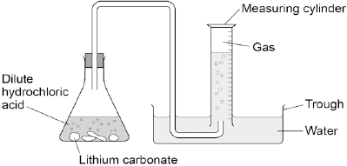

(a)     **Figure 2** shows the measuring cylinder.

**Figure 2**

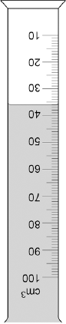

What volume of gas has been collected?

Volume = __________________ cm3 **(1)**

(b)     The table below shows the students’ results.

|  |  |
| --- | --- |
| **Mass of lithium carbonate in g** | **Volume of gas in cm3** |
| 0.0 | 0 |
| 0.1 | 22 |
| 0.2 | 44 |
| 0.3 | 50 |
| 0.4 | 88 |
| 0.5 | 96 |
| 0.6 | 96 |
| 0.7 | 96 |

On **Figure 3**:

•        Plot these results on the grid.

•        Complete the graph by drawing **two** straight lines of best fit.

**Figure 3**

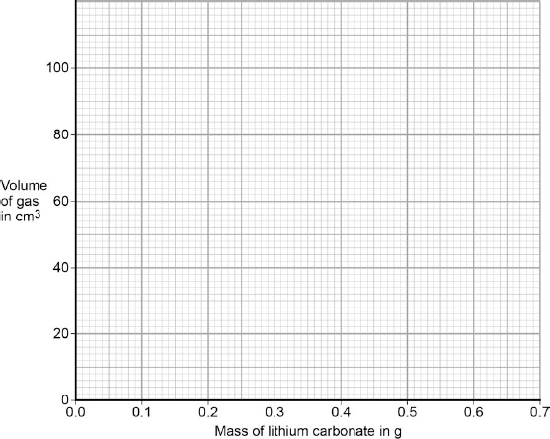

**(4)**

(c)     What are **two** possible reasons for the anomalous result?

|  |  |
| --- | --- |
| Tick **two** boxes. |  |
| Too much lithium carbonate was added. |  |
| The bung was not pushed in firmly enough. |  |
| There was too much water in the trough. |  |
| The measuring cylinder was not completely over the delivery |  |
| The conical flask was too small. |  |

**(2)**

(d)     Describe the pattern the graph shows up to 0.4 g of lithium carbonate added.

___________________________________________________________________

___________________________________________________________________

___________________________________________________________________

___________________________________________________________________

**(2)**

(e)     Lithium carbonate decomposes when heated.

The equation shows the decomposition of lithium carbonate.

Li2CO3 (s)   →   Li2O (s)   +   CO2 (g)

**Figure 4** shows the apparatus a student used to decompose lithium carbonate.

**Figure 4**

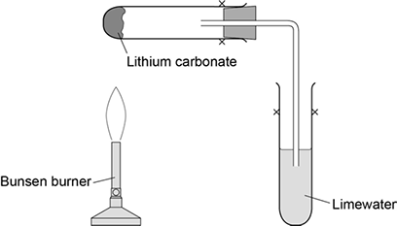

Why does the limewater bubble?

___________________________________________________________________

___________________________________________________________________

**(1)**

(f)     The student repeated the experiment with potassium carbonate.

The limewater did not bubble.

Suggest why there were **no** bubbles in the limewater.

___________________________________________________________________

___________________________________________________________________

**(1)**

**(Total 11 marks)**

**Q19.**

The diagram shows three stages in the treatment of reservoir water.

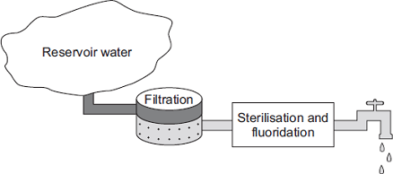

(a)     (i)      What is separated from the reservoir water during filtration?

Tick (✔) **one** box.

|  |  |
| --- | --- |
| Bacteria |  |
| Dissolved nitrates |  |
| Solids |  |

**(1)**

(ii)     What is added to sterilise the water?

Tick (✔) **one** box.

|  |  |
| --- | --- |
| Calcium |  |
| Chlorine |  |
| Magnesium |  |

**(1)**

(iii)    State **one** advantage of adding fluoride to drinking water.

______________________________________________________________

______________________________________________________________

**(1)**

(b)     The diagram shows a water filter used in the home.

Water in  
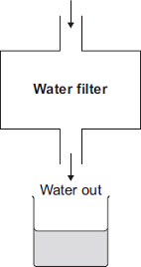

A student collected a sample of water from the filter.

The student could show that the filtered water contains dissolved salts without using a chemical test.

Describe how.

___________________________________________________________________

___________________________________________________________________

___________________________________________________________________

___________________________________________________________________

___________________________________________________________________

___________________________________________________________________

**(2)**

(c)     Seawater is forced through a membrane to make drinking water.

Seawater  
             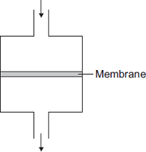  
Drinking water

Suggest why water molecules can pass through the membrane, but sodium ions and chloride ions cannot.

___________________________________________________________________

___________________________________________________________________ **(1)**

**Q19.** Burgundy Mixture is a formulation used to kill fungi on grapevines.

It is made by mixing two compounds, **A** and **B**.

The ratio by mass of **A** : **B** in the mixture is 1 : 8

(a)     Calculate the mass of A needed in a mixture containing 125 g of **B**.

___________________________________________________________________

___________________________________________________________________

Mass of **A** = ____________________ g

**(2)**

Scientists test a solution of compound **A**.

The table shows their results.

|  |  |
| --- | --- |
| **Test** | **Result** |
| Add sodium hydroxide solution | Blue precipitate |
| Add dilute hydrochloric acid and barium chloride solution | White precipitate |

(b)     Which **two** ions are in compound **A**?

Choose the answers from the box.

|  |  |  |
| --- | --- | --- |
| **bromide** | **chloride** | **copper** |
| **iron(II)** | **iron(III)** | **sulfate** |

___________________ ions and ___________________ ions

**(2)**

(c)     The scientists think that compound **B** is sodium carbonate.

Describe how the scientists can test a solution of **B** to see if sodium ions are present.

Give the result of the test if sodium ions are present.

___________________________________________________________________

___________________________________________________________________

___________________________________________________________________

___________________________________________________________________

**(2)**

(d)     Describe how the scientists can test a solution of **B** to see if carbonate ions are present.

Give the result of the test if carbonate ions are present.

___________________________________________________________________

___________________________________________________________________

___________________________________________________________________

___________________________________________________________________

___________________________________________________________________

___________________________________________________________________

**(3)**

**20.** This is part of an article about food additives.

|  |
| --- |
| **THE PERIL OF FOOD ADDITIVES** |
| Some orange drinks contain the additives E102 (Tartrazine), E104 (Quinoline Yellow) and E110 (Sunset Yellow).These three coloured additives are thought to cause hyperactivity in children. |

(a)     State **two** reasons that a manufacturer might give to justify the use of these additives.

1. _________________________________________________________________

___________________________________________________________________

2. _________________________________________________________________

___________________________________________________________________

**(2)**

(b)     Some scientists asked 4000 twelve-year-old children to help them investigate if there is a link between these three coloured additives and hyperactivity.

How would the scientists use these 4000 children to investigate if there is a link between these three coloured additives and hyperactivity in children?

___________________________________________________________________

___________________________________________________________________

___________________________________________________________________

___________________________________________________________________

___________________________________________________________________

___________________________________________________________________

___________________________________________________________________

___________________________________________________________________

**(4)**

(c)     A manufacturer used an independent scientist to show that their orange drink did not contain these three coloured additives.

(i)      Suggest why the manufacturer would use a scientist who was independent instead of using their own scientist.

______________________________________________________________

______________________________________________________________

**(1)**

(ii)     The scientist had samples of E102, E104 and E110 and the orange drink. The scientist used paper chromatography for the test.

Describe how the scientist could use the results to show if the orange drink contained any of these three coloured additives.

You may include a diagram of the paper chromatography results.

______________________________________________________________

______________________________________________________________

______________________________________________________________

______________________________________________________________

______________________________________________________________

______________________________________________________________

**(2)**

**(Total 9 marks)**