**OASB Science Department**

**Biology Paper 2 Revision Pack (Triple HT)**

**Name: ______________________**

|  |  |  |
| --- | --- | --- |
| Contents | Lesson | Date |
| Mastery Matrix Biology Paper 2 |  |  |
| Knowledge | 1 |  |
| Reproduction and DNA Summary Page |
| Notes page |
| Exam Questions |
| Knowledge | 2 |  |
| The brain and the eye Summary Page |
| Notes page |
| Exam Questions |
| Knowledge | 3 |  |
| Introducing ecosystems and interdependence Summary Page |
| Notes page |
| Exam Questions |
| Knowledge | 4 |  |
| Plant hormones and natural recycling Summary Page |
| Notes page |
| Exam Questions |
| Knowledge | 5 |  |
| Humans and the environment and classifying organisms Summary Page |
| Notes page |
| Exam Questions |
| Knowledge | 6 |  |
| Natural selection and evolution and selective breeding Summary Page |
| Notes page |
| Exam Questions |
| Knowledge | 7 |  |
| The nervous system and the endocrine system Summary Page |
| Notes page |
| Exam Questions |
| Knowledge | 8 |  |
| Homeostasis and diabetes Summary Page |
| Notes page |
| Exam Questions |
| Knowledge | 9 |  |
| Kidneys and hormones in reproductive system Summary Page |
| Notes page |
| Exam Questions |
| Knowledge | 10 |  |
| Required practicals 7-10 Summary Page |
| Notes page |
| Exam Questions |



|  |  |  |  |
| --- | --- | --- | --- |
| **Topic** | **Tier** | **Revision Guide** | **Learning statement** |
| Cell division (mitosis) | F | B 12 | Describe how cloning can be used in “cuttings”, “tissue cultures”, “embryo transplants”, “adult cell cloning” (triple only) |
| Sexual and asexual reproduction | F | B 74 | Explain the process of sexual reproduction and link this to variation |
| Sexual and asexual reproduction | F | B 74 | Explain the process of meiosis which leads to the formation of gametes |
| Sexual and asexual reproduction | F | B 74 | Explain the process of asexual reproduction |
| Sexual and asexual reproduction | F | B 74 | Model the behaviour of chromosomes during meiosis |
| Sexual and asexual reproduction | F | B 74 | Compare advantages and disadvantages of sexual and asexual reproduction (triple only) |
| The DNA code | F | B76 | Describe the structure of DNA |
| The DNA code | F | B76 | Explain how genes code for a particular sequence of amino acids which in turn code for a particular protein (triple only) |
| The DNA code | F | B76 | Explain what the human genome is and the importance of mapping it |
| The DNA code | F | B76 | Use genetic crosses to predict outcomes of a monohybrid cross |
| Developing new medicines | F | B76 | Explain the issues with the development of new antibiotics in the race against antibiotic resistance and what we can do as a society to reduce the rate of development of antibiotic resistance bacteria (linking to medicine and agriculture) |
| The Brain | F | B48 | Describe the structure and the role of the brain (triple only) |
| The Brain | F | B48 | Identify three specific parts of the brain from a diagram and explain their specific functions – cerebral cortex, cerebellum, medulla (triple only) |
| The Brain | F | B48 | Explain some difficulties in investigating brain function and treating brain damage and diseases (triple only) |
| The Brain | F | B48 | Explain how neuroscientists have mapped regions of the brain to particular functions (triple only) |
| The Brain | F | B48 | Evaluate the risks and benefits of procedures carried out on the brain and the nervous system (triple only) |
| The Eye | F | B48 | Describe the function of the eye (triple only) |
| The Eye | F | B48 | Label a diagram of the eye (triple only) |
| The Eye | F | B48 | Explain the process of accommodation (triple only) |
| The Eye | F | B48 | Explain the causes of short sightedness (myopia) and long sightedness (hyperopia) (triple only) |
| The Eye | F | B48 | Describe how these defects are treated and how new technologies are helping to improve this (triple only) |
| The Eye | F | B48 | Interpret ray diagrams, showing these two defects and showing how spectacle lens correct this (triple only) |
| Kidneys | F | B50 | Describe the function of the kidneys (triple only) |
| Kidneys | F | B50 | Describe how urea is formed from excess amino acids (triple only) |
| Kidneys | F | B50 | Explain how the kidneys produce urine (triple only) |
| Kidneys | F | B50 | Use bar charts & tables of glucose, ions & urea to analyse data from before & after filtration (triple only) |
| Kidneys | F | B50 | Describe the effect of ADH on the permeability of the kidney tubules and link to the ‘negative feedback loop’ (triple only) |
| Kidneys | F | B50 | Explain how kidney failure may be treated (including dialysis and kidney transplant) (triple only) |
| Kidneys | F | B50 | Evaluate treating organ failure with mechanical devices e.g. transplant (triple only) |
| Introducing ecosystems | F | B86 | Define “ecosystem” |
| Introducing ecosystems | F | B86 | Define ‘interdependence’ and explain what species depend on |
| Introducing ecosystems | F | B86 | Describe what plants and animals ‘compete’ with each other for |
| Introducing ecosystems | F | B86 | Describe structural, behavioural and functional adaptations of organisms |
| Introducing ecosystems | F | B86 | Define extremophiles linking to the conditions that they inhabit (bacteria in deep sea vents) |
| Interdependence | F | B86 | Interpret data from graphs and tables relating to predator and prey relationships predicting numbers of species based on changes in this data |
| Interdependence | F | B86 | List biotic and abiotic factors and explain how changes in them would affect a given community |
| Interdependence | F | B86 | Define primary, secondary and tertiary consumers |
| Interdependence | F | B86 | Explain the role of producers in food chains |
| Interdependence | F | B86 | Use a range of experimental methods to calculate the abundance and distribution of species in a given ecosystem |
| Interdependence | F | B86 | **RP Field Invesitgations** (a - triple only): Measure the population size of a common species(b - double & triple)Investigate the effects of a factor on the distribution of a species using sampling techniques |
| Interdependence | F | B86 | Describe the differences in the trophic levels of organisms within an ecosystem (triple only) |
| Interdependence | F | B86 | Describe the numbering system of tropic levels and the importance of each level (triple only) |
| Interdependence | F | B86 | Describe the role of decomposers within an ecosystem (triple only) |
| Interdependence | F | B86 | Construct accurate pyramids of biomass (triple only) |
| Interdependence | F | B86 | Explain how biomass is lost between the different tropic levels (triple only) |
| Interdependence | F | B86 | Describe quantitatively the proportion of energy transferred between trophic levels and use this to calculate efficiency (triple only) |
| Plant Hormones | F | B54 | Identify 3 plant hormones and their effects within plants (triple only) |
| Plant Hormones | F | B54 | Describe the processes of phototropism, geotropism/gravitropism (triple only) |
| Plant Hormones | F | B54 | Describe how the 3 plant hormones are used in agriculture and horticulture (triple only) |
| Plant Hormones | F | B54 | **RP Plant Responses:** Investigate the effect of light or gravity on the growth of newly generated seeds (triple only) |
| Natural Recycling | F | B88 | Describe the carbon cycle and its importance |
| Natural Recycling | F | B88 | Describe the water cycle and its importance |
| Natural Recycling | F | B88 | Explain factors that affect the rate of decay, calculating rate changes using this to explain how to speed up the production of compost (triple only) |
| Natural Recycling | F | B88 | Explain how biogas generators can be used to produce a fuel (triple only) |
| Natural Recycling | F | B88 | **RP Decay:** Investigate the effects of temperature on the rate of decay of fresh milk by measuring pH change (triple only) |
| Natural Recycling | F | B88 | Evaluate the impact of environmental factors on the distribution of a species (temperature, availability of water, atmospheric gas composition) (triple only) |
| Humans and the environment | F | B88 | Define biodiversity and explain its importance |
| Humans and the environment | F | B90-92 | Explain in detail human impact on biodiversity (waste management, pollution, land use, deforestation, global warming) |
| Humans and the environment | F | B90-92 | Describe and evaluate some of the programs used to reduce the negative effects of humans on ecosystems and biodiversity (breeding programs, protection/regeneration of rare habitats, reintroduction of field margins and hedgerows, reduction of deforestation, reduction of carbon emissions, increased recycling) |
| Humans and the environment | F | B90-92 | Describe 6 biological factors threatening food security (triple only) |
| Humans and the environment | F | B90-92 | Define ‘sustainability’ (triple only) |
| Humans and the environment | F | B90-92 | Explain how to improve the efficiency of food production (triple only) |
| Humans and the environment | F | B90-92 | Describe and evaluate modern farming techniques (including: intensive farming, sustainable fisheries and sustainable farming) (triple only) |
| Humans and the environment | F | B90-92 | Explain how microorganisms can be cultured for food (e.g. fungus fusarium -> mycoprotein) (triple only) |
| Classifying organisms | F | B84 | Describe the role of Carl Linnaeus in development of a classification system (kingdom, phylum, class, order, family, genus, species) |
| Classifying organisms | F | B84 | Explain the binomial naming system of organisms |
| Classifying organisms | F | B84 | Define ‘species’ (linking to future fertility and breeding) |
| Classifying organisms | F | B84 | Explain how classification models have developed over time due to improvements in microscopy and biochemistry) |
| Natural selection and evolution | F | B80 | Describe and explain the theory of ‘natural selection’ and ‘evolution’ |
| Natural selection and evolution | F | B80 | Describe the role of Charles Darwin and his book ‘The origin of species’ on the development of the theory of evolution and the issues he had with getting people to accept this theory (triple only) |
| Natural selection and evolution | F | B80 | Explain the theory of Jean Baptiste Lamarck and the theory of evolution (triple only) |
| Natural selection and evolution | F | B80 | Explain the role of Alfred Russell Wallace in developing the theory of evolution and his pioneering work on speciation (triple only) |
| Natural selection and evolution | F | B80 | Describe the evidence for evolution including antibiotic resistant and the fossil record |
| Natural selection and evolution | F | B80 | Describe what a fossil is and explain how they form and explain why these cannot be used as evidence for how life began on Earth |
| Natural selection and evolution | F | B80 | Interpret information from evolutionary trees |
| Natural selection and evolution | F | B80 | Explain what extinction is and describe factors which may contribute to the extinction of a species |
| Natural selection and evolution | F | B80 | Explain the role of Mendel and other scientists on our changing understanding of genetics (triple only) |
| Selective breeding & genetic engineering | F | B82 | Describe selective breeding and explain the potential benefits and risks of this process (linking to disease resistance in crops, animals with more milk and meat, large or unusual flowers and domestic dogs with a gentle nature) |
| Selective breeding & genetic engineering | F | B82 | Define ‘genetic engineering’ |
| Selective breeding & genetic engineering | HT | B82 | Describe the main steps in genetic engineering |
| Selective breeding & genetic engineering | F | B82 | Give examples of genetic engineering (including crop resistance to diseases, insect attack and herbicides, crops with bigger, better fruits and bacterial cells used in the production of insulin) |
| Selective breeding & genetic engineering | F | B82 | Evaluate the use of genetic engineering and modification and describe the potential uses of this in the future |
| The Nervous System | F | B48 | Describe the structure of the nervous system |
| The Nervous System | F | B48 | Explain how it is adapted for its function and why it is important |
| The Nervous System | F | B48 | Describe the pathway of a message from stimulus to response |
| The Nervous System | F | B48 | Describe the design of a reflex arc and explain its purpose |
| The Nervous System | F | B48 | Use tables and graphs to extract information about reflex actions |
| The Nervous System | F | B48 | **RP Reaction Time:** Plan and carry out an investigation into the effect of a factor on human reaction time |
| Homeostasis | F | B50 | Define ‘homeostasis’ and explain why it is important |
| Homeostasis | F | B50 | List three factors controlled by homeostasis in the human body (blood glucose concentration, temperature, water levels) |
| Homeostasis | F | B50 | Explain how these automatic systems are controlled |
| Homeostasis | F | B50 | Describe what monitors and controls body temperature (triple only) |
| Homeostasis | F | B50 | Explain the role of the skin in thermoregulation (triple only) |
| Homeostasis | F | B50 | Describe and explain the body’s response to extreme body temperature (triple only) |
| The endocrine system | F | B50 | Describe the principals of hormonal coordination including what makes up the endocrine system |
| The endocrine system | F | B50 | Describe what hormones are and label six glands in the body |
| The endocrine system | F | B50 | Describe the role of the pituitary gland |
| The endocrine system | HT | B50 | Explain the roles of thyroxine (produced by the thyroid gland) and adrenaline (produced by the adrenal gland) linking this to negative feedback loops (HT only) |
| The endocrine system | F | B50 | Describe and explain how the body controls blood glucose concentration (making reference to glucose, glycogen, glucagon, negative feedback cycle, insulin and the pancreas) |
| The endocrine system | F | B50 | Explain the effect on cells of osmotic changes in bodily fluids (triple only) |
| The endocrine system | F | B50 | Describe how water ions and urea are lost from the body (triple only) |
| Diabetes | F | B50 | Explain type 1 and type 2 diabetes and how they can be treated |
| Diabetes | F | B50 | Compare and contrast the two types of diabetes |
| Diabetes | F | B50 | Compare data (from graphs) regarding blood glucose levels in people with and without diabetes |
| Hormones in the reproductive system | F | B52 | Describe the roles of FSH, LH, Oestrogen and progesterone in the menstrual cycle |
| Hormones in the reproductive system | F | B52 | Describe the roles of oestrogen and progesterone in puberty |
| Hormones in the reproductive system | HT | B52 | Interpret graphs relating to hormone levels in the menstrual cycle (HT only) |
| Hormones in the reproductive system | F | B52 | Link hormone cycles to ovulation and menstruation |
| Hormones in the reproductive system | F | B52 | Evaluate hormonal and non-hormonal methods of contraception (oral, injection, implant, skin patch, condoms, diaphragms, intrauterine device, spermicidal agents, abstinence, sterilisation) |
| Hormones in the reproductive system | F | B52 | Explain why issues around contraception are not answered solely by the field of Science |
| Hormones in the reproductive system | F | B52 | Explain the process of embryo screening and evaluate based on ethical, social and economic perspectives |
| Hormones in the reproductive system | F | B52 | Explain the use of FSH and LH as a fertility drug (HT only) |
| Hormones in the reproductive system | HT | B52 | Explain IVF (in vitro fertilisation) (HT only) |
| Hormones in the reproductive system | HT | B52 | Explain how developments in microscopy have enabled IVF treatments to be improved (HT only) |
| Hormones in the reproductive system | HT | B52 | Evaluate social and ethical issues and risks from the perspective of patients and doctors in IVF (HT only) |
| Hormones in the reproductive system | F | B52 | Compare nervous system and hormonal responses |

**Lesson 1**

|  |  |  |
| --- | --- | --- |
|  | **Topic:** | **Sexual and asexual reproduction (meiosis) (B.5)** |
| 1 | Another word for sex cells is… | gametes |
| 2 | State the 2 gametes in animals | Sperm & egg cells |
| 3 | State the 2 gametes in flowering plants | Pollen & egg cells |
| 4 | State the number of parents involved in sexual reproduction | 2 |
| 5 | State the number of parents involved in asexual reproduction | 1 |
| 6 | Describe the cells produced from mitosis | 2 genetically identical daughter cells |
| 7 | Describe the cells produced from meiosis | 4 genetically different daughter cells |
| 8 | What is mitosis used for? | Growth and repair |
| 9 | What is meiosis used for? | Making gametes |
| 10 | Define "diploid cell" | A cell with a full set of chromosomes |
| 11 | Define "haploid cell" | A cell with half of the number of chromosomes |
| 12 | How many divisions occur in mitosis? | 1 |
| 13 | How many divisions occur in meiosis? | 2 |
| 14 | Are haploid or diploid cells produced during mitosis? | Diploid |
| 15 | Are haploid or diploid cells produced during meiosis? | Haploid |

|  |  |  |
| --- | --- | --- |
|  | **Topic:** | **The DNA code (B.6)** |
| 1 | State the name of the genetic material found in the nucleus of a cell | DNA |
| 2 | Describe the structure of DNA | Double helix |
| 3 | State the name given to one molecule of DNA | Chromosome |
| 4 | State the name of a small section of DNA | A gene |
| 5 | What does a gene code for? | A sequence of amino acids which join to form a specific protein |
| 6 | Define the "human genome" | The sequence of the human DNA |
| 7 | State 3 reasons for mapping the human genome | 1) locating disease causing genes 2) treating inherited disorders 3) tracing human migration patterns |
| 8 | Define "homozygous" | two of same alleles e.g. BB |
| 9 | Define "heterozygous" | Two different alleles e.g. Bb |
| 10 | Define "dominant" | always expressed |
| 11 | Define "recessive" | Expressed only with 2 of this allele present |
| 12 | Define 'genotype' | The 2 alleles present e.g. Bb |
| 13 | Define 'phenotype' | The characteristic expressed e.g. brown eyes |
| 14 | Is cystic fibrosis caused by a dominant or recessive allele? | Recessive |
| 15 | Is Huntingdon's caused by a dominant or recessive allele? | Dominant |

Notes

**Biology Revision: Reproduction**

Mastery Matrix Points

|  |
| --- |
| Explain the process of sexual reproduction and link this to variation |
| Explain the process of meiosis which leads to the formation of gametes |
| Explain the process of asexual reproduction |
| Model the behaviour of chromosomes during meiosis |
| Compare advantages and disadvantages of sexual and asexual reproduction (triple only) |

Understanding and Explaining

1. What is the type of cell division that produces gametes? __________________
2. What is the type of cell division that enables the embryo to grow? ____________________
3. Describe, in detail, the steps in meiosis and what is produced.

Step 1: ________________________________________________________________________________

Step 2: ________________________________________________________________________________

Step 3: ________________________________________________________________________________

Step 4: ________________________________________________________________________________

Step 5: ________________________________________________________________________________

Step 6: ________________________________________________________________________________

1. Describe how these examples of organisms that reproduce sexually and asexually – malarial parasites, fungi and daffodils.

**Malarial parasites**: *Sexually*: ________________________________________________________________

_____________________________________________________________________________________

*Asexually*: _____________________________________________________________________________

**Fungi**: Sexually: ________________________________________________________________

_____________________________________________________________________________________

*Asexually*: _____________________________________________________________________________

**Daffodils**: Sexually: ________________________________________________________________

_____________________________________________________________________________________

*Asexually*: _____________________________________________________________________________

1. Compare sexual and asexual reproduction.

_____________________________________________________________________________________

_____________________________________________________________________________________

_____________________________________________________________________________________

Key Knowledge

Definitions:

Sexual reproduction – _____________

______________________________

Asexual reproduction – ____________

______________________________

Variation – _____________________

Mitosis – _______________________

______________________________

Meiosis – _______________________

______________________________

*What are the gametes in animals?*

*______________________________*

*What are the gametes in flowering plants?*

*______________________________*

Three advantages of sexual reproduction:

-_____________________________

-_____________________________

-_____________________________

Four advantages of asexual reproduction:

-_____________________________

-_____________________________

-_____________________________

-_____________________________

**Biology Revision: DNA**

Key Knowledge

Definitions:

Genome – _______________________

______________________________

DNA – _________________________

______________________________

Chromosomes – __________________

______________________________

Gene – _________________________

______________________________

Three reasons why studying the human genome is important.

-_____________________________

-_____________________________

-_____________________________

Nucleotides – ___________________

______________________________

Protein synthesis – _______________

______________________________

Two ways genes influence your characteristics (phenotype):

-_____________________________

-_____________________________

Mastery Matrix Points

|  |  |
| --- | --- |
| Describe the structure of DNA | Explain what the human genome is and the importance of mapping it |
| Explain how genes code for a particular sequence of amino acids which in turn code for a particular protein (triple only) | Use genetic crosses to predict outcomes of a monohybrid cross |

Understanding and Explaining

1. Explain the process of protein synthesis.

Step 1: ________________________________________________________________________________

Step 2: ________________________________________________________________________________

Step 3: ________________________________________________________________________________

Step 4: ________________________________________________________________________________

Step 5: ________________________________________________________________________________

Step 6: ________________________________________________________________________________

1. Describe the possible effects of mutations during protein synthesis.
2. __________________________________________________________________________________________
3. __________________________________________________________________________________________
4. Describe the structure and function of DNA.

_________________________________________________________________________________________________

_________________________________________________________________________________________________

1. Draw a genetic cross to show the likelihood of a child having these diseases: a) polydactyly if one parent is heterozygous and the other is homozygous recessive. B) cystic fibrosis if both parents are carriers of the disease.

**Exam questions:**

**Q1.** (a)     Sex cells are produced by meiosis.

Describe what happens to the chromosomes when a cell divides by meiosis.

_________________________________________________________________________________________

_________________________________________________________________________________________

_________________________________________________________________________________________

_________________________________________________________________________________________

**(2)**

(b)     Darwin’s theory of natural selection depends on the fact that individual organisms within a species may show a wide range of variation.

Explain how meiosis and sexual reproduction give rise to variation.

_________________________________________________________________________________________

_________________________________________________________________________________________

_________________________________________________________________________________________

_________________________________________________________________________________________

**(2)**

(c)     Mutation may also give rise to variation.

(i)      What is meant by mutation?

_________________________________________________________________________________________

_________________________________________________________________________________________

**(1)**

(ii)     Are all mutations harmful? Explain the reason for your answer.

_________________________________________________________________________________________

_________________________________________________________________________________________

_________________________________________________________________________________________

_________________________________________________________________________________________

**(2)**

**Q2. Figure 1** shows an image of a small section of DNA.

**Figure 2** shows the structure of a small section of DNA.

**Figure 1**                                                              **Figure 2**

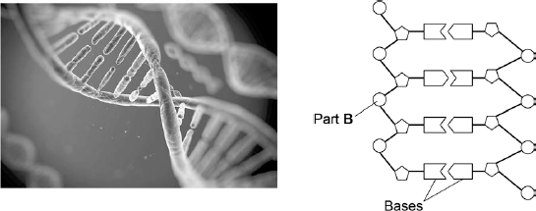

(a)     What is Part **B**?

_________________________________________________________________________________________

_________________________________________________________________________________________

**(1)**

(b)     In **Figure 1** the structure of DNA shows four different bases.

There are four different bases and they always pair up in the same pairs.

Which bases pair up together?

___________________________________________________________________

**(1)**

(c)     Syndrome H is an inherited condition.

People with syndrome H do **not** produce the enzyme IDUA.

**Figure 3** shows part of the gene coding for the enzyme IDUA.

**Figure 3**

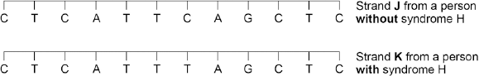

Strand **K** shows a mutation in the DNA which has caused syndrome H.

The enzyme IDUA helps to break down a carbohydrate in the human body.

The enzyme IDUA produced from Strand **K** will not work.

Explain how the mutation could cause the enzyme **not** to work.

_________________________________________________________________________________________

_________________________________________________________________________________________

_________________________________________________________________________________________

_________________________________________________________________________________________

_________________________________________________________________________________________

_________________________________________________________________________________________

_________________________________________________________________________________________

_________________________________________________________________________________________

_________________________________________________________________________________________

_________________________________________________________________________________________

_________________________________________________________________________________________

**(5)**

(d)     A recessive allele causes syndrome H.

A heterozygous woman and a homozygous recessive man want to have a child.

Draw a Punnett square diagram to determine the probability of the child having syndrome H.

Identify any children with syndrome H.

Use the following symbols:

**A** = dominant allele

**a** = recessive allele

Probability = ___________________ %

**(5)**

**Lesson 2**

|  |  |  |
| --- | --- | --- |
|  | **Topic:** | **The Brain and eye (triple only) (B.13)** |
| 1 | State the location & function of the cerebral cortex | Outer section - perception, memory, language |
| 2 | State the location & function of the cerebellum | Base of brain - balance & co-ordination of voluntary movement |
| 3 | State the location & function of the medulla | In brain stem - controls involuntary functions e.g. breathing |
| 4 | Why is it difficult to investigate brain function? | Lots of different areas work together |
| 5 | State three ways of investigating brain functions & regions | Brain damage patients, electrical stimulation of brain regions, MRI scanning |
| 6 | State two changes that can occur in the eye | Accommodation (for focussing on near/far objects) Adaptation to dim/bright light |
| 7 | State two things that the eye organ is sensitive to | Light intensity & colour |
| 8 | State the name of the coloured part of our eye that expands in bright light and contracts in dim light. | Iris |
| 9 | State the name of the whole in the front of our eye that allows light in | Pupil |
| 10 | What happens to the size of the iris and pupil during bright light | Pupil = small Iris = big |
| 11 | What is the name for the light detecting cells at the back of the eye? | Retina |
| 12 | What happens to the eye during accommodation for focussing on near objects? | 1) Ciliary muscles contract 2) Suspensory ligaments loosen 3) lens is thick -> more refraction |
| 13 | What happens to the eye during accommodation for focussing on far objects? | 1) Ciliary muscles relax 2) Suspensory ligaments pulled tight 3) lens is thin -> less refraction |
| 14 | State the name for short sightedness | Myopia (focal point in front of retina) |
| 15 | State the name for long sightedness | Hyperopia (focal point past retina) |

**Biology Revision: The Brain**

Mastery Matrix Points (TRIPLE ONLY)

|  |  |
| --- | --- |
| Describe the structure and the role of the brain (triple only) | Explain how neuroscientists have mapped regions of the brain to particular functions (triple only) |
| Identify three specific parts of the brain from a diagram and explain their specific functions – cerebral cortex, cerebellum, medulla (triple only) | Evaluate the risks and benefits of procedures carried out on the brain and the nervous system (triple only) |
| Explain some difficulties in investigating brain function and treating brain damage and diseases (triple only) |  |

Key Knowledge

The brain controls ________ behaviour whereas the spinal cord controls _______ actions.

The brain is made up of billions of _________.

Label the cerebral cortex, cerebellum and medulla on this diagram:

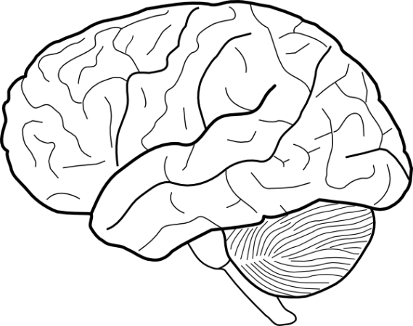

Function of the cerebral cortex:

______________________________

Function of cerebellum:

_____________________________

Function of medulla:

_____________________________

Reasons why it is difficult to investigate the brain

* ________________________

______________________________

-_____________________________

______________________________

Three ways scientists study the brain:

- _____________________________

- _____________________________

- _____________________________

Understanding and Explaining

1. Evaluate three techniques scientists have used to study the brain.

Technique 1: _________________________________________________________________________________________

___________________________________________________________________________________________________

___________________________________________________________________________________________________

Technique 2:_________________________________________________________________________________________

___________________________________________________________________________________________________

___________________________________________________________________________________________________

Technique 3: _________________________________________________________________________________________

___________________________________________________________________________________________________

___________________________________________________________________________________________________

1. Describe how have scientists been able to map the part of the brain that carries out a particular function?

___________________________________________________________________________________________________

___________________________________________________________________________________________________

___________________________________________________________________________________________________

1. Describe the parts of the brain and their functions.

(a)_________________________________________________________________________________________________

(b)________________________________________________________________________________________________

(c)_________________________________________________________________________________________________

(d)________________________________________________________________________________________________

**Biology Revision: The Eye**

Understanding and Explaining

1. Explain how the eye adapts to focus on **near** objects. _____________________________________________________

___________________________________________________________________________________________________

___________________________________________________________________________________________________

1. Explain how the eye adapts to focus on **distant** objects. __________________________________________________

___________________________________________________________________________________________________

___________________________________________________________________________________________________

1. Explain how the eye adapts to dim light. _______________________________________________________________

___________________________________________________________________________________________________

___________________________________________________________________________________________________

1. Describe the difference between myopia and hyperopia. _________________________________________________

___________________________________________________________________________________________________

___________________________________________________________________________________________________

1. Describe how myopia and hyperopia are treated using spectacle lenses.

Myopia: ______________________________________________________________________________________________

Hyperopia: ____________________________________________________________________________________________

1. Suggest three new technologies that are used to treat eye defects.

(i)___________________________________________________________________________________________________

(ii)___________________________________________________________________________________________________

(iii)__________________________________________________________________________________________________

Mastery Matrix Points TRIPLE ONLY

|  |  |
| --- | --- |
| Describe the function of the eye (triple only) | Explain the causes of short sightedness (myopia) and long sightedness (hyperopia) (triple only) |
| Label a diagram of the eye (triple only) | Describe how these defects are treated and how new technologies are helping to improve this (triple only) |
| Explain the process of accommodation (triple only) |

Key Knowledge

The eye is sensitive to ______ and ______.

Label the diagram of the eye.

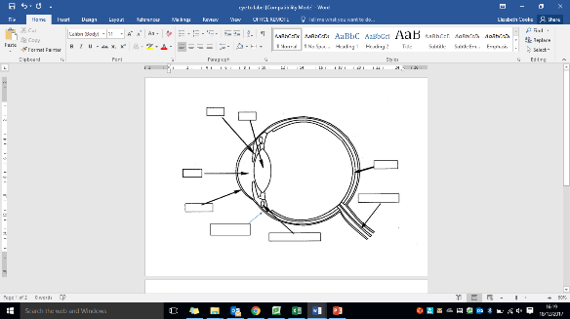

|  |  |
| --- | --- |
| **Part of the Eye:** | **Function:** |
| Retina |  |
| Optic Nerve |  |
| Sclera |  |
| Cornea |  |
| Iris |  |
| Ciliary Muscles |  |
| Suspensory Ligaments |  |

Notes

**3.Figure 1** shows a reflex in the iris of the human eye in response to changes in light levels.

**Figure 1**

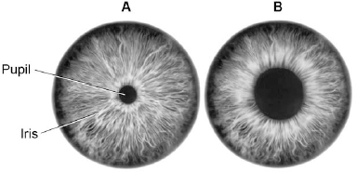

1. Describe the changes in the pupil and iris going from **A** to **B** in **Figure 1**. Explain how these changes occur. Refer to the changes in light level in your answer.

________________________________________________________________________________________

________________________________________________________________________________________

________________________________________________________________________________________

________________________________________________________________________________________

________________________________________________________________________________________

________________________________________________________________________________________

________________________________________________________________________________________

**(4)**

(b)     Some people wear glasses to improve their vision. **Figure 2** shows light entering the eye in a person with blurred vision. **Figure 3** shows how this condition is corrected with glasses.

**Figure 2**                                                  **Figure 3**

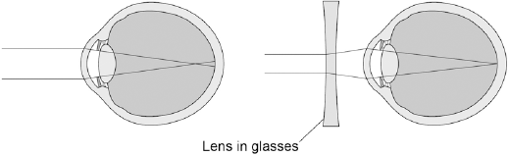

Compare **Figure 2** and **Figure 3**. Explain how the blurred vision is corrected.

________________________________________________________________________________________

________________________________________________________________________________________

________________________________________________________________________________________

________________________________________________________________________________________

________________________________________________________________________________________

**(2)**

**4 .** A man hurt his head in an accident.  
Doctors found that he could not remember anything that had happened on the day of the accident.

(a)     (i)      Name the part of the brain concerned with memory.

...............................................................................................................

**(1)**

(ii)     Name **one** method the doctors could use to find out how much the brain was damaged.

...............................................................................................................

**(1)**

(b)     The doctors were worried that the man might also have injured his spine.  
They touched different areas of his skin with a sharp point.  
They asked him to tell them each time if he could feel the sharp point.

(i)      Explain how the information about the sharp point touching the skin reaches the man’s brain.

________________________________________________________________________________________

________________________________________________________________________________________

________________________________________________________________________________________

________________________________________________________________________________________

________________________________________________________________________________________

________________________________________________________________________________________

________________________________________________________________________________________

________________________________________________________________________________________

________________________________________________________________________________________

________________________________________________________________________________________

**(6)**

(ii)     The doctors found that the man could feel the sharp point when the point touched his arms but not when the point touched his legs.

Suggest what this information could tell the doctors about the damage to the man’s spinal cord. Explain your answer.

________________________________________________________________________________________

________________________________________________________________________________________

________________________________________________________________________________________

________________________________________________________________________________________

________________________________________________________________________________________

**(2)**

**Lesson 3**

|  |  |  |
| --- | --- | --- |
|  | **Topic:** | **Introducing ecosystems and interdependence (B.20)** |
| 1 | State the name given to a habitat and all of the organisms living inside of it? | Ecosystem |
| 2 | What is the name for living factors that affect species? | Biotic |
| 3 | What is the name for non-living factors that affect an environment? | Abiotic |
| 4 | State the 3 types of adaptations that exist | 1) Structural 2) Behavioural 3) Functional |
| 5 | State 4 things that animals compete for | Water, mates, territory, food |
| 6 | State 4 things that plants compete for | Nutrients, Water, Space, Light |
| 7 | What is the scientific word for species relying on each other? | Interdependence |
| 8 | Similar organisms that can breed together to produce fertile offspring are know to be the same _______? | Species |
| 9 | Name 7 abiotic factors | 1) Light intensity, 2) temperature, 3) moisture, 4) soil pH, 5) wind intensity, 6) CO2 levels (plants) 7) oxygen levels (aquatic animals) |
| 10 | Name 4 biotic factors | 1) food availability, 2) new predators, 3) new pathogens, 4) species outcompeting |
| 11 | What is the name given to an organism that lives in an extreme environment? | Extremophile |
| 12 | What is the name given to the TYPE of organism that absorbs sunlight and uses it to produce glucose? | Producer |
| 13 | What type of animal feeds off of the dead remains of other animals? | Scavenger |
| 14 | State two experimental techniques used to determine the abundance and distribution of a species | Transect (line across an environment) & quadrat (1m metal square) |
| 15 | What is the name given to the type of sampling that is done along a line? | Transect |

|  |  |  |
| --- | --- | --- |
|  | **Topic:** | **Interdependence (triple only) (B.22)** |
| 1 | Which organisms make up the tropic level 1? | Plants and algae (producers) |
| 2 | Which type of organisms make up trophic level 2? | Primary consumers/herbivores |
| 3 | Which type of organisms make up trophic level 3? | Secondary consumers/carnivores |
| 4 | Which type of organisms make up trophic level 4? | Tertiary consumers/carnivores |
| 5 | What is the name given to a carnivore that has no predators? | Apex predator |
| 6 | What is the name given to an organism that breaks down dead plant and animal matter? | Decomposer |
| 7 | How do decomposers break down dead plant and animal matter? | Secreting enzymes |
| 8 | How do decomposers absorb food molecules? | Diffusion |
| 9 | What is the name given to the diagram drawn to represent the amount of biomass found at each trophic level? | Pyramid of biomass |
| 10 | Which trophic level is always found at the bottom of a pyramid of biomass? | Trophic level 1 |
| 11 | What happens to the amount of biomass as you move up the food chain? | It decreases |
| 12 | Approximately what percentage of incident energy from light is transferred into plants during photosynthesis? | 0.01 |
| 13 | Approximately what percentage of biomass is transferred from each trophic level to the trophic level above? | 0.1 |
| 14 | Which is biomass lost between trophic levels? | 1) lost as faeces 2) lost as CO2, water and urea 3) used as glucose in respiration |
| 15 | How do you calculate the efficiency of biomass transfer between each trophic level? | Biomass transferred/initial biomass x 100 |

**Biology Revision: Ecosystems**

Key Knowledge

Define:

Ecosystems – _________________________

___________________________________

Interdependence – ____________________

___________________________________

Species depend on each other for:

-__________________________________

-__________________________________

-__________________________________

-__________________________________

A stable community – ___________________

___________________________________

Animals compete for:

-__________________________________

-__________________________________

-__________________________________

Plants compete for:

-__________________________________

-__________________________________

-__________________________________

-__________________________________

Types of adaptations:

|  |  |  |
| --- | --- | --- |
|  | Definition | Example |
| Structural |  |  |
| Behavioural |  |  |
| Physiological/  functional |  |  |

Extremophile: ________________________

___________________________________

Mastery Matrix Points

|  |  |
| --- | --- |
| Define “ecosystem” | Describe structural, behavioural and functional adaptations of organisms |
| Define ‘interdependence’ and explain what species depend on | Define extremophiles linking to the conditions they inhabit (bacteria in deep sea vents) |
| Describe what plants and animals ‘compete’ with each other for |

Understanding and Explaining

1. Explain what interdependence is and how it can be affected if a species is removed from a community.

__________________________________________________________________________________________________

__________________________________________________________________________________________________

__________________________________________________________________________________________________

1. Compare what plants and animals compete for.

__________________________________________________________________________________________________

__________________________________________________________________________________________________

__________________________________________________________________________________________________

1. What are adaptations? Describe the structural, functional and behavioural adaptations of a venomous snake.

__________________________________________________________________________________________________

__________________________________________________________________________________________________

__________________________________________________________________________________________________

__________________________________________________________________________________________________

1. Describe the three conditions that are considered to be conditions that only extremophiles can live in.

__________________________________________________________________________________________________

__________________________________________________________________________________________________

__________________________________________________________________________________________________

1. Describe an example of an extremophile and the habitat it lives in.

__________________________________________________________________________________________________

__________________________________________________________________________________________________

__________________________________________________________________________________________________

**Biology Revision: Interdependence**

Mastery Matrix Points

|  |  |
| --- | --- |
| Interpret data from graphs and tables relating to predator and prey relationships predicting numbers of species based on changes in this data | Describe the differences in the trophic levels of organisms within an ecosystem (triple only) |
| List biotic and abiotic factors and explain how changes in them would affect a given community | Describe the numbering system of tropic levels and the importance of each level (triple only) |
| Define primary, secondary and tertiary consumers | Describe the role of decomposers within an ecosystem (triple only) |
| Explain the role of producers in food chains | Construct accurate pyramids of biomass (triple only) |
| Use a range of experimental methods to calculate the abundance and distribution of species in a given ecosystem | Explain how biomass is lost between the different tropic levels (triple only) |
| Required practical: Investigate the effects of a factor on the distribution of a species using sampling techniques | Describe quantitatively the proportion of energy transferred between trophic levels and use this to calculate efficiency (triple only) |

Understanding and Explaining

1. Sketch, label and explain a simple predator prey graph.
2. Explain how the calculate the efficiency of an energy or biomass transfer in the food chain.

__________________________________________________________________________________________________

__________________________________________________________________________________________________

1. Explain the role of producers in the food chain: ________________________________________________________

__________________________________________________________________________________________________

__________________________________________________________________________________________________

1. Explain what decomposers are and their role in the food chain: ____________________________________________

__________________________________________________________________________________________________

__________________________________________________________________________________________________

1. Explain the difference between using a quadrat for random sampling and for doing a transect experiment.

__________________________________________________________________________________________________

__________________________________________________________________________________________________

__________________________________________________________________________________________________

__________________________________________________________________________________________________

__________________________________________________________________________________________________

Key Knowledge

Abiotic factor: __________________

______________________________

*Examples: ______________________*

______________________________

Biotic factor: ___________________

______________________________

*Examples:* ______________________

______________________________

What is found at each trophic level?

Level 1 – _______________________

______________________________

Level 2 – _______________________

______________________________

Level 3 – _______________________

______________________________

Level 4 - _______________________

______________________________

Sketch and label a pyramid of biomass –

____% of light incident on a plant is used in photosynthesis. Only about ______% of biomass moves up the food chain at each level, because:

-_____________________________

-_____________________________

-_____________________________

Notes

**5.** Students investigated a food chain in a garden.

**lettuce**     →     **snail**     →     **thrush (bird)**

The students:

•        estimated the number of lettuce plants in the garden

•        estimated the number of snails feeding on the lettuces

•        counted two thrushes in the garden in 5 hours.

The table below shows the students’ results and calculations.

|  |  |  |  |  |  |  |
| --- | --- | --- | --- | --- | --- | --- |
|  | **Organism** | **Population size** | **Mean mass of each organism in g** | **Biomass of population in g** | **Biomass from previous organism that is lost in g** | **Percentage of biomass lost** |
|  | Lettuce | 50 | 120.0 | 6000 |  |  |
|  | Snail | 200 | 2.5 | 500 | 5500 | 91 |
|  | Thrush | 2 | 85.0 | 170 | 330 | 66 |

(a)     (i)      Give **two** ways that biomass is lost along a food chain.

________________________________________________________________________________________

________________________________________________________________________________________

**(2)**

(ii)     Scientists estimate that about 90% of the biomass in food is lost at each step in a food chain. Suggest **one** reason why the students’ value for the percentage of biomass lost between the snails and the thrushes is only 66%.

________________________________________________________________________________________

________________________________________________________________________________________

**(1)**

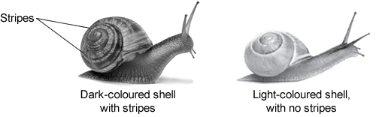(b)     European banded snails have shells with different colours (light or dark) and with stripes or with no stripes. **Figure 1** shows two examples of European banded snails.

**Figure 2** shows results from surveys in woodlands and in grasslands of the percentage of snails with light-coloured shells and the percentage of snails with no stripes.

Each point on the graph represents the results of one survey in one habitat.

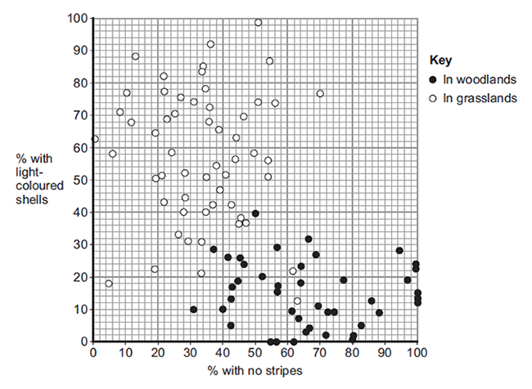(i) **Figure 2** is a scatter graph. Why is a scatter graph used for this data?

________________________________________________

______________________________________________**(1)**

(ii)     Compare the general appearance of snails that live in woodlands with the general appearance of snails that live in grasslands. ________________________________________________

________________________________________________

________________________________________________

______________________________________________**(2)**

(iii)     Suggest a reason for the general appearance of snails that live in woodlands. ________________________________________________

____________________________________________ (**1)**

**6.**(a)     Which term describes organisms that can tolerate very hot or very cold places?

Draw a ring around the correct answer. **(1)**

|  |  |  |  |
| --- | --- | --- | --- |
|  | **an environmental species** | **an extremophile species** | **an indicator species** |

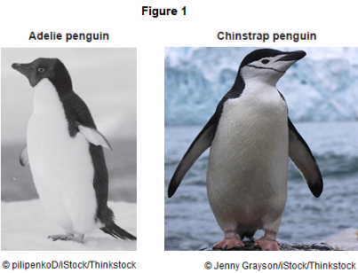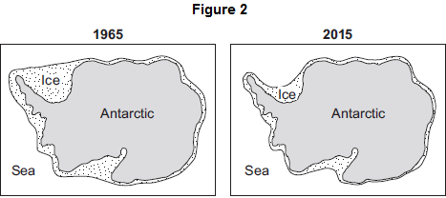(b)     **Figure 1** shows photographs of an Adelie penguin and a chinstrap penguin. Adelie penguins and chinstrap penguins live in the Antarctic at temperatures below 0 °C.

Adelie penguins spend most of their time on the ice around the Antarctic. Chinstrap penguins live mainly in the sea around the ice. Since 1965 the number of Adelie penguins has **decreased** by 6 million.

**Figure 2** shows changes to the ice around the Antarctic over the past 50 years.

(i)      Use information from **Figure 2** to explain why the number of Adelie penguins has decreased since 1965.

________________________________________________________________________________________

________________________________________________________________________________________

________________________________________________________________________________________

________________________________________________________________________________________

**(2)**

(ii)     Suggest what has happened to the number of chinstrap penguins since 1965.

Draw a ring around your answer.      **increase / decrease**

Give a reason for your answer.

________________________________________________________________________________________

_____________________________________________________________________________________ **(1)**

(c)     The number of penguins can be used to monitor changes in temperature of the environment. Temperature readings could also be taken using a thermometer. What is the advantage of using penguins, instead of a thermometer, to monitor changes in temperature of the environment? Tick () **one** box.

|  |  |  |
| --- | --- | --- |
|  | Living organisms show long-term changes. |  |
|  | Thermometers cannot measure temperatures below 0 °C. |  |
|  | Thermometers do not give accurate readings. | **(1)** |

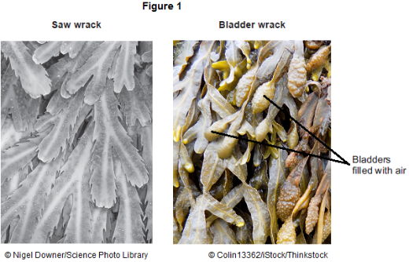**7.**Organisms compete with each other.

(a)     **Figure 1** shows two types of seaweed which live in similar seashore habitats.

Most of the time the two seaweeds are covered with water.

Bladder wrack has bladders filled with air.

Bladder wrack grows more quickly than saw wrack.  
Suggest an explanation why.

________________________________________________________________________________________

________________________________________________________________________________________

________________________________________________________________________________________

________________________________________________________________________________________

________________________________________________________________________________________

________________________________________________________________________________________

**(3)**

(b)     **Figure 2** shows an angler fish.

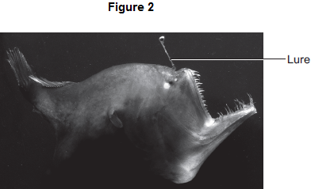

Angler fish live at depths of over 1000 m. In clear water, sunlight does not usually reach more than 100 m deep. Many angler fish have a transparent ‘lure’ containing a high concentration of bioluminescent bacteria. Bioluminescent bacteria produce light. Suggest an advantage to the angler fish of having a lure containing bioluminescent bacteria.

________________________________________________________________________________________

________________________________________________________________________________________

________________________________________________________________________________________

________________________________________________________________________________________

________________________________________________________________________________________

________________________________________________________________________________________

**(2)**

**Lesson 4**

|  |  |  |
| --- | --- | --- |
|  | **Topic:** | **Plant hormones (triple only) (B.27)** |
| 1 | What is the name of a plant's response to (a) light (b) gravity (triply only) | (a) light = phototropism (b) gravity = gravitropism/geotropism |
| 2 | Which plant hormone initiates seed germination? (triple only) | Gibberellins |
| 3 | Which hormone causes cell division and fruit ripening (triple only) | Ethene |
| 4 | State three uses of auxins | 1) weed killer, 2) rooting powder, 3) tissue culture |
| 5 | State one use of ethene | Controlling fruit ripening |
| 6 | State three uses of gibberellins | 1) end seed dormancy, 2) promote flowering 3) increase fruit size |
| 7 | When a shoot grows towards the light, what kind of tropism is demonstrated? | Positive phototropism |
| 8 | When a root grows away from the light, what kind of tropism is demonstrated? | Negative phototropism |
| 9 | When a root grows down (with gravity), what kind of tropism is demonstrated? | Positive geotropism |
| 10 | When a shoot grows up (against gravity), what kind of tropism is demonstrated? | Negative geotropism |
| 11 | How does auxin cause a shoot to grow towards light? | Auxin moves to shady side -> elongation of cells |
| 12 | How does auxin cause a plant to against gravity? | Auxin moves to lower side -> elongation of cells |
| 13 | State the names of 3 plant humans | 1) Ethene, 2) Gibberellins, 3) Auxin |
| 14 | Which transport method is used to move auxin from the tip of a plant to other parts? | Diffusion |
| 15 | Which part of a plant contains lots of new forming cells? | Meristem |

|  |  |  |
| --- | --- | --- |
|  | **Topic:** | **Natural recycling (triple only) (B.28)** |
| 1 | How do plant remove carbon from the air? | Photosynthesis (CO2 in) |
| 2 | How is carbon moved from living organisms back into the air? | Respiration (CO2 released) |
| 3 | How is carbon moved from fossil fuels back into the air? | Combustion (CO2 released) |
| 4 | How is carbon moved from dead organisms into the air? | Decomposition (by decomposers) (CO2 released) |
| 5 | What is the scientific name for rain? | Precipitation |
| 6 | How does water move from lakes/the sea into the air? | Evaporation |
| 7 | Which process leads to cloud formation? | Condensation |
| 8 | What is the name of evaporation of water from plants? | Transpiration |
| 9 | State 3 factors that affect the rate of decay (triple only) | Temperature, water, availability of oxygen |
| 10 | State one human use of decomposition (triple only) | Making compost |
| 11 | Which gas is produced by a biogas generator? (triple only) | Methane |
| 12 | Describe the effect of temperature on rate of decay (triple only) | increase temp -> increase decay (to 37⁰C) |
| 13 | Which enzyme breaks down the fat in milk? (triple only) | Lipase |
| 14 | State the colour of phenolphthalein in acidic and alkaline conditions (triple only) | Alkaline (pink) Acid (colourless) |
| 15 | How do decomposers feed? (triple only) | Secrete enzymes, small food molecules diffuse into decomposer |

**Biology Revision: Plant Hormones**

Understanding and Explaining

1. Describe how auxins work as selective weed killers.______________________________________________________

___________________________________________________________________________________________________

1. Explain how phototropism causes a plant’s shoot to grow towards the light. ____________________________________

___________________________________________________________________________________________________

___________________________________________________________________________________________________

1. Explain how phototropism causes a plant’s root to grow away from the light.

___________________________________________________________________________________________________

___________________________________________________________________________________________________

___________________________________________________________________________________________________

1. Explain how gravitropism causes the roots of the plant to grow down.

___________________________________________________________________________________________________

___________________________________________________________________________________________________

__________________________________________________________________________________________________

1. Explain how gravitropism causes the shoots of the plant to grow upward.

___________________________________________________________________________________________________

___________________________________________________________________________________________________

___________________________________________________________________________________________________

1. An experiment into phototropism is completed. The tips of a plant is cut off, then a layer of material is added at the tip is replaced. When the material is permeable, such as agar, the plant continues to grow, but when it is impermeable, it does not grow. Explain these results.

___________________________________________________________________________________________________

___________________________________________________________________________________________________

___________________________________________________________________________________________________

___________________________________________________________________________________________________

___________________________________________________________________________________________________

___________________________________________________________________________________________________

Mastery Matrix Points (TRIPLE ONLY)

|  |  |
| --- | --- |
| Identify 3 plant hormones and their effects within plants (triple only) | Describe how the 3 plant hormones are used in agriculture and horticulture (triple only) |
| Describe the processes of phototropism, geotropism/gravitropism (triple only) | **RP:: Investigate the effect of light or gravity on the growth of newly generated seeds (triple only)** |

Key Knowledge

Three plant hormones are:

1. Gibberellins

Natural effect – _________________

______________________________

Use in horticulture/agriculture

-_____________________________

-_____________________________

-_____________________________

1. Ethene

Natural effect – _________________

______________________________

Use in horticulture/agriculture

-_____________________________

1. Auxins

Natural effect – _________________

______________________________

Use in horticulture/agriculture

-_____________________________

-_____________________________

-_____________________________

Negative gravitropism: _____________

______________________________

Positive gravitropism: _____________

______________________________

Positive phototropism: _____________

______________________________

Where are auxins produced? ________

______________________________

What is the effect of auxins on the shoots of a plant? _____________

______________________________

What is the effect of auxins on the roots of a plant? _____________

______________________________

**Biology Revision: Natural Recycling**

Mastery Matrix Points

|  |  |
| --- | --- |
| Describe the carbon cycle and its importance | Explain how biogas generators can be used to produce a fuel (triple only) |
| Describe the water cycle and its importance | **Required practical: Investigate the effects of temperature on the rate of decay of fresh milk by measuring pH change (triple only)** |
| Explain factors that affect the rate of decay, calculating rate changes using this to explain how to speed up the production of compost (triple only) |

Understanding and Explaining

1. Describe and explain how carbon is cycled around the environment.

__________________________________________________________________________________________________

__________________________________________________________________________________________________

__________________________________________________________________________________________________

__________________________________________________________________________________________________

__________________________________________________________________________________________________

1. What is the role of microorganisms like bacteria and fungi in the carbon cycle? Why are they so important?

__________________________________________________________________________________________________

__________________________________________________________________________________________________

__________________________________________________________________________________________________

__________________________________________________________________________________________________

1. Explain what biogas is and how does a biogas generators work.

__________________________________________________________________________________________________

__________________________________________________________________________________________________

__________________________________________________________________________________________________

__________________________________________________________________________________________________

1. Describe the optimum conditions for increasing the rate of decay.

__________________________________________________________________________________________________

__________________________________________________________________________________________________

__________________________________________________________________________________________________

__________________________________________________________________________________________________

Key Knowledge

Carbon cycle – ___________________

______________________________

Sedimentation – __________________

______________________________

|  |  |  |
| --- | --- | --- |
| How carbon is absorbed from the atmosphere: | How carbon moves from place to place: | How carbon is released into the atmosphere: |
|  |  |  |
|  |  |  |
|  |  |  |
|  |  |  |

Water cycle –

|  |  |
| --- | --- |
| **Process** | **Description** |
| Precipitation |  |
| Condensation |  |
| Runoff |  |
| Infiltration |  |
| Subsurface flow |  |
| Evaporation |  |
| Transpiration |  |

Decay/decomposition – ________________

_________________________________

Factors that affect the rate of decay:

-_____________________________

-_____________________________

-_____________________________

-_____________________________

Compost is made from _____________ and is used for __________________.

Notes

**8.** Hormones called auxins control plant growth. A student investigated plant growth responses in roots. This is the method used.

1.      Grow three bean seeds until their roots are 1 cm long.

2.      Attach the three bean seeds to moist cotton wool in a Petri dish. Each bean seed root should point in a different direction.

3.      Fix the Petri dish vertically for 2 days in the dark.

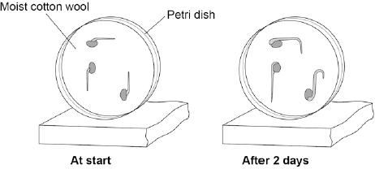**Figure 1** shows the results.

(a)     Describe the direction of growth of the bean **roots** after 2 days. Give **one** reason for this growth response.

Direction of root growth _________________________________________

Reason ____________________________________________________________________________

________________________________________________________________________________**(2)**

(b)     The student then noticed the shoots growing from the seeds. He then:

1.      put a light above the Petri dish but did not move the seeds

2.      allowed the seeds to grow for 2 **more** days.

Predict the direction of growth of the bean **shoots** after 2 days.

Give **one** reason for your prediction.

Direction of root growth _________________________________________

Reason ____________________________________________________________________________

________________________________________________________________________________**(2)**

(c)     Ethene is a plant hormone. Ethene causes fruit to ripen. Scientists measured the concentration of ethene found in fruit at different stages of ripeness. **Figure 2** shows the results.  At which stage of ripeness is there most ethene?

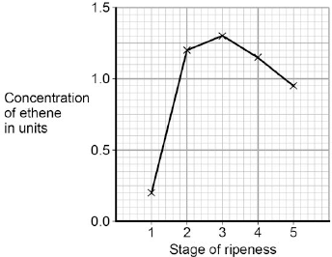

|  |  |
| --- | --- |
| Tick **one** box. |  |
| Stage **1** |  |
| Stage **2** |  |
| Stage **3** |  |
| Stage **4** |  |
| Stage **5** |  |

**(1)**

(d)     Suggest how the scientists can find out if the result for Stage **1** was an anomaly.

________________________________________________________________________________________

______________________________________________________________________________________**(1)**

(e)     Gibberellins are a different type of plant hormone. Farmers growing cotton plants in cold climates sometimes soak their seeds in a solution of gibberellins before planting the seeds.

Suggest an advantage of soaking seeds in a gibberellin solution in cold climates.

________________________________________________________________________________________

______________________________________________________________________________________**(1)**

**9.Figure 1** shows some information about ‘stem cell burgers’.

**Figure 1**

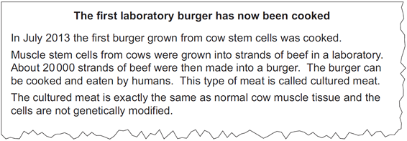

(a)     (i)      Some scientists think using cultured meat instead of traditionally-produced meat will help reduce global warming.

Suggest **two** reasons why using cultured meat may slow down the rate of global warming.

1 ______________________________________________________________________________________

2 ____________________________________________________________________________________ **(2)**

(ii)     Suggest **two** other possible advantages of producing cultured meat instead of farmed meat.

Do **not** refer to cost in your answer.

1 ______________________________________________________________________________________

________________________________________________________________________________________

2 ____________________________________________________________________________________**___**

______________________________________________________________________________________**(2)**

(b)     Mycoprotein is one type of food that is mass-produced. **Figure 2** shows a fermenter used to produce mycoprotein.

**Figure 2**

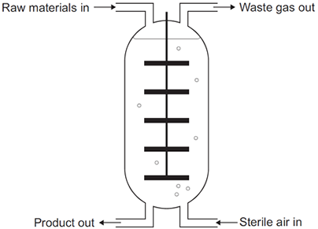

Describe how mycoprotein is produced.

____________________________________________________________________________________________

____________________________________________________________________________________________

____________________________________________________________________________________________

____________________________________________________________________________________________

____________________________________________________________________________________________

____________________________________________________________________________________________

____________________________________________________________________________________________

____________________________________________________________________________________________

____________________________________________________________________________________________

____________________________________________________________________________________________

**(4)**

**Lesson 5**

|  |  |  |
| --- | --- | --- |
|  | **Topic:** | **Humans and the environment (B.29)** |
| 1 | Define by "biodiversity" | variety of all the different species on earth/within an ecosystem |
| 2 | Why is increased biodiversity good? | Increases ecosystem stability |
| 3 | State three ways that humans can cause water pollution | Sewage, fertilisers, toxic chemicals |
| 4 | State three ways that humans can cause air pollution | Smoke, acidic gases |
| 5 | State three ways that humans can cause land pollution | Landfill sites, toxic chemicals |
| 6 | State 4 ways that humans are decreasing the land available for living organisms | building, quarrying, farming, dumping waste |
| 7 | State two uses of peat | Fuel & fertiliser |
| 8 | What is the name for 'cutting down trees' | Deforestation |
| 9 | State two reasons for deforestation occurring | Land for farming & growing biofuels |
| 10 | State 5 ways that humans are trying to increase biodiversity | 1) Breeding endangered species 2)protecting rare habitats 3) Hedgerows 4) Afforestation 5) Recycling |
| 11 | Define "food security" (triple only) | Having enough food to feed a population |
| 12 | State 5 factors threatening food security (triple only) | 1) Increasing birth rate, 2) changing diets, 3) new pests/pathogens, 4) environmental changes, 5) conflicts |
| 13 | State two ways of intensively farming (triple only) | 1) restricting movement, 2) controlling temperature of surroundings |
| 14 | State two ways that fishing can be made more sustainable (triple only) | 1) Controlling net size, 2) introducing fishing quotas |
| 15 | State two uses of biotechnology (triple only) | Culturing microorganisms for food and modifying bacteria to produce human insulin |

|  |  |  |
| --- | --- | --- |
|  | **Topic:** | **Classifying organisms (B.30)** |
| 1 | Name the 7 classification levels proposed by Carl Linnaeus (in order) | Kingdom, Phylum, Class, Order, Family, Genus, Species |
| 2 | What does "binomial" literally mean? | Two names |
| 3 | What do the two parts of a binomial name tell us? | (i) Genus (ii) Species |
| 4 | Who introduced the 'domain' level to the classification system? | Carl Woese |
| 5 | State two pieces of evidence that helped scientists to add the additional 'domain' level to the classification system | *better understanding of biochemical processes *being able to look at DNA |
| 6 | State the meaning of the domain "archaea" | Primitive bacteria usually living in extreme environments (DNA is NOT contained in a nucleus) |
| 7 | State the meaning of the domain "bacteria" | DNA is NOT contained in a nucleus, don't live in extreme environments |
| 8 | State the meaning of the domain "eukaryote" | Their DNA is contained in a nucleus (protists, fungi, plant and animals) |
| 9 | Define "species" | organisms that can breed together to produce FERTILE offspring |
| 10 | List the 5 'classes' of classification | Mammals, reptiles, birds, fish, amphibians |
| 11 | List 4 ways a species can become extinct slowly | *New predators *New diseases *Changes to the environment over time *More successful competitors |
| 12 | State one way a species can become extinct rapidly | Catastrophic event e.g. volcanic eruption |
| 13 | State the purpose of an evolutionary tree | A diagram used to show how closely related we think organisms are to each other |
| 14 | State two pieces of evidence used to create an evolutionary tree | Fossil records and DNA samples |
| 15 | List the 5 kingdoms? | Prokaryote, Protoctista, Fungi, Animals, Plants |

**Biology Revision: Humans & Environment**

Mastery Matrix Points

|  |  |
| --- | --- |
| Define biodiversity and explain its importance | Define ‘sustainability’ (triple only) |
| Explain in detail human impact on biodiversity (waste management, pollution, land use, deforestation, global warming) | Explain how to improve the efficiency of food production (triple only) |
| Describe and evaluate some of the programs used to reduce the negative effects of humans on ecosystems and biodiversity (breeding programs, protection/regeneration of rare habitats, reintroduction of field margins and hedgerows, reduction of deforestation, reduction of carbon emissions, increased recycling) | Describe and evaluate modern farming techniques (including: intensive farming, sustainable fisheries and sustainable farming) (triple only) |
| Describe 6 biological factors threatening food security (triple only) | Explain how microorganisms can be cultured for food (e.g. fungus fusarium -> mycoprotein) (triple only) |

Understanding and Explaining

1. Explain how our use of the land will have impacted on habitats. _____________________________________________

_______________________________________________________________________________________________

_______________________________________________________________________________________________

1. Explain why biodiversity is important. _______________________________________________________________

_______________________________________________________________________________________________

1. List six biological factors that are threatening our food security.

* _________________________________________ - _______________________________________________
* _________________________________________ - _______________________________________________
* _________________________________________ - _______________________________________________

1. Explain what intensive farming is and how they maximise the efficiency of meat production: _______________________

_______________________________________________________________________________________________

_______________________________________________________________________________________________

1. Describe two ways that fishing can be made more sustainable: _____________________________________________

_______________________________________________________________________________________________

_______________________________________________________________________________________________

1. Describe and explain how the fungus Fusarium can be used to produce protein rich food. __________________________

_______________________________________________________________________________________________

_______________________________________________________________________________________________

1. Explain how GM crops such as golden rice may improve food security. ________________________________________

_______________________________________________________________________________________________

_______________________________________________________________________________________________

Key Knowledge

Biodiversity – _______________________

_________________________________

More resources are being used because the ___________ is increasing and our standard of _________ is increasing.

|  |  |
| --- | --- |
| Type | Examples |
| Land |  |
| Air |  |
| Water |  |

Ways land is being used for humans which destroys habitats:

-_________________________________

-_________________________________

-_________________________________

-_________________________________

-_________________________________

-_________________________________

Two reasons why humans do deforestation:

-_________________________________

-_________________________________

Five ways humans are trying to reduce the negative effects of people on the planet

-_________________________________

-_________________________________

-_________________________________

-_________________________________

-_________________________________

Food security: _______________________

__________________________________

Sustainability: _______________________

___________________________________

**Biology Revision: Classifying Organisms**

Mastery Matrix Points

|  |  |
| --- | --- |
| Describe the role of Carl Linnaeus in development of a classification system (kingdom, phylum, class, order, family, genus, species) | Define ‘species’ (linking to future fertility and breeding) |
| Explain the binomial naming system of organisms | Explain how classification models have developed over time due to improvements in microscopy and biochemistry) |

Understanding and Explaining

1. Describe each of the three domains.
2. ____________________________________________________________________________________________

____________________________________________________________________________________________

1. ____________________________________________________________________________________________

____________________________________________________________________________________________

1. ____________________________________________________________________________________________

____________________________________________________________________________________________

1. Name the five kingdoms and give an example from each.

(i) ____________________________________________________________________________________________

(ii) ____________________________________________________________________________________________

(iii) ____________________________________________________________________________________________

(iv) ____________________________________________________________________________________________

(v) ____________________________________________________________________________________________

1. Explain how and why classification systems have changed over time. __________________________________________

______________________________________________________________________________________________

______________________________________________________________________________________________

______________________________________________________________________________________________

______________________________________________________________________________________________

Key Knowledge

**Carl Linnaeus**

Linnaean system of classification:

- ___________________

- ___________________

- ___________________

- ___________________

- ___________________

- ___________________

- ___________________

Binomial names are…__________________

_________________________________

_________________________________

Species definition:___________________

_________________________________

_________________________________

Two reasons why classification models have changed:

* ___________________________

_________________________________

* ___________________________

_________________________________

**Carl Woese**

Added the three-domain system due to evidence from __________ ___________.

Three domains:

- ___________________

- ___________________

- ___________________

Notes

**10.**Human activities have many effects on our ecosystem.

The graph shows the volume of peat compost and peat-free compost used in gardening from 1999 to 2009.

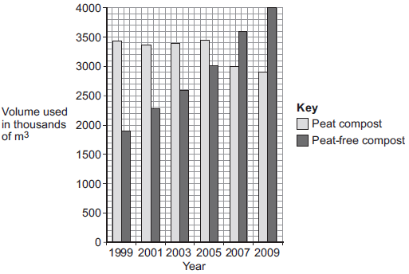

(a)     Describe the trends shown in the graph.

___________________________________________________________________________

___________________________________________________________________________

___________________________________________________________________________

**(2)**

(b)     What effect does the destruction of peat bogs have on the gases in the atmosphere?

___________________________________________________________________________

___________________________________________________________________________

**(1)**

(c)     Deforestation is also damaging ecosystems. Describe **one** effect of deforestation on ecosystems.

___________________________________________________________________________

___________________________________________________________________________

**(1)**

(b)     Deforestation also results in a loss of *biodiversity*.

(i)      What is meant by *biodiversity*?

___________________________________________________________________________

___________________________________________________________________________

**(1)**

(ii)     Give **two** reasons why it is important to prevent organisms becoming extinct.

1._________________________________________________________________________

___________________________________________________________________________

2.________________________________________________________________________

___________________________________________________________________________

**(2)**

**Q11.**         Some people are concerned about the distance that food is transported between the grower and the supermarket. The bar chart shows the distances for some foods.

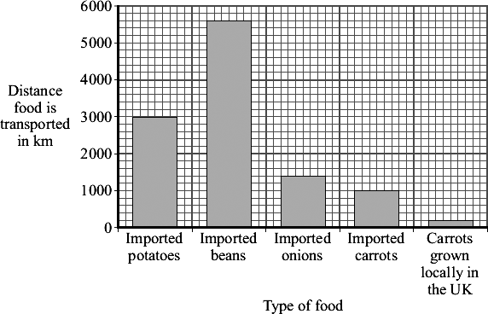

(a)     Both imported carrots and carrots grown locally in the UK can be bought in supermarkets all year round. How many times further are imported carrots transported than carrots grown locally in the UK? Show clearly how you work out your answer.

___________________________________________________________________________

______________________________________________________________________ times

**(1)**

(b)     Many of the beans sold in supermarkets in the UK are grown in Kenya, a tropical country in Africa.

Beans grow faster in Kenya than they do in the UK.

Suggest and explain **one** reason why.

Reason:____________________________________________________________________

**__________**_________________________________________________________________

Explanation:________________________________________________________________

__________________________________________________________________________

**(2)**

(c)     Many people believe that we should buy locally produced food instead of food imported from abroad. Explain how this would help the environment.

__________________________________________________________________________

___________________________________________________________________________________________________________________________________________________(2)

**Lesson 6**

|  |  |  |
| --- | --- | --- |
|  | **Topic:** | **Natural selection and evolution (B.31)** |
| 1 | State three factors that can cause variation in a species | The environment, random mutations, sexual reproduction |
| 2 | Define 'evolution' | The gradual change in the inherited characteristics of a population over time |
| 3 | If enough variation occurs over time due to evolution, a new ________ is created | species |
| 4 | What was Charles Darwin's theory called? | Theory of evolution through natural selection |
| 5 | State the 4 steps to natural selection? | *Variation (Sexual reproduction/random Mutations) *environment Changes *better adapted organisms Survive and Reproduce *pass on their Genes to their offspring |
| 6 | State three reasons why Darwin's theory was not originally accepted | *didn't know HOW characteristics were inherited *people believed GOD created all living things *Insufficient EVIDENCE |
| 7 | What is a fossil? | The remains of an organism from hundreds of thousands of years ago |
| 8 | List 4 ways a fossil may have formed | *hard parts of animals not decaying properly *conditions didn’t allow decay *minerals replaced parts of the organism as it decayed *traces (e.g. footprints) preserved |
| 9 | Describe how scientists use fossils | As evidence of how organisms have changed over time (evolution |
| 10 | Explain why fossils can't be used to provide evidence of how life began on Earth | Fossil record is incomplete (there are gaps) |
| 11 | Explain why there are gaps in the fossil record | *Early animals had soft bodies so decayed easily *Geological activities destroyed fossils |
| 12 | What is an antibiotic-resistant bacterium? | A bacteria that cannot be killed by an antibiotic |
| 13 | What was the name of Charles Darwin's book? | The origin of species 1859 |
| 14 | Describe Jean-Baptiste Lamarck's (incorrect) theory (triple only) | Changes that occur DURING an organisms lifetime can be inherited by it's offspring |
| 15 | List the 3 steps in speciation (Alfred Wallace's theory) (triple only) | *Separation (e.g. by water) *Adaptation *Reproductive isolation (organisms so different they can't interbreed) |

|  |  |  |
| --- | --- | --- |
|  | **Topic:** | **Selective breeding and genetic engineering (B.32)** |
| 1 | Describe Gregor Mendel's main discovery (triple only) | Inheritance of each characteristic is determined by 'units' that are passed on to descendants unchanged |
| 2 | Describe the purpose of selective breeding | Humans breed plants & animals with particular desirable characteristics |
| 3 | State two reasons to use selective breeding | *produce food crops *produce domesticated animals |
| 4 | List 4 steps in selective breeding | 1) Choose parent with desired characteristic 2) Breed them together 3) Choose best offspring 4) Continue over many generations |
| 5 | State 4 examples of characteristics that you may selectively breed an organism for | *Disease resistance (food crops) *More milk/meat (animals) *Gentle nature (domestic animals) *Large/unusual flowers |
| 6 | State one disadvantage of selective breeding in animals | Inbreeding -> health issues |
| 7 | State one disadvantage of selective breeding in crops | Crops have very similar DNA so disease can kill them all |
| 8 | Why was Mendel's work initially not accepted? | *He was a monk *He didn’t publish his work in a well know journal |
| 9 | Who discovered the structure of DNA? | Franklin, Watson & Crick |
| 10 | Describe "gene theory" | The idea that genes are "units" of inheritance |
| 11 | Define "genetic engineering" | Modifying (changing) the genome (genes) of an organism to give a desired characteristic |
| 12 | State two examples of genetic engineering in practice | *Bacterial cells engineered to produce insulin *Plant crops engineered to be resistant to disease/have bigger better fruits |
| 13 | Describe the 4 stages of genetic engineering | 1) select desired characteristic 2) isolate gene 3) insert gene into vector 4) replicate |
| 14 | Define "vector" | A ring of DNA (plasmid) or an organism that carries a gene from one organism into another |
| 15 | Is the allele dominant or recessive for (a) Huntingdon's disease (b) cystic fibrosis? | (a) Huntingdon's = dominant (b) Cystic fibrosis = recessive |

**Biology Revision: Natural Selection &**

Mastery Matrix Points

|  |
| --- |
| Describe and explain the theory of ‘natural selection’ and ‘evolution’ |
| Describe the role of Charles Darwin and his book ‘The origin of species’ on the development of the theory of evolution and the issues he had with getting people to accept this theory (triple only) |
| Explain the theory of Jean Baptiste Lamarck and the theory of evolution (triple only) |
| Explain the role of Alfred Russell Wallace in developing the theory of evolution and his pioneering work on speciation (triple only) |
| Describe the evidence for evolution including antibiotic resistance and the fossil record |
| Describe what a fossil is and explain how they form and explain why these cannot be used as evidence for how life began on Earth |
| Interpret information from evolutionary trees |
| Explain what extinction is and describe factors which may contribute to the extinction of a species |
| Explain the role of Mendel and other scientists on our changing understanding of genetics (triple only) |

Key Knowledge

Natural selection – ___________________

_________________________________

_________________________________

Evolution – _________________________

_________________________________

_________________________________

The name of Charles Darwin’s book and when it was published: _____________________

__________________________(______)

What led Darwin to develop this theory?

-_______________________________

-_______________________________

-_______________________________

Three reasons why people didn’t believe Darwin:

-_______________________________

-_______________________________

-_______________________________

Jean Baptiste Lamarck’s theory –

_______________________________

_______________________________

_______________________________

Alfred Russell Wallace:

-_______________________________

-_______________________________

-_______________________________

Speciation – ________________________

_________________________________

_________________________________

_________________________________

**Evolution**

Understanding and Explaining

1. Describe some factors that may lead to the extinction of a species.

Factor 1: ________________________________________________________________________________________

_______________________________________________________________________________________________

Factor 2:________________________________________________________________________________________

_______________________________________________________________________________________________

Factor 3:________________________________________________________________________________________

_______________________________________________________________________________________________

1. Compare Darwin and Lamarck’s theories of how the giraffe came to have a log neck.

_______________________________________________________________________________________________

______________________________________________________________________________________________________________________________________________________________________________________________

1. Describe the evidence for the theory of evolution by natural selection. __________________________________________

______________________________________________________________________________________________________________________________________________________________________________________________

_______________________________________________________________________________________________

1. How are fossils formed and why can’t they be used as evidence of how life began? _________________________________

_______________________________________________________________________________________________

_______________________________________________________________________________________________

1. Describe the role of Mendel in changing our understanding of inheritance. ________________________________________

_______________________________________________________________________________________________

_______________________________________________________________________________________________

**Biology Revision: Selective Breeding & Genetic Engineering**

Understanding and Explaining

1. Evaluate the use of selective breeding to produce cows with more meat. ______________________________________

____________________________________________________________________________________________

____________________________________________________________________________________________

____________________________________________________________________________________________

____________________________________________________________________________________________

1. Evaluate the use of genetic engineering to produce wheat that is resistant to insect attack.

____________________________________________________________________________________________

____________________________________________________________________________________________

____________________________________________________________________________________________

____________________________________________________________________________________________

____________________________________________________________________________________________

1. Explain how bacteria cells are genetically engineered to produce insulin.

____________________________________________________________________________________________

____________________________________________________________________________________________

____________________________________________________________________________________________

____________________________________________________________________________________________

____________________________________________________________________________________________

____________________________________________________________________________________________

____________________________________________________________________________________________

____________________________________________________________________________________________

____________________________________________________________________________________________

Mastery Matrix Points

|  |
| --- |
| Describe selective breeding and explain the potential benefits and risks of this process (linking to disease resistance in crops, animals with more milk and meat, large or unusual flowers and domestic dogs with a gentle nature) |
| Define ‘genetic engineering’ |
| Describe the main steps in genetic engineering |
| Give examples of genetic engineering (including crop resistance to diseases, insect attack and herbicides, crops with bigger, better fruits and bacterial cells used in the production of insulin) |
| Evaluate the use of genetic engineering and modification and describe the potential uses of this in the future |

Key Knowledge

Selective breeding – __________________

_________________________________

Five uses of selective breeding

-__________________________

-__________________________

-__________________________

-__________________________

-__________________________

Genetic engineering – _________________

_________________________________

_________________________________

Give uses of genetic engineering

-__________________________

-__________________________

-__________________________

-__________________________

-__________________________

Steps in genetic engineering:

1) ________________________________

_________________________________

2) _______________________________

_________________________________

3) _______________________________

_________________________________

4) _______________________________

_________________________________

5) _______________________________

_________________________________

6) ________________________________

_________________________________

Notes

**12. Figure 1** shows a type of camel called a dromedary (*Camelus dromedarius*).

The dromedary lives in hot, dry deserts.

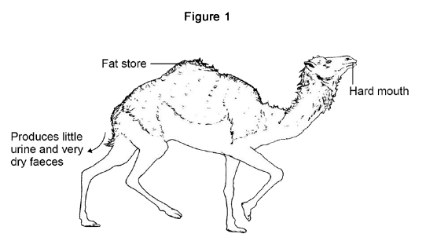

(a)     One adaptation of the dromedary is ‘temperature tolerance’. This means that the animal’s body temperature can rise by up to 6 °C before it starts to sweat.

Explain how temperature tolerance can help the dromedary to survive in the desert.

_________________________________________________________________________________________

_________________________________________________________________________________________

_________________________________________________________________________________________

_________________________________________________________________________________________

**(2)**

(b)     Three more adaptations of the dromedary are given in **Figure 1**.

Give a reason why each adaptation helps the animal survive in the desert.

Fat store _________________________________________________________________________________

_________________________________________________________________________________________

Produces little urine and very dry faeces ________________________________________________________

_________________________________________________________________________________________

Hard mouth ______________________________________________________________________________

_________________________________________________________________________________________

**(3)**

There are several species of the camel family alive today.

Scientists think these species evolved from a common ancestor that lived in North America about 45 million years ago (Mya).

**Figure 2** shows:

•   where four modern species of the camel family live today

•   how the ancestors of these camels migrated from North America.

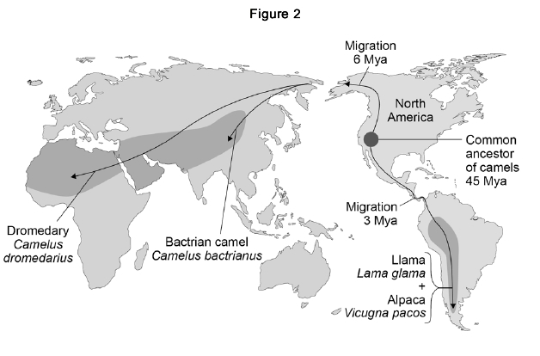

(c)     Which **two** of the four modern species of camel do scientists believe to be most closely related to each other? Give the reason for your answer.

_____________________________ and _____________________________

Reason __________________________________________________________________________________

_________________________________________________________________________________________

**(1)**

(d)     Describe the type of evidence used for developing the theory of camel migration shown in **Figure 2**.

_________________________________________________________________________________________

_________________________________________________________________________________________

_________________________________________________________________________________________

_________________________________________________________________________________________

**(2)**

(e)     Explain how several different species of camel could have evolved from a common ancestor over 45 million years.

_________________________________________________________________________________________

_________________________________________________________________________________________

_________________________________________________________________________________________

_________________________________________________________________________________________

_________________________________________________________________________________________

_________________________________________________________________________________________

_________________________________________________________________________________________

_________________________________________________________________________________________

_________________________________________________________________________________________

_________________________________________________________________________________________

_________________________________________________________________________________________

_________________________________________________________________________________________

_________________________________________________________________________________________

_________________________________________________________________________________________

**(6)**

**Q13.**

The diagram shows how scientists can use genetic engineering to produce human growth hormone.

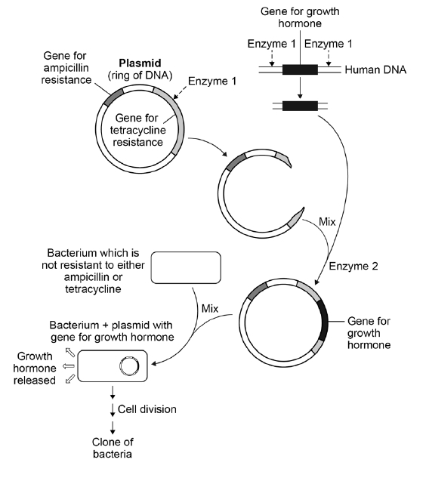

(a)     Human growth hormone is made by the pituitary gland. The human DNA containing the gene for growth hormone can be taken from a white blood cell.

Give the reason why the gene does **not** have to be taken from cells in the pituitary gland.

_________________________________________________________________________________________

_________________________________________________________________________________________

**(1)**

The figure above shows that the plasmid contains two genes for antibiotic resistance:

•   a gene for resistance to the antibiotic ampicillin

•   a gene for resistance to the antibiotic tetracycline.

(b)     Explain how the structure of **Enzyme 1** allows it to cut the gene for tetracycline resistance, but **not** the gene for ampicillin resistance.

_________________________________________________________________________________________

_________________________________________________________________________________________

_________________________________________________________________________________________

_________________________________________________________________________________________

_________________________________________________________________________________________

**(3)**

(c)     In the final step of the diagram above, very few bacteria take up a plasmid containing the gene for growth hormone.

Some bacteria take up an unmodified plasmid.

Most bacteria do **not** take up a plasmid.

Complete the table below.

•   Put a tick in the box if the bacterium **can** multiply in the presence of the given antibiotic.

•   Put a cross in the box if the bacterium **cannot** multiply in the presence of the given antibiotic.

|  |  |  |
| --- | --- | --- |
|  | **Bacterium can multiply in the presence of** | |
|  | **Ampicillin** | **Tetracycline** |
| Bacterium + plasmid with growth hormone gene |  |  |
| Bacterium without a plasmid |  |  |
| Bacterium with an unmodified plasmid |  |  |

(d)     The figure above shows that the bacterium containing the gene for human growth hormone multiplies by cell division.

This produces a clone of bacteria.

Explain why **all** the bacteria in this clone are able to produce growth hormone.

_________________________________________________________________________________________

_________________________________________________________________________________________

_________________________________________________________________________________________

_________________________________________________________________________________________

_____________________________________________________________________________________  **(3)**

**Lesson 7**

|  |  |  |
| --- | --- | --- |
|  | **Topic:** | **The nervous and endocrine system (B.33)** |
| 1 | Define "CNS" | Central Nervous System (brain and spinal cord) |
| 2 | Define "PNS" | Peripheral Nervous System (neurones) |
| 3 | Define "stimulus" | A change in the environment detected by receptors e.g. light, temperature, pressure, smell |
| 4 | Define "receptor" | Specialised cells that detects the stimulus e.g. tongue, skin, nose, eye |
| 5 | Define "effector" | Muscle/gland that responds to the motor neurone to cause a change |
| 6 | Define "sensory neurone" | Neurone carrying electrical impulse FROM receptor to CNS |
| 7 | Define "motor neurone" | Neurone carrying electrical impulse FROM the CNS to effector |
| 8 | Define "relay neurone" | Neurone carrying electrical impulse from one part of the CNS to another |
| 9 | Define "reflex response" | Rapid response which does not use conscious part before response occurs |
| 10 | Describe how messages are sent through the nervous system | Through neurones (electrical) |
| 11 | Describe how messages are sent through the endocrine system | Through blood (chemical) |
| 12 | Which system (nervous or endocrine) transfers messages around the body quicker? | Nervous |
| 13 | Which system (nervous or endocrine) does the response last for longer? | Endocrine |
| 14 | Which gland is called the 'master gland'? | The pituitary gland |
| 15 | Define "synapse" | A gap or junction between two neurons |

|  |  |  |
| --- | --- | --- |
|  | **Topic:** | **Homeostasis (B.34)** |
| 1 | Name the 6 glands/organs in the endocrine system | Thyroid gland, pituitary gland, pancreas, adrenal gland, testes, ovaries |
| 2 | State the hormone that is released from the adrenal gland and it's effect on the body | Adrenaline - "fight or flight" (heart rate increases, blood directed to muscles, air passages dilate) |
| 3 | State the hormone that is released from the thyroid gland and it's effect on the body | Thyroxine - increases metabolism (chemical reactions) |
| 4 | State the hormones that is released from the pituitary gland and their effect on the body | FSH (egg development) & LH (ovulation) |
| 5 | State the hormone that is released from the testes and it's effect on the body | Testosterone - puberty & sperm production (in boys) |
| 6 | State the hormones that is released from the ovaries and their effect on the body | Oestrogen - causes uterus lining to rebuild Progesterone - maintains uterus lining |
| 7 | Which two systems help to control homeostasis? | Nervous system and endocrine system |
| 8 | Which disease is linked to an inability to control your blood glucose levels? | Diabetes |
| 9 | Define "homeostasis" | Regulation of internal conditions of a cell or organism to maintain optimum conditions |
| 10 | State three reasons for organisms requiring homeostasis | *So cells don't burst (too much water) *so enzymes work properly (temperature *so chemical reactions occur (water and glucose) |
| 11 | State 4 things that are regulated in the body | Body temperature, blood glucose, water levels, ion levels |
| 12 | Which part of the body detects and controls body temperature | Thermoregulatory centre (in the brain) |
| 13 | State three ways that your body increases your body temperature if you get too cold | *Muscles contract and relax (shiver) to release thermal energy due to respiration *blood vessels in skin constrict to reduce blood flow and thermal energy loss *hairs on arms stand on end, trapping air beneath them |
| 14 | State three ways that your body decreases it's temperature if you get too hot | *Sweat glands release sweat which evaporates - transferring thermal energy to the air *blood vessels in skin dilate so blood flow increases and more thermal energy lost *Hairs on arms lay flat |
| 15 | What happens to the enzymes in your body if you get (a) too hot (b) too cold | (a) too hot = denatured (b) too cold = work too slowly |

**Biology Revision: The Nervous System**

Mastery Matrix Points

|  |  |
| --- | --- |
| Describe the structure of the nervous system | Describe the design of a reflex arc and explain its purpose |
| Explain how it is adapted for its function and why it is important | Use tables and graphs to extract information about reflex actions |
| Describe the pathway of a message from stimulus to response | **RP Reaction Time:** Plan and carry out an investigation into the effect of a factor on human reaction time |

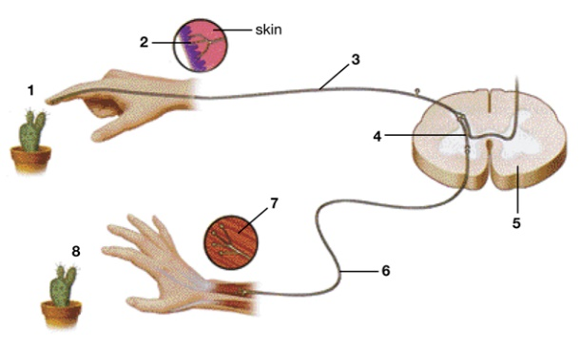

Understanding and Explaining

1. Describe the path of a reflex response in detail, such as touch a very hot object.

____________________________________________________________________________________________

____________________________________________________________________________________________

____________________________________________________________________________________________

____________________________________________________________________________________________

1. Label the parts of the reflex arc on the diagram.

1.___________________ 5. __________________

2. __________________ 6. __________________

3. __________________ 7. ___________________

4. __________________ 8. __________________

1. Describe how the message is transmitted across a synapse.

____________________________________________________________________________________________

____________________________________________________________________________________________

____________________________________________________________________________________________

1. Write a plan for how to investigate if caffeine affects reaction time.

Step 1:______________________________________________________________________________________

Step 2:______________________________________________________________________________________

Step 3:______________________________________________________________________________________

Step 4:_______________________________________________________________________________________

Step 5:_______________________________________________________________________________________

Step 6:______________________________________________________________________________________

Key Knowledge

The nervous system – _________________

_________________________________

_________________________________

CNS (Central nervous system) –__________

_________________________________

_________________________________

Three types of neurones –

1. __________________________
2. __________________________
3. __________________________

Where are relay neurones found?

________________________________

Synapses – ________________________

_________________________________

Reflex actions – ___________________

_________________________________

These are important because…

_________________________________

_________________________________

_________________________________

How does the message travel (electrical or chemical?) in…

1. The sensory neurone:

_________________________

1. Synapses

_________________________

1. The relay neurone

_________________________

1. The motor neurone?

_________________________

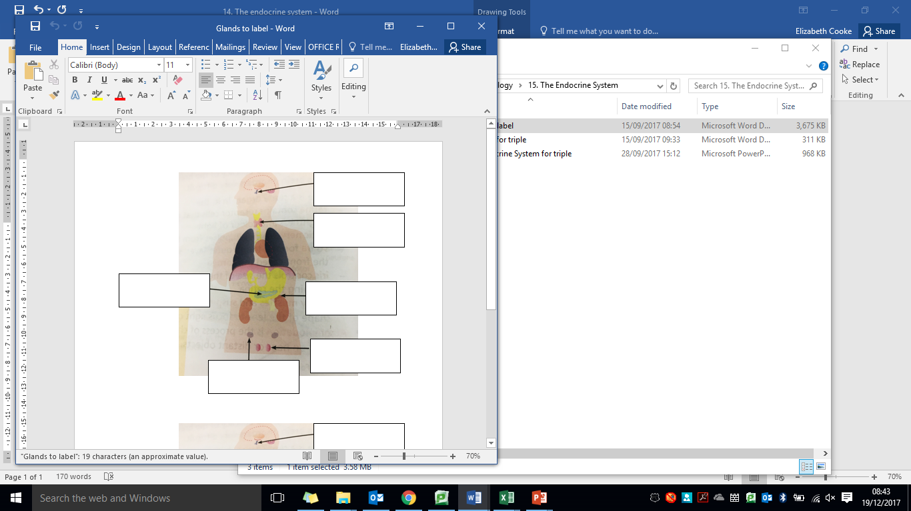**Biology Revision: The Endocrine System**

Understanding and Explaining

1. Compare hormonal responses to nervous system responses. ______________________________________________

___________________________________________________________________________________________

___________________________________________________________________________________________

___________________________________________________________________________________________

___________________________________________________________________________________________

___________________________________________________________________________________________

___________________________________________________________________________________________

1. Label the glands on the diagram.
2. Explain how the body controls the concentration of glucose in the blood.
3. When blood glucose is too high____________________________________________________________

___________________________________________________________________________________________

___________________________________________________________________________________________

______________________________________________________________________________________________________________________________________________________________________________________

___________________________________________________________________________________________

1. When blood glucose is too low _________________________________________________________________

___________________________________________________________________________________________

___________________________________________________________________________________________

___________________________________________________________________________________________

___________________________________________________________________________________________

___________________________________________________________________________________________

1. Why is the pituitary gland called the master gland?

Key Knowledge

Endocrine system – ___________________

_________________________________

Hormones – ________________________

_________________________________

How are hormones transported– _________

_________________________________

Name six glands in the human body:

-________________________________

-________________________________

-________________________________

-________________________________

-________________________________

-________________________________

**Thyroxine**: Produced in … _____________

Job: ____________________________

________________________________

**Adrenaline:** Produced in…_____________

Job: ____________________________

________________________________

Negative feedback loops: _____________

________________________________

If blood glucose is too high…___________

________________________________

If blood glucose is too low……___________

________________________________

Mastery Matrix Points

|  |  |
| --- | --- |
| Describe the principals of hormonal coordination including what makes up the endocrine system | Explain the roles of thyroxine (produced by the thyroid gland) and adrenaline (produced by the adrenal gland) linking this to negative feedback loops (HT only) |
| Describe what hormones are and label six glands in the body | Describe and explain how the body controls blood glucose concentration (making reference to glucose, glycogen, glucagon, negative feedback cycle, insulin and the pancreas) |
| Describe the role of the pituitary gland |

Notes

**Q14.Figure 1** shows a reflex in the iris of the human eye in response to changes in light levels.

**Figure 1**



(a)     Describe the changes in the pupil and iris going from **A** to **B** in **Figure 1**.

Explain how these changes occur. Refer to the changes in light level in your answer.

________________________________________________________________________________________

________________________________________________________________________________________

________________________________________________________________________________________

________________________________________________________________________________________

________________________________________________________________________________________

________________________________________________________________________________________

________________________________________________________________________________________

________________________________________________________________________________________

________________________________________________________________________________________

**(4)**

(b)     Some people wear glasses to improve their vision.

**Figure 2** shows light entering the eye in a person with blurred vision.

**Figure 3** shows how this condition is corrected with glasses.

**Figure 2**                                                  **Figure 3**



Compare **Figure 2** and **Figure 3**.

Explain how the blurred vision is corrected.

________________________________________________________________________________________

________________________________________________________________________________________

________________________________________________________________________________________

________________________________________________________________________________________

______________________________________________________________________________________(2)

**Q15.**

Many functions of the human body are controlled by chemicals called hormones.

(a)     What is a hormone?

________________________________________________________________________________

________________________________________________________________________________

________________________________________________________________________________

________________________________________________________________________________

________________________________________________________________________________

**(3)**

(b)     Name the **two** hormones that control blood glucose concentration.

_____________________________ and _____________________________

**(1)**

The graph shows changes in the concentration of glucose in the blood of a healthy person following a meal.

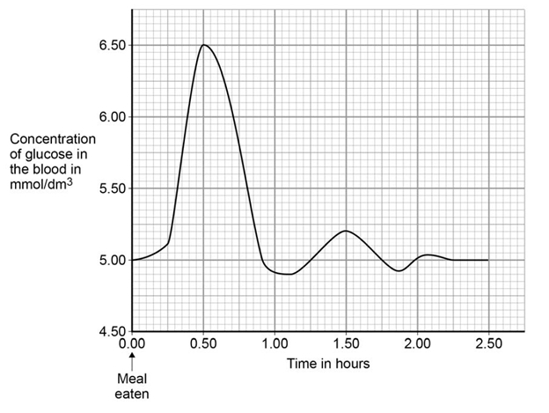

(c)     Explain how negative feedback controls the blood glucose concentration during the first one and a half hours after the meal.

________________________________________________________________________________

________________________________________________________________________________

________________________________________________________________________________

________________________________________________________________________________

________________________________________________________________________________

________________________________________________________________________________

________________________________________________________________________________

________________________________________________________________________________

________________________________________________________________________________

________________________________________________________________________________

________________________________________________________________________________

**(4)**

**Lesson 8**

|  |  |  |
| --- | --- | --- |
|  | **Topic:** | **Diabetes (B.35)** |
| 1 | Which organ monitors and controls your blood glucose concentration? | The Pancreas |
| 2 | Which hormone is released if there is too much glucose in the blood? | Insulin |
| 3 | Which hormone is released if there is too little glucose in the blood? | Glucagon |
| 4 | Describe the effect of insulin have in the body? | (Soluble) glucose stored in the muscle & liver cells as (insoluble) glycogen |
| 5 | Describe the effect of glucagon have in the body? | (Insoluble) glycogen turned into (soluble) glucose and released from liver and muscle cells into blood |
| 6 | Describe what is wrong with a person if they have type one diabetes and how it is treated | Not producing enough insulin (genetic) -> treat with insulin injections |
| 7 | Describe what is wrong with a person if they have type two diabetes and how it is treated | Insulin not having an effect on the muscle/liver cells -> treat with controlled diet and exercise |
| 8 | State the hormones that is released from the pancreas and it's effect on the body | Insulin - decreases blood glucose  Glucagon - increases blood glucose |
| 9 | Define "gland" | An organ that releases a hormone into the blood |
| 10 | Define "hormone" | A chemical messenger that travels in the blood and targets organs |
| 11 | Define 'negative feedback' (higher tier only) | Our body's way of monitoring changes in internal conditions and then responding to these changes so that homeostasis is regained |
| 12 | Which type of diabetes is inherited? | Type one |
| 13 | Which type of diabetes is caused by lifestyle | Type two |
| 14 | How do glucagon & insulin travel around the body? | In blood |
| 15 | State a risk factor for type 2 diabetes | Obesity |

Notes

**Biology Revision: Homeostasis**

Mastery Matrix Points

|  |  |
| --- | --- |
| Define ‘homeostasis’ and explain why it is important | Explain the role of the skin in thermoregulation (triple only) |
| List three factors controlled by homeostasis in the human body (blood glucose concentration, temperature, water levels) | Describe and explain the body’s response to extreme body temperature (triple only) |
| Explain how these automatic systems are controlled | Explain the effect on cells of osmotic changes in bodily fluids (triple only) |
| Describe what monitors and controls body temperature (triple only) | Describe how water ions and urea are lost from the body (triple only) |

Key Knowledge

Homeostasis – ______________________

_________________________________

_________________________________

Homeostasis is important because…. _____

_________________________________

_________________________________

Three things that are controlled in the body

- _______________________________

- _______________________________

- _______________________________

All control systems contain

- _______________________________

- _______________________________

- _______________________________

How the body loses water/ions:

- _______________________________

- _______________________________

- _______________________________

How the body keeps water:

- _______________________________

- _______________________________

- _______________________________

How the body cools down

- _______________________________

- _______________________________

- _______________________________

How the body keeps warm:

- _______________________________

- _______________________________

- _______________________________

Understanding and Explaining

1. Describe what happens to cells if they are:

a) dehydrated _____________________________________________________________________________

________________________________________________________________________________________

_________________________________________________________________________________________

b) overhydrated. __________________________________________________________________________

_________________________________________________________________________________________

_________________________________________________________________________________________

1. Explain how the body monitors and maintains a constant temperature.

_________________________________________________________________________________________

_________________________________________________________________________________________

_________________________________________________________________________________________

_________________________________________________________________________________________

1. Explain how vasodilation and vasoconstriction help to maintain the optimum body temperature.

Vasoconstriction: ___________________________________________________________________________

_________________________________________________________________________________________

________________________________________________________________________________________

Vasodilation: _____________________________________________________________________________

_________________________________________________________________________________________

________________________________________________________________________________________

1. Why is a constant body temperature important?

_________________________________________________________________________________________

_________________________________________________________________________________________

_________________________________________________________________________________________

**Biology Revision: Diabetes**

Mastery Matrix Points

|  |
| --- |
| Explain type 1 and type 2 diabetes and how they can be treated |
| Compare and contrast the two types of diabetes |
| Compare data (from graphs) regarding blood glucose levels in people with and without diabetes |

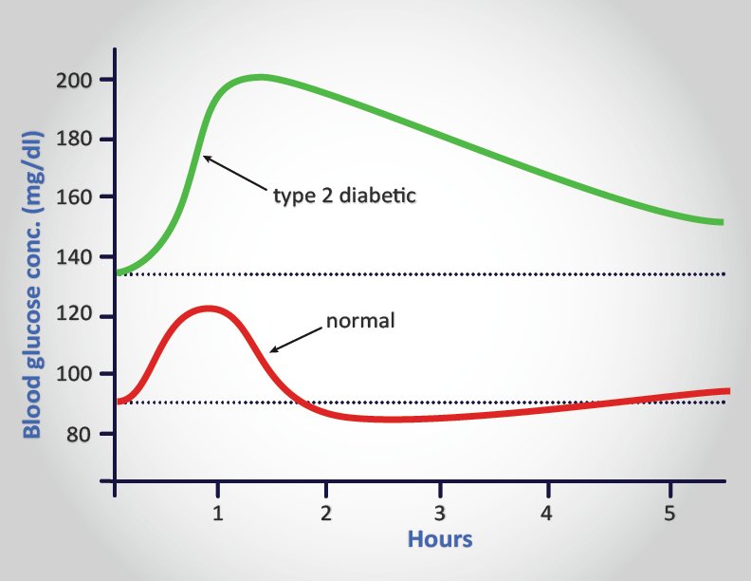

Understanding and Explaining

1. Compare and contrast the two types of diabetes. _______________________________________________________

_______________________________________________________________________________________________

_______________________________________________________________________________________________

_______________________________________________________________________________________________

_______________________________________________________________________________________________

1. Describe how bacteria can be used to produce a treatment for diabetes. (hint: Link to genetic engineering)

_______________________________________________________________________________________________

_______________________________________________________________________________________________

_______________________________________________________________________________________________

_______________________________________________________________________________________________

_______________________________________________________________________________________________

_______________________________________________________________________________________________

1. Describe and explain the differences between the blood glucose levels for the two people shown on the graph.

_______________________________________________________________________________________________

_______________________________________________________________________________________________

_______________________________________________________________________________________________

_______________________________________________________________________________________________

_______________________________________________________________________________________________

_______________________________________________________________________________________________

_______________________________________________________________________________________________

_______________________________________________________________________________________________

_______________________________________________________________________________________________

_______________________________________________________________________________________________

_______________________________________________________________________________________________

_______________________________________________________________________________________________

Key Knowledge

Type 1 Diabetes

Cause – ___________________________

_________________________________

_________________________________

Effect – ___________________________

_________________________________

_________________________________

Treatment – ________________________

_________________________________

_________________________________

Type 2 Diabetes

Cause – ___________________________

_________________________________

_________________________________

Effect – ___________________________

_________________________________

_________________________________

Treatment – _______________________

_________________________________

_________________________________

16. The human body is kept at a constant internal temperature of about 37 °C.

Body temperature is monitored and controlled by the thermoregulatory centre in the brain.

Describe what happens in the body to keep the body temperature constant.

_____________________________________________________________________________________

_____________________________________________________________________________________

_____________________________________________________________________________________

_____________________________________________________________________________________

_____________________________________________________________________________________

_____________________________________________________________________________________

_____________________________________________________________________________________

_____________________________________________________________________________________

_____________________________________________________________________________________

_____________________________________________________________________________________

_____________________________________________________________________________________

_____________________________________________________________________________________

_____________________________________________________________________________________

_____________________________________________________________________________________

_____________________________________________________________________________________

_____________________________________________________________________________________

_____________________________________________________________________________________

_____________________________________________________________________________________

**(Total 6 marks)**

**17.** Homeostasis controls the internal conditions of the body.

(a)     Explain how blood glucose levels are controlled in the body of someone who does **not** have diabetes.

_____________________________________________________________________________________

____________________________________________________________________________________

_____________________________________________________________________________________

_____________________________________________________________________________________

_____________________________________________________________________________________

_____________________________________________________________________________________

_____________________________________________________________________________________

_____________________________________________________________________________________

___________________________________________________________________________________(4)

(b)     Compare how each type of diabetes is caused.

Suggest how each type of diabetes can be treated.

_____________________________________________________________________________________

_____________________________________________________________________________________

_____________________________________________________________________________________

_____________________________________________________________________________________

_____________________________________________________________________________________

_____________________________________________________________________________________

_____________________________________________________________________________________

_____________________________________________________________________________________

_____________________________________________________________________________________

_____________________________________________________________________________________

**(4)**

(c)     Look at the table below.

|  |  |
| --- | --- |
| **Population of UK in 2015** | 6.5 × 107 |
| **Number of people diagnosed with diabetes** | 3.45 × 106 |
| **Estimated number of people with undiagnosed diabetes** | 5.49 × 105 |

Calculate the percentage (%) of the UK population estimated to have diabetes.

You should include both diagnosed and undiagnosed people in your calculation.

Give your answer to 2 significant figures.

_____________________________________________________________________________________

_____________________________________________________________________________________

_____________________________________________________________________________________

_____________________________________________________________________________________

_____________________________________________________________________________________

_____________________________________________________________________________________

Estimated percentage of population with diabetes = ___ %

**(3)**

(d)     A urine test can be used to check for the presence of glucose in the urine.

Diabetes can also be diagnosed with a blood test to measure the concentration of blood glucose.

Suggest why a blood test is more reliable than a urine test.

_____________________________________________________________________________________

_____________________________________________________________________________________

_____________________________________________________________________________________

_____________________________________________________________________________________

**(1)**

(e)     A blood test called the glucose tolerance test checks how well the body processes glucose.

Concentrations of glucose in the blood are measured before and after drinking a glucose drink.

Patients are not allowed to eat food for 8 hours before the glucose tolerance test.

Suggest why patients are **not** allowed to eat for 8 hours before the test.

_____________________________________________________________________________________

_____________________________________________________________________________________

**(1)**

(f)     The diagram below shows the results of a glucose tolerance test for two patients, **A** and **B**.

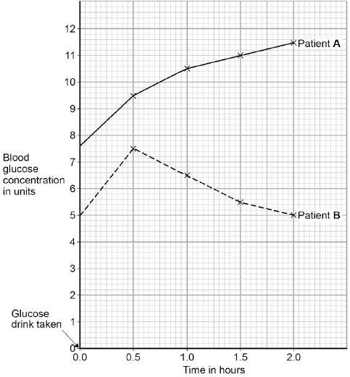

Which patient has diabetes?

Justify your answer.

Patient  _____________

Justification  ________________________________________________________

___________________________________________________________________

___________________________________________________________________

___________________________________________________________________

**(2)**

**(Total 15 marks)**

**Lesson 9**

|  |  |  |
| --- | --- | --- |
|  | **Topic:** | **Kidneys (triple only) (B.18)** |
| 1 | When amino acids are broken down by the liver, what is produced? | Amino acid -> ammonia (toxic) -> urea |
| 2 | What is the name for the process where amino acids are converted into ammonia? | Deamination |
| 3 | Where in the body are amino acids converted into ammonia? | The liver |
| 4 | Why is ammonia converted straight into urea? | Because it's toxic |
| 5 | What is the name for the process where useful substances are reabsorbed from urine into the blood? | Selective reabsorption |
| 6 | What are the tiny tubes in the kidney called? | Tubules |
| 7 | Which hormone controls the water level in the body? | Antidiuretic hormone (ADH) |
| 8 | Where is the hormone that controls the water level in the body released from? | Pituitary gland |
| 9 | What happens to the amount of ADH released when there is too much water in the blood? | Very little ADH released |
| 10 | What happens to the amount of ADH released when there is too little water in the blood? | A lot of ADH released |
| 11 | Name a treatment for kidney failure? | Dialysis or transplant |
| 12 | What is the name of the blood vessel going into and out of the kidney? | In: Renal ARTERY Out: Renal VEIN |
| 13 | What type of transport is used for water to be reabsorbed from the kidney tubules into the blood? | Osmosis |
| 14 | What type of transport is used for glucose/mineral ions to be reabsorbed from the kidney tubules into the blood? | Active Transport |
| 15 | Why is protein not filtered out of the blood by the nephron? | Too big |

|  |  |  |
| --- | --- | --- |
|  | **Topic:** | **Hormones in the reproductive system (B.36)** |
| 1 | State the function of FSH (follicle stimulating hormone) | Causes egg to mature |
| 2 | State where FSH is produced | Pituitary Gland |
| 3 | State the hormone that FSH stimulates the production of (HT only) | Oestrogen from ovaries |
| 4 | State the effect of oestrogen | Causes uterus lining to build up |
| 5 | Which hormone inhibits FSH release? (HT only) | Oestrogen |
| 6 | Which hormone does oestrogen stimulate? (HT only) | Luteinising hormone (LH) |
| 7 | State the effect of luteinising hormone (LH) on the body | Causes ovulation |
| 8 | Where is luteinising hormone produced? | Pituitary Gland |
| 9 | Where is progesterone produced? | The empty egg follicle (corpus luteum) |
| 10 | State the role of progesterone | Maintains uterus lining Inhibits FSH & LH |
| 11 | Name 3 non-hormonal methods of contraception | Barrier method (diaphragm or condoms), abstinence, spermicide, sterilisation, some intrauterine devices |
| 12 | Name 3 hormonal methods of contraception | Oral contraceptive pill, implant, injection, some intrauterine devices |
| 13 | What does IVF stand for? | In Vitro Fertilisation (outside of the body) |
| 14 | What are the 4 stages of IVF? (higher tier only) | 1) Mother given FSH & LH to stimulate maturation of several eggs 2) eggs collected from mother and fertilised by sperm in lab 3) Fertilised eggs develop into embryos 4) Two embryos inserted into mothers uterus |
| 15 | What is embryo screening? | Check embryo for genetic diseases and decide whether or not to use/abort the embryo |

Notes

**Biology Revision: Kidneys**

Key Knowledge

Two functions of kidneys:

-_____________________________

-_____________________________

Deamination:____________________

_____________________________

______________________________

Where does deamination happen?

_____________________________

Urine: :____________________

_____________________________

Where is urine made and stored?

_____________________________

Negative feedback:________________

_____________________________

ADH stands for ___________ ____________ and is released by the _________________________.

ADH is released when you are hydrated/dehydrated. ADH makes the kidney tubules more/less permeable, and so causes more/less water to be reabsorbed. This means more/less water is released in the urine.

Dialysis:________________________

_____________________________

Advantages – _____________________

_____________________________

_____________________________

Disadvantages – ___________________

_____________________________

_____________________________ Kidney Transplant:_______________

_____________________________

Advantages – _____________________

_____________________________

_____________________________

Disadvantages – ___________________

_____________________________

_____________________________

Mastery Matrix Points

|  |  |
| --- | --- |
| Describe the function of the kidneys (triple only) | Describe the effect of ADH on the permeability of the kidney tubules and link to the ‘negative feedback loop’ (triple only) |
| Describe how urea is formed from excess amino acids (triple only) | Explain how kidney failure may be treated (including dialysis and kidney transplant) (triple only) |
| Explain how the kidneys produce urine (triple only) |
| Use bar charts & tables of glucose, ions & urea to analyse data from before & after filtration (triple only) | Evaluate treating organ failure with mechanical devices e.g. transplant (triple only) |

Understanding and Explaining

1. Describe how urea is formed from excess amino acids.

__________________________________________________________________________________________________________

__________________________________________________________________________________________________________

1. Explain the processes of filtration and selective reabsorption.

Filtration: ________________________________________________________________________________________

______________________________________________________________________________________________

Selective reabsorption:______________________________________________________________________________

______________________________________________________________________________________________

1. Why is ammonia converted to urea during deamination?

______________________________________________________________________________________________

1. Use the rules in the box to explain the what has happened to each of the four chemicals in the table below.



1) Protein: _____________________________________________________________________________________________________

_____________________________________________________________________________________________________________

2) Glucose: _____________________________________________________________________________________________________

_____________________________________________________________________________________________________________

3) Urea: _____________________________________________________________________________________________________

_____________________________________________________________________________________________________________

4) Sodium ions: __________________________________________________________________________________________________

_____________________________________________________________________________________________________________

**Rules:**

If its not in the filtrate, its too big to be filtered by the kidney tubules/nephrons.

If its in the filtrate, but not in the urine, its been reabsorbed.

If it seems like there’s more in the urine than filtrate, water must have be reabsorbed, making it more concentrated.

**Biology Revision: Hormones in the**

Mastery Matrix Points

|  |  |
| --- | --- |
| Describe the roles of FSH, LH, Oestrogen and progesterone in the menstrual cycle | Explain the process of embryo screening and evaluate based on ethical, social and economic perspectives |
| Describe the roles of oestrogen and progesterone in puberty | Explain the use of FSH and LH as a fertility drug (HT only) |
| Interpret graphs relating to hormone levels in the menstrual cycle (HT only) | Explain IVF (in vitro fertilisation) (HT only) |
| Link hormone cycles to ovulation and menstruation | Explain how developments in microscopy have enabled IVF treatments to be improved (HT only) |
| Evaluate hormonal and non-hormonal methods of contraception (oral, injection, implant, skin patch, condoms, diaphragms, intrauterine device, spermicidal agents, abstinence, sterilisation) | Evaluate social and ethical issues and risks from the perspective of patients and doctors in IVF (HT only) |
| Explain why issues around contraception are not answered solely by the field of Science | Compare nervous system and hormonal responses |

Key Knowledge

**Male hormones**

Testosterone – ____________________

________________________________

**Female hormones**

|  |  |
| --- | --- |
| Hormone | Roles: |
| FSH |  |
| Oestrogen |  |
| LH |  |
| Progesterone |  |

Ovulation is…________________________

Ovulation happens about every _____ days.

Hormonal contraceptive methods include…

1. _________________________
2. _________________________
3. _________________________
4. _________________________

Non-hormonal contraceptive methods include…

1. _________________________
2. _________________________
3. _________________________
4. _________________________

Embryo screening – _________________

________________________________

________________________________

IVF – ____________________________

________________________________

________________________________

**Reproductive System**

Understanding and Explaining

1. Compare oral contraceptives to a barrier method of contraception.

__________________________________________________________________________________________________________

__________________________________________________________________________________________________________

__________________________________________________________________________________________________________

1. Explain why issues around contraception cannot be answered by science alone.

__________________________________________________________________________________________________________

__________________________________________________________________________________________________________

1. Improvements in which piece of equipment have allowed IVF to be developed?

__________________________________________________________________________________________________________

__________________________________________________________________________________________________________

1. Give some pros and cons of embryo screening.

__________________________________________________________________________________________________________

__________________________________________________________________________________________________________

1. Explain the process of IVF.

__________________________________________________________________________________________________________

__________________________________________________________________________________________________________

1. Give some drawbacks of using IVF treatment.

__________________________________________________________________________________________________________

__________________________________________________________________________________________________________

**18.** Blood is filtered in the kidneys.

Some substances are then reabsorbed.

The amount of each substance reabsorbed varies.

Each day, a person:

•   filters 180 dm3 of water out of the blood

•   produces 2 dm3 of urine.

The diagram shows the process of filtration in the kidney.

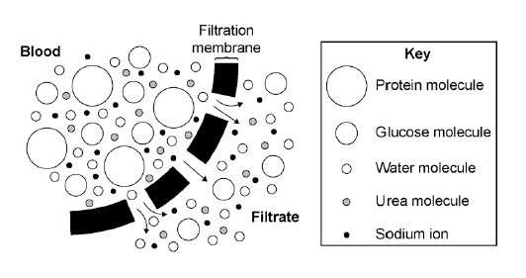

(a)     Explain why protein is **not** found in the urine of a healthy person.

___________________________________________________________________

___________________________________________________________________

___________________________________________________________________

___________________________________________________________________

**(2)**

(b)     Explain why glucose is **not** found in the urine of a healthy person.

___________________________________________________________________

___________________________________________________________________

___________________________________________________________________

___________________________________________________________________

**(2)**

(c)     Explain:

•   why urea and sodium ions are found in urine

•   why their concentration is higher on a hot day than on a cold day.

___________________________________________________________________

___________________________________________________________________

___________________________________________________________________

___________________________________________________________________

___________________________________________________________________

___________________________________________________________________

**(3)**

(d)     The information below gives some features of two types of treatment for kidney disease.

|  |
| --- |
| **Dialysis treatment**  •   A dialysis session lasts about 8 hours.  •   A person needs 3 dialysis sessions every week for the rest of their life.  •   The person must have a diet low in protein and salt.  •   Dialysis costs £30 000 per year.  **Kidney transplant**  •   A kidney transplant requires surgery using general anaesthetic.  •   A suitable kidney donor is needed.  •   Drugs are used to suppress the immune system.  •   A transplant, and the first year’s medical care, costs £51 000.  •   After the first year, the cost of drugs is £5 000 per year. |

Evaluate the use of a kidney transplant instead of dialysis treatment for kidney disease.

___________________________________________________________________

___________________________________________________________________

___________________________________________________________________

___________________________________________________________________

___________________________________________________________________

___________________________________________________________________

___________________________________________________________________

___________________________________________________________________

**(6)**

**(Total 13 marks)**

**19.**

Endocrine glands produce hormones.

(a)     Hyperthyroidism is caused by an overactive thyroid gland.

Suggest what would happen in the body of a person with hyperthyroidism.

___________________________________________________________________

___________________________________________________________________

___________________________________________________________________

___________________________________________________________________

___________________________________________________________________

___________________________________________________________________

**(3)**

(b)     Describe the roles of FSH and LH in the menstrual cycle.

___________________________________________________________________

___________________________________________________________________

___________________________________________________________________

___________________________________________________________________

**(2)**

(c)     The combined pill is a contraceptive that contains progesterone **and** oestrogen.

The ‘mini-pill’:

•        is a contraceptive that **only contains** the progesterone hormone

•        has to be taken at the same time each day to prevent pregnancy.

The success rate of the mini-pill in preventing pregnancy is lower than that of the combined pill.

Explain why missing a dose of the mini-pill would reduce the success rate of the mini-pill.

___________________________________________________________________

___________________________________________________________________

___________________________________________________________________

___________________________________________________________________

___________________________________________________________________

___________________________________________________________________

___________________________________________________________________

___________________________________________________________________

___________________________________________________________________

________________________________________________________________**(4)**

**Lesson 10:**

**Required practicals 7-8**

|  |  |  |
| --- | --- | --- |
|  | **Topic:** | **RP: Reaction time (B7) (B.47)** |
| 1 | What is the independent variable? | Attempt number |
| 2 | What is the dependent variable? | Reactione time (s) |
| 3 | Name 3 control variables | 1) Same hand used 2) Same person dropping ruler 3) Hand placed in same position each time |
| 4 | How is the reaction time measured? | A ruler is dropped and caught and the distance on the ruler is recorded |
| 5 | Name one source of error in the method | Measuring the distance from a different place on the ruler each time |
| 6 | Give two ways to improve the accuracy of the results | 1) Measure from above the thumb 2) Use a computer programme |
| 7 | How do we turn the distance on the ruler to a reaction time? | Use a conversion chart to turn the distance into a time |
| 8 | Name the equipment | Metre rule, chair, table, partner |
| 9 | Describe where the hand should be placed | Place the forearm of your arm across the table with your hand overhanging the edge of the table |
| 10 | Describe where the ruler should start from | The bottom of the ruler at 0cm between the thumb and forefinger |
| 11 | Describe how the ruler should be dropped | Your partner drops the ruler without telling you |
| 12 | Describe how the ruler should be caught | As quickly as you an between thumb and forefinger |
| 13 | Name one risk in the investigation | Care should be taken to avoid injury from the falling ruler |
| 14 | What results should you see? | As the number of practice attempts increases, the reaction time decreases |
| 15 | What are possible variations on this method? | 1) Effect of sugary drinks 2) Effect of caffeine 3) Effect of age |

|  |  |  |
| --- | --- | --- |
|  | **Topic:** | **RP: Plant responses (B8) (triple only) (B.48)** |
| 1 | What is the independent variable? | The amount of light (dark, partial light, full light) |
| 2 | What is the dependent variable? | Height of seedlings |
| 3 | Name 3 control variables | 1) Type of seed 2) Volume of water 3) Number of seedlings in dish |
| 4 | Give one precaution in the investigation | Wash hands after touching seedlings |
| 5 | Name the equipment needed | mustard seeds, 3 petri dishes, cotton wool, ruler, water |
| 6 | Name the 3 conditions of the seedlings | 1) No light 2) Partial light 3) Full light |
| 7 | How is the height of the seedlings measured? | Using a ruler |
| 8 | How do you make the measurements more accurate? | Measure the height of 10 seedlings each day and calculate a mean |
| 9 | How will you represent the data? | Plot a line graph of mean height against the day |
| 10 | Name one error in the investigation | Not measuring the seedling from the base to the top |
| 11 | What will happen the seedlings in full light? | They will grow towards the light source |
| 12 | What will happen to the seedlings in partial light? | They will grown towards the light source |
| 13 | What will happen to the seedlings in the dark? | 1) They will grow the tallest 2) The leaves will be small and yellow |
| 14 | Why is there more growth in no light? | The seedling grow faster to find the light |
| 15 | What are possible variations on this method? | Effect of gravity on growth |

|  |  |  |
| --- | --- | --- |
|  | **Topic:** | **RP: Field investigations (B9) (B.49)** |
| 1 | What is the first aim? | Investigating the population size of a plant species using random sampling |
| 2 | How do we prepare the area we are investigating? | Lay out two measuring tapes at right angles to each other |
| 3 | Name the equipment | a 25 cm x 25cm quadrat, a 30 m tape measure, a clipboard, a pen, paper. |
| 4 | How do we ensure the sample is random? | Choose random co-ordinates and palce the quadrat in these places |
| 5 | What are the steps in the method? | 1) Place the quadrat down and count the number of organisms inside. 2) Repeat for 10 quadrats 3) Calculate the mean |
| 6 | How do we work out an estimate for the whole area? | estimated population size = (area sampled /total area) x mean number of organisms counted |
| 7 | How can we improve the accuracy of the estimate? | increase the number of quadrat throws and calculate the mean |
| 8 | Why might the estimate be inacurate? | Not all parts of the area contain an equal distribution of the organism and so the sample may not be representative |
| 9 | What is the second aim? | Investigating the effect of light intensity on plant distribution using a transect line. |
| 10 | How do we set up a transect line? | Place a tape measure from one part of the area to another |
| 11 | How do we measure the number of organisms? | Place a quadrat down and count the number of organisms inside |
| 12 | How do you measure the change in distribution of the organism? | Move the quadrat 1m along the transect and count the number of organisms. Repeat every 1m. |
| 13 | How do you measure the light intensity? | Use a light meter or light probe |
| 14 | How do you represent the data? | Plot a graph of light intensity againt number of organisms |
| 15 | What are possible variations on this method? | 1) Effect of pH 2) Effect of temperature 3) Effect of carbon dioxide levels 4) Distance from a factory/road |

|  |  |  |
| --- | --- | --- |
|  | **Topic:** | **RP: Rate of decay (B10) (triple only) (B.50)** |
| 1 | What is the independent variable? | The temperature of the solutions |
| 2 | What is the dependent variable? | The time taken for the indicator to turn yellow |
| 3 | Name 3 control variables | 1) Volume of milk 2) Volume of lipase 3) Volume of sodium carbonate |
| 4 | Why is this method only a model for decay? | Decay in milk is too slow |
| 5 | Name the indicator used | Cresol red |
| 6 | How is each temperature maintained? | Using a water bath |
| 7 | Name the enzyme, the substrate and the product | Lipase breaks down lipids into fatty acids and glycerol |
| 8 | What observation is made when 'decay' has occurred? | The Cresol red turns from purple (alkaline) to yellow (acidic) |
| 9 | What product makes the solution acidic? | Fatty acids |
| 10 | Name one risk and precaution in the method | Cresol red is an irritant so goggles should be worn and skin washed immediately if it comes into contact |
| 11 | How can you make the results more accurate? | Use a measuring syringe, use a digital water bath, repeat at more temperatures |
| 12 | Why is a measuring syringe more accurate than a measuring cylinder? | It has a smaller meniscus and less of the solution remains inside the syringe |
| 13 | Name one error in the investigation | Starting and stopping the timer at the incorrect time |
| 14 | What results should you see? | As temperature increases, rate of decay should increase up to 40⁰C. It should then decrease as enzymes become denatured. |
| 15 | What are possible variations on this method? | Effect of lipase concentration |

**Biology Revision – Reaction Times**

Understanding and Explaining

Equipment:

_____________________________________________________________________________________________________________________________

_____________________________________________________________________________________________________________________________

_____________________________________________________________________________________________________________________________

Method:

Step 1:__________________________________________________________________________________________________________________

_____________________________________________________________________________________________________________________________

Step 2:__________________________________________________________________________________________________________________

_____________________________________________________________________________________________________________________________

Step 3:__________________________________________________________________________________________________________________

_____________________________________________________________________________________________________________________________

Step 4:__________________________________________________________________________________________________________________

_____________________________________________________________________________________________________________________________

Step 5:__________________________________________________________________________________________________________________

_____________________________________________________________________________________________________________________________

Step 6:__________________________________________________________________________________________________________________

_____________________________________________________________________________________________________________________________

Step 7:__________________________________________________________________________________________________________________

_____________________________________________________________________________________________________________________________

Key Knowledge

Define:

IV:____________________________

_______________________________

DV:____________________________

_______________________________

CV:____________________________

_______________________________

Repeatable: _____________________

_______________________________

Reproducible: _____________________

_______________________________

Accurate: _____________________

_______________________________

IV in this experiment:

_______________________________

DV in this experiment:

_______________________________

CV in this experiment:

1. __________________________
2. __________________________
3. __________________________

**Biology Revision – Tropisms (triple only)**

Understanding and Explaining

Equipment:

_____________________________________________________________________________________________________________________________

_____________________________________________________________________________________________________________________________

_____________________________________________________________________________________________________________________________

Method:

Step 1:__________________________________________________________________________________________________________________

_____________________________________________________________________________________________________________________________

Step 2:__________________________________________________________________________________________________________________

_____________________________________________________________________________________________________________________________

Step 3:__________________________________________________________________________________________________________________

_____________________________________________________________________________________________________________________________

Step 4:__________________________________________________________________________________________________________________

_____________________________________________________________________________________________________________________________

Step 5:__________________________________________________________________________________________________________________

_____________________________________________________________________________________________________________________________

Step 6:__________________________________________________________________________________________________________________

_____________________________________________________________________________________________________________________________

Step 7:__________________________________________________________________________________________________________________

_____________________________________________________________________________________________________________________________

Key Knowledge

Define:

Tropism:_________________________

_______________________________

Phototropism: ___________________

_______________________________Geotropism:_____________________

_______________________________

Auxin:__________________________

_______________________________

Elongate: _____________________

_______________________________

Inhibit: _____________________

_______________________________

**Biology Revision – Field investigations**

Understanding and Explaining

Estimating the number ladybirds in a field (random)

Equipment:

_____________________________________________________________________________________________________________________________

_____________________________________________________________________________________________________________________________

_____________________________________________________________________________________________________________________________

Method:

Step 1:__________________________________________________________________________________________________________________

_____________________________________________________________________________________________________________________________

Step 2:__________________________________________________________________________________________________________________

_____________________________________________________________________________________________________________________________

Step 3:__________________________________________________________________________________________________________________

_____________________________________________________________________________________________________________________________

Step 4:__________________________________________________________________________________________________________________

_____________________________________________________________________________________________________________________________

Investigating the impact of distance from the sea on the number of shells (transect)

Equipment:

_____________________________________________________________________________________________________________________________

_____________________________________________________________________________________________________________________________

Method:

Step 1:__________________________________________________________________________________________________________________

_____________________________________________________________________________________________________________________________

Step 2:__________________________________________________________________________________________________________________

_____________________________________________________________________________________________________________________________

Step 3:__________________________________________________________________________________________________________________

_____________________________________________________________________________________________________________________________

Step 4:__________________________________________________________________________________________________________________

_____________________________________________________________________________________________________________________________

Key Knowledge

Define:

Transect_________________________

_______________________________

Quadrat_________________________

_______________________________

Repeatable: _____________________

_______________________________

Reproducible: _____________________

_______________________________

Accurate: _____________________

_______________________________

**Biology Revision – Rate of decay**

Understanding and Explaining

Equipment:

_____________________________________________________________________________________________________________________________

_____________________________________________________________________________________________________________________________

_____________________________________________________________________________________________________________________________

Method:

Step 1:__________________________________________________________________________________________________________________

_____________________________________________________________________________________________________________________________

Step 2:__________________________________________________________________________________________________________________

_____________________________________________________________________________________________________________________________

Step 3:__________________________________________________________________________________________________________________

_____________________________________________________________________________________________________________________________

Step 4:__________________________________________________________________________________________________________________

_____________________________________________________________________________________________________________________________

Step 5:__________________________________________________________________________________________________________________

_____________________________________________________________________________________________________________________________

Step 6:__________________________________________________________________________________________________________________

_____________________________________________________________________________________________________________________________

Key Knowledge

Define:

Define:

Waterbath:

_______________________________

Denatured:

_______________________________

IV in this experiment:

_______________________________

DV in this experiment:

_______________________________

CV in this experiment:

1. __________________________
2. __________________________
3. __________________________

**20.** Two students investigated reflex action times.

This is the method used.

1.      Student **A** sits with her elbow resting on the edge of a table.

2.      Student **B** holds a ruler with the bottom of the ruler level with the thumb of Student **A**.

3.      Student **B** drops the ruler.

4.      Student **A** catches the ruler and records the distance, as shown in the diagram below.

5.      Steps **1** to **4** were then repeated.

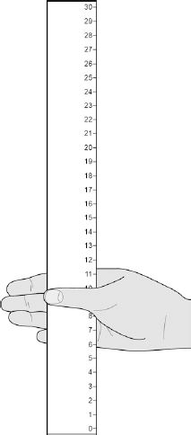

(a)     Suggest **two** ways the students could improve the method to make sure the test would give valid results.

1. _________________________________________________________________

___________________________________________________________________

2. _________________________________________________________________

___________________________________________________________________

**(2)**

(b)     The table below shows Student **A**’s results.

|  |  |
| --- | --- |
| **Test Number** | **Distance ruler dropped in mm** |
| 1 | 117 |
| 2 | 120 |
| 3 | 115 |
| 4 | 106 |
| 5 | 123 |
| 6 | 125 |
| 7 | 106 |

What is the **median** result?

|  |  |
| --- | --- |
| Tick **one** box. |  |
| 106 |  |
| 115 |  |
| 116 |  |
| 117 |  |
| 123 |  |

**(1)**

(c)     The mean distance the ruler was dropped is 116 mm.

Calculate the mean reaction time.

Use the equation:

**reaction time in s =** 

Give your answer to 3 significant figures

___________________________________________________________________

___________________________________________________________________

___________________________________________________________________

Mean reaction time = ______________________ s

**(3)**

(d)     The students then measured Student **A**’s reaction time using a computer program.

This is the method used.

1.       The computer shows a red box at the start.

2.       As soon as the box turns green the student has to press a key on the keyboard as fast as possible.

3.       The test is repeated five times and a mean reaction time is displayed.

Student **A**’s mean reaction time was 110 ms.

Using a computer program to measure reaction times is likely to be more valid than the method using a dropped ruler.

Give **two** reasons why.

1. _________________________________________________________________

___________________________________________________________________

2. _________________________________________________________________

___________________________________________________________________

**(2)**

(e)     A woman has a head injury.

Her symptoms include:

•        finding it difficult to name familiar objects

•        not being able to remember recent events.

Suggest which part of her brain has been damaged.

___________________________________________________________________

**(1)**

(f)     A man has a head injury.

He staggers and sways as he walks.

Suggest which part of his brain has been damaged.

___________________________________________________________________

**(1)**

**)**

**21.** A student was asked to estimate how many clover plants there are in the school field.

The image below shows the equipment used.

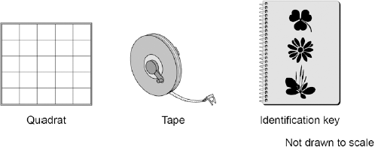

This is the method used.

1.      Throw a quadrat over your shoulder.

2.      Count the number of clover plants inside the quadrat.

3.      Repeat step **1** and step **2** four more times.

4.      Estimate the number of clover plants in the whole field.

(a)     What is the tape in the image above used for in this investigation?

___________________________________________________________________

___________________________________________________________________

**(1)**

(b)     The teacher told the student that throwing the quadrat over his shoulder was **not** random.

The method could be improved to make sure the quadrats were placed randomly.

Suggest **one** change the student could make to ensure the quadrats were placed randomly.

___________________________________________________________________

___________________________________________________________________

**(1)**

(c)     How could the student improve the investigation so that a valid estimate can be made?

|  |  |
| --- | --- |
| Tick **two** boxes. |  |
| Weigh the clover plants |  |
| Compare their results with another student’s results |  |
| Count the leaves of the clover plants |  |
| Place more quadrats |  |
| Place the quadrats in a line across the field |  |

**(2)**

(d)     The table below shows the student’s results.

|  |  |
| --- | --- |
| **Quadrat number** | **Number of clover plants counted** |
| 1 | 11 |
| 2 | 8 |
| 3 | 11 |
| 4 | 9 |
| 5 | 1 |
| Total | 40 |

The area of the school field was 500 m2.

The quadrat used in the table above had an area of 0.25 m2.

Calculate the estimated number of clover plants in the school field.

___________________________________________________________________

___________________________________________________________________

Estimated number of clover plants = __________**(3)**

(e)     What was the mode for the results in the table above?

|  |  |
| --- | --- |
| Tick **one** box. |  |
| 1 |  |
| 8 |  |
| 11 |  |
| 40 |  |

**(1)**

(f)     Suggest which quadrat could have been placed under the shade of a large tree.

Give **one** reason for your answer.

Quadrat number ___________________

Reason ____________________________________________________________

___________________________________________________________________

**(1)**

**(Total 9 marks)**

**Q3.**

(a)     When a seed starts to grow, the young root grows downwards towards gravity.  
The young shoot grows upwards, away from gravity.

(i)      Name this type of plant response to gravity.

______________________________________________________________

**(1)**

(ii)     Give **two** reasons why it is useful for a young root to grow towards gravity.

1. ____________________________________________________________

______________________________________________________________

2. ____________________________________________________________

______________________________________________________________

**(2)**

(iii)    The root grows towards gravity due to the unequal distribution of a substance in the root.

Draw a ring around the correct answer to complete the sentence.

|  |  |
| --- | --- |
| This substance is | auxin.  chlorophyll.  sugar. |

**(1)**

(b)     The drawings show some apparatus and materials.

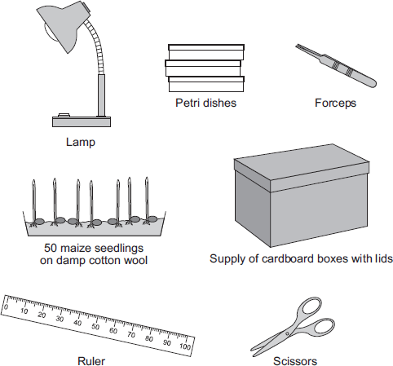

*In this question you will be assessed on using good English, organising information clearly and using specialist terms where appropriate.*

Describe how the students could use some or all of the apparatus and materials shown in the drawings to investigate the growth response of maize seedlings to light shining from one side.

You should include a description of the results you would expect.

___________________________________________________________________

___________________________________________________________________

___________________________________________________________________

___________________________________________________________________

___________________________________________________________________

___________________________________________________________________

___________________________________________________________________

___________________________________________________________________

___________________________________________________________________

___________________________________________________________________

___________________________________________________________________

___________________________________________________________________

___________________________________________________________________

___________________________________________________________________

___________________________________________________________________

___________________________________________________________________

___________________________________________________________________

___________________________________________________________________

___________________________________________________________________

___________________________________________________________________

___________________________________________________________________

___________________________________________________________________

**(6)**

**(Total 10 marks)**

**Q4.**

Microorganisms can decay potatoes.

(a)     Microorganisms obtain carbohydrates from the potato to use inside their cells.

Describe how.

___________________________________________________________________

___________________________________________________________________

___________________________________________________________________

___________________________________________________________________

**(2)**

(b)     A group of students investigated decay in potatoes.

The students made the hypothesis:

**‘The higher the temperature the faster the potato will decay.’**

The students:

•        cut five 50 g cubes of potato and put each one in a Petri dish

•        kept each dish at a different temperature for 14 weeks

•        measured the mass of each potato cube every week and recorded the mass.

The results are shown in the graph.

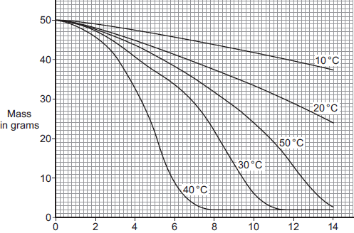  
        Time in weeks

(i)      The potato cubes decreased in mass over the 14 weeks.

Explain why.

______________________________________________________________

______________________________________________________________

______________________________________________________________

______________________________________________________________

______________________________________________________________

______________________________________________________________

**(3)**

(ii)     Do the students’ results support their hypothesis?

Explain your answer.

______________________________________________________________

______________________________________________________________

______________________________________________________________

______________________________________________________________

**(2)**

**(Total 7 marks)**