**PAPER 2 MOCK**



**Figure 1**

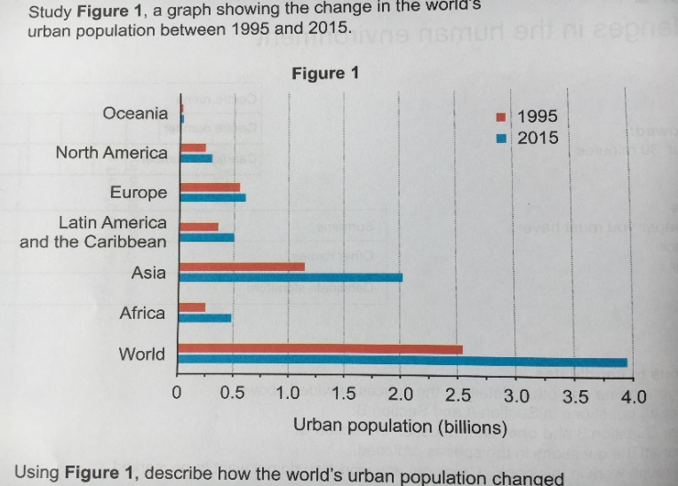

**Figure 2**

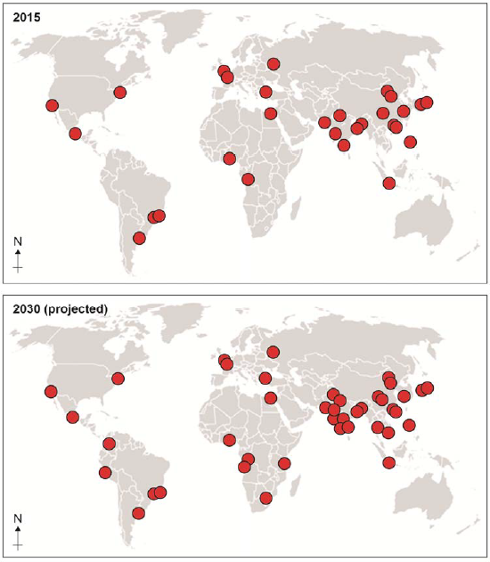

**Figure 3**

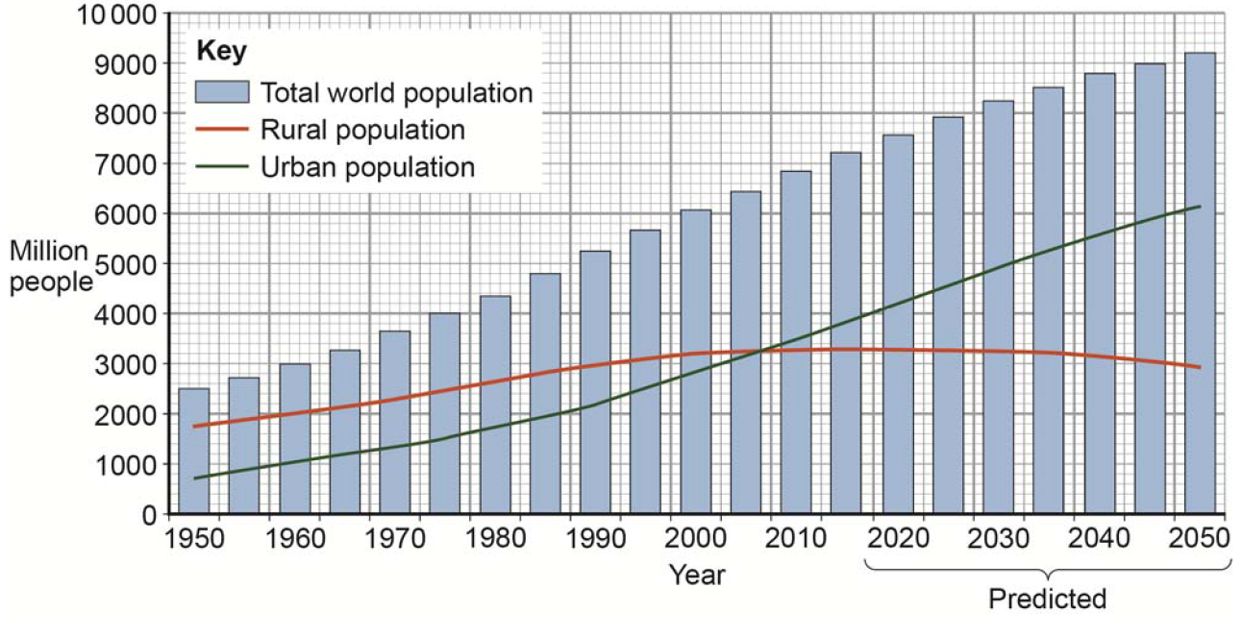

**Figure 4**

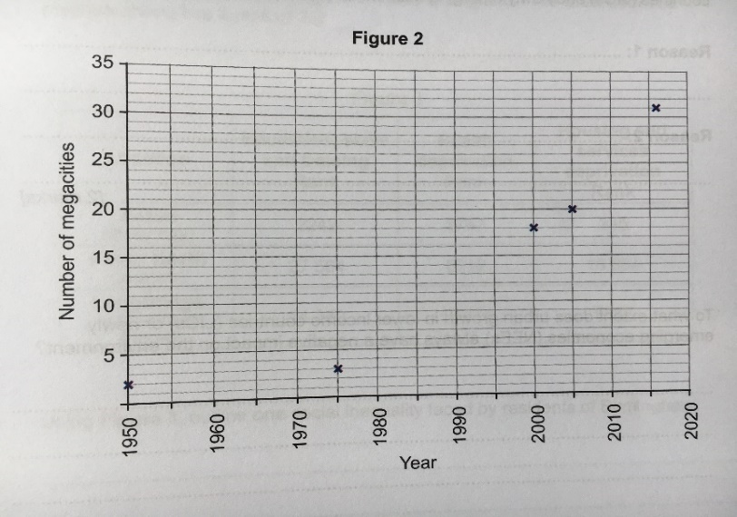

1. Study **Figure 1**, a graph showing the change in the world’s urban population between 1995 and 2015.
2. Using **Figure 1**, compare how urban populations changed in Asia and Europe between 1995 and 2015. (2 marks)
3. Suggest one reason for the variation in urban population growth in Asia and Europe. (2 marks)
4. Study **Figure 2**, a map showing megacities in 2015 and 2030 (projected). Complete the following paragraph to describe the changes shown by the maps 2015 – 2030. Choose the **three** correct answers from this list:

**Africa, South America, Australasia, Southern Asia, half, one, two, four**

*The greatest increase in the number of megacities is in _________________. There are no new megacities in ________ of the continents on the 2030 map. The continent of ______________ shows a 100% growth in number of megacities between 2015 and 2030.*

1. Suggest how Asia’s economic development might have affected their growth in urban populations. (2 marks)
2. Suggest **two** reasons for the slow rate of urban growth in many higher income countries (HICs). (2 marks)
3. Using **Figure 3**, which **two** of the statements about the world’s rural and urban population are true? (2 marks)

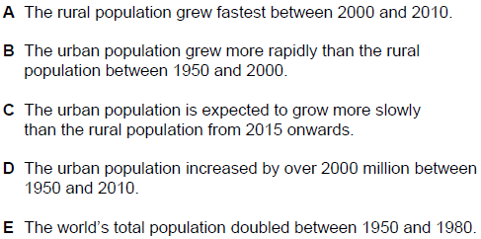

1. Study **Figure 4**, a graph showing the increase in the number of megacities since 1950. Using **Figure 4**, which one of the following statements is correct?

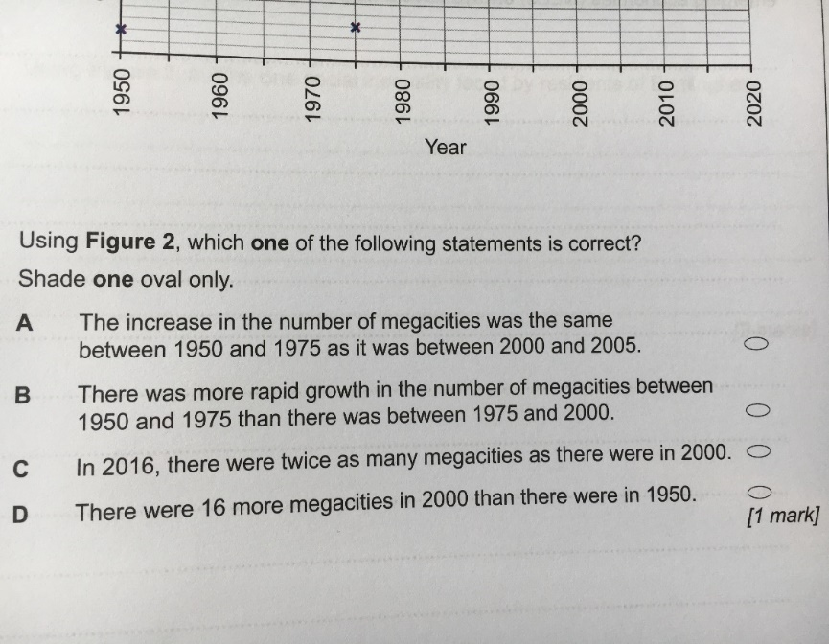

**Case study of a major city in an LIC or NEE: Rio de Janeiro**

1. Using an example of a LIC or NEE city you have studied, suggest one cause of its growing national importance. (2 marks)
2. Describe how urban areas provide social and economic opportunities for people. Use a case study of a city in a LIC or NEE. (6 mark)
3. Use a case study of a city in a LIC or NEE to discuss the challenges of managing rapid urban growth. (6 marks)

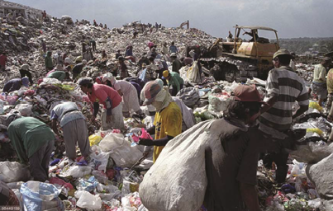

1. Study Figure 4, a photograph of a rubbish dump in the Payatas slum in Manila, a city in the Philippines. Using Figure 4 and your own understanding, to what extent does urban growth in an LIC or NEE provide economic opportunities? Use a case study of a city in an LIC or NEE. (6 marks)
2. Describe how squatter settlements provide challenges for people living in them. (4 marks)
3. Evaluate the effectiveness of an urban planning scheme in helping to improve the quality of life for the urban poor. Use an example of a city in a LIC or NEE. (9 marks)

**Case study of a major city in the UK: London**

1. Using an example of a major city in the UK, suggest one cause of its local economic importance. (2 marks)

**Figure 1**

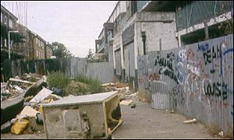

**Figure 2**



1. Study Figure 1, an inner city area in Leicester. Using Figure 1, suggest why many inner cities of urban areas in the UK have become derelict. (4 marks)
2. What is the rural-urban fringe? (2 marks)
3. Suggest one threat to the rural-urban fringe. (2 marks)
4. Suggest one way the rural-urban fringe is being protected. (2 marks)
5. Outline two ways that UK cities are responding to the challenge of providing housing. (2 marks)
6. Study Figure 2, a photograph of a new housing development located in the rural urban fringe of Bristol. Using Figure 2 and your own understanding, suggest two ways new housing developments on the edge of a cities are likely to be different from brownfield housing developments towards the centre of a city. (4 marks)
7. Explain how urban growth harms the environment. (6 marks)

**Urban sustainability**

1. Discuss the effectiveness of an urban transport scheme(s) you have studied. (6 marks)
2. ‘Urban areas can be sustainable if resources are carefully managed.’ Do you agree with this statement? Justify your answer. (9 marks)

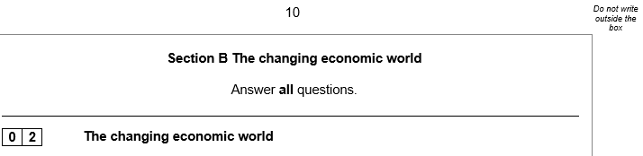

1. Study **Figure 5**, a map showing the Human Development Index (HDI) scores for countries in North and South America. Using Figure 5, describe the variation in HDI scores in North and South America (2)
2. Using **Figure 5**, describe the variation in HDI scores in North and South America. (2 marks)
3. Suggest two reasons for the variation in HDI scores in North and South America. (4 marks)
4. Using **Figure 5**, suggest how the differences in HDI might affect international migration in North and South America. (2 marks)
5. Using **Figure 5**, suggest how the differences in HDI might affect quality of life in North and South America. (4 marks)
6. Give **two** reasons why the birth rate changes as a country develops. (2 marks)
7. Outline **two** strategies that are being used to developed lower income countries (LICs) and newly emerging economies (NEEs). (4 marks)

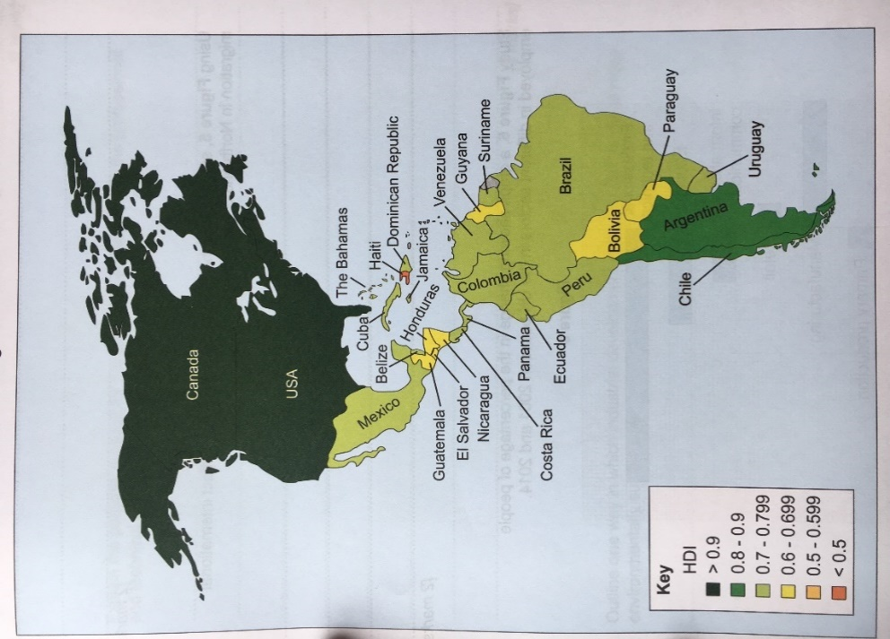

1. Study **Figure 8**, a graph showing the annual average amount of money that Syria received in international aid during each decade since the 1970s.
2. Using **Figure 8**, calculate the range in the average amount of international aid received by Syria. (1 mark)
3. Outline one reason why international aid may not be successful in reducing the global development gap. (2)

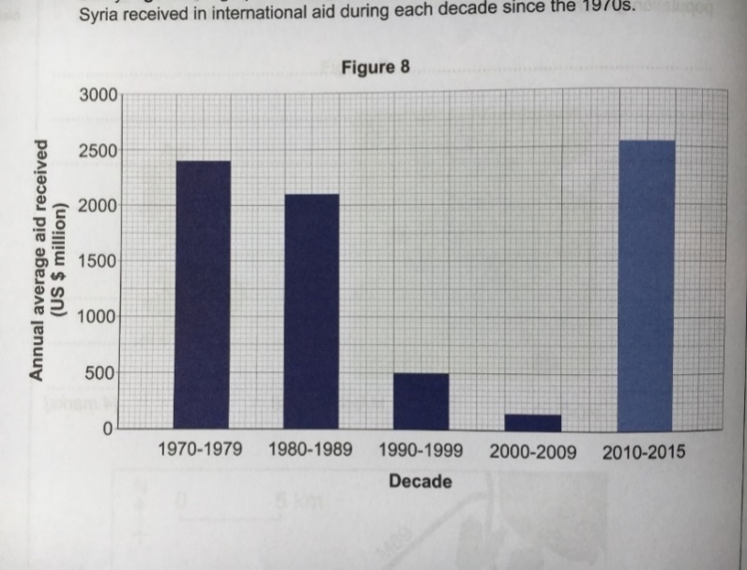

1. Debt relief is an alternative strategy to reduce the development gap. Outline one way in which debt can reduce this gap between rich and poor countries. (2 marks)
2. Discuss the social and economic impacts of tourism using a named example. (6 marks)
3. Study Figure 2, a map showing the top five recipients of aid from the UK Government in 2010. Use the following information to complete the figure:

* *Aid from UK to Bangladesh: £150 million*. (1 mark)

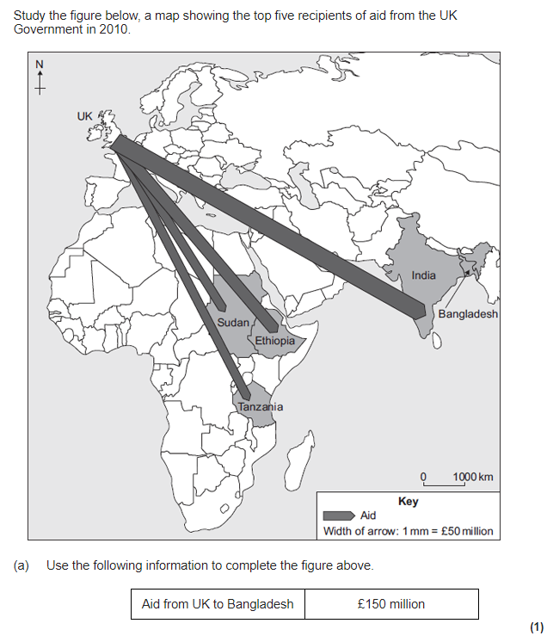

**A case study of an LIC or NEE: Nigeria**

1. Suggest how the changing trading relationship of a named LIC/NEE country with the wider world has changed its global importance. (2 marks)
2. Discuss the social and economic impacts of industrial growth on an LIC or NEE you have studied. (6 marks)
3. Using a case study of a lower income country (LIC) or newly emerging economy (NEE), describe how international aid has encouraged sustainable development. (6 marks)

**Figure 3**

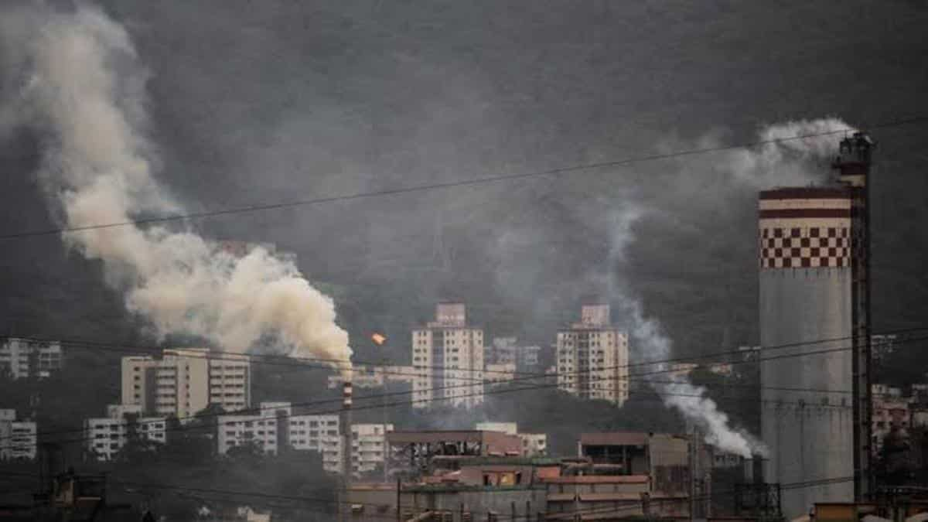

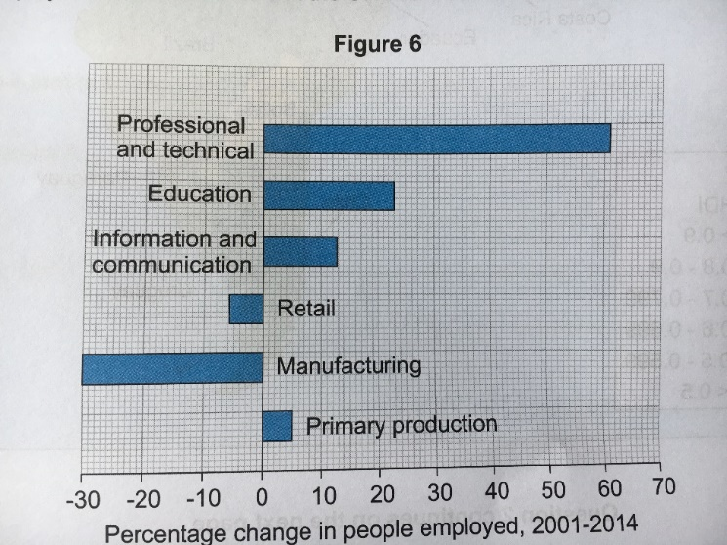

**Figure 8**

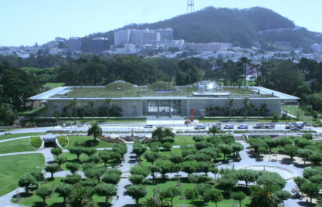

1. Study Figure 3, a photograph of Mumbai’s industrial district. Using Figure 3 and a case study of a LIC or NEE to explain how rapid economic development can impact on the environment. (6 marks)

**A case study of the UK’s economy**

1. Study Figure 6, a graph showing change in the percentage of people employed in different sectors in the UK between 2001 and 2014.
2. State the number of sectors in which the percentage of people employed decreased between 2001 and 2014. (1)
3. Explain the possible reasons for the change in employment in the “professional and technical” and “manufacturing” sector shown in Figure 6. (4 marks)
4. Outline the main characteristics of the UK’s current economic structure. (4 marks)
5. Discuss the social and economic impacts of changing rural populations in the UK. (6 marks)
6. To what extent has the UK’s global links benefited the country’s people and economy? (9 marks)
7. Study Figure 8, a photograph showing a modern industrial development. Using Figure 8 and an example you have studied, explain how modern industries can be more sustainable. (4 marks)
8. Explain reasons why there are regional differences within the UK. (6 marks)
9. Explain how the UK has tried to reduce the UK’s regional differences. (6 marks)

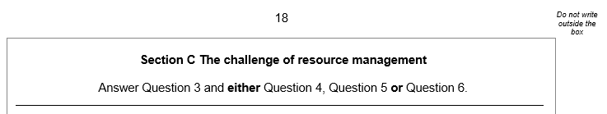

1. Suggest how inequalities in the consumption of resources influence well-being. (3 marks)
2. Explain how inequalities in the supply of resources influence social well-being. (3 marks)

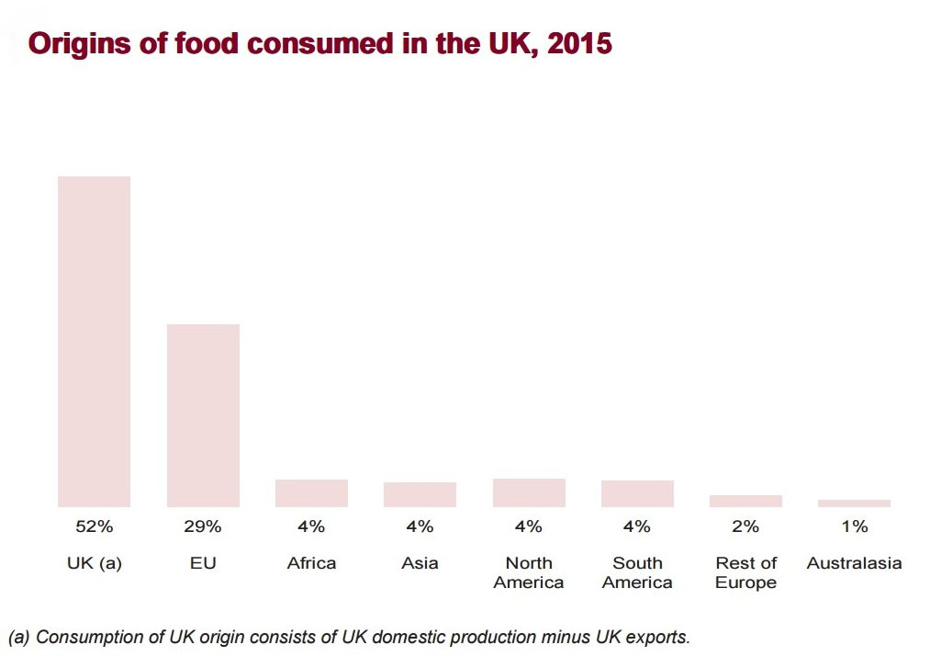



1. Study Figure 10, a bar chart showing the origin of food consumed in the UK in 2015.
2. Describe the pattern of food sources, as shown in Figure 10. (3 marks)
3. State one impact of the pattern shown in Figure 10. (2 marks)
4. Explain one reason for increase in imported food goods to the UK.(3 marks)
5. Assess the effectiveness of strategies used to reduce the UK’s carbon footprint within agriculture. (6 marks)
6. Study **Figure 10**, pie charts showing the types of fuel used to generate electricity in the UK in 2010 and 2016. Use **Figure 10**, which one of the statements below is correct? (1 mark)

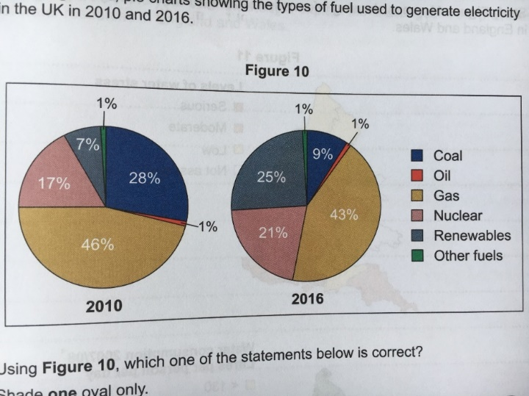



1. Using Figure 10, suggest how and why the UK’s energy mix will likely change in the future. (6 marks)
2. Outline how water transfer can help reduce issues caused due to water deficits. (3 marks)

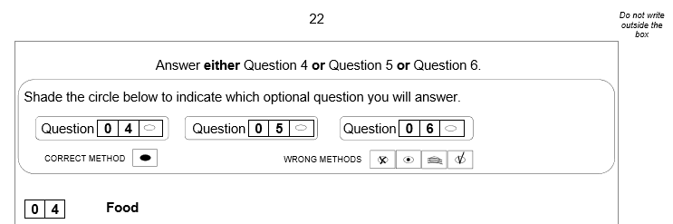

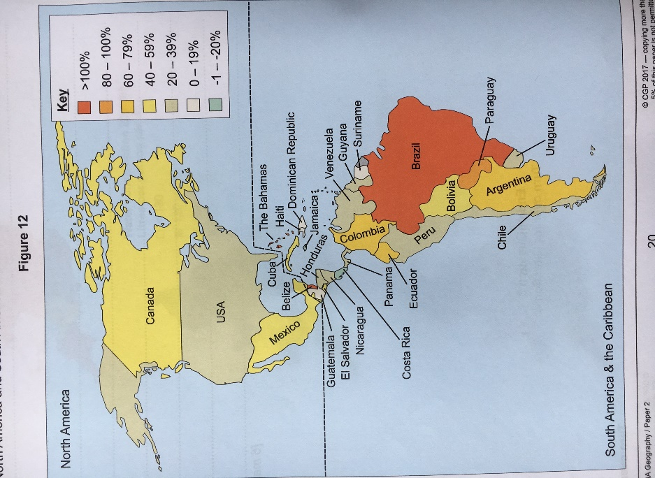

1. Study **Figure 12**, a map showing the percentage change in crop yields in North America and South America and the Caribbean between 1994 and 2014.
2. Which **one** of the following countries increased its crop yields by more than 100% between 1994 and 2014? (1)

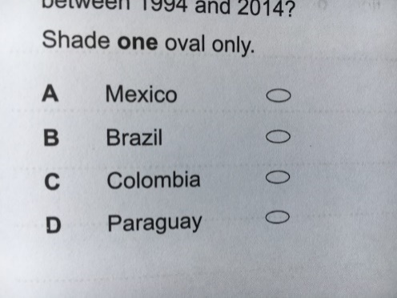

1. Describe two differences in the percentage change in crop yields in North America and South America and the Caribbean. (2 marks)

**Difference 1**…………………………………………………………………

**Difference 2**…………………………………………………………………

1. How many South American countries had an increase in crop yields between 60-79%? (1 mark)
2. Study Figure 11, a world map showing the risk of food security in 2013.

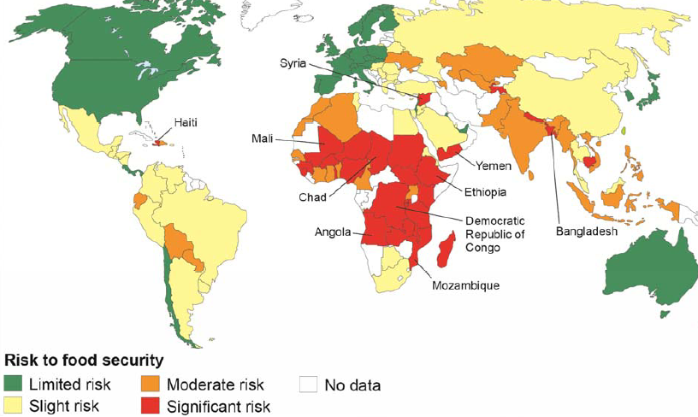

1. Name one Asian or Middle Eastern country with a significant risk to food security. (1 mark)
2. How many South American countries which data is shown have a moderate risk to food security? (1)  
   
3. What percentage of the 13 countries in mainland South America for which data is shown have a moderate risk to food security? (1 mark)
4. Describe the distribution of countries with a significant risk to food security shown in Figure 11. (2 marks)
5. Outline one physical reason why some countries have a significant risk of food security. (2 marks)
6. Suggest one way in which food insecurity might impact on the environment. (3 marks)
7. Suggest one way in which a lack of food security might affect the quality of life of people. (3 marks)
8. Discuss the effectiveness of strategies used to increase food supply. (6 marks)
9. Explain how appropriate strategies can increase food supply in the world’s less developed regions. (6 marks)
10. Explain how local strategies to increase sustainable supplies of food can have social and economic benefits. (6 marks)